Title: Association of fruit and vegetable consumption with mild cognitive impairment in low- and middle-income countries

Lee Smith¹, Guillermo F. López Sánchez²*, Nicola Veronese³, Pinar Soysal⁴, Hans Oh⁵, Karel Kostev⁶, Masoud Rahmati⁷, Laurie Butler¹, Poppy Gibson⁸, Helen Keyes⁹, Yvonne Barnett¹, Jae Il Shin¹⁰*, Ai Koyanagi^{11,12}

- Centre for Health Performance and Wellbeing, Anglia Ruskin University, Cambridge, UK.
- Division of Preventive Medicine and Public Health, Department of Public Health Sciences, School of Medicine, University of Murcia, Murcia, Spain.
- University of Palermo, Department of Internal Medicine, Geriatrics Section, Palermo, Italy.
- Department of Geriatric Medicine, Faculty of Medicine, Bezmialem Vakif University, Istanbul, Turkey.
- Suzanne Dworak Peck School of Social Work, University of Southern California, Los Angeles, CA, USA.
- University Clinic of Marburg, Marburg, Germany.
- Lorestan University, Department of Physical Education and Sport Sciences, Faculty of Literature and Human Sciences, Khoramabad, Iran.
- Faculty of Education and Social Care, Anglia Ruskin University, Chelmsford, UK.
- School of Psychology and Sport Science, Anglia Ruskin University, Cambridge, UK.
- Department of Pediatrics, Yonsei University College of Medicine, Seoul, South Korea.
- Research and Development Unit, Parc Sanitari Sant Joan de Déu, CIBERSAM, ISCIII, Dr. Antoni Pujadas, Sant Boi de Llobregat, Barcelona, Spain.
- ICREA, Pg. Lluis Companys 23, 08010, Barcelona, Spain.

* Corresponding authors:
Dr. Guillermo F. López Sánchez. gfls@um.es
Prof. Jae Il Shin. shinji@yuhs.ac

Conflict of interest: None.
Funding: Dr. Guillermo F. López Sánchez is funded by the European Union – Next Generation EU.
Ethics statement: Ethical approval was obtained from the WHO Ethical Review Committee and local ethics research review boards.
Consent to participate: Written informed consent was obtained from all participants.
Acknowledgment: This paper uses data from WHO’s Study on Global Ageing and Adult Health (SAGE). SAGE is supported by the U.S. National Institute on Aging through Interagency Agreements OGHA 04034785, YA1323–08-CN-0020, Y1-AG-1005–01 and through research grants R01-AG034479 and R21-AG034263.

ABSTRACT
Background: Inadequate fruit and vegetable intake may be associated with cognitive decline but its association with mild cognitive impairment (MCI) (a preclinical stage of dementia) is largely unknown. Therefore, we examined the association of fruit and vegetable consumption with MCI among middle-aged and older adults from low- and middle-income countries (LMICs).
Methods: Cross-sectional, nationally representative data from the WHO Study on global AGEing and adult health (SAGE) were analyzed. MCI was defined using the National Institute on Aging-Alzheimer's Association criteria. Quintiles of vegetable and fruit consumption were created based on the number of servings consumed on a typical day. Multivariable logistic regression analysis was conducted.
Results: Data on 32,715 individuals aged ≥50 years were analyzed [mean (SD) age 62.1 (15.6) years; 51.7% females]. Greater fruit consumption was dose-dependently associated with lower odds for MCI. For example, the highest quintile (vs. lowest) had 47% lower odds for MCI (OR=0.53; 95%CI=0.43-0.66). For vegetable consumption, compared to the lowest quintile, the second to fourth quintiles had significant 38% to 44% lower odds for MCI but there was no significant difference for the highest quintile (OR=0.82; 95%CI=0.59-1.15).
Conclusions: Higher fruit and vegetable consumption was associated with lower odds for MCI among middle-aged and older adults from LMICs, but no significant differences were found between the highest and lowest quintiles of vegetable consumption. Future longitudinal studies are required to explore these findings in more depth, and mechanistic studies are required to elucidate on the observed possible U-shaped association between vegetable consumption and MCI.
Key Words: Nutrition, Vegetable, Fruits, Mild cognitive impairment, Dementia, Low- and middle-income countries

INTRODUCTION
Dementia is a syndrome in which there is deterioration in cognitive function (i.e., the ability to process thought) beyond what might be expected from normal ageing, and this condition may present symptomatically as memory loss, confusion, disorientation, difficulty speaking or understanding language, and other symptoms [1]. This syndrome increases with age, and the estimated prevalence in people aged ≥60 years is between 5% and 8%. Given rapid population ageing occurring across the world, the prevalence of dementia is expected to rise drastically in the coming years [2]. Dementia is associated with a lower quality of life and wellbeing, particularly among those with greater behavioral and psychological symptoms [3,4]. Moreover, the care and support of patients with dementia has wide-ranging consequences for families, health-care systems, and society as a whole [5]. Importantly, there is currently no cure for dementia, and thus, interventions aimed at the preclinical state of dementia [e.g., mild cognitive impairment (MCI)] to prevent or delay the emergence of this syndrome are of upmost importance.

MCI is a syndrome defined as cognitive decline greater than expected for an individual’s age and education level, but that does not interfere notably with activities of daily life [6], and is recognized as an important “target” for the prevention of dementia. MCI has a high conversion rate to dementia (annual conversion rates ranging from 10% to 15% in clinical samples and 3.8% to 6.3% in community-based samples [7–9]. In the case of amnestic MCI, the overall rate of progression to Alzheimer’s Disease has been reported to be 11.5% per year [10].

Currently, there is emerging interest in the role of nutrition in the prevention of cognitive decline [11–13]. For example, evidence exists of a protective effect of certain nutrients (e.g., folate, flavonoids, vitamin D, and some lipids) or food groups (e.g., seafood, vegetables, fruits, and potentially moderate alcohol and caffeine consumption) on cognitive decline in older people [11]. Indeed, one possibly important but understudied potential risk factor for MCI is that of fruit and vegetable consumption. It is possible for higher consumption of vegetable and fruits to contribute to reduced risk for cognitive decline for the high content of antioxidants such as vitamin C, carotenoids, and other active ingredients [14]. For instance, in one systematic review analyzing six longitudinal studies, it was found that increased fruit and vegetable intake was associated with reduced risk of cognitive impairment (OR: 0.79; 95% CI: 0.67–0.93; P = 0.006) [14]. Moreover, a dose–response meta-analysis showed that an increment of 100 g per day of fruit and vegetable consumption was related to an approximately 13% (OR = 0.87, 95% CI 0.77–0.99) reduction in cognitive impairment and dementia risk [15]. However, studies on this topic specifically focusing on MCI, which carries a heightened risk for dementia, are lacking.

Thus, the aim of the present study was to examine the association of fruit and vegetable consumption with MCI in a large sample of adults aged ≥50 years from six LMICs (China, Ghana, India, Mexico, Russia, South Africa). Studying this association in the context of LMICs is particularly important given that more than two-thirds of those with dementia reside in this setting [16].

METHODS
We analyzed data from the Study on Global Ageing and Adult Health (SAGE), which was a survey undertaken in China, Ghana, India, Mexico, Russia, and South Africa between 2007 and 2010. Based on the World Bank classification at the time of the survey, Ghana was a low-income country, and China and India were lower middle-income countries although China became an upper middle-income country in 2010. The remainder of the countries were upper middle-income countries. Details of the survey methodology can be found elsewhere [17]. Briefly, in order to obtain nationally representative samples, a multistage clustered sampling design method was employed. The sample consisted of adults aged ≥18 years with oversampling of those aged ≥50 years. Trained interviewers conducted face-to-face interviews using a standard questionnaire. Standard translation procedures were undertaken to ensure comparability between countries. The survey response rates were: China 93%; Ghana 81%; India 68%; Mexico 53%; Russia 83%; and South Africa 75%. Sampling weights were constructed to adjust for the population structure as reported by the United Nations Statistical Division. Ethical approval was obtained from the WHO Ethical Review Committee and local ethics research review boards. Written informed consent was obtained from all participants.

Mild cognitive impairment
MCI was ascertained based on the recommendations of the National Institute on Aging-Alzheimer’s Association [18]. We applied the identical algorithms used in previous SAGE publications using with the same survey questions to identify MCI [19,20]. Briefly, individuals fulfilling all of the following conditions were considered to have MCI:
(a) Concern about a change in cognition: Individuals who replied ‘bad’ or ‘very bad’ to the question “How would you best describe your memory at present?” and/or those who answered ‘worse’ to the question “Compared to 12 months ago, would you say your memory is now better, the same or worse than it was then?” were considered to have this condition.
(b) Objective evidence of impairment in one or more cognitive domains: was based on a <-1 SD cut-off after adjustment for level of education, age, and country. Cognitive function was assessed through the following performance tests: word list immediate and delayed verbal recall from the Consortium to Establish a Registry for Alzheimer's Disease [21], which assessed learning and episodic memory; digit span forward and backwards from the Weschler Adult Intelligence Scale [22], that evaluated attention and working memory; and the animal naming task [21], which assessed verbal fluency.
(c) Preservation of independence in functional abilities: was assessed by questions on self-reported difficulties with basic activities of daily living (ADL) in the past 30 days [23]. Specific questions were: “How much difficulty did you have in getting dressed?” and “How much difficulty did you have with eating (including cutting up your food)?” The answer options were none, mild, moderate, severe, and extreme (cannot do). Those who answered either none, mild, or moderate to both of these questions were considered to have preservation of independence in functional activities. All other individuals were deleted from the analysis (935 individuals aged ≥50 years).
(d) No dementia: Individuals with a level of cognitive impairment severe enough to preclude the possibility to undertake the survey were not included in the current study.
Fruit and vegetable consumption
Participants were asked the two following questions: “How many servings of fruit do you eat on a typical day?” and “How many servings of vegetables do you eat on a typical day?” The participants were grouped into five categories based on quintiles of the answer to these questions [24].

Control variables
The selection of the control variables was based on past literature [25], and included age, sex, years of education received, wealth quintiles based on income, marital status [currently married/cohabiting or else (never married, separated, divorced, widowed), body mass index (BMI) based on measured weight and height (<18.5, 18.5–24.9, 25.0–29.9, 30 kg/m²), alcohol consumption, smoking (never, current, past), physical activity, diabetes, hypertension, stroke, and angina. Consumers of at least four (females) or five drinks (males) of any alcoholic beverage per day on at least one day in the past week were considered ‘heavy’ drinkers. Those who had ever consumed alcohol but were not heavy drinkers were categorized as ‘non-heavy’ drinkers [26]. Levels of physical activity were assessed with the Global Physical Activity Questionnaire and were classified as low, moderate, and high based on conventional cut-offs [27]. Stroke and diabetes were based solely on self-reported lifetime diagnosis. Hypertension was defined as having at least one of: systolic blood pressure ≥140 mmHg; diastolic blood pressure ≥90 mmHg; or self-reported diagnosis. Angina was based on self-reported diagnosis and/or the validated Rose questionnaire [28].

Statistical analysis
The statistical analysis was performed with Stata 14.2 (Stata Corp LP, College station, Texas). The analysis was restricted to those aged ≥50 years as MCI is an age-related condition. The difference in sample characteristics by MCI status were tested by Chi-squared tests and Student’s t-tests for categorical and continuous variables, respectively. The association of fruit consumption and vegetable consumption (exposures) and MCI (outcome) was estimated by multivariable logistic regression. The analysis was conducted using the overall sample, and samples stratified by sex and age groups (i.e., 50-64 years, ≥65 years). The analyses were adjusted for age, sex, education, wealth, marital status, BMI, alcohol consumption, smoking, physical activity, diabetes, stroke, hypertension, angina, and country, except for the sex-stratified analysis which was not adjusted for sex. For all regression analyses, fruit consumption and vegetable consumption were mutually adjusted for. Adjustment for country was done by including dummy variables for each country in the model as in previous SAGE publications [19,29]. All variables were included in the models as categorical variables with the exception of age and education (continuous variables). The sample weighting and the complex study design were taken into account in the analyses. Results from the regression analyses are presented as odds ratios (ORs) with 95% confidence intervals (CIs). The level of statistical significance was set at P<0.05.

RESULTS
A total of 32,715 individuals aged ≥50 years with preservation of independence in functional abilities constituted the final sample. The sample size (% females) per country was: China n=12,815 (50.2%); Ghana n=4,201 (47.4%); India n=6,191 (48.2%); Mexico n=2,070 (52.8%); Russia n=3,766 (60.6%); South Africa n=3,672 (56.0%). The sample characteristics are provided in Table 1. The mean (SD) age was 62.1 (15.6) years (range 50-114 years; median 60 years) and 51.7% were females. Those with MCI were significantly older, and were more likely to be females, with lower levels of wealth, education, and physical activity. Furthermore, they were more likely to be non-married/non-cohabiting, heavy drinkers, and have hypertension and stroke. The association between fruit or vegetable consumption and MCI estimated by multivariable logistic regression is shown in Table 2. In the overall sample, greater fruit consumption was dose-dependently associated with lower odds for MCI. For example, the highest quintile (vs. lowest) had a 47% lower odds for MCI (OR=0.53; 95%CI=0.43-0.66). Similar trends were observed in the sex-stratified and age-stratified samples. In contrast, for vegetable consumption, in the overall sample, compared to the lowest quintile, the second to fourth quintiles had a significant 38% to 44% lower odds for MCI but there was no significant difference for the highest quintile (OR=0.82; 95%CI=0.59-1.15). Similar patterns were observed for both age groups but there were some sex-differences where for females, second to fifth quintiles were all associated with significantly lower odds for MCI. For males, only the second quintile was significantly associated with lower odds for MCI. The adjusted predicted probability of MCI by fruit consumption quintiles (Figure 1) and vegetable consumption quintiles (Figure 2) illustrates the dose-dependent decline in odds for MCI for fruit consumption, and the U-shaped association between vegetable consumption and MCI.

DISCUSSION
Main findings
In the present large representative sample of middle-aged and older adults from six LMICs, we found a dose-dependent association between higher fruit consumption and lower odds for MCI. For example, in the overall sample, compared to the lowest quintile of fruit consumption, the odds for MCI in the highest quintile was almost halved (OR=0.53; 95%CI=0.43-0.66). For vegetable consumption, the association was more complex. Specifically, in the overall sample, compared to the lowest quintile, the second to fourth quintiles were associated with significant 38% to 44% lower odds for MCI, but the highest quintile was not significantly associated with lower odds for MCI. Vegetable consumption was more strongly associated with lower odds for MCI among females. To the authors’ knowledge this is the first study to investigate the associations of fruit or vegetable consumption with MCI.

Interpretation of the findings
Findings from the present study are broadly in line with those of the previous review article which found that increased vegetable and fruit consumption is associated with lower odds for cognitive decline [14]. The finding that higher fruit and vegetable consumption is associated with lower odds for MCI (although very high vegetable consumption may not be associated with lower odds for MCI especially among males) can be explained through several mechanisms. First, the intake of dietary antioxidants, found in abundance in fruits such as berries and vegetables, could affect the development of MCI. Indeed, the brain is susceptible to oxidative damage, and oxidative stress or inadequate antioxidant defense likely mediates the pathogenesis and progression of dementia and potentially MCI [11]. Second, fruits and vegetables also contain an abundance of flavonoids. Flavonoids are thought to enhance cognitive function via their neuroprotective properties, enhancing neuronal function and by stimulating neurogenesis [30]. Third, fruits and vegetables contain an abundance of folate. Folate participates in the DNA methylation process as a donor of methyl, while DNA methylation plays a crucial role in aging and dementia pathogenesis [31]. In addition, folate regulates the expression of both β-secretase and γ-secretase which contribute to Aβ generation and neurotic plaque formation. Moreover, folate inhibits tau phosphorylation and subsequent neurofibrillary tangle formation by indirectly regulating the activity of protein phosphatase cyclin-dependent kinase and glycogen synthase kinase [31]. Finally, the fruit and vegetable mediated cognitive benefits are likely dependent on the bioavailability of multiple bioactive compounds, rather than a single nutrient. Indeed, taking dietary supplements has not been consistently found to be effective in preventing dementia in older adults [32,33].

The potential U-shaped association between vegetable consumption and MCI is interesting and worth noting. The reason why highest vegetable consumption was not significantly different from lowest vegetable consumption is elusive and more mechanistic research is needed to shed light on this association. For example, although speculative, this may be related to the content of vegetables that are consumed among people who consume large amounts of vegetables. Indeed, it is possible for some types of vegetables (e.g., leafy green vegetables rich in vitamin K and folate) to provide more protective effects against cognitive decline than others [34]. Alternatively, there is also a possibility of reverse causation; that is, those who begin to have MCI may change their dietary behavior to include more vegetables owing to the well-known cognitive benefits.

Another interesting finding worth noting is that vegetable consumption was more strongly associated with lower odds for MCI among females. A rationale for this sex difference is unclear and further research on the mechanisms is required. However, research has reported different food items within dietary patterns between males and females, and it is possible that food items females regularly consume, in comparison to males, may provide more protective effects against MCI [35].

Implication of study findings
The finding that fruit intake is dose-dependently associated with a lower risk for MCI in this sample of middle-aged and older adults across six LMICs tentatively suggests that the promotion of fruit intake in such settings may aid in the prevention of MCI and subsequently dementia. In terms of vegetable consumption, this may also hold up to a certain level especially among females. Future cohort studies with precise reporting of vegetable consumption are necessary to determine whether there exists a threshold for vegetable consumption in terms of its beneficial effects on cognition.

Indeed, current global fruit and vegetable intakes are low. A systematic analysis of 266 country-specific nutrition surveys worldwide found that in 2010, global fruit intake was 81.3 g/day, with only two countries having mean intakes of at least 300 g/day [36]. A range of global plans have been developed to prompt action to increase fruit and vegetable intake, including the WHO Global Action Plan for the Prevention and Control of Non-Communicable Diseases (NCDs), and the United Nations (UN) Decade of Action on Nutrition 2016–2025. Similarly, the NOURISHING framework of the World Cancer Research Fund International (WCRF) has been established to guide national efforts to improve public health nutrition. The framework specifies a range of interventions across 10 key policy areas in three key domains: food environment (e.g., food labelling standards), food system (e.g., supply chain actions) and behavioral change communication (e.g., nutrition counselling).

Strengths and limitations
The analyses of large representative samples of middle-aged to older adults across six LMICs are clear strengths of the present study. However, findings must be interpreted in light of the study’s limitations. First, the study was cross-sectional in nature and thus, temporal associations cannot be established. For example, as mentioned previously, the non-linear association between vegetable consumption and MCI could be due to reverse causality where people with MCI may prefer to consume more fruits and vegetables for their known benefits on cognition. Furthermore, it is possible for cognitive function to impact the ability to make healthy food choices. Second, the majority of variables were self-reported potentially introducing social desirability and recall bias into the findings. Third, as in most epidemiological studies, a clinical assessment for dementia was not conducted in our study. Thus, our sample could have included people with mild dementia but the prevalence of MCI in our study was similar to previously reported figures [37]. We also lacked information on the exact type of fruit or vegetable people consume, despite the fact that some types of vegetables or fruits may be more beneficial for cognitive health. Moreover, the dietary patterns of each of the countries analyzed may vary greatly as different continents are represented. Future studies should also consider the impact of dietary patterns on MCI. Finally, it is also possible that people who consume greater amounts of fruits and vegetables are those who are more health-conscious and have healthier lifestyle habits. For example, they may consume other types of food or foods of certain dietary patterns that may promote cognitive health. However, we were unable to adjust for other types of food that may affect cognition due to lack of data, and thus, residual confounding may exist. In addition, while we did adjust for factors such as alcohol consumption, smoking, and physical activity, these variables only reflected current levels and we lacked information on past patterns of these behaviors, which could also be important in terms of their influence on cognitive function.

Conclusion
In the present study consisting of analyses of large representative samples of middle-aged to older adults across six LMICs, we observed a dose-dependent inverse association between fruit consumption and MCI, and a potential U-shaped association between vegetable consumption and MCI. Future longitudinal studies are required to understand temporal associations, and especially whether there exists a threshold for benefits of vegetables on cognition.

REFERENCES
1. World Health Organization. Dementia. Published 2021. https://www.who.int/news-room/fact-sheets/detail/dementia
2. Alzheimer’s Disease International. Dementia statistics. Numbers of people with dementia. Published 2022. Accessed January 6, 2022. https://www.alzint.org/about/dementia-facts-figures/dementia-statistics/
3. Hurt C, Bhattacharyya S, Burns A, et al. Patient and caregiver perspectives of quality of life in dementia. Dement Geriatr Cogn Disord. 2008;26(2):138-146.
4. Kushkestani M, Parvani M, Ghafari M, Avazpoor Z. The role of exercise and physical activity on aging-related diseases and geriatric syndromes. Sport TK-Revista Euroam Ciencias del Deport. 2022;11:6.
5. Nichols E, Szoeke CEI, Vollset SE, et al. Global, regional, and national burden of Alzheimer’s disease and other dementias, 1990–2016: a systematic analysis for the Global Burden of Disease Study 2016. Lancet Neurol. 2019;18(1):88-106.
6. Gauthier S, Reisberg B, Zaudig M, et al. Mild cognitive impairment. Lancet. 2006;367(9518):1262-1270.
7. Bohlken J, Jacob L, Kostev K. Progression of mild cognitive impairment to dementia in German specialist practices. Dementia. 2019;18(1):380-390.
8. Farias ST, Mungas D, Reed BR, Harvey D, DeCarli C. Progression of mild cognitive impairment to dementia in clinic-vs community-based cohorts. Arch Neurol. 2009;66(9):1151-1157.
9. Morris JC. Mild cognitive impairment and preclinical Alzheimer’s disease. Geriatrics. Published online 2005.
10. Mauri M, Sinforiani E, Zucchella C, Cuzzoni MG, Bono G. Progression to dementia in a population with amnestic mild cognitive impairment: clinical variables associated with conversion. Funct Neurol. 2012;27(1):49.
11. Scarmeas N, Anastasiou CA, Yannakoulia M. Nutrition and prevention of cognitive impairment. Lancet Neurol. 2018;17(11):1006-1015.
12. Fares K, Barada D, Hoteit M, Abou Haidar M. Prevalence and correlates of food insecurity among Lebanese University students of Hadath Campus. Atena J Public Heal. 2020;2:5.
13. El Haddad RF, Yahfoufi N, Abou Haidar M, Hoteit M. Knowledge, Attitude and Practices of Lebanese Married Women towards Food Safety. Atena J Public Heal. 2020;2:1.
14. Mottaghi T, Amirabdollahian F, Haghighatdoost F. Fruit and vegetable intake and cognitive impairment: a systematic review and meta-analysis of observational studies. Eur J Clin Nutr. 2018;72(10):1336-1344.
15. Jiang X, Huang J, Song D, Deng R, Wei J, Zhang Z. Increased consumption of fruit and vegetables is related to a reduced risk of cognitive impairment and dementia: meta-analysis. Front Aging Neurosci. 2017;9:18.
16. Wimo A, Guerchet M, Ali GC, et al. The worldwide costs of dementia 2015 and comparisons with 2010. Alzheimer’s Dement. 2017;13(1):1-7.
17. Kowal P, Chatterji S, Naidoo N, et al. Data resource profile: the World Health Organization Study on global AGEing and adult health (SAGE). Int J Epidemiol. 2012;41(6):1639-1649.
18. Albert MS, DeKosky ST, Dickson D, et al. The diagnosis of mild cognitive impairment due to Alzheimer’s disease: recommendations from the National Institute on Aging‐Alzheimer’s Association workgroups on diagnostic guidelines for Alzheimer’s disease. Alzheimer’s Dement. 2011;7(3):270-279.
19. Koyanagi A, Lara E, Stubbs B, et al. Chronic physical conditions, multimorbidity, and mild cognitive impairment in low‐and middle‐income countries. J Am Geriatr Soc. 2018;66(4):721-727.
20. Koyanagi A, Oh H, Vancampfort D, et al. Perceived stress and mild cognitive impairment among 32,715 community-dwelling older adults across six low-and middle-income countries. Gerontology. 2019;65(2):155-163.
21. Morris JC, Heyman A, Mohs RC, et al. The consortium to establish a registry for Alzheimer’s disease (CERAD): I. Clinical and neuropsychological assessment of Alzheimer’s disease. Neurology. Published online 1989.
22. Tulsky DS, Ledbetter MF. Updating to the WAIS–III and WMS–III: Considerations for research and clinical practice. Psychol Assess. 2000;12(3):253.
23. Katz S, Ford AB, Moskowitz RW, Jackson BA, Jaffe MW. Studies of illness in the aged: the index of ADL: a standardized measure of biological and psychosocial function. Jama. 1963;185(12):914-919.
24. Kim J, Lee Y, Kye S, Chung YS, Kim KM. Association of vegetables and fruits consumption with sarcopenia in older adults: the Fourth Korea National Health and Nutrition Examination Survey. Age Ageing. 2015;44(1):96-102.
25. Sheng LT, Jiang YW, Alperet DJ, Feng L, Pan A, Koh WP. Quantity and variety of fruit and vegetable intake in midlife and cognitive impairment in late life: a prospective cohort study. Br J Nutr. Published online 2022:1-30.
26. Koyanagi A, Stickley A, Garin N, et al. The association between obesity and back pain in nine countries: a cross-sectional study. BMC Public Health. 2015;15(1):1-9.
27. Bull FC, Maslin TS, Armstrong T. Global physical activity questionnaire (GPAQ): nine country reliability and validity study. J Phys Act Heal. 2009;6(6):790-804.
28. Rose GA. The diagnosis of ischaemic heart pain and intermittent claudication in field surveys. Bull World Health Organ. 1962;27(6):645.
29. Koyanagi A, Garin N, Olaya B, et al. Chronic conditions and sleep problems among adults aged 50 years or over in nine countries: a multi-country study. PLoS One. 2014;9(12):e114742.
30. Macready AL, Kennedy OB, Ellis JA, Williams CM, Spencer JPE, Butler LT. Flavonoids and cognitive function: a review of human randomized controlled trial studies and recommendations for future studies. Genes Nutr. 2009;4(4):227-242.
31. Zhang X, Bao G, Liu D, et al. The association between folate and Alzheimer’s disease: a systematic review and meta-analysis. Front Neurosci. Published online 2021:385.
32. Malouf R, Evans JG. Folic acid with or without vitamin B12 for the prevention and treatment of healthy elderly and demented people. Cochrane Database Syst Rev. 2008;(4).
33. Farina N, Llewellyn D, Isaac MGEKN, Tabet N. Vitamin E for Alzheimer’s dementia and mild cognitive impairment. Cochrane database Syst Rev. 2017;(1).
34. Harvard Health Pulblishing. Foods linked to better brainpower. Published 2021. Accessed July 9, 2022. https://www.health.harvard.edu/healthbeat/foods-linked-to-better-brainpower
35. D’Amico D, Parrott MD, Greenwood CE, et al. Sex differences in the relationship between dietary pattern adherence and cognitive function among older adults: findings from the NuAge study. Nutr J. 2020;19(1):1-8.
36. Micha R, Khatibzadeh S, Shi P, Andrews KG, Engell RE, Mozaffarian D. Global, regional and national consumption of major food groups in 1990 and 2010: a systematic analysis including 266 country-specific nutrition surveys worldwide. BMJ Open. 2015;5(9):e008705.
37. Petersen RC. Mild cognitive impairment. Contin Lifelong Learn Neurol. 2016;22(2 Dementia):404.

Table 1 Sample characteristics (overall and by mild cognitive impairment)
 |  |  | Mild cognitive impairment
Characteristic |  | Overall | No | Yes | P-valueª
Age (years) | Mean (SD) | 62.1 (15.6) | 61.7 (15.2) | 64.4 (17.2) | <0.001
Sex | Female | 51.7 | 51.4 | 55.1 | 0.006
 | Male | 48.3 | 48.6 | 44.9
Wealth | Poorest | 16.9 | 16.1 | 22.6 | <0.001
 | Poorer | 18.9 | 18.5 | 22.8
 | Middle | 19.4 | 18.6 | 24.5
 | Richer | 21.5 | 22.0 | 18.6
 | Richest | 23.3 | 24.9 | 11.5
Education (years) | Mean (SD) | 6.1 (8.9) | 6.2 (9.1) | 4.8 (7.5) | <0.001
Marital status | Married/cohabiting | 76.3 | 76.6 | 73.9 | 0.043
 | Else | 23.7 | 23.4 | 26.1
Body mass index (kg/m²) | <18.5 | 16.2 | 16.6 | 14.8 | 0.045
 | 18.5-24.9 | 47.8 | 47.3 | 51.6
 | 25.0-29.9 | 24.5 | 24.6 | 23.5
 | ≥30 | 11.5 | 11.4 | 10.1
Alcohol consumption | Never | 66.7 | 66.3 | 67.1 | 0.006
 | Non-heavy | 29.1 | 29.7 | 27.2
 | Heavy | 4.2 | 4.0 | 5.7
Smoking | Never | 58.7 | 58.2 | 59.0 | 0.381
 | Current | 34.9 | 35.5 | 34.1
 | Past | 6.4 | 6.4 | 6.9
Physical activity | High | 49.9 | 51.1 | 47.7 | <0.001
 | Moderate | 23.0 | 23.4 | 19.6
 | Low | 27.1 | 25.5 | 32.7
Diabetes | No | 93.3 | 93.4 | 93.1 | 0.703
 | Yes | 6.7 | 6.6 | 6.9
Hypertension | No | 45.2 | 46.1 | 39.0 | <0.001
 | Yes | 54.8 | 53.9 | 61.0
Stroke | No | 96.2 | 96.8 | 92.9 | <0.001
 | Yes | 3.8 | 3.2 | 7.1
Angina | No | 82.8 | 82.9 | 81.5 | 0.286
 | Yes | 17.2 | 17.1 | 18.5
Abbreviation: SD Standard deviation
Data are % unless otherwise stated.
ª P-value was based on Chi-squared tests and Student’s t-tests for categorical and continuous variables, respectively.

Table 2 Association between fruit or vegetable consumption and mild cognitive impairment estimated by multivariable logistic regression
 |  |  |  | Sex |  |  |  | Age
 |  | Overall |  | Male |  | Female |  | 50-64 years |  | ≥65 years
Exposure | Quintile | OR | 95%CI | OR | 95%CI | OR | 95%CI | OR | 95%CI | OR | 95%CI
Fruit | Q1 (Lowest) | 1.00 |  | 1.00 |  | 1.00 |  | 1.00 |  | 1.00
consumption | Q2 | 0.80* | [0.66,0.96] | 0.86 | [0.64,1.16] | 0.75** | [0.61,0.91] | 0.71** | [0.56,0.89] | 0.92 | [0.67,1.26]
 | Q3 | 0.79** | [0.67,0.92] | 0.74** | [0.60,0.91] | 0.82 | [0.67,1.02] | 0.72*** | [0.59,0.87] | 0.88 | [0.69,1.11]
 | Q4 | 0.71*** | [0.58,0.86] | 0.69* | [0.50,0.94] | 0.73** | [0.58,0.92] | 0.64*** | [0.50,0.82] | 0.84 | [0.60,1.16]
 | Q5 (Highest) | 0.53*** | [0.43,0.66] | 0.55*** | [0.43,0.72] | 0.52*** | [0.40,0.69] | 0.53*** | [0.41,0.68] | 0.52*** | [0.38,0.72]
Vegetable | Q1 (Lowest) | 1.00 |  | 1.00 |  | 1.00 |  | 1.00 |  | 1.00
consumption | Q2 | 0.62*** | [0.51,0.75] | 0.68* | [0.49,0.93] | 0.60*** | [0.45,0.79] | 0.62** | [0.47,0.83] | 0.63** | [0.48,0.84]
 | Q3 | 0.60*** | [0.46,0.78] | 0.98 | [0.66,1.47] | 0.40*** | [0.29,0.54] | 0.59** | [0.43,0.82] | 0.65* | [0.43,0.98]
 | Q4 | 0.56*** | [0.40,0.79] | 0.83 | [0.50,1.36] | 0.41*** | [0.29,0.60] | 0.53** | [0.35,0.81] | 0.62* | [0.40,0.98]
 | Q5 (Highest) | 0.82 | [0.59,1.15] | 1.21 | [0.75,1.96] | 0.60** | [0.41,0.87] | 0.85 | [0.57,1.28] | 0.75 | [0.47,1.20]
Abbreviation: OR Odds ratio; CI Confidence interval
Models are adjusted for age, education, wealth, marital status, body mass index, alcohol consumption, smoking, physical activity, diabetes, hypertension, stroke, angina, and country. Analyses using the overall sample and age-stratified samples are also adjusted for sex. Fruit consumption and vegetable consumption are mutually adjusted for in all models.
* p<0.05, ** p<0.01, *** p<0.001

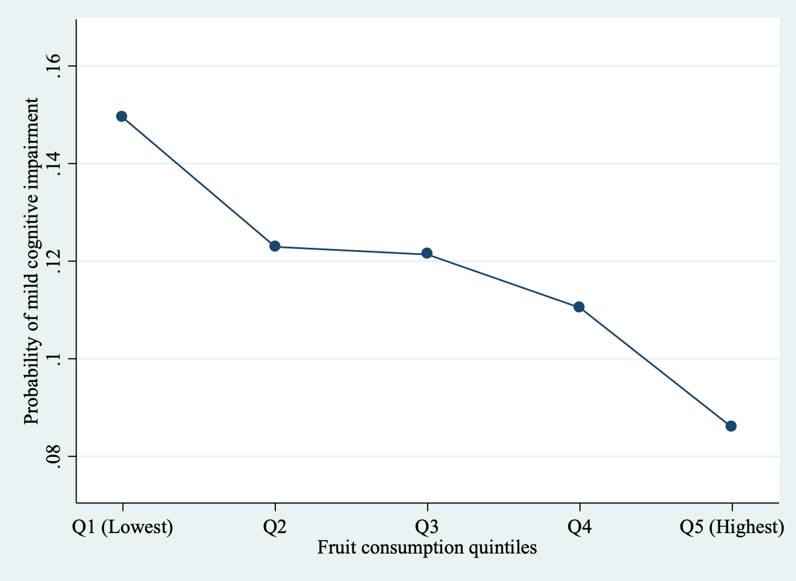
Figure 1 Predicted probability of mild cognitive impairment by fruit consumption quintiles
Predictions are based on a model adjusted for age, sex, education, wealth, marital status, body mass index, alcohol consumption, smoking, physical activity, diabetes, hypertension, stroke, angina, vegetable consumption, and country, using mean values.

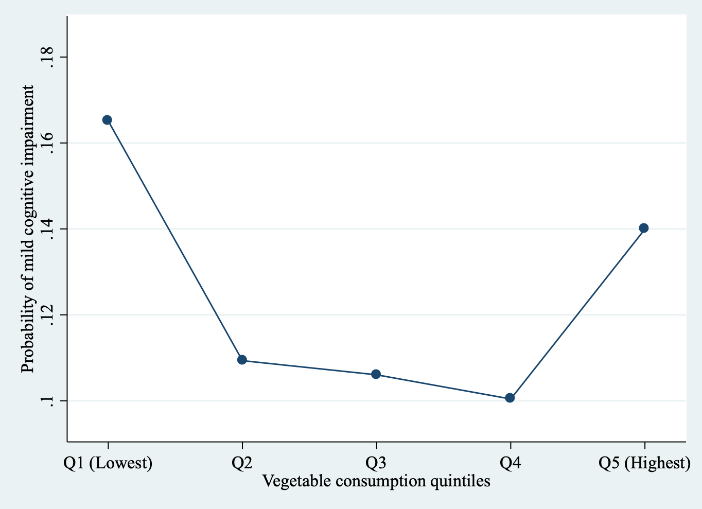
Figure 2 Predicted probability of mild cognitive impairment by vegetable consumption quintiles
Predictions are based on a model adjusted for age, sex, education, wealth, marital status, body mass index, alcohol consumption, smoking, physical activity, diabetes, hypertension, stroke, angina, fruit consumption, and country, using mean values.

