ANGLIA RUSKIN UNIVERSITY
FACULTY OF ARTS, HUMANITIES AND SOCIAL SCIENCES

PERFORMING NONVIOLENT RESISTANCE: TOWARDS AN UNDERSTANDING OF THE MEMPHIS SANITATION WORKERS’ STRIKE OF 1968

SHARON J. REIVES

A thesis in partial fulfilment of the requirements of Anglia Ruskin University for the degree of PhD

Submitted: June 2019

‘I didn’t know what had led Martin Luther King to come to Memphis.’
(UK audience member 2018, Appendix 1: 243)

ANGLIA RUSKIN UNIVERSITY

ABSTRACT

FACULTY OF ARTS, HUMANITIES AND SOCIAL SCIENCES

DOCTOR OF PHILOSOPHY

PERFORMING NONVIOLENT RESISTANCE: TOWARDS AN UNDERSTANDING OF THE MEMPHIS SANITATION WORKERS’ STRIKE OF 1968

SHARON J. REIVES
June 2019
This is a practice-as-research project using theatrical practice as its major research strategy. Through archival research and testimony, I created a play entitled A Balm in Gilead, which I also produced and directed. A filmed record of that performance is submitted as an integral part of my project. This piece was performed in Zion Baptist Church in Cambridge on 15 January 2018, to commemorate the fiftieth anniversary of the assassination of Dr. Martin Luther King, Jr. It is a play with music and dance, but it is not a musical. I hypothesize that the principles of nonviolent resistance, which King’s stance in the civil rights movement epitomized, can be taught through theatrical performance. Teaching of the principles of nonviolent resistance is still very much relevant today. Furthermore, A Balm in Gilead is Community Theatre. I intentionally used members of the various communities as part of the cast and crew in both countries.
My thesis provides the historical and contextual basis of the performance. Dr. King was in Memphis to support the strike of the city’s sanitation workers in 1968. I investigate the Memphis strike and the wider social conditions in which it took place, enabling a more informed understanding of this episode and its significance. The Memphis sanitation workers’ strike also reveals lessons of nonviolent resistance and self-determination. Through this strike, I investigate the tumultuous battle for union and civil rights in Memphis. The strike forced the nation to see and hear its working poor. My study shows that the Memphis strike also became a turning point for the civil rights movement. My research findings further indicate that the Memphis strike is a story primarily about economic and racial injustice.
I will present first-hand research evidence gathered from audience interviews and testimonies, that theatrical performance can indeed be effectively used to teach the principles of nonviolent resistance. From this research, I conclude that future studies of theatre for social change is needed as a cadre of performing artists and theatre companies are putting social, political and civic causes at the forefront of their work.
Keywords: Nonviolence, Theatre, Preaching, Faith, Labour, Protest
Acknowledgements

It is with sincere gratitude that I thank my mother who worked for her union, United Food and Commercial Workers Local 1991, for over thirty years, and who also served as its secretary. My thanks also go to the brave 1300 Memphis sanitation workers of 1968 (of whom 14 are still living and 4 are still working on the job) for their remarkable courage and determination. I want to thank Rev. Dr. Martin Luther King, Jr. for changing our nation and the world for the better, who paid the ultimate sacrifice with his life on behalf of God’s ‘least of these’.
To my supervisory team: Dr. Sue Wilson, my superb first supervisor and mentor, a very special thanks for her indelible guidance and encouragement and Dr. Nigel Ward, second supervisor, for his unfailing support and humour. Without their direction, this thesis could not have been written. My thanks also to the marvellous subject librarian, Ms. Cushion, and to the ARU library IT support team, especially Richard and Peter. I wish to thank Theresa, Matt and the many kind people who make up the ARU library staff. Thanks to Dr. Pamela Jenner for setting up the radio interview regarding my play.
Thanks to ALSS administrator Ms. Ranchetti for all of her kind support and assistance; special thanks to Mrs. Futter in the ARU Housing office, and my writing seminar professor, Dr. Kate Williams.
Special thanks to Rev. Gale Richards and Zion Baptist Church in Cambridge, UK, and to Joy for the making of the iconic ‘I AM A MAN’ signs. Thanks to pastors Idris Kolade Oyinlade and Olayinka Oyinlade of RCCG, City of David Church, UK, as well as Sister Funke. Also, thanks to Rev. Dr. Mark Kelly Tyler, Joetta Cryer and family, and Mother Bethel A.M.E. Church, in Philadelphia; as well as Rev. Dr. Michael N. Harris and Wheat Street Baptist Church, in Atlanta.

To Jay: I marvel at your incredible faith. I am most indebted to my referees: Dr. Patrick Henry and Rev. Dr. Harry Adams, my first preaching professor. Thanks to my mentor and spiritual father, Rev. Dr. J. DeOtis Roberts. Special thanks to the late Mr. Alvin Turner for his most generous interview and to my fellow PhD students for their kindness and friendship. I would also like to thank my family for their wonderful love and support while on this educational journey.
Thanks to my pastor, the late Rev. Dr. Fred C. Lofton, who introduced me to the story of the 1968 Memphis sanitation workers’ strike, and who ordained me a Baptist preacher. I thank the late Rev. Dr. Frank McRae for his commitment to social justice and for his most compelling storytelling of the Memphis strike.
To my stage manager, Sharese Shallow, sound technician, Will Smythe, and indeed to all of the talented and gifted cast and crew of A Balm in Gilead in the U.S. and the UK; a special thanks to my long-time choreographer and dear friend, Rev. Faye Chandler for her commitment and unwavering support, and to the Elevation Youth Dance Company in Cambridge, and the London Adventist Chorale under the superb direction of Mr. Ken Burton, and to our remarkable drummer, Llewelyn Vann. Thanks to the ARU Arts Council and Ms. Claire Kenny and Unison public service union for their outstanding financial support. I would like to thank my band director, Mr. Adkins, who saw me perform in our high school play and encouraged me to pursue a career in theatre. Special thanks to the late Dr. Eddie W. Jones for choosing me to write the dramatic piece for The Gospel Feast, and to my college theatre director, Mr. John Johnson, for his confidence in me.
Thanks to my grandmother, ‘Big Mama’, who was only afforded a 7th grade education, yet possessed astonishing wisdom and invaluable mother wit. Thanks to my mother who attended segregated schools and who had to leave home at age 15 in order to have the opportunity to attend high school, because there was no high school in the rural area where she lived for African American students. I wish to thank my third teacher who cast me in my first play based on the ‘Mother Goose Rhymes’; a seed was planted which resulted in a love of theatre for a lifetime.
Finally, I pray for people at all levels of learning from Pre-Kindergarten to post doctorate and beyond, especially those with learning disabilities, traumatic brain injuries, as well as those with other physical and mental health challenges.

TABLE OF CONTENTS
Epigraph…………………………………………………………………………………………..i
Abstract…………………………………………………………………………………………...ii
Acknowledgements………………………………………………………………...….…….....iii
Preface……………………………………………………………………………..……..…......x
A Note about the Production….……………………………………….………………...……xiii
Introduction………………………………………………………….............……………..….1
Chapter 1:
Strategies of Nonviolence in the American Civil Rights Movement
- The American Civil Rights Movement……………………..………….…………....14
- The Memphis Sanitation Workers’ Strike of 1968………………………………....28
- The Poor People’s Campaign…………………………………….……………….…39
- Nonviolent Resistance……………………………………………..………………....51
Chapter 2:
Sustaining Faith During the Freedom Struggle
- Black Liberation Theology……………………………………………………….….58
- Faith and Music in the Memphis Strike…………………………………………....77
- Songs of Faith and Freedom Songs……………………………………………….83
Chapter 3:
Theatre for Social Change
- Athol Fugard…………...……….………………………………………….………...101
- Lorraine Hansberry…………………..………………………………………..…….110
- Augusto Boal……………………………………………………………..……….….118
- James Baldwin: Theatrical Performance as Preaching……………… ………....126

Chapter 4:
Community Theatre
- Range and Scope…………………………………………………………………….139
- Theatre in Prisons…..…………………………………………….………………….153
- Audience Testimony: Analysis and Reflection………….…………….…………..163

Conclusion………………………………………………………………………………..…..183
Bibliography…………………………………………………………………………………..197
Appendices
Appendix 1: Interviews, Feedback and Testimonies………………………………….…..228
Appendix 2: Interview Transcript: The late Mr. Alvin Turner………………………..…….262
Appendix 3: Living Stage Theatre Company – email from Fracaswell Hyman………….311
Appendix 4: ARU Arts Council Funding Application and Report……………………..…..314
Appendix 5: Yolanda King Tribute……………………………………………….………….321
Appendix 6: Audience Response Consent Form………………………………….………323
Appendix 7: I AM A CHILD Photo……………………………………………………….…..324
Appendix 8: Historical Photographs……………………………………….………………..325
Appendix 9: The African Methodist Episcopal [A.M.E.] Contribution……………..……...344
Appendix 10: Save-the-date Card…………………………………………………….…….347
Appendix 11: UK Photos of A Balm in Gilead (2018)…………………………………..….348
Appendix 12: Philadelphia Photos of A Balm in Gilead (2017)………….…………..……354
Appendix 13: Atlanta Photos of A Balm in Gilead (2012-14)…………….…………..…...359
Appendix 14: 50th Anniversary Commemoration (2018)…………………………….……364
Appendix 15: Script, A Balm in Gilead……………..……………………………….………367
Epigraph………………………………………………………………………………….…...383

PERFORMING NONVIOLENT RESISTANCE: TOWARDS AN UNDERSTANDING OF THE MEMPHIS SANITATION WORKERS’ STRIKE OF 1968
Sharon J. Reives

COPYRIGHT
Attention is drawn to the fact that copyright of this thesis rests with
- Anglia Ruskin University for one year and thereafter with
- Sharon J. Reives
This copy of the thesis has been supplied on condition that anyone who consults it is bound by copyright.

This work may:
- be made available for consultation within Anglia Ruskin University Library, or

- be lent to other libraries for the purpose of consultation or may be photocopied for such purposes

- be made available in Anglia Ruskin University’s repository and made available on open access worldwide for non-commercial educational purposes, for an indefinite period.

Preface

I was first introduced to the story of the 1968 Memphis sanitation workers’ strike through the documentary, ‘At the River I Stand’ (1993) and by reading Rev. Dr. Fred C. Lofton’s Book, The Trash Man: Redeeming the Landfill, Volume I (1999). I was particularly drawn to Rev. Dr. Frank McRae’s essay ‘I Wanted to be a Garbage Man’ because this white, United Methodist pastor brought another tension to the story. Also, I found his words to be most skillful storytelling. I began workshopping the play overseas at US Department of Defense (DoD) Schools in Okinawa, Japan. Then it was performed at the US Naval Hospital in Lemoore, California for Black History Month. Afterwards, it was performed at the US Navy’s Chapel of Hope in Yokosuka, Japan for Black History Month, and at another DoD School there as well.
In 2007 my dear friend, Yolanda Denise King, the daughter of Rev. Dr. Martin Luther King, Jr., and Mrs. Coretta Scott King, died suddenly from congestive heart failure, and I wanted to perform the play in her memory in her hometown of Atlanta. She was a thespian. Consequently, the play was performed for the first time in its entirety in 2012. The play, now named A Balm in Gilead, was performed in Atlanta for three consecutive years. When, I first read McRae’s essay, it read like a play; as a theatre-maker, I could feel all of the starts and stops. When I read his words, ‘[t]hen I met the garbage men’ (McRae, 1999: 12), John P. Kee’s gospel song, ‘Stand’, immediately dropped into my spirit. It was thrilling to witness black, British choir members singing along to that song as the principal actors marched into the sanctuary wearing the strikers’ ‘I AM A MAN’ signs in Cambridge’s Zion Baptist Church on January 15, 2018.
I grew up in Mississippi during the time of segregation. I have sat in the balcony of a movie theatre because black people were not allowed on the main floor. I attended segregated schools. I went through the transition from segregation to integration. However, before integration, there was a test pilot program in my hometown, called Freedom of Choice, where they allowed three black children to attend Central Middle School in West Point, Mississippi in order to see how integration would fair. My oldest sister was one of those black children. Many years passed, and one of my younger sisters became the principal of that same school, a school that at one time we were not allowed to attend.
We were privileged to have the prestigious London Adventist Chorale to perform during our UK production. The chorale was formed in 1981 in order to bring together and to develop the talents of singers from various Seventh-day Adventist Churches. Additionally, we were fortunate to have Cambridge’s own Elevation Youth Dance Company to perform. The song which they ministered through dance with was ‘In My Dream’. This song was recorded by the US Army Field Band. If I had not been in the military, it is unlikely that I would have been introduced to this important song. Our US choreographer brought more than three decades of experience of praise dancing to the US and UK productions. Additionally, she brought with her a rich history of praise dance’s origins and purpose.
More than anything, I was drawn to the 1968 Memphis sanitation workers’ strike story because it is a faith story. Also, may I quickly add that it is very much underrepresented in American civil rights’ history. By faith, ordinary people, in Memphis, accomplished extraordinary things during this most challenging struggle. My play tells this story through words, music and dance; the whole performance, with its cast of over 40, delivers a sermon and tests theatre as a means of preaching.
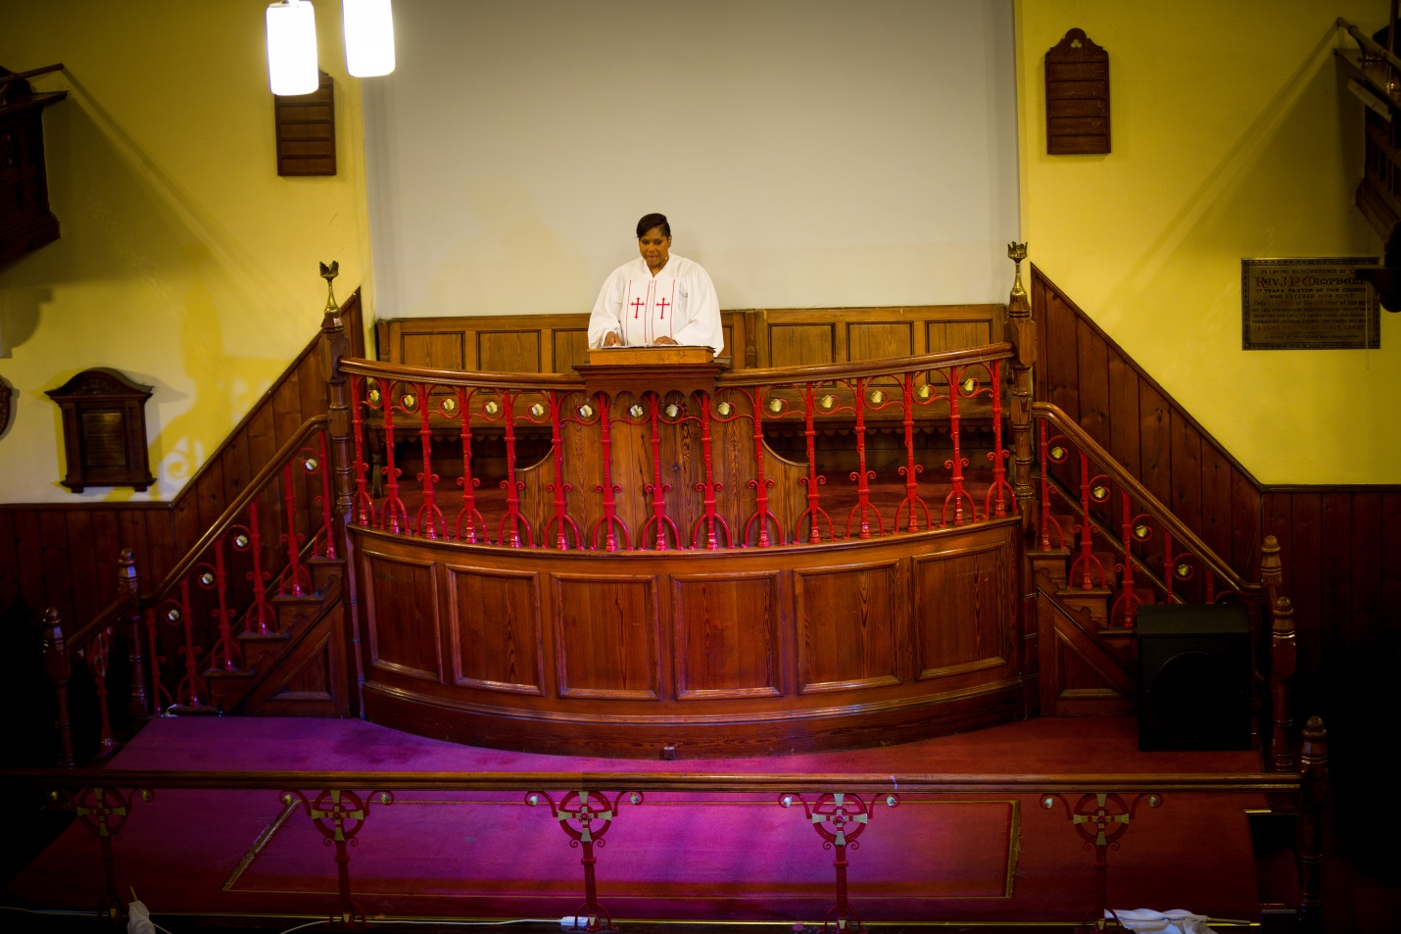
Figure 1: Rev. Sharon J. Reives during the performance of A Balm in Gilead at Zion Baptist Church in Cambridge.

A Note about the Production: A Balm in Gilead in Cambridge, 2018

The very first job I had to fulfil as producer and director of the play, A Balm in Gilead, was to find a place where the play could be performed. I chose Zion Baptist Church, located right next door to Anglia Ruskin University, and which has historically enjoyed a strong relationship with the university. The pastor there is Rev. Gale Richards. She provided the welcome and invocation prior to the performance and offered her cooperation in hosting the play. Most intentionally, the production was performed on January 15, 2018, the birthday of Rev. Dr. Martin Luther King, Jr.
I was able to find actors by going to RCCG, City of David Church and to Pembroke College Chapel and making public announcements. Performers also included children. Rehearsals ran each evening for a full week, beginning on Monday, January 8 and included rehearsals on the day of the performance, January 15, which was the only day that we could rehearse with the choir. I directed each session of rehearsals, including the dress and technical rehearsal on the Sunday ahead of Monday’s performance. I was able to find a local dance company in Cambridge called the Elevation Youth Dance Company, and I coordinated with them so that they could learn the choreography by the U.S. choreographer via video prior to her arrival. I also met with the dance company so that they could see the church’s sanctuary prior to the start of rehearsals.
The choir for the production was the London Adventist Chorale. As producer of the play, I mailed an audio CD of the required music, in the African American tradition, to the choir director for the choir to learn for the show. The drummer for the production was an employee of John Smith’s Bookstore at ARU Cambridge. The sound technician was a staff member of ARU’s theatre department, and the stage manager was a graduate of the University of Cambridge. I provided the narrative re-telling of the 1968 Memphis sanitation workers’ strike through the words of Rev. Dr. Frank McRae. Furthermore, six spontaneous testimonies came from members of the audience about contemporary human rights issues.
I applied for funding from the University Arts Council of ARU. As a result, I received partial funding for the production, which was most helpful. I was required to submit a budget and an After-Action Report following the production, which is supplied in Appendix 4. I also applied for more substantial funding through a U.S. Embassy Grant Application which required a detailed budget narrative and project description. However, that application was not successful. However, I did receive a modest financial contribution from Unison West Midlands, a branch of the national union for the public services sector. I am indeed grateful for all financial contributors.
The planning for this production, which was part of the global 50th Anniversary commemoration of the assassination of Rev. Dr. Martin Luther King, Jr., began in February 2017. This community theatre project included students from Anglia Ruskin University and the University of Cambridge as well as members of various local churches.

Introduction

This research emerges from my experience as an ordained Baptist preacher. I have also served as a US Navy Chaplain, and have degrees in theology, music and theatre. The starting point for this practice-based research project stems from my interest in testing whether the principles of nonviolent resistance can be taught through theatrical performance. My research will focus on a case study of the Memphis sanitation workers’ strike of 1968. This story is an outstanding example of the nonviolent resistance strategy of the larger civil rights movement. The story of the Memphis strike is about individuals who extended faith into the daily tasks and challenges of their lives. This story further illustrates that any serious task, any undertaking that tests our commitment, will require us to look beyond the incomplete data, beyond the fears that are so easily conjured, and to make a leap based on a faith surmised.
This research will address the following questions:
- To what extent can theatrical performance be used to teach the principles of nonviolent resistance?

- What role did faith play in the Memphis strike and how did this contribute to discourses about nonviolent resistance?

- To what extent can theatrical performance help to facilitate preaching?

This project will contribute to the Practice as Research (hereafter PaR) discussion. In his book, Practice as Research in the Arts (2013), Robin Nelson posits, ‘[t]he term PaR involves a research project in which practice is a key method of inquiry and where, in respect of the arts, a practice … is submitted as substantial evidence of a research inquiry’ (Nelson, 2013: 8-9). PaR is a methodology ‘located at the confluence of different, but interlocking, spheres, notably “the arts world”, “the mediasphere” and “the academy”’ (Nelson, 2013: 23). I have selected this methodology to unify practice with theory. The different parts of the research project have run in parallel, over the course of three years. This approach also highlights my interest in developmental processes, rather than in specific preconceived outcomes.
PaR can also generate new kinds of art, novel means for art-making, and new understanding regarding the significance of the performing arts. Furthermore, it can affect the manner in which we perceive and experience ourselves, one another, and the world around us. Research via artistic practice could include playwriting, acting, directing, theatre performance, dance theatre, music theatre, or music performance. PaR requires creative projects designed to interrogate, and provide evidence on, the research objectives within one’s chosen practice. With PaR, each creative project is accompanied by an analytical commentary, as incorporated into this thesis. This can be a contentious process; as Shannon Rose Riley warns, ‘Practice as Research (PaR) doctoral programmes are not well established in the US, and are established least of all in theatre and performance’ (Riley, 2013: 175). In my project, its practical elements are designed to trigger cross-disciplinary conversations regarding the 1968 Memphis strike, the wider civil right movement, faith issues and theatre practice among its cast and audience. It also tests my hypothesis of theatrical performance as a type of preaching and a means of teaching the principles of nonviolent resistance in a context of injustice. This research can be contemplated in library research, but not tested outside of a live performance event.
The case study of the Memphis sanitation workers’ strike is about thirteen-hundred men who walked off their job, with no union. These were everyday citizens engaged in a struggle for social transformation, at a time of entrenched segregation in the South. I will investigate these broader social conditions in which the strike took place. The strikers were first supported by the local black churches, but the strike also brought together people from throughout the country, from various backgrounds, races and religions in order to fight against injustice. A world leader, Rev. Dr. Martin Luther King, Jr., was assassinated during this fight for economic justice. The Old Testament Book of 2 Chronicles says, ‘If my people, who are called by my name, will humble themselves and pray and seek my face and turn from their wicked ways, then I will hear from heaven, and I will forgive their sin and will heal their land’ (2 Chronicles 7:14). In the case of Memphis in 1968, and the wider U.S., the land cannot be healed without economic justice. In this project, I use the Memphis strike to argue that the principles of nonviolent resistance can be an effective tool for socio-economic change, and I do this through theatrical performance in order to reach a broad audience, which includes the churched as well as the unchurched.
My research will show how both King and the Student Nonviolent Coordinating Committee (SNCC) were able to help to transform U.S. society through nonviolent strategies of resistance throughout the broader civil rights movement. This project aims to diversify the current discussion around performing nonviolent resistance through its contextualization with discourses in the fields of performance studies and nonviolence studies, which also I will use to engage critically with the prevailing history of the Memphis sanitation workers’ strike of 1968. This project will also test my theatrical production, A Balm in Gilead, which promotes nonviolent resistance, in an academic and performance environment. My aim is to present this theatrical performance from a faith perspective, as is key to the Memphis sanitation workers’ strike itself. The production is planned both as an independent theatrical work, and as a performance to be analyzed as part of my thesis. By scrutinizing my practice in this way, I hope to broaden my own production into the larger area of theatre as preaching. Opening up theology through performance is part of my history as a theatre-maker. When I worked with a Latino ministry in the Bronx in New York City called the Latino Pastoral Action Center, we had a partnership with the American Bible Society (ABS). Through this after-school program, ABS provided age-appropriate books for us to teach Bible stories to children. However, instead of reading the stories, we had the children to perform them. Some people learn theology through music, poetry, and theatre. This project will break new ground by showing how the principles of nonviolent resistance can also be taught through theatrical performance from a faith perspective. I consider that my project represents an original contribution to nonviolence studies and to performance studies, as well as to the field of preaching.
The interrelationship of disciplines and topics within this research project is illustrated in figure 2:
Figure 2: Venn diagram of interlocking research areas
The three circles indicate the three main areas of my research project. The first area is the Memphis sanitation workers’ strike of 1968, which is the historical foundation of this study. The second area is nonviolent resistance, which was the strategy used to conduct the Memphis strike by its leaders, as well as by Rev. Dr. Martin Luther King, Jr. throughout other important civil rights struggles. The third area is theatrical performance, the means by which this story is told for my project, and the methodology I am testing as a teaching tool for the principles of nonviolent resistance. Accordingly, the overlapping segments indicate the coherence of the communities that supported the Memphis sanitation workers’ strike; they were the civil rights movement, the labour movement and the local faith community. The final overlapping segment is Theatre as Preaching, again being tested as a means of communication outside of the sermonic form.
I will extend my theatre practice and research to include community theatre and Theatre-In-Education (TIE). These areas operate in a tradition of raising social and political awareness, providing a lineage and context for my own theatrical practice. As Helen Nicholson writes:
‘Theatre-In-Education (TIE) belonged to a tradition of popular and political theatres that had developed earlier in the twentieth century. Theatre had been used as a tool of social and political mobilization by the Workers' Theatre Movement of the 1920s and 1930s, when groups of theatre activists had performed plays with socialist messages in factories, pubs and working men's clubs and on the street’ (Nicholson, 2009 :22).

A goal of TIE is to create socially-minded theatre, and also to make work for young audiences. Since the beginning of TIE, there is increasingly international interest in drama as an educational medium, and many innovations in its deployment for diverse communities. For example, Kaiser Permanente Educational Theatre is the largest educational theatre program in the United States; its performances are free of charge and are captivating a tremendous audience, while inspiring, entertaining, and, in some instances, changing lives. This program reaches communities through the power of theatre while addressing health care issues. ArtSpot Educational Theatre brings the arts and the English language to children across the globe. Likewise, the Creative Arts Team (CAT) is an educational theatre company now working out of City University of New York, following a 30-year tenue at New York University. It is interactive theatre where participants have a chance to act out problems, with now over forty years of success in teaching conflict resolution through drama. Recent students of CAT explored the original conflicts behind the 50th Anniversary historic march across the Edmund Pettus Bridge in Selma, Alabama. Through CAT, young people learn how to settle conflicts in a constructive way, while learning the principles of nonviolent resistance through theatrical performance. CAT is using the power of drama to engage young people in discussions about what is going on in their lives and in the world around them.
Additionally, El Teatro Campesino, the farmworkers’ theatre, is still producing original nonviolent resistance theatre over 50 years since its founding. Harry J. Elam, Jr. asserts, 'El Teatro, embracing the nonviolent strategies of Cesar Chavez and the UFWOC [United Farmworkers Organizing Committee] and emanating from the Mexican performance tradition, employed slapstick and satire as its primary means of theatrical communication' (Elam, 2001: 45). Cesar Chavez is arguably the most important Latino leader in America’s history. He was co-founder of the United Farm Workers union, which was in large part inspired by his Catholic faith. Chavez ‘always wanted the idea behind the union to be respect, and for the patron to share the riches he is able to earn’ (Ferriss and Sandovall, 1977: 270). Chavez fought a similar fight for migrant farmworkers in California as Dr. King did for the Memphis sanitation workers. Like King, Chavez led a nonviolent movement. Chavez stated, 'nonviolence is not inaction. It is not discussion. It is not for the timid or weak ... Nonviolence is hard work. It is the willingness to sacrifice. It is the patience to win' (Chavez cited in Tejada-Flores and Telles, 1996: film). In accordance, Elam defines social protest performance as ‘an ever-evolving genre appearing wherever oppressed people assert their subjectivity and contest the status quo’ (Elam, 2001: vi).
The practice as research methodology is also a stimulus to investigate the work and context of other related artists and studies close to this project’s field of theatrical performance. As further examples of socially conscious theatre, I have chosen playwrights from South Africa, North America and South America, respectively. This study will explore theatre for social change while specifically investigating the works of playwrights Athol Fugard (1932-), Lorraine Hansberry (1930-1965), Augusto Boal (1931-2009), and James Baldwin (1924-1987). Nonviolent resistance is implicit in the theatre of Fugard and Hansberry, and deeply embedded as a principle in Augusto Boal’s Theatre of the Oppressed. Research on the biographies of these playwrights will establish links between their lives and their work, with particular focus on their experience with performing nonviolent resistance. Similarly, historical analysis will embed the playwrights’ work into the wider context of theatre history, and the boarder social conditions in which the work was produced.
This thesis is organized to address its interlocking and interdisciplinary subject matters as follows. Chapter One will establish a historical foundation for this study, examining the broad context of the American civil rights movement and the 1968 Memphis sanitation workers’ strike, in particular, as a crucial episode within that movement. I will move on to investigate the Poor People’s Campaign (1968) and its spotlight on the nation’s working poor. The principles of nonviolent resistance underpin all three campaigns and these are examined through the practice and writings of Gandhi, King and Chavez. I will argue that strategies of nonviolent resistance were the most effective weapon within the civil rights movement.
In chapter two, I will discuss Black Liberation Theology and the important roles of faith and music within the Memphis strike and civil rights movement. I will discuss a social gospel as preached by Dr. King and other black preachers during the time of Jim Crow laws in America. Protesters held mass meetings at local black churches and regularly kneeled to pray and sing songs of faith before many demonstrations. Chapter Two provides the faith framework behind the Memphis strike.
Chapter Three will entail the study of theatre for social change. In this chapter, I will argue that this motive was at the forefront of the work of the playwrights Fugard, Hansberry, Boal and Baldwin. Baldwin’s The Amen Corner (1954) has a particularly important place in my thesis as it is an excellent catalyst for investigating theatrical performance as preaching. Chapter Three provides a context of related social protest theatre within which my production of A Balm in Gilead sits. Additionally, I will explore two theatre companies, El Teatro Campesino (The Farmworkers’ Theatre) and SNCC’s Free Southern Theatre. El Teatro Campesino (1965) was formed on the picket line during the Grape Strike in Delano, California, and the Free Southern Theatre (1963) was born out of the American civil rights movement. This study will examine the parallels of these playwrights and theatre companies that shared the difficulties of producing resistance theatre during turbulent times in their countries’ history. SNCC used the dramatic arts as a strategy, incorporating Boal’s Theatre of the Oppressed techniques to train its activists. Boal, as a political activist, used ‘drama as pedagogy for social transformation among poor people in Brazil during the 1960s’ (Gilliam-Smith, 2008: 38). SNCC volunteers practiced the ideas of freedom and nonviolence through performances, social dramas, role-playing, and theatre. The aim of Boal’s theatre was ‘to help participants invent new ways of confronting oppression’ (Gilliam-Smith, 2008: 45). I will examine the Greensboro Sit-in, which reflects Theatre of the Oppressed tenets directly within the civil rights movement. Boal stresses that we must ‘rethink how theatre should be done in order to value the experiences of the oppressed’ (Gilliam-Smith, 2008: 51). Boal believed that theatre should be a force for radical change. Like Boal, I believe that ‘theatre can be placed at the service of oppressed’ (Gilliam-Smith, 2008: 51).
Chapter Four will explore community theatre, and theatre in prisons under the umbrella term of applied theatre. I will examine the effectiveness of applied theatre historically and the unifying factors it can bring to bear for its audiences and participants. This chapter aims to consolidate my arguments about the social effectiveness of theatre-making processes for non-professional performers. Some of my own non-professional performers for A Balm in Gilead shared that they were inspired and educated about civil rights by the play.
Furthermore, this chapter includes audience testimony and analyses the effectiveness of my production of A Balm in Gilead at Zion Baptist Church in Cambridge to commemorate the 50th Anniversary of the assassination of Rev. Dr. Martin Luther King, Jr. I will examine audience responses and interviews with the performers in the UK production (2018) and also audience feedback from earlier productions of this play in Philadelphia (2017) and in Atlanta (2012, 2013 and 2014). I aim to demonstrate that theatre as preaching can be especially effective as a means of conveying the essence of a historical case study and also its contemporary relevance. This latter point was made evident through immediate and spontaneous responses by the UK audience, which took the content of the ‘sermon’ in many unexpected directions. Appendices follow providing all of the raw data from audience feedback, plus full transcripts of interviews with audience members, performers and the late Alvin Turner, one of the original sanitation workers in the Memphis strike of 1968.
The Memphis sanitation workers’ strike was one of the most important events of the American civil rights movement. By deepening an understanding of the American civil rights movement, this study underscores what has been gained through struggle, as well as acknowledges the goals that are yet to be attained. As Thomas F. Jackson observes in From Civil Rights to Human Rights, social justice is always an on-going process:
‘A country of radically unequal places, schools, earning opportunities, a nation of prisons swollen with drug users serving punitive mandatory sentences, a society condoning widespread homelessness and single mothers shifting for themselves in low-wage labor markets, these are the features of a nation defined by “law and justice.” But the dream of a public sphere in which all citizens equally pursue their happiness on a firm stage of economic security still has powerful allure. Democracy, community, a broad international vision of human rights, and compassion for the basic human dignity of all God’s children remain powerful taproots for people determined to make history’ (Jackson, 2007: 370).

I raise the question: why teach the principles of nonviolent resistance now? It is because we live in a time where violence seems to prevail as a ‘strategy’. This study comes in the aftermath of the recent racially-charged events in Charlottesville, Virginia where one woman was killed and many others injured; the bomb attack in Manchester, in the United Kingdom, where twenty-two people were killed; the Charleston church shootings, in the United States, where nine black church members were killed; the Texas church shooting where twenty-six people were killed; the Las Vegas shootings which left fifty-eight people dead; the London Bridge attack where eleven people were killed; and the attacks in Paris where at least one hundred and twenty-eight people were killed.
During his speech about the 50th Anniversary of the Selma Marches, President Barack Obama proclaimed:
‘We are storytellers, writers, poets, artists, who abhor unfairness and despise hypocrisy, and give voice to the voiceless and tell truths that need to be told … fifty years from Bloody Sunday, our march is not yet finished, but we’re getting closer. Two hundred and thirty-nine years after this nations’ founding, our union is not yet perfect, but we are getting closer. Our job is easier because somebody just got us through that first mile. Somebody already got us over that bridge’ (Obama, 2015: online).

I am from a union family. This is a subject that is close and dear to my heart, because when my mother started her factory job, there was no union and as a result, she and other employees worked to form a union, which she served for over thirty years. The historic March on Washington (1963) where Dr. King delivered his famous ‘I Have a Dream’ speech was for jobs and freedom, and it is still a topic that is most relevant today. It is my hope that a new generation will be engaged in nonviolence education through the powerful medium of theatrical performance, thus reaching a wider audience. I envision that more theatre for social change will be created, that is, theatre with a purpose. It is wonderful to find great art where we can question ourselves on important issues, and it is equally a delight to find playwrights writing about issues that matter. This is theatre that reveals powerful lessons. The Memphis strike was Dr. King's last stand as a leader of nonviolent resistance. The benefits of the play, A Balm in Gilead, will be for actors and spectators, whites and blacks, as well as other races, to be presented with the principles of nonviolent resistance and to gain an understanding of the struggles of the Memphis sanitation workers’ strike. It also provides a chance to encounter public issues through a faith lens. As this research will show, theatrical performance, which addresses social justice issues through a faith perspective, can be used as a catalyst to raise awareness, to erode stigmas, to promote understanding and resilience, and to stir our fellow citizens to action. Theatrical practice, in the form of A Balm in Gilead, provides the basis for my research into all of these issues to proceed.
Chapter One:
Strategies of Nonviolence in the American Civil Rights Movement
‘The higher you build your barriers, the taller I become.
The farther you take my rights away, the faster I will run.
You can deny me, you can decide to turn your face away.
No matter ‘cus there’s something inside so strong.’

i) The American Civil Rights Movement

The American civil rights movement was a nonviolent revolution. It marked a march toward freedom for African American citizens through mass action and national legislation. Although many regard the history of the civil rights movement to run from the 1954 Brown v. Board of Education Supreme Court decision to the death of Dr. Martin Luther King, Jr. in 1968, it is important to recognize that the civil rights movement can trace its roots back to nineteenth-century abolitionism and even further to the earliest resistance by slaves. However, this study will focus on the mid-twentieth century, investigating both the systemic oppression embodied in American race relations and the strategies developed by activists and organizers during the civil rights movement. American history can be divided into a pre- and post- civil rights period. The young, charismatic, black minister, Dr. King, became the movement’s most influential spokesman. In historian Clayborne Carson’s words, King was ‘a leader who stood out in a forest of tall trees’ (Carson, 1987: 542). King often ‘referred to the civil rights movement as simply one expression of an international human rights revolution that demanded economic rights to work, income, housing, and security’ (Jackson, 2007: 1).
During the civil rights era, ‘Blacks had to use separate toilets, attend separate schools, sit at the back of buses and trains, address whites with respect while being addressed disrespectfully, be sworn in on different bibles in the court room, purchase clothes without first trying them on, pass by “white only” lunch counter seats after purchasing food, and travel without sleep because hotels would not accommodate them’ (Morris, 1999: 518). Additionally, blacks were mandated to use separate drinking fountains, waiting rooms, parks, and the like. As John Hope Franklin explains, white supremacist groups, most notoriously the Ku Klux Klan and the Knights of the White Camellia, ‘used intimidation, force, ostracism in business and society, and bribery at the polls, arson, and even murder to accomplish their deeds’ (Franklin, 1967: 327). Violence akin to terrorism and deliberate economic deprivation were used to keep African Americans at the bottom of society. As new resistance to this long status quo, Clayborne Carson argues that it was the southern civil rights movement that initially combined ‘social gospel Christianity with Gandhian ideas of non-violent struggle’ (Carson, 1996:117) implemented by civil rights activists ‘to create radical alternatives to both traditional black nationalism and Marxism’ (Carson, 1996: 117).
The modern civil rights movement transformed laws and countless lives. As Aldon D. Morris argues, ‘the civil rights movement was able to overthrow the Southern Jim Crow regime because of its successful use of mass nonviolent direct action’ (Morris, 1999: 517). In Dennis Chong’s judgment, ‘the modern civil rights movement is probably the quintessential example of public-spirited collective action in our times’ (Chong, 1991:1).
In the segregated South, as Larry Bobo reports:
‘The available survey data suggest that anti-Black attitudes associated with Jim Crow racism were once widely accepted. The Jim Crow social order called for a society based on deliberate segregation by race. It gave positive sanction to anti-Black discrimination in economics, education, and politics … All of this was expressly premised on the notion that Blacks were the innate intellectual, cultural and temperamental inferiors to whites’ (Bobo, 1997: 35).

The crucial Brown v. Board of Education decision was handed down from the United States Supreme Court on May 17, 1954. The decision was intended to overturn state laws on segregated schooling, which it declared to be unconstitutional. The hope generated by the Brown v. Board of Education ruling was followed by outrage the following year in 1955 by the lynching and mutilation of fourteen-year old, Emmett Till, in Money, Mississippi following his alleged whistling at a white woman. Both events ‘helped set the stage for the emergence of the modern civil rights movement’ (Morris, 1999: 522). However, the Supreme Court’s ruling did not immediately change segregation at the state level. In 1957, the integration of Little Rock Central High School in Arkansas sparked massive protest. As a result, President Eisenhower dispatched federal troops to escort black students to school. Wide-spread and systemic inequality in public education, even after the 1954 Court ruling, showed just how far away the country was from living the ideal of equal opportunity for all.
Higher education was similarly segregated. In 1962, James Meredith enrolled in the University of Mississippi, which set a precedent; President Kennedy sent more federal officials to integrate the University of Alabama. Subsequently, in 1963, thousands of school children marched on downtown Birmingham, Alabama, a youth movement that became known as the Children’s Crusade. The media was a powerful tool during the civil rights movement. In Birmingham, television pictures of police using attack dogs and blasts from fire hoses to break school children’s protests were broadcast worldwide. As Richard Cohen, an attorney with the Southern Poverty Law Center, reports, ‘The violence was being perpetrated by the oppressors, not the oppressed and that was an incredibly powerful message’ (Cohen cited in Simkins, 2014: online). This state violence was a provocation rather than a deterrent. Within weeks of the Birmingham protest, ‘758 demonstrations occurred in 186 cities across the South and at least 14,733 persons were arrested’ (Sale, 1973:83).
One of the historic events of the movement was the refusal of Rosa Parks to give up her seat in 1955 to a white passenger, which led to the Montgomery Bus Boycott of three hundred and eighty-one days. A ruling by the Supreme Court ‘that declared bus segregation in Alabama unconstitutional, sealed the victory for the movement’ (Morris, 1999: 525). The Court’s decision also ended segregation in interstate travel, which should have ended all forms of bus segregation. However, on May 4, 1961, the first Freedom Ride took place to challenge the de facto continuation of segregated busing in the South. The Freedom Riders’ first bus was held under siege and fire-bombed near Anniston, Alabama and a bomb threat preceded the arrival of the second bus in Meridian, Mississippi. Despite the violence with which activists were met, their actions were a symbol of redemption and promise: ‘The Freedom Rides provided a stimulus for the massive Albany protests of December 1961, which became a model for mass mobilizations of black communities elsewhere in the South’ (Carson, 1986: 25).
Participants in the civil rights movement believed that collective action could bring about change in both federal law and the operation of those laws at state level. In state and local environs, such action could also lead to their own physical harm and dismissal from jobs. Nevertheless, through two decades of mass action and personal sacrifice, the civil rights movement demonstrated that ‘a relatively powerless group was able to overthrow the formal Jim Crow system’ (Morris, 1999: 523). Furthermore, ‘[t]he Black Church, which had a mass base and served as the main repository of Black culture, proved to be capable of generating, sustaining, and culturally energizing large volumes of protest’ (Morris, 1999: 524).
During the civil rights movement in the South, the strategies of nonviolence were all-encompassing and varied; as Morris enumerates, ‘The disruptive tactics included boycotts, sit-ins, freedom rides, mass marches, mass jailings, and legal challenges’ (Morris, 1999: 525). In the 1960s, direct action was often initiated independently by student groups; the sit-ins at segregated lunch counters was a case in point. This protest at Woolworth stores in Greensboro, North Carolina in February 1960 began with the refusal of service at a ‘whites only’ counter, but led to the mobilization of newly found tactics of resistance and mass protest against segregation. As Morris explains, the ‘sit-in tactic was innovative because other tactics span off it, including “wade-ins” at segregated pools, “kneel-ins” and “pray-ins” at segregated churches, and “phone-ins” at segregated businesses’ (Morris, 1999: 525). Michelle Norris reports an interview with one of the original Greensboro Four, Franklin McCain:
‘An older white woman sat at the lunch counter a few stools down from McCain and his friends. “And if you think Greensboro, North Carolina, 1960, a little old white lady who eyes you with that suspicious look ... she's not having very good thoughts about you nor what you're doing," McCain says. Eventually, she finished her doughnut and coffee. And she walked behind McNeil and McCain — and put her hands on their shoulders. “She said in a very calm voice, ‘Boys, I am so proud of you. I only regret that you didn't do this ten years ago.’” McCain recalls. “What I learned from that little incident was ... don't you ever, ever stereotype anybody in this life until you at least experience them and have the opportunity to talk to them. I'm even more cognizant of that today — situations like that — and I'm always open to people who speak differently, who look differently, and who come from different places,” he says. On that first day, February 1, the four men stayed at the lunch counter until closing. The next day, they came back with fifteen other students. By the third day, three hundred joined in; later, one thousand. The sit-ins spread to lunch counters across the country — and changed history’ (Norris, 2008: radio).

The Student Nonviolent Coordinating Committee (SNCC) grew out of the sit-in movement and the mass direct action that it inspired. SNCC became a social movement organization of both black and white college students; subsequently, many local communities were also organized and mobilized into national programs of nonviolent social protest. As Morris recognizes, ‘[t]his organization increased the formal organizational base of the movement, which already included the Southern Christian Leadership Conference (the SCLC), the Congress of Racial Equality (CORE), the NAACP, and numerous local movement organizations’ (Morris, 1999: 525). The student-led sit-in movement, direct action and SNCC itself brought a substantial number of white students into the American civil rights movement; indeed, the injured and integrated Freedom Riders were refused an overnight stay in Anniston Memorial Hospital after threats by Klansman to burn down the building if black and white patients were treated together. SNCC produced new ‘leaders, organizers, and tactics’ (Morris, 1999: 532) and this student-led formation ‘shaped collective action by carving out its own spheres of organizational activity’ (Morris, 1999: 532). It fed into the civil rights movement as a new source of energy.
The goal of the civil rights movement was to end state-sanctioned segregation and dismantle other forms of discrimination against black Americans, especially in employment laws and practices at state level. In the legal system, the most important strategy was to secure federal protection of the rights of black citizens, which meant ensuring that the rights enshrined in the Constitution applied to all American citizens without discrimination. In August 1963, ‘a quarter of a million blacks and whites marched on Washington to demand black equality’ (Burson, 1986: 39). As Robert H. Zieger recognizes:
‘Civil rights was about public accommodations, voting rights, and schools. Certainly, demonstrators in southern towns and cities had demanded employment in the stores and shops. But, it was the classrooms, the voting booths, and the hotels and restaurants that made the biggest headlines … without jobs, freedom was a coin of limited value. Jobs were the modern equivalent of the Reconstruction era’s forty acres and a mule ꟷ and we all know what happened when the freedmen were denied title to the land that they and their forebears had worked for generations. Yes, it was true: this was indeed about jobs and freedom’ (Zieger, 2007: 1).

There were almost as many whites attending the March as blacks; the crowded demonstration at the Lincoln Memorial steps was peaceful, with no arrests. However, ‘just weeks after the March on Washington, tragedy struck in Birmingham when a bomb exploded beneath the Sixteenth Street Baptist Church during Sunday school classes. Four young girls were killed and twenty-three others were injured. It was an awful blow to Dr. King and the civil rights movement’ (Simkins, 2014: online). Following a ‘tainted investigation by the FBI, Robert Chambliss, an active member of the Klu Klux Klan, was arrested and charged with murder and the possession of dynamite without a permit. Chambliss was acquitted of murder charges until 1977 when the reopening of the case resulted in his conviction, fourteen years after the bombing’ (Civil Rights Digital Library, 2013: online). The lack of protection under the law was evident in numerous acquittals of white defendants tried by white juries; these include the Emmett Till case, the assassination of Medgar Evers and the murder of three civil rights workers, James Chaney, Andrew Goodman and Michael Schwerner during SNCC’s Freedom Summer. Stephen Smith of CBS News reports on the latter case:
‘The three men’s disappearance made national headlines. While looking for these three men, federal agents dredged out of the water nine black bodies that no one had even heard of. The tragedy is that it took the deaths of two Whites to legitimize the tragedy of being murdered if you wanted to vote. It took decades to achieve any kind of justice for the murder of Chaney, Goodman and Schwerner. Eighteen men were arrested in 1967. Half a dozen were convicted, but only of civil rights violations. None served more than six years. No one was convicted of murder. Jerry Mitchell, an investigative reporter in Jackson, Mississippi, began looking at the case again in the late eighties. He found evidence and wrote about it so much that he embarrassed the powers that be to investigate the case. Thanks to Mitchell’s reporting, the state reopened the case and in 2005, KKK preacher, Edgar Ray Killen, went to trial for the killings. Killen was found guilty of manslaughter. He was sentenced to serve 60 years in prison. It was a long overdue measure of justice for the victims’ families.’ (Smith, 2014: online).

In his history of the civil rights movement, David Levering Lewis argues that ‘By the early 1950s the cumulative impact of balance of power politics, rising incomes, federal court decisions, coalition with organized labor, and the string of exemplary racial “firsts” had primed much of the nation for an end to segregation. There was change even in the South, where Smith v. Allwright brought Afro-American [voter] registration from a mere 250,000 in 1944 to 1,008,614 by 1952 – still only 20 percent of its voting age population there’ (Lewis, 1986: 13). In a historic nonviolent protest, Dr. King led thousands of demonstrators to the state capital in Montgomery, Alabama on March 25, 1965, during a five-day, fifty-four-mile march from Selma, Alabama to protest for the right to vote. A prior march led by John Lewis and Hosea Williams for voting rights in Selma went down in history as Bloody Sunday because of the violence inflicted upon the protesters. Some of the policies and practices of black voter suppression were the requirement to tell the number of jelly beans in a jar, how many bubbles were in a bar of soap, an African-American literacy test, voter intimidation and other indignities which made it more difficult, and many times impossible, for blacks to vote. As George Burson records, ‘The Civil Rights Commission reported in 1963 that, “Citizens of the United States have been shot, set upon by vicious dogs, beaten and otherwise terrorized because they sought to vote.” Less dramatic than violence, but even more effective, was economic intimidation’ (Burson, 1986: 39). For instance, if a black doctor tried to register to vote, white employers would warn their workers not to go to that doctor. Deprived of patients, the doctor would have to abandon his practice and leave the state. Eight years earlier, King demanded from the Lincoln Memorial, ‘Give us the ballot’, during the May 1957 Prayer Pilgrimage to Washington:
‘Give us the ballot and we will no longer have to worry the federal government about our rights … Give us the ballot and we will get the people judges … who will do justly and love mercy … Give us the ballot and we will quietly, lawfully, and nonviolently, without rancour or bitterness, implement the Supreme Court decision of May seventeenth, 1954’ (King, 1957:48).

The election of segregationists to public office in the South contributed greatly to the delay in implementing the federal law to integrate schools as passed on May 17, 1954. For instance, on June 11, 1962, Governor George Wallace blocked the entrance and attempted to halt a federal court order to admit black students, Vivian Malone and James A. Hood, to the University of Alabama. During his campaign for governor, Wallace promised not to integrate the university. President Kennedy brought the Alabama National Guard under federal control, the only way in which to admit the students to the university against the opposition of the state’s political leadership.
African American women played ‘a multitude of important roles in the civil rights movement’, women such as ‘Jo Ann Robinson, Fannie Lou Hamer, Septima Clark, Ella Baker’ (Atwater, 1996: 540) and Daisy Bates. Additionally, ‘the story of the white progressive response to black activism is part of the story of the civil rights movement. Respectable white women worked effectively inside the system to achieve racial justice’ (Murray, 2006: 1166). In Personal Politics: The Roots of Women’s Liberation in the Civil Rights Movement and the New Left, Sara Evans’ investigation confirmed that ‘most white women who participated in the early years of the civil rights movement tended to be southerners, and virtually without exception white southern women who joined the civil rights movement came to it first through the Church’ (Evans, 1979: 35).
Dr. Martin Luther King, Jr., as much as any change agent in modern times, stressed self-determination. Yet, Dr. King recognized that, historically, meaningful economic development has often involved a partnership between the public and the American government. In the following speech in 1968, Dr. King is promoting another March on Washington, designed to energize the Poor People’s Campaign:

‘At the very same time that America refused to give the Negro any land, through an act of Congress, our government was giving away millions of acres of land … in the west and the mid-west, which meant that it was willing to undergird its white peasants from Europe with an economic floor …
But, not only did they give the land, they built Land-Grant Colleges with government money to teach them how to farm. Not only that, they provided county agents to further their expertise in farming.
Not only that, they provided low interest rates in order that they could mechanize their farms. Not only that, today many of these people are receiving millions of dollars in federal subsidies not to farm and they are the very people telling the black man that he ought to lift himself up by his own boot straps. And this is what we’re faced with … and this is a reality.
Now, when we come to Washington in this campaign, we are coming to get our check’ (King 1968: online).

Dr. King was on the side of the poor; he became a voice for the voiceless. King exclaimed, ‘All we say to America is be true to what you said on paper’ (King, 1968: 213). In other words, King was holding the architects of our great nation accountable for its promise of ‘life, liberty and the pursuit of happiness’ and for its words found in the Pledge of Allegiance of the United States, ‘freedom and justice for all’. King recognized that there was a calamitous gap between America’s promise and America’s performance.
The American civil rights movement should never just be chapters in history books. Still, the ‘intellectual work based on the civil rights movement have been substantial and transformational’ (Morris, 1999: 537-538). It remains the most important social movement in the United States. Yet, despite so many ‘hard won victories within the civil rights movement, we must remember that those victories could be lost without meaningful enforcement of the laws which advocates fought so hard to win more than half a century ago’ (Edelman, 2014: online). Black Americans must utilize and protect the rights that they have won at such a tremendous cost. In his 1956 speech, ‘The Birth of a New Age’, King describes the need and difficulties of forging a new America. King’s dream was of ‘a world in which men no longer take necessities from the masses to give luxuries to the classes. A world in which men will throw down the sword and live by the higher principle of love’ (King, 1956, Papers 3: 346).
By example, the civil rights movement helped other groups locate their own agency. Struggle is universal; that is why so many other groups have been able to identify with this movement. Simon Wendt argues that ‘more could have been said about the civil rights movement’s impact on and interaction with other minorities struggling for justice in the 1960s and 1970s, including Native Americans and Mexican Americans’ (Wendt, 2008: 229). As Angela Davis recognizes, ‘the Black freedom struggle in America has taught other groups about the nature of human oppression and important lessons about their own subjugation’ (Davis, 1981:40). Participants in the movement recognized the links among issues, and drew solace and support from their connections to other activists locally and across the nation. Their work is part of a larger and longer, indeed ongoing, struggle against an indivisible and pervasive foe which is racism, in all of its manifestations. In an interview with Morris and Herring, William Gamson inserts important connections, ‘If there hadn’t been a civil rights movement, there might not have been an anti-war movement; if there hadn’t been these movements there might not have been an Environmental Movement. Without these movements there wouldn’t have been people coming into the field who were receptive to a new orientation’ (Gamson cited in Morris and Herring 1987: online). Gamson further explains, ‘[t]he civil rights, anti-Vietnam War, and antinuclear power movements: each of these produced feisty challengers willing to break rules and disrupt their antagonists’ (Gamson, 1989: 459).
The conduct of the civil right movement taught the moral courage and made the extraordinary sacrifices that collective action requires, ‘lessons that can be transplanted to other movements under conditions favorable to social protest’ (Morris, 1999: 534). The creation of publics, or groups of concerned citizens that meet publicly to challenge ‘[h]egemonic discourses and shift public opinion, is crucial to social change and specifically social movements’ (Jones, 2011: 213). The civil rights movement demonstrated that ‘oppressed groups are able to develop the moral courage and make the extraordinary sacrifices that collective action requires’ (Morris, 1999: 528). After the performance of A Balm in Gilead in the UK, some audience members were inspired to speak about other forms of oppression and discrimination. The topics covered were health and social security, Asperger syndrome, asylum seekers, refugees, immigration law, gypsies and travellers’ right to a home, and abuse: sexual, physical, and emotional. As Morris writes, ‘[t]he civil rights movement provides a rich empirical case for the continuance of this work; because, it was a movement in which women and men converged in their activity for the sake of liberating a people’ (Morris, 1999: 536). In their book, The Civil Rights Movement in American Memory, Renee C. Romano and Leigh Raiford observe that:
‘The civil rights movement didn’t end in 1965, with the passage of the Voting Rights Act; in 1968, with Martin Luther King’s death; or in the 1970s, with the splintering of civil rights organizations amid the rise of Black Power. The movement was, and remains, an ongoing process with meanings that remain contested, a fact underscored by the centrality of the memory of the movement in American culture and politics … Ultimately our hope is that this nation will not be lulled by the memory of an activist past into slumbering during a present and future that needs our activism now more than ever’ (Romano and Raiford, 2006: xxii).

What is clear are the ways in which the civil rights movement has captured our imaginations and influenced the ways in which we construct and manage our identities as heirs to and partners of this most revolutionary movement. The civil rights era included two crucial legislative landmarks, the Civil Rights Act (1964) and the ‘Voting Rights Act (1965), generally regarded as the greatest achievement of the so-called classical phase of the civil rights movement, the phase that began in 1954 with Brown v. Board of Education’ (Menand, 2013: online). Dr. Martin Luther King, Jr., and thousands of people whose names we have never heard of, fought to make America more inclusive. Dr. King’s words are just as relevant today as in 1968, ‘Let us rise up tonight with a greater readiness. Let us stand with a greater determination. And let us move on in these powerful days, these days of challenge, to make America what it ought to be. We have an opportunity to make America a better nation’ (King, 1968: 219). Dr. King expressed these words during his famous, ‘I’ve Been to the Mountaintop’ speech before the striking sanitation workers at Mason Temple in Memphis. The speech fell on April 3, 1968, the evening before his assassination.

ii) The Memphis Sanitation Workers’ Strike of 1968

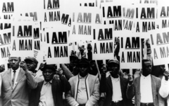
Figure 3: Memphis Sanitation Workers' demonstration, 1968
‘There are thirteen hundred of God’s children here suffering, sometimes going hungry, going through dark and dreary nights wondering how this thing is going to come out.
That’s the issue.
And we’ve got to say to the nation, we know how it’s coming out.
For when people get caught up with that which is right and they are willing to sacrifice for it, there is no stopping point short of victory’ (King, 1968: 211).

Those are the prophetic words of Dr. Martin Luther King, Jr., from his famous ‘Mountaintop’ speech, to the striking Memphis sanitation workers hours before his death. The Memphis strike became the backdrop for the assassination of Dr. King. The Memphis sanitation workers’ strike began with thirteen hundred men who walked off their job, with no union, on President Lincoln’s Birthday, February 12, 1968. These ‘workers refused to report to work demanding higher wages, safer working conditions, and recognition of their union, local 1733 of the American Federation of State, County, and Municipal Employees’ (Civil Rights Digital Library, 2013: online). However, the strike was based on more fundamental demands than a fifteen-cents-an-hour wage increase. The signs that the workers wore around their necks displayed a simple but powerful mantra, ‘I AM A MAN.’ These everyday citizens were engaged in a process of self-determination that has a powerful social dimension. The workers ‘went on strike demanding their basic rights to organize a union, to gain a living wage, but also to receive the respect and dignity due all working men and women’ (Gibbons, 2010: online).
The media well documented the Memphis strike on television and in newspapers, reporting how volatile the atmosphere was in the city of Memphis, and telling the story of the courage and determination of these sanitation workers. The Memphis sanitation workers’ strike reveals lessons of nonviolent resistance and self-transformation. In his book, Going Down Jericho Road: The Memphis Strike, Martin Luther King’s Last Campaign, (2007) Michael K. Honey meticulously traces the story of this important event in American history. It is primarily about economic and racial injustice. The title of the book comes from the parable about the Good Samaritan, which King told to the striking workers on the night before he was assassinated. The message of the parable is that we must be called to action for those who are in need, even if it endangers our own situation. Solidarity means running the same risks. The 1968 Memphis sanitation workers’ strike is a modern-day Good Samaritan story.
As Laurie B. Green argues, Memphis’ function as an ‘urban-rural crossroads’ (Green, 2007:7) is key to this story. In Memphis, Tennessee, black workers contended with the disparity between their aspirations for economic justice and ‘their urban white employers’ efforts to perpetuate in the city the plantation relations of the South’s rural history’ (Green, 2007:1). Brian Kelly likewise recognizes ‘the ways in which the array of indignities visited upon black Memphians acted to sustain a social order that ultimately rested on low-paid black labor, and to show how collective struggles against this social order laid the foundations for the 1968 strike’ (Kelly, 2008: 871). The Memphis strike exemplifies ‘the consciousness, culture, and politics that inspired and shaped the freedom movement’ (Green, 2007: 4) in the civil rights era.
Although it has clear regional and national resonances, the Memphis sanitation workers’ strike is also a response to local city conditions. Former Mayor, ‘Boss’ Edward Crump, set in place a most ‘effective machine that combined paternalism, corruption and intermittent brutality to safeguard an arrangement that kept black workers at the bottom’ (Kelly, 2008: 871). Crump served three two-year terms as mayor of Memphis (1910-1915), and again briefly in 1940. There existed a ‘complex relationship between the Crump machine and black leadership’ (Kelly, 2008: 871). In Green’s view, ‘Crump drew into his circle a select group of black leaders who delivered votes and advocated racial cooperation … Crump, however, also ruled with an iron fist’ (Green, 2007, 22). There was little pretense of racial cooperation in the policing of Memphis. According to Kelly, ‘[m]embers of Crump's notorious police force were at the center of suppressing labor militancy in the pre-war and post-war periods … Their involvement in a series of sexual assaults on black working women, incidents that powerfully demonstrated the gendered dimensions of Jim Crow in Memphis, galvanized an outraged black community in the post-war period and had a cathartic effect in generating a challenge to the “plantation mentality”’ (Kelly, 2008: 871). As Green confirms also, ‘’[a]t the end of the Second World War … police brutality against veterans and police sexual assaults of women sparked heated protest movements in neighborhoods heavily populated with black migrants’ (Green, 2007: 9). Police brutality and intimidation of the city’s black population was not limited to physical abuse. For example, Russell Sugarmon recalls an incident when Crump’s political machine posted police officers outside of the drugstore of his father’s friend, black pharmacist J.B. Martin, for expressing his political views. It resulted in driving away Martin’s customers and putting him out of business. Consequently, Sugarmon left Memphis to attend college and then law school. He was determined to return home and change the racial and economic climate of Memphis.
It is important to note that black women played a key role in the revival of labor militancy in Memphis. I agree with Green who ‘contends that the slogan that would eventually galvanize the sanitation workers – “I AM A MAN” – resonated no less powerfully among them [women], embodying for all black workers the struggle against the plantation legacy’ (Kelly, 2008, 871). For example, strike supporter and community activist, Cornelia Crenshaw, asserts, ‘[w]e were so proud of the fact that the sanitation folk had stood as men … and they showed a kind of togetherness that maybe some of us had never shown … When you are very poor and you don’t have very much to lose anyway, just maybe you can get together a little better’ (Crenshaw cited in Honey, 2007: 98). It was women who organized Black Monday, an all-out work stoppage in the city of Memphis, where black workers refused to go to work and children were kept out of school on that day. Green posits, ‘[t]he sanitation strike, although it has often been portrayed as erupting out of the blue in an otherwise placid city, represented the most visible and symbolically resonant labor struggle amidst a groundswell of activism among working-class black Memphians’ (Green, 2007:252). For instance, Memphian, George Holloway, a black worker at the Firestone Tire and Rubber Company, saw unions as his only hope for a better life. His father belonged to A. Philip Randolph’s Brotherhood of Sleeping Car Porters, and he was able to provide a better life for his family through union wages.
The prelude to the 1968 strike was ‘a wave of spirited rural organizing which helped to pull Memphis’ “moribund” civil rights activism out of the doldrums’ (Kelly, 2008: 871). As a result, ‘the freedom movement, drawing upon rising student militancy, helped revive labor militancy in the city and black workers subsequently channeled local civil rights agitation into areas relevant to working people’ (Kelly, 2008: 871). The Memphis strike came four years after landmark Civil Rights Act of 1964, and ‘marked not the end, but the beginning of an extended period of black workers’ activism in Memphis’ (Kelly, 2008: 871). Strike organizers masterfully uncovered ‘the well-springs out of which Memphis' distinctive freedom movement surged’ (Kelly, 2008: 872).
‘When the history books are written in the future, somebody will have to say, “[t]here lived a race of people, a black people, fleecy locks and black complexion, a people who had the moral courage to stand up for their rights. And thereby they injected a new meaning into the veins of history and civilization”’ (King, 1955: 12). These words of Rev. Dr. Martin Luther King, Jr., initially addressed to the first Montgomery Improvement Association Meeting (1955), also accurately describe the 1968 Memphis sanitation workers. William (Bill) Lucy, former AFSCME national leader, described the impact of his own participation in the Memphis sanitation workers’ strike as ‘a life-altering experience’ (Lucy, 2003: online). By contrast, prior to his own study, Honey considered the Memphis strike as a story that was almost lost to history. However, in its own context, ‘the Memphis sanitation strike became a turning point for the Movement comparable to the Montgomery bus boycott of 1955’ (Honey, 2007: xvi). Honey asserts, ‘This story is only part of a much longer and continuing odyssey of the world’s working poor – taking us not to the reassuring civil rights legislative victories of 1964 and 1965 but to the hard, unresolved issues of racism and poverty that continue to haunt us in the present’ (Honey, 2007: xviii).
The decisive precipitating factor for the Memphis strike occurred on February 1, 1968, when two black garbage collectors, Echol Cole, aged thirty-six, and Robert Walker, aged thirty, were crushed to death when an outmoded garbage compactor was accidentally triggered. In 1964, two other workers died under similar circumstances. What initially appeared to be just another local tragedy would become the catalyst for change in 1968. In 1935, the Wagner Labor Relations Act came into U.S. employment law, which enabled workers the right to establish a trade union if such a motion was supported in a secret ballot. However, southern congressmen prevented the Wagner Act from covering government, agricultural, and domestic workers; in the South, blacks made up the vast majority of the last two groups and were excluded from this legislation. Dr. King stated that he learned immediately that ‘the inseparable twin of racial injustice was economic injustice’ (King, 1998:10). Study of the Memphis strike provides a closely related insight into the experience of black workers in the South through the 1960s and the agency of black working people in determining their collective power and identity. Civil Rights Activist, Rev. Samuel ‘Billy’ Kyles posits, ‘the sign that they carried during the strike, it didn’t say peace. It didn’t say freedom. It didn’t say justice. It said I AM A MAN’ (Kyles cited in Eyes on the Prize, 1990: film). The strikers’ ‘I AM A MAN’ signs pricked the conscience of the nation. As Honey explains:
‘Bill Lucy told workers on February 13, after their first and only meeting with Mayor Henry Loeb: “He’s treating you like children, and this day is over because you are men and must stand together as men and demand what you want.” “I AM A MAN” meant self-determination, freedom to choose, the right to organize. Lucy first used the phrase in a strategy session. Epps [Jesse Epps, national AFSCME leader] spoke of it, and strikers took it over wholesale. James Robinson first heard the phrase from a striker, preacher, and singer named Theodore Hibbler. Robert Beasley said workers finally “got the fear out of them in some kind of way,” and the slogan helped them to do that’ (Honey, 2007: 212).

The slogan was taken to the picket line: ‘Reverend Malcolm Blackburn, the white minister of Clayborn Temple, printed it up on hundreds of placards. Carl Montgomery carried the ‘I AM A MAN’ placard every day. “That is the only sign he would wear,” said Beasley’ (Honey, 20017: 212). It was a phrase that declared dignity and self-determination: ‘For emphasis, workers underscored the verb: “I AM A MAN.” Everyone got the message’ (Honey, 2007: 213). This was an era in which any white person could address you as ‘boy’ if you were a black man, even in the presence of your wife and children. The Memphis strike ushered in a new model of manhood espoused by Rev. James Lawson, a black United Methodist Pastor and local strike leader. In his powerful endorsement to the striking sanitation workers he declared, ‘It is justice, manhood, racism, power. For there is no freedom without dignity. There is no dignity without justice, without manhood, and without power’ (Lawson cited in Keep Your Trash,1971: film).
The sanitation workers worked full-time but made ‘so little that many still qualified for welfare’ (Appleby, Graham and Ross cited in At the River I Stand, 1993: film). Ten days after the strike began, they marched into city council chambers, singing, ‘We Shall Not Be Moved’ in hope that the predominantly white city council would meet their specific demands. Loeb cited Tennessee law that rendered a city employees’ strike illegal and refused to meet with the sanitation workers. Furthermore, he dismissed the assertion that strike was a civil rights issue; in this he had the agreement of the white citizens of Memphis. As Epps argues, ‘The state of Tennessee says public employees could not strike. But, also the moral law says that a man who works eight hours a day ought to be given a living wage and his wife and his kids should not be hungry, and they should have running water, and they should have cleanliness of the house and they should have health care and education. That law is bigger than Tennessee Law’ (Epps cited in Eyes on the Prize, 1990: film). The black church ministers in the community supported the sanitation workers. Jerry Wurf came to Memphis from Washington to support the workers; as strike historian, Joan Beifuss writes, ‘Sometime before midnight another man walked into the parish hall, rumpled gray hair, horn-rimmed glasses, one leg dragging slightly in a polio limp, gesticulating hands, sharp clipped accent of New York. The international president of the union had come to Memphis’ (Beifuss, 1990: 83). While the strike was still in progress, Dr. Martin Luther King was closely engaged in organizing the Poor People’s Campaign, a major national project. The civil rights movement would take a new direction new under his leadership; King said, ‘It is easier to integrate a lunch counter than it is to eradicate slums’ (King cited in Eyes on the Prize, 1990: film). The vast economic division between blacks and whites exposed during this strike was a prime example of what the Poor People’s Campaign was formed to change.
On March 18, King arrived in Memphis; the strike had already been going on for over a month. Memphis Sanitation Worker, Taylor Rogers explained, ‘Morale had begin to get low, and men had start to wondering about thangs. So, when Dr. King came in, we knew we had him and God on our side’ (Rogers cited in Eyes on the Prize, 1990: film). The initial plan was for King to give just one speech in support of the strikers, but before he left the platform that night, he had agreed to come back and lead a peaceful march. King said in his speech, ‘One day our society will come to respect the sanitation worker if it is to survive; for the person who picks up our garbage in the final analysis is as important as the physician. For if he doesn’t do his job, diseases are rampant’ (King cited in Eyes on the Prize, 1990: film). The March 28 mass protest, led by King, started out as a peaceful demonstration; however, disorder broke out during the march. Some people were breaking store windows; some were looting. Unruly young people took the sticks off placards and began to use them to vandalize property; the police entered the crowd, beating anyone within reach. This was the only march not organized by King’s staff. Lines of marchers extended all the way onto the sidewalk; it was difficult to maintain order this way. One of the major leaders of the strike, Rev. James Lawson, stopped the march and turned it back; Dr. King was ushered away, while a riot developed. The ‘ensuing violence resulted in the death of Larry Payne, a sixteen-year-old African American who was killed by Memphis police officers, [and] the imposition of a city-wide curfew, and the mobilization of nearly four thousand National Guard Troops’ (Civil Rights Digital Library, 2013: online).
Dr. King was criticized for abandoning the march. After this demonstration which ended in a riot, King was committed to come back and lead a nonviolent march. This left the upcoming Poor People’s Campaign in jeopardy nationally. Epps reasoned, ‘you can’t go to Washington but by Memphis because, if we cannot have a peaceful march in Memphis, they make a case that you’re not going to have it in Washington’ (Epps cited in Eyes on the Prize, 1990: film). King’s staff argued that they were too busy with preparations for the Poor People’s Campaign to go to Memphis. However, King convinced them that the situation in Memphis was what that Poor People’s Campaign was about.
On April 3, 1968, in Memphis, despite storm warnings, over two thousand people turned out hoping to hear King speak at Mason Temple. King was not feeling well so he sent Rev. Ralph Abernathy instead to deliver the main speech in his place. However, when the ministers arrived and saw the overflowing crowd of people, they sent a car back to the motel to get Dr. King. With no script, King stood and delivered his famous ‘Mountaintop’ speech:
‘Well, I don't know what will happen now; we've got some difficult days ahead. But it really doesn't matter with me now, because I've been to the mountaintop. And I don't mind.
Like anybody, I would like to live a long life – longevity has its place. But I'm not concerned about that now. I just want to do God's will. And He's allowed me to go up to the mountain. And I've looked over, and I've seen the Promised Land. I may not get there with you. But I want you to know tonight, that we, as a people, will get to the Promised Land.
And so I'm happy, tonight; I'm not worried about anything; I'm not fearing any man. Mine eyes have seen the glory of the coming of the Lord’ (King, 1968: 222-223).

On April 4, the next day, Dr. King was shot and killed while standing on the balcony of the Lorraine Motel. The day after King’s assassination, the white clergy, along with the black ministers, went to the mayor’s office to challenge him to settle the strike. In the ‘wake of King's death, President Lyndon B. Johnson sent James Reynolds, Undersecretary of Labor, to Memphis to help resolve the strike’ (Civil Rights Digital Library, 2013: online). On April 9, 1968, Dr. Benjamin E. Mays delivered the final eulogy for Dr. King. Mays asserted:
‘He drew no distinction between the high and low; none between the rich and the poor … [he] believed especially that he was sent to champion the cause of the man farthest down. He would probably say that if death had to come, I am sure there was no greater cause to die for than fighting to get a just wage for garbage collectors’ (Mays, 2003: 359).

On April 16, nearly two weeks after King’s death, the strike was concluded when wages were raised for African American sanitation workers and their union was officially recognized. As a result, the workers voted overwhelmingly to end the strike. Rev. Dr. Frank McRae observed, ‘The sanitation strike in Memphis was where Memphis was catapulted into a new age and a new day for the life of this city. We can no longer go back and live the way we once did. And some of that is frightening, but nevertheless, we must persevere’ (McRae cited in Eyes on the Prize, 1990: film). Sixty-five days after walking off their jobs, the Memphis sanitation workers returned to work as heroes. On the historic anniversary of April 4, 2018, fifty years have passed since the fight for union rights in Memphis and the assassination of Rev. Dr. Martin Luther King Jr. in the city. Coretta Scott King summed up her husband’s work in 1968 by saying, ‘He gave his life for the poor of the world, the garbage workers of Memphis and the peasants of Vietnam. The day that Negro people and others in bondage are truly free, on the day want is abolished, on the day wars are no more, on that day I know my husband will rest in a long-deserved peace’ (Scott King cited in Honey, 2006: online).

iii) The Poor People’s Campaign
I first learned about the Poor People’s Campaign (PPC) many years ago by reading Dr King’s widow’s book, My Life with Martin Luther King, Jr. (1969). The Memphis strike exemplified the combination of civil rights and working poverty that the Campaign sought to address. There was considerable opposition to both; as Honey recognizes, ‘[m]any whites verbally attacked black workers and unions, some saying that garbage workers did not deserve higher wages or benefits and that the Poor People's Campaign’s demands for expanded social programs discriminated against whites’ (Honey, 2007: 464). The initial impetus for a Poor People’s March on Washington came to Marion Wright, which she took to her friend, Rev. Dr. Martin Luther King, Jr.: ‘he immediately understood that it was right, and then we chatted a bit about how it would be done. But, there was never any discussion about whether that was the right thing to do’ (Wright cited in Eyes on the Prize, 1990: film). Originally called the Washington Spring Project, the event, part mass demonstration and part lobbying program, was designed to draw attention to American poverty in all of its diversity. The PPC was a crusade coordinated by Dr. King, and the SCLC. It was then implemented under Rev. Ralph Abernathy’s leadership after King’s assassination. This campaign stipulated human rights and economic justice for the poor from every race and background. Mrs. Coretta Scott King stated, ‘Martin felt the most difficult task might be to get the poor whites to see that they had a common interest with us. However, he was confident that it could be done’ (Scott King, 1969: 278). King considered the Poor People’s Campaign as the necessary second half of the civil rights movement. King insisted that the focus of the campaign ‘must not be just black people,’ but ‘all poor people. We must include American Indians, Puerto Ricans, Mexicans, and even poor whites’ (King cited in Korstad and Leloudis, 2010: 313). James Figgs confessed ‘we were very excited about this Poor People’s Campaign that he spoke about. First time that the concentration had been on poor peoples and their living conditions, and we wanted to be a part of that. That’s what we had been working toward. We felt through voter registration that political power would bring economic power’ (Figgs cited in Eyes on the Prize, 1990: film). After King’s assassination, ‘his successor, Ralph D. Abernathy, went ahead with plans to caravan thousands of the PPC participants to Washington, D.C., to dramatize the condition of the poor’ (Dickerson, 2001: 902). Without King, the campaign was also under the direction of Rev. Andrew Young, Rev. Hosea Williams, and Rev. Jesse Jackson. Honey reports, ‘Andrew Young freely admitted, “In SCLC we were working with college students, with independent business people. The civil rights movement, up until 1968 anyway, was really a middle-class movement […] Cesar Chavez and George Wiley had poor people’s movements”’ (Honey, 2007: 184). In making the ‘abolition of poverty a national priority, Martin Luther King, Jr. sought to revive the movement, […] by broadening its base to include poor people of all races’ (Fairclough, 1999: 314).
The PPC’s plan was to build Resurrection City, a shanty town, on the National Mall and in view of the Lincoln Memorial. This city would showcase unity among a multi-ethnic coalition of poor people and would serve as a strategic launch pad for protests, marches and civil disobedience. As Mrs. King explains, ‘[a]s part of the preparation for the Poor People’s Campaign, the program of getting local people ready to make the big trip, Martin continued the people-to-people tours. He and other SCLC staff members would go on tours of the various southern regions, make speeches, hold meetings, and recruit local leadership, always explaining to the people what they would have to do, and how they would get to Washington, and so forth’ (Scott King, 1969: 282). The goal was to ‘draw national attention to poverty in America, with hopes of pressuring lawmakers into passing an Economic Bill of Rights to address America’s economic disparities’ (Houston and
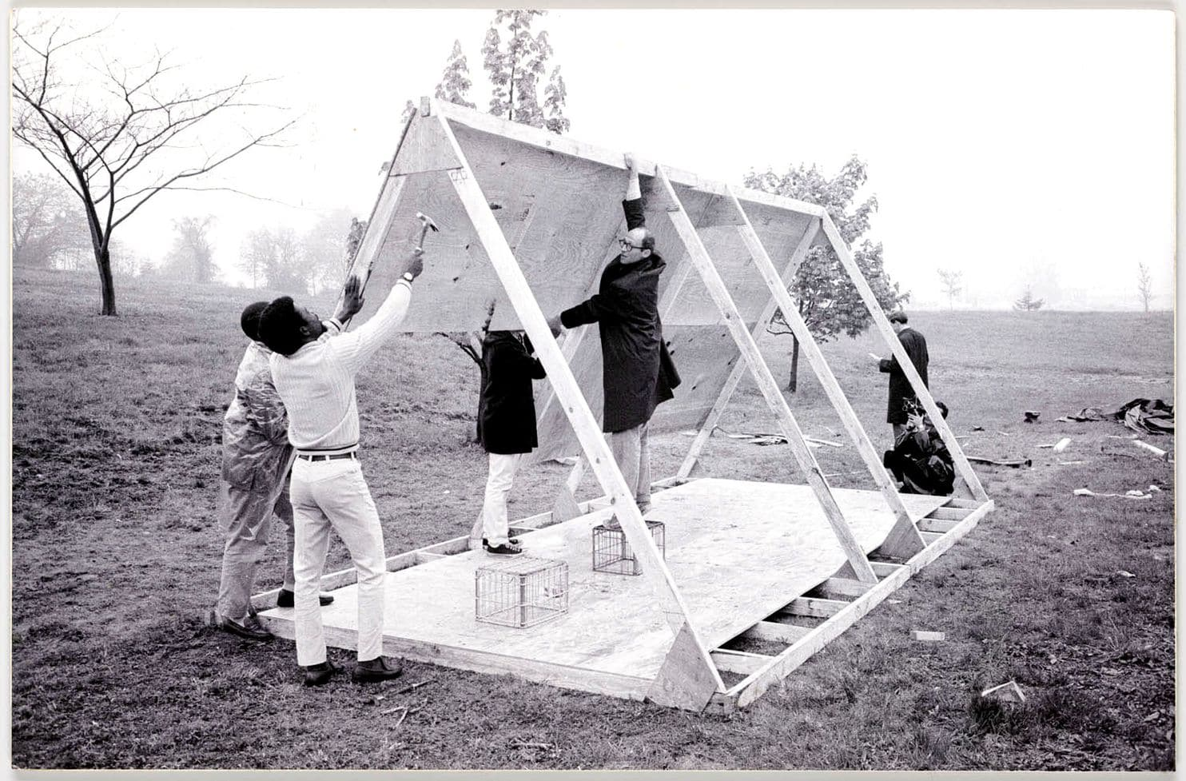
Figure 4: John Wiebenson, a local architect, and others build a structure to use during the 1968 Poor People’s Campaign on the Mall. (credit: Leah Binkovitz)

Bryant, 2008: 1272). Reiterating and expanding the American Constitution, the SCLC ‘called for an economic and social bill of rights to demand the inalienable rights to life, liberty and the pursuit of happiness for African Americans. It would include the right of every employable citizen to a decent job, the right of every citizen to a minimum income, the right to a decent house in a neighbourhood of choice, the right to an adequate education, the right to health care, and the right to full participation in political decision-making’ (Thekingcenter.org, 2018: online). Such proposals followed an Economic Bill of Rights first delineated by President Franklin Delano Roosevelt [FDR] in 1944, that was never implemented; ‘[t]wenty-four years later, the Poor People’s Campaign organized by the SCLC and Dr. King picked up FDR's theme, presenting various versions of what an Economic Bill of Rights should contain and using the concept to educate the nation and its political leaders about the nature of poverty and the measures necessary to end it’ (SCLC, 1968: online). The Campaign also had modest and practical aims, ‘to force a change in the Government’s food programs, to get more food to the poor’ (Society for Science & the Public, 1968: 545). King wanted lawmakers to see that poverty does exist in the nation amid great affluence. Thus, he wanted to ‘direct national attention to claimed inequities in the federal handling of such matters as public welfare and surplus food distribution’ (Gilbert, 1968: 200). This was part of King’s social protest agenda and his growing focus upon economic justice issues.
For King, ‘equal access to quality healthcare and education, affordable housing, and gainful employment were a matter of civil rights promised by the Constitution and the American dream’ (Houston and Bryant, 2008: online). Through the nonviolent struggle for freedom in the civil right movement, King could see the fortitude of oppressed people in working towards achieving lasting social change. The PPC was conceived as a substantial move in civil rights history as the Montgomery Bus Boycott in 1955 and all that followed. As William ‘Bill’ Rutherford, the SCLC staff member, explains:

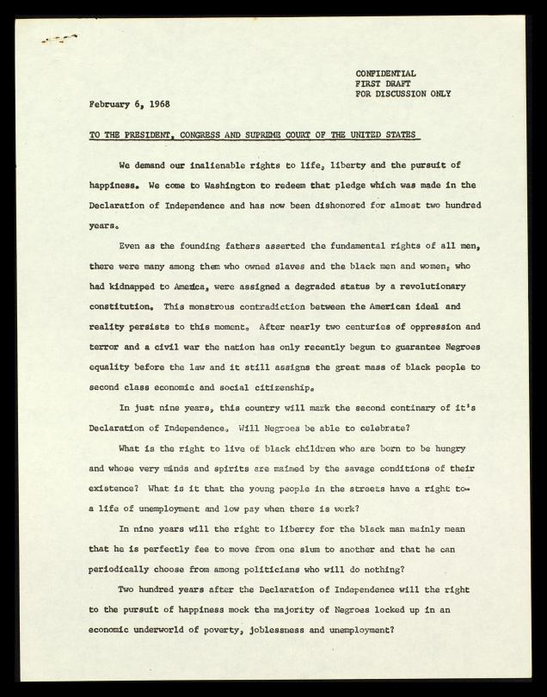
Figure 5: First draft of an Economic and Social Bill of Rights, February 6, 1968 (Source: thekingcenter.org)

‘The purpose and goal of the Poor People’s Campaign was to focus the attention of the nation and the world on poverty. The tactic being used was to gather the poorest of the poor in the nation’s capital in the heart of the wealthiest country in the world to camp them, these homeless, hungry people, in the heart of the city and its fabulous mall situated between the Lincoln Memorial and the Washington Memorial’ (Rutherford cited in Eyes on the Prize, 1990: film).

The PPC was originally scheduled for April 1, 1968. However, the date was pushed back due to King’s support of the Memphis strike. The march of the poor began from the Lorraine Motel on May 2, 1968 with Mrs. King leading the way, as mule teams symbolizing the plight of the rural poor pulled wagons through places King had visited in Mississippi, Alabama, and Georgia, then on to Washington. Resurrection City opened on May 13; it lasted six weeks until June 24. It was a city of plywood, A-frame shacks and fluttering plastic. The population was ‘continually changing with new arrivals and some returnees’ (Society for Science & the Public, 1968: 545). Ben W. Gilbert, of The Washington Post, reports it had ‘a peak population of 2,600’ (Gilbert, 1968: 197). This population included children. The PPC ‘marked King’s desire to broaden the black freedom struggle into a larger human rights struggle. Inviting a wide cross-section of citizens to participate, including American Indians, Puerto Ricans, and people of Mexican descent’ (Pearlman, 2014: 25). King and the SCLC planned to cash this ‘promissory note to which every American was to fall heir’ (King, 1963: 82). Moreover, King wanted to lay at the foot of the nation’s capital the economic struggles in the lives of everyday individuals. Simultaneously, in ‘Memphis, Tennessee, the bitter strike of black garbage workers echoed the issues of the Poor People’s Campaign, the same issues King planned to bring to Washington’ (Eyes on the Prize, 1990: film). As Young outlines:
‘The Poor People’s Campaign was to be a more massive, long-range campaign of civil disobedience than we had ever previously undertaken. … The demonstrators would live in Washington in temporary housing [that] we would construct and begin the petitioning of government agencies and Congress for what was, in effect, an economic Bill of Rights. During the Great Depression, Bonus Marchers, Veterans of World War I, had come to Washington and camped out, demanding a promised “bonus.” In many ways, the Poor People’s Campaign was part of a constitutionally protected tradition of Americans petitioning the government for the redress of grievances’ (Young, 2008: 443).
Throughout Dr. King’s career, he was ‘immersed in the problems of poverty and inhumanity’ (Houston and Bryant, 2008: 1273). Despite the wide popular support for this national goal, Dr. King’s renewed focus on this issue of poverty had adversaries in the American power structure. King recalled the words of Frederick Douglass from 1857 in his West India Emancipation speech at Canadaigua, New York, ‘[i]f there is no struggle, there is no progress … Power concedes nothing without demand. It never did and it never will’ (Douglass, 1857: online). Despite formidable challenges, King ‘viewed the plight of the poor as the necessary next stage of the black freedom struggle’ (Dickerson, 2001: 902). The PPC could be perceived as an even greater threat to the establishment than the civil right movement because of its ‘mobilization of grassroots activists across the spectrum of class, region, and race’ (Dickerson, 2001: 902). Rev. Andrew Young argued,
‘We believed that as segregation was immoral in a democracy, poverty was immoral in a nation as wealthy as the United States of America. What had begun as a movement for racial equality had evolved until Martin could no longer ignore the role that war and poverty played in the oppression of people of color in America and around the world. Racism, war, and poverty were intertwined. Only when we removed the first layer of segregation did we see clearly the cancer of poverty eating away at the hope and strength of black people in America. Segregation nourished that cancer, but the elimination of segregation could not eradicate it. But, by attacking poverty, Martin was calling into question fundamental patterns of American life. There was scarcely any power center that was unaffected by his challenge’ (Young, 2008: 446-47).

In his essay, ‘A Testament of Hope’ (1968), King posits, ‘The black revolution is much more than a struggle for the rights of Negroes. It is forcing America to face all its interrelated flaws – racism, poverty, militarism, and materialism. It is exposing evils that are rooted deeply in the whole structure of our society … and suggests that radical reconstruction of society is the real issue to be faced’ (King, 1968: 315). Not until a visit to Los Angeles following the Watts riots in the summer of 1965 ‘did King come to appreciate fully the depths of urban black alienation outside the South and to broaden his quest to include economic empowerment and an end to poverty’ (Sitkoff, 2008: 211). Dr. King identified an entrenched and enforced hopelessness as the cause of such riots, which could only be ended by profound social reform in civil, human and economic rights.
On April 4, 1967, in a sermon at The Riverside Church in New York City, Dr. King spoke out about the war in Vietnam; King proclaimed, ‘We must find new ways to speak for peace in Vietnam and justice throughout the developing world, a world that borders on our doors’ (King, 1967a: 162). Despite his signing of the Civil Rights Act of 1964, and the Voting Rights Act of 1965, King publicly became an opponent of President Johnson. As Perkins recounts, King went on to present ‘a gut-wrenching and trenchant analysis of the Vietnam War as connected to civil rights. The true cost of war, he reported, was in the lives of the young poor, disproportionally Black men, sent to fight for political rights they could not expect to be honoured back home. He talked about his own integrity in asking young Blacks of the North not to protest with violence while appearing through his silence to condone military violence in Vietnam’ (Perkins, 2019: 251). The conduct of the war under Johnson’s administration was open to a particular critique: ‘King then recounted how the United States promised democracy and land reform while killing more citizens than the Vietcong by a factor of 10 to 1, burning their crops, poisoning their water, and devastating their children. “They must see America,” King told the audience, “as strange liberators … We have destroyed their two most valued institutions: the family and the village”’ (King cited in Perkins, 2019: 251). King’s progressively more explicit denunciations of the Vietnam War caused him to lose allies as well as financial supporters for the SCLC. As a result, it drew intense criticism from many who had backed him, including clergy both black and white. As Cone observes, ‘By 1967-68, Martin’s militancy had deepened to the extent of disturbing many people, not only in government and the media but in the civil rights movement itself … Martin had begun to sound like a nonviolent Malcolm. His outspoken opposition to the war in Vietnam and his advocacy of mass civil disobedience in Washington isolated him from many former supporters’ (Cone, 1992: 306-07). Moreover, King had planned an April 15, 1968 New York march to the United Nations to protest the war; he was assassinated on April 4 of that year. According to Perkins, ‘King’s formation and experience as a Black leader in a public world dominated by White oppression empowered him to speak out against the war when it was not politically expedient’ (Perkins, 2019: 251). In his book, The Last Crusade: Martin Luther King, Jr., the FBI, and the Poor People’s Campaign, Gerald D. McKnight argues that King’s growing focus upon economic justice issues and his outspoken opposition to the Vietnam War from 1967 were both ‘fostered by his mounting despair over the callous and reactionary political climate in Washington’ (McKnight, 1998: 13). King believed that Vietnam could be viewed as a direct cause of continued poverty at home; as Houston and Bryant observe, ‘America’s interests in global conflict funnelled much-needed financial resources away from the social programs that would elevate the nation’s poor. President Lyndon Johnson’s War on Poverty was overshadowed by his war in Vietnam and political ideology abroad eclipsed domestic needs’ (Houston and Bryant, 2008: online). ‘The pursuit of this widened war,’ King argued, ‘has narrowed the promised dimensions of the domestic welfare programs, making the poor white and Negro bear the heaviest burdens both at the front and at home’ (King, 1967: online). As Michael K. Honey contends, ‘[u]ntil the nation stopped spending its fortune on wars abroad, we would never solve the problems of poverty and racism at home’ (Honey, 20017: xiii).
Although the SCLC was still grieving King’s assassination in April 1968, as it approached its implementation of the Poor People’s Campaign, it wholeheartedly ‘committed itself to carry out King’s campaign. From Mississippi, from New Mexico, from New York, thousands set out for Washington. Five weeks after King’s death, his Poor People’s Campaign reached the nation’s capital. Five years after the March on Washington, his movement built a city on the same ground’ (Eyes on the Prize, 1990: film). There was stable health care in Resurrection City thanks to six organizations that participated in the Health Services Coordinating Committee (HSCC), which was formed specifically to serve during the Poor People’s Campaign. These organizations included the National Medical Association, the Medico-Chirurgical Society of the District of Columbia, the local chapter of the American Medical Association, the St. Luke’s Physician’s Guild, the Medical Committee for Human Rights, and the American Red Cross. Over two hundred and eighty registered nurses from the greater Washington D.C. area volunteered their services. There were annoyed D.C. citizens and government officials who had hope that torrential rains might drive the poor people from Resurrection City. However, Nurse Wendy Pritzker noted that ‘conditions in the City really weren't much worse than many of its people were accustomed to in their own homes' (Pritzker cited in Billings, 1968:1695). Despite the medical arrangements and outstanding coordination of health volunteers by HSCC, there was nobody inside the City to assess medical needs around the clock. As a result, Nurse Pritzker decided to spend her remaining leave from her job, living at the site. She ‘stayed to the end in the city of the poor’ (Billings, 1968: 1695).
In Dr. King’s last speech to the Memphis sanitation workers on the eve of his assassination, he articulated what united the Memphis strike and the Poor People’s Campaign: ‘[t]he question is not if I stop to help this man in need, what will happen to me? The question is, if I do not stop to help the sanitation workers, what will happen to them? That’s the question’ (King, 1968: 219). The Memphis strike was a precise lesson on the need to move from civil rights on to fighting for economic justice for the working poor. The arrangements for Dr. King’s funeral at Ebenezer Baptist Church on April 9 in 1968 emphasized the importance of the PCC. As his widow explained, ‘[w]e chose the mule train to transport Martin’s body through the streets of Atlanta because it was symbolic of the Poor People’s Campaign and of the conditions among the poor of this nation with whom he wanted to be identified; and, it characterized the struggle that he had waged for them throughout his life’ (Scott King, 1969: 305).
The PPC is a key but often forgotten chapter in American civil rights history. In Michael K. Honey’s assessment, ‘King’s Poor People’s Campaign proved to be one of the most disconcerting defeats for social change movements in the wake of the Memphis strike’ (Honey, 2007: 500). It is ‘impossible to know whether the PPC, under King’s personal direction, might have achieved its goals’ (Fairclough, 1999: 314). Still, many positive things were accomplished through the PPC: for six weeks, civil rights leaders came together with a unifying purpose, and shined a spotlight on problems of poverty and inhumanity in the nation’s capital. Furthermore, for six weeks in Resurrection City, the poor received free dental and medical care that they could not access in their hometowns. The PPC brought together a multi-racial group of residents ‘united in one common problem – poverty’ (Scott King, 1969: 279). Furthermore, participants returned to their communities with a new commitment and a renewed vision for the poor. Participants left Washington with the challenge ‘to regroup, rethink and get up and figure out new strategies, to build new paths towards the future, to deal with the issues of poverty and deal with the issues of race that were going to be ongoing’ (Wright cited in Eyes on the Prize, 1990: film). The Children’s Defense Fund emerged from the PPC and has made giving every child ‘a healthy start, a head start, a fair start, a safe start and a moral start in life and … a successful passage into adulthood’ (Children’s Defense Fund, 2018: online) its mission for over forty-five years. Today it continues Dr. King's prophetic call for justice for the poor. Further, as Rev. Joseph Lowery proclaimed, ‘[t]he nation became conscious of the fact that it had an expanding poor population. It’s one thing to have the right to check in Hiltons and Marriotts [hotels]; it’s another thing to have the means to check out’ (Lowery, 2008).
I agree with Rev. Arthur Price, Jr., pastor of the 16th Street Baptist Church in Birmingham, Alabama. ‘There still needs to be a voice crying out in the wilderness,’ Price says, ‘[t]here still needs to be a charge from the pulpit to ignite people, to prick the consciousness of our brothers and sisters and to keep the mirror up in America’s face, to let them know that they do have a responsibility to the least of these’ (Price, 2008: online). We, too, must take up this call today on behalf of the poor. As with King and the SCLC, it will require a most radical approach for highlighting the plight of the poor of our nation.

iv) Nonviolent Resistance

‘A great human revolution in just a single individual will help achieve a change in the destiny of a nation, and further, can even enable a change in the destiny of all humankind’
(Ikeda cited in Saka Gakkai, 2015: online).

Nonviolent resistance was deployed during the Memphis sanitation workers’ strike, as well as the PPC and was fundamental to Dr. Martin Luther King’s leadership strategy within the civil rights movement. ‘The term nonviolence did not come into use until the twentieth century’ (Irwin and Faison, 1984:3), but it is an ancient wisdom. It is always connected to strategies and blueprints for change. While in South Africa, Mohandas K. Gandhi (1869-1948) rejected the terms pacifism, passive resistance, and non-resistance. Gandhi rejected these terms because what he was experimenting with, what he first called nonviolence, and then ‘satyagraha’ (Chaudhary & Starosta, 1992: 1) was indeed powerful. The birth of satyagraha occurred in Johannesburg, South Africa on September 11, 1906 at the Empire Theatre. About three thousand Indians, from all walks of life, crowded into the building. Before it was demolished, it was originally on the corner of Commissionary and Ferreira streets; this is where the mass meeting chaired by Gandhi took place. Satyagraha literally means clinging to truth. The term satyagraha matters to my project because it means vindication of truth by enduring suffering oneself, not by inflicting suffering on one’s enemy. Gandhi assigns his own understanding of the power of nonviolent resistance to oppression to Count Leo Nikolayevich Tolstoy (1828-1910). We can trace firm links in this strategy from Tolstoy to Gandhi to Martin Luther King, Jr. and to Cesar Chavez. As Congressman John Lewis explains, ‘we were prepared to sit-in. We didn’t just wake up one morning and say we were going to sit in; we studied. We studied the philosophy and discipline of nonviolence. We studied what Gandhi attempted to do in South Africa … what he accomplished in India’ (Lewis cited in Soundtrack for a Revolution, 2009: film).
A text that is important in Nonviolence Studies is The Search for a Nonviolent Future: A Promise of Peace for Ourselves, Our Families, and Our World (2004) by Michael N. Nagler. According to Nagler, the number of such movements has grown since 1948 both quantitatively and qualitatively: ‘In one year alone, 1989-1990, there were thirteen uprisings against despotic rule, of which twelve were essentially nonviolent’ (Nagler, 2013: online). Mary-Wynne Ashford and Guy Dauncey report, ‘Biblical scholar, Walter Wink, noted that successful revolutions that started in 1989 involved 1.7 billion people; if we add up all the people involved in all the nonviolent movements of the 20th Century, the figure comes to 3.4 billion people’ (Ashford and Dauncey, 2013: 41). Thus, nonviolent resistance has been crucial to fighting injustice. Nonviolent resistance is a revolutionary philosophy.
Nonviolence Studies involves two kinds of nonviolence: principled nonviolence and strategic nonviolence. Strategic nonviolence is mostly negative. In it, one is not using physical violence, which means, ‘we are not going to hit you now.’ It is a strategy; it is not a principle. People can grow from a strategic posture to a principled commitment to nonviolence. What Gandhi and King did in their respective nonviolent struggles, by putting their lives on the line, may be considered principled nonviolence. A principled approached to nonviolence means, in practice, that one is striving for a kind of reconciliation with one’s opponent. A great contributor to Nonviolent Theory is Kenneth E. Boulding, one of the inventors of Peace Theory. Towards the end of his life, Boulding wrote The Three Faces of Power. His proposition is, if we define power as the proposition to get something done, then, in human interactions, we have three ways to do it: Threat Power, Exchange Power and Integrative Power.
Threat Power works this way. You say, ‘You do something that I want, or I will do something that you do not want’ (Boulding, 1990: 25). ‘Get out of the car, or I will kill you’ is a clear example of Threat Power. In Exchange Power, ‘You do something I want, and I will do something that you want’ (Boulding, 1990: 27). For example, you make a donation to my nonprofit; I will give you a book. The third strategy is Integrative Power. With Integrative Power, you are saying to the other person who is involved in the interaction, I will be authentic. I am going to represent truth in this exchange with the idea in mind that we are going to end up closer, more integrated. Boulding says that ‘[i]ntegrative power may be thought of perhaps as an aspect of productive power that involves the capacity to build organizations, to create families and groups, to inspire loyalty, to bind people together, to develop legitimacy. Integrative power has a negative sense, to create enemies, to alienate people; it has a destructive as well as a productive aspect’ (Boulding, 1990: 25). Nonviolent resistance is the productive aspect of Integrative Power; it is principled nonviolence in action. Using this principle, you should never treat your opponent in such a way that the person cannot also become your friend. Following on from Gandhi, ‘peace activists have created a large body of work about the strategy of nonviolent protest that brings out both its strengths and advantages over and above violent insurrection’ (Hardiman, 2013: p.41).
Dr. King admitted that the person who has influenced his life more than anyone is Mahatma Gandhi. He came to learn of Gandhi during his theological seminary days. King stated, ‘I remembered hearing a message by the president of Howard University, Dr. Mordecai Johnson, who had just returned from India. [Johnson] spoke in Philadelphia about his trip to India, and the whole philosophy of Gandhi and nonviolent resistance’ (King cited in Blackburn, 2011: online). King was so impressed by the message that he began to study Gandhi and the Gandhian technique. King said that he never realized that he would be living in a situation where this philosophy would be useful to him. King ‘credits Mahatma Gandhi as his model for non-violence resistance strategies’ (Gilliam-Smith, 2008: 33). King later wrote, ‘It was in this Gandhian emphasis on love and nonviolence that I discovered the method for social reform that I had been seeking’ (King, 1958: 84-85). Describing the influence that Gandhi had on his philosophy of nonviolence and its application within the civil rights movement, King proclaimed:
‘We must continue to delve deeper into the philosophy of nonviolent resistance. There is something about this method that has power. They try to handle it by throwing us in jail… but what happens? We go into the jails of Jackson, Mississippi and transform these jails from dungeons of shame to havens of freedom and human dignity.
He could call out the state militia. He could call out the National Guard. They know how to handle violence, but they have proved over and over again that they don’t know how to handle nonviolence.
I believe firmly that this is the way; it exposes the moral defenses of the opponent. It has morality with it; because, it gives us the opportunity to work to secure moral ends through moral means …
Violence in our struggle is impractical. We have another method that is much more powerful.
Let us recognize that violence is not the answer’ (King cited in Blackburn, 2011: online).
Nonviolence was key to the many achievements of the civil rights movement. Led by King, millions of blacks created a mass movement of peaceful protest as well as civil disobedience actions and economic boycotts. King’s faith in nonviolence was unshakable. Even after his home was bombed in Montgomery, Alabama with his wife and baby inside, he calmed the crowd and sent the would-be rioters away peacefully.
However, King’s philosophy of nonviolence was not without critics. The Memphis strike occurred during King’s move to economic justice issues and following the rise of the Black Power Movement. Malcolm X asserted, ‘When a black man strikes you back, he is an extremist. He’s supposed to sit passively, and have no feelings … be nonviolent, and love his enemy. No matter what kind of attack … be it verbal or otherwise, he is supposed to take it. But if he stands up in any way and tries to defend himself, then he is an extremist … the day of the sit-in, the lie-in, the crawlin’, the cryin’, and the beggin’ is outdated’ (Malcolm X cited in Olsson, 2011: film). Huey P. Newton and Bobby Seale founded the Black Panther Party in 1966 in Oakland, California; it symbolized the new, black militancy of the 60s. Black Panthers offered free breakfast and lunch programs, as well as training to the poor to deal with the police, landlords, and authorities. They also offered free clothes and legal defense to political prisoners. The Black Panther activist Stokely Carmichael believed that the fifty million blacks in the United States had to be able to fight for their liberation. From Carmichael’s vantage point, nonviolence or passive resistance was not a viable strategy to achieve the profound change urgently needed. Musician Talib Kweli argued, ‘It wasn’t an option at all. Now, in 2010, you can see how King and all them who were influenced by Gandhi… how it did work. You know, the passive resistance of the bus boycott; it did work, but it would have never worked without people like Stokely Carmichael on the other side’ (Kweli cited in Olsson, 2011: film). It was precisely because of this radicalism in the Black Power movement that King became more militant in his nonviolent tactics. Amiri Baraka, born LeRoi Jones, was an American writer of poetry, drama, fiction, essays and music criticism. After the assassination of Malcolm X, he took the name Amiri Baraka and became involved in the Black Nationalist poetry and literature scenes. His influence and ideas extended to playwright August Wilson, who writes, ‘My youth was fired in the kiln of black cultural nationalism as exemplified by Amiri Baraka in the sixties… The ideas of self-determination, self-respect, and self-defence which it espoused are still very much a part of my life as I sit down to write’ (Wilson, 1991: ix).
The Black Power Movement and the Black Panther Party are often imagined to be antithetical to the civil rights movement. Although the Black Panthers were a secular community-based revolutionary party, upon their return from exile in Algeria, Eldridge Cleaver and his wife, Kathleen, had become born-again Christians. In his article, ‘Black Religion and Black Power’, Matthew J. Cressler posits:
‘Black Power has typically been conceived as northern (and western) whereas civil rights was southern, violent while civil rights was nonviolent, and secular in contrast to the inherent religiousness of civil rights … Journalists were quick to contrast what they took to be the irrational rage of urban youth shouting “Black Power!” with caricatures of a more palatable southern Christian nonviolence – needless to say, neither of these characterizations approximated the reality of either. … Even as more recent scholars have challenged many of the classic binaries separating Black Power from civil rights, the secular/religious divide usually persists since it serves as a convenient category for marking the elusive shift from one style of social justice struggle to another. … Even the Black Panthers … met in churches and collaborated with religious people and communities from the get-go’ (Cressler, 2014: online).

According to Cone, Martin Luther King, Jr. ‘was the most powerful symbol of the Civil Rights Movement and Malcolm X was the voice behind the Black Power Movement. In Black Theology, I wanted to make Martin King and Malcolm X one voice because each spoke a truth that was essential in the Black freedom struggle’ (Cone, 2010: 265).
A question to consider is the interaction between nonviolent resistance, faith and theology. In chapter two, I will turn to the origins and pioneers of Black Liberation Theology in America to examine its place in the civil rights movement. Black Liberation Theology encompasses those theologies that have as their essence the liberation of marginalized people. Historically, it particularly centered on ending the injustices endured by African Americans during the Jim Crow era. I will also introduce the Social Gospel, with its emphasis on activism and reform. Here, the message of salvation is always accompanied by work to eradicate poverty; it opposes any theology that seeks to exclude social issues from religious discourse. Its vision instead was of uplift for workers and the poor. As Honey reports, United Methodist minister, Rev. Dr. Frank McRae concluded ‘Most whites thought religion should be a salve to individuals locked in poverty but not a basis for social action to end that poverty’ (McRae cited in Honey, 2007: 152). Black Liberation Theology and the Social Gospel expand a version of Christianity that directly addresses and resists racial and economic oppression and does not leave social or political issues unchallenged.

Chapter Two:
Sustaining Faith during the Freedom Struggle

i) Black Liberation Theology
The role of the black church as an agent of change includes ‘specific strategies to address social problems in the Black community’ (Barnes, 2005: 967). There was a time in history when black churches were more regularly involved in social justice issues, when Dr. King was pushing for fundamental social reform. Barnes posits that ‘little research based on quantitative techniques has been forwarded relative to the relationship between longstanding Black Church cultural components – specifically, scripture, songs, prayers, and sermons – and activism among Black churches’ (Barnes, 2005: 967). The late Rev. Dr. Fred C. Lofton asserts:
‘During the early days of the civil rights struggle in Columbus, Georgia, Rev. Johnny Flakes and I went to the Royal Crown Bottling Company headquarters to secure employment opportunities for African Americans; that headquarters was lily white. As we sat there talking with the Vice President of Marketing about the possibilities of obtaining employment for just one black woman as secretary, this big-time company executive looked at us and asked, “When do you preachers get your sermons?” Brother Flakes said to him, “This is our sermon. We love our folk enough to bestir ourselves to get out here and work for economic development for blacks, so that we can enjoy some of the same things that you enjoy, Mr. Vice President”’ (Lofton,1999: 58-59).

Everyday black churches in the South had to speak for the community, where, in many instances, the members of the Klu Klux Klan were the mayors or sitting on the city council. As Barnes recognizes, the African Methodist Episcopal Church tradition ‘reflects advocacy and community service by the Black church in the Black community’ (Barnes, 2005: 973). This is practiced through ‘a continuing program’:
‘of (1) preaching the gospel, (2) feeding the hungry, (3) clothing the naked, (4) housing the homeless, (5) cheering the fallen, (6) providing jobs for the jobless, (7) administering to the needs of those in prisons, hospitals, nursing homes, asylums and mental institutions, senior citizens’ homes, caring for the sick, the shut-in, the mentally and socially disturbed, and (8) encouraging thrift and economic advancement’ (Lincoln and Mamiya 1990: 55).

During the civil rights era, black churches took a central part in community action, as was true with the Memphis sanitation workers’ strike. Furthermore, many specific sermons led to a sharp ‘focus on social justice issues’ (Barnes, 2005: 978) in order to invoke community involvement. The Christian Church universal must make God’s liberation of the oppressed the focus of its mission and proclamation. In his book, The Burden of Black Religion, Curtis J. Evans posits, ‘[p]rogress is never direct and inevitable and has always come at an astonishing cost to African Americans’ (Evans, 2008: X).
When I told the late Rev. Dr. William Augustus ‘Bill’ Jones that I would be joining a particular church in Brooklyn, which has a white pastor, he looked at me and said emphatically, ‘You will not hear one word about the liberation of our people there’. What Dr. Jones was referring to was Black Liberation Theology. As Presidential Contender, Senator Barack Obama’s former pastor, Rev. Dr. Jeremiah Wright, Jr., ‘catapulted Black Liberation Theology on to the national stage’ (Bradley, 2008: online) during the 2008 United States Presidential campaign. National Public Radio host, Melissa Block declared, ‘[a]s we’ve been reporting, Senator Barack Obama defended his long-time pastor today even as he repudiated some of his views. Rev. Jeremiah Wright of Trinity Church of Christ has given a number of inflammatory sermons about race and politics’ (Block cited in Pinn, Hopkins and Thomas, 2008: interview). Wright is pastor emeritus of Trinity United Church of Christ (UCC) in Chicago, which proclaims, ‘We are a congregation which is unashamedly black and unapologetically Christian. Our roots in the black religious experience and tradition are deep, lasting, and permanent’ (Stewart, 2008: interview). Since its founding, Trinity UCC has had a proud tradition of emphasis on social justice. It follows Jesus’ focus on the poor, the orphan, the widow, and the ‘least of these’ (Matthew 25:40). The church has a commitment to liberation, equality, and working toward economic parity. It has eight to ten thousand members and its emphasis on politics, religion, and race makes the church a powerful force in the community. Professor Anthony Pinn, who teaches philosophy and religion at Rice University, insists that ‘God’s presence in the world is best depicted through God’s involvement in the struggle for justice. That God is so intimately connected to communities that suffer that God becomes a part of that community’ (Pinn, Hopkins and Thomas, 2008: interview). The current Pope, Pope Francis, uses the language of ‘the church of the poor’; his aim is ‘to reach out more to the poor and social outcasts’ (Gibson, 2015: online). In his own words, the present Pope preaches that ‘[w]e will not find the Lord unless we truly accept the marginalized … Truly the Gospel of the marginalized is where our credibility is at stake, where it is found, and where it is revealed’ (Pope Francis cited in Gibson, 2015: online). Jesus went out and found the people who were on the outskirts of society, the people who were forgotten, and that is where Jesus concentrated His efforts, and His energy. What is God saying to the church from the perspective of the poor? That is where God is at work. How do we let God speak to us from that position? How do we go to the poor and learn from them? Gustavo Gutierrez Merino, Peruvian theologian and Dominican priest, is regarded as one of the founders of Liberation Theology in South America. Gustavo Gutierrez Merino believes that Liberation Theology is an expression of the right of the poor to think out their own faith. In his book, Farewell to Innocence: A Socio-Ethical Study on Black Theology and Black Power, South African theologian, Allan Boesak avers:
‘While we acknowledge that all expressions of liberation theology are not identical, we must protest very strongly against the total division (and contrast) some make between Black Theology in South Africa and Black Theology in the United States; between Black Theology and African theology; between Black Theology and Latin American theology of liberation. As a matter of principle, we have therefore treated all these different expressions within the framework where they belong: the framework of the theology of liberation’ (Boesak, 1976: 7).

In the United States, the National Committee of Negro Churchmen (NCNC) could be identified as amongst the founders of Black Liberation Theology. The NCNC was formed as an association of 51 black pastors to support of young civil rights workers who advocated ‘Black Power’ during the 1966 ‘March Against Fear’ at Greenwood, Mississippi. Their brand of Black Liberation Theology was born when ‘on July 31, 1966, the NCNC purchased a full-page ad in The New York Times publishing their statement of support for “Black Power”, arguing that the call was in fact consistent with the movement’s principles and the teachings of Jesus’ (Walker, 2016: 102). NCNC’s statement on Black Power asserted, ‘Powerlessness breeds a race of beggars’ (Boesak, 1976: 46). The late Rev. Dr. James H. Cone, ordained minister in the African Methodist Episcopal (A.M.E.) Church and distinguished professor emeritus of Systematic Theology at Union Theological Seminary in New York City, is regarded as the architect of Black Liberation Theology. Cone defined Black Liberation Theology as:
‘a theology that sees God primarily as concerned with the poor and the weak in society. Since this theology comes out of the black community, we call it Black Liberation Theology but, it is not just for black people in a narrow sense of that term. It is for black people in the sense that it focuses on the concerns of blacks who are living and who are voiceless in this society. That makes it Black Liberation Theology, but it is concerned about the Gospel for everybody. And if everybody is for the Gospel in this society, then they are for the poor and the weak, and if you are for the poor and the weak, you are also concerned about the liberation of black people too. So, Black Theology is an understanding of the Gospel which sees justice for the poor as the very heart of what the Christian Gospel is about and the very heart of what God is doing in the world’ (Cone, 2008: interview).

Cone was inspired by both King and Malcolm X, who left the church and converted to Islam, firstly in the form of the Nation of Islam, a branch of black nationalism that advocated the establishment of an autonomous African American state and so opposed racial integration. According to Cone, ‘King gave Black Theology its Christian identity … Malcolm X, who was not a Christian; … gave Black Theology its black identity’ (Cone, 2008: interview). He points out that this was important ‘because we were black before we were Christian’ (Cone, 2008: interview). Cone explains in his essay titled, ‘Martin, Malcolm, and Black Theology’:
‘From King black liberation theology received its Christian identity, which he understood as the practice of justice and love in human relations and the hope that God has not left the least of these alone in their suffering. However, that identity was only one factor that contributed to the creation of black theology. The other was Malcolm X, who identified the struggle as a black struggle. As long as black freedom and the Christian way in race relations were identified exclusively with integration and nonviolence, black theology was not possible. Integration and nonviolence required blacks to turn the other cheek to white brutality, join the mainstream of American society, and do theology without anger and without reference to the history and culture of African Americans. It meant seeing Christianity exclusively through the eyes of its white interpreters. Malcolm prevented that from happening’ (Cone cited in Pollard, III and Whelchel, Jr., 2003: 125).

For Cone, ‘No religious thinker has made a greater impact upon American culture and its churches than Martin King. He has communicated the Christian message of freedom more effectively, prophetically, and creatively than anyone in the United States before or after him’ (Cone, 1992: 295). On the other hand, Malcolm X created the space for blacks to affirm their blackness: ‘He decolonized the black mind, and thereby transformed “Negroes” into proud black African people. Muhammad Ali proclaimed “I am the greatest,” Aretha Franklin started to demand “Respect,” and James Brown began to sing “I’m Black and I’m Proud,” and African-Americans began to say proudly to themselves and to the world that “Black is beautiful, baby.” The whole of black America began to walk and talk to the rhythm and beat of a cultural renaissance stretching back to the African homeland. Dashikis and Afros became outward signs of an inward transformation of the black self’ (Cone, 1992: 291). Cone reflects on the difficult and long history that blacks have endured in America; there have ‘been 246 years of slavery and 100 years of segregation and lynching, in a society where white domination is so powerful on the minority group, and where black has been defined as evil and as negative’ (Cone, 2008: interview). Cone explains, ‘[w]e have to turn that understanding of black on its head, and see ourselves as loving ourselves and not hating ourselves’ (Cone, 2008: interview). Bill Moyers asserts, ‘[a]s I understand it, Black Liberation Theology reads the Bible through the experience of people who have suffered, and who then are able to say to themselves that we read the Bible differently, because we have struggled, than those do who have not struggled’ (Moyers cited in Wright, 2008: interview). One of Cone’s former students, Dr. Dwight Hopkins, professor of theology at the University of Chicago Divinity School defines Black Theology of Liberation in this way:
‘The theology part of the phrase, Black Theology of Liberation, speaks to us being rooted into the Christian tradition of Jesus the Christ; so that’s the theology part. The liberation part is to say the message of Jesus Christ, in that tradition, is one of liberation and healing for the physically poor and oppressed, and for those who are spiritually and emotionally broken … And [the] black part of Black Liberation Theology answers the question: How does the tradition of theology link to the work of God, of Jesus of liberation, reveal itself in black culture? Hence, you have Black Liberation Theology’ (Hopkins cited in Oblate School of Theology, 2016: online).

In 1969, in Black Theology and Black Power, Cone wedded together the social justice part of black power, black identity and black self-love with the liberation part of Christian theology. Subsequently, a whole new generation of young, black people were brought back to the church as a result of his writing. These young people learned that they can be a supporter of both their black African identity and also a supporter of Christianity again, because they had left the church dissatisfied prior to the introduction of Black Theology. In the late 1960s, Black Theology was introduced to the world as a category of theological studies. Cone believes also that there was a need to respond to the critique of Black Theology, by opposing theologians who argued that blacks ‘are not free to violate the canon of exact reflection, careful weighing of evidence, and apt argument, if they want to make a case for other intellectually responsible listeners’ (Holmer, 1971: 211). Boesak contends, ‘Black Theology is the theological reflection of black Christians on the situation in which they live and on their struggle for liberation. Blacks ask: What does it mean to believe in Jesus Christ when one is black and living in a world controlled by white racists? And what if these racists call themselves Christians also?’ (Boesak, 1976: 1-2). Black Theology is not subsumed within other emerging theological currents but maintains its own place among theological developments and demands a place among the recognized religions of the world. Cone explains:
‘I must conclude that my theological reflections are inseparable from the Bearden [Arkansas] experience. I say with Claude McKay that “what I write is urged out of my blood” and out of the blood of blacks in Bearden and elsewhere who see what I see, feel what I feel, and love what I love, that is why Black Theology differs in perspective, content, and style from the western theological tradition transmitted from Augustine to Barth’ (Cone, 1997: 3).

What disappointed Cone about the white church was that it did not recognize that the Gospels were wholly applicable to black people struggling for justice. Cone argues, ‘I don’t know how anybody can preach the Gospel of Jesus Christ and, in a slave society, or in a segregated society or in a society where people are lynched, unless you make that Gospel stand in opposition to slavery, segregation and lynching. And the white church [in America] did not do that; and they did not do it when King was marching either. They did not make the Gospel identical with the struggle of blacks for justice’ (Cone, 2008: interview). Cone was also critical of the many black churches that did not want to follow King, because they saw the Gospel primarily as going to heaven when they die. Cone’s view is that the Gospel is not primarily that at all; rather it is what happens to you now in this world. Cone wanted the black churches to see that they cannot preach the Gospel unless they preach about justice and peace for all people.
For Cone, it was ‘especially the exodus of the Israelites from Egypt [that] became a central theme in my theology because it’s been a central theme in black religion’ (Cone, 2008: interview). In the Exodus Story, there is salvation and liberation of an enslaved people. In the Bible, salvation means deliverance from bondage, to be set free. The prophets Jeremiah, Amos, Isaiah, Hosea and Micah spoke for the poor and the weak; as Cone explains, ‘[i]f you read the message of the prophets, it is a condemnation of the nation and also of the religious practices of that time for oppressing the poor’ (Cone, 2008: interview). That is why Amos said, ‘Let justice roll down like waters, and righteousness like an ever-flowing stream’ (Amos 5:24). In his March 18, 1968 address to the striking Memphis sanitation workers, ‘King spoke to black women and men alike about the psychic pain they endured due to racism and poverty, but he added the master touch based on his own experiences that not many others could command – the certainty that there could be a better world, optimism mixed with outrage at oppression’ (Honey, 2007: 301). Honey accurately described King as having one foot planted on the Bible and the other on the Constitution. King proclaimed:
‘And so in Memphis, we have begun. We are saying, now is the time … to make real the promises of democracy. Now is the time to make an adequate income a reality for all of God’s children, now is the time for city hall to take a position for that which is just and honest, now is the time . . . justice rolls down like water, and righteousness like a mighty stream. Now is the time’ (King, 1968: online).

Cone saw that context makes a difference to how you read the Bible; his context is the struggle for civil rights and the black power movement. Cone revealed that he began to feel empowered to write with, as Jeremiah describes, ‘a fire shut up in my bones’ (Jeremiah 20:9). Acts 17 reads, ‘And He has made from one blood every nation…’ (Acts 17:26). That kind of passage validates oppressed people’s sense of worth. Similarly, the theologian Howard Thurman, ‘demonstrates how the gospel may be read as a manual of resistance for the poor and disenfranchised. Jesus is partner in the pain of the oppressed’ (Thurman cited in The Upper Room, 1996: online). The Biblical mandate, if for equality for all, is inclusive of all humanity. The New Testament Gospel of John 1:14, New International Version, reads, ‘The Word became flesh and made His dwelling among us. We have seen His glory, the glory of the One and only Son, who came from the Father, full of grace and truth’ (John 1:14). This passage of Scripture tells the story of Jesus’ Incarnation, that the Word becomes flesh and lives among us. It means unequivocally that all creation is good, and that all flesh, no matter what colour, no matter what shade, is good. Many years after the Jim Crow era in the United States, the struggle for inclusivity remains for many people of colour. In church history, theological minds spent a great deal of time trying to explain the doctrine of the Incarnation, that Jesus was wholly God and wholly man, and used that as a way of countering hierarchy. However, less time has been spent on the meaning of Incarnation, and what it means to practice the equality of all humanity. In his book, Speaking the Truth: Ecumenism, Liberation and Black Theology, Cone avers, ‘If theology is derived from this divine story, then it must be a language about liberation. Anything else would be an ideological distortion of the gospel message’ (Cone, 1986b: 6). Cone believes that if the church had spent more time on the meaning of the practice of the Incarnation, we would not have such terrible racial discrimination that we still have today. This belief is reflected in the timeless words of Dr. King:
‘In this day and time when all of the forces of history are in tremendous flux… [t]he Church can speak out with clarity and vision, pointing the way far beyond the law to a kingdom where all men are brothers. Where each person … no matter how rich or poor, how educated or illiterate, how black or white can contribute to his society in love and confidence that his worth is insured by the fact that he is God’s child and that God has breathed into him the breath of life; placed him in a certain spot in history and society and challenged him to live as an heir and partner to the kingdom of God. If the Church takes this challenge and opportunity, the whole world will shout for joy, and the sons of God will weep no more; but if we fail, some future Toynbee, writing the annals of the history of our civilization, will say that, in the hour of trial, the Church and the Christian were weighed in the balance and found wanting, and this was the beginning of the end of an age’ (King, 1965: online).

This King speech appeared in Ebony Magazine in August 1965 and was titled ‘The Un-Christian Christian: SCLC leader looks closely at Christianity in troubled land’. King asserts, ‘Un-Christian Christian is represented by men like Mayor Clyde S. Fair of Orangeburg, S.C. [South Carolina], who bars church door to college students, Emmanuel Hixson and Dorothy Vann, saying, “Go worship with your own people. This is a segregated church”’ (King, 1965: online). As Honey writes, ‘King ‘offered an alternative to southern religious conservatism, preaching the Social Gospel of labor and social reform movements that had emerged with industrialization and urbanization. King demanded a righteous religion that resisted racial and economic oppression, and his version of the Social Gospel struck a rich chord among African Americans, who had used Christianity as a means to resist exploitation going back to slavery’ (Honey, 2007: 152). The underlying theme of Black Theology could also be identified with the Social Gospel. Both are based on a conception and conviction of equal personhood. Honey reports:
‘In his inimitable way, King combined scriptural teachings and the black Social Gospel with a direct political attack on the American power structure. He politicized issues of wealth and poverty that ministers usually left at the level of generalities. People in the crowd understood the difference. He reminded the leaders of America that God’s voice would render a judgment that it could never enter the kingdom of greatness by ignoring the poor. By speaking of God’s coming “indictment on America,” King brought a larger power to bear’ (Honey, 2007: 299).

The Social Gospel was evident throughout the Memphis sanitation workers’ strike. Honey reports, ‘Lawson and his colleagues in the clergy aimed to create a nonviolent coalition that the civil rights movement had never seen before – bringing together unions with civil rights groups, black workers with black preachers, alienated students and young black men disconnected from work with the black middle class, and black and white religious followers of the Social Gospel with each other’ (Honey, 2007: 310). In a television interview in 2014, Rev. Dr. Frank McRae described his church in this way, ‘This is a school house. This is a hospital. This is a learning centre for seniors. This is an educational referral program for people with AIDS. Six months from today, we will be engaged in ministry, the need for which we do not know at the present time. It's been constant’ (McRae, 2014: interview). The soup kitchen at St. John's United Methodist Church in Memphis still serves the hungry on Tuesday nights, a ministry staffed by Rhodes College students, in the spirit which McRae encouraged them to embrace. The day after King’s assassination, it was McRae who organized black and white ministers to go to Mayor Loeb’s office and demand an end to the strike. Honey explains, ‘King offered an alternative to southern religious conservatism, preaching the Social Gospel of labor and social reform movements that had emerged with industrialization and urbanization. King demanded a righteous religion that resisted racial and economic oppression, and his version of the Social Gospel struck a rich chord among African Americans, who had used Christianity as a means to resist exploitation going back to slavery’ (Honey, 2007: 152).
Furthermore, King’s Letter from Birmingham City Jail is an example of Social Gospel at its best. King wrote his famous letter when he was imprisoned for participating in nonviolent protests against segregation. Dr. King wrote the letter in longhand, as a response to eight Southern white religious leaders who had urged him to show caution and restraint. From his jail cell in Birmingham, King contrasted legality with a ‘higher moral law’:
‘Of course there is nothing new about this kind of civil disobedience. It was seen sublimely in the refusal of Shadrach, Meshach, and Abednego to obey the laws of Nebuchadnezzar because a higher moral law was involved. It was practiced superbly by the early Christians, who were willing to face hungry lions and the excruciating pain of chopping blocks before submitting to certain unjust laws of the Roman Empire. To a degree, academic freedom is a reality because Socrates practiced civil disobedience.
We can never forget that everything Hitler did in Germany was “legal” and everything Hungarian freedom fighters did in Hungary was “illegal”. It was illegal to aid and comfort a Jew in Hitler’s Germany. But I am sure if I had lived in Germany during this time, I would have aided and comforted my Jewish brothers even though it was illegal. If I lived in a Communist country today where certain principles dear to the Christian faith are suppressed, I believe I would openly advocate disobeying these anti-religious laws’ (King cited in Washington, 1986: 289).

Many church leaders have been taught to ignore social justice issues, but that is not sound advice. To serve God means being involved in making a difference in this world, a difference in one’s country, a difference in one’s own community. As part of a new generation of preachers of the Gospel, we are symbolically co-signers of King’s letter. Still today, it is of most importance to provide social, political and theological commentary on the issues of race and discrimination. In so doing, the Bible comes alive in a real way regarding social, political, historical and cultural concerns. The Social Gospel helps to communicate a people’s worldview, their history, their hopes and their aspirations. We must see Social Gospel as being redemptive, but King emphasized that social change should not be left to God as if we were idle bystanders to injustice.
German theologian Jürgen Moltmann, in his Theology of Hope, pointed to the cultural and political aspects of theology. Yet, G. Clarke Chapman, Jr. says that black theology finds Moltmann’s understanding of the theology of hope ‘too oriented towards the future and to be set in a context too alien to the black experience’ (Chapman cited in Wilmore and Cone, 1979: 197). Furthermore, Cone critiques Moltmann’s hope theology for being too philosophically oriented, while neglecting the situation of the oppressed. Black Liberation Theology arose specifically from the experience of being black and oppressed in the United States. Rufus Burrow, Jr. ‘maintains that after criticism by some black theologians for too great a dependence upon white theology, Cone sought to base his theology wholly upon black experience and the experience of the oppressed’ (Williams, 1996: 138). The uniqueness of black theology is found ‘in its commitment to be in solidarity with the black suffering poor’ (Williams, 1996: 138). Hence, those experiences inform and shape black people’s theology. Historically, the black church uplifted and empowered black people. Liberation, social, economic, and political, have come to be seen as what was most urgently needed. Therefore, liberation became and remains the central theme of Black Liberation Theology. The fact that religious culture matters to political attitudes and behaviour should not be overlooked. M. Allison Calhoun-Brown posits, ‘Black religion developed as a response and expression of a people oppressed on the basis of race’ (Calhoun-Brown, 1996: 197). As Hans A. Baer and Merrill Singer observe too, ‘Black Religion has emerged as a sometimes stormy mixture of diverse responses to oppression and heartfelt yearning for both spiritual and material salvation’ (Baer and Singer, 1992: 27).
In his later book, A Black Theology of Liberation, Cone explains, ‘Unless we can articulate clearly an image of Christ that is consistent with the essence of the Biblical message and at the same time relate it to the struggle for black liberation, Black Theology loses its reason for being’ (Cone, 1986a: 203). Black Liberation theologians insist that ‘[t]o believe in heaven is not to accept hell on earth’ (Williams, 1971: 563). A. Roger Williams points out, ‘Judging from pronouncements of older black convention presidents and black Methodists bishops, many have not caught up with Martin Luther King, Jr., much less the black Revolution’ (Williams, 1971: 564). Black theology ‘verifies for the dispossessed what he is less articulately aware of, namely, that their struggle is Christ’s’ (Williams, 1971: 561). In other words, ‘for those buried under the weight of injustice [the poor and oppressed] … God has made the oppressed conditions His own’ (Williams, 1971: 562). Cone propounds the thought, ‘there is no use for a God Who loves whites the same as blacks. What we need is the divine love as expressed in Black Power which is the power of black people to destroy their oppressors, here and now, by any means at their disposal. Unless God is participating in this holy activity, we must reject His love’ (Cone, 1986a: 74). Like Williams, here I also prefer to follow Dr. King and his teachings of nonviolent resistance. Without question, ‘God is the God of the oppressed’ (Williams, 1971: 565). However, Abraham asks, ‘Will not the Judge of all the earth do right?’ (Genesis 18:15). In describing Cone’s contribution, Williams writes,
‘He has challenged white theologians to address themselves to racism. The social prophets of the early twentieth century wrote voluminously on war. They helped the laboring man to reach the zenith industrially. They showed solicitude for the poverty-stricken. But what have the theologians written about racism? So much to do, so little done. For all practical purposes there has been a conspiracy of silence. A service has been rendered. White theologians have been reminded to concern themselves on this inexcusable neglect’ (Williams, 1971: 566).

Black Liberation Theology ‘lays the obligation on all to identify with the oppressed’, (Williams, 1971: 567) and to ‘more effectively execute Christ’s mandate for human liberation’ (Williams, 1971: 566). As Cone explains in his article, ‘Some Brief Reflections on Writing Black Theology and Black Power’, ‘For the last four decades, I have been exploring what the Christian gospel means in the context of Black people’s struggle for justice in the United States. Whatever else we may say about the gospel of Jesus, it is first and foremost a story of God’s solidarity with the poor, empowering them in the fight for freedom. Anybody who talks about the gospel and omits God’s liberation of the poor is not talking about the gospel of Jesus’ (Cone, 2010: 265). Theologian, Dr. Diana L. Hayes, in her book, And Still We Rise: An Introduction to Black Liberation Theology, asserts that ‘Black Theology looks ahead to a future that is full of challenges but also bright with hope-filled possibilities. African-Americans have been a people whose minds were “set on freedom” but whose spirit encompassed all who came within their community and provided, with the help of God, sustenance for the journey. That journey is not yet over, but our eyes are still “watching God” and our minds are still set on freedom. It will come’ (Hayes, 1996: 196). Hayes writes as a ‘Womanist’ theologian, a term that first appeared in Alice Walker’s book, In Search of Our Mother’s Gardens: Womanist Prose (1983). A womanist, in Walker’s definition, is a black feminist or feminist of colour. In ‘Journey to Liberation: The Legacy of Womanist Theology and Womanist Ethics’ (2014), when speaking of experiences of racism and sexism, Womanist ethicist, Rev. Dr. Emilie Townes, asserts, ‘Take seriously that this is the land of the free. Create spaces and more spaces and more spaces of freedom so that people can become who they are, what they’re about, what they can be, and that there are no limits. And in the midst of that, do so with a strong sense of justice and bringing others along with us’ (Townes cited in Gibbons, 2014: online).
Another pioneer in this field is Rev. Dr. J. DeOtis Roberts. His 1971 book, Liberation and Reconciliation: A Black Theology (republished 2005) was largely written in response to Cone’s Black Theology and Black Power. Roberts agreed with the importance of liberation for African Americans but argued that reconciliation between whites and blacks must also be central to the social and political agendas. The coexistence of liberation and reconciliation is integral to Roberts’ theology. Minister Angela Lee Price asserts, ‘[b]ecause of the tumultuous climate of the Black Power movement and student activism at Howard University in the 1960s, Roberts became actively engaged in the intersection between the question of black liberation and classical theological notions of forgiveness and reconciliation’ (Price, 2007: online). Likewise, in the Memphis strike, the themes of liberation and reconciliation were an integral part of its strategy of nonviolent resistance. As Roberts posits:
‘There can be no real reconciliation between blacks and whites henceforth without liberation. No white liberal or black moderate will be able to turn the clock back. As Dr. King put it: “No one can ride your back unless you stoop.” Black youth desire to move into a future where one does not need to stoop because of black skin. We must be liberated; Christ is liberator. But the liberating Christ is also the reconciling Christ. The One who liberates reconciles, and the One who reconciles liberates’ (Roberts, 2005: 20).

Roberts’ argument is that nonviolent reconciliation should be the response to and cure of racial oppression. He further explains, ‘Reconciliation between equals based upon mutual respect is the only premise upon which blacks and whites may transcend the “skin color” of Christ and thereby worship the universal Christ’ (Roberts, 2005: 73). In his introduction to Roberts’ essays, David Emmanuel Goatley recognizes that ‘[t]heology ought to be liberating regardless of the perspective from which the theological task is approached. Theology should free and facilitate us to move continually toward a fuller realization of whom God is calling us to be and what God is calling us to do. Further, Christian theology ought to be reconciling because Christians are reconciled to God through Christ and are called to a ministry of reconciliation’ (Goatley, 2003: 7). Many blacks believe that the Gospel helps them to deal with the systematic and individual problems that come with racism; they further believe that they must begin a redemptive dialogue regarding this matter. Similarly, in his book, Jesus and the Disinherited, Howard Thurman expounded on ‘the idea of Jesus as a liberating figure, bringing New Testament Gospel together with nonviolent resistance’ (Thurman cited in PBS, 2013: online).
Walter E. Fluker, Professor of Ethical Leadership at Boston University, reports that Howard Thurman spoke of Martin Luther King, Jr. as a ‘fallen prophet’ when interviewed on radio station KSFO in San Francisco on the evening of King’s assassination. Thurman writes:
‘Martin Luther King was the living epitome of a way of life that rejected physical violence as the lifestyle of a morally responsible people. His assassination reveals the cleft deep in the psyche of the American people, the profound ambivalence and ambiguity of our way of life. Something deep within us rejects nonviolent direct action as a dependable procedure for affecting social change.
Yet, against this rejection, something always struggles pushing, pushing always pushing with another imperative, another demand. It was King’s fact that gave to this rejection flesh and blood, courage and vision, hope and enthusiasm … Racial prejudices, segregation, discrimination were not regarded by him as merely un-American, un-democratic, but as mortal sins against God. For those who are religious, it awakens guilt. For those who are merely superstitious, it inspires fear. And it was this fear that pulled the trigger of the assassin’s gun that took his life’ (Thurman cited in The Conversation, 2019: online).

For Martin Luther King, Jr., social justice was, of course, always at the heart of the Gospel. King delivered his last Sunday sermon at the National Cathedral in Washington, D.C. on March 31, 1968, titled ‘Remaining Awake through a Great Revolution’. In this speech King said that ‘[n]ot only do we see poverty abroad, I would remind you that in our own nation there are about forty million people who are poverty-stricken. (King, 1968c: 272). King emphasizes the necessity of urgent action:
‘And it may well be that we will have to repent in this generation. Not merely for the vitriolic words and the violent actions of the bad people, but for the appalling silence and indifference of the good people who sit around and say, “Wait on time.” Somewhere we must come to see that human progress never rolls in on the wheels of inevitability. It comes through the tireless efforts and the persistent work of dedicated individuals who are willing to be co-workers with God. And without this hard work, time itself becomes an ally of the primitive forces of social stagnation. So we must help time and realize that the time is always ripe to do right’ (King cited in Washington, 1986: 268).

Jesus began His ministry talking about social justice. He declared it when he said, ‘The Spirit of the Lord is on me, because he has anointed me to proclaim good news to the poor. He has sent me to proclaim freedom for the prisoners and recovery of sight for the blind, to set the oppressed free, to proclaim the year of the Lord’s favor’ (Luke 4:18-19). Similarly, according to A. Roger Williams, ‘Black Theology is a theology that emancipates, that breaks shackles, that lets the oppressed go free. If it is anything less, it cannot be Christian’ (Williams, 1971: 561).
After having graduated from divinity school and served both civilian and military ministries, I better understand what the late Rev. Dr. Bill Jones was trying to tell me. He supported local and national civil rights causes far beyond his Brooklyn pulpit. I now realize that he was talking about the Social Gospel. We need to hear from the pulpit messages about social justice. People have been going to church forty and fifty years and have not heard a sermon about social justice. I agree with Rev. Dr. Jones, ‘the Gospel does take root through preaching; it saves, it rescues, it delivers, it liberates’ (Jones, 2015: online). We are urgently called to commit ourselves wholeheartedly to the struggle for liberation and social justice, which is an essential element of the Gospel and which is also at the heart of the Theology of Liberation.

ii) Faith and Music in the Memphis Strike

‘People get ready
There's a train a-coming
You don't need no baggage
You just get on board
All you need is faith
To hear the diesels humming
Don't need no ticket
You just thank the Lord
People get ready
For the train to Jordan
Picking up passengers
From coast to coast
Faith is the key
Open the doors and board them
There's room for all
Among the loved the most’ (Mayfield, 1996: 6).
In Curtis Mayfield’s classic song, ‘People Get Ready’, the lyrics explain, ‘All you need is faith to hear the diesels humming’ and in the second verse he adds, ‘Faith is the key.’ According to the Epistle to the Hebrews, ‘Now faith is confidence in what we hope for, and assurance about what we do not see’ (Hebrews 11:1). In this chapter, I will investigate the role of faith and then music in the Memphis Strike. Janel Kragt Bakker maintains, ‘All good theology has the weight of lived faith beneath it’ (Bakker, 2015: online). Moreover, in this struggle, Rev. Dr. Martin Luther King, Jr.’s faith becomes a theology of resistance. In King’s famous ‘I’ve Been to the Mountaintop’ speech to the Memphis sanitation workers, it is evident that King’s faith is that he would win the ultimate victory despite constant death threats. I will augment the current theatrical discourse regarding performing nonviolent resistance by adding a faith perspective, in other words, from the perspective of belief in a divine mover behind or within history. My study will show that out of the merger of theatrical performance and the principles of nonviolent resistance comes an ability to reach a wider audience, those from organized religions as well as persons from no faith group at all. For this study, I will be using two definitions of faith from The Oxford Dictionary of the Christian Church (2005):

(a) ‘unformed faith’ (fides informis), i.e. pure intellectual assent to a proposition, and (b) ‘faith formed by love’ (fides formata caritate), i.e. the developed faith as expressed e.g. of St. Paul in Galatians 5:6 (For in Christ Jesus neither circumcision nor uncircumcision has any value. The only thing that counts is faith expressing itself through love.) It is in the light of this distinction that the apparent opposition between the teaching of the author of the Epistle of St. James and that of St. Paul about faith has been capable of reconciliation. As a supernatural act, faith is a higher faculty than reason’ (Cross and Livingstone, 2005: 595-596).

Here the Apostle Paul did not care one way or the other about circumcision. His position was that one must not attempt to maintain union to Christ on an outward rite, rather on one’s faith. He believed that love is the expression of true faith. The church played a hugely significant role in the Memphis movement; I will argue how trust and faith, the religious and secular, were utterly entwined in this context.
In the article ‘Faith Engaging Politics’, David Price writes that ‘the happy experience of the civil rights movement and of many movements since is that one can bring one’s deepest convictions to political advocacy and at the same time ally with people whose theological and philosophical perspectives differ greatly and sometimes do not have conventional religious roots at all’ (Price, 2007: online). Price further believes that ‘our religious traditions teach us humility, and that too should shape and constrain our politics’ (Price, 2007: online). Faith can inspire passionate engagement in the political arena. Alan Lurie advises, ‘This is the “leap of faith”; not a desperate grasping for certainty, but an acceptance of uncertainty with the confidence that all will be well’ (Lurie, 2010: online). Krista Tippett writes, ‘We make the discovery that when we are honest and vivid and particular in describing what is most personal and important in life, we can summon universal and redemptive places at the very edge of words’ (Tippett cited in Bakker, 2015: online). I will argue that during the civil rights movement, faith was at the very core of its being and a prompt to political action.
The civil rights movement is important to my project in the way that it constantly allied with other faith communities for support, in the face of eminent danger, with a goal of political action in a struggle that extended over many years. In a taped interview, veteran sanitation worker Rev. Leslie R. Moore asserted,
‘The first thang we did was put the Lord in the front of us, and He guide us; because, we knowed that when we walked out, we know … we realized that we was gon’ face a lot of thangs. But, we stood up and we kept on, kept on fighting. When Dr. King got involved, it mean that huh… you’d be surprised; something just lit all up on the inside of me; because, first thang I said to myself, “God don’ sent us somebody, to huh… another Moses to brought us out the…out of the land of Egypt”’ (Moore, 2008: online).

Likewise, original striker Cleo Smith declared, ‘There was a still voice in me that kept saying, “‘Hold on; it was gon’ get better.”’ (Smith interviewed in Curry, 2013: online).
King preached hope. In his ‘I Have a Dream’ speech, Dr. King proclaimed a number of the most compelling statements of faith:
‘This is our hope. This is the faith that I go back to the South with. With this faith we will be able to hew out of the mountain of despair a stone of hope. With this faith we will be able to transform the jangling discords of our nation into a beautiful symphony of brotherhood. With this faith we will be able to work together, to pray together, to struggle together, to go to jail together, to stand up for freedom together, knowing that we will be free one day. This will be the day when all of God’s children will be able to sing with new meaning:
My country, ‘tis of thee,
Sweet land of liberty, of thee I sing.
Land where my fathers died, land of the pilgrim’s pride
From every mountainside, let freedom ring!’ (King, 1963: 86).

Dr. King was a man of faith. He died fighting for what he believed while demonstrating remarkable faith. His final speech was addressed to the Memphis sanitation workers on April 3, 1968; Dr. King proclaimed, ‘And He’s allowed me to go up to the mountain. And I’ve looked over, and I’ve seen the Promised Land’ (King, 1968a: 223). For King, the Promised Land was not just some distant, faraway place in heaven. Rather, it was also the promise here on earth of economic justice, of a livable wage, of decency and equality. The Memphis strike provides a chance to encounter political issues through a faith lens. The strike participants and leaders brought their faith with them to this struggle for economic justice. These workers had hopes of making a difference not only in their lives as sanitation workers, but in the lives of future generations as well. The strike leaders did not try to teach faith convictions; rather, they emanated from their core the values of care and service to the community. Furthermore, this story is terribly underrepresented in American history, overshadowed as it is by the assassination of Dr. King, whose presence in Memphis was precisely because of his support for the striking workers. Honey posits, ‘It is a story that has been almost lost to history’ (Honey, 2007: xvii). The story of the Memphis sanitation workers’ strike is an example of individuals who extended faith into the daily tasks and challenges of their lives. This story further illustrates that any serious task, any undertaking that tests our commitment, will require us to look beyond the incomplete data, beyond the fears that are so easily conjured and to make a leap based on a faith surmised. The Memphis sanitation workers and the strike leaders brought all of the deep resources of their faith to bear on these matters of public concern while utilizing the principles of nonviolent resistance. These are still current issues; the Reverend John F. Hudson asserted in 2015, ‘America, we’ve come a long way. America, we’ve still got miles to go to reach our promised land’ (Hudson, 2015: online). At the core of my project is the issue of nonviolent resistance; to demonstrate nonviolent resistance in the face of entrenched evil is itself an act of tremendous faith. Additionally, workers walking off their job with no union was an act of faith, and continuing to stay the course after Dr. King was assassinated also demonstrated an incredible level of faith. King stated, ‘Our actions must be guided by the deepest principles of the Christian faith’ (King, 1958: 62). I agree with Michael K. Honey that ‘King had his heart on the pulse of people, and that is why they were able to listen to him. As a Baptist preacher he created a spiritual path they could follow, come what may’ (Honey, 2007: 425).
The history of the 1968 Memphis sanitation workers is the modern-day Jericho Road story. In the Gospel of Luke chapter ten, verses 30-37 of the New International Version, Jesus told the parable of the Good Samaritan:
‘In reply Jesus said: “A man was going down from Jerusalem to Jericho, when he was attacked by robbers. They stripped him of his clothes, beat him and went away, leaving him half dead. A priest happened to be going down the same road, and when he saw the man, he passed by on the other side. So too, a Levite, when he came to the place and saw him, passed by on the other side. But a Samaritan, as he traveled, came where the man was; and when he saw him, he took pity on him. He went to him and bandaged his wounds, pouring on oil and wine. Then he put the man on his own donkey, brought him to an inn and took care of him. The next day he took out two denarii and gave them to the innkeeper”. “Look after him,” he said, “and when I return, I will reimburse you for any extra expense you may have.” “Which of these three do you think was a neighbor to the man who fell into the hands of robbers?” The expert in the law replied, “The one who had mercy on him.” Jesus told him, “Go and do likewise”’ (Luke 10:30-37).

The key hermeneutical question is who else is bound in the parable of The Good Samaritan other than the man who was attacked by robbers? Bound also were the priest and the Levite who were constricted by the sin of hardness of heart. They are both shackled by spiritual blindness; because, they cannot see their lack of compassion. On the other hand, a Samaritan, who is considered a social outcast, was able to ‘see’ the man’s needs through the eyes of Christ and ‘hear’ his suffering through Christ’s ears, which caused him to take action and take care of the man who was in need, no matter what it cost him. The Samaritan risked his own personal safety, but he did not think of himself; rather, he focused on the one who was in greater need.
Similarly, testimonies at the end of my production of A Balm in Gilead also brought narratives of suffering into the performance event. They dramatized suffering spontaneously and in the live moment. For example, an NHS campaigner who deals with issues of health and social security shared, ‘this play tonight, listening to the story …, we are all dealing with it [labour injustices]’ (Appendix 1:229), and although different from the American context, he experienced the play as addressing human rights. Through tears, he said, ‘We need events like this to help to understand that it is a constant struggle’ (Appendix 1:229). In another case, a woman related the story to a man with Asperger’s Syndrome who was held in a detention centre in the UK while an extradition order was heard in court. He was under threat of extradition to a maximum-security prison in America. A book of his poems was published in Edinburgh; it garnered some notice. People started to think: ‘What is Asperger’s? What does it mean? What does it mean if that person is in prison? What will it do to him?’ (Appendix 1: 231). As a result, the extradition case was dropped, because it was proven that it would be detrimental for his health. That victory was won by a family of activists. The speaker stressed that we have to be a voice for those who are voiceless in our society. Another woman was reminded of the Peterborough Asylum and Refugee Community Association. She explained that its founder said that when he came to the UK after ‘escaping conflict and through all of the difficulties of asylum, his primary thought was “I’m human”; she related this to the slogan on the “I AM A MAN” signs in the play’ (Appendix 1:231).
Likewise, the Poor People’s Campaign was designed to dramatize the suffering of the nation’s poor by taking them to Washington, D.C. to camp out on the great lawn, forcing the nation to see and hear its working poor. As Honey recognizes, ‘The essence of King's Poor People’s Campaign was to convince the better-off to exercise “dangerous altruism” and “dangerous unselfishness” to aid the poor and oppressed’ (Honey, 2007: 421).
iii) Songs of Faith and Freedom Songs
The Memphis sanitation workers stood up against injustice by faith, and through it all, their songs of faith were there. Each meeting opened and closed with prayer, accompanied with unifying songs of faith. The Memphis sanitation workers demonstrated the faith found in the Old Testament Book of Isaiah: ‘Every valley shall be exalted, and every mountain and hill shall be made low: and the crooked shall be made straight, and the rough places plain’ (Isaiah 40:4). This was enduring faith, the kind of faith where those born in slavery, and who died in slavery, believed that somehow God was going to turn it around. At rallies, there was much singing and clapping. Honey reports, ‘On Wednesday, March 13, late in the morning, 150 to 170 people, many of them teenagers, marched downtown and held a prayer – and songfest in front of city hall’ (Honey, 2007: 278). During the dispute, ‘strikers and their supporters sang hymns in the City Council chambers.’ (Honey, 2007: 319). These songs were passed on using the oral tradition. ‘The music coming out of the civil rights movement was not created by us. It was throughout our entire stream of history; the oral tradition was the only tradition that has been able to sustain black life in America. The only tradition through which we were able to know who we are’ (Belafonte, 2009: film).
Through segregation and subsequent integration in the 1960s, songs of faith were there. Through separate water fountains, restrooms, hospitals, buses, movie theatres, and local swimming pools, songs of faith were there. ‘All of the songs were inspirational. All of the songs had one purpose: and that was to reach into our moments of the greatest anguish… and to say, “We’ve had worse than this. We can endure”’ (Belafonte, 2009: film). The 1968 Memphis sanitation workers’ strike was a nonviolent protest, as these strikers were depending on moral and spiritual forces. Theologian and civil rights leader, Howard Thurman asserts, ‘[t]he movement of the Spirit of God in the hearts of men often calls them to act against the spirit of their times or causes them to anticipate a spirit which

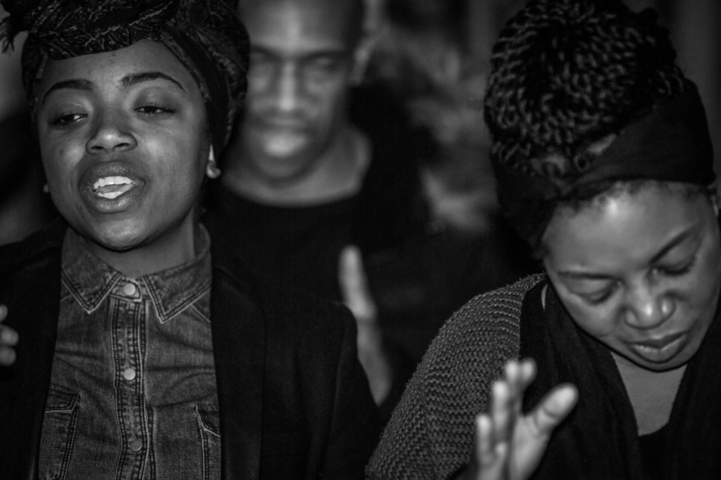
Figure 6: The London Adventist Chorale
is yet in the making. In a moment of dedication, they are given wisdom and courage to dare a deed that challenges and to kindle a hope that inspires’ (Thurman, 1949: 7). This spirit was evident through their songs. They were songs of faith and freedom songs. There is a long list of such songs:
‘Everybody say… Freedom, Freedom, Freedom, Freedom, Freedom’
‘This May Be the Last Time, I Don’t Know’
‘Ain’t Gon’ Let Nobody Turn Me ‘Round’
‘Wade in the Water’
‘This Little Light of Mine’
‘We Shall Overcome’
‘Lord, Hold My Hand While I Run This Race’
‘Reign Freedom’
‘I’m on My Way to Freedom Land’
‘We Shall Not, We Shall Not be Moved’
‘Will the Circle be Unbroken, Bye and Bye Lord, Bye and Bye’
‘Yes, we want our freedom, we want our freedom and we want it now’
‘Governor Wallace, Segregation’s Bound to Fall’
‘Woke Up This Morning with my Mind Stayed on Freedom’
‘Leaning on the Everlasting Arm’
‘Oh Freedom’

Harry Belafonte, actor and activist, emerged as a strong voice for the civil rights movement in the 1950s and 1960s and was one of Dr. Martin Luther King, Jr.’s closest confidants. He continually used his public stature to advance the black freedom struggle. Belafonte posited, ‘they were all great songs from the movement, but none spelled out our sense of future and history like “We Shall Overcome”’ (Belafonte, 2009: film). The refrain proclaims, ‘Deep in my heart, I do believe, we shall overcome someday’. According to Dr. Eddie W. Jones, Sr., ‘a new theme, “We Shall Overcome,” was truly meant to represent all oppressed peoples who had suffered under unjust laws because of a long overdue need for enforceable civil rights legislation’ (Jones, 2015: 168). ‘We Shall Overcome’ did not come out of the labour struggle. Rather, it was adapted from one of the great hymns of the old, black church titled, ‘I’ll Overcome Someday by Charles Albert Tindley’ (Hymnary.org, 2007: online).
On Easter weekend, 1960, white singer and musician, Guy Carawan sang ‘We Shall Overcome’ and, ‘within weeks, it became the theme song of the civil rights movement’ (Bond, 1990: film). The new words and music arrangement were by ‘Zilphia Horton, Frank Hamilton, Guy Carawan, and Pete Seeger’ (Scheips, 1971: 43). As Honey notes, ‘[A]s tanks and military vehicles once again rolled down Beale Street, in Room 306 they sang, "We Shall Overcome”’ (Honey, 2007: 450). Room 306 was where Dr. King was staying at the Lorraine Motel, and the room he stepped out of when he was assassinated. Through dogs and water hoses, songs of faith were there. A chorus of untrained voices joined to sing, ‘Ain’t scared of your dog ‘cause I want my freedom, and I want my freedom now’.
John Lewis was one of the central figures in the civil rights movement. Lewis was a Freedom Rider, spoke at 1963’s March on Washington and [co] led the demonstration that became known as ‘Bloody Sunday’ on March 7, 1965 in Selma, Alabama with Hosea Williams. Dr. Howard Robinson, Archivist, National Center for the Study of Civil Rights and African American Culture reports:
‘Almost every civil rights event and confrontation, John Lewis was playing a role throughout the sixties. He is working on strategy tactics. He’s at the very center of the civil rights movement. SNCC had been in Selma since early 1963. King arrives January 2, 1965. And so, by time the world focuses its attention on Selma, students had been organizing and thousands of people had been arrested in Selma for the preceding two years. John Lewis was a part of that. […] He stayed side by side with [the] SCLC and Martin Luther King for the duration of that campaign. So, the victory that comes out of the Selma to Montgomery March, the culminating victory, that also includes all of those episodes that occurred before hand, John Lewis was a part of that’ (Robinson cited in Biography, 2019: online).

Lewis was the youngest of the civil rights leaders who served as chairman of SNCC from 1963 to 1966. He confesses, ‘it was the music that gave us the courage, the will, the drive to go on in spite of it all’ (Lewis, 2009: film). Through sit-ins and jail cells, their songs of faith provided courage and determination. These were songs which addressed segregation and inequality; they were also faith songs specifically of the nonviolent freedom struggle. The narrative of the civil rights movement can be divined through these protesters’ songs of faith. Their songs were sung on the front lines, and in paddy wagons, on picket lines, and in mass meetings. Black youth sang such songs as ‘We Shall Not Be Moved’; as Honey observes: ‘[t]his church hymn, transformed into a labor-movement anthem by the Southern Tenant Farmers Union in the 1930s, had returned to the freedom struggle in the 1960s and now was part of both movements through the sanitation strike’ (Honey, 2007: 294). Honey reports, ‘[b]lack youths also sang another old church song, transformed by the freedom movement:
“I woke up this morning with my mind stayed on freedom,
You know I woke up this morning with my mind, stayed on freedom,
I woke up this morning with my mind stayed on freedom,
Hallelu, hallelu, hallelujah!”’ (Honey, 2007: 294)

Through Brown vs. Board of Education, the Montgomery Bus Boycott, Freedom Rides, the bombing of the 16th Street Baptist Church and Bloody Sunday, these faith-filled songs were there. Through the Little Rock Nine, James Meredith, Ella Baker, the Nashville Sit-ins, the deaths of Emmitt Till, Medgar Evers, the Freedom Summer volunteers: Schewener, Chaney and Goodman, through the pivotal Memphis sanitation workers’ strike and the assassination of Dr. King, their songs of faith, hope and courage were there. The Rev. Samuel ‘Billy’ Kyles asserts, ‘those songs helped to reinforce that we are going to win, not in some arrogant way, but we know we’re gonna win because we’re right, and if there is a God somewhere and His words are true … then we’re gonna win’ (Kyles, 2009: film). As Kyles points out, ‘policemen can’t stop you from singing. They can put you in jail, but they can’t stop you from singing, unless he puts a rag in your mouth or something. Then you can hum it’ (Kyles, 2009: film). Harry Belafonte put it this way, ‘you can cage the singer, but not the song’ (Belafonte, 2009: film). Bernard Lafayette observes, ‘they could take away everything else except our songs, which meant we kept our souls’ (Lafayette, 2009: film).
In Dr. King’s address to the protesters at the Selma to Montgomery March, he declared, ‘[t]hey told us we wouldn’t get here. And there were those who said that we would get here only over their dead bodies, but all the world today knows that we are here and we are standing before the forces of power in the state of Alabama saying, "We ain’t gon' let nobody turn us around”’ (King, 1965: 120). As in many of his speeches, King used lyrics from songs of faith to encourage the marchers. When speaking of King’s last music request before his death, Honey reports, ‘[h]e told [Ben] Branch how much he had enjoyed his version of “Precious Lord”, which Branch had played for him in Chicago, and he asked to hear it again at that night's rally: “I want you to play it real pretty”’ (Honey, 2007: 433). ‘Precious Lord’ is a song about faith in the face of devastating loss, written by Thomas A. Dorsey. The lyrics read: ‘At the river I stand; guide my feet, hold my hand. Take my hand, Precious Lord, lead me home’ (Lovely Land UMC, 2016: online). Likewise, At the River I Stand (1990) is the most fitting title of the earlier book about the Memphis strike written by Joan Turner Beifuss.

Rev. Harold Middlebrook asserted, ‘in slavery, songs were our way of communicating. Singing was also our method of expressing inner emotions’ (Middlebrook, 2009: film). The song, ‘Oh Freedom’ was taught to me by Yolanda Denise King, the eldest child of Dr. King and Mrs. Coretta Scott King. The lyrics say, ‘And before I’d be a slave, I’ll be buried in my grave and go home to my Lord and be free’ (SZABO, 2018: online). The condition of truth is to allow suffering to be expressed through spoken words or through song. Music was not just for entertainment; it was always about something far more, which can be heard in the spirituals and hymns of the black church. It has always been part and at the heart of the black culture. When referring to Bayard Rustin, Honey reports, 'He was a grand singer, one of those in the Movement who had helped to transform spirituals into labor and civil rights anthems’ (Honey, 2007: 283). It was music that truly drove the movement and helped to create community. Recalling the actions of young protesters, through the words of Chaplain Dick Moon, Honey reported, ‘Some of them, said Moon, “were cheering and crying at the same time” – thrilled that adults had stood up to the white power structure. Those arrested marched as if through a battle line, singing:
“Leaning, leaning, leaning on the everlasting arm,
Leaning, leaning, leaning on the everlasting arm”’ (Honey, 2007: 263-264).

Furthermore, as Honey recognizes, ‘[a]s thousands of jubilant strikers and their supporters left Mason Temple after four hours of singing, speeches, and prophecy, something new had been born’ (Honey, 2007: 305). Young believed, as did Lucy, that ‘the FBI had paid provocateurs to disrupt the recent march,’ (Honey: 2007: 429). Honey reports, ‘Kyles arrived and started singing old church favorites with Jesse Jackson and members of his Breadbasket Band – songs such as “Yield Not to Temptation,” “I've Been Buked and I've Been Scorned,” and “I'm So Glad Trouble Don't Last Always”’ (Honey, 227: 430). The music tells an integral part of the 1968 Memphis sanitation workers’ strike story. What the music also did was to consolidate the nonviolent freedom struggle. John Lewis explains a reason for this: ‘it was the music that created a sense of solidarity, and when there was some concern about the possibility of violence, or someone being beaten, someone being arrested and jailed, or even after we were thrown in jail, someone would sing a song’ (Lewis, 2009: film). Many of the songs were powerful Negro Spirituals; ‘these were songs of protest. These were songs of rebellion’ (Bond, 2009: film). They sang songs such as ‘This Little Light of Mine’ and ‘We Shall Not Be Moved’. Rev. Harold Middlebrook explained, ‘so, when the Movement comes, being that there is that spiritual quality, what do you do? You take that which has expressed your innermost feelings over the centuries and you use it as the vehicle, the tool, to express where you are and the oppression and suffering that you feel at this given time’ (Middlebrook, 2009: film).
The Memphis sanitation workers’ strike is about the past, but as William Faulkner accurately asserted, ‘[t]he past is never dead. It’s not even past’ (Faulkner, 1951: 92). Struggles of economic justice still exist today. Although the strikers did not know what tomorrow would bring, they kept the faith even in the face of certain danger. These were people who were not afraid; the changes they fought for meant, as the song says, wading in the water, not standing on the shore in comfort and complacency. By faith, the strikers continued their peaceful protest and fought with the weapon of nonviolent resistance. Through loss of lives, they continued their nonviolent mass protest:
‘King’s murder on Thursday night had made him the second person (following Larry Payne on March 28) killed during the strike-related actions; on Friday night, Memphis police killed a third. Initial police reports said Ellis Tate, twenty-six, fired at officers who interrupted his looting at a liquor store. Several days later, the story changed: police said they interrupted Tate, age forty, who ran and fired one shot at them, but then his rifle jammed. Both reports agreed that the police had shot him nine times’ (Honey, 2007: 446).

Despite these tragic deaths the strikers did not give up. They did not become bitter; they did not become hostile. Dr. King’s final speech to the Memphis sanitation workers further dramatized extraordinary faith. By faith, over three thousand disciplined, organized, and nonviolent protesters waged a campaign for the rights of the working poor. Even after King’s death, there would be no turning back for them. The sanitation workers would not turn around, because two of their own had been crushed to death in the back of a faulty garbage truck. Protesters were beaten and tear gassed by police. Yet, by faith, they continued their protest. When the sanitation workers won the strike, it was a most triumphant moment for local union leader, T.O. Jones, for the Memphis workers, and for the many activists who put King’s principles of nonviolent resistance into action.
The Black Church was essential to the Memphis movement. It was crucial in supporting the demands of the Memphis sanitation workers. The church was a place to gather and where the protesters felt safe and a sense of community. Music of the movement provided sustenance to the group from the black, religious tradition. Memphis was a marking point where the issue of economic injustice for America’s working poor was brought to the forefront. As Honey recognizes, ‘Memphis thus became one of the most important stops on a long road to freedom that people have traveled for generations, and still do’ (Honey, 2007: 506). The problems that we have around racial injustice and discrimination in our country are still systemic. It is not something that is yesterday. It is not something that is only in Memphis. The Freedom Rides took place after the Supreme Court ruled that segregation on buses was unconstitutional. Today, in the same way, laws say that we are equal; yet, reality says differently. We are not all treated equally and with justice under the law. By faith, in 1968, a most determined group of Memphis sanitation workers stood up and said so.
My play, A Balm in Gilead, includes songs that ‘tell the story of the historical struggles of African Americans for “earthly freedom”’ (Barnes, 2005, 973). The African American church tradition is the inspiration for the music in this production. The production opens with both audience and cast singing ‘Lift Every Voice and Sing’. The song originates from a poem by James Weldon Johnson, first performed by school children on the birthday of President Lincoln. As the poem was set to music by Johnson's brother, John Rosamond Johnson, it was adopted by the National Association for the Advancement of Colored People (NAACP). ‘Now ‘‘Lift Every Voice and Sing” is one of the most cherished songs of the African American civil rights movement and is often referred to as the Black National Anthem’ (PBS, 2019: online). The lyrics read:
‘Lift every voice and sing
Till earth and heaven ring,
Ring with the harmonies of Liberty;
Let our rejoicing rise
High as the listening skies,
Let it resound loud as the rolling sea.
Sing a song full of the faith that the dark past has taught us,
Sing a song full of the hope that the present has brought us,
Facing the rising sun of our new day begun
Let us march on till victory is won.
Stony the road we trod,
Bitter the chastening rod,
Felt in the days when hope unborn had died;
Yet with a steady beat,
Have not our weary feet
Come to the place for which our fathers sighed?
We have come over a way that with tears has been watered,
We have come, treading our path through the blood of the slaughtered,
Out from the gloomy past,
Till now we stand at last
Where the white gleam of our bright star is cast.
God of our weary years,
God of our silent tears,
Thou who has brought us thus far on the way;
Thou who has by Thy might, led us into the light,
Keep us forever in the path, we pray.
Lest our feet stray from the places, our God, where we met Thee,
Lest, our hearts drunk with the wine of the world, we forget Thee;
Shadowed beneath Thy hand,
May we forever stand.
True to our God,
True to our native land’ (Johnson, 1901: online)

The last verse is a prayer, and frequently black preachers will use Johnson’s words to open public prayers as did Rev. Joseph Lowery at the inauguration of President Barack Obama in January 2009. Many times in public prayer, I have paraphrased the words of Johnson’s last verse to say: ‘Thou who has brought us, and sought us and loved us on the way’.
The title song of the play is ‘There Is a Balm in Gilead’. It features a solo lead singer and is a favourite Negro Spiritual. In the Cambridge production of 2018, it was performed by the London Adventist Chorale, a professional choir that perform songs in the African American tradition. Richard Niell Donovan explains:
‘African American slaves sang spiritual songs to bring some light into their otherwise bleak existence. Their songs comforted and strengthened them. Some songs, such as “Go Down, Moses,” held out promise of freedom, but in a way that slave owners found it difficult to repress. After all, who could deny slaves the right to recount the Biblical story of God freeing the Israelites from Egyptian slavery? The spiritual, “There Is a Balm in Gilead,” takes a different tack, emphasizing the comfort that God makes available, as a balm or ointment reduces pain or heals sores. “There Is a Balm in Gilead” finds its roots in Jeremiah 8:22, where the prophet asks, “Is there no balm in Gilead? Is there no physician there?” Gilead … was known for plants and herbs that could be used to produce healing balms. … But this song also assures those who are discouraged, or suffering that there is, indeed, “a balm in Gilead to make the wounded whole. There is a balm in Gilead to heal the sin-sick soul”’ (Donovan, 2015: online).

The song was first published in 1919 and arranged by Henry ‘Harry’ Thacker Burleigh. This song expresses the possibility of defeat, ‘[b]ut then the Holy Spirit revives my soul again’ (v.1) and enjoins faith and resilience:
‘If you cannot preach like Peter,
If you cannot pray like Paul,
Just tell the love of Jesus,
And say He died for all (v.2)’ (Hymnary, 2007: online).

As Dean McIntyre explains, it was an ‘African American songwriter who first sang "There is a Balm in Gilead," suffering through the miseries and indignities of slavery’ (McIntyre, 2017: online). The next song in the production is a medley, ‘I Am on the Battlefield / I'm A Solider’, recorded by the United States Army Field Band, the musical ambassadors for the army. This song choice is important because there is a military presence within the story of the Memphis sanitation workers’ strike of 1968, the National Guard. This medley is from their CD titled In My Dream: A Celebration of African-American Music which was released in 2006. The lyrics are by Sylvanna Bell and Estelle V. McKinley Banks respectively, the arrangement by Robert L. Jefferson. It is a stirring arrangement of the gospel classic for unaccompanied male voices:
‘I am on the battlefield for my Lord,
I'm on the battlefield for my Lord;
And I promised Him that I would serve Him till I die.
I am on the battlefield for my Lord.’ (Sylvanna Bell and Estelle V. McKinley Banks cited in US Army Field Band, 2006: CD)

Additionally, a favorite congregational song of the African American church is ‘I Feel Like Going On’ (1991), lyrics by Edwin Hawkins and sung by Marvin Winans:
‘I feel like going on
I feel like going on
Though trials come on every hand, I feel like going on’ (The Historic Charles Street A.M.E. Church, 2014: online).

The culminating song of the play is ‘We Shall Overcome’, which became the anthem for the civil rights movement. It has roots in African American hymns; yet, it represents all people. It is not a marching song; it is a promise: ‘We shall overcome someday’. It defines the civil rights movement. One of the verses say, ‘We are not afraid’; this song exemplifies the sanitation workers’ courage and their faith, and that of the wider civil rights movement.
The final song in the play, A Balm in Gilead, is the ‘Battle Hymn of the Republic’ (Hymnary.org, 2007: online) written by Julia Ward Howe. She was known for her social justice activism during the Civil War and was a strong opponent of slavery. King’s last speech, on the night before his assassination, ended with the words of Julia Ward Howe, ‘Mine eyes have seen the glory of the coming of the Lord’ (Hymnary.org, 2007: online). King’s widow declared, ‘So intense was the audience’s emotional response to Martin’s words, so high was his own exaltation responding to their excitement, the action and reaction of one to the other, that he was overcome; he broke off there. I believe he intended to finish the quotation – “His truth is marching on.” But he could not’ (Scott King, 1969: 328). In that moment in history, there was a coming together of King’s and Howe’s mission and vision, although Howe could not have envisioned the profound impact that her poem would have on the American civil rights movement.
During the civil rights era music was often theology. Through music, one brings a people who are hurting towards hope and healing. That is what this era’s musical tradition has done, and that is what the spirituals have done; ‘the songs were expressions of resistance and were not tied to freedom in heaven but on earth. They reflect three central themes: freedom from slavery, the desire for justice, and strategies of resistance’ (Wilcots, 2002: 8). Historically, blacks have used spirituals and gospel music for social advocacy, as well as the ‘unifying influence of singing to bolster solidarity and courage’ (Barnes, 2005: 974). The songs reminded protesters to expect and anticipate victory. When singing during the civil rights demonstrations, blacks were ‘reassuring each other of a future time’ when God would turn things around and to reinforce their ‘belief that their faith would eventually manifest in a society where they would be free’ (Barnes, 2005: 973). These songs enabled blacks to visualize and ‘conceptualize freedom and implement plans to actualize this goal’ (Barnes, 2005: 973). In his book, The Spirituals and the Blues: An Interpretation, Rev. Dr. James H. Cone reflects on the theological and sociological implications of these songs:
‘Black people sang about Joshua and the battle of Jericho, Moses leading the Israelites from bondage, Daniel in the lions’ den, and the Hebrew children in the fiery furnace. Here the emphasis was on God’s liberation of the weak from the oppression of the strong, the lowly and downtrodden from the proud and mighty’ (Cone, 1992: 33).

Cone further explains, ‘Black music is unity music. It unites the joy and the sorrow, the love and the hate, the hope and the despair of black people; and it moves the people toward the direction of total liberation’ (Cone, 1992:5).
Black spirituals were another form of resistance and a useful instrument in the struggle for freedom. During the Memphis sanitation workers’ strike, events were framed using prayer, songs of faith and messages ‘imbedded in music expressions and sermons that foster community action’ (Barnes, 2005: 986). What is remarkable is that after the tremendous force of the water hoses in Birmingham, a small group of students were still standing and could be heard singing ‘Freedom’. A Balm in Gilead is leaving its music not only in each church’s library where it is performed, but in the repertoire of each church, choir, musician, and praise dance group in various states in the US and now in the UK. Historically this music has been ‘linked to group solidarity, liberation themes, racial dynamics and the need for social justice’ (Barnes, 2005: 985). A Balm in Gilead shows a clear linkage ‘between gospel music as a cultural symbol and community action’ (Barnes, 2005: 985). The performance of the play and its music join together to form a theatre for social change. In the next chapter, I will examine the lineage of such work in the civil rights movement, and the further social activism which is evident within the work of Athol Fugard, Lorraine Hansberry, Augusto Boal and James Baldwin.

Chapter Three:
Theatre for Social Change

The works of the Student Nonviolent Coordinating Committee’s (SNCC) Free Southern Theatre, the El Teatro Campesino Theatre Group, Athol Fugard, Lorraine Hansberry, Augusto Boal and James Baldwin are important to my study because they demonstrate a remarkable history of theatre for social change. This study will examine the parallels between these theatre companies and playwrights, as each shared the difficulties of producing resistance theatre during momentous and tumultuous historical junctures. Historical analysis of the backgrounds of each will show that their work is embedded into broader social conditions and that there are specific conditions giving rise to their particular methods of performing nonviolent resistance. The key strategies of all of these practitioners informed my own theatrical production.
The Free Southern Theatre (FST) was born out of the civil rights movement in 1963. According to Rhonda Gilliam-Smith, ‘FST’s objective was to aid blacks in their struggle for freedom using theatrical methods and was undoubtedly the most dramatic and engaging of the freedom acts’ (Gilliam-Smith, 2008: 80). John O’Neal, the director of the Free Southern Theatre, used ‘public places for his dramas such as churches, parks, and the streets’ (Gilliam-Smith, 2008: 62). Gilliam-Smith further reports that O’Neal, like the other artists included in this chapter, ‘understood how to use history and current events as revolutionary drama to address the black community’s social issues’ (Gilliam-Smith, 2008: 143). For example, one of the Free Southern Theatre’s plays was The Life and Death of Medgar Evers, depicting Evers’ work as a civil rights activist in Mississippi and his assassination in 1963. Performance as social protest was the primary purpose of the Free Southern Theatre.
El Teatro Campesino is a theatre by and for farm workers, founded by Luis Valdez in California with the full support of César Chávez. Chávez was an American labour leader and civil rights activist who co-founded the National Farm Workers Association with Dolores Huerta in 1962, which later became the United Farm Workers’ Union. El Teatro Campesino was born on the picket line to support the Delano Grape Strike of 1965, led by Chávez. El Teatro Campesino is a ‘Chicano theatre company that started in California in 1965 as the theatrical arm of the United Farm Workers’ Union’ (Mundel, 2007: 1). The company’s original actors were all farmworkers and their performances were based on the lives of both these actors and audiences. Their social justice works were used as catalysts for discussion, awareness of historical and contemporary issues and also self-expression. Valdez’s aim was to communicate with the workers with humour and with a great deal of energy and of spirit. Valdez was aware that he was creating performances by and for some people who were experiencing theatre for the very first time in their lives. In 2015, this theatre company celebrated its 50th anniversary. El Teatro Campesino still aims to unite both audience and performers in rebellious, triumphant protest within the theatre and encourage political and social activism outside its walls. As Elam argues, this kind of theatre can ‘invoke ritualistic social protest performances to encourage community empowerment and to inculcate a spirit of collective faith and revolutionary optimism’ (Elam, 2001: 139). As with the Free Southern Theatre, ‘El Teatro symbolically links the spiritual, cultural, and political in the realm of the performative’ (Elam, 2001: 84). As Harry J. Elam recognizes, ‘When the audience participated with activist/performers in the social protest performance, they responded not only to the signs, symbols, and messages within the performance text but also to the immediate call for social action in the outside social environment and in the social dramas within their own daily lives’ (Elam, 2001: 128).
i) Athol Fugard

South African playwright, director and actor, Athol Fugard, deployed theatrical performance as protest against South Africa’s apartheid regime throughout his life and career. I will explore his work in Swize Banzi is Dead (1972), The Island (1973), Statements After an Arrest under the Immorality Act (1972) and ‘Master Harold’ … and the Boys (1982). For Dennis Walder, ‘[h]is plays make us aware not only of the South African dimension of man’s inhumanity to man, but also of the secret pain we all inflict upon each other in the private recesses of our closest relationships’ (Walder,1984: 2-3). When speaking of Fugard, Albert Wertheim posits, ‘He is an engaged, consummate genius of the theatre who has struggled with the staging of each production; fought the authorities to produce his plays; striven to end racial segregation in South Africa on the stage and in the seating areas of the theatre; initiated the careers of at least three brilliant, black actors: John Kani, Zakes Mokae, and Winston Ntshona; and found it necessary to premiere some of his plays in America, especially at the Yale Repertory Theatre under the aegis of Lloyd Richards, in order to have them produced without banning in South Africa’ (Wertheim, 2000: ix). Furthermore, Fugard founded the theatre company, the Serpent Players, in Port Elizabeth in 1963 in order to encourage theatrical collaboration. This coalition led to the long-term friendship and partnership between Fugard and the theatre company. Fugard co-wrote Sizwe Banzi is Dead with black South African actors, John Kani and Winston Ntshona; The Island too was developed through a workshop process by Fugard and same actors, Kani and Ntshona. Fugard used his actors as creative rather than merely as interpretive artists. This collaboration itself can be seen as resistance to the apartheid regime, simply because it united a white writer with black actors in a shared enterprise. With this working practice came scrutiny, arrest and periods of detention for both actors imposed by the apartheid government.
Sizwe Banzi is Dead premiered in South Africa in 1972 and in the United Kingdom the following year. It is a play that was widely recognized as a beacon for the global fight against apartheid, as it is about identity and the quest to change it. Directed by Fugard, this play depicts the struggle for freedom and identity in the apartheid era in South Africa. In apartheid South Africa, every black and ‘coloured’ citizen had to carry an identity book that restricted travel and employment in the country. Today the play resonates far beyond the South African situation about which it was written. At this moment in the world, undocumented people are languishing in jails; others are dealing with problems with identity documents every day. My study will argue that the strength of the play lies in such commonalities and its protest against them.
After receiving Tony Awards in 1975, Kani and Ntshona jointly won for Best Actor in a Play for their performances in both Sizwe and The Island. The next day, The New York Times reported their accepting the award as a powerful political statement made against the Republic of South Africa, where they were not even recognized as actors. That New York Times’ statement resulted in their arrest upon their return to South Africa, because it declared plays as political statements too. Subsequently, in a town hall they performed Sizwe with a mixed black and white audience with the exits blocked. Kani and Ntshona were arrested as they took the curtain call. Consequently, the play was stopped. Kani was detained for twenty-three days in solitary confinement; Ntshona was detained in a town one-hundred-and-twenty miles away. Kani asserted that he was on a hit list, as the authorities believed that he was an activist rather than an actor. As a result, actors on Broadway protested and carried signs calling for their release, as did actors in London in Trafalgar Square. Sizwe also became a statement that articulated the anger of black people against apartheid laws. Sizwe is predicated upon the ‘pass laws’ established by the South African government. Every black South African over the age of sixteen was obliged by law to carry a pass book; as Alistair Boddy-Evans explains:
‘The pass book was similar to a passport in that it contained details about the individual, including a photograph, fingerprint, address, the name of his employer, how long the person had been employed, and other identifying information. Employers often entered an evaluation of the pass holder's behavior. As defined by law, an employer could only be a White person. … If a pass book didn't have a valid entry, officials could arrest its owner and put him in prison. Colloquially, passes were known as the dompas, which literally meant the “dumb pass.” These passes became the most hated and despicable symbols of apartheid’ (Boddy-Evans, 2018: online).

Although arising from a specifically South African context, the play has become a universal story about identity, and its message of struggle is most effectively conveyed without the use of violence. Sizwe Banzi is Dead depicts a racist society that inflicts devastating discrimination on individuals and families. As a result, Fugard ‘is driven by a deep sense of justice and feeling of personal and moral responsibility to tell the stories of the “nameless people,” to express their emotions and to give them a voice (Port Elizabethan, 2016: online).
The Island which is set in South Africa’s infamous prison, Robben Island, which reflects and condemns the life of apartheid in South Africa. As typical of Fugard’s method, this play documents South African racial strife while exploring the pressure this context exerts on human relationships. Fugard developed the play from several experiments with his actors. As Robert J. Green posits, ‘[d]rama is perhaps a more fragile, imperilled genre than fiction. In these forbidding circumstances [in South Africa], under the constant threat of censorship or closure, it is inspiring and remarkable that Fugard has created plays at all’ (Green cited in Heywood, 1976: 167). The Island expresses the treatment of the black majority by a minority white justice system with its disproportionate punishments for resistance. Fugard’s work is of great ‘value to the people in their struggle for a more humane South Africa’ (Mshengu, 1982; 178), but has also become a voice for oppressed people throughout the world. The characters of the play are incarcerated on a prison island for sentences of ten years and life imprisonment for the burning of a pass book and membership of a banned organisation. The ‘island’ recalls Robben Island, where Nelson Mandela and other African National Congress (ANC) members were imprisoned on charges of sabotage in 1964 for their role in the fight against apartheid. Another Fugard play, Statements After an Arrest under the Immorality Act, is a play which is as political as it is personal. The Immorality Act in apartheid South Africa forbade sexual relationships and outlawed marriage between white and black people. Fugard examines the effects of such legislation and the human reactions to them. In ‘Statements, love transcends for pitifully short moments the reality of the lovers’ situation’ (Mshengu, 1982: 171). Their relationship itself is an act of defiance to the apartheid laws. The ‘play is a compelling and deeply moving love story in which the physically and emotionally naked lovers expose not only their bodies, but also their deepest longings for personal and emotional freedom’ (Skinner, 2019: online). The politically-charged events that the play depicts should now be a thing of the past in post-apartheid South Africa, but there are still similar laws operating in many countries around the world today.
Fugard’s play, ‘Master Harold’ … and the Boys, (1982) shows relationship deformed by internalized apartheid thinking. The setting of the play is Port Elizabeth, South Africa in 1950 in St. George’s Park Tea Room, a locale and era well known to Fugard. Here, Fugard places three characters: Hally, a seventeen-year-old white boy, Sam, a black man in his mid-forties, and Willie, also black and about the same age. Like the 1968 Memphis sanitation workers, Sam and Willie are almost powerless adults. Although men in their forties, they have little power in apartheid South Africa. The irony is that Hally, a seventeen-year-old, maintains power and authority over Sam and Willie, who may be addressed as ‘boys’. The playwright needs Willie’s character in order to show the difference between his and Sam’s relationship to Hally. Willie addresses Hally as Master Harold but Sam does not. Rather, Sam is Hally’s father figure, because Hally’s own father is an alcoholic. At the same time, Sam is Hally’s servant. Sam made a kite for Hally when he was a boy, although Hally doubts his competence:
‘The sheer audacity of it took my breath away. I mean, seriously, what the hell does a black man know about flying a kite? I’ll be honest with you, Sam, I had no hopes for it. If you think I was excited and happy, you got another guess coming. In fact, I was shit-scared that we were going to make fools of ourselves. When we left the boarding house to go up onto the hill, I was praying quietly that there wouldn’t be any other kids around to laugh at us’ (Fugard, 2000: 23).

Hally’s words demonstrates how apartheid affected the relationship between children and adults of different races in South Africa. Sam and Hally are close but society breaks them apart. Sam explains to Hally:
‘I couldn’t sit down there and stay with you. It was a “Whites Only” bench. You were too young, too excited to notice then. But not anymore. If you’re not careful… Master Harold … you’re going to be sitting up there by yourself for a long time to come, and there won’t be a kite in the sky’ (Fugard: 2000: 47).

Sam realizes that Hally cannot free himself from apartheid attitudes. He explains, ‘You don’t have to sit up there by yourself. You know what that bench means now, and you can leave it any time you choose. All you’ve got to do is stand up and walk away from it’ (Fugard, 2000: 48). The play explores close and tense relationships against the background of the wider social conditions in 1950s’ South Africa. It engages our sympathies for South Africans of all races in their struggles to attain dignity and hope.
Fugard’s plays manifest local origins and accents. Although he is an internationally-acclaimed playwright, his works always deal with the personal, social and political turmoil caused by the apartheid system in South Africa. His plays Blood Knot, My Children! My Africa! and The Road to Mecca address this intolerant political system, and further express Fugard’s rich and diverse body of work. Dennis Walder maintains, ‘His dark vision of pain never totally excludes the possibility of a flicker of light, of compassion, or dignity’ (Walder cited in Fugard, 2000: ix). Fugard’s plays can make us feel with an intensity that is almost unbearable. In 1958, ‘The only job the playwright could find was as a clerk in a “Native Commissioner’s Court”, where pass-law offenders were tried. If he thought he knew his society was evil before, “seeing the machinery in operation taught me how it works and in fact what it does to people”’ (Walder cited in Fugard, 2000: xiv). Fugard was not immune as a target for state sanctions; allegedly for reasons of national security, Fugard’s passport was revoked in 1967. In 1963, Fugard was initiator of an international playwrights’ boycott of South Africa where their work could only be seen by segregated audiences. Walder explains, ‘Fugard has often remarked that the ten-month experience of living and working side by side with men of all races on the SS Griagaur liberated him from the prejudice endemic among those with his background’ (Walder cited in Fugard, 2000: xviii). That prejudice was inculcated from his childhood, a time when Fugard spat in the face of a black man. As an adult, he retained the shame on his side over that incident, admitting that it is difficult for him to talk about it to this day.
The dilemma of Fugard’s position as a white, liberal, English-speaking Afrikaner is that he strives to proclaim the possibility of human dignity in a situation of widespread suffering and oppression. Fugard made clear that Master Harold … and the Boys was a long over-due reckoning about the life he has lived and the choices he has made. The rain, which is persistent throughout the entire play, represents apartheid as an environment of legal discrimination, very much as were the Jim Crow Laws in America. However, Fugard captures the perspective of both blacks and whites in apartheid South Africa. Each time the phone rings within the drama, the conflict is heightened. The characters cannot stay safe inside of the little tea room; they must deal with the realities and difficulties of the outside world. Fugard’s plays and the theatre became a rallying point for both whites and blacks at a time when apartheid had a mutilating effect on the quality of South Africans’ lives. His relationship with a black drama group in Port Elizabeth made him realize just how potent a thing theatre could be in a situation in which people were frightened to speak. The South African government’s mentality was that theatre was un-important, but, in such times, there is so much one could say by way of the stage; Fugard’s theatre was used as a weapon in a resistance campaign. The lack of understanding of the white supremacists contributed to the existence of his drama, ‘Master Harold’ … and the Boys. Fugard’s work received enormous recognition in America that gave him a reputation outside of his country and that afforded him a degree of protection. Ironically, this play deals with discrimination issues in apartheid South Africa which we can now see re-surface in America.
There is also faith that is heard in song. Fugard talks about singing in many of his plays; a civilization without song is desolate. Singing allows the soul to soar. It is when we raise our voice in praise, in song, that something extraordinary happens. Indeed, music is important to ‘Master Harold’ … and the Boys. At the play’s conclusion, Willie places his bus fare in the juke box and as a result will have to walk home in the rain. However, he knew that Sam needed the music and the two men dance together as Willie says to Sam, ‘Let’s dream’ (Fugard: 2000: 48). The song choice is very deliberate and most appropriate; it is ‘Little Man You’ve Had a Busy Day’, recorded by Sarah Vaughan:
‘Little man you’re crying
I know why you’re blue,
Someone took your kiddy car away;
Better go to sleep now,
Little man you’ve had a busy day …
Johnny won your marbles,
Tell you what we’ll do;
Dad will get you new ones right away;
Better go to sleep now,
Little man you’ve had a busy day’ (Fugard, 2000: 48-49).

There are three predominant themes in this play: metaphors, flashbacks and relationships. Metaphors regarding the consequences and hardships of apartheid are used numerous times throughout the play. Flashbacks help the audience to comprehend the complex relationships between Willie, Sam and Hally. Apartheid is even the antagonist on the dance floor; dancers have been taught the wrong steps. Hally fails to get the steps right when he spits in Sam’s face. Sam asserts, ‘A long time ago I promised myself I was going to try and do something, but you’ve just shown me… Master Harold… that I’ve failed’ (Fugard, 2000: 46). These words symbolize the damage to the father/son relationship between Sam and Hally.
The insidious institutions of slavery in America and apartheid in South Africa reveal blacks’ search for first-class citizenship, the refusal of which causes a degradation of the soul. Fugard is a masterful storyteller, not a politician, but by telling the human element in the story, there will be a comment about the political world. The focus changes from the chamber drama in ‘Master Harold’ … and the Boys to issues of racial discrimination all across the world, and local and regional theatres celebrate Fugard’s work. The play, ‘Master Harold’ … and the Boys, from Broadway to university theatre to community theatre, generated the kind of world-wide recognition that Fugard needed. He needed pressure from outside of South Africa. United States’ sanctions were instrumental in causing Nelson Mandela to walk free in 1990. Fugard’s theatre has been a force for social change, despite the fact that so much still needs to be done regarding race relations in South Africa. One cannot just erase forty years of abuse. Fugard shares his internal struggle about the power of nonviolent resistance which is inherent in his work:
‘I was forced to ask myself shouldn’t I also actually, instead of sitting at my desk, putting words on paper, shouldn’t I also actively commit myself to violent action? That, the play, My Children! My Africa! is actually about my internal debate in terms of this very issue. At the end of which I found myself believing, and it is a belief and act of faith that has stayed to me to this day: that putting words on paper is a valid form of action. You know, you can throw stones, petrol bombs and Molotov cocktails as hard, as much as you like at those armoured cars coming with their big guns, but you are not going to do much damage. Words can do much, much more than that. Words can get inside those armoured cars. Words can get inside the heads of the people inside those armoured cars, and in a way … that basic belief, that act of faith, underlies all my work in theatre. That in a space like this, for example, with an audience listening, you can get inside their heads. If what you have written and put out there on the stage, if the actors have embodied it in their performance as an act of truth then, you stand a chance of really affecting people, maybe even changing people in their attitudes to certain things’ (Fugard cited in SignatureTheatreNY 2012).

Fugard is now among the most respected and published playwrights in South Africa itself. As Mshengu observes, ‘Fugard’s work with the Serpent Players, and especially Sizwe Banzi, and The Island, represents an extremely important and influential contribution to the development of South African theatre’ (Mshengu, 1982: 175). His plays also consolidate the resonance of nonviolent resistance to racial oppression.
ii) Lorraine Hansberry
Lorraine Hansberry’s play, A Raisin in the Sun (1959) dramatizes the issues of racism, gender, economics, and segregation in the United States. The play’s title comes from Langston Hughes’ poem, ‘Harlem’, which is included in his Montage of a Dream Deferred (1951). The play’s universal themes made possible its entrance into mainstream American theatre, which was a remarkable achievement in 1959. At age twenty-eight, Hansberry ‘became the youngest American playwright, the fifth woman, the only black ever to win the New York Drama Critics Circle Award for “The Best Play of The Year”’ (Nemiroff cited in Hansberry, 1969: xvii). The play centres on a 1950s’ black family in Chicago, but its first director, Lloyd Richards, director of the Yale Repertory Theatre, immediately saw A Raisin in the Sun as ‘An historic … and … a timeless piece’ (Richards cited in Case, 1990: 119). In a 1983 review in The New York Times, Mel Gussow cited the play as ‘an enduring work of contemporary theatre’ (Gussow, 1983: C23).
In A Raisin in the Sun, Hansberry makes a link between the African American within the United States and African nations’ struggle for liberation. As Çigdem Üsekes observes, ‘Hansberry cites specifically the African connection in this context: “the ultimate destiny and aspirations of the African people and twenty million American Negroes are inextricably and magnificently bound up together forever”’ (Hansberry cited in Üsekes, 2008: 12-13). Hansberry is referring to blacks’ sense of struggle for freedom and self-determination from European colonialism in Africa and from segregation in the United States. The play was also inspired by events in Hansberry’s own life concerning ‘[r]esidential segregation in Chicago’ (Gordon, 2008: 125) and entrenched racism. Hansberry’s family moved to a white neighbourhood and were violently attacked by neighbours, who then launched a legal bid to have them evicted under housing restrictions that enforced segregation. As Lyonette Louis-Jacques recounts:
‘Anna M. Lee and others brought an action in the Circuit Court of Cook County to enforce a restrictive covenant, and enjoin the Hansberrys from occupying their home. Under the “restrictive agreement”, about 500 Chicago property owners agreed that no part of the real estate should be “sold, leased to, or permitted to be occupied by any person of the coloured race”. … The trial court held that Burke v. Kleiman (1934), in which the parties stipulated to the validity of the covenant, bound Mr. Hansberry even though he was not a party to that litigation. In Lee v. Hansberry (1939), the Supreme Court of Illinois affirmed the trial court’s judgment. Ms. Hansberry’s father and mother, represented by Earl B. Dickerson J.D. … and several other members of an NAACP litigation team, appealed the decision to the U.S. Supreme Court. In Hansberry v. Lee, 311 U.S. 32 (1940), Justice Stone, writing for the majority, reversed the Illinois Supreme Court decision on the basis that neither party to the Burke litigation represented Mr. Hansberry’s interests’ (Louis-Jacques, 2003: online).

Despite this ultimate legal victory in US Supreme Court, Hansberry’s father planned to relocate the family outside of Chicago and the country. He died while looking for property in Mexico.
A Raisin in the Sun debuted on Broadway March 11, 1959, covering this biographical history. Alongside this, the effects of the lynching of Emmett Till four years earlier were still flooding the consciousness of black Americans. The play’s ‘phenomenal reception can be attributed, in part, to its timeliness, for this drama reflects that moment in U.S. history when the country was poised on the brink of cataclysmic social and legal upheavals that would forever change its character’ (Wilkerson, 1986: 442). In 1954, four years ‘before the opening of A Raisin in the Sun, the Supreme Court had declared racial segregation in public schools illegal, marking a climax to decades of advocacy and legal challenges, but initiating a new level of resistance’ (Wilkerson, 1986: 443). The 1950s were the years of the rise of the civil right movement. The Montgomery Bus Boycott took place the following year in 1955, leading to Martin Luther King’s identification as a leader of the civil rights movements. As Wilkerson explains, Hansberry’s work was launched into tumultuous times:
‘During the play’s run and shortly thereafter, Black and white Freedom Riders headed South and were greeted by a wave of terrorism as Southern segregationists retaliated; lunch counters in over 100 Southern cities were integrated; sit-ins and protests accelerated; Martin Luther King was arrested and jailed repeatedly; Black children were murdered, and churches were burned by racists’ (Wilkerson, 1986: 443).

The ‘play touched the vibrating nerve of a country on the verge of change and a people on the move’ (Wilkerson, 1986:444). In describing the character of Mama Younger, Hansberry calls her ‘The Black matriarch incarnate: The bulwark of the Negro family since slavery; the embodiment of the Negro will to transcendence. It is she who, in the mind of the Black poet, scrub the floors of a nation in order to create Black diplomats and university professors. It is she who, while seeming to cling to traditional restraints, drives the young on into the fire hoses and one day simply refuses to move to the back of the bus in Montgomery’ (Hansberry cited in Case, 1990: 125).
This story is American history and there are themes of faith throughout the drama. The character of Mama Younger retains faith and deep religious beliefs that provide her the strength to go on in the face of devastating adversity for her family and its future. Mama relies heavily on her unyielding faith in God and in a poignant scene in the play, Mama Younger and her daughter butt heads over the issue of faith. Messages of faith within the play are for all humankind. For instance, everyday working people believe, by faith, that they can achieve the American dream of owning a home despite the odds. The plant, which is central to the story, will always survive as long as there is faith and hope in the future. Rather than giving up on the plant, Mama does all she can for it and has faith. There is no conflict between spiritual and economic progress in the overall analysis of the play. Writing in her ‘scrapbook of reviews, Hansberry agreed with a 1959 passage by Daniel Gottlieb of the Hartford Times: the playwright “manages to weave the threads of the Negro-white conflict, materialism vs. spiritualism, and the individual vs. his conscience into the play”’ (Gottlieb cited in Case, 1990: 123). Hansberry’s own comment on Gottlieb’s review stated, ‘One reviewer who really understood the play’ (James, 1992: 42).
Hansberry’s play ‘served as a potent symbol of integrationist hopes’ (Southern, 1996: 419). For many, it remains the quintessential civil rights drama. In The Work of Democracy, ‘Ben Keppel examines the lives of Ralph Bunche, Kenneth B. Clark and Lorraine Hansberry, explaining how they became both participants and symbols in the quest for racial equality’ (Southern, 1996: 419). A telegram from Martin Luther King, Jr. was read aloud at her funeral. It said in part: ‘Her commitment of spirit … her creative literary ability and her profound grasp of the deep social issues confronting the world today will remain an inspiration to generations yet unborn’ (King cited in Tracy, 2011: 212). Since the Broadway production of the play in 1959, ‘we have witnessed the Black revolution of the 60s and 70s, the Black Feminist movement of the 80s, the fight for the right to abortion, a resurgence of white racist nationalism in America, and a cry for unity with African peoples: It is more important than ever to educate people with this play. Lorraine Hansberry addressed all of these issues and more before America lived through them, and she was dead before these events occurred’ (Freydberg, 1988: 27). Hansberry believed in art with a purpose. She contends:
‘I was born in a depression after one world war, and came into my adolescence during another. While I was still in my teens the first atom bombs were dropped at Nagasaki and Hiroshima, and by the time I was twenty-three years old my government and that of the Soviet Union had entered into the worst conflict of nerves in human history – the Cold War. I have lost friends and relatives through cancer, lynching and war. I have been personally the victim of physical attack which was the offspring of racial and political hysteria’ (Hansberry cited in Loos, 2008: 5).

As Hansberry indicated, she was very much affected by both global, national and personal experiences. Hansberry is still ‘[s]poken of with passion and reverence by a younger generation of writers and critics whom she encouraged and influenced. … What has inspired them is not only the quality of her art, but also her courage and commitment’ (Washington, 1988: 109). Hansberry was fearless enough to declare that ‘art does have a purpose, and that purpose is to change things’ (Hansberry, 1969: xiv). A Raisin in the Sun was not just a theatrical performance, but a political and philosophical statement. Despite his socio-economic conditions, Walter Lee, the principle male character, still retains his faith, his version of the American Dream. He faces racist obstacles when ‘he is directly confronted with in Act II, Scene 3, in the person of Carl Linder, who tries to bribe the family in order to keep them out of his white neighbourhood. Even then it has no real effect on his dream or his plans’ (Washington, 1988: 109). For Mama, ‘[h]ers is, in short, not the true American Dream, but a second-class version of it reserved for Black Americans and other poor people. Considering all the obstacles she has had to face as a Black woman, one can hardly fault her for what she does. Nevertheless, her dream is unacceptable to Walter, who will have nothing less than the complete American Dream, since her version of it only amounts to surviving, not living in the fullest sense’ (Washington, 1988: 114).
Walter Lee compares himself to young white men who are free to pursue their American Dream; he considers himself eminently capable of the same level of achievement. His longings go beyond Jim Crow discrimination and is not gender specific. Rather, it represents everyone, regardless of race or gender, whose potential has been too often stifled. He explains: ‘[m]ama – sometimes when I’m downtown and pass them cool, quiet-looking restaurants where them white boys are sitting back talking ‘bout things … sitting there turning deals worth millions of dollars … sometimes I see guys don’t look much older than me’ (Hansberry, 1959: 53). Walter represents ‘[b]lack people’s struggles and triumphs’ (Washington, 1988: 122); his personal stake in his dream is balanced by the primary purpose for which he seeks it ꟷ a radical change in his family’s living conditions’ (Washington, 1988: 118). The play ‘illustrates the American Dream as it is felt not just by African Americans, but by all Americans’ (Gordon, 2008: 124). Freedom from racism, discrimination and a reckoning of the history of slavery only goes so far, as Martin Luther King recognized in the launch of the Poor People’s Campaign in 1968. Hansberry ‘pointed out through Walter in 1959 a much more important kind of freedom, economic freedom, which, with few exceptions (most notably Marcus Garvey in the 1920s), Blacks leaders and intellectuals only began to discuss a decade later’ (Washington, 1988: 120). Walter is ‘astute enough to recognize the power of money as a source of both social and political freedom in America’ (Washington, 1988: 120). Yet, at the end of the play, Walter refuses ‘to exchange his family’s racial pride and dignity for money’ (Washington, 1988: 121).
Near the end of Act II, Scene One, he exclaims, ‘Here I am – a giant – surrounded by ants! Ants who can’t even understand what it is the giant is talking about’ (Hansberry, 1959: 62). This strong ‘faith in himself is the basis of his typically American self-reliance and rugged individualism’ (Washington, 1988: 114). The ‘dreams, hopes and fears of the Younger family are universal reflections of those shared by all races all over the world, and these are universally American aspirations’ (Washington, 1988: 115). Any ‘universally American aspirations’ are contradictory if they are not applicable to an African American family. Nevertheless, Hansberry ‘discovered the basis of universal hope, indeed of her faith in humanity, in the Black experience’ (Washington, 1988: 124). She held that, ‘if blackness brought pain, it was also a source of strength, renewal and inspiration, a window on the potentials of the human race. For if Negroes could survive America, then there was hope for this human race indeed’ (Hansberry, 1969: xx-xxi). Thus, Hansberry’s play advanced our understanding of race issues which still remains the unfinished work of American democracy, and made for a most meaningful professional theatre experience for its audiences. But it remains the case that many ‘[c]ritics have not yet fully engaged the dynamics of segregation – around which Hansberry structures the entire play – and therefore have not yet fully recognized Raisin’s aesthetics of segregation as a form of social protest’ (Gordon, 2008: 124). This extends to audiences too; as John A. Davis asserts, ‘Miss Hansberry’s play is social protest, but is such a consummate work of art that the objects of the protest applaud it vigorously each night on Broadway’ (Davis cited in Keppel, 1995: 177). The play confronts America’s Jim Crow order, yet, white critics refused ‘to engage with – or even recognize – the politics of the play’ (Gordon, 2008: 124). Hansberry explained that, ‘in A Raisin in the Sun, she created the Youngers as a working-class black family, as opposed to a middle-class family like her own, because she believed the world’s coming freedom movements would emerge most forcefully from its laboring classes’ (Gordon, 2008: 125).
Hansberry writes, ‘[m]y father was typical of a generation of Negroes who believed that the “American Way” could successfully be made to … democratize the United States. Thus, twenty-five years ago, he spent a small personal fortune, his considerable talents, and many years of his life fighting, in association with NAACP attorneys, Chicago’s “restrictive covenants” in one of the nation’s ugliest ghettoes’ (Hansberry, 1969: 20). Hansberry calls ‘into question tools and ideologies of the nation’s oppressive social order – “American Way”, “restrictive covenants,” “white neighborhood.” She places theses contested terms at the heart of the tremendous racial divide in the US and the highly profitable systems of white supremacy’ (Gordon, 2008: 126). Her art deals with the implicitly enforced segregation in urban North, as opposed to the plainly recognized Jim Crow laws in the South. Her protest anticipated what was fermenting in the North; much as ‘Hansberry had attempted in Raisin, the Chicago Freedom Movement of the 1960s endeavored to “stage a crisis” around Chicago’s segregated housing and schools, thereby forcing public dialogue, negotiation, and change’ (Gordon, 2008: 130-131). Hansberry’s close friend, James Baldwin, mused,
‘Perhaps it is just as well, that [Hansberry] did not live to see with the outward eye what she saw so clearly with the inward one … [T]he horses and tanks are indeed upon us, and the end is not in sight … And it is not at all farfetched to suspect that what she saw contributed to the strain which killed her, for the effort to which Lorraine was dedicated is more than enough to kill a [wo]man’ (Baldwin cited in Hansberry, 1969: xx).

iii) Augusto Boal

Augusto Boal (1931-2009) was a Brazilian director and dramatist who conceived and developed the Theatre of the Oppressed, which was principally designed to enact social change. Boal’s ‘theatrical techniques were born from the realisation in the 1960s that the people in the slums and rural communities of Latin America, whom he was trying to reach, were not responding to his initial style of didactic and politically motivated theatre. His new ideas allowed involvement at all levels from the communities’ (Mills, 2009: 552). In this way, Boal believed that theatre could be a radical force emerging from communities. Because of this work as cultural activist, Boal become a target in the political context of Brazil when a 1964 coup led to a military dictatorship. Returning home from an Arena Theatre performance in 1971, Boal was arrested and subjected to torture. He was exiled to Argentina, where his first major treatise, The Theatre of the Oppressed, was published in 1973. Self-exile in Europe followed; while in Paris, Boal established Centres for teaching the principles of the Theatre of the Oppressed, with the first International Festival of the Theatre of the Oppressed organised in 1981. Returning to Rio de Janeiro in 1992, Boal was elected as a vereador in 1992 for the Workers’ Party (PT), on a platform that proposed Forum theatre as a mean to establish popular democracy. As recognised by Heritage, artists throughout ‘history have become active politicians; recent theatrical candidates include examples as diverse as Vaclav Havel in Czechoslovakia, Glenda Jackson in Britain, Ronald Reagan’ and latterly Arnold Schwarzenegger in the United States (Heritage, 1994: 25). Unlike many of the other theatre professionals turned politician, Boal drew a close parallel between theatre and politics:
‘I want to make politics but I don’t want to change my profession – I am a man of the theatre! For me, this was always possible and now it is necessary: theatre is political and politics is theatre’ (Boal cited in Heritage, 1994: 25).

Boal’s Theatre of the Oppressed is a means for the empowerment of communities on a journey to social justice. Boal realized that ‘unless theatre of the oppressed is practiced in much greater quantity and frequency, its potential as a collective tool for political organizing is limited’ (Schutzman, 1990: 81); it is now indeed practiced in many contexts across the world. Boal saw theatre as a place for transform. I, too, believe that theatre has the capacity to transform people and communities, which is a central aim of A Balm in Gilead. Boal did through theatre what Dr. King did with mass demonstrations and what the Student Nonviolent Coordinating Committee (SNCC) did with sit-ins. He affected social change, using theatre to encourage communities to claim their political and civil rights.
Forum Theatre, or ‘participatory theatre’ is a principal technique within the Theatre of the Oppressed. In the summer of 2016, I was privileged to attend a workshop with Augusto Boal’s son, Julian Boal, titled, ‘Hoping, but Concretely: Framing a Question Through Forum Theatre’ as part of the Association for Theater in Higher Education 2016 Annual Conference in Chicago. Sanjoy Ganguly reports, ‘The workshops emphasize consciousness-raising exercises aimed at creating opportunities for people to learn about their social world, reflect upon issues which surface, and research channels for making change’ (Ganguly, 1999: 60). Boal’s explanation of Forum theatre defines it as a ‘democratic political forum’:
‘Each project is stimulated by a specific community’s experience of disempowerment and struggle, and the desire for creative solutions and capacity-building through egalitarian means. Forum theatre is designed to achieve this by, first, developing a conventional play that reflects the community’s lived experience of a chosen issue and culminates in unresolved crisis within that context. This play is then presented to the broader public in a participatory format so that the knowledge, aspirations and capacities of this public may be brought to bear on the exploration of viable solutions on the stage. After observing the play a first time, the play is performed again; audience members are invited to stop the play at any point, replace a character whose experience they feel they understand, and attempt to change the course of dramatic action. In this way, spectators are transformed into “spect-actors”, not only observing but truly acting to change the scenes they are presented’ (Boal 1995: 13).

As Paterson explains further, in Forum theatre the ‘structure is simple’:
People from a given community decide what issues are at this moment important. Then, either people from that community or actors from Boal’s CTO [Center for the Theater of the Oppressed] enact a dramatization of the specific problem. These skits normally last between 15-30 minutes, though they can be as short as one minute or as long as a full-length play. A Joker or facilitator then reminds the spectators, as the company performs a second time, that they are encouraged to enter the action – to become spect-actors. The action can be halted at any time with a vigorous “Stop!”. The Joker invites the spec-actor into the scene to demonstrate the suggested solution’ (Paterson, 1994: 38).

The audience can identify with the intervening ‘spect-actor’; he or she comes from their midst as a member of the affected community, for which he or she stands. This stance engages with community authorization. Boal stresses that we must ‘rethink how theatre should be done in order to value the experience of the oppressed’ (Gilliam-Smith, 2008: 51); in this form, theatre serves those previously without a voice or representation within society. This theatre can help participants ‘invent their future instead of waiting for it’ (Boal, 2002: 5).
Boal’s discovery of Forum Theatre occurred at a breakthrough moment ‘when a woman in the audience said that the wife onstage, dominated by her husband, needed to have “a very clear” discussion with him. The woman was so upset by the actors’ apparent inability to do what she imagined that she walked onto the stage and showed what she meant – beating the husband/actor with a broom until he stopped abusing his wife’ (Paterson, 1994: 37). Hence, this was ‘the birth of the spect-actor’ (Paterson, 1994: 37). Forum Theatre ‘works best when everyone in the audience has a direct stake in the issue performed’ (Paterson, 1994: 38); therefore, the ‘Rio de Janeiro CTO encouraged “spect-actors” to interject their actual community issues into the conditional theatrical ones’ (Paterson, 1994: 40). In Forum Theatre, there must be a ‘dialogic relationship between stage and audience constructed through the use of the space, the performance style, and the conduct of the actors and the Joker. The theatrical goal is to achieve a common purpose with the audience, as solutions are sought and rehearsed in a shared space’ (Heritage, 1994: 30). In forum theatre ‘will is used in a way that doesn’t oppress somebody else’ (Boal, Cohen-Cruz, and Schutzman, 1990: 72). Boal’s theatre enables the ‘spectator to become actor and the citizen to become legislator’ (Heritage, 1994: 34).
Another of the core techniques of Theatre of the Oppressed is Image Theatre. As Mady Schutzman explains, ‘Boal’s Image Theatre consists of several nonverbal techniques in which participants express feelings, roles, attitudes, relationships, and abstract concepts through physical imagery. These often static images define a common, visual language for the group; they are read and/or manipulated to represent individual and group oppressions. Boal uses Image Theatre in conjunction with other Theatre of the Oppressed techniques, particularly cop in the head’ (Schutzman, 1990: 82). For instance, ‘[s]ix street children were murdered in Brazil while the 7th International Festival of the Theatre of the Oppressed took place nearby’ from 15 July to August 2, 1993 (Paterson, 1994: 44). Subsequently, an Image Theatre piece was created ‘to enact the impoverished lives and killing of street children. Image Theatre became a mechanism for participants to filter their angry responses’ (Paterson, 1994: 44). The front-line procession for the festival consisted of street children, but not for a photo opportunity; rather Boal’s Center of the Theatre of the Oppressed had already been working with the street children prior to the murders. Forum Theatre and Image Theatre have also been used as ‘tools for addressing issues of race, gender, disability, and sexual preference in education and the workplace’ (Paterson, 1994: 49). As Schutzman observes, ‘Boal insists that theatre of the oppressed does not open any doors. Its techniques are weapons requiring subjects to implement them, to extrapolate them for real life, whether one defines real life in therapeutic or political terms’ (Schutzman, 1990: 82).
Vereador Boal created Legislative Theatre as a specific branch of Forum theatre while in office. It is performed at neighbourhood level to address local or city-wide problems. Boal used the Forum concept in Legislative Theatre to have citizens voice their views on the laws that should be enacted or revised to address community concerns. Boal used some of these discussions to propose legislation in the Chamber of Vereadors. Legislative Theater democratizes politics through theatre; it is Legislative Theater without the Legislator. Scenes in Legislative Theater are about situations of oppression. Boal published Legislative Theatre in 1998 to detail how this type of Forum Theatre functioned. As Tracey Mitchell argues:
‘Like all Boal’s Theater of the Oppressed practices, legislative theater trusts the wisdom of the audience, and provides them an opportunity to try out their ideas on stage to see how they might work in real life. Legislative theater simply takes that process one step further, making a direct connection between the ideas generated in the theater and the legislative process, which so desperately needs creative approaches to problem solving’ (Mitchell, 2017: online).

Invisible Theatre is a further technique implemented by Boal. It occurs when actors create a scene in a public area where the audience is unaware that a performance is taking place, and that the people initiating it are really just actors. The intent of Invisible Theatre is to address important societal issues, political problems or similar concerns. By holding these performances in public spaces with unsuspecting bystanders, the performance can evoke a more realistic response to the issues that are brought to attention.
Furthermore, Boal’s designed therapeutic processes that addressed how to overcome a state of internalized oppression. Boal’s phrase ‘Cop in the Head’ specifically ‘concerns those oppressions that have been internalized’ (Boal and Epstein, 1990: 35). ‘Cop in the Head’ is a technique of Theatre of the Oppressed where individuals explore their own tendency to oppress themselves through fear; the aim is to enact the voices that play internally for the protagonist and prevent action to free themselves. For example, one topic is unwanted sexual attention from men. Using this technique, one actor stands in the centre of the stage as the protagonist. Then, spect-actors are invited to enter the scene and add the voices that they know when in the protagonist’s position. For instance, a spect-actor enters the scene and says, ‘You brought this on yourself!’ Another spect-actor enters and says, ‘No big deal; you’re making too much fuss.’ A third spect-actor then enters and says, ‘Don’t make him angry; you could get raped’. The facilitator asks the audience, ‘How many of you recognize this voice within yourself?’ The audience members raise their hands and acknowledge the voices that they identify with in their own heads. Often these voices come from other people, media, and society. Some audience members might resonate with all of these voices. The facilitator then asks the audience, ‘What other voices do you have in your head that prevents you from taking action?’ The facilitator invites audience members to come up, strike a shape as in Image Theatre and say their line. All three initial spect-actors say their lines simultaneously while audience members join the scene with their own line. All of the voices (spect-actors) say their lines to the person in the centre simultaneously repeatedly. Then, all spect-actors are instructed to transform into the opposite of the negative message (the ‘Cop in the Head’ line) in order to help the person in the centre to be the person she/he wants to be. All spect-actors then transform into a positive voice in the head.
According to Boal, whether it is ‘a group of poor people in Brazil or in Paris, the themes that concern them are police, money, home or homelessness, violence, sexual/racial/age violence, things like that’ (Boal, Cohen-Cruz, and Schutzman, 1990: 68). Boal’s techniques ‘point the way to awareness of the politicization of gender, class, race, family, and/or psyche’ (Schutzman, 1990: 82). Boal provides ‘a truly liberating performer-spectator dynamic’ (Paterson, 1994: 38). It is theatre for transformation and empowerment and ‘[t]he potential of the collective to bring about change’ (Mills, 2009: 550). The aim was always to transform communities through the theatre process. In fact, ‘his work has its own power to generate interest and activity at the most important level – in the street and with the people’ (Heritage, 1994: 28). Boal ‘proves over and again that theatre is a place of action beyond theory’ (Heritage, 1994: 31). Forum Theatre workshops are for those marginalized, and without a voice to state their will; Boal’s techniques work within ‘community environments such as work with battered women, blacks, hispanics, gays, artists, the homeless, and the imprisoned’ (Schutzman, 1990: 80). Paul Heritage writes, ‘[i]n looking at just the last two years in Brazil, it is possible to see the way in which the street has been the focal point of cultural representation and resistance. The impeachment of a president in 1992 was brought about, not by the craft of investigative journalism as in North America 20 years previously, but by a deeply theatrical street protest movement’ (Heritage, 1994: 32). Boal’s Legislative Theatre was an innovation to bring the voices enunciated in Forum Theatre directing into political institutions, ‘making theatre as politics rather than merely making political theatre’ (Boal, 1998: 20).
iv) James Baldwin: Theatrical Performance as Preaching

‘I'd rather see a sermon than hear one any day;
I'd rather one should walk with me than merely tell the way…
Though an able speaker charms me with his eloquence, I say,
I'd rather see a sermon than hear one any day’.
(Guest, 1935: 599)

James Baldwin (1924-1987) was a boy preacher, who become an esteemed writer and an influential figure in the civil rights movement. Baldwin, best known as a novelist, essayist and social critic, also wrote two plays, The Amen Corner (1954) and Blues for Mister Charlie (1964). This study will focus on The Amen Corner, Baldwin's first play following his novel Go Tell It on the Mountain (1953). The play has an entirely black cast and is a canonical text within African American theatre. It is a play with music, but not a musical. My relationship with this play has been as college drama director, then as an actor in the lead role of Sister Margaret Alexander performed at the Cook Convention Center in Memphis, Tennessee, where I was also its musical director. When I was a presenter at the ‘Spirituality through the Arts’ Workshop at Howard University in 2006, I used The Amen Corner to address a sense of call. Furthermore, as a divinity school student, I organized a staged reading of The Amen Corner script with students from the Yale School of Drama, along with students from Yale Divinity School, in order to encourage the performers to look at the drama also for its theological value, and to focus on the transformative power of theatrical performance. As my thesis indicates, theatrical performance can be used as preaching in order to reach a broader audience. For Gene Taylor, preaching has been defined as ‘the authoritative proclamation of the word of the living God by living men of God in God's ordained manner of moving people to Christ and salvation and on to eternal life’ (Taylor, 1998: online). Romans 10:14-17 states, ‘How, then, can they call on one they have not believed in? And how can they believe in one of whom they have not heard? And how can they hear without someone preaching to them?’ Furthermore, as Taylor observes, ‘It is at this point that preaching differs from all other public speech and rises above secular activity’ (Taylor, 2016: online).
We are preaching to an electronic culture. We have come to a world now of 24/7 entertainment and information overflow. Therefore, people are more accessible than ever, but it is harder to hold their attention. This study seeks to experiment with the unique nature of theatre as a live, proximate and dynamic process to invigorate preaching as exciting and impactful. Composition, character, costume, suspense, improvisation and narrative can all be deployed within preaching as a process that is theatrical in essence. I believe that it is within the power of performance to connect a sermon with both the churched as well as the unchurched.
James Baldwin’s The Amen Corner is an excellent example of how theatrical performance can be most effectively used as preaching. Baldwin acknowledges the parallels of preaching and performance: ‘I knew that out of the ritual of the church, historically speaking, comes the act of the theatre, the communion which is the theatre. And I knew that what I wanted to do in the theatre was to recreate moments I remembered as a boy preacher, to involve the people, even against their will, to shake them up, and, hopefully, to change them’ (Baldwin, 1968: 10-11). Similarly, Jana Childers in her book, Performing the Word: Preaching as Theatre, ‘destigmatizes the performance-based approach to preaching and shows how the experience and skills, and modi operandi of actors and their performance arts may be applied to preaching’ (Abingdon Press cited in Childers, 1998: back cover).
I will show that Baldwin uniquely illustrates how theatrical performance can be used as an effective preaching tool. I grew up hearing old, black preachers say, ‘Y’all help me make it live!’ Theatrical performance as preaching helps to bring the sermon to life, while embodying the Gospel and proclaiming the Word.
The Amen Corner was first staged for an audience of students at Howard University in 1955 in early draft form. It ran for just four performances on May 11-14, 1955. It took another ten years before the play reached the professional stage. It premiered on Broadway in 1965, running for eighty-four performances from April 4 to June 26, 1965. Most recently, the play was revived at the Royal National Theatre in London in the summer of 2013. It is impossible to regard The Amen Corner outside of its historical context. It was the ‘decade in which the play was written and is set that laid the seeds that bloomed into the tumultuous 1960s’ (University of Maryland Department of Theatre, 2006: online), with America in the middle of a period of great change and turmoil. Just two weeks before the play opened at the Ethel Barrymore Theatre, President Lyndon B. Johnson delivered his famous speech imploring Congress to pass the Voting Rights Act. This bill removed the requirement for would-be voters to take a literacy test, and came into force on August 6, 1965. Earlier in 1965, Malcolm X was assassinated at the Audubon Ballroom in Harlem.
Baldwin’s play ‘addresses themes of the role of the church in the African-American family, the complex relationship between religion and earthly love, and the effect of a poverty born of racial prejudice on the African-American community’ (Encyclopedia.com, 2009: online). The Amen Corner has two settings: a corner, storefront church in Harlem in New York City and the apartment of the pastor, Sister Margaret Alexander, which she shares with her son, David, and her sister, Odessa. James Baldwin ‘brought all of the fervour and majestic rhetoric of the storefront churches of his childhood along with an unwavering awareness of the price those churches exacted from their worshipers. The Amen Corner is a play about faith and family, about the gulf between black men and black women and black fathers and black sons. It is uplifting and sorrowful and a masterpiece of the modern American theatre’ (Random House High School Catalogue, 2018: online). Baldwin uses the theatre as a pulpit; the meaning of salvation never lost its urgency for him.
The Amen Corner proves to be a play for all of life. Sister Margaret Alexander, the central figure, seeks refuge in her faith, and the play addresses ‘the complex relationship between religion [and] earthly love’ (Cengage Learning Gale, 2017: Introduction). It further addresses themes of forgiveness and reconciliation. Baldwin tells the story of Sister Margaret’s fall from pride. As the play opens, her ‘need for human affirmation, and also for vengeance, expresses itself in her merciless piety; and her love, which is real but which is also at the mercy of her genuine and absolutely justifiable terror, turns her into a tyrannical matriarch’ (Baldwin, 1968: 10). Years earlier, Sister Margaret was sure she had to choose between her whisky-drinking husband, Luke, and her devotion to the spirit of the Lord. Through her rejection of her husband, she loses her old self, ‘the fiery, fast-talking little black woman whom Luke loved’ (Baldwin, 1968: 10). She is simply inflexible. The theme for the Sunday morning service is ‘Set thine house in order, for thou shalt die and not live’ (Baldwin, 1968: 20). From her pulpit, Sister Margaret rebukes a particular member of the congregation:

‘Some of you say, “Ain’t no harm in me working for a liquor company. I ain’t going to be drinking the liquor, I’m just going to be driving the truck!” But a saint of God ain’t got no business delivering liquor to folks all day – how you going to spend all day helping folks into hell and then think you going to come here in the evening and help folks into heaven? It can’t be done. The Word tells me, no man can serve two masters!’ (Baldwin, 1968: 19-20).

Here we see demonstrated Sister Margaret’s single-minded insensitivity to the practical needs of her congregation. She vainly attempts to insulate her life from the aches and joys of human circumstance. Her devotion to the Lord is so impassioned that she loses touch with other kinds of love. A religious calling has rid her of such passion.
In the pulpit, Margaret is a fine preacher, but unable to take her own sermons back to the home front. This dynamic Harlem puritan chooses her religious calling over human compassion. Baldwin gives the message, the sermon, to the apparently dissolute character of Luke. The true sermon comes from him, the trombone-playing, jazz musician husband, and not from Sister Margaret, the pastor of the church. It is Luke who makes Margaret realise that she has mistaken her own religion if she thinks it must be incompatible with human love. This poignant message is presented yet never preached in Baldwin’s play. Furthermore, it is Luke who understand the power of faith: [t]ell me there’s all kinds of ways for ruined men to keep on living. You hears about guys sometimes who got a bullet in their guts and keeps on running – running – spilling blood every inch, keeps running a long time – before they fall, I don’t know what keeps them going. Faith – or something – something – something I never had’ (Baldwin, 1968: 53). That is most fitting because throughout the Gospel of Mark in the New Testament, it is the outsiders who truly understand the meaning of Jesus’ suffering; this is indicated too in the Gospel of Luke:
‘And when the centurion, who stood there in front of Jesus, saw how he died, he said, “Surely, this man was the Son of God!”’ (Mark 15:39).

‘The thief on the cross, who has not professed any faith, pleads, “Jesus, remember me when you come into your kingdom”’ (Luke 23:42).

What we are left with is a humane, homiletic drama. Baldwin’s play is a reminder that one can preach thousands of sermons and still be spiritually bankrupt. Margaret, in her very public decline, personifies Baldwin’s message of human redemption, a genuine deliverance. The lesson Baldwin is at pains to heap on the head of this particular tyrant and church leader is something subtle and difficult to grasp. All the years she has peddled the Word of the Lord to her tiny, fractious flock, she has failed to grasp the one simple tenet of the true Christian. Baldwin’s point is that love in action is more important than love in words, however beautifully sung on a Sunday, and the message is clearly brought home. Although Sister Margaret loses the pulpit to Sister Moore, she learns and gives witness to the nature of love, and living, more effectively than a hundred sermons could teach. The pulpit is a hiding place, an atonement for the death of her child, and stepping down from it marks an 11th-hour conversion to womanhood and an all-too-sudden awareness of her own fallibility. Sister Margaret discovers that the true work of the Lord is in loving all of his children. As she says:

‘Children. I’m just now finding out what it means to love the Lord. It ain’t in all the singing and the shouting. It ain’t in all the reading of the Bible. It ain’t even – it ain’t even – in running all over everybody trying to get to heaven. To love the Lord is to love all His children – all of them, everyone! – and suffer with them and rejoice with them and never count the cost!’ (Baldwin, 1968: 97).

Another important part of the message of the play is the songs that the playwright was deliberate in choosing. One of the songs is ‘Come to Jesus’:
‘Come to Jesus, come to Jesus,
Come to Jesus, just now.
Come to Jesus, come to Jesus just now.

He will save you, He will save you,
He will save you, just now.
He will save you, He will save you just now’ (Baldwin, 1968: 22).

As the play’s music director, I chose the song ‘Revival in the Land’ by the Brooklyn Tabernacle Choir for the finale. The word revival is defined as ‘a restoration to life or consciousness; a reawakening of religious fervour, especially by means of evangelistic meetings’ (OED, 2017: online). Only the first part of this definition applies to Sister Margaret, who experiences a personal revival, although she lost her husband and her son. Baldwin’s drama is indeed a sermon, although it is not in sermonic form. The Amen Corner is Baldwin’s pulpit, and through the words of this powerful drama we can hear Baldwin’s theology. The first line written for the play became Sister Margaret’s lines in the Third Act, ‘It’s an awful thing to think about, the way love never dies’ (Baldwin, 1968: 90).
Memphis Theological Seminary offers a course entitled ‘Readings in Black Theatre and Theology: The Amen Corner’. In this course, students investigate the religious and secular meanings and implications within Baldwin’s play. Students are instructed to investigate these issues in terms of their personal ministries. This drama can be used as a tool to examine one’s own calling, and to teach lessons about what pastoral care ought to be. The Amen Corner is also semi-autobiographical. Baldwin was a storefront preacher for three years, starting at age 14. He left the church at age 17; as Baldwin well knew, many people in Harlem had a gimmick and, as a boy preacher, he realized that had become his gimmick. His drama takes a hard look at religion. Baldwin’s time in the pulpit lends honest insight and an autobiographical resonance to the play. This first-hand knowledge makes The Amen Corner a stirring experience. A sick, prodigal husband returns home to claim his family. Baldwin also penned a most telling father-son reconciliation scene. Luke has returned home to die, and David wants to leave home so that he may begin to live. David comes to know and accept his father and in so doing discovers himself. This play addresses David’s own sense of call. After an important conversation with his dying father, David determines to follow his own calling as jazz musician. Consequently, instead of rejecting her son and his devilish new fancy for jazz, Sister Margaret eventually uses his example to question her own role in the church. She begins to question whether her faith is a rock or merely a refuge. She has ‘used religion as an excuse to escape from the struggles of life and love’ (Cengage Learning Gale, 2017: Introduction). Religion entered Margaret’s life when she abandoned her husband after her second child died at birth. She wrestles with her soul as to whether her neglect of her drunken husband in exchange for God has been justified. However, Margaret ultimately learns humility and in Luke’s deathbed scene, admits her love for him.
Baldwin’s play is a reminder that it is not necessarily those who preach the loudest sermons or bend our ears with the most strident voices who have the direct hot-line either to God or to goodness. This play is a reminder that you cannot shut out life by letting in the Lord. Margaret’s words at the end of the play, ‘My Lord, if I could only start again! If I could only start again!’ (Baldwin, 1968: 95), is the forlorn prayer of the truly repentant. The answer to Margaret’s survival is love. The play insists joyfully, and I think wisely, on pain as a condition of being alive. Human frailty, Margaret learns, is not inconsistent with the worship of the Almighty. Sister Margaret must face the realization that when she turned to God, she committed the sin of turning away from the suffering of those around her. Her triumph is that ‘Although she has lost everything, she also gains the keys to the kingdom. The kingdom is love, and love is selfless, although only the self can lead one there. She gains herself’ (Baldwin, 1968: 10). Though Luke dies, their love and her being are re-affirmed. Though David leaves, she is paradoxically stronger by having the strength to let him go and become the man he will be. Sister Margaret confronts the illusion of her piety and the many lies of her life, and in a moment of epiphany, she discovers that the true work of the Lord is indeed in loving all of his imperfect and impaired children.
Connection with others is a key determinant of faith in Baldwin’s theology. The Amen Corner ‘ends with a young man abandoning the church and his preacher/mother being removed from authority and essentially excommunicated’ (Olson, 1997: 297). Yet, the play ‘cannot be said unequivocally to reject Christianity itself’ (Olson, 1997: 298). Furthermore, ‘believers and unbelievers alike could very well conclude that Christianity has been celebrated, not mocked’(Olson, 1997: 296). This play is indisputably honest and powerful. Its message is ‘not at all at odds with Christian dogma, a message not at all discordant with the strains of “Jesus Loves Me”’ … It is true that her congregation resists this Word of love she brings them, but their reaction only reminds us that this is a Word she do and not just preach’ (Olson, 1997:300). Preaching is meant to do something. Theology is doing. It is widely disputed whether Saint Francis of Assisi said ‘Preach the Gospel in everything you do, if necessary use words’. Jamie Arpin-Ricci argues that St. Francis’ actual words were far more nuanced: ‘It is no use walking anywhere to preach unless our walking is our preaching’ (Arpin-Ricci, 2012: online). As Arpin-Ricci reports:
‘While not a priest, St. Francis was given a dispensation by Rome to preach. However, more often than not, he did choose to do so outside the context of a church, the formal place of worship. He became widely known for his extra-liturgical preaching, with sermons being delivered in the open air of piazzas and pastures. He used styles and tactics borrowed from the troubadours of his day, both through romantic prose and foolish frolicking. Without rejecting the traditional liturgies of the Church, he broke past the norms and conventions of both the church and the culture to preach in ways that caught peoples’ attention’ (Arpin-Ricci, 2012: online).

As Javier Cienfuegos observes, ‘The Amen Corner is able to fully embrace the theatricality of religion in general, but also the particular theatrics of black Christianity’ (Cienfuegos, 2013: online). As a theatre worker, Carlton Molette assures that ‘the play, built, as it is, “upon the rhythms of the Afro-American Church… is one of the most successful Afro-American plays that I have seen”’ (Molette cited in Olson, 1997: 298). The black Pentecostal worship experience had never before been presented on stage. The ‘excitement’ of his own time as a preacher in a black Pentecostal church never left Baldwin:
‘The church was very exciting. It took a long time for me to disengage myself from this excitement, and on the blindest, most visceral level, I never really have, and never will. There is no music like that music, no drama like that drama of the saints rejoicing, the sinners moaning, the tambourines racing, and all those voices coming together and crying holy unto the Lord’ (Baldwin, 1963: 47).

Baldwin was highly influenced by the rhetoric and reality of the church. Baldwin presents the theatricality of black Christianity as a re-creation and reminder for the audience of both ritual and passion. Like Baldwin, the theatre is my pulpit, because I am particularly interested in theatrical performance as preaching. Much has been written about preaching as theatre. However, the same is not true regarding theatrical performance itself as preaching. In the late eighties, I was an actor in a play in Memphis, Tennessee titled, Property Values, performed at a local episcopal church and addressing issues of race and class. This theatrical production joins the ranks of other productions which have acted as a type of pulpit regarding crucial issues which affect our society. The play was commissioned by the Episcopal Diocese of Tennessee and exemplifies theatre as preaching. No sermon followed the play; the play was the sermon. The message of the play is that it is very charitable to send money to a foreign country to help the poor; however, when people of colour want to move into the neighbourhood, many white Christians reject them in fear that their presence will bring down their property values. Theatrical performance was a most effective way to convey this message.
Through theatrical performance, we believe that we can make a difference by the stories we tell. Theatrical performance uses art to draw attention to critical social issues. Through theatre, people are made to think, to laugh, to cry, and maybe to feel uncomfortable about some of those issues. This is a tradition with deep roots. In his ‘essay on “The Problem Play”, George Bernard Shaw describes drama as “a major tool for exposing and helping to overcome the ills of society, far better”, in his opinion, “than writing pamphlets or preaching sermons”’ (Shaw cited in Waren, 1986: 5). Barrett H. Clark posits that Shaw maintained that it is the ‘function of the drama to teach and serve a practical and immediate purpose for the community and society’ (Clark, 1983: 471).
The Amen Corner is Baldwin’s sermon through theatre. Theatrical performance as preaching transcends the confines of the stage. It brings preaching out of the church’s walls and into the world. This is also the primary function of the varieties of Community Theatre, which encompasses my production of A Balm in Gilead. The process of planning and the creation of the production follow the playwrights Fugard, Hansberry, Boal and Baldwin, who have shown social justice issues to be paramount in their work. As with Fugard’s work, A Balm in Gilead is a form of Protest Theatre which engages the audience regarding a real-life issue in the fight for economic justice by the Memphis Sanitation workers of 1968. It has similarities with Hansberry’s exposure of overt housing discrimination within her drama, A Raisin in the Sun. Likewise, I drew from Boal’s Theatre of the Oppressed, which gave voice to those who were voiceless in society and helped to change laws regarding workers’ rights and job protection. The striking Memphis sanitation workers of 1968 demanded a living wage, safe working conditions and recognition of their union. Like Baldwin’s drama, The Amen Corner, A Balm in Gilead is an example of Theatre as Preaching, although not in sermonic form. As theatre, its message reaches a broader audience. I was also influenced in the creation of A Balm in Gilead by growing up in the African American Church and by a play titled Don’t Bother Me, I Can’t Cope (1972), which I performed in with my college theatre guild. It addresses racism, civil rights, being an American, and the African American experience; it has been described as ‘edutainment’, as could my production of A Balm in Gilead. Additionally, my creation of A Balm in Gilead was influenced not only by my experiences growing up as an African American in the segregated South, but by my concerns as a human being. Those concerns have been directed by a Constitution which professes, ‘[a]ll men [humankind] are created equal’. Yet I grew up in the Jim Crow Era where I was not treated equally regarding many areas of life, including education. My work in the theatre has been focused on erasing such discrimination and helping to make our constitutional laws truly inclusive. The location of my play, A Balm in Gilead, is also within the community; its impact as both a form of preaching and a community theatre piece will be assessed in the following chapter and the coming conclusion.

Chapter Four:
Community Theatre
i) Range and scope
It is important to articulate a theatre’s community value and how theatre can further the social and cultural well-being and interests of its community. Furthermore, community theatres reflect the diversity of their surroundings, and have both theatre and a social purpose at their core. Through this research, I have examined a number of artists and theatre companies who put social, political and civic causes at the forefront of their work. In March 2016, the Penumbra Theatre Company staged Amiri Baraka’s controversial play, Dutchman, in Minneapolis; the play unveils truths about black lives in America. The Stella Adler Studio reaches out to the incarcerated on Riker’s Island. Catherine Filloux’s play, Selma ’65, confronts voting rights rollbacks. There are myriad theatre companies which address racism, sexism, class, labour, language and power in New York City and across the nation today. Plan-B Theatre Company in Salt Lake City is theatre dedicated to addressing local issues such as campus rape. Cleveland Public Theatre fights for clean water, and Theatre of the Oppressed in New York City corners city politicians giving at-risk communities a chance to respond to local problems. Rev. Billy Talen does something similar through activist protest performance. For instance, Rev. Billy and his group of activist performers protested against Monsanto’s Roundup, a toxin that is sprayed on grass. They noted that this toxin is not sprayed in affluent areas. This is environmental racism and could affect the next seven generations; this spray causes birth defects, fertility disruptions, and cancers of various kinds. Rev. Billy reported that earth workers across the country are dying from this poison. He is supported by his ‘stop-shopping’ choir and has received television news and radio coverage regarding his disruption of consumerism. Although Rev. Billy is not an ordained preacher, his persona is apt because he becomes what he impersonates. In some campaigns, he is supported by the church. From Yemeni prayers at Borough Hall in Brooklyn, New York
Figure 7: Reverend Billy delivers speech in support of the Occupy Wall Street Demonstration
to sing-alongs at John F. Kennedy International Airport in Queens, New York, at Terminal 4 and the sea of pussy-capped marchers on January 21, 2017, the reporting of such protests keeps attention on these issues and their effect on the community. The activists-who-sing, from the 16 year-long project called The Church of Stop Shopping, have been jailed for singing against the Koch Brothers in the divestment campaign, jailed in Ferguson, Missouri with Black Lives Matter’s ‘Moral Monday,’ and taken to the Manhattan Detention Complex, which is colloquially called the Tombs, for blocking the front door of Goldman Sachs near Zuccotti Park in lower Manhattan. They take the knee at Trump Tower and have incursions there on a regular basis.
A community theatre is, above all, one that is loved by its community, and one that is cared about enough to bring the community together to coordinate action to secure the future of their bases as a resource for that community. My play, A Balm in Gilead, is a community theatre project. Before its production in Cambridge, UK for this research project in 2018, it was performed in churches in Atlanta and Philadelphia in the United States in 2012, 2013, 2014, and 2017 respectively. As a community theatre project, A Balm in Gilead puts me in touch with people in many situations in an active way where the work that we are doing might contribute to something in their lives that needs attending to, such as those who work for companies that continue to keep their employees from unionizing. Moreover, this research project addresses the trends in Resistance Theatre historically in the United States and Africa. This type of theatre is a cross-sector work where people from the performing arts might be working with people in the prison system, the military, the health care system, and labour unions so that the project has a theatre component which is community-based. This project will join the company of other plays that were created out of real stories, while working across sectors in terms of disciplines. I hope that this project will encourage people who are artists and who are currently working with community organizers. The actual community theatre experience tends to be very face-to-face. According to Brian Magorrian, ‘[t]heatre at its best communicates with an audience, challenges the views people hold and in the process creates a sense of community. It should also, in the widest sense, entertain’ (Magorrian, 2001: online). Mhora Samuel, the 2014 director of The Theatres Trust, argues that ‘[a] community theatre needs to have a strong artistic vision informed by community theatre practice and volunteerism. It needs to be able to articulate its social and cultural value and purpose, be in a location that is accessible to its community and be “owned” by its community’ (Samuel, 2014: 2). Its mission is to provide an arts and cultural, leisure and social resource for everyone in the community.
Many companies are making performances by, with and for people in the local community. As Stella Adler observes, ‘The word theatre comes from the Greeks. It means seeing place. It is the place people come to see the truth about life and the social situation. The theatre is a spiritual and social x-ray of its time. The theatre was created to tell the truth about life and social situation’ (Adler, 2000: 29-30). Richard Schechner and James Thompson define Performance Studies in very similar terms; it is a discipline that ‘promises to lead theatre studies out of its parochialism’:
Performance studies recognizes all areas of social life as topics for the performance theorist. Social theatre carries this banner into practice by going to hospitals, prisons, and war zones and proving that performance itself is a method for understanding what goes on there; for intervening, participating, and collaborating in positive ways with people who live in these sites’ (Thompson and Schechner, 2004:16).
Furthermore, community theatre takes theatre to the working class, the streets, the not-yet-educated or the poorly educated. In many cases, community theatre has been ‘steadfastly guided by fixed or deep-rooted political convictions, […] the product of a more pragmatic dance encompassing different constituencies, (un)common partnerships, advocacy, activism, cultural democracy and theatrical innovation’ (Acta-Bristol, 2015: online). For instance, Anna Deavere Smith ‘has invented her own system for making theatre’ (Syme, 2016: 5). She created a show titled Notes from the Field: Doing Time in Education which is about ‘the school-to-prison pipeline that has created and perpetuated cycles of violence and inequality in America’ (Syme, 2016: 4). In a draft version of Notes, the author played the part of writer, James Baldwin: ‘I was thinking about that painting [by Kerry James Marshall] that said, “IF THEY COME IN THE MORNING”, she said, referring to one of Marshall’s canvases, in which the phrase is written in bold red letters on a clashing red background’ (Smith cited in Syme, 2016: 5).
Figure 8: Marshall’s painting displayed at the Metropolitan Museum of Art in New York City.

James Baldwin wrote this phrase in a letter to black power activist, Angela Davis, while she was imprisoned in 1970; it became the title of a subsequent book by Davis. Baldwin’s passage in context is about solidarity; he told Davis that he and others must ‘fight for your life as though it were our own – which it is – and render impassable with our bodies the corridor to the gas chamber. For, if they take you in the morning, they will be coming for us that night’ (Smith cited in Syme, 2016: 6). Smith ‘remembered how she spent two summers studying Davis’ every word so that she could play her in Fires in the Mirror’ (Syme, 2016: 6). She has also performed theologian, James Cone and Professor Cornell West. Smith opened the show at the Kreeger Theater at Arena Stage at the Mead Center for American Theater in Washington, DC, in February 2011 portraying James Cone, the black liberation theologian, and her depiction was disarming. The audience might have expected his character to be as sharp, edgy, and militant. Instead, Smith played him as dreamy, vulnerable, and open to suggestion; the overall effect was otherworldly and liberating. It suggested possibilities.
Although ‘group therapists, recreation workers and social workers have long made use of dramatics, community theatre can be seen as a new way of achieving development and deliberate social change in impoverished urban neighbourhoods’ (Chetkow, 1978: online). For example, Kenny Leon, the former artistic director of the True Colors Theatre Company in Atlanta, directed and produced the play The Mountaintop by Katori Hall. It is an important play which looks at the personal side of Dr. King, a man who did extraordinary things, to inspire the younger generation to believe that they can do the same. Historically, the relationship of community theatre to role playing, sociodrama and psychodrama has been effective as when used by the Living Stage Theatre Company in Washington D.C. for thirty-four years. Living Stage took theatre to schools, housing projects, community centres, churches, and to anywhere where there was an unserved population who did not have an outlet for their imagination. From 1966 to 2001, this company worked with the forgotten people of our communities: children, youth, seniors, as well as children and adults in prison, and children and adults who have physical and mental disabilities. Its theatre ‘dealt with the subconscious and how it affects the conscious’ (Aya Arts and media, 2015: online). The company’s work with senior citizens stems from the belief that people never run out of creativity and never lose the need and desire to express themselves. Likewise, an intense need to create can stay alive in prison. Living Stage facilitates prisoners to communicate their thoughts and feelings in an art form. Moreover, when they visit women in prison, they can see even more acutely the position that women hold in this society. They have explored the mother/daughter relationship extensively, and there are certain threads that run through all of those relationships. One is a chain of pain passed on generationally. It would be a dis-service to the prisoners if the company left them merely with the problem; rather, the company asks the prisoners to participate in the solution, and that is the liberation. One of the basic art forms in their company is the creation of living sculptures where one uses one’s body to communicate feelings on a given theme. The themes always come from each audience and so they can express what is most important to them. In an email attachment, Fracaswell Hyman, a member of the Living Stage Theatre Company for five years in the 1980s explains:
‘Our audiences were widely varied, from pre-school to high school, senior citizen groups, disabled children and adults, PINS (young People In Need of Supervision) and once each month we would visit Lofton Prison for Men and the D.C. Jail for Women. Each performance/theme was tailored to inspire the specific groups. My experience as a member of the Living Stage Theatre company was life changing. It was my introduction to politics, the forces in our lives that shape how we live and treat each other, and the power of the imagination. When I left the company after five years, I was transformed and it has influenced my writing and performing ever since. I grew close to many of the teens in need of supervision and marveled at how the revelation of their own creativity changed so many lives. The Living Stage Theatre Company was a powerful community outreach experiment that was a great success, and I’m proud to have been a part of it’ (Hyman, 2018: online).

Today’s community theatre continues to be created for those with special needs, spotlighting the performers’ abilities rather than their disabilities. Political and cultural concerns are evident in the everyday practices of making community theatre and are reflected in grant applications, fund raising, relationship building with specific communities or audiences, partnership formation, performance methods, advocacy and activism.
There is a connection between the participatory processes used in community theatre practice and the texts and performances that are the result and form the learning of participants. Subsequently, participants in community theatre exercise agency in taking up aspects of what is offered. Thus, the practice and performance of community theatre work might dovetail into other theatre projects which address social justice issues. In this way, tracking the impact of community and theatre practitioners is possible. Also possible is the measurement of the contribution of community arts to connecting communities. Community theatre can be a place of development and growth; it can enrich, empower, include, educate and entertain. I am interested in how community theatre addresses problems in a community, and how theatrical techniques and methods relate to these goals. Another form of community theatre was the People’s Theatre movement, which was effective in ‘taking theatre to the working class, the “masses”’ (Kirby, 1977: 2). Additionally, there is black community theatre such as the Free Southern Theatre co-founded by John O’Neal in 1963 in Mississippi. What was never resolved for many community theatres was the fact that they could not depend on foundations and external organizations to sustain them. Community people had to fund this community theatre. However, the black communities were poor. If its founders tried to support a theatre like the Free Southern Theatre solely by charging admission, they would have had to charge twenty dollars a ticket. Once they do that, they have cut off the community.
Community theatre includes vulnerable, disadvantaged, and marginalized communities. I was privileged to direct community theatre with residents at a homeless shelter in Minnesota in 2002. James Thompson and Richard Schechner refers to this kind of community theatre as Social Theatre which ‘involves learning the conventions and behaviors of the spaces and communities in which a project unfolds’:
‘For example, theatre practitioners research prisoner rehabilitation and crime policy before they work in prison. The artist discovers the needs of young disabled people before starting a project. The writer investigates HIV/AIDS in order to create the educational piece for her school participants. But this research needs to eventuate in more than simple translation. It ought to become a performance that can transform the practitioners, the participants, and the public’s existing knowledge and experience’ (Thompson and Schechner, 2004: 13).

When conducting theatre workshops at Spofford Juvenile Center in Bronx, New York in 1982-1983, our theatre company, The Creative Arts Team, learned the vernacular expression of the inmates. The Creative Arts Team workshopped a song chorus for inmates that was created using their own vernacular language and company members and Spofford inmates each collaborated to write their own verses. Consequently, the inmates expressed a great sense of pride and accomplishment.
Eugenio Barba, Italian author and theatre director, describes the essence of theatre as ‘an artistic discipline that reaches beyond the aesthetic domain to a social, political, or educational vocation for the masses’ (Barba, 2002: 21). By ‘creating a theatre of, by, and with silenced, marginalized, and oppressed peoples, social theatre workers assert that we all can experience performance in a broader and deeper way than before’ (Thompson and Schechner, 2004: 16). This includes theatre which is performed in churches. So, drama, ‘as an expression of God-given creativity, may have a place of honor in the life of faith’ (Magorrian, 2001: online). Brian Magorrian asserts:
‘One aspect that came to my attention through placement interviews more than reading was that there seems to be a perception that all the non-theatre building based activity (such as school work, street theatre, etc.) is there as a mechanism for ultimately drawing people in to experience "real theatre" in the home building. It is my assertion that it is better to see such activities as being worthwhile in themselves, rather than as a conduit for people on the way to another place. In a similar way, when we have church house groups or pub groups … these should not be seen as mere funnels to "real" church but should be viewed as "proper" expressions of church in themselves’ (Magorrian, 2001: online).

Community theatre in churches is also an effective tool to reach out to future generations, particularly as participants and performers. Moreover, with community theatre in the church, it is more likely that a sense of community will arise. The ‘[c]orollary for the church is that leaders should feel more relaxed about having events where “an answer” is not rammed down people’s throats: where space is left for individuals to reflect and form their own opinion … The fact is that the intrinsic nature of theatre, and one hopes the church, leads to a greatly increased chance of a person being challenged by what they see and hear’ (Magorrian, 2001: online). Nigel Forde posits, ‘[w]e are challenged with theatre as our minds are engrossed: we know that everything that goes on a stage – movement, action, sound – has meaning. Thought fills the stage when nothing is going on’ (Forde cited in Magorrian, 2001: online). Community theatre in the church can deal with community issues in a direct way that appeals to its audiences. Philip Hedley comments, ‘[a] healthy arts organization must be… in touch with actual and potential audiences: reflecting their interests, checking that all communications with them really connect, listening to them, making them feel welcome’ (Hedley cited in Magorrian, 2001: online). As Magorrian argues, we now face a key decision, ‘whether to pander to the technical society by largely giving up the idea of meeting together in favor of utilizing new technology channels such as the Internet and/or digital TV; or, holding to the centrality of community for theatre and church’ (Magorrian, 2001: online). A theatre and church that want to remain relevant to their community, ‘[m]ust wake up to the fact that so much of what [they do] inside [their] building is frankly irrelevant. That “truth”, in terms of the artistic endeavour and challenges that are carried through are important – but pointless if there is nothing to be heard …. The nature of both theatre and church is that to be successful, they each need to have community in order to challenge and communicate’ (Magorrian, 2001: online). As Magorrian argues, ‘[w]hen we understand the importance of community, mutually challenging and jointly communicating, and its place within the creative universe of God, then we will abide in “the joy of God and the enjoyment of each other in God”’ (Magorrian, 2001: online).
Some of the most interesting current work is being made with audiences, not just for them; examples include the remarkable work of Theatre of the Oppressed worldwide, and the outstanding work of the Creative Arts Team, which is in residence in New York City, with international collaborations in South Korea, the Middle East, Barbados, Africa, England, and Japan. I would like to see more help to develop a deeper understanding of the shared values held by those who are running, championing and building all types of community theatres, whose strength is in their diversity. They all have something to learn from each other. Community theatres are reaching across cultural and racial divides to address some of the most urgent issues of our day.
The planning and production of A Balm in Gilead is situated within this genre of Community Theatre. The play provided a creative way to bring the community together around issues of racial and economic injustice. I was deliberate in bringing together a diverse group of performers and crew in hope of attracting a similarly diverse audience. The choir was a culturally diverse a’cappella singing group from London. The dancers were an all-white, British youth group from Cambridge; their choreographer was African American and from the US. The principal actors were all black, as dictated by the history of the strike, and from an all-black Pentecostal Church in the UK. Consequently, audience members were made up of persons who reached across race, class, religion and age groups. This Community Theatre event ended by granting audience members the opportunity to reflect upon the production and to make connections with present-day human rights and labour rights struggles by sharing their public statements. More than sixty years ago, Dr. King proclaimed, ‘During these days of human travail, we must encourage creative dissenters … we must demonstrate, teach and preach until the very foundations of our nation are shaken’ (King, 1967b: online). Community Theatre can be a most effective way to ‘teach and preach’ about injustice; it can be a voice for social change.
Community Theatre can be a means of describing both injustice and encouraging those who are working for change. Also, it can be a means of challenging the legacy of American democracy, as it is not yet available as justice for all. For example, we have seen throughout our history false accusations that led to the convictions and imprisonment of the Scottsboro Boys, and more recently the prejudices ready to be used as a diversion by Susan Smith, who murdered her own children in 1994 but blamed instead an imagined black man. There are continued brutal killings and shootings of black men; in the first half of 2020, three white men have been indicted in the murder of Amuad Arberry who was shot while jogging in Georgia, and the highly-publicized killing of George Floyd by Minneapolis police, which has galvanised the Black Lives Matter movement across the world. Almost three months to the day of George Floyd’s killing, Jacob Blake, Jr., a 29-year-old black man, was shot in the back and paralyzed from the waist down by Kenosha, Wisconsin police. Black women are also killed by police. Breonna Taylor, a 26-year-old African American emergency medical technician, was fatally shot by three Louisville Metro Police Department officers on March 13, 2020, while she and her boyfriend lay sleeping. Furthermore, justice for all must include democracy for Native Americans whose land was stolen. This includes renewed calls for racial and economic justice regarding the wealth gap and the housing gap. Community Theatre can be a useful tool in striving for a democracy which makes our nation a more just and equitable place for all of its citizens.
My hope is that Community Theatre will also empower activism within the community. It is a creative way in which to encourage activism, and to address silence as well as violence regarding issues of injustice. A Balm in Gilead portrayed how the Memphis Sanitation workers of 1968 wished to be treated. The play is used as an invitation for leaders to rise to the occasion for workplace and racial justice. Community Theatre necessitates commitment enacted in practices which press forward against the inertia of social disparities and toward justice. A Balm in Gilead seeks to pave the way for deepening resistance and identifying cracks in the walls of exclusions.
Since the performances of the production of A Balm in Gilead, in the US and in the UK, alliances of solidarity have been formed across lines of racial differences. Consequently, injustices which need to be practically changed may be verbally, visibly, and bodily exposed through Community theatre. Community Theatre can change mind sets and cause paradigm shifts. A Balm in Gilead placed on stage the experiences of the working poor who were disenfranchised. The Memphis strike cultivated a voice of moral courage, and A Balm in Gilead staged the strategies which embodied it. A Balm in Gilead was a means to use Community Theatre in order to strive for Dr. King’s beloved community. King envisioned the beloved community as a society based on justice, equal opportunity, and love of one's fellow human beings. As Cone explains, ‘Integration and the beloved community emerged as the goals of the black freedom struggle, and nonviolence and love became the means for achieving them’ (Cone, 1992: 260). King’s beloved community includes those who are in prisons; my Community Theatre work includes over three decades of theatre in prisons, and my goal is to take A Balm in Gilead there. In all their diversity, community theatres are similar in their aspiration towards a more just society and theatre in prisons is at the heart of this endeavour.

ii) Theatre in Prisons
At Attica, black men took a stand,
At Attica, human dignity was their plan.
At Attica, black manhood
Hit hard and deep,
At Attica, the black man
Awoke from his sleep
(Harris cited in Hart, 1986a: 427)

Protests at the state prison in Attica, New York in 1971 grew into the worst prison riot in US history. The action resulted in scores of injuries and 39 deaths, including 10 guards. After this, as Steven Hart observes, ‘significant number of American artists became interested in the lives and needs of prison inmates’ (Hart, 1986c: 11). The role of theatre programs in prisons is now a very significant section of community theatre internationally. For instance, for over thirty years, the United Kingdom’s Geese Theatre Company has been committed to helping to break the cycle of prison release and re-offending. The company has become an ‘authority on theatre practice with offenders … In 2016 and 2017, Geese delivered forty-two creative projects in secure settings for 709 young people and adults’ (Geese Theatre Company, 2018: online). This work provides ‘powerful, interactive performances and theatre-based group work within a range of custodial and community criminal justice and forensic mental health settings’ (Geese Theatre Company, 2018: online).
My own work with theatre in prisons began when I was a graduate theatre student at New York University. I was introduced to a theatre company called The Family, Inc., also known as La Familia. This prison theatre group achieved national prominence with their production of Miguel Pinero’s play, Short Eyes, at the Lincoln Center in the early 1970s under the direction of Marvin Felix Camillo, The Family’s executive and artistic director. The play was winner of the 1974 New York Drama Critics’ Circle Award for Best American Play, and that same year it won the Obie Award for Best American Play. The company, composed largely of ex-inmates, has since achieved an international reputation both as a force in the arts and in the field of corrections. Camillo was the driving force behind The Family; Steven Hart says of him:
‘He began his prison work in New York State as a “Ghetto Arts Consultant” at the Ossining Correctional Facility (Sing Sing). While there, he discovered that a number of people he had known in his childhood were among the prison population. At Sing Sing, Camillo worked as an acting coach and played the roles that the inmates themselves were reluctant to perform. He then set up his own workshops at the Bedford Hills Correctional Facility, a low security men’s prison in Westchester County, New York. When Bedford Hills was converted to a women’s prison in late 1972, some of the male inmates were given early release. Among that group were many of the participants in Camillo’s workshop who, to his surprise and delight, were anxious to continue their work after release. In 1973, this group became The Family, Inc.’ (Hart, 1986a: 429).

During my work with The Family, I was privileged to perform for the Pennsylvania Prison Society in 1986. This Society has ‘exhibited unusual courage and imagination in supporting the Prisons Arts and Humanities Program under the direction of Patricia Finio, a woman of extraordinary courage, intelligence and creativity. Through her inspiration and the leadership of Janet Leban, the Society commissioned an original work, “Dreams,”’ (Hart, 1986b: ii), which was performed at the 1986 Annual Meeting by the Family, Inc. This performance was especially significant, as the work was commissioned from a company of inmate artists.
At the request of the French government, Camillo established a branch of The Family Theatre Company in France. Their work began 1981, with an invitation to perform at the World Theatre Festival held in Nancy. During the prison workshop at the Charles III Prison in the city, the ‘company demonstrated to the inmates its daily training and rehearsal process, which includes physical and imagination exercises, dancing, singing, and group improvisation … The aim of brief workshops such as this one is to familiarize the inmates with the training and rehearsal techniques used by The Family and to offer them an opportunity to experience the potential for self-expression in the theatre arts’ (Camillo and Khosropur, 1986: 28). An advisor to the Minister of Culture, Jean-Pierre Colin, was in attendance and briefed the Minister on the effect of the workshop:
‘the prison building itself is very old and decaying and the prisoners have become so apathetic that, in the beginning of the workshop, those seated in the rear of the performance space didn’t make the slightest effort to get a better view of the activities. By the end of the afternoon, however, the atmosphere was completely different. It was astonishing’ (Colin cited in Camillo and Khosropur, 1986: 27).

Marvin Felix Camillo and Soodabeh Khosropur in their article, “Cultural Exchange in the Correctional Milieu: The Family Theatre Company in France”, documented the activities of The Family in French prisons. At ‘one facility, inmates performed series of original vignettes and songs based on scenes from their own lives. At the second facility, the inmates performed original material as well as a segment from The Family’s play, Throw Down’ (Camillo and Khosropur, 1986: 32). The Family ‘members worked at St. Martin de Re prison complex during the day and performed, as well as conducting workshops and open rehearsals at Mireuil’s community centre, the Hexagone at night’ (Camillo and Khosropur, 1986: 35). During their three-month tenure at Mireuil, members of The Family were in receipt of letters from inmates about the effect of their work; an inmate, Jean-Francios Guirad, wrote:
‘I want you to know before the end of this workshop, I have never met people who knew me so little yet brought me so much. Most of what I know I have learned myself (I left school at age of eleven), from mistakes, whatever, and to have learned from contact with others, to have learned from someone else truly brought me so many things, among which are a little tolerance, a little less mistrust and a lot of pleasure. I sincerely thank you. I’ve enjoyed talking with you about other things, even though we don’t all speak the same language, there are some languages without barriers. You know, Pancho, last time you were here you said that you felt sad leaving the rehearsals. It may be foolish, but I was happy that you said that. It means that we are giving you a little bit of ourselves to take out, along with a little imagination, though I don’t lack that, at least I hope I don’t. You’ve made me love the theatre, and that’s not bad.’ (Guirad cited in Camillo and Khosropur, 1986: 32-33).

Subsequently, as a result of its interest in working with low-income communities, The Family moved into the streets of Mireuil to perform an original work based on oral histories drawn from a local housing estate. The youth of the town were incorporated as performers for the company. This work was a quite deliberate ‘demonstration of The Family’s philosophy that a correctional facility should be both a part of and a reflection of the community’ (Camillo and Khosropur, 1986: 350. While ‘[t]he process used by The Family to create and to rehearse a theatrical piece can also serve to teach inmates’, they do not ‘rehabilitate or practice therapy. It is not a social service organization. Its work is creating theatre’ (Camillo and Khosropur, 1986: 37-38). However, many times the valuable by-product of their process has been changed lives and a voice given to those who are voiceless and outcast members of the community. On October 17, 1985, ‘the Ministries of Culture and of Justice in La Rochelle officially recognized a sister organization of the American Family in Mireuil. Twenty-four hours later, the American and French Families delivered their first performance of Passé, Present, Futur, at the prison of Fontenay-le-Compte’ (Camillo and Khosropur, 1986: 37).
When I was in seminary, I took a class in Prison Ministry which included regular visits to Sing Sing Correctional Facility, a maximum-security men’s prison, in Ossining, New York. A Sing Sing chaplain of the 1830’s recalled, ‘[t]he prisoner was taught to consider himself dead to all without the prison walls’ (Rothman, 1971: 95). I also took a group of female divinity school students, along with an all-female cast, made up of Mount Holyoke College students, to Bedford Hills Correctional Facility to perform a play for inmates at this maximum-security women’s prison. All involved were able to witness the power of drama within a prison setting. We hugged the inmates’ necks, we wiped their tears, and we held their babies while in prison. Furthermore, as part of my supervised ministry while in divinity school, I directed an all-female cast for a performance at the Central Mississippi Correctional Facility for women in Pearl, Mississippi. The prison course that I took while in seminary was designed by New York Theological Seminary, where Sing Sing inmates graduate with a Master of Professional Studies Degree in Theology. Most recently they boast a zero-recidivism rate. I have also done prison work at the Minnesota Correctional Facility for men in St. Cloud, Minnesota, and the Federal Correctional Institute for men in Memphis, Tennessee. During my time in the military in Japan, I directed an all-male cast of inmates in a play at the brig in Okinawa. I have found that theatre is particularly suited for use as a tool for bringing various groups together. For instance, when I was Director of Theatre at Rust College in Mississippi, a group of inmates came to the college as part of a special program, and I directed them, along with members of the college’s theatre guild, in some improvisational scenes about crime and street life using music and conflict resolution through drama techniques. Most arts programs ‘seek to help the inmate expand beyond his [or her] role as inmate, not simply fulfil it through performance’ (Hart, 1968c: 15). Moreover, I want to use the power of theatre and drama, within the context of the criminal justice system, where sometimes inmates are later proven innocent.
American correctional facilities used to be called penitentiaries, taken from the Biblical word penitence, and so meaning a place to show repentance for one’s wrongdoing. David Rothman explains in The Discovery of the Asylum, the ‘concept of crime as sin dates in America from the inception of the penitentiary system in the eighteenth century (1971)’ (Rothman cited in Hart, 1986: 19). As Rothman reports, ‘The jails facilitated the process of criminal punishment but were not themselves instruments of discipline. They did not expand in function during the course of the eighteenth century to become a method for penalizing as well as detaining offenders’ (Rothman, 1971: 53). However, the ‘notions of incarceration for the purpose of punishment and containment have again become paramount’ (Hart, 1986c: 12). Nevertheless, ‘as in many countries of the world, the arts continue to be an important part of corrections in the United States’ (Hart, 1986c: 12). Tim Robbins, the lead actor in the film, The Shawshank Redemption, has a remarkable prison program called The Actors’ Gang Prison Project. This program has cut reoffending rates. Mickey Rapkin of New York Magazine reports, ‘[t]he recidivism rate in the state [of California] is more than 50 percent. But a recent preliminary study by the California Department of Corrections and Rehabilitation showed that, for inmates who completed the Prison Project, that number dropped to 10.6 percent … Beyond recidivism, the Actors’ Gang Prison Project work has led to a nearly 90 percent reduction in behavioral infractions for participants, one of the unexpected effects the program has had outside of class’ (Rapkin, 2016: online). Through this program, inmates are expressing emotions that they normally would not express in a prison setting. Relationships between inmates have flourished through a collaborative work effort. This helps ‘to foster more decent race relationships within the prison population’ with 'a similar effect on integration beyond the prison walls’ (Waren, 1986: 8).
The United States has the largest prison population in the world. Ava Duvernay’s extraordinary and galvanizing documentary, 13th, sheds light on America’s devastating mass incarceration. A Bureau of Justice statistic study, dated March 25, 2016, finds ‘inmates released from state prisons have a five-year recidivism rate of 76.6%. The US Sentencing Commission (USSC) study calculated comparable federal prisoners released have a 44.7% re-arrest rate after five years’ (Zoukis, 2017: online). Gresham Sykes posits:
‘The lack of a sense of duty among those who are held captive, the obvious fallacies of coercion, the pathetic collection of rewards and punishments to induce compliance, the strong pressures towards the corruption of the guard in the form of friendship, reciprocity, and the transfer of duties in the hands of trusted inmates – all are structural defects in the prison’s system of power rather than individual inadequacies’ (Sykes, 1958: 61).

Yet, prison can also be a location for deep self-reflection. Many times people who have been in prison are catapulted to greater levels of service; Nelson Mandela and Malcolm X are most notable examples. Performance ‘can serve to resolve the contradictory nature of imprisonment’ (Hart, 1986c: 17). Another ‘by-product of theatre performance … is that increased communication skills help the individual deal with the institution and its hierarchy more effectively … Performance provides people with a way to look at the choices and circumstances of their lives inside and outside prison through active re-creation of them. They can rethink, modify, and through imagination expand their range of options for dealing with the world they will re-enter’ (Hart, 1986c: 18-19). Performance ‘in particular offers more emotive, intuitive, and analytical modes of relating to the world’ (Hart, 1986c: 19). Retribution and punishment are insufficient to prevent future criminal behaviour; instead, as Hart recognizes:
‘The neutrality and austerity of the prison environment can be constructively converted through the necessary, and wholly voluntary, discipline of performance. Without the need to deal with the basic survival, people in prison – if nothing else – have a fair amount of time to think. Art is a relatively inexpensive, and highly flexible, realization of such thought. It empowers the inmate to visualize himself and his strength through what he creates’ (Hart, 1986: 20).

The performing arts can thus provide ‘excellent opportunities for using their lives that do not involve crime’ (Hart, 1986c: 22). Furthermore, for members of The Family, theatre was a way of surviving on the outside as well. Illusion, in the form of art, blended with the reality of the company working together, in mutual support, to create a productive lifestyle. That blend is one of the central themes of the company’s history and works.
Cell Block Theater beginning in March of 1972 as a program in New York City, differs from other companies explored as it seeks to demonstrate explicitly how acting training can be used as rehabilitation therapy:
‘Cell Block has a number of rehabilitation exercises for people with criminal pasts who are in prison, or just out … The goal is not to create actors, but to teach social skills necessary for finding and keeping jobs … The 17-week classes for ex-offenders at Cell Block’s headquarters are set up as much as possible to resemble the routine of regular employment. This is to instill habits of punctuality and diligence … Each of the 24 participants in a recent class (all of whom were black or Hispanic) was paid a weekly stipend of $80.50 for 40 hours’ work and was docked for lateness without a legitimate excuse. Classes consist of stagecraft and design, improvisational acting, speech, writing, dance, videotape, and finally the production of a play. Graduates are placed in jobs or return to the school … Cell Block thus claims an extraordinarily low recidivism rate of about seven percent of its students’ (Young, 1976: 13-16).

As Stanley A. Waren argues, ‘The arts should definitely be employed as a tool in prison (a societal institution) in the same manner that they are used by other societal institutions. They should not be viewed with distrust because the means of measuring carry-over objectively with inmates does not exist at the time’ (Waren, 1986: 7). The results of prison theatre are often based in boosting self-worth, fostering a sense of achievement and group belonging. Personal and interpersonal values can be addressed. Its value in as a means of rehabilitation might come from the imaginative process of envisaging an alternative life to crime, recidivism and a return to prison. Performance offers ‘the ability to imagine oneself in the future’ (Hart, 1986b: ii). Prison theatre can preview change; as German dramatist, stage director, and 20th century poet, Bertolt Brecht asserted, ‘Art is not a mirror to reflect reality, but a hammer with which to shape it’ (Brecht cited in Greinke, 2007: online). Its therapeutic effects are acknowledged by Waren, even if hard to measure:
‘It is the very nature of the arts – the goals, the techniques utilized, the flexibility of the creative process, and the ultimate fulfillment that comes with achievement – plus the shared response of the observer/participant to the completed and integrated work of art that makes the arts so valuable not only as aesthetic ends in themselves, but as a major societal tool, and particularly suitable in prison’ (Waren, 1986: 9).

The future of theatre in prisons is supported by the National Endowment for the Arts which provides funding for prison arts programs. The value of theatre in prisons is indelible as theatre presents a broader set of options for working with inmates. Steven Hart posits:
‘Just as people who have been imprisoned need to live with the community, the community needs to find ways to live with them and to come to grips with the conditions that precipitate crime. If those needs are to be met, the artistic vision from inside prison seems irreplaceable to an enlightened society’ (Hart, 1986c: 24).

There still needs to be more research done on Arts in Prisons. I believe, like Hart, that many often ‘reject viable approaches to working with prisoners because they do not fit traditional modes’ (Hart, 1986: ii). Theatre in prisons provides the vehicle for one’s ‘ability to imagine alternative possibilities to the choices one has made before’ (Hart, 1986b: i) as well as the inmates’ reintegration with society. The late archbishop of Atlanta, James P. Lyke, says, ‘next to the church, the theatre should be the most viable institution in the community’ (Lyke, 1992: letter). I whole-heartedly agree, and prison inmates are also an integral part of our community.
iii) Audience Testimony: Analysis and Reflection

The testimonies of audience members of the UK production of A Balm in Gilead connects with theatre in prison in that they reference outcast groups such as Asperger sufferers, asylum seekers, refugees, immigrants, gypsies and travellers, those who suffer sexual, physical, and emotional abuse as well as labour union members. This performance was a practice-as-research community theatre production, and is necessary to this project to test my contention that the principles of nonviolent resistance can be taught effectively through theatrical performance. Although based on the story of the 1968 Memphis sanitation workers’ strike, its audience quickly recognized how this history can be related to issues that are relevant today. It was performed at Zion Baptist Church on January 15, 2018, in the city of Cambridge in the United Kingdom, and brought together performers, who had previously performed in Philadelphia and Atlanta in the United States, with new cast members from local UK communities. The order of the play for the UK production of A Balm in Gilead was as follows:
Welcome & Invocation
Rev. Gale Richards, Pastor
Zion Baptist Church

‘Lift Every Voice and Sing’
Congregation

‘There Is a Balm in Gilead’,
‘I AM on the Battlefield’ / ‘I’m A Solider’
London Adventist Chorale
Ken Burton, Director

Spoken Word
Cast
Video: ‘Memphis Comes to Washington’
Liturgical Dance / ‘In My Dream’
Rev. Faye Chandler, Choreographer with
Elevation Youth Dance Company
Offering
Dramatic Presentation
Rev. Sharon J. Reives

Final Scene
Cast
Song
Juliet Onuoha & London Adventist Chorale
Closing Remarks & Benediction Rev. Gale Richards, Pastor
Closing Song
London Adventist Chorale

As an ordained Baptist preacher, my role in the production of A Balm in Gilead, both in the US and in the UK, was to serve as producer, director, singer, and to be the narrative voice of the 1968 Memphis sanitation workers’ strike through the words of the late Rev. Dr. Frank McRae. He was a white United Methodist pastor and a most skillful pulpiteer. What McRae writes, I preached as part of the larger performance:
‘From childhood to adulthood, I seldom gave a thought to the garbage men. I never considered what their work was like. I just guessed that they poured people’s garbage into their rusty, gray tubs and dumped it into their bright orange wagons. I never wondered why their carts were painted orange. I never realized how smelly their world was. I never knew that liquid garbage drained over those who once toted garbage on their heads. I never realized that they had no place to wash their dirty hands. I never saw them wear gloves. They just did their work in silent submission’ (McRae, 1999: 10).

Moreover, McRae tells of how the 1968 Memphis sanitation workers, by incredible faith, stayed the course and persevered in their cause despite overwhelming odds against them based on both race and class. He invokes the nature and power of their nonviolent resistance:

‘The flavor of the 1968 Memphis job action was peaceful, worshipful, and blessed. … The “little people” rejected tyranny and accepted the weapons of non-violence to win a victory. It is the teaching of Christian Scriptures. Victory for the Sanitation Workers was greater than a 15 cents-an-hour wage increase. It was a testament to their courage, their determination, and their commitment to a dream. They proudly wore around their necks the sign that proclaimed what their action proved: “I Am A Man!” Historians will forever debate the merits and folly of the actions of the Memphis sanitation workers. Claims and false claims will continue. But no one will doubt the determination of 1,300 men who met injustice and changed it’ (McRae, 1999: 15).

My address about this example of nonviolent resistance in Memphis in 1968 was contained within a performance where the choir, the dancers and the principal actors were all from the UK. The London Adventist Chorale is a professional a’cappella singing group who perform songs in the African American tradition, under the direction of Ken Burton. The play began and ended with such music. The Elevation Youth Dance Company is based in Cambridge and was started by Helen Garner and her daughters, Bryony Garner-Sullivan and Emily Garner. Their choreography was provided by US choreographer, Rev. Faye Chandler. She brought to the production more than three decades of work with liturgical dance. The principal actors were all members of Redeemed Christian Church of God, (RCCG) City of David, which is a Pentecostal Church in Cambridge.
Through the words of Rev. Dr. Frank McRae, I explained, during the performance, how all segments of the Memphis community were affected by the 1968 strike. As the final act of the performance, audience members were invited to tell of their own experiences that the performance and the Memphis history might have touched upon within a contemporary context. These spontaneous testimonies at the end of the production became the opportunity for audience members to share their own civil rights and human rights stories. As these testimonies showed, a 1968 American story resonated with audience members in 2018 in the UK in a profound way. It is a play that one needs a hug after seeing, as one UK audience member requested. In the previous year, in Philadelphia, a march and rally culminated with the play on the annual, federal holiday honouring the birthday of Rev. Dr. Martin Luther King, Jr. One Philadelphia audience member affirmed, ‘This was one of the most blessed days for me in a while. Thank you all for a day like this. This could of only [been] a MLK Day’ (Appendix 1:250). The choreographer for the production declared, ‘As a person trained in urban ministry, the culmination from the rally into the production and re-enacting the Memphis, Tennessee sanitation workers’ strike was a phenomenal way to just embody the spirit of King’ (Appendix 1:246). From the feedback received in the US and in the UK, the theatrical performance was effective in ways that an article, seminar or lecture could not have been. A member of the UK audience said that he has been drawn to Dr. Martin Luther King in the past three or four years and that images and quotes of King keep popping into his world. Another UK audience member described the play as an ‘educative experience in both theatre and civil rights history’ (Appendix 1:236):
‘A very, very powerful piece of theatre. It was challenging, informative, emotionally engaging. It was a story I knew nothing about, and so I learned a lot, … but also picked up the heart of the civil rights movement, a broader movement. You could hear that in that particular story. … What strikes me particularly about him [King] is his nonviolence, and the way that he was able to use that so powerfully to stand against power by not responding with power but responding in a nonviolent way. I think the involvement of the audience at the end … was very powerful in realizing that it’s not just something that happened in the past but it’s something that has meaning for today. And the struggle continues for a lot of people in terms of human rights. So, I thought it was a very, very powerful way to draw the theatre to a close’ (Appendix 1:237-38).

The play was also necessary as a way to join the global 50th Anniversary Commemoration of Dr. King’s assassination through theatre. A performer in Philadelphia commented, ‘I can write this down like on a tablet of life that I was in this play, and it was about something that was tragic but true that happened in the past for blacks and sanitation workers’ (Appendix 1:254). A performer in Atlanta explained, ‘A lot of people were not even born during the garbage strike and [other struggles] involving Dr. King and other African American people who are working with civil rights for black people. It’s very important that we come out and hear about our heritage, the things that happened way back then. And it brings us up to date in what is still occurring in some parts of our world’ (Appendix 1:260). Furthermore, workers identified with the play’s message. An audience member in the UK reported, ‘As a human being, immigrant worker in this country, I felt heart and soul touched of the emotions shared today’ (Appendix 1:236). The play was also necessary because history was taught using theatrical performance. A UK performer said, ‘It was so powerful really and … really, really, overwhelming. It made you think about what the story was really, really about. It wasn’t just fictional; it was something that happened; it was something real’ (Appendix 1:240). She continued:
‘I have been really inspired. I think just being involved in the play reflects into my life. Well, what do I want people to remember me for, and I’m thinking about how I live my life, making sure that I am making the right decisions, and just making sure that I’m actually not just living for myself; I’m hopefully making a statement for someone else. I really want to get involved in helping people. And I think this has really pushed me to do more than just talking about it but now, even just being in the church; there’s a homeless shelter next door. I’m thinking, “gosh, I want to get involved in that”; I’m gonna make sure I sign myself up and do something and not just talk about it now, but just taking the action’ (Appendix 1:240-41).

The play was a reminder that we all can contribute to help to make King’s dream a reality. A UK audience member now had insight into King beyond the famous speeches: ‘The singing was great … I didn’t know what to expect when I came. But everything was just so deep and so powerful. I was very inspired by the day. Obviously, he [King] is a legend, and he is very inspirational. But, I think sometimes we focus on the big works he did, … but tonight really reminded me that sometimes, it’s the lesser-known, smaller things that he did that were really inspirational and those are the things that we could do’ (Appendix 1:242). The UK choir director asserted, ‘This message needs to be spread and more people need to hear it. I think it would be a great inspiration to people from all walks of life’ (Appendix 1:245). A UK principal actor said, ‘Bringing us together in the same room, and [putting] that performance on, gave people the avenue to speak up on the things that they believe about civil rights as well’ (Appendix 1:229). He continued, ‘There are so many people who came here today who have never been a part of that, like me, who have never been a part of something like that before … And little kids who also attended and performed ... will have that sort of imagery in their minds about the things they’ve learned about Martin Luther King. You know, they take that with them as they grow, and I feel like that’s a blessing to them’ (Appendix 1:245-46). A photograph or video never truly captures the power of these productions; a UK performer put it this way: ‘You could feel the room’ (Appendix 1:239). She continued, ‘All those people that were trying to silence the sanitation workers, you don’t even hear about them now. You don’t know their names because these were the people trying to oppose a greater good … I don’t think I ever would have gotten such an opportunity if it wasn’t her [Rev. Reives] and this is one of the nights that I am going to remember for the rest of my life’ (Appendix 1:239-40).
What has proved to be a research outcome gained from this performance is that the Memphis sanitation workers’ story resonates powerfully in another country, even though it is a fifty-year old American story. Likewise, this story continues to resonate in the context of labour rights for workers in my own country today. Further, because of the play, I have learned how theatrical performance itself can help to break down barriers and divisions of race, class and religion, and help to build bridges in communities. As a result of the play, it has also become clear that all ages respond well to theatrical performance as a tool to teach the principles of nonviolent resistance. The knowledge that I have gained through this practice-as-research project is that theatrical performance can be an effective and engaging way to teach the history of the Memphis sanitation workers’ strike to all ages and, furthermore, lead them to the broader history of the civil right movement and its effective implementation of nonviolent resistance.
A Balm in Gilead has always been a community theatre project. In the UK, it not only brought the broader community together as an audience, but also the performers; the actors, the dancers, the choir, the children, the drummer, stage manager and the sound technician and choreographer were also from various communities. They were from different churches, different schools, universities, different cities and countries. The UK pastor who hosted the play commented, ‘It’s been amazing the way in which people from so many different communities have come together for this play: different faith backgrounds, different ages, different social classes, people who have experienced homelessness, loneliness, all sorts of things, quite a unique gathering of people, the diversity was really powerful’ (Appendix 1:243). The UK choir director stated, ‘I think what was really very excellent and commendable about tonight’s program was it actually used a variety of age groups, and a variety of cultures and also at the end where people had the opportunity to share their experiences it allowed the program to have a sort of organic evolution and a uniqueness about it’ (Appendix 1: 244).
Additionally, there was an enjoyment and communal feeling through the performance aspects of the piece, especially through music and dance. One Philadelphia audience member said, ‘My first time at an event such as this. I enjoyed the singing, participation and the theatre’ (Appendix 1:249). Another Philadelphia audience member commended the music used in the show: ‘Although every aspect of what we experienced was respectful, beautiful and filled with praise and honor to God … what moved me most – as it usually does when well performed – was the music. We not only look forward to overcoming brutality, injustice and conscious and unconscious racism in our beloved country, we are overcoming every day’ (Appendix 1:249). A retired college professor in Philadelphia agreed: ‘What I liked best about the event today was the music. It stirred the soul. There was real fellowship today’ (Appendix 1:249). In its American context too, the play included education about the civil rights movement’s history. In Philadelphia, an audience member confirmed, ‘I learned more than I expected about the garbage men who made history’ (Appendix 1:250). Other comments were similar; ‘It was very educational and gave yet another look into the civil rights movement in another lens … it taught me something I didn’t know about history and the civil rights movement’ (Appendix 1:250). Also in Atlanta, a performer said, ‘I was one of the sanitation workers, and I enjoyed that role. It was informative. I learned more about the strike there in Memphis, Tennessee … it gave me … a better feeling, a better sense of what those people went through at that particular time with Dr. King coming to town and being behind the movement’ (Appendix 1:259).
The UK choir director shared this particular sense of emotional engagement with the Memphis history; he stated that, ‘tonight’s program was moving, was touching. I was in tears at several points throughout it. I actually did not know the story of the sanitation workers. So many know about Martin Luther King through his speech, “I Have a Dream”, but this particular story, it was actually the first time I was coming across it, and it was a very, very powerful hearing it for the first time’ (Appendix 1:244).
For many audience members and performers, particularly in the US, the play evoked personal experiences and memories of the American civil rights era. One Philadelphia audience member insisted that ‘We need to be always reminded of the past!’ (Appendix 1:251). Another Philadelphia performer said that his life was the movement:
‘I was involved in the civil rights movement … I was involved in sit-ins in ‘62, 1962. I was involved with a group called … Crusade for Voters, that basically backed a youth movement. It was the advent of Black Power. We had guys coming through: Stockley Carmichael, [H.] Rap Brown, everybody who was somebody came through Tuskegee because it was really like an oasis. You know, it was hostile territory. I was president of the student government when Dr. King was killed. There was a riot on campus. They ended up closing the school down. But, we were in the midst, it was …. a great time for young folks who wanted to do something. And before Dr. King was killed, we were invested in making our education relevant. You know, it was a real freedom movement. It was bigger than us; it was much bigger. You know, why it happened at that period of time; it was a good reason that can be traced back even to even World War II and the people, the men that came back who wanted more. They knew that they weren’t gon’ settle for that, and they put it in their children. And we weren’t gon’ have it’ (Appendix 1:252-53).
Direct experience of racial segregation was part of this audience member’s life; ‘I remember at 10 years old, 10 or 11, around that age, getting on a bus seeing [a sign which read], “Whites sit from front to back”, “Coloreds sit from back to front”. I knew something was wrong with it. It was crazy. You couldn’t go to Crest or whatever the little store was to sit at a lunch counter’ (Appendix 1:253). Many US audience members and performers talked about their childhood during segregation, with very mixed reactions to this. One Philadelphia performer said, ‘I was born in the summer of 1955 in Savannah, Georgia, and we were still in segregation. So, I lived in a neighborhood just with people of my color … Everybody was watchful of each other and children felt safe, at least I did, felt safe back then. But, segregation to me, black people were better to each other. So, in the 60s, I came up in a better time even though it was segregation’ (Appendix 1:253-54). A Philadelphia choir member shared a personal story about school discrimination: ‘My mother, Dr. Gladys Span Winfro went on through her educational field at Temple [University] and the University of Pennsylvania where she received her doctorate, but she went to an undergraduate school that did not care for African Americans and would rather them go to a black college. I followed in her footsteps. I went to that school, Westchester State University. I was one of the first African Americans on the cheerleading squad’ (Appendix 1:255). A teen in Atlanta talked about the unsung heroes in civil right history. Another Atlanta teen said, ‘My great grandma actually had to walk through the back door. She was in segregation and she didn’t like it. I know I wouldn’t have liked it either … We got to learn not just only Martin Luther King had done something great for us … So, even though we thank all the other people for black history, it’s more people who are not [pictured] on the walls that we should be thankful for too, because they helped make the world a better place’ (Appendix 1:260-61).
There was a great satisfaction in passing this history on to the younger generation through this performance. An audience member in Philadelphia stated, ‘Inspirational, intergenerational, inclusive of all ages, informative’ (Appendix 1:251), and in the same city another audience member said, ‘I really had a great time being part of living history’ (Appendix: 1:251). Furthermore, A Balm in Gilead is most relevant to today’s civil rights struggles. A Philadelphia audience member commented, ‘There is so much to know about the civil rights movement. The rights of the sanitation workers is about a story that must be told. We cannot know where we are going if we don’t know where we came from’ (Appendix 1:251).
One Atlanta performer asserted, ‘The play is going to be spiritually full, and the play gives you a history of black people’s struggle, and we all need to know our history … black people and kids from ages from children up to youth to adults and even some of our seniors, we need to be more informed of our history here in America, because it was a trying time in America for black people especially at that time and right now today’ (Appendix 1:259). This play embodies the continuing relevance of the original civil rights movement and one of the values of the performance is often in engaging young people with that history and its meaning now. A child performer in the UK shared, ‘It’s good that it was passed down from generations, and I hope that it passes down to the next generation too. I learned a few studies about Martin Luther King at school and I learned more about it here too’ (Appendix 1:239). An audience member in Atlanta said, ‘I think that all of our young people of today should get involved in the future civil rights movement’ (Appendix 1:257).
Additionally, theatre as preaching was accomplished through this play. Each time A Balm in Gilead was performed either in the US or in the UK, a sermon was preached through theatrical performance. As with Baldwin’s drama, The Amen Corner, the performance of the play, A Balm in Gilead is the sermon. One UK audience member said, ‘It is a difficult time, a difficult age we are living in where we have to act before it is too late to keep our memory against injustice and stand up against evil as tomorrow we could all be garbage men. Thank you to open my mind to Christianity’ (Appendix 1:236). In this particular instance, a person who came to the church to see a play, also experienced a sermon through theatrical performance. A Philadelphia performer said, ‘I think I’m gonna start taking up with the Performance Ministry’ (Appendix 1:252), which involves a Christian Theatre group within the church. Another important component of theatre as preaching is music. The play also proved to be a worthwhile experience to a UK choir member who said, ‘We have sung as LAC [London Adventist Chorale] in front of queens and presidents, but this was the best’ (Appendix 1:236).
The teaching of nonviolent resistance was also an aim of A Balm in Gilead. During the 50th anniversary of his assassination in Memphis, Tennessee on April 4, 2018, the daughter of the Rev. Dr. Martin Luther King, Jr., Rev. Dr. Bernice King, remembered him as ‘the apostle of nonviolence’ (King, 2018: online). While speaking about Dr. King, an Atlanta performer said, ‘How could you have went through such an ordeal with people persecuting you and yet be nonviolent? And I just understand that in greater detail now that Dr. King had to be standing on the shoulders of Jesus Christ to be able to withstand all of that persecution. And I just thank God for those men and women that were before us that stood so that we could have a better life right here in America’ (Appendix1: 259). Remarkably, a choir member in Philadelphia had her own story of nonviolent protest directly involving Dr. King:

‘I was born in Marion, South Carolina. And I attended Allen University, and while I was a student at Allen University, I participated in a demonstration, and a sit-in [at the] downtown Columbia, South Carolina theatre and we bought our tickets and we went upstairs and we sat down, and immediately after we sat down, the ticket agent came up and told us that we had to go into the segregated part and we looked at our tickets and we told him that our ticket was marked paid. It was not marked segregated, and we were not gonna go into the segregated part. And he told us that if we did not move, he was going to call the police, and we would be put in jail. So, we said, we shall not be moved. And while we sat, the police came; they arrested us and they told us that they were gonna take us to jail. After they finger-printed us, to our surprise, they took us to the state penitentiary. And we were in the state penitentiary with all the criminals who had committed murders, and other kinds of offenses. And while we were there, Dr. Martin Luther King, Jr. got the word that some college students had been jailed, and he drove through the night until he reached Columbia, South Carolina. And once he got to Columbia, he came to the penitentiary, and one of the inmates who was next door in the cell to us told us not to say anything, but she heard that Dr. Martin Luther King was in town, and he had heard about the college students who had been arrested for demonstrating. And the next morning early, we were told to get up, and we were taken to the cafeteria, and we met Dr. Martin Luther King, Jr. He shook each of our hands, and he told us that he was very proud of us, and he had come and he had bailed us out of jail. And our fingerprints would be exonerated, and he took us back to Allen University. Once we got back to Allen University, we stood him in the centre, and we formed a circle around him, and we sang, “We Shall Overcome”. He told us, and this was back in the 60s, he told us that we could not stop fighting for social justice. And here it is some 50 some odd years later, and things have not changed. We’re still fighting for social justice. And this time in my life, really reminds me of the time when I was a young student at Allen University in Columbia, South Carolina’ (Appendix 1: 247-48).

The choir director in the UK did comment on the changes that have happened since: ‘I think tonight’s program, by the fact that it was in a Baptist church, and Dr. King being a Baptist preacher, I saw many of the connections. So, I’m grateful to him for what he did for the fact that he did it in a way that is nonviolent, and I think that’s very, very important to know that things can change. Things can happen. Change can be affected through not having people being killed or shot, but really through peaceful demonstration, peaceful protest, and really keeping God at the centre of it as well’ (Appendix 1:244).
The performance of A Balm in Gilead was a very special event for workers as its central story is about a strike over deplorable working conditions and economic injustice. A performer in Atlanta stated, ‘You know, I go way back in the union movement, and I knew it was a hard time trying to survive. Still in the South, it’s still hard for people to understand how important unions are’ (Appendix 1:258). The play gave people who are still working in harsh conditions a voice. One Philadelphia performer said, ‘It gave people an idea of what they have missed, and what they are now going to learn. And we’re hoping that it will encourage people to get more involved in the right, the right for just basic things: your speech, your opportunity to say what you need to say, and to do what you need to do’ (Appendix 1:252). Additionally, the director of the Children’s Ministry in Atlanta disclosed:
‘I work for an organization called N’Cobra, and [we] do this fight for reparations for African American people, and in order to do that, we have to pull together as a people to get what the needs are. Some people think reparations is asking just for money, but it’s more to it than that. We need our people to be helped in the mental health state. We need our people to be helped in education. We need our people just to be helped in being who they are to identify themselves. I would especially state to them, do you remember what Dr. Martin Luther King really did for us when he went to fight for our rights and our working rights, our pay rights as the sanitation workers were on strike? He lost his life standing up for us. So, I would definitely let people know to remember Dr. King, come out to our play and even participate’ (Appendix 1:258).

The Philadelphia production was preceded with a march and rally in honour of Dr. King. A Philadelphia audience member explained, ‘I started off this morning with the march and it ended up here with Mother Bethel, my first march ever’ (Appendix 1:248). A UK performer said, ‘It really touched me. This is probably the first time I’ve really delved into Martin Luther King, and the story of sanitation workers as well; I never came across that before, but getting involved in the play enabled me to really understand their struggles and just how brave they were to be able to go on a long strike without pay. That was something that really spoke to me’ (Appendix 1:240). A UK audience member professed similar admiration of Dr. King: ‘to have that mission still go beyond your own life, that’s fruitfulness in action’ (Appendix 1:242). Part of King’s mission was also to combat poverty. The Poor People’s Campaign which was carried out posthumously following King’s assassination in 1968, is being revived in 2018 with some of its original leaders including Rev. Jesse Jackson. The co-chairs are Rev. Dr. William J. Barber, II and Rev. Dr. Liz Theoharis. Like the 1968 sanitation workers’ strike, the campaign is supporting the nation’s working poor and low-income workers; it includes poor children and veterans. Dr. King asserted, ‘The curse of poverty has no justification in our age’ (King cited in Poor People’s Campaign, 2018: online). Dr. King’s vision of the Poor People’s Campaign of 1967-68 is still very much needed today, and like the original campaign, it is supported by a racially-diverse group of citizens.
The After-Production Event at the end of the play, in both countries, was a time of reflection for audience members and performers. One UK audience member stated, ‘I really, really loved that audience members were invited to come and share their stories of injustice and inequality’ (Appendix 1:242). In the US, a choir member reported, ‘I am the executive director of the black women’s health alliance here in Philadelphia. And so, the synergy between health rights, health equality, civil rights, racism is real, and the impact that it is having on health disparities. So, once again, wrapping up, 365 days a year, we have to be focused on removing injustice, removing racism, advocating for our equality and health equity’ (Appendix 1:255-56). Dr. King preached a message of hope; as the UK pastor saw, that was also a message inherent in the performance: ‘I was the minister of the church that hosted the play, very emotional, very much touched by the dancers, the singing, and the spoken word, very, very inspirational, a real sense of hope. And a reminder of some of the challenges in the world, but also a reminder, as we said, the little people, the minority people, can succeed in if we gather together, work together for better’ (Appendix 1:243). Likewise, a UK host church member asserted, ‘I definitely felt that sort of hope of a better sort of future, more equal, and more free; those words came to me during the whole performance, the idea of freedom and equality’ (Appendix 1:237). In particular, I found the individual testimonies to be calls to action to other audience members as well as to the performance participants. As a UK audience member stated, ‘The foundation has been laid, which was excellent. And there is still a lot more work to be done, you know, in America and in the UK as well’ (Appendix 1:237). This production brought together community members who are admirers of Gandhi, King and Chavez, who took a nonviolent approach to social justice struggles. Audience members shared how the play conjured thoughts of some of their own current struggles for equality. Furthermore, community theatre is a powerful advocate in giving voice to marginalized groups who too often are left voiceless. The play most effectively brought the community together around common themes.
Dr. King packed a lifetime of service to humanity within thirty-nine years. The choir director in the UK said, ‘One thing that struck me about Dr. King tonight really was just how young he was. I’m 48 years young. And he was nine years younger than I am, and the impact that he made on the world – he is respected by people across cultures’ (Appendix 1:244). On the occasion of the 50th anniversary commemorating the assassination of Rev. Dr. Martin Luther King, Jr., we cannot wait another 50 years for a war on poverty. The time is now for new hope and for new possibilities for our nation’s working poor. Fifty years later, many Americans still do not have a living wage, or decent and affordable housing. We cannot stop fighting now. Hard-earned voting rights are currently under attack. Still, so many people are without health care. Every worker worldwide has the right, not only to a living wage, but also to be treated with respect and dignity on their jobs. I believe that we can use community theatre to strive for the community of love, compassion and care about which Dr. King so eloquently spoke. A Balm in Gilead as a theatre performance represents hope and healing. Social justice theatre is an ever-growing voice, which shall not be silenced. I am so pleased that A Balm in Gilead may be used to express the struggles for freedom, justice, and equality for working women and men. What the performance achieved for the audience as a community theatre production was encouragement for people to take a stand regarding issues that matter in their own lives. For example, a UK audience member commented, ‘It really makes me think and reflect about what I could do in this community with everything that’s going on’ (Appendix 1:242). She continued, ‘So, even though we might think, “Oh, I won’t have the platform like Martin Luther King did”. Actually, he did it on a smaller scale with small things. And I found that really inspirational. So, I know I can make an impact from a smaller level, and it’s those little things that really make the difference’ (Appendix 1:242).
I require a Practice as Research (hereafter PaR) methodology to frame my own theatre and performance practice as research. Furthermore, this pinpoints the rigor in which a theatre artist works. My play, A Balm in Gilead, sits within a multi-disciplinary area between community engagement and artistic practice. Both were potent for me because of the community theatre nature of my practical research project. The thematic ideas which were at play during the theatrical performance were nonviolence, economic justice, civil rights and expanding the definition of what a ‘sermon’ may be. PaR allows me to look at the performative effectiveness and significance of what I have done, and to be aware of its rigor and its originality. The vital ingredient that turns practice into research is that analysis extends beyond the immediate context of practice. The analysis must bring action and reflection into useful relationships with each other, and theory and practice into a productive encounter with one another, which then leads to further action, practice and understanding. PaR can lead the researcher into new kinds of practice driven by new kinds of understanding. For instance, one of my concerns was how to engage the audience once the performance was completed. Consequently, I needed to provide the audience an opportunity to share their own civil rights or human rights stories within a variety of contexts. Given this chance, the audience clearly demonstrated how they had made connections with the performance in very powerful ways. The performance promoted some very strong emotive responses both from spectators and performers. There were tearful moments of learning according to performers’ and audience members’ own testimonies.
The PaR methodology suggests a relationship between performance and learning, not only for the researcher. For my project, PaR is best conceptualized as a crafted, careful engagement with complex experiences which remain open to improvised encounters. In the US and UK, A Balm in Gilead performances encouraged people to value their cultural identity and their own stories of struggle and triumph. Audience members who were union workers, or who were from union families, said that they felt proud as a result of the play. The performance and rehearsals were one way of pinning down and passing on that history, as were subsequent interviews with participants and audience members.
When we bring ‘creative arts into PaR or into a research process, we are creating the conditions to encounter moments of surprise, chance, contradiction, of not knowing, as much as knowing’ (Hughes and Sjoberg, 2010: online). I created conditions as part of my research that shifted the grounds of what I already think I know about our world. That is a common feature of PaR methodology. Robin Nelson asserts, ‘Increasing recognition that knowing is a matter of doing as much as a matter of facts has opened spaces for knowing in which performatives can make substantial contributions, both conceptual and actual. PaR has moved into these spaces to the benefit of all those whose minds and bodies are open to new modes of perception and new ways of understanding how knowledge might be generated and disseminated beyond (though not excluding) the written word’ (Nelson, 2013: 114). I believe that it is this feature which makes PaR useful as a methodology of discovery, supplemented in this thesis by detailed analysis of the effect of A Balm in Gilead in both its US and UK performances. This chapter aims to situate the play firmly within the context of community theatre, from evidence gained from both audiences and performers. In the conclusion, I will also examine some of the most surprising and spontaneous moments within the UK and US performances, which were unplanned but prompted by the practice. These further aspects of audience response were themselves public and became part of the performance. A UK audience member remarked that ‘[t]he audience participation at the end [of the play] emphasized that the struggle for human rights continues for many in our world’ (Appendix 1: 235). My conclusion will reflect further on theatre and its potential impact on social justice issues as demonstrated by the responses to A Balm in Gilead during its own performances.

Conclusion

I was first introduced to theatre that addresses social justice issues when I was a member of the theatre company, The Creative Arts Team, which was in residence at New York University. We performed the play, Rosa Parks: Back of the Bus, at the Brooklyn Academy of Music. That experience has influenced my conceiving and directing the play A Balm in Gilead, which is located within the richly diverse and ever-changing fields of community theatre and applied theatre. It is theatre for the purpose of social change, education, and social action. My play is designed to facilitate change by offering performances in churches, schools, community centres, village squares, labour union halls, and prisons, to name a few of its past and potential sites. I am committed to understanding social justice struggles through an understanding of theatre and a desire to bring about nonviolent social change. It is a performance centred on reform by the nonviolent resistance of injustice.
The performance text, as enacted from the words of Rev. Dr. Frank McRae, is a message to convey and compel both cultural affirmation, the positive affirmation of a people’s identity, and social action that is consistent with nonviolent social change. The story told, of the Memphis sanitation workers’ strike of 1968, mirrored the American civil rights movement itself. This history is dramatic and emotional, but is a little-known story about the final days of Dr. King, and the struggle that led to his death. The context of this story also includes the black power rebellions of the mid-1960s, when the effectiveness of nonviolent resistant was under direct challenge.
When most effective, performances of A Balm in Gilead are an interactive process. All elements of the exchange between audience and stage contribute to make the performance a participatory experience. When the spectators and performers come together in a spontaneous cultural and ideological community, the performance embodies a delicate but dynamic duality, which is common to rituals of transformation and essential to the impact of social protest theatre. The live performance of the play was imperative for this to be possible.
Social protest performances can then inform social consciousness through audience participation. The transformative power of theatrical performance can itself induce audience participation, which further enhances the communion between audience and performers. This was evident for three consecutive years of performances of A Balm in Gilead in Atlanta, as well as in Philadelphia and in the United Kingdom. As an audience member in the UK commented, the play was ‘emotionally engaging …; the mixture of dance, song and spoken word engaged body, mind and soul’ (Appendix 1:235). During A Balm in Gilead performances, the whole church became a performance space. For instance, in Philadelphia, the choir and the entire audience linked hands and formed a chain during the finale song, which was a tradition during the civil rights movement. It was entirely spontaneous. The play’s message took root and created a communion of revolutionary spirit. My aim is that the play will inspire as well as disturb; the most brutal histories can still inspire hope for change. For example, in an interview with Gilbert Moses, a founding member of The Free Southern Theatre, Elam reports that Moses observed that ‘the number of black people participating in voter registration efforts dramatically increased in certain cities following the performances of Slave Ship’ (Elam, 2001:124). That play, about the middle passage depicting enslaved Africans being transported to America, inspired black people to rise up and make their voices heard by casting their ballots at the polls. Similarly, in my play, A Balm in Gilead, both men and women intentionally portray the 1,300 Memphis sanitation workers and all wear the iconic ‘I AM A MAN’ signs. The words on the signs are not about gender; nevertheless, they might invoke themes of pay inequality, where women are still not paid the same wage to perform the same work as their male co-workers. One of the social purposes of the play is to speak for those who are voiceless on the job, jobs where the workers have no union representation. Audience members commented that the visual effect of the actors wearing the ‘I AM A Man’ signs was powerful.
Furthermore, music is the heartbeat of the play and remains constant throughout the theatrical performance. The music which was played and sung within the productions of A Balm in Gilead was varied, from Negro spirituals to contemporary gospel songs, as well as traditional songs from the American civil rights movement. It is music which inspired a nation. Younger generations were influenced by the music of the movement with freedom songs such as ‘Ella’s Song’, named in honour of civil rights pioneer, Ella Baker. The refrain and first verse state:
Refrain

‘We who believe in freedom cannot rest.
We who believe in freedom cannot rest until it comes.

Verse:
Until the killing of Black men, Black mothers’ sons
Is as important as the killing of White men, White mothers’ sons …’ (Reagon, 2013: online).

The civil rights movement was sustained by music, with protesters singing in the face of hostility, dogs, water hoses, mass jailings and even death. These songs fed their spirits and gave them hope, songs where just the title is self-explanatory such as ‘It’s Been a Long Time Coming, but a Change is Gonna Come’, ‘Keep Your Eyes on the Prize’, ‘The Times They are a-Changing’ and ‘I’m Free At Last’. This musical revolution, which began in the 1960s, would also inspire the next generation of civil rights leaders. An audience member in the UK commented, ‘One thing I enjoyed definitely was the music. I think music has a way of moving people a bit more; so, I really enjoyed the dance as well’ (Appendix 1:237). Another UK performer was in agreement, ‘My favorite thing … was the choir for me because they were just amazing; … they sent shivers down my spine’ (Appendix 1:239). Through this play, we are planting music from the civil rights movement in different US communities and now in the UK. Following the performance, the play’s soloist was invited to London to sing by the choir and the dancers were asked to perform in London for Black History Month in October 2018.
Historically, black preachers’ role in the black liberation struggle was specific as they addressed the oppressive socioeconomic conditions of the Memphis sanitation workers. Moreover, these preachers used as their strategy the weapon of nonviolent resistance. My production of A Balm in Gilead also addresses a very different spiritually bankrupt Christian ethos which promoted and legitimized racism. For example, many white preachers, in America, did not preach a Gospel which spoke out against economic injustice and racism. In contrast, the role of faith and the black church in social protest is evident in the Memphis sanitation workers’ strike. The protesters continued to believe in the strike despite the riots, the beatings, the macing, and the assassination of Dr. King. The strike was supported by the local faith community, and many of the sanitation workers were people of faith. By telling this story, I hope that the play will encourage the audience to engage effectively with the socioeconomic issues that are reflected in the performance and which continue today. I further hope that the play will extend into the performers’ and audiences’ daily reality. In the US as well as in the UK, we have discovered that some audience members and performers currently work on union jobs. One performer in Atlanta was a member of AFSMCE, the American Federation of State, County and Municipal Employees, which represented the striking Memphis sanitation workers. For each performance, my hope is that the cultural background of the audience will reflect the wider community. This is a community theatre project that should be accessible to everyone and not only to traditional theatre goers. To this end, we performed excerpts from A Balm in Gilead at an adult day care centre in London in 2018 and at nursing homes each year since 2012 in Atlanta and Philadelphia. The feedback from the adult day care residents in London was rich and rewarding. One of the residents was the first black mayor for the borough of Barnet. Another resident, Gloria Times, had written a book titled Rhythm Played in a Fire, which was published, about her aunt who opened her home to the extended members of her family after the devastating Castries fire of 1948. The family members were forced to accept their new living conditions surrounded by near-total destruction. Many residents of the nursing home were originally from Africa or the Caribbean Islands and they shared their own stories of struggle and discrimination. UK cast members similarly found that conversations about social justice have been started, because of this play, among blacks who have grown up in the UK.
In Atlanta, Philadelphia and in the UK, the performances translated into cohesive, committed ensemble productions through the creativity and adaptability of the performers. Additionally, in the US, audiences came to the performances steeped in the rituals and traditions of the black church, in which participation was not only encouraged but expected. During some of the songs, the audience joined in singing, a spontaneous aspect of participation that was totally unrehearsed. There were further extensive, and also spontaneous, aspects of audience participation in the UK where spectators became active participants in the theatrical event. Unique to the UK, during this performance, six speakers came to the podium to share their own stories of current human rights struggles, each of whom expressed their surprise that they were moved to do so. In each instance, they were an informed audience, many of whom were from union families or were activists in a variety of social and political contexts. Additionally, one UK performer’s mother fights for black people on her job; she speaks with union representatives and, in cases of racism, speaks out on behalf of those whom she represents. Furthermore, one woman paid similar tribute to Cambridge and the Community Forum for the work that they do with people in poverty, as well as with asylum seekers and refugees.
Another UK audience member, a black, female human rights lawyer, who deals with Immigration Law, spoke of a story about one of the most difficult cases that she had to deal with concerning human rights. Her story was about a woman from Georgia, seeking asylum and held in a detention centre in the UK. While an interview was being conducted, the woman had a picture of her child beside her; she said that her ‘daughter had been murdered and that she could not speak. Nonetheless, the interview officially continued. The case was placed on Fast Track, where an immigration and asylum claim is determined within seven days. On this very tight schedule, asylum was refused. The case went to appeal and the attorney reported that she had an opportunity to bring her own interpreter. The woman felt very intimidated speaking to a male interviewer and she could not express herself, because she had been through a situation where she had been repeatedly raped by Russian soldiers. The lawyer said that she felt that she needed to fight further, and she made an application to the upper tribunal and eventually it was decided that this was a gender issue. The case was, in fact, taken back to the beginning, and the woman was granted a proper interview, and, as a result, she was released from detention’ (Appendix 1:232-33).
Another UK audience member reported that she had ‘just come from a planning committee meeting at the district council, one of many which occur regarding denying gypsies and travellers a place to call their home. She told the story of a family who has lived on a particular location for 19 years, and have had numerous, repeated planning applications turned down. The woman explained further that she does not think that people understand the situation that affects gypsies and travellers in this country. Gypsies and travellers, under the new Equality Act, now have protected status as a minority group; however, in planning they do not have protection. The speaker said that she ‘cannot think of any other group of people who have their human rights recognized in one area, but not in another. She pointed out that we were gathered at a church where one of its facilities is the homeless shelter, Jimmy’s. She stressed that the right to a home is a human right and yet, people are still fighting for that right to be recognized’ (Appendix 1:234).
Finally, one UK woman came to the microphone and told us that, during her childhood, she ran away and had suffered sexual and physical abuse. She then met people who introduced her to drugs and alcohol. She added that this was a long time ago; she goes to synagogue now. She reported that it was a black, gospel church that helped her a great deal. Now she works with homeless people and refugees, many of whom have also endured great suffering. She told the audience that ‘we should not judge people by the way they look, the way they act, because they are homeless, or have alcohol problems or drug problems; she explained that a lot of them are hurting as well. She instructed us that we should try to help people who are fleeing, whether they are refugees or homeless. She said that when people say that have been raped and abused, we think it is by some monstrous person; she shared that in her case, it was by lawyers and doctors who claimed to be Christians. She closed by saying that if anyone present was hiding their own suffering, that they should talk about it. In her concluding message, she said that ‘[a] way to feel much stronger is to help people; and that when one is helping, loving other people, through that love, that helper is healed’ (Appendix 1:235). I could see audience members wiping tears during the performances in the US as well as in the UK. A civil rights story from 1968 gave rise to many types of human rights stories in 2018. The currency of civil rights continues in this way. Common to all of the civil rights and human rights stories was people’s desire to be treated with dignity and respect. In both countries, the audience was inspired to relate the theatrical production to their own experience.
The 2018 production of A Balm in Gilead in Cambridge brought together the homeless, scholars, various faith leaders, local activists, educators, youths, the arts communities and local citizens. There were two people in the cast with disabilities, and a person in the audience who was visually-impaired, as well as a man confined to a wheelchair. Even though the play was presented in a Christian church, one of the dancers was of the Jewish faith. One of the Zion Baptist Church members made the iconic signs for the UK performance; she is from China and is pursuing a master’s degree in book illustration at Anglia Ruskin University. This model of community theatre is unique, because it was performed in a different country and with participants who did not encounter the civil rights movement as a lived experience in the same way as some members of the cast and audience for the US productions. There were more whites in attendance at the UK performance than blacks, yet there was a far more diverse cast and crew in the UK than for the US productions, including those of African, African-American, Caribbean and British descent. The stage manager was a graduate of the University of Cambridge and from the island of St. Vincent. The experience of performing in the play together as an ensemble has created an indelible bond among its participants, which did not exist prior to the play’s rehearsals and performance. Also, children had age-appropriate spoken parts in the production. A British audience member said, ‘I loved the inclusivity of it, and the inspiring nature of the message – that it sometimes only needs one person to speak out about injustice to start changing things’ (Appendix 1:236). The audience recognized that the Memphis story has a resonance beyond its original context, which inspired the testimonies about a range of human rights issues that are current now. The 1968 Memphis sanitation workers’ strike and the wider civil rights movement are not confined to history but have a contemporary currency that moved each speaker to recount different, but often parallel, experiences.
Similar to the school teacher in the Ruby Bridges story, many southern whites were great supporters of the civil rights movement. Ruby Bridges ‘was the first black child to desegregate the all-white William Frantz Elementary School in Louisiana [during the New Orleans school desegregation crisis] in 1960’ (Hall, 2018: online). It was a brave and dedicated white teacher who taught this first-grade child for the entire school year, when white parents had taken all of the other students out of the class. Similarly, the late Rev. Dr. Frank McRae, the local white pastor and former district superintendent of the United Methodist Church, was a major supporter of 1968 the Memphis sanitation workers’ strike. One of the UK choir members, as well as the Zion Baptist Church pastor, expressed an interest in learning more about McRae’s ministry. Dr. King declared, ‘In the end, we will remember not the words of our enemies, but the silence of our friends’ (King cited in Battle, Bennett and Lemelle, 2006: 75). Rev. Dr. Frank McRae was not a silent witness of the Memphis sanitation workers’ strike but instead the primary source for this civil rights story for the performance.
Most intentionally, the play was performed on the 89th birthday of Rev. Dr. Martin Luther King, Jr., on January 15, 2018. It was also performed at a 180-year-old Baptist church in Cambridge, honouring Dr. King as a Baptist preacher. The performance of the play felt like a church service. Audience members used the words ‘congregation and audience’ interchangeably in their comments about the play. Yet, people who were not religious at all confessed that, for them, it did not matter that it was held in a church setting. One male, UK audience member commented, ‘I’m not a religious person myself; I hope I’m a spiritual person. I’m a musician, and I am a campaigner for all sorts of human rights things, particularly Palestine … So, I learned a lot, but it was also just very enjoyable and very inspirational. …. I’m sure people’s faith, for a lot of people there, their faith is what drives what they do. But, for me, just a belief in justice, human justice is enough for me, and I loved it’ (Appendix 1:243).
The local dance company was made up of all-white, British teenagers, and they were very open to working with an African American choreographer from the US. They had also previously performed excerpts from Alvin Ailey’s work, an African American choreographer and activist. One woman commented, ‘I thought that I was at a Broadway Show. I kept wondering if I was in the right place. Then, I saw Sharon’ (Appendix 1:237). In the US, a teen performer commented, ‘I’m very appreciative [for all] who died for us and made it so that we don’t have to come in the back of the building. Because I know if I had to do that, I would be one of those protesters who just walk through the front door, because I’m not no back-door-type girl’ (Appendix 1:260). Another teen performer said, ‘What the civil right movement means to me is like people fighting for their rights as a human being. It doesn’t matter what color you are, just fighting for their rights as a person. The play was so much fun. A Balm in Gilead gave us information that we didn’t even know’ (Appendix 1:260).
Through Baldwin’s The Amen Corner, as well as through A Balm in Gilead, theatrical performance as preaching remains a potentially dynamic and powerful theatrical event. The audiences of A Balm in Gilead in both US cities and in the UK were non-traditional theatre audiences from various cultural backgrounds. Each audience made their own decoding of the performance and could apply it to situations that are alive to them now. Elam argues that ‘the audience of the converted, who shared a sense of community, of values and beliefs, was more predisposed to respond collectively and to commune with the activist/performers as co-celebrants in the ritualistic social protest event’ (Elam, 2001:120). The audiences for A Balm in Gilead also seemed to be able to contextualize the performance based on their own social and cultural experiences. Today dramatic social events poignantly demonstrate a current state of turmoil, upheaval, and dissatisfaction. The contemporary relevance of the themes of the production speak to the many acts of violence in my own country and around the world.
The message of A Balm in Gilead is one of militancy and revolution. The social context and political objectives of our performances require versatility of the performers. It is my hope that A Balm in Gilead will earn a deserving place within the fields of community theatre and social protest theatre. After performances of A Balm in Gilead in Atlanta, Philadelphia and the UK, the word that was repeated during audience feedback in both countries more than any other was ‘inspirational’. An Atlanta audience member commented, ‘The production was very rewarding to me … For Chaplain Reives has Godly done a knowable, outstanding, inspirational part of history about Martin Luther King Jr. that must forever be told to the world’ (Appendix 1: 257). My hope is that people, who might be undecided regarding the principles of nonviolent resistance, will make a decision to follow this teaching as practiced by Gandhi, King and Chavez. I hope we are planting seeds in the lives of young people for generations to come.
On April 4, 2018, the world cast its eyes upon Memphis, Tennessee in order to reflect upon Dr. King’s assassination fifty years prior. In his famous ‘I Have a Dream’ speech in 1963, King quotes words from the Declaration of Independence: ‘We hold these truths to be self-evident, that all men are created equal’ (King, 1963: 219). Yet, black men in Memphis in 1968 wore signs which read, ‘I AM A MAN’ in their fight to be treated as equal citizens, and in their fight to be treated like men. The twenty-first century rallying cry in various parts of the US is ‘Black Lives Matter’. Fifty years later, there is still a need for a balm in Gilead. There is still a great need for healing of old wounds and new ones inflicted by racism and economic injustice. Fifty years later, there are those who still believe that the church should stay out of political issues and miss the important message of King’s ‘Letter from Birmingham City Jail’ (1963). In the same year, Dr. King proclaimed from the Lincoln Memorial in Washington, D.C., ‘I have a dream that my four little children will one day live in a nation where they will not be judged by the color of their skin but by the content of their character’ (King, 1986: 219). Yet, we are living on the heels of the deaths of Trayvon Martin, Michael Brown, Jordan Davis and Eric Garner and far too many more names of the disproportionate number of black males who have been senselessly killed in the United States. Fifty years later, we can still connect the history of the civil rights movement to contemporary issues, as was done by audiences of A Balm in Gilead in the US and the UK. On the 50th anniversary of Dr. King’s death, let us honour and reflect upon the past, evaluate the present and propose solutions for the future by addressing Dr. King’s work on poverty, education, housing, jobs, nonviolence, militarism and justice. Fifty years later, we use A Balm in Gilead as a way to look back at America in 1968, what it stood for then, and also to look at what America stands for now. The play is not only an observance and tribute to Dr. King, but also a tribute to the courageous 1968 Memphis sanitation workers. Its aim is to promote inter-generational dialogue, collaboration, action, and unity. Fifty years later, let us honour King's quest for racial, economic, and educational equity and justice.
Dr. Martin Luther King, Jr. ‘was not only a leader who ushered in a movement for justice, peace and reconciliation, but a man who changed the course of history’ (LiUNA, 2019: online). For those of us who come from a union family, ‘we owe a special debt for the work he did to advance the American Labor movement. Dr. King was committed to the cause of working people and believed that labor rights were inextricably linked with racial justice and civil rights’ (LiUNA, 2019: online). This was the reason why Dr. King was in Memphis to support striking sanitation workers in 1968. Fifty years later, I think that Dr. King would be pleased that we use theatre as a force in addressing social justice issues, while taking inspiration from his legacy. The audience’s reception of the performance, and even their decision to attend the performance, can influence their lives outside of the social protest theatre. One ARU student commented, ‘I had no idea that going to your play would change the course of my life. Calling A Balm in Gilead a play seems like a giant understatement. The convergence of your storytelling, choreography of the dancers and singing of the singers that you included was phenomenal’ (Appendix 1:236). The play will soon be performed at the Interdenominational Theological Center in Atlanta, Dr. King’s hometown, and in other US cities. Elam asserts, ‘For those without power in society, theatre offers a means of empowerment and, as a result, has repeatedly been used as a social weapon’ (Elam, 2001: 139). My profound hope is that audiences of A Balm in Gilead will leave more empowered to stand up and fight in their own lives, and to build coalitions as a strategy of resistance and reform.

Bibliography
Alarcon, N., Chicana Feminism: In the Tracks of ‘the’ Native Woman. Cultural Studies. 4: 3 (October 1990), pp.248-56.
Ashford, M.W., and Dauncey, G., 2006. Enough Blood Shed: 101 Solutions to Violence, Terror and War. Canada: New Society Publishers.
Atwater, D.F., 1996. The Voices of African American Women in the Civil Rights Movement. Journal of Back Studies, 26(5), pp.539-542.
Babbage, F., 2004. Augusto Boal. New York: Routledge.
Baldwin, J., 1963. The Fire Next Time. New York: The Dial Press.
Baldwin, J., 1968. The Amen Corner. New York: Samuel French.

Baldwin, J., 1995. Blues for Mister Charlie (1964). London: Vintage Books.
Baldwin, J., 1998. James Baldwin: Collected Essays: Notes of a Native Son / Nobody Knows My Name / The Fire Next Time / No Name in the Street / The Devil Finds Work / Other Essays. New York: Literary Classics of the United States, Inc.
Baer, H.A. and Singer, M., 1992. African American Religion in the Twentieth Century: Varieties of Protest and Accommodation. Knoxville: University of Tennessee Press.
Baraka, A., 1991. The LeRoi Jones/Amiri Baraka Reader. New York: Thunder’s Mouth Press.
Barba, E., 2002. The Essence of Theatre. The Drama Review. 46: 3, pp.12-30.
Barnes, S.L., 2005. Black Church Culture and Community Action. Social Forces, 84 (2), pp. 967-994.
Barrett, E. and Bolt, B. eds., 2007. Practice as Research: Approaches to Creative Arts Enquiry. New York: I.B. Tauris & Co.
Bartlett, J. and O’Brien, G., ed., 2012, Bartlett’s Familiar Quotations 18th Edition. New York: Little, Brown and Company.
Bassey, M. O., 2008. Malcolm X and African American Self Consciousness. Black Theology: An International Journal, Black Studies Volume 6 (2), pp. 273-274.
Bassey, M., 2003. Malcolm X: The Seeker of Justice. Bloomington: Xlibris Publishing Company.

Battle, J., Bennett, M., and Lemelle, A. eds., 2006. Free at Last? Black America in the Twenty-First Century. New Brunswick: Transaction Publishers.
Beifuss, J.T., 1990. At the River I Stand. Memphis: St. Lukes Press.
Beik, M.A., 2005. Labor Relations: Major Issues in American History. Westport: Greenwood Press.
Belafonte, H., 2009. Soundtrack for a Revolution. [Film] Directed by Bill Guttentag and Dan Sturman. USA: Freedom Song Productions.
Berndt, H., 2000. Non-violence in the World Religions: Vision and Reality. London: SCM Press.
Bernstein, L., 2010. America Is the Prison: Arts and Politics in the 1970s. Chapel Hill: North Carolina Press.
Bible, 2000. Contemporary English Version. London: Harper Collins.
Bible, 2011. New International Version. Grand Rapids: Zondervan.
Billings, G., 1968. Health Care in Resurrection City. The American Journal of Nursing. 68: 8, pp.1695-1698.
Boal, A., 2002. Games for Actors and Non-Actors. Second Edition (A. Jackson, Trans.). London: Routledge.
Boal, A., 1998. Legislative Theatre: Using Performance to Make Politics. New York: Routledge.
Bobo, L.D., 1997. The Color Line, the Dilemma, and the Dream: Race Relations in America at the end of the Twentieth Century. In: Higham, J. ed., 1997. Civil Rights and Social Wrongs: Black-White Relations Since World War II. University Park: The University of Pennsylvania Press, pp.31-57.
Boal, A., 1979. Theatre of the Oppressed. New York: Theatre Communications Group.
Boal, A., 1995. The Rainbow of Desire: The Boal Method of Theatre and Therapy. New York: Routledge.
Boal, A., Cohen-Cruz, J., and Schutzman, M., 1990. Theatre of the Oppressed Workshops with Women: An Interview with Augusto Boal. The MIT Press. 34: 3, pp.66-76.
Boal, A. and Epstein, S., 1990. The Cop in the Head: Three Hypotheses. The Drama Review. 34: 3, pp. 35-42.
Boesak, A.A., 1976. Farewell to Innocence: A Socio-Ethical Study on Black Theology and Black Power. Eugene: Wipf and Stock Publishers.
Bogad, L.M., 2005. Electoral Guerrilla Theatre: Radical Ridicule and Social Movements. New York: Routledge.
Bond, J., 2009. Soundtrack for a Revolution. [Film] Directed by Bill Guttentag and Dan Sturman. USA: Freedom Song Productions.
Branch, T., 1989. Parting the Waters: America in the King Years 1954-63. New York: Simon & Schuster.
Branch, T., 1999. Pillar of Fire: America in the King Years 1963-65. New York: Simon & Schuster.
Branch, T., 2007. At Canaan’s Edge: America in the King Years, 1965-68. New York: Simon & Schuster.
Breitman, G. ed., 1965. Malcolm Speaks: Selected Speeches and Statements. 2nd Edition. New York: Grove Press.
Boulding, K.E., 1990. The Three Faces of Power. California: Sage Publications.
Burrow, R., 2014. Extremist for Love: Martin Luther King, Jr., Man of Ideas and Nonviolent Social Action. Minneapolis: Fortress Press.
Burrow, Jr. R., 2007. Remembering Yolanda King. DisciplesWorld. Volume 6, No. 6, July/August, pp. 30-31.
Burson, G., 1986. The Black Civil Rights Movement. OAH Magazine of History. 2: 1, pp.35-36, 39-40.
Calhoun-Brown, M.A., 1996. The Politics of African American Churches: The Psychological Impact of Organizational Resources. Journal of Politics. 58, pp.935-953.
Camillo, M.F. and Khosropur, S., 1986. Cultural Exchange in the Correctional Milieu: The Family Theatre Company in France. The Prison Journal. 66: 2, pp. 26-39.
Cannon, K.G, Townes, E.M., and Sims, A.D., eds., 2011. Womanist Theological Ethics: A Reader. Louisville: Westminster John Knox.

Clark, K.B., 1985. King, Malcolm, Baldwin: Three Interviews. rev. ed. Middletown: Wesleyan University Press.
Carson, C., 1986. Civil Rights Reform and the Black Freedom Struggle. In: Eagles, C.W., ed., 1986. The Civil Rights Movement in America. Oxford: University Press of Mississippi, pp.19-38.
Carson, C., 1987. Martin Luther King, Jr.: Charismatic Leadership in a Mass Struggle. Journal of American History. 74: 2, p. 452.
Carson, C., 1996. Rethinking African-American Political Thought in the Post-Revolutionary Era. In: Ward, B. and Badger, T., eds., 1996. The Making of Martin Luther King and the Civil Rights Movement. London: MacMillan Press, pp.115-130.
Carson, C., ed. 1998. The Autobiography of Martin Luther King, Jr. New York: Warner Books.
Carson, C. and Shepard, K., eds., 2001. A Call to Conscience: The Landmark Speeches of Dr. Martin Luther King, Jr. New York: Warner Books.
Carson, C. ed., 2001. The Autobiography of Martin Luther King, Jr. New York: Warner Books.
Carter, S.R., 1991. Hansberry’s Drama: Commitment Amid Complexity. Champaign: The University of Illinois.
Carter, W., 2010. Theology for a Violent Age: Religious Beliefs Crippling African American Youth. Bloomington: iUniverse.
Case, S., ed., 1990. Performing Feminism: Feminist Critical Theory and Theatre. Baltimore: The Johns Hopkins University Press.
Cengage Learning Gale, 2017. A Study Guide for James Baldwin’s “The Amen Corner”: Drama for Students Volume 11. Gale, Study Guide.
Chapman, Jr., G.C., 1979. Black Theology and Theology of Hope: What Have They To Say To Each Other? In: Wilmore, G. S. and Cone, J.H., eds., 1979. Black Theology: A Documentary History, 1966-1979. Maryknoll: Orbis Books, pp.193-219.
Chaudhary, A.G. and Starosta, W.J., 1992. Gandhi’s Salt March: A Study of Satyagraha with Rhetorical Implication. World Communication. 21: 1, p.1.
Cheney, A., 1984. Lorraine Hansberry. Boston: Twayne.
Chenoweth, E. and Stephan, M.J., 2011. Why Civil Resistance Works: The Strategic Logic of Nonviolent Conflict. New York: Columbia University Press.
Childers, J., 1998. Performing the Word: Preaching as Theatre. Nashville: Abingdon Press.
Chong, D. 1991. Collective Action and the Civil Rights Movement. Chicago: University of Chicago Press.
Chong, D., 1992. Collective Action and the Civil Rights Movement. The American Political Science Review. 86: 3 (September), pp. 796-797.
Clark, B.H., ed., 1983. European Theories of the Drama. Danvers: Crown Publishing Group.
Clark, J.E., ed. 2016. Albert Cleage, Jr. and the Black Madonna and Child. (Black Religion/ Womanist/Thought/Social Justice). New York: Nature America.
Cone, J. H., 1969. Black Theology and Black Power. New York: Harper & Row.
Cone, J.H., 1986a. A Black Theology of Liberation. Maryknoll: Orbis Books.
Cone, J.H., 1986b. Speaking the Truth: Ecumenism, Liberation and Black Theology. Maryknoll: Orbis Books.
Cone, J.H., 1992. The Spirituals and the Blues: An Interpretation. Maryknoll: Orbis Books.
Cone, J.H., 1992. Martin & Malcolm & America: A Dream or a Nightmare. Maryknoll: Orbis Books.
Cone, J.H., 1997. God of the Oppressed. Second Edition. Maryknoll: Orbis Books.
Cone J.H., 2003. Martin, Malcolm, and Black Theology. In: Pollard A.B., Whelchel, Jr., L.H., eds. How Long This Road. Black Religion/Womanist Thought/Social Justice. New York: Palgrave Macmillan.
Cone, J.H., 2008. Black Liberation Theology in its Founder’s Words. Interviewed by Terry Gross. [radio] NPR, Fresh Air, 31 March 2008, 10:59 AM.
Cone, J., 2010. Some Brief Reflections on Writing Black Theology and Black Power. Black Theology: An International Journal, Volume (3), pp. 264-265.
Cross, F.L. and Livingstone, E.A., eds., 2005. The Oxford Dictionary of the Christian Church. Third Edition Revised. London: Oxford University Press.
Crow, B., 1996. ‘A Truly Living Moment': Acting and the Statements Plays. In: Davis, G. V. and Fuchs, A., eds., 1996. Theatre and Change in South Africa. Amsterdam: Hardwood Publishers, pp.13-24.
Daniel, J., and Elgendy, R., eds., 2015. Renegotiating Power, Theology, and Politics. New York: Palgrave Macmillan.
Davis, A.Y., 1981. Women, Race, & Class. New York: Random House.
Davis, C., 2013. Creating Postcolonial Literature: African Writers and British Publishers. Houndmills: Palgrave Macmillan.
Davis, J.A., et al, 1960. The American Negro Writer And His Roots: Selected Papers from The First Conference of Negro Writers, March 1959. New York: American Society of African Culture.
Dent, T. and Ward, Jr., J.W., 1987. After the Free Southern Theatre: A Dialog. The Drama Review. 31 (Autumn), pp.120-125.
Dickerson, D.C., 2001. The Last Crusade: Martin Luther King, Jr., the FBI, and the Poor People’s Campaign by Gerald D. McKnight. The Journal of Southern History. Volume 67 (4), pp. 901-902.
Dortch, R.W., 2018. 1300 Men: Memphis Strike '68 (Episode 2: CRUSHED). [Film] USA: The Root and Striking Voices.
Eagles, C.W., ed., 1986. The Civil Rights Movement in America. Oxford: University Press of Mississippi.
Elam, H.J., 2001. Taking it to the Streets: The Social Protest Theatre of Luiz Valdez and Amiri Baraka. Ann Arbor: University of Michigan Press.
Evans, C.J., 2008. The Burden of Black Religion. New York: Oxford University Press.
Evans, S., 1979. Personal Politics: The Roots of Women's Liberation in the Civil Rights Movement and the New Left. New York: Vintage Books.
Fairclough, A., 1999. The Last Crusade: Martin Luther King, Jr. the FBI, and the Poor People’s Campaign. The Journal of American History. Volume 86 (1), pp. 314-315.
Faulkner, W., 1951. Requiem for a Nun. New York: Random House.
Ferriss, S. and Sandoval, R., 1997. The Fight in the Fields: Cesar Chavez and the Farmworkers’ Movement. Berkeley: Paradigm Productions.
Flora, J.M., MacKethan, L.H., and Taylor, T.W. eds., 2002. The Companion to Southern Literature: themes, genres, places, people, movements, and motifs. Baton Rouge: Louisiana State University Press.
Florence, A.C., 2007. Preaching as Testimony. Louisville: Westminster John Knox Press.
Franklin, J.H., 1967. From Slavery to Freedom: A History of American Negroes. New York: Knopf.
Freydberg, E.H., 1988. A Raisin in the Sun: After 25 Years More Significant Than Ever. Feminist Teacher, Volume 3 (2), pp.24-27.
Forde, N., 1997. The Lantern and the Looking Glass: Literature and Christian Belief (Gospel and Cultures). London: S.P.C.K. Publishing.
Foucault, M., 1979. Discipline and Punish: The Birth of the Prison. London: Penguin Books.
Fugard, A., 1989. My Children! My Africa! New York: Theatre Communications Group.
Fugard, A., 2000. Port Elizabeth Plays. Oxford: Oxford University Press.
Gamson, W.A., 1989. “The Strategy of Social Protest” Reviewed Work(s): The Strategy of Protest by William A. Gamson. Sociological Forum, Volume 4 (3), pp. 455-467.
Garrow, D.J., 2015. Bearing the Cross: Martin Luther King, Jr., and the Southern Christian Leadership Conference Kindle Edition. New York: Open Road Media.
Ganguly, S., 1999. Group Building is very important: Jana Sankriti evaluates the workshop experience. Seagull Theater Quarterly. 20-21, p.60.
Gautney, H., 2012. Play, Creativity and Social Movements. Working USA. 15: 2, pp.315-318.
Gharavi, L., ed., 2012. Religion, Theatre, and Performance: Acts of Faith. New York: Routledge.
Gilbert, B.W. and the Staff of The Washington Post. 1968. Ten Blocks from the White House: Anatomy of the Washington Riots of 1968. London: Pall Mall Press.
Gilbert, K.R., 2017. A Pursued Justice: Black Preaching from the Great Migration to Civil Rights. Waco: Baylor University Press.
Goatley, D.E. ed., 2003. Black Religion, Black Theology: The Collected Essays of J. DeOtis Roberts. New York: Bloomsbury T&T Clark.
Goldman, P., 1979. The Death and Life of Malcolm X. 2nd ed. Urbana: University of Illinois Press.
Goodwin, D., 1991. Cesar Chavez: Hope for the People. New York: Fawcett Columbine.
Gordon, M., 2008. “Somewhat like War”: The Aesthetics of Segregation, Black Liberation, and “A Raisin in the Sun”. African American Review, Volume 42 (1), Representing Segregation, pp. 121-133.
Gottlieb, D.W., 1959. A Raisin in the Sun Premieres at Schubert. Hartford Times. 24 January.
Green, L.B. 2007. Battling the Plantation Mentality: Memphis and the Black Freedom Struggle. (The John Hope Franklin Series in African American History and Culture). Chapel Hill: University of North Carolina Press.
Gussow, M., 1983. Stage: A Raisin in the Sun at Yale. The New York Times. 9 November, p.C23.
Guest, E.A., 1935. Collected Verse of Edgar A. Guest. Chicago: The Reilly & Lee Co.
Gutierrez, G., 1973. A Theology of Liberation: History, Politics and Salvation. Maryknoll: Orbis Books.
Halberstam, D., 1967. The Second Coming of Martin Luther King, Harper’s Magazine. August, p. 47.
Hall, J.D., 2005. The Long Civil Rights Movement and the Political Uses of the Past. The Journal of American History. 91:4 (March), pp.1233-1263.
Hamilton, C.V., 1973. The Black Experience in American Politics (New Perspectives on Black America). New York: G. P. Putnam’s Sons.
Hansberry, L., 1959. A Raisin in the Sun. New York: Random House.
Hansberry, L. 1969. To Be Young Gifted and Black: An Informal Autobiography of Lorraine Hansberry. New York: New American Library.
Harding, V., 1981. There Is a River: The Black Struggle for Freedom in America. Orlando: Harcourt Brace & Company..
Hardiman, D., 2013. Towards a History of Non-violent Resistance. Economic & Political Weekly. 48: 23, pp.41-48.
Hardiman, D., 2013. Towards a History of Non-violent Resistance. Economic & Political Weekly EPW, Volume xlviiI (June/ no. 23), p.41.
Hart, S., 1986a. The Theme of ‘Race’ in Inner-City/Prison Theatre: The Family, Inc. Theatre Journal. 38: 4, pp.427-440.
Hart, S., 1986b. Introduction: A Re-vision of Imprisonment. The Prison Journal. 66: 2, pp.i-iii.
Hart, S., 1986c. The Historical and Social Role of the Arts in Prisons. The Prison Journal. 66: 2, pp.11-25.
Hart, S., 1986d. Short Eyes and Contemporary Prison Drama. The Prison Journal. 66: 2, pp.40-56.
Hastings, T.H., Shiva, V., Eickelmann, A., Nelson, E. and Lansford, T., 2008. Justice, Nonviolence, and Sustainability Inseparable. Peace and Conflict: Journal of Peace Psychology. 14: 2, pp.225-228.
Hayes, D.L., 1996. And Still We Rise: An Introduction to Black Liberation Theology. New York: Paulist Press.
Hayes, III, F.W., ed., 2000. A Turbulent Voyage: Readings in African American Studies. Third Edition. San Diego: Collegiate Press.
Heritage, P., 1994. The Courage to Be Happy: Augusto Boal, Legislative Theatre, and the 7th International Festival of the Theatre of the Oppressed. TDR/ The Drama Review (1988- ). Volume 38 (3), pp. 25-34.
Heschel, A., 1969. The Prophets, An Introduction (Volume 1). New York: Harper & Row.
Heywood, C., ed., 1976. Aspects of South African Literature. London: Heinemann.
Higham, J. ed., 1997. Civil Rights and Social Wrongs: Black-White Relations Since World War II. University Park: The University of Pennsylvania Press.
Hill, H. and Jones, J.E., Jr. eds., 1993. Race in America: The Struggle for Equality. Madison: University of Wisconsin Press.
Holmer, P., 1971. Remarks Excerpted from The Crises in Rhetoric. Theological Education. VII: 3 (Spring, p.211.
Honey, M.K., 2018. To the Promised Land: Martin Luther King and the Fight for Economic Justice. New York: W.W. Norton & Company.
Honey, M.K., 2007. Going Down Jericho Road: The Memphis Strike, Martin Luther King’s Last Campaign. New York: W.W. Norton & Company.
Howard, L.A., 2004. Speaking Theatre / Doing Pedagogy: Revisiting Theatre of the Oppressed. Communication Education. 53: 3, pp.217-233.
Jackson, T.F., 2007. From Civil Rights to Human Rights: Martin Luther King, Jr. and the Struggle for Economic Justice. (Politics and Culture in Modern America). Philadelphia: University of Pennsylvania Press.

James, N., 1971. The Living Theatre: Its Use of the Stage. The Journal of Aesthetics and Art Criticism. 29: 4 (Summer), pp.475-483.
Jamieson, K. H., 1993. Dirty Politics: Deception, Distraction, and Democracy. Oxford: Oxford University Press.
Joachim, F., 1986. Between Theater and Anthropology. Theater Research International. 11, pp.275-276.
Johnson, J. W., 1976. God’s Trombones: Seven Negro Sermons in Verse. Third Edition. New York: Penguin Books.
Jolivette, A., ed., 2006. Cultural Representation in Native America. Lanham: AltaMira Press.
Jones, A., 2011. African American Civil Rights: Early Activism and the Niagara Movement. Santa Barbara: Praeger.
Jones, Sr., E.W., 2015. Gospel Music: The Sound of Hope. Enumclaw: Redemption Press.
Joseph, P.E., 2020. The Sword and the Shield: The Revolutionary Lives of Malcolm X and Martin Luther King, Jr. New York: Basic Books.
Joseph, P., 2020. Black Power Scholar Illustrates How MLK And Malcolm X Influenced Each Other. Interviewed by Terry Gross. [radio] Fresh Air, 12 August 2020, 12:39 PM.
Kavanagh, R.M., 1982. Political Theatre in South Africa and the Work of Athol Fugard. Theatre Research International. 7: 3, pp.160-179.
Kelly, B., 2008. Battling the Plantation Mentality: Memphis and the Black Freedom Struggle. The American Historical Review, Volume 113, (June/3), pp. 870-872.

Keppel, B., 1995. The Work of Democracy: Ralph Bunche, Kenneth B. Clark, Lorraine Hansberry, and the Cultural Politics of Race. Cambridge: The President and Fellows of Harvard College.

Kershaw, B., 1992. The Politics of Performance: Radical Theatre as Cultural Intervention. London: Routledge.
Kilson, M., 1971. Black Politics: A New Power. Dissent ‘18’ (August), pp.333-345.
King, Jr., M.L., 1955. Address to the First Montgomery Improvement Association (MIA) Mass Meeting’. In: Carson, C. and Shepard, K. eds., 2001. A Call to Conscience: The Landmark Speeches of Dr. Martin Luther King, Jr. New York: Warner Books, pp.7-12.
King, Jr., M.L., 1956. The Birth of a New Age. (The Martin Luther King, Jr., Papers Project: Papers 3:346). Stanford: The Martin Luther King, Jr., Research and Education Institute.
King, Jr., M.L., 1957a. Give Us the Ballot. In: Carson, C. and Shepard, K. eds., 2001. A Call to Conscience: The Landmark Speeches of Dr. Martin Luther King, Jr. New York: Warner Books, pp.47-56.
King, Jr., M.L., 1957b. The Most Durable Power. The Christian Century. 74 (June), p.709.
King, Jr., M.L., 1958. Stride Toward Freedom: The Montgomery Story. Boston: Beacon Press.
King, Jr., M.L., 1963. I Have a Dream. In Carson, C. and Shepard, K., eds., 2001. A Call to Conscience: The Landmark Speeches of Dr. Martin Luther King, Jr. New York: Warner Books, pp.81-87.
King, Jr., M.L., 1965. Address at the Conclusion of the Selma to Montgomery March. In Carson, C. and Shepard, K., eds., 2001. A Call to Conscience: The Landmark Speeches of Dr. Martin Luther King, Jr. New York: Warner Books, pp.119-132.

King, Jr. M.L., 1966. The Parable of the Good Samaritan. In: Lischer, R., 1995. The Preacher King: Martin Luther King, Jr. and the Word that Moved America. Oxford: Oxford University Press, p.189.

King, Jr., M.L., 1967a. Beyond Vietnam. In Carson, C. and Shepard, K., eds., 2001. A Call to Conscience: The Landmark Speeches of Dr. Martin Luther King, Jr. New York: Warner Books, pp.133-164.

King, Jr., M.L., 1967b. The Trumpet of Conscience. London: Hodder and Stoughton.
King, Jr., M.L., 1968a. I’ve Been to the Mountaintop. In: Carson, C. and Shepard, K. eds., 2001. A Call to Conscience: The Landmark Speeches of Dr. Martin Luther King, Jr. New York: Warner Books, pp.207-223.
King, Jr., M.L., 1968b. A Testimony of Hope. In: Washington, J.M., ed., 1986. A Testament of Hope: The Essential Writings of Martin Luther King, Jr. New York: Harper and Row, pp.313-329.
King, Jr., M.L., 1968c. Remaining Awake Through a Great Revolution. In: Washington, J.M., ed., 1986. A Testament of Hope: The Essential Writings and Speeches of Martin Luther King, Jr. New York: HarperCollins Publishers, pp. 279-288.
King, Jr., M.L., 1998. The Autobiography of Martin Luther King, Jr. New York: Warner Books.
King, III M.L., and C.S. King., 2001. The Words of Martin Luther King, Jr. Second Edition. New York: HarperCollins Publishers.
Kirby, M. 1977. Theatre and Social Action Issue: An Introduction, The Drama Review. 21: 1, p.2.
Klejment, A., 2011. Dorothy Day and César Chávez: American Catholic Lives in Nonviolence. U.S. Catholic Historian. 29: 3, pp.67-90.
Korstad, R.R. and Leloudis, J.L., 2010. To Right These Wrongs: The North Carolina Fund and the Battle to End Poverty. Chapel Hill: The University of North Carolina Press.
Kyles, S., 2009. Soundtrack for a Revolution. [Film] Directed by Bill Guttentag and Dan Sturman. USA: Freedom Song Productions.
Lafayette, B., 2009. Soundtrack for a Revolution. [Film] Directed by Bill Guttentag and Dan Sturman. USA: Freedom Song Productions.
Lewis, D.L., 1986. The Origins and Causes of the Civil Rights Movement. In: Eagles, C.W., ed., 1986. The Civil Rights Movement in America. Oxford: University Press of Mississippi, pp.3-18.
Lewis, J., 2009. Soundtrack for a Revolution. [Film] Directed by Bill Guttentag and Dan Sturman. USA: Freedom Song Productions.
Lincoln, C.E., and Mamiya, L.H., 1990. The Black Church in the African American Experience. Durham: Duke University Press.

Lischer, R., 1995. The Preacher King: Martin Luther King, Jr. and the Word that Moved America. Oxford: Oxford University Press.
Lofton, F.C., 1999. The Trash Man: Redeeming the Landfill. Volume I. Orlando: FOUR-G Publishers.
Loos, P., 2008. A Reader’s Guide to Lorraine Hansberry’s A Raisin in the Sun. Berkeley Heights: Enslow Publishers.
Lovell, Jr., J., 1972, Black Song: The Forge and the Flame. New York: Paragon House Publishers.
Lowery, J., 2008. Poor People’s Campaign: A Dream Unfulfilled. Interviewed by Kathy Lohr. [radio] NPR Radio, 19 June 2008, 12:01.
Lyke, J.P., 1992. Permission to use quote. [letter] (Personal communication, 5 June 1992).
Madison, S.D., 2012. Critical Ethnography: Method, Ethics, and Performance. Second Edition. Thousand Oaks: SAGE Publications.
Martin, B.D., 2004. The Theatre is in the Street: Politics and Performance in Sixties America. Amherst: University of Massachusetts Press.
Mayfield, C., 1996. People Get Ready. In: Curtis Mayfield. 1965, People Get Ready: The Curtis Mayfield Story, [CD]. U.S.: Rhino Entertainment, track 6.
Mays, B.E., 2003. Born to Rebel: An Autobiography. Athens: University of Georgia Press.
McCain, F., 2008. The Woolworth Sit-In That Launched a Movement. Interviewed by… Michelle Norris. [radio] NPR Radio, 1 February 2008, 4:00 PM ET.
McCarthy, T.P. and McMillian, J.C. eds. 2011. The Radical Reader: A Documentary History of American Radical Tradition. New York: The New Press.
McRae, F.L., 1999. ‘I Wanted to Be A Garbage Man’. In Lofton, F.C., ed., 1999. The Trash Man: Redeeming the Landfill. Volume I. Orlando: Four-G Publishers, pp. 10 and 15.
McRae, F.L., 2014. Humble Preacher Remembered for his Role in Memphis Ministries. Interviewed by Joe Birch. [television] WBRC Fox 6 News, 22 May 2014, 4:25 pm.
McKnight, G.D., 1998. The Last Crusade: Martin Luther King, Jr., the FBI, and the Poor People's Campaign. Boulder: Westview Press.
Meyer, S.G., 2000. As Long As They Don't Move Next Door: Segregation and Racial Conflict in American Neighborhoods. Lanham: Rowman and Littlefield.
Middlebrook, H., 2009. Soundtrack for a Revolution. [Film] Directed by Bill Guttentag and Dan Sturman. USA: Freedom Song Productions.
Miller, D.Q., ed., 2000. Re-Viewing James Baldwin: Things Not Seen. Philadelphia: Temple University Press.
Miller, H.D., 2010. Theorizing Black Theatre: Art Versus Protest in Critical Writings, 1898–1965. Jefferson: McFarland and Company.
Mills, S., 2009. Theatre for Transformation and Empowerment: A Case Study of Jana Sanskriti Theatre of the Oppressed. Taylor & Francis, LTD on behalf of Oxfam GB, Volume 19 (4). pp. 550-559.
Molette, C. and Molette, B., 2013. Afrocentric Theatre. Bloomington: Xlibris LLC.
Moltmann, J., 1967. Theology of Hope. London: SCM Press.
Moltmann, J., 1973. Theology and Joy. London: SCM Press.
Morris, A.D., 1999. A Retrospective on the Civil Rights Movement: Political and Intellectual Landmarks. Annual Review of Sociology, Vol. 25, pp. 517-539.
Morris, A.D., 1984. The Origins of the Civil Rights Movement: Black Communities Organizing for Change. New York: The Free Press.
Mshengu, R.K., 1982. Political Theatre in South Africa and the Work of Athol Fugard. Theatre Research International. 7:(3), pp.160-179.
Mundel, I., 2007. Performing (R)evolution: The Story of El Teatro Campesino. Postcolonial Text. 3: 1, pp.1-16.
Murray, G.S., ed., 2004. Throwing Off the Cloak of Privilege: White Southern Women Activists in the Civil Rights Era. Gainesville: University Press of Florida.
Nagler, M.N., 2004. The Search for a Nonviolent Future: A Promise of Peace for Ourselves, Our Families, and Our World. Second Edition. Novato: New World Library.
Nelson, E.S., ed., 2004. African American Dramatists: An A-to-Z Guide. Westport: Greenwood Press.
Nelson, R., 2013. Practice as Research in the Arts: Principles, Protocols, Pedagogies, Resistances. New York: Palgrave Macmillan.
Nicholson, H., 2009. Theatre & Education. Basingstoke: Palgrave MacMillan.
Norman, B. and Williams, P.K. eds., 2010. Representing Segregation: Toward an Aesthetics of Living Jim Crow, and Other Forms of Racial Division. Albany: State University of New York Press.
Okey, T., ed., 1909. The Little Flowers of Saint Francis. London: Kegan Paul, Trench, Trubner and Co.
Ongiri, A.A., 2009. Spectacular Blackness: The Cultural Politics of the Black Power Movement and the Search for a Black Aesthetic. Charlottesville: University of Virginia Press.
Olson, B.K.,1997. “Come-to-Jesus Stuff” in James Baldwin’s Go tell it on the Mountain and The Amen Corner. African American Review, Volume 31 (2), pp. 295-301.
OyamO. 1995. I AM A MAN: A New Play by OyamO. New York: Applause Books.
Paterson, D.L., 1994. A Role to Play for the Theater of the Oppressed. The Drama Review. 38: 3 (Autumn), pp.37-49.
Pearlman, L., 2014. More Than a March: The Poor People’s Campaign in the District. Washington History. Volume 26 (2), pp. 24-41.
Perkins, M.Y., 2019. The Praxis of Prophetic Voice: Martin Luther King, Jr. and Strategies for Resistance. Black Theology: An International Journal, Volume 17 (3), 241-257.
Pinero, M., 1975. Short Eyes. New York: Hill and Wang.
Pinn, A., Hopkins, D., and Thomas, L., 2008. A Closer Look at Black Liberation Theology. Interviewed by Barbara Bradley Hagerty. [radio] NPR News, 18 March 2008, 4:00.
Price, Jr., A., 2008. Poor People’s Campaign: A Dream Unfulfilled. Interviewed by Kathy Lohr. [radio] NPR Radio, 19 June 2008, 12:01.
Reichart, K.S., Durrenberger, and E.P. & Ebrary, I., 2010. The Anthropology of Labor Unions. Boulder: University Press of Colorado.
Rich, F., 1983. Theatre: Raisin in the Sun Anniversary in Chicago. The New York Times. 5 October, p.C24.
Rich, F., 1984. Stage: Short Eyes by Pinero, in Revival. The New York Times. 28 November, p.C19.
Roberts, J.D., 1980. Roots of a Black Future: Family and Church. Philadelphia: The Westminster Press.
Roberts, J.D., 2005. Liberation and Reconciliation: A Black Theology. Louisville: Westminster John Knox Press.
Romano, R. and Raiford, L., 2006. The Civil Rights Movement in American Memory. Athens: University of Georgia Press.
Rothman, D. J., 1971. The Discovery of the Asylum: Social Order and Disorder in the New Republic. Boston: Little, Brown and Company.
Sale, K., 1973. SDS: The Rise and Development of the Students for a Democratic Society. New York: Vintage Books.
Samuel, M., 2014. Community Theatres. Theatres Magazine. 39 (Spring), pp.1-5.
Schechner, R., 1988. Performance Theory. Revised and Expanded Edition. New York: Routledge.
Schechner, R., 2013. Performance Studies: An Introduction. Third Edition. New York: Routledge.
Scheips, P.J.,1971. Hold the Fort!: The Story of a Song from the Sawdust Trail to the Picket Line. Smithsonian Studies in History and Technology, 9, pp. 1-57.
Schraff, A., 2005. Rosa Parks: Tired of Giving In. New York: Enslow Publishing LLC.
Schutzman, M., 1990. Activism, Therapy, or Nostalgia? Theatre of the Oppressed in NYC. The MIT Press. 34: 3 (Autumn), pp.77-83.
Scott King, C., 1969. My Life with Martin Luther King, Jr. London: Hodder and Stoughton.
Shandell, J., 2018. The American Negro Theatre and the Long Civil Rights Era. Iowa City: University of Iowa Press.
Sharp, G., 1985. Dynamics of Nonviolent Action. Boston: Porter Sargent.
Shaw, G.B., 1965. “The Problem Play.” In European Theories of Drama, edited by Barrett H. Clark, New York: Crown Publishers.
Sitkoff, H., 2008. King: Pilgrimage to the Mountaintop. New York: Hill and Wang.
Smith, K.L. and Zepp, Jr., I.G., 1998. Search for the Beloved Community: The Thinking of Martin Luther King Jr. King of Prussia: Judson Press.
Society for Science & the Public, 1968. Medicine in the Mud for Poor People’s March. Science News, Volume 93, (23), p. 545.
Southern, D.W., 1996. The Work of Democracy: Ralph Bunche, Kenneth B. Clark, Lorraine Hansberry, and the Cultural Politics of Race by Ben Keppel. The Journal of Southern History, Volume 62 (2), pp. 419-420.
Stephan, M.J. and Chenoweth, E., 2008. Why Civil Resistance Works: The Strategic Logic of Nonviolent Conflict. International Security. 33: 1, pp.7-44.
Stevenson, B., 2015. Just Mercy: A Story of Justice and Redemption. New York: Spiegel & Grau.
Stewart, A., 2008. Understanding Jeremiah Wright. Interviewed by Alison Stewart. [radio] NPR News, 24 March 2008, 07:00.
Sykes, G.M., 1958. The Society of Captives: A Study of a Maximum Security Prison. Second Edition. Princeton: Princeton University Press.
Sylvander, C.W., 1980. James Baldwin. New York: Frederick Ungar Publishing Co.
Thompson, J. and Schechner, R., 2004. Why ‘Social Theatre’? The Drama Review. 48: 3, pp.11-16.
Thurman, H., 1949. Jesus and the Disinherited. Nashville: Abingdon Press.
Thurman, H., 1978. Deep Is the Hunger. Richmond: Friends United Press.
Thurman, H., 2009. Footprints of a Dream: The Story of the Church for the Fellowship of All Peoples. Eugene: Wipf and Stock Publishers.
Tocci, L., 2007. The Proscenium Cage: Critical Case Studies in U.S. Prison Theatre Programs. New York: Cambria Press.
Tracy, S. C., ed., 2011. Writers of the Black Chicago Renaissance. Chicago: The Board of Trustees of the University of Illinois.
US Army Field Band, 2006. In My Dream: A Celebration of African American Music. [CD]. Franklin: Altissimo! Recordings.
Üsekes, C., 2008. James Baldwin and Lorraine Hansberry: Two Revolutionaries, One Heart, One Mind. Obsidian III: Literature & Art in the African Diaspora. 9: 2, pp.12-25.
Walder, D., 1984. Athol Fugard. London: Macmillan Publishers.
Walker, A., 2016. Politics Is Sacred: The Activism of Albert B. Cleage, Jr. In: Clark, J.E., ed., Albert Cleage, Jr. and the Black Madonna and Child (Black Religion/Womanist Thought/Social Justice). New York: Nature America, pp. 97-114.
Ward, B. and Badger, T., eds., 1996. The Making of Martin Luther King and the Civil Rights Movement. London: MacMillan Press.
Waren, S.A., 1986. Rationale: Arts in Prisons. The Prison Journal. 66: 2, pp.3-10.
Washington, J.C., 1988. A Raisin in the Sun Revisited. Black American Literature Forum, Volume 22 (1), Black Women Writers Issue, pp. 109-124.
Washington, J.M., ed., 1986. A Testament of Hope: The Essential Writings and Speeches of Martin Luther King, Jr. New York: HarperCollins Publishers
Wendt, S., 2008. The Civil Rights Movement by Mark Newman. The Journal of Southern History. Volume 74 (1), p. 229.
Wertheim, A., 2000. The Dramatic Art of Athol Fugard: From South Africa to the World. Bloomington: Indiana University Press.
Wicker, T., 1975. A Time To Die. New York: Penguin Books.
Wilcots, B.J., 2002. African American Folk Culture. In: Flora, J. M. and MacKethan, L.H., eds., The Companion to Southern Literature: Themes, Genres, Places, People, Movements and Motifs (Southern Literary Studies). Baton Rouge: Louisiana State University Press.
Wilkerson, M.B., 1986. “A Raisin in the Sun”: Anniversary of an American Classic. Theatre Journal, Volume 38 (4), pp. 441-452.
Williams, A. R., 1971. A Black Pastor Looks at Black Theology. The Harvard Theological Review. 64: 4 (October), pp.559-567.
Williams, P., 1996. James H. Cone and the Black Liberation Theology by Rufus Burrow. The Journal of Religion, Volume 76 (1), pp.137-138.
Wilson, A., 1991. Three Plays by August Wilson. Pittsburgh: University of Pittsburgh Press.
Wilson, L., 1998. Balm in Gilead. New York: Dramatists Play Service, Inc.
Wink, W., 2000. Peace is the Way: Writings on Nonviolence from the Fellowship of Reconciliation. New York: Orbis Books.
X, M., Haley, A. and Shabazz, A., 1999, The Autobiography of Malcolm X: As Told to Alex Haley. New York: Ballantine Books.
X, M., 1992. By Any Means Necessary: Malcolm X Speeches and Writings. 2nd ed. New York: Pathfinder Press.
Young, A. 2008. An Easy Burden: The Civil Rights Movement and the Transformation of America. Waco: Baylor University Press.
Young, C.M., 1976. Cell Block Theatre. Corrections Magazine. 11: 6, pp.13-14, 16-17.
Zieger, R.H., 2007. For Jobs and Freedom: Race and Labor in America since 1865. Lexington: University Press of Kentucky.

Filmography
13TH, 2016. [Film] Directed by Ava DuVernay. USA: Kandoo Films, Forward Movement.
1300 Men: Memphis Strike ’68 (Episode 2: CRUSHED), 2018. [Film] USA: The Root and Striking Voices.
At the River I Stand. 1993. [Film] Directed by David Appleby, Allison Graham, Steve Ross. USA: California Newsreel.
Black Panthers: Vanguard of the Revolution, 2015. [Film] Directed by Stanley Nelson, Jr. USA: Firelight Films / PBS Distribution.
Eyes on the Prize: Awakenings, 1954-1956 (Part 1). 1987 [Film] Directed by Judith Vecchione. USA: PBS.
Eyes on the Prize: The Promised Land, 1967-1968 (Part 10). 1990 [Film] Directed by Jacqueline Shearer and Paul Stekler. USA: PBS.
I Am Not Your Negro, 2017. [Film] Directed by Raoul Peck. USA: Magnolia
Keep Your Trash. 1971. [Film] Directed by Churchill Roberts. USA: UFDC.

Soundtrack for a Revolution, 2009. [Film] Directed by Bill Guttentag and Dan Sturman. USA: Freedom Song Productions.
The Black Power Mixtape 1967-1975. 2011. [Film] Directed by Goran Hugo Olsson. Sweden: Story AB and Louverture Films.
The Fight in the Fields: Cesar Chavez and the Farmworkers’ Struggle, 1997. [Film] Directed by Tejada-Flores, Rick and Telles, Ray. USA: Independent Television Service (ITVS) and Paradign Productions.

Online Sources
Abernathy, R., 1985. Interview on Eyes on the Prize: America's Civil Rights Years (1954-1965). Interviewed by Callie Crossely. Blackside, Inc., 6 November 1985 [online]. Available at:<http://digital.wustl.edu/e/eop/eopweb/abe0015.0818.001revralphabernathy.html> [Accessed 2 April 2017].
Abramovic, M., 2012. AP Interview: Being Marina Abramovic, Serbia-born performance artist relaxes iron self-control [online]. Available at: http://www.foxnews.com/world/2012/10/06/ap-interview-being-marina-abramovic-serbia-born-performance-artist-relaxes-iron.html [Accessed 10 June 2017].
Acta-Bristol, 2015. Critical Dialogue 1: The Politics of Community Theatre, and Introduction. [pdf] Bristol. Available at: https://www.acta-bristol.com/wp-content/uploads/2015/10/Critical-Dialogue-1-an-introduction.pdf [Accessed 20 April 2018].
Arpin-Ricci, J., 2012. Preach the Gospel at All Times? [online]. Available at: http://www.huffingtonpost.com/jamie-arpinricci/preach-the-gospel-at-all-times-st-francis_b_1627781.html [Accessed 9 June 2017].

Aya Arts and Media, 2015. Living Stage Theatre Company Promo. [online]. Available at: https://www.youtube.com/watch?v=TdpeSW1zfYo [Accessed 2 July 2018].

b5e5n1n9y86 [user-name], 2009. Muhammad Ali, Attica Prison Riot Poem! [video online]. Available at: <https://www.youtube.com/watch?v=bhGX8f7vEqc> [Accessed 22 June 2017].
Bakker, J.K., 2015. First Person Faith. Bearings Magazine [online]. Available at: <http://collegevilleinstitute.org/bearings/first-person-faith/> [Accessed 20 February 2015].
Berkley, S., 2011. Recognizing Environmental Justice in History: Resistance and Agency in the Cross Bronx Expressway and the Memphis Sanitation Workers’ Strike. History Honors Papers 7. Connecticut College. Available at: <http://digitalcommons.conncoll.edu/histhp/7> [Accessed 31 December 2018].
Belaza, S., 2013. Lyrics for Revival in the Land by Brooklyn Tabernacle Choir [online]. Available at: <https://www.musixmatch.com/lyrics/Brooklyn-Tabernacle-Choir/Revival-in-the-Land> [Accessed 10 June 2017].
Biography, 2019. John Lewis. [online] Available at: <https://www.biography.com/political-figure/john-lewis> [Accessed 2 October 2017].
Blackburn Production’s Channel, 2011. The Influence of Gandhi on Martin Luther King and the Civil Rights Movement [video online]. Available at: <https://www.youtube.com/watch?v=eDpd0oM2x_E> [Accessed 2 April 2017].
Boddy-Evans, A., 2018. Pass Laws During Apartheid. [online] Available at: < https://www.thoughtco.com/pass-laws-during-apartheid-43492> [Accessed 15 September 2017].
Bradley, A.B., 2008. The Marxist Roots of Black Liberation Theology. [online] Available at: < https://www.catholicamericanthinker.com/2008-obama-ethos.html> [Accessed 26 January 2017].
Chetkow, B.H., 1978. Community theatre: another tool for achieving social change in poverty neighborhoods. Mental Health Soc., [online] Available at: <https://www.ncbi.nlm.nih.gov/m/pubmed/750874/> [Accessed 24 June 2028].
Children’s Defense Fund: Leave No Child Behind, 2018. Our Mission. [online] Available at: < https://www.childrensdefense.org/about/who-we-are/our-mission/> [Accessed 12 October 2018].
Cienfuegos, J., 2013. Black Acts: James Baldwin. [online] Available at: http://blackacts.commons.yale.edu [Accessed 14 May 2013].
Civil Rights Digital Library, 2013. Memphis Sanitation Workers Strike. [online] (update 20 December 2018) Available at: <http://crdl.usg.edu/events/memphis_sanitation_strike/?Welcome=&Welcome=> [Accessed 27 December 2018].
Civil Rights Digital Library, 2013. Birmingham Bombing (Sixteenth Street Baptist Church). [online] (updated 24 March 2019) Available at: < http://crdl.usg.edu/events/birmingham_bombing/> [Accessed 27 March 2019].
Cressler, M.J., 2014. Black Religion and Black Power. [online] Available at: < http://usreligion.blogspot.com/2014/05/black-religion-and-black-power.html> [Accessed 1 July 2020].
Curry, A., 2013. NBC Nightly News: Remembering Dr. King and the Memphis Sanitation Strike [online]. Available at: <https://www.youtube.com/watch?v=koMs_IyYji0> [Accessed 2 July 2015].
Douglass, F., 2007. West India Emancipation (1857). BlackPast.org: An Online Reference Guide to African American History [online]. Available at: <http://www.blackpast.org/1857-frederick-douglass-if-there-no-struggle-there-no-progress> [Accessed 9 April 2017].
Donovan, R.N., 2015. Hymn Story: There Is A Balm in Gilead. [online] Available at: https://www.sermonwriter.com/hymn-stories/there-is-a-balm-in-gilead/ [Accessed 20 July 2017].
Dries, B., 2016. Clayborn Reborn Effort Charts Different Pre-vitalization Path. [online]. Available at: < https://www.memphisdailynews.com/news/2016/oct/24/clayborn-reborn-effort-charts-different-pre-vitalization-path/> [Accessed 29 September 2018].
Edelman, M.W., 2014. Steps Forward on School Discipline. [online] Available at:
<http://cdf.childrensdefense.org/site/MessageViewer?dlv_id=33061&em_id=35181.0> [Accessed 7 October 2018].
Eichler, A., 2015. Gregory Hines, Tonya Pinkins, Jammin’ on Broadway [online]. Available at: <https://www.youtube.com/watch?v=Yf-_mHCZmws> [Accessed 4 June 2017].
Encyclopedia Britannica, 2019. Gusatvo Gutierrez: Peruvian Theologian. [online] Available at: <https://www.britannica.com/biography/Gustavo-Gutierrez> [Accessed 17 November 2018].
Encyclopedia.com, 2009. The Amen Corner. [online] Available at: < https://www.encyclopedia.com/arts/educational-magazines/amen-corner> [Accessed 16 June 2018].
Fortune Media IP Limited, 2018. Monsanto has to pay $289 million in damages in first Roundup Cancer Trial. [online] Available at: <http://fortune.com/2018/08/11/monsanto-roundup-cancer-trial-verdict/> [Accessed 12 October 2018].
Freedman, S., 2009. Israel’s Vile Anti-Miscegenation Squads. [online] Available at: < https://www.theguardian.com/commentisfree/2009/sep/29/israel-jewish-arab-couples> [Accessed 21 October 2018].
Funders’ Network for Smart Growth and Livable Communities, 2013. Beyond the Bio: Rev. Samuel “Billy” Kyles. [pdf] Coral Gables: Funders’ Network. Available at: < http://www.fundersnetwork.org/files/misc/Funders_Network_Billy_Kyles_130315_Layout.pdf> [Accessed 9 June 2018].
Geese Theatre Company, 2018. Geese Theatre Company: 30 Years [online]. Available at: <http://www.geese.co.uk/> [Accessed 15 July 2018].
Gibbons, A. 2014. Journey to Liberation: The Legacy of Womanist Theology [online] Available at: <https://www.youtube.com/watch?v=PjhtUGqFCWg> [Accessed 22 June 2020].
Gibbons, T., 2010. I AM A MAN. Busted Halo: Faith Shared Joyfully, [online] Available at: < https://bustedhalo.com/blogs/i-am-a-man> [Accessed 12 December 2018].
Gibson, D., 2015. Pope Francis calls for a welcoming church that isn’t afraid of the margins. Washington Post, [online] 15 February. Available at: < https://www.washingtonpost.com/national/religion/pope-francis-calls-for-a-welcoming-church-that-isnt-afraid-of-the-margins/2015/02/15/698b224a-b526-11e4-bc30-a4e75503948a_story.html?utm_term=.9896f6955bd0> [Accessed 17 March 2018].
Gilliam-Smith, R., 2008. Freedom Acts: A Historical Analysis of the Student Non-Violent Coordinating Committee and Its Relationship to Theatre of the Oppressed. PhD. Miami University [online]. Available at: <https://etd.ohiolink.edu/!etd.send_file?accession=miami1218820340&disposition=inline> [Accessed 30 April 2017].
Grécourt Gate News, 2007. Actress, Producer, Author Yolanda King ’76 Dies’. Smith College [online]. Available at: < https://www.smith.edu/news-stories/2006-07/YolandaKing.php> [Accessed 22 October 2017].
Greinke, R., 2007. Art Is Not a Mirror to Reflect Reality, But a Hammer to Shape It: How the Changing Lives through Literature Program for Juvenile Offenders Uses Young Adult Novels to Guide Troubled Teens. The Alan Review [online]. Available at: <https://scholar.lib.vt.edu/ejournals/ALAN/v34n3/greinke.pdf> [Accessed 22 June 2017].
Hall, R.B., 2018. Ruby Bridges: Linda Brown’s Powerful Legacy Is a Reminder That ‘Our Schools Are Still Not Equal’. [online] Available at: < https://www.glamour.com/story/ruby-bridges-linda-browns-powerful-legacy-is-a-reminder-that-our-schools-are-still-not-equal> [Accessed 12 April 2018].
Herrington, C. 2016. The 9:01 Column, The Commercial Appeal, [online] 21 October. Available at: <http://home.cableone.net/news/read/category/State/article/the_commercial_appea-the_commercial_appeal_memphis_tenn_the_901_column-tca> [Accessed 17 March 2018].
Honey, M. 2006. Chasing the Dream. The Seattle Times, 2 April [online]. Available at: <http://old.seattletimes.com/html/opinion/2002902910_sundayhoney02.html> [Accessed on 20 March 2017].
Hopkins, D., 2016. Oblate School of Theology. Black Liberation Theology [video online]. Available at: <https://www.youtube.com/watch?v=mw4Ntb5r5qw> [Accessed 22 April 2017].
Houston, R. and Bryant, A. 2008. Most Daring Dream: Robert Houston Photography & the 1968 Poor People’s Campaign. Callaloo, [online] Available at: http://muse.jhu.edu/article/257074 [Accessed 22 June 2018].
Hudson, J., 2015. America as a Promised Land for All People – Almost, Not Yet. Bearings Magazine [online]. Available at: <http://collegevilleinstitute.org/bearings/america-as-a-promised-land-for-all-people-almost-not-yet> [Accessed 21 June 2015].
Hughes, J. and Sjoberg, J. 2010. Hands on with minds on: What is practice as research? [video online] Available at: <https://www.youtube.com/watch?v=kENLpbIA3U4> [Accessed 21 January 2018].
Hyman, F., [private email address] 2018. Living Stage. [email]. Message to Reives, S. J. (sharon.reives@pgr.anglia.ac.uk) on Friday 13 July 2018. Available at: <https://mail.google.com/mail/u/0/?tab=wm#search/Cas45%40mac.com/16493d52ab21dcc6> [Accessed 13 July 2018].
Hymnary.org, 2007. Battle Hymn of the Republic. [online] Available at: <https://hymnary.org/text/mine_eyes_have_seen_the_glory> [Accessed 6 March 2016].
Hymnary.org, 2007. I’ll Overcome Someday. [online] Available at: <https://hymnary.org/text/this_world_is_one_great_battlefield> [Accessed 15 June 2018].
Hymnary. Org, 2007. There Is a Balm in Gilead. [online] Available at: < https://hymnary.org/text/sometimes_i_feel_discouraged_spiritual> [Accessed 2 April 2018].
Irwin, B. and Faison G., 1984. Why Nonviolence? Introduction to Nonviolence Theory and Strategy (Vernal Project) [online]. Available at: <http://www.vernalproject.org/papers/understanding/WhyNV/WhyNonviolence1.html> [Accessed 22 May 2015].
Johnson, J. W., 1901. Lift Every Voice and Sing. [online] (2000) Available at <https://www.poetryfoundation.org/poems-and-poets/poems/detail/46549> [Accessed 19 May 2017].
Jones, E. 2015. Rev. Dr. William Augustus Jones, Jr. “Where the Trumpet Is Expected, The Flute Will Not Suffice!” [video online] Available at: <https://www.youtube.com/watch?v=df5fSAf_LIo> [Accessed 3 June 2019].
Jones, L., 1965. The Revolutionary Theatre. ChickenBones: A Journal for Literary and Artistic African-American Themes [online]. Available at: http://www.nathanielturner.com/revolutionarytheatre.htm [Accessed 25 June 2017].
Kennethpricedotcom. 2015. MLK, Poor People’s Campaign, and Economic Justice [video online]. Available at: <https://www.youtube.com/watch?v=DNR_28RberA> [Accessed 2 April 2017].

King, B. A., 2018. Martin Luther King Called ‘Apostle of Nonviolence’ on 50th anniversary [online]. Available at: < http://www.independent.com.mt/articles/2018-04-04/world-news/Martin-Luther-King-called-apostle-of-nonviolence-on-50th-anniversary-6736187466> [Accessed 4 April 2018].
King, Jr., M.L., 1963. Letter from a Birmingham Jail [online]. Available at: <https://www.africa.upenn.edu/Articles_Gen/Letter_Birmingham.html> [Accessed 12 June 2017].
King, Jr., M. L., 1965. The Un-Christian Christian: SCLC Leader Looks Closely at Christianity in Troubled Land. Ebony Magazine [online]. Available at: <https://books.google.co.uk/books?id=N94DAAAAMBAJ&pg=PA80&lpg=PA80&dq=if+the+church+takes+this+challenge+and+opportunity,+the+whole+world&source=bl&ots=dBBv5rIJls&sig=vKup3osCIPFXiV33VSAiesQ6BXQ&hl=en&sa=X&ved=0ahUKEwjdmc_ujLXTAhUHZVAKHS37APkQ6AEIIjAA#v=onepage&q=if%20the%20church%20takes%20this%20challenge%20and%20opportunity%2C%20the%20whole%20world&f=false> [Accessed 21 April 2017].
King, Jr., M. L., 1967a. Cold War Episode 11 – Vietnam: The Script. InternationalSchoolhouse/IGCSEHistory. [online]. Available at: <http://www.internationalschooltoulouse.net/igcsehistory/term5/vietnam/script.htm> [Accessed 7 April 2017].
King, Jr., M. L., 1967b. The Casualties of War in Vietnam. [online] Available at:
<http://www.aavw.org./special_features/speeches_speech_king02.html> [Accessed 2 May 2016].
King, Jr., M. L., 1968a. MLK, Poor People’s Campaign, and Economic Justice (Two Nations of Black America). Kennethpricedotcom, 2015 [video online]. Available at: <https://www.youtube.com/watch?v=DNR_28RberA> [Accessed 2 April 2017].
King, Jr., M. L. 1968b. Excerpts from a Speech Given by Rev. Martin Luther King, Jr. to Sanitation Workers Striking in Memphis, March 18, 1968. [pdf] NOWCJR// STAND WITH DIGNITY, Community Evaluation Commission [online]. <http://nowcrj.org/wp-content/uploads/2016/10/King-Speech-Excerpts-1968-03-18-FINAL.pdf> [Accessed 24 April 2017].

LearnOutLoud.com, 2019. Martin Luther King Speeches and Sermons from the King Institute. [online] Available at: < https://www.learnoutloud.com/Free-Audio-Video/History/American-History/Martin-Luther-King-Speeches-and-Sermons-from-the-King-Institute/45849> [Accessed 2 November 2017].
LiUNA! Local 42, 2019. Honoring the Legacy of Dr. Martin Luther King, Jr. [online] Available at: < https://www.liuna42stl.com/honoring-the-legacy-of-dr-martin-luther-king-jr/> [Accessed 7 February 2019].
Lovely Lane United Methodist Church, 2016. The Third Sunday of Lent. [online] Available at: http://lovelylane.net/home/2016/02/sunday-february-28-2016/ [Accessed 12 February 2017].

Louis-Jacques, L., 2013. Lorraine Hansberry: Her Chicago Law Story [online]. Available at: <http://news.lib.uchicago.edu/blog/2013/03/06/lorraine-hansberry-her-chicago-law-story/> [Accessed 1 June 2018].
Lucy, W., 2003. ‘I AM A MAN’ Exhibition. Wayne State University Archives of Labor and Urban Affairs [online]. Available at: <https://digital.library.wayne.edu/iamaman/> [Accessed 10 April 2017].
Lurie, A., 2010. A Different Perspective on ‘Faith’. Press Financial Times [online]. Available at:<http://www.ftpress.com/blogs/blog.aspx?uk=A-Different-Perspective-on-Faith> [Accessed 22 June 2015].
Magorrian, B., 2001. For What It’s Worth: Theatre and Church. Quodilbet Journal, Volume 3: 2 [online]. Available at: https://web.archive.org/web/20170305065855/http:/www.quodlibet.net/articles/magorrian-theater.shtml [Accessed 1 September 2017].

McIntyre, D., 2017. Black History Month: There Is a Balm in Gilead. Discipleship Ministries: The United Methodist Church. [online]. Available at: https://www.umcdiscipleship.org/resources/black-history-month-there-is-a-balm-in-gilead [Accessed 17 May 2017].
McMillin, Z., 2008. Sanitation Strike Veteran Remembers Past, Cherish Progress [online]. Available at: <http://www.zackmcmillin.com/wp-content/uploads/2012/09/MLK-Sanitation-Worker.pdf> [Accessed on 20 March 2015].
Menand, L., 2013. The Color of Law: Voting Rights and the Southern Way of Life. The New Yorker, [online] Available at: <https://www.newyorker.com/magazine/2013/07/08/the-color-of-law> [Accessed 25 October 2018.
Mitchell, T., 2017. Tactic: Legislative Theater. Beautiful Trouble: A Toolbox for Revolution [online]. Available at: <http://webcache.googleusercontent.com/search?q=cache:qNk9UdrEXM4J:beautifultrouble.org/tactic/legislative-theater/+&cd=1&hl=en&ct=clnk&gl=uk> [Accessed 22 May 2017].

Moore, L. R., 2008. Memphis Sanitation Workers Remember the 1968 Strike, 40 years Later. The Commercial Appeal Channel, Fox 13 News [video online]. Available at: <https://www.youtube.com/watch?v=zN3ko9kjuxc> [Accessed 23 April 2017].
Morris, A.D. and Herring, C., 1987. Theory and research in social movements: a critical review. Available at:<https://deepblue.lib.umich.edu/bitstream/handle/2027.42/51075/307.pdf> [Accessed 12 June 2018].
Murrow, E. R., (1958), Speech to the Radio and Television News Directors Association. Chicago, IL. [online]. Available at: <https://www.poynter.org/news/today-media-history-edward-r-murrow-challenged-broadcast-industry-his-1958-rtnda-speech> [Accessed on 23 April 2016].

Nagler, M. N., 2013. Hope or Terror? Gandhi and the Other 9/11 [online]. Available at: <http://metacenter.org/wp-content/uploads/2008/08/hot.pdf> [Accessed 21 June 2015].
National Civil Rights Museum at the Lorraine Motel, 2018. DAY OF REMEMBRANCE – April 4, 2018. [online] Available at: < https://myemail.constantcontact.com/Museum-February-March---MLK50-Events.html?soid=1110009660710&aid=glLdKf8Dzwc> [Accessed 14 May 2018].
Nicks, C., and the St. James Mass Choir, Come to Jesus. PDF [online]. Available at: <http://pmbcmusic.weebly.com/uploads/1/1/2/0/11201932/come_to_jesus_reverend_charles_nicks_and_st.pdf> [Accessed 12 June 2017].
Obama, B., 2015. ‘Remarks by the President at the 50th Anniversary of the Selma to Montgomery Marches’ [online]. Available at: <https://www.whitehouse.gov/the-press-offfice/2015/03/07/remarks-president-50th-anniversary-selma-montgomery-marches> [Accessed 1 May 2016].
Oxford English Dictionary (OED), 2018. English Oxford Living Dictionaries [online]. Oxford: Oxford University Press. Available at: <https://en.oxforddictionaries.com/> [Accessed 12 August 2017].
Paterson, D., 2019. A Brief Biography of Augusto Boal. [online] Available at: < https://ptoweb.org/aboutpto/a-brief-biography-of-augusto-boal/> [Accessed 7 January 2019].
PBS: Black Culture Connection, 2019. Lift Every Voice and Sing. [online] Available at: < http://www.pbs.org/black-culture/explore/black-authors-spoken-word-poetry/lift-every-voice-and-sing/> [Accessed 15 October 2017].
PBS: The Faith Project, Inc., 2013. This Far By Faith/ PEOPLE OF FAITH: Howard Thurman. [online] Available at: <https://www.pbs.org/thisfarbyfaith/people/howard_thurman.html> [Accessed 10 November 2018].
Poor People’s Campaign, 2018. Poor People’s Campaign: A National Call for Moral Revival [online]. Available at:< https://www.poorpeoplescampaign.org/> [Accessed 16 July 2018].
Port Elizabethan, 2016. Cast of Athol Fugard’s play “The Island” – a PE Notable. [online] Available at: <http://mype.co.za/new/cast-of-athol-fugards-play-the-island-a-pe-notable/58956/2016/01> [Accessed 12 May 2018].
Price, A. L. 2007. Dr. J. DeOtis Roberts Speaks at Simmons College of Kentucky. [online] Available at: < http://jesussavesministries.blogspot.com/2007/05/> [Accessed 12 October 2018].
Price, D. E., 2007. Faith Engaging Politics: Passion and Constraint. Yale University Reflections [online]. Available at: <http://reflections.yale.edu/article/faith-and-citizenship-turbulent-times/faith-engaging-politics-passion-and-constraint> [Accessed 8 March 2015].
Professions for Peace, 2012. Sermons We See [online]. Available at: <https://professionsforpeace.com/2012/06/17/sermons-we-see/> [Accessed 10 July 2017].
Random House Dictionary, 2017. Dictionary.com [online]. New York: Random House, Inc. Available at: <http://www.dictionary.com/browse/revival?s=t> [Accessed 10 June 2017].
Random House High School Catalogue, 2018. The Amen Corner A Play Written by James Baldwin. [online] Available at: < http://www.randomhouse.com/highschool/catalog/display.pperl?isbn=9780375701887&view=print> [Accessed 10 November 2017].
Rapkin, M. 2016. Tim Robbins’s Prison Improv Classes Make Inmates Less Likely to Re-Offend. New York Magazine [online]. Available at: <http://nymag.com/vindicated/2016/11/tim-robbins-proves-acting-classes-for-inmates-work.html> [Accessed 20 June 2017].
Reagon, B. J., 2013. Ella Baker Center for Human Rights [online]. Available at: <http://ellabakercenter.org/blog/2013/12/ellas-song-we-who-believe-in-freedom-cannot-rest-until-it-comes> [Accessed 3 May 2017].

Rich, F. 1982. Stage: Master Harold, Fugard’s Drama on Origin of Hate’. The New York Times, 5 May [online]. Available at: <http://www.nytimes.com/1982/05/05/theater/stage-master-harold-fugard-s-drama-on-origin-of-hate.html?pagewanted=all> [Accessed on 29 December 2017].
Saka Gakkai International Buddhism in Action for Peace, 2015. A Great Human Revolution by Daisaku Ikeda [online]. Available at: <http://www.sgi.org/about-us/president-ikedas-writings/human-revolution.html> [Accessed 8 June 2017].
Samuel French, Ltd, 2019. Statements After an Arrest Under the Immorality Act. [online] Available at: < https://www.samuelfrench.co.uk/p/15152/statements-after-an-arrest-under-the-immorality-act> [Accessed 10 January 2019].
Sanitation Workers Striking in Memphis, March 18, 1968. [pdf] NOWCJR// Stand with Dignity (Community Evaluation Commission) [online]. <http://nowcrj.org/wp-content/uploads/2016/10/King-Speech-Excerpts-1968-03-18-FINAL.pdf> [Accessed 24 April 2017].
Shedden, D., 2014. Today in Media History: Edward R. Murrow Challenged the Broadcast Industry in his 1958 RTNDA Speech [online]. Available at: <https://www.poynter.org/2014/today-in-media-history-edward-r-murrow-challenged-the-broadcast-industry-in-his-1958-rtnda-speech/274529> [Accessed 16 April 2017].
SignatureTheatreNY, 2012. Athol Fugard on My Children! My Africa! [video online]. Available at: <https://www.youtube.com/watch?v=7SnzRFnUCeQ> [Accessed 3 May 2017].
Simkins, C., 2014. Non-violence Was Key to Civil Rights Movement. [online] Available at: <https://www.voanews.com/a/nonviolencekey-to-civil-rights-movement/1737280.html> [Accessed 30 November 2018].
Skinner, C., 2019. Powerful Athol Fugard Classic for Fugard Theatre. The Theatre Times. [online] Available at: <https://thetheatretimes.com/powerful-athol-fugard-classic-for-fugard-theatre/> [Accessed 14 May 2019].
Southern Christian Leadership Conference, 1968. Economic and Social Bill of Rights [online]. Available at: <http://www.thekingcenter.org/archive/document/economic-and-social-bill-rights> [Accessed 10 October 2017].
Syme, R., 2016. Anna Deavere Smith Contains Multitudes. The New Yorker [online]. Available at: <http://www.newyorker.com/culture/persons-of-interest/anna-deavere-smith-contains-multitudes> [Accessed 4 June 2017].

Szabo Music, 2018. Oh Freedom Civil Rights Lyrics Words Best Black History. [video online] Available at: <https://www.youtube.com/watch?v=dfzbI4KmoIU> [Accessed 23 June 2018].
Taylor, G., 1998. Communicating the Word of God Publicly. SCRIBD [online]. Available at: <https://www.scribd.com/document/317206052/Communicating> [Accessed 15 June 2017].
Taylor, G., 2016. What Is Preaching? Expository Sermon Outline [online]. Available at: <http://www.expositorysermonoutlines.com/articles/good-preaching.html> [Accessed 14 June 2017].
The Civil Rights Digital Library, 2013. Birmingham Bombing (Sixteenth Street Baptist Church). [online] Available at: < http://crdl.usg.edu/events/birmingham_bombing/?Welcome> [Accessed 29 September 2018].
The Conversation, 2019. Professor Walter Fluker reads Howard Thurman’s speech on Martin Luther King Jr’s death. [video online] Available at : <https://www.youtube.com/watch?time_continue=17&v=lLPp0KWmYMo> [Accessed 23 January 2019].
The Faith Project, Inc., 2013. This Far By Faith/ PEOPLE OF FAITH: Howard Thurman. [online] Available at: <https://www.pbs.org/thisfarbyfaith/people/howard_thurman.html> [Accessed 10 November 2018].
The Historic Charles Street A.M.E. Church, 2014. Sharing the Dream. [online] Available at: < https://www.wellesleyvillagechurch.org/sites/default/files/1.19.14.pdf> [Accessed 10 September 2018].

The Martin Luther King, Jr. Center for Nonviolent Social Change, 1968. Economic and Social Bill of Rights [online]. Available at: <http://thekingcenter.org/archive/document/economic-and-social-bill-rights#> [Accessed 20 January 2018].
The Root and Striking Voices, 2018. 1300 Men: Memphis Strike '68. [online] Available at: <https://www.youtube.com/watch?v=8R1HKx3qrk0> [Accessed 10 May 2018].
The Upper Room, 1996. Jesus and the Disinherited Overview. [online] Available at: < https://bookstore.upperroom.org/Products/CL1029/jesus-and-the-disinherited.aspx>. [Accessed 7 October 2017].
TRT World, 2020. Who Was Malcolm X? [video online] Available at: <https://www.youtube.com/watch?v=ZaVIucxNeTY> [Accessed 23 March 2020].
Twin Cities Pioneer Press, 2007. Yolanda King, Like her Father, was Advocate for Civil Rights. [online]. Available at: <https://www.twincities.com/2007/05/16/yolanda-king-like-her-father-was-advocate-for-civil-rights/> [Accessed 30 November 2018].
Udo, J., 2017. Thousands March Through Old City to Honor MLK Day [online]. Available at: <http://philadelphia.cbslocal.com/2017/01/16/thousands-march-through-old-city-to-honor-mlk-day/> [Accessed 18 January 2018].
University of Maryland Department of Theatre, 2006. The Amen Corner by James Baldwin. [pdf] College Park: UM Department of Theatre. Available at: http://tdps.umd.edu/sites/default/files/program-notes/The%20Amen%20Corner.pdf [Accessed 20 April 2018].
U.S. Department of Defense, 2007. Troops Overseas Celebrate Martin Lither King’s Birthday. [online] Available at: < https://archive.defense.gov/news/newsarticle.aspx?id=2730> [Accessed 10 September 2018].

V., Lisa, 2016. Master Harold ... and The Boys - an Athol Fugard play [online]. Available at: <https://www.meetup.com/fr-FR/africana-35/events/236070784/> [Accessed 29 December 2017].
Wikipedia, 2015. The Amen Corner. [online] Available at: < https://en.wikipedia.org/wiki/The_Amen_Corner> [Accessed 24 December 2017].
Wikiquote, 2012. Talk: Stella Adler [online]. Available at: <https://en.wikiquote.org/wiki/Talk:Stella_Adler> [Accessed 10 May 2017].
Wright, J., 2008. Bill Moyers Journal. Interviewed by Bill Moyers. [transcript] Available at:< http://www.pbs.org/moyers/journal/04252008/transcript1.html> [Accessed 18 March 1018].
Yan, H., 2018, Jurors Give $289 Million to a Man They Say Got Cancer from Monsanto’s Roundup Weed Killer [online]. Available at: <https://edition.cnn.com/2018/08/10/health/monsanto-johnson-trial-verdict/index.html.> [Accessed 12 August 2018].
Zoukis, C., 2017. Report Documents U.S. Recidivism Rates for Federal Prisoners. [online] Available at: <https://www.huffpost.com/entry/report-documents-us-recid_b_9542312> [Accessed 14 November 2018].

APPENDIX 1

Interviews, Feedback and Testimonies
A Balm in Gilead was performed in Cambridge, UK at Zion Baptist Church in 2018, in Philadelphia at Mother Bethel A.M.E. Church in 2017, and at Wheat Street Baptist Church in Atlanta in 2012, 2013, and 2014. Below is feedback from performers, participants and members of the audiences.
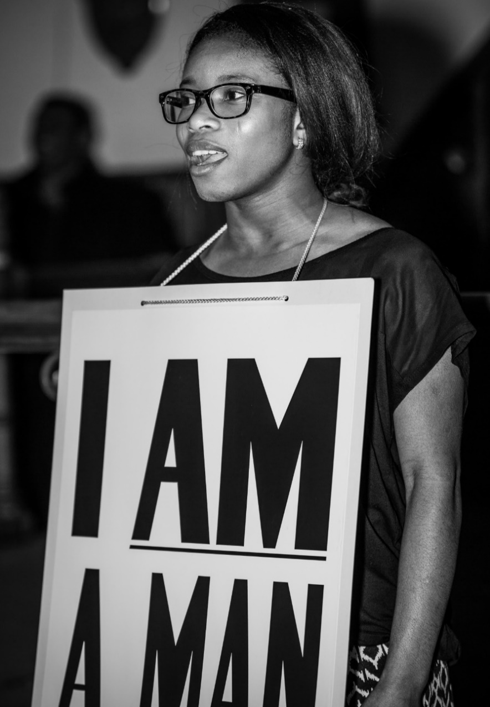
i) Cambridge, UK (2018)

Figure 1:1. Female performer wearing ‘I AM A MAN’ sign (Cambridge, 2018)
(Principal Actor) I was talking to Rev. Reives, and I said, ‘I’ve never had an experience like that before; I’ve never been part of something this meaningful before’. Because, I know about Martin Luther King and everything he fought for in terms of civil rights, but I never knew the story about the garbage workers. So, I felt like I learned that today. It was a long and elaborate teaching on all the things that went on, the people that were killed, and the resistance that had to come forth from that so people could be treated fairly, so workers could be treated fairly. So, I learned that from it, and then all the people kinda, from the congregation who spoke up about their own feelings about civil rights. It was really inspiring because you know you get to see people also expressing the same feeling that they had with her. So, it’s not just her feelings, but [feelings that] some of a lot of us have… And so bringing us together in the same room, and being putting that performance on, gave people the avenue to speak up on the things that they believe about civil rights as well. So, I learned that, and I really enjoyed it.
(Drummer) ‘I also would just like to say thank you for asking me to take part in your wonderful play. I felt the play moved a lot of people including myself and I thoroughly enjoyed taking part’.
The following six audience members came to the microphone following the performance of the play. As I do not have expressed permission to share their words, I have provided a paraphrase of their public testimonies.
(Audience Member #1) One man shared that he has been drawn to Dr. Martin Luther King in the past three or four years and that images and quotes of King keep popping into his world as an NHS campaigner, dealing with issues of health and social security.
Although different from the American experience, he said that in the UK right now, they are experiencing a human rights issue. Through tears, he said, ‘this play tonight, listening to the story’; he continued saying that ‘we are all dealing with it and we need events like this to help to understand that it is a constant struggle’.
He announced that he will be putting the song, ‘We Shall Overcome’, in a show that he will be doing in two weeks’ time, because somehow, he said, ‘I have to be reminded… because of the bravery of those workers to stand together and stand up against what must have been a really powerful thing. Not only were they garbage men, but I am assuming that they were all from a black background and living in America at that time, it must have been a huge thing’.
He admonished that that is what he wants the public of his country to take part in because, in his words, ‘we do need to stand together’. He thanked the audience for attending the play and added that he hopes that everyone present would go away feeling they too can stand up to, not only the UK’s powers, but he expressed that globally it seems to be that we are in an age, where we need to stand together. Furthermore, he said he thinks that just holding your hand and saying, ‘We Shall Overcome’, may give us a moment of real hope.
(Audience Member #2) One woman told the story about five men who were held in a detention centre in the UK and who were under the threat of being extradited to America under the terror laws which is, she reported, ‘America can ask for anybody from here without giving any evidence of what crime they have committed or why they want them. And our government has to give those people to them.’ Two of those people were UK citizens, (she gave their names). One of the men, people might have heard of through the newspapers. The other man, people had not heard of and she was corresponding with the lesser-known man while he was in prison, and he was interested in the kind of work that she was doing in Edinburgh.
The man was writing poems and she suggested that they publish them. So, then began about six months of liaising with him and he was sending her his poems. She was organizing the poetry and explaining to him that instead of doing it as an anthology of all of his poems, she suggested to have the poems structured. And he loved the idea, and her daughter did the illustration and they had a booklet, and she sent it to him with all of the spelling mistakes and everything. And he was a little bit annoyed at first because he is a poet, he is a real poet, and he was worried about the spacing and lines and things like that. He is only allowed to phone her. She cannot phone him. She reported that these are people that have no voice. She finally had his poems printed again the way he wanted, and that became his voice.
Therefore, he was under threat of extradition to a maximum-security prison in America for having done nothing that he knew of, and she reported that the UK government was going to give him over to them. And he is an Asperger sufferer, and they were campaigning and saying that being an Asperger sufferer, if he goes into a maximum-security prison, in isolation, he will be suicidal.
She reported that all the time she communicated with him, the only time he spoke of suicidal ideas was when he was in a maximum-security prison, because he was extradited. But the important thing was because of this campaign, making people aware of Asperger, the other person who was accused of something by America and they wanted him extradited as well; she gave his full name which I will not reveal. She says that he is a white guy, and that he also had Asperger. For ten years, he was under threat of extradition, but, he was imprisoned for it. The fellow was in a special detention unit in Long Lartin but, the other man was not.
Subsequently, because she published his book of poems in Edinburgh, it got a little bit of notice. People started to think: What is Asperger? What does it mean? What does it mean if that person is in prison? What will it do to him?
And the man’s case was dropped, because it was proven that it would be detrimental for his health. Therefore, they had that victory as a family of activists. They all helped the man’s family to stop him from being extradited. The other man is now back. He is rebuilding his life, but they won that victory. She said that she thinks that they got the men back probably earlier than they would have done, by raising awareness. She stressed that we have to be a voice for those who don’t have a voice, and she added that, ‘We’ve got to sing loud.’
(Audience Member #3) One woman paid tribute to the Peterborough Asylum and Refugee Community Association, with which she says that she has been privileged to work. It was started in 2002 by some members of the African refugee community. She explained that the man who founded it said that when he came here after escaping conflict and through all of the difficulties of asylum, his primary thought was ‘I’m human’, which is similar to the slogan of the ‘I AM A Man’ signs in the play.
And that is something that he has kept going, ‘We are all human, and we all help one another. Additionally, she paid similar tribute to Cambridge and the Community Forum for the work that they do with people in poverty, as well as people facing discrimination and asylum seekers refugees.
(Audience Member #4) A black, female human rights lawyer, who deals with Immigration Law, shared about one of the most difficult cases that she has had to deal with, which was referred to her, concerning human rights. It was the case of a woman, who came from Georgia, who had a horrific background which the attorney said that she did not know about when she took over the case.
The lawyer was sent to a particular detention centre, just on call, from someone who said they knew her. When the attorney went to the centre, she was aware that the woman had claimed asylum, but the lawyer was not well aware of her background.
The lawyer reported that she attended this interview with a male interviewer, and she could see that this woman who could not speak English, was clearly distressed. There was a male interpreter and there were times when the interview was stopped because the woman felt physically sick. And the lawyer mentioned that she did not feel that it was quite right, but they continued with the interview anyway.
And while this interview was going on, the woman had a picture of her child beside her and it was very difficult for her to speak, and she said that her child had been murdered and she also said that she couldn’t speak. But, nonetheless, they continued with this interview.
After this interview, it was transparent that this woman was placed on something called Fast Track, and Fast Track is basically, where they deal with an immigration asylum case in the process of seven days. So, within this very tight schedule, they had made a decision and they refused it and it went before the appeal.
When it went before the appeal, prior to that time, the attorney had an opportunity to bring her own interpreter. The woman did not have any money but the lawyer managed to help her to put something together and when the lawyer went to see her, she explained her case: stating that the woman felt it very intimidated speaking with a male interviewer and she felt that she could not express herself; because, she had been through a situation where she had been repeatedly raped by Russian soldiers. Her daughter had been murdered and her story was quite horrific.
They went before the appeal and it was a male judge and the lawyer protested and said that she did not feel that it was right that she had not had the opportunity to express herself. And nonetheless, it went forward and the appeal was rejected.
Yet, the lawyer said that she felt that she needed to fight further, and she made an application to the upper tribunal and eventually it was decided that this was a gender issue. And her case was, in fact, taken back to the beginning, and the woman was granted an interview, and as a result, she was released from detention. This was a case where this human rights attorney was triumphant because this woman whom she represented had been through a horrific experience. The woman came to the UK and she did not know where to go. Someone had directed her to a refugee centre where she had put a placard on and she was taken to Croydon Homelessness and there she was detained. Consequently, the woman was eventually released and the attorney said, with pride, that that was one of her greatest stories of human rights.
(Audience Member #5) This audience member reported that she had just come from a planning committee meeting at the district council, which is one of many that goes on denying gypsies and travellers the right to a home, and a place to call their home, despite the fact that they may own the plot that they are sitting their campground on. They are denied the right to place a caravan on a particular site. In an era where there is so much talk about low impact on the environment. The woman explained that this lifestyle is actually quite a good solution to sustainable kind of living.
She told the story of a family who has lived on a particular location for 19 years, and has had numerous, repetitive planning applications turned down, but given two years, three years, four years temporary; but the family has to keep coming back, and the stress on families is enormous. The woman explained further that she does not think that people quite realize the situation that affects gypsies and travellers in this country.
The woman said that the issues in the UK is that although gypsies and travellers, under the new Equality Act, now have protected status as a minority group; however, in planning they do not have protection.
She said that she cannot think of any other example of a group people who have their human rights recognized in one area, but not in another area, which is incredibly important. She pointed out that we were gathered at a church where one of its facilities that it offers is for the homeless, Jimmy’s. She stressed that the lack of a home and the right to a home is a human right and yet, people are fighting for that right all of the time.
Sadly, she reported that these people do not have any friends and when it comes to settling in a community, people are often not supporting these groups of people. There is a stereotypical view of these travellers that they will be criminal in their many ways and people are uncomfortable around them. They are dealing with people who are nomadic; people who do not settle in one place, and the sense is that you do not exactly know what they are up to, and there are many issues surrounding that. She said that she believes that these people deserve the right to a home like anyone else. Finally, she instructed the audience that if we hear of these stories, we should look a bit harder at what’s actually happening.
(Audience Member #6) One woman came to the microphone and said that she is a ‘Jewish girl’. She told us that during her childhood, she ran away because, in one thing or another, she suffered very bad abuse: sexual, physical, and the like.
She continued by saying that after she ran away, she returned and joined different groups of people: musicians and groups like that, and they introduced her to alcohol, and things like that. She added that that was a long time ago. However, she goes to synagogue now. She reported that it was some lovely people in a ‘black, gospel church’ that helped her a great deal. She said that she was a ‘mess’, and that they helped her a great deal to get back together. She added that she loves black, gospel people of every sorts.
She works with homeless people and refugees and many of those people have suffered terrible things. She said to the audience that we should not judge people by the way they look, or the way they act, or because they are homeless, or maybe they have an alcohol problem, or drug problem; because, a lot of them are hurting people. She continued by saying that they have been through rape; they have been through abuse, and they have been through all kinds of things. She does some volunteer work at Jimmy’s and says that the people there are amazing.
She instructed us that we should really try to help people who are fleeing from situations, whether they are refugees or homeless people or whatever. She said that when people say that they have been raped and abused, many times people think it is by some horrible person. However, in her case, she said that it was by lawyers and doctors who claimed to be Christians.
She added that she has forgiven them; because, she does not want to be bitter. She closed by saying that if anyone present has got anything that they are hiding, that they should talk about it. She said that you will feel a lot better and a lot stronger and also when you help people, it takes your mind off your own problems. She believes that when one is helping, loving other people, through that love, the helper gets healed.
ii) Cambridge, UK: Comment Box Responses
Rev. Reives… What a play!!! It was amazing and it really has inspired me.
This is an obvious West End production … excellent from start to finish.
I’ve been moved. I’ve learnt and connected and loved the music and dancing. Thanks for a performance and sharing it with so much HEART. We’ll walk hand in hand.
Thank you very much – it was all so well done! ... beautiful singing, dancing and everything.
An extremely powerful piece of theatre, both informative of a story I knew nothing about, as well as emotionally engaging with the heart of the wider civil rights movement. The audience participation at the end emphasized that the struggle for human rights continues for many in our world. The mixture of dance, song and spoken word engaged body, mind and soul. Thank you!
Sharon, it was wonderful to join you today on this 50th celebration of the death of Martin Luther King. It was amazing to see the play, and I confess I have been very emotional. As a human being, immigrant, worker in this country, I felt heart and soul touched of the emotions shared today. Thank you.
Very professional performance … lovely music and captivating theme. Well done!
It is a difficult time, a difficult age we are living in where we have to act before it is too late to keep our memory against injustice and stand up against evil as tomorrow, we could all be garbage men. Thank you to open my mind to Christianity.
We have sung as LAC [London Adventist Chorale] in front of queens and presidents, but this was the best!!! Must do it again – please… fantastic.
Amazing, phenomenal and very informative… a show that touched my heart, I would recommend it to everyone! Martin Luther King was such a visionary.
I enjoyed the show, it was well-organized, professional, good singers /cast, etc., quite emotional as well and very educative. Thanks for organizing the show.
It was an honour to be present on Monday at such a powerful and moving event.
A Balm in Gilead is a profoundly moving and beautiful production of voice, music, dance and dramatic oratory. I am so grateful to have been here for an extraordinary encounter with living history.
‘I loved the inclusivity of it, and the inspiring nature of the message – that it sometimes only needs one person to speak out about injustice to start changing things’.
‘An educative experience in both theatre and civil rights history’.
‘I had no idea that going to your play would change the course of my life. Calling A Balm in Gilead a play seems like a giant understatement. The convergence of your storytelling, choreography of the dancers and singing of the singers that you included was phenomenal’.
‘I thought that I was at a Broadway Show. I kept wondering if I was in the right place. Then, I saw Sharon’.
iii) Cambridge, UK: Video Comments
(Audience Member) Yes, I find the play very, very good, interesting. Unfortunately, we were late getting here; because naturally, we couldn’t find anywhere to park. But, as far as history is concerned, I am one that follows for Martin Luther [King] History right throughout.
And at the present moment, I know that the struggle that they had in America right toward this time, and, ah, what they been through, yes. The foundation has been laid which was excellent. And there is still a lot more work to be done, you know, in America and in the UK as well. But, I found it very good. And yes, the performance itself was wonderful.
(Audience Member) One thing I enjoyed definitely was the music. I think music has a way of moving people a bit more; so, I really enjoyed the dance as well. The interpretive dance, especially the music going into it talking about ah, sort of the dream. Gale also mentioned about hope. You know, I definitely felt that sort of hope of a better sort of future a better, more equal, and more free, ah sort of those words came to me during the whole performance; you know the idea of freedom and equality. And that was something I definitely enjoyed while watching the whole performance, yea.
One thing I appreciate about his [King’s] work was something that was mentioned throughout the performance today, it was the underlying idea of freedom and equality, but from also from a theological perspective, speaking from it as a Christian, that sort of resonates with me. ‘Cause when we speak of it not from a political stance, a human stance, but it’s very ideological and very true, sense of the word, freedom and equality and that sort of makes it more hopeful. That if we achieve that it’s gonna be a very liberal world and a very free, in the true sense of the word, free world.
(Audience Member) As a member of the audience, yea, it’s was a very, very powerful piece of theatre. It was challenging, informative, emotionally engaging. It was a story I knew nothing about, and so I learned a lot about the story, but also picked up the heart of the civil rights movement, a broader movement. You could hear that in that particular story. There was much more of the wider movement caught in there.
As a number of people have already said, I am a fan of Martin Luther King as well, and to hear that particular story and not having heard about it much before was very, very… enjoyable is the wrong word. It was moving, challenging, stirring, yea.
I think what strikes me particularly about him [King] is his nonviolence, and the way that he was able to use that so powerfully to stand against power by not responding with power, but responding in a nonviolent way. I think in terms of what inspires me most about him, I think that for me, that sums up a Christian response, but you see that in people like Gandhi as well and others who have taken a nonviolent approach to struggles and have been victorious against the odds. So, I think particularly Martin Luther King, Jr. That’s what inspires me about him.
I think the involvement of the audience at the end, to invite them to talk about their own experiences either of their own civil rights, human rights struggles, or things they’ve been involved in or advocating for. I thought that was very powerful in realizing that it’s not just something that happened in the past but it’s something that has meaning for today. And the struggle continues for a lot of people in terms of human rights. So, I thought that was very, a very powerful way to draw the theatre to a close.
(Child Performer) I was a performer. It was, well it wasn’t that long ‘cus we only were practicing for a week, but it turned out very well. The lines were like maybe three or four lines a page. So, it wasn’t that much.
(Child Performer) I was a performer. I think it went really, really well and I think it moved a lot of people and some people felt emotional, and I had a lot of fun just rehearsing and stuff and I was fully committed, and it was a big opportunity. I liked the dance and the fact that we were celebrating Martin Luther King, Jr’s assassination day, oh yea, 50 years since he was assassinated.
And I think that it’s good that it was passed down from generation, and I hope that it passes down to the next generation too. I learned a few studies about Martin Luther King at school and, I learned more about it here too.
(Soloist) I was a performer. I think it was very much, you know, you didn’t know what to expect, but what you did end up expecting was just nothing compared to what actually happened; because it was just mind-blowing. You could feel the room. It was, I mean you could hear every single thing that happened and the performers were just like, ‘Okay, we’re doing this now. We’re gonna blow the roof off’, and that’s exactly what happened. [My favorite thing] I think for me it was the choir; it was the choir for me because they were just amazing; like when we were in the dress rehearsals, it was completely different and when the choir actually came in, you could just see the difference and, they sounded so perfect; they sent shivers down my spine and then you had the workers that came out and when they were saying their lines, you could really feel it, and I think that was probably the most emotional part for me, the fact that you could feel what they were saying and it was so, so perfect the way they did everything, that you could actually relate to them and yea, yea, it was just amazing.
I think he’s [King] a really phenomenal man; in the sense that, he was opposed by so many people, but, you know, all those people that were opposing him, none of them have the monuments that he has now. None of them have like a public holiday. He has his own like statue dedicated to him. He has this eternal flame and he just has this holiday dedicated to him. He’s probably one of the most talked about people ever and all those people that were trying to silence him, all those people that were trying to silence the sanitation workers, you don’t even hear about them now. You don’t know their names because these were the people trying to oppose a greater good. And at the end, good always wins; it always does. And no matter how long it takes, it always will prevail; that’s just it.
I think Rev. Reives really did a fantastic job with this because when she first approached me I was, ‘Yea, we’ll do this’, and I didn’t understand how big it was going to be until today, like this evening when the performance actually happened. And you could see the amount of passion and the dedication that she’s put into it and without her dedication and her commitment to this it wouldn’t have gotten this great and this amazing and really just a special thank you to her. Because, I don’t think I ever would have gotten such an opportunity if it wasn’t for her and this is one of the nights that I am going to remember for the rest of my life.
(Principal Actor) [I was] a performer; it really touched me. This is probably the first time I’ve really delved into Martin Luther King, and the story of sanitation workers as well; I never came across that before, but getting involved in the play enabled me to really understand their struggles and just how brave they were to be able to go on a long strike without pay. That was something that really spoke to me. My favorite thing apart from being in it myself? The choir was really good. But, just Juliet when she came up and when she started singing, and we’ve done so many rehearsals, and tonight, I think, that was so real. It was so natural; it was so powerful really and it [was] really, really overwhelming. It made you really think about what the story was really, really about. It wasn’t just fictional; it was something that happened; it was something real. You could tell she was so moved by it. It moved us as well to say, ‘My goodness, me, it’s the people who fought for what they believed in and they went through all lengths to make sure their voices were heard.’
He is such an inspirational man and just, you know, seeing his legacy and seeing what he stood for. And just, you know, I mean, it’s 50 years since he was assassinated, but yet, we are still celebrating him, because, he’s the man that really stood out; and someone that’s gonna be remembered in history for a very long time. So, yea, when I think about him, I think about, you know, everything that he stood for and just seeing President Obama being president of the United States, just that dream that he had that one day things were going to change and we are seeing change. It means it’s not the complete change, but you can see things have certainly moved on from where it was before back in the 60s to where we are now.
I have been really inspired. I think just being involved in the play just kinda reflects into my life. Well, what do I want people to remember me for, and I’m just kinda thinking about how I live my life, making sure that I am making the right decisions and, and just making sure that I’m actually not just living for myself; I’m hopefully making a statement for someone else. I really want to get involved in helping people. And I think this has really pushed me to do a lot more than just talking about it but now, even just being in the church; there’s a homeless shelter next door. I’m thinking gosh, ‘I want to get involved in that: I’m gonna make sure I sign myself up and do something and not just talk about it now, but just taking the action’. That’s what Martin Luther King did; he went out. The sanitation workers were there. He went out there; he went to meet with them. He could have been like, ‘Okay, guys, I hear your story’ and then that’s it, but he actually, physically went there it be with them so that was touching as well. You’re actually involved in people’s lives.
(Audience Member) I was a member of the audience and very happy to be one. I really enjoyed it. Yea, it was really nice; I mean, obviously it’s a story; it’s a true story. But, I didn’t know, in depth, about the workers, the men, you know, and just hearing a bit more about it and hearing about it from the reverend’s point of view, I mean his own take on it which was really, really powerful, the story.
Obviously, the singing, the gospel choir was amazing! And then just combine that with the dance. So, you’ve all these multi-disciplines, of creative multi-disciplines going on, it was really good. The way it was put together was excellent. So, the message was strong and it kinda left me, yea, it moved me. It moved me, especially because of what we are going through at this time. It moved me definitely.
We’re here on a mission; every single one of us has got a mission, as far as I’m concerned. And Dr. King’s mission was big and bigger than him. And the fact that 50 years later we are still celebrating the mission and the man. But, the mission, you know, and I find that really, really important and for me, I would like my life to reflect that. You know, I’m never gonna be Dr. Martin Luther King, don’t get me wrong. But, I want my mission to have as much impact in the smaller space that God is calling me to be, you know? So, he is an example to follow and, ah, yea, he didn’t compromise on the Word. He didn’t compromise on the mission and that showed. And it has lasting effects.
And, you know, his words are still, unfortunately, they kinda pertinent now still 50 years later, you know. We hope there would have been more of a change, but nevertheless, to have words that can last that amount of time and to have that legacy and to have that mission still go beyond your own life, that’s fruitfulness in action and for me, that’s amazing.
I really, really loved that audience members were invited to come and share their stories of injustice and inequality. I felt that was almost as powerful, if not just as powerful, you know, to be able to put things in context like today and see the struggles that everyone is going through, and to be able to share that; I thought it was really good to invite the audience to do that.
When we make performances interactive, it sorta makes a lot more impact, and so for me, that interaction was brilliant, was really good, yea.
(Audience Member) I was just in the audience, just enjoying the time. It was just powerful, the good singing. The singing was great. It really makes me think and reflect about what I could do in this community with everything that’s going on. I thought that it was just so powerful. Everything was communicated so well. I didn’t know what to expect when I came. But everything was just so deep and so powerful. I was very inspired by the day.
Obviously, he [King] is a legend, and he is very inspirational. But, I think sometimes we focus on the big works he did, big things he did and those things, but tonight really reminded me that sometimes, it’s the lesser-known, smaller things that he did that were really inspirational and those are the things that we could do.
So, even though we might think, ‘Oh, I won’t have the platform like Martin Luther King did’. Actually, he did it on a smaller scale with small things. And I found that really inspirational. So, I know I can make an impact from a smaller level, and it’s those little things that really make the difference. And the testimonies at the end as well, after the service, was absolutely fantastic. So, again I emphasize the fact that it’s the smaller things that we can do that could make the difference.
(Host Church Pastor) I was the minister of the church that hosted the play, very emotional, very much touched by the dancers, the singing, and the spoken word, very, very inspirational, a real sense of hope. And a reminder of some of the challenges in the world, but also a reminder, as we said, the little people, the minority people can succeed in if we gather together, work together for better.
A very inspirational man [King]; I have been inspired by him for many, many years since I was a young child. I love the way that he was able to mobilize people of all ages [and] backgrounds to do good, inspirational, and I love the fact that it was all rooted in love; and to grow up to be a Baptist minister as he was, for me, amazing.
I would say it’s been amazing the way in which people from so many different communities have come together for this play: different faith backgrounds, different ages, different social classes, people who have experienced homelessness, loneliness, all sorts of things, quite a unique gathering of people, the diversity was really powerful. And of course, I have to say something about Sharon J. Reives in terms of producing and directing it: creative, excellent, inspirational.
(Audience Member) I was in the audience. It was a wonderful day. I have to say that I’m not a religious person myself; I hope I’m a spiritual person. I’m a musician, and I am a campaigner for all sorts of human rights things, particularly Palestine, but as a musician and yes, I just loved everything about it. I loved the singing, the dancing, and the way people spoke and the thing of it was so important: I was not really aware about the garbage men as I gather they were called, who became, what did they become? What were they called after that, sanitation workers, slightly nicer name really isn’t it?
But, I didn’t know what had led Martin Luther King to come to Memphis. So, I learned a lot, but it was also just very enjoyable and very inspirational. And as I said, not being religious myself, it didn’t really matter, you know. I’m sure people’s faith, for a lot of people there, their faith is what drives what they do. But, for me, just a belief in justice, human justice is enough for me, and I loved it. Thank you very much.
(Choir Director) Tonight I was a choral director, and also pianist. Tonight’s program was moving, was touching. I was in tears at several points throughout it. I actually did not know the story of the sanitation workers. So, many know about Martin Luther King through his speech, ‘I Have a Dream’, but this particular story, it was actually the first time I was coming across it, and it was a very, very powerful hearing it for the first time.
And the way tonight it was presented, using a variety of art forms, was very powerful, I love programs which combine arts where people are coming in from behind you, in front of you, where there’s colours, and also I think what was really very excellent and commendable about tonight’s program was it actually used a variety of age groups, and a variety of cultures and also at the end where people had the opportunity to share their experiences it allowed the program to have a sort of organic evolution and a uniqueness about it.
One thing that struck me about Dr. King tonight really was just how young he was. I’m 48 years young. And he was nine years younger than I am and the impact that he made on the world; he is respected by people across cultures. And that’s what he was really in favor of, of cultures coming together recognizing their individual worth and people looking inside and saying we have this strength inside ourselves; we have this strength collectively with each other and we have the strength that we draw from God as well, and I think that’s where the intersection of Dr. Martin Luther King’s legacy [is so powerful] that he’s left. And I think tonight’s program, by the fact that it was in a Baptist church, and Dr. King being a Baptist preacher. I saw many of the connections. So, I’m grateful to him for what he did for the fact that he did it in a way that is nonviolent, and I think that’s very, very important to know that things can change. Things can happen. Change can be affected through not having people being killed or shot, but really through peaceful demonstration, peaceful protest, and really keeping God at the centre of it as well.
Well, I think lots of commendation really to, soon-to-be doctor, Sharon Reives for what she’s put together. I think it was a really creatively sequenced program tonight. And when she first contacted me about a year ago, I was like okay, ‘What is this all about?’ I didn’t know what to expect. So, when we rehearsed earlier today, it was actually quite an emotional experience hearing lots of things and hearing a lot of the songs; the interpretive dance was just really, really skillfully done so, hat’s off. So, one of the audience members came across and said that we should tour this, and I could see this really working in different venues. So, it’s a shame it’s just a one off, but really, I think this message needs to be spread and more people need to hear it. I think it would be a great inspiration to people from all walks of life.
(Principal Actor) Today I was a performer. I was one of the garbage workers who presented on the stage with the sign on my chest that said, ‘I AM A MAN’ […].
I liked the dance. I like dance a lot. I’m a huge dance enthusiast. So, I loved that. I loved the colourfulness of it. I loved the message of the song, the song that they danced to; I thought it was very interesting. I think that part was right before our dramatic part, but I really enjoyed the dance. I really enjoyed it. I thought it was nice.
Dr. Martin Luther King, I don’t know too much about him. I have heard a lot about his fight for equal treatment of African American people, black people in America. And his fight to make sure that the next person was treated at the same level as anybody else; because before him, things were really kinda tenuous between African American people and other people, and I would say white people in America. And he tried to fight for that. I also understand that he also used nonviolent means to kinda fight for equality. He wasn’t going out there, and you know, and trying to wage war with people physically, but he kinda advocated for peaceful protest and I like that. I think that part was the part that struck me the most, was that he thought the best way to actually bring people together is to talk about problems that we’re having, and ensure that people work together, people are able to come together without actually fighting each other, and that’s what he stood for, and I really. That’s one thing about him that sticks to me.
I really do appreciate this program that Rev. Reives put on. I really appreciate it, because there are so many people who came here today who have never been a part of that, like me, who have never been a part of something like that before who have learned a lot from that and little kids who also attended and performed as well. You know, will have that sort of imagery in their minds about the things they’ve learned about Martin Luther King. You know, they take that with them as they grow, and I feel like that’s a blessing to them. That’s a blessing to the rest of us to be able to come together, not just learning about him, learning about him in a church, learning about the spirit of God that ties all of that that follows Martin Luther King, that follows the rest of us. Yea, so I’m grateful to be a part of it. I really am. I really am grateful to be a part of it, yes. Thank you very much.

iv) Philadelphia (2017)
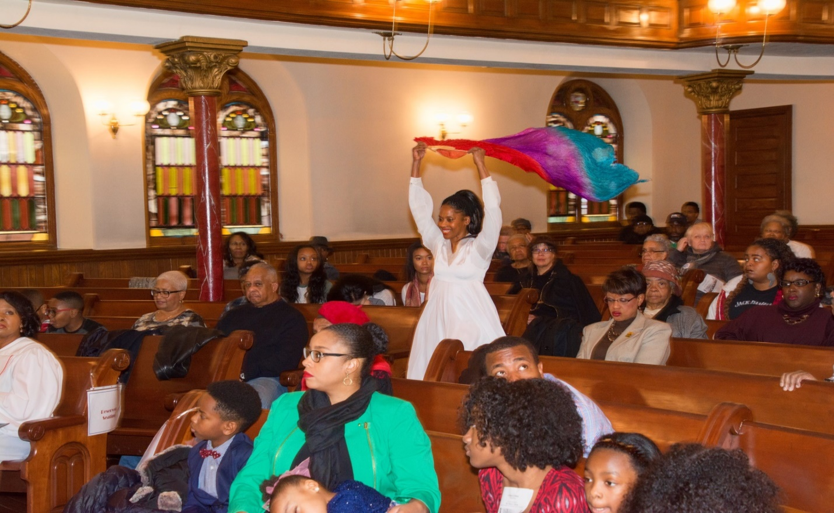
Figure 1:2. Praise dancer and choreographer (Philadelphia, 2017)
(Choreographer) I am just delighted to be here and be a part of this production today. This day had a unique experience; as a person trained in urban ministry, the culmination from the rally into the production and re-enacting the Memphis, Tennessee Sanitation Workers’ Strike was a phenomenal way to just embody the spirit of King, and I really believe that this would be a good kick off for people to put into action what they are rallying about. It was a phenomenal day. It’s really, really exciting to be a part of this moment in history being able to contribute to helping our people remember.
(Soloist) I attend Mother Bethel African Methodist Episcopal Church, and my family has been attending this church since Martin Luther King, Jr. Day 2005, and we have been coming here ever since, and have enjoyed the fellowship, the preaching, the teaching, the music and we’re grateful to be here. One of the things that I enjoy about being here is how the adults in the congregation nurture the children in the congregation, and this bulletin board is an example. My daughter is an art student at Moore College of Art and Design, and the pastor asked her to create a memorial for the nine African Methodist Episcopal Church members who were killed at Mother Emmanuel, and this is what she came up with to memorialize them.
And when I tell you that this has truly been a church family effort, every aspect of the play from promoting the play, soliciting donations, getting donations, and volunteers, every aspect of it has been church members who have just opened their hearts and said yes in a very generous way. So, I am grateful to have been part of this event.
(Choir Member) I was born in Marion, South Carolina. And I attended Allen University, and while I was a student at Allen University, I participated in a demonstration, and a sit-in downtown Columbia, South Carolina theatre, and we bought our tickets and we went upstairs and we sat down, and immediately after we sat down, the ticket agent came up and told us that we had to go into the segregated part; and we looked at out tickets and we told him that our ticket was marked paid. It was not marked segregated, and we were not gonna go into the segregated part. And he told us that if we did not move, he was going to call the police, and we would be put in jail. So, we said, we shall not be moved. And while we sat, the police came; they arrested us, and they told us that they were gonna take us to jail. After they finger-printed us, to our surprise, they took us to the state penitentiary. And we were in the state penitentiary with all the criminals who had committed murders, and other kinds of offenses. And while we were there, Dr. Martin Luther King, Jr. got the word that some college students had been jailed, and he drove through the night until he reached Columbia, South Carolina. And once he got to Columbia, he came to the penitentiary, and one of the inmates who was next door in the cell to us told us not to say anything, but she heard that Dr. Martin Luther King was in town, and he had heard about the college students who had been arrested for demonstrating. And the next morning early, we were told to get up.
And we were taken to the cafeteria, and once we got to the cafeteria we met Dr. Martin Luther King, Jr. He shook each of our hands, and he told us that he was very proud of us, and he had come, and he had bailed us out of jail. And our fingerprints would be exonerated, and he took us back to Allen University. Once we got back to Allen University, we stood him in the centre, and we formed a circle around him, and we sang, We Shall Overcome. He told us, and this was back in the 60s, he told us that we could not stop fighting for social justice. And here it is some 50 some odd years later, and things have not changed. We’re still fighting for social justice. And this time in my life, really reminds me of the time when I was a young student at Allen University in Columbia, South Carolina.
(Audience Member) What a great experience it was this evening, A Balm in Gilead. It was something that I’ve never seen before, but something I was interested in seeing, something that could be on Broadway, a nice musical, nice performance, well-done, well-directed. And I look for it to go further. I started off this morning with the march and it ended up here with Mother Bethel, my first march ever. And I was glad I could take part of it. But, I really enjoyed today, a long day but it was worth it all to enjoy Dr. King’s Birthday celebration with friends and fellowship, a great experience.
(Audience Member) First I’d like to say what an inspiring afternoon this has been. Ah, it’s really got my juices going.
(Child Audience Member) My favorite part of the play was actually the Praise Dancers. My favorite part ‘bout the part at the end was the part where they were somehow fanning it a certain way to make wobble in the air. I actually, it looked cool to me. And then and especially the part where they was like.. it was somehow… the way it looked, looked like they were actually trying to clap without doing this because like they were doing this with their hands. That’s actually my favorite part. Actually, my second part favorite is the part where they sang, I forget the name of the song. It was the part when they were walking in; the part was, the song was called Join Every Hand, I think, and I remember. And that’s actually just my favorite part. I liked the whole entire play but, out of everything that was my favorite part.
(Retired College Professor) What I liked best about the event today was the music. It stirred the soul. There was real fellowship today.

v) Philadelphia: Comment Box Responses
I love your church! The performance of the praise dancers, the choir, poetic prose, the play and the story of the bravery and courage of the Memphis Sanitation Workers was awesome, and incredible.

[I] liked the play because we got to sing.

My first time at an event such as this, I enjoyed the singing, participation and the theatre… as well as the refreshments!

‘We Shall Overcome’ always leaves me speechless with tears. Thank you very much.

We walked into the sanctuary first when Rev. Reives began to speak – awed we were by the beauty of Mother Bethel and the people gathered to remember Dr. Martin Luther King, Jr. on this annual American honor ceremony. Although every aspect of what we experienced was respectful, beautiful and filled with praise and honor to God… what moved me most, as it usually does when well-performed, was the music. We not only look forward to overcoming brutality, injustice and conscious and unconscious racism in our beloved country, we are overcoming every day. We don’t, as Mrs. Obama said, need to ‘Make our country great again, it is’. God bless America.

I was very glad to be a part of the 1968 Memphis Sanitation Worker dramatization. I enjoyed the spirit of the director to get best from us as a group. Rev. Reives have a great organizational drive, along with a drive to do and get the best. I was happy to be a part of the finish product. Good job.

On MLK Day: What a great time and uplifting experience… a blessing to be had by all. God bless.

This was one of the most blessed days for me in a while. Thank you all for a day like this. This could of only [been] a MLK Day.
Thank you for setting up this play. I loved it!
This was a great event.

Job well done. Praise the Lord!

Inspiring and educational

Today’s play was educative, inspirational and entertaining. I am very glad I came.

Enjoyed performance… educational… had a great time.

Production was great. It was a real experience, learned a lot about the sanitation workers.

Very well done, the dramatization was first rate. I learned more than I expected about the garbage men who made history.

The experience was absolutely wonderful and moving. It was very educational and gave yet another look into the civil rights movement in another lens.

I thoroughly enjoyed this play because it taught me something I didn’t know about history and the civil rights movement. It also reminded me of a play I attended called ‘The Mountaintop’ with my Mom which is a fond memory for me. In both instances, my eyes were opened… They inspired an example that we should all strive to follow. The divisiveness that has immensely overtaken our ability to love and break bread with others these days is not insurmountable.

What a great way to reflect and focus on the contributions of those who came before us.

I loved seeing people’s engagement in the play and hearing how the story resonated with those who lived through it. It was a very pleasant experience… The MLK Story with the Sanitation Workers was illuminating. The play was excellent! The commentary was very thought-provoking and expansive in giving an overview. It was uplifting, timely in impact (Trump’s election, smile). I enjoy every aspect.

A very compelling program! We need to be always reminded of the past!

Inspirational, intergenerational, inclusive of all ages, informative

A wonderful hopeful day – a story to be proclaimed, and proclaimed, and proclaimed!

Dear Rev. Reives… Thank you so much for allowing me to participate in this historic event. I really had a great time being part of living history.

This was an awesome presentation! It helped us all appreciate the power of standing together and all that the sanitation workers did for workers’ rights.

There is so much to know about the civil rights movement. The rights of the sanitation workers is a story that MUST be told. We cannot know where we are going, if we don’t know where we came from.
vi) Philadelphia: Video Comments
(Principal Actor) I’m one of the principal actors in the play, A Balm in Gilead production by Pastor Reives. I really enjoyed working with her. She was very, very thorough and meticulous. She had a good grasp of civil rights history, and was open and encouraging others to share their part. For that, I’m thankful; and I’m thinking that now this will become one of my things. I think I’m gonna start taking up with the Performance Ministry [Performance Ministry involves a group in the church who ministers through Christian Theatre for various events in the life of the church].
(Principal Actor) Praise God. It was an opportunity, awesome, awesome opportunity for me to be part of the play that Rev. Reives gave today. It was historical. It gave people an idea of what they have missed, and what they are now going to learn. And we’re hoping that it will encourage people to get more involved in the right, the right for just basic things: your speech, your opportunity to say what you need to say, and to do what you need to do. Thank you.
(Principal Actor) I was involved in the civil rights movement. I am originally from Savannah, Georgia. And I was involved in sit-ins in ‘62, 1962. I was involved with a group called, it was Crusade for Voters, that basically backed a youth movement basically that wanted to do something in Savannah. It was a wave all over the South.
And I was 16 or 17, about 16 and we decided we wanted to start up something in Savannah; we did. Hosea Williams, who became associated with the Southern Christian Leadership Conference [the SCLC], basically was the adult that was with us. As a result of my association with Hosea, I was able to meet Dr. King at a retreat in Frogmore, South Carolina, which was right across the bridge from Savannah.
But, they would have periodic retreats. So, I had an opportunity to work with him, to see him there and to be around the core of [the] SCLC: Ralph Abernathy, Wyatt T. Walker, Dorothy Cotton, they were all there. James Bevel, I think even; I don’t know if James Bevel was there at that time, but I know he became involved in the SCLC. After I left Savannah, I went to Tuskegee, and I was involved in the, ah movement in Alabama. It was the advent of Black Power. We had guys coming through: Stockley Carmichael, [H.] Rap Brown, everybody who was somebody came through Tuskegee because, it was really like an oasis. You know, it was hostile territory. And so, if they could get a break, they’d come in, as they say now ‘chill’, or rest.
But, it was, my life was the movement. It was about elevating. I became president of the student government there at Tuskegee. In fact, I was president of the student government when Dr. King was killed. There was a riot on campus. They ended up closing the school down. But, we were in the midst, it was ah, ah, a great time for young folks who wanted to do something. And before Dr. King was killed, we were invested in making our education relevant. You know, it was a real freedom movement. It was bigger than us; it was much bigger. And a lot of people try to claim it. There’s no one person. You know, Martin Luther King wouldn’t claim it; he knew it was bigger than him.
You know, it was something that had to be done. And it wasn’t about heroes. It was, you did what you had to do. I mean your life, to that point; it dictated you to move in [a] certain kind of way. You know, sometimes I don’t know why, but it was in me and that’s another story. You know, why it happened at that period of time; it was a good reason that can be traced back even to even World War II and the people, the men that came back who wanted more. They knew that they weren’t gon’ settle for that, and they put it in their children. And we weren’t gon’ have it.
Even if I couldn’t have it, I would have knocked the doors down. You know, you not gon’ do this to me. I remember at 10 years old 10 or 11, around that age, getting on a bus seeing, ‘Whites sit from front to back’, ‘Coloreds sit from back to front’. I knew something was wrong with it. It was crazy. You couldn’t go to Crest or whatever the little store was to sit at a lunch counter. That was just arrogance to me as a 12-year-old. I’m gon’ say, ‘How these people gon’ do [this to] us for no good reason?’ So, that was me; that was my involvement with it. But, there was nothing like it. I’ve seen Dr. King. He had a mystique of magic about him when he talked. You know, I also saw Malcom X, when I was at Tuskegee, two weeks. You know, about two months before he was killed, and he had that same kind of charisma. That you couldn’t deny.
(Principal Actor) I was born in the summer of 1955 in Savannah, Georgia, and we were still in segregation. So, I lived in a neighborhood just with people of my color. And ah, being born in 1955, I remember ah, everybody on my block knew each other. Everybody was watchful of each other and children felt safe, at least I did, felt safe back then. But, as I got older and my mother and father separated that left us going to four different homes by the time 1968 came. So, in 1968, I do remember the death of Dr. Martin Luther King, and I remember watching it on T.V. I remember the sadness in the home. But, I don’t quite remember too much because we had our own thing going on. But, segregation to me, black people were better to each other. So, in the 60s, I came up in a better time, even though it was segregation.
I was glad I came out one night. I heard about the play. I came out to Mother Bethel, and I saw Rev. Reives. She says, ‘Okay, everybody gather whose gon’ be in the play’. So, I made my decision right then I was gon’ be in the play. And, ah, I went through all the training, and everything, and I saw her enthusiasm and her spirit of being ah, just wanting to do this, and having it done and done right. So, I like her firmness and I liked her keeping things orderly. I really liked that because I was use to that coming up now. You were in everybody’s house so you had rules always; so I was use to that and I felt good. You know, it brought back memories to me. I guess is what I’m saying. It brought back memories of family and stuff I lived with I the past. And I really enjoyed being in the play. And I feel good ‘cause now I can write this down like on a tablet of life that I was in this play and it was about something that was tragic but true that happened in the past for blacks and sanitation workers.
(Choir Member) Good evening; I am a member here at Mother Bethel African Methodist Episcopal Church. When we come to tell the story of our people, I get very excited. I get excited because we’ve had a struggle. When my grandparents migrated from South Carolina, they came to Philadelphia and they resided in south Philadelphia where Mother Bethel is. Unfortunately, my grandparents had [an] eighth grade education; so, they could not send their children to college, only my mother. My uncles, John C. Span and Edward Span, went to the military. They were in World War II. I did not know until after he was deceased about his great story in our history. He was an original member of the 99th Pursuit Squadron in Tuskegee. However, he did not fly because they could not afford to send them to college. He was in charge of the mechanics.
And [I am] moving on to my Uncle Eddie, who worked his way up through Bell Telephone to become manager. My mother, Dr. Gladys Span Winfro went on through her educational field at Temple [University] and the University of Pennsylvania where she received her doctorate, but she went to an undergraduate school that did not care for African Americans and, would rather them go to a black college. I followed in her footsteps. I went to that school, Westchester State University. I was one of the first African Americans on the cheerleading squad. So, when we tell our story to our children, and I am a teacher, when we tell our story, our children need to know from whence they’ve come, in order to know where they are going. So, when we have the performance here, A Balm in Gilead. We had an expression that we wanted to share with the people in the audience, and I think they received it. That it doesn’t matter what color you are: red, black, blue or green or what your ethnic composure is, we must make sure that we share what we have and the character and what’s in our heart with others.
(Choir Member) I am a member here at Mother Bethel A.M.E. Church. I am the chair of the health commission, as well as a member of the choir, and we had fun today praising the Lord and acknowledging Dr. King which I plan to do 365 days of the year. The other thing that was wonderful today was the march and the rally. I understand that over 5000 people gathered with Mother Bethel and all the others. It was an inter-denominational gathering through P.O.W.E.R. [Philadelphians Organized to Witness, Empower and Rebuild], and the march came from 6th and Market, down 6th street to Mother Bethel, at 6th and Lombard. And it was over 5000 people [thousands of Philadelphians observed Martin Luther King, Jr. Day 2017 by participating in the mass march and rally, in order to call attention to making America better through: racial justice, economic justice and corporate accountability]. It was absolutely wonderful, and I did have the opportunity to participate in the program after the rally, after the rally occurred, after the walk, and that was also absolutely phenomenal.
We do appreciate the leadership of the producer, and we had a great time. One other thing, another hat that I wear is I am the executive director of the black women’s health alliance here in Philadelphia. And so the synergy between health rights, health equality, civil rights, racism is real, and the impact that it is having on health disparities. So, once again, wrapping up, 365 days a year, we have to be focused on removing injustice, removing racism, advocating for our equality and health equity.’
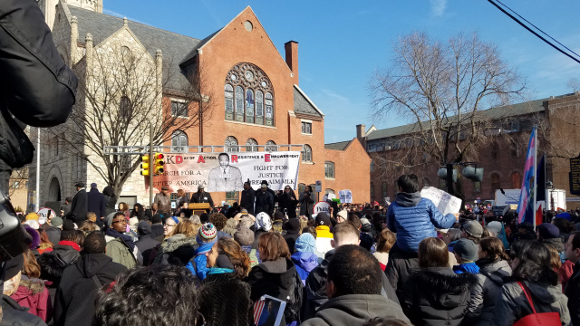
Figure 1:3. MLK March and Rally at Mother Bethel A.M.E. Church (Philadelphia, 2017, credit: Justin Udo)
(Child Actor) Today, we’re going to talk about how we really like the play and how we share different opinions and share different questions.
(Brother of child actor) We had a good time, and I’m really happy for my sister, and she did a good job. And I’m really proud of her. And I’m really successful for myself. I help everyone. I serve the food, and I had a good year.
(Child Actor) Today I had a good time because, I was in the play and my brother got the experience of how it is to be in a play, and how it feels and how, and what you do and what you say in your parts and in your lines. And we also like this day because we had some fun eating and serving some food.

vii. Atlanta (2012-14)
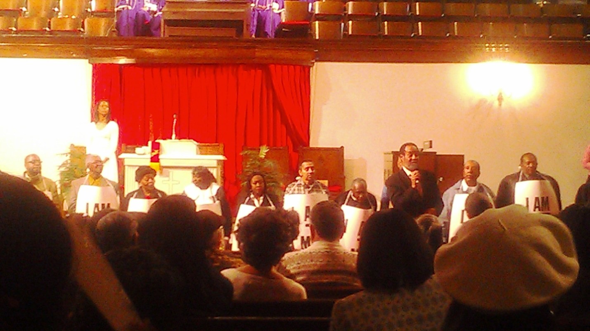
Figure 1:4. Scene from A Balm in Gilead at Wheat Street Baptist Church (Atlanta, 2012)
(Audience Member) The Production was very rewarding to me; I did enjoy. For Chaplain Reives has Godly done a knowable, outstanding, inspirational part of history about Martin Luther King Jr. that must forever be told to the world.
(Audience Member) I thought it was a very interesting play, and prayerfully, I will be back this year to see it. I will be there to invite all my friends and family. The civil rights movement is very interesting, and I think that all of our young people of today should get involved in the future civil rights movement. I would ask all my friends, and neighbors, and even my church members to come out this year to see this wonderful play, and you will enjoy it; believe me. I enjoyed it last year, and I intend to enjoy it this year.
(Director of Children’s Ministry) I was over the children and the youth and we sung a couple of songs during that time. We sung, ‘There Is a Balm in Gilead’. We actually started it, and led it into the choir singing it. We also sung ‘We Shall Overcome’. We also worked with the children in helping them to learn their parts as they did speaking parts in the play.
I feel like we all should have the equal rights that others have. I work for an organization called N’Cobra, and [we] do this fight for reparations for African American people, and in order to do that, we have to pull together as a people to get what the needs are. Some people think reparations is just asking just for money, but it’s more to it than that. We need our people to be helped in the mental health state. We need our people to be helped in education. We need our people just to be helped in being who they are to identify themselves. I would especially state to them, do you remember what Dr. Martin Luther King really did for us when he went to fight for our rights and our working rights, our pay rights as the sanitation workers were on strike? He lost his life standing up for us. So, I would definitely let people know to remember Dr. King, come out to our play and even participate.
(Principal Actor) My role was one of the singers and one of the chanters. You know, we kinda repeated a lot of stuff. And I can identify real closely with that because, I came out of the union movement. And, AFSCME (the American Federation of State County and Municipal Employees), which is the union that I have been affiliated with over fifty years. We were part organizing in west New York. And when they had that film, I can identify heavily. It was easier to organize up north than it was in the south. And I can see the problems that they had. I thought it was a very interesting play.
My favorite part of the play was when we would say that we will stand up for the rights. You know, the protest movement in regard [to] what was right and what was wrong. And we said we will survive. We will hang in there and all of that… the fortitude of the group. I thought it was outstanding that we hung in even though Dr. King, and all that during the movement, we still stood up for our rights. The play was realistic. It was something I can identify with me being my age. You know, I go way back in the union movement, and I knew it was a hard time trying to survive. Still in the South, it’s still hard for people to understand how important unions are. I think they’re trying to down-size unions all over the country right now. And I think it’s important that we get involved.
(Principal Actor) I participated in last year’s A Balm in Gilead that was given here at Wheat Street Baptist Church, and my active role was, I was ah one of the sanitation workers, and I enjoyed that role. It was informative. I learned more about the strike there in Memphis, Tennessee and just participating in it, it gave me some, a better feeling, a better sense of what those people went through at that particular time with Dr. King coming to town and being behind the movement at… I don’t remember the year. I think it was 1968. And I thought about that, that particular time, I was 10 years old. But, anyway, it was a worthwhile experience participating in a play, and I enjoyed it and I’m looking forward to being a participant this year also.
My intake on the civil rights movement was that those were courageous people both behind the scene and there right on hand for Dr. King. And I know all this stuff was because, how could you have went through such an ordeal with people persecuting you and yet be nonviolent? And I just understand that in greater detail now that Dr. King had to be standing on the shoulders of Jesus Christ to be able to withstand all of that persecution. And I just thank God for those men and women that were before us that stood so that we could have a better life right here in America.
I would encourage them that the play is going to be inspirational. The play is going to be spiritually full, and the play gives you a history of black people’s struggle, and we all need to know our history… black people and kids from ages, from children up to youth to adults, and even some of our seniors, we need to be more informed of our history here in America, because it was a trying time in America for black people, especially at that time and right now today. So, I would encourage everyone to come out to A Balm in Gilead that’s gonna be given here at Wheat Street and you could feel the inspiration. You could feel the motivation… the sprit-filled ah, you could feel the presence of God in this place ‘cause I did last year. I cried last year. This is going to be a moving experience. God bless you all and pray that each and every one of you that might see this, will come out and share in this production, and I thank God for everyone that’s behind it, and all the hard work that sister [Rev Reives] gave such a input that she would bring her production to Wheat Street again this year and we thank God.
(Principal Actor) I think it was an excellent play. It was involving the garbage workers when they were striking and had a lot of involvement with Dr. Martin Luther King. Jr. who has been well-respected by others from every walk of life. I think it was an excellent play. We had to memorize certain parts of that play. It is important for people to come out to the play because it talks about a lot of history. A lot of people were not even born during the garbage strike and involving Dr. King and other African American people who are working with civil rights for black people. It’s very important that we come out and hear about our heritage, the things that happened way back then. And it brings us up to date in what is still occurring in some parts of the world. It’s a wonderful play and you will thoroughly enjoy it.
(Teen #1) I’m very appreciative [for those] who died for us and made it so that we don’t have to come in the back of the building. Because I know if I had to do that, I would be one of those protesters who just walk through the front door, because I’m not no back- door-type girl.
(Teen #2) What the civil right movement means to me is like people fighting for their rights as a human being. It doesn’t matter what color you are, just fighting for their rights as a person. The play was so much fun. A Balm in Gilead gave us information that we didn’t even know.
(Teen #3) Why I am so appreciative of the civil rights movement is because that I’m the type of person that loves any color, any kind of race you are. I don’t really care what the color of your skin is. And I’m just so grateful because my great grandma actually had to walk through the back door. She was in segregation and she didn’t like it. I know I wouldn’t have liked it either. But, I’m just really appreciative, and I just want to thank you all: Martin Luther King, Rosa Parks even more for that. Well, I think everybody should come out [to see A Balm in Gilead] because it was a great experience. I mean we had great dancing, great music; we had really good music going, and then plus we got to learn [that] not only Martin Luther King had done something great for us. It was others, was other people, but they were more in the background. So, even though we thank all the other people for black history, it’s more people who are not [displayed with their pictures] on the walls that we should be thankful for too, because they helped make the world a better place.
(Teen #4) If it were not for Martin Luther King, and he didn’t march, I think we all would be still fighting ‘til this day.

Appendix 2

Interview Transcript: The late Mr. Alvin Turner, interviewee (AT)
11 July 2016

Interviewer: Sharon J. Reives (SJR)

SJR: Mr. Turner, thank you kindly for your time today.
SJR: Mr. Bill Lucy made this statement. He said, ‘The Memphis Sanitation Workers’ Strike of 1968 and participation in it was a life-altering experience.’ Is this true for you also?
AT: Oh, yea.
SJR: Uh, huh. How so?
AT: How is it true? How is it true?
SJR: Yea, how is it true that it was a life-altering experience, not only for Bill Lucy, but also for you?
AT: Well, after the strike was over, I got a better position. And I was able to educate my kids.
SJR: Wonderful, okay.
SJR: What are your children doing today?
AT: Uh, my oldest daughter she retired out of the Navy…
SJR: Wow!
AT: and she got a high position at VA Hospital.
SJR: Excellent.
AT: Sherry… my… which is my, uh, middle daughter, she got a high position in the Negro College Fund.
SJR: Alright.
AT: And, uh, Sylvia, which is my baby daughter, she… now, these got doctorate degrees now.
SJR: She has a… they all have doctorates?
AT: These two
SJR: Theses two… okay, the youngest.
AT: And she is… uh… at UT Knoxville in which she got her, she got her students … they’s overseas somewhere.
SJR: Wonderful.
AT: And uh, my son, he’s… uh… with Raleigh Egypt.
SJR: Okay.
AT: He’s a teacher.
SJR: He’s a teacher? Okay.
SJR: Well, you and your wife did an excellent job.
AT: Yea.
SJR: Okay.
SJR: Now, there were two men who were crushed to death. Their names were Echol Cole and Robert Walker. They sat in the back of the compactor to get out of the rain, and eleven days later… uh, you, sanitation workers went to picket… went to the picket line. Can you say more about that?
AT: Huh, the two men who were crushed…
SJR: Uh huh…
AT: …was uh… uh.. yea, somewhere about two weeks…two weeks after they was crushed we uh… because they was our main talking point… and uh, we had told all the men that uh, the things that happened to these men is the same thing that can happen to either one of us.
SJR: Uh huh.
AT: And uh we told them that uh, the only way to stop it is to organize.
SJR: Uh huh.
AT: And we decided to uh… that we needed a union. And we voted to go on strike.
SJR: Okay, thank you.
SJR: Please explain this statement, ‘Their trash truck was their lunch counter.’
AT: The trash truck was the lunch counter?
SJR: uh huh. How was that true? Did you have a place to… for the workers to…
AT: Naw…
SJR: Okay.
AT: What they meant ‘bout that is uh, you would eat with yo’… ‘round yo’ truck. Now, some people had special places they could go and eat. And who would.. uh… prepare ‘em a lil’ room uh… a place in back of the store… back yard of the store.
SJR: Uh huh.
AT: There was some people… which I did… and uh, and then… some would have to eat around the truck.
SJR: Uh huh… but it was not a place for all workers to sit in the building and have meal?
AT: No, no, no.
SJR: Okay.
SJR: Describe the 1968 Memphis Strike… where it says, ‘Where workers were at the lowest rung of the social ladder’ … 1968 Memphis rather. What was Memphis like in ’68?
AT: Huh, you know… during that time, you had to carry garbage on yo’ head.
SJR: Uh, huh.
AT: And what that did… that was uh… you would… the tub had holes and you would… the liquid ... a lotta people … you actually had some people who cared, but a lotta people would uh … would … the lid wouldn’t be on the can … and would rain in there.
And what would happen when you po’d the stuff in yo’ tub, it would uh… that liquid would run all down yo’ back. And maggots would crawl all over you. And everybody thought that you was the lowest thang it was.
SJR: Uh huh… In 1968 in Memphis, how was it like in terms of economically … for blacks?
AT: In 1968, I thank we was making somewhere like a dollar ten… a dollar fifteen. And uh… what would happen…uh… this was… was uh… most of the men would have to deal with the loan sharks in order to try to make ends meet.
Now, everybody… now, me personally, uh…I knew how to do plumbing work, and I was a plumber. When I get off in the afternoon, I was heading somewhere to a plumbing job which that’s how… what put me a step above… uh… the regular ones.
SJR: Okay… uh, the strike began in February of 1968.
AT: It was uh… February the 13th. Now, this is what I remember. Now, that been a long time, and I heard a lot of people say it was a different date from huh… but I gon’ stick with my February 13th. That’s what I remember.
SJR: Okay. So, the strike began February 13, 1968. The strike was described as a battle for economic and civil rights. Can you say more about that?
AT: Naw, naw, naw, naw… What it was… when we first went out on strike, it was for economics… when we first went out.
SJR: uh huh.
AT: And uh… after we was out, about two weeks, then we discovered we weren’t getting any place. So, what we had to do, we had to get the community involved.
SJR: Uh huh.
AT: And we… Rev. Lawson, he was our spokesman.
SJR: Uh huh. I’m going to ask you about him later.
AT: And what he did… he would set up different churches and we would go to those churches two and three times a week. And we had Elder Gilbert Patterson.
AT: And uh… we had had him… he had uh.. I thank it was… it might have been a hour on WLOK… uh Radio Show. And he would spend that whole hour talking about the injustice that was being treated to blacks.
Now, we had… had him. Then, we had a bunch a mo’ and ain’t no way for me to call all ministers names who was participating in our …
SJR: Of course.
AT: in our strike. But, uh what we did… this is how it become community. Uh, what we… we did… we would go to these churches… different churches. And we would uh… talk about the injustice that was being did to the community.
SJR: Uh, huh.
AT: And uh… we got the black community involved and uh… what we did once we got the community involved, then the community gave us all the support they could.
SJR: Wonderful
SJR: What did Dr. King’s participation do for the strike?
AT: Uh… when Dr.… that hope get the community solid behind us…
SJR: Great.
AT: Once he come… came to Memphis that… then, they… you had people participating with us who had said that they wouldn’t.
SJR: Um…okay, Dr. King said, ‘All Labor has dignity.’ What do you think Dr. King was saying by this statement?
AT: What Dr. King was saying that it was a… and he said this in… ‘It was a crime…’
SJR: Uh, huh!
AT: ‘For people to live in this rich nation and receive starvation wages.’
SJR: Yes.
AT: That’s what he meant.
SJR: Okay.
SJR: Please talk about how the scabs affected the strike.
AT: We didn’t have but a few. Now, we had few that they hired and uh… we had a few that uh… went to… went back to work. And if they had…uh.. if they hada had enough… see these people they didn’t know the route. And they didn’t know the operation of the trucks.
SJR: Uh huh.
AT: And uh… they just had just a few; they would uh… and then mostly the helpers, they didn’t know how to operate a truck ‘cause the biggest of the drivers… was uh… was out on strike.
And so the scabs, they didn’t huh… affect it too much.
SJR: Okay.
AT: Course when we went back to work, we had tons and tons of garbage.
SJR: Wow!
AT: We’d pull up in one house, and we’d be there an hour.
SJR: My goodness!
AT: Cleaning …. yea.
SJR: How did wearing the ‘I AM A MAN’ signs make you feel?
AT: Made me feel just like that sign said, I’m a man; I’m not a li’l boy, and I deserve to be treated like a man.
SJR: Uh huh… Uh huh
SJR: Huh… you were 34 years old when the strike began. Is that correct?
AT: That’s correct.
SJR: What would you say to that 34-year-old Alvin Turner today?
AT: I would.. if huh.. if… well, I could go back, I would join T.O. Jones much earlier…
SJR: Uh huh
AT: than I did.
SJR: Okay, huh… the first march down Main Street resulted in violence which resulted in the city being placed under martial law. There was curfew. There were armored trucks rolling on the pavement of downtown Memphis. There were soldiers with bayonets drawn. Police used tear gas and bully clubs… billy clubs on the protesters. Will you talk about the violence?
AT: Uh… I was a victim police brutality. I got a scar right here.
SJR: Um… Uh huh, I see it.
AT: It’ll go to my grave. And what I was doing… you see. It was three… 1300 employees and it was… uh… I don’t know how many policemen, but they would almost have as many police as it was employees.
SJR: Uh!
AT: And they would… would provoke us to do just any l’il thang. Now, what started this first was Mrs. Crenshaw. She was a lady who took on Memphis Light, Gas and Water.
SJR: Um.
AT: for charging… I believe it was… she was charging too much money for water… any way… this was part of the thang.. what she had been doing. So, when we went on strike, she joined us.
And she acted as if she was a secretary. Well, she was… worked in the office and then she would march with us. And what the police was doing, she was getting a lot of press. And what the police was doing… was trying to run over her, and they had… if it hadn’t been for…uh… I thank it was ‘bout seven or eight of us. If it hadn’t a been for us lifting that car, it would’ve hit her.
SJR: Uh!
AT: He would’ve hit her. And this is what started this first riot.
SJR: Uh huh
AT: The second… this what started the first beating. ‘Cus they was beating this one guy. And I say… me and James Jones… was standing up. I said, James look how they beating that po’ man. This policeman was standing right side of me, and he hauled off and took that stick and I went to look at him like that and he was coming down on me..
SJR: Ummm!
AT: … my head right there.
SJR: Umm!
AT: Right there.
SJR: Uh huh.
AT: And I was too scared to go to the hospital… which I needed to do. But, I went over to my sister’s and she huh… went to the drug sto’ and got different stuff and uh… she packed it up… cleaned it up… packed it up… and uh… I went on. And I didn’t tell my wife about it; because, I know that it wouldn’t do nothing but worry her… but, anyway… it was.. it was uh… that was the first riot.
The second was a… we didn’t have anything to do with that… the second… now I’m speaking only of police brutality.
SJR: Alright.
AT: They had went to huh… we had this march and it was Hamilton School. We had done been in the neighborhood… been to different schools. They had done started this uh… Black Monday. I don’t thank you was old enough to remember that.
SJR: Is that some economic…
AT: Yea, Black Monday was huh… it was a day that they would have a general work stoppage.
SJR: Uh huh.
AT: ‘Cus this was after Dr. King had came and huh… made his first… first speech, and he suggested that we would have general work stoppage. And during that time, we had uh… we had uh… the community. This was women started working on this and they come up with Black Monday. Now, what we gon’ do.. Black Monday is all of those can… they gon’ take off from work. We weren’t gon’ send no… our kids to school.
SJR: Uh huh.
AT: And uh… Do you? Naw… how old was you?
SJR: I was eight years old when Dr. King was killed.
AT: Naw, naw… you wouldn’t remember that. But, if you was eight years old.. where was you living?
SJR: I was living in Mississippi… down in northeast… uh huh.
AT: Oh, okay. But, uh… what they did… if you hada been in Memphis, you have been.. wouldn’t go to school on Monday.
SJR: Right, okay, okay.
AT: So, and then you had a lot of people that didn’t go to work… on Monday.
SJR: Okay.
AT: And those was yo’… the days they would have a Work Stoppage. We had a lot of peoples who they would talk about firing.
SJR: Uh huh.
AT: And we would send representatives to the job and tell ‘em… if you fire these people, you will never receive another Black Dollar.
SJR: Uh huh.
AT: There was… the second… was uh.. the kids at Hamilton school. Ah, they had… uh…a bus was supposed to pick ‘em up… Mata Bus… and something happened to the bus. Anyway, they didn’t… it didn’t come. Them kids left Hamilton School and walked to uh… Clayborne Temple… and huh… by the time they had got to Clayborne Temple, they had told ‘em that the police had killed somebody. And they was… them kids was sho’ nuf’ worked up.
SJR: Uh huh… which was untrue, right?
AT: No, that was untrue. But, it’s.. somebody just was passing them and hollered out the window.
SJR: Uh huh.
AT: ‘The police don’ killed somebody!’ And when they got to Clayborn Temple, they was sho’ nuf’ worked up.
SJR: Ummm.
AT: And that’s when they’d… Dr. King was… that was the second march. And huh… Dr. King led the march… well, they was in the… then the sanitation workers was behind Dr. King and the school was last. And when they… we was coming up Beale… and huh… I heard the glass breaking. I knew then that huh… that we was gon’ gon’ gon’ get beat again.
And that was when me and Russell Walton was together then… and huh… we tried to go into Malco, but they wouldn’t let us in there.
SJR: That’s the movie theatre?
AT: Uh huh.
SJR: Okay.
AT: And huh… these was the two main violence.
SJR: Okay. Uh… would you say that the Memphis Sanitation Workers’ Strike… uh… the Memphis Sanitation Workers… rather… were 1300 men fighting for decency and dignity?
AT: Yea.
SJR: Will you explain more about that?
AT: Uh… you know, this is part of thing that come up that … ‘I AM A MAN’. They had been treated less than human beings. You know huh… I always had a car so it didn’t affect me. Uh… but a lot of people… a lot of the employees would have to ride the bus. And uh… and I can understand how a lot of people felt about… ‘cus they was… had been out there all day in …and… all that maggots and stuff on ‘em.
SJR: Uh huh.
AT: And huh… when they get on the bus, they would have to… wouldn’t nobody want to sit beside ‘em.
SJR: Uh huh.
AT: So, I could understand that; I could understand that. But, that part didn’t bother me ‘cus I always had a car.
SJR: Uh huh.
SJR: The song, ‘Ain’t Gone Let Nobody Turn Me ‘Round’ … what did those words mean to you?
AT: It meant that I had don’ made up my mind what I wanted to do, and I wasn’t gon let nothing turn me around. You know, now this was uh… I knew that uh… I wasn’t gon’…uh… I was gon’ educate my kids. I was gon’ make sho’ that they didn’t have to go through the stuff that I had went through.
SJR: Uh huh.
AT: And the only way to sure that they wouldn’t was to get ‘em a good education.
SJR: Uh huh.
AT: And this was… I wasn’t gon’ let nothing turn me around.
SJR: You were determined.
AT: Yea.
SJR: There was an injunction. Dr. King was served with and injunction stating that he cannot march again. Were you also under any injunction?
AT: Yes, ma’am.
SJR: Tell me about that.
AT: Uh… we… they put… they put uh… got an injunction against us on about two weeks after we had went out on strike. What the mayor really wanted to do… he wanted to see nine… it was nine of us… which it got ten listed.
SJR: Uh huh.
AT: But, one of them was a plant. One of them was working with him and he was going back telling… telling the mayor everything that we had did… we was doing. And that was his… well, ain’t gon’ call his name. But, huh… it was nine he really wanted to see do some time.
SJR: Ummm
AT: And huh…
SJR: The mayor?
AT: The mayor, yea… and we went to trial…uh …uh here. And they found us guilty, and what we did… we huh… appealed it to the State Supreme Court.
SJR: Ummm.
AT: And by the time it had…the hearing come up, Dr. King had been killed, and we had gon’ back to work. Everythang had been settled.
SJR: Uh huh.
AT: We had gone back to work. And uh… what he uh… what they did… they still sentenced us to ten days, but they delayed the sentence… the time. Say, now if y’all ever go on strike again you gon’ serve these ten days for… uh whatever time you get for going on strike. ‘Cus it is the law against it.
SJR: Uh huh. Uh huh.
SJR: What were you found guilty of?
AT: Striking against huh… huh…
SJR: A public employee striking against your employer… okay.
AT: Yea.
SJR: Okay, and so those nine people were found guilty.
AT: Yea.
SJR: And so as a result, you nine could not be on a certain part of the sidewalk or could you… ?
AT: What we… what we could do… you wasn’t supposed to be within 50 feet of the main body. And uh… now, Main Street… if they was uh… if they was marching, this side, we… you’d have to be on that other side.
SJR: You couldn’t march with them?
AT: NO, you couldn’t do that. If they had seen you within the 50 feet of ‘em, then, they could arrest you, and put you in jail right then. Once they put you in jail, then you were gon have to serve yo’ time.
SJR: Uh huh.
AT: And I believe it was 60 days. I don’t know how many exactly. But, I know the ten days stuck with me.
SJR: Okay, so, why weren’t the whole 1300 not guilty for striking against their employee and just the nine? Were you the leaders?
AT: We were… yea, that’s what they say.
SJR: Okay… y’all were the leaders.
SJR: Please talk about Mayor Henry Loeb’s position regarding the strike.
AT: The main thing the mayor huh… wanted to see… he wanted to see these nine peoples… he wanted to see them doing some… he wanted to see them in jail.
SJR: Uh huh
AT: And huh… course… see I knew if we didn’t win the strike, I wasn’t gon’ come back. He wasn’t gon hire me back. And uh… he was… uh… disappointed because what the Loeb… what the mayor had did… uh, he had said, ‘Anybody that… that worked a year can get uh… a vacation’.
It wasn’t no vacation until he come in and then he said, ‘If you is sick, and you go to a doctor then, we gon pay you up to’… I thank it was… uh… twelve days.
SJR: Uh huh.
AT: ‘Cus you would get one day a month. He had it figured out. And, then, he had a lotta people really thinking that he was a good mayor… for which he was a commissioner then. And he had a lot of people thanking that he was good and fair.
SJR: He was commissioner of what?
AT: He was commissioner… well, see they didn’t have councilman. They had… he was commissioner of Public Works.
SJR: of Public Works…
AT: And huh… they had commissioner of Fire and Police, and then they had… I think… uh… Park and something.
SJR: Okay.
AT: They had commissioner. And, but he was… he was a really good commissioner and this just something that they had… was doing for Whites and they were not doing it for the blacks. So, he decided to… uh… he was gon do it for the blacks.
SJR: The workers’ efforts to organize were brutally suppressed by police mace and billy clubs. Say a little more about that.
AT: Huh… this was… well, let me… I have to go back over this same thang again.
SJR: Okay.
AT: If you.. you see… only this started… they were just doing what the mayor wanted them to do.
SJR: UH huh.
AT: You go down there … and beat them niggers butts. That’s what was the thing: I’m saying that the mayor told the police. Course it was… all of them wasn’t bad. You had some that was on our side. And huh… ‘cus I had one that would meet us every evening down at the gate hall. We’d go down at the gate hall every day.
SJR: The police officer?
AT: Yea, they would come down there.
SJR: Okay. Workers efforts to organize were brutally suppressed… keeping you from organizing a union by police mace and billy clubs. You showed me the scar on your head that will be with you for the rest of your life.
AT: Yea, and huh… so let me get this.. so what we did.. Kanesha Crenshaw… she was uh…she was… had got a lot of press when she was talking about Light, Gas and Water. And uh… the police they seen that she was well-known and the police seen her and they… now we on the side walk, and this fool gon’ run his car up on the side walk to hit her.
SJR: This is a police officer?
AT: Yea! Yea! …and this how the first thang got started. Uh… so, we got and a… and picked it up, and that car was… had we hada got chance to get just one mo’ bounce on it, it would a went over.
SJR: Uh… huh, huh, huh.
AT: And he.. a bunch of ‘em … and they had don…I had don' just backed up against the wall and uh… up against the sto’ and uh… me and James Jones… and boy, they were beating that.. when they were beating that … I said, ‘Ooo, man look how they beating that po’ man. And when I went to look around this police come down on me with that billy club and I… I…’.
SJR: Uh, huh… right there. I see it, yep.
AT: Yea. And said my goodness… so I was… blood was shooting everywhere.
SJR: My goodness!
AT: And huh… I went on around to my sister’s and she went to the sto’ got witch hazel and different stuff… bandage and bandaged it up. Then, when I… I had been home three or four days before my wife really seen it.
SJR: Uh huh
AT: And then she asked, ‘What is that?’ All the swelling had gone out of it.
SJR: Uh huh.
AT: And I had a li’l small bandage on.
SJR: And that police officer could have run over people on that side walk and killed them?
AT: Yea, he could’ve did it! And he would’ve did it! … if we hadn’t just reached and got that car.
SJR: Uh.
AT: But we was young, strong men.
SJR: Uh huh… thank God.
AT: What can you tell me about Rev. James Lawson’s role in the strike?
AT: Rev Lawson, he was spokesman for… for the sanitation workers. And if it hadn’t been for Rev. Lawson… now… they say.. uh... Rev… wait a minute… they said that huh.. Rev…
SJR: Lawson? James Lawson?
AT: NO, no.
SJR: Somebody else?
AT: Anyway, I’m thinking that it was Rev. Lawson was the one who got Dr. King to come to Memphis.
SJR: Yes, he made the actual phone call.
AT: Yea.
SJR: The committee had voted; that they wanted some national leaders to come in… Dr. King was one of those leaders, and Rev. James Lawson was the person who actually made the phone call…
AT: Yea.
SJR: to Dr. King to get him here.
AT: Uh huh
SJR: So, he played a major role in the strike.
AT: Yea.
SJR: And he was the spokesperson.
AT: And then when we saw him in Los Angeles, he told me says, ‘You know, you is my hero.’
SJR: Wow.
AT: And I said, Naw, you the hero. Because if it wasn’t for you, we wouldn’t.. uh… have..
SJR: You wouldn’t have a union.
AT: Yea, we wouldn’t have won.
SJR: Uh huh… huh… I was going to say, what year was it that you all went to uh Los Angeles… where you were Grand Marshall through Dr. Lawson?
AT: Huh..
SJR: grand marshal for that parade?
AT: Wait a minute. Let me see. It was 1981.
SJR: This year, Rev. Samuel ‘Billy’ Kyles died this year at the age of 81. What was his role in the strike?
AT: He was one of our spokesmen. He huh… spent a lot of time with us and he hoped with our Strategy Sessions.
SJR: With the Strategy Sessions?
AT: Uh huh.
SJR: Okay, alright; talk about the Memphis Department of Public Works of 1968.
AT: Huh… now… we.. Public Works got two departments there. You got uh… the sanitation department; then, you had Public Works Department.
SJR: Uh huh.
AT: Public Works Department… that was to maintain streets, asphalt that was huh… was there… we put down asphalt… ours…. and stuff… that was public works.
SJR: Uh huh.
AT: Huh… but then sanitation… which the department I was in… they took care the garbage and they took care… well, that was the biggest.
SJR: Uh huh.
AT: What else did we do? You have to remember now I’m 81.
SJR: That’s alright. You’re doing great.
AT: What else? Aw… they did sewage and drains.
SJR: Sewage and drains… okay.
AT: And huh…. they took care of weeds.
SJR: Alright. The role of young radicals… militants in the strike… you had Charles Cabbage, John Burl Smith who were co-founders of the Invaders. Dr. King wanted to forge an alliance with them as he made preparations for the Poor People’s Campaign. Will you say more about that?
AT: Uh, you know, the only thing we went to uh… Marks, Mississippi. Now, that’s where uh… it started… in Marks. And we went there ….. somebody…out back in the pasture.. that’s where we met. And that’s where the Po’ People’s Campaign started. And that’s where they had they meeting...
SJR: Uh huh.
AT: back in that pasture.
SJR: You remember the role of the young militants at that time: Charles Cabbage, John Burl Smith?
AT: Yea… Sweet Willy Wine
SJR: (Chuckle)
AT: Yea, yea… now, the thing that I remember with them was they could… they could burn if… and when they started burning Memphis, it was the Invaders. That’s who did that.
SJR: Okay. So, they reacted with some physical violence and burning things and burning… okay.
Uh… during the time that you worked in 1968, there were no grievance procedures at your job. There were no over-time pay… no sick leave. Wages were so low ‘til a full-time worker could qualify for welfare. Will you say more about this?
AT: Okay, there were sick leave.
SJR: Okay, there was sick-leave? Okay…. correction.
AT: Uh huh… this is the thing that I was telling you about Henry Loeb.
SJR: Uh huh.
AT: Huh… he had don’ got that set up… sick leaves and vacations. But, wait a minute… what you want me to…
SJR: Okay, so I’ll say no grievance procedures, no over-time. There was sick leave. The mayor got that set up. Wages were so low ‘til a full-time worker could, if they chose to, qualify for food stamps. Will you say more about that?
AT: Huh… tell you… Robert Rose was one of our employees.
SJR: Rose... R-O-S-E-?
AT: Uh huh.
SJR: Okay.
AT: And his wife was on Food Stamps. And… where which… my family, if I hada had one mo’ kid, then I would qualify. But, I just had the three little girls.
SJR: Uh huh.
AT: And I was… I needed four.
SJR: To qualify? Uh huh… okay.
SJR: Uh… T.O. Jones, uh.. union leader… there was a first strike that took place in 1963 when the workers walked off the job. Uh… they were threatened…
AT: Was it ’63?
SJR: ‘63. They were fired. The black community leaders pressured them, and they were re-hired, but it was clear that union activity would not to be tolerated. The men went back, but T.O. Jones did not return to work. Will you talk about him?
AT: Huh… you know, T.O. was a determined man. Huh… he was a man… now, they say it was ’63. I said it was ’60.
SJR: Okay.
AT: Now, I might be wrong.
SJR: Okay, we can go back and review it.
AT: Where? I got it on his interview. I’m gon’ see if they got it on there.
SJR: Okay.
AT: But, it might been ’63.
SJR: But, T.O. Jones…. you say he was determined.
AT: He was a… and he didn’t give up. And this is what I would tell the average man today. Don’t give up. Just think what would happen if he had did what I suggest… I had told him… I says well… when he first asked me… He called me… me and him talking… he says now, look.
He says, ‘Now, you gotta lotta people who look up to you… who respect you’… say, ‘If you join’… I say man, I say listen, I say, you must be crazy.
And huh… I say man you must be crazy. I say, you thank I’m gon’ get out here and lose my… take a chance on losing my job. Course, they had don’ fired them.
SJR: Uh huh. Right, this is in ’63.
AT: I say, now, I’m not gon’ get out here take a chance. You crazy… crazy as hell, man! I’m not gon’ get out here. And if he had listened at what I had told him, he’d a give up.
SJR: Uh huh.
AT: Say, well, ‘These fellas don’t want nothing’…. and give up.
SJR: Uh huh.
AT: But, he hung on in there. And it took him from… you said ‘63
SJR: ’63.
AT: And he said, ‘It took him from ’63 to ’68… uh’.
SJR: Five years.
AT: Uh… five years. It took him five years to.. uh… uh… organize.
SJR: Uh huh
AT: And he hung in there.
SJR: Uh huh.
AT: And it took him two years to get me to come in with him. And I… after I got in there… uh… see, what T.O. had did, he was determined to get a union.
SJR: Uh huh.
AT: And he was determined not to get anybody else fired. Because he had been… he was fired… him and them Strong Brothers. Them the only ones I know.
SJR: Uh huh
AT: T.O. and them Strong… he had don’ got uh… they had been fired.
SJR: Uh huh… those were the 33 men who walked off in 1963… uh huh.
AT: Now… uh… after he don’ got everything, and had got the union… dues check-off, union. Got 1300 people paying dues. Probably more than that because when uh.. went back to work, we uh… got all them scabs. We made them sign. You… before you can get on… on one of them trucks, you got to be uh… you got to sign this card.
SJR: Uh huh… good.
AT: Before you… and this was…
SJR: They joined the union… the scabs? Okay.
AT: All the scabs.
SJR: Wonderful.
AT: Or else… we ain’t working with you. We had two or three white fellas… if you want to stay here…. And I was sho’ nuf tough on them.
SJR: Uh..huh.
AT: And….and … got suspended
SJR: Got what now?
AT: Suspended.
SJR: You did?
AT: What I had… representing one of them scabs.
SJR: Wow.
AT: But, see they had… we had went to school for… on Sunday.
SJR: Uh huh.
AT: Saturday and Sunday. And this is what huh… I was taught… regardless to… if he don’ sign his union card, you represent him. And this was one of the things that we had… I had learned that weekend we went through… to school.
We went through and we had… and we went through huh… really acting.
SJR: Uh huh… so, you went to school to train as union leaders.
AT: Yea, this is after everything.
SJR: Right… after you won.
AT: was over… we had don’ won strike and gon back to work and they was telling what I could do and couldn’t do… uh.. with uh… with representative and uh Crumb come in. Now, he’s a scab.
SJR: Who is he? What’s his name?
AT: His name was Crumb.
SJR: C-R-U-M…
AT: and he came in and told Willy, ‘Look, he says… can you…’ now he didn’t have no sick time. He said, ‘Can you let me work on this truck?’ Say, ‘the doctor’s office is right there.’ And say, ‘What I need to do is… huh… when the truck leaves going to the dump, I can go to the doctor and when he come back I can be through’… ‘Naw!’
And I sitting there listening. I said, what did you ask him? He explained it to me. I said, I tell you what to do. I say you gon on to the doctor. You gon on to the doctor and get a doctor’s statement and brang it. Don’t give it to him. You brang it to me.
SJR: uh huh.
AT: And I present it to him. And huh… I went to him… he say, ‘What?’… I say, Listen, I say, the man is sick. I say this is one of the main thangs that we had discussed. I says, you is supposed to let him go to the doctor. I say, you don’t know whether he having a heart attack or what.
SJR: Uh huh.
AT: I say, you suppose to let him go to the doctor. And… huh… it really was the Chief Stewart. I was just a l’il orderly.
SJR: Uh huh.
AT: And so he said, ‘I tell you what…. Come here Lent!’
SJR: Come here who?
AT: Lent
SJR: L-E-N-T? Okay,
AT: Uh huh… Come here, Lent. Lent was the Chief Stewart. So, he says huh… they went on back there in the l’il back and huh… me and Crumb was still standing up there. Then he says, ‘I’m gon’… he come back out. ‘I tell you what I’m gone do…. I’m gon.. I’m gon.. pull you off today. I’m gon' ground you. You gon' learn.’
SJR: So, you were suspended from your job?
AT: Uh huh.
SJR: For how many days?
AT: Naw, I was Crew Chief. He put me on the back of another truck.
SJR: Okay.
AT: So… ‘What you want me to do?’ I said, What you suppose to do? He said well. Listen, he gon’ do couple of days and then you get your truck back, yea. I say, but he ain’t supposed to do that.
So, I say, I tell you what, I’m through… I ain’t helping nobody else if I got to get in trouble. And I went on. So, somebody called Jesse Epps… and told Jesse Epps what had happened.
SJR: Uh huh.
AT: Epps called me… ‘I heard…. I knew…’
SJR: What was Jesse Epps’ role? He was a union representative.
AT: He was representative from National.
SJR: Okay… National AFSCME?
AT: Yea.
SJR: Okay.
AT: So, he said… huh… ‘What happened? Tell me.’ I told him what it was. I say and I told CRUMB to…huh… to bring me his doctor statement. He was sick. I say now, he a union man; he done joined the union. I say, course the reason I know he joined, I’m the one that signed him up.
SJR: Uh huh.
AT: He say…. ‘Alright.’ He called Lent… then called me back. He said, ‘Listen, he says huh… if you don’t quit…’ says huh… you is the Chief. He says, ‘as of tonight, I’m making you Chief Stewart at Driver Street.’
SJR: Okay, at what street?
AT: Driver Street Installation
SJR: Driver? Okay.
AT: And huh… that’s how uh… I was elected Chief Stewart.
SJR: Okay.
AT: And then, I was Chief Stewart until I was… about two, three years.
SJR: What was AFSCME’s Officials’ role in the strike… people like: P.J. Ciampa, Jerry Wurf, Bill Lucy, Jesse Epps? What was their official role?
AT: These were international people.
SJR: Okay.
AT: All these people come from Washington, D.C. Uh.. now, it’s T.O. Jones’ union. He was the one that fought until uh… from day one… until uh… the strike was over. Then, what they told T.O… they told T.O. that he was a good organizer and they uh… gave him a job with International as an organizer.
SJR: Uh huh.
AT: Then, they… Jesse Epps… Bill Lucy…
SJR: Uh huh…Jerry Wurf?
AT: Jerry Wurf… all the … and
SJR: Ciampa?
AT: and Ciampa
SJR: Uh huh
AT: Now, all these people were international people. They come from… from uh… Washington.
SJR: Okay.
AT: And they took over T.O.’s Union. And it wasn’t long before they fired T.O. And once they fired him, uh… then they… instead they giving his union back, the 1733…. until…. they just throwed him out in the street. And the last time I talked to T.O., he was living in high-rise.
SJR: Huh.
AT: And I had came through there… and I seen some doors. And I asked him, I says, is y’all throwing them doors away? He say, ‘Yea.’ I say, well, shoot, I need them doors. And I got… and he said get ‘em! And I got the doors and we were sitting there talking after I had don load them up. They were remodelling … and they was taking them old doors down, putting up new ones … and I says they didn’t give you your job? They didn’t offer you your… ‘Naw.’ They didn’t… they just took the man’s job.
SJR: So, did they fire him after the strike ah, was won?
AT: Yes, after the strike.
SJR: Okay… after the strike was won.
AT: And see what had happened… after everythang done, then, they told him, says, now, ‘You ain’t no mo’ local. We need you as an organizer’. And he went to Washington and huh.. huh.. and I believe he went to New York too. And then after that, he went to Florida.
SJR: Uh huh.
AT: And then they fired him. I think they fired him after he come out of Florida.
SJR: Yea, they fired him in Florida.
AT: Say they did?
SJR: Uh huh. I think I remember reading they fired him in Florida… uh huh … okay. Uh, but, Ciampa.. PJ Ciampa, Jerry Wurf, Bill Lucy were International Supporters.
AT: Yea.
SJR: Okay, and representatives of AFSCME
AT: Uh huh
SJR: And supported the strike.
AT: ‘Cus that’s who ran the thang after they sent T.O. away.
SJR: After what now?
AT: After T.O. left.
SJR: Okay.
AT: And then, ah we… was Reverend
SJR: I thought they didn’t send him away until after the strike was won.
AT: Yea, the strike had won.
SJR: Okay, but they sent him away after that… okay.
AT: They had done won the strike. And everything was… going on pretty good… I thought.
SJR: And he had his own office down there. And then, once they put him on uh the international payroll, then they had uh… they were free to send him anywhere they wanted him to go.
AT: Uh huh.
SJR: And he went, I think first was Washington and then New York… and then, Florida.
SJR: Okay.
AT: And when … Florida. So…
SJR: Uh huh.
AT: that’s where they fired him.
SJR: That’s where they fired him. Okay.
The strike support consisted of a coalition between the religious community of Memphis, the civil rights community and the labor movement. How important was this support to the workers?
AT: Oh, it was very important. If it hadn’t been for the civil rights part and then these others, we wouldn’t have won that strike. It took everybody.
SJR: Right.
AT: The signs read simply, ‘I AM A MAN’. How proud were you to wear the sign?
AT: I was real proud. ‘Cus it represented me. And I was a man.
SJR: Yes.
SJR: And had been treated like a boy too long.
AT: Yea.
SJR: Uh huh… The Strike was more than an economic strike, it was a social struggle. Would you agree?
AT: Yea.
SJR: About far more than wages? About far more than a 15 cents-an-hour wage increase…
AT: Yea.
SJR: but dignity, respect, decency… being treated like a man.
AT: Right.
SJR: You want to say any more?
AT: No, that’s about it.
SJR: Okay, alright… uh… how important was this strike for the future of your family? You mentioned some.
AT: It was very important. See I had don’ went through… because… see, once the strike was over, I qualified to huh…for heavy equipment. And then…
SJR: You qualified to what now?
AT: To do heavy equipment…
SJR: Heavy equipment… okay
AT: which wasn’t no blacks in there.
SJR: Ummm
AT: See, blacks wasn’t…. see, that was a white man’s job.
SJR: Okay.
AT: You see, once I got that, then I was able to sho’ nuf’ educate my kids. Give them the best.
SJR: Okay…you were able to advance on your job because of the strike… okay… which meant better income.
AT: Yea.
SJR: Okay…. and a better life for you and family? Wonderful.
AT: Uh huh
SJR: President Obama has said that the Memphis strike paved the way for his election. How does that make you feel?
AT: Aw, I felt good. When he told me, he says, ‘I’m standing on your shoulders’. And he reading it…on that picture…
SJR: Uh huh
AT: He’s reading uh… Joe’s discharge. They had done promise him. I don’t know…
SJR: Who’s discharge? Joe Warren right here sitting in that wheel chair.
AT: Okay, the one close closest to me?
AT: Uh huh.
SJR: Okay.
AT: That’s his discharge.
SJR: From?
AT: From.. from service.
SJR: Okay, from the military.
AT: And he was asking him… they had promised him something.
SJR: Uh huh
AT: And was any of this… discharge? And he was asking about that. But, what he had did after he had finished that… what he had did, he had just spoke to us one-on-one.
SJR: Oh, he did? I did not know that.
AT: And then he congratulate…
SJR: You agreed that the strike was more than an economic strike; rather, it was also a social struggle.
AT: Yea.
SJR: Why so?
AT: Uh, you know after the strike was over, one of the first thangs that we did was make sure that it’s no discrimination. This is how…uh… the women. See, you… prior to ’68, you didn’t have… uh… police women. You didn’t have fire women. And you didn’t have no women in sanitation.
SJR: Ummm
AT: And the first woman we got on… in sanitation was a white woman. Jo Anne Matlock was her name. She was the first woman …
SJR: So, it was far more than an economic strike.
AT: Yea.
SJR: Would you agree that the civil rights movement was more than a civil rights movement, rather, it was a freedom movement?
AT: Uh huh
SJR: Why was it?
AT: Because, once the strike was over… then.. uh…we got all of these other things in place such as: no discrimination, and this is how… uh… women got these… and this is something I’m go down there and find out. How many women… uh… is working in sanitation.
SJR: Uh huh.
AT: And then, I got to go and find out how many women working in.. in the police department. Memphis Light, Gas and Water… the only women ever worked in Light Gas and Water was white women. And, I was down there the other day and the biggest of those women is black.
SJR: Are now black?
AT: Uh huh
SJR: In 2016?
AT: Yea.
SJR: Okay….okay… huh… the meeting place was Clayborne Temple. What did this place mean to the workers?
AT: It was… it was huh… Clayborne Temple was… I would say home for the sanitation workers.
SJR: It was a home?
AT: It was a home.
SJR: That’s beautiful… uh huh.
SJR: How does the struggle for economic justice continue today for workers?
AT: I’m not satisfied with what is happening. We, the black sanitation workers, bled and fought for… to get a union. And we today is the lowest thang on the totem pole.
SJR: What do you mean, ‘The lowest thing on the totem pole’?
AT: They is giving everybody a raise, but you don’t hear them but you don’t hear them say nothing ‘bout the sanitation department.
SJR: Ummm… uh huh… and other city workers are getting raises?
AT: Yea.
SJR: Like police, firemen… that type of thing?
AT: Yea.
SJR: huh…Yea, and the sanitation workers’ job is so critical to the public health of the city.
AT: Yea.
SJR: Uh… I know.. uh… Jesse Epps said something about, we can’t afford to go back.
AT: Yea.
SJR: And that’s what you’re saying… you’re not satisfied with what you are seeing today?
AT: Uh huh.
SJR: Not from… you’ve shed blood, you’ve struggled, you’ve fought and then… things still not the way…
AT: Uh huh.
SJR: Uh huh… still unacceptable.
AT: You know, huh… when we was in uh… at the Teamsters Convention, they played huh… a tape… what they did, they was building us up, you know …and huh…and it… they showed a piece in there that … where it said that we need to fight. That we fought in ’68. We gon’ have to fight that same fight in 2016.
SJR: Ummm
AT: They showed… put that little stripe in there, and then it is… we gon’ have to fight it. Then, what… main thang what is happening today… this uh… when they called the meeting, don’t but… out of… I think they say they got 600 in… men now in the sanitation. Don’t but four or five come, when they call a meeting. Just four or five shows up.
SJR: Ummmm
AT: And that’s not… that’s part of the reason that the thangs is going downhill.
SJR: Okay… four or five of the union members? Okay.
AT: Yea.
SJR: Huh… will you talk about Dr. King’s death… what it meant for the strike and for the nation?
AT: What… you know, I’m start in huh… when we went to his funeral.
SJR: Uh huh
AT: We had huh… it was.. we was… they dropped us off at this big Catholic Church downtown
SJR: Uh huh
AT: …. and huh.
SJR: Downtown Atlanta?
AT: Yea.
SJR: Okay.
AT: So, and now they had… all… they’d prepared all kind of food for us.
SJR: Uh huh
AT: And uh… after the parade, then, they brought us back to the church and it was so many people wanted to see these sanitation workers, ‘til they took us from… from the church and they took us to the ball park. Now, when we got to the ball park, it was… I really felt that Memphis was gon’ to explode.
SJR: Ummm
AT: Because it was so many people coming to me and telling me, ‘Memphis gon’ be a city for everybody or nobody.’ And this is what huh… I was afraid of. I was afraid that… uh… uh… See, Memphis was home to me.
SJR: Uh huh.
AT: And they had… I had all of my uh… business and stuff here.
SJR: Uh huh.
AT: And kids were in school. We had found the best schools for them.
SJR: Uh huh
AT: And they was in there… and I didn’t want to see nothing happen in Memphis, but these fellas was coming. And they were mad. They were mad.
SJR: After Dr. King’s death?
AT: Yea.
SJR: Uh huh.
AT: Now, and they were from different parts of the city.
SJR: Uh huh.
AT: Even some from California.
SJR: Uh huh
AT: Different parts… and they…they was at… had… had come to his funeral.
SJR: Uh huh.
AT: And it was so many people… when we got here, the church was full. We couldn’t even get close to the church. So, they carried us too this big Catholic Church downtown. I guess it was Catholic Church. That’s something I’m gon’ have to quit doing; because, I don’t know what it was.
I seen one of these uh… women with the long dress and they had hair covered up. So, I thought they was Catholic.
SJR: Okay.
AT: And… but didn’t nobody tell me.
SJR: Anything else you want to say about King’s death and what it meant to the strike and for the whole of the United States?
AT: Yea…. uh.. what uh… what happened after the death of Dr. King, the black ministers… now the white ministers had been against the strike up until after Dr. King death. Then, they joined in with the black ministers and they went to uh… Loeb and they told him, says uh… we gon’ have to get together and settle this thang. If we don’t settle it, say this city gon’ blow up. And this was the white ministers and the uh… black ministers.
SJR: Uh huh… uh, after the sanitation workers won the strike, there was victory, there were tears. Can you talk about the emotions?
AT: Uh… yea… because what had happened, I didn’t… I know I was in tears and uh… with joy. These weren’t sad tears.
SJR: Uh huh.
AT: They was joyful tears.
SJR: Yes.
AT: And uh… after we had won the strike, then I knew that the thing that we had negotiated had no discrimination. I knew that… that uh… I could… could apply for the job, and I knew that… uh… I could educate my kids. And that was the main thang. I had these three little girls and uh… this was one of the main thangs that… that I wanted to do.
SJR: Uh huh
AT: And then, uh, uh, when uh, my oldest kid…when she… she said, ‘Daddy, can I go in the Navy?’ And then she started telling me what all they would…they would do. And I said… well, if you want to. And she went and she…she stayed in the Navy twenty-five years.
SJR: Made a career out of it…. retired.
AT: Yea.
SJR: That’s wonderful.
AT: And then she had uh… she had uh… she went to Guam. That was her last uh… station where she…
SJR: Uh huh
AT: And she… she had don’ sent for our passport… late coming. ‘Cus she had done said that, ‘I want y’all to come here’. And I said well, alright. And then, they had this war… and broke out with it… Saddam Hussein, and they were fixing to do a war there and they had done told her says, ‘We gon’ send you to’… she was in Guam. They were gon’ send her to… over there to Hussein. She say, ‘Oh, no my time is up.’
SJR: Ummmm
AT: She say my time is up. She says, I ain’t going nowhere. Then, she come here after she got out. Then uh…. she went to uh the VA Hospital.
SJR: Okay, the one here in Memphis?
AT: And she got … yea…. and she got a nice job.
SJR: Okay. Oh, good… good, excellent.
SJR: We are getting ready to close. There was an article that came out in the Commercial Appeal, the local newspaper here in Memphis covering when the sanitation workers were inducted into the Department of Labor’s Labor Hall of Fame. Tell me what that meant to you that your local paper covered that.
AT: You know, after… after I made this speech, and uh… we talked to the President…
SJR: Uh huh.
AT: I really… course they had told me… say, ‘Mr. Turner, says uh… uh… you don’t know it yet’.
SJR: You don’t know what now?
AT: Say, ‘You don’t know it yet.’
SJR: Uh huh.
AT: Say but, you is a rock star.
SJR: Wow.
AT: Says all of you… and when uh… I really didn’t realize it until we went to… we went to uh… Vegas. And I spoke to seven thousand and something people.
SJR: Wow!
SJR: And that was this month?
AT: Yea.
SJR: Okay.
AT: And these people every one of them wanted to shake my hand. And I guess I… after I shook hands with ‘bout a thousand…
SJR: (laughter)
AT: And then, they told them says look says uh… I got to take ‘em to the room now. That’s when I really found out that how Michael Jackson and all of ‘em felt when everybody just want… and they… you don’ shook hands with so many people. And the… after… I’m talking about after I couldn’t come out of the room and go nowhere. ‘Cus I was meeting people that wanted to shake hands.
One woman say she don’ showed it on… on monitor… was crying.
SJR: Ummm
AT: And uh… she told me says, ‘I just wanted to touch you.’ I say now… she says uh… ‘When you spoke’, says, uh… ‘I was crying and I look ‘round at my husband and he was crying.’
SJR: Uh huh.
AT: I says… and then uh.. uh… my daughter in Atlanta she says, Daddy look up and she looked and… I say now, I don’t know what it is that I said got these people wanna cry and stuff. She said uh… she found… and found people crying.
SJR: Uh huh
AT: But, I don’t… it’s just a happy cry. What I started off… you know talking about how nice they had been.
SJR: Uh huh
AT: You know… when I started off… that was the way I started… in talking ‘bout how nice they had been to me…. which they… I wasn’t lying about it. ‘Cus they had. Anythang I wanted… they had it. Even… I had told them that… now I can’t walk too far. They went and got me a… they had a first just a regular wheel chair you push. And Baxter told them, ‘I ain’t got nobody to push that thang.’ So, they went then they brought us some motorized wheel chairs… scooters.
SJR: Uh huh… uh huh.
AT: And huh… course, it was… we had a long ways to walk.
SJR: Uh huh.
AT: Did I answer your question?
SJR: You did. I was asking you about huh.. the induction into the Department of Labor’s Labor Hall of Fame. That happened in 2011?
AT: Yea.
SJR: And I was saying how proud were you that your local Commercial Appeal Newspaper covered that…
AT: Yea.
SJR: in such a beautiful and excellent way
AT: Uh huh
SJR: in the paper.
AT: And now… and now… the White House…
SJR: Uh huh
AT: They sent… they gave us that picture…
SJR: Okay.
AT: To come home… brang it home.
SJR: Great.
AT: And huh… they mailed that one.
SJR: Oh, wow!...wonderful
AT: But, you didn’t have it framed. And this… we have to go to Rhodes College Thursday.
SJR: You do?
AT: Yea.
SJR: I wish I was gonna be here to go with you.
AT: Uh, wait a minute… this one they was supposed to…
SJR: You gonna be recognized by Rhodes College?
AT: Ah, yea…. we been recognized. They had a… this one they supposed to been kept. They supposed to been kept it. And they told me says…
SJR: That’s you?
AT: Uh huh… it was hand… one the students
SJR: Wow! You got to get the right frame for that… by a student? It is beautiful!
AT: This one… they had this one hanging up in… in the school.
SJR: Oh!
AT: And… ‘Cus see… they had don’ promised me that he was gon’ do two. This one was for the school.
SJR: Okay.
AT: And then… supposed to been gave… and I worried them so about the picture they supposed to be giving me.
We go there and speak to their classes
SJR: Speak in classes of students?
AT: Uh huh
SJR: Okay.
AT: And uh… and that’s Thursday.
SJR: Okay.
AT: But, they nice. Then, we got one out of Texas. One out of… we speak to they class every year.
SJR: Oh
AT: Then we speak to uh…
SJR: In Texas?
AT: Uh huh
AT: And huh… we speak to huh… the Law Classes… they for civil rights.
SJR: Uh huh
AT: And… every year they… we speak to them.
SJR: Okay. So, you travel to Texas?
AT: Naw, they come here.
SJR: They come? Okay.
AT: They come here. They come here.
SJR: Okay.
AT: And uh uh… Texas and uh… what this law school?
SJR: Law school where… in where?
AT: Naw, out of Florida.
SJR: Out of Florida… okay.
AT: They … what they… they take their graduating class, and they goes to Alabama, and they goes to Atlanta, and then they uh…. well, a couple of years, for a couple of years, they had us to come to uh… Nashville. And then… Nashville they uh… book… after they leave Atlanta… then they uh… come here… ‘cus we supposed to be the best.
SJR: Uh huh
AT: Well, they know we ain’t the best.
SJR: I think… I think you are.
AT: But they… we… the last one we have are taught.
SJR: Would you say that uh… the Memphis… the 1968 Memphis sanitation workers’ story is a faith story?
AT: Aw, yea.
SJR: How so?
AT: Uh, because it was a story that changed the United States.
SJR: Uh huh… and you didn’t know what the outcome was gon’ be.
AT: I didn’t know.
SJR: That’s the faith part.
AT: I didn’t know… I didn’t know until really… until really until I had all these people… 7000 wanting to… just… I had some just touch… I just want to touch you.
SJR: Uh huh
AT: And they didn’t… I was so busy shaking hands over here… ‘til… come out there… I just want to touch you. I said uh… I didn’t know that I would be that famous and then… they had told that they want me to come all over the United States.
SJR: Wonderful.
SJR: Any thoughts on God’s role in the strike?
AT: Yea, God was in all of it… is God… was God doin’. Course I hate to see the death of Dr. King which I had felt that uh… uh… the Movement was over. But, ..uh… T.O., we were sitting up there in his office and he said, ‘Listen, says you got… got 1300 men behind you.’ Says… ‘All you have to do is just be a good leader.’ Says, ‘You got the people behind you.’
SJR: Uh huh
AT: And that gave me courage. And sho’ nuf, after a while, they had a… we had don’… uh… the strike was over.
SJR: Okay, as we’re getting ready to wrap up now and before we do, I just want to ask, Mr. Turner is there anything else you want to add that we haven’t covered?
AT: I think we pretty well covered everythang.
SJR: Okay, Okay. Well, again, I thank you kindly for your time. You have been most uh… generous. And uh… I just want to personally thank you for what the 1300… you and the 1300 sanitation workers for what you did in this city and for our nation and the world. Uh.. I personally thank you.
AT: Yea… well, what I’m gon do, I’m gon give you that paper there.
SJR: Okay.
AT: And what the President…
SJR: Okay.
AT: I don’t know…. I had another one.
SJR: Who thought of the ‘I AM A MAN’ slogan?
AT: All of us were up there.
SJR: Uh huh
AT: And uh…
SJR: Was it one person?
AT: Joe… wasn’t but one person …. So, I just didn’t… course now… really, I don’t
SJR: Who thought to put the ‘I AM A MAN’ words on that sign in ’68?
AT: Look, you know what, now, what happened… we had a print shop down in the basement of Clayborn Temple.
SJR: Uh huh
AT: And Uh… we all up in… in the office relaxing and we had the tv on, and Loeb said, ‘They better get back to work.’
SJR: Uh huh
AT: And they said… somebody said, ‘I’m a man.’ And they went down in the… Naw… they went down in the basement… and they had a print shop in the basement of Clayborn Temple, and they come back up there with… with that sign.
SJR: Really!!!???
AT: And uh… the next day, they had don printed up huh… four or five hundred
SJR: Wow! Just because Loeb said, ‘Get back to work’.. and then somebody said, ‘I’m a man!’
AT: Exactly. ‘You better get back to work.’
SJR: You better get back to work... then somebody said, ‘I’m a man!’
AT: Yea.
SJR: And somebody…
AT: But, now, Joe said it was him.
SJR: Who?
AT: Joe Warren
SJR: Is he on that picture?
AT: Uh huh.
SJR: Which one is he?
AT: What? Joe Warren?
SJR: Uh huh
AT: Uh… the one up there on that picture
SJR: Is he here?
AT: Uh, naw, he dead.
SJR: Oh, okay, he’s dead… okay
AT: Uh huh…. yea.
SJR: Again, I thank you so much for the pleasure your time and for your generosity.
Appendix 3
Living Stage Theatre Company – email from Fracaswell Hyman

I was a member of the Living Stage Theatre Company for five years in the mid-1980s. The company was founded by Robert Alexander as the community outreach arm of Washington D.C.’s renowned Arena Stage.
As a new company member, I was put through rigorous training in improvisation (scenes and songs) and various techniques the company had created throughout the years:
Sculptures: As a poem is read or a song is sung, the actor listens to the words and allows the body to react in quick explosions that then freeze like a sculpture and transforms again as the words trigger new emotions. Sculptures are not subtle, they are extreme expressions of every emotion from hatred to joy to fear to love. Audiences react to the raw expression before them. Actors performing this technique must be physically fit and daring and unselfconscious enough to follow and express their feelings with the entire body.
Note by Note Movement: Usually performed to a song, actors move note by note to reveal the inner life provoked by the music.
Imperceptible Movement: In a scene or the performance of a poem or a song, actors move so slowly as to be almost imperceptible as they transform into an emotion replicating the inner life of a character or song.
The Living Stage Theatre Company has a four-to-five-hundred-page book of poetry that the actors were required to remember verbatim, so that they could be used at any moment of an improvised scene. The poems were written by famous poets, children or words of philosophers or excerpts of speeches by leaders like Malcolm X, Martin Luther King, Winston Churchill or [President] John F. Kennedy.
On a typical performance day, the cast would arrive early and along with our pianist/musical director, create a brand-new jam (song) based on the theme we were concentrating on that day. As the audience arrived into the performance space, we would greet them by singing the jam. Our audiences were widely varied, from pre-school to high school, senior citizen groups, disabled children and adults, PINS (young People In Need of Supervision) and once each month we would visit Lofton Prison for Men and the D.C. Jail for Women. Each performance/theme was tailored to inspire the specific groups.
After the audience was seated, a leader would introduce the company and the theme for the day, (love, family, racism, war, hopelessness, drug addiction, parenting, etc.) The actors perform a pre-rehearsed scene that would lead the main character to a heightened moment, a crossroad or at a time when they had to make a momentous decision, then the leader would call for a ‘freeze!’
The audience would be invited to tell the performers how they wanted the scene to end. What decision the main character should make. Do they choose to use the heroin? Does a God send an angel to earth to intervene? All ideas are listened to, and when the scene resumes, the actors use one or a combination of suggestions to improvise a satisfying and empowering ending.
After the performance, the next hour would be used doing a workshop with the group where they get to perform, dress in costumes, sing and dance. The workshops would end on a high note with everyone learning and singing the jam from the beginning of the experience.
After each performance, the actors would gather to have a note session [while] going over what worked and did not work. My experience as a member of the Living Stage Theatre Company was life-changing. It was my introduction to politics, the forces in our lives that shape how we live and treat each other, and the power of the imagination. When I left the company after five years, I was transformed, and it has influenced my writing and performing ever since.
I grew close to many of the teens in need of supervision and marveled at how the revelation of their own creativity changed so many lives. The Living Stage Theatre Company was a powerful community outreach experiment that was a great success and I’m proud to have been a part of it.
Appendix 4: ARU Arts Council Funding Application and Report
The University Arts Council exists to enrich the cultural life of students, staff and the wider University community by providing financial support for, and encouraging involvement in, a wide variety of creative arts activities.
Funding applications invited for creative arts activities in 2017-2018

Mission Statement
The University Arts Council exists to enrich the cultural life of students, staff and the wider University community by providing financial support for, and encouraging involvement in, a wide variety of creative arts activities.

APPLICATION FORM

Important: before completing this form, please read the preceding guidance, taking particular note of the kinds of activities we do not support.

Title/short description of proposed activity | A Balm in Gilead  It is a play in observance of the 50th Anniversary commemorating of the assassination of Rev. Dr. Martin Luther King, Jr. This activity is part of a global 50th Anniversary King Observance and is part of my PhD. Project. The 1968 Memphis sanitation workers’ strike became the backdrop for the assassination of Dr. King. This event also honours the 1300 sanitation workers who walked off their job with no union. It is a story almost lost to civil rights history.
Name of group/department organising the above (in whose name payment will be made) | ALSS/ Department of Music and Performing Arts  Payment will be made to: Sharon J. Reives, c/o Anglia Ruskin University
If organised by Anglia Ruskin staff, please provide your Faculty / Department / Support Service cost code | N/A
Date(s) of proposed activity | January 8 through January 15, 2018, culminating with theatrical performance.
Venue(s) of proposed activity | This theatrical production will be performed at Zion Baptist Church, next door to ARU, and is open to the public.
To your knowledge, has the above activity received Arts Council support in the past? | No X

Please complete the budget plan on the following page in full before completing this summary:
From your budget plan, please indicate:  A. Total projected expenditure  B. Total projected income  C. Projected deficit | £16,996.00  £12,996.00  £4,000.00
D. How much are you applying for? | £4,000.00
Name and address of the person with overall responsibility for the activity  Signed: Sharon J. Reives Date: 12 June 2017 | Name: SHARON J. REIVES  Anastasia House 2.4  East Road  Cambridge  CB1 1BG  sharon.reives@pgr.anglia.ac.uk
Please use the space below to describe your proposed activity in detail, including…

a) How it is expected to benefit those taking part,
b) How it is expected to enrich our University’s cultural life,
c) Who the target audience is for the activity/project,
d) How the activity/project is to be promoted/marketed.

Resume of Project Event
This production will benefit those who will take part in it by affording ARU students the opportunity to participate by using their talents in music, theatre, dance, and technical support. At the same time, they will be educated about this most significant event from American civil rights history. Furthermore, this theatrical production will be used to teach the principles of nonviolent resistance at a time of unspeakable acts of violence world-wide.
Additionally, theatre is a way for all ages to learn about social justice issues, which includes economic justice. This is a cross disciplinary arts project involving: theatre, music, dance, theology, history, labour unions, and civil rights. The theatre production is transgenerational, educational, as well as entertaining. It includes a professional gospel choir from London and a local youth dance company.
This production will enrich ARU’s cultural life by giving theatre, music, history, and political science students the opportunity to use and to expand their gifts, and simultaneously by granting the whole ARU Community the opportunity to attend this theatrical production about civil rights history. This event has the potential to reach a wider audience across Cambridge and can be more effective than an article, seminar, or lecture.
The target audience of this theatrical production is all four ARU Communities (Cambridge, Chelmsford, Peterborough, and London), as well as the University of Cambridge and The Cambridge Theological Federation. This event will benefit ARU not only by involving its students, but also by bringing together different communities including providing a link with Zion Baptist Church.
This Community Theatre project will target local schools, other colleges and universities, churches, civic organizations, labour unions, area theatre companies, dance institutes, seminaries, historians, UK King scholars, social justice organizations, the London Office of Facing History and Ourselves, and local American military personnel. Additionally, this production will be performed at a London Adult Day Care Centre, which is the outreach arm of this project. This theatre project will reach those who cannot read and who can no longer read due to various reasons, including military service.
The theatre production will be promoted through the mailing of save-the-date cards, ARU announcements, and invitations extended to other colleges and universities. Also, an invitation will be mailed to the London Office of Saving History and Ourselves. Furthermore, I will try to obtain a feature or interview with a local newspaper about the performance, as well as an interview by a local radio station. Additional announcements will be sent to local churches through the ARU Performing Arts Department. Most recently, this event was promoted by my giving a talk at the Black Cultural Archives in Brixton.
In 1968, in Memphis, Tennessee, the Labour Movement and the Civil Rights Movement came together in a monumental struggle for human and public employee rights. Dr. Martin Luther King, Jr. championed the cause of these 1300 sanitation workers, who went on strike demanding their basic rights to organize a union, to gain a living wage and to receive the respect and dignity due all working men and women. The performance date of January 15, 2018, will mark the 89th birthday of Rev. Dr. Martin Luther King, Jr. and the year, 2018, will mark the 50th anniversary of Dr. King’s assassination in Memphis and will explain his presence in the city. I hope that this UK observance will attract a considerable audience, both from within the university and the wider community.

University Arts Council Application for Financial Support -- Budget plan
Items of expenditure | Projected Costs
1. Printing: Posters/handbills | £300.00
Programmes/catalogues | In-Kind £600.00
2. Advertising/Marketing | In-Kind £400.00
3. Hire of equipment:  Lighting/sound | In-Kind £250.00
Display boards | In-Kind £100.00
Other: Rolling cart for supplies and cord for iconic signs | £200.00
4. Costumes/props/stage set | In-Kind £3165
5. Script/music hire or purchase (including commissions) | £200.00
6. Rights and royalties | £1,500.00
7. Hire of rehearsal/performance/display premises | In-Kind £100.00
8. Professional engagement fees,  e.g., director, performer(s), designer, stage management | In-Kind £1500.00  £1500.00
9. Reimbursement of expenses (e.g., travel, accommodation) of visiting artistes, lecturers | £6326.00
10. Transport, e.g., van hire, etc. | In-Kind £150.00
11. Other costs not listed above (please itemise) | Designer of save-the-date cards £185.00  Printing of save-the date cards £160.00  Photographer… In-Kind £ 160.00  Videographer… In-Kind £200.00
A. Total projected expenditure | £16,996.00

Anticipated sources of income | Projected income
Ticket sales ………… Tickets @ £………….
Concessions ………… Tickets @ £ ………….

Membership fees / subscriptions @ £…………
Programme / catalogue sales
Programme advertising
Other sources of income (including funding from your Faculty or Support Unit, and any external grants) | £1000.00 Faculty  £100.00 Unison  £3371.00 U.S. Embassy
Support in kind (value of donated items or services) | £6625.00
B. Total projected income | £11,096.00

C. Projected deficit (expenditure less income, A-B) | £5900.00

D. How much are you applying for?* | £4000.00
*NOTE: If you are applying for less than your projected deficit, please explain how you expect to meet the remaining costs, using another page if required. In the absence of such a statement, it will be assumed that your proposal is not financially viable, and your application will be rejected. If you do not anticipate a projected deficit, it will be assumed that you do not require University Arts Council financial support.

Post-Performance / ARU Arts Council Report

A Balm in Gilead, a play with music, is theatre for the purpose of social change, education, and social action. It tells the story of the Memphis sanitation workers’ strike of 1968. It is the dramatic and emotional, but little-known, story of the final days of Rev. Dr. Martin Luther King, Jr. and the struggle that led to his death. During its 2018 performance at Zion Baptist Church, the whole church became a performance space. Furthermore, music is the heartbeat of the play and remained constant throughout the theatrical performance. This performance translated into a cohesive, committed ensemble performance which required the creativity and adaptability of the performers.
The play brought the community together in a magnificent way. It brought together the homeless, scholars, various faith leaders, local activists, educators, youths, the arts communities and local citizens. The London Adventist Chorale, an a’cappella singing group, provided music from the African American tradition. Elevation Youth Dance Company was made up of all-white, British teenagers, and the African American choreographer was from the United States. Also, children had spoken parts in the production, and the cast included Anglia Ruskin University students. The audience was a non-traditional theatre audience from various cultural backgrounds.

This play provides a platform for learning about the history of the American civil rights movement. Moreover, this production of A Balm in Gilead was in unity with the countless 50th anniversary observances of Dr. King’s assassination around the world. It is my hope that performances like this will help to move the next generation beyond King’s dream and into reality.

Appendix 5: Yolanda King Tribute

Director’s Message

In Loving Memory of Yolanda Denise King

With this 50th Anniversary Commemoration of the assassination of Rev. Dr. Martin Luther King, Jr., comes the opportunity to honour the memory of Yolanda Denise King, whom many lovingly knew as ‘Yoki’. She was the eldest child of Dr. King and Mrs. Coretta Scott King. Additionally, she was the best friend and best sister in Christ to me and to so many. She loved the theatre. According to Rufus Burrow, Jr. Yolanda King ‘viewed theatre as her ministry and the venue through which she could make her contributions. She noted that through theatre and the arts one can influence people’s attitudes and values in positive ways’ (Burrow, Jr. 2007:31). She endeavoured to ‘keep her father’s dream of the beloved community alive by working toward that goal through theatre and the arts’ (Burrow, Jr., 2007: 30).
Yolanda ‘told the youth of the importance of loving God and of striving to be doers of what we sing, pray, teach, and preach. She also stressed the need of intentionally working together if there is to be a real hope of overcoming the divisions that separate us. She further explained, “It is important, therefore, for youth to familiarize themselves with the realities of the day: racism, sexism, and classism.” King also reminded the youth that her father was assassinated because of his increasingly militant nonviolence. In this regard she made explicit reference to the Poor People's Campaign, which would have occurred just weeks after Dr. King's fateful detour to Memphis in March [and April] 1968’ (Burrow, Jr., 2007: 30).
As the Grécourt Gate News of Smith College recounts:
‘A founding member of Christian Theatre Artists, Yolanda also served for 10 years as the co-director, with Malcolm X’s daughter, Attallah Shabazz, of NUCLEUS, a company of performing artists that travelled to high schools, colleges, and communities nationwide, promoting “positive energy through the arts.” A seasoned and respected actress, Yolanda performed frequently in theatre, film and television projects. Through her company, Higher Ground Productions, Yolanda toured extensively with a one-woman play called Tracks, which she was inspired to produce after encountering an elderly woman who told her, “The tracks have already been laid; you just have to stay in them.” Through this play and her one-woman production, Achieving the Dream, which she produced at the National Black Theatre Festival in Winston Salem, Yolanda brought her father’s message to today’s youth. “I want everyone who hears my father’s words to feel empowered. I want them to know they hold the key to a better life,” she explained.’ (Grécourt Gate News, 2007: online)

Multiple news reports paid tribute to her use of drama and performance to communicate her father’s message and to recount civil rights history:
‘At her father's Ebenezer Baptist Church in Atlanta, she performed a series of solo skits that told stories including a girl's first ride on a desegregated bus and a college student's recollection of the 1963 campaign to desegregate Birmingham, Alabama. She also urged the audience to be a force for peace and love, and to use the King Holiday to ask tough questions about their own beliefs about prejudice. “We must keep reaching across the table and, in the tradition of Martin Luther King Jr. and Coretta Scott King, feed each other”, she said’ (Twin Cities Pioneer Press, 2007: online).

Sharon J. Reives / Director and Producer
Appendix 6: Audience Response Consent Form
AUDIENCE RESPONSE CONSENT FORM

NAME : ________________________________________
Title of the project: Performing Nonviolent Resistance: towards an understanding of the Memphis Sanitation Workers’ Strike of 1968
Main investigator and contact details: Sharon J. Reives / sharon.reives@pgr.anglia.ac.uk
- I agree that my comments may be used as part of the research project named above. Any comments used will be anonymous.

- I understand that I am free to withdraw the right for the researcher to use my comments, for any reason and without prejudice.

- I hereby consent to the University using images of my comments captured in audio/video recordings, and/or photographs.
- I am free to ask any questions at any time before and after my comments have been recorded.
- I have been provided with a copy of this form and the Participant Information Sheet.
Data Protection: I agree to the University processing personal data which I have supplied. I agree to the processing of such data for any purposes connected with the Research Project as outlined to me.*
Name (print)…………………………..….Sign……………................……...….Date………………
YOU WILL BE GIVEN A COPY OF THIS FORM TO KEEP
If you wish to withdraw your comments from this research project, please complete the form below and return it to the main investigator named above
Title of Project: Performing Nonviolent Resistance: towards an understanding of the Memphis Sanitation Workers’ Strike of 1968

I WISH TO WITHDRAW MY COMMENTS FROM THIS PROJECT
NAME: _____________________________________ Date: ________________________
Please note: If you have a concern about any aspect of your participation or any other queries, please raise this with the investigator, Sharon J. Reives, sharon.reives@pgr.anglia.ac.uk (or since the researcher is a student, you can also contact the Director of Studies). However, if you would like to contact an independent party, please contact the Director of Studies: Dr Shaun Leboutillier - Shaun.Leboutillier@anglia.ac.uk or Head of Department: Dr. Paul Jackson – paul.jackson@anglia.ac.uk
Appendix 7: I AM A CHILD PHOTO

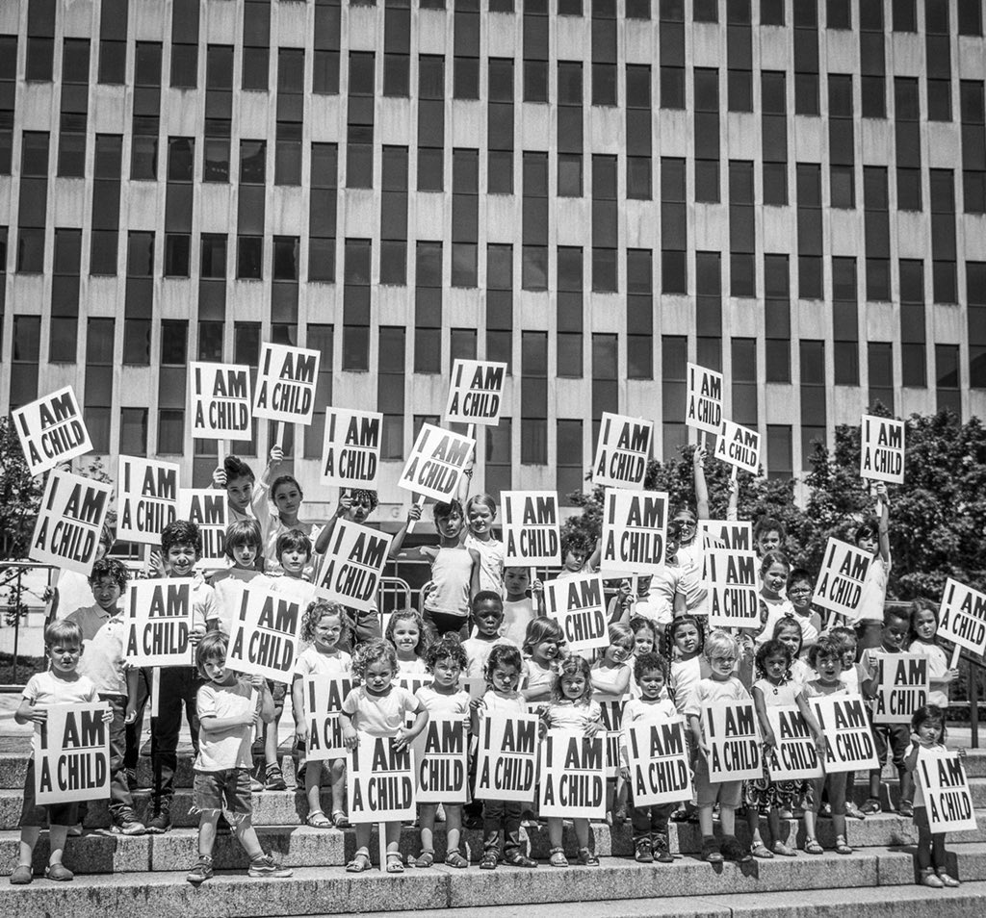
Figure 7:1. The 1968 signs used as a message of protest for 2018 immigrant children (credit: Kisha Bari)

Appendix 8: Historical Photographs
Historical Photos Memphis Sanitation Workers’ Strike 1968

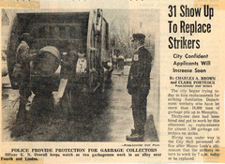 |  | 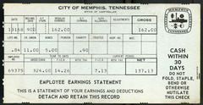
31 Show up to Replace Strikers. (Creator: Brown, Charles A.; Date: 1968-03) |  | This January 31, 1968 pay stub for a Memphis sanitation worker shows he earned $137.13 for 90 hours of work … (Date: 1968-01-31)
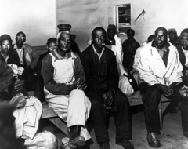 |  | 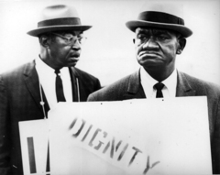
Members of Memphis Local 1733 are seated on benches during the 1968 sanitation workers' strike. (Date: 1968) |  | Memphis Local 1733 strikers demand dignity during their 1968 campaign. (Creator: Copley, Richard L.; Date: 1968)
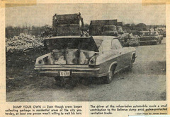 |  | 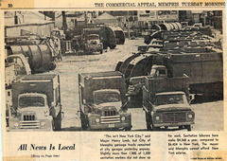
Memphis resident can't wait for crews to pick up garbage and drives own trash to Bellevue dump. (Creator: Shearin, James; Date: 1968)  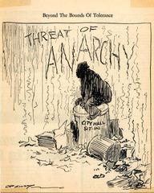 |  | Mayor Henry Loeb said that Memphis was not New York when comparing wages of sanitation workers. (Creator: Sellers, Barney; Date: 1968)  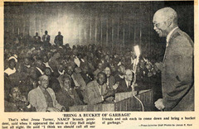
Beyond the bounds of tolerance, a threat of anarchy (Creator: Alley, Cal, 1915-1970; Date: 1968) |  | Jesse Turner tells crowd to bring a bucket of garbage to city hall (Creator: Reid, James R.; Date: 1968)
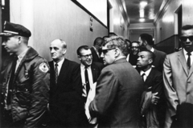 |  | 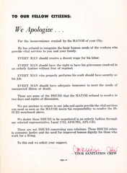
AFSCME International Field Staff Director P.J. Ciampa (left), AFSCME International President Jerry Wurf (middle, with back turned), and then executive assistant to Wurf, William (Bill) Lucy (far right with pipe), receive contempt of court charges on March 6, 1968, during the Memphis Local 1733 sanitation workers' strike. (Date: 1968-03-06) |  | Letter to citizens of Memphis apologizing for the strike and stating that the mayor should negotiate to resolve the strike
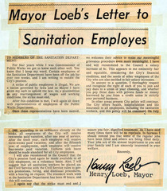 |  | 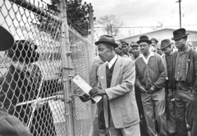
Mayor Loeb's letter in the paper to the sanitation workers telling them the strike is illegal and return to work. |  | Strikers picking up their last pay check on February 20, Scott Street Sanitation Station. Benny Booker, Willie Cartwright and Joe Jackson (left to right). (Creator: Sellers, Barney)
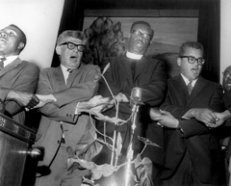 |  | 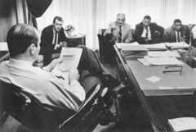
Rev. Ezickel Bell, President Jerry Wurf, Rev. Harry L. Starks and Rev. James Lawson (left to right), attending a striker support rally. |  | Mayor Henry Loeb (far left) meeting with AFSCME Officials on February 13. Joe Paisley, Field representative, P.J. Ciampa, national director of field services, William Lucy, national associate director of legislation and T.O. Jones, president of Memphis Local 1733 February 13 (left to right). (Creator: Sellers, Barney; Date: 1968-02-28)
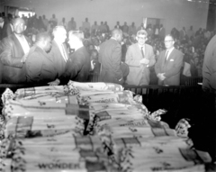 |  | 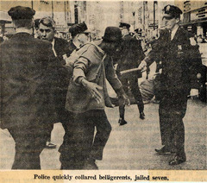
Bologna sandwiches were made for the strikers and supporters at a sit-in city council chambers while they waited for the council committee to reconvene. Nelson Jones, T.O. Jones, John Blair, Joe Paisley, Jerry Wurf and Taylor Blair (left to right). |  | Police quickly collared protesters, jailed seven
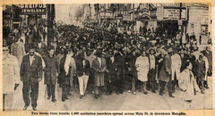 |  | 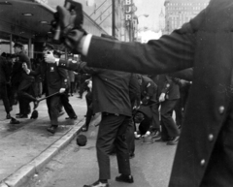
Two blocks from trouble, 1,000 sanitation marchers spread across Main Street in downtown Memphis |  | Police spray mace on AFSCME Memphis Local 1733 sanitation strikers (Date: 1968-02-23)
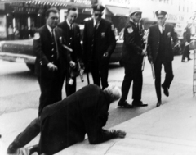 |  | 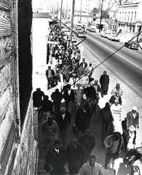
AFSCME international representative P.J. Ciampa is maced by police in Memphis during Local 1733's sanitation workers' strike (Date: 1968-01-23) |  | Protesters march during the 1968 AFSCME Local 1733 sanitation workers strike in Memphis (Date: 1968)
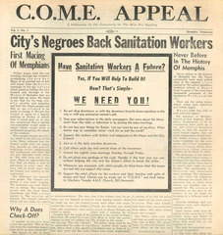 |  | 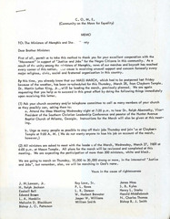
Community on the Move for Equality newsletter Volume 1 Number 1. City's Negroes Back Sanitation Workers (Date: 1968) |  | Community on the Move for Equality letter to Memphis ministers informing them about re-scheduled march with Martin Luther King, Jr. (Date: 1968)
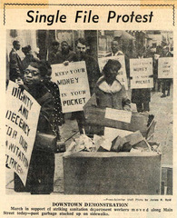 |  | 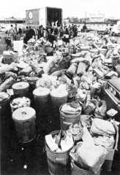
March in support of sanitation workers along Main Street Memphis (Date: 1968) |  | The Parkway Village Jaycees in Memphis dispose of more than 20 truckloads of garbage brought to an area shopping center, February 25. (Creator: Shearin, Jim; Date: 1968-02-25)
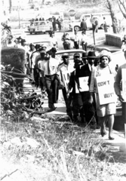 |  | 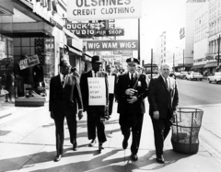
Boycott supporters led by Miss Cornelia Crenshaw. (Creator: Copley, Richard) |  | Rev. H. Ralph Jackson, Rev. L.E. Donaldson, police commissioner Frank Holloman, and Dr. Baxton Bryant, Tennessee council on human relations (left to right). (Creator: Copley, Richard)
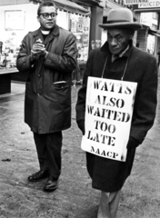 |  | 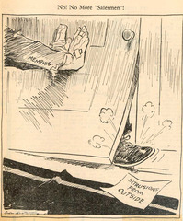
Rev. James Lawson with a supporter of the Memphis downtown boycott. |  | No! No More Salesmen political cartoon saying no more intrusions from the outside. (Creator: Alley, Cal, 1915-1970; Date: 1968)
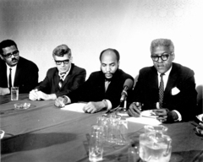 |  | 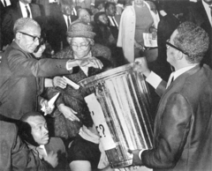
Press conference announcing a launch of national support for the sanitation workers, March 15. Rev. Billy Kyles, Pres. Jerry Wurf, Rev. James Bevel and Bayard Rustin (left to right). (Date: 1968-03-15) |  | Rev. Samuel Billy Kyles used a garbage can to collect money at a rally, Mason Temple, Memphis, March 14. (Creator: Cantrell, Jack E.; Date: 1968-03-14)
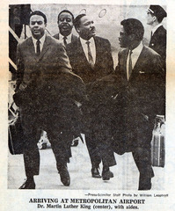 |  | 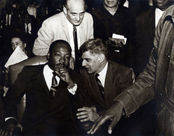
Dr. Martin Luther King, Jr. greeting his supporters upon his arrival in Memphis on March 18, 1968. (Creator: Leaptrott, William; Date: 1968-03-18) |  | AFSCME President Jerry Wurf consults with Martin Luther King, Jr. who traveled to Memphis to lend support to the striking sanitation workers of Local 1733. AFSCME Field Director P.J. Ciampa stands behind them. (Creator: Copley, Richard L.; Date: 1968)
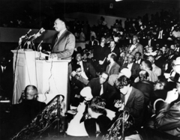 |  | 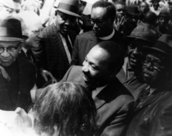
Dr. Martin Luther King, Jr. speaks to a crowd in Memphis during the AFSCME Local 1733 sanitation workers' strike. (Creator: Withers, Ernest C., 1922-2007; Date: 1968-03) |  | Dr. Martin Luther King, Jr. meets with a crowd in Memphis during the AFSCME Local 1733 sanitation workers' strike. (Date: 1968-03)
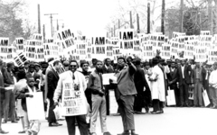 |  | 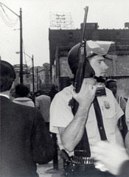
Striking members of Memphis Local 1733 hold signs whose slogan symbolized the sanitation workers' campaign in 1968. (Creator: Copley, Richard L.; Date: 1968) |  | A well-armed Memphis City policeman monitors striking sanitation workers during the 1968 AFSCME Local 1733 strike in support of which Martin Luther King, Jr. lost his life. (Date: 1968-03-28)
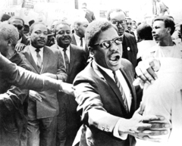 |  | 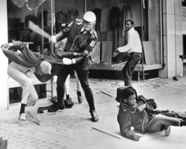
Bernard Lee escorts Martin Luther King and Ralph Abernathy to safety after the march erupted in violence. (Creator: Melhorn, Sam; Date: 1968-03-28) |  | A police officer beats a youth during the violence that erupted during the march. Larry Payne, the 16-year-old in the background, was killed by police later in the day. (Creator: Thornell, Jack; Date: 1968-03-28)
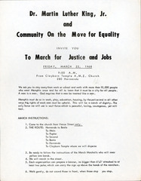 |  | 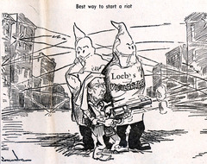
Announcement for the march from the Community on the Move for Equality (COME). (Creator: Community on the Move for Equality; Date: 1968-03) |  | (Date: 1968-03)
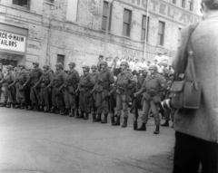 |  | 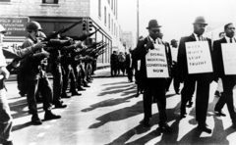
Memphis Mayor Henry Loeb called in the National Guard during AFSCME Local 1733's sanitation workers' strike. (Date: 1968-03-28) |  | AFSCME Local 1733 sanitation workers strike in Memphis with National Guard members looking on, 1968. (Date: 1968)
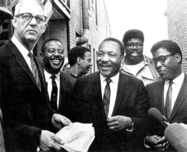 |  | 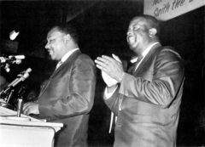
U.S. Marshal Cato Ellis (far left) is serving Dr. Martin Luther King Jr. with a restraining order that forbid the group from leading a march in Memphis on April 8th. Behind Dr. King are Rev. Ralph Abernathy, Andrew Young, James Orange and Bernard Lee (left to right). (Creator: Sellers, Barney; Date: 1968-04-03) |  | Ralph Abernathy (right) applauds Martin Luther King, Jr. as he delivers the "Mountaintop" speech at Memphis's Mason Temple. (Creator: Withers, Ernest C., 1922-2007; Date: 1968-04-03)
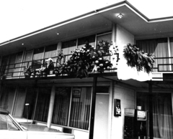 |  | 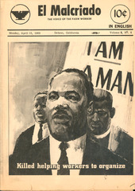
A memorial erected at the spot where Dr. Martin Luther King, Jr. was assassinated at the Lorraine Motel. (Date: 1968-04-04) |  | April 15, 1968 edition of El Malcriado: The Voice of the Farm Worker, commemorating Martin Luther King. (Creator: Zermeno, A.; Date: 1968-04-15)
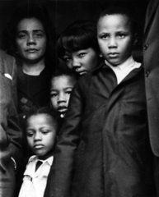 |  | 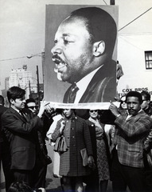
 | Martin Luther King, Jr.’s widow, Coretta Scott King, and their children disembark the plane carrying King's body to Atlanta for his funeral. (Creator: Benson, Harry; Date: 1968-04-08) |  | Mourners and supporters carry a picture of Martin Luther King, Jr. during a memorial march shortly after his assassination--likely the funeral march held in Atlanta. (Creator: Hayes, Guy; Date: 1968-04-08)
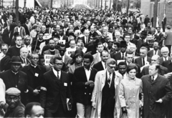 |  | 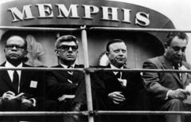
AFSCME President Jerry Wurf and UAW President Walter Reuther march in memory of Martin Luther King, Jr. (Date: 1968-04-08) |  | Seated on the speakers' platform in front of Memphis City Hall at the rally following the memorial march for Martin Luther King, Jr. are from left: Bishop B. Julian Smith of the Christian Methodist Episcopal Church, AFSCME International President Jerry Wurf, UAW President Walter P. Reuther, and AFL-CIO Civil Rights Director Don Slaiman. King was assassinated while supporting striking sanitation workers from Local 1733. (Creator: Copley, Richard L.; Date: 1968-04-08)
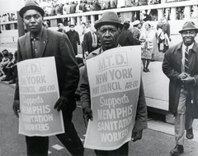 |  | 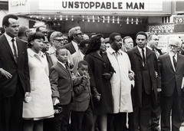
Members of the New York Maritime Trades support striking sanitation workers of AFSCME Memphis Local 1733 by participating in the memorial march for Martin Luther King. (Creator: Copley, Richard L.; Date: 1968-04-08) |  | Labor and civil rights leaders march with the King family in honor of Martin Luther King, Jr. a few days after his assassination while supporting striking sanitation workers of AFSCME Local 1733. First row from left: singer, actor, and civil rights leader Harry Belafonte; King's daughter Yolanda; King's sons, Martin III and Dexter; King's widow, Coretta Scott King; Reverend Ralph Abernathy; Reverend Andrew Young; and Rabbi Abraham Heschel. Second row, beginning right of Yolanda: Bishop B. Julian Smith of the Christian Methodist Episcopal Church; AFSCME President Jerry Wurf; civil rights leader Bayard Rustin; May Reuther and her husband, UAW President Walter Reuther; and AFL-CIO Civil Rights Director Don Slaiman. (Creator: United Press International; Date: 1968-04-08)
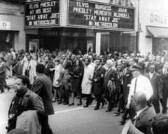 |  | 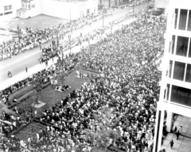
Martin Luther King, Jr.'s family leads the memorial march held in Memphis after he was assassinated while showing his support for AFSCME Local 1733's sanitation workers' strike. To the right of Coretta Scott King and her children Yolanda, Martin III, and Dexter, are Rev. Ralph Abernathy and Rev. Andrew Young. (Creator: Withers, Ernest C., 1922-2007; Date: 1968-04-08) |  | Crowds gather to mourn Martin Luther King, Jr. (Date: 1968-04-08)
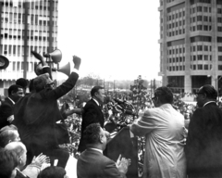 |  | 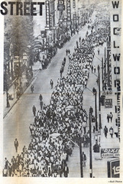
Walter P. Reuther, President of the United Auto Workers, at the podium, with Bayard Rustin, Jerry Wurf and H. Ralph Jackson (left to right). (Date: 1968-04-08) |  | Marchers remember Martin Luther King in Memphis. (Date: 1968-04-08)
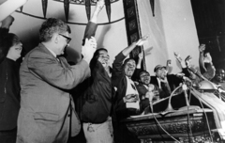 |  | 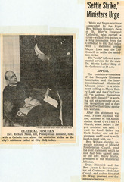
Jerry Wurf celebrates with officers of local 1733 and supporters after ratification. (Creator: Copley, Richard L.; Date: 1968-04-16) |  | Memphis clerics supported the sanitation workers. (Date: 1968-04)
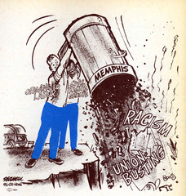 |  | 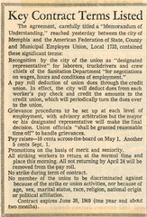
Cartoon about the success of AFSCME and civil rights leaders winning the sanitation workers union recognition and improved working conditions after a 65 day strike. (Creator: Bernard Seaman; Date: 1968-04) |  | Key terms for the contract AFSCME Local 1733 signed with the City of Memphis to improve working conditions for sanitation workers. (Date: 1968-04)
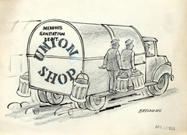 |  | 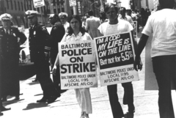
Cartoon showing the success of AFSCME to make the Memphis sanitation workers department a union shop. (Creator: Bellandang; Date: 1968-04-12) |  | Members of AFSCME Local 1195 Baltimore, Maryland Police Union strike in 1969. (Date: 1969)
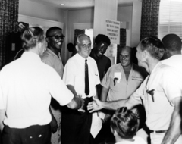 |  | 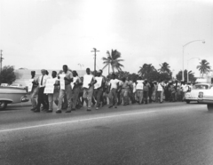
Striking workers congratulate AFSCME Field Staff Director P.J. Ciampa following the union agreement with the city for a representation election. City employees in Miami Beach had struck for recognition of Local 1544 in 1968. (Creator: Ardmore Studio; Date: 1968) |  | Miami Beach city employees protest for union recognition of AFSCME Local 1544 in 1968. (Creator: Ted Press; Date: 1968)
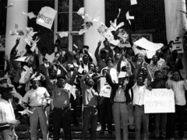 |  | 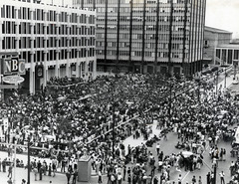
In September 1968, members of AFSCME Local 850, Atlanta, Georgia Maintenance & Sanitation Department Employees, struck for higher wages. (Date: 1968-09) |  | 15,000 supporters jam Memphis City Hall Plaza during a commemoration ceremony on the first anniversary of Martin Luther King, Jr.'s assassination. (Date: 1969-04-03)
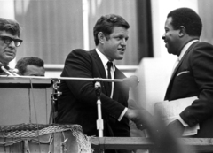 |  | 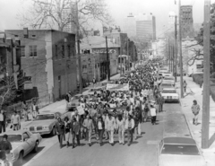
AFSCME International President Jerry Wurf watches as Reverend Ralph Abernathy (right), leader of the Southern Christian Leadership Conference, welcomes Senator Ted Kennedy to the rostrum at the one year memorial for Martin Luther King, Jr. in Memphis in April 1969. (Date: 1969-04-03) |  | AFSCME leads a march in Memphis in 1980 to commemorate the 12th anniversary of the assassination of Martin Luther King, Jr. (Creator: Withers, Ernest C., 1922-2007; Date: 1980-04-04)
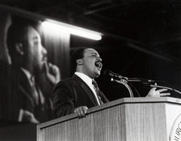 |  | 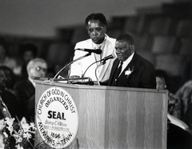
Martin Luther King III speaks at an event commemorating the twentieth anniversary of his father's assassination in the Memphis Mason Temple where King, Jr. delivered his "I have been to the mountaintop" speech. (Date: 1988-04-03) |  | T. O. Jones, the first president of Memphis Local 1733 and leader of the 1968 sanitation workers strike, speaks at an event commemorating the twentieth anniversary of the assassination of Martin Luther King, Jr. Then president of Local 1733 Taylor Rogers looks on. Jones speaks at the Memphis Mason Temple where Dr. King delivered his "I have been to the mountaintop" speech. (Date: 1988-04-04)
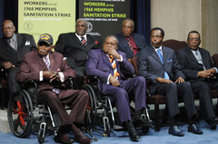
AFSCME Memphis Local 1733 members who participated in the 1968 sanitation workers strike were inducted into the Department of Labor’s Labor Hall of Fame. Front row, left to right: Joe Warren, Russell Walton, Cloe Smith, Herbert Parson. Back row, left to right: Alvin Turner, Baxter Leach, Ozell Ueal. (Creator: Watkins, Fred; Date: 2011-04-29)

Appendix 9: The African Methodist Episcopal [A.M.E.] Contribution to the Memphis Strike

In January 2017, the pastor of Mother Bethel A.M.E. Church located in Philadelphia, Pennsylvania, Rev. Dr. Mark Kelly Tyler, asked me to include something about the A.M.E. contribution to the 1968 Memphis strike. Clayborne Temple, where the strikers met for their daily marches, was an A.M.E. Church. Rev. Dr. H. Ralph Jackson was an A.M.E. pastor and a major supporter of the strike. Jackson's niece, Dr. Beverly Coleman, is a member of Mother Bethel A.M.E. Church in Philadelphia, and the pastor requested that she share the information about the A.M.E. contribution for the opening address of the production. My primary source for the report below are recent issues of the Memphis Daily News.

Clayborn Temple A.M.E. Church served as the home for the Memphis Sanitation Strike in 1968, which was a starting point for the civil rights movement in Memphis. This historic site is located at 294 Hernando Street in Downtown Memphis, Tennessee and is where the iconic I AM A Man signs were created. A meeting of some 1,500 strikers and supporters was held at Clayborn Temple on February 26, 1968. The meeting was sponsored by more than 100 ministers, a few of them white. More than $500 was taken up in a collection for the families of strikers, and gifts and pledges from churches and other organizations brought the total raised to more than $1,500.
Clayborn Temple was at the very centre of the 1968 Memphis sanitation workers’ strike. Thousands gathered before the Clayborn Temple A.M.E. Church on March 28, 1968 prior to a march led by Dr. Martin Luther King Jr. Violence erupted on Beale and Main streets ending the march. Chris Herrington of the Memphis Commercial Appeal Newspaper writes…
‘When we think of physical spaces related to the 1968 sanitation strike and Dr. Martin Luther King Jr.’s time in Memphis, we think of the Lorraine Motel, where King was slain and where the National Civil Rights Museum has risen in his honor. And we think of Mason Temple, where King delivered his “Mountaintop” speech the night before his death. But most of us probably don’t think often of Clayborn Temple, the sanctuary where the March 28, 1968 sanitation strike march, which included King, began, and where fleeing marchers found refuge when the demonstration was aborted’ (Herrington, 2016: online).
When violence disrupted the march, Clayborn Temple became a safe haven. At the River I Stand, Joan Turner Beifuss’ definitive local history of the sanitation strike, offers the most detailed account of all of this:
‘Sanctuary. Clayborn Temple. They came to it terrified, angry, stunned, some hurt, forgotten now the high moment of the cause and Martin Luther King, conscious now only of the need to protect their own bodies and to get safely home out of this nightmare. The church could hold fifteen hundred persons and when its pastor Rev. Malcolm Blackburn got back, every seat on the main floor was taken and groups thronged the aisles. To the pulpit came the ministers and union leaders to make what order they could. The names of lost children were read; instructions were given on how to treat tear gas in the eyes. They would all stay in the church until it was safe to leave’ (Beifuss, 1990: 306).
As Bill Dries reported:
‘[n]ot only was ‘Clayborn Temple a meeting place, it was the place where the marches of the sanitation workers strike began in 1968, including this one in March of 1968 that Dr. Martin Luther King Jr. joined late and later was stopped as it became violent once the marchers reached Beale Street and turned onto Main Street. The church became the gathering point as the march dissolved into violence and chaos. Police chased protesters from Main Street and Gayoso Avenue back to the sanctuary, firing tear gas into the church. The block of Hernando Street on the west side of the church was where those who marched with King gathered for decades after King’s assassination to mark the anniversary of his death and call attention to the issues of new times. The church sanctuary, because of the association with King and the movement, was also an important symbol in the rise of black Memphians to a political majority’ (Dries, 2016: online).

Rev. Dr. H. Ralph Jackson was director of the Minimum Salary Department of the African Methodist Episcopal Church at Clayborn Temple. Black clergymen, under the leadership of Rev. Dr. H. Ralph Jackson, had reacted to the police spraying mace on the marchers by holding mass meetings, directing daily marches, and initiating boycotts of the white newspapers and of the Loeb family stores. Sanitation workers and supporters lined up at Clayborn Temple to begin their march to downtown on March 29, 1968, a day after a march led by Dr. Martin Luther King Jr. ended in violence. Daily marches began and ended at Clayborn Temple. Change came only through protest and activism.
The A.M.E. Church made an indelible contribution to the Memphis Strike. Power concedes nothing without a struggle. Accordingly, the Clayborn Temple A.M.E. Church played an invaluable role in the 1968 Memphis sanitation workers’ strike.

Appendix 10: Save-the-date Card
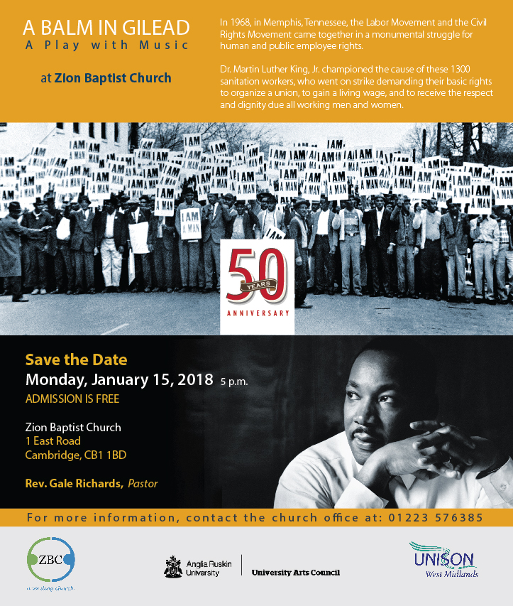

Appendix 11: UK Photos of A Balm in Gilead
Cambridge, UK, 2018
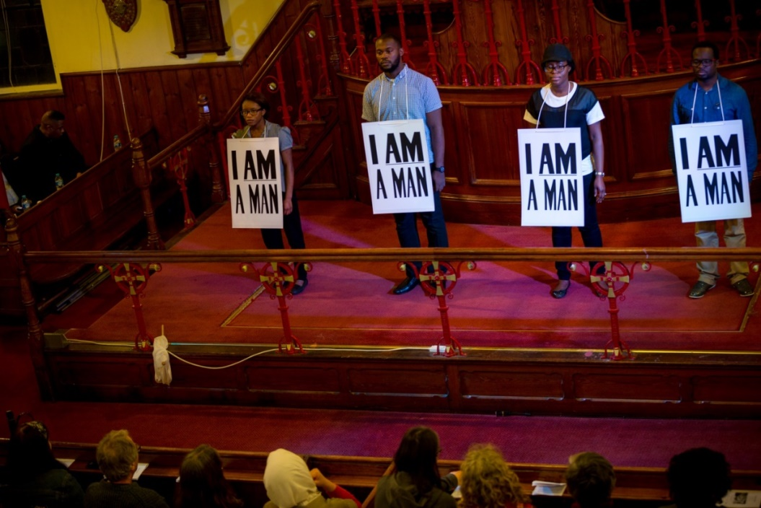
Figure 11:1. Actors in A Balm in Gilead (Cambridge, 2018)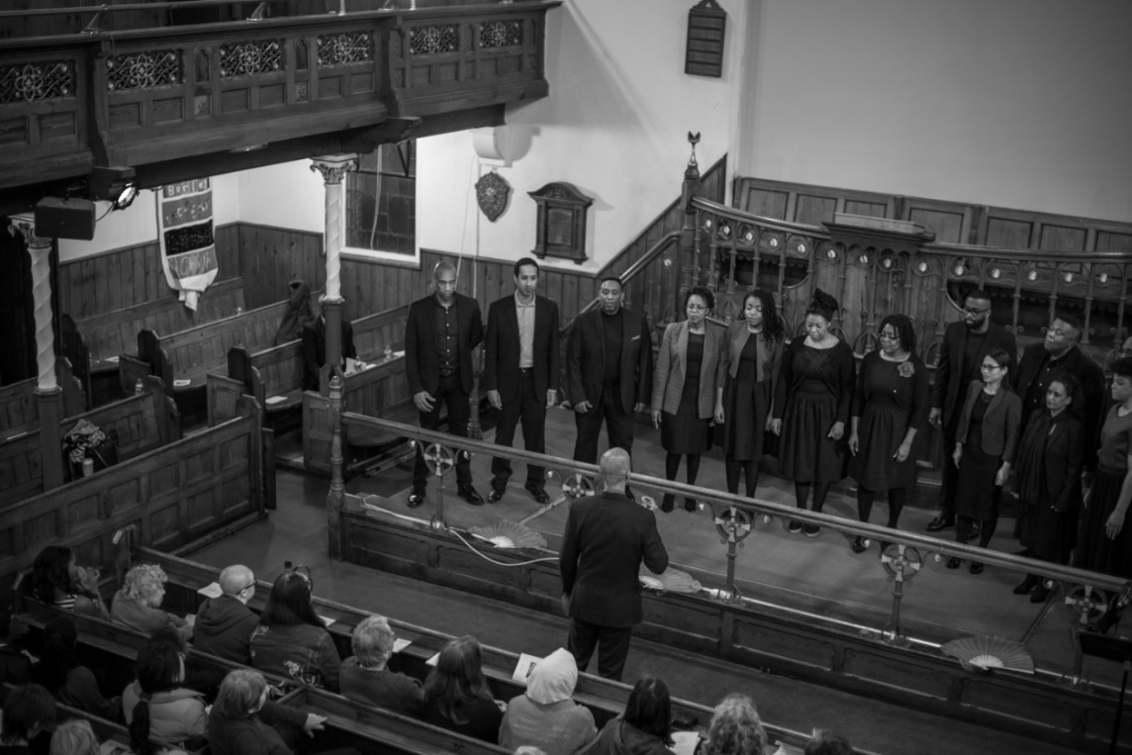
Figure 11:2. The London Adventist Chorale (Cambridge, 2018)
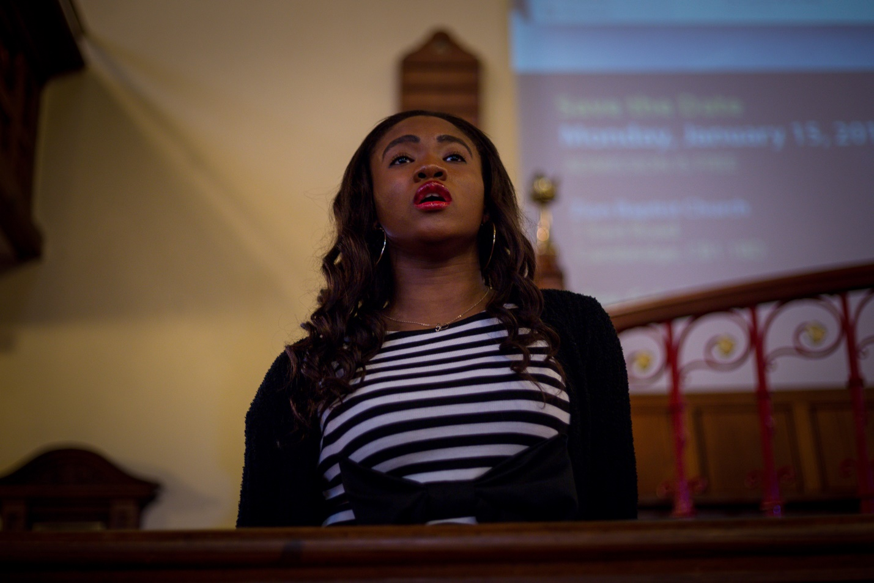
Figure 11:3. Soloist for A Balm in Gilead (Cambridge, 2018)
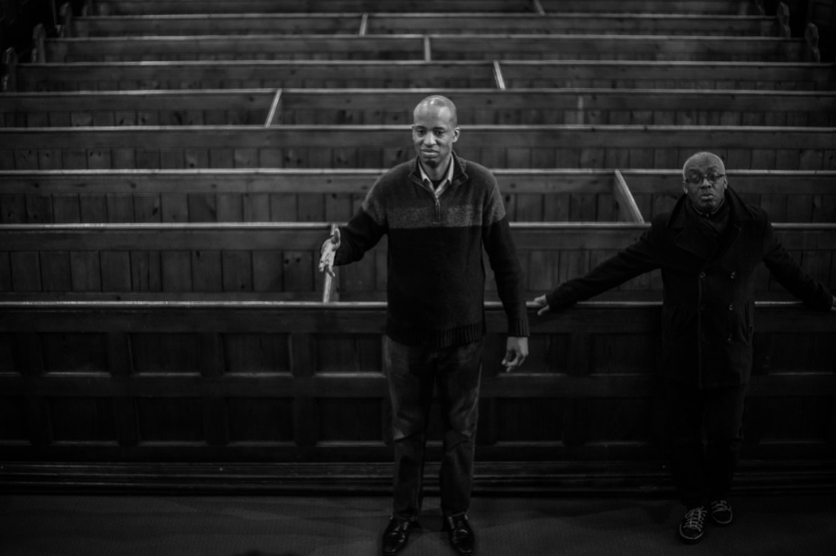
Figure 11:4. Choir Director and soloist (Cambridge, 2018)
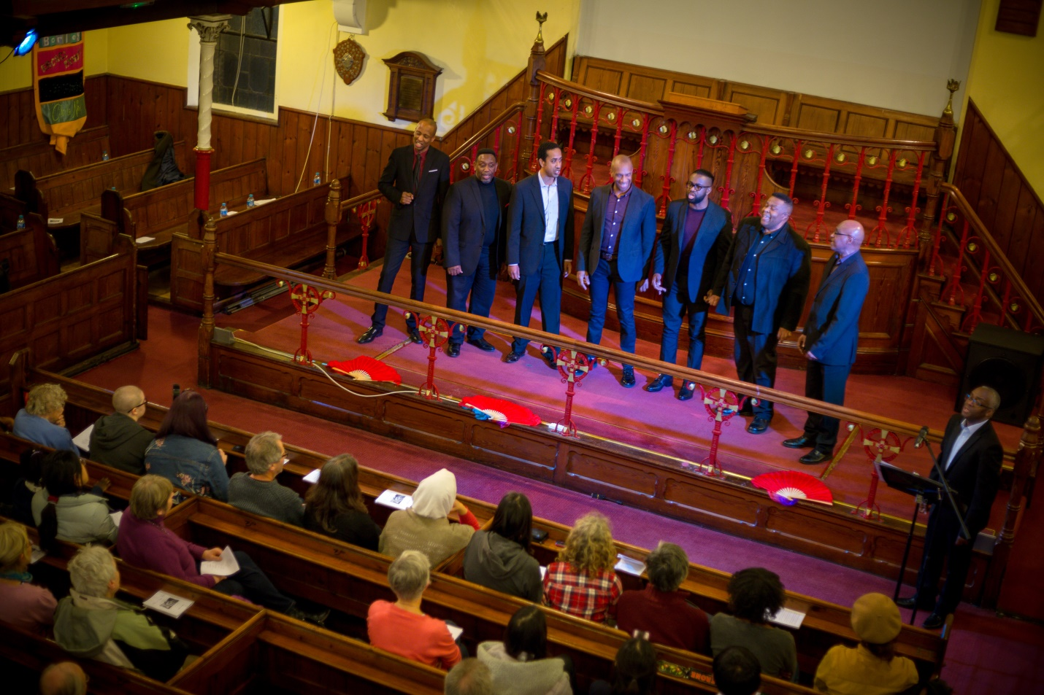
Figure 11:5. Male voices from the London Adventist Chorale (Cambridge, 2018)
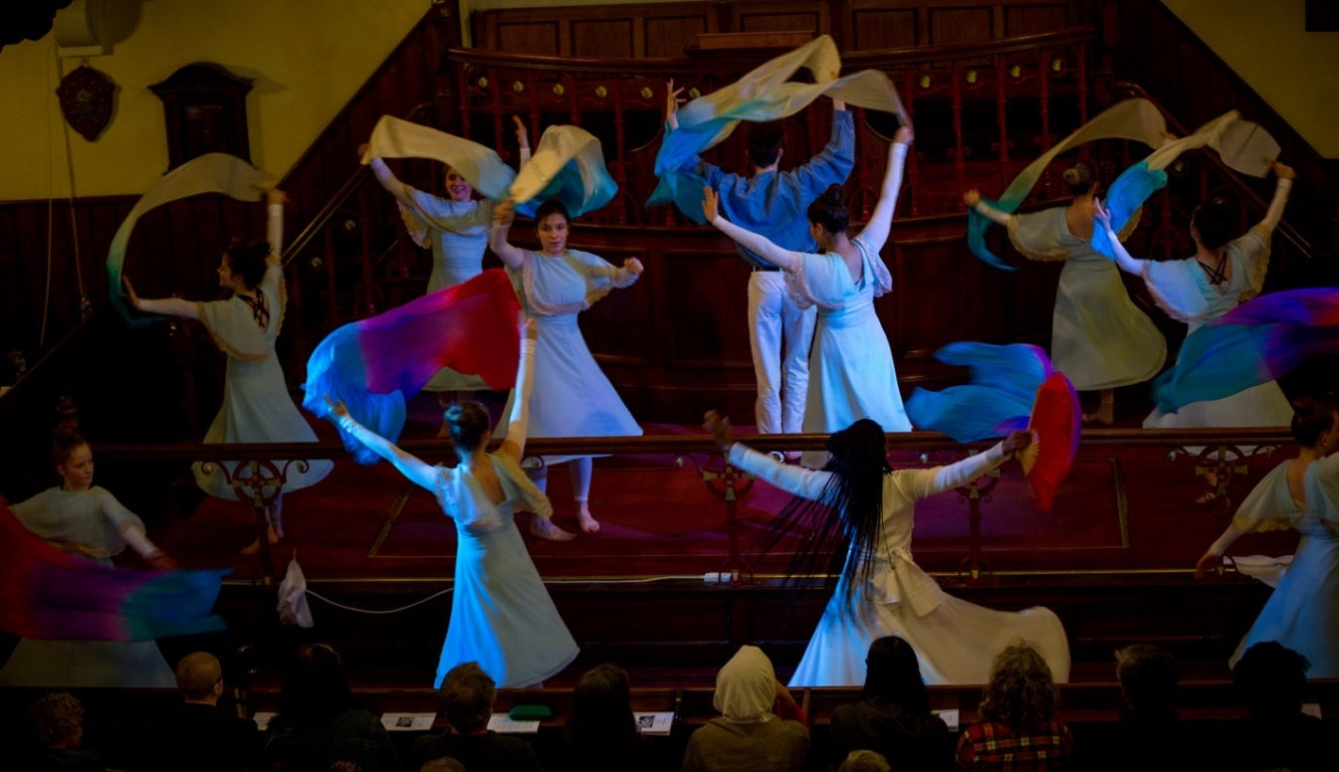
Figure 11:6. Praise dancing by the Elevation Youth Dance Company (Cambridge, 2018)
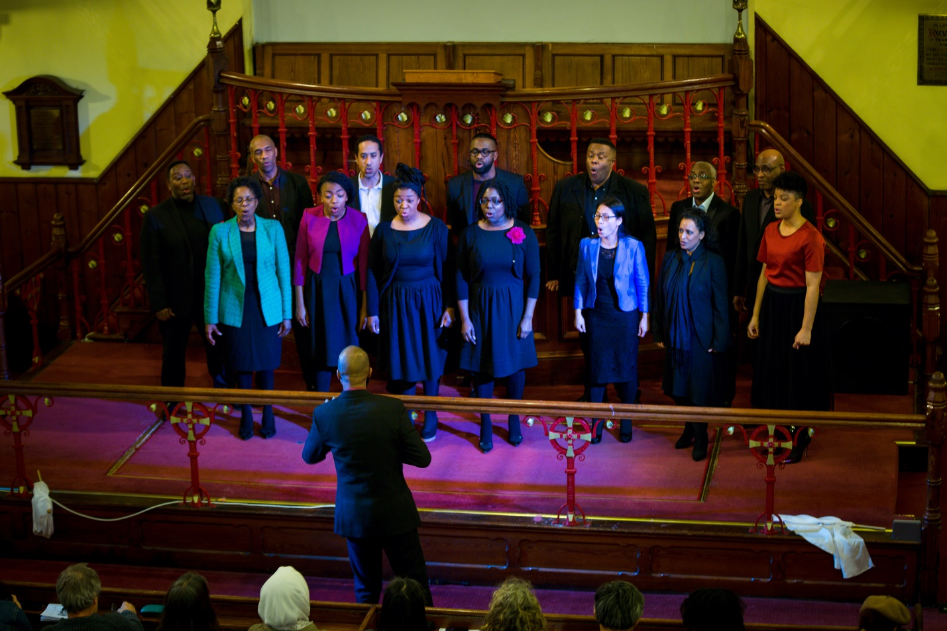
Figure 11:7. The London Adventist Chorale (Cambridge, 2018)
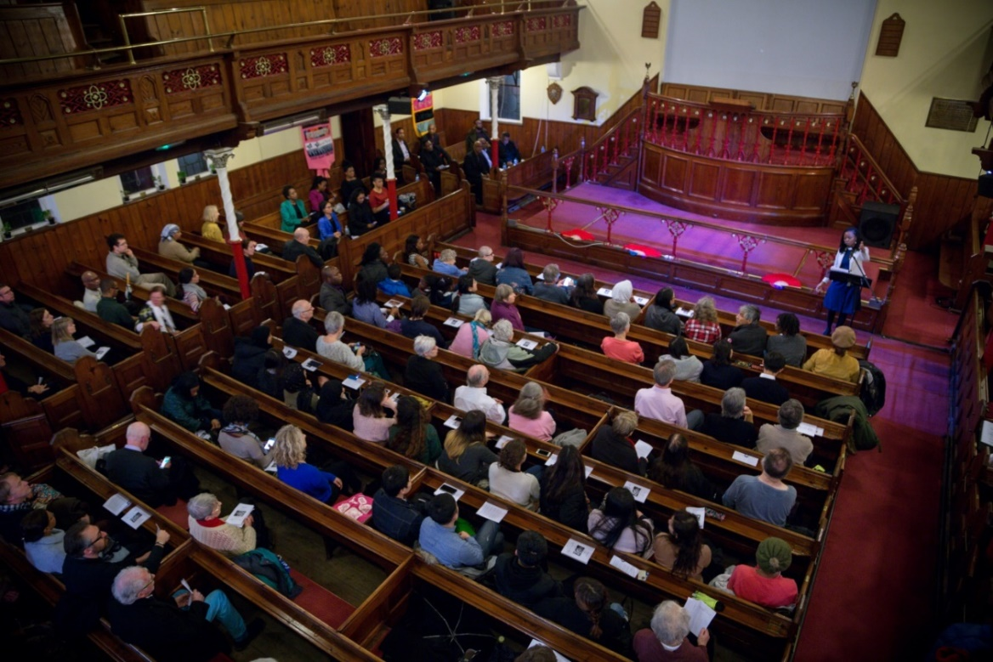
Figure 11:8. Opening address by Rev. Richards, pastor of Zion Baptist Church (Cambridge, 2018)
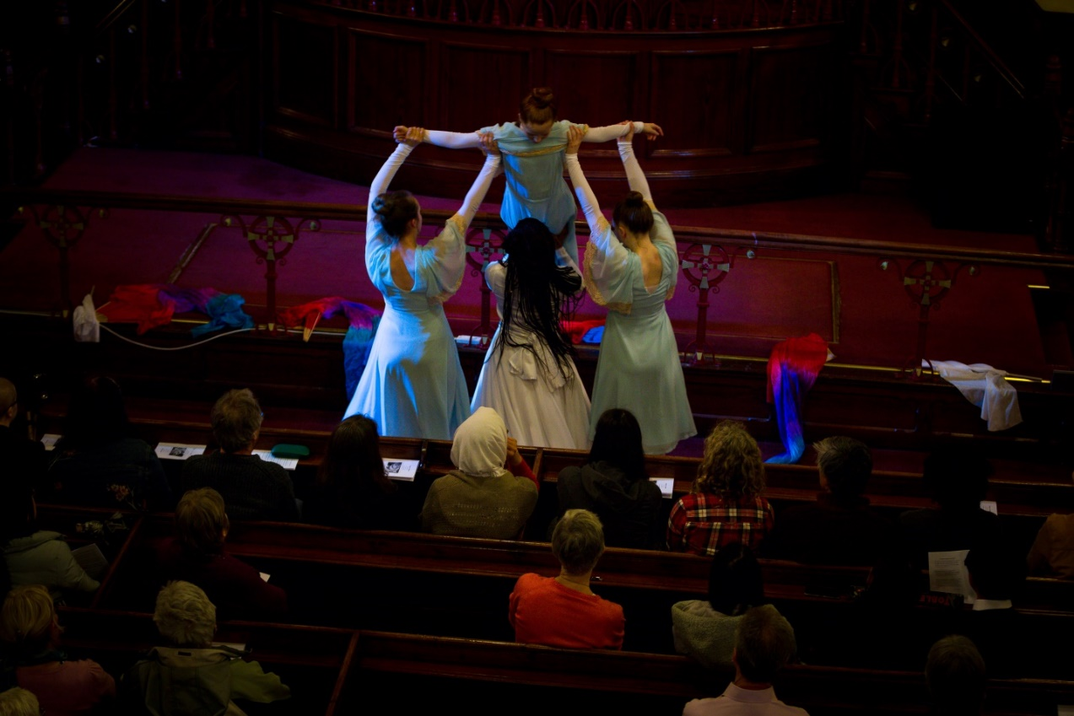
Figure 11:9. Choreographer, Rev. Faye Chandler and Praise dancers (Cambridge, 2018)
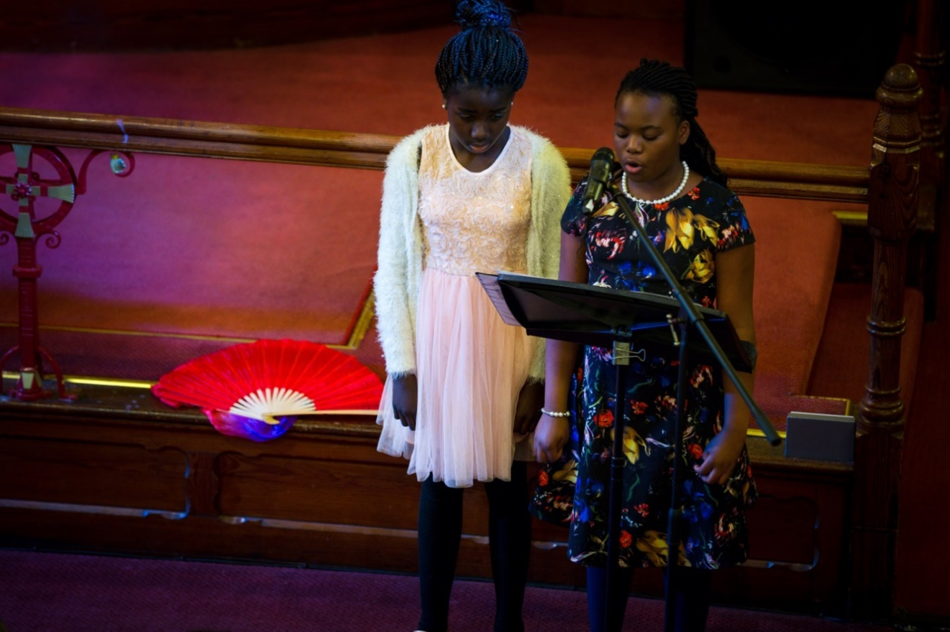
Figure 11:10. Spoken word section by children (Cambridge, 2018)
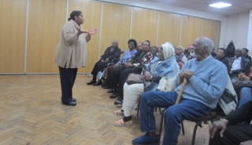
Figure 11:11. Sharon J. Reives introducing performance at a London Adult Day Care Centre (London, 2018)

Appendix 12: Philadelphia Photos of A Balm in Gilead (2017)

Figure 12:1. Child performers at Mother Bethel A.M.E. Church (Philadelphia, 2018)
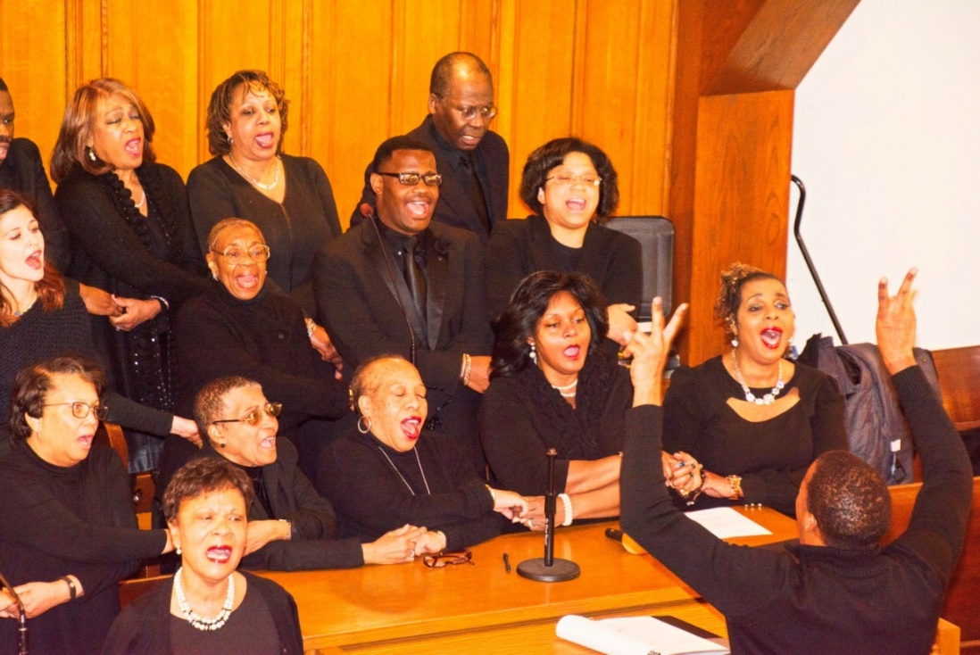
Figure 12:2. Mother Bethel A.M.E. Church Choir (Philadelphia, 2018)
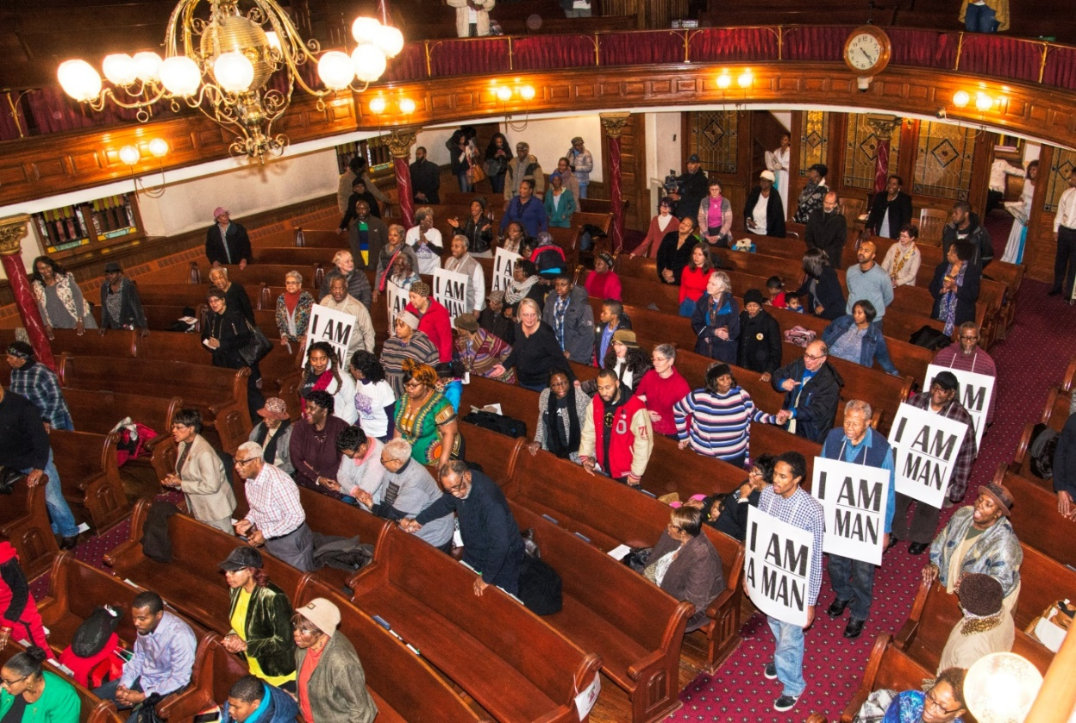
Figure 12:3. ‘I AM A MAN’ sign procession during finale (Philadelphia, 2018)

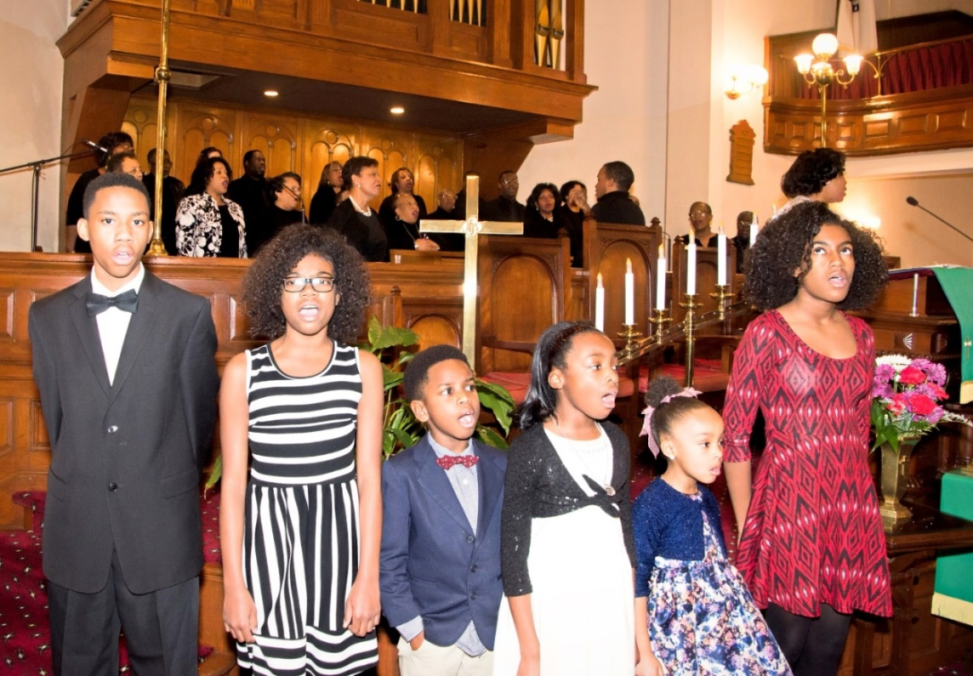
Figure 12:4. Teen and child performers of Mother Bethel A.M.E. Church (Philadelphia, 2018)
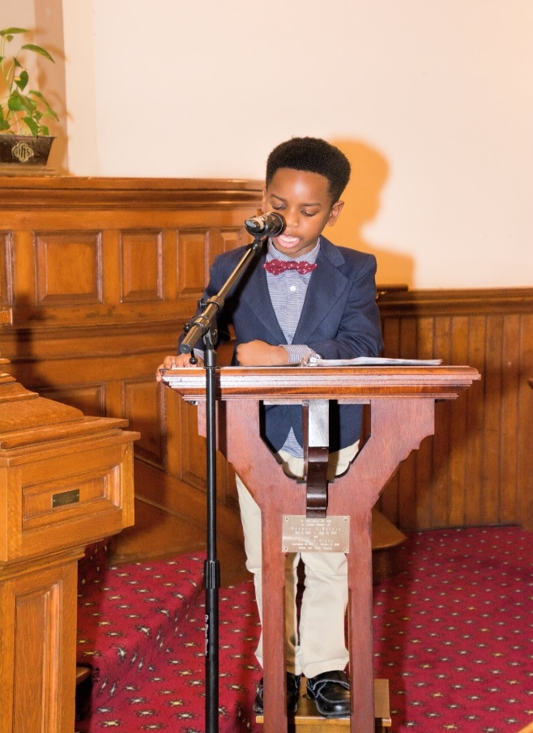
Figure 12:5. Child actor for spoken word section (Philadelphia, 2018)
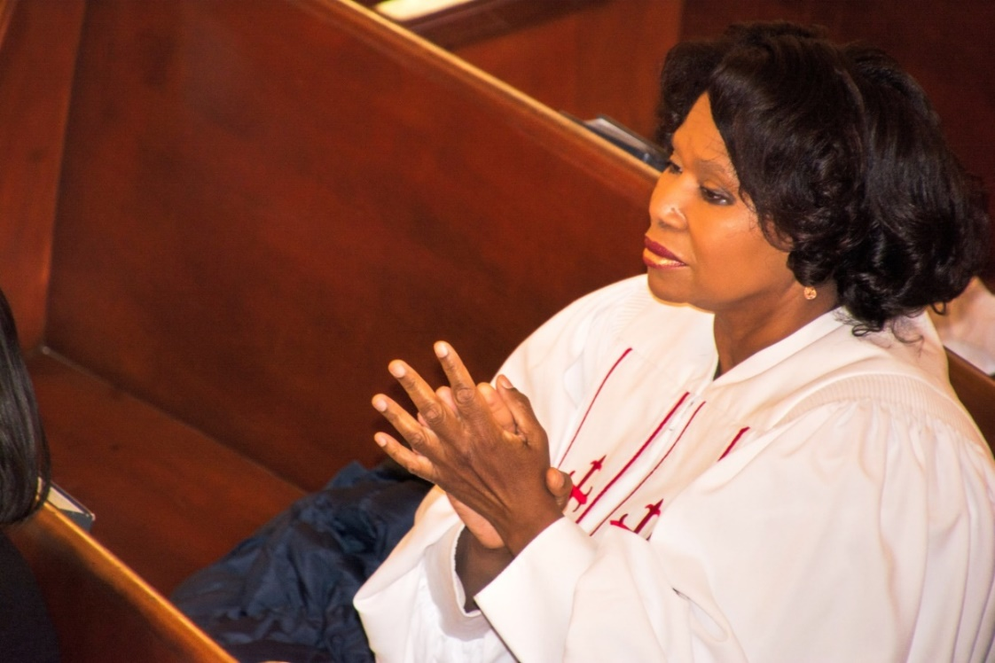
Figure 12:6. Rev. Sharon J. Reives observing praise dancers (Philadelphia, 2018)
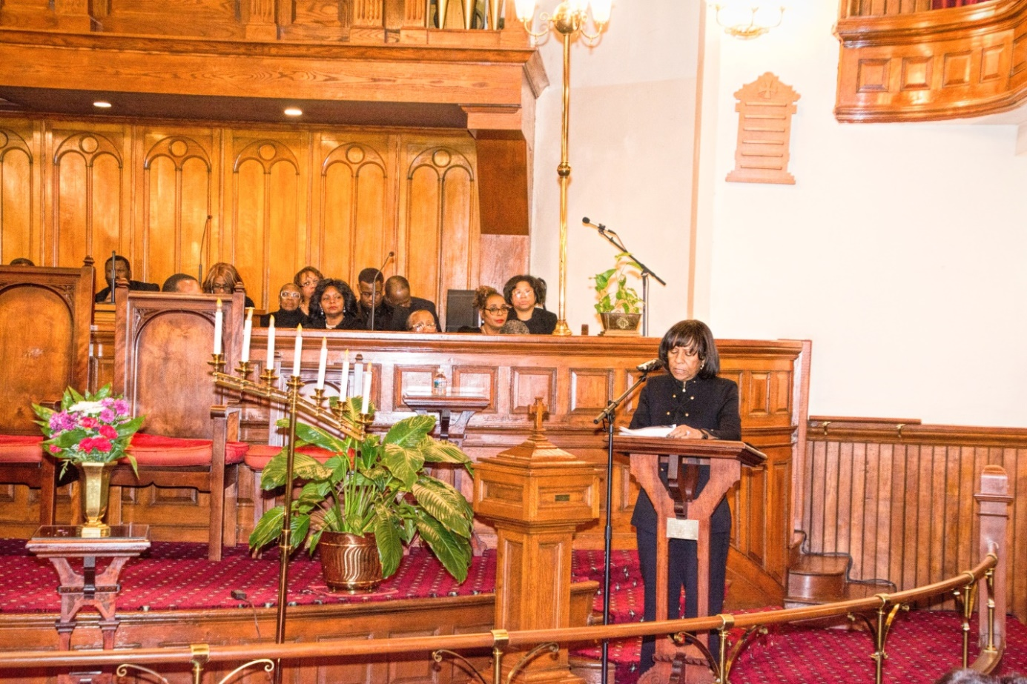
Figure 12:7. Dr. Beverly Coleman shares A.M.E. contribution to Memphis strike (Philadelphia, 2018)
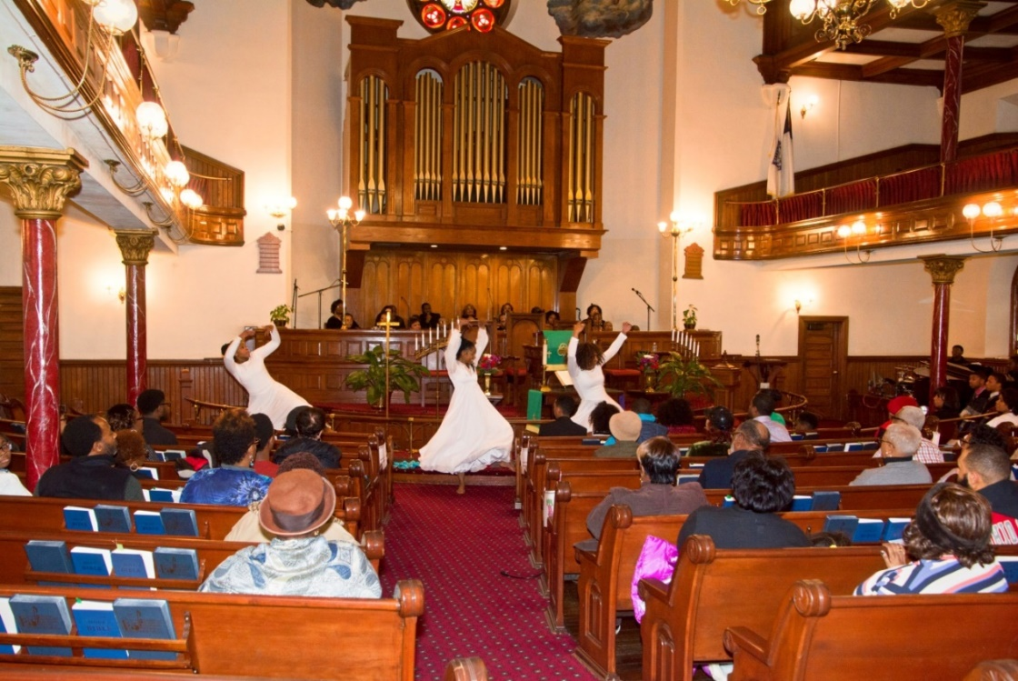
Figure 12:8. Mother Bethel Praise Dance Team with choreographer (Philadelphia, 2018)
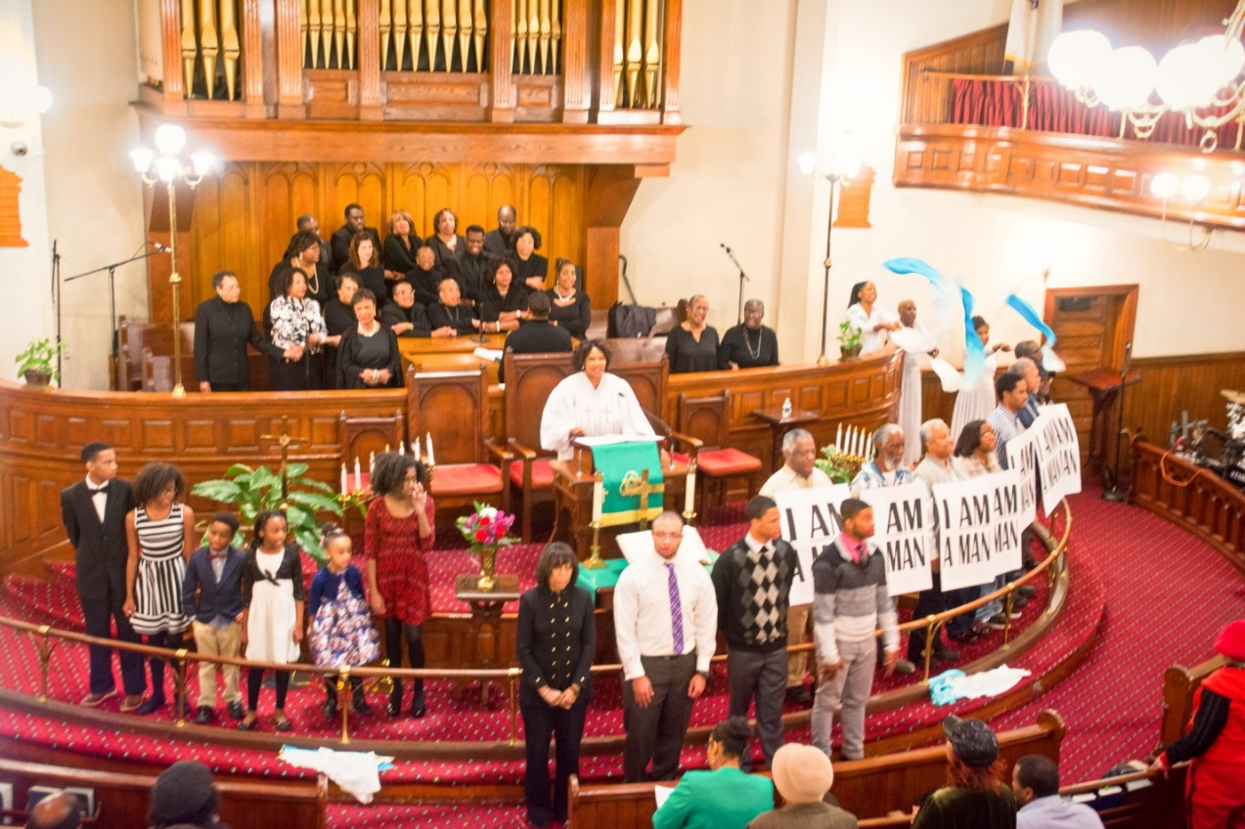
Figure 12:9. Final scene of A Balm in Gilead (Philadelphia, 2018)
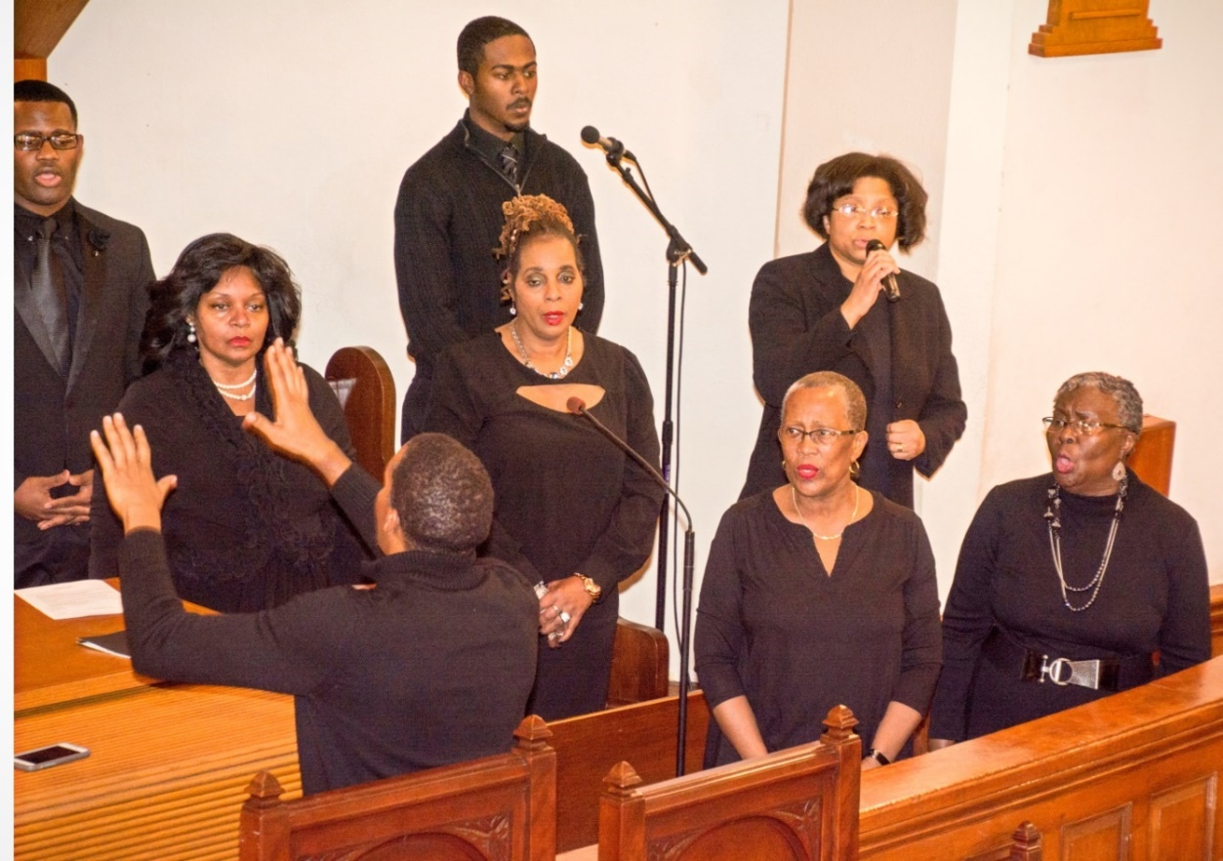
Figure 12:10. Soloist, Joetta Cryer (Philadelphia, 2018)
Appendix 13: Atlanta Photos of A Balm in Gilead (2012-14)

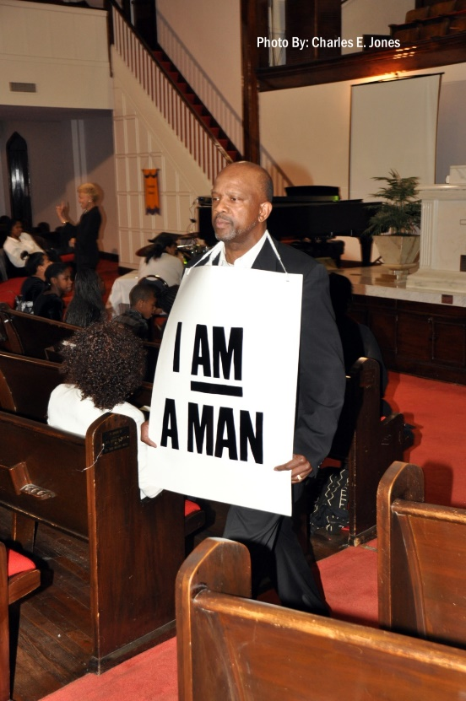
Figure 13:1. ‘I AM A MAN’ actor (Atlanta, 2014)

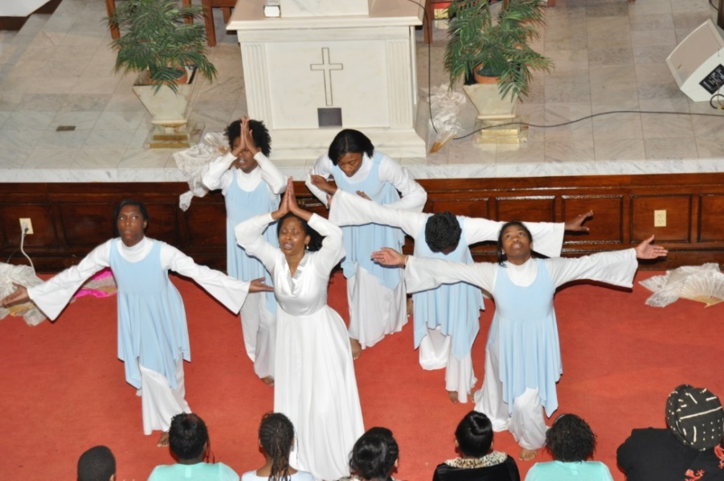
Figure 13:2. Praise Dance Team of Spelman College (Atlanta, 2014)
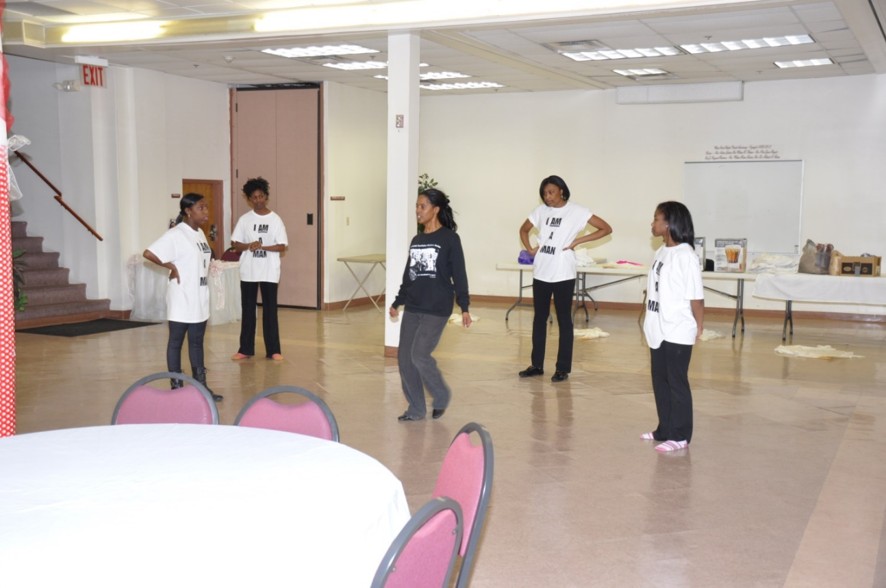
Figure 13:3. Praise dance rehearsal with choreography by Rev. Faye Chandler (Atlanta, 2014)

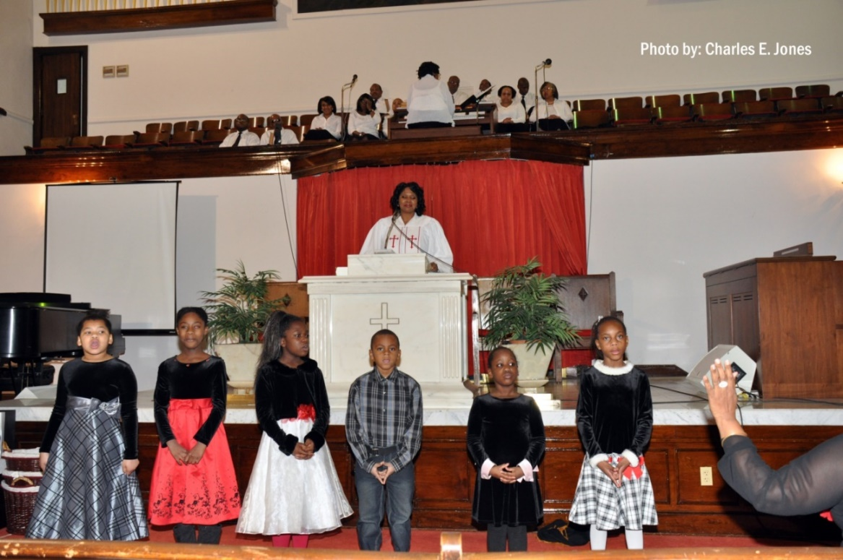
Figure 13:4. Child singers for A Balm in Gilead (Atlanta, 2014)
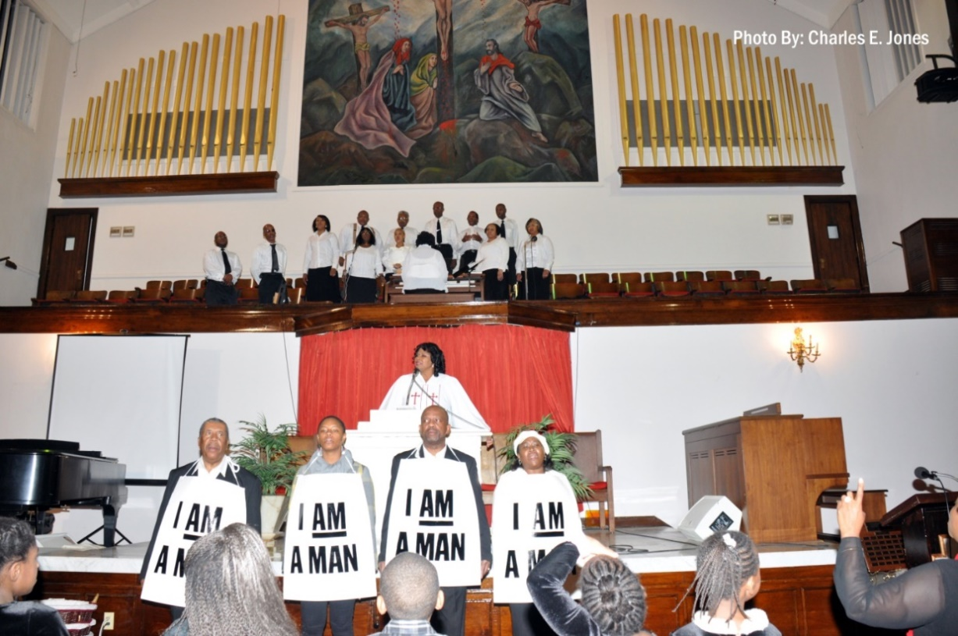
Figure 13:5. Choir, Rev. Reives, and actors at Wheat Street Baptist Church (Atlanta, 2014)

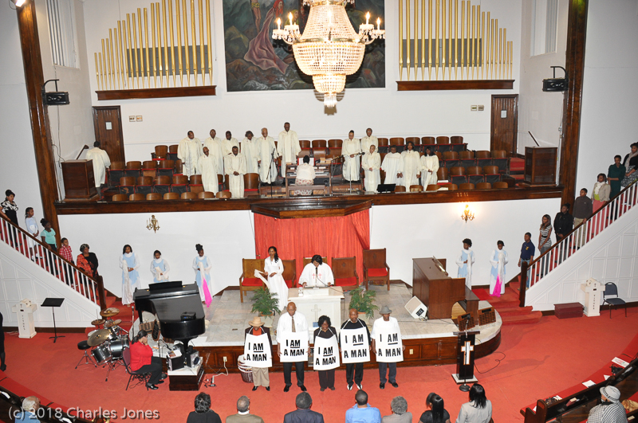
Figure 13:6. Final scene of A Balm of Gilead (Atlanta, 2014)
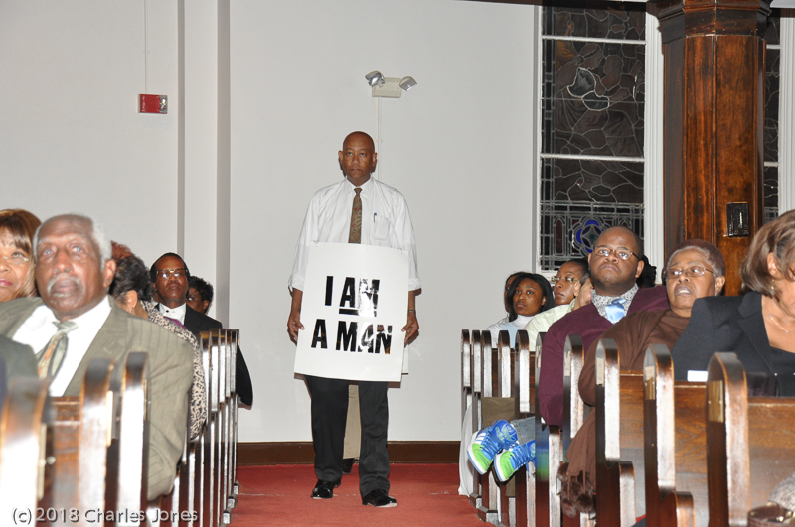
Figure 13:7. First marcher of strikers’ procession (Atlanta, 2014)

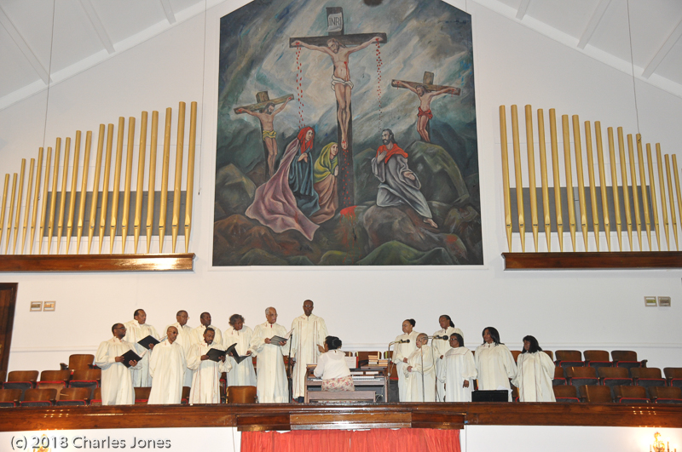
Figure 13:8. Wheat Street Baptist Church Choir (Atlanta, 2014)
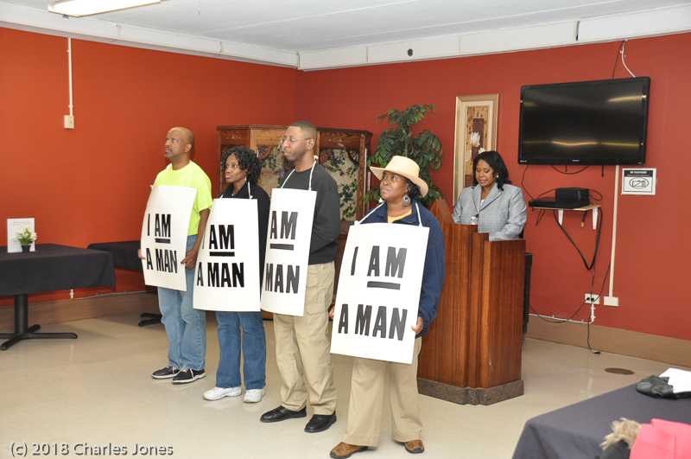
Figure 13:9. Performance segments at nursing home for residents (Atlanta, 2013)
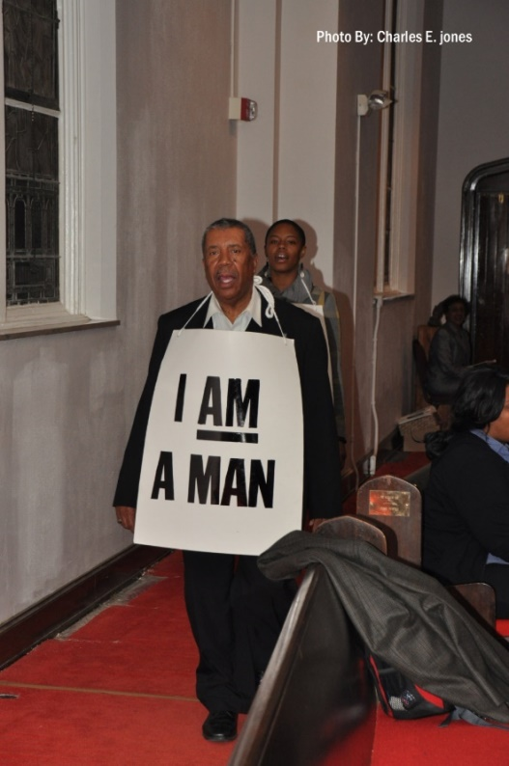
Figure 13:10. AFSCME Union member leads marchers (Atlanta, 2012)
Appendix 14: MLK50: A Commemoration of Dr. King and the 1968 Memphis sanitation workers (2018)
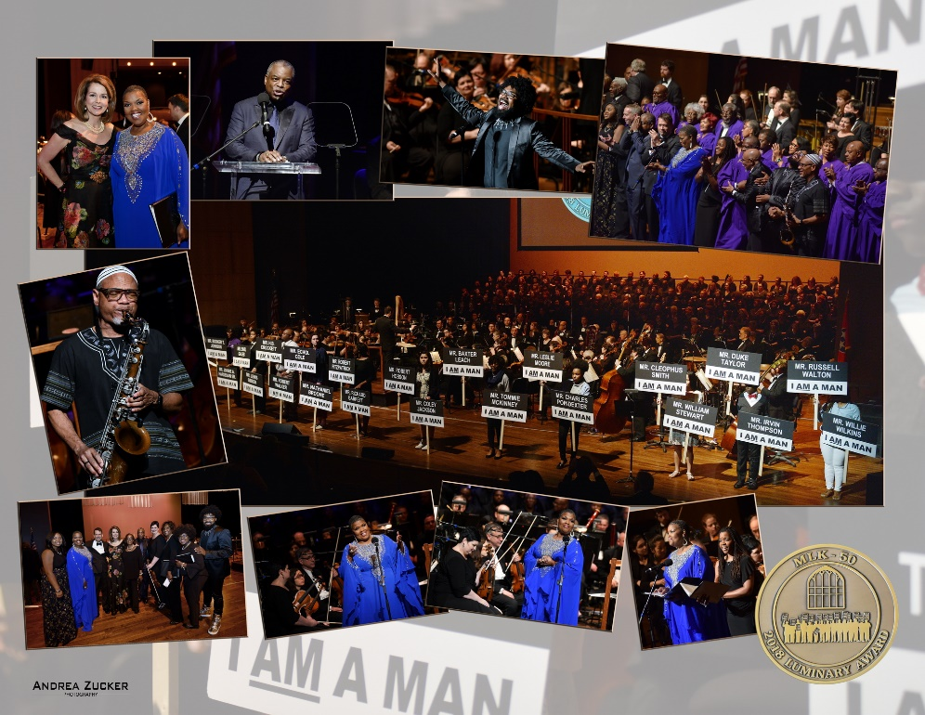
Appendix 14:1. MLK50 Luminary Awards Concert honoured Memphis' sanitation workers of 1968 at the Cannon Center for the Performing Arts on April 2, 2018
Appendix 14:2. Current Mayor of Memphis, Jim Strickland, awards medals to all of the surviving 1968 sanitation workers.
Appendix 14.3. Luminary Award recipient, Mr. Cleo Smith, 1968 Memphis sanitation worker, with Mayor Strickland
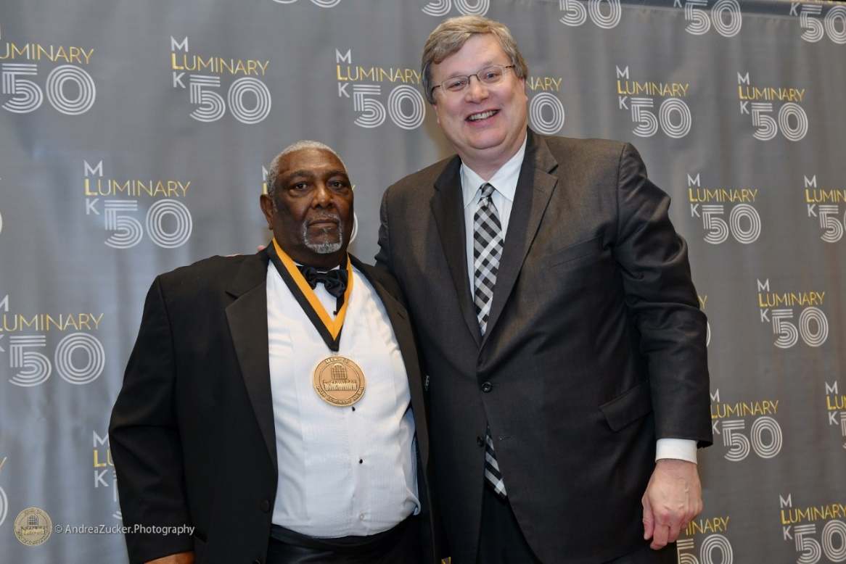
Appendix 14.4. Luminary Award recipient, Mr. Baxter Leach, 1968 Memphis sanitation worker, with Mayor Strickland
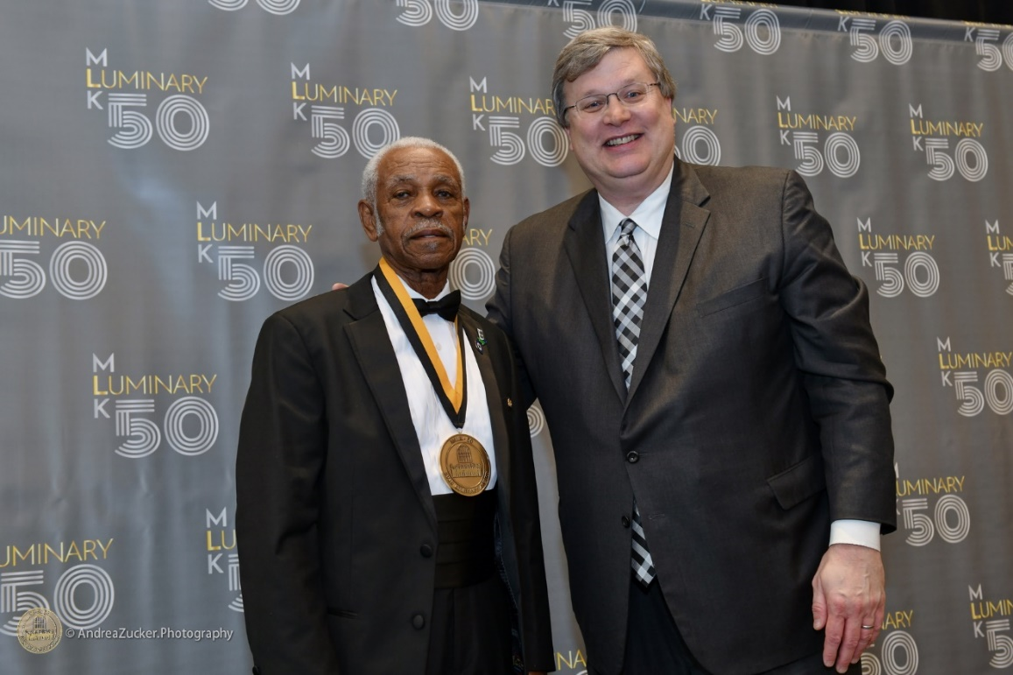
Appendix 14.5. Luminary Award recipient, Mr. Elmore Nickelberry, 1968 Memphis sanitation worker, with Mayor Strickland

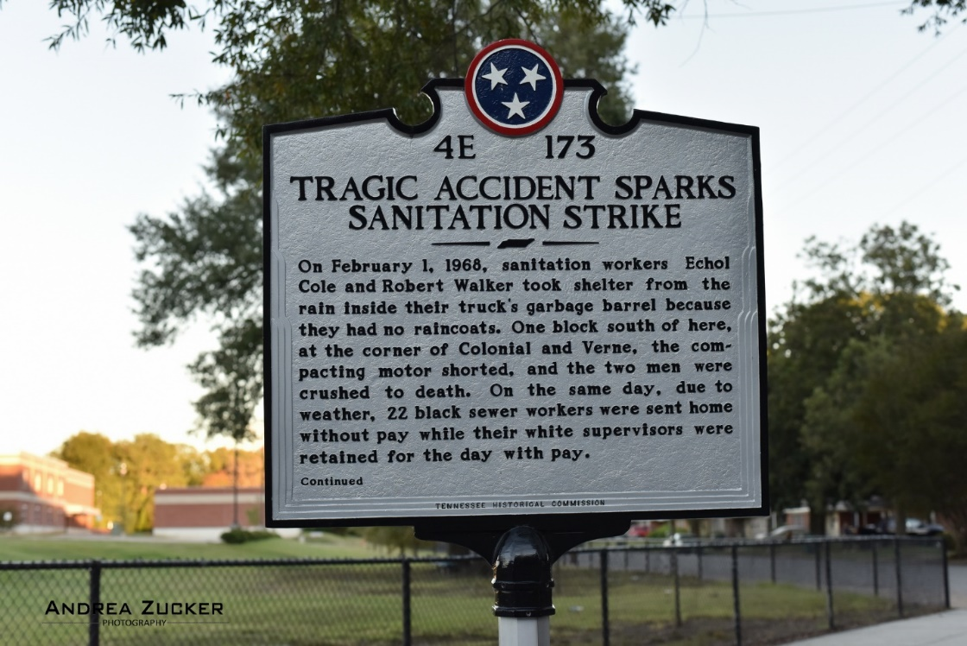
Appendix 14.7. Marker by Tennessee Historical Commission marks the place of Echol Cole and Robert Walker’s tragic deaths.
Appendix 15: A Balm in Gilead Script
A balm in Gilead

Conceived & Directed by
REV. Sharon J. Reives
(Based on “I Wanted To Be A Garbage Man” by Rev. Dr. Frank McRae)

In partial fulfilment of
Doctor of Philosophy Degree
Anglia Ruskin University
Welcome and Invocation……..……..Zion Baptist Church Pastor, Rev. Gale Richards
Teen #1: Rev. Dr. Martin Luther King, Jr. noted that our African American ancestors were of such faith that they could, despite their horrific slave circumstances, take Jeremiah’s question mark (‘Is there no balm in Gilead?’) … and straighten it into an exclamation point, “There is a balm in Gilead!”
London Adventist Chorale……………..………..… ‘There Is A Balm in Gilead’
“I Am On the Battlefield for My Lord / I’m a Solider’
(snare drum transition for medley)
Teen # 2: On February 1, 1968, two black garbage collectors - - Echol Cole age 36, and Robert Walker age 30 – were crushed to death in Memphis, Tennessee, when a garbage truck’s compactor was accidentally triggered. What initially appeared to be just another local tragedy would become the catalyst for change. In 1964, two other workers died under similar circumstances.
Teen #3: Almost two weeks later, 1,300 black sanitation workers began striking for improved job safety and better wages. An earlier attempt to strike did not garner support from Memphis’ religious community and black middle class.
The severity of the situation broadened, however, when Dr. Martin Luther King, Jr. came to Memphis in support of the sanitation workers. The mantra of their movement: “I AM A MAN.”
Teen #4: The Memphis Sanitation Workers’ Strike was a marvellous coalition of the religious community, the civil rights community and the labour movement in the workers’ struggle for dignity, decency, and equality.
Teen #5: It was the Memphis Strike that marked a turning point in the civil rights movement by demanding that the nation see and hear its working poor.

Teen #6: The 1,300 sanitation workers who participated in the historic 1968 strike in Memphis, Tennessee, members of AFSCME Local 1733 were enshrined into the U.S. Department of Labor’s ‘Labor Hall of Fame’ on April 29, 2011.
Eight of the original strikers attended the induction ceremony before a full house in the Grand Hall of the Department of Labor in Washington, D.C.
Video………………………………….……..….’Memphis Comes to Washington’
Liturgical Dance…………………………………………...………… ‘In My Dream’
Rev. Faye Chandler & Elevation Youth Dance Company
The Witness…………………………………………………..Rev. Sharon J. Reives

Ladies and gentlemen… good evening.

In 1968, in Memphis, Tennessee,
the labour movement and the civil rights movement
came together in a monumental struggle for human and public employee rights.

On February 11, of that year, over 1,300 sanitation workers,
nearly all were African American,
went on strike demanding their basic rights to organize a union,
to gain a living wage,
and to receive the respect and dignity due all working men and women.

During the strike, Dr. Martin Luther King, Jr. came to Memphis to support the
workers, and was tragically assassinated.
And 65 days after walking off their jobs, these men returned to work as heroes.
Today we salute the bravery of these 1300 men.

I love this story because… it is a faith story.

And I may I quickly add that it is so… under-represented. It is a story that has been almost lost to history.

This story is told through the voice of a white United Methodist Pastor,
Rev. Dr. Frank McRae, showing how all segments of the Memphis Community were affected by this strike.
The Witness: He says…
When I was a kid, I wanted to be a garbage man.
This was in the 1930’s, when the Memphis garbage men drove two-wheeled, orange-colored horse carts. Their weekly arrival at our home on 1165 Kyle was a special occasion for my brother and me.

Their garbage wagon had high wheels and long spokes.
We got to climb on them and peek over into our neighbor’s loaded trash.
It was pretty exciting, and we also got to pet the horses.

Dead shrubs, raw garbage, and broken bottles were all tossed into this open cart. Little did we recognize the hazards facing these public servants. At Christmas we gave gifts to the garbage men just as we did to our postman and our schoolteachers. These haulers of trash were just nameless characters in our domestic drama. We never knew much about them.

From childhood to adulthood, I seldom gave a thought to the garbage men. I never considered what their work was like. I just guessed that they poured people’s garbage into their rusty, gray tubs and dumped it into their bright orange wagons. I never wondered why their carts were painted orange. I never realized how smelly their world was. I never knew that liquid garbage drained over those who once toted garbage on their heads. I never realized that they had no place to wash their dirty hands. I never saw them wear gloves. They just did their work in silent submission.
I never knew their names or where they lived. I never knew if they had children who called them ‘daddy.’ I never knew how much money they earned. Did they ever get sick? Did they get paid if they were sick? Did they go to church? They were just faceless employees, but when I was a kid,
I wanted to be one of them.

Then one day my hometown blew up in our faces!
These benign garbage collectors set off an explosion, which disrupted my city and changed it forever. What began as a labor dispute for better working conditions, cascaded into the most significant event in 20th Century Memphis.
Who were these garbage men and how did they change the course of modern Memphis history? Not since childhood had I come in contact with these dealers in the city’s dirt. How were they able to cripple my city?
What began as a disruption of a public service, ended with a national event and a wake-up call to a sleepy town. From almost every dimension of the city came voices of support or rejection of the sanitation workers’ demands. When your garbage is not collected on schedule, the situation becomes personal very quickly.
(IMAGES OF OVER-RUN GARBAGE FROM THE 1968 STRIKE)

As the Memphis District Superintendent for the United Methodist Church, I became involved early in the controversy. The first meeting I had with an official of Local 1733 of the American Federation of State, County, and Municipal Employees, which represented the striking workers, was fresh revelation to my thirty-seven-year-old white mind set. I was immediately suspicious and defensive. Why had these outside union agitators targeted my peaceful city for their disruption? Later, I would develop a more definitive response to that question.
I was a close friend of Mayor Loeb, who quickly emerged as the villain to these workers. I had voted for Loeb. I had offered the invocation when he was sworn into that office. I trusted his leadership. I knew that he would protect this city from harmful, exterior elements. He had my support.
Then… I met the garbage men.
(ENTER SANITATION WORKERS)

SONG: "Stand” by John P. Kee (Actors march in wearing "I AM
A MAN" Signs; recording of “Stand” is played as actors enter).

I discovered early that these were not law-breaking, greedy, unreasonable, disloyal agitators. They were hard-working, almost powerless adults. They only asked for a fair shake from their municipal bosses. They were weary of injustice. They deserved more for themselves and their families, and thus they joined hands and said so. When I learned about their working conditions, I wanted to cry in disbelief. Their weak demands seemed fair as payment for the service they provided. I would not have done their work for ten times their pay.
When I grew up the garbage man was on the lowest rung of the social ladder. But he performed a difficult job, which was described by the mayor as essential to the public safety of the city. How could such a lowly position be described as vital to the community’s well-being? Why were these men paid such a weak wage for such a critical function? The answer would be revealed in time.
I met the Sanitation Workers first in the basement of Clayborn Temple. Food was being distributed to the strikers’ families. I had never seen anything like it. Flour and sugar and canned goods were being stuffed into brown grocery bags. It was a joyful and a sad scene. What was most impressive was the gratitude of the workers. They were finally feeling the support of the community.
They realized that they had taken a dangerous step by striking. They had felt the curses of those inconvenienced by their actions. But now different eyes viewed them as heroes. Their courage was rewarded. They now had hope. Now there was the added dimension of dignity, which had been a stranger to them previously. For me, it was quite a sight. I was both proud and uncomfortable when the National United Methodist Church sent funds to feed the striking workers. I knew how it would please the workers and enrage many pew-packing Methodists, and I was their District Superintendent, responsible for interpreting the Church’s actions.
As the days crept by, the battle lines were formed. All segments of the Memphis community were attempting a solution, but all had failed. Politicians and preachers, lawyers and union members, academics and Boy Scouts… all had opinions, but no solutions fell. It seemed that the conflict would never cease.
Then… Dr. Martin Luther King, Jr. came to Memphis, and the people held their breath.
The Witness: (The Sanitation Workers gather around King as he delivers his speech)
"Nothing would be more tragic than to stop at this point in Memphis...

Sanitation Workers: We've got to see it through.

Be concerned about your brother.
You may not be on strike.
But either we go up together,

Sanitation Workers: or we go down together.

The question is not: If I stop to help this man in need, what will happen to me? The question is...

Sanitation Workers: If I do not stop to help the Sanitation Workers,
what will happen to them?
That's the question!

And so I say we’re not gonna let any dogs
or water hoses turn us around.
We aren’t gonna let any injunction turn us around!
(Cries and shouts from the crowd)

We're gonna march again.
And we’ve gotta march again…
in order to put the issue where it’s suppose to be.
And force everybody to see that there are 1300 of God’s children
here suffering…

Sanitation Workers: sometimes going hungry!
(King pauses here)

Now, about injunctions…
We have an injunction and we’re going into court tomorrow
morning to fight this illegal, unconstitutional injunction.

All we say to America…
be true to what you said on paper.
If I lived in China or even Russia or any totalitarian country,
maybe, I could understand some of these illegal injunctions.

Maybe I could understand the denial of certain basic First
Amendment privileges because they haven't committed themselves
to that over there.
But, somewhere I read…
Sanitation Workers: of the freedom of assembly.

Dr. King: Somewhere I read…

Sanitation Workers: of the freedom of speech.

Dr. KING: Somewhere I read…

Sanitation Worker: of the freedom of press.

Dr. KING: Somewhere I read…
that the greatness of America

Sanitation Workers: is the right to protest for right!

The Witness: Union actions were followed by police reaction. Store windows were shattered, and armed troops came to Main Street. Patience was an infrequent visitor. Sides were taken, primarily along racial lines.

The Mayor, who opposed the sanitation workers’ demands, was an ally to be trusted. He was an experienced politician and a caring person. But my sympathies were shifted early to the humble garbage men. I held a unique and uncomfortable position. I was trusted by both sides, but not completely by either. My goal, like others, was to bring about a reasonable resolution as quickly as possible. But what resources did I possess?

Soon I would discover what I had never known;
Speaker 1: the enormous power of people committed to an ideal
The Witness: Commitment can bring change.

Speaker 2: Total commitment can bring total change.

The Witness: Politicians and union organizers threw the same curses at one another. Their efforts varied. But the courage of the voiceless men made loud noises in the streets of Memphis. No one needs to glamorize the role of these sanitation workers. Their stand against intolerance was documentation enough for those who could see beyond fear.

Sanitation Workers: beyond fear!

The Witness: beyond racism,

Sanitation Workers: beyond racism!

The Witness: and beyond injustice

Sanitation Workers: And beyond injustice!

The Witness: They risked all they had because they felt they were right…

All: And they were!
The Witness: Indeed, they were.

SONG: “I Feel Like Going On” (Sanitation workers exit while singing).

The Witness: (Instrumental music continues) As is often the case… because truth is on their side, a minority prevails over the majority. The so-called ‘little people’ turned around the power people of Memphis.
The contagion of courage brought a powerful leader to the city.
Whether or not Dr. King’s presence or his death turned the tide in Memphis is left to historical speculation.
But… without the fortitude of those who dared to claim what was theirs, King would not have come. Memphis would have perpetuated the intolerance.
What are the messages from that Memphis… of more than five decades ago?

***From a theological perspective… there are continuing claims of God’s intervention on behalf of the sanitation workers.

***From a political vantage, victorious players are quick to claim credit.

Union operatives declared their strategies as the margin of success… which ultimately ended this critical time… in that River Town.
What the garbage men learned was the importance of organized actions… to reduce injustice.

***It was a people of faith who united their struggle… it was a Jew named Jerry and a Christian named Martin who challenged evil… and won.
God’s Spirit is always the champion of truth… and justice… and righteousness.
The presence of God was felt by the Memphis Sanitation Workers because their cause was justified.
They were purely within God’s will.

***Victims of injustice are always the priority of the Divine Spirit.
The flavor of the 1968 Memphis job action was peaceful, worshipful… and blessed.
The “little people” rejected tyranny and accepted the weapons of non-violence to win a victory.
***It is the teaching of Christian Scriptures.
Victory for the Sanitation Workers was greater than a 15 cents-an-hour wage increase.

It was… a testament to their courage… their determination… and their commitment to a dream.
*****Historians will forever debate the merits and folly of the actions of the Memphis Sanitation Workers.
Claims and false claims will continue.

But… no one will doubt the determination of 1,300 men who met injustice… and changed it. (Instrumental music ends here.)
Teen #7: And in the timeless words of Dr. King…
“Let us stand with a greater determination. And let us move in these powerful days, these days of challenge, to make America what it ought to be.
We have an opportunity to make America a better nation.”
The Witness: *****Today’s Memphis recognizes the changes evolving there. It all dates to 1968, and the last stand of Rev. Dr. Martin Luther King, Jr.

Garbage men have become… sanitation workers.
White compactors have replaced orange horse carts.
Garbage men no longer confront backyard dogs.
Citizens wheel their trash to the curb once or twice weekly.
The workers wear gloves to protect their hands.
The garbage man’s social status has been elevated as little as his
hourly wage. But his story is heroic history.

Annually, the people still march in the street to remind the city once again… ‘I AM A MAN!’

What has been God’s role in the modest elevation of the ‘little people’s’ lot in life? Who can say?
Claims made disclaimers balance out each other.
But, ask the veterans of Local 1733: they will tell you that God was with them. Whether or not their action would have resulted in glory or defeat… they felt God’s Hand on their shoulders.
What they lacked in Systematic Theology… they possessed in the Presence of the Holy Spirit. And no one can shake their belief in what God did through them.
(Children enter)
The Witness: Maybe that is God’s usual way of self-preservation. The ‘little people’ always seemed to win Jesus’ favor:
Child #1: the poor
Child #2: the blind
Child # 3: the hungry
All: the children!
The Witness: Jesus cared for them all… in special ways.

Jesus’ view of greatness surrounded those who were vulnerable,
those who were in need, and those who were the servants of all.

The culture will never name the weakness as strength, but Jesus declared the slave to be master.
My boyhood dream of becoming a garbage man will never be fulfilled.
But, these courageous men of the 60’s Memphis have revealed to me the real meaning of greatness.
(Children begin to sing “We Shall Overcome” a’cappella, then, music begins and choir cast, and dancers join the singing:)
- We Shall Overcome… Someday
- We Are Not Afraid
- The Lord Will See Us Through
- We’ll Walk Hand in Hand
- God is on Our Side… Today

Finale: (with cast, choir, children and dancers)
- Curtain Call
- Remarks by Rev. Sharon J. Reives
- Invite audience to share their Civil Rights Stories
- After-Production Event…………………Reflections by Audience
- Closing Remarks & Benediction………Rev. Richards
- Battle Hymn of the Republic……….…….Soloist and Choir
(CAST, CHILDREN, AND DANCERS EXIT)

‘Martin Luther King, he was already in place. He knew it was gon’ be some heartaches. He knew it was gonna be some big losses, but to get to what we was asking for, praying for, someone had to give up something. I had to give up dad.’

(Pastor Ruth Walker Dortch, daughter of Robert Walker, 2018: film)

Siffre, L., 1995. ‘Something Inside So Strong’. In: Various artists, Verity Records Presents: A Tribute to Mrs. Rosa Parks, [CD]. USA: Verity Records, a 40th Anniversary commemoration of Rosa Parks sparking the 1955 Montgomery Bus Boycott.
Evans reported, ‘In the very early years of SNCC the only white woman with a northern background was Dorothy Miller, whose family had a tradition of radical activism. Every white woman from the south I have interviewed or learned about joined the civil rights movement through Church-related activities’ (Evans, 1979: 35).
‘Witnesses came forward to say the police coldly and deliberately murdered Larry Payne’ (Honey, 2007: 360). The police officers claimed that they saw Payne with a knife, and later ‘produced a rusty butcher knife that they said belonged to Payne’ (Honey, 2007: 359). None of Payne’s fingerprints were found on it. ‘Police had thrown the knife, shotgun pellets, and Payne’s clothing into the Mississippi River… so no evidence remained for investigation of the case’ (Honey, 2007: 360).
Today, fifty-one years after Dr. King and the 1968 Poor People’s Campaign, a 21st century Poor People’s Campaign has been launched titled, ‘Poor People’s Campaign: A National Call for a Moral Revival’. Its co-chairs are Rev. Dr. Liz Theoharis and Rev. Dr. William J. Barber, II.
For instance, ‘[m]any Jews in Israel and the diaspora frown upon the idea of their children marrying out of the flock, some even going as far as cutting their children out of their wills and mourning them as though they had died should they take a non-Jewish partner for a spouse. While this is by no means restricted to the Jewish faith, the idea of such proscriptions being incorporated at state level –whether against Jews, Muslims or any other category of “undesirables” – is racism reminiscent of the dark days of segregationist America and pre-enlightened European states’ (Freedman, 2009: online).
A vereador is the equivalent of a city councillor, elected by the whole city rather than by ward or borough.
‘Sermons We See’ (1935) was written by Edgar A. Guest (1881-1959), who became known as the ‘People’s poet’. Born in Birmingham in the UK, his family emigrated to the United States in 1891. His professional writing career began with the Detroit Free Press.
In August 2018, jurors ordered $289 million to be awarded to Dewayne Johnson, whose cancer, they ruled, was connected to use of Monsanto’s Roundup weed killer. The ‘case is Dewayne Johnson v. Monsanto Co., CGC-16-550128, California Superior Court, County of San Francisco’ (Fortune Media IP Limited, 2018: online).
Fracaswell Hyman’s complete statement regarding his years with the Living Stage Theatre Company is located in the Appendix 3.
Neil Harris, ‘At Attica’ in Straight from the Ghetto (first published privately by the author, 1971), p. 43.
‘Steven Hart’s 1981 doctoral dissertation remains the most comprehensive discussion of this crucial organization’s founding, development, flourishing, and struggles’ (Bernstein, 2010: 207). The Family, Inc.’s director, Marvin Felix Camillo, died as a result of a car accident in 1988 while in La Rochelle, France. Three Family cousins, Felix Rojas, Antone Pagan and Camillo's son, Marvin Felix Camillo, Jr., worked hard to rekindle the Family Theatre's legacy. As a result, they had the company fully restarted by its 40th anniversary in November 2012.

