Trans-Atlantic Aeromedical Repatriation of Multiple COVID-19 Patients: a hybrid military-civilian model

1. Keywords:
1) COVID-19
2) Infection prevention and control
3) Aviation Medicine
4) Transfer Medicine
5) Acute respiratory illness
2. Correspondence:
Sqn Ldr Andrew Dagens MRCP, 22 Group RAF High Wycombe, UK, drewdagens@doctors.org.uk
3. Authors:
a. Sqn Ldr Andrew Dagens MRCP, PASA, RAF High Wycombe
b. Flt Lt Jacqueline McKinnon BSc, Aeromedical Evacuation Sqn, RAF Brize Norton, UK
c. Sgt Rosalyn Simpson, Aeromedical Evacuation Sqn, RAF Brize Norton, UK
d. Cpl Caitlyn Calvert, Aeromedical Evacuation Sqn, RAF Brize Norton, UK
e. Cpl Thomas Keast, Aeromedical Evacuation Sqn, RAF Brize Norton, UK
f. Cpl Nathan Hart, Deployable Aeromedical Response Team, RAF Brize Norton, UK
g. Wg Cdr Michael K Almond FRCP, 4626 Sqn, RAF Brize Norton, UK

4. Word count:1991

5. Contributors
AD coordinated the project and wrote the manuscript. JM provided expertise on infection control. RS, CC, TK and NH led the sections on equipment, patient details and risk assessment. The final manuscript was discussed as a group. All authors contributed to the final drafting of the manuscript. MA provided overall direction and advice as well as approving the final manuscript.
6. Funding
This project was not funded.
7. Competing Interests
All authors have completed the ICMJE uniform disclosure form at www.icmje.org/coi_disclosure.pdf. All authors are employed by the Royal Air Force. They have no other relationships or activities that could appear to have influenced the submitted work.
8. Study approval
This study is a personal view and as such requires no ethical approval.
Main Points
- The aeromedical evacuation of a significant number of patients suffering from COVID-19 on a single aircraft is possible while maintaining the safety of aircrew, clinical staff and patients.
- Give the clinical spectrum of COVID-19 a thorough risk assessment is essential before movement of infected patients.
- Despite the vulnerable population, of mostly older people, the medical intervention required was low, the focus is on nursing and infection control.
- Concordant with PHE guidance relevant at the time, personnel used level one PPE throughout the flight (with Level 2 PPE available in case of AGPs), we found this to be comfortable enough to facilitate efficient working in the aircraft for the duration of the trans-Atlantic flight.
- Designating the aircraft into ‘clean’ and ‘dirty’ areas allowed staff to safely ‘don’ and ‘doff’ PPE to take rest periods throughout the flight.
- Isolating confirmed COVID-19 patients in a separate section of the aircraft is feasible and minimises contact with the other patients.

Word count 1911

Abstract
Here we report the first known transcontinental aeromedical evacuation of a large number (55) of known and suspected positive COVID-19 patients. These patients were evacuated from Havana, Cuba to the UK through MOD Boscombe Down as part of Operation BROADSHARE, the British military’s overseas response to COVID-19. We describe the safe transfer of patients with COVID-19 using a combined military-civilian model. In our view, we have demonstrated that COVID-19 patients can be aero medically transferred whilst ensuring the safety of patients and crew using a hybrid military-civilian model; this report contains lessons for future aeromedical evacuation of COVID-19 patients.

Introduction
At the start of the 2020 COVID-19 pandemic, governments sought to repatriate their citizens to ensure their safety. To facilitate their movement, states relied upon both civilian and military aircraft(1, 2). The aeromedical transfer of patients, particularly in large numbers, presents an unusual challenge for clinicians. The physiological effects of the aviation environment and the logistical challenge of delivering safe care in an aircraft are different to those experienced ‘on the ground.’ These challenges are magnified when conducting long-distance repatriation(3). Whilst UK military physicians have extensive experience of aeromedical transfer, and unique expertise in the repatriation of patients with infectious disease(4) military aircraft will not always be available to fulfil this role. Conversely, civilian airlines may be unwilling to risk the safety of their personnel in the transport of infected or potentially infected patients.
In March 2020, the UK government asked the Royal Air Force (RAF) to provide Military Aid to the Civilian Authorities in the recovery of 55 infected or potentially infected passengers from the MS Braemar. MS Braemar is a large cruise ship capable of transporting over 1,000 passengers and a crew of over 300. In early 2020, whilst sailing through the western Caribbean Sea, five passengers aboard Braemer became unwell and subsequently tested positive for the SARS CoV-2 virus. Within a few weeks, a further 54 passengers began to display symptoms of COVID-19(5).
On 19 Mar 2020, four aircraft were charted by the British Department of Health and Social Care to transport the patients and other passengers back to the UK. Three aircraft were from a national UK carrier and transported asymptomatic passengers; a fourth aircraft was chartered from an overseas airline to evacuate confirmed or suspected COVID-19 patients.

Flight details & personnel
The MS Braemer docked at the port of Mariel, 40 kilometres west of Havana. The medical team and the equipment required to escort the patient group were pre-positioned the day before the repatriation flight. The medical information on the patients available to the clinical team was sparse and relied upon relay from ship to shore and though several co-ordinating hubs, being limited to; ‘COVID-19 +ve or -ve’, concurrent medical problems, medication, mobility and age. All aircraft were crewed by civilian personnel from their respective companies. The role of the RAF was to provide medical cover only.
Havana is a 9-hour flight from the United Kingdom, over the Atlantic Ocean, with few options for re-routing. Given the potential for patient deterioration, resuscitation equipment was carried but no ventilator support was taken. The clinical team consisted of a consultant physician, infectious disease specialist registrar, an infection prevention and control nurse (IPC nurse), two nurses, one medic and a paramedic. The medical equipment taken weighed approximately 300kg in total (Table 1).

Table 1 Equipment for Aeromedical Evacuation
Equipment | Purpose
Tympanic thermometers  Oxygen saturation probes  Blood pressure cuffs | Basic observations
2 x Defibrillators with reserve batteries  Suction device  Infusion pump  ALS drugs  35 CD Oxygen cylinders  12x 500ml Normal Saline  12x Giving Sets  12x Normal Oxygen Masks  5x Nasal Specs  35 non re-breather oxygen masks  800 tympanic probe covers | Resuscitation equipment
Alcohol hand rub, Tissues  Gloves  Surgical and N95 Masks  Aprons,  Surgical masks  Liquid Soap  Gowns | Personal Protective equipment  Both basic and for exposure prone procedures.
2000 paracetamol tablets  Anti-emetics  Estimated total Weight: 297.8kg | Symptom control

Clinical data
The confirmed COVID-19 patient complained of intermittent fevers but was otherwise well. He had been quarantined in his cabin aboard ship and kept separate from the other passengers. He was generally healthy but suffered from mental health problems. He was physically well but very anxious and required frequent reassurance throughout the flight. The ship’s doctor had screened all of the passengers and identified 54 as having likely COVID-19. These patients fitted the Public Health England (PHE) definition for suspected COVID-19 based on their symptoms and likely contact with one of the confirmed COVID-19 passengers. Details of the patient cohort are provided in Table 2.

Table 2 Details of patient cohort
Demographic
Sex  M  F | 25  30
Age  Max  Min  Median  Mode | 89  58  74  66
Comorbidities  Hypertension  Asthma  Reduced mobility  Fibromyalgia  Dementia  Type 2 Diabetes  Mental health condition unspecified | 4  4  2  1  1  1  1

All patients complained of influenza like symptoms: aches, cough and high fevers. 4 of the patients also complained of diarrhoea. 12 suffered from co-morbidities, with asthma and hypertension being the most common. Three of the patients were taking empirical doxycycline but were clinically stable. Two of the evacuees required assistance with mobilisation, no patients were in respiratory distress. All cases met the WHO case definition of mild disease(6). There were no critical incidents in flight and the only interventions made by the medical team were to treat the symptoms of travel sickness.

Infection prevention and control
Infection prevention and control (IPC) aboard the flight was primarily dictated by the policy of the contracted airline, with the agreement of the IPC nurse. Unfortunately, no visit had been granted to view the aircraft before loading the equipment, which took place immediately before emplaning the patients. The aircraft was divided into sections (Figure 1) by plastic sheeting which had been erected by the airline ground crew.
An area of the aircraft was designated for ‘donning and doffing equipment,’ and a medical crew area was assigned (Figure 2). The confirmed COVID-19 patient was kept in a separate area away from the rest of the patients. It was unclear what effect this ‘cohorting’ with plastic sheeting would have had on a potential emergency aircraft evacuation, although the sheeting was robust and could be easily punctured.
As instructed by their employer civilian Cabin crew wore level three enhanced PPE when serving meals in the patient area; consisting of a long-sleeved gown with hood, full-length disposable plastic apron, FFP3 respirator goggles, nonlatex disposable gloves & disposable boot covers.
At the insistence of the company, each passenger was asked to wear surgical gloves and a fluid-resistant surgical mask (FRSM) throughout the flight, regardless of whether they were coughing. Masks were only to be removed during eating and drinking. Movement around the cabin by patients was limited to accessing the toilet only.
Clinical staff followed IPC protocols provided by Brize Norton’s Tactical Medical Wing in accordance with guidance issued by Public Health England(7). When interacting with the passengers an FRSM, gloves and an apron were worn. Extra PPE, including gowns and N95 masks, were available if aerosol-generating procedures (AGPs) were considered but were not required during the flight.

Discussion

Risk assessment in COVID-19 Aeromedical evacuation
This report presents lessons for future large-scale repatriation of patients suffering from COVID-19 or any acute respiratory virus. Safe aeromedical evacuation requires that moving a patient from extant, in-situ care is clinically justified(3). As the clinical course of COVID-19 becomes more clearly delineated, the risks involved in the transport of COVID-19 patients can be better calculated.
The patients on this flight required very little clinical input. The focus was on safety and maintaining good IPC. Indeed, most patients with COVID-19 develop only mild or moderate symptoms, with just 6% requiring intensive care. As clinical experience of COVID-19 grows, clinicians will in future be able to rationalise the personnel and equipment deployed when moving COVID-19 patients. The clinical team in this case deployed with a large volume of oxygen which was heavy, cumbersome, classed as dangerous air cargo and ultimately not needed. Future teams may opt to take less, or no oxygen, predicting that it is unlikely to be useful and accepting that the clinical risk is low in a screened population. Similarly, accepting that the risk of rapid clinical deterioration is low, allows a passive rather than an active model of in-flight observations to be adopted i.e. there is little benefit in repeatedly performing routine observations on large numbers of patients, being not only impractical but also placing clinical staff at greater risk of infection.
Age and co-morbidities are the most significant determinants of prognosis in COVID-19 and every effort should be made to ascertain this information during operational planning. The pre-existing medical problems and mobility of the patients may represent a greater challenge to the clinical team than COVID-19.
An opportunity to meet with and discuss clinical concerns, on-board IPC procedures and siting of equipment and patients with the civilian crew would have proved invaluable in this hybrid military-civilian repatriation.

Infection control in COVID-19 Aeromedical evacuation
This report demonstrates the ability to evacuate confirmed and suspected COVID-19 patients by aircraft while ensuring the safety of clinicians. The clinical team in this evacuation spent over 12 hours with the patients in the cramped surrounds of the aircraft, despite this at 14 days no crew member had contracted COVID-19.
The ability of a viral disease to spread to a defined susceptible population (such as passengers on aircraft) is called the Secondary Attack Rate (SAR). The SAR of COVID-19 in aviation has not been determined; indeed, it is unclear whether air travel produces a high risk of infection at all.
The popular belief that aircraft ventilation systems are a route of infection is incorrect. The air within an aircraft cabin is recycled every few minutes. Fresh air is pulled from outside the aircraft and filtered before being injected into the cabin. It moves vertically from ceiling to floor where half is filtered and reused(8). As COVID-19 spreads through the transmission of respiratory droplets it is unfeasible (albeit untested) that the ventilation system aboard an aircraft itself spreads COVID-19.
As such, any transmission of viral particles will be limited to coughing and their spread confined to susceptible people nearby, just as occurs on the ground. Such an understanding of the spread of COVID-19 has implications for the PPE worn by clinical staff and patients. PHE guidance advises that clinicians wear Level 2 PPE when exposed to AGPs. Air travel alone should not be considered an AGP and clinicians should be reassured that Level 1 PPE is sufficient, just as it would be in standard clinical settings.
While there are numerous case studies of in-flight transmission of viral infections, systematic review reveals this data to be flawed. Retrospective case studies have varied enormously in the quality of contact tracing, outcome measures used, range of flight times, selection and ascertainment bias(9).
Perhaps more reliably, the person-to-person transmission of ARI on aircraft has been modelled using details of differential passenger movement in-flight. Assumptions on passenger movement (passengers sat at aisles move much more than those at window seats), points of congregation (lavatories and overhead luggage bins) and the movement of staff (much more contact to passengers than passenger to passenger contact) inform transmission rate. Such modelling suggests a transmission rate of 0.0018 per minute (for influenza) of contact averaging at most two additional infected passengers per flight, with those within 1 metre of infected passengers being at highest risk(10). Whilst the reproductive rate of COVID-19 is thought to be higher than for influenza, these numbers are reassuring.
Our experience was that basic PPE was well tolerated both by clinical staff and passengers for the duration of the trans-Atlantic flight. Practical measures such as assigning space for donning/doffing allowed clinicians to rotate into the patient area and created a ‘clean’ area for staff to rest.

Conclusion
The safe movement of significant numbers of COVID-19 patients can be achieved using a joint civilian-military model. Strict adherence to basic IPC measures can ensure the safety of clinical staff. Joint planning and discussion on site between military clinicians and civilian air crew prior to emplaning is strongly recommended.

References
1. Coronavirus: Britons evacuated from Wuhan arrive at quarantine facility. BBC News. 2020.
2. Chappell B. Coronavirus: Americans Evacuated From Wuhan Will Remain At U.S. Air Base For 3 Days. National Public Radio. 2020.
3. Gradwell D, Rainford D. Ernsting's Aviation & Space Medicine2016.
4. Nicol ED, Mepham S, Naylor J, Mollan I, Adam M, d'Arcy J, et al. Aeromedical Transfer of Patients with Viral Hemorrhagic Fever. Emerg Infect Dis. 2019;25(1):5-14.
5. St. Maarten denies ‘MS Braemar’ request to allow passengers to fly out. The Daily Herald. 2020 12 Mar 2020.
6. Clinical management of severe acute respiratory infection (SARI) when COVID-19 disease is suspected. Interim Guidance Version 1.2. In: Organization WH, editor. Geneva2020.
7. England PH. Official Guidance. COVID-19: Guidance for infection prevention and control in healthcare settings. Version 1.0.: . In: Department of Health and Social Care (DHSC) PHWP, Public Health Agency (PHA) Northern Ireland, Health Protection Scotland (HPS) and Public Health England, editor. 2020.
8. Medical Manual. In: Association IAT, editor. 11 ed. Montreal-Geneva2018.
9. Union E. Risk assessment guidelines for infectious diseases transmitted on aircraft (RAGIDA): Influenza. In: Control ECfDPa, editor. Stockholm2014.
10. Hertzberg VS, Weiss H, Elon L, Si W, Norris SL, FlyHealthy Research T. Behaviors, movements, and transmission of droplet-mediated respiratory diseases during transcontinental airline flights. Proc Natl Acad Sci U S A. 2018;115(14):3623-7.

Figure 1
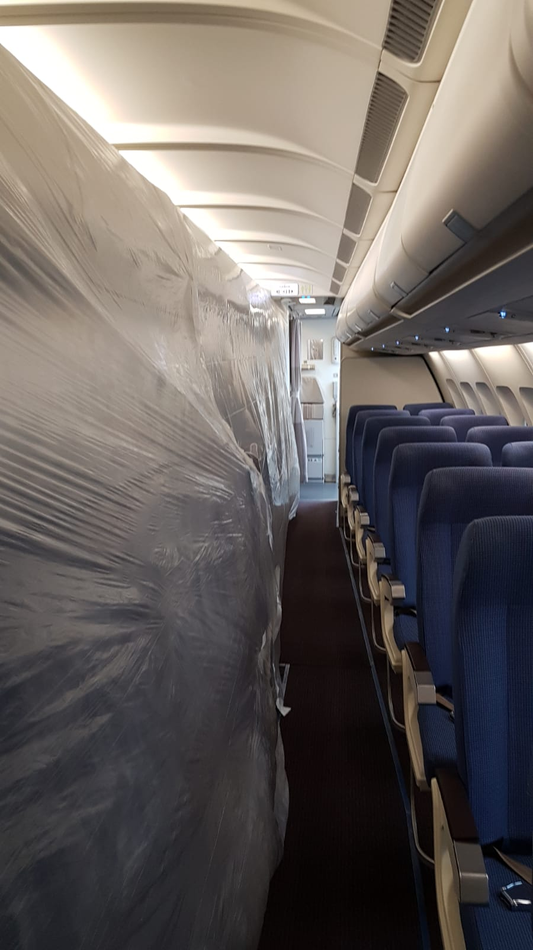
Figure 1 The aircraft was divided into sections using simple plastic sheeting, erected by the airline ground crew.

Figure 2
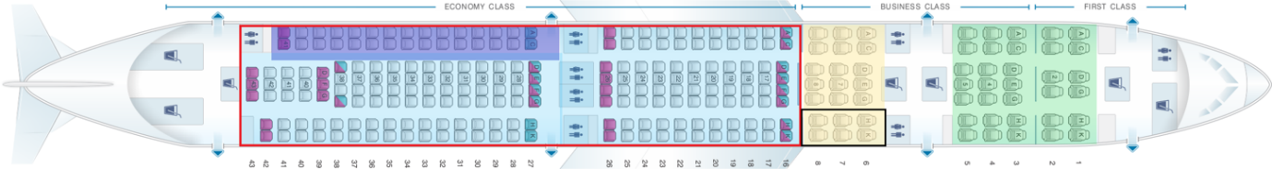
Figure 2 All patients were contained within the ‘dirty area’ (red), confirmed COVID patients were further separated within the dark blue area. A ‘donning and doffing equipment area’ (black) was set next to the medical crew rest area (beige). Non clinical personnel remained in the green area.

