Microvascular breast reconstruction and thromboembolic events in patients on hormone therapy: audit of practice from a tertiary referral centre

^{1,2} S Samaras, ^{1,3} S Ashfield, ^{1,3} SF Ali, ¹Fopp LJ, ^{4,5}JR Benson, ^{1,4,5}CM Malata

Institutional Affiliations:
¹Department of Plastic and Reconstructive Surgery, Addenbrooke’s Hospital, Cambridge University
Hospitals NHS Foundation Trust, Cambridge, UK.
²Captain Medical Doctor, Department of Plastic & Reconstructive Surgery, 401 Military Hospital of Athens, Greece
³ School of Clinical Medicine, University of Cambridge, UK.
⁴Cambridge Breast Unit, Department of Surgery, Addenbrooke’s Hospital, Cambridge University Hospitals NHS Foundation Trust, Cambridge, UK.
⁵ School of Medicine, Anglia Ruskin University, Cambridge & Chelmsford, UK.

Corresponding Author:
Professor Charles M Malata, BSc (HB), MBChB, MRCS LRCP, FRCS (Glasg), FRCS (Plast),
Plastic and Reconstructive Surgery Department, Addenbrooke’s Hospital, Box 186,
Cambridge University Hospitals NHS Foundation Trust, Hills Road, Cambridge, CB2 2QQ, UK

Keywords: tamoxifen, aromatase inhibitors, thrombosis, thromboembolism, breast reconstruction, flap outcomes

Abstract
Introduction: Hormonal therapy with tamoxifen and aromatase inhibitors reduces breast cancer recurrence and mortality but represents a risk factor for thromboembolic events. Therefore, most surgeons discontinue hormonal agents before microvascular surgery and for a variable period thereafter. There are no guidelines as to when therapy should be stopped (preoperatively) or when it should be resumed (postoperatively). We therefore audited our hospital practice with the objective of making recommendations for microvascular breast reconstruction patients.
Patients & methods: A review was performed of all free flap breast reconstructions between 2014 and 2019. Patients were classified according to hormone medication status at operation. Timings of drug cessation and recommencement were recorded. Thrombotic events namely flap microvascular thrombosis, DVT, SVT and PE were compared.
Results: 240 patients had 275 free flaps over five years with 36 receiving hormone therapy within one month prior to surgery which was discontinued 8.5 days (range 0-28) before surgery. Intra-operative microvascular thromboses (HT 2.0%, NHT 0%; p=0.869) and post-operative microvascular complications/flap re-explorations (HT 6.6%, NHT 0%; p=0.234) were comparable between the two groups. Systemic venous thromboembolic events were also similar (HT 8.3%, NHT 6.1%; p= 0.893). Age, BMI, smoking status and preoperative chemotherapy did not influence the incidence of thrombotic complications.
Conclusion: Hormone therapy did not significantly increase risk of thromboembolic events. Despite the widespread practice of withholding it for 2 weeks prior to reconstructive surgery, this study does not support such practice being beneficial in terms of thromboembolic events and flap viability. Larger scale trials are needed to establish definitive protocols.

Introduction
Over the past decade, the incidence of breast cancer in females within the UK increased by 6%, with an estimated lifetime risk for developing breast cancer of 1 in 7 (15%) (1). Prompt diagnosis, along with various surgical and other treatment approaches, has decreased corresponding mortality rates by 19% during the same period (2). Adjuvant therapies include chemotherapy, radiotherapy and targeted therapies with hormones and trastuzumab based on expression of oestrogen, progesterone or human epidermal growth factor (HER2 receptors).
The most common biological subtype is HER2-negative luminal that expresses hormone receptors and account for approximately 70% of the newly diagnosed breast cancers (3). For hormone sensitive premenopausal patients, tamoxifen is standard endocrine therapy combined with ovarian suppression with higher risk cases receiving chemotherapy (3). Tamoxifen was originally prescribed for 5 years with proportional reductions in recurrence and mortality rates of almost one-third (4, 5). Recent trials have shown that extending tamoxifen treatment to 10 years confers additional reduction in recurrence and mortality, especially after year 10 and is independent of any carry-over effect (6).
In postmenopausal patients, tamoxifen and aromatase inhibitors (AIs) are both valid options, either as monotherapy for 5 years or in sequence, with a beneficial effect for both recurrence and mortality rates (7). The aromatase inhibitors such as anastrozole (Arimidex®), letrozole (Femara®) and exemestane (Aromasin®) are associated with fewer troublesome side effects compared to tamoxifen.
Free tissue transfer represents the gold standard for either immediate or delayed autologous breast reconstruction and constitutes a popular option amongst women seeking reconstruction (8). It is a safe and effective technique that crucially depends on the patency of the arterial and venous anastomoses. Overall flap success rates in the senior author’s experience approach 100% (99.7%) (9).
Although hormone therapy is an independent risk factor for thromboembolic events, studies linking usage of perioperative tamoxifen or AIs with thrombotic flap complications are conflicting (10, 11, 12, 13, 14, 15). Patients undergoing breast reconstruction with free tissue transfer techniques are intrinsically susceptible to thrombotic events due to prolonged operating time, reduced postoperative mobility and duration of hospital stay. Moreover, cancer surgery itself is associated with doubling of risk for deep vein thrombosis (DVT) and trebled risk of fatal pulmonary embolism (PE) (10, 16). Extended endocrine therapy for up to 10 years adds to the risk for thrombotic events that could be detrimental to free flap reconstruction via affecting the microvascular anastomoses. Notwithstanding these known risks, there is no consensus on when to discontinue or restart the hormonal treatment in patients undergoing breast reconstruction surgery involving microvascular techniques.
Recent studies recommend discontinuation of tamoxifen therapy 2-4 weeks prior to reconstructive surgery but there is lack of evidence on the optimal duration for withholding tamoxifen therapy post-operatively (11, 13, 17, 18). The aim of this study was to audit current practice in terms of timing for cessation and resumption of hormone therapy amongst patients undergoing microvascular breast reconstruction to determine the impact of hormone exposure with either tamoxifen or aromatase inhibitors on thrombotic events. In the absence of existing guidelines addressing these issues, a secondary objective was to formulate some provisional guidance on timing of cessation and resumption of hormonal therapy in free-flap breast reconstruction.

Patients and methods
A retrospective review of 240 consecutive patients who underwent free flap breast reconstruction from October 2014 to October 2019 at a single institution was undertaken. Patients were identified from a prospectively maintained departmental free flap database. Electronic medical records and clinical letters documented by the multidisciplinary team (medical oncologists, breast surgeons, plastic surgeons, breast care nurses) as well as anaesthetists were reviewed to ascertain details of hormone treatment in the perioperative period; searches were carried out using key terms that included generic (“tamoxifen”, “letrozole”, “anastrozole”, “exemestane”) and trade names (Nolvadex®, Arimidex®, Femara® and Aromasin®) of hormonal agents.
Data were collected for the following factors: 1) type of reconstruction 2) biological subtype of tumour (i.e., expression of hormone receptors), 3) incidence of chemotherapy prior to reconstructive surgery (neoadjuvant for immediate and adjuvant for delayed reconstructions), 4) preoperative treatment with hormonal therapy (if and when stopped), 5) when hormonal therapy was restarted post-operatively and 6) any history of thromboembolic complications prior to the operation. In addition, specific demographic parameters (age, BMI and smoking status) were included in the analysis. The aforementioned factors were evaluated to determine any association with risk of thrombotic events and flap complications. Patients were considered to have been exposed to hormonal therapy if administered within 4 weeks of surgery – the half-life of the active metabolite of tamoxifen is approximately 2 weeks, and therefore at 4 weeks less than a quarter of tamoxifen should be remaining in their system (11, 17). Of note, the half-life for AIs is much shorter and between 24 and 48 hours (17).
Patients on hormonal therapy were subdivided into tamoxifen and aromatase inhibitor groups. Types of reconstruction were classified as immediate (when the reconstructive surgery took place at the same time as the mastectomy), delayed (when the reconstruction was performed at a second stage) or tertiary/salvage (when it totally replaced a previous failed or suboptimal reconstruction). Thrombotic complications recorded were intraoperative microvascular complications, postoperative microvascular complications/flap re-exploration, systemic venous thromboembolic events, and fat necrosis. The latter is an indication of long-term flap hypo-perfusion and thromboembolic events included deep vein thrombosis (DVT), superficial vein thrombosis (SVT) or radiologically-confirmed pulmonary embolism (PE). Other complications, such as seroma formation and wound dehiscence/ healing problems, were excluded from analysis due to lack of evidence for these being risk factors for thromboembolism.

Statistical analysis
For the statistical analysis, a two-sided chi-squared test was used to compare the categorical variables in cases of more than 5 patients in each group. When fewer than 5 patients were in a group, Fisher's exact test was used. For comparing continuous variables (e.g. BMI and age) a two-sided T test (where there were 2 groups) or a Kruskal-Wallis test (where there were more than 2 groups) were used.

Perioperative anticoagulation protocol
All patients had a bilateral intermittent pneumatic compression device applied during surgery and received 5000 units of subcutaneous heparin 6 hours post-operatively that was continued until discharge. In addition, thromboembolism-deterrent (TED) stockings were fitted pre-operatively and were worn throughout their hospital stay. Local physiotherapy protocols encouraged early mobilisation from the first post-operative day.

Results
A total of 275 free flap breast reconstructions were performed (240 patients) over the study period. Information on hormonal therapy was available for 233 patients thus seven patients with missing data were excluded from the analysis.
Patients who had received their last dose of hormonal therapy at least one month prior to their operation comprised the hormone therapy group (HT). Using this cut off 36 patients fell into the hormone therapy (HT) group and 197 patients into the no-hormone therapy (NHT) group. Within the hormone therapy group, 21 patients were on tamoxifen while 15 patients were on an aromatase inhibitor (Table 1).

Table 1: Patient Demographics of Hormone Therapy Use
Type of therapy | Patients (%)
No hormone therapy | 197 (84.5%)
Hormone therapy | 36 (15.5%)
- Tamoxifen | 21 (9.0%)
- Aromatase inhibitor | 15 (6.4%)
- Anastrozole | 6 (2.6%)
- Letrozole | 7 (3.0%)
- Exemestane | 2 (0.9%)
Total | 233 (100%)

Preoperative hormone therapy
More than half of patients in the patients in the hormone therapy group had undergone delayed reconstruction (over 60%) (Table 2) (Figure 1). By contrast, there were few cases of delayed reconstruction in the non-hormone group. Therefore patients on hormone therapy at the time of breast reconstruction were significantly more likely to have undergone delayed reconstruction (61.8% versus 8.2%, p<0.001). This observation is consistent with being prescribed tamoxifen as adjuvant therapy after mastectomy. Similarly, in the past, those patients undergoing tertiary or salvage reconstruction after mastectomy had a much higher chance of being on hormonal agents as adjuvant therapy (20.6% versus 4.1%, p= 0.001). Conversely patients who were not on hormone therapy at the time of reconstruction were significantly more likely to be undergoing immediate reconstruction than those receiving hormone therapy (87.7% versus 17.6%, p<0.001) (Figure 2). However, some patients undergoing mastectomy and immediate reconstruction for recurrent or contralateral disease were taking tamoxifen as adjuvant therapy. Thus two patients were on tamoxifen after previous ipsilateral lumpectomy whilst three patients underwent contralateral mastectomy and immediate reconstruction for either a new cancer or as a prophylactic procedure. The HT and NHT groups were similar in terms of risk factors for thrombotic complications including preoperative chemotherapy, age, BMI and smoking status (Table 2).

Table 2: Patient Demographics for Type of Reconstruction and Risk Factors
 | Hormone therapy group | No-hormone therapy group | p-value
No. of patients | 36 | 197
Pre-operative chemotherapy | 9/23 (39.1%) | 77/185 (41.6%) | 0.997
Immediate reconstruction | 6/34 (17.6%) | 171/195* (87.7%) | <0.001
Delayed reconstruction | 21/34 (61.8%) | 16/195* (8.2%) | <0.001
Tertiary/salvage reconstruction | 7/34 (20.6%) | 8/195* (4.1%) | 0.001
Mean Age | 51.9 | 50.0 | 0.218
Mean BMI | 27.1 | 27.3 | 0.675
Former smoker | 12/27 (44.4%) | 46/172 (26.7%) | 0.098
Current smoker | 1/27 (3.7%) | 5/172 (2.9%) | 1

- 2 cases in the no hormone therapy group were immediate and delayed so were excluded from this particular analysis.

Analysis of complications
There was no statistically significant difference in either the overall incidence of complications (p = 0.539) or type of complication between the hormone therapy and no-hormone therapy groups (Table 3). Complications involving intra-operative microvascular and post-operative microvascular complication/flap re-exploration only occurred in the no-hormone therapy group. In contrast flap-unrelated venous thromboembolic events (DVT, SVT or PE) were observed slightly more frequently in the hormone therapy group than the no-hormone therapy group. There was a similar incidence of fat necrosis in both the hormone therapy and no-hormone therapy group.

Table 3: Incidence of Perioperative Complications
 | Hormone therapy group | No-hormone therapy group | p-value
Number of patients | 36 | 197
Intraoperative anastomotic complication | 0 | 4/197 (2.0%) | 0.869
Postoperative microvascular complication/re-exploration | 0 | 13/197 (6.6%) | 0.234
DVT/SVT/PE | 3/36 (8.3%) | 12/197 (6.1%) | 0.893
Fat necrosis | 6/27* (22.2%) | 39/179* (21.8%) | 1.000
None | 33/36 (91.7%) | 168/197 (85.3%) | 0.539

*Fat necrosis details were not available for 9 patients in the hormone therapy group and 18 patients in the no-hormone therapy group.

Analysis of Complications within hormonal groups
The incidence of complications was analysed separately for the no-hormone therapy group and for those on tamoxifen and aromatase inhibitors. No statistically significant differences were found for incidence of any complication although numbers are small and could represent a type II error (Table 4 and Table 5).

Table 4: Perioperative Complication Incidence Based on Hormone Therapy Type
 | No hormone therapy group | Tamoxifen group | Aromatase inhibitors group | p-value
No. of patients | 197 | 21 | 15
Intraoperative microvascular complication | 4/197 (2.0%) | 0 | 0 | 0.689
Postoperative microvascular reexploration | 13/197 (6.6%) | 0 | 0 | 0.284
DVT/SVT/PE | 12/197 (6.1%) | 2/21 (9.5%) | 1/15 (6.7%) | 0.83
Fat necrosis | 39/179 (21.8%) | 4/14 (28.6%) | 2/13 (15.4%) | 0.698
None | 168/197 (85.3%) | 19/21 (90.5%) | 14/15 (93.3%) | 0.575

Table 5: Perioperative Complication Incidence in Tamoxifen and Aromatase Inhibitor Therapy Groups

 | Tamoxifen group | Aromatase inhibitors group | p-value
No. of patients | 21 | 15
Intra-operative microvascular complication | 0 | 0
Post-operative microvascular complication/re-exploration | 0 | 0
DVT/SVT/PE | 2/21 (9.5%) | 1/15 (6.7%) | 1
Fat necrosis | 4/14 (28.6%) | 2/13 (15.4%) | 0.648
None | 19/21 (90.5%) | 14/15 (93.3%) | 1

Risk factor analysis
The effect of thrombotic risk factors on incidence of complications in the hormone therapy and no-hormone therapy group was analysed. Preoperative chemotherapy, mean age at the time of the operation, mean BMI at the time of the operation, and smoking status did not have a statistically significant impact on the incidence of complication in either the hormone therapy or no-hormone therapy group (Table 6).

Table 6: Perioperative Comorbidities and Complication Incidence in Hormone Therapy and No-Hormone Therapy Group
 | Hormone therapy group |  | No-hormone therapy group
 | Perioperative complication | No complication | Perioperative complication | No complication | p-value
No. of patients | 3 | 33 | 29 | 167
Pre-operative chemotherapy | 0 | 7/23 (30.4%) | 13/28 (46.4%) | 62/156 (39.7%) | 0.508
Mean Age | 54 | 51.8 | 52.9 | 49.5 | 0.176
Mean BMI | 29.6 | 26.9 | 27.5 | 27.3 | 0.353
Former smoker | 0 | 12/26 (46.2%) | 6/27 (22.2%) | 40/144 (27.8%) | 0.17
Current smoker | 0 | 1/26 (3.8%) | 0 | 5/144 (3.5%) | 0.833

Timing of therapy: cessation and restarting
Amongst the 36 patients on hormone therapy in the perioperative period, 21 patients were receiving tamoxifen and 15 AIs. The average time for suspension of tamoxifen was 10.9 days (range 0 - 28 days) and the median duration 7 days, whilst the average suspension time for AI therapy was 5.3 days (range 0 - 28 days) and median duration 0 days (Table 7). Therefore hormone treatment was suspended for twice as long in the case of tamoxifen compared with AIs and this may reflect different pharmacokinetics between these agents.

Table 7: Timing of Therapy Cessation
 | Number of patients
Length of suspension pre-operation (days) | Tamoxifen | Aromatase inhibitor
0 | 5/21 (23.8%) | 8/15 (53.3%)
1-14 | 11/21 (52.4%) | 5/15 (33.3%)
15-28 | 5/21 (23.8%) | 2/15 (13.3%)

Information on restarting of therapy was available for 18 of the 21 patients on tamoxifen and 13 of the 15 patients on AI treatment. The average time for resumption of therapy postoperatively was 10.6 days (range of 0 to 28 days) and the median length was 7 days. The corresponding times for AI therapy was 4.8 days (range of 0 to 28 days) with a median length of 4 days (Table 8).

Table 8: Timing of Therapy Restarting
 | Number of patients
Length of suspension post-operation (days) | Tamoxifen | Aromatase inhibitor
0 | 2/18 (11.1%) | 5/13 (38.5%)
1-14 | 12/18 (66.7%) | 7/13 (53.8%)
15-28 | 4/18 (22.2%) | 1/13 (7.7%)

Discussion
Systemic hormone therapy in breast cancer patients expressing oestrogen or progesterone receptors has proven efficacy in reducing recurrence and mortality from ipsilateral disease as well as reduction in risk of contralateral breast cancer (4, 5). Tamoxifen and to a lesser extent aromatase inhibitors (Ais), are associated with an increased risk of thromboembolic events such as DVT and PE. In the context of microvascular reconstructive surgery, this could potentially increase the risk of flap failure. Results of previous studies have been conflicting and there is no consensus on the timing for suspension of hormone treatment prior to reconstructive surgery (11 - 18). The increasing adoption of extended endocrine treatments and increasing numbers of patients undergoing reconstructive surgery provide an imperative to determine the balance of benefits and risks of peri-operative hormonal therapy in the reconstructive setting, especially when microvascular techniques are employed (6, 8).
This retrospective study of 233 patients has revealed neither an increased risk of flap complications or thromboembolic events in patients receiving hormone therapy (either tamoxifen or AIs) within one month prior to breast reconstruction. Furthermore, rates of thrombotic complications were not significantly higher for smokers (current and former), or for delayed and tertiary reconstructions compared with immediate breast reconstruction. Our findings concur with recent studies showing that hormone therapy is not associated with higher incidence of flap or systemic thrombotic events (12, 14, 15, 17, 18).
The current study was prompted by an analysis of four studies by Parikh et al involving 1700 patients and 2245 procedures (13). These authors concluded that breast cancer patients receiving perioperative tamoxifen therapy, compared to those who were not, have an increased risk of thrombotic flap complications (including total flap loss) following microvascular breast reconstruction (13). Results from the present, albeit much smaller, study do not support these findings. It should be noted that Parikh et al’s analysis was heavily influenced by the large number of patients in one particular study. (11). Furthermore, although the study in question was innovative, it has been criticised for not addressing the higher incidence of non-abdominal flap complications in the tamoxifen group (19). Contrary to expectation our study has shown slightly lower flap complication rates for patients taking hormone treatment. Nonetheless, the small number of patients in the current study may have led to a type II error and thus the failure to demonstrate any impact of hormonal therapy on thrombotic flap complications. Of course, our conflicting results may be attributed to the small size of the hormone therapy group.
The majority of the hormone therapy group underwent either delayed or tertiary/salvage reconstruction, with few having immediate breast reconstruction. Some of these patients would have previously received adjuvant treatment (chemo-radiation in addition to hormonal therapy). This would include radiation to either the breast or chest wall and the latter often encompasses the internal mammary vessels, the recipient microanastomotic choice in our tertiary centre (9, 20, 21, 22). Both radiotherapy and chemotherapy, are well established risk factors for flap complications as late normal tissue effects of radiation may adversely affect the recipient bed and axial vessels (18). Our study showed a higher incidence of preoperative chemotherapy in the non-hormone therapy group who predominantly underwent immediate reconstruction whilst hormone sensitive tumours are innately less sensitive to neoadjuvant chemotherapy.
The current study does have some limitations including its retrospective design, with data derived from a single institution with a relatively small index sample size, few events and confounding from comparison of unbalanced hormonal and non-hormonal groups. A multi-institutional (national) audit would address some of these limitations and in particular the issue of small numbers of thrombotic complications. This study only included those thromboembolic events, such as DVT and PE, that were radiologically confirmed. Therefore conceivably some patients with subclinical pathology would not have been detected and the true incidence of these events could be higher than reported herein. Finally, although we advise patients to restart hormone therapy one week post-operatively, there is often lack of clear documentation and potential compliance problems due to poor documentation has not been taken into account in this analysis. It is now the authors’ practice to document during pre-admission when the patients should stop and restart hormone therapy and this will be re-audited after 3 years when more precise data will be available to establish an evidence-based protocol for clinical management of peri-operative hormonal therapy.
This study emphasises the importance of clearly documenting timings for cessation and re-starting of hormone therapy in patients undergoing microvascular breast reconstruction. Moreover, free flap patients who have been taking hormonal therapy in the period preceding surgery should be carefully monitored for signs of subclinical thromboembolic events, including flap complications – the latter might be attributed to a state of hypercoagulablity secondary to hormonal therapy.

Conclusion
The present study has revealed a lack of clarity about when to stop hormone therapy and when to recommence it. Nonetheless, stopping hormone therapy two weeks before reconstructive microsurgery does not appear to negatively impact flap outcomes nor increase the incidence of systemic thromboembolic complications. It is not possible to determine the optimal time for restarting hormonal therapy as it is unknown whether these patients suffered any consequent oncological detriment or not. It is suggested that a larger multi-institutional audit or survey be conducted in an effort to establish a consensus.

Author contributions
Professors Malata and Benson were the lead surgeons, designed the study, reviewed and edited the manuscript, Mr Samaras collected the data, wrote and edited the manuscript, Miss Ashfield collected the data, performed the statistical analysis, reviewed and edited the manuscript, Miss Ali collected the data, reviewed and edited the manuscript. Miss Fopp was involved in designing the study, data collection and editing. The final manuscript was approved by all the co-authors.

Conflict of interest statement: None.

Funding: No funding was received for this article.

Acknowledgements: None.

References

- Lifetime risk estimates calculated by the Statistical Information Team at Cancer Research UK. Based on Office for National Statistics (ONS) 2016-based Life expectancies and population projections. Accessed December 2017, and Smittenaar CR, Petersen KA, Stewart K, Moitt N. Cancer Incidence and Mortality Projections in the UK Until 2035. Brit J Cancer 2016.
- Cancer Research UK, https: //www.cancerresearchuk.org/health-professional/cancer-statistics/statistics-by-cancer-type/breast-cancer/mortality#ref-. Accessed Feb 2020.
- Harbeck N, Gnant M. Breast cancer. Lancet. 2017 Mar; 389(10074): 1134–1150.
- Davies C, Godwin J, Gray R, et al. Relevance of breast cancer hormone receptors and other factors to the efficacy of adjuvant tamoxifen: patient-level meta-analysis of randomised trials. Lancet. 2011 Aug; 378(9793): 771–784.
- Early Breast Cancer Trialists' Collaborative Group (EBCTCG). Effects of chemotherapy and hormonal therapy for early breast cancer on recurrence and 15-year survival: an overview of the randomised trials. Lancet, 2005 May; 365(9472): 1687–1717.
- Davies C, Pan H, Godwin J, et al. Long-term effects of continuing adjuvant tamoxifen to 10 years versus stopping at 5 years after diagnosis of oestrogen receptor-positive breast cancer: ATLAS, a randomised trial. Lancet. 2013 Mar; 381(9869): 805–816.
- Early Breast Cancer Trialists’ Collaborative Group (EBCTCG). Aromatase inhibitors versus tamoxifen in early breast cancer: patient-level meta-analysis of the randomised trials. Lancet 2015 Oct; 386(10001): 1341–52.
- Kamali P, Paul MA, Ibrahim AMS, et al. National and Regional Differences in 32,248 Postmastectomy Autologous Breast Reconstruction Using the Updated National Inpatient Survey. Ann Plast Surg. 2017 Jun; 78(6): 717–722.
- Sasaki Y, Madada-Nyakauru R, Samaras S, Oni G, Di Candia M, Malata CM. The ideal intercostal space for internal mammary vessel exposure during total rib-sparing microvascular breast reconstruction: A critical evaluation. J Plast Reconstr Aesthet Surg. 2019 Jun; 72(6): 1000-1006.
- Jiang D, Lee AI. Thrombotic Risk from Chemotherapy and Other Cancer Therapies. Cancer Treat Res. 2019; 179: 87–101.
- Kelley BP, Valero V, Yi M, Kronowitz SJ. Tamoxifen Increases the Risk of Microvascular Flap Complications in Patients Undergoing Microvascular Breast Reconstruction. Plast Reconstr Surg. 2012 Feb; 129(2): 305–314.
- Jokuszies A, Radtke C, Betzler C, Branski L, Krämer R, Vogt PM. Is tamoxifen associated with an increased risk for thromboembolic complications in patients undergoing microvascular breast reconstruction? Ger Med Sci. 2013; 11: Doc05.
- Parikh RP, Odom EB, Yu L, Colditz GA, Myckatyn, TM. Complications and thromboembolic events associated with tamoxifen therapy in patients with breast cancer undergoing microvascular breast reconstruction: a systematic review and meta-analysis. Breast Cancer Res Treat. 2017 May; 163(1): 1–10.
- Billon R, Bosc R, Belkacemi Y, et al. Impact of adjuvant anti-estrogen therapies (tamoxifen and aromatase inhibitors) on perioperative outcomes of breast reconstruction. J Plast Reconstr Aesthet Surg. 2017 Nov; 70(11): 1495-1504.
- Tran BNN, Ryan QZ, Cohen JB, et al. Does Hormone Therapy Use Increase Perioperative Complications in Abdominally Based Microsurgical Breast Reconstruction? Plast Reconstr Surg. 2018 Jun; 141(6): 805e–813e.
- Pannucci CJ, Chang EY, Wilkins EG. Venous Thromboembolic Disease in Autogenous Breast Reconstruction. Ann Plast Surg. 2009 Jun; 63(1): 34–38.
- Mirzabeigi MN, Nelson JA, Fischer JP, et al. Tamoxifen (Selective Estrogen-Receptor Modulators) and Aromatase Inhibitors as Potential Perioperative Thrombotic Risk Factors in Free Flap Breast Reconstruction. Plast Reconstr Surg. 2015 Apr; 135(4): 670e-679e.
- Salibian AA, Bokarius AV, Gu J, et al. The Effects of Perioperative Tamoxifen Therapy on Microvascular Flap Complications in Transverse Rectus Abdominis Myocutaneous/Deep Inferior Epigastric Perforator Flap Breast Reconstruction. Ann Plast Surg. 2016 Dec; 77(6): 630–634.
- Disa JJ. Discussion. Tamoxifen increases the risk of microvascular flap complications in patients undergoing microvascular breast reconstruction. Plast Reconstr Surg. 2012 Feb; 129(2): 315–316.
- Oni G, Malata CM. New Surgical Technique: Simultaneous Use of Contiguous Intercostal Spaces During Total Rib Preservation Exposure of the Internal Mammary Vessels in Microvascular Breast Reconstruction. J Plast Reconstr Aesthet Surg. 2019 Sep; 72(9): 1525-1529.
- Rosich-Medina A, Bouloumpasis S, Di Candia M, Malata CM. Total 'Rib'-Preservation Technique of Internal Mammary Vessel Exposure for Free Flap Breast Reconstruction: A 5-year Prospective Cohort Study and Instructional Video. Ann Med Surg (Lond). 2015 Aug; 4(3): 293-300.
- Malata CM, Moses M, Mickute Z, Di Candia M. Tips for successful microvascular abdominal flap breast reconstruction utilizing the “total rib preservation” technique for internal mammary vessel exposure. Ann Plast Surg. 2011 Jan; 66(1): 36–42.

Figures and Legends
Figure 1: Delayed left breast reconstruction with a bipedicled DIEP in a 64-year old patient on tamoxifen (for a Grade 2 lobular carcinoma, ER+ve, HER2 –ve) with obvious radiotherapy skin changes of the chest wall. 4-year postoperative appearances after nipple reconstruction and areolar tattooing.

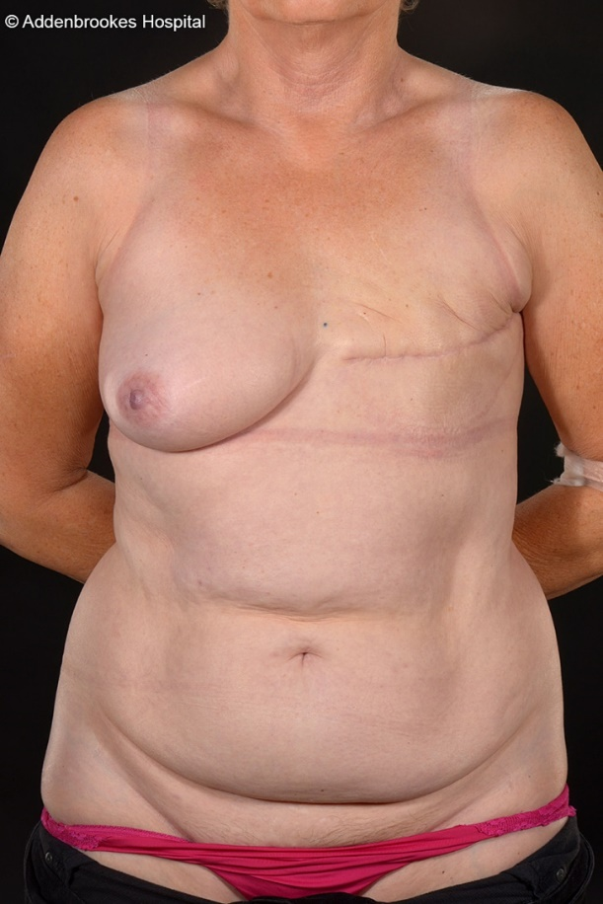


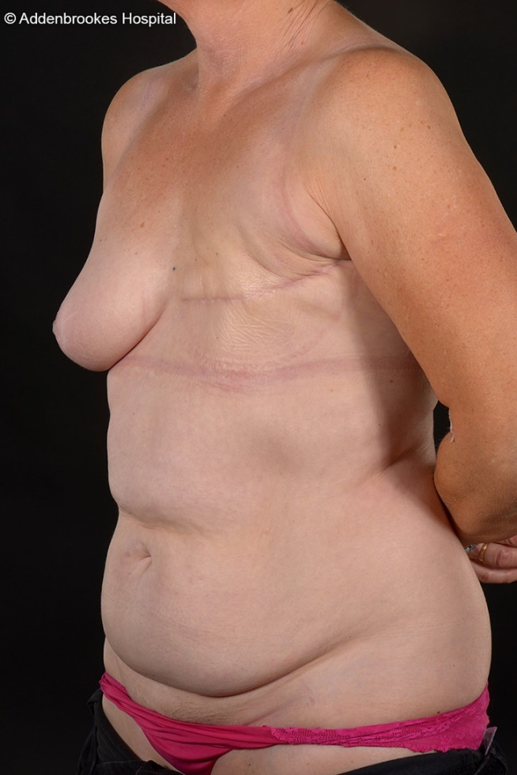

Figure 2: Immediate bilateral DIEP flap breast reconstruction for a left high-grade DCIS and right risk-reducing mastectomy in a 52-year old after previous lumpectomy. Patient was not on hormonal therapy. Pre and 3.5-year postoperative appearances. The nipple reconstructions were performed using the C-V flap technique.







