Engineering Romanticism

Engineering Romanticism is a Leverhulme Trust Research Fellowship led by Professor John Gardner.
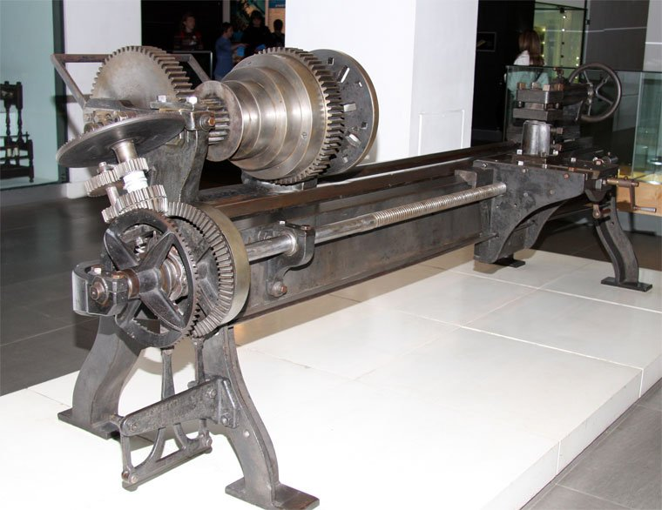Richard Roberts Lead-screw Lathe (1817), Science Museum, London (Grace’s Guide)
‘Engineering Romanticism’ is a Leverhulme Trust Research project led by John Gardner. This research investigates intersections between engineering and literary cultures in the first half of the nineteenth century.
The project analyses how engineers and writers engaged in revolutionary experimentation focussing on innovation and economy. It begins in 1798 with the arrival of the lead-screw lathe and ends in 1851 with the Great Exhibition. This event showcased the results of half a century of innovation and standardisation. The outputs for the project will include this website, articles, talks and a monograph. Here you can find links to John Gardner’s author biography, a research blog, talks, and links to other projects that engage with engineering and literary cultures.

Poets and Machines
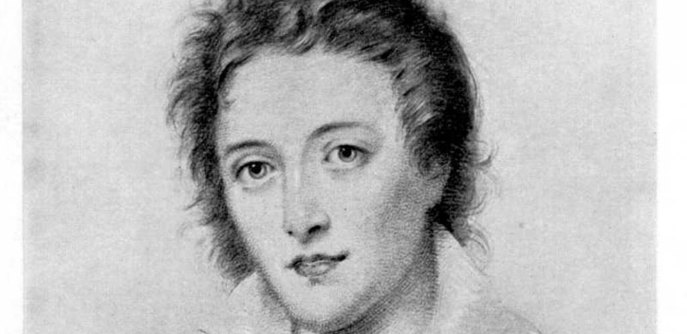P. B. Shelley
Engineering Romanticism starts from the notion that literature and machines are more closely linked in the Romantic period than has been acknowledged. Many, including Percy Shelley and William Hazlitt, saw literature as a kind of engine capable of work. They anticipated writers, such as William Carlos Williams, who recognised that ‘A poem is a small (or large) machine made out of words’ (The Wedge, 1944).
The Romantic period saw a huge amount of experimentation in literary and engineering cultures. Texts can transmit power from the written word to physical action. When Shelley wrote poems on the condition of England he thought they would effect political change. For Shelley a poem was a force that could be transmitted over distances to his audience. Shelley hoped that people would read his poems and then act accordingly. At the time of writing his most revolutionary poetry Shelley was also engaged on making a steam ship, which pushed the technology of his time.
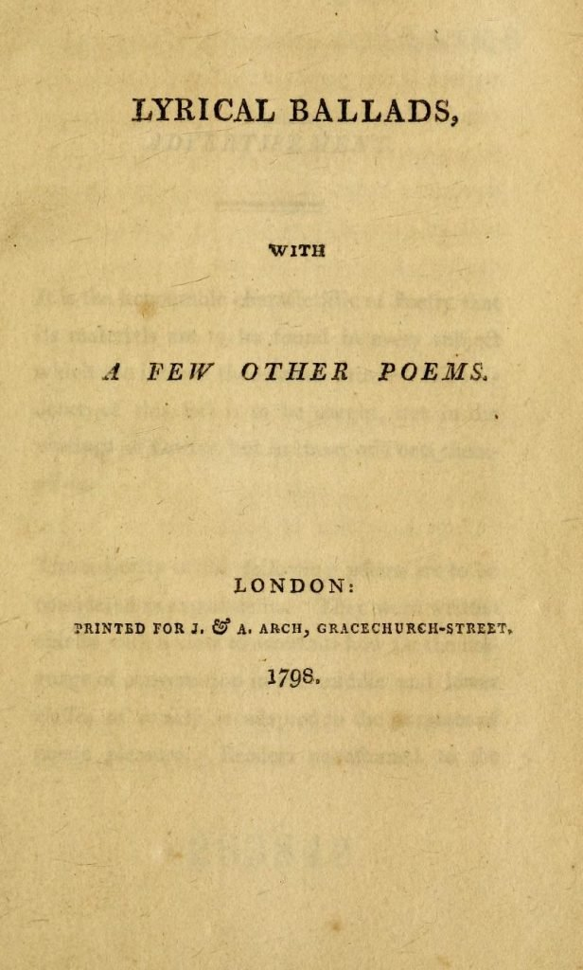Lyrical Ballads
Experimentation, economy, and the belief that literature, like machines, could ‘do work’ is evident throughout the Romantic Period. In 1798, the year that Henry Maudsley’s screw-cutting lathe arrived, Wordsworth and Coleridge published their Lyrical Ballads. On the face of it these poems have little to do with scientific cultures, but even so Wordsworth claimed that:
“The majority of the following poems are to be considered as experiments.”
William Wordsworth, from ‘Advertisement’, Lyrical Ballads (1798)
For Wordsworth poetry was also ‘the history or science of feelings’ (note to ‘The Thorn’, Lyrical Ballads).
Experimentation permeates literary and engineering cultures in the Romantic period and both were influenced by worldwide revolutions of the time.

Romanticism and Engineering: Making Machines
The drive to create new machines in the later half of the eighteenth century was accelerated by the revolutionary wars in America (1775-1783) and Europe (1789-1815). In 1782 Thomas Jefferson questioned if his country could improve on ‘the construction of muskets’. Jefferson wanted standardisation so that ‘in the making of every part of them so exactly alike, that what belongs to any one, may be used for every other musket.’ Before Maudsley’s screw-cutting lathe replication was rare. With this innovation it became possible for parts to be made anywhere that could then be assembled together.
The screw-cutting lathe brought the capacity to replicate and standardise. It enabled a global engineering industry to emerge. I’ll give one quick example. Before this innovation screw threads were bespoke. In the main individual nuts could only fit individual mating bolts. The new railway locomotives built from the 1820s on needed standards to ensure efficient manufacture and quick repairs. It took until 1841 before Joseph Whitworth published a hugely influential paper on standardising screw-threads that would transform the efficiency of industry. By the 1850s British Standard Whitworth threads were universally used. These standards persisted in Britain until the 1970s and have their uses still.

Engineering and Literature
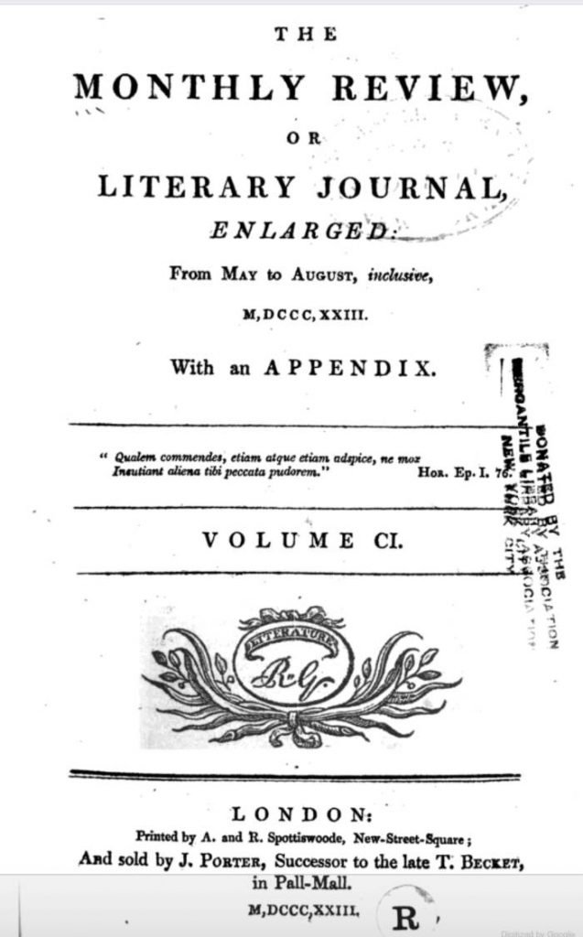
New machines created in the Romantic period affected ways that people wrote and thought as can be seen in poetry, magazines, and novels of the time. As The Monthly Review stated of the steam engine in 1823:
“the steam-engine ought not to be considered merely in the light of an ingenious mechanical construction, but as a most gigantic national resource, claiming equally the attention of the philosopher and the political economist”.
May, 1823
This magazine, like several others in the period, could discuss a new engine design or the latest poem by Byron. Engineering and literature could be found in the same publications. Just as literature could strive to end slavery in the work of Olaudah Equiano or to fight for women’s rights in the works of Mary Wollstonecraft, innovative machines could offer the potential for better lives. This is something that William Godwin argued in Political Justice, writing that machines could be beneficial to ‘the most important interests of the multitude’ (Ch. VI).
Machines could offer better health through the pumping of clean water and the completion of tasks that were impossible for manual labour, such as deep mine drainage. As the The Monthly Review stated, ‘the capacity of these machines becomes effective in various instances in which human strength could by no possibility be employed’.
Literary forms and standards influenced engineering and, in turn, engineering influenced literary cultures. This project will concentrate on three main areas:
- Forms and Standards
- Education at Mechanics’ Institutes
- Engineering and Literary Print Cultures
Buster Keaton, from The Goat (1921)
The investigation of these subjects is the centre of research on Engineering Romanticism. You can access preliminary findings on this website as the project progresses. If you want to get in touch please fill in the Contact form.
This work is supported by the Leverhulme Trust
© 2020 Engineering Romanticism | John Gardner

