Blackrock Sequence: a creative dialogue between an artist and a poet
Jim Butler,
Cambridge School of Art, Anglia Ruskin University, UK.

Abstract
In 2016 my brother David was awarded a grant from Dún Laoghaire / Rathdown Council, in Ireland, to write a sequence of poems. He invited me to collaborate with him to make a book of poems and images. I had never collaborated with my brother before, so it was important for me establish my role and how the project would work in practical and financial terms. There was no formal agreement just discussions over drinks in The Harbour Bar, near where my brother lives outside Dublin. David had received a grant of €11000 to write the poems and he would keep all of this – he would see if could get some additional funding to cover art materials and the cost of an exhibition. The book, however, would be my project – I would design and print the book and all money from sales would be mine. My practice as a printmaker and book artist meant that I have a particular ambition for the material aspects of a book, for example the way ink interacts with different papers, and this would not be compromised. I had previously printed and bound a number of my artist’s books in small editions and these had been acquired by many public collections including The Tate. I had also written about the financial challenges involved (Butler 2013), so I was going into this project with my eyes open. In terms of the book itself, David had initially suggested a chapbook but was happy to respect my judgement, creative independence and expertise. We also agreed that if we ended up in a situation in which either of us felt there was a significant mismatch between his intentions for the suite of poems, my images and the book I had designed, then I would not publish the book.

In deciding what I wanted to achieve with the book, two texts were fundamental to my thinking: Ulises Carrión’s essay The New Art of Making Books and Yves Peyré’s study of artists’ books Peinture et Poésie (‘Painting and Poetry’). This article explores the relationship which we established between poems and images and how the book’s structure developed to allow this relationship to be realised.

A book is not a case of words, nor a bag of words, nor a bearer of words
– Ulises Carrión, The New Art of Making Books, (Carrión, 2008: 129)

Poems and Images
​Ut picture poesis (as is painting, so is poetry), Horace’s dictum from Ars Poetica (Horace, 1926: 480-481), is often cited in discussions concerning the nature of poems and images. Much of this aesthetic discussion is about kinship and hierarchy and the singular qualities of each form. W.J.T Mitchell’s work Iconology (1986) is a particularly stimulating exploration of the nature of images in comparison to verbal language. Although interesting in describing the limitations of each form, these do not consider the interaction of poems and images in a single work.

Regarding text and image acting in conjunction, the seminal text is Roland Barthes’ Rhetoric of the Image (1964), in which he examines an advertising poster, a quintessentially multimodal work where text and image operate simultaneously. He asks the question: “What is the signifying structure of ‘illustration’?” (Barthes, 1977: 38). If one is to go beyond duplication or redundancy, Barthes considers an additive relationship. For this he coins two terms: anchorage and relay. Barthes states that images are polysemic, describing the image as a floating chain of signifiers. ‘Anchorage’ is where the text anchors a particular meaning and as such is a means of controlling the viewer’s reception of the image (Barthes 1977:39). Barthes explains ‘relay’ as when:
the text (most often a snatch of dialogue) and image stand in a complimentary relationship; the words, in the same way as the images, are fragments of a more general syntagym and the unity of the message is realized at a higher level, that of the story, the anecdote, the diegesis” (Barthes 1977:41)

This has been the basis for further elaborations and refinements (e.g. Spillner, Nöth, etc) summarised in by John Bateman as “illustration, where the picture is ‘semiotically subordinate’ to the text; pictorial exemplification, where the picture provides additional new information; labelling, where a textual element identifies the picture; mutual determination, which seems to combine relay and anchorage; contradiction.” (Bateman 2014:43-44)

Text – image – dialogue
While neither anchorage nor relay provide the answer for the sort of relationship I was hoping to achieve with this book of poems and images, one term I’ve found particularly useful is “le livre de dialogue” (the book of dialogue). Yves Peyré coined this term to distinguish certain livres d’artiste, finely printed books of poems and images, where an equilibrium between poems and images is achieve. Peyré uses the term specifically to describe certain books which achieve an equilibrium between poems and images. For Peyré certain aspects are essential: La rencontre de deux créateurs (un poète, un peintre) dans un espace commun, accepté et investi par l’un et l’autre: le livre (The meeting of two creators (a poet, a painter) in a common space, accepted and invested by one and the other: book) (Peyré 2001:6). He is particularly interested in the way the poems and images are set up to interact in the spaces of the book le jeu d’écho, le vis-à-vis, le dialogue actif, (the play of echoes, the face to face, the active dialogue) (Peyré 2001:6). In defining the term “livre de dialogue” to distinguish it from other examples of livres d’artiste, Peyré is insistent on a reciprocity between poet and painter and the creative freedom of each. (Peyré 2001:32-33)

Though Peinture et Poésie is an inspiring study of 126 livres d’artiste, Peyré’s focus is not directed on unpicking the specifics of the text and image relationship. To develop a deeper understanding how poems and images might act in dialogue, I have looked in more detail at David Hockney and Nikos Stangos’s 1967 book Fourteen Poems for C.P. Cavafy, and this study is published separately in this volume. What I’ve found here is that while certain lines in the poems can be regarded as anchoring their corresponding images, this is not the defining text and image relationship in the book. Instead the book uses the two parallel voices of Stangos’s translations and Hockney’s images to form a dialogue about homosexual love through a play of echoes and counterpoints. The lack of controlling anchorage between the voices is important here and it seems to me to correspond closely to Mikhail Bakhtin’s term polyphony which underpins his ideas of dialogic narrative.

I decided I should apply a dialogic approach to text and image for this book. The question was now how to apply this to creative practice. For dialogue to take place, I needed to create visual materials which would be independent of the content of the poems to avoid anchorage / illustration / elaboration of the texts. I needed to undertake some research, and in keeping with Carole Gray’s definition of practice-led research, this would be through methodologies familiar to me as a practitioner (Gray 1998:3). Drawing from observation is a fundamental part of my practice, so a research drawing trip to the locations was an obvious step to create these materials.

Primary Research: drawing on location, Dublin, February 2017
Stephanie Black in her article about research methods in illustration argues for an inductive approach and specifically “removing the known outcome” (Black, 2014: 290). What I was hoping to find was a series of starting points, not a series of outcomes.
In his 1953 essay Drawing, the critic and artist John Berger writes about observational drawing as discovery:
It is the actual act of drawing that forces the artist to look at the artist in front of him, to dissect it in his mind’s eye and put it together again…. A line, an area of tone, is not really important because it records what you have seen but because of what it will lead you on to see.” (Berger 2001:3).

Berger is at pains to emphasise that he is talking here about working drawings, which he regards as “private work, related only to the artist’s own needs” (Berger 2001:4) For him, that distinction between public and private work “is in the working of the artist’s mind” (Berger 2001:4). Because the work is private, he argues that the artist need not consider how the work might communicate to an audience.

Drawing on location is my principal means of understanding the visual world – slowing down, concentrating, looking for a sustained period of time. The materials I use on location play a significant part in this process of looking. Alongside ink and drawing sticks, I carry with me bags of scraps of paper, sorted by colour. This helps me to see how different areas of colour work against each other, to see relative composition and how shapes move with parallax. The fact that I am matching colour through torn paper collage leads to an emphasis on shape rather than detail and a certain amount of approximation.

Line drawing for me has a different quality, even though I frequently combine line and collage. For me, line is a means of codifying the areas of a drawing – a horizontal line and a circle, for example can change the otherwise blank white page into sun, sky and land. In the way that I tend to use line to delineate space through scale, weight and perspective, it also fixes my location in relation to the space depicted. In semiotic terms, the line is an indexical sign of me drawing, the autographic line anchoring the shapes of the drawing to my hand. At this stage of the process I wanted to avoid fixing anything so made a deliberate decision against using line.

In Dublin, I made a series of collage drawings at some of the locations which inspired the poems. David initially took me on a tour of the locations, but I worked on my own and avoided reading the poems. I was hoping that drawing on location would lead me to see things I hadn’t anticipated - and it worked. The weather was very mixed: rain, wind and some sunshine. A collage I was making on Dún Laoghaire pier blew into the sea, but the colours of wet sand and greys of the sky and its reflected colour in the sea started to emerge as a palette across the series of collages. After working at Blackrock Baths, I chanced upon a nearby bronze plaque to the diving champion Eddie Heron, with text in English and Irish. At other locations I had recorded typographic fragments through collage but here I made a rubbing of this plaque as I wanted to capture the detail of the cast relief lettering of both English and Irish scripts (figure 1)
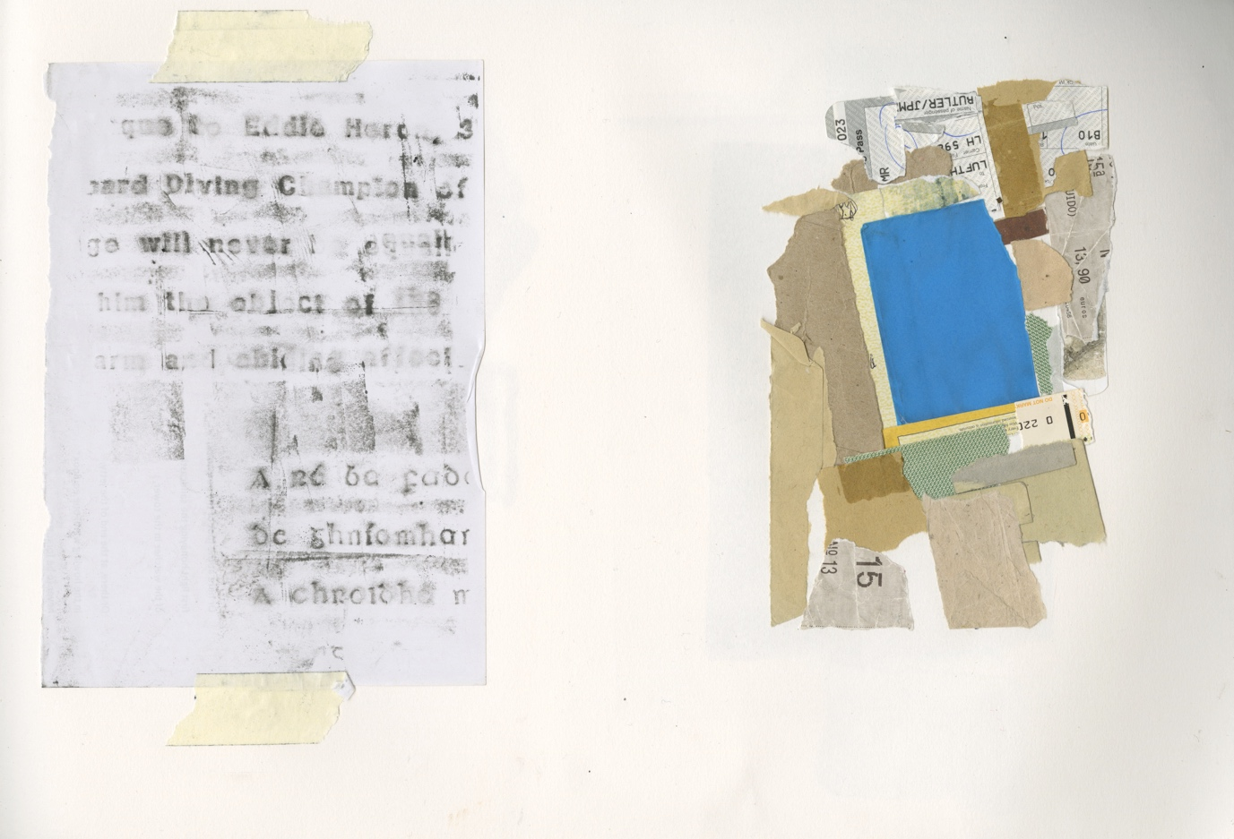
Fig 1: Sketchbook page: Blackrock Baths collage and rubbing

Back in the studio: developing through printmaking, Cambridge, February – March l 2017

I returned from my short trip to Dublin with a collection of collage drawings, some rubbings and no idea how I might use the drawings. Although I had no clear idea what the final book might look like, there were two key constraints which dictated how I went about developing the work:

The material, printed book was to be the final artwork. This is not just a question of page design. As a printmaker, I find it really important to develop imagery through the medium, allowing ideas to emerge and develop iteratively through trial prints. The qualities and limitations of the medium become part of the creative decision-making process and to quote McLuhan the medium becomes (at least part of) the message. I chose to work with screen-printing so that I could visually exploit the layering of colour, reflecting the layers of meaning in the poems. More specifically, in the poem Stations, the line “The map of a city is a palimpsest: history lessons, imperfectly erased” gave a hint of something which I wanted to echo in my imagery.

The images would need to act a series, so rather than resolving each image solely in relation to its corresponding poem, I wanted to play with ideas of repetition across the series to allow ideas to emerge. It made sense therefore to work on a group of images simultaneously.

To start with, I chose a group of four poems to work on: ‘Martello Tower’, ‘Blackrock Market’, ‘Blackrock Baths’ and ‘Stations’ as these had in common ideas of memory. A collage I had made of the Martello Tower at Sandycove was a starting point (figure 2).
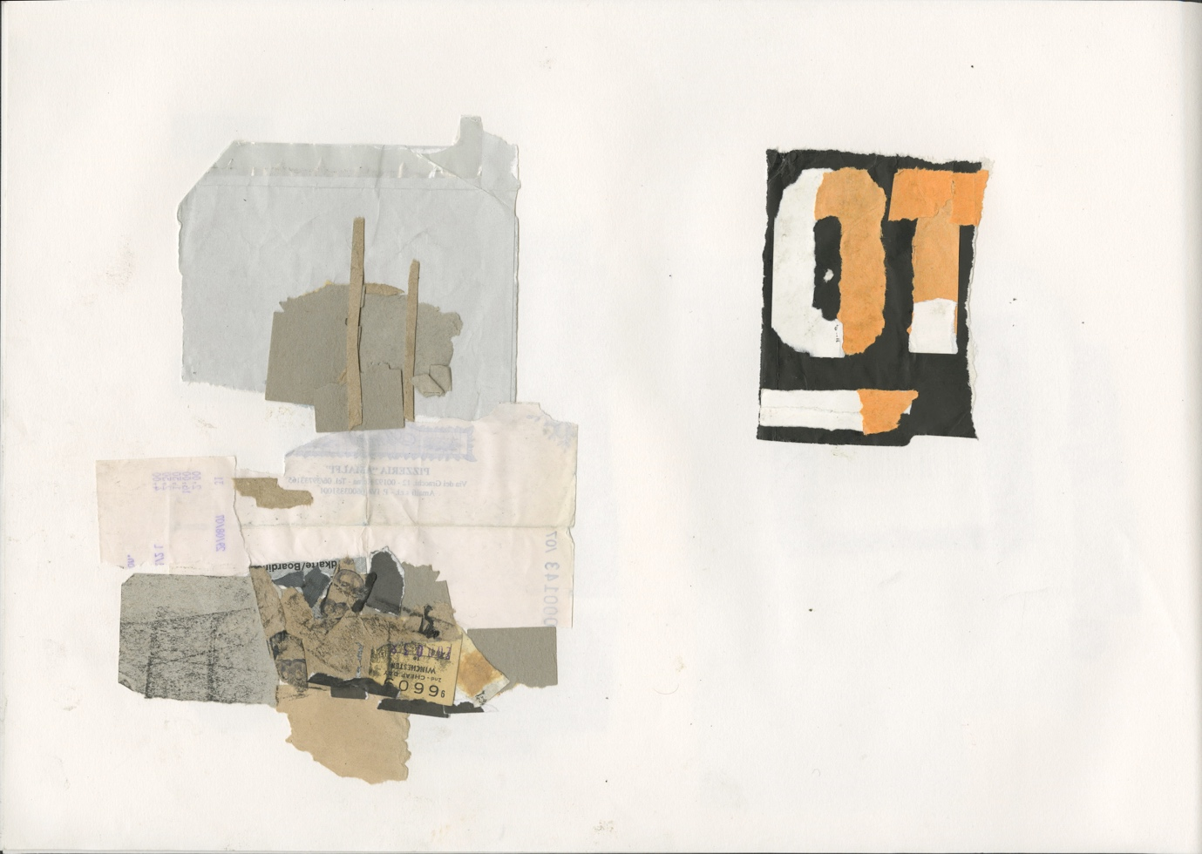
Figure 2: Sketchbook page: Sandycove Martello Tower and forty Foot Sign

I made some stencils based on the torn paper shapes from the collage and printed some trials with grey, buff and white inks. I tried incorporating some textures and elements of text. The results were not what I was looking for. The imagery was far too literal, too obviously a resemblance of the place, the text I’d included in the image was visually crude. Indeed, the most interesting image seemed to me a basic colour test where I’d simply pulled a buff and then a white rectangle over a rectangle of grey ink – an unexpected pale blue-grey and a wet sand colour resulted from the overlays.

When in Dublin I had been to Blackrock Market, a second-hand market. I hadn’t made any work there but had been struck by a tacky nostalgic nationalism on offer– the reproduced photos of rebel heroes Michael Collins and Dan Breen in cheap frames on sale for €50. I tried printing elements from a facsimile I have of the 1916 Proclamation of the Irish Republic, distinctive for its letterpress type, and a rubbing from motorbike number plate I’d bought in a different junk market and combined these with some of the colours I’d remembered from the market. In the most abstract of the combinations I felt something interesting was starting to happen. This was especially true at the points where three or four layers overlapped, resulting in unanticipated colours. (figure 3)
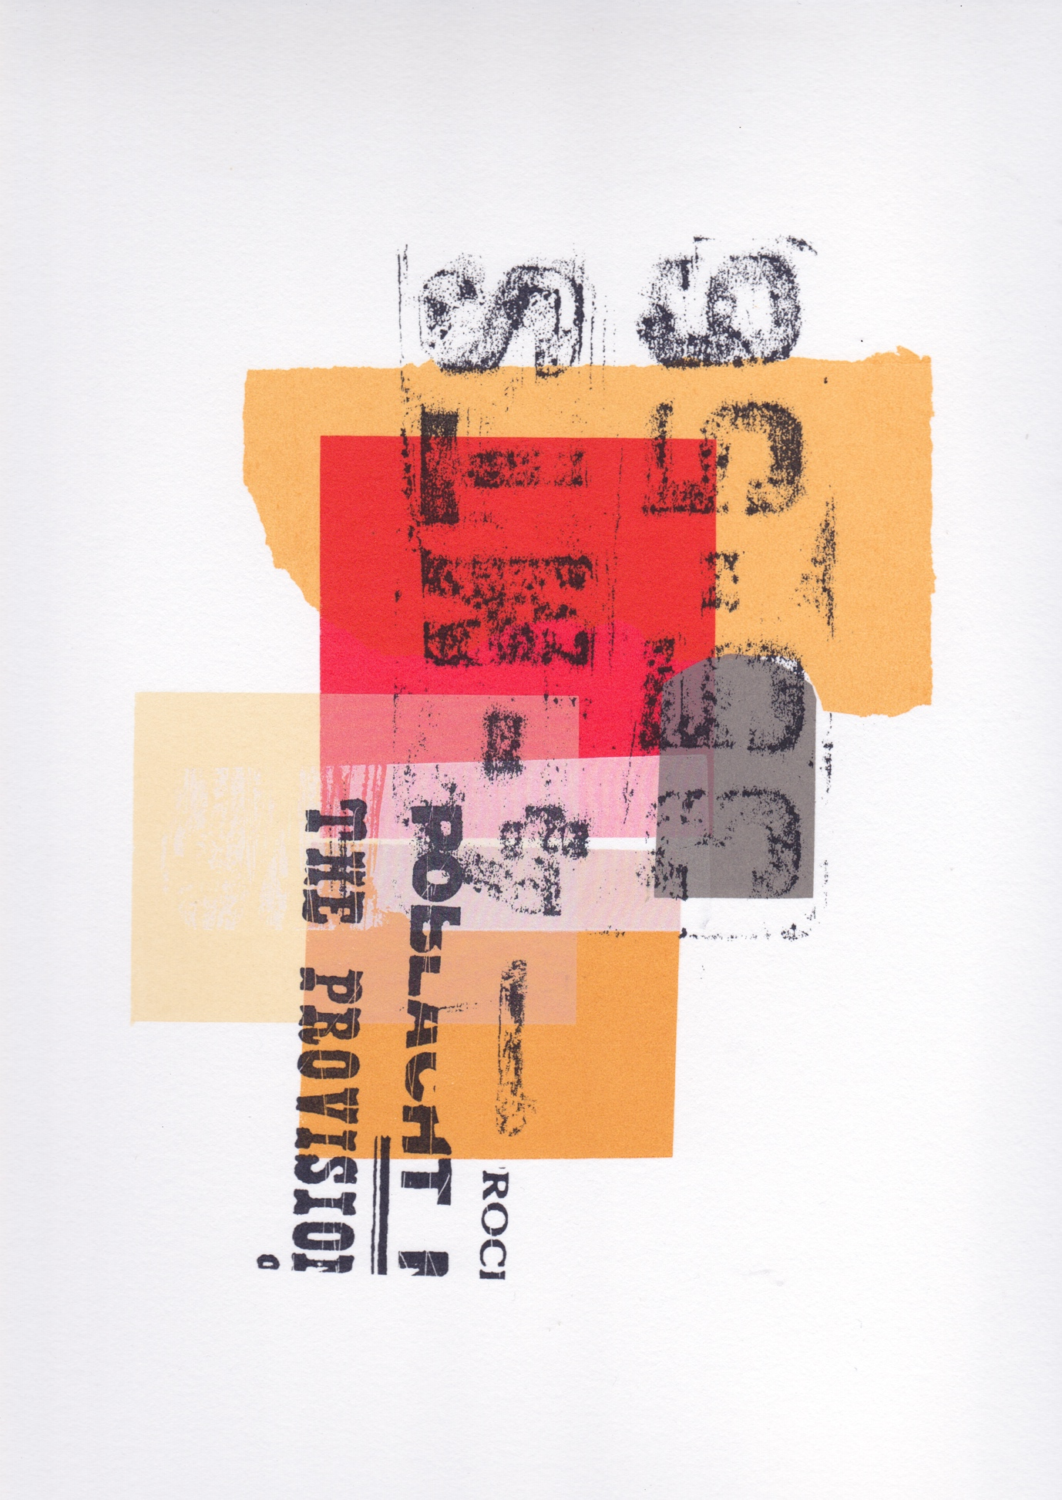
Figure 3: Screenprint: Blackrock Market
Blackrock Baths, where we’d sometimes swum as children is now derelict. The collage drawing I’d made there was of remnants of the blue tiled foot bath at the old changing room entrance. The shapes were already quite abstracted and combined easily with the rubbing I’d made of the plaque to the diver Eddie Heron.

‘Stations’ is not about a specific location but follows the line of the DART, the Dublin suburban rail line. It ends jokingly “and the pillar-boxes: VR; ER; GR; post-colonial.” In 1922 the Irish Free State government decreed that the pillar boxes should be repainted green but left the existing Royal emblems unaltered. This superficial transformation of the pillar-boxes has been seen as emblematic of the betrayal of Republican ideals by the Irish Free State. The authorship of this observation is of course disputed, variously attributed to Sean O’Casey (Kiberd 2000: 483) and Brendan Behan (Mikhail 1982: 281). The fact that the pillar boxes across the Empire were standardised allowed me to make a series of rubbings from pillar boxes in Cambridge in the knowledge that they would be the same as those in Dublin.

As the textual rubbings were now forming a unifying element, I returned to ‘Martello Tower’. More than just a visual element, the rubbings of incidental texts were providing a direct contact to the physical world, perhaps a literal metatext. Still in Cambridge, I was looking for an example of a 3-dimensional text which might evoke June 16th 1904. Taking inspiration from Paddy Dignam’s funeral in James Joyce’s Ulysses, I spent an interesting day in Mill Road cemetery looking for a gravestone with this date, in the knowledge that typographically it would be contemporaneous with Bloomsday. In the end I couldn’t find the exact date but made a series of rubbings of the same raised lead letter typeface found on a number of graves from the period from which I could construct the date. Although Paddy Dignam is a fictional character and therefore has no actual grave, my brother and I have often visited the grave of Matthew F. Kane on whom Dignam’s funeral, in the ‘Hades’ chapter of Joyce’s Ulysses was based. Kane was accidentally drowned in Dublin Bay in July 1904 and his grave is directly behind our great-grandparents’ grave in Glasnevin Cemetery, Dublin. Kane’s actual headstone was erected in 1988.

As a result of these trials, I had a series of prints in relation to each of the poems. What was starting to emerge was the beginnings of an abstracted visual language. This is not unusual within the context of the livre d’artiste. W. J. Strachan makes the case for the successful use of abstract imagery when illustrating contemporary poetry, so that “the artist resembles the choreographer interpreting a piece of music… the descriptive element present in other forms of illustration can be dispensed with and yet the artist must be in complete sympathy with the poet. His compositions or decorations must not overweight the content (metaphorical or physical) of the text.” (Strachan 1969:23).

I was looking not only for a visual coherence across the images, but also some rules, or repeated elements, which might be meaningful across the series. The colours I was using were derived directly from the collages I’d made at the different locations. Because I was forming colours through printed layers rather than mixing before printing, I was able to make these layers visible by the way they overlapped, or not, in printing. I decided to explicitly leave the same inks, warm grey, buff, white and paynes grey partly visible in every image, and combined these with a further range of raw sienna, vermillion, phthalo green and turquoise to form the colours I needed. This way, the layers of each image would find echoes in other images. I was aware that I needed to find a balance between the abstracted shapes I was using and their resemblance of physical features, so that, for example, a Martello tower could be suggested. The final black text layer of the images was obviously visually important in pulling the compositions together, much in the way I use line drawing over collage as mentioned earlier. Where I was using rubbings rather than my drawings of text, there was something about the directness and lack of intervention that appealed to me and which I felt warranted further exploration.

Primary Research: drawing on location, Dublin, Easter 2017
I returned to Dublin with a clearer idea of the sort of visual information I now needed to find. Most importantly I wanted to find incidental texts within the locations of the poems from which I could make a series of rubbings. I wasn’t looking at this point to match these to specific poems, but rather to have a large collection of textual elements to work from. It was also an opportunity to make some more collages in the locations. These were still vitally important to provide starting points for my compositional explorations through printing.

I also used the time to discuss with my brother how I was starting to envisage the book and finalise the number and sequence of the poems. He fixed on eleven poems in a sequence that moved south from sunrise in Dún Laoghaire as far The Forty Foot before returning northwards through Dún Laoghaire, Seapoint, Blackrock and Booterstown to Poolbeg at dusk. Allowing a double-page for each poem and corresponding image would make a twenty four page book, including a title page and a blank page at the end. I showed him a selection of trial prints and he particularly liked the colour palette. He was very interested in the way the work had moved on from the observational collages and intrigued by the screenprinting process.

Back in the studio: development and refinement through printmaking. Cambridge April 2017
I needed to resolve a pair of poems with contrasting atmospheres, ‘Impression Sunrise, Dún Laoghaire' and ‘Maritime History’. The latter is the bleakest poem in the sequence

… famine fleet of a silent people
the land expelled in dry retches
those years the drills were blight-stalked -
with wind bellying the canvas west
they made bare ballast in the holds
of coffin-ships, in whose wake
the throats of our harbours closed.

The location itself had offered little of interest. In working on these as a pair I was keen to make connections between the two so they would echo each other.

The image for ‘Impression Sunrise, Dún Laoghaire’, developed from a collage of a lifebuoy on Dún Laoghaire pier through various prints and collages made form these. The circle of the sun became reflected and broken in the red circle of the lifebuoy. The number 2 arrived by chance in a collage so I retained it in the final print. The final textual layer includes an inscription to “na hÉireanaigh Dhearmadta” (the forgotten Irish) the generations who had emigrated from the pier.

The image for 'Maritime History’ was developed directly from the stencils used in ‘Impresssion Sunrise’. I printed the circle used for the sun in buff and with a pattern of black derived from an image of a blighted potato, so that it becomes moon and potato. The textured stencil which had been printed green for the sea in Impression Sunrise I printed black, and pulled layers of white over this (figure 4).
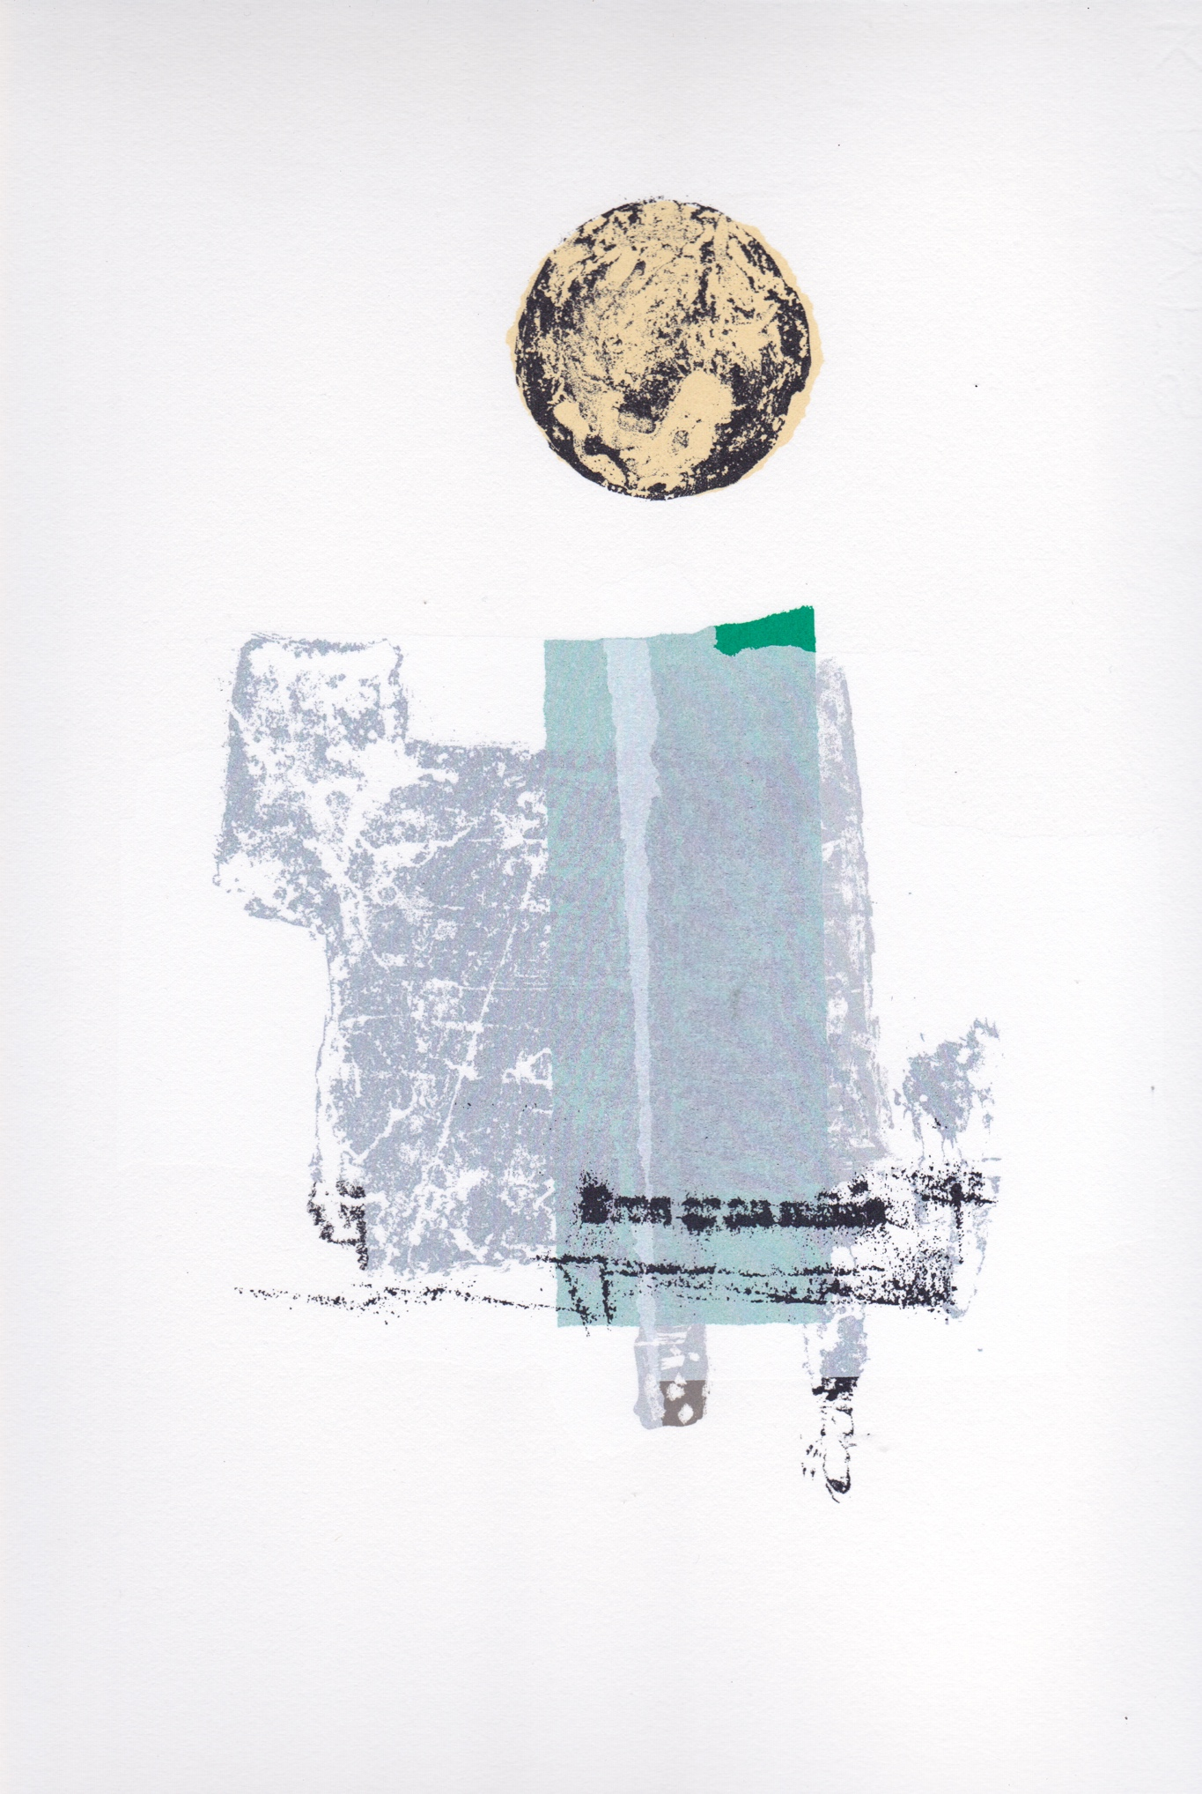
Figure 4: Screenprint: Martime History
The final layer “Brón ar an mBás” (grief at the death) is taken from a memorial to the R.M.S. Leinster, but is also the opening phrase Bean Sléibhe ag Caoineadh a Mhac (A woman of the mountains keens her son), a poem by Pádraic Pearse (Pearse 1922) whose 1916 Proclamation of the Irish Republic appears in ‘Blackrock Market’. There is a further significance to this fragment of text which I hadn’t noticed when I first took the rubbing. Brón is actually misspelled on the plaque as Bron, the fada accent omitted. This type of inaccurate usage of Irish in signs was a cause of much discussion and amusement between David and me. Indeed, the only specific case I can remember where David asked my advice about a poem was whether he should use “den line b(h)uí” (the yellow line) in the poem Stations to reflect the multiple, inconsistent grammar of the different signs at DART stations. In the end he used “den line buí” while my image alludes to both versions.

It would be wrong to think that all of the texts have a literary or political significance. The suite is book-ended by “C of DL” (Corporation of Dun Laoghaire) with the rubbing taken from a manhole cover, as are the rubbings “Dun Laoghaire Harbour” and the scallop shaped “uisce” (water). In these the cast relief letters play against abstracted patterns which presumably help shoes to grip.

As I tackled more poems in the sequence I made collages from torn fragments of my trial prints to develop the compositions in my sketchbook before starting to print. This way I was able to incorporate fragments of texture and colour which would allow the images to echo each other.

Designing the final book
“If two subjects communicate in space, then space is an element of this communication. Space modifies this communication” (Carrión 2008: 137)

Although I had decided on the number of spreads in the book, I had not yet worked out how the poems and and images might interact on the page. One of the livres de dialogue I am fascinated by is André Du Bouchet and Pierre Tal Coat’s 1974 collaboration Laisses (‘Leashes’) where, to quote Emma Wagstaff, 'the blocks and strokes of colour complement, cover, penetrate, illuminate and contradict the words on the page’ (Khalfa 2001: 105). I tried some tests with poems printed over areas colours, and while these were visually exciting, I felt the colour was crowding the poems. It was also the case that two of the poems, ‘Impression Sunrise, Dún Laoghaire’ and ‘Carnegie Library, Blackrock’ had been written with a specific visual shape in mind and that the blocks of colour interfered with this. Carrión argues that printed poetry gains ‘a spatial reality that the so lamented sung and spoken poets lacked…. using space is a characteristic of written poetry… space is the music of unsung poetry” (Carrión 2001: 136)

While I was making the test prints I came across a revealing interview with the book artist Ron King. He recounted getting frustrated with the screenprints he was making for ‘The Prologue’ (Chaucer 1967), tearing them up and going to the pub. When he returned “The way The Knight’s ‘presence’ had torn allowed the floor to be drawn into the image, and in the same way, I went on to use the white of the background page inside the imagery, creating much more of a sense of the wholeness of the book.” (Courtney 1990:12).

The images I’d made used the white of the page, the materiality of the paper, as part of their design and I always had in mind that torn and straight edges of the shapes I was using could echo the the uneven line length of my brother’s poems. Because they were developed from handmade stencils, all my images have a set physical size and changing this would mean remaking all the stencils. The poems and final text layer in the images were both printed in the same Payne’s grey ink.

The elements of text I had employed in the images were predominantly san-serif and related mainly to the period from the late-nineteenth to early twentieth centuries. I was looking for a typeface which might echo this but without the historical baggage and Englishness of a font like Gill Sans. In the end I chose Jonathan Hoefler’s Knockout, whose variety of widths has a rich non-uniformity reminiscent of late nineteenth century playbills. I set this at 11 point with a large surrounding area of white.

When I emailed him some layout proofs, the size of the type caused my brother some concern: he felt that his poems looked too small by comparison with my images, that I was trying to make my images dominate. I had to argue that while this appears small on screen, on printed on paper this is very different. My main concern in page design was to allow a generous amount of white space around both the images and poems so the reader could be drawn into either. I asked him reserve judgement until he saw a printed and bound proof at full scale. When open, the book is 520mm wide and 370mm high. (figure 5).
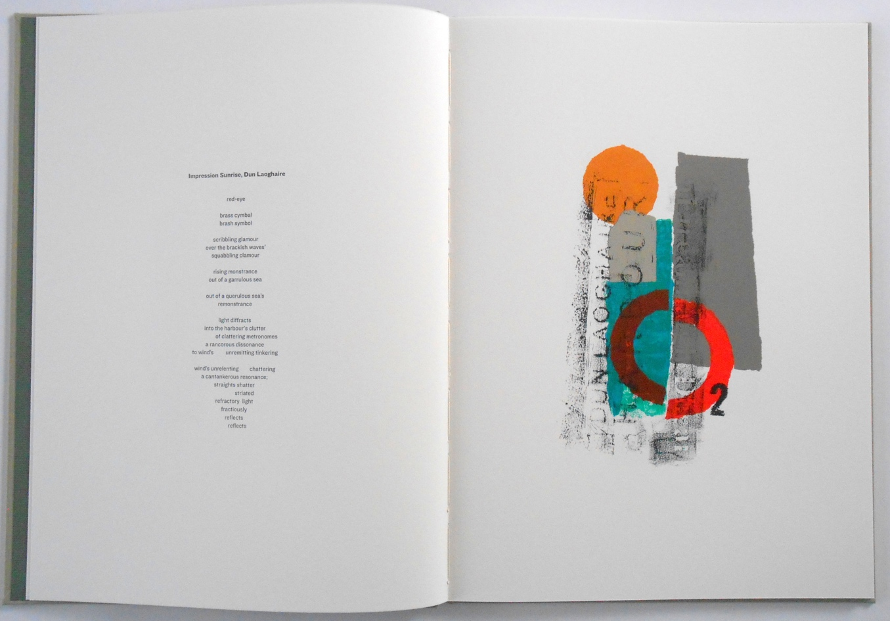
Figure 5: Spread form final book: Impression Sunrise Dún Laoghaire

Once he had see the size of the poems when he was holding the book, he was satisfied that the choice of font size was correct.

Thinking about Bakhtinian polyphonic dialogue, I think the large gutter, around 160 mm, separating poems and images helps distinguish these as separate voices. I think there is also a third voice present, coming from the rubbings. This is a public voice of Ireland, revealed in the area. Importantly, the rubbings are direct quotations, left intact. Sometimes, they are typographically exquisite while at other times they are careless and inaccurate in their expression.

Afterword.
I published Blackrock Sequence in 2017, in a hand bound limited edition of 20 copies. Since its publication, Blackrock Sequence has been acquired by many leading public collections including the Tate, the British Library, the Bodleian Library, the National Irish Visual Arts Library, the Bavarian State Library and the Yale Center for British Art. In 2018 it won the Professional Book category of the Association of Illustrators World Illustration Awards. I
Following our successful collaboration on Blackrock Sequence, we are currently working on a second book of poems and images Liffey Sequnece. The setting this time is the river Liffey and thematically the poems deal with dispossession. The images are still at an early stage of development.

References
Barthes, Roland 1977. Image Music Text. London: Fontana
Bateman, John A. 2014. Text and Image: a critical introduction to the visual-verbal divide. London: Routledge
Black, Stephanie 2014. Illumination through Illustration Journal of Illustration, 1 (2)
Berger, John 2001. Berger On Drawing. Cork: Occasional Press
Butler David and Butler Jim (2017) Blackrock Sequence Cambridge: Jim Butler http://jimbutlerartist.com/images/blackrocksequence/blackrocksequencestart.htm [accessed August 7, 2020]

Butler, Jim, 2013. The Printmaker and the Challenge of the Editioned Book. The Blue Notebook, 7(2)
Chaucer , Geoffrey (1967) ill. Ron King, ‘Prologue’ to The Canterbury Tales. Chichester: Circle Press.
Courtney, Cathy, 1999. Speaking of Book Art, Los Altos Hills CA.: Anderson-Lovelace
Carrión, Ulises, 2008. Quant aux Livres, Geneva: Editions Héros-Limite
Emerson, Carly, 2019. Mikhail Bakhtin, http://filosofia.dickinson.edu/encyclopedia/bakhtin-mikhail/ [Accessed June 4, 2020]
Gray, Carole 1996 Inquiry through Practice: developing appropriate research strategies http://carolegray.net/Papers%20PDFs/ngnm.pdf [accessed June 4, 2020]

Horace, Satires. Epistles. The Art of Poetry (1926) Translated by H. Rushton Fairclough. Loeb Classical Library 194. Cambridge, MA: Harvard University Press.
Khalfa, Jean , 2001. The Dialogue between painting and Poetry. Cambridge: Black Apollo Press
Kiberd, Declan, 2000. Irish Classics. London: Granta Publications
Michail,E.H. (ed) 1982. Brendan Behan: Interviews and Recollections Volume 2 Dublin: Gill & Macmillan.
Mitchell, W.J.T. (1987) Iconology: Image, Text, Ideology. Chicago Ill.: Chicago University Press.
Pearse, Pádraic (1922) ‘A Woman of the Mountain Keens Her Son’ from Colum, Padraic Anthology of Irish Verse. [Online] https://www.bartleby.com/250/113.html [accessed June 9, 2020].
Peyré, Yves, 2001. Peinture et Poésie. Paris: Gallimard
Strachan, W.J. 1969. The Artist and the Book in France, London: Peter Owen

David Butler is the author of three novels, a short-story collection, two poetry collections and several one-act plays. City of Dis (New Island) was shortlisted for the Kerry Group Irish Novel of the Year, 2015. Literary prizes include the ITT/Red Line and Fish International Award for his short stories, the Scottish Community Drama, Cork Arts Theatre and British Theatre Challenge awards for drama, and the Ted McNulty, Brendan Kennelly and Poetry Ireland/ Trócaire awards for poetry
At that time, my artist’s books had been acquired by collections including The Tate, British Library, Bodleian Library, National Irish Visual Arts Library, Huis van het Boek (The Hague), and the Art Institute of Chicago
Polyphony is a term Bakhtin borrowed from music, literally meaning many voices. For Bakhtin a polyphonic approach, exemplified by Dostoevsky’s novels, is “a decentered authorial stance that grants validity to all voices” (Emerson, 2019).
Eddie Heron was an Irish high diving and springboard diving champion. He won the British Diving Championship in 1932 and represented Ireland at the 1948 Olympic Games (the ‘Austerity Games’) in London.
The Forty Foot is famous sea bathing place in Sandycove, Dublin.
Pádraic Pearse (1879 – 1916) was an Irish poet, barrister and revolutionary nationalist political leader. One of the leaders of the Easter Rising in Dublin in 1916, Pearse was executed by firing squad following the failure of the rising and subsequently regarded as a martyr to the cause of Irish nationalism.

