Hybrid manufacturing and mechanical characterisation of Cu/PLA composites

Javaid Butt (Corresponding Author)
javaid.butt@anglia.ac.uk

Peter Oxford
peter.oxford@anglia.ac.uk

Shabnam Sadeghi-Esfahlani
shabnam.sadeghi-esfahlani@anglia.ac.uk

Mohammad Ghorabian
mohammad.ghorabian@anglia.ac.uk

Hassan Shirvani
hassan.shirvani@anglia.ac.uk

Anglia Ruskin University, Chelmsford, CM1 1SQ, Essex, United Kingdom

Abstract
Fused Deposition Modelling (FDM) is a widely used additive manufacturing process. It utilizes a variety of homogeneous and heterogeneous materials for product development. A new manufacturing process termed as Hybrid Fused Deposition Modelling (HFDM) has been used for the manufacture of various copper metal mesh (99.99% pure) / PLA (polylactic acid or polylactide) plastic composites. These products have been subjected to standardized experimental testing for evaluating properties such as tear resistance, tensile strength, water absorption, hardness, and flexural strength. The tests have been conducted to analyze the effectiveness of the HFDM process in manufacturing stronger composites compared to commercially available PLA and copper-infused PLA. Microstructural characterization has also been carried out to analyze the bond between the plastic and metal mesh layers. The results have been promising and demonstrate the effectiveness of HFDM to produce Cu/PLA composites with superior mechanical properties compared to parent FDM-printed PLA plastic as well as copper-infused FDM-printed PLA. Multiple copper mesh layers have been placed strategically within the test specimens to study their effect on the composites made by HFDM. The experimental results show that the process is capable of manufacturing high-quality composites (Cu/PLA) with tailored properties for various engineering applications.

Keywords: Copper mesh; Composite; Flexural test; Fused deposition modeling; Hardness; Hybrid process; PLA plastic; Tear resistance; Tensile test; Thermoplastics; Water absorption

Introduction
The manufacture of composite materials has been garnering interest from both the academic communities and industrial platforms. This has led to extensive research activities into the conceptualization and development of techniques capable of manufacturing different composites i.e., plastic/metal, metal/metal, ceramic/metal and other combination of materials [1], [2], [3], [4], [5], [6]. This rapid shift towards composite materials is due to the advantages that they offer which include tailored properties, good strength-to-weight ratio, and part consolidation. Composites are made from two or more different types of materials. The materials used tend to have different properties so that the resulting composites can be as versatile as possible. However, mechanical integrity comes into question in the absence of a strong bond among the materials as this could lead to a catastrophic failure. Several features need to be considered for the manufacture of composites. They range from the choice of the materials to be bonded/joined to the manufacturing process. Different manufacturing methods have been used over the years for the development of composites. To that effect, plastics have been one of the main materials that are being used for the development of composites because they are easier to process and are readily available. Thermoset and thermoplastics are two types that have been extensively researched and used for the manufacture of composites [7], [8], [9]. The process of molding is a popular choice for the manufacture of thermoset (materials that undergo a chemical reaction and transform from a liquid to a solid) composites. These methods have their limitations mostly in terms of design flexibility, operating parameters and cycle times. However, the focus of this work is on thermoplastic materials and composites.
A common method used for manufacturing thermoplastics (materials that are processed with heat) is called Fused Deposition Modelling (FDM) which is one of the most popular additive manufacturing (AM) processes in the market. AM methods provide design flexibility and can manufacture any geometry by adding layers on top of each other. FDM works strictly with thermoplastic filaments including acrylonitrile butadiene styrene (ABS), polycarbonate (PC), polylactide (PLA), polyamide (PA), and different mixtures of any two types of thermoplastic materials [10], [11]. The process starts with a 3D CAD file, preferably in .stl (stereolithography) format that is sliced into a series of cross-sections. The thickness of these cross-sections/horizontal layers can be changed based on the product requirements. Once the thickness has been selected then the fabrication begins. Industrial FDM systems make use of two materials i.e., build and support. The support material is used to provide stability to the part being built and can be easily dissolvable in a chemical bath. Parts made by FDM are very good for prototyping and visualization purposes, but they are not used for load-bearing applications due to the lack of strength [12], [13]. This has limited the use of FDM in technological applications, but extensive research is being undertaken to impregnate thermoplastics with other materials to improve their mechanical properties. Different fibres including glass, single-walled carbon nanotubes and copper have been used with ABS and PLA to supplement their mechanical characteristics [14], [15], [16]. Research done by Gray, et al., [17] on the development of thermo-tropic liquid crystalline polymer (TLCP) fibre reinforced polypropylene filament for FDM has resulted in improved tensile strength. Carbon fibres are a popular option for reinforcing plastics. Li, et al., [18] reinforced PLA with carbon fibres and developed filaments to be used in FDM. Tensile and flexural tests of the reinforced composites showed improved properties with the increase in carbon fibre content. Van Der Klift, et al., [19] used a Mark One FDM based 3D Printer to manufacture carbon fibre reinforced thermoplastics. They conducted tensile testing on the products by adding layers of carbon fibre to enhance tensile strength. The work done by Lu, et al., [20] showed the fabrication of continuous carbon fibre reinforced plastic composites by material extrusion and stereolithography (SLA). They found that the bond strength is stronger in SLA compared to material extruded parts. In addition to enhancing plastics by carbon fibres, metal enhanced PLA/ABS filaments for FDM are also becoming readily available. However, the metal content is not high enough to effectively enhance the mechanical properties of the final products.
The attempts to impregnate thermoplastics with different reinforcements to be used in FDM have resulted in different approaches that often involve completely changing the manufacturing process for the filaments to improve their properties. Also, there are no reported comprehensive experimental investigations of enhanced thermoplastic materials according to British and European standards. This work will develop on the research done by the authors previously where they proposed a new Hybrid Fused Deposition Modelling (HFDM) process for the manufacture of metal/plastic parts. The process has been explained in detail in our previous work [21]. This paper focuses on the effect of adding copper mesh layers to PLA and standardized mechanical testing of the composites to investigate the behavior of the plastic- metal bonding. The next section will provide a breakdown of activities undertaken to manufacture the metal/plastic composites.

Materials and Manufacturing Process
The complex HFDM process was broken down into simple steps for practicality by creating an experimental setup to demonstrate the functionality of the process. PrimaValue PLA filament, with a filament diameter of 1.75 mm (from 3D Prima, Sweden), and 30 microns thick copper mesh sheets (from The Mesh Company, UK) of 99.99% purity were used to build specimens for mechanical testing that include tear resistance, tensile, water absorption, hardness and flexural. All the composites were tested and compared with FDM-printed PLA specimens. The results of the tensile test were also compared with annealed PLA and copper enhanced PLA (from ColorFabb, The Netherlands) specimens (after annealing) to analyze the fracture load values. The specimens were manufactured and experimentally tested based on British and International standards. A low-cost DIY desktop 3D printer called Anet E12 (from Shenzen Anet Technology Company Limited, Hong Kong) was used that has a large working envelope of 300 mm x 300 mm x 400 mm as shown in Fig. 1. The 3D CAD model of the part to be built was sent to an open-source 3D printer slicing software package called Ultimaker Cura 3.5 that began the build operation. The part was built at a speed of 30 mm/s with a layer thickness of 0.2 mm. PLA was printed at 210 °C with the bed temperature set at 60 °C as shown in Fig. 2a. Copper enhanced PLA specimens were printed at the same print speed but at 220 °C nozzle temperature and 55 °C as bed temperature. The copper mesh was added to the part by pausing the build operation and then resuming it (Fig. 2b). For improved adhesion between plastic and metal mesh, the number of shells was increased from two to three, infill density was set at 100% and the infill pattern is selected as ‘Lines’ in the Cura software. Other options could have been considered such as choosing a different infill pattern (e.g., tri-hexagon, octet, grid) and increasing the thickness of the top as well as bottom layers. Optimization of 3D printing parameters is a complex process; therefore, the build process was kept simple to ensure consistent results promptly. For statistical accuracy, a total of three specimens were tested for all the different materials and configurations.
Insert Figure 1 here
Insert Figure 2 here

2.1. Configuration of Cu/PLA composites
A variety of mechanical tests were performed on the Cu/PLA composites. They included tear resistance, tensile, water absorption, three-point flexural, and hardness. A maximum of three Cu mesh layers were interlaced within the PLA specimens for all the tests. One mesh layer was placed at 50% of the overall thickness of the specimen based on the test (referred as Cu/PLA1), two mesh layers were placed at 40% and 80% (referred as Cu/PLA2) whereas three layers were placed at 30%, 60% and 90% (referred as Cu/PLA3). For the hardness test, additional Cu/PLA specimens were manufactured. They were made with a single layer of copper mesh placed at 10% intervals of build and then at 20% and so on (30%, 40%, 50%, 60%, 70%, 80%, 90%).
The reason for adding another set of Cu/PLA composites (in addition to the standard Cu/PLA specimens with 1, 2 and 3 layers of copper mesh) is the nature of the test. None of the other tests (tear resistance, tensile and three-point flexural) are affected by the placement of the copper mesh layers closer to the surface due to how the force is applied for them. For example, if the copper mesh is placed closer to the surface then the hardness number from the indentation test would be different compared to when the mesh layer would be farther away from it. Hence, testing the specimens with copper mesh placed at 10% build intervals helps to quantify the hardness of the Cu/PLA composites.

Experimental Methodology

Tear resistance testing
Cu/PLA and PLA specimens were manufactured based on BS 2782-3: Method 360C: 1991 [22]. This method is used for the mechanical testing of plastics to determine the tear resistance of plastic film and sheeting by the initiation method. It is suitable for flexible film and sheeting up to approximately 2.5 mm in thickness. It was utilized to test the effect of increasing the number of copper mesh layers (one, two and three) within the 2.5 mm thick specimen (as explained in Section 2.1) and comparing it to the FDM-printed PLA specimen. Experimentation has shown that there should be one metal mesh layer per 1 mm thickness to ensure that enough plastic layers could be deposited to develop consistent bonding [21]. This indicates that the specimen with three layers (Cu/PLA3) will cause issues and this has been addressed in Section 4.1. The dimensions of the part used for determining the tear resistance are shown in Fig. 3. The specimens were 3D printed with a thickness of 2.5 mm ± 0.1 mm (precision of the Anet E12 printer). The Hounsfield Tinius Olsen Tensile Testing machine was used to undertake the test at a rate of 250 ± 25 mm/min grip separation as indicated by the standard. The tear strength (S_{i}) of the specimens (in kN/m) is calculated by dividing the force in newtons during the test by the thickness in millimeters (2.5 mm).
Insert Figure 3 here

Tensile testing
Cu/PLA specimens (with one, two and three layers), PLA specimens and copper enhanced PLA specimens were manufactured based on BS EN ISO 527-2: 2012 [23]. The addition of copper mesh layers (according to the description provided in Section 2.1) is being used to increase the tensile strength to indicate how many layers are needed for superior properties compared to these commercially available materials (PLA and copper enhanced PLA). The dimensions of the specimen are given in Fig. 4. The overall thickness of the specimens was kept at 4 mm ± 0.1 mm (precision of the printer). PLA and copper enhanced PLA specimens were also annealed at 70, 80 and 90 °C to compare their fracture load values post annealing with untreated Cu/PLA specimens. The specimens are shown in Fig. 5.
Insert Figure 4 here
Insert Figure 5 here

Water absorption testing
Plastics are prone to water absorption and this effect can result in adverse changes to their mechanical properties. Generally, this test is performed by immersing the specimens in distilled water and measuring the amount of water absorbed. In this case, however, the specimens will be subjected to tensile testing after the measurements to obtain a tangible measure of a change in their tensile properties. This test is being done to evaluate the deterioration in the tensile strength of the Cu/PLA composites at different numbers of copper mesh layers to analyze if they are better suited under moisture-rich conditions compared to FDM-printed PLA.
The PLA and Cu/PLA specimens (with one, two and three layers of Cu mesh) were manufactured according to BS EN ISO 527-2:2012. The procedure for water absorption was based on BS EN ISO 62: 2008 [24]. Within the standard, there are four methods; first is the immersion in water at 23 °C, second is the immersion in boiling water, third is the determination of the water-soluble matter and fourth is water absorption after exposure to 50% relative humidity. Method 1 is being used here that comprises three major steps. In step 1, each specimen is measured with a scale having an accuracy of ± 0.1 mg, dried in a convective heat oven at 50 ± 2 °C for 24 hours, cooled down to room temperature and weighed to the nearest 0.1 mg (mass m₁). In step 2, the specimen is immersed in distilled water maintained at 23.0 °C ± 1.0 °C for 24 ± 1 hours, removed from the water and dried with a clean, dry cloth or with filter paper and reweighed within 1 minute of removing from water (mass m₂). In step 3, the dried-up specimen is left for 2 hours and reweighed (mass m₃). The percentage change in mass c relative to the initial mass is calculated by using Eq. 1 as shown below:

$c= \frac{m_{2}- m_{3}}{m_{1}} x 100\%$ (1)

where,
m₁ = mass of the specimen, in milligrams (mg), after initial drying and before immersion;
m₂ = mass of the specimen, in milligrams (mg), after immersion;
m₃ = mass of the specimen, in milligrams (mg), after immersion and final drying.
After the measurements, the samples were subjected to tensile testing to analyze the effect of water absorption on their tensile properties. The testing was done according to BS EN ISO 527-2:2012 and the fractured surfaces were also observed under a scanning electron microscope (SEM).

Three-point flexural testing
Cu/PLA and PLA specimens were manufactured based on BS EN ISO 178: 2019 [25]. The specimens were 100 mm long, 25 mm wide and 3 mm thick. The tested specimens were made with increasing layers of copper mesh (1, 2 and 3) while keeping the overall thickness to 3 mm ± 0.1 mm (precision of the printer) as explained in Section 2.1. This was done to analyze whether the increase in the number of metal mesh layers at appropriate intervals can provide a subsequent increase in strength when the specimens are subjected to flexural loading. The test was done using a TIRAtest 2810 Universal Testing Machine with a speed of 2 mm/min. The former and supports are 10 mm in diameter based on the size of the tested specimens. The former is used to apply force in the middle of the specimen whereas the supports are set at 10 mm from the ends leaving a span of 80 mm for the test.

Hardness testing
The three categories of hardness measurements are scratch, indentation, and rebound. Each category comprises individual scales for measurements. In this case, indentation hardness was carried out. Indentation hardness measures the resistance of a specimen to material deformation due to a constant compression load from a sharp object. Common indentation hardness scales are Rockwell, Vickers, Brinell, and Shore, amongst others. In this case, the Rockwell hardness scale L was utilized. The preparation of specimens and testing procedures were based on BS EN ISO 2039-2: 2000 [26]. This test focus on determining the hardness number and whether the addition of copper mesh layers plays a part in affecting this property of the composites. To this effect, three different products were FDM-printed according to the British standard. The parts were 40 mm in length, 40 mm in width with 6 mm thickness and were FDM-printed to analyze the effect of Cu mesh layers on the hardness of the composites (as described in Section 2.1).
An Avery type 6402 Rockwell hardness testing machine was utilized. According to Rockwell hardness scale L, the indenter diameter was 6.35 mm. The minor load was 98.07 N and its dwell time was 8s, whereas the major load was 588.4 N with a dwell time of 15s. The indentation was measured using a hand-held gauge. Each Rockwell hardness scale division represents a 0.002 mm vertical movement of the indenter. The Rockwell hardness number is derived from the following equation:
HR = 130 – e (2)
where,
HR = Rockwell number
e = depth of impression after removal of the major load, in units of 0.002 mm.

Results and Discussion

4.1. Results from tear resistance testing
Tear resistance is generally reserved for testing a flexible film of plastic, but it served as a good starting point to assess the bond integrity between PLA and Cu mesh. This test requires special attention to ensure that the specimen tears across its width right where the notch is present. The notch for such specimens is created with the help of a punch or a sharp-edged knife. Both options cannot be used as FDM works by building the precise geometry layer by layer. FDM creates shells (walls of a print) that often deposit slightly more material at edges, corners, and notches compared to the rest of the part. This could create issues as the tear should initiate from the notch rather than away from it. To ensure this aspect, the slightly longer edge of the specimen was carefully clamped in the moving gripper. The specimens are shown in Fig. 6a before testing. It is quite evident from Figs. 6b and 6c that the tear initiated from the notch and not around it.
Insert Figure 6 here
The tear resistance testing results are shown in Fig. 7. The specimens with the metal mesh layers showed a larger displacement range compared to the parent PLA. This effect is evident in Fig. 6c with the slight discoloration around the fracture zone of the Cu/PLA composite. This indicates that adding metal mesh layers add slight ductility to an otherwise brittle material. The tear strength (S_{i}) of the specimens in kN/m is shown in Table 1. In addition to larger displacement, the results also showed increased fracture load value for the specimen with a single layer of copper mesh (indicated by Cu/PLA1) at 358.5N as compared to 342.5N for the parent/control PLA specimen (indicated by C-PLA). This is a 4.6% increase in fracture load and this trend continues to grow with the double-layered Cu/PLA (indicated by Cu/PLA2) specimen that showed a 7% increase compared to FDM-printed PLA. The increase in fracture load values is attributed to the addition of the copper mesh layers. The mesh is laid down while the last plastic layer is still molten. This allows the molten plastic to seep through the openings in the mesh and when the next layer of plastic is extruded then it adheres to the previous layer providing good cohesion between layers.
Insert Figure 7 here
Insert Table 1 here
Although the fracture load values increased from the single-layered to the double-layered Cu/PLA specimen, the specimen with three layers of copper mesh (indicated by Cu/PLA3) only showed a 5.5% increase compared to the FDM-printed PLA specimen. This percentage lies between the single and double-layered specimens. It is important to note that Cu/PLA3 did not show a delamination failure as the layers were still intact, only lower fracture load value. The result is supported by the previous work that a single layer requires at least 1 mm of thickness to ensure that enough plastic layers could be deposited and develop consistent bonding [21]. To overcome this limitation, a minimum thickness of one-millimeter is recommended for the addition of a single layer of metal mesh. This means that a product of 3 mm thickness can only have three metal mesh layers and the addition of another metal layer would require increasing the thickness of the specimen by one millimeter (i.e., 4 mm).

4.2. Results from tensile testing
A crosshead speed of 5 mm/min was used to undertake the tensile testing of all the specimens. It has already been proven through tear resistance testing that Cu/PLA specimens made by HFDM have superior properties compared to FDM-printed PLA. Therefore, different types of specimens were added for tensile testing to ascertain a better understanding of the tensile strength for Cu/PLA composites. Three different types of specimens were manufactured for tensile testing. The first two were from commercially available PLA and copper enhanced PLA materials respectively. After the build process, the FDM-printed specimens (PLA and copper enhanced PLA) were subjected to a post-process termed as annealing. It is to be noted that the focus of the investigation is not the process of annealing but its effect on the mechanical properties. This process has been utilized for decades to improve the mechanical properties of metals and has been extended for use with plastics as well. The focus of the investigation is on the effect of annealing and whether it can provide a substantial increase in tensile strength to compete with composites made by HFDM.
Annealing works very well with FDM-printed parts to relieve stresses in highly affected areas and can dissipate them more evenly through the print, resulting in enhanced mechanical strength. The reason for the popularity of annealing lies in the working of the FDM process. It heats a thermoplastic material that is extruded and then cooled rapidly to form a part. This rapid cooling can leave behind empty spaces due to limited adhesion causing residual stresses in the material [27]. Annealing involves reheating the plastic based on its glass transition temperature, but below its melting temperature. Plastic is kept at the annealing temperature for a specified duration and then gradually cooled down to allow its microstructure to relax and reduce the effects of residual stresses. The glass transition temperature of PLA as well as copper enhanced PLA is around 60 to 65 °C. The temperatures chosen for annealing both materials were slightly above their glass transition temperature (i.e., 70, 80 and 90 °C). The specimens were heated in a convective heating oven for 1 hour. After the time had elapsed, the oven was turned off to allow the specimens to gradually cool down. After annealing, PLA specimens were tensile tested with the results shown in Fig. 8 that demonstrate an increase in fracture load values with increased temperatures of annealing. It is to be noted that setting the parameters for annealing is an extremely challenging process and PLA materials from different vendors don’t exhibit consistent properties. Different heating times can result in widely different properties. Therefore, a simple approach for the temperatures and time was adopted to provide a basis for comparison with the new Cu/PLA specimens made by HFDM. The results for annealed PLA are promising but require the use of additional resources i.e., time and equipment. In contrast to this effective post-processing, Fig. 8 also shows the tensile test results of the Cu/PLA specimens with one, two and three layers along with the annealed PLA specimens. The comparison showed a contrast between the specimens annealed at three different temperatures (70A, 80A, and 90A) and the layered Cu/PLA specimens (Cu/PLA1, Cu/PLA2, and Cu/PLA3) with the layered Cu/PLA composites showing higher increments in fracture load values (6.3%, 8.8% and 12%) compared to the annealed specimens (4.5%, 6.7%, and 9.8%). The fractured surfaces of the FDM-printed PLA, annealed PLA specimen (at 90 °C) and a single-layered Cu/PLA specimen are shown in Fig. 9. The increase in load values compared to the parent material is also consistent with our previous work with Cu/ABS specimens [21]. The parameters for the FDM process also play an important role in enhancing the properties of the Cu/PLA specimens further. Just like utilizing a simple approach to annealing, the Cu/PLA parts were also printed with default settings of the Anet E12 FDM system. There are aspects that can be optimized to achieve superior adhesion and improved mechanical properties (e.g., number of shells, infill pattern, top and bottom layer thickness, print speed, and layer thickness). The test results for tear resistance (Section 4.1) showed increased ductility or a larger displacement range of the Cu/PLA specimens compared to the parent PLA, but such an increase was not observed for tensile testing. This can be attributed to the different geometries and how they can play a role in altering the properties of the resulting Cu/PLA products. It is commonly reported that parts made by FDM are anisotropic which is affected not only by the build process but also the build orientation [28], [29]. In the case of the tensile test, a uniform cross-sectional area is being stretched between two grippers whereas the tear resistance test makes use of a notched specimen. This effect will be further investigated in future works by optimizing the build orientation to produce Cu/PLA composites.
Insert Figure 8 here
Insert Figure 9 here
The annealing for copper enhanced PLA was done in the same manner as PLA specimens and the results. The fractured surfaces for parent copper enhanced PLA and a specimen annealed at 90 °C are shown in Fig. 10. It is to be noted that metal-infused filaments contain a high percentage of the metal as compared to plastic. Due to the inclusion of metal powder, this filament is three times denser than PLA. That is why the parts made with copper enhanced PLA material are relatively heavier compared to PLA as well as Cu/PLA composites. The main advantage of working with metal-infused filaments is that the final product can have a metallic finish but unfortunately it requires extensive post-processing (e.g., metal polishing, spray painting). These materials help to achieve the aesthetics of metal prints at an affordable cost compared to commercial metal AM systems such as direct metal laser sintering and electron beam melting. On the other hand, these materials have their own set of challenges and are difficult to print with FDM systems as they require a wear-resistant nozzle. Retractions can also be an issue resulting in sections with blobs where the extruder starts and stops the extrusion process. Metal filled filaments are quite heavy and that limits their bridging performance. When the molten material is extruded across either side of the bridge, the excessive drooping could lead to breakage before the completion of the bridge. This limits the complexity of the products that can be printed using metal-infused filaments. FDM generally requires optimization of process parameters and metal enhanced filaments require additional precautions that can result in longer processing and maintenance times.
Insert Figure 10 here
Infusion of metal powders into plastic filaments is done for a variety of reasons by precisely controlling the metal content to ensure consistent product development. Metal infused filaments are brittle to start with and annealing could make this behaviour more prominent. As can be seen from Fig. 11, parent material (C-Cu) has a larger displacement range whereas all the three annealed specimens show relatively shorter ranges. Introducing metal powder had already increased the thermal conductivity of the material which mean that it can heat up and cool down faster. The subsequent post-process heating at different temperatures followed by gradual cooling had rearranged the molecular chains of the material. The process of annealing gave the specimens improved tensile properties with a trade-off regarding ductility. Even though the results showed higher fracture load values, they were still lower compared to PLA or composites made by HFDM. The highest load value for copper enhanced specimen annealed at 90 °C is 805N (specimen indicated by 90A’) which is about 184% less than parent PLA at 2287.5N. On the other hand, a comparison with the highest valued copper enhanced specimen (805N) showed that Cu/PLA specimens (Cu/PLA1: 202%; Cu/PLA2: 209%; Cu/PLA3: 218%) had over 200% better fracture load values as shown in Fig. 11. The results from the tensile testing of all the specimens are also summarized in Table 2. The comparison of Cu/PLA composites with annealed PLA and copper enhanced PLA materials showed the superiority of HFDM parts. It demonstrates that commercially available materials even after post-processing are inferior in terms of their tensile strength compared to the composites made by HFDM.
Insert Figure 11 here
Insert Table 2 here

4.3. Results from water absorption testing
The water absorption measurements followed by tensile testing were undertaken to demonstrate whether Cu/PLA composites made by HFDM are suitable for use in moisture-rich environments. Water absorption is a problem for plastics and can degrade mechanical properties. To obtain reliable results, the three steps described in Section 3.3 were carefully followed. The percentage change in mass c relative to the initial mass for all the specimens is calculated using Eq. 1 and the results are shown in Table 3. It is also important to note that the copper mesh was cut larger than the dog-bone specimen which makes the Cu/PLA samples heavier than they should be if it was cut according to the exact dimesons. Moreover, the dimensions of the copper mesh were kept the same for all the specimens to ensure consistent readings.
Insert Table 3 here
It is clear from Table 3 that an increase in the number of Cu mesh layers in the Cu/PLA composites resulted in higher water absorption. The control PLA sample also experienced water absorption but to a very small extent. The percentage change in mass for Cu/PLA composite with three layers of metal mesh is 2.54 compared to 0.18 for control PLA (an increase of 2.36%). The reason for a higher rate of water absorption in Cu/PLA composites is attributed to the inclusion of metal mesh layers. PLA absorbed water and this resulted in the diffusion of water molecules between the molecule chains causing volumetric swelling leading to molecular degradation. It can result in loss of mechanical properties, reduction in chemical resistance, change in aesthetics, the evolution of volatiles and carbonyl formation. Factors affecting molecular degradation include the type of polymer, effectiveness of stabilization additives, temperature and stress levels. In this case, PLA bonded with Cu mesh under heat with an increased number of shells and a higher infill percentage has resulted in enhancing the rate of water absorption. Hydrolysis is often confused with water absorption; therefore, it is imperative to recognize that these are two different phenomena [30].
Tensile testing after immersion of the Cu/PLA composites in water has shown that the properties have dwindled (Fig. 12) due to the increased water absorption. Parts made by FDM are not free from cracks or voids and as the number of Cu mesh layers increased, water was absorbed more rapidly through those areas that increased porosity in the composite specimens. This phenomenon of reduced mechanical properties has been widely reported by researchers working with PLA and PLA composites [31], [32], [33]. These ‘wet’ results of water absorption are presented in Table 4 and are very close to the values obtained from the tensile testing of annealed PLA samples in Section 4.2 (Table 2). Even though there is a reduction in the mechanical properties, there is still no need for post-processing as the tensile strength is still considerably higher than the parent PLA.
Insert Figure 12 here
Insert Table 4 here
The side by side comparison of SEM images for the fractured surfaces of PLA and WQ-PLA is shown in Fig. 13 at x50 magnification. Although 0.18% of water was absorbed that resulted in 2% less fracture load value for WQ-PLA compared to control PLA, there are very few cracks visible. On the other hand, Cu/PLA composites have shown reduced values. Due to increased water absorption, the layers have swelled resulting in porosity, cracks, and voids in these composite specimens. These can be seen quite clearly in Fig. 14 for a single-layered Cu/PLA composite.
Insert Figure 13 here
Insert Figure 14 here

4.4. Results from three-point flexural testing
This test was conducted to assess the bond strength of composites manufactured by HFDM under flexural loading as shown in Fig. 15. The results from the flexural test are illustrated in Fig. 16 and the calculated values of flexural strength are shown in Table 5. All the specimens followed a similar PLA characteristic curve which shows the presence of a strong bond. Based on the results, it is evident that the Cu/PLA composites made by HFDM show better flexural properties compared to FDM-printed PLA and the increasing number of metal mesh layers has also increased the flexural strength. The single, double and triple layered composites are 5%, 7.6%, and 11% better than the parent PLA. Furthermore, these values are comparable to the increase observed during tensile testing as discussed in Section 4.2.
Insert Figure 15 here
Insert Figure 16 here
Insert Table 5 here
The fractured surfaces for the PLA and three-layered Cu/PLA specimens are shown in Fig. 17. PLA as expected fractured with a clean break as shown in Fig. 17a, but the three-layered Cu/PLA did not show a break (Fig. 17b). Since the material is light in colour and the first (out of three) metal mesh layer is at 30%, the presence of striations is evident on the surface of the specimen. This means that the metal mesh continually resisted the flexural loading and kept the plastic fibres as well as the grain boundaries together which in turn stopped the specimen from completely deforming as can be seen in the case of PLA. There are generally two types of striations: brittle and ductile [34]. The striations, in this case, are ductile and the introduction of three metal mesh layers has moved the failure mechanism, from brittle (in case of PLA) to ductile (in case of three-layered Cu/PLA). It is also clear that there are multiple striations grouped along the length of the specimen that shows evidence of excessive material tearing during the striation formation process. Similar patterns are also observed on the bottom side of the specimen (the side facing the supports). However, an in-depth analysis is required to understand these striations and the extent to which they can help improve mechanical properties. Fatigue testing will be a prime candidate to shed more light on this phenomenon. Nonetheless, these results are promising as they show that the bond created by the HFDM process without any pre or post-treatment (that adds to the manufacturing time) is strong and imparts good mechanical properties to the manufactured composites. The bond integrity has also been analyzed by carrying out a three-point flexural test on a PLA specimen where the metal mesh layers have not been bonded to the plastic and simply put together and held in place by tape to investigate how much flexural loading the specimen can withstand. The results of the test compared to a bonded two-layered metal mesh are shown in Fig. 18 which shows that the unbonded specimen failed in steps indicating the lack of bonding between the plastic and metal mesh layers whereas the specimen made by HFDM exhibited a characteristic curve with no individual breaks.
Insert Figure 17 here
Insert Figure 18 here

4.5. Results from hardness testing
Hardness measurements quantify the resistance of a material to plastic deformation and indentation hardness tests are used to determine material hardness. There are two main categories for indentation hardness tests i.e., micro-indentation and macro-indentation tests. Micro-indentation tests typically have forces less than 2 N. The results obtained in this section are based on macro-indentation as the applied minor and major loads were 98.07 N and 588.4 N respectively. As with any testing procedure, there are sources of errors that should be mitigated. These errors include but are not limited to poor technique, poor calibration of the equipment, and the strain hardening effect of the process. In addition to the hardness test-related issues, the Cu/PLA composite specimens pose their own set of challenges. FDM-printed PLA part is anisotropic due to the layer by layer process which means that the properties are different in different directions. These materials frequently fail more easily when loaded along the build direction due to weak interlayer bonding [35]. In this case, layers of metal mesh have been interlaced with PLA layers to form a composite structure. To obtain a better understanding of the hardness characteristics of Cu/PLA composites, two different configurations were manufactured. The results (calculated using Eq. 3) from the configuration where a single Cu layer is placed within the square specimen at 10% intervals are shown in Fig. 19. The one at 0% is the FDM-printed PLA material. A single layer of metal mesh was added to the PLA specimen when it was 90% complete and it was tested in that orientation so that there was very little distance between the mesh layer and the top of the specimen where the indenter was placed. The subsequent tests were done in the same configuration with the 10% specimen indicating the addition of the mesh layer when the 3D printer had only printed 10% of the specimen and in this case, the indenter was the furthest from the metal mesh layer. An average of 5 values was taken from each specimen that was equidistant from each other as shown in Fig. 20.
Insert Figure 19 here
Insert Figure 20 here
Hardness is a surface property that deals with the resistance provided against indentation. This resistance is higher if the atoms at the surface are closely packed with each other. It is clear from Fig. 19 that the specimens with the copper mesh placed closer to the surface (90%, 80%, and 70%) showed lower hardness numbers compared to the parent PLA. However, an upward trend can be seen from 60% from where the hardness number kept on increasing with the highest value shown at 10% to be 54.6HRL compared to 38.4HRL of the parent PLA. The reason for the inconsistency and lower values close to the surface can be attributed to the indenter not being able to compress a uniformly packed surface. Hardness values are greatly affected by surface roughness. FDM-printed specimens are usually rougher than other types of plastic parts because of the layer by layer operation and these layers are visible on the surface of the specimens after the print [36]. Two situations may arise in practice i.e., the indenter meeting a peak or a valley. In the former, the non-uniform contact will increase the localized stress at the contact point and will deform the material to a greater depth at relatively low loads. This will result in greater penetration depth and lower calculated hardness value. In the case of the latter when the indenter meets a valley, the true contact area will be underestimated and consequently, the calculated hardness will be overestimated [37]. The interaction between PLA and Cu mesh is shown in Fig. 21. The surface roughness combined with the proximity of the metal mesh layer to the indenter as well as contact with peaks and valleys has resulted in lower hardness number values.
Insert Figure 21 here
The hardness number begin rising from 60% onwards as more and consistent resistance was offered to the indenter from the entire structure due to the presence of a metal mesh layer. A material experiences tension and compression forces upon the application of a load and subsequently reaction forces are generated due to the material properties. In the case of Cu/PLA composite, the additional Cu mesh layer also experiences tension and compression but provides stronger reaction forces as shown in Fig. 22 that has led to higher hardness numbers. Cu/PLA is an anisotropic composite and comprises Cu mesh and PLA; Cu is more elastic and stronger than PLA. Because a small percentage of the composite is made from Cu mesh, there are areas within the composite that are more elastic than others. When the composite is loaded, it deforms an amount depending upon its overall average material properties. The composite displays elastic strain recovery from the 60% completion mark as the load causes permanent deformation in less elastic parts of the composite and only temporary deformation in the more elastic parts of the composite. When the Cu/PLA composite is unloaded, the overall deformation reduces due to the parts of the composite which were not permanently deformed contracting toward its original unloaded dimensions. Since the non-elastic parts of the composite do not contract, the composite does not completely return to its original shape, hence leaving behind indentations [38].
Insert Figure 22 here
After achieving optimized results that prohibit the use of metal mesh layers beyond 60% completion of an FDM-printed part for hardness testing, multiple layers were introduced to analyze their effect. Keeping in mind the 60% barrier, the position of the copper mesh layers was changed from the other tests. Three specimens were made; one with a single layer of Cu mesh at 20% completion (previous tests at 50% completion), second with two layers at 20% and 40% (previous tests at 40% and 80% completion) whereas the third with three layers at 20%, 40%, and 60% (previous tests at 30%, 60%, and 90% completion). These are different from the previously tested Cu/PLA composites as described in Section 2.1. The test results are shown in Fig. 23 that indicates an upward trend with the increase in the number of Cu mesh layers. 68.5HRL is the highest value observed with three layers of Cu mesh (indicated by Cu/PLA3) compared to 38.4HRL for parent PLA (indicated by C-PLA). The reason is that more layers offer more resistance to the indentation, hence a greater force is required for the layers to slide over each other.
Insert Figure 23 here

Conclusions
Different configurations of metal/plastic (Cu/PLA) composites have been manufactured using the principles of Hybrid Fused Deposition Modelling (HFDM) including tear resistance test specimens, dog-bone specimens for tensile testing, hardness testing specimens and three-point flexural testing specimens. All the specimens have been tested according to British and International standards to analyze the consistency and effectiveness of HFDM in terms of manufacturing high-quality composites. The Cu/PLA composites have shown enhanced mechanical properties under different loading conditions which makes the process of HFDM a strong candidate to produce high-quality metal/plastic composites with bespoke properties for customized engineering applications.
The research work presented in this paper led to the following conclusions:
- Adding copper mesh layers in the tear resistance specimen increased its tear strength but it should have been restricted to two layers as adding a third layer resulted in a lower value of tear strength. This led to a recommendation that the addition of a single Cu mesh layer should be restricted to a thickness of 1 mm (i.e., only a 3 mm thick specimen should have 3 layers of metal mesh). This principle was utilized for subsequent tests.
- A consistent increase in fracture load values was observed as layers of metal mesh were added to the dog-bone specimens for tensile testing. The multi-layered Cu/PLA specimens showed fracture load values that were 12% higher compared to parent PLA. These values were also higher than annealed PLA specimens that show a maximum increase of 9.8%. Copper enhanced PLA specimens showed increased strength upon annealing, but these values were 200% lower than parent PLA and hence don’t provide a substitute for Cu/PLA composites.
- Water absorption adversely affected the fracture load values of the Cu/PLA composites with the values decreasing as the number of Cu mesh layers increased. The value for the Cu/PLA composite with three layers of Cu mesh decreased from 12% (observed from tensile testing) to 9.1% (2.9% reduction). More layers of Cu mesh made the composite prone to more water absorption leading to voids and cracks (studied through microstructural analysis) resulting in reduced strength.
- Three-point flexural testing also showed flexural strength increasing upon the addition of Cu mesh layers in-line with the tensile test results. The Cu/PLA composite with three Cu layers showed a flexural strength of 116 N/mm² compared to 104.2 N/mm² of the parent PLA.
- Testing the Cu/PLA samples for Rockwell hardness (scale L) showed that Cu mesh should be placed at any interval before 60% completion to take advantage of the material’s elastic strain recovery. After 60%, the Cu mesh along with the valleys and peaks formed by its bonding to the PLA layers result in under or over-estimation of the hardness number. This optimal placement led to 68.5HRL for a Cu/PLA specimen with three Cu layers compared to 38.4HRL for parent PLA.

Funding: This research received no specific grant from any funding agency in the public, commercial, or not-for-profit sectors.
Conflicts of Interest: The authors declare no conflicts of interest.

List of Figures
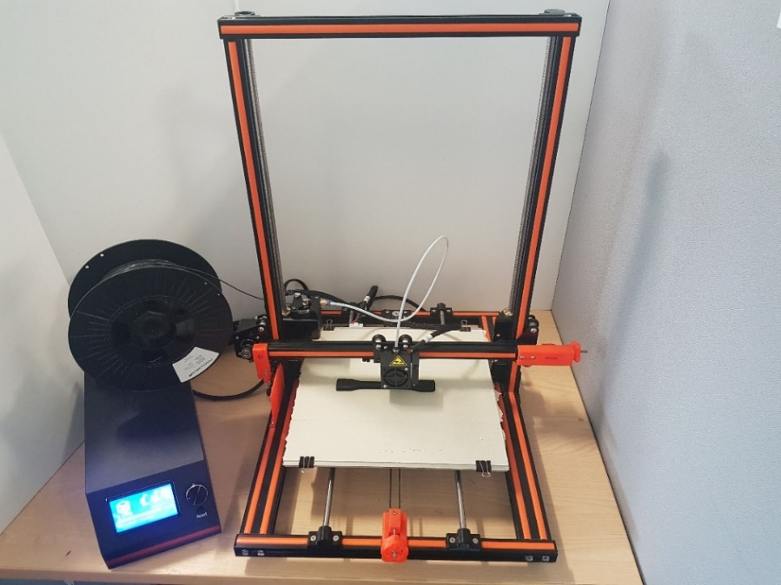
Figure 1: Anet E12 3D printer in operation
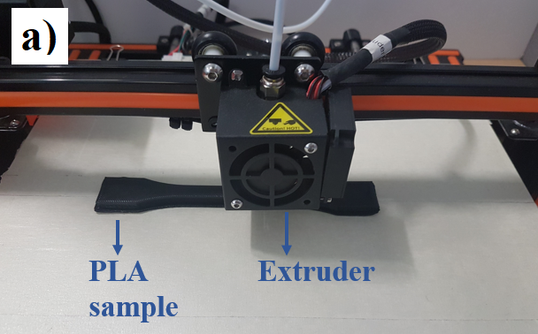
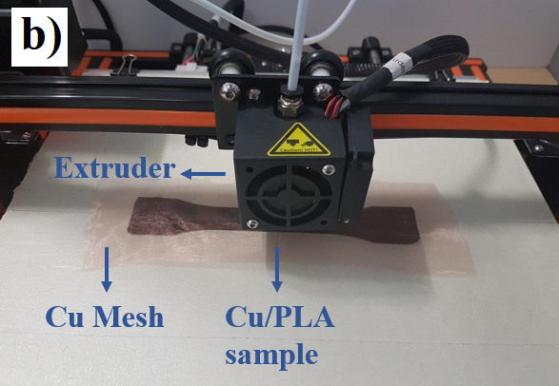
Figure 2: Production of testing specimens: a) PLA specimen; b) Cu/PLA specimen
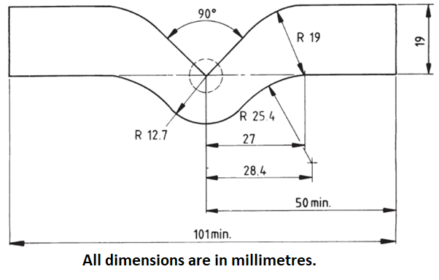
Figure 3: Dimensions of the tear resistance test piece
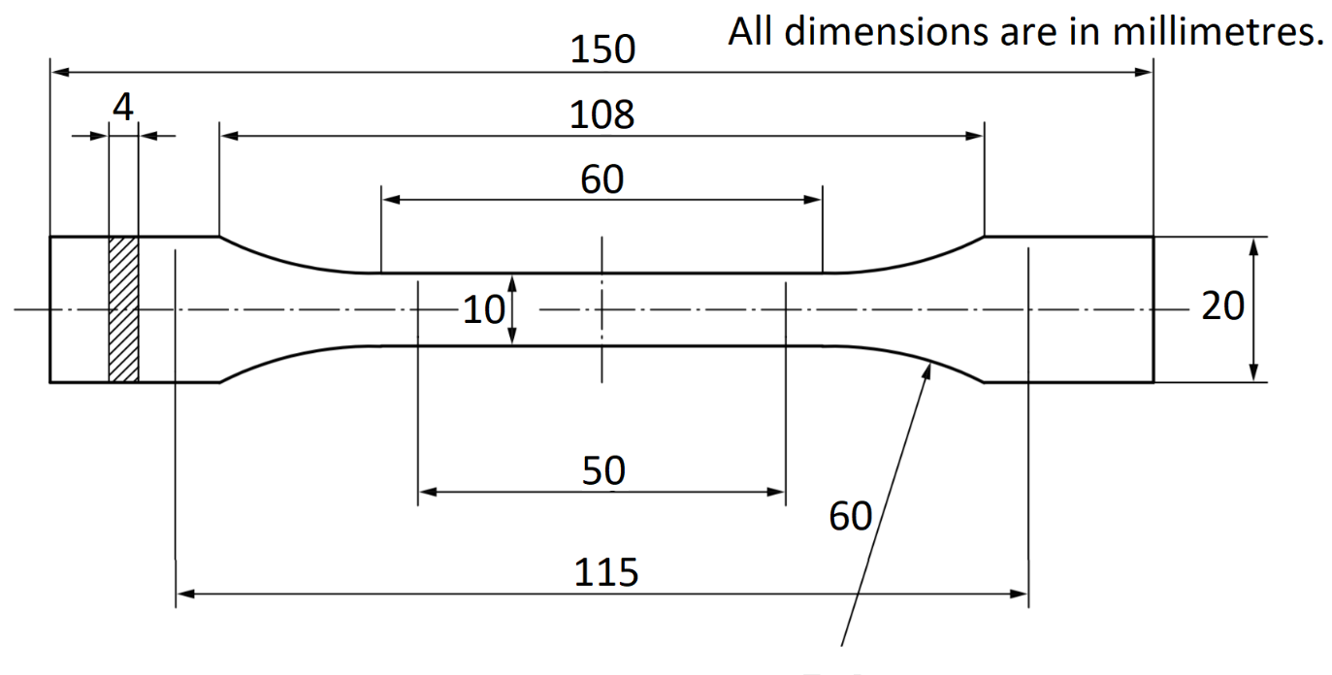
Figure 4: Dimensions of the tensile testing dog-bone specimen

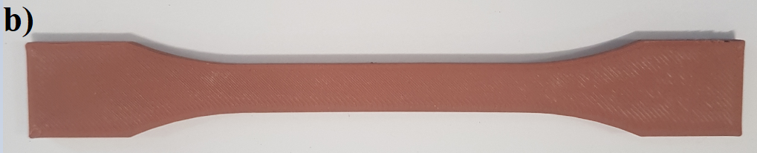
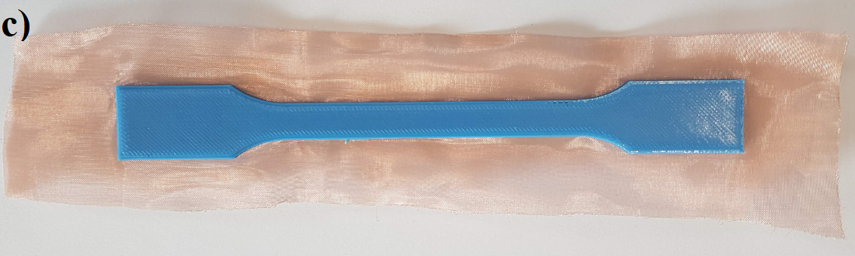
Figure 5: Tensile testing specimens; a) Parent PLA; b) Copper enhanced PLA; c) Cu/PLA composite with a single layer of metal mesh
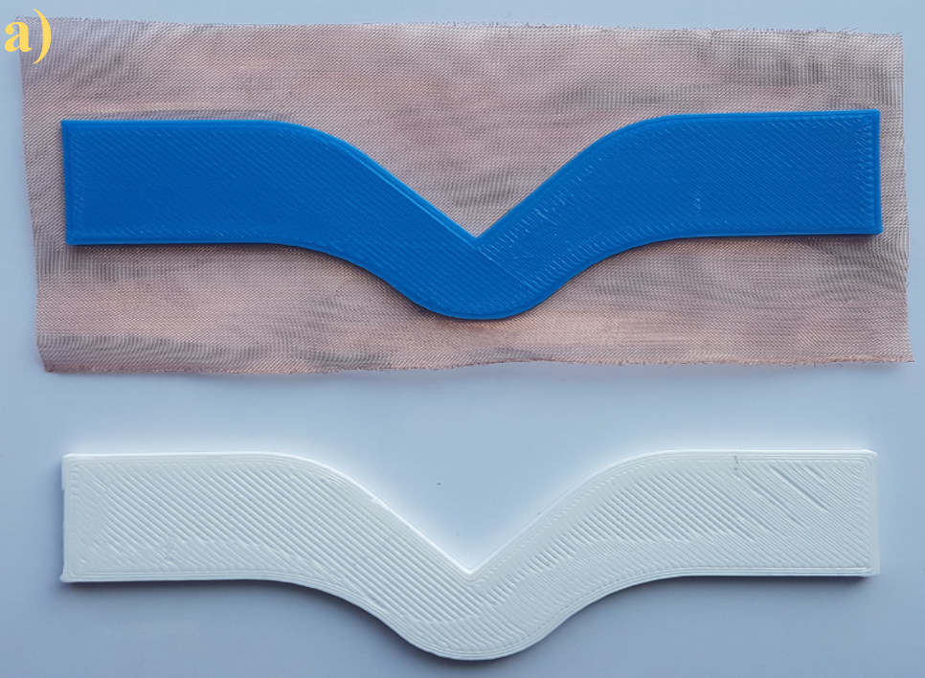
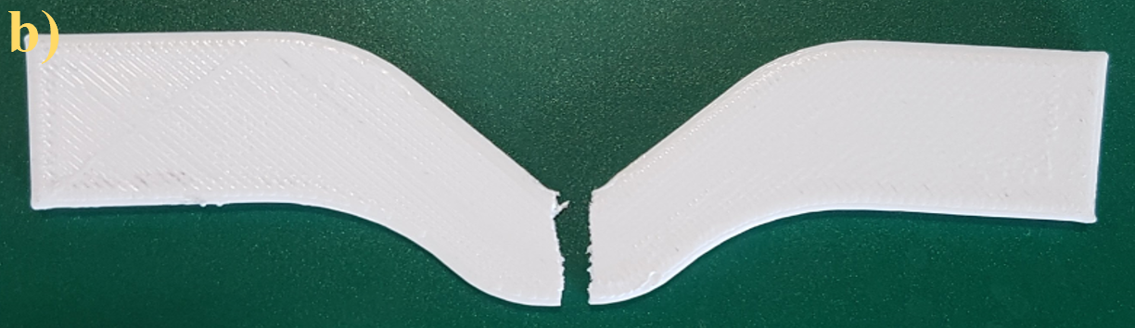
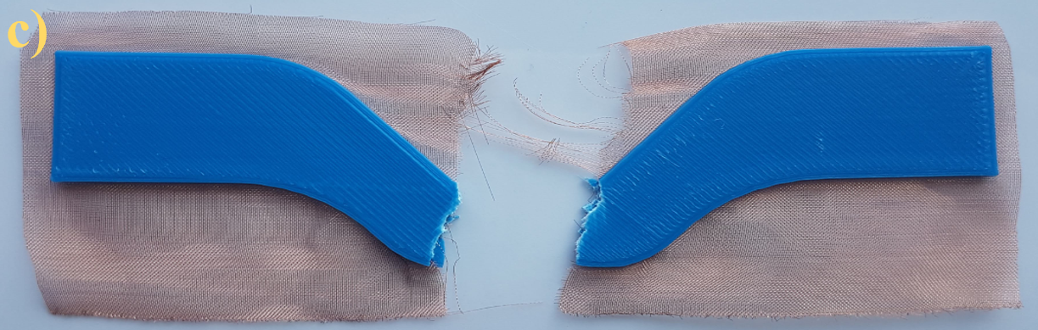
Figure 6: Tear resistance testing: a) Specimens before testing; b) PLA specimen after testing; c) Cu/PLA specimen after testing

Figure 7: Tear resistance testing results

Figure 8: Comparative tensile test results among PLA, annealed PLA and Cu/PLA specimens
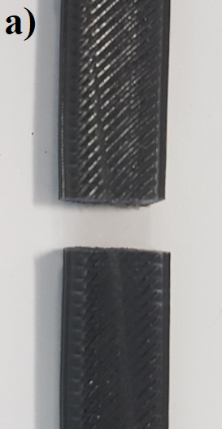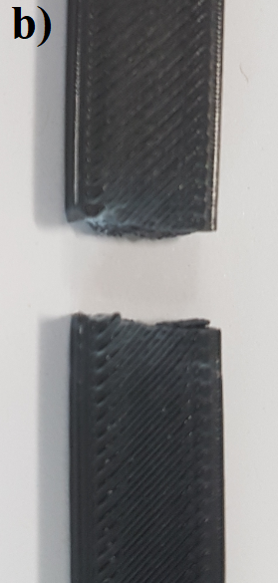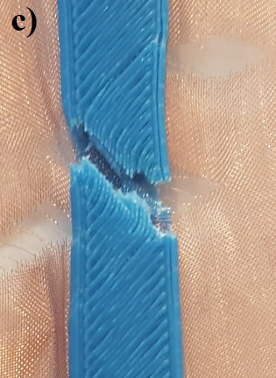
Figure 9: Tensile tested specimens; a) FDM-printed PLA; b) PLA annealed at 90 °C; b) Cu/PLA composite with a single layer of metal mesh

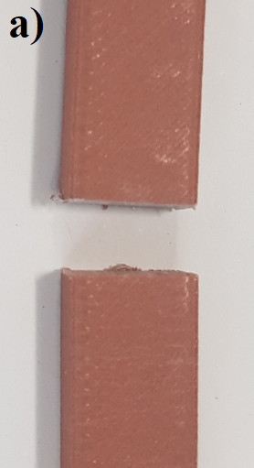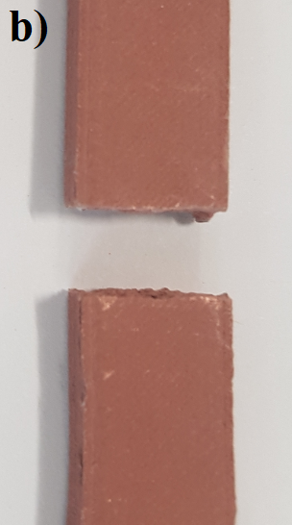
Figure 10: Fractured surfaces; a) Parent copper enhanced PLA; b) Copper enhanced PLA annealed at 90 °C

Figure 11: Comparative tensile test results among copper enhanced PLA, annealed copper enhanced PLA and Cu/PLA specimens

Figure 12: Tensile test results after water absorption
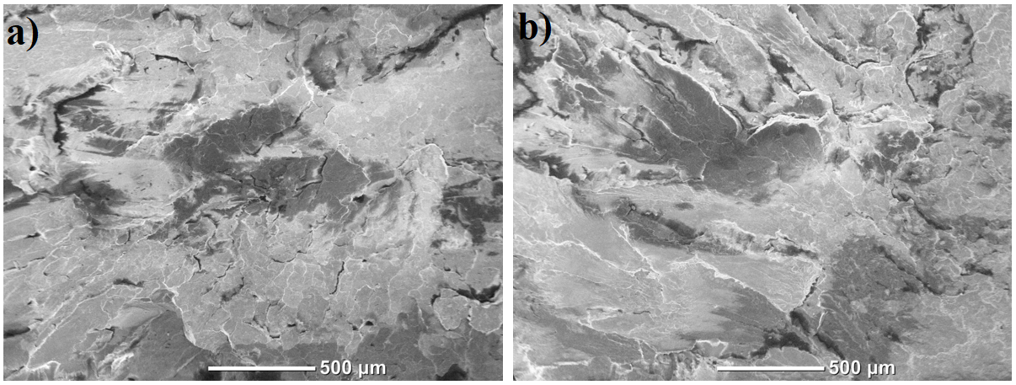
Figure 13: SEM images at x50; a) PLA specimen; b) Water absorbed PLA specimen
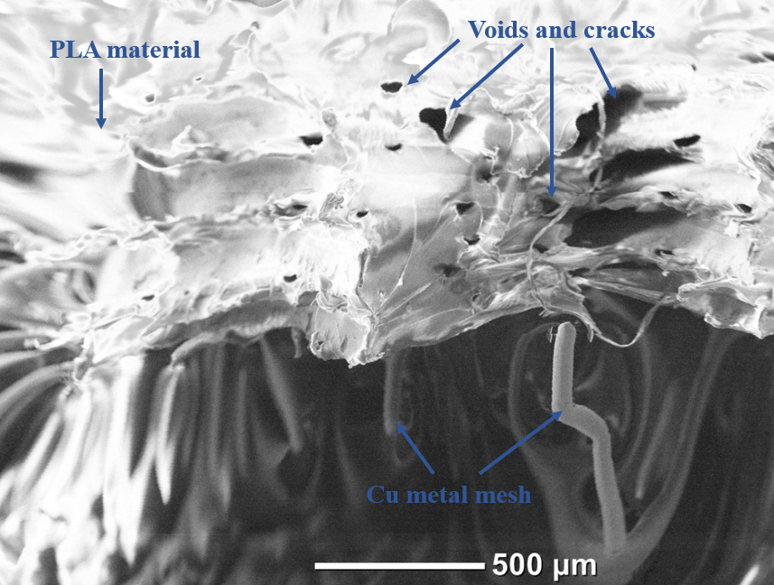
Figure 14: SEM image of a single layered metal mesh Cu/PLA specimen at x50
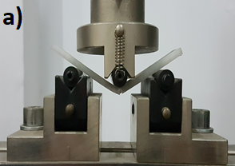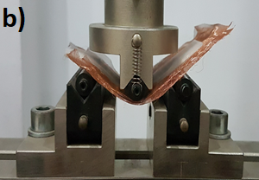
Figure 15: Three-point flexural testing; a) PLA specimen; b) 3 layered Cu/PLA specimen

Figure 16: Three-point flexural test results
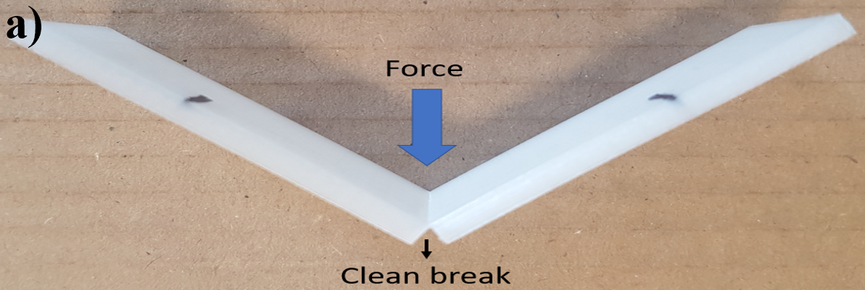
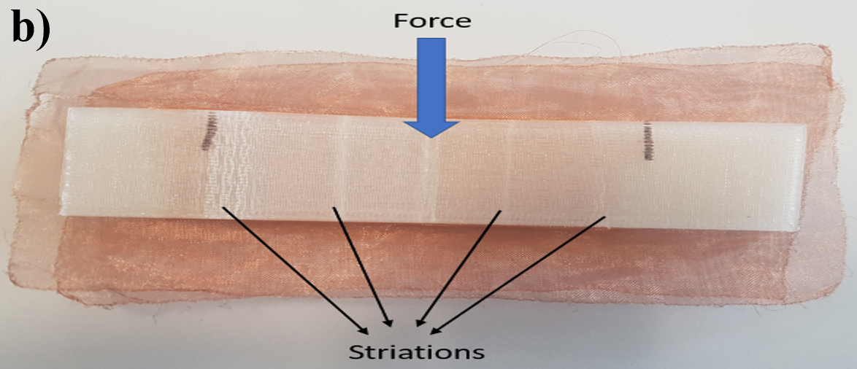
Figure 17: Fracture modes: a) FDM-printed PLA specimen; b) Three-layered Cu/PLA specimen
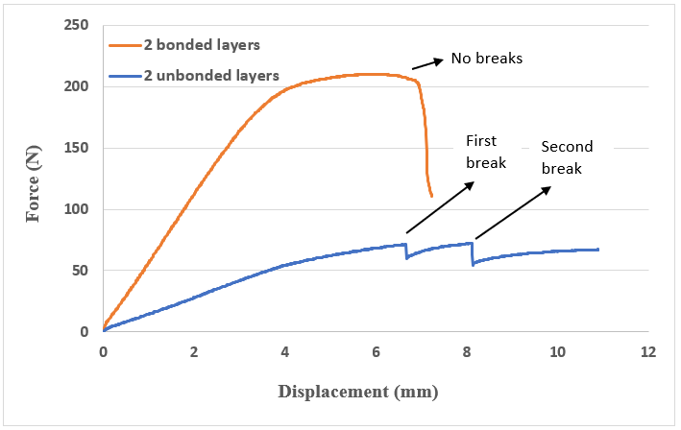
Figure 18: Comparison between bonded and unbonded metal mesh/plastic parts

Figure 19: Rockwell hardness test results with error bars
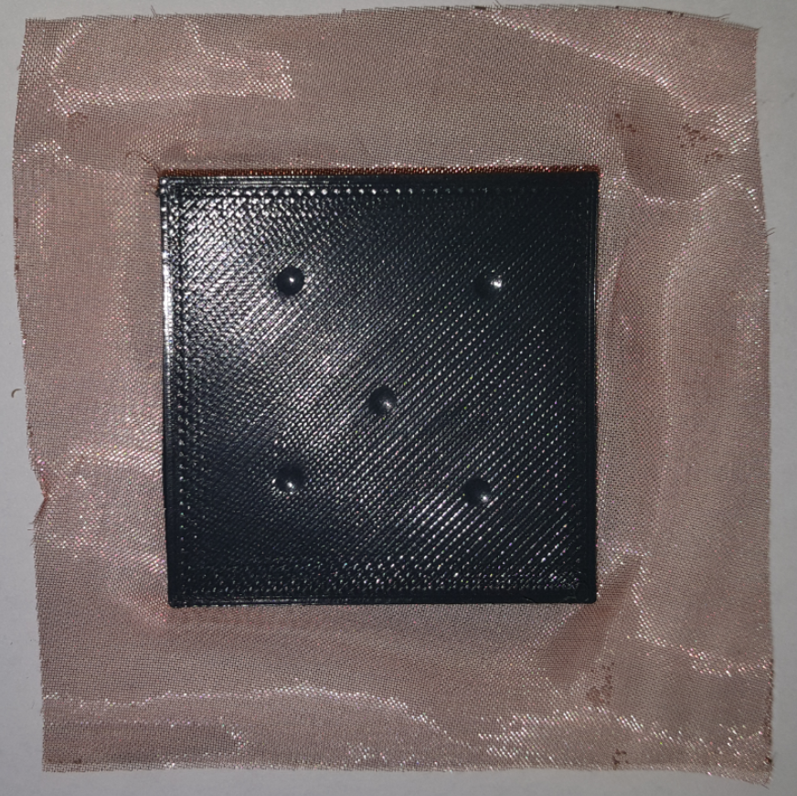
Figure 20: Cu/PLA specimen after hardness testing
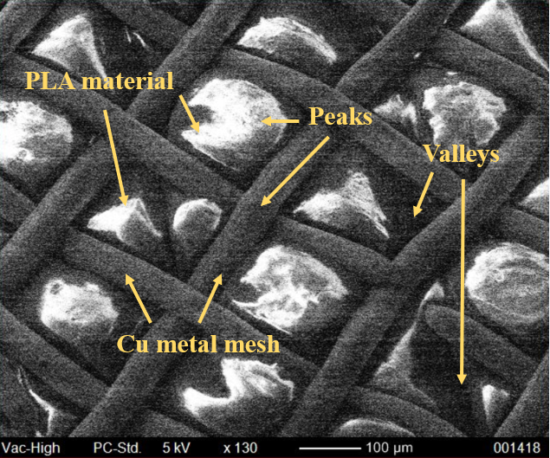
Figure 21: SEM image showing the interaction between Cu mesh layer and PLA
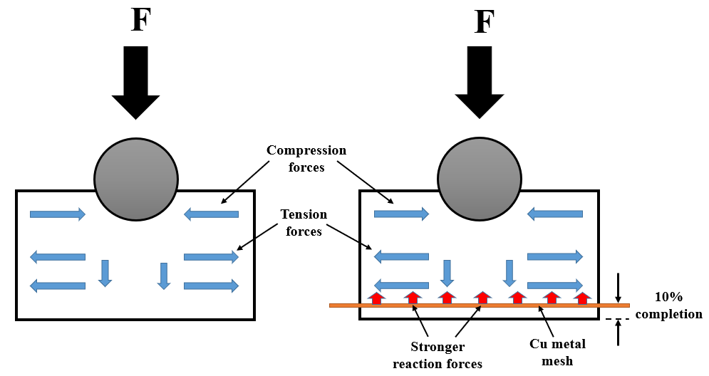
Figure 22: Indentation hardness mechanism showing the action and reaction forces for FDM-printed PLA (left) and Cu/PLA composite (right)

Figure 23: Hardness test results for multi-layered Cu/PLA composites with error bars

List of Tables
Table 1: Load and percentage values for tear resistance testing
Specimen Type | Load (N) | Tear strength, S_{i} (kN/m) | Percentage Change (compared to C-PLA)
C-PLA | 342.5 | 137 | --
Cu/PLA1 | 358.5 | 143.4 | + 4.6%
Cu/PLA2 | 366.5 | 146.6 | + 7%
Cu/PLA3 | 361.5 | 144.6 | + 5.5%

Table 2: Load and percentage values for tensile testing
Specimen Type | Load (N) | Percentage Change (compared to C-PLA)
C-PLA | 2287.5 | --
70A | 2390 | + 4.5%
80A | 2442.5 | + 6.7%
90A | 2512 | + 9.8%
Cu/PLA1 | 2432.5 | + 6.3%
Cu/PLA2 | 2490 | + 8.8%
Cu/PLA3 | 2564 | + 12%
C-Cu | 650.25 | - 252%
70A’ | 710.25 | - 222%
80A’ | 733.5 | - 212%
90A’ | 805 | - 184%

Table 3: Measurements for water absorption testing
Specimen Type | m₁ (mg) | m₂ (mg) | m₃ (mg) | c (%)
C-PLA | 12635.4 | 12697.2 | 12674.4 | 0.18
Cu/PLA1 | 13823.7 | 14009.3 | 13861.1 | 1.07
Cu/PLA2 | 14945.2 | 15192.5 | 15006.4 | 1.24
Cu/PLA3 | 16009.6 | 16440.6 | 16032.7 | 2.54

Table 4: Load and percentage values for wet tensile testing
Specimen Type | Load (N) | Percentage Change (compared to C-PLA)
C-PLA | 2287.5 | --
WQ-PLA | 2240.5 | - 2%
Cu/PLA1 | 2392.5 | + 4.6%
Cu/PLA2 | 2440 | + 6.6%
Cu/PLA3 | 2497 | + 9.1%

Table 5: Flexural strength calculation from the three-point flexural test
Specimen Type | Force (N) | Flexural Strength (N/mm²) | Percentage Change (compared to C-PLA)
C-PLA | 195.45 | 104.2 | --
Cu/PLA1 | 205.29 | 109.5 | + 5.1%
Cu/PLA2 | 210.45 | 112.2 | + 7.6%
Cu/PLA3 | 217.57 | 116 | + 11.3%

References
[1] Zhang X, Chueh YH, Wei C, Sun Z, Yan J, Li L. 2020. Additive manufacturing of three-dimensional metal-glass functionally gradient material components by laser powder bed fusion with in-situ powder mixing. Addit Manuf, 2020; 33: 101113.
[2] Wu H, Fahy W, Kim S, Kim H, Zhao N, Pilato L, Kafi A, Bateman S, Koo JH. Recent developments in polymers/polymer nanocomposites for additive manufacturing. Progress in Materials Science, 2020:100638.
[3] Butt J, Mebrahtu H, Shirvani H. Numerical and experimental analysis of product development by composite metal foil manufacturing. International Journal of Rapid Manufacturing. 2018;7(1):59-82.
[4] Butt J, Mebrahtu H, Shirvani H. Microstructure and mechanical properties of dissimilar pure copper foil/1050 aluminium composites made with composite metal foil manufacturing. J Mater Process Technol 2016; 238: 96-107.
[5] Nieto A, Bisht A, Lahiri D, Zhang C, Agarwal A. Graphene reinforced metal and ceramic matrix composites: a review. Int Mater Rev 2017; 62(5): 241-302.
[6] Singh R, Kumar R, Feo L, Fraternali F. Friction welding of dissimilar plastic/polymer materials with metal powder reinforcement for engineering applications. Composites Part B: Engineering. 2016; 101: 77-86.
[7] Duc F, Bourban PE, Plummer CJ, Månson JA. Damping of thermoset and thermoplastic flax fibre composites. Composites Part A: Applied Science and Manufacturing. 2014; 64: 115-23.
[8] Stavrov D, Bersee HE. Resistance welding of thermoplastic composites-an overview. Composites Part A: Applied Science and Manufacturing. 2005; 36(1): 39-54.
[9] Biron M. Thermoplastics and thermoplastic composites. William Andrew; 2018.
[10] Butt J, Onimowo DA, Gohrabian M, Sharma T, Shirvani H. A desktop 3D printer with dual extruders to produce customised electronic circuitry. Front Mech Eng 2018; 13(4): 528-34.
[11] Butt J, Mebrahtu H, Shirvani H. Production of Multiple Material Parts Using a Desktop 3D Printer. In Advances in Manufacturing Technology XXXI: Proceedings of the 15th International Conference on Manufacturing Research, Incorporating the 32nd National Conference on Manufacturing Research, September 5–7, 2017, University of Greenwich, UK (Vol. 6, pp. 148-153). IOS Press. DOI: 10.3233/978-1-61499-792-4-148.
[12] Butt J, Shirvani H. Additive, Subtractive, and Hybrid Manufacturing Processes. In Advances in Manufacturing and Processing of Materials and Structures. CRC Press, 2018, pp. 187-218.
[13] Butt J, Mebrahtu H, Shirvani H. Metal Rapid Prototyping Technologies. In Advances in Engineering Research; Petrova, V.M., Ed.; Nova Science Publishers, Inc.: New York, NY, USA, 2017, Volume 14, Chapter 2, pp. 13–52.
[14] Zhong W, Li F, Zhang Z, Song L, Li Z. Short fiber reinforced composites for fused deposition modeling. Materials Science and Engineering: A. 2001; 301(2): 125-30.
[15] Shofner ML, Lozano K, Rodríguez‐Macías FJ, Barrera EV. Nanofiber‐reinforced polymers prepared by fused deposition modeling. J Appl Polym Sci 2003; 89(11): 3081-90.
[16] Singh R, Singh S, Mankotia K. Development of ABS based wire as feedstock filament of FDM for industrial applications. Rapid Prototyping Journal. 2016; 22(2): 300-10.
[17] Gray IV RW, Baird DG, Helge Bøhn J. Effects of processing conditions on short TLCP fiber reinforced FDM parts. Rapid Prototyping Journal. 1998; 4(1): 14-25.
[18] Li N, Li Y, Liu S. Rapid prototyping of continuous carbon fiber reinforced polylactic acid composites by 3D printing. J Mater Process Technol 2016; 238: 218-25.
[19] Van Der Klift F, Koga Y, Todoroki A, Ueda M, Hirano Y, Matsuzaki R. 3D printing of continuous carbon fibre reinforced thermo-plastic (CFRTP) tensile test specimens. Open J. Compos. Mater. 2016 Jan; 6(1):18-27.
[20] Lu Y, Poh GK, Gleadall A, Zhao L, Han X. Fabrication of the continuous carbon fiber reinforced plastic composites by additive manufacturing.
[21] Butt J, Shirvani H. Experimental analysis of metal/plastic composites made by a new hybrid method. Addit Manuf 2018; 22: 216-22.
[22] BS 2782-3: Method 360C: 1991. Methods of testing Plastics — Part 3: Mechanical properties — Method 360C: Determination of tear resistance of plastics film and sheeting by the initiation method; British Standard: London, UK, 2010.
[23] BS EN ISO 527-2: 2012. Plastics -- Determination of tensile properties -- Part 2: Test conditions for moulding and extrusion plastics; British, European and International Standard: London, UK, 2012.
[24] BS EN ISO 62: 2008. Plastics — Determination of water absorption; British, European and International Standard: London, UK, 2008.
[25] BS EN ISO 178: 2019. Plastics – Determination of flexural properties; British, European and International Standard: London, UK, 2011.
[26] BS EN ISO 2039-2: 2000 BS 2782-3: Method 365C:1992. Plastics – Determination of hardness – Part 2: Rockwell Hardness; British, European and International Standard: London, UK, 2000.
[27] Torres J, Cotelo J, Karl J, Gordon AP. Mechanical property optimization of FDM PLA in shear with multiple objectives. Jom. 2015; 67(5): 1183-93.
[28] Ning F, Cong W, Qiu J, Wei J, Wang S. Additive manufacturing of carbon fiber reinforced thermoplastic composites using fused deposition modeling. Composites Part B: Engineering. 2015; 80: 369-78.
[29] Shaffer S, Yang K, Vargas J, Di Prima MA, Voit W. On reducing anisotropy in 3D printed polymers via ionizing radiation. Polymer. 2014; 55(23): 5969-79.
[30] Jansen J. Plastic Failure Through Molecular Degradation: Multiple mechanisms can attack polymer chains—here's what can go wrong. Plast Eng 2015; 71(1): 34-9.
[31] Siparsky GL, Voorhees KJ, Miao F. Hydrolysis of polylactic acid (PLA) and polycaprolactone (PCL) in aqueous acetonitrile solutions: autocatalysis. Journal of environmental polymer degradation. 1998; 6(1): 31-41.
[32] Ayrilmis N, Kariz M, Kwon JH, Kuzman MK. Effect of printing layer thickness on water absorption and mechanical properties of 3D-printed wood/PLA composite materials. Int J Adv Manuf Technol 2019; 102(5-8): 2195-200.
[33] Yew GH, Yusof AM, Ishak ZM, Ishiaku US. Water absorption and enzymatic degradation of poly (lactic acid)/rice starch composites. Polym Degrad Stab 2005; 90(3): 488-500.
[34] Liu, A.F., 2005. Mechanics and mechanisms of fracture: an introduction. ASM International.
[35] Song Y, Li Y, Song W, Yee K, Lee KY, Tagarielli VL. Measurements of the mechanical response of unidirectional 3D-printed PLA. Materials & Design. 2017; 123: 154-64.
[36] Pei E, Lanzotti A, Grasso M, Staiano G, Martorelli M. The impact of process parameters on mechanical properties of parts fabricated in PLA with an open-source 3-D printer. Rapid Prototyping Journal. 2015.
[37] Zurita Hurtado OJ, Di Graci Tiralongo VC, Aguirre C, Cristina M. Effect of surface hardness and roughness produced by turning on the torsion mechanical properties of annealed AISI 1020 steel. Revista Facultad de Ingeniería Universidad de Antioquia. 2017; 84: 55-9.
[38] Lawn BR, Howes VR. Elastic recovery at hardness indentations. J Mater Sci 1981; 16(10): 2745-52.

