Title: Bullying victimization and sexual behavior among adolescents aged 12-15 years from 53 countries: a global perspective

Lee Smith^{1*}; Igor Grabovac²; Louis Jacob^{3,4}; Guillermo F. López-Sánchez⁵; Lin Yang⁶; Jae Il Shin⁷; Min Sohn⁷; Philip B. Ward⁸; Daragh T. McDermott⁹; Ai Koyanagi^{4,10}

- The Cambridge Centre for Sport and Exercise Sciences, Anglia Ruskin University, Cambridge, CB1 1PT, UK
- Department of Social and Preventive Medicine, Centre for Public Health, Medical University of Vienna, Vienna, Austria
- Faculty of Medicine, University of Versailles Saint-Quentin-en-Yvelines, Montigny-le-Bretonneux 78180, France
- Research and Development Unit, Parc Sanitari Sant Joan de Déu, CIBERSAM, Barcelona, Spain
- Faculty of Sport Sciences, University of Murcia, Spain.
- Department of Cancer Epidemiology and Prevention Research, Cancer Control Alberta, Alberta Health Services, Calgary, Canada; Departments of Oncology and Community Health Sciences, Cumming School of Medicine, University of Calgary, Calgary, Canada
- Department of Pediatrics, Yonsei University College of Medicine, Seoul, Korea
- School of Psychiatry, UNSW Sydney, Australia; Schizophrenia Research Unit, Ingham Institute for Applied Medical Research, Liverpool, NSW Australia
- School of Psychology and Sport Science, Anglia Ruskin University, Cambridge, CB1 1PT, UK
- ICREA, Pg. Lluis Companys 23, Barcelona, Spain
*Corresponding author: Dr Lee Smith; lee.smith@anglia.ac.uk; The Cambridge Centre for Sport and Exercise Sciences, Anglia Ruskin University, Cambridge, CB1 1PT, UK

ABSTRACT
Background: Identifying correlates of sexual behavior among young adolescents is critical for preventing adverse outcomes linked to such behavior.
Aim: This study examined the relationship of bullying victimization with sexual intercourse, multiple sexual partners and non-condom use in adolescents aged 12-15 years across 53 countries.
Methods: Cross-sectional data from 145,342 adolescents aged 12-15 years participating in the Global School-based Student Health Survey 2003-2016 were analyzed. Data on bullying victimization was assessed by the question “During the past 30 days, on how many days were you bullied?”
Outcomes: Data on several sexual behaviors were collected: (i) ever having had intercourse; among those who reported having had intercourse, (ii) multiple (≥2) lifetime sexual partners and (iii) condom use in last sexual intercourse.
Results: Multivariable logistic regression analyses were used to assess the associations. The overall prevalence of any bullying in the past 30 days and lifetime sexual intercourse were 28.8% and 13.1%, respectively. Compared to those who were not bullied in the past 30 days, those who were bullied for 20-30 days were 2.08 (95%CI=1.65-2.63), 1.70 (95%CI=1.10-2.63), and 1.72 (95%CI=1.12-2.67) times more likely to report sexual intercourse, non-condom use, and multiple sex partners, respectively.
Clinical Implications: This study provides further evidence that bullying victimization is a global phenomenon and interventions are required to reduce its prevalence and unwanted consequences.
Strengths & Limitations: The main strength was the large sample of young adolescents across 53 countries. However, findings from the present study should be interpreted in light of its limitations. First, the study was cross-sectional in nature and thus the direction of the association cannot be established. Second, the data only included young adolescents who attend school. Third, data were self-reported and thus, reporting bias may exist. Fourth, the measure of sexual activity used was not able to distinguish between penetrative and non-penetrative sex. Fifth, adolescents who are victims of bullying may also be exposed to other types of violence such as child maltreatment and sexual assaults, for which data were not available. Finally, the present dataset did not contain data on sexual orientation.
Conclusion: These findings highlight the need for interventions either acting to educate about the potential negative consequences or to prevent risky sexual behavior in young adolescents who experience bullying victimization.
Keywords: Bullying; Victimization; Sexual Behavior; Adolescents; Multi-Country Study

INTRODUCTION
Previous literature has shown that the global prevalence of past 12-month sexual intercourse in adolescents aged 12 to 15 years is approximately 12%.¹ This may be a cause for concern as risky sexual intercourse in young adolescents is generally associated with negative outcomes such as a higher prevalence of sexually transmitted infections compared to older populations, and it has been shown that teenage females report the highest rates of Chlamydia infection.² Risky sexual intercourse in adolescents may also result in unwanted pregnancy and importantly, adolescent pregnancy is associated with high risks of eclampsia, puerperal endometritis, and systemic infections.³ Adolescent pregnancy has also been shown to interrupt education, with such interruptions having sustained deleterious effects on life trajectories.⁴ Finally, a recent study found that engaging in sexual intercourse and having multiple sex partners in adolescence was associated with increased risk of suicide attempts.⁵ Owing to these detrimental outcomes, it is important to identify correlates of sexual behavior in young adolescents to inform targeted interventions to educate or prevent premature sexual intercourse.

One understudied potential correlate of risky sexual behavior in adolescents is bullying victimization. Bullying can be defined as repeated undesired aggressive behaviors perpetrated by a peer or a group of peers that involve a power imbalance favoring the perpetrator ⁶ and includes verbal (i.e., teasing and calling names), relational (i.e., excluding and spreading rumors), or physical (i.e., physical threats and harm) forms.⁷ Based on a meta-analysis of 80 studies, approximately 36% of adolescents experience bullying.⁸

Although to our knowledge no data exists on the relationship between bullying victimization and risky sexual behavior in young adolescents, a body of literature suggests that exposure to violence (of which bullying victimization an exemplar) is associated with risky sexual behavior, https://jamanetwork.com/journals/jamapediatrics/article-abstract/191181 https://psycnet.apa.org/doiLanding?doi=10.1037%2Fa0027265 suggesting that investigating such an association is warranted. For example, in one study, African American women reporting a history of intimate partner violence were more likely to report risky sexual encounters, inconsistent condom use and more likely to test positive for a sexually transmitted infection.⁹ Another study found that adolescents exposed to family or community violence were four times more likely than peers not exposed to such violence to report a higher number of HIV-related risk behaviors.¹⁰ In addition, boys exposed to family violence were almost three times more likely than girls to report multiple partners and use of drugs during sex.¹⁰

Although the exact mechanisms linking exposure to violence and risky sexual behavior are largely unknown, it has been hypothesized that exposure to violence can disrupt normal parental social support and monitoring functions,¹¹ which are associated with increased sexual risk among adolescents.¹² It is also possible that these adolescents engage in risky sexual behavior as a way to cope with their negative experiences.¹³ Finally, exposure to violence can lead to lower self-esteem, which in turn, can result in risky sexual behavior as those with a lower self-esteem may be less concerned about the future and more worried about satisfying their immediate basic needs (i.e., sexual behavior),¹⁴ although this potential pathway remains untested. It is also important to note here that literature does suggest that gender may influence the role between bullying victimization and risky sexual behaviors with girls at greater risk than boys. https://pubmed.ncbi.nlm.nih.gov/25213749/ https://journals.sagepub.com/doi/abs/10.1177/0886260515599658?journalCode=jiva

Thus, the aim of the present study was to examine the relationship of bullying victimization with sexual intercourse, multiple sexual partners and non-condom use (including gender differences) in 145,342 adolescents aged 12-15 years across 53 countries. Multinational studies are important as they allow the investigation of whether associations are generalizable across countries, while between-country differences may provide greater clarity as to how cultural factors may influence associations.

METHODS
Publicly available data from the Global School-based Student Health Survey (GSHS) were analyzed. Details on this survey can be found at http://www.who.int/chp/gshs and http://www.cdc.gov/gshs. Briefly, the GSHS was jointly developed by the World Health Organization (WHO) and the US Centers for Disease Control and Prevention (CDC), and other UN allies. The core aim of this survey was to assess and quantify risk and protective factors of major non-communicable diseases. The survey draws content from the CDC Youth Risk Behavior Survey (YRBS) for which test-retest reliability has been established.¹⁵ The survey used a standardized two-stage probability sampling design for the selection process within each participating country. For the first stage, schools were selected with probability proportional to size sampling. The second stage involved the random selection of classrooms which included students aged 13-15 years within each selected school. All students in the selected classrooms were eligible to participate in the survey regardless of age, and thus, the survey also included students who were not within this age range (i.e., 13-15 years). Data collection was performed during one regular class period. The questionnaire was translated into the local language in each country and consisted of multiple choice response options; students recorded their response on computer scannable sheets. All GSHS surveys were approved, in each country, by both a national government administration (most often the Ministry of Health or Education) and an institutional review board or ethics committee and have therefore been performed in accordance with the ethical standards laid down in the 1964 Declaration of Helsinki and its later amendments. Student privacy was protected through anonymous and voluntary participation, and informed consent was obtained as appropriate from the students, parents and/or school officials. Data were weighted for non-response and probability selection.
From all publicly available data, we selected all nationally representative datasets that included the variables used in the current analysis. If there were more than two datasets from the same country, we chose the most recent dataset. A total of 53 countries were included in the current study. The characteristics of each country or survey are provided in Table 1. For the included countries, the survey was conducted between 2003 and 2016.

Sexual behavior
Lifetime sexual intercourse was assessed by the question “Have you ever had sexual intercourse?” with “yes” and “no” answer options. Condom use was assessed with the question “The last time you had sexual intercourse, did you or your partner use a condom?” with “yes” and “no” answer options. Number of sexual partners was based on the question “During your life, with how many people have you had sexual intercourse?” We considered those with two or more sexual partners to have multiple sexual partners. Data on multiple partners were not available from Bangladesh and Kenya.

Bullying victimization
First, the students were provided with the following definition of bullying: “Bullying occurs when a student or group of students say or do bad and unpleasant things to another student. It is also bullying when a student is teased a lot in an unpleasant way or when a student is left out of things on purpose. It is not bullying when two students of about the same strength or power argue or fight or when teasing is done in a friendly and fun way.” Subsequently, bullying victimization was assessed by the question “During the past 30 days, on how many days were you bullied?” with answer options 0, 1-2, 3-5, 6-9, 10-19, 20-29, and all 30 days. Those who were bullied on at least 1-2 days were considered to be a victim of bullying (any bulling). We also created a five-category variable from these answer options (i.e., 0, 1-2, 3-5, 6-19, 20-30 days) to indicate intensity of bullying. Answer options of 6-9 and 10-19 days were collapsed into a single category due to small numbers.

Control variables
The control variables were selected because they were hypothesized to be independently associated with both the exposure and the outcomes and included sex, age, food insecurity (as a proxy of socioeconomic status), and alcohol consumption. As in a previous GSHS study, food insecurity was used as a proxy for socioeconomic status as there were no variables on socioeconomic status in the GSHS.¹⁶ Specifically, this was assessed by the question “During the past 30 days, how often did you go hungry because there was not enough food in your home?” Answer options were categorized as “never”, “rarely/sometimes”, and “most of the time/always”. Alcohol consumption was defined as having had one drink containing alcohol for at least one day in the past 30 days.

Statistical analysis
Statistical analyses were performed with Stata 14.1 (Stata Corp LP, College station, Texas). The analysis was restricted to those aged 12-15 years as most students were within this age group while information on the exact age outside of this age range was not available. First, using the overall sample, the association between bullying victimization (i.e., exposure) and sexual intercourse, condom non-use, or multiple sex partners (i.e., outcomes) was assessed by multivariable logistic regression analysis. The five-category bullying victimization variable (i.e., bullied on 0, 1-2, 3-5, 6-19, and 20-30 days) was used as the exposure variable. Sex-wise analyses were also conducted. We also assessed whether the magnitude of the association between bullying victimization and sexual behavior differ by sex by including an interaction term (i.e., bullying victimization X sex) in the model. The analysis was adjusted for sex, age, food insecurity, alcohol consumption, and country with the exception of the sex-wise analysis, which was not adjusted for sex. Adjustment for country was done by including dummy variables for each country in the model as in previous GSHS publications.^{17,18}
Finally, to assess the generalizability of the findings across countries, we also conducted country-wise analysis. Specifically, the association between bullying victimization (i.e., exposure) and sexual intercourse, condom non-use, or multiple sex partners (i.e., outcomes) was assessed by multivariable logistic regression analyses using country-wise samples. For this analysis, we used the dichotomized variable on bullying (i.e., any bullying) as the exposure variable as the sample size in each country was small and stable estimates could not be obtained otherwise. Pooled estimates were obtained by meta-analysis with random effects based on country-wise estimates. In order to assess the level of between-country heterogeneity in the association between bullying victimization and sexual behavior, we also calculated the Higgins’s I² which represents the degree of heterogeneity that is not explained by sampling error with a value of <40% often considered as negligible and 40-60% as moderate heterogeneity.¹⁹
The analysis on condom non-use and multiple sex partners was restricted to those who ever had sexual intercourse (n=26,094). All variables were included in the regression analysis as categorical variables with the exception of age (continuous variable). Sampling weights and the clustered sampling design of the surveys were taken into account. Results from the logistic regression analyses are presented as odds ratios (ORs) with 95% confidence intervals (CIs). The level of statistical significance was set at p<0.05.

RESULTS
A total of 145,342 adolescents aged 12-15 years were included in the analysis. The mean (SD) age was 13.8 (1.0) years and 50.6% were boys and 49.4% were girls. The overall prevalence of any bullying in the past 30 days and lifetime sexual intercourse were 28.8% and 13.1%, respectively, while among those who had had sexual intercourse, the prevalence of condom non-use at last sex and lifetime multiple sex partners were 44.1% and 51.6%, respectively. The prevalence of any bullying and sexual behaviors varied widely across countries (Table 2). For example, only 3.6% had experienced sexual intercourse in Vietnam, while this figure was 55.7% in Samoa. The prevalence of sexual behavior by intensity of bullying is shown in Figure 1. The prevalence of sexual intercourse increased linearly with greater intensity of bullying victimization. Specifically, while the prevalence was 10.7% among those who were not bullied in the past 30 days, this increased to 26.2% among those who were bullied 20-30 days. Similar increasing trends were also observed for risky sexual behavior (i.e., condom non-use and multiple sex partners) among those who ever had sex. The association between intensity of bullying victimization and sexual behavior estimated by multivariable logistic regression is shown in Table 2. In the overall sample, intensity of bullying victimization was dose-dependently associated with higher odds for sexual intercourse, condom non-use, and multiple sex partners, although the estimates for 3-5 days and 6-19 days were similar for condom non-use. Specifically, compared to those who were not bullied in the past 30 days, those who were bullied for 20-30 days were at 2.08 (95%CI=1.65-2.63), 1.70 (95%CI=1.10-2.63), and 1.72 (95%CI=1.12-2.67) times higher odds for sexual intercourse, condom non-use, and multiple sex partners. There were no significant interactions by sex with the exception of being bullied for 6-19 days for condom non-use where the association was significantly stronger among boys compared to girls. The results of the country-wise analysis are shown in Figures S1-S3 of the supplementary material. Any bullying victimization was positively associated with sexual intercourse in most countries with the overall estimate based on a meta-analysis being OR=1.46 (95%CI=1.36-1.58) with a moderate level of heterogeneity (I²=59.0%) being observed. The corresponding figures for condom non-use and multiple sex partners were 1.17 (95%CI=1.06-1.29; I²=0.0%) and 1.14 (95%CI=1.04-1.25; I²=0.0%), respectively.

DISCUSSION
In the present sample, comprising 145,342 adolescents aged 12-15 years from 53 countries, we found that the overall prevalence of any bullying in the past 30 days and lifetime sexual intercourse were 28.8% and 13.1%, respectively. Among those who had had sexual intercourse, the prevalence of condom non-use at last sex and lifetime multiple sex partners were 44.1% and 51.6%, respectively. Intensity of bullying victimization was dose-dependently associated with higher odds for sexual intercourse, condom non-use, and multiple sex partners.

Findings from the present study support the hypothesis that bullying victimization is a correlate of risky sexual behavior in young adolescents and this association is dose-dependent. Such findings corroborate previous work that has shown exposure to violence to be associated with risky sexual behavior.¹⁰ Several plausible explanations exist that may explain the observed associations. First, bullying victimization is associated with lower self-esteem and consequently those with low self-esteem may act to fulfil basic needs as opposed to considering future consequences.¹⁴ On the other hand, it is plausible that those with low self-esteem engage in sexual behavior in an attempt to raise self-esteem, however, these hypotheses remain untested and warrant systematic investigation. Second, if bullying victimization occurs within intimate relationships, it may facilitate risky sexual behavior as the victim may feel coerced into sexual activities.²⁰ Importantly, such coercion has been shown to be associated with poor mental health and an increased risk of sexually transmitted infections.²¹ Third, violence can disrupt normal parental social support and monitoring functions,¹¹ which was associated with increased sexual risk among adolescents.¹² Fourth, it is also possible that adolescents engage in risky sexual behavior as a way to cope with their negative experiences.¹³ Finally, it is possible that adolescents who are exposed to bullying victimization engage in sexual activity to increase their popularity, as it has been previously been shown that engaging in such activities results in higher levels of popularity.²²

A clear strength of the present study is the large sample of young adolescents across 53 countries. However, findings from the present study should be interpreted in light of its limitations. First, the study was cross-sectional in nature and thus the direction of the association cannot be established. Longitudinal research examining these relationships is warranted. Second, the data only included young adolescents who attend school. Thus, the findings may not be generalizable to those not in full-time education. Third, data were self-reported and thus, reporting bias may exist. Moreover, the reporting bias here did not contain a “controlled approach”, for example through the utilization of content analysis. Relatedly, the potential causes attributed to those individuals not answering the survey are not known, but it may partly be owing to embarrassment since the outcome and exposure survey questions referred to sexual activity and bullying, respectively. Fourth, the measure of sexual activity used was not able to distinguish between penetrative and non-penetrative sex. Fifth, adolescents who are victims of bullying may also be exposed to other types of violence such as child maltreatment and sexual assaults, for which data were not available. Thus, some level of residual confounding may exist. Finally, the present dataset did not contain data on sexual orientation. Lesbian, gay and bisexual youth may experience more bullying victimization and may engage in more risky sexual practices. Future research should investigate the present associations by sexual orientation.

CONCLUSION
In conclusion, this is the first study to examine the relationship between bullying victimization and sexual behavior in a large multi-country sample of young adolescents. Strikingly, the present study showed that intensity of bullying victimization was dose-dependently associated with higher odds for sexual intercourse, condom non-use, and multiple sex partners. These findings provide support for the implementation of interventions either acting to educate about the potential negative consequences or prevent risky sexual behavior in young adolescents who are subject to bullying victimization. On the other hand, it also provides further evidence that bully victimization is a global phenomenon and interventions are required to reduce its prevalence in order to reduce unwanted consequences. Schools may be appropriate settings for such interventions to take place and better results have previously been observed when multiple disciplines are involved.²³

Compliance with Ethical Standards
Disclosure of potential conflicts of interest
All authors declare no conflicts of interest.
Ethical Approval
All GSHS surveys were approved, in each country, by both a national government administration (most often the Ministry of Health or Education) and an institutional review board or ethics committee and have therefore been performed in accordance with the ethical standards laid down in the 1964 Declaration of Helsinki and its later amendments.
Informed Consent
Student privacy was protected through anonymous and voluntary participation, and informed consent was obtained as appropriate from the students, parents and/or school officials.

REFERENCES
1. Smith L, Jackson SE, Jacob L, et al. Leisure-Time Sedentary Behavior, Alcohol Consumption, and Sexual Intercourse Among Adolescents Aged 12-15 Years in 19 Countries From Africa, the Americas, and Asia. J Sex Med 2019;16(9):1355-1363.
2. Centers for Disease Control and Prevention. Sexually Transmitted Disease Surveillance 2017. Atlanta: U.S. Department of Health and Human Services, 2018.
3. World Health Organization. Adolescent pregnancy. Available at: https://www.who.int/news-room/fact-sheets/detail/adolescent-pregnancy. Accessed October 2, 2019 Atlanta: U.S. Department of Health and Human Services; 2018.
4. Klein JD. Adolescent pregnancy: current trends and issues. Pediatrics 2005;116(1):281-286.
5. Smith L, Jackson SE, Vancampfort D, et al. Sexual behavior and suicide attempts among adolescents aged 12-15 years from 38 countries: A global perspective. Psychiatry Res 2019:112564.
6. Gladden RM, Vivolo-Kantor AM, Hamburger ME, Lumpkin CD. Bullying Surveillance Among Youths: Uniform Definitions for Public Health and Recommended Data Elements, Version 1.0. Atlanta, GA: National Center for Injury Prevention and Control, Centers for Disease Control and Prevention and
U.S. Department of Education, 2014.
7. Smith PK, Cowie H, Olafsson RF, et al. Definitions of bullying: a comparison of terms used, and age and gender differences, in a fourteen-country international comparison. Child dev. 2002;73(4):1119-1133.
8. Modecki KL, Minchin J, Harbaugh AG, Guerra NG, Runions KC. Bullying prevalence across contexts: a meta-analysis measuring cyber and traditional bullying. J Adolesc Health 2014;55(5):602-611.
9. Seth P, Raiford JL, Robinson LS, Wingood GM, Diclemente RJ. Intimate partner violence and other partner-related factors: correlates of sexually transmissible infections and risky sexual behaviours among young adult African American women. Sex health 2010;7(1):25-30.
10. Voisin DR. The relationship between violence exposure and HIV sexual risk behavior: does gender matter? Am J Orthopsychiatry 2005;75(4):497-506.
11. Margolin G. Effects of domestic violence on children. Violence against children in the family and the community. Washington, DC, US: American Psychological Association; 1998: 57-101.
12. DiClemente RJ, Wingood GM, Crosby R, et al. Parental monitoring: association with adolescents' risk behaviors. Pediatrics 2001;107(6):1363-1368.
13. Motley R, Sewell W, Chen YC. Community Violence Exposure and Risk Taking Behaviors Among Black Emerging Adults: A Systematic Review. J Community Health 2017;42(5):1069-1078.
14. Tsaousis I. The relationship of self-esteem to bullying perpetration and peer victimization among schoolchildren and adolescents: A meta-analytic review. Aggress Violent Behav 2016;31:186-199.
15. Brener ND, Collins JL, Kann L, Warren CW, Williams BI. Reliability of the Youth Risk Behavior Survey Questionnaire. Am J Epidemiol 1995;141(6):575-580.
16. Carvalho AF, Stubbs B, Vancampfort D, et al. Cannabis use and suicide attempts among 86,254 adolescents aged 12-15 years from 21 low- and middle-income countries. Eur psychiatry 2018;56:8-13.
17. McKinnon B, Gariepy G, Sentenac M, Elgar FJ. Adolescent suicidal behaviours in 32 low- and middle-income countries. Bull World Health Organ 2016;94(5):340-350.
18. Vancampfort D, Stubbs B, Firth J, Van Damme T, Koyanagi A. Sedentary behavior and depressive symptoms among 67,077 adolescents aged 12-15 years from 30 low- and middle-income countries. Int J Behav Nutr Phys Act 2018;15(1):73.
19. Higgins JP, Thompson SG. Quantifying heterogeneity in a meta-analysis. Stat Med 2002;21(11):1539-1558.
20. Brousseau MM, Bergeron S, Hebert M, McDuff P. Sexual coercion victimization and perpetration in heterosexual couples: a dyadic investigation. Arch Sex Behav 2011;40(2):363-372.
21. de Visser RO, Smith AM, Rissel CE, Richters J, Grulich AE. Sex in Australia: experiences of sexual coercion among a representative sample of adults. Aust N Z J Public Health 2003;27(2):198-203.
22. Prinstein MJ, Meade CS, Cohen GL. Adolescent oral sex, peer popularity, and perceptions of best friends' sexual behavior. J Pediatr Psychol 2003;28(4):243-249.
23. Vreeman RC, Carroll AE. A systematic review of school-based interventions to prevent bullying. Arch Pediatr Adolesc Med 2007;161(1):78-88.

Table 1: Survey characteristics and prevalence of any bullying, sexual intercourse, condom non-use, and multiple sex partners by country
Country | Year | Response rate (%) | Nª | Any bullying (%) | Sexual intercourse (%) | Condom non-use (%)^{b} | Multiple sex partners (%)^{b}
Antigua & Barbuda | 2009 | 67 | 1,235 | 25.1 | 36.4 | 31.6 | 68.3
Argentina | 2012 | 71 | 21,528 | 24.4 | 35.5 | 23.6 | 55.5
Bahamas | 2013 | 78 | 1,308 | 23.7 | 26.6 | 42.2 | 59.9
Bangladesh | 2014 | 91 | 2,753 | 23.7 | 9.8 | 42.2 | NA
Barbados | 2011 | 73 | 1,504 | 13.2 | 33.3 | 34.8 | 59.3
Belize | 2011 | 88 | 1,600 | 30.7 | 21.0 | 33.6 | 64.2
Benin | 2016 | 78 | 717 | 48.4 | 25.4 | 66.6 | 61.4
Bolivia | 2012 | 88 | 2,804 | 30.4 | 20.1 | 36.6 | 44.6
Botswana | 2005 | 95 | 1,397 | 52.2 | 17.2 | 44.3 | 52.9
Brunei Darussalam | 2014 | 65 | 1,824 | 23.3 | 9.9 | 62.5 | 38.2
Cambodia | 2013 | 85 | 1,812 | 22.1 | 13.0 | 52.4 | 41.9
Cayman Islands | 2007 | 79 | 1,147 | 26.6 | 28.0 | 30.0 | 63.6
Chile | 2013 | 60 | 1,353 | 15.1 | 23.0 | 47.4 | 47.1
Costa Rica | 2009 | 72 | 2,265 | 19.1 | 18.1 | 36.0 | 50.3
Curaçao | 2015 | 83 | 1,498 | 26.8 | 19.2 | 37.9 | 41.4
Dominica | 2009 | 84 | 1,310 | 27.0 | 42.0 | 35.2 | 66.8
East Timor | 2015 | 79 | 1,631 | 31.3 | 19.7 | 50.0 | 51.3
El Salvador | 2013 | 88 | 1,615 | 22.5 | 18.8 | 25.4 | 51.9
Fiji | 2016 | 79 | 1,537 | 30.0 | 15.6 | 48.3 | 56.9
French Polynesia | 2015 | 70 | 1,902 | 25.1 | 28.9 | 41.8 | 47.6
Ghana | 2012 | 82 | 1,110 | 62.8 | 29.5 | 56.3 | 57.2
Grenada | 2008 | 78 | 1,299 | 27.5 | 24.4 | 44.6 | 60.8
Guatemala | 2015 | 82 | 3,611 | 23.0 | 14.3 | 41.2 | 64.4
Guyana | 2010 | 76 | 1,973 | 38.4 | 29.5 | 36.1 | 58.6
Honduras | 2012 | 79 | 1,486 | 32.3 | 21.6 | 37.4 | 46.4
Indonesia | 2015 | 94 | 8,806 | 21.0 | 5.4 | 74.4 | 59.5
Kenya | 2003 | 84 | 2,971 | 58.3 | 32.9 | 57.9 | NA
Kiribati | 2011 | 85 | 1,340 | 36.8 | 21.7 | 75.7 | 53.9
Laos | 2015 | 70 | 1,644 | 13.2 | 9.5 | 37.8 | 56.1
Macedonia | 2007 | 93 | 1,550 | 9.8 | 8.8 | 22.0 | 39.8
Malawi | 2009 | 94 | 2,224 | 44.9 | 22.8 | 35.0 | 41.3
Malaysia | 2012 | 89 | 16,273 | 21.0 | 8.1 | 65.6 | 57.4
Mauritius | 2011 | 82 | 2,074 | 35.2 | 22.4 | 56.8 | 51.1
Mongolia | 2013 | 8 | 3,707 | 31.4 | 9.5 | 51.3 | 48.6
Mozambique | 2015 | 80 | 668 | 45.7 | 42.4 | 26.8 | 49.3
Namibia | 2013 | 89 | 1,936 | 45.9 | 35.8 | 31.4 | 58.9
Nepal | 2015 | 69 | 4,616 | 50.3 | 19.4 | 47.0 | 55.9
Peru | 2010 | 85 | 2,359 | 47.2 | 16.8 | 37.5 | 48.0
Samoa | 2011 | 79 | 2,200 | 74.1 | 55.7 | 42.9 | 69.4
Seychelles | 2015 | 82 | 2,061 | 50.8 | 36.2 | 48.8 | 61.8
St. Lucia | 2007 | 82 | 1,072 | 25.6 | 23.3 | 48.3 | 67.9
St. Vincent & the Grenadines | 2007 | 84 | 1,188 | 30.1 | 27.9 | 40.9 | 67.8
Suriname | 2009 | 89 | 1,046 | 26.2 | 23.6 | 27.5 | 51.7
Swaziland | 2003 | 96 | 6,866 | 39.5 | 11.1 | 55.9 | 51.8
Tanzania | 2014 | 87 | 2,615 | 26.9 | 17.8 | 66.9 | 49.5
Thailand | 2015 | 89 | 4,132 | 32.7 | 13.9 | 35.4 | 51.8
Trinidad & Tobago | 2011 | 90 | 2,363 | 14.5 | 23.9 | 44.8 | 58.6
Tuvalu | 2013 | 90 | 679 | 30.1 | 15.5 | 46.5 | 59.6
Uganda | 2003 | 69 | 1,904 | 45.6 | 20.7 | 40.7 | 50.8
Uruguay | 2012 | 77 | 2,869 | 19.1 | 27.7 | 15.7 | 47.9
Vanuatu | 2011 | 72 | 852 | 67.9 | 11.2 | 36.1 | 40.1
Vietnam | 2013 | 96 | 1,743 | 26.1 | 3.6 | 56.4 | 6.5
Zambia | 2004 | 70 | 1,365 | 65.0 | 37.0 | 47.2 | 61.8
  - ª Restricted to those aged 12-15 years.
  - ^{b} Restricted to those who ever had sex.

Table 2: Association between number of days bullied in past 30 days and sexual behavior estimated by multivariable logistic regression
 | Days bullied in past 30 days | Overall |  | Boys |  | Girls
Outcome |  | OR | 95%CI | OR | 95%CI | OR | 95%CI
Sexual intercourse | 0 days | 1.00 |  | 1.00 |  | 1.00
 | 1-2 days | 1.20*** | [1.08,1.32] | 1.12 | [0.98,1.28] | 1.32*** | [1.14,1.52]
 | 3-5 days | 1.53*** | [1.28,1.84] | 1.62*** | [1.27,2.08] | 1.31* | [1.04,1.65]
 | 6-19 days | 1.60*** | [1.27,2.01] | 1.73** | [1.25,2.40] | 1.44** | [1.10,1.90]
 | 20-30 days | 2.08*** | [1.65,2.63] | 2.29*** | [1.70,3.10] | 1.94*** | [1.39,2.70]
Condom non-useª | 0 days | 1.00 |  | 1.00 |  | 1.00
 | 1-2 days | 0.96 | [0.72,1.29] | 1.11 | [0.75,1.64] | 0.76 | [0.53,1.08]
 | 3-5 days | 1.36 | [0.96,1.93] | 1.34 | [0.85,2.13] | 1.29 | [0.79,2.10]
 | 6-19 days | 1.32 | [0.83,2.11] | 1.81* | [1.01,3.23] | 0.71 | [0.37,1.39]
 | 20-30 days | 1.70* | [1.10,2.63] | 1.82* | [1.00,3.29] | 1.75 | [0.99,3.10]
Multiple sex partners^{a,b} | 0 days | 1.00 |  | 1.00 |  | 1.00
 | 1-2 days | 1.18 | [0.97,1.44] | 1.16 | [0.90,1.49] | 1.28 | [0.91,1.79]
 | 3-5 days | 1.26 | [0.90,1.75] | 1.37 | [0.92,2.03] | 1.07 | [0.63,1.79]
 | 6-19 days | 1.55* | [1.09,2.21] | 1.53* | [1.03,2.29] | 1.69 | [0.96,3.00]
 | 20-30 days | 1.72* | [1.12,2.67] | 1.38 | [0.82,2.35] | 2.61** | [1.36,5.01]
  - Abbreviation: OR Odds ratio; CI Confidence interval
  - Models are adjusted for sex, age, food insecurity, alcohol consumption, and country, with the exception of the sex-stratified analysis which was not adjusted for sex.
  - ª Restricted to those who ever had sexual intercourse.
  - ^{b} Bangladesh and Kenya are not included due to lack of data.
  - * p<0.05, ** p<0.01, *** p<0.001

  - Figure 1 Prevalence of sexual intercourse and prevalence of condom non-use and multiple sex partners among those who ever had sexual intercourse by number of days bullied in past 30 days
  - *Restricted to those who ever had sexual intercourse.

SUPPLEMENTARY MATERIAL

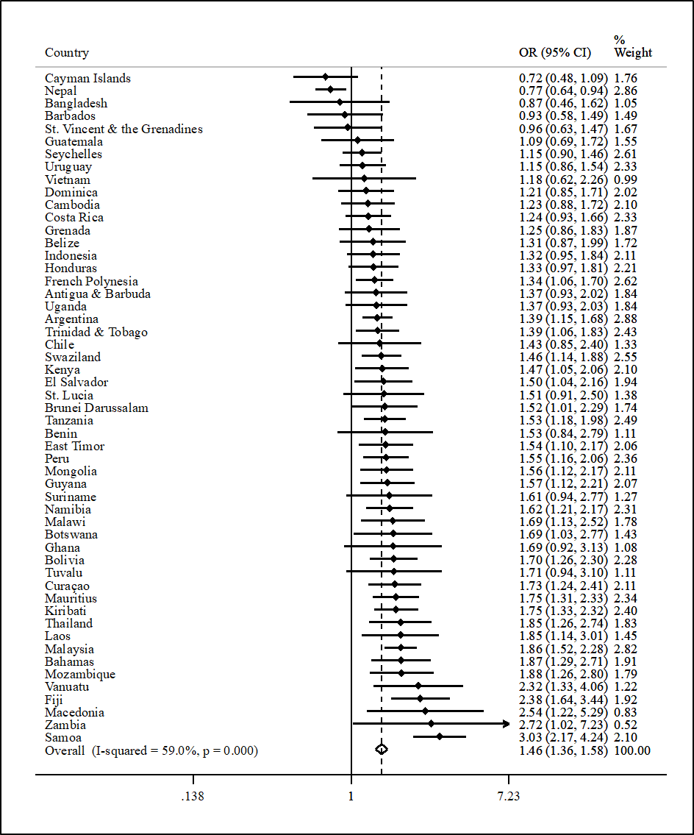

Figure S1 Country-wise association between any bullying victimization (exposure) and sexual intercourse (outcome) estimated by multivariable logistic regression
Abbreviation: OR Odds ratio; CI Confidence interval
Models are adjusted for sex, age, food insecurity, and alcohol consumption.
Overall estimate was obtained by meta-analysis with random effects.
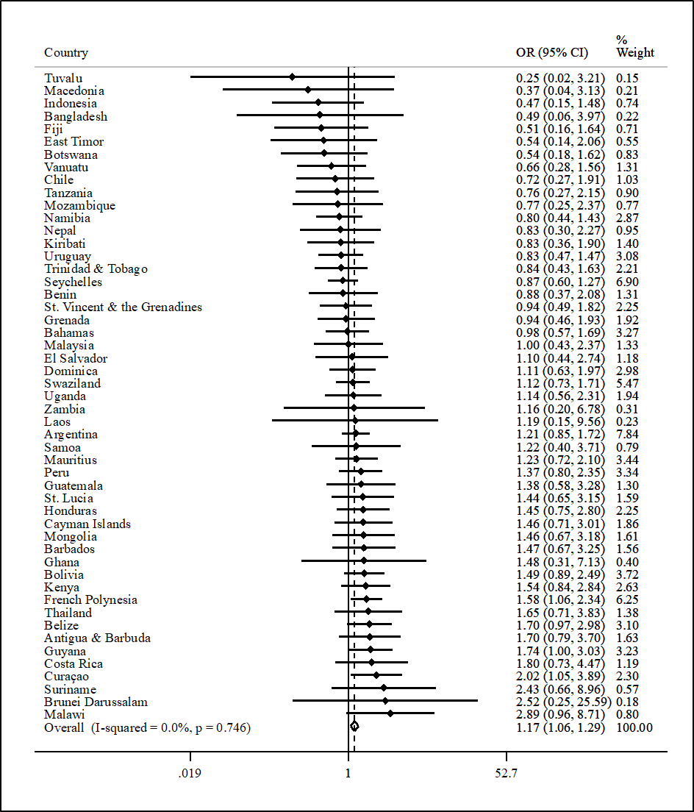

Figure S2 Country-wise association between any bullying victimization (exposure) and condom non-use (outcome) estimated by multivariable logistic regression
Abbreviation: OR Odds ratio; CI Confidence interval
Models are adjusted for sex, age, food insecurity, and alcohol consumption.
Overall estimate was obtained by meta-analysis with random effects.
Analysis is restricted to those who ever had sexual intercourse.
Estimates for Cambodia and Vietnam could not be obtained due to low numbers.

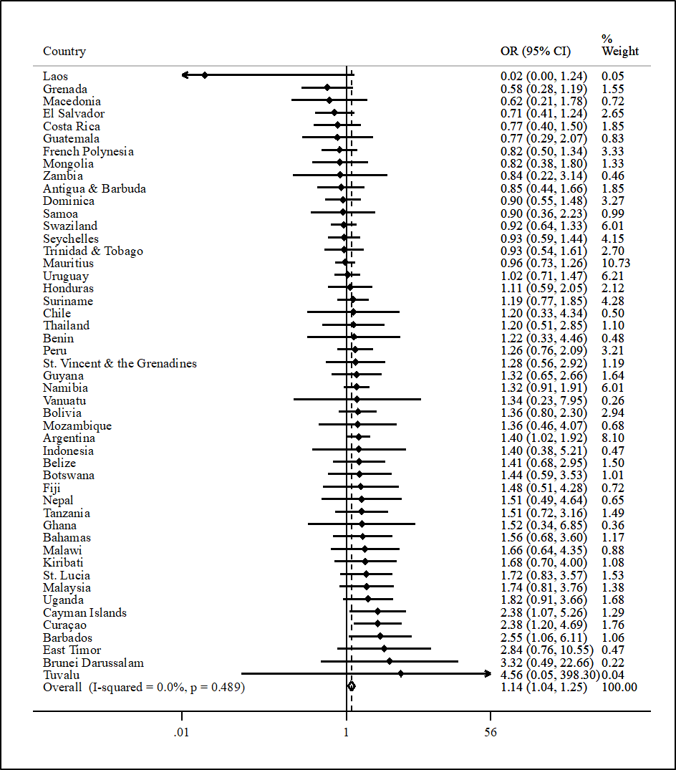

Figure S3 Country-wise association between any bullying victimization (exposure) and multiple sex partners (outcome) estimated by multivariable logistic regression
Abbreviation: OR Odds ratio; CI Confidence interval
Models are adjusted for sex, age, food insecurity, and alcohol consumption.
Overall estimate was obtained by meta-analysis with random effects.
Analysis is restricted to those who ever had sexual intercourse.
Estimates for Bangladesh, Cambodia, Kenya, and Vietnam could not be obtained due to low numbers or lack of data.

