Effects of Stent Post-Dilatation during primary PCI for STEMI:
Insights from Coronary Physiology and Optical Coherence Tomography

Grigoris V Karamasis MD^{1,2}, Andreas S Kalogeropoulos MD PhD³, Reto A Gamma MD¹, Gerald J Clesham MBBChir PhD^{1,2}, Valeria Marco RN⁴, Kare H Tang MBBS¹, Rohan Jagathesan MBBS MD¹, Jeremy W Sayer MBBS MD¹, Nicholas M Robinson MBBChir MD¹, Alamgir Kabir MBBS PhD¹, Rajesh K Aggarwal MBChB MD¹, Paul A Kelly MBChB MD¹, Francesco Prati MD PhD⁴, Thomas R Keeble MBBS MD^{1,2}, John R Davies MBBS PhD^{1,2}

¹ Cardiology Department, Essex Cardiothoracic Centre, Basildon, United Kingdom
² School of Medicine, Anglia Ruskin University, Chelmsford, United Kingdom
³ Cardiology Department, Mitera General Clinic - Hygeia Group, Athens, Greece
⁴ Cardiology Department, San Giovanni Hospital & Saint Camillus International University of Health Sciences, Rome, Italy

Corresponding author: Dr Grigoris Karamasis, Consultant Interventional Cardiologist,
Essex Cardiothoracic Centre, Basildon, SS165NL, United Kingdom
Email: grigoris.karamasis@gmail.com

Keywords: acute myocardial infarction, drug-eluting stents, optimization
Short running title: Impact of post-dilatation during STEMI
Word count: 4415

Objectives: This study aimed to assess the impact of stent optimisation by NC-balloon post-dilatation (PD) during primary-PCI for STEMI with the use of coronary physiology and intracoronary imaging.
Methods: This was a prospective observational study (ClinicalTrials.gov:NCT02788396). Optical coherence tomography (OCT) and physiological measurements were performed immediately before and after PD with the operators blinded to all measurements. The index of microcirculatory resistance (IMR), coronary flow reserve (CFR) and fractional flow reserve (FFR) were measured. OCT analysis was performed for assessment of stent expansion, malapposition, in-stent plaque-thrombus prolapse (PTP) and stent-edge dissections (SED). The change in IMR before and after PD as a measure of microvascular injury was the primary objective of the study.
Results: Thirty-two STEMI patients undergoing primary-PCI had physiological measurements before and after PD. All patients received 2nd generation DES (diameter 3.1±0.5mm, length 29.9±10.7mm) and post-dilatation with NC-balloons (diameter 3.6±0.6 mm, inflation pressure 19.3±2.0atm). IMR (44.9±25.6 vs. 48.8±34.2, p=0.26) and CFR (1.60±0.89 vs. 1.58±0.71, p=0.87) did not change, while FFR increased after PD (0.91±0.08 vs. 0.93±0.06, p=0.037). At an individual patient level, IMR increased in half of the cases. PD improved significantly absolute and relative stent expansion, reduced malapposition and increased PTP. There was no difference in clinically relevant SED.
Conclusion: In this exploratory, hypothesis-generating study, post-dilatation during primary-PCI for STEMI improved stent expansion, apposition and post-PCI FFR, without a significant effect on coronary microcirculation overall. Nevertheless, IMR increased in a group of patients and larger studies are warranted to explore predictors of microcirculatory response to post-dilatation.
1. INTRODUCTION
Vessel recanalization by primary percutaneous coronary intervention (PPCI) with drug eluting stents (DES) is the gold standard treatment for ST-segment elevation myocardial infarction (STEMI). Although stents are deployed over the commonly soft underlying lipid plaque and thrombus, optimal stent deployment in this setting is challenging due to factors like the presence and subsequent resolution of thrombus and vessel vasoconstriction^{1,2}. Stent optimisation with post-dilatation using non-compliant (NC) balloons could improve deployment features as stent expansion and stent struts apposition³. Nevertheless, further device manipulation within the culprit vessel carries the risk of atherothrombotic material fragmentation and embolization to the distal vessel⁴. Distal vessel embolization is a recognised cause of microvascular obstruction and therefore, post-dilatation in the context of STEMI has been related with microvascular injury and the no-reflow phenomenon^{5,6}.
The aim of this study was to investigate the effects of stent optimisation by NC balloon stent post-dilatation during PPCI in STEMI patients with the use of invasive coronary physiology measurements and intracoronary imaging. Changes in microvascular function and other physiological indices along with features of stent deployment were assessed before and after post-dilatation.

2. MATERIALS AND METHODS
2.1 Study design
This was a single centre observational study [“The impact of post stenting balloon dilatation on coronary microcirculation in STEMI patients undergoing PPCI (POSTDIL – STEMI)”, ClinicalTrials.gov: NCT02788396] that prospectively recruited STEMI patients undergoing PPCI at a tertiary cardiac centre. Patients included were 18 years old or above and presented with ST elevation ≥0.1mV in ≥2 contiguous leads, signs of a true posterior infarction or newly developed left bundle branch block on their ECG within 12 hours of symptoms onset. Patients with previous myocardial infarction or CABG, haemodynamic instability, known eGFR<30 ml/min/1.73m² and contradiction to adenosine were excluded. The study protocol was approved by the local ethics committee (NRES ref:16/EE/0096) and all subjects gave written informed consent prior to participating in the study.

2.2. Coronary intervention
Primary PCI was performed according to international guidelines and local standards. In brief, all patients were preloaded with Aspirin and Clopidogrel (given by ambulance crew at point-of care) and given a loading dose of Ticagrelor post-procedure. During the procedure, patients were anti-coagulated with heparin (70-100U/Kg) with a target ACT of >250s. Use of GIIbIIa inhibitors, balloon pre-dilatation and thrombus aspiration were at the discretion of the operator. 2nd generation everolimus-eluting stents were used in all patients.

2.3 Stent optimisation by post-dilatation
After successful stent deployment, the operator decided the need for post-dilatation based on his/her clinical judgement. If no post-dilatation was needed, the patient exited the study. In case post-dilatation was indicated, then optical coherence tomography (OCT) studies and coronary physiology measurements were performed immediately before and after post-dilatation. NC balloons were used for post-dilatation and sized at a ratio 1:1 with the size of the artery. Post-dilatation was performed at the stented segment where the operator felt it was needed. The NC balloon was inflated at high pressures (≥18Atm) for at least 10 seconds.

2.4 Coronary physiology measurements
A dedicated combined pressure/temperature guidewire (PressurewireTM X, St Jude Medical/Abbott Vascular, USA) was used for the physiological measurements. Before post-dilatation, and after intracoronary administration of nitro-glycerine, the guidewire was equalized and advanced to the distal third of the coronary artery. Subsequently, mean aortic pressure (P_{a}), mean distal coronary pressure (P_{d}), and mean transit time (mT_{t}) calculated as the average measurement during three separate intracoronary injections of 3mL of room temperature 0.9% saline solution were measured⁷. The same parameters were measured during hyperaemia induced by intravenous infusion of adenosine at 140mcg/Kg/min via a peripheral line. The operator proceeded to post-dilatation and coronary wedge pressure (P_{w}) was measured during balloon inflation. All measurements were rerepeated after post-dilatation. Dedicated software was used online for recording pressure traces, temperature curves and for physiological indices calculation (Coroventis CoroFlowTM, Uppsala, Sweden).
The index of microcirculatory resistance (IMR) is a validated measure of microvascular function ⁸. The change in IMR (dIMR) was used to assess changes in microvascular function before and after post-dilatation and was the primary endpoint of the study. IMR and IMR corrected for wedge pressure (IMR_{c)} were calculated by the following equations: IMR=P_{d} x mT_{t} (hyperaemia) and IMR_{c}=(P_{a} x mT_{t}) x [(P_{d}–P_{w})/(P_{a}–P_{w})] (hyperaemia)^{7,9}. Furthermore, coronary flow reserve (CFR), fractional flow reserve (FFR) and coronary FFR (FFR_{cor}) were calculated as CFR=mT_{t} (baseline)/mT_{t} (hyperaemia), FFR=P_{d}/P_{a} and FFR_{cor}=P_{a}-P_{w} /P_{d} -P_{w}¹⁰. FFR_{cor} as described in the original FFR validation study assesses the pressure gradient drop across the epicardial vessel.

2.5 Optical coherence tomography analysis
An FD-OCT Dragonfly OPTIS Catheter (St. Jude Medical/Abbott Vascular, USA) was used for intracoronary imaging before and after post-dilatation. OCT imaging acquisition was performed according to international expert standards and guidance¹¹. Prior to each OCT run, 200mcg of intracoronary nitrates were given. The entire length of the area of interest (i.e. stented segment and at least 5mm from the proximal and distal stent edges) was scanned. The operator was blinded to the OCT findings.

Off-line analysis was performed by an independent imaging core laboratory (EuroImage Research, Rome, Italy). OCT images were analysed at 0.2mm intervals. For the purpose of the analysis, lumen area and stent area where measured by planimetry. The lumen area (LA) was obtained by automated lumen-detection software and additional manual corrections, when necessary. The stent area (SA) was obtained manually by a multiple point detection function. The maximum distance between the two measured areas if not overlapping was measured automatically by the dedicated software application. In the case of co-existing stent malapposition and in-stent tissue prolapse the intra-stent flow area was drawn manually by the multiple point detection function. Stent deployment features assessed by OCT analysis were absolute and relative stent expansion, stent struts malapposition, intra-stent tissue prolapse and stent edge dissections. The definition of the calculated parameters is available in the appendix.

2.6 Statistical analysis Quantitative variables were tested for normal distribution according to the Kolmogorov-Smirnov test. Continuous variables were reported as mean and standard deviation values. Categorical variables were expressed as frequency and proportion. Comparisons between before and after post-dilatation were estimated using the paired t-test analysis for variables with normal distribution and the Wilcoxon test in case of non-normal distribution. For differences between independent variables, the independent samples t-test analysis was applied. Group differences of categorical variables were tested by a chi-square test. Pearson’s correlation coefficients or Spearman’s correlation coefficients were used to assess the relationship between two variables as appropriate. The level of statistical significance was set at p >0.05 with two tails. Statistical analysis was carried out using SPSS 24 software (SPSS Inc., Chicago, Illinois, USA).

3. RESULTS
Between September 2016 and June 2017, a total of 107 patients presenting with STEMI at the Essex Cardiothoracic Centre (Basildon, UK) were assessed for eligibility. Thirty-one patients did not fit the inclusion/exclusion criteria and were excluded. Seventy-six patients gave signed informed consent and were recruited in the study. Thirty-nine of these patients were excluded after diagnostic angiography or during PCI based on the pre-specified exclusion criteria and five were withdrawn from the study after initiation of the research protocol (patients’ flow chart is shown at figure 1). The remaining 32 patients completed the study with physiological measurements before and after post-dilatation.
Mean age was 66±11years and 78% were men. Symptoms onset to balloon time was 251±175 minutes and LAD was the most common culprit vessel (43.7%). The use of Glycoprotein IIbIIIa inhibitors and thrombus aspiration was relatively high (59% and 72% respectively). 1.2±0.5 stents were implanted with a maximum diameter of 3.1±0.5mm and a total length of 29.9±10.7mm. Post-dilatation was performed in all patients with NC-balloons with a maximum mean diameter of 3.6±0.6mm inflated at 19.3±2.0atm. Mean number of NC-balloons inflations was 2.0±0.6. Baseline and procedural characteristics are presented in Tables 1 and 2.
A comparison of the baseline and procedural characteristics between patients who underwent post-dilatation and the research protocol (n=32) and patients who had a stent, but the PCI operator decided that post-dilatation was not needed (n=9) has been included in the appendix (Appendix tables 1 and 2). There was no difference in any of the parameters apart from stent length with patients who had post-dilatation receiving longer stents. Furthermore, as expected for patients who had post-dilatation and the research protocol more contrast volume was used and there was a trend for longer procedure duration.

3.1 Coronary physiology measurements
IMR at baseline was 44.9±25.6 and did not change significantly after post-dilatation (48.8±34.2, p=0.26). Similarly, there was no significant change in IMR_{c} before and after post-dilatation (43.5±25.6 vs. 48.4±33.9 respectively, p=0.16). There was no difference in baseline characteristics or PCI procedural steps between patients with an increase or a decrease in IMR after post-dilatation, apart from more patients with the LAD as the culprit vessel in the increase group (68.8% vs. 18.8%, p=0.016) (Appendix tables 3 and 4). There was no difference in CFR measured before and after post-dilatation (1.60±0.89 vs. 1.58±0.71, p=0.87). However, FFR significantly increased from 0.91±0.08 to 0.93±0.06 (p=0.037). FFR_{cor}, increased from 0.87±0.11 to 0.90 ± 0.08 (p=0.017). Changes in physiological indices are shown in Figures 2 to 4.

3.2 Predictors of microcirculatory response
The potential relations between changes in IMR (dIMR) and IMR after post-dilatation with baseline characteristics and procedural factors including measures of the residual post stenting in-stent prolapsing athero-thrombotic material (PTP) were assessed. In bivariate correlation analysis, there was no significant correlation with any of the measured parameters.

3.3. Optical coherence tomography measurements
Post-dilatation improved absolute and relative stent expansion. Minimum lumen area across the stent length (in-stent MLA) increased from 5.3±1.8 to 5.8±2.0mm² (p <0.001) and minimum stent area (MSA) from 5.6±1.9 to 5.9±2.2mm² (p=0.017). The percentage of cases with a relative expansion >70% ¹² increased from 35% to 61% (p=0.039). When a cut-off value of >80% was used ¹¹, there was a strong trend towards increase of optimal relative expansion (16% vs. 32%, p=0.063). However, the number of cases with an in-stent MLA<4.5mm² did not change (Table 3).
Post dilatation improved all variables used to quantify stent strut malapposition. Maximum and mean areas of malapposition were reduced more than 50% (2.6±2.2 vs. 1.1±1.0mm², p<0.001 and 0.8±0.7 vs. 0.4±0.4mm², p=0.001, respectively). The degree of reduction for the malapposition volume and burden was even greater (7.9±9.7 vs. 2.2±2.4mm³, p<0.001 and 3.8±4.0 vs. 0.9±0.9mm³, p<0.001, respectively). Before post-dilatation the maximum malapposition distance was 0.7±0.5mm and was reduced significantly to 0.4±0.2 mm (p=0.004). Both the maximum consecutive and total length of malapposed struts was reduced from 3.9±3.3 to 2.0±1.6mm (p=0.002) and 7.9±5.9mm to 4.5±3.7mm (p<0.001) respectively. Finally, post-dilatation reduced the number of malapposed stent struts from 145.0±132.0 to 53.2±46.2 (p<0.001). The above changes led to a reduction in the cases with malapposed struts with a maximum axial distance of 0.5mm from 71% to 41.9% (p=0.022) (Table 4).
In contrast to stent expansion and malapposition, there was an increase in tissue protrusion through the stent struts as shown by maximum and mean areas, total length and volume. However, plaque-thrombus protrusion thickness and % protrusion area/stent area did not change (Table 5).
There was no stent-edge dissection detected by coronary angiography in any of the patients. However, OCT showed 8 patients having a stent-edge dissection before post-dilatation and 12 afterwards. Table 6 shows the per stent-edge distribution. Operators were blinded to OCT results and none of these dissections was treated.

3.4 Correlation of FFR with lumen area
FFR and FFR_{cor} before post-dilatation showed a statistically significant positive correlation with in-stent MLA before post-dilatation (r=0.408, p=0.023 and r=0.398, p=0.029 respectively). Similarly, FFR and FFR_{cor} after post-dilatation had a significant positive correlation with in-stent MLA after post-dilatation (r=0.353, p=0.05 and r=0.363 p=0.05 respectively). There was no correlation between FFR and FFR_{cor} with relative stent expansion (p>0.05). After post-dilatation FFR and FFR_{cor} were significantly higher for patients with an MLA>4.5 mm² (0.94±0.05 vs. 0.89±0.06, p=0.014 and 0.92±0.07 vs. 0.85±0.07, p=0.012 respectively) (Figure 5).

4. DISCUSSION
This prospective observational study evaluated the effects of stent post-dilatation in STEMI patients using for the first time a combination of invasive coronary physiology and intracoronary imaging. The novel study design led to a number of interesting observations. Stent post-dilatation did not lead to an increase in IMR overall. Nevertheless, at an individual patient level, IMR increased in half of the cases. Overall CFR did not change either, but FFR and FFR_{cor} showed a small statistically significant increase after post-dilatation. Regarding, intracoronary imaging assessment, post-dilatation improved absolute and relative stent expansion and all variables of stent struts malapposition. In contrast, post-dilation increased tissue protrusion through the stent struts. OCT-detected stent edge dissections were common even before stent post-dilatation and post-dilatation led to a numerical increase of stent edge dissections at the distal stent edge. Finally, there was a positive correlation of FFR and in-stent minimum lumen area.

In POSTDIL-STEMI, stent post-dilatation did not produce a consistent and predictable microvascular injury as it would be depicted by a significant increase in IMR. Therefore, contradicting theoretical concerns, post-dilatation did not cause significant universal microvascular injury. However, at an individual patient level, IMR increased in half of the patients and decreased in the other half. Two previous studies have used sequential measurements of IMR in the context of primary PCI for STEMI to assess the impact of PCI procedural steps^{13,14}. In a study of 81 patients IMR measured before stent implantation and at the end of the PCI procedure improved overall¹³. However, the improvement was not universal as in specific patients’ groups IMR remained elevated or even increased further. In the second study of 41 patients randomised to manual thrombectomy or balloon angioplasty prior to stent deployment, manual thrombectomy did not lead to a change in IMR, but in the specific group of patients with low IMR after initial vessel recanalization, any device manipulation (i.e. balloon pre-dilatation or thrombus aspiration) led to an increase in IMR¹⁴. Both studies suggested that the response of microcirculation to coronary intervention in the context of STEMI is not universal and varies between cases. This supports the findings of POSTDIL-STEMI where IMR at an individual patient level had a variable response to post-dilatation equally shared between increase and decrease. In agreement to previous studies, it can be hypothesized that in the cases with an IMR increase, fragmentation and distal embolization of atherothrombotic material by NC balloon intracoronary manipulation and inflation led to further microvascular injury. Regarding the cases with an improvement of IMR after post-dilatation, the mechanism can only be speculated. In a previous study in STEMI patients showed that stent placement resulted in a reduction in IMR with the proposed mechanism being the increase of coronary flow after obstruction resolution that led to increased perfusion pressure and subsequent downstream relaxation of microcirculatory tone¹³. A similar mechanism could be hypothesised in this study after stent deployment optimisation.

Although there was no change in microvascular function overall, there were two distinct patients’ groups: those with an increase in IMR/CFR and those with a decrease. From a clinical perspective it would be ideal to be able to identify these patients in advance and tailor our procedure accordingly. However, our study failed to identify predictors of microcirculatory response probably limited by its small sample size. Larger, adequately powered studies are warranted to explore potential correlations of baseline and procedural characteristics with changes in microvascular function.

As expected, stent post-dilatation significantly improved absolute and relative stent expansion and apposition. Nevertheless, post-dilatation did not abolish stent under-expansion or malapposition. Relative stent expansion remained below the optimal target of >90% used in randomised trials¹⁵ and the number of patients with an absolute stent expansion below the clinically significant cut off value of 4.5 mm² ¹² did not change. Furthermore, the number of patients with significant malapposition as defined by the recent EAPCI consensus¹¹ remained high. These observations, on one hand, highlight the limitations of angiographically guided stent optimisation and the potential role of intracoronary imaging in the process. On the other hand, they underly the fact that absolute and relative stent expansion suggested cut-off values are not always feasible in real life and should be viewed not as absolute targets, but as guidance aids during PCI.

Protrusion of tissue or thrombus through stent struts have been related with adverse clinical outcomes in patients with acute coronary syndromes¹⁶ and in previous studies post-dilatation has been used to reduce it ¹⁷. In contrast in this study post-dilatation increased prolapsing tissue. This could be explained by the fact that further stent expansion achieved by post-dilatation led to better stent apposition against the vessel wall, compressing and protruding the underlying thrombus or soft tissue through the stent struts. Furthermore, in previous studies a prolonged inflation of the NC-balloon was part of the protocol (i.e. 60sec)¹⁷, while the duration of the inflation in our study was much shorter.

The small but statistically significant increase in FFR and FFR_{cor} is an interesting finding. FFR could be false high in the case of microvascular dysfunction as in the acute state of STEMI, however, the observed increase cannot be attributed to further microvascular injury as both IMR and CFR did not change significantly, and another explanation should be attempted. It has been suggested that post-PCI FFR could be the result of suboptimal stent deployment and recent studies have used it to guide immediate post procedure decision-making and optimisation of PCI acute result ^{18,19}. A recent study that used OCT to delineate the causes of suboptimal post-PCI FFR showed that 62% of the patients had suboptimal stent results with the more prominent findings being stent malapposition and underexpansion ¹⁹. OCT guided further optimisation led to an increase in FFR from 0.80±0.02 to 0.88±0.01 (p=0.008). In our study, FFR and FFR_{cor} before and after PCI showed significant correlation with in-stent minimum lumen area suggesting that the larger lumen areas after post-dilatation could lead to higher FFR. However, the small FFR increase should be interpreted with caution as it was driven by significant increase mainly in two cases as evident in figure 3. Importantly, these two patients, in contrast with the rest of the cohort, had a low post-stenting FFR potentially allowing for correction of suboptimal results by post-dilatation.

This study has a number of limitations. It was a single centre observational study of a limited sample size. As such, the study should be viewed as an exploratory, hypothesis generating one and its results to be interpreted with caution. It is still possible that a larger study may show that post-dilatation hampers microcirculatory function. The decision for post-dilatation was not mandated or guided by a pre-specified protocol but relied on operator’s clinical judgement. Although this study design might have introduced a degree of selection bias, it was purposely selected in order to reflect everyday clinical practice. The fact that cases, where the operator decided post-dilatation was not needed, received shorter stents is an indication that appropriate clinical decision making was applied. Finally, the study did not report any clinical endpoints and the clinical implications of the changes observed in physiological indices and stent deployment need to be assessed in future studies.

5. CONCLUSION
In this exploratory, hypothesis-generating study, stent optimisation by post-dilatation with NC balloons in STEMI patients undergoing primary PCI improved significantly stent expansion, apposition and post PCI FFR, without a significant effect on coronary microcirculation overall. Nevertheless, there was a group of patients with increase in IMR and larger studies are warranted to explore predictors of microcirculatory response to post-dilatation.

Funding information
This study was funded via an unrestricted research grant from Abbott Vascular.

Conflict of interest statement
Grigoris V Karamasis has received honoraria and institutional research grant from Abbott Vascular and Boston Scientific. Thomas R Keeble has received institutional research grant from Abbott Vascular and Boston Scientific. All other authors declare no potential conflict of interest.
References

1. De Bruyne B, Barbato E. Drug-Eluting Stent Implantation. JACC Cardiovasc Interv. 2008;1:32–33.

2. Guo N, Maehara A, Mintz GS, et al. Incidence, Mechanisms, Predictors, and Clinical Impact of Acute and Late Stent Malapposition After Primary Intervention in Patients with Acute Myocardial Infarction: An Intravascular Ultrasound Substudy of the Harmonizing Outcomes With Revascularization and Stents in Acute Myocardial Infarction (HORIZONS-AMI) Trial. Circulation. 2010;122:1077–1084.

3. Romagnoli E, Sangiorgi GM, Cosgrave J, Guillet E, Colombo A. Drug-Eluting Stenting: the case for post-dilation. JACC Cardiovasc Interv. 2008;1:22–31.

4. Vrints C, Haine S. Prevention of coronary microvascular plugging: the next target in STEMI? EuroIntervention. 2016;12:1201–1202.

5. Niccoli G, Scalone G, Lerman A, Crea F. Coronary microvascular obstruction in acute myocardial infarction. Eur Heart J. 2016;37:1024–1033.

6. Yamaji K, Brugaletta S, Sabaté M, et al. Effect of Post-Dilatation Following Primary PCI With Everolimus-Eluting Bioresorbable Scaffold Versus Everolimus-Eluting Metallic Stent Implantation. JACC Cardiovasc Interv. 2017;10:1867–1877.

7. Fearon WF, Balsam LB, Farouque HM, et al. Novel index for invasively assessing the coronary microcirculation. Circulation. 2003; 107:3129-3132.

8. Carrick D, Haig C, Ahmed N, et al. Comparative Prognostic Utility of Indexes of Microvascular Function Alone or in Combination in Patients With an Acute ST-Segment–Elevation Myocardial Infarction. Circulation. 2016;134:1833–1847.

9. Aarnoudse W, Fearon WF, Manoharan G, et al. Epicardial Stenosis Severity Does Not Affect Minimal Microcirculatory Resistance. Circulation. 2004;110:2137–2142.

10. Pijls NHJ, van Son JA, Kirkeeide RL, De Bruyne B, Gould KL. Experimental Basis of Determining Maximum Coronary, Myocardial, and Collateral Blood Flow by Pressure Measurements for Assessing Functional Stenosis Severity Before and After Percutaneous Transluminal Coronary Angioplasty. Circulation. 1993;87:1354-1367.

11. Räber L, Mintz GS, Koskinas KC, et al. Clinical use of intracoronary imaging. Part 1: guidance and optimization of coronary interventions. An expert consensus document of the European Association of Percutaneous Cardiovascular Interventions. EuroIntervention. 2018;14:656-677.

12. Prati F, Romagnoli E, Burzotta F, et al. Clinical Impact of OCT Findings During PCI: The CLI-OPCI II Study. JACC Cardiovasc Imaging. 2015;8:1297-1305,

13. De Maria GL, Cuculi F, Patel N, et al. How does coronary stent implantation impact on the status of the microcirculation during primary percutaneous coronary intervention in patients with ST-elevation myocardial infarction? Eur Heart J. 2015;36:3165-3177.

14. Hoole SP, Jaworski C, Brown AJ, et al. Serial assessment of the index of microcirculatory resistance during primary percutaneous coronary intervention comparing manual aspiration catheter thrombectomy with balloon angioplasty (IMPACT study): a randomised controlled pilot study. Open Heart. 2015;2:e000238.

15. Ali ZA, Maehara A, Généreux P, et al. Optical coherence tomography compared with intravascular ultrasound and with angiography to guide coronary stent implantation (ILUMIEN III: OPTIMIZE PCI): a randomised controlled trial. Lancet. 2016;388:2618-2628.

16. Prati F, Romagnoli E, Gatto L, et al. Clinical Impact of Suboptimal Stenting and Residual Intrastent Plaque/Thrombus Protrusion in Patients With Acute Coronary Syndrome: The CLI-OPCI ACS Substudy (Centro per la Lotta Contro L'Infarto-Optimization of Percutaneous Coronary Intervention in Acute Coronary Syndrome). Circ Cardiovasc Interv. 2016;9:e003726.

17. Di Giorgio A, Capodanno D, Ramazzotti V, et al. Optical coherence tomography guided in-stent thrombus removal in patients with acute coronary syndromes. Int J Cardiovasc Imaging. 2013;29:989-996.

18. Agarwal SK, Kasula S, Hacioglu Y, Ahmed Z, Uretsky BF, Hakeem A. Utilizing Post-Intervention Fractional Flow Reserve to Optimize Acute Results and the Relationship to Long-Term Outcomes. JACC Cardiovasc Interv. 2016;9:1022-1031.

19. Wolfrum M, De Maria GL, Benenati S, et al. What are the causes of a suboptimal FFR after coronary stent deployment? Insights from a consecutive series using OCT imaging. EuroIntervention. 2018;14:e1324-1331.

Figure 1. Patients’ flow chart.
PD = post dilatation, STEMI = ST-segment elevation myocardial infarction, MI = myocardial infarction, PPCI = primary percutaneous coronary intervention, OCT = optical coherence tomography, PEA = pulseless electrical activity.

Figure 2. IMR before and after post-dilatation.
A) IMR values before and after PD. B) Individual changes in IMR before and after PD.
IMR = Index of microcirculatory resistance, PD = post-dilatation.

Figure 3. CFR before and after post-dilatation.
A) CFR values before and after PD. B) Individual changes in CFR before and after PD.
CFR = coronary flow reserve, PD = post-dilatation.

Figure 4. FFR before and after post-dilatation.
A) FFR values before and after PD. B) Individual changes in FFR before and after post dilatation.
FFR = fractional flow reserve, PD = post-dilatation.
Figure 5. FFR after post dilatation and in-stent MLA.
Patients with an MLA>4.5 mm² after post-dilatation had a higher FFR.
MLA = minimum lumen area.

Figure 1.
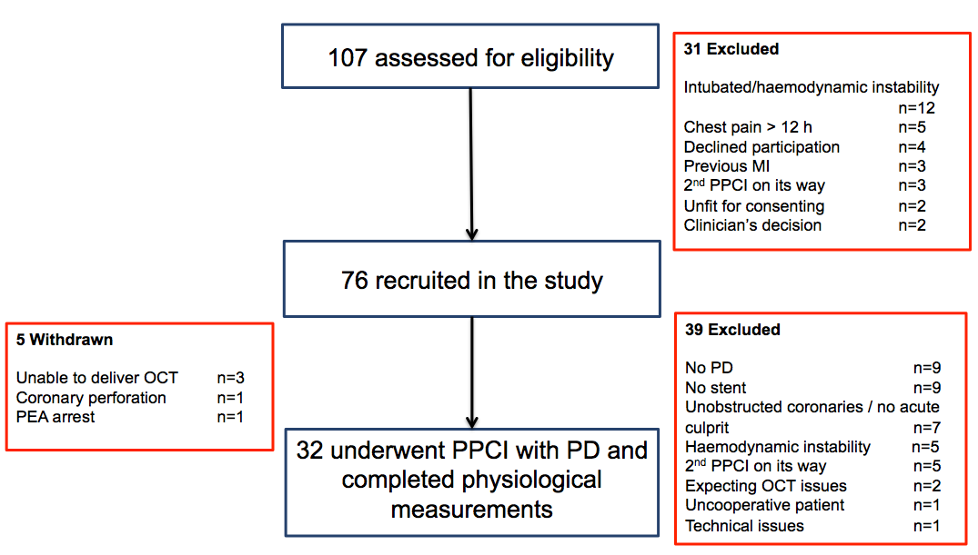

Figure 2.
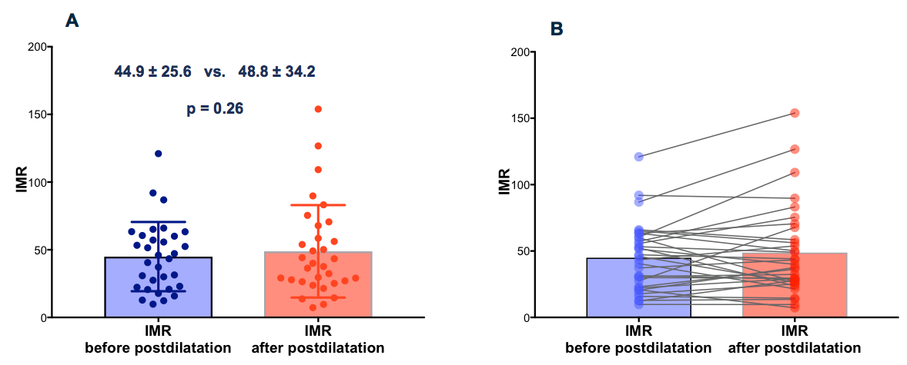

Figure 3.
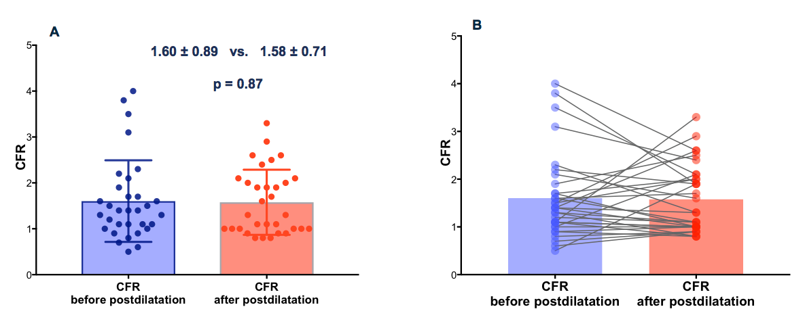

Figure 4.
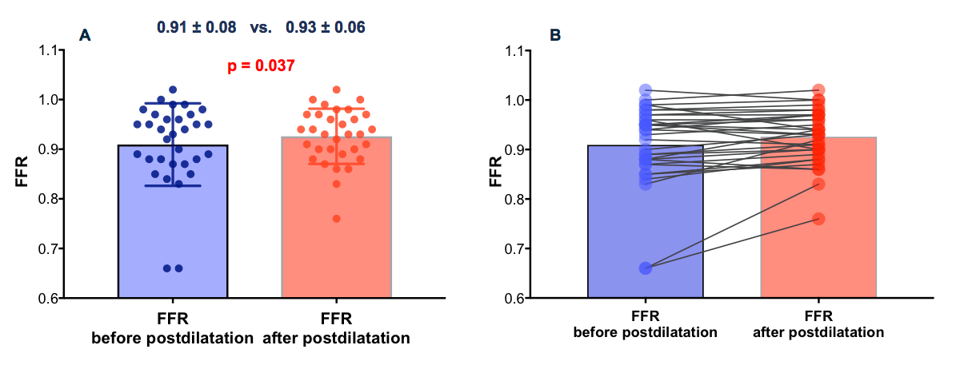

Figure 5.
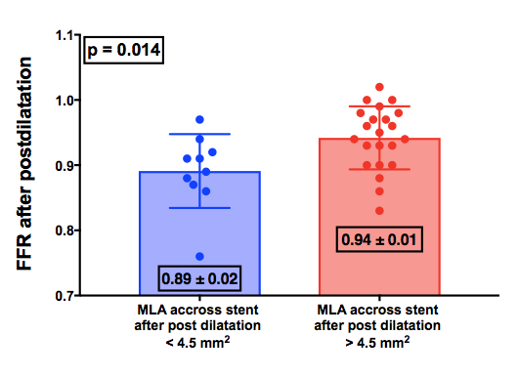

Table 1. Baseline characteristics.
Demographics
Age(years) | 66.0±11.0
Male sex(%) | 25 (78)
Past medical history
Diabetes mellitus(%) | 4 (12.5)
Hypertension(%) | 15 (46.8)
Hypercholesterolemia(%) | 14 (43.7)
Family history of premature CAD(%) | 4 (12.5)
Current smoker(%) | 7 (21.8)
Ex-smoker(%) | 11 (34.3)
Previous MI(%) | 2 (6.2)
Previous PCI(%) | 2 (6.2)
Previous CVA(%) | 1 (3.1)
Presentation characteristics
Symptoms to device time (minutes) | 252±175
Culprit vessel(%)
LAD(%) | 14 (43.7)
Cx(%) | 5 (15.6)
RCA(%) | 13 (40.6)
Culprit lesion at proximal segment(%) | 19 (59.3)
Number of diseased vessels(%)
1(%) | 10 (31.2)
2(%) | 15 (46.8)
3(%) | 7 (21.8)
TIMI flow presentation(%)
0(%) | 26 (81.2)
1(%) | 2 (6.2)
2(%) | 4 (12.5)
3(%) | 0 (0)

Table 2. Procedural characteristics.
Procedural Characteristics
Radial access(%) | 31(96.8)
Thrombus aspiration(%) | 23(71.8)
Pre-dilatation(%) | 26(81.2)
GPIIbIIIa inhibitors(%) | 19(59.3)
Drug eluting stents | 32(100)
Number of stents | 1.2±0.5
Stent diameter(mm) | 3.1±0.5
Stent length(mm) | 29.9±10.1
Stent max inflation pressure(atm) | 14.68±2.68
Post-stent TIMI flow
0-1(%) | 1(3.1)
2(%) | 1(3.1)
3(%) | 30(93.7)
Post-dilatation (PD) with NC-balloons | 32(100%)
PD balloon diameter(mm) | 3.6±0.6
PD balloon length(mm) | 15.8±3.4
Number of PD inflations | 2.0±0.6
Maximum PD balloon inflation pressure(atm) | 19.3±2.0
PD balloon inflation duration(sec) | 17.6±6.7
PD location
Proximal stent(%) | 30(93.7)
Mid stent(%) | 28(87.5)
Distal stent(%) | 4(12.5)
TIMI flow after post-dilatation(%)
0 - 1(%) | 1(3.1)
2(%) | 3(9.3)
3(%) | 28(87.5)

Table 3. OCT analysis of stent expansion before and after post-dilatation.
 | Before  Post dilatation | After  Post dilatation | p-values
Stent expansion parameters
In-stent MLA (mm²) | 5.3±1.8 | 5.8±2.0 | <0.001
Mean in-stent LA (mm²) | 7.3±2.4 | 8.3±2.5 | <0.001
MSA (mm²) | 5.6±1.9 | 5.9±2.2 | 0.017
Mean SA (mm²) | 7.3±2.4 | 8.6±2.6 | <0.001
In-stent MLA <4.5mm², n(%) | 11(35) | 11(35) | 1
In-stent MLA/Mean reference LA, %± | 67.4±9.7 | 72.8±11.4 | 0.001
Mean in-stent MLA/Mean reference LA, % | 92.1±11.4 | 105.0±12.2 | <0.001
Proximal MSA (mm²) | 6.0±2.0 | 7.2±2.1 | <0.001
Distal MSA (mm²) | 5.9±2.2 | 6.3±2.5 | 0.007
Stent expansion >90%, n(%) | 1 (3.2) | 3 (9.7) | 0.5
Stent expansion >80 % n(%) | 5 (16) | 10 (32) | 0.063
Stent expansion >70%, n(%) | 11 (35.5) | 19 (61.3) | 0.039

Table 4. OCT analysis of stent malapposition before and after post-dilatation.
 | Before  Post-dilatation | After  Post-dilatation | p-values
Stent malapposition parameters
Max malapposed area (mm²) | 2.6±2.2 | 1.1±1.0 | <0.001
Mean malapposed area (mm²) | 0.8±0.7 | 0.4±0.4 | 0.001
Malapposed volume (mm³) | 7.9±9.7 | 2.2±2.4 | <0.001
Malapposed volume/stent volume (%) | 3.8±4.0 | 0.9±0.9 | <0.001
Max malapposition distance (mm) | 0.7±0.5 | 0.4±0.2 | 0.004
Mean malapposition distance (mm) | 0.3±0.1 | 0.2±0.1 | 0.009
Max stent length with consecutive frames of malapposition (mm) | 3.9±3.3 | 2.0±1.6 | 0.002
Total stent length with malapposition (mm) | 7.9±5.9 | 4.5±3.7 | <0.001
Number of malapposed struts | 145.0±132.0 | 53.2±46.2 | <0.001
Malapposition >0.5 mm, n(%) | 22(71) | 13(41.9) | 0.022
Malapposition with axial distance >0.4mm and consecutive length of >1mm | 20(64%) | 16(52%) | 0.125

Table 5. OCT analysis of plaque-thrombus prolapse (PTP) before and after post-dilatation.
 | Before  Post-dilatation | After  Post-dilatation | p-values
Plaque-thrombus prolapse parameters
Max PTP area (mm²) | 1.21±0.66 | 1.46±0.81 | 0.007
Mean PTP area (mm²) | 0.42±0.23 | 0.52±0.29 | 0.004
Total PTP length (mm) | 11.9±5.8 | 15.7±8.9 | 0.001
PTP volume (mm³) | 5.4±4.6 | 8.1±6.4 | 0.001
PTP burden (%) | 2.5±2.0 | 3.0±2.0 | 0.06
Maximum PTP thickness (mm) | 0.85±1.05 | 0.66±0.25 | 0.71
Mean PTP thickness (mm) | 0.28±0.08 | 0.29±0.09 | 0.27
Protrusion area/Stent area (%) | 15.97±6.69 | 15.09±6.38 | 0.5
Protrusion area/Stent area ≥10%, n(%) | 23(74.2) | 22(71) | 1

Table 6. OCT analysis of stent edge dissection.
 | Before  Post-dilatation | After  Post-dilatation | p-values
Any Dissection detected by OCT
Proximal(%) | 5(16) | 6(19) | 1.00
Distal(%) | 4(12) | 7(22) | 0.25
Major Dissection detected by OCT *
Proximal(%) | 3(9) | 4(12) | 1.00
Distal(%) | 1(3) | 4(12) | 0.25
* Lateral expansion >60º & longitudinal expansion >2mm

