Accepted Manuscript

Hayre, Christopher M. and Bungay, Hilary and Jeffery, Christopher (2020) How effective are lead-rubber aprons in protecting radiosensitive organs from secondary ionizing radiation? Radiography. ISSN 1532-2831

How effective are lead-rubber aprons in protecting radiosensitive organs from secondary ionizing radiation?

Word Count: 3,641

Introduction

Lead-rubber aprons are widely utilised in medical imaging environments in order to limit ionising radiation to staff, patients and carers/comforters alike.^{1,2} A number of studies continue to demonstrated dose reduction strategies with lead-rubber in the literature and thus it remains pertinent for practitioners due to his high density and atomic number.³⁻⁷ A recent study by Johansen et al⁸ has identified alternate forms of radiographic aprons in contemporary practice, namely aprons which remain lead-free whilst still offering high X-ray absorption. A basic necessity of any lead-rubber apron is to provide shielding from secondary radiation whereby doses to radiosensitive organs are limited by 75%.⁹ In general radiography, lead-rubber shapes are often available, coincided with aprons and gonad shielding in order to protect organs in and outside of the primary beam. Because all ionizing radiation carries some form of stochastic risk, radiographers are required to justify, optimize and limit radiation where possible. Further, if a patient requests a lead-rubber apron in anticipation it may limit their radiological exposure, however small, this study may help practitioners decide how to respond to such questioning. The theoretical linear non-threshold (LNT) dose response model reaffirms the rationale for assuming that ionising radiation (however small) has the potential to induce malignant change,¹⁰ and therefore remains the theoretical foundation of current legislation internationally and dose limiting techniques in diagnostic radiography transnationally.^{3, 4, 5}
Attempts to understand the induction of stochastic cancers within diagnostic radiography has been debated for decades. Yet, within the current radiobiological paradigm it is generally accepted that a ‘safe’ radiation exposure, does not exist.¹⁰ To date, however, few studies have examined secondary ionising radiation to radiosensitive organs upon wearing a lead-rubber apron in general imaging thus important to explore the effects of those that remain in close proximity. A left lateral radiographic examination of the elbow is important experimentally because when in a sitting position, it remains in close proximity to a number of radiosensitive organs, typically, the thyroid, breasts and eyes.^{2, 11} This is important as the International Atomic Energies Agency (IAEA) affirms that shielding (where appropriate) should be used to protect a patient’s radiosensitive organs, typically the breast, gonads, eyes and thyroid.^{1,11} It is pertinent to highlight other radiosensitive organs that exist in this radiographic position, including the head, neck and thorax, yet our intention is to focus on dose limitation to the breast, gonads, eyes, thyroid and spleen.¹¹ Further, Hayre¹² recently observed that some radiographers may not always utilise lead-rubber in practice, due to an uncertainty surrounding scattered ionising radiation. In short, this remained a key driver for this paper whereby quantification of scattered ionizing radiation (limiting or not) is recorded in order to provide a critical examination of dose limitation if/when a lead-rubber apron is implemented for patients when sitting for a left lateral radiographic examination of the elbow.

Aim
The aim of this study was to investigate secondary ionising radiation scatter to radiosensitive organs upon wearing a lead-rubber apron for a lateral radiographic examination of the elbow.

Objectives
- Design an experiment resembling the positioning of a lateral radiographic elbow examination
- Expose a phantoms radiosensitive organs without a lead-rubber apron
- Repeat exposure to radiosensitive organs with a lead-rubber apron and identify dose limitation.

Materials and methods

This experiment was undertaken in a controlled X-ray laboratory environment at an investigating academic institution and remained part of larger experiment that has previously added to the existing literature both methodologically and empirically.¹¹ The equipment used included a Siemens Multix Pro with Optilix HC100 X-ray rotating tungsten anode (angle of 12°) (Siemens Healthcare, GmbH, Erlangen, Germany); Polydoros ITS 35 generator; Knight imaging lead vinyl apron (0.35mm) and thyroid collar (0.50mm); female anthropomorphic phantom and 15cc ioniszation chamber model no.96035b and electrometer model no.35050A.

Anthropomorphic phantom and elbow construction

A female anthropomorphic phantom was used to simulate the patient. The anthropomorphic phantom (Rando Alderson Research Laboratory, Stamford, Connecticut, USA) was designed such that any ionising radiation absorption would mimic an adult patient.¹³ The phantom contained a density of 0.99 g/cm³, an atomic number similar to human tissue (7.3).¹³ The arm was constructed using real bone(s), made available by the university to make the elbow joint, consisting of the humerus, radius and ulna (density 1.75 g/cm³).¹¹ Water (density 1.00 g/cm³) was injected into a saline bag (density 1.11 g/cm³) simulating soft tissue.¹¹ This was used because it contains similar densities associated with human muscle (1.06 g/cm³) and fat (0.91 g/cm³).¹¹ A plastic mesh (1.15 g/cm³) was created encapsulating the materials, simulating anatomical shape and radiographic positioning of a patient attending for a lateral radiographic examination of the elbow.¹¹ This offered close resemblance to that of a human elbow as illustrated previously,¹¹ but it is important to recognise that the X-ray beam will undergo different absorption and scattering effects on these materials and thus impacting on scattered ionising radiation. This continues to remain a limitation of this methodology.¹¹

Lead-rubber apron (0.35mm) and lead-rubber thyroid garment (0.5mm)

Following acceptable quality assurance testing the lead-rubber apron and thyroid collar were used as part of this experiment.⁸ Upon completion and satisfaction of the results the lead-rubber apron was first employed in order to meet the initial aim and objectives of this study and thus draped over the phantom, mimicking a clinical situation. A 0.35 mm lead vinyl apron was used as this would be deemed most appropriate (and available) at the selected kVp techniques used for extremity examinations. Figure 1 illustrates the anthropomorphic phantom set up. The rationale for adding the thyroid protector is discussed later.
Radiographic positioning mimicked a patient attending for a left lateral radiographic examination of the elbow. In accordance with radiography positioning literature the phantom and arm construction were positioned resembling a patient in a sitting position with the patient’s arm and forearm placed in the lateral position with the elbow joint flexed at 90$°$ with the hand rotated externally into the true lateral position.¹⁴

Figure 1: Anthropomorphic phantom with lead-rubber apron and thyroid
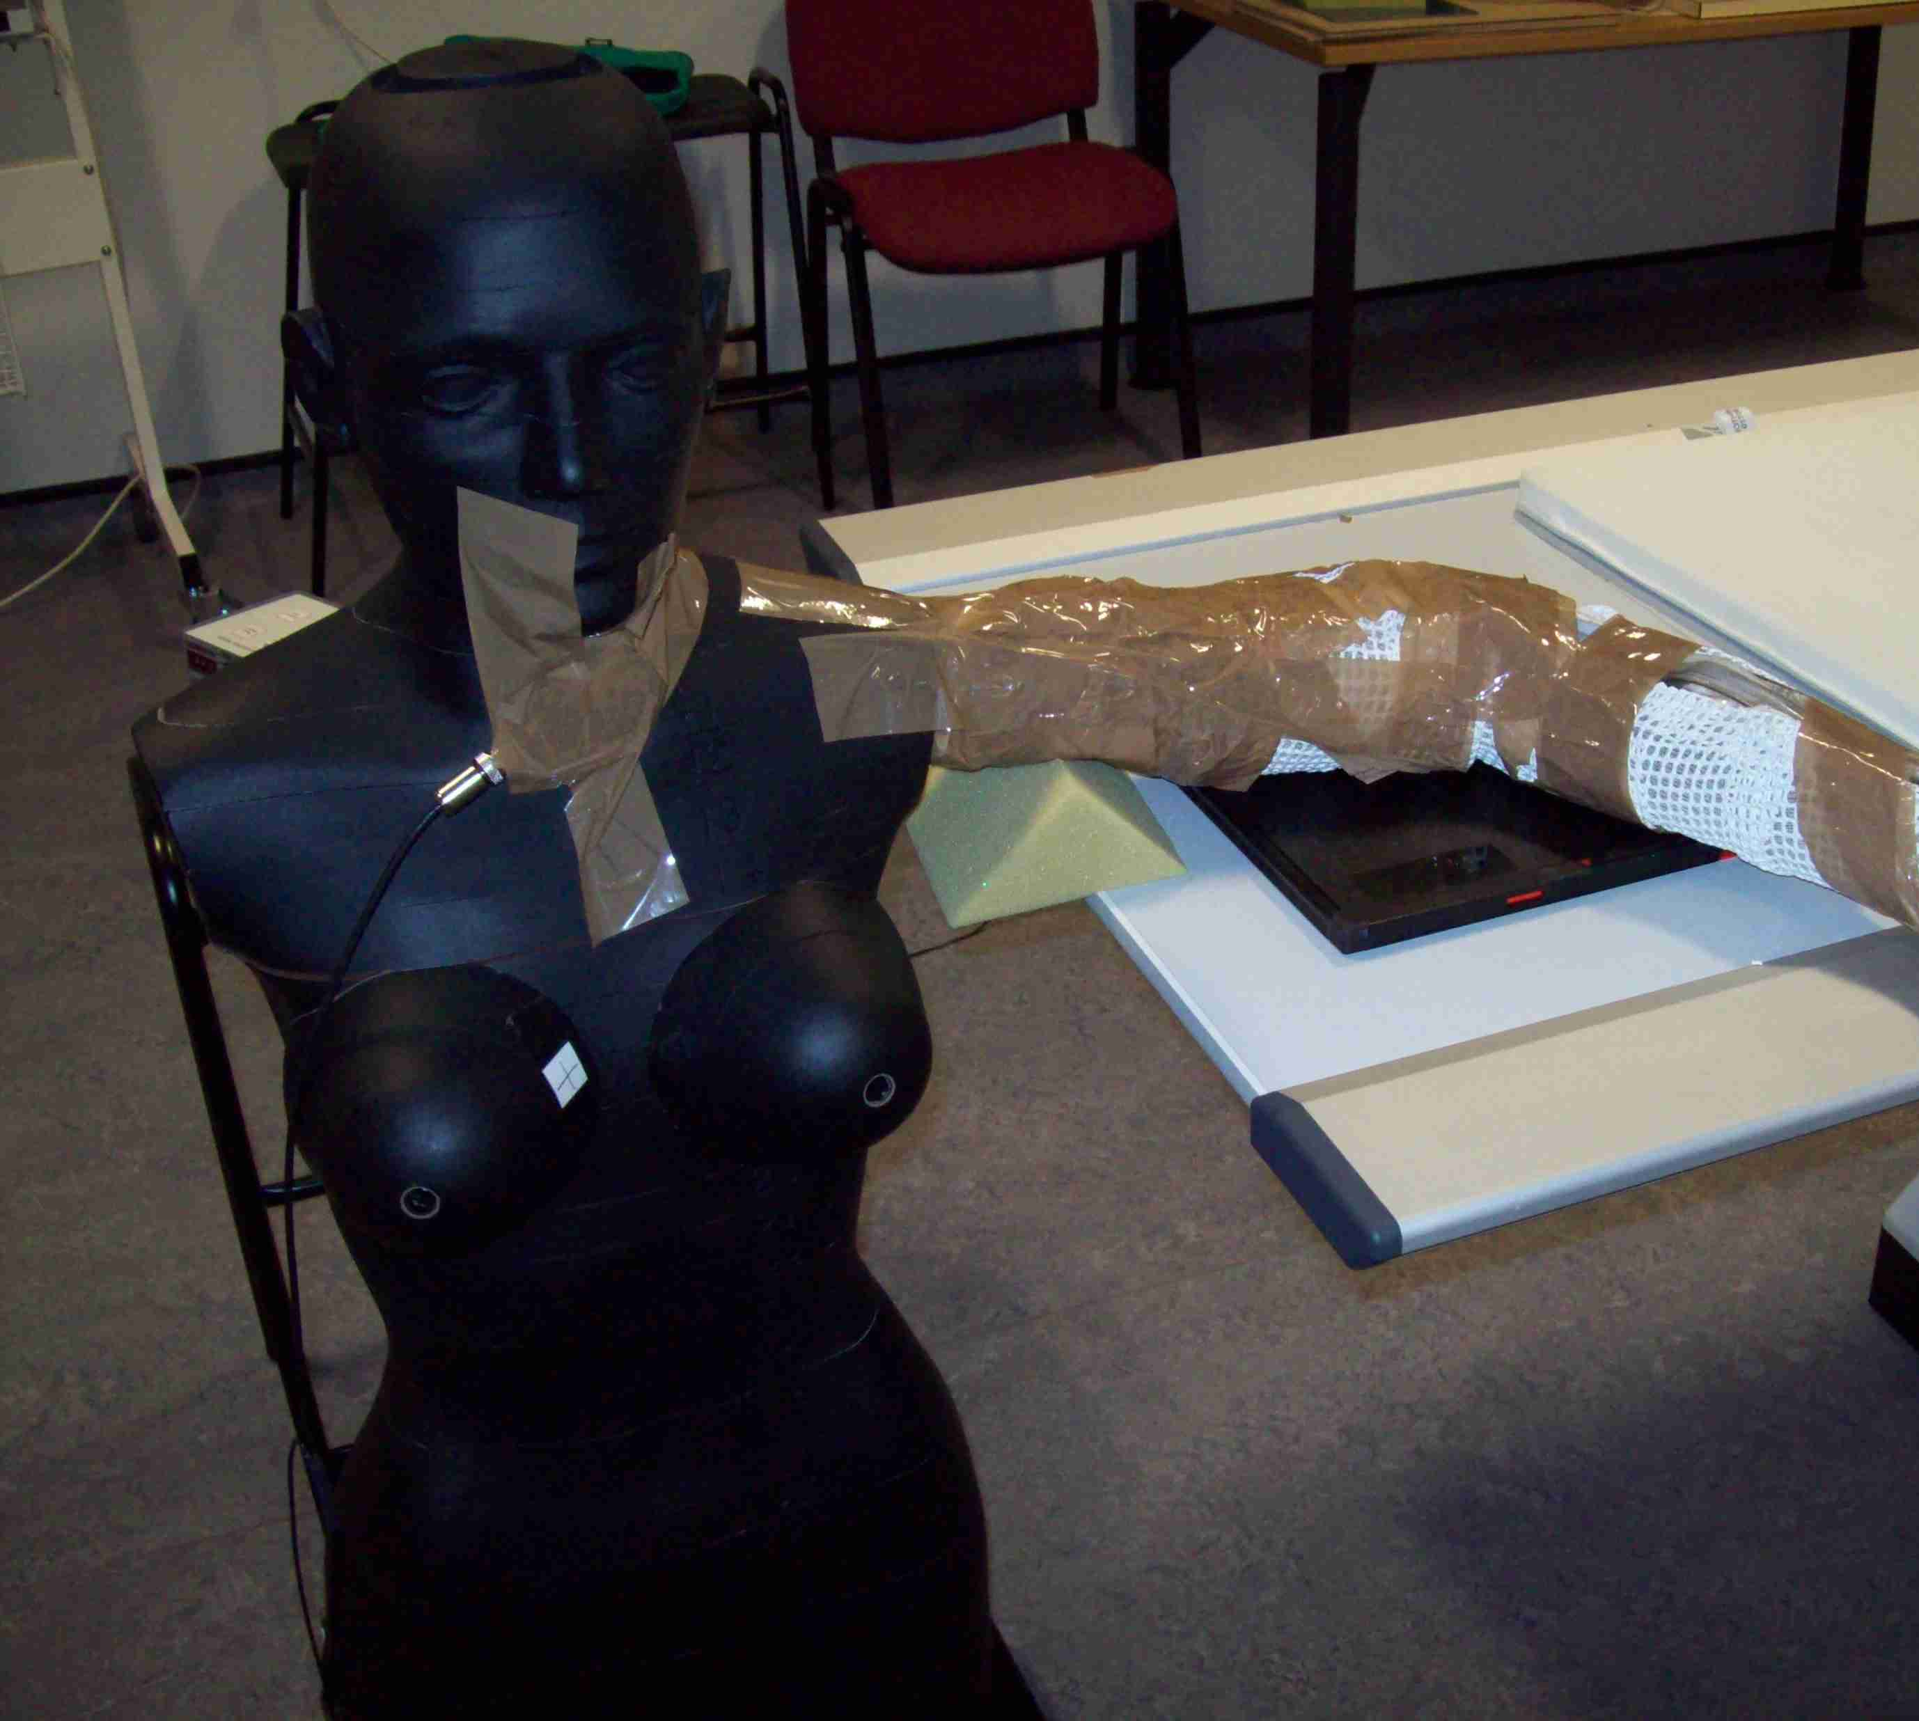  Image 1: Anthropomorphic phantom control experiment - positioning representing a patient attending a lateral elbow examination, without lead-rubber apron (0.35 mm). | 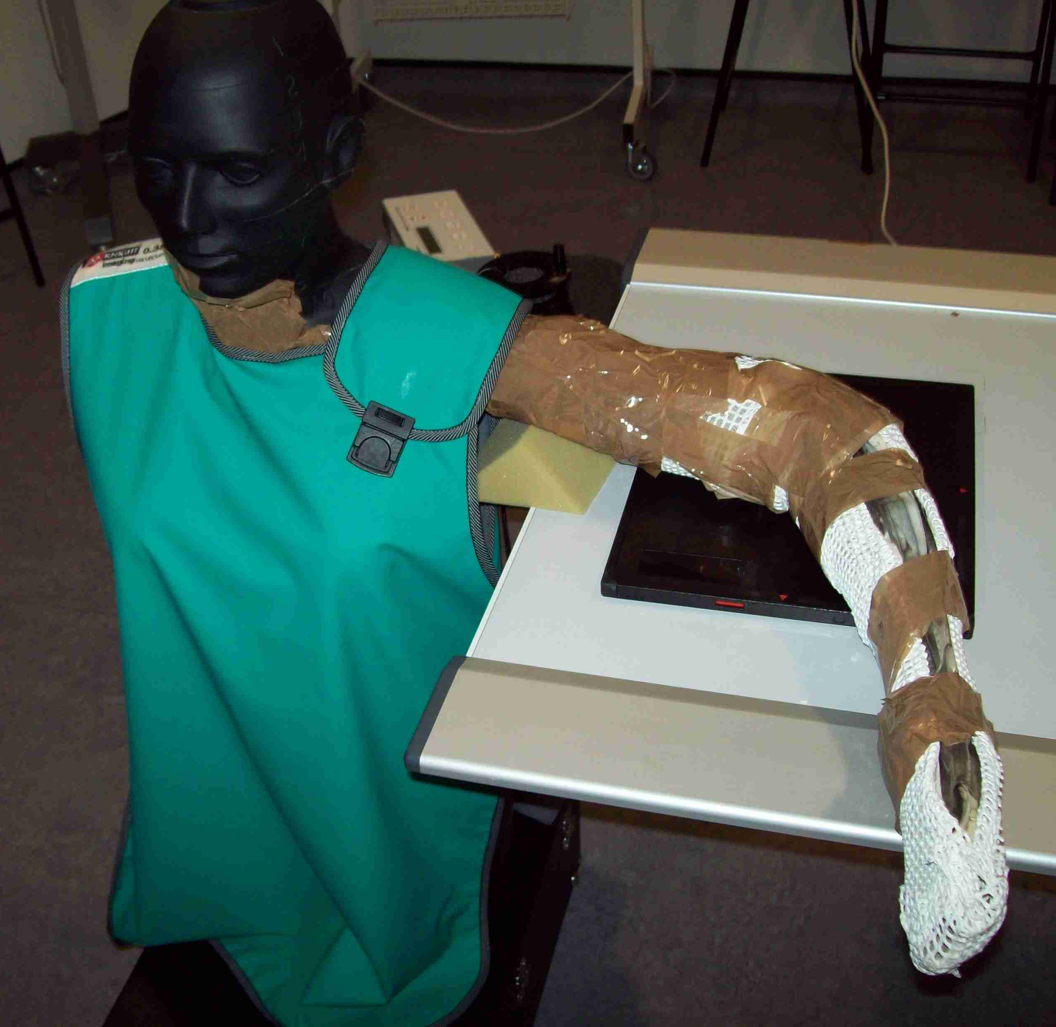  Image 2: Anthropomorphic phantom with lead-rubber apron (0.35 mm).
Image 3: Anthropomorphic phantom with lead-rubber apron (0.35mm) and lead-rubber thyroid collar (0.50 mm) for follow up experiment. | 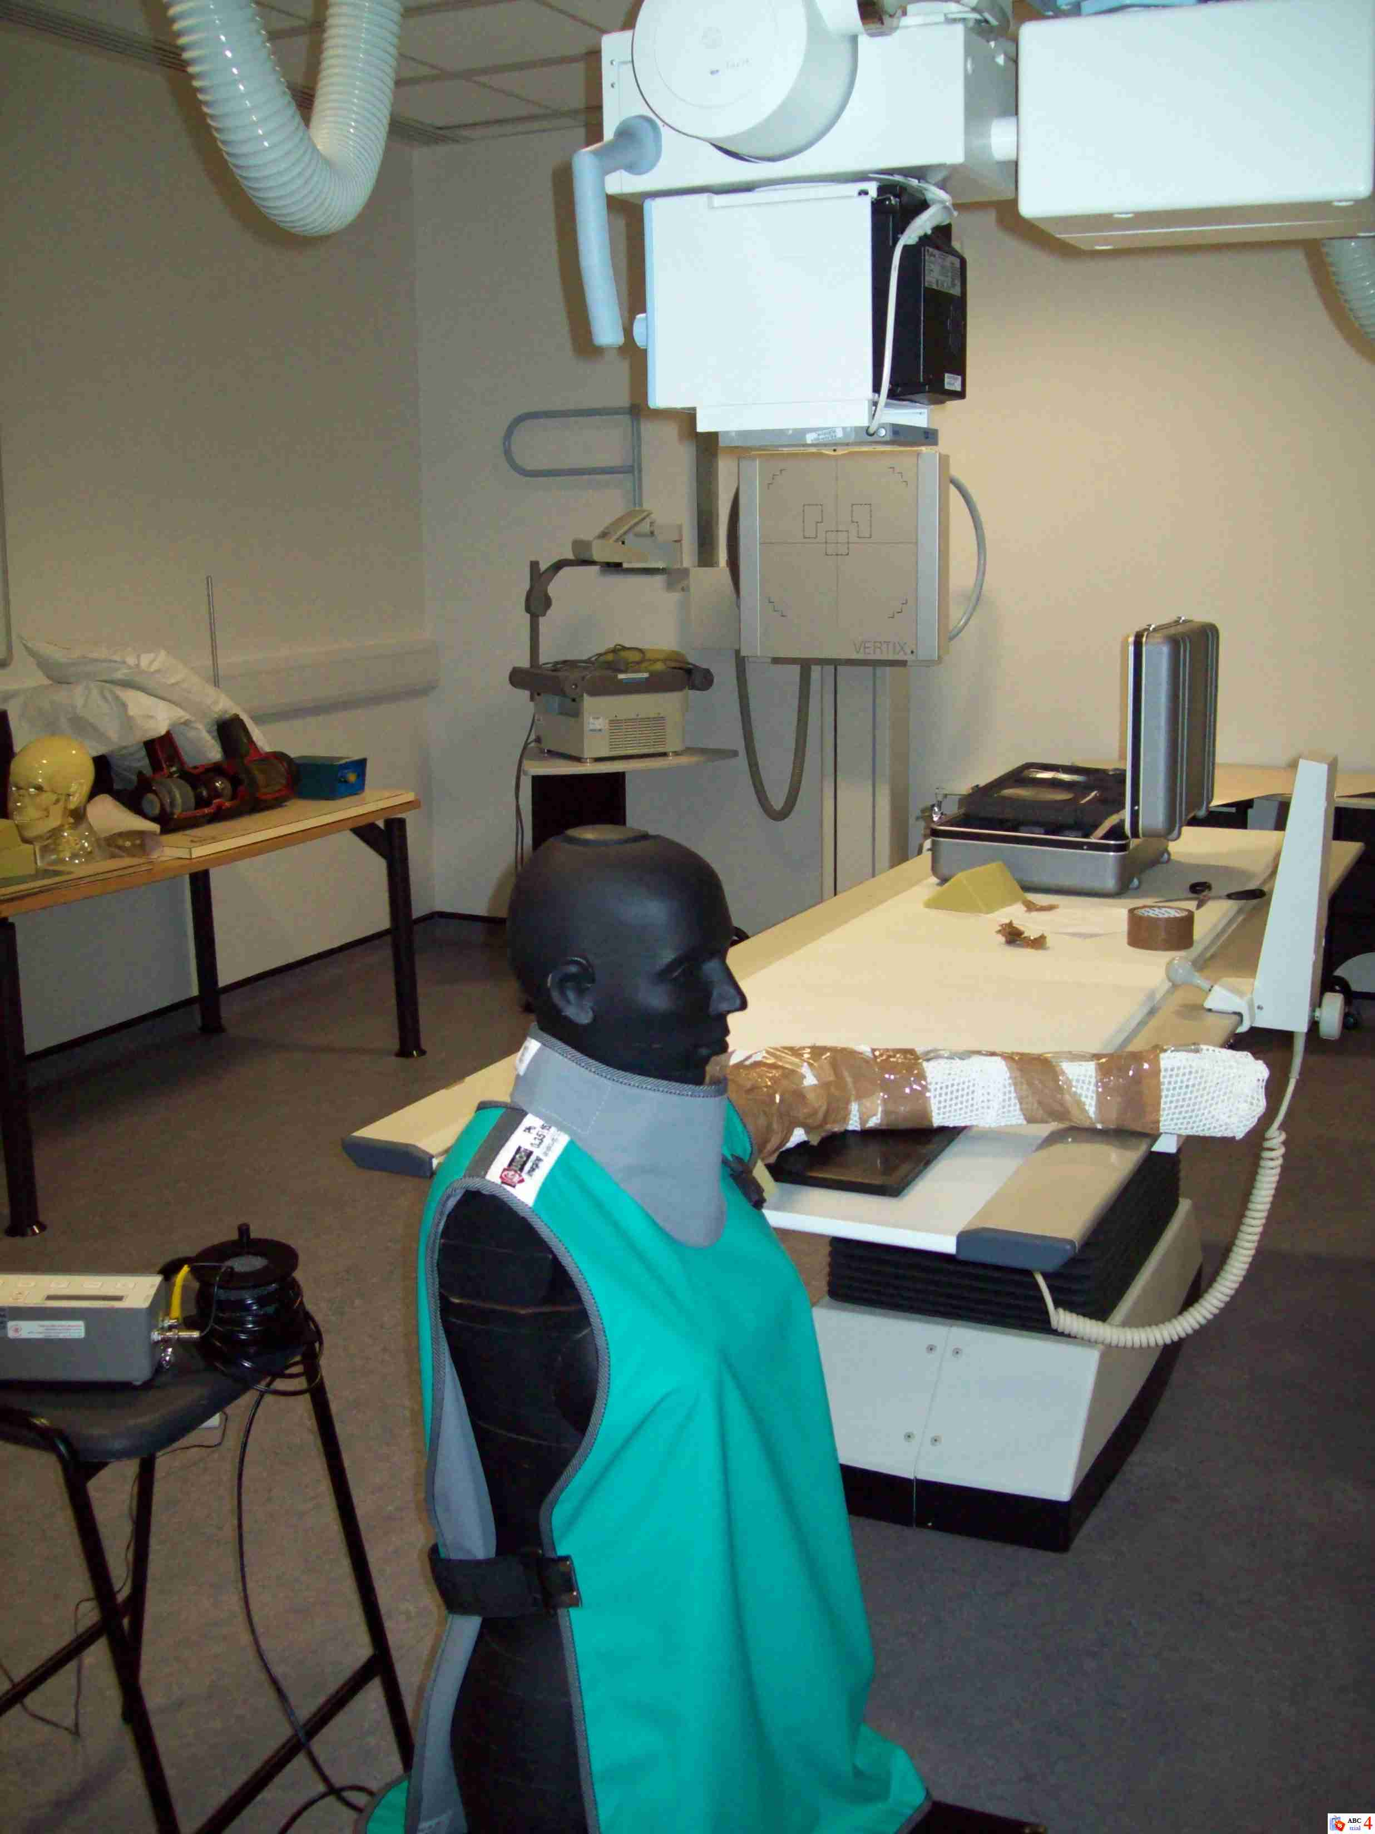

Radiographic parameters and recording of dose

Prior to undertaking the experiment the X-ray equipment underwent quality control checks, assessing both tube output and beam alignment. Upon completion and satisfaction in line with operational standards, the experiment began. Exposure rates (µGy/sec) were recorded with a 15cc ionisation chamber measuring the skin dose to the phantom. The 15cc ionisation chamber (model 10100 AT TRIAD) is a technologically advanced, microprocessor-controlled ionisation chamber and had been calibrated prior to undertaking the experiment. It was calibrated in accordance with European manufacturer specifications for a diagnostic unattenuated beam performed at the Fluke Biomedical, Radiation Management Services equivalent of DV70 (PTB defined as 70kVp, first HVL of 2.45 mm Al).¹⁵ The exposure accuracy of the device is ± 1% of reading ± 2 range resolution steps over a range of 18° to 28°C and ± 2% of reading ± 2 range resolution steps over the full operating temperature range of 0° to 50°C.¹¹ Exposure time accuracy is ± 0.1% of reading ± 0.2 msec.¹¹ Maximum exposure time is 6.5 seconds and measurement resolution is 0.2 msec. Due to the effective range of the ionisation chamber (1-20 µGy/sec), levels of ionising radiation remained undetected using a clinically relevant mAs (3.20 mAs).¹¹ This required an increase to the mAs value (63 mAs, 320 mAs and 560 mAs) to record exposure rates for radiosensitive organs in order to quantify the scattered radiation to the ionisation chamber, thus altering the overall intensity of the X-ray beam.¹¹ This is represented by equation 1.¹⁶

$I ∝mA$ (Equation 1)

A regression formula was later applied in order to obtain the corrected exposure rate, and undertaken methodologically as part of the wider study.¹¹ Other independent variables such as kVp (57), source to image distance (110cm) (SID), focal spot size (small), and field size (18 x 18 cm) remained constant throughout.

Figure 3: Pictorial examples of ionisation chamber placement during experiment

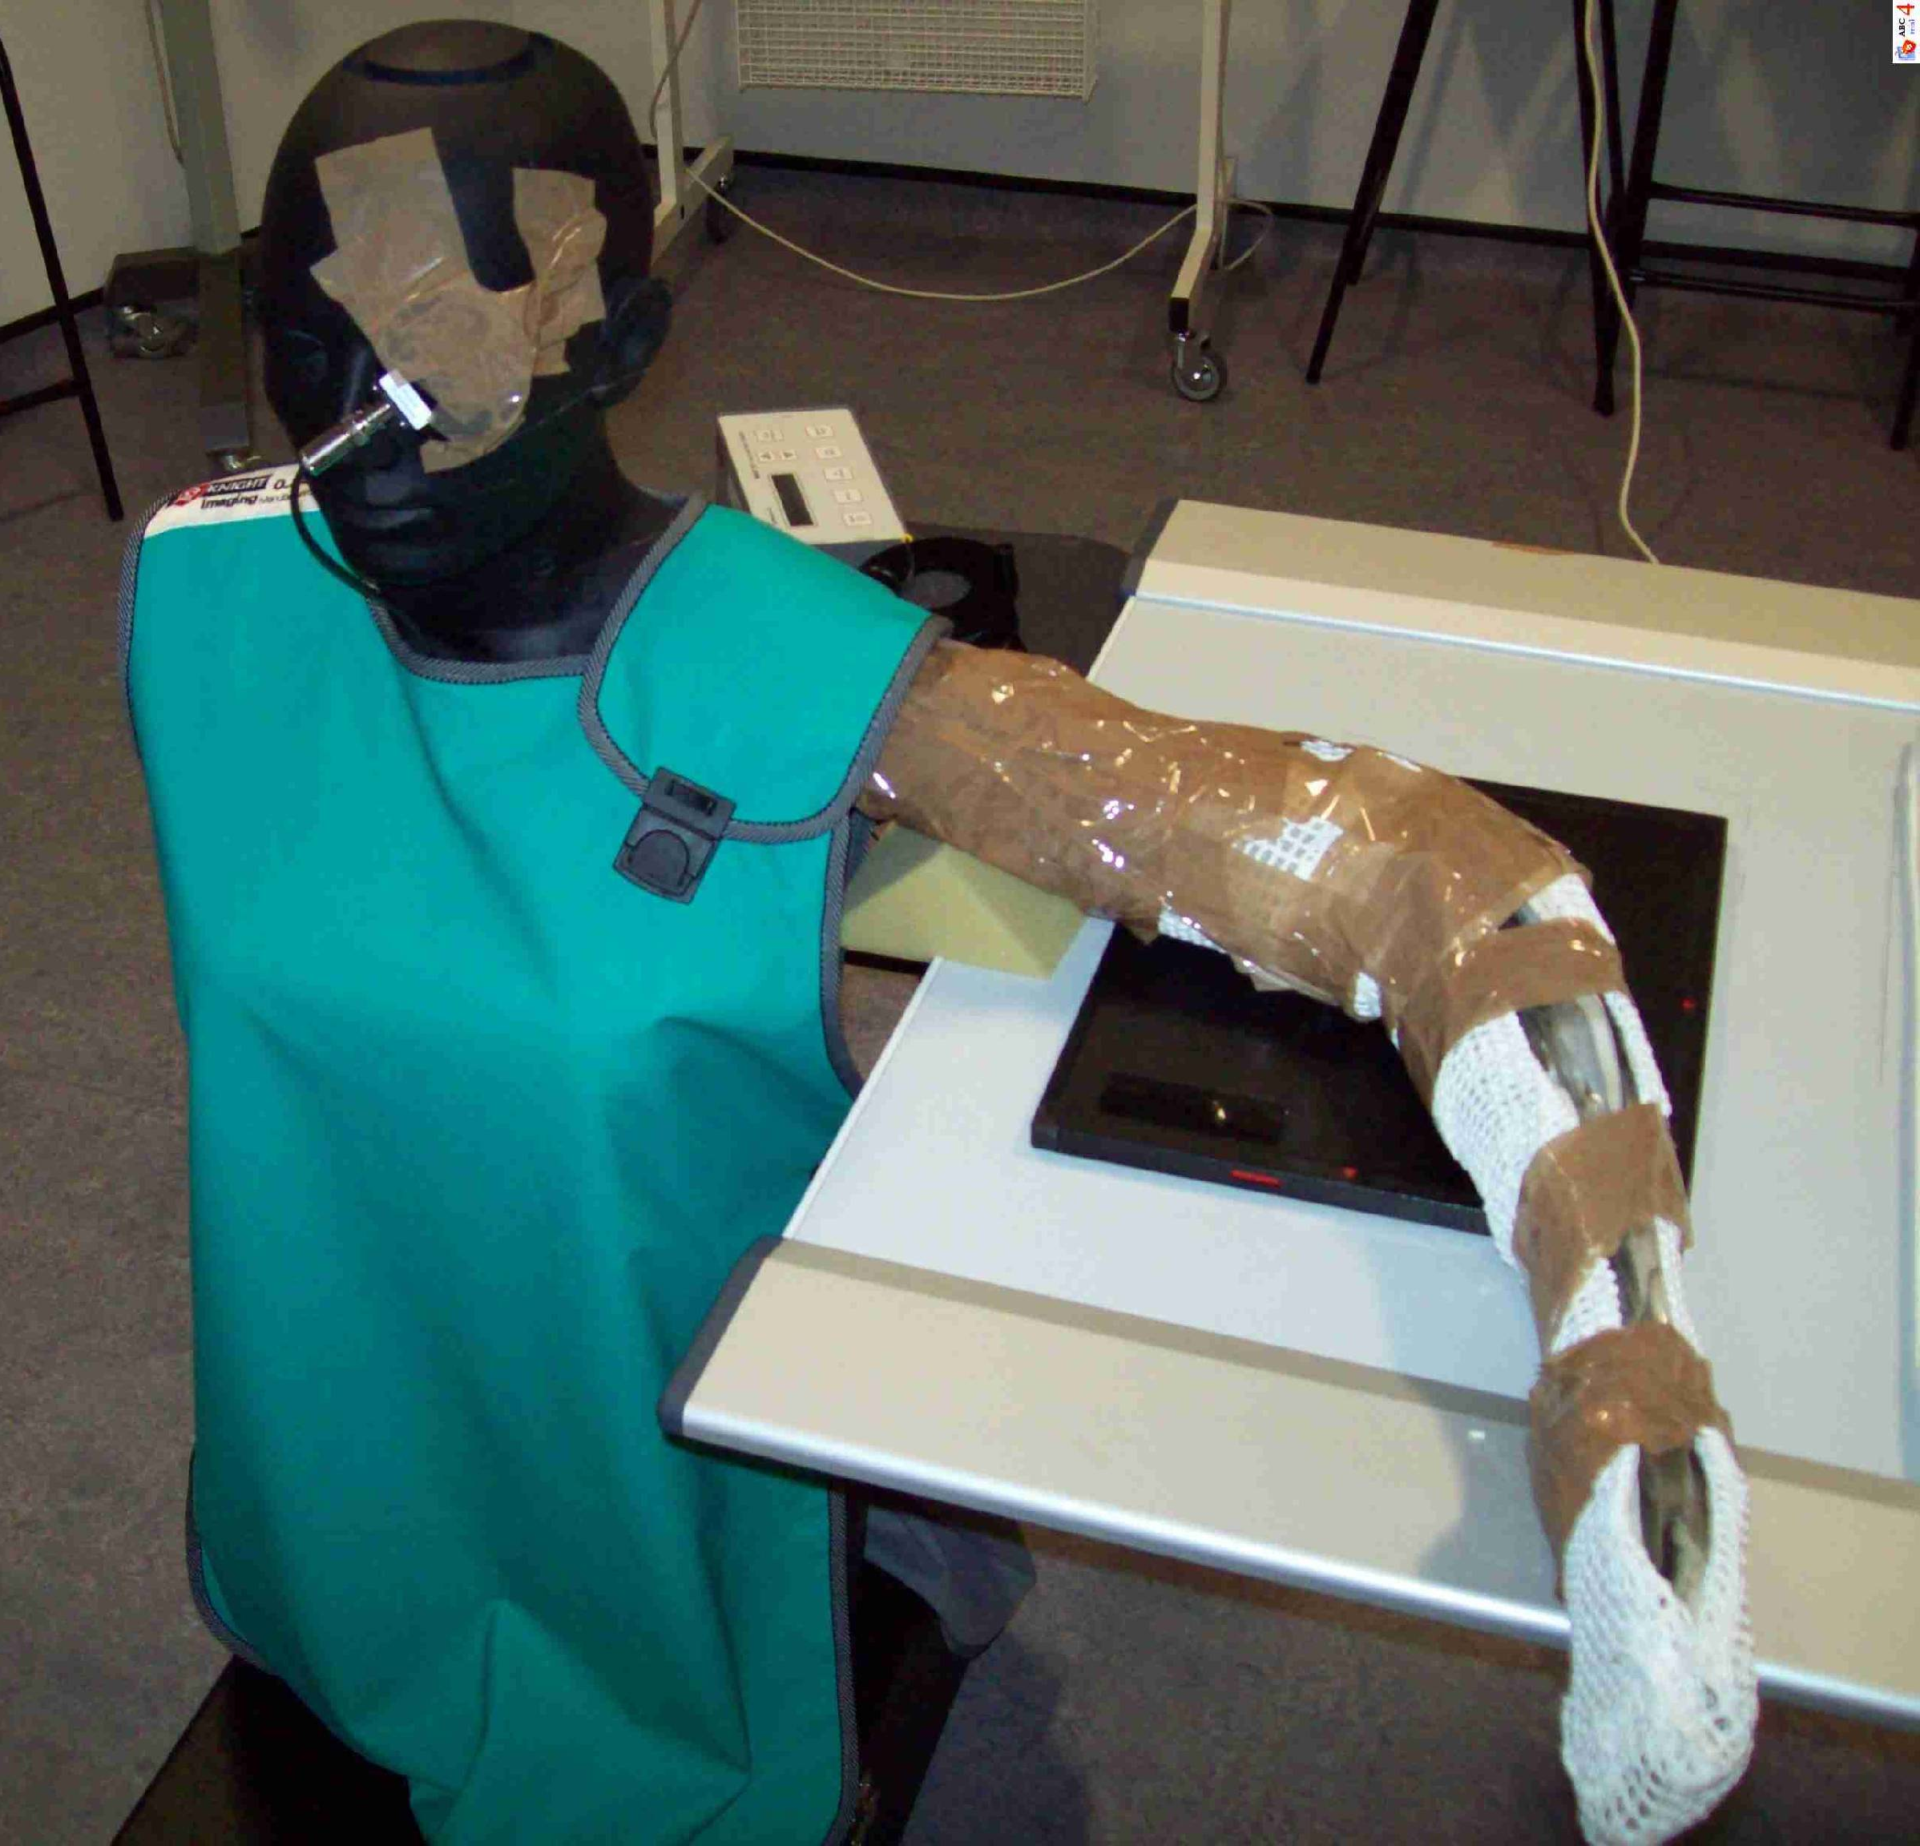 | 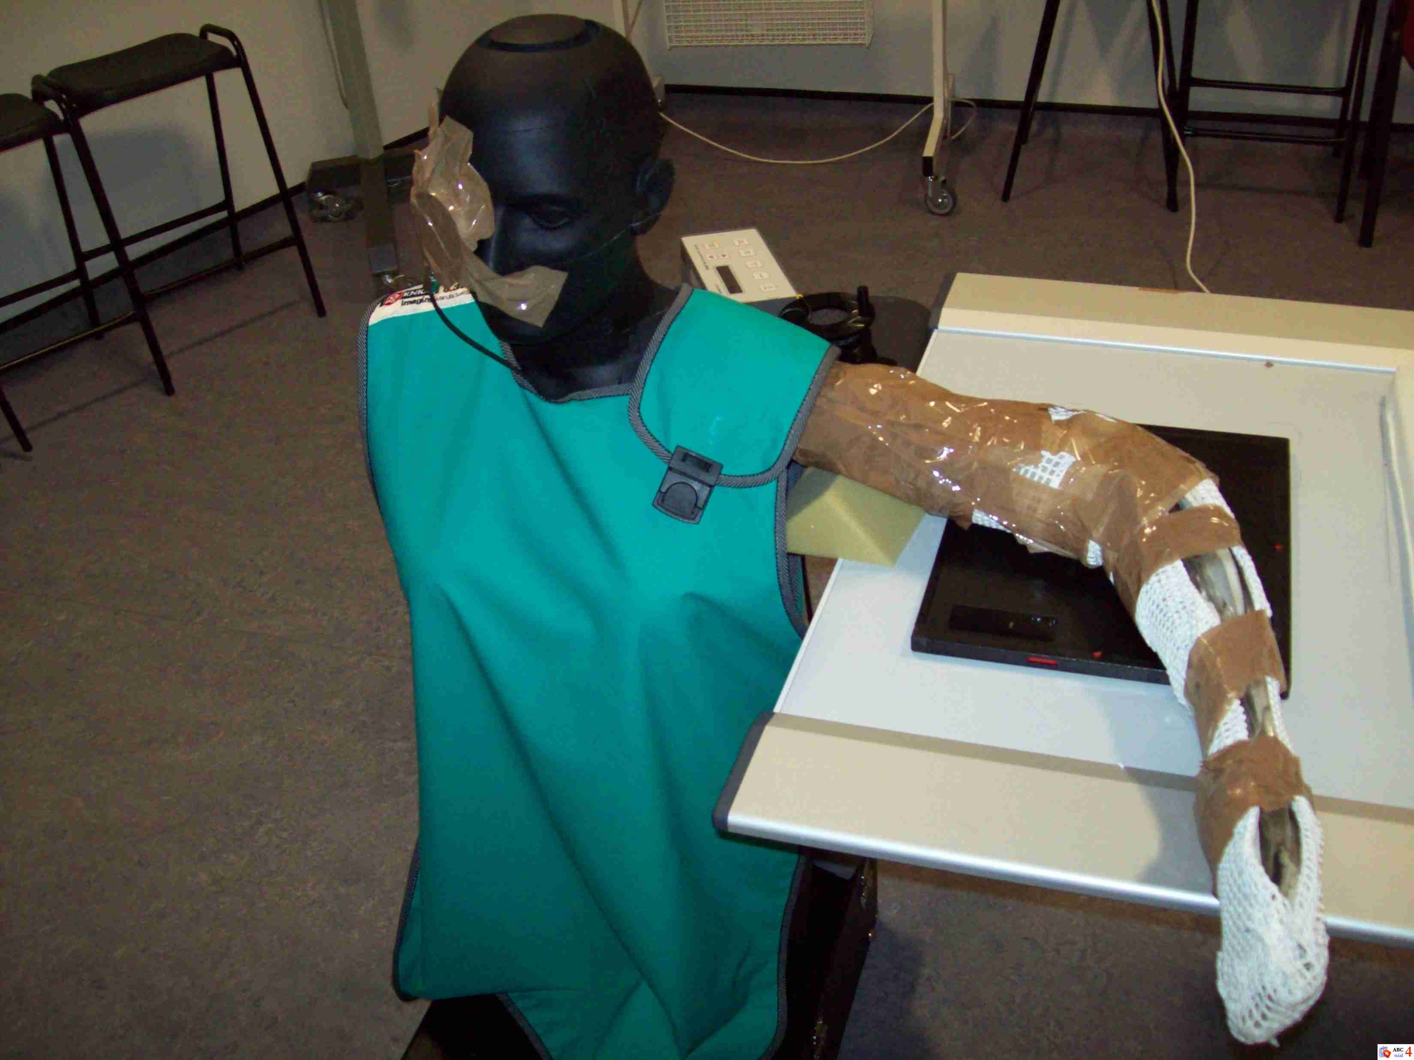
Left eye | Right eye | Thyroid

Upon selection of the lateral elbow examination, three consecutive exposures were made at the location of each radiosensitive organ. This was performed in order to minimise random error in the findings. This was important because recording multiple measurements enhanced the precision of dose output and thus decreased any uncertainty with the ionisation chamber, whilst improving statistical inferences. The observed mean dose value was corrected using the formula depicted in equation 2, which was later used for statistical analysis.

$Corrected mAs=\left(\frac{a}{b}\right)×c$ (Equation 2)

Where $a$ $=$mean of exposure rate (µGy/sec), $b$ $=$set mAs and $c$ $=$clinically relevant mAs (3.20 mAs).
Keeping a small focal spot size maintained consistency. The author(s) decided not to exceed 560 mAs in order to prevent the rotating X-ray tube from overheating. Placement of the ionisation chamber in some positions did not record any observable readings using 560 mAs thus deemed ‘below dosimeter threshold’. This is represented empirically by the value <0.0001 throughout this paper.

Statistical analysis

Pearson’s correlation and linear regression statistics were undertaken to support the correction of mean dose values, using the mathematical formula, as identified previously.¹¹ Statistics demonstrated strong correlation between observed and corrected mean dose values r(8) =.99, p < 0.001, supported with linear regression, strongly affirmed linearity β=.94, t(8) = 23.10, p < 0.001,¹¹ thus data extrapolated using the mathematical formula can be used to support discussions and conclusions in this paper. In addition, the data sets were tested, and confirmed for normality of distribution using the Kolmogorov-Smirnov test.
In addition to the aforementioned statistical outputs, a t-test was undertaken to calculate if dose limitation remained statistically significant between the controlled experiment and the utilisation of a lead-apron. By using the paired sample t-test this would suggest whether or not the lead-rubber could remain an appropriate method of dose limitation within the clinical environment for limiting dose to the radiosensitive organs.¹⁷ The t-test was undertaken to determine a p – value, indicating how likely the results were attributable to chance. However, due to an observed outlier (thyroid) the researchers deemed it necessary to add an additional variable to support or refute the observed scores. In response, a one way analysis of variance (ANOVA) was used in order to compare multiple means and enhance statistical output. By convention, if there is less than 5% (p < 0.05) chance of the observed differences, it is deemed statistically significant, which this study accepts.

Results

Exposure rates for each experiment are demonstrated in table 1, demonstrated by the mean (µGy) and corrected mean values (µGy). The corrected mean was later used for statistical analysis as this mathematically represented a clinically relevant exposure of 3.20 mAs.

Table 1: Mean exposure rate (µGy/sec) for experiments one, two and three
No lead-rubber protection (control) |  |  |  | Lead-rubber apron (0.35mm) |  |  | Lead-rubber apron (0.35mm) and lead-rubber thyroid (0.5mm)
Radiosensitive Organ | Mean (µGy) | Corrected Mean (µGy) | SD | Mean (µGy) | Corrected Mean  (µGy) | SD | Mean  (µGy) | Corrected Mean  (µGy) | SD
Left eye | 7.2966 | 0.3706 | 0.0058 | 6.9866 | 0.3548 | 0.0642 | 6.9600 | 0.3535 | 0.0435
Right eye | 2.8266 | 0.1436 | 0.0231 | 2.2266 | 0.1131 | 0.0152 | 2.2200 | 0.1127 | 0.0173
Thyroid | 2.7466 | 0.1395 | 0.0208 | 3.4133 | 0.1733 | 0.0305 | 1.9000 | 0.0190 | 0.0264
Left Breast | 7.1500 | 0.3632 | 0.0556 | 0.8333 | 0.0083 | 0.0152 | 0.8466 | 0.0084 | 0.0115
Right Breast | 2.5700 | 0.1305 | 0.0300 | <0.0001 | <0.0001 | n/a | <0.0001 | <0.0001 | n/a
Spleen | 1.1033 | 0.0560 | 0.0115 | 2.6233 | 0.0262 | 0.0305 | 2.5933 | 0.0259 | 0.0305
Testes | 0.7466 | 0.0075 | 0.0115 | <0.000 | <0.0001 | n/a | <0.0001 | <0.0001 | n/a
Left Ovary | 0.9766 | 0.0056 | 0.0057 | 0.0266 | 0.0001 | 0.0461 | <0.0001 | <0.0001 | n/a
Right Ovary | <0.0001 | <0.0001 | n/a | <0.0001 | <0.0001 | n/a | <0.0001 | <0.0001 | n/a

The corrected mean values and percentage different between exposure rates (µGy/sec) to radiosensitive organs with an apron and thyroid are shown in table 2, which were used for statistical analysis. It is important to highlight that whilst the mean (µGy) value for the spleen appears to have increased upon placement of the lead-apron, this was due to increasing the mAs in order to observe a dosimeter reading.¹¹ For example, an observed reading on the dosimeter was achieve using 63mAs for no lead-rubber placement, yet upon placement of the lead-rubber apron, 320mAs was utilised in order to demonstrate a reading. As outlined above, it was decided not to exceed 560mAs in order to protect the X-ray tube. Whilst important, this figure does not impact on the overall findings of this study because the mathematical formula mitigates the increase to mAs and regresses back to a clinically relevant exposure, as outlined previously.¹¹ The values demonstrate mean data with each lead garment, supported with observed differences. The quantified data suggests that dose limitation was generally achieved to radiosensitive organs. However, one outliner was observed. The thyroid achieved a greater dose of 20% upon wearing a lead apron in this study. Importantly, 98% and 99% reductions were achieved to the left and right breasts respectively and interestingly 4% and 21% to the left and right eyes respectively, whilst not directly covered. Because of the observed outlier it was deem necessary to introduce a second variable, a thyroid collar and repeat the X-ray experiment. In response, dose to the thyroid reduced (and when compared to the lead apron, by 89%). Whilst other radiosensitive organs demonstrate minimal dose limitation it remains important in accordance with the LNT dose response model.

Table 2: Corrective mean dose to radiosensitive organs (µGy)
Body Part | No lead | Diff. (%)  No Lead vs. Lead Apron | Lead Apron | Diff. (%)  Lead Apron vs. Lead Apron and thyroid | Lead apron and thyroid
Left Eye | 0.3706 | -4% | 0.3548 | +0.64% | 0.3535
Right Eye | 0.1436 | -21% | 0.1131 | -0.46% | 0.1127
Thyroid | 0.1395 | +20% | 0.1733 | -89% | 0.0190
Left Breast | 0.3632 | -98% | 0.0083 | +1.2% | 0.0084
Right Breast | 0.1305 | -99.9% | <0.0001 | n/a | <0.0001
Spleen | 0.0560 | -99.9% | 0.0262 | -1.2% | 0.0259
Testes | 0.0075 | -99% | <0.0001 | n/a | <0.0001
Left Ovary | 0.0056 | -64% | <0.0001 | n/a | <0.0001
Right Ovary | <0.0001 | n/a | <0.0001 | n/a | <0.0001

As outlined in table 2, the data offers paradoxical findings whereby ionising radiation was reduced to the eyes, breasts, spleen, testes and ovaries, but increased to the thyroid upon placement of a lead-rubber apron alone. Data sets were tested and confirmed for normality of distribution using the Kolmogorov-Smirnov test (p = 0.03). Parametric paired sample t-test was undertaken in order to compare the sum of dose data collected and then averaged.
Parametric t-tests were undertaken in order to examine the significance of dose limitation to radiosensitive organs upon placement of a lead-apron. The t-test demonstrated no significance of upon placement of the lead apron when compared to the control (t = 1.52, df = 7, p = 0.171) and is presented in table 5.

Table 5: t-test: Paired sample of mean scores
 | n | Mean (µGy) | SD | df | t-stat | CI range (95%) | p value
No Pb Protection | 8 | 0.67 | 0.44 | 7 | 1.527 | -0.037 ± 0.172 | 0.171
Pb Apron (0.35mm)

As outlined above, the first author decided to repeat the experiment but implement an additional variable, a thyroid protector (0.50mm). A one-way analysis of variance (ANOVA) was then used to compare the means of each and examine the variances between the mean group scores. Upon analysis it demonstrated high significance F(5,2) = 97.824, p = 0.010 when compared with both control and implementation of the thyroid protector.

Discussion

Inadvertent increasing dose to the thyroid upon wearing a lead-rubber apron

Lead-aprons are generally expected to limit ionizing radiation to radiosensitive organs when worn, as outlined in the literature. For example, lead aprons of 0.25 – 0.5 mm thickness have been cited to attenuate over 90% and 99% of radiation dose, respectively.¹⁸ Further, Simon found the transmission of radiation ranged from 2.9-7.6% for 0.25mm lead and 0.4-2.2% for 0.5 mm lead,¹⁹ which has been supported by others.²⁰ On the contrary, however, other studies have reported higher rates of transmission ranging between 20-35% for 0.25 mm lead aprons.^{21, 22} There is also the potential for ionizing radiation to increase, if lead aprons are not worn appropriately. For example, the National Council on Radiation Protection (NRCP)²³ reports of one example whereby loosely fitted lead aprons were shown to increase ionizing radiation to the breast. This highlights that whilst lead aprons are widely accepted to limit doses to humans, a risk of increasing dose does remain. Further, whilst dose reduction for most radiosensitive organs was observed, the thyroid demonstrated a 20% increase and could therefore be attributed as ‘secondary scatter’. This is important to consider for two reasons. First, thyroid garments are generally unavailable within the general X-ray room, and are typically worn in theatre and interventional environments. If a patient requests a lead apron for a left lateral radiographic examination of the elbow (in anticipation it will limit their exposure) there is a strong possibility that dose to a patient’s thyroid will increase. Second, this finding builds on from a previous qualitative study whereby some radiographers were reluctant to use lead-rubber in their day-to-day practices due to uncertainty surrounding radiation that could become ‘trapped’ and thus increase doses to patients.^{12 (p.16)} This small, but relevant experiment provides empiricism supporting this conjecture whereby lead-rubber may not always protect all radiosensitive organs if the appropriate protection method is not used. Further, whilst dose limitation is generally possible when using lead-aprons in practice, if used alone during a left lateral examination of the elbow it may increase ionising radiation to the thyroid upon exposure. Mitigating this risk was achieved with the placement of a lead-rubber thyroid garment.
It is important to recognize that this study examines one radiographic protection (out of a potential many) thus caution and further experimentation should be undertaken in order to support or refute the findings presented here. Further, it is problematic to generalise these findings to all patients that sit for other radiographic projections due to the variability in attenuation for different radiographic examinations.

Direction of secondary radiation scatter

Empirical studies exploring the direction of scattered ionizing for general radiographic examinations are limited, yet it is generally accepted that scattered ionizing radiation exists within the X-ray room whereby secondary scatter is reemitted from within the patient.^{24 (p.11)} The World Health Organization²⁴ reaffirms this whereby primary and secondary radiation has the ability to scatter through ceilings, floors and thin walls when no protective barriers are employed. In addition, they demonstrate the interactions within a patient and the likelihood of secondary radiation emitting in various directions upon interaction.^{24 (p.16)} In response, this study provides insight into the direction of secondary radiation during a left lateral radiographic examination of the elbow. Two aspects stand out. First, upon placement of the lead apron the data identifies dose reduction to the left and right eyes, 4% and 21%, respectively when using the lead-rubber apron. This highlights that secondary radiation emitting from the lateral elbow examination is not only directed towards the patient and to other radiosensitive organs, but also becomes attenuated by the lead-apron limiting doses to left and right eyes respectively. Second, whilst this experiment replicated an elbow examination of the left elbow, greater dose reduction was achieved to the opposite side of the phantom upon placement of the lead-rubber apron suggesting that attenuation is greater to the opposite side of the patient.
It is important to recognize here that this study explored secondary scatter for a patient in a conventional sitting position, as depicted within the radiographic literature.¹⁴ There is an argument, however, that the attenuation of secondary scattered ionizing radiation could be limited with the patient simply rotating their head laterally 90° (away from the primary beam). This was not explored within this paper but does offer an opportunity for prospective researchers and highlights the potential for alternate patient positioning in order to limit ionizing radiation. Further, the authors would like to recognize that there are alternate lead apron designs that can be purchased, which may overlap the lateral area of the abdomen. These lead-rubber aprons were unavailable to the researchers at the time of this experiment, but central to overarching discussions in order to critically examine the effects of lead-rubber aprons in the clinical setting.
The direction of scatter, then, remains an additional finding in this study whereby secondary, as well as primary radiation is being limited by the lead apron (even when not directly covered, strengthening its use in the clinical environment. It is important to remind readers that this study should be observed with caution and not generalised. The authors encourage further research in other projections in order to build a sound evidence based on the scattered ionising radiation to patients undergoing general radiographic examinations.

Conclusion
The quantification of scattered ionising radiation to radiosensitive organs during a left lateral elbow examination has been explored using a female phantom and simulated arm construction. Under these conditions, statistical analysis demonstrated that whilst doses can be limited using a lead-rubber apron, there is a potential for increasing dose to the thyroid (p = 0.01). Implementation of a thyroid collar, however, mitigates this risk as observed in this experiment. This study offers original insight by not only examining dose limitation and increases upon using a lead-apron and thyroid collar, it also provides insight into the direction of radiation scatter for an examination which remains in close proximity to radiosensitive organs. It is hoped that this paper will generate further discussion around the application of lead protection in the general X-ray environment.

Conflict of interest

None.

References

- International Atomic Energy Agency. Radiation Protection for Patients. [Online] Available from: https://rpop.iaea.org/RPOP/RPoP/Content/InformationFor/HealthProfessionals/4_InterventionalRadiology/fluoroscopy-operating-theatres/fluoroscopy-patient-protection.htm#FULP-FAQ10 (Accessed: 7th July 2016).
- The Ionising Radiation (Medical Exposure) Regulations. [Online] Available from: https://www.gov.uk/government/publications/the-ionising-radiation-medical-exposure-regulations-2000 (Accessed: 8th July 2016).
- Mekis N, Dejan Z, Skrk D. The effect of breast shielding during lumbar spine radiography. Radiology and Oncology. 2013; 47(1):26-31.
- Mekis, N, McEntree, MF, Stegnar, P. PA positioning significantly reduces testicular dose during sacroiliac joint radiography. Radiography. 2010;16:333–338.
- Fung KK, Gilboy WB. The effect of beam tube potential variation on gonad dose to patients during chest radiography investigated using high sensitivity LiF: Mg, Cu, P thermoluminescent dosemeters. British Journal of Radiology. 2001; 74(880): 358-67.
- Guo H, Lui WY, He XY, Zhou XS, Zeng Ql, Li BY. Optimizing image quality and radiation dose by the age-dependent setting of tube voltage in pedatric chest digital radiography. Korean Journal of Radiology. 2013; 14(1):126-131.
- Hamer OW, Volk M, Zorger N, Borisch I, Buttner R, Feuerbach S, Strotzer M. Contrast-detail phantom study for X-ray spectrum optimization regarding chest radiography using a cesium iodide-amorphous silicon flat-panel detector. Investigative Radiology. 2004; 39(10):610-618.
- Johansen S., Hauge IHR., Hogg P., England A., Lanca L., Gunn C and Sanderud A. Are Antimony-Bismuth Aprons as Efficient as Lead Rubber Aprongs in Providing Shielding again Scattered Radiation. Journal of Medical Imaging and Radiation Sciences. 2018; 49:201-206.
- Hubbert TE., Vucich JJ., Armstrong MR. Lightweight aprons for protection against scattered radiation during fluoroscopy. Am J Roentgenol; 1993; 161:1079-81.
- ICRP. The 2007 recommendations of the International Commission on Radiological Protection. ICRP Publication 103; 2007. Ann. ICRP (37) 2-4.
- Hayre C, Bungay H, Jeffery C, Cobb C, Atutornu A. Can placing lead-rubber inferolateral to the light beam diaphragm limit ionising radiation to multiple radiosensitive organs? Radiography. 2017; 24(1):15-21.
- Hayre CM, Blackman S, Carlton K, Eyden A. Attitudes and perceptions of radiographers applying lead (Pb) protection in general radiography: An ethnographic study. 2018; 24(1):e13-e18.
- Williams L, Adams C. Computed tomography of the head: An experimental study to investigate the effectiveness of lead shielding during three scanning protocols. Radiography. 2006; 12(2):143-152.
- Whitely CS, Sloane C, Hoadley G, Moore AD, Alsop CW. Clark’s Positioning in Radiography. 12th Edn. London: Hodder Arnold; 2005.
- Fluke Biomedical. 10100AT TRIADTM TnT Field Service Kit Operators Manual. Manual No.38651 Rev.1; 2005.
- Graham DT, Cloke P. Principles of Radiological Physics. 4th Edn, London: Churchill Livingstone; 2006.
- Langdridge D, Hagger-Johnson G. Introduction to Research Methods and Data Analysis in Psychology. Harrow: Prentice Hall; 2009.
- Bushberg, JT., Seibert JA., Leidholdt EMJ., Boone JM. The essential physics of medical imaging, Williams and Wilkins, Baltimore, 1994.
- Simon, SL. Organ-specific external dose coefficients and protective apron transmission factors for historical dose reconstruction for medical personnel. Health Physics. 101 (1), pp.13-27; 2011.
- Christodoulou EG., Goodsitt MM., Larson SC., Darner KL., Satti J., Chan HP. Evaluation of the transmitted exposure through lead equivalent aprons used in the radiology department, including the contribution from backscatter. Med Phys. 30 (6); 1033-1038; 2003.
- Lyra M., Charalambatou P., Sotiropoulos M., Diamantopoulos S. Radiation protection of staff in 111in radionuclide therapy – is the lead apron shielding effective? Radiation Protection Dosimetry. 147 (1-2); 272-276; 1991.
- McGuire EL., Baker ML., Vandergrift JF. Evaluation of radiation exposures to personnel in fluoroscopic X-ray facilities. Health Physics. 45 (5); 975-980 (1983).
- National Council on Radiation Protection and Measurements (2012) Radiation dose management for fluoroscopically-guided interventional medical procedures. NCRP report 168. Bethesda (MD), National Council on Radiation Protection and Measurements.
- World Health Organisation. Basics of radiation protection – How to achieve ALARA: Working tips and guidelines. WHO: Geneva; 2004.

