Dark Classics in Chemical Neuroscience: An Evidence-Based Review of Belladonna
Vimal K Maurya^{1#}, Swatantra Kumar^{1#}, Russell Kabir², Gaurav Shrivastava³, Karuna Shanker⁴, Debadatta Nayak⁵, Anil Khurana⁵, Raj K Manchanda⁵, Srinivasulu Gadugu⁶, Sujita K Kar⁷, Anoop K Verma⁸, Shailendra K Saxena¹,^{9#*}
¹Centre for Advance Research, Faculty of Medicine, King George’s Medical University, Lucknow 226003, India.
²School of Allied Health, Faculty of Health, Education, Medicine, and Social Care, Anglia Ruskin University, Chelmsford CM1 1SQ, United Kingdom.
³National Institute of Allergy and Infectious Diseases, National Institutes of Health, Rockville, Maryland 20852, USA.
⁴CSIR-Central Institute of Medicinal and Aromatic Plants, Lucknow 226015, India.
⁵CCRH, Ministry of Ayush, Government of India, New Delhi 110058, India.
⁶Department of Medicine, JSPS Government Medical College, Hyderabad 500013, India.
⁷Department of Psychiatry, King George’s Medical University, Lucknow 226003, India.
⁸Department of Forensic Medicine and Toxicology, King George’s Medical University, Lucknow 226003, India.
⁹CSIR-Centre for Cellular and Molecular Biology, Hyderabad 500007, India.
#Contributed equally as first author
KEYWORDS: Atropine, Belladonna, Tropane Alkaloids, Toxicity, Safety, efficacy, Pharmacotherapeutic.
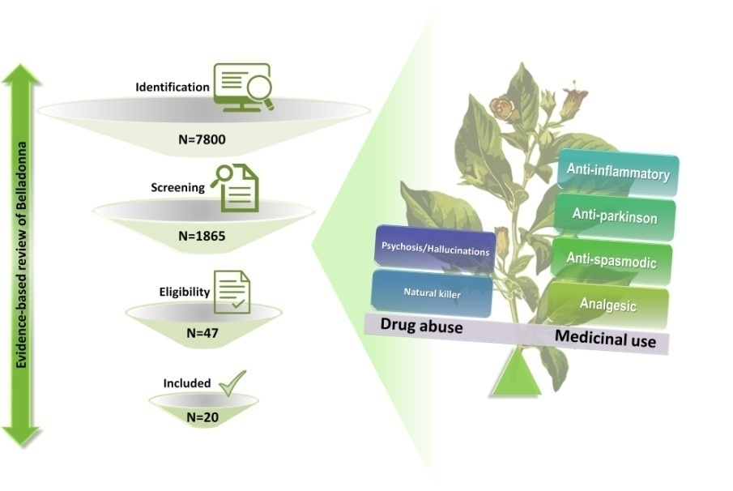
ABSTRACT: Belladonna has diverse pharmacotherapeutic properties with shadowy history of beauty, life, and death. Alkaloids present in belladonna have anti-inflammatory, anticholinergic, antispasmodic, mydriatic, analgesic, anticonvulsant, antimicrobial, which makes it widely applicable for the treatment of various diseases. However, due to its associated toxicity, the medicinal use of belladonna is debatable. Therefore, an evidence-based systematic review was planned to elucidate the pharmacotherapeutic potential of belladonna. A comprehensive literature search was performed in PubMed, MEDLINE, Cochrane database, Embase, and ClinicalTrial.gov using keywords ‘belladonna’ or ‘belladonna and clinical trials’ or ‘safety and efficacy of belladonna’. Articles published from 1965 to 2020, showing the efficacy of belladonna in diverse clinical conditions were included. The quality of evidence was generated using GRADE approach and twenty studies involving 2302 patients were included for the systematic review. Our analyses suggest that belladonna treatment appears to be safe and effective in various disease conditions including acute encephalitis syndrome, urethral stent pain, myocardial ischemia injury, airway obstructions during sleep in infants, climacteric complaints, irritable bowel syndrome, and throbbing headache. However, the better understanding of the dosage, toxicity of tropane alkaloids of belladonna could make it efficient remedy for treating diverse medical conditions.

1. INTRODUCTION
Belladonna is a perennial herbaceous plant with a shadowy history of beauty, life, and death. The plant is commonly known as deadly nightshade or belladonna, devils herb, naughty man’s cherries, poison black cherry, dwayberry, devil’s cherries, dwale, divale, Cro.velebilje, bun, bunika and gray morel.^{1,2} Belladonna taxonomically classified in the family Solanaceae which includes potatoes, tomatoes, eggplants and more. The scientific name of belladonna is Atropa belladonna. The genus Atropa comprises of four species with typical five-lobed flowers and alternate leaves. The plant species are cultivated worldwide but mainly inhabitant to Europe, North Africa, and Western Asia. The plant is favorably grown as a subshrub in northern hemisphere.^{3,4} The morphology of belladonna is described as, 1.5 to 2 meters of height with 18 cm long leaves, flowers is purple in color and has a bell like structure and the berries of belladonna can be likened to blueberries in size and shape that contains many seeds, sweet pleasant taste and dark purple juice.⁵ This attractive color and sweet pleasant taste may responsible for risk of poisoning in children because misunderstanding of black/dark blue belladonna berries with other edible berries.^{6,7} However, various studies are available in literature are reported accidental intoxication of belladonna berries but no study is available on traditional intentional use to achieve hallucinogenic effects.⁸ The root, leaves and fruits of belladonna contains various tropane alkaloids (mainly atropine, hyoscyamine and scopolamine) which are known for their diverse pharmacotherapeutic properties including anti-inflammatory, anticholinergic antispasmodic, mydriatic, analgesic, anticonvulsant, antimicrobial which makes it widely applicable for the management of various diseases including encephalitis, chronic inflammation, gastro-intestinal spasms, biliary and hepatic colic and tremor and rigidity in Parkinson's disease when used at therapeutic doses.^{9,10} At the same time, higher consumption of these alkaloids can cause severe problem that ranges from simple mouth dryness to dilation of eye pupils and paralysis to unpredictable hallucinations.¹¹

1.1 History of use and abuse of belladonna
Belladonna has a long and clear history of use and abuse. In 1753, Linnaeus formally gave this plant a scientific name with acknowledging toxic nature and its social importance. Throughout the history of humanity, belladonna has been reputed to be a beautifying agent, natural killer, and medicinal plant.

1.1.1 Belladonna as beautifying agent
The name 'Atropa' comes from the Greek goddess Atropos (which means "inexorable" or the "inflexible,"), one of the three sisters of Fate and known as the cutter of the life thread according to Greek mythology.¹² The name "belladonna" comes from the Italian language, meaning "beautiful lady".¹³ The name is given for the use of belladonna as a face cosmetic or possibly to increase the size of pupil in females. During the middle ages, tinctures of belladonna eye-drops were also used by Venetian ladies for the dilation of pupils and beauty tonic made from the leaves and berries was used to redden the pigment of their skin for a blush-like appearance to enhance their beauty. However, the things that started as a beautiful agent quickly became much more malicious and didn't take long for the plant to be used as a poison in spite of its use as a beautifying agent. There's a saying in French, “Il faut souffrir pour etre belle,” which basically means “one must suffer to be beautiful.” Unfortunately, excessive use of belladonna as cosmetic results in blurred vision, increased heart rate and eventually blindness.¹⁴ Death and deceit’s horror stories soon entered the public consciousness and were making their way into the legends and mythology of the time. The plant has a reputation of being the poison of choice for murderers and criminals, and folk stories suggest that it was chosen by witches and sorcerers for occult potions.¹⁵

1.1.2 Belladonna as natural killer
Historically; belladonna is labeled as killer of kings, emperors, and warriors.¹⁷ Belladonna in Roman times was commonly used by military people as a biological agent to contaminate the enemy's food supply. Similarly, a poisonous paste of belladonna was used to make the poison-tipped arrows by the archers. An evidence of belladonna poisoning was also available in a play called Macbeth written by William Shakespeare where he described how the Scottish army defeats the Danes by contaminating their liquor supply with belladonna; causing deep comatose sleep and killing them in their hapless state.¹⁸ tropane alkaloids present in belladonna have a dark side due to its associated toxicity. British pharmacopeia has kept belladonna in omitted monographs due to the its severe adverse effects in humans.¹⁶ Currently, more than ~15,000 toxic instances have been reported which are associated with higher exposure of belladonna alkaloids predominantly by atropine and scopolamine.¹⁹ However, these adverse effects in the patients might be associated with the intake of other class of drugs such as tricyclic antidepressants, antihistamines and sleeping tablets containing doxylamine with belladonna alkaloids. Currently, atropine has been kept in the list of schedule V drugs in USA.^{20,21}

1.1.3 Belladonna as medicinal agent
After centuries of being used as a poison and cosmetic, belladonna's medical benefits were eventually understood and it was said that "Beautiful Lady" saves more lives than she does past days. Belladonna is well known for its use in complementary and alternative medicines (CAM) in various medicinal systems such as Ayurveda, Yoga and Naturopathy, Unani, Siddha and Homoeopathy (Figure 1).²² Tropane alkaloids present in belladonna have a history of medicine that ranges from antique homicidal poisons to starting material for the synthesis of modern pharmaceuticals that have various physiological effects whereas some of these compounds have been presented as examples in the textbook of natural medicines in the form of well-known drugs for the treatment of pain, hay fever, muscle spasm, inflammation, and whooping cough.^{23,24} Now days, newer synthetic and semisynthetic drugs like propantheline, glycopyrrolate, benztropine, ipratropium, tiotropium, and methscopolamine have been developed to minimize the toxicity and adverse effects caused by naturally occurring alkaloids of belladonna.²⁵⁻²⁷ Atropine is a chief constituent of belladonna and used as preanesthetic agent to treat bradycardia, minimize salivation and respiratory secretions during surgery.²⁸ In ophthalmology, atropine is used as mydriatic to reduce painful ciliary muscle spasm that allows examination of retina and other deep structures of the eye.²⁹ in medical science; atropine is extensively used as an antidote for the management of organophosphate piosioning.³⁰⁻³² Atropine was also used as antidote for the management of paralysis caused by deadly, odorless nerve gas during World War II.^{33,34} More specifically, atropine and scopolamine were extensively used for the management of bradycardia, seasickness and anesthetics for postoperative sickness in the 20th century. Afterward, the management of sea sickness attracted the medicinal features of belladonna alkaloids.³⁵ The anticholinergic effect of the plant is mostly attributed to ‘atropine’ which is a diastereomeric mixture of hyoscyamine. Scopolamine present in belladonna has potent antidepressant action in bipolar and unipolar depression patients.³⁶

Considering the diverse pharmacological activities of belladonna and its associated toxicity, there is a need to systematically review the safety and efficacy of belladonna in various medical conditions. Most of the trials assess the effectiveness of belladonna in combination with other drugs, such as barbiturates, opium and ergot alkaloids whereas few belladonna monotherapy trials are also available. Preliminary evidence indicates that belladonna found to be effective in various disease conditions. However, the use of belladonna for the management of various diseases is presently having ambiguous scientific evidence and due to clinical and methodological heterogeneity, the meta-analysis could not be performed. Therefore in the present study, we planned a systematic review to evaluate the safety and efficacy of belladonna/alkaloids monotherapy or in combination with other drugs in various disease conditions. This article also presents insights into the pharmacotherapeutic advancements of belladonna and provides evidence-based data, which helps the clinicians, researchers, and health policymakers to understand the chemical constituents, mechanism of action, toxicology, pharmacodynamics, and pharmacokinetics of tropane alkaloids in the biological systems.
2. METHODS
A systematic review was conducted according to the Preferred Reporting Items for Systematic Reviews and Meta-analyses (PRISMA) guidelines given by the PRISMA group, which mainly consists of Cochrane authors.³⁷
2.1 Literature search and selection of studies
A search for relevant studies was performed in the PubMed, MEDLINE, Cochrane database, Embase, and ClinicalTrial.gov using keywords Belladonna or Belladonna and clinical trials or safety and efficacy of belladonna (Table 1). The articles published from 1965 to 2020 were included for this systematic review. At first stage of screening, articles were selected if the title, abstract or full texts contained the word “Belladonna” or name of any alkaloids that present in belladonna. Studies published in English language, clinical trials in humans of any age, gender or nationality, Case-control studies, cohort studies, randomized, double-blind, placebo-controlled and parallel-group trials were considered for the systematic review.
2.2 Eligibility criteria
2.2.1 Types of studies
Case-control, cohort studies, randomized, double-blind, placebo-controlled and parallel-group trials published from 1965 to 2020 that described the effectiveness and safety of belladonna/alkaloids were included for the systematic review.
2.2.2 Types of participants
Patients having any disease, age or gender, taking the belladonna/alkaloids as monotherapy or in combination with other drugs were included.
2.2.3 Types of interventions
Any doses, duration, route of administration of belladonna/alkaloids as a monotherapy or in combination with other drugs irrespective of disease conditions were included.
2.2.4 Types of outcomes
Safety and efficacy of belladonna/alkaloids monotherapy or in combination with other drugs are the primary outcomes measures (Table 2).
2.3 Exclusion criteria
Studies demonstrating the safety and efficacy of belladonna in cell culture, insilico and animal models were excluded for this systematic review. Conference abstracts without full data or experimental information, letters to editors and opinion papers; reviews, systematic reviews and meta-analyses were also excluded.
2.4 Data collection
We collected the following information from each selected study: (1) Disease condition; (2) Type of studies (randomized clinical trials, cohort studies, or case-control studies); (3) Authors name and year of the publication; (4) Age of the patients; (5) Number of patients in the study; (6) Number of patients taking belladonna/alkaloids; (7) Number of patients in the placebo group; (8) Outcome of the study (Table 3).³⁸⁻⁵⁷
2.5 Risk of bias assessment
The data from these studies was further checked by at least three authors in order to prevent the risk of biasness and conflicts were discussed with the corresponding author and after the post-discussion consensus were resolved.
2.6 Quality of evidence
Grading of recommendations assessment, development and evaluation (GRADE) approach has been used to assess the quality of evidence in the included studies as per the Jadad scale and American college of gastroenterology’s clinical practice guidelines briefly described in (Table 4). Grades reflect the level of available scientific evidence in support of the efficacy of a given therapy for a specific indication. All the selected studies have been graded as A to F based on the available scientific evidence in support of the safety and efficacy of belladonna treatment in various diseased conditions. Grade A is given to those studies that have strong scientific evidence, B: Studies have good scientific evidence, C: Studies have unclear or conflicting scientific evidence and D: Studies have fair negative scientific evidence.⁵⁸⁻⁶⁰
2.7 Statistical analysis
The following parameters were calculated from the respective studies for statistical analysis and given in Table 5.^{61,62} although, initially 20 studies have been selected but only 13 studies were found with sufficient data to perform statistical analysis.
Absolute risk reduction or Risk difference: The difference in the risk between treatment (belladonna/alkaloid) and control group.
Risk ratio: Risk in the treatment group/Risk in the control group.
Relative risk reduction: Reduction of risk due to the treatment makes in relative terms and calculated as 100 - Risk ratio.
Number needed to treat: Calculated as 1/Absolute risk reduction.
Odds ratio: Odds of any adverse event in the treatment group/odds of an adverse event in the placebo group.
Odds reduction: Calculated as 100 - Odds ratio.

- RESULTS AND DISCUSSION

3.1 Selection and characteristics of studies
The initial database search identified 7800 articles: 1602 from PubMed, 5969 from MEDLINE, 157 from Cochrane database, 61 from Embase and 11 from ClinicalTrials.gov. In the first step of analysis, 4895 articles were excluded because they were indexed in two or more databases and considered as duplicates. The remaining 2905 were screened and 1040 removed by selecting English language only (n=1865). Additional screening was done by selecting species: human (n=437), article types: clinical trials (n=61) and text availability: full text (n=47). The second stage of screening was carried out by evaluating the papers’ titles, abstracts, and full-length papers according to the inclusion criteria (Figure 2). After the second stage of screening, only 20 studies were found to be appropriate according to the inclusion criteria.

3.2 Description of evidence
B: Studies have good scientific evidence
Acute encephalitis syndrome:
Acute encephalitis syndrome (AES) has been a major health problem with associated high morbidity and mortality globally. Belladonna has been used for the management of AES including the Japanese encephalitis virus which is a primary causative agent of AES. Recently Oberai et al., 2018, have conducted an open-label randomized placebo-controlled trial in order to assess the effectiveness of homeopathic preparations of belladonna and other drugs against acute encephalitis syndrome in children’s during 2013 to 2015. The study included 612 children’s where 304 have given homeopathic medicines and 308 were considered as control. Patients of any gender with age between 0.6 to 18 years, diagnosed with AES were included. Similarly, patients diagnosed with cancer, HIV, and febrile convulsions were excluded from the study. Glasgow Outcome Scale (GOS) was used to analyze the effectiveness of homeopathic medicines. In the same way, Liverpool Outcome Score was also applied to calculate the morbidity in patients. In this study, belladonna was prescribed to 91 patients with AES and 78 had found with good recovery, 2 with moderate disability, 3 with severe disability and 8 patients have died. Therefore, the statistical analysis reveals that belladonna treatment led to approximately 16% absolute risk reduction and 52% relative risk reduction compared to control in the occurrence of AES. The study concluded that homeopathic preparation of belladonna may have improved clinical outcomes in children with AES.
Urethral pain:
In a randomized, double-blinded, placebo-controlled study, Lee et al., 2017 have investigated Belladonna and opium (B and O) suppositories for reduction of stent-related discomfort during ureteroscopy (URS) and stent placement. The trial includes 69 patients with an average age of 18 years where 34 have administered B and O (15 mg/30 mg) and 35 were also given placebo suppositories. The effectiveness of the treatment regimen was measured in terms of quality of life (QOL) score. The B and O group reported a higher mean global quality of life score with better mean quality of work score, and less pain during urination. Reduction in ureteral stone burden was measured for the statistical analysis and it is reported that the administration of B and O suppositories significantly reduces the ureteral stone burden with 7% of absolute risk reduction and 20.5% relative risk reduction compared to control group. Therefore, the study concluded that the B and O suppository administered preoperatively reduced urinary related pain after URS with stent and provides better QOL measures.

C: Studies have unclear or conflicting scientific evidence
Acute viral tonsillitis:
Acute viral tonsillitis is an upper respiratory tract infection mainly widespread to the children’s between 6 to 12 years. A randomized, double-blind, placebo-controlled, 6-day pilot study was conducted by Malapane E et al., 2014 in South Africa to investigate the efficacy of Tonzolyt® against acute viral tonsillitis. Tonzolyt® is a marketed formulation comprises of various homeopathic medicines including belladonna. Thirty school-going children were diagnosed with acute viral tonsillitis were included and divided into treatment (15) and placebo (15) group. The various parameters such as pain on swallowing, tonsil size, and pain associated with tonsillitis, erythema and inflammation of the pharynx were measured both in treatment and placebo groups. The outcomes of the study reported that Tonzolyt® exhibited significant analgesic and anti-inflammatory activity in children’s for the management of acute viral tonsillitis without any adverse effects.
Myocardial ischemia injury:
The role of belladonna/ alkaloids was evaluated in myocardial ischemia injury and vagal response in order to confirm the cardioprotective effect. A randomized clinical trial conducted by Xing K et al., 2015 to investigate the efficacy of Anisodamine (alkaloid belladonna) for the treatment of acute myocardial infarction. The study comprises of 118 patients who were divided into control (60) and treatment (58) groups. The clinical presentation of the disease, diagnosis results, age and risk factors are some baseline inclusion criteria of the study. It is reported that higher creatine kinase-MB (CK-MB) has a direct impact on myocardial cells. The study has reported that anisodamine treatment improves myocardial perfusion and heart function by significantly decreasing the AUC of CK-MB (24.18 %) in patients with acute myocardial infarction. Major adverse cardiac events (MACE) have been investigated for statistical analysis and it is found that anisodamine treatment reduces the risk of major adverse cardiac events up to 5% with 59% of relative risk reduction compared to the control group.
Vagal response:
A prospective single-blind placebo-controlled study published by Bettermann et al. in 2001, to investigate the dose-dependent vagolytic and vagotonic effects after a single oral administration of Atropa belladonna tincture (0.1 mg/ml alkaloid concentration, atropine/scopolamine 20:1). A total of 8 healthy individuals were included in the trial and administered various doses of belladonna tincture. The vagal activity markers such as mean RR interval (RR), non-invasive baroreflex sensitivity (BRS) and high-frequency spectral power of heart rate variability (HF) were studied during the trial. The results have been shown that 6 of 8 individuals at higher doses (5ml) are found decreased RR and HF values which is an indication of reduced vagal activity whereas low dose of the same drug has opposite effect on the vagal activity. The study concluded that the mode of vagal activation changes between 2 and 5 ml single-dose from vagotonic to vagolytic without any or very little effect on blood pressure control.
Irritable bowel syndrome:
Patients with irritable bowel syndrome are suspected of being colonically abnormal and symptoms can be replicated with the use of cholinergic agonists during the diseases. So far, the therapy of irritable bowel syndrome has been based on anticholinergic medicines. In the past years, belladonna is an extensively used remedy for inflammatory diseases like otitis media and irritable bowel syndrome. Some studies showed that the combination of belladonna alkaloids and barbiturates (phenobarbital) have demonstrated good clinical efficacy in patients with irritable bowel syndrome. A controlled, double-blind crossover study has been conducted by Rhodes et al., in 1978 to evaluate the effectiveness of sedative-anticholinergic medications with placebo in 16 patients of irritable bowel syndrome. A combined dose of belladonna alkaloids (8 mg) and phenobarbital (30 mg) was administered to the patients. The statistical analysis revealed that a combined dose of belladonna alkaloids and phenobarbital significantly decreases the risk of irritable bowel syndrome in patients (17% of absolute risk reduction and 33% relative risk reduction) compared to the control group.
Anxiety associated gastrointestinal disorders:
A randomized clinical trial carried out by Samet et al., in 1976 to compare the efficacy of Bellergal and chlordiazepoxide hydrochloride or placebo therapy in anxiety associated gastrointestinal disorders. Bellergal comprises of belladonna alkaloids (0.1 mg), phenobarbital (20 mg) and ergotamine tartrate (0.3 mg). A total of 75 patients were included and divided into 3 groups. The results revealed that both Bellergal and chlordiazepoxide therapy was beneficial in patients with anxiety and gastrointestinal disorders. Both the medications are shown to be effective but the clinical data suggested that Bellergal therapy has greater impacts compared to chlordiazepoxide hydrochloride in patients with anxiety and gastrointestinal disorders.

Ulcer and gastric acid secretion:
The anticholinergics have historically used for the management for ulcer and gastric acid secretion related diseases due to their potential to inhibit gastrointestinal secretions. During 1968-70 Kaye et al., have been conducted two randomized trials to evaluate the anti-ulcer property of L-hyoscyamine, short and long-acting preparations of L-hyoscyamine compared with glycopyrronium and placebo in duodenal ulcer and gastric acid secretions respectively. A controlled single-blind trial was performed to investigate the efficacy of two anticholinergics, L-hyoscyamine, and glycopyrronium in patients with duodenal ulcer. The study comprises 91 patients of age 20 to 65 were divided into three groups L-hyoscyamine (31), glycopyrronium (32) and placebo (28). The drugs were given for the period of one year and improvement was measured on the basis of occurrence and severity of symptoms, antacid consumption, and radiology. The statistical analysis reported that study l-hyoscyamine (relative risk reduction -26%) has failed to reduce symptoms of ulcer and gastric acid secretion compared to glycopyrronium (relative risk reduction 24%) and results demonstrated that glycopyrronium and L-hyoscyamine were not significantly superior to placebo.

Asthma and airway obstruction:
During asthma, bronchoconstriction is caused by excessive release of acetylcholine (ACh) due to the binding of ACh to M3 mAChRs in parasympathetic nerves. Belladonna alkaloids primarily atropine can block the binding of ACh to mAChRs on bronchial smooth muscles, nerves and glands to prevent bronchoconstriction. Belladonna comprises of several tropane alkaloids which have anticholinergic properties and used as a relaxant for smooth muscle for the management of chronic obstructive pulmonary diseases (COPD). A study published by Kahn et al., reported that the administration of belladonna tinctures to treat airway obstruction in children during sleep was found to be significantly alleviating the breathing capacity in 50% of children. The statistical analysis revealed that belladonna treatment significantly reduces (absolute risk reduction 47% and relative risk reduction 64%) the attacks of asthma in children during sleep compared to control. Nevertheless, toxicity and cellular mechanism of belladonna need to be investigated and mechanistic research is required to develop belladonna alkaloids as a potent anti-asthmatic agent for the prevention of airway obstruction.
D: Studies have fair negative scientific evidence
Vaginal surgery:
Belladonna and opium (B and O) suppositories were tested in both the clinical conditions. Recently, a randomized, double-blind, placebo-controlled trial was conducted by Butler K et al. (2017) to evaluate the use of B and O suppositories for pain reduction after vaginal surgery. The study includes 90 patients having average age 55 years where 41 patients were administered with B and O and 49 patients were administered with placebo suppositories rectally immediately after surgery every 8 hours for a total of 3 doses. The study reported that there is no significant difference between the treatment and placebo group. Although, B and O suppositories were shown to be safe for use after vaginal surgery while their efficacy to reduce the pain has not been confirmed. Reduction in Preoperative pain and urinary retention were considered for statistical analysis and it is found that B and O suppositories failed to lessen preoperative pain and urinary retention after the vaginal surgery. Therefore, researchers suggested that further trials are required to identify a population that may optimally benefit from the use of belladonna and opium.

- PHARMACOTHERAPEUTIC CHARACTERIZATION OF BELLADONNA
4.1 Pharmacognosy of belladonna
Belladonna is a perennial plant with the commercial source of several bioactive tropane alkaloids. These alkaloids have been identified by several chromatographic techniques such as thin-layer chromatography (TLC), high-performance liquid chromatography (HPLC), high-performance liquid chromatography-mass spectrometry (HPLC-MS), and gas chromatography-mass spectrometry (GC-MS).⁶³ Belladonna includes up to 20 distinct compounds of tropane alkaloid. These alkaloids are present in all parts of the plant including leaves, roots, and berries. GLC and GLC-MS analysis suggested that 13 alkaloids are present in the root and 7 alkaloids are present in other parts of the plant.⁶⁴ Along with the other chemical constituents belladonna primarily comprises of tropane alkaloids such as atropine, scopolamine, 6-β-hyoscyamine, hyoscyamine, belladonnine, apoatropine, norhyoscyamine, tropine, and cuscohygrine, etc. (Table 6). The alkaloids found in the largest quantities in leaves are Hyoscyamine (68.7%), apoatropine (17.9%), 3 ἀ-phenylacetoxytropane (2.8%), and cuscohygrine (2.5%), scopolamine (0.8%). Similarly, hyoscyamine (36.7%), cuscohygrine (31.5%), 6-hydroxyhyoscyamine (8.9%), hygrine (6%), 6-hydroxyapoatropoine (3.6%), scopolamine (2.9%), and apoatropine (1.7%) also present in roots.⁶⁵
4.2 Biosynthesis of tropane alkaloids
The biosynthesis of tropane alkaloids takes place mostly in the roots after which they are transported to other parts of the plant. Putrescine N-Methyltransferase (PMT) is an enzyme essential for the biosynthesis of these alkaloids and catalyses methylation of putrescine, diamine molecule. The product N-methyl putrescine is the primary metabolite for the formation of tropane alkaloids. This catalytic process is dependent on S-adenosylmethionine.⁶⁶ it was found that PMT has evolutionary origin from spermidine synthase.⁶⁷ the biosynthetic pathway of these tropane alkaloids follows the formation of tropinone from N-methyl putrescine which involves the intermediates such as 4-methylaminobutanal, N-methyl-pyrrolium cation and hygrine. This tropinone is converted to tropine through the action of tropinone reductase I.⁶⁸ Tropine is finally converted to hyoscyamine by condensing with phenyl-lactate to form littorine which is further oxidized and rearranged enzymatically to form hyoscyamine. Scopolamine on the other hand is formed from hyoscyamine by the enzymatic activity of hyoscyamine-6-hydroxylase (Figure 3).⁶⁹⁻⁷¹ Calystegines, a group of alkaloids with nortropane skeleton have also been reported in belladonna which is derived from the tropane alkaloid biosynthetic pathway like that of the tropane alkaloids but with pseudotropine to be the first metabolite in the biosynthesis of these compounds.⁷² Calystegines have been reported to have inhibitory role on glycosidase enzymes.⁷³

4.3 Mechanism of action of belladonna alkaloids
Tropane alkaloids present in belladonna act as competitive antagonists against all subtypes (M1-M5) of muscarinic acetylcholine receptors (mAChRs). These receptors are located in various parts of the body. M1 receptor is excitatory in nature and primarily present in both central nervous system and peripheral regions (gastric parietal cells) and regulates various pharmacological functions like homeostatic regulation, CNS excitation, and regulation of gastric acid secretion. M2 receptor is found in heart cells and inhibitory in nature. M3 receptor is present on smooth muscle (gastro-intestinal tract, urinary tract, and bronchial muscles), vascular endothelium, and exocrine gland to perform various key functions including smooth muscle contraction, secretions of glands and vasodilatation. M4 and M5 are mainly located in CNS and regulate memory, arousal, attention and analgesia. Muscarinic receptors are G-protein coupled receptors (GPCRs) that have seven helical amino acid structures. Muscarinic acetylcholine receptors mediate various important cellular functions such as modulation of potassium channels, inhibition of phosphoinositides and adenylate cyclase through the action of G proteins (Figure 4). Atropine, scopolamine and hyoscyamine are the principal constituents of belladonna have greater affinity towards the muscarinic receptors than agonist acetylcholine.^{74,75} we have perform molecular docking study to confirm the binding affinity pattern of atropine, scopolamine and hyoscyamine with M3 and M4 receptors. The results demonstrated that scopolamine has highest binding affinity toward M3 and M4 receptors followed by atropine and hyoscyamine (Figure 5).
4.4 Pharmacodynamics of belladonna alkaloids
The tropane alkaloids present in belladonna mediate an anticholinergic action via blocking the activity of acetylcholine in central as well as the peripheral nervous system. Also, these alkaloids increase the activity of acetylcholinesterase, an enzyme responsible for the metabolism of acetylcholine.⁷⁶ the various pharmacological actions of tropane alkaloids such as CNS stimulation, inhibition of all body of secretions including gastric acid, tachycardia, pupillary dilation, and smooth muscle relaxation have shown to be beneficial in various diseased conditions.⁷⁷
4.5 Pharmacokinetics of belladonna alkaloids
Atropine, scopolamine, and hyoscyamine are frequently administered in a different dosage form such as transdermal patches, suppository, and aerosols via intravenous, oral, intramuscular route.^{78,79} The lipophilic nature and low molecular mass of atropine (289 g/mol) and scopolamine (303 g/mol) help in the fast absorption and actions of drugs in gastric mucosa.⁸⁰ The pharmacokinetic data of atropine suggest that upon exposure, approximately 95% of the atropine is bioavailable and the highest plasma levels of atropine are reached in 1.5-4 hrs, 1 hour and 13 minutes when given via aerosol, oral, and intramuscular injection respectively.⁸¹ The elimination half-life of atropine is 2-4 hrs and 20-50% excreted unchanged in the urine. Atropine can cross the BBB and placenta barrier.⁸² Scopolamine has low bioavailability and short half-life after oral administration. Physiological effects of the drug were seen within an hour after ingestion and excreted (65%) as glucuronide and sulfate conjugates within 24 hours.^{83,84} similarly, hyoscyamine also has low bioavailability (approximately 43 %) and half-life varies in serum (3.5 hours) and plasma (7 hours).⁸⁵ The pharmacological effects and duration of action of hyoscyamine depend on the type of formulations such as solutions, elixirs, capsules, and tablets. The drug is widely distributed to all parts of the body, crosses all the organ barriers and even traces of the drug were reported in breast milk. All the alkaloids of belladonna get metabolized in the liver and excreted through urine.⁸⁶
4.6 Toxicology of belladonna alkaloids
The adverse effects and toxicity of belladonna, mainly linked to their recognized anticholinergic activities, can be found in comprehensive literature. The tropane alkaloids of belladonna are well known for their medicinal uses primarily due to their anticholinergic activities.⁸⁷ However, anticholinergic activity may be dangerous with higher than the recommended doses.^{88,89} The anticholinergic syndrome includes both the clinical manifestations of central and peripheral effects. The neurological sign and symptoms like disorientation, ataxia, hallucinations, short-term amnesia, seizures, psychosis, confusion, respiratory failure, coma, agitated delirium and cardiovascular collapse are generally dependent upon the pharmacological dose and type of anticholinergic agent.⁹⁰⁻⁹² Similarly, peripheral adverse effects of belladonna which include, tachycardia with severe hypertension urinary retention, cycloplegia with accompanying mydriasis, flushed skin, hyperreflexia, dry mucous membranes, and diminished bowel sounds. Apart from this, belladonna is also contraindicated in several conditions like narrow-angle glaucoma, severe ulcerative colitis, low blood pressure, and chronic constipation. Atropine and scopolamine at a concentration of 0.3 mg/L and 0.005 mg/L in the peripheral blood were considered as lethal concentration.⁹³
4.7 Pharmacotherapeutic applications of belladonna
Belladonna is traditionally used for the treatment of several conditions including cold and hay fever, headache, inflammation, motion sickness, peptic ulcer; to prevent bronchial spasms in whooping cough and asthma. Belladonna is also effective in rheumatism, sciatica, neuralgia and psychiatric disorders.^{94,95} The plant is also shown to possess significant antioxidant, antimicrobial, analgesic and anti-inflammatory activities especially by those fractions which are extracted using methanol.⁹⁶ Atropine extensively used as an antispasmodic agent, analgesic for gastro-intestinal spasms, biliary and hepatic colic. It is also used for the treatment of bradycardia, cardiac arrest, mydriasis and cycloplegia, tremor and rigidity in Parkinson’s disease. Atropine can be used as a pre-anesthetic agent and antidote to nerve agent poisoning. It has been observed that atropine at the cellular level increases intracellular calcium sequestration at higher doses.^{97,98} In addition to atropine; other tropane alkaloids also exhibit imperative medicinal properties. Scopolamine can be used as a potent antidepressant, anxiolytic and treatment of motion sickness.⁹⁹ Belladonna extract has been used in variable dilutions in the management of childhood behavioral problems like – attention deficit hyperkinetic disorder (ADHD), conduct disorder, violent aggressive behaviors and autism spectrum disorders.¹⁰⁰Moreover; hyoscyamine is used for symptomatic relief in various gastrointestinal disorders such as peptic ulcers, spasms, and irritable bowel syndrome. Other tropane alkaloids in belladonna such as apoatropine, belladonnine, norhyoscyamine does not have reported medicinal uses.
4.7.1 Belladonna as complementary and alternative medicines
Belladonna is well known for its use in complementary and alternative medicines (CAM). According to the homeopathic pharmacopeia of India, the whole plant has been used in medicinal preparations.¹⁰⁰ these preparations are ultra-diluted combined with the process of succession (potentization) thereby the toxic effects of the whole plant use are extremely minimized. Studies have shown many beneficial effects of belladonna medicines prepared in accord with potencies. Belladonna preparations modulate peritoneal inflammation reactions in mice with increased phagocytosis in groups treated with high potencies.¹⁰¹ Though these ultra dilutions have not been completely characterized owing to the sensitivity range of analytical instruments, studies have shown that ultra diluted solutions retain the starting materials due to a couple of factors such as the formation of nano-sized bubbles during the process of succussion that levitates the particles during the dilution processes. All these uses of belladonna suggest the vast potential of the plant which may be further exploited for its medicinal values.¹⁰²
4.7.2 Belladonna for the management of depression
The hyperactivity of the cholinergic system in the central nervous may be one of the causes of depression. Therefore; the development of anticholinergic compounds may be shown to be a promising therapeutic approach for treating depressive disorders.¹⁰³ Scopolamine is a bioactive alkaloid of belladonna and used for the treatment of depression which is often resistant to conventional antidepressants like selective serotonin reuptake inhibitors (SSRIs) or serotonin-nor-adrenaline reuptake inhibitors (SNRIs). Initial evidence suggested that scopolamine for unipolar and bipolar depressed patients provide comparatively fast and long-lasting symptom relief via acting as non-selective muscarinic acetylcholine receptors (mAChRs) antagonist.¹⁰⁴ Therefore; additional research is required to decipher the antidepressant action of scopolamine and the role of other anticholinergics for the management of panic attacks, depression, nervousness, and anxiety.
4.7.3 Belladonna for the management of Parkinsonism
Parkinsonism is a result of the imbalance between neurotransmitters (dopamine and acetylcholine) in the basal ganglia that leads to the various motor symptoms like rigidity, tremor, bradykinesia, and later postural instability.^{105,106} Belladonna is beneficial for the management of Parkinsonism or Parkinson’s disease-like disorders. Despite treatment with levodopa or other dopamine receptors agonist, belladonna might be effective in these advance patients reported with persistent tremor.¹⁰⁷ the psychoactive tropane alkaloids present in belladonna (scopolamine) act as an acetylcholine receptor antagonist and may be used to treat excessive salivation in Parkinson patients and may have anti-neurodegenerative effects.¹⁰⁸ Considering the central anticholinergic properties, it may have potential scope in the management of extra pyramidal side effects produced by the antipsychotic medications.
4.7.4 Belladonna for the management of motion sickness
Motion sickness is commonly associated with travelling that induces disorientation, nausea, and fatigue due to head motion.¹⁰⁹ the currently available treatment has low efficacy with various side effects. Scopolamine is shown to be effective for the management of motion sickness due to their anticholinergic property. The transdermal patches of scopolamine are shown to reduce the gastrointestinal secretions, motility, saliva, and sweat secretions and have less adverse effects than conventional treatment.¹¹⁰
- CONCLUSIONS
Several medicinal plants in the 20th century have been disregarded as the dark classics due to insufficient information. However, the medicinal properties of these plants need to be explored which can be used for safeguarding the human race. The active components of belladonna act as competitive antagonists against all subtypes (M1-M5) of muscarinic acetylcholine receptors (mAChRs). This article discussed the historical perspective; current literature and various randomized trials to evaluate the effectiveness of belladonna/alkaloids. Preliminary evidence indicates that belladonna found to be effective in various disease conditions. We have found that belladonna is effective in acute encephalitis syndrome, urethral stent pain, and myocardial ischemia injury, airway obstructions during sleep in infants, climacteric complaints, irritable bowel syndrome, and throbbing headache. This comprehensive systematic review provides robust information that the safety and efficacy of belladonna are dose-dependent i.e. at lower concentrations drug was found to be effective and safe while at higher concentrations drug may produce mild to severe complications. Nevertheless, these studies have various limitations such as methodological insufficiencies and lack of relevant scientific evidence. Therefore, understanding of medicinal features of belladonna could make it a potential choice of therapy for various diseases.
- FUTURE PERSPECTIVES
Belladonna has been used therapeutically for the management of various diseases. The available literature suggested that belladonna/ alkaloids as monotherapy or in combination with other drugs have been successfully used but newer studies are required that establishes the safety and efficacy of belladonna in various disease conditions. The better understanding of the dosage and toxicity of belladonna and its active tropane alkaloids could make it efficient in treating human diseases. However, the extensive use of alkaloids remains to be restricted due to their very high toxicity. To minimize the toxicities associated with belladonna, the understanding of pharmacodynamics and toxicokinetics properties of tropane alkaloids in conjugation with other classes of drugs may be crucial. To support specific clinical recommendations, various multicenter trials with advanced methodological quality, high sample size, and standardization of active components of belladonna are needed. Therefore, the development of newer and safer molecules is crucial to limit adverse effects and to enhance the therapeutic efficacy of belladonna.
AUTHOR INFORMATION
*Corresponding Author
Prof. Shailendra K Saxena
Department of Centre for Advanced Research (CFAR), Faculty of Medicine, King George’s Medical University (KGMU),
Lucknow 226003, India.
Tel: 91 522 2257450; E-mail: shailen@kgmcindia.edu.
Author Contributions
SKS conceived the idea. VKM and SKS collected the data, devised the initial draft and reviewed the final draft. SKS, VKM, SK, SG, DN, AK, and RKM finalized the draft for submission. All authors read and approved the final version of the manuscript.
Funding Sources
Authors receive no specific funding for this work and have no conflict of interest.
ACKNOWLEDGMENT
The authors are grateful to the Vice Chancellor, King George’s Medical University (KGMU) Lucknow, for the encouragement for this work. SK Saxena is supported by CCRH, Government of India. The authors have no other relevant affiliations or financial involvement with any organization or entity with a financial interest in or financial conflict with the subject matter or materials discussed in the manuscript apart from those disclosed.
Ethics’s Statement
An ethics approval was not required for this study as it utilized available data from published research articles.
REFERENCES
1. Lee M. R. (2007). Solanaceae IV: Atropa belladonna, deadly nightshade. The journal of the Royal College of Physicians of Edinburgh, 37(1), 77–84.
2. Lacković Z. (2017). "Bunanje": XX century abuse of Atropa belladonna halucinogenic berries in continental croatia. Psychiatria Danubina, 29(3), 379–382. https://doi.org/10.24869/psyd.2017.379
3. Avsar, B., Zhao, Y., Li, W., and Lukiw, W. J. (2020). Atropa belladonna expresses microRNA (aba-miRNA-9497) highly homologous to Homo sapiens miRNA-378 (hsa-miRNA-378); both miRNAs target the 3'-untranslated region (3'-UTR) of the mRNA encoding the neurologically relevant, zinc-finger transcription factor ZNF-691. Cellular and molecular neurobiology, 40(1), 179–188. https://doi.org/10.1007/s10571-019-00729-w
4. Joshi, P., Wicks, A. C., and Munshi, S. K. (2003). Recurrent autumnal psychosis. Postgraduate medical journal, 79(930), 239–240. https://doi.org/10.1136/pmj.79.930.239
5. Trabattoni, G., Visintini, D., Terzano, G. M., and Lechi, A. (1984). Accidental poisoning with deadly nightshade berries: a case report. Human toxicology, 3(6), 513–516. https://doi.org/10.1177/096032718400300607
6. Mateo Montoya, A., Mavrakanas, N., and Schutz, J. S. (2009). Acute anticholinergic syndrome from Atropa belladonna mistaken for blueberries. European journal of ophthalmology, 19(1), 170–172. https://doi.org/10.1177/112067210901900130
7. Fatemeh Ashtiania, 2011. Tropane alkaloids of Atropa belladonna L. and Atropa acuminata royle ex miers plants. J. Med. Plants Res. 5. doi:10.5897/JMPR11.482
8. Caksen, H., Odabaş, D., Akbayram, S., Cesur, Y., Arslan, S., Uner, A., and Oner, A. F. (2003). Deadly nightshade (Atropa belladonna) intoxication: an analysis of 49 children. Human and experimental toxicology, 22(12), 665–668. https://doi.org/10.1191/0960327103ht404oa
9. Tallini, L. R., Andrade, J. P., Kaiser, M., Viladomat, F., Nair, J. J., Zuanazzi, J., and Bastida, J. (2017). Alkaloid constituents of the amaryllidaceae plant amaryllis belladonna L. Molecules (Basel, Switzerland), 22(9), 1437. https://doi.org/10.3390/molecules22091437
10. Saxena, S. K., Kumar, S., and Maurya, V. K. (2019). Pathogen-associated acute encephalitis syndrome: therapeutics and management. Future microbiology, 14, 259–262. https://doi.org/10.2217/fmb-2018-0334
11. Chan T. (2017). Worldwide occurrence and investigations of contamination of herbal medicines by tropane alkaloids. Toxins, 9(9), 284. https://doi.org/10.3390/toxins9090284
12. Holzman R. S. (1998). The legacy of Atropos, the fate who cut the thread of life. Anesthesiology, 89(1), 241–249. https://doi.org/10.1097/00000542-199807000-00030
13. Forbes T. R. (1977). Why is it called 'beautiful lady'? A note on belladonna. Bulletin of the New York Academy of Medicine, 53(4), 403–406.
14. Feinsod M. (2000). The blind beautiful eye. Journal of neuro-ophthalmology: the official journal of the North American Neuro-Ophthalmology Society, 20(1), 22–24. https://doi.org/10.1097/00041327- 00008.
15. Müller J. L. (1998). Love potions and the ointment of witches: historical aspects of the nightshade alkaloids. Journal of toxicology. Clinical toxicology, 36(6), 617–627. https://doi.org/10.3109/15563659809028060.
16. Belladonna adhesive plaster. British Pharmacopeia (Omitted Monographs). 915-916 (https://www.pharmacopoeia.com/omitted-text?sort-by=html-titleandpage-size=20).
17. Kotsias B. A. (2002). Scopolamine and the murder of King Hamlet. Archives of otolaryngology--head and neck surgery, 128(7), 847–849. https://doi.org/10.1001/archotol.128.7.847
18. Smulyan H. (2018). The beat goes on: The story of five ageless cardiac drugs. The American journal of the medical sciences, 356(5), 441–450. https://doi.org/10.1016/j.amjms.2018.04.011
19. Zhang, X. C., Farrell, N., Haronian, T., and Hack, J. (2017). Postoperative anticholinergic poisoning: concealed complications of a commonly used medication. The Journal of emergency medicine, 53(4), 520–523. https://doi.org/10.1016/j.jemermed.2017.05.003
20. Durán, C. E., Azermai, M., and Vander Stichele, R. H. (2013). Systematic review of anticholinergic risk scales in older adults. European journal of clinical pharmacology, 69(7), 1485–1496. https://doi.org/10.1007/s00228-013-1499-3
21. Lakstygal, A. M., Kolesnikova, T. O., Khatsko, S. L., Zabegalov, K. N., Volgin, A. D., Demin, K. A., Shevyrin, V. A., Wappler-Guzzetta, E. A., and Kalueff, A. V. (2019). DARK Classics in Chemical Neuroscience: Atropine, scopolamine, and other anticholinergic deliriant hallucinogens. ACS chemical neuroscience, 10(5), 2144–2159. https://doi.org/10.1021/acschemneuro.8b00615
22. Italia, S., Brand, H., Heinrich, J., Berdel, D., von Berg, A., and Wolfenstetter, S. B. (2015). Utilization of complementary and alternative medicine (CAM) among children from a German birth cohort (GINIplus): patterns, costs, and trends of use. BMC complementary and alternative medicine, 15, 49. https://doi.org/10.1186/s12906-015-0569-8
23. Grynkiewicz, G., and Gadzikowska, M. (2008). Tropane alkaloids as medicinally useful natural products and their synthetic derivatives as new drugs. Pharmacological reports: PR, 60(4), 439–463.
24. Owais, F., Anwar, S., Saeed, F., Muhammad, S., Ishtiaque, S., and Mohiuddin, O. (2014). Analgesic, anti-inflammatory and neurophramcological effects of Atropa belladonna . Pakistan journal of pharmaceutical sciences, 27(6 Spec No.), 2183–2187.
25. Veeresham C. (2012). Natural products derived from plants as a source of drugs. Journal of advanced pharmaceutical technology and research, 3(4), 200–201. https://doi.org/10.4103/2231-4040.104709
26. Shader, R. I., and Greenblatt, D. J. (1971). Uses and toxicity of belladonna alkaloids and synthetic anticholinergics. Seminars in psychiatry, 3(4), 449–476.
27. Gal, T. J., and Suratt, P. M. (1981). Atropine and glycopyrrolate effects on lung mechanics in normal man. Anesthesia and analgesia, 60(2), 85–90.
28. Kulkarni, M., and Patil, A. (2017). A cross-sectional pharmacoepidemiological study of the utilization pattern of pre-anesthetic medications in major surgical procedures in a tertiary care hospital. Cureus, 9(6), e1344. https://doi.org/10.7759/cureus.1344
29. Centanni, S., Camporesi, G., Tarsia, P., Guarnieri, R., and Allegra, L. (1998). Effect of atropine on ciliary beat in human upper respiratory tract epithelial cells. International journal of tissue reactions, 20(4), 131–136.
30. Eddleston, M., Buckley, N. A., Eyer, P., and Dawson, A. H. (2008). Management of acute organophosphorus pesticide poisoning. Lancet (London, England), 371(9612), 597–607. https://doi.org/10.1016/S0140-6736(07)61202-1
31. Eddleston, M., and Chowdhury, F. R. (2016). Pharmacological treatment of organophosphorus insecticide poisoning: the old and the (possible) new. British journal of clinical pharmacology, 81(3), 462–470. https://doi.org/10.1111/bcp.12784
32. El-Ebiary, A. A., Elsharkawy, R. E., Soliman, N. A., Soliman, M. A., and Hashem, A. A. (2016). N-acetylcysteine in acute organophosphorus pesticide poisoning: A randomized, clinical trial. Basic and clinical pharmacology and toxicology, 119(2), 222–227. https://doi.org/10.1111/bcpt.12554
33. Smythies, J., and Golomb, B. (2004). Nerve gas antidotes. Journal of the Royal Society of Medicine, 97(1), 32. https://doi.org/10.1258/jrsm.97.1.32
34. Geller, R. J., Lopez, G. P., Cutler, S., Lin, D., Bachman, G. F., and Gorman, S. E. (2003). Atropine availability as an antidote for nerve agent casualties: validated rapid reformulation of high-concentration atropine from bulk powder. Annals of emergency medicine, 41(4), 453–456. https://doi.org/10.1067/mem.2003.103
35. Koch, A., Cascorbi, I., Westhofen, M., Dafotakis, M., Klapa, S., and Kuhtz-Buschbeck, J. P. (2018). The neurophysiology and treatment of motion sickness. Deutsches Arzteblatt international, 115(41), 687–696. https://doi.org/10.3238/arztebl.2018.0687
36. Lee, J. C., Park, J. H., Ahn, J. H., Park, J., Kim, I. H., Cho, J. H., Shin, B. N., Lee, T. K., Kim, H., Song, M., Cho, G. S., Kim, D. W., Kang, I. J., Kim, Y. M., Won, M. H., and Choi, S. Y. (2018). Effects of chronic scopolamine treatment on cognitive impairment and neurofilament expression in the mouse hippocampus. Molecular medicine reports, 17(1), 1625–1632. https://doi.org/10.3892/mmr.2017.8082
37. Moher, D., Shamseer, L., Clarke, M., Ghersi, D., Liberati, A., Petticrew, M., Shekelle, P., Stewart, L. A., and PRISMA-P Group (2015). Preferred reporting items for systematic review and meta-analysis protocols (PRISMA-P) 2015 statement. Systematic reviews, 4(1), 1. https://doi.org/10.1186/2046-4053-4-1
38. Oberai, P., Varanasi, R., Padmanabhan, M., Upadhyaya, A., Singh, S., Singh, S. P., Vikram, D., Khan, T., Prasad, R., Gupta, A. K., Singh, J. R., and Manchanda, R. K. (2018). Effectiveness of homeopathic medicines as add-on to institutional management protocol for acute encephalitis syndrome in children: an open-label randomized placebo-controlled trial. Homeopathy: the journal of the Faculty of Homeopathy, 107(3), 161–171. https://doi.org/10.1055/s-0038-1656715
39. Butler, K., Yi, J., Wasson, M., Klauschie, J., Ryan, D., Hentz, J., Cornella, J., Magtibay, P., and Kho, R. (2017). Randomized controlled trial of postoperative belladonna and opium rectal suppositories in vaginal surgery. American journal of obstetrics and gynecology, 216(5), 491.e1–491.e6. https://doi.org/10.1016/j.ajog.2016.12.032
40. Lee, F. C., Holt, S. K., Hsi, R. S., Haynes, B. M., and Harper, J. D. (2017). Preoperative belladonna and opium suppository for ureteral stent pain: a randomized, double-blinded, placebo-controlled study. Urology, 100, 27–32. https://doi.org/10.1016/j.urology.2016.07.035
41. Xing, K., Fu, X., Jiang, L., Wang, Y., Li, W., Gu, X., Hao, G., Miao, Q., Ge, X., Peng, Y., Geng, W., Bai, S., Wei, L., and Bi, X. (2015). Cardioprotective effect of Anisodamine against myocardial ischemia injury and its influence on cardiomyocytes apoptosis. Cell biochemistry and biophysics, 73(3), 707–716. https://doi.org/10.1007/s12013-015-0642-4
42. Malapane, E., Solomon, E. M., and Pellow, J. (2014). Efficacy of a homeopathic complex on acute viral tonsillitis. Journal of alternative and complementary medicine (New York, N.Y.), 20(11), 868–873. https://doi.org/10.1089/acm.2014.0189
43. Bettermann, H., Cysarz, D., Portsteffen, A., and Kümmell, H. C. (2001). Bimodal dose-dependent effect on autonomic, cardiac control after oral administration of Atropa belladonna. Autonomic neuroscience: basic and clinical, 90(1-2), 132–137. https://doi.org/10.1016/S1566-0702 (01)00279-X
44. Walach, H., Köster, H., Hennig, T., and Haag, G. (2001). The effects of homeopathic belladonna 30CH in healthy volunteers a randomized, double-blind experiment. Journal of psychosomatic research, 50(3), 155–160. https://doi.org/10.1016/s0022-3999(00)00224-5
45. Goodyear, K., Lewith, G., and Low, J. L. (1998). Randomized double-blind placebo-controlled trial of homoeopathic 'proving' for Belladonna C30. Journal of the Royal Society of Medicine, 91(11), 579–582. https://doi.org/10.1177/014107689809101108
46. Whitmarsh, T. E., Coleston-Shields, D. M., and Steiner, T. J. (1997). Double-blind randomized placebo-controlled study of homoeopathic prophylaxis of migraine. Cephalalgia: an international journal of headache, 17(5), 600–604. https://doi.org/10.1046/j.1468-2982.1997.1705600.x
47. Kahn, A., Rebuffat, E., Sottiaux, M., Muller, M. F., Bochner, A., and Grosswasser, J. (1991). Prevention of airway obstructions during sleep in infants with breath-holding spells by means of oral belladonna: a prospective double-blind crossover evaluation. Sleep, 14(5), 432–438. https://doi.org/10.1093/sleep/14.5.432
48. Bergmans, M. G., Merkus, J. M., Corbey, R. S., Schellekens, L. A., and Ubachs, J. M. (1987). Effect of Bellergal Retard on climacteric complaints: a double-blind, placebo-controlled study. Maturitas, 9(3), 227–234. https://doi.org/10.1016/0378-5122(87)90005-3
49. Rhodes, J. B., Abrams, J. H., and Manning, R. T. (1978). Controlled clinical trial of sedative-anticholinergic drugs in patients with the irritable bowel syndrome. Journal of clinical pharmacology, 18(7), 340–345. https://doi.org/10.1002/j.1552-4604.1978.tb01603.x
50. Stieg R. L. (1977). Double-blind study of belladonna-ergotamine-phenobarbital for interval treatment of recurrent throbbing headache. Headache, 17(3), 120–124. https://doi.org/10.1111/j.1526-4610.1977.hed1703120.x
51. Samet C. M. (1976). The evaluation of Bellergal Tablets compared to librium and placebo in the treatment of symptoms of anxiety tension states associated with functional gastrointestinal disorders. Psychosomatics, 17(4), 202–209. https://doi.org/10.1016/S0033-3182(76)71117-4
52. Postlethwaite, A. E., Ramsdell, C. M., and Kelley, W. N. (1974). Uricosuric effect of anticholinergic agent in hyperuricemic subjects. Archives of internal medicine, 134(2), 270–275.
53. Lalli A. F. (1974). Urographic contrast media reactions and anxiety. Radiology, 112(2), 267–271. https://doi.org/10.1148/112.2.267
54. Levine, F. M., Spitalnik, R., and Dobos, C. (1973). Caudate nucleus effects on geriatric senility: effect of belladonna on learning and memory of geriatric patients. Perceptual and motor skills, 37(3), 1003–1007. https://doi.org/10.2466/pms.1973.37.3.1003
55. Kaye, M. D., Rhodes, J., Beck, P., Sweetnam, P. M., Davies, G. T., and Evans, K. T. (1970). A controlled trial of glycopyrronium and l-hyoscyamine in the long-term treatment of duodenal ulcer. Gut, 11(7), 559–566. https://doi.org/10.1136/gut.11.7.559
56. Kaye, M. D., Beck, P., Rhodes, J., and Sweetnam, P. M. (1969). Gastric acid secretion in patients with duodenal ulcer treated for one year with anticholinergic drugs. Gut, 10(10), 774–778. https://doi.org/10.1136/gut.10.10.774
57. Dotevall, G., and Walan, A. (1965). The effect of 1-hyoscyamine in tablets with sustained release on gastric secretion of acid in man. Acta medica Scandinavica, 178(6), 759–764. https://doi.org/10.1111/j.0954-6820.1965.tb04328.x
58. Jadad, A. R., Moore, R. A., Carroll, D., Jenkinson, C., Reynolds, D. J., Gavaghan, D. J., and McQuay, H. J. (1996). Assessing the quality of reports of randomized clinical trials: is blinding necessary? Controlled clinical trials, 17(1), 1–12. https://doi.org/10.1016/0197-2456 (95)00134-4
59. Bisol, Â., de Campos, P. S., and Lamers, M. L. (2020). Flavonoids as anticancer therapies: A systematic review of clinical trials. Phytotherapy research: PTR, 34(3), 568–582. https://doi.org/10.1002/ptr.6551
60. Meyer, C., Bowers, A., Wayant, C., Checketts, J., Scott, J., Musuvathy, S., and Vassar, M. (2018). Scientific evidence underlying the American college of gastroenterology's clinical practice guidelines. PloS one, 13(10), e0204720. https://doi.org/10.1371/journal.pone.0204720
61. Schechtman E. (2002). Odds ratio, relative risk, absolute risk reduction, and the number needed to treat--which of these should we use. Value in health: the journal of the International Society for Pharmacoeconomics and Outcomes Research, 5(5), 431–436. https://doi.org/10.1046/J.1524-4733.2002.55150.x
62. Prasad, K. (2007). What are relative risk, number needed to treat and odds ratio? Annals of Indian Academy of Neurology, 10(4), 225.
63. Aehle, E., and Dräger, B. (2010). Tropane alkaloid analysis by chromatographic and electrophoretic techniques: an update. Journal of chromatography. B, Analytical technologies in the biomedical and life sciences, 878(17-18), 1391–1406. https://doi.org/10.1016/j.jchromb.2010.03.
64. Naumann, A., Kurtze, L., Krähmer, A., Hagels, H., and Schulz, H. (2014). Discrimination of Solanaceae taxa and quantification of scopolamine and hyoscyamine by ATR-FTIR spectroscopy. Planta medica, 80(15), 1315–1320. https://doi.org/10.1055/s-0034-1383046
65. Jaremicz, Z., Luczkiewicz, M., Kisiel, M., Zárate, R., El Jaber-Vazdekis, N., and Migas, P. (2014). Multi-development-HPTLC method for quantitation of hyoscyamine, scopolamine and their biosynthetic precursors in selected solanaceae plants grown in natural conditions and as in vitro cultures. Phytochemical analysis : PCA, 25(1), 29–35. https://doi.org/10.1002/pca.2455
66. Biastoff, S., Brandt, W., and Dräger, B. (2009). Putrescine N-methyltransferase--the start for alkaloids. Phytochemistry, 70(15-16), 1708–1718. https://doi.org/10.1016/j.phytochem.2009.06.012
67. Junker, A., Fischer, J., Sichhart, Y., Brandt, W., and Dräger, B. (2013). Evolution of the key alkaloid enzyme putrescine N-methyltransferase from spermidine synthase. Frontiers in plant science, 4, 260. https://doi.org/10.3389/fpls.2013.00260
68. Ziegler, J., and Facchini, P. J. (2008). Alkaloid biosynthesis: metabolism and trafficking. Annual review of plant biology, 59, 735–769. https://doi.org/10.1146/annurev.arplant.59.032607.092730
69. Hashimoto, T., Hayashi, A., Amano, Y., Kohno, J., Iwanari, H., Usuda, S., and Yamada, Y. (1991). Hyoscyamine 6 beta-hydroxylase, an enzyme involved in tropane alkaloid biosynthesis, is localized at the pericycle of the root. The Journal of biological chemistry, 266(7), 4648–4653.
70. Underhill EW, Youngken HW, Jr (1962). Biosynthesis of hyoscyamine and scopolamine in Datura stramonium. Journal of pharmaceutical sciences, 51, 121–125. https://doi.org/10.1002/jps.2600510208
71. Walton, N. J., Robins, R. J., and Peerless, A. C. (1990). Enzymes of N-methylputrescine biosynthesis in relation to hyoscyamine formation in transformed root cultures of Datura stramonium and Atropa belladonna. Planta, 182(1), 136–141. https://doi.org/10.1007/BF00239995
72. Rothe, G., Garske, U., and Dräger, B. (2001). Calystegines in root cultures of Atropa belladonna respond to sucrose, not to elicitation. Plant science: an international journal of experimental plant biology, 160(5), 1043–1053. https://doi.org/10.1016/s0168-9452(01)00355-7
73. Asano, N., Kato, A., Matsui, K., Watson, A. A., Nash, R. J., Molyneux, R. J., Hackett, L., Topping, J., and Winchester, B. (1997). The effects of calystegines isolated from edible fruits and vegetables on mammalian liver glycosidases. Glycobiology, 7(8), 1085–1088. https://doi.org/10.1093/glycob/7.8.1085
74. Svoboda, J., Popelikova, A., and Stuchlik, A. (2017). Drugs Interfering with Muscarinic Acetylcholine Receptors and Their Effects on Place Navigation. Frontiers in psychiatry, 8, 215. https://doi.org/10.3389/fpsyt.2017.00215
75. Radu, B. M., Osculati, A., Suku, E., Banciu, A., Tsenov, G., Merigo, F., Di Chio, M., Banciu, D. D., Tognoli, C., Kacer, P., Giorgetti, A., Radu, M., Bertini, G., and Fabene, P. F. (2017). All muscarinic acetylcholine receptors (M1-M5) are expressed in murine brain microvascular endothelium. Scientific reports, 7(1), 5083. https://doi.org/10.1038/s41598-017-05384-z
76. Houghton, P. J., Ren, Y., and Howes, M. J. (2006). Acetylcholinesterase inhibitors from plants and fungi. Natural product reports, 23(2), 181–199. https://doi.org/10.1039/b508966m
77. Thawabteh, A., Juma, S., Bader, M., Karaman, D., Scrano, L., Bufo, S. A., and Karaman, R. (2019). The biological activity of natural alkaloids against herbivores, cancerous cells and pathogens. Toxins, 11(11), 656. https://doi.org/10.3390/toxins11110656
78. Zhang, X. C., Farrell, N., Haronian, T., and Hack, J. (2017). Postoperative anticholinergic poisoning: concealed complications of a commonly used medication. The Journal of emergency medicine, 53(4), 520–523. https://doi.org/10.1016/j.jemermed.2017.05.003
79. Spinks, A., and Wasiak, J. (2011). Scopolamine (hyoscine) for preventing and treating motion sickness. The Cochrane database of systematic reviews, 2011(6), CD002851. https://doi.org/10.1002/14651858.CD002851.pub4
80. Brown, T. P. (2003) Agonists and antagonists of muscarinic receptors. In Goodman and Gilman’s Pharmacological Basis of Therapeutics (Hardman, J. G., and Limbird, L. E., Eds), 10th ed., pp 162−181, McGraw-Hill, New York.
81. John, H., Rychlik, M., Thiermann, H., and Schmidt, C. (2018). Simultaneous quantification of atropine and scopolamine in infusions of herbal tea and Solanaceae plant material by matrix-assisted laser desorption/ionization time-of-flight (tandem) mass spectrometry. Rapid communications in mass spectrometry: RCM, 32(22), 1911–1921. https://doi.org/10.1002/rcm.8264
82. Kohnen-Johannsen, K. L., and Kayser, O. (2019). Tropane alkaloids: chemistry, pharmacology, biosynthesis and production. Molecules (Basel, Switzerland), 24(4), 796. https://doi.org/10.3390/molecules24040796
83. Putcha, L., Cintrón, N. M., Tsui, J., Vanderploeg, J. M., and Kramer, W. G. (1989). Pharmacokinetics and oral bioavailability of scopolamine in normal subjects. Pharmaceutical research, 6(6), 481–485. https://doi.org/10.1023/a:1015916423156
84. Putcha, L., Tietze, K. J., Bourne, D. W., Parise, C. M., Hunter, R. P., and Cintrón, N. M. (1996). Bioavailability of intranasal scopolamine in normal subjects. Journal of pharmaceutical sciences, 85(8), 899–902. https://doi.org/10.1021/js950327b
85. Virtanen, R., Kanto, J., and Iisalo, E. (1980). Radioimmunoassay for atropine and l-hyoscyamine. Acta pharmacologica et toxicologica, 47(3), 208–212. https://doi.org/10.1111/j.1600-0773.1980.tb01561.x
86. Tian, F., Li, C., Wang, X., Ren, S., Li, N., Liu, Q., Zhou, S., Lu, Y., Zhao, D., and Chen, X. (2015). Comparative study on pharmacokinetics of a series of anticholinergics, atropine, anisodamine, anisodine, scopolamine and tiotropium in rats. European journal of drug metabolism and pharmacokinetics, 40(3), 245–253. https://doi.org/10.1007/s13318-014-0192-y
87. Berdai, M. A., Labib, S., Chetouani, K., and Harandou, M. (2012). Atropa belladonna intoxication: a case report. The Pan African medical journal, 11, 72.
88. Mateo Montoya, A., Mavrakanas, N., and Schutz, J. S. (2009). Acute anticholinergic syndrome from Atropa belladonna mistaken for blueberries. European journal of ophthalmology, 19(1), 170–172. https://doi.org/10.1177/112067210901900130
89. Demirhan, A., Tekelioğlu, Ü. Y., Yıldız, İ., Korkmaz, T., Bilgi, M., Akkaya, A., and Koçoğlu, H. (2013). Anticholinergic toxic syndrome caused by Atropa belladonna fruit (Deadly Nightshade): A case report. Turkish journal of anaesthesiology and reanimation, 41(6), 226–228. https://doi.org/10.5152/TJAR.2013.43
90. Sanaei-Zadeh H. (2012). Can Atropa belladonna L. poisoning result in acute subdural hematoma? Human and experimental toxicology, 31(12), 1303–1304. https://doi.org/10.1177/0960327112445938
91. Fidan, T., and Kirpinar, I. (2011). Psychiatric aspects of a case with deadly nightshade intoxication. Journal of academic emergency medicine, 10(2), 86.
92. Gupta, V. K., and Sharma, B. (2017). Forensic applications of Indian traditional toxic plants and their constituents. Forensic Res Criminol Int J, 4(1), 00101.
93. Glatstein, M., Alabdulrazzaq, F., and Scolnik, D. (2016). Belladonna alkaloid intoxication: the 10-year experience of a large tertiary care pediatric hospital. American journal of therapeutics, 23(1), e74–e77. https://doi.org/10.1097/01.mjt.0000433940.91996.16
94. Rommer, P. S., König, N., Sühnel, A., and Zettl, U. K. (2018). Coping behavior in multiple sclerosis-complementary and alternative medicine: A cross-sectional study. CNS neuroscience and therapeutics, 24(9), 784–789. https://doi.org/10.1111/cns.12857
95. Almubayedh, H., Albannay, R., Alelq, K., Ahmad, R., Ahmad, N., and Naqvi, A. A. (2018). Clinical uses and toxicity of Atropa belladonna; an evidence based comprehensive retrospective review. Biosci Biotech Res Comm, 11, 41-48.
96. Othman, L., Sleiman, A., and Abdel-Massih, R. M. (2019). Antimicrobial activity of polyphenols and alkaloids in Middle Eastern plants. Frontiers in microbiology, 10, 911. https://doi.org/10.3389/fmicb.2019.00911
97. Dawson, A. H., and Buckley, N. A. (2016). Pharmacological management of anticholinergic delirium - theory, evidence and practice. British journal of clinical pharmacology, 81(3), 516–524. https://doi.org/10.1111/bcp.12839
98. Loprinzi, C. L., Stearns, V., and Barton, D. (2005). Centrally active nonhormonal hot flash therapies. The American journal of medicine, 118 Suppl 12B, 118–123. https://doi.org/10.1016/j.amjmed.2005.09.045
99. Chávez-Castillo, M., Núñez, V., Nava, M., Ortega, Á. Rojas, M., Bermúdez, V., and Rojas-Quintero, J. (2019). Depression as a neuroendocrine disorder: emerging neuropsychopharmacological approaches beyond monoamines. Advances in pharmacological sciences, 2019, 7943481. https://doi.org/10.1155/2019/7943481
100. Abhijith Ranjan, S. (2019). A clinical study on the homoeopathic management of attention deficit hyperactivity disorder (Doctoral dissertation, Sarada Krishna Homoeopathic Medical College, Kulasekharam).
101. Marín-Sáez, J., Romero-González, R., Garrido Frenich, A., and Egea-González, F. J. (2018). Screening of drugs and homeopathic products from Atropa belladonna seed extracts: Tropane alkaloids determination and untargeted analysis. Drug testing and analysis, 10(10), 1579–1589. https://doi.org/10.1002/dta.2416
102. Chikramane, P. S., Kalita, D., Suresh, A. K., Kane, S. G., and Bellare, J. R. (2012). Why extreme dilutions reach non-zero asymptotes: a nanoparticulate hypothesis based on froth flotation. Langmuir: the ACS journal of surfaces and colloids, 28(45), 15864–15875. https://doi.org/10.1021/la303477s
103. Dulawa, S. C., and Janowsky, D. S. (2019). Cholinergic regulation of mood: from basic and clinical studies to emerging therapeutics. Molecular psychiatry, 24(5), 694–709. https://doi.org/10.1038/s41380-018-0219-x
104. Anacker C. (2018). New insight into the mechanisms of fast-acting antidepressants: what we learn from scopolamine. Biological psychiatry, 83(1), e5–e7. https://doi.org/10.1016/j.biopsych.2017.11.001
105. Magrinelli, F., Picelli, A., Tocco, P., Federico, A., Roncari, L., Smania, N., Zanette, G., and Tamburin, S. (2016). Pathophysiology of motor dysfunction in parkinson's disease as the rationale for drug treatment and rehabilitation. Parkinson's disease, 2016, 9832839. https://doi.org/10.1155/2016/9832839
106. Smith, Y., Wichmann, T., Factor, S. A., and DeLong, M. R. (2012). Parkinson's disease therapeutics: new developments and challenges since the introduction of levodopa. Neuropsychopharmacology : official publication of the American College of Neuropsychopharmacology, 37(1), 213–246. https://doi.org/10.1038/npp.2011.212
107. Banjari, I., Marček, T., Tomić, S., and Waisundara, V. Y. (2018). Forestalling the epidemics of parkinson's disease through plant-based remedies. Frontiers in nutrition, 5, 95. https://doi.org/10.3389/fnut.2018.00095
108. Kwakye, G. F., Jiménez, J., Jiménez, J. A., and Aschner, M. (2018). Atropa belladonna neurotoxicity: Implications to neurological disorders. Food and chemical toxicology: an international journal published for the British Industrial Biological Research Association, 116(Pt B), 346–353. https://doi.org/10.1016/j.fct.2018.04.022
109. Lackner J. R. (2014). Motion sickness: more than nausea and vomiting. Experimental brain research, 232(8), 2493–2510. https://doi.org/10.1007/s00221-014-4008-8
110. Spinks, A. B., Wasiak, J., Villanueva, E. V., and Bernath, V. (2004). Scopolamine for preventing and treating motion sickness. The Cochrane database of systematic reviews, (3), CD002851. https://doi.org/10.1002/14651858.CD002851.pub2.

Figure legends:
Figure 1: Traditional preparations of belladonna. (A) Carter's smart weed and belladonna back ache plasters smart weed (polygonum hydropiper) (b) old homeopathic belladonna remedy. Both the images are in the public domain.
Figure 2: Flow diagram of study selection process.
Figure 3: Biosynthesis of atropine, hyoscyamine and scopolamine.
Figure 4: Mechanism of action of belladonna alkaloids. The tropane alkaloids antagonize the action of acetylcholine on muscarinic acid receptors (mAChRs) in central nervous system. The binding of the tropane alkaloids with mAChRs results in the activation of phospholipase C, inactivation of adenylyl cyclase enzyme and opening of K+ channels.
Figure 5: Structural views of ligand-binding site interactions of scopolamine, atropine and hyoscyamine with M3 and M4 receptor. The 3D (a-c) and 2D (d-f) interaction view are given for M3 receptor. 3D and 2D structures display H-bond interactions (green dashed lines) among; scopolamine (a, d), atropine (b, e) and hyoscyamine (c, f) with M3 receptor. Similarly, 3D (g-i) and 2D (j-l) interaction view are given for M4 receptor. 3D and 2D structures display H-bond interactions (green dashed lines) among; scopolamine (g, j), atropine (h, k) and hyoscyamine (i, l) with M4 receptor. Simplified visualization is illustrated in 2D (d-f, j-l) respectively, which displayed the H-bonding (dark green circles associated with the green dashed lines); van der Waals forces (medium light green circles); carbon-oxygen dipole-dipole interaction (light green circles with dashed lines); alkyl-pi interactions (light pink circles with dashed lines); T-shaped pi-pi stacking and (parallel) pi-pi stacking (both indicated with dark violet circles); cation-pi interaction (orange circle). The blue halo surrounding the interacting residues represents the solvent accessible surface that is proportional to its diameter. Images were generated using Discovery Studio Visualizer 4.5.

Table Legends:
Table 1: Keywords for databases and the number of search results
Table 2: Key eligibility criteria for the systematic review.
Table 3: List of clinical trials evaluating the effectiveness of belladonna/ alkaloids in various disease conditions.
Table 4: Scientific evidence for efficacy of belladonna in various diseases.
Table 5: Summary of effects of belladonna/ alkaloids in various disease conditions.
Table 6: List of chemical constituents present in belladonna

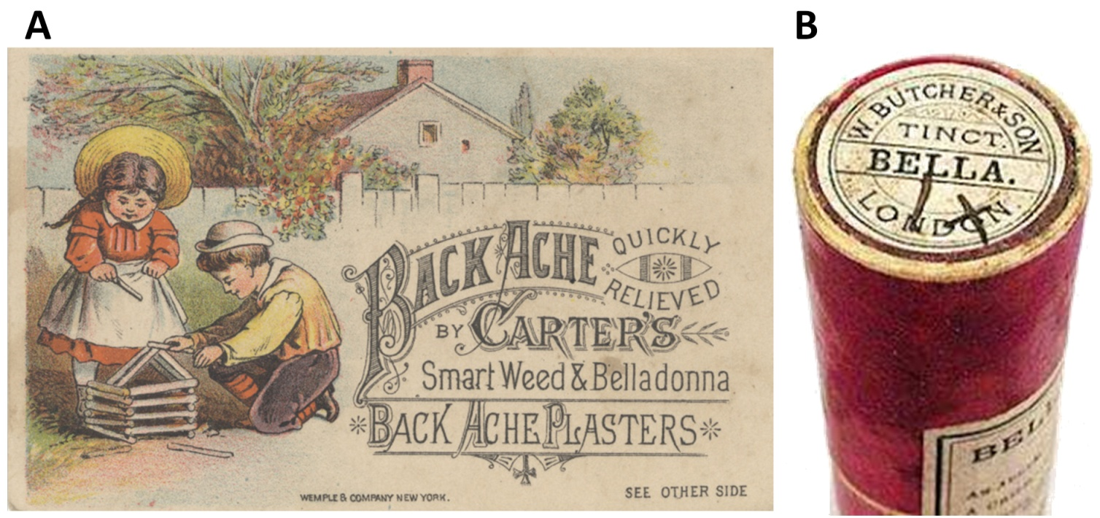
Figure 1: Traditional preparations of belladonna. (A) Carter's smart weed and belladonna back ache plasters smart weed (Polygonum hydropiper) (B) Old homeopathic belladonna remedy. Both the images are in the public domain.

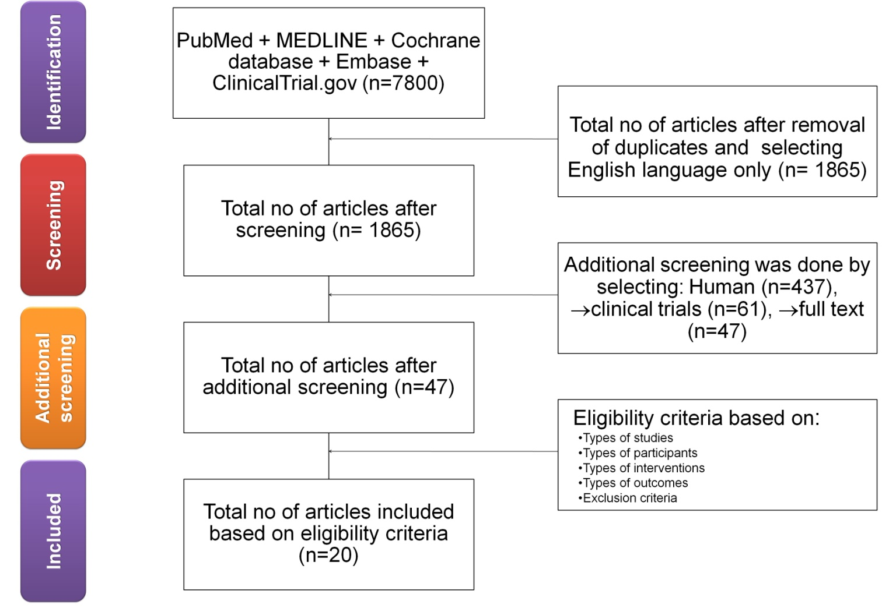
Figure 2: Flow diagram of study selection process.

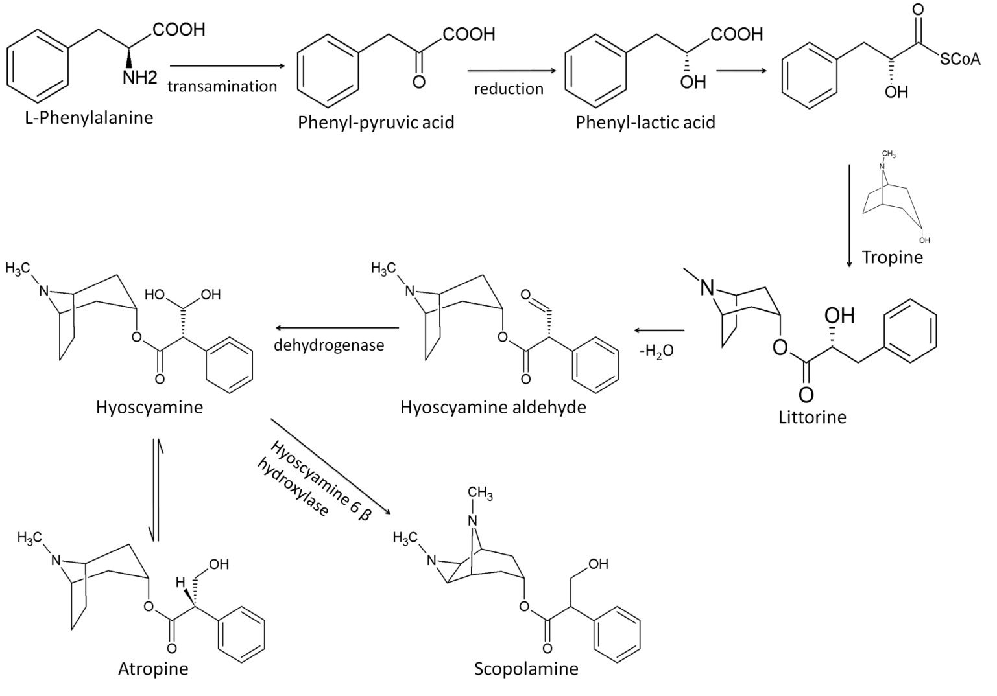
Figure 3: Biosynthesis of atropine, hyoscyamine and scopolamine.

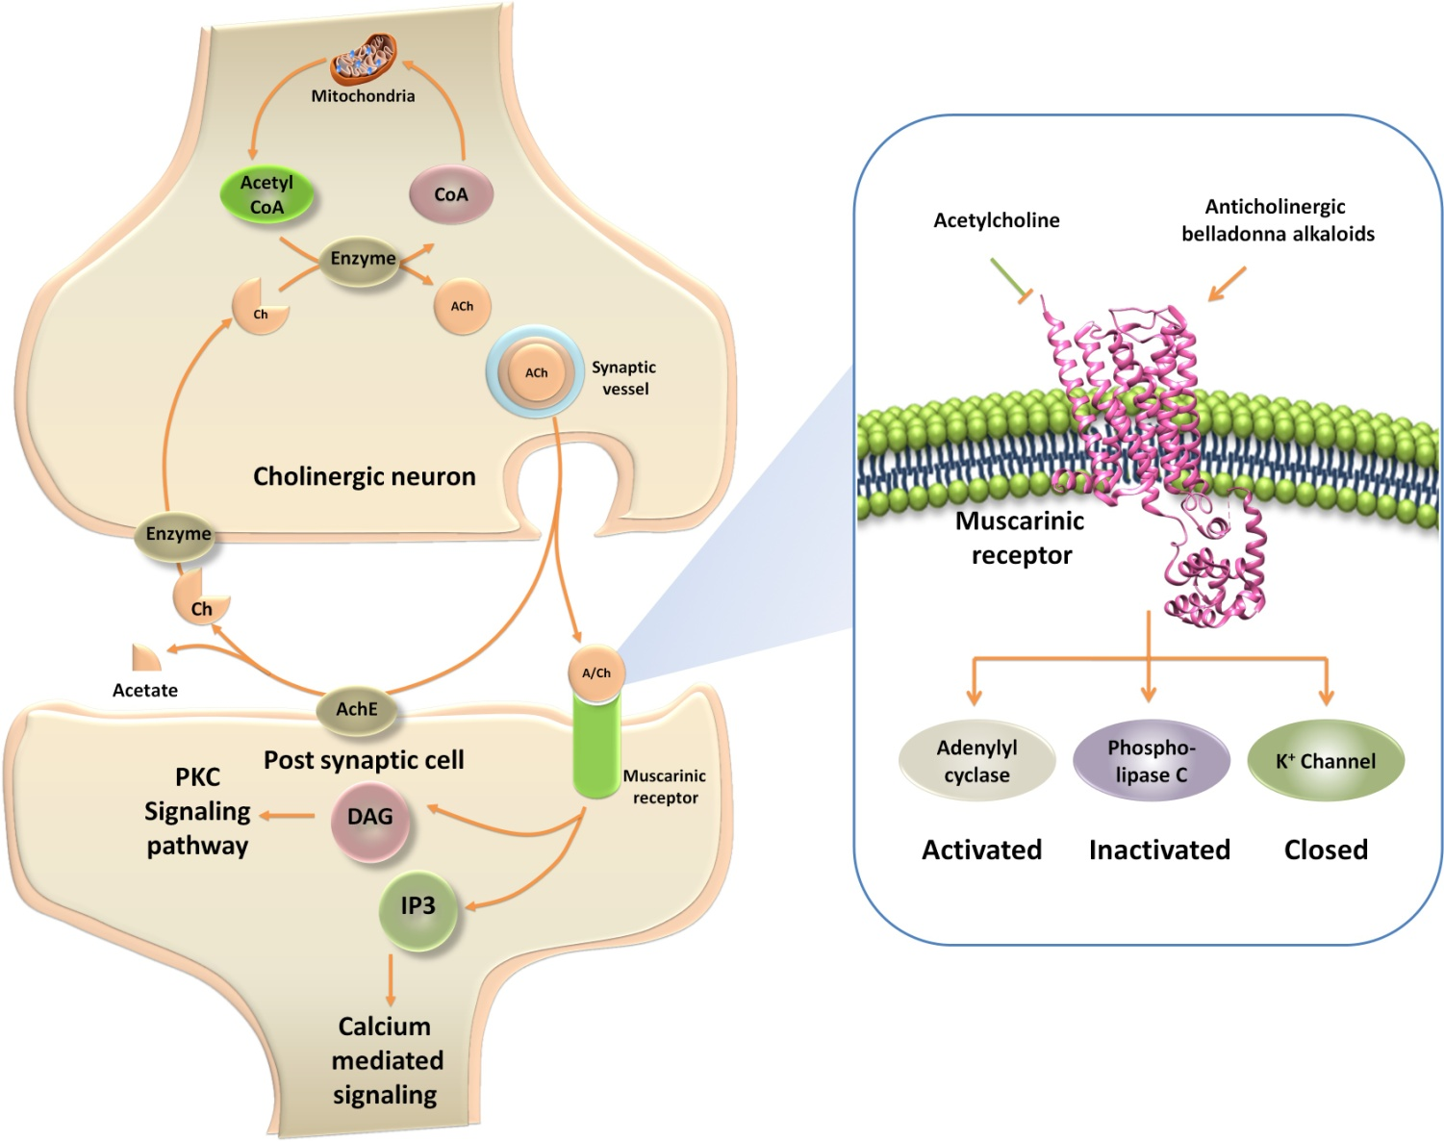
Figure 4: Mechanism of action of belladonna alkaloids. The tropane alkaloids antagonize the action of acetylcholine on muscarinic acid receptors (mAChRs) in central nervous system. The binding of the tropane alkaloids with mAChRs results in the activation of phospholipase C, inactivation of adenylyl cyclase enzyme and opening of K+ channels.

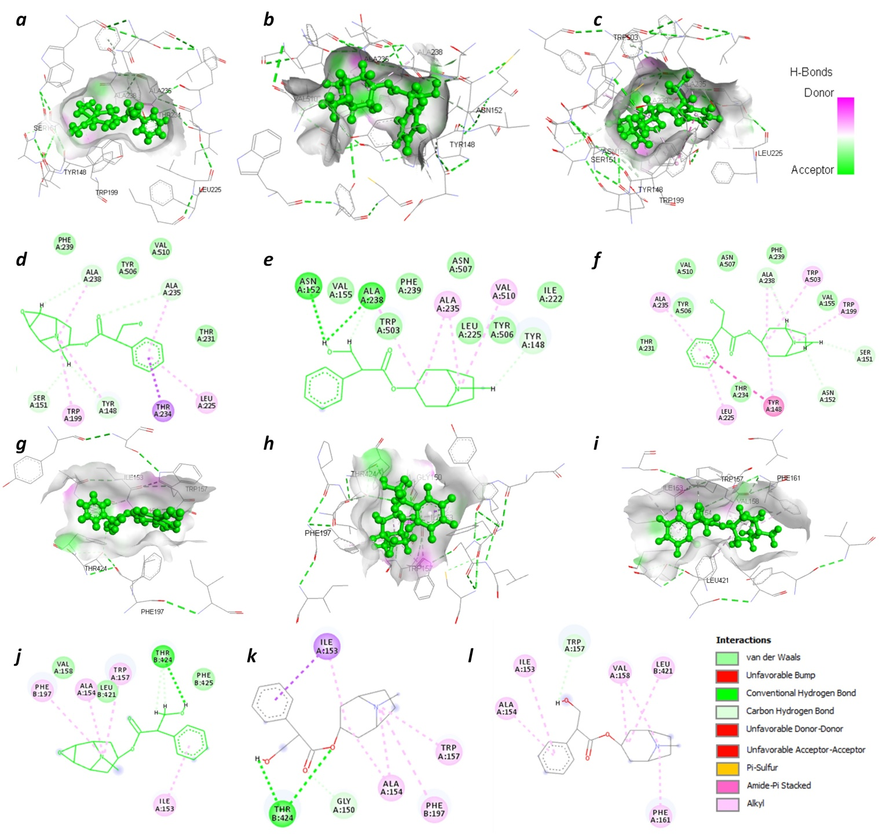
Figure 5: Structural views of ligand-binding site interactions of scopolamine, atropine and hyoscyamine with M3 and M4 receptor. The 3D (a-c) and 2D (d-f) interaction view are given for M3 receptor. 3D and 2D structures display H-bond interactions (green dashed lines) among; scopolamine (a, d), atropine (b, e) and hyoscyamine (c, f) with M3 receptor. Similarly, 3D (g-i) and 2D (j-l) interaction view are given for M4 receptor. 3D and 2D structures display H-bond interactions (green dashed lines) among; scopolamine (g, j), atropine (h, k) and hyoscyamine (i, l) with M4 receptor. Simplified visualization is illustrated in 2D (d-f, j-l) respectively, which displayed the H-bonding (dark green circles associated with the green dashed lines); van der Waals forces (medium light green circles); carbon-oxygen dipole-dipole interaction (light green circles with dashed lines); alkyl-pi interactions (light pink circles with dashed lines); T-shaped pi-pi stacking and (parallel) pi-pi stacking (both indicated with dark violet circles); cation-pi interaction (orange circle). The blue halo surrounding the interacting residues represents the solvent accessible surface that is proportional to its diameter. Images were generated using Discovery Studio Visualizer 4.5.
Table 1: Keywords for databases and the number of search results
Keywords | Database | No of studies found
Belladonna | PubMed | 1527
Belladonna and clinical trials | PubMed | 70
Safety and efficacy of belladonna | PubMed | 5
Belladonna | MEDLINE | 2,932
Belladonna and clinical trials | MEDLINE | 1,534
Safety and efficacy of belladonna | MEDLINE | 1,503
Belladonna | Cochrane database | 100
Belladonna and clinical trials | Cochrane database | 51
Safety and efficacy of belladonna | Cochrane database | 6
Belladonna | Embase | 34
Belladonna and clinical trials | Embase | 26
Safety and efficacy of belladonna | Embase | 1
Belladonna | ClinicalTrials.gov | 7
Belladonna and clinical trials | ClinicalTrials.gov | 2
Safety and efficacy of belladonna | ClinicalTrials.gov | 2

Table 2: Key eligibility criteria for the systematic literature review.
Population | Age: 4 months to 80 years  Gender: any  Race: any  Disease: any
Intervention | Belladonna/ alkaloids monotherapy  Belladonna/ alkaloids in combination with other drugs
All clinical trials | Nonrandomized controlled trials  Observational studies (retrospective analysis, prospective studies, cohort studies, case–control studies, case series and case reports)
Subgroup analysis | No subgroup analysis

Table 3: List of clinical trials evaluating the effectiveness of belladonna/ alkaloids in various disease conditions.
Condition | Study Design | Author, Year | Age in  Years | No. of patients | Belladonna/  alkaloids Intervention | Placebo | Outcome of the study
Acute Encephalitis Syndrome | Randomized Placebo-Controlled Trial | Oberai et al., 2018 | 0.5 -18 | 612 | 91 | 90 | The study concluded that homeopathic medicines may have improved clinical outcomes of children with AES.³⁸
Vaginal surgery | Randomized clinical trial | Butler et al., 2017 | 55 | 90 | 41 | 49 | This study demonstrated that the use of B and O suppositories did not significantly impact pain after vaginal surgery and that there were no significant adverse effects on perioperative outcomes.³⁹
Urethral Stent Pain | Randomized, Double-blinded, Placebo-controlled Study | Lee et al., 2017 | ≥18 | 69 | 35 | 34 | B and O suppository administered preoperatively improved quality of life measures and reduced urinary related pain after URS with stent.⁴⁰
Myocardial  Ischemia Injury | Radomized trials | Xing et al., 2015 | 34-69 | 118 | 58 | 60 | Anisodamine can significantly improve cardiac function and reduce apoptosis in myocardial infarction conditions.⁴¹
Acute Viral Tonsillitis | Randomized, double-blind, placebo-controlled | Malapane et al., 2014 | 6-12 | 30 | 15 | 15 | The homeopathic complex used in this study exhibited significant anti-inflammatory and pain relieving qualities in children with acute viral tonsillitis.⁴²
Vagolytic and vagotonic effects | Single-blind placebo-controlled study | Bettermann et al., 2001 | 29 | 8 | 6 | 2 | The comparison between oral administered atropine and Atropa belladonna tincture (ABT) was not carried out in this study. Thus, the very interesting question of whether the herbal composition ABT is more effective than atropine alone, as assumed in literature, still remains unanswered.⁴³
Safety of belladonna on Healthy volunteers | Randomized, double-blind experiment | Walach et al., 2001 | 31-35 | 87 | 58 | 29 | There is no indication that belladonna 30CH produces symptoms different from placebo or from no intervention.⁴⁴
homoeopathic 'proving' | Double-blind randomized controlled trial | Goodyear et al., 1998 | 18-40 | 47 | 20 | 27 | This pilot study does not demonstrate a clear proving reaction for Belladonna C30 versus placebo.⁴⁵
Migraine | Double-blind randomized placebo-controlled study | Whitmarsh et al., 1997 | - | 60 | 1 | 2 | There was no significant benefit over placebo of homeopathic treatment.⁴⁶
Airway obstructions during  sleep in Infants | Double-blind crossover evaluation | Kahn et al., 1991 | 0.4 | 19 | 19 | 19 | The drug was administered orally in a dosage equivalent to 0.01 mg per kg per day of atropine, a dosage close to that recommended for the treatment of infants with laryngospasm.⁴⁷
climacteric complaints | Double-blind, placebo controlled study | Bergmans et al., 1987 | 45-55 | 38 | 21 | 17 | Combination formula including belladonna studied. Trend towards improvement at 2-4 weeks, but no effect at 8 weeks.⁴⁸
Irritable Bowel Syndrome | Controlled clinical trial | Rhodes et al., 1978 | 42-70 | 16 | 15 | 15 | The patients preferred 30 mg phenobarbital plus 8 mg belladonna) to placebo.⁴⁹
Throbbing Headache | Double-blind study | Stieg et al., 1977 | 20-30 | 55 | 55 | 38 | The crossover design indicates that BEP offers benefits in the prophylaxis of recurrent throbbing headache, without serious or frequent side effects compared to parallel design.⁵⁰
Anxiety and Gastrointestinal Disorders | Radomized trials | Samet et al., 1976 | 22-65 | 75 | 25 | 25 | Bellergal therapy is superior to chlordiazepoxide HC1 in the relief of the anxiety tension states and the accompanying gastrointestinal symptoms.⁵¹
Hyperuricemia |  | Postlethwaite et al., 1974 | - | 34 | 3 | 3 | The uricosuric effect of anticholinergic agents like glycopyrrolate, tridihexethyl chloride and L-hyoscyamine was studied and glycopyrrolate was found to be most effective agent.⁵²
Anxiety | Double-blind study | Lalli et al., 1974 | 47-51 | 728 | 154 | 134 | It is demonstrated that intravenous diazepam, subcutaneous atropine, and oral tincture of belladonna failed to reduce reactions to the contrast medium whereas hypnotics was found to be useful for reducing these reactions.⁵³
Learning and memory | Radomized trials | Levine et al., 1973 | 70-80 | 60 | 30 | 30 | There was no difference between Belladonna and placebo groups in number of patients who were able to learn the task. This indicates that Belladonna was not effective in helping these patients learn the task.⁵⁴
Duodenal ulcer | Controlled single-blind trial | Kaye et al., 1970 | 20-65 | 91 | 31 | 32 | Glycopyrronium and 1-hyoscyamine were not significantly superior to placebo.⁵⁵
Investigation of anticholinergic compounds efficacy. | Radomized trials | Kaye et al., 1968 | - | 56 | 23 | 33 | Treatment with optimal effective doses of an anticholinergic agent (1- hyoscyamine in sustained release form) gave a marked prolongation of antacid action.⁵⁶
Gastric Secretion | Radomized trials | Dotevall et al., 1965 | - | 9 | 9 | 9 | The study reported that the long-acting Preparation of 1-hyoscyamine is significantly reduced the gastric acid secretion as compared to conventional hyoscyamine and placebo.⁵⁷

Table 4 : Scientific evidences for efficacy of belladonna in various diseases
Study name | Was the study described as randomized (this includes words such as randomly,  Random and randomization | Was the method used to generate the sequence of randomization described and  Appropriate (table of random numbers, computer-generated | Was the study described as double blind? | Was the method of double binding described and appropriate (identical placebo, active placebo, dummy, etc.)? | Was there a description of withdrawals and dropouts? | Deduct one point if the method used to generate the sequence of randomization  was described and it was inappropriate (patients were allocated alternately, or  According to date of birth, hospital number, | Deduct one point if the study was described as double blind but the method of  Blinding was inappropriate (e.g., comparison of tablet vs. injection with no double dummy | GRADE*
Acute Encephalitis Syndrome | 1 | 1 | 1 | 1 | 1 | 0 | 0 | B
Vaginal surgery | 1 | 1 | 1 | 1 | 1 | 0 | 1 | D
Urethral Stent Pain | 1 | 1 | 1 | 0 | 1 | 0 | 1 | B
Myocardial  Ischemia Injury | 1 | 1 | 0 | 0 | 0 | 0 | 0 | C
Acute Viral Tonsillitis | 1 | 0 | 1 | 0 | 0 | 0 | 0 | C
Vagolytic and vagotonic effects | 0 | 0 | 0 | 1 | 0 | 0 | 0 | C
Safety of belladonna on Healthy volunteers | 1 | 0 | 1 | 1 | 1 | 1 | 0 | C
homoeopathic 'proving' | 1 | 1 | 1 | 1 | 1 | 0 | 0 | C
Migraine | 1 | 0 | 1 | 1 | 1 | 0 | 0 | C
Airway obstructions during  sleep in Infants | 1 | 0 | 1 | 1 | 1 | 0 | 0 | C
climacteric complaints | 1 | 0 | 1 | 1 | 1 | 0 | 0 | C
Irritable Bowel Syndrome | 0 | 1 | 1 | 1 | 1 | 1 | 0 | C
Throbbing Headache | 1 | 0 | 1 | 1 | 1 | 1 | 0 | C
Anxiety and Gastrointestinal Disorders | 1 | 0 | 1 | 1 | 1 | 0 | 0 | C
Hyperuricemia | 0 | 0 | 0 | 0 | 0 | 0 | 0 | C
Anxiety | 0 | 0 | 1 | 0 | 0 | 0 | 1 | C
Learning and memory | 1 | 0 | 0 | 0 | 0 | 0 | 0 | C
Duodenal ulcer | 1 | 1 | 0 | 0 | 1 | 0 | 0 | C
Investigation of anticholinergic compounds efficacy. | 1 | 0 | 0 | 0 | 0 | 0 | 0 | C
Gastric Secretion | 1 | 0 | 0 | 0 | 0 | 0 | 1 | C
*Evidence-based validated grading rationale. Grades reflect the level of available scientific evidence in support of the efficacy of a given therapy for a specific indication as per following criteria.
Grade | Level of evidence | Criteria
A | Strong scientific evidence | Statistically significant evidence of benefit from > 2 properly randomized trials (RCTs), OR evidence from one properly conducted RCT AND one properly conducted meta-analysis, OR evidence from multiple RCTs with a clear majority of the properly conducted trials showing statistically significant evidence of benefit AND with supporting evidence in basic science, animal studies, or theory.
B | Good scientific evidence | Statistically significant evidence of benefit from 1-2 properly randomized trials, OR evidence of benefit from ≥1 properly conducted meta-analysis OR evidence of benefit from > 1 cohort/case-control/ non-randomized trials AND with supporting evidence in basic science, animal studies, or theory.
C | Unclear or conflicting scientific evidence | Evidence of benefit from ≥1 small RCT(s) without adequate size, power, statistical significance, or quality of design by objective criteria,* OR conflicting evidence from multiple RCTs without a clear majority of the properly conducted trials showing evidence of benefit or ineffectiveness, OR evidence of benefit from ≥1 cohort/case-control/non-randomized trials AND without supporting evidence in basic science, animal studies, or theory, OR evidence of efficacy only from basic science, animal studies, or theory.
D | Fair negative scientific  evidence | Statistically significant negative evidence (lack of evidence of benefit) from cohort/case-control/nonrandomized trials, AND evidence in basic science, animal studies, or theory suggesting a lack of benefit.
E | Strong negative scientific  evidence | Statistically significant negative evidence (lack of evidence of benefit) from ≥1 properly randomized adequately powered trial(s) of high-quality design by objective criteria.
F | Lack of evidence | Unable to evaluate efficacy due to lack of adequate available human data.

Table 5: Summary of effects of belladonna/ alkaloids in various disease conditions
Condition | Author, Year | intervention | ARR (%) | RD | RR (%) | RRR (%) | NNT (%) | Odds ratio  (%) | Odds reduction
Acute encephalitis syndrome | Oberai P et al., 2018 | Belladonna  control | 14.28  30 | -15.71 | 47.61 | 52.38 | 7 | 38.88 | 61.11
Vaginal surgery | Butler K et al., 2017 | Preoperative pain  Belladonna + opium  control | 15.38  8.88 | 6.49 | 173.07 | -73.07 | 6.5 | 196.36 | -96.36
 | Butler K et al., 2017 | Urinary retention  B and O  control | 51.21  46.93 | 4.28 | 109.11 | -9.11 | 1.95 | 118.69 | -18.69
Urethral stent pain | Lee FC et al., 2017 | Ureteral stone burden  B and O  control | 25.71  32.35 | -6.63 | 79.48 | 20.51 | 3.88 | 72.37 | 27.62
Myocardial  Ischemia Injury | Xing K et al., 2015 | Anisodamine  control | 3.44  8.33 | -4.88 | 41.37 | 58.62 | 29 | 39.28 | 60.71
Safety of Belladonna on healthy volunteers | Walach H et al., 2001 | Belladonna  control | 46.55  82.75 | -36.20 | 56.25 | 43.75 | 2.14 | 18.14 | 81.85
Airway obstructions during sleep in Infants | Kahn A et al., 1991 | Belladonna  control | 26.31  73.68 | -47.36 | 35.71 | 64.28 | 3.8 | 12.75 | 87.24
Climacteric complaints | Bergmans MG et al., 1987 | Belladonna  control | 47.61  82.35 | -34.73 | 57.82 | 42.17 | 2.1 | 19.48 | 80.51
Irritable bowel syndrome | Rhodes JB et al., 1978 | Belladonna  control | 33.33  50 | -16.66 | 66.66 | 33.33 | 3 | 50 | 50
Throbbing headache | Stieg RL et al., 1977 | Belladonna  control | 61.81  78.94 | -17.12 | 78.30 | 21.69 | 1.61 | 43.17 | 56.82
Hyperuricemia | Postlethwaite AE et al., 1974 | L- hyoscyamine  control | 66.66  33.33 | 33.33 | 200 | -100 | 1.5 | 400 | -300
Anxiety | Lalli AF et al., 1974 | Belladonna  Placebo | 16.88  10.44 | 6.43 | 161.59 | -61.59 | 5.92 | 174.10 | -74.10
Learning and memory | Levine FM et al., 1973 | Belladonna  control | 66.66  53.33 | 13.33 | 125 | -25 | 1.5 | 175 | -75
Duodenal ulcer | Kaye MD et al., 1970 | Glycopyrronium  1-hyoscyamine  placebo | 21.42  35.48  28.12 | -6.69  7.35 | 76.19126.16 | 23.80  -26.16 | 4.66  2.81 | 69.69  140.55 | 30.30  -40.55
ARR: Absolute risk reduction, RD: Risk difference, RR: Risk ratio, RRR: Relative risk reduction, NNT: Number needed to treat

Table 6. List of chemical constituents present in belladonna
Name Structure Pharmacological use
Alkaloids
Atropine | 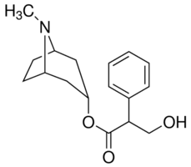 |  | Mydriatic, antispasmodic, preoperative medication, antidote for organ phosphorus poising
Hyoscyamine | 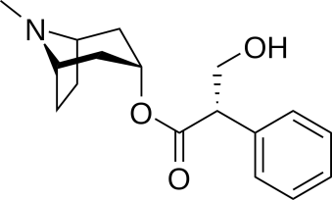 |  | Anti-spasmodic agent to treat abdominal cramps and pain. In parkinsonism used to reduce the rigidity and tremors. Antiarrhythmic agent to control acute arrhythmias
Apoatropine | 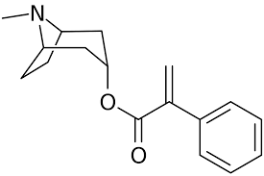 |  | Anti-spasmodic agent
Scopolamine | 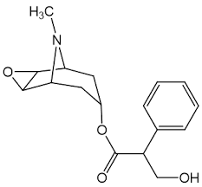 |  | Used for the management of motion sickness, nausea and vomiting. It also has antiemetic and amnesic effect.
Belladonnine | 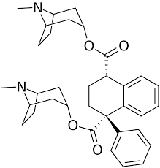 |  | Anti-spasmodic agent
Cuscohygrine |  |  | Anti-spasmodic agent
Flavnoids
Kaempferol | 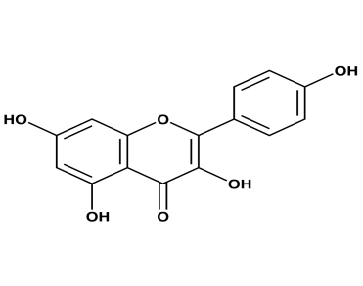 | Kaempferol have a wide range of pharmacological activities, including antioxidant, anti-inflammatory, antimicrobial, neuroprotective
Quercetin | 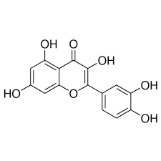 | Quercetin has been used to treat hay fever, peptic ulcer, inflammation, asthma, gout, viral infections, chronic fatigue syndrome (CFS)
Benzopyranoids
6,7-Dihydroxy- 2H-1- benzopyran- 2-one | 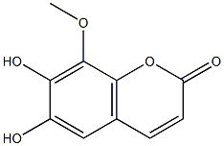 | Antifungal, anti inflammatory properties
7-Hydroxy-6- methoxy-2H-1- benzopyran-  2-one | 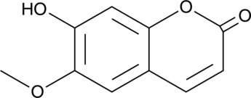 | Antispasmodic agent, anti-inflammatory, eicosanoid release inhibitor

