How do Fractional Flow Reserve, whole-cycle PdPa and instantaneous wave-Free Ratio correlate with exercise coronary flow velocity during exercise-induced angina?

Short title: FFR, PdPa iFR and exercise coronary flow

Christopher M Cook^{1,4} MBBS BSc, James P Howard^{1,4} MB BChir., Yousif Ahmad^{1,4} BMBS, Matthew J Shun-Shin^{1,d} ⁴ BM BCh. Ph.D., Amarjit Sethi¹ MBBS Ph.D., Gerald J Clesham^{2,3} MB BChir., Ph.D., Kare H Tang² MBBS., Sukhjinder S Nijjer^{1,4} MB ChB., Ph.D, Paul A Kelly² MB ChB, MD, John R Davies^{2,3} MBBS, Pd.D., Iqbal S Malik^{1,4} MBBChir MA PhD., Raffi Kaprielian¹ MBBS, M.D., Ghada Mikhail^{1,4} MBBS, M.D., Ricardo Petraco^{1,4} M.D., Takayuki Warisawa¹ M.D., Firas Al-Janabi^{2,3} MBBS, Grigoris V Karamasis^{2,3} M.D., Shah Mohdnazri^{2,3} M.D., Reto Gamma² M.D., Guus A. de Waard¹ M.D., Rasha Al-Lamee^{1,4} MBBS Ph.D., Thomas R Keeble^{2,3} MBBS, M.D., Jamil Mayet^{1,4} MB ChB, M.D., MBA, Sayan Sen^{1,4} MBBS, Ph.D., Darrel P Francis^{1,4} MB BChir., MA, M.D. and Justin E Davies⁴ M.D., Ph.D.

¹ National Heart and Lung Institute, Imperial College London, London, UK; ² Essex Cardiothoracic Centre, Basildon, UK; ³ Anglia Ruskin University, UK; ⁴ Imperial College Healthcare NHS Trust, London, UK.

Address for correspondence

Dr Justin Davies,
The Hammersmith Hospital,
B block South, 2nd floor,
Du Cane Road,
London W12 0NN

Email: drjustindavies@gmail.com
Tel: +44 207 594 1093
Fax: +44 208 082 5109

Word count: 799

The use of either Fractional Flow Reserve (FFR) or instantaneous wave-Free Ratio (iFR) is currently recommended to guide ischemia-driven revascularisation decision-making in patients with stable angina¹. However, the recently presented International Study of Comparative Health Effectiveness With Medical and Invasive Approaches (ISCHEMIA) trial dispels the prognostic potential of ischemia-driven revascularisation in patients with (non-left main) stable coronary artery disease ². Instead, in such patients, the therapeutic role of myocardial revascularisation is further focused on improving angina-limiting symptoms.

Pervasive arguments persist against the use of ‘resting’ coronary pressure measurements to inform about coronary stenosis hemodynamics during angina-limiting exercise. Paramount among these is the belief that FFR may be the physiologically more representative index, owing to its use of maximal pharmacological hyperemia - a condition considered similar to physical exercise³. Accordingly, proponents of adenosine hyperemia may question the ability of non-hyperemic coronary pressure measurements to inform about coronary flow hemodynamics during angina-limited exercise.
The aim of this study was to determine the respective associations between peak-exercise coronary flow velocity measured at the onset of exercise-induced angina symptoms and baseline FFR, whole-cycle PdPa (PdPa) and iFR values in patients with single-vessel stable coronary artery disease.
Our full research protocol has previously been reported ⁴. In brief, patients with stable angina and single-vessel coronary stenosis underwent cardiac catheterization and baseline FFR, PdPa and iFR measurement (calculated offline during maximal hyperemia, during the whole-cycle resting phase and during the wave-free period of diastole, respectively). Patients immediately then incrementally exercised on a catheter-table-mounted supine ergometer until the development of exercise-induced angina. Surrogate markers of myocardial ischemia such as electrocardiogram abnormalities were not used to determine peak-exercise capacity. Continuous trans-stenotic coronary-pressure-flow measurements were made in the target-vessel throughout exercise using a dual pressure and velocity sensor 0.014-in intracoronary wire (Combowire XT, Volcano Corp, California). The study was approved by the regional ethics committee (16/LO/1928) and all subjects gave informed consent.

Comparison was made between coronary flow velocity at the point of onset of exercise-induced angina (Flow_{angina}) and baseline FFR, PdPa and iFR values, respectively. Pearson correlation coefficients were used to compare Flow_{angina} and FFR, PdPa and iFR, respectively. Tests for non-linearity were performed to validate this approach and exclude the need for modelling using restricted cubic splines. The data, analytical methods, and study materials will not be made available to other researchers for purposes of reproducing the results or replicating the procedure.
Twenty-three patients (mean age, 60.6±8.1 years) completed the study protocol. The majority (96%) of patients were in Canadian Cardiovascular Society class II/III. The mean number of antianginal medications per patient was 1.4±0.7. All stenoses were focal and predominantly proximal (57% [13/23]). The most frequently assessed vessel was the left anterior descending artery (52% [12/23]).

Mean stenosis diameter was 74.6%±10.4. Median baseline FFR, PdPa and iFR were 0.54 (interquartile range 0.44-0.72), 0.70 (0.53-0.90) and 0.53 (0.38-0.83), respectively. Mean exercise time was 144±77 seconds (4.3±1.2 METs).

The associations between Flow_{angina} and FFR, PdPa and iFR are displayed in Figure 1. Correlations were R=0.65 (0.32-0.84) for FFR, R=0.76 (0.50-0.89) for PdPa and R=0.73 (0.45-0.88, p<0.001 for all) for iFR. The median values at which angina symptoms developed were 0.66 (0.54-0.82) for PdPa and 0.59 (0.39-0.76) for iFR.

Notwithstanding the limited sample size, in this highly-selected population of severe, single vessel stable angina patients; baseline FFR, PdPa and iFR all demonstrated similar positive associations with coronary flow velocity measured invasively at the point of developing exercise-induced angina. Accordingly, our findings challenge the notion that resting, non-hyperemic coronary pressure measurements are unable to provide accurate information about exercise stress hemodynamics.

Furthermore, these mechanistic data support the link between coronary physiology, exercise physiology and angina symptom development. Following the results of the ISCHEMIA trial, further investigation of these associations, and the potential identification and validation of coronary physiology-based ‘angina-thresholds’, may be an important new role for coronary physiology in the management of stable angina patients.

In the present small study, the median values at which angina symptoms developed were 0.66 (0.54-0.82) for PdPa and 0.59 (0.39-0.76) for iFR. However, these values do not represent validated angina thresholds. To determine such thresholds, dedicated research protocols will be required to validate thresholds within the continuous variables of PdPa and iFR as a marker of anginal symptom onset. Furthermore, such validation must consider true positives, false positives, true negatives, and false negatives that are then appropriately weighted for safe and effective clinical application.

In summary, our findings provide proof-of-concept for the positive association between baseline FFR, PdPa and iFR with coronary flow velocity measured invasively at the point of exercise-induced angina. Further study is required to determine if such associations remain true in more borderline severity disease cohorts given the large inter-individual variability that exists in patient-reported ischemia symptoms and, with future study, the potential validation of ‘angina thresholds’ for coronary physiology indices.

Funding

This study was funded in part by the National Institute for Health Research (NIHR) and Imperial College Healthcare NHS Trust Biomedical Research Centre. CC (MR/M018369/1), SS (G1000357) and SSN (G1100443) are Medical Research Council fellows. JH is a Wellcome Trust fellow (212183/Z/18/Z). RP (FS/11/46/28861), MSS (FS/14/27/30752), JED (FS/05/006), and DPF (FS 04/079) are British Heart Foundation fellows.

Conflicts of interest statement

JED and JM hold patents pertaining to the iFR technology. JED and AS are consultants for Philips Volcano. RA-L, SS, RP, CC, and SSN have received speaker’s honoraria from Philips Volcano. JED and TK have received research grants from Philips Volcano. All other authors declare no competing interests.

References:
1. Neumann F-J, Sousa-Uva M, Ahlsson A, Alfonso F, Banning AP, Benedetto U, Byrne RA, Collet J-P, Falk V, Head SJ, Jüni P, et al. 2018 ESC/EACTS Guidelines on myocardial revascularization. Eur Heart J. 2019;40:87-165
2. Presentations/Workshops: Hochman JS. International Study of Comparative Health Effectiveness With Medical and Invasive Approaches - ISCHEMIA. Oral presentation at: American Heart Association Annual Scientific Sessions (AHA 2019); November, 2019; Philadelphia, PA.
3. Jeremias A, Kirtane AJ, Stone GW. A Test in Context: Fractional Flow Reserve: Accuracy, Prognostic Implications, and Limitations. J Am Coll Cardiol. 2017;69:2748–2758.
4. Cook CM, Ahmad Y, Howard JP, Shun-Shin MJ, Sethi A, Clesham GJ, Tang KH, Nijjer SS, Kelly PA, Davies JR, et al. Impact of Percutaneous Revascularization on Exercise Hemodynamics in Patients With Stable Coronary Disease. J Am Coll Cardiol. 2018;72:970–983.

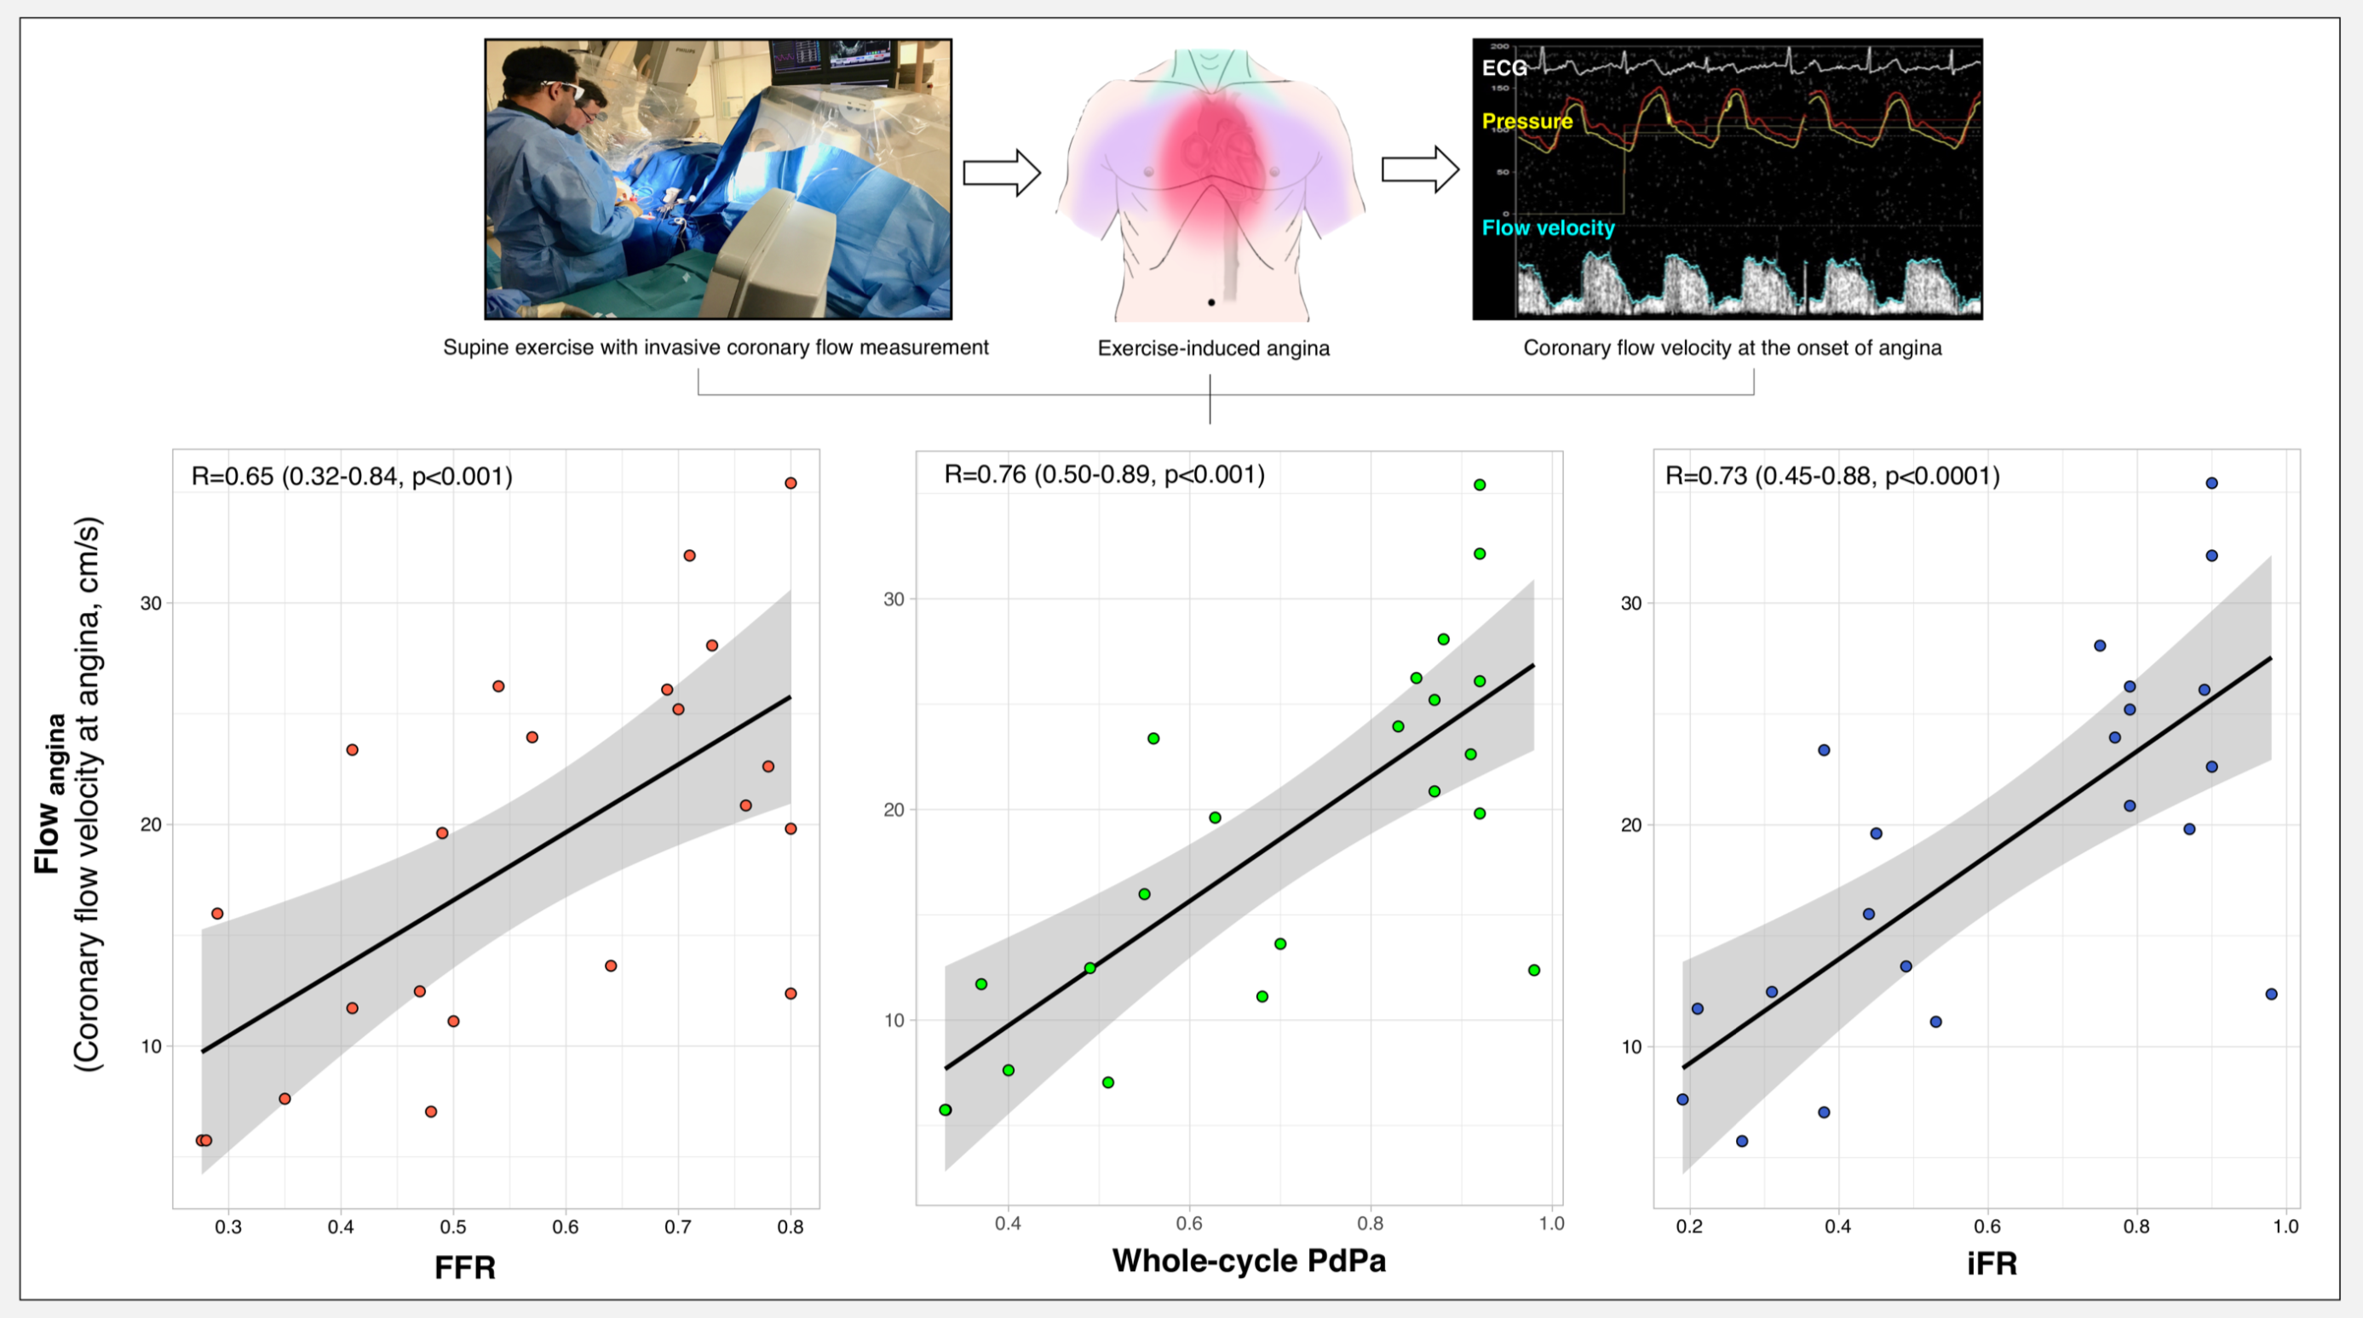
Figure 1: Top panel: Schematic representation of the research protocol. Bottom panel: Scatter plots of the relationship between coronary flow velocity during the onset of exercise-induced angina (Flow_{angina}) and baseline FFR (red), baseline whole-cycle PdPa (green) and baseline iFR (blue).

