Mike Trott¹; Sarah E. Jackson²; Joseph Firth^{3,4,5}; Abigail Fisher⁶; James Johnstone¹; Amit Mistry^{7,8}; Brendon Stubbs^{9,10,11}; Lee Smith¹

Exercise addiction prevalence and correlates in the absence of eating disorder symptomology. A systematic review and meta-analysis.

Mike Trott – PhD candidate, Anglia Ruskin University
mike.trott@pgr.anglia.ac.uk
+353834450792
¹Cambridge Centre for Sport and Exercise Sciences, Anglia Ruskin University, Compass House, Cambridge, CB1 1PT; ORCID ID: 0000-0001-5978-3407

Sarah Jackson – Senior Research Associate
² Department of Behavioural Science and Health, University College London, London, WC1E 7HB

Joseph Firth
³Division of Psychology and Mental Health, University of Manchester, Manchester, UK
⁴Centre for Youth Mental Health, University of Melbourne, Melbourne, Australia
⁵NICM Health Research Institute, Western Sydney University, Westmead, Australia

Abigail Fisher
⁶Health Behaviour Research Centre, Department of Epidemiology and Public Health, Institute of Epidemiology and Health Care, University College London, London

James Johnstone
Head of Department, Sport and Exercise Sciences¹

Amit Mistry
⁷Eating Disorders Service, Barnet, Enfield & Haringey Mental Health Trust
⁸RCPsych Sport & Exercise Psychiatry Special Interest Group

Brendon Stubbs
⁹Positive ageing research institute (PARI), Anglia Ruskin University
¹⁰Physiotherapy Department, South London and Maudsley NHS Foundation Trust, Denmark Hills, London SE5 8AZ, United Kingdom;
¹¹Department of Psychological Medicine, Institute of Psychiatry, Psychology and Neuroscience, King's College London, De Crespigny Park, London, Box, SE5 8AF, United Kingdom

Lee Smith
Reader in Exercise Medicine, Director of Research and Income Generation¹

Financial support

This research did not receive any specific grant from funding agencies in the public, commercial, or not-for-profit sectors.

Conflict of interest

None

Abstract (231/250)

Background: Exercise addiction (EA) can be debilitating and can be a symptom of an eating disorder. To date, the prevalence rates of EA without indicated eating disorders in the general population and associated correlates remain unreported.

Methods: Two authors searched major databases from inception to 31/12/2018 to identify studies investigating the prevalence of EA in any population without indicated eating disorders. We conducted a random effects meta-analysis to report i) prevalence rates of EA using the exercise addiction inventory and exercise dependence scale and compare sub-populations, ii) compare methods of EA measurement and explore heterogeneity, and iii) report on correlates.

Results: A total of 13 studies including 3635 people were included. The prevalence of EA among general exercisers was 8.1% (95% CI 1.5-34.2%), amateur competitive athletes was 5.0% (95% CI 1.3-17.3%), and university students was 5.5% (95% CI 1.4-19.1%%). Overall prevalence rates varied depending on the EA measurement tool. EA subjects were more likely to have lower levels of overall wellbeing (only in amateur competitive athletes), higher anxiety levels, and have greater frontal brain activity.

Conclusions: EA is prevalent in the absence of indicated eating disorders across populations but varies more depending on measurement tool. Further research is needed to explore EA without indicated eating disorders in different populations using homogenous measurement tools, further determine psychological correlates, and examine which measures of EA without indicated eating disorders predict poor health outcomes.

Key words: exercise addiction; exercise dependence; addiction; pathological exercise; disordered eating; eating disorders

1. Introduction

Exercise may be defined as ‘a subset of physical activity that is planned, structured, repetitive and has as a final or an intermediate objective the improvement or maintenance of physical fitness’¹. Regular participation in exercise has been shown to be beneficial for almost all facets of health across the lifespan. In the UK, 61% of adults are estimated to adhere to the Department of Health² guidelines of 150 minutes of moderate intensity activity per week. Despite the various positive health outcomes of regular exercise, for a subset of people, exercise can become excessive to an extent where the exerciser experiences negative social and physiological symptoms, including training through injury, withdrawal symptoms, and the detriment of important social relationships through excessive exercise³, with extreme cases reporting subjects to have exercise related financial debts, trouble concentrating, with some individuals reporting that ‘their life becomes unbearable’ if they cannot exercise⁴. The specific terms used to name this phenomenon has had several synonyms in the literature, including (but not limited to) ‘exercise addiction’, ‘compulsive exercise’, ‘obligatory exercise’, and ‘exercise dependence’^{5,6}. Szabo et al.⁷ and ﻿Berczik et al.⁸ argue that the term ‘exercise addiction’ is the most appropriate, as the term incorporates ‘both dependence and compulsion’. For this review, the term exercise addiction (EA) will be used.

EA can be separated into two sub-categories: primary and secondary. Primary EA can be defined as having EA where there is no evidence of the EA being a symptom of another disorder (such as an eating disorder), with secondary EA showing evidence of another condition in which the EA can be accounted for, such as an eating disorder^{9,10}. Currently, no form of EA is recognised by the American Psychiatric Association (APA)¹¹ or the World Health Organisation (WHO)¹² as a clinical disorder, with gambling addiction the only psychological addiction to be formally recognised by the APA, and gambling and gaming disorder recognised by the WHO. The APA does state, however, that EA is not listed due to lack of peer-reviewed evidence to support any diagnostic classification, which includes data regarding prevalence rates (to determine the scale of the potential issue) and aetiology.

Several measurement tools have been created for the classification of subjects at risk of EA; some drawing on underlying addiction theories, such as the Exercise Addiction Inventory¹³ (EAI), based on Brown’s components of behavioural addictions¹⁴, and the Exercise Dependence Scale¹⁵ (EDS), based on the Diagnostic and Statistical Manual of Mental Disorders 4¹⁶ criteria for substance dependence. Other tools have been developed that lacked such an underlying framework, including questionnaires evolved from previous, population specific questionnaires, such as the Obligatory Exercise Questionnaire¹⁷ (OEQ), modified from the Obligatory Running Questionnaire¹⁸. Furthermore, other tools have been developed by using qualitative data from self-identified ‘exercise addicts’ to create measurable traits, such as the Exercise Dependence Questionnaire¹⁹ (EDQ). Primary studies have suggested that different EA measuring tools yield different prevalence rates in the same populations^{20,21}, with several authors arguing that only the EAI and EDS should be used in future studies as they broadly measure the same constructs and are therefore ‘broadly comparable’^{7,8}.

A recent narrative systematic review²² has estimated that the prevalence rates of EA range from 3-14.2% depending on the population, however this review failed to report whether or not the populations had indicated eating disorders. As several studies have shown that subjects with indicated eating disorders have higher prevalence rates than those without^{23,24}, with some authors arguing that all cases of EA are secondary to eating disorders²⁵, reporting on the prevalence of EA without indicated eating disorders is warranted. Furthermore, several psychological correlates that have been associated with EA, such as anxiety, body dysmorphia, and personality²⁶, have also been associated with eating disorders^{27–29}. Without stratifying primary and secondary EA it is impossible to associate these correlates with EA independently, highlighting a need for such an exploratory review.

Therefore, the primary aim of this study was, using meta-analytic techniques, to aggregate the prevalence rates of EA as measured by the EAI and EDS in subjects without indicated eating disorders and stratify this across different populations. A second aim was to compare overall prevalence rates across all EA measurement tools, with a third aim to report on any and all correlates of EA (measured with the EAI or EDS) without indicated eating disorders that have been reported to date.

2. Method

This systematic review was conducted according to the Strengthening the Reporting of Observational Studies in Epidemiology (STROBE) criteria³⁰ and the recommendations in the Preferred Reporting Items for Systematic Reviews and Meta-Analyses (PRISMA) statement³¹.

2.1 Search strategy

Two investigators searched PsycINFO, Medline, and SportDiscuss from inception to 31/12/18. The search terms (title) used were: (exercise OR physical activity OR fitness OR sport OR sports) and (addition OR dependence OR dependency OR compulsion OR addict) or (maladaptive OR excessive OR compulsive OR obligatory OR obsessive) and (exercise OR physical activity OR fitness OR exerciser OR exercisers OR sport OR sports).
Any inconsistencies were resolved by discussion, with further disagreements resolved through discussion with a third reviewer (which was not required in this study). The reference lists of articles included in the analysis were hand-searched to identify additional publications. Conference abstracts were also considered, (no conference abstracts were included in the final review).

2.2 Study selection

Titles and abstracts were independently assessed by two authors for eligibility against the inclusion and exclusion criteria. Any disagreements were resolved through discussion with a third reviewer (which was not required in this study). Articles were included that met the following inclusion and exclusion criteria:

2.3 Inclusion Criteria
1. Cross sectional or longitudinal studies
2. Written in English
3. In adults (≥18 years)
4. That measure the prevalence of EA in any population.
5. Screen for eating disorders using a validated measure (to exclude for EA with indicated eating disorders)

2.4 Exclusion Criteria
1. Studies that fail to screen for eating disorders using a validated measure (therefore precluding indicated/no indicated eating disorder categorisation).
3. Subjects who have scored above published cut-offs for eating disorders (including clinician diagnosed ED)
4. Samples that include elite athletes, as elite athletes have been shown to interpret EA measurement tools in such a way that indicates falsely high EA risk⁷.

2.5 Data extraction

The following information was extracted by the lead author including demographic (age, sex, BMI) and prevalence (total n, events n, measuring instrument of EA, screening instrument of eating disorders) data. Missing information was obtained by contacting lead authors. If prevalence data were missing/incomplete (e.g. unknown eating disorder status) and the authors did not respond/have access to the data (two attempted contacts to authors over a one-month period), these studies were excluded. Studies with missing demographic data, but full prevalence data were included. Subjects failing to meet established cut-off for eating disorders and meeting established cut offs for EA were classified as at risk of EA. Subjects failing to meet established cut-offs for both eating disorders and EA were categorised as not at risk of EA. All subjects scoring over the published cut-offs for eating disorders were excluded.

2.6 Quality assessment

Included studies were assessed for quality by the lead author using Newcastle-Ottawa Quality Assessment Scale³² (NOS), modified for cross sectional studies. The NOS has established content validity and inter-rater reliability and has a scoring system based on positive answers to questions regarding appropriateness of research design, recruitment strategy, response rate, representativeness of sample, objectivity/reliability of outcome determination, power calculation, and appropriate statistical analyses, with points being assigned to positive answers, with a maximum quality score of 10, with higher scores indicting higher quality studies (see supplementary data for full scale and scoring criteria)

2.7 Meta-analysis

Due to the anticipated heterogeneity, a random-effects model was conducted, calculating the prevalence rates with 95% confidence intervals (CIs) using Comprehensive Meta-Analysis Version 3³³. The meta-analysis was conducted in the following steps. 1. Prevalence rates for the total sample and population sub-groups were conducted using only studies that used the EAI and EDS 2. EA measurement tool sub-groups (using all EA measurement tools) were calculated with 95% CIs using total ns and event ns. 2. Heterogeneity was assessed with the Cochrane Q³⁴ and I² statistics³⁵. I² values of 25%, 50%, and 75% suggested low, moderate, and high heterogeneity, respectively³⁶. 3.
Publication bias was assessed with a visual inspection of funnel plots and with the Begg-Mazumdar Kendall’s tau³⁷ and Egger bias test³⁸. As per recommendations from Fu et al.³⁹ and Sterne, Egger, & Moher⁴⁰, these tests were only conducted if the number of studies exceeded 10. If the Egger bias test was significant, to adjust for potential publication bias, the trim-and-fill adjusted analysis was used to remove the most extreme small studies from the positive side of the funnel plot and effect sizes re-calculated, until the funnel plot was symmetrical with the new effect size⁴¹. A sensitivity analyses was calculated around the primary analyses, using a one-study removed method. This was to detect whether the observed effect was overly influenced by any one study.

2.8 Narrative synthesis of correlates of EA without indicated eating disorders

For the correlates of EA without indicated eating disorders, a narrative synthesis was conducted of all the available evidence within the included articles. Correlates that failed to stratify between indicated/no indicated EDs were excluded.
3. Results

The initial literature search yielded 1,541 results, of which there were 425 duplicates, which were removed, leaving 1,116 studies screened using the title and abstract. From the 1,116 titles and abstracts screened, 235 studies were selected for full-text review. Of the 235 studies reviewed, 13 studies^{15,20,42–52} were eligible for inclusion. Descriptive statistics for included studies are shown in Table 1. Reasons for exclusion and a PRISMA flowchart are shown in Figure 1. Of the thirteen studies, four studies used the EDS¹⁵, two studies used the EAI¹³, four studies used the EDQ¹⁹, and three studies used the OEQ¹⁷. For the eating disorder screening, three studies used the Eating Attitudes Test-26⁵³, two studies used the Eating Attitudes Test-40⁵⁴, three studies used the Eating Disorder Examination Questionnaire⁵⁵, one study used the Eating Disorder Inventory-2 ⁵⁶, two studies used the Questionnaire for Eating Disorders Diagnosis⁵⁷, and two studies used the SCOFF Questionnaire⁵⁸. For the EDS and EAI sub-population analysis, three sub-populations were identified. Amateur competitive athletes (subjects who exercised in a competitive sporting context), general exercisers (subjects who exercised in a non-sporting context, such as people who use health clubs and non-specified ‘exercisers’), and university students. Table 2 shows full population information. The mean NOS score for all of the included studies was 6.29 ± 1.2 (range: 4-8) - full NOS scoring is shown in Supplementary Table 1.

Table 1: Descriptive statistics for included studies
Author | Year | Population | Country | Total n | Events n | M Age | BMI | Sex (percentage female) | EXD Measure Used† | ED Measure Used‡ | NOS Score
Bamber et. al.⁴² | 2000 | General exercisers (non-athletes) | UK | 153 | 43 | NR | NR | 100 | EDQ | EDE-Q | 7
Blaydon and Lindner⁴³ | 2002 | Amateur competitive athletes (amateur triathletes) | Multi-national | 65 | 23 | NR | NR | NR | EDQ | EAT-40 | 7
Blaydon et. al.⁴⁴ | 2004 | Amateur competitive athletes (multiple sports) | UK | 296 | 58 | NR | NR | 27.70 | EDQ | EAT-40 | 8
De Young and Anderson⁴⁵ | 2010 | University students (undergraduate and graduate) | NR | 207 | 66 | 19 | 24.2 | 49.28 | OEQ | EDE-Q | 4
﻿Di Lodovico et. al.⁴⁶ | 2018 | Amateur competitive athletes (runners) | NR | 129 | 11 | 30.39 | NR | 46.51 | EAI | SCOFF | 6
Gapin et. al.⁴⁷ | 2009 | General exercisers (non-athletes) | USA | 28 | 9 | 32.43 | 23.37 | 100 | EAI | QEDD | 6
﻿Grandi et. al.⁴⁸ | 2011 | People using health clubs | Italy | 79 | 32 | 30 | 21.6 | 57.00 | EDQ | EDI-2 | 7
Hausenblas et. al.¹⁵ | 2002 | Undergraduate students | USA | 373 | 39 | 20.32 | NR | 48.39 | EDS | QEDD | 4
﻿Lease and Bond²⁰ | 2013 | Health club users | Australia | 227 | 47 | 23 | 23.35 | 100 | OEQ | EAT-26 | 6
﻿Menczel et. al.⁴⁹  ﻿ | 2017 | Health club users | Hungary | 1346 | 30 | 32.18 | 23.63 | 56.70 | EDS | SCOFF | 6
 |  | Amateur competitive exercisers (self-identified) | Hungary | 93 | 2 | 29.35 | 23.41 | 26.90 | EDS | SCOFF | 6
﻿Meulemans et. al.⁵⁰ | 2014 | Physically active population (undergraduate students) | USA | 480 | 13 | 19.76 | 22.14 | 54.12 | EDS-R | EAT-26 | 7
﻿Müller et. al.⁵² | 2015 | Health Club users | Germany | 111 | 7 | 26.5 | 22.54 | 36.94 | EDS-G | EDE-Q | 6
﻿Serier et. al.⁵¹ | 2018 | Women seeking help for body-dissatisfaction | USA | 48 | 20 | 36.23 | NR | 100 | OEQ | EAT-26 | 8

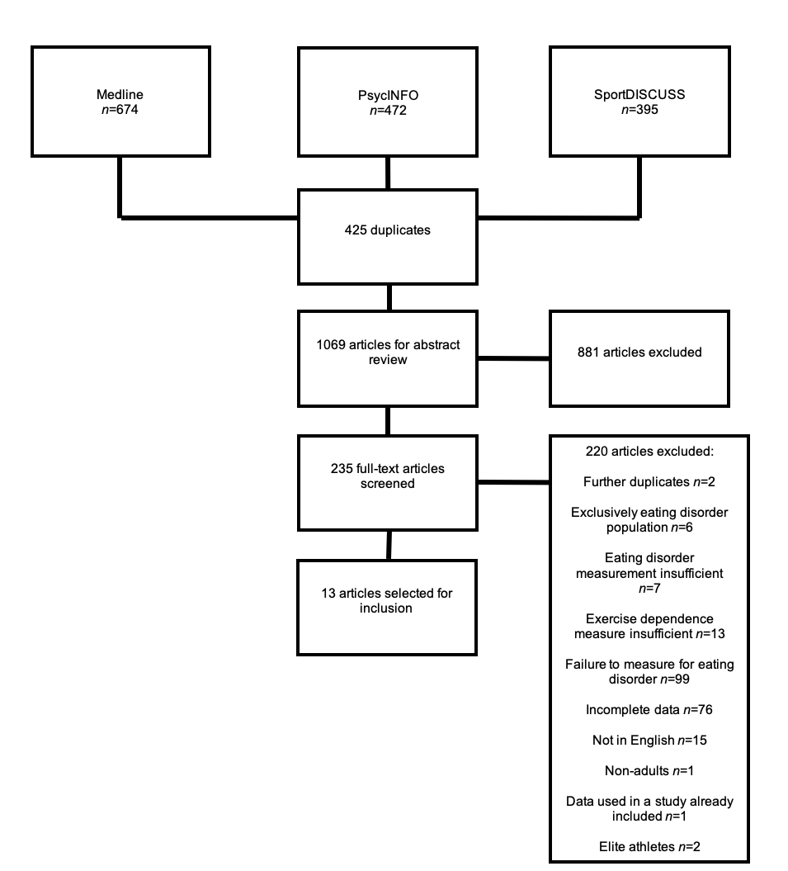

Figure 1: Prisma flowchart of included studies

Table 2: Description of sub-populations (using the exercise addiction inventory and the exercise dependence scale)
Sub-group | Populations included in sub-group
Generally active population (3 studies) | - Women who were regularly physically active (Gapin et al.⁴⁷)  - Fitness centre members (Menczel et al.⁴⁹)  - Habitual exercisers recruited at fitness clubs (Muller et al.⁵²)
Amateur competitive athletes (2 studies) | - ﻿Runners recruited from running specific social media pages (Di Lodovico et al.⁴⁶)  - Self-identified ‘amateur competitive exercisers’ (Menczel et al.⁴⁹)
University students (3 studies) | - Non-specified undergraduate students (Hausenblas and Downs¹⁵)  - Students in various undergraduate and graduate classes (Meulemans et al.⁵⁰)

3.1 Meta-analysis results

3.1.1 Prevalence proportions of EA without indicated eating disorders across different settings using the EAI and EDS

As shown in Table 3, the highest prevalence of EA was among the general exercisers (8.1%, 95% CI=1.5-34.2%), university students (5.5%; 95%CI=1.4-19.1%), with amateur competitive athletes (5.0%, 95% CI=1.3-17.3%), yielding the lowest prevalence rate. Forest plots for all sub-groups are shown in Figure 2. The average pooled prevalence rate was 6.2% (95% CI 3.0--12.6).

Table 3: Prevalence of exercise addiction in non-ED subjects across different settings using the exercise addiction inventory and the exercise dependence scale.
 |  |  |  | Meta-analysis |  | Heterogeneity | Publication Bias
Sub-group | Number of studies (number of sub-samples) | Number of subjects | Total events | Event Rate | 95% CI | I² | Egger bias and P-value | Trim-and-fill (95%CI) [number of trimmed studies]
Amateur competitive athletes | 2 | 222 | 13 | 5.0% | 1.3-17.3% | 70.765 | NA (too few studies) | NA (Egger bias not significant)
University students | 3 | 853 | 52 | 5.5% | 1.4-19.1% | 94.761 | 7.718 p=0.308 | NA (Egger bias not significant)
General exercisers (non-athletes) | 2 | 1485 | 46 | 8.1% | 1.5-34.2% | 95.856 | NA (too few studies) | NA (Egger bias not significant)
Average across groups | 6 (7) | 2560 | 111 | 6.2% | 3.0--12.6% | 92.545 | 1.016 p=0.800 | NA (Egger bias not significant)

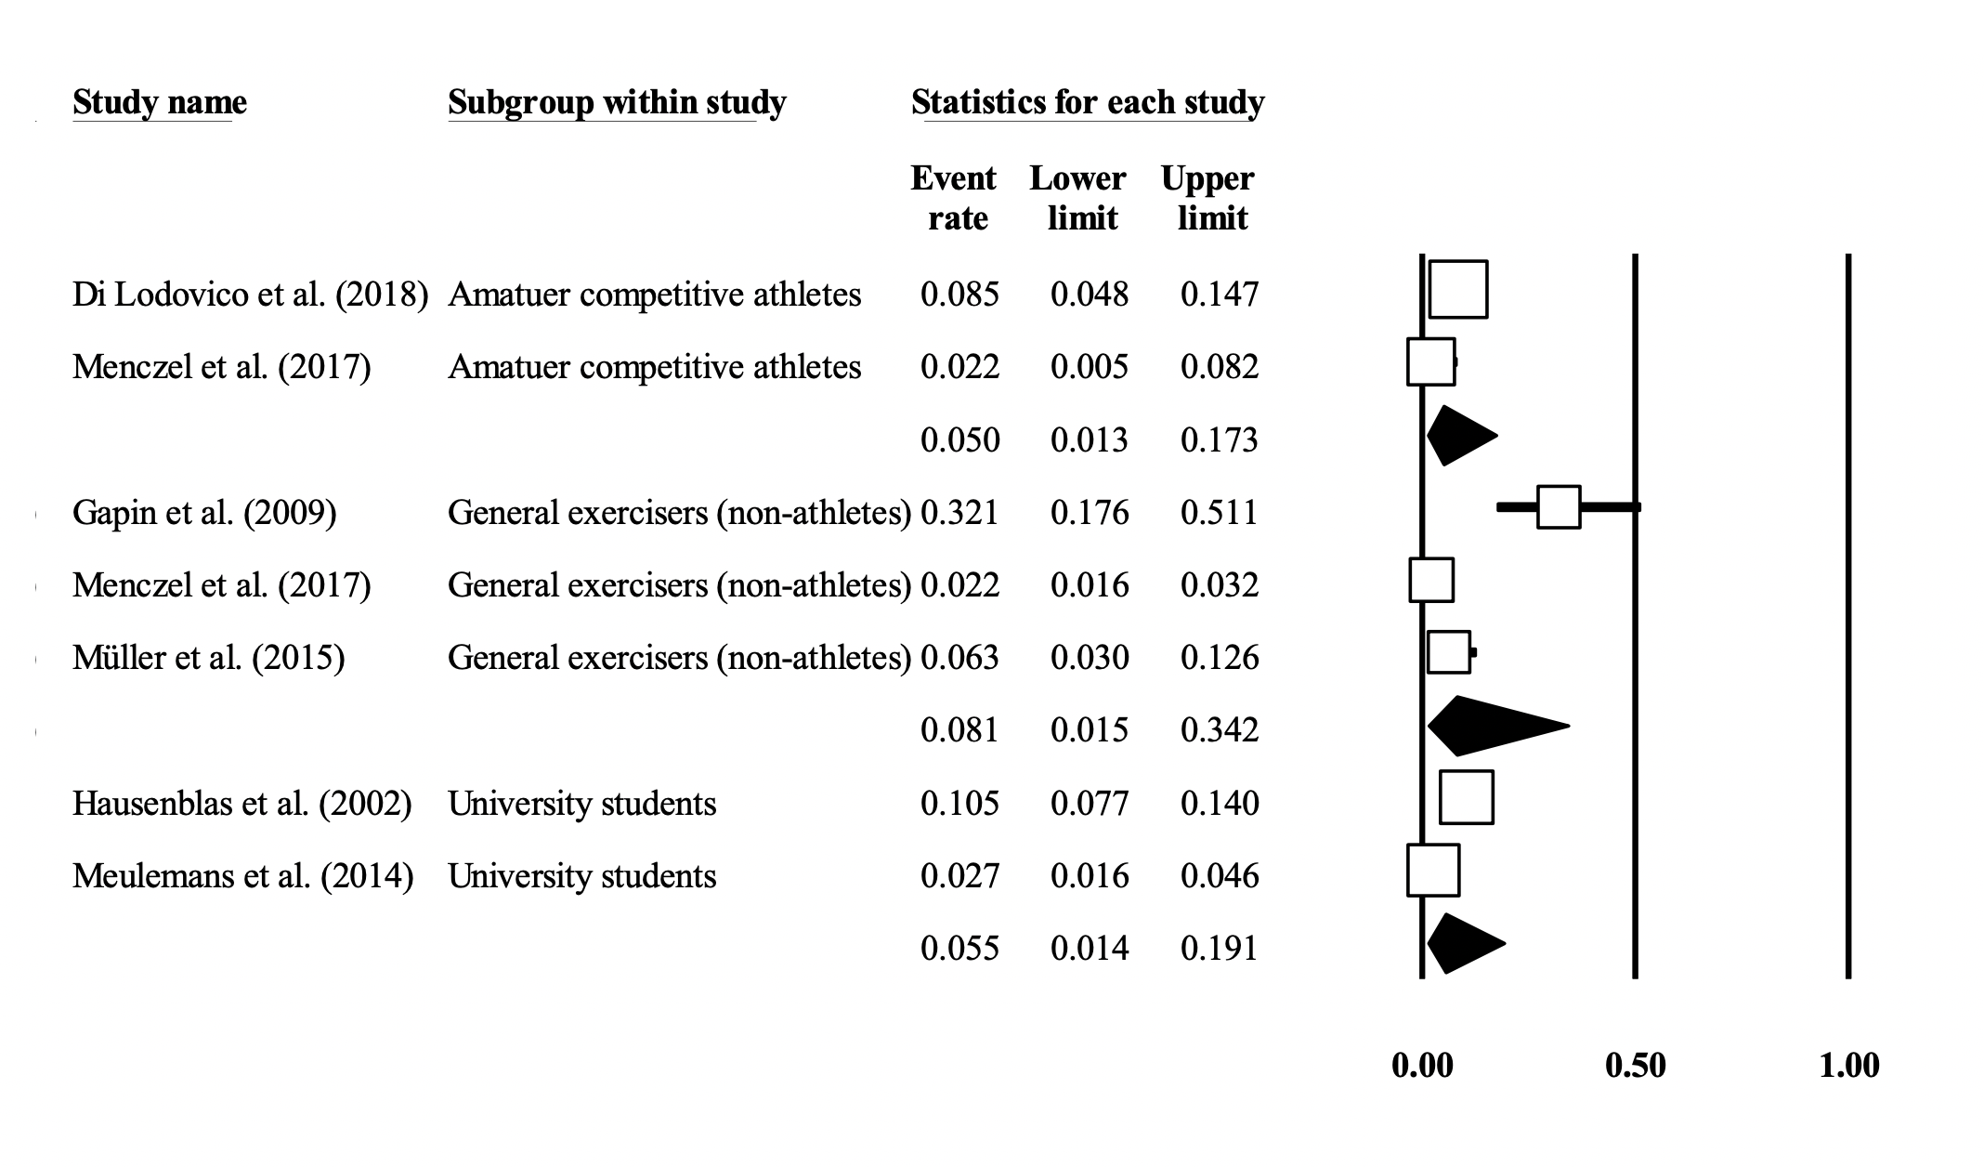
Figure 2: Forest plot showing exercise addiction (as measured by the exercise addiction inventory and the exercise dependence scale) without indicated eating disorders prevalence rates by sub-population group

3.1.2 Sensitivity analysis

The overall prevalence rates were not changed by the sensitivity analysis, with prevalence rates ranging from 4.6-7.5%, with no studies having a large effect on the magnitude of results.

3.1.3 Prevalence proportions of EA without indicated eating disorders across differing measuring tools

As shown in Table 4, the highest prevalence of EA was among samples using the OEQ (29.9%, 95% CI=20.2-41.9%), followed by the EDQ (29.7%, 95% CI=20.9-40.3%), the EAI (17.1%, 95% CI=4.50.3%), with the EDS showing the lowest prevalence rate (4.1%, 95% CI= 1.8-8.9). Forest plots for all sub-groups are shown in Figure 3.

Table 4: Prevalence of exercise addiction in non-eating disordered subjects by measurement tool
 |  |  |  | Meta-analysis |  | Heterogeneity | Publication Bias
Sub-group | Number of Studies | Number of subjects | Total events | Event Rate | 95% CI | I² | Egger bias and P-value | Trim-and-fill (95%CI) [number of trimmed studies]
Obligatory Exercise Questionnaire | 3 | 482 | 133 | 29.9% | 20.2-41.9% | 83.004 | 4.012 p=0.65 | NA (Egger bias not significant)
Exercise Dependence Questionnaire | 4 | 593 | 156 | 29.7% | 20.9-40.3 | 82.944 | 8.907 p=0.08 | NA (Egger bias not significant)
Exercise Addiction Inventory | 2 | 157 | 20 | 17.1% | 4.0-50.3% | 90.042 | NA (not enough studies) | NA (Egger bias not significant)
Exercise Dependence Scale | 5 | 2403 | 91 | 4.1% | 1.8-8.9% | 91.912 | -1.903 p=0.69 | NA (Egger bias not significant)

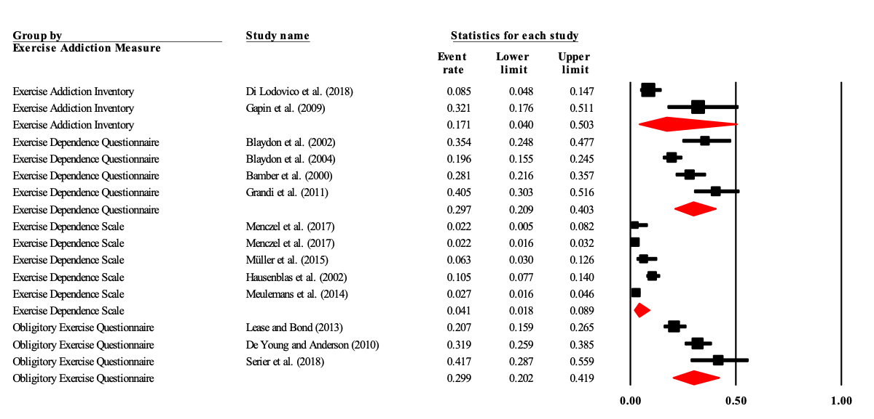Figure 3: Forest plot showing non-eating disordered exercise addiction prevalence rates by measurement tool

3.2 Measured correlates of EA (measured using the EAI and EDS) without indicated eating disorders

All data including p-values, 95% CIs and demographic data have been reported where available. All studies were cross-sectional in study design.

3.2.1 Negative psychological behavioural correlates

Wellbeing

Menczel et al.⁴⁹ explored, in their study of both people who use health clubs and amateur competitive exercisers, correlations between EA without associated eating disorders and wellbeing using the WHO Well-Being Questionnaire⁵⁹. They found a statistically significant negative correlation between EA amateur competitive exercisers and wellbeing (r= -0.204, p=0.049; no reported adjustments), with no such correlation being found in recreational exercisers, with no other statistically significant correlations.

Self-esteem

Menczel et al.⁴⁹ explored self-esteem and EA without indicated eating disorders using the Rosenberg self-esteem scale⁶⁰ and found that having EA was a significant correlate of higher self-esteem scores (F=13.211, p<0.001; no reported adjustments).

3.2.3 Physiological correlates

Gapin et al.⁴⁷ explored, in their study comprising of regularly active women, differences in frontal brain asymmetry in EA vs a non-EA control group. Their regression analysis found that exercise dependence was a suggestive predictor of frontal brain asymmetry (F (1,27) = 6.4, p=0.05; no reported adjustments), with greater left frontal brain activity correlated with higher EA scores.

4. Discussion

The current meta-analysis of the six studies that used either the EAI or EDS to measure EA demonstrated that prevalence rates of EA varied depending on the population, with the lowest prevalence among amateur competitive athletes (5.0%), followed by university students (5.5%), with general exercisers yielding the highest prevalence rates (8.1%). One should note however that all subgroups had low numbers of individual studies and further estimates are needed to produce reliable results for specific populations. The meta-analysis also demonstrated that overall EA prevalence rates differed depending on the measurement tool, with the OEQ yielding the highest prevalence rates (29.9%), followed by the EDQ (29.7%), the EAI (17.1%), with the EDS showing the lowest prevalence rate (4.1%). A number of potential correlates have been assessed, showing significant differences between EA and non-EA control groups. EA subjects were more likely to have lower levels of overall wellbeing (only in amateur competitive athletes), higher anxiety levels, and have greater frontal brain activity.

Our stratified prevalence estimates were lower than a recent meta-analysis by Di Lodovico and colleagues²² (e.g. amateur competitive athletes 5.0% vs 10.4-15.3%). This concurs with the current literature suggesting that subjects without ED symptomology score lower on measures of EA than their ED symptomology counterparts^{23,24}, which could be skewing overall EA prevalence rates if no eating disorder stratification is being used. Interestingly, several studies in this review were excluded due to failure to screening for EDs (n=90). It is recommended that all future studies should attempt to make this stratification so that true prevalence rates can be determined. It is possible that primary and secondary EA are separate conditions with differing aetiologies, and as such need to be stratified routinely. Currently no single measurement tool exists that is able to distinguish between EA with and without indicated eating disorders; currently two questionnaires need to be administered. Future research that focuses on creating a measurement tool that encompasses a valid EA measure and eating disorder screening tool would be highly beneficial.

This meta-analysis also showed that reported EA prevalence rates were different depending on the measurement tool used. The two tools that used underlying addiction theory (EDS and EAI) yielded considerably lower prevalence rates than the EDQ and OEQ. Although this could have been because of the differing populations being studied, the authors agree with Szabo et al.⁷ in that it is more likely because the measurement tools are measuring different aspects of EA, with only the EAI and EDS broadly measuring the same thing. It is therefore recommended that any future research in EA prevalence utilise either the EDS or EAI as an EA measurement tool, as well as screening for EDs.

If EA can lead to decreases in the quality of life, as suggested by various case studies^{4,61}, then further research is warranted: specifically, qualitative investigation to explore to what extent scoring above a quantitative threshold on an EA measurement tool decreases quality of life in subjects without indicated eating disorders. This would add a great deal of insight into this phenomenon, as it is not currently known to what extent EA decreases a subject’s quality of life. Qualitative investigations have been conducted on EA subjects, however very few have explicitly tested for, and/or interviewed for, eating disorder symptomology. One such qualitative assessment⁶² quantitively explored EA four groups, EA without indicated eating disorders, EA with indicated eating disorders, non-EA without indicated eating disorders and non-EA with indicated eating disorders, and concluded that all subjects with apparent EA without indicated eating disorders either had false-negative results in the eating disorder screen, or showed healthy exercise behaviours (indicating a false-positive on the EA screen), and were thus deemed non-EA, leading to the authors’ overall conclusion that EA may not exist independently of eating disorders. More research exploring interviews of suspected EA subjects is critical to confirming or refuting this hypothesis.

The correlates measured indicate that there are some negative psychological symptoms associated with EA without indicated eating disorders, including higher levels of anxiety compared to control groups. Exercise has been consistently shown to lower anxiety levels^{63,64}, because of the release of b-endorphins⁶⁵, therefore subjects could be exercising to alleviate symptoms of anxiety. Furthermore, these higher levels of anxiety are have also been shown in subjects with eating disorders compared to controls^{28,29}. One clear finding from this study is that there is currently a lack of empirical studies that measure correlates of EA while also stratifying subjects without eating disorders. It has been suggested in a recent review that EA in populations with and without indicated eating disorders may have largely different prevalence rates and also may have differing underlying aetiologies⁶⁶. It is recommended that further research in the EA domain focus on stratifying these two populations to provide evidence of different aetiologies.

4.1 Limitations

While this meta-analysis is the first to measure EA prevalence rates in adults without indicated eating disorders, the findings should be considered within the limitations of this study. The heterogeneity of population groups and measurement tools, and the exclusion of subjects with indicated eating disorders, mean that this should only be considered a broad overview. In the meta-analysis, there were high levels of heterogeneity that could not be explained. Moreover, the sub-groups had a limited number of subjects, and very low numbers of studies, which limits the statistical power of prevalence rates and limits the power of conclusions. We also did not have a complete set of demographical data, which was relevant as a complete set of data would have added statistical power to the meta-regressions, meaning that we are unsure whether demographics are true moderators of EA. A further limitation is potential eating disorder under-reporting in the exercising population. Several studies have shown that questionnaire-based eating disorder screening tools can increase the occurrence of false-negative results, particularly in athletic populations⁶⁷. Given that studies including EA subjects with indicated eating disorders have shown higher prevalence rates than reported in this meta-analysis^{23,52}, this could have increased our prevalence rates.

4.2 Directions for future research

Qualitative investigation is warranted to explore to what extent EA decreases quality of life, or whether or not EA truly exists in the absence of eating disorders. Moreover, currently no EA measurement tool exists that incorporates an effective screen for eating disorders. The creation and validation of such tool could make the stratification of EA easier. In the absence of such a consolidatory tool, the authors recommend either the EAI or EDS as a means of EA measurement, as well as an ED screening tool to stratify primary and secondary EA. Furthermore, primary studies are needed in several population groups with numerous subjects to determine more accurate prevalence rates and correlates in sub-populations.

5. Conclusion

EA appears to be prevalent in exercisers without indication of eating disorders. Furthermore, it is possible that EA measurement tools are measuring different aspects of the same phenomenon, making comparison of results difficult. Moreover, some negative psychological symptoms are associated with EA independent of eating disorders. Because of the very small number of studies included, and the heterogeneity of the measurement tools and studies, more primary studies using homogenous measurement tools and exploring correlates would be beneficial. It is recommended that all future EA prevalence research include an eating disorder screen to add clarity to sub-populations and identify possible secondary EA. Further research comparing the underlying experiential aspects of exercise engagement in subjects with and without EA in indicated and no-indicated eating disordered samples would greatly add to the understanding of this phenomenon.

6. References

1. Caspersen CJ, Powell KE, Christenson GM. Physical activity, exercise, and physical fitness: definitions and distinctions for health-related research. Public Health Rep. 1985;100(2):126-126.
2. Department of Health. Physical Activity Guidelines for Adults (19-64 years). 2011. https://assets.publishing.service.gov.uk/government/uploads/system/uploads/attachment_data/file/213740/dh_128145.pdf. Accessed January 10, 2019.
3. Landolfi E. Exercise addiction. Sports Med. 2013;43(2):111-119. doi:10.1007/s40279-012-0013-x
4. Griffiths M. Exercise addiction: A case study. Addict Res. 1997;5(2):161-168.
5. Leuenberger A. Endorphins, exercise, and addictions: a review of exercise dependence. Prem J Undergrad Publ Neurosci. 2006;3:1-9.
6. Adams J. Understanding exercise dependence. J Contemp Psychother. 2009;39(4):231.
7. Szabo A, Griffiths MD, de La Vega Marcos R, Mervó B, Demetrovics Z. Methodological and Conceptual Limitations in Exercise Addiction Research. Yale J Biol Med. 2015;88(3):303-308.
8. Berczik K, Szabó A, Griffiths MD, et al. Exercise addiction: symptoms, diagnosis, epidemiology, and etiology. Subst Use Misuse. 2012;47(4):403-417.
9. de Coverley Veale DM, Veale DMWD. Exercise dependence. Br J Addict. 1987;82(7):735-740.
10. Veale D. Does primary exercise dependence really exist. Exerc Addict Motiv Particip Sport Exerc. 1995:1-5.
11. American Psychiatric Association. Diagnostic and Statistical Manual of Mental Disorders (DSM-5®). American Psychiatric Pub; 2013.
12. World Health Organization. International classification of diseases for mortality and morbidity statistics (11th Revision). 2018. https://icd.who.int/browse11/l-m/en. Accessed January 1, 2020.
13. Terry A, Szabo A, Griffiths M. The exercise addiction inventory: A new brief screening tool. Addict Res Theory. 2004;12(5):489-499. doi:10.1080/16066350310001637363
14. Brown RIF. Some contributions of the study of gambling to the study of other addictions. In: Eadington W, Cornelius J, eds. Gambling Behavior and Problem Gambling. Nevada: Commercial Gaming, University of Nevada; 1993:241-272.
15. Hausenblas HA, Downs DS. How much is too much? The development and validation of the exercise dependence scale. Psychol Health. 2002;17(4):387-404. doi:10.1080/0887044022000004894
16. American Psychiatric Association. Diagnostic and Statistical Manual of Mental Disorders IV. 4th ed. Washington, DC; 2000.
17. Pasman L, Thompson JK. Body image and eating disturbance in obligatory runners, obligatory weightlifters, and sedentary individuals. Int J Eat Disord. 1988;7(6):759-769. doi:10.1002/1098-108X(198811)7:6<759::AID-EAT2260070605>3.0.CO;2-G
18. Blumenthal JA, O’Toole LC, Chang JL. Is running an analogue of anorexia nervosa?: An empirical study of obligatory running and anorexia nervosa. JAMA. 1984;252(4):520-523.
19. Ogden J, Veale D, Summers Z. The development and validation of the Exercise Dependence Questionnaire. Addict Res. 1997;5(4):343-355. doi:10.3109/16066359709004348
20. Lease HJ, Bond MJ. Correspondence between alternate measures of maladaptive exercise, and their associations with disordered eating symptomatology. J Behav Addict. 2013;2(3):153-159. doi:10.1556/JBA.2.2013.012
21. Cunningham HE, Pearman 3rd S, Brewerton TD. Conceptualizing primary and secondary pathological exercise using available measures of excessive exercise. Int J Eat Disord. 2016;49(8):778-792. doi:10.1002/eat.22551
22. Di Lodovico L, Poulnais S, Gorwood P. Which sports are more at risk of physical exercise addiction: A systematic review. Addict Behav. 2019;93:257-262.
23. Bratland-Sanda S, Sundgot-Borgen J, Rø Ø, Rosenvinge JH, Hoffart A, Martinsen EW. Physical activity and exercise dependence during inpatient treatment of longstanding eating disorders: an exploratory study of excessive and non-excessive exercisers. Int J Eat Disord. 2010;43(3):266-273. doi:10.1002/eat.20769
24. Dalle Grave R, Calugi S, Marchesini G. Compulsive exercise to control shape or weight in eating disorders: prevalence, associated features, and treatment outcome. Compr Psychiatry. 2008;49(4):346-352. doi:10.1016/j.comppsych.2007.12.007
25. Bamber DJ, Cockerill IM, Rodgers S, Carroll D. Diagnostic criteria for exercise dependence in women. Br J Sports Med. 2003;37(5):393-400. doi:10.1136/bjsm.37.5.393
26. Lichtenstein MB, Hinze CJ, Emborg B, Thomsen F, Hemmingsen SD. Compulsive exercise: links, risks and challenges faced. Psychol Res Behav Manag. 2017;10:85-95. doi:10.2147/PRBM.S113093
27. Phillips KA. The Broken Mirror: Understanding and Treating Body Dysmorphic Disorder. Oxford University Press, USA; 2005.
28. Cassin SE, von Ranson KM. Personality and eating disorders: a decade in review. Clin Psychol Rev. 2005;25(7):895-916.
29. Pallister E, Waller G. Anxiety in the eating disorders: Understanding the overlap. Clin Psychol Rev. 2008;28(3):366-386.
30. Von Elm E, Altman DG, Egger M, et al. The Strengthening the Reporting of Observational Studies in Epidemiology (STROBE) statement: guidelines for reporting observational studies. PLoS Med. 2007;4(10):e296-e296.
31. Liberati A, Altman DG, Tetzlaff J, et al. The PRISMA statement for reporting systematic reviews and meta-analyses of studies that evaluate health care interventions: explanation and elaboration. PLoS Med. 2009;6(7):e1000100-e1000100.
32. Wells GA, Shea B, O’connell D, et al. The Newcastle-Ottawa Scale (NOS) for assessing the quality of nonrandomised studies in meta-analyses. Ottawa (ON): Ottawa Hospital Research Institute; 2009. 2009.
33. Borenstein M, Hedges L, Higgins J, Rothstein H. Comprehensive Meta Analysis. Englewood, NJ: Biostat; 2013.
34. Cochran WG. The combination of estimates from different experiments. Biometrics. 1954;10(1):101-129.
35. Higgins JP, Thompson SG. Quantifying heterogeneity in a meta‐analysis. Stat Med. 2002;21(11):1539-1558.
36. Higgins JP, Thompson SG, Deeks JJ, Altman DG. Measuring inconsistency in meta-analyses. Bmj. 2003;327(7414):557-560.
37. Begg CB, Mazumdar M. Operating Characteristics of a Rank Correlation Test for Publication Bias. Biometrics. 1994. doi:10.2307/2533446
38. Egger M, Smith GD, Schneider M, Minder C. Bias in meta ­ analysis detected by a simple, graphical test. BMJ. 1997. doi:10.1136/bmj.315.7109.629
39. Fu R, Gartlehner G, Grant M, et al. Conducting quantitative synthesis when comparing medical interventions: AHRQ and the Effective Health Care Program. J Clin Epidemiol. 2011;64(11):1187-1197.
40. Sterne JA, Egger M, Moher D. Addressing reporting biases. Cochrane Handb Syst Rev Interv Cochrane Book Ser. 2008:297-333.
41. Duval S, Tweedie R. Trim and fill: A simple funnel-plot-based method of testing and adjusting for publication bias in meta-analysis. Biometrics. 2000. doi:10.1111/j.0006-341X.2000.00455.x
42. Bamber D, Cockerill IM, Carroll D. The pathological status of exercise dependence. Br J Sports Med. 2000;34(2):125–132. doi:10.1136/bjsm.34.2.125
43. Blaydon MJ, Lindner KJ. Eating disorders and exercise dependence in triathletes. Eat Disord. 2002;10(1):49-60.
44. Blaydon MJ, Linder KJ, Kerr JH. Metamotivational characteristics of exercise dependence and eating disorders in highly active amateur sport participants. Personal Individ Differ. 2004;36(6):1419-1432. doi:10.1016/S0191-8869(03)00238-1
45. De Young KP, Anderson DA. The importance of the function of exercise in the relationship between obligatory exercise and eating and body image concerns. Eat Behav. 2010;11(1):62-64. doi:10.1016/j.eatbeh.2009.09.001
46. Di Lodovico L, Dubertret C, Ameller A. Vulnerability to exercise addiction, socio-demographic, behavioral and psychological characteristics of runners at risk for eating disorders. Compr Psychiatry. 2018;81:48-52. doi:10.1016/j.comppsych.2017.11.006
47. Gapin J, Etnier JL, Tucker D. The relationship between frontal brain asymmetry and exercise addiction. J Psychophysiol. 2009;23(3):135-142. doi:10.1027/0269-8803.23.3.135
48. Grandi S, Clementi C, Guidi J, Benassi M, Tossani E. Personality characteristics and psychological distress associated with primary exercise dependence: An exploratory study. Psychiatry Res. 2011;189(2):270-275. doi:https://doi.org/10.1016/j.psychres.2011.02.025
49. Menczel Z, Griffiths MD, Vingender I, et al. Exercise dependence in amateur competitors and non-competitor recreational exercisers. Int J Ment Health Addict. 2017;15(3):580-587. doi:10.1007/s11469-016-9661-7
50. Meulemans S, Pribis P, Grajales T, Krivak G. Gender differences in exercise dependence and eating disorders in young adults: a path analysis of a conceptual model. Nutrients. 2014;6(11):4895-4905. doi:10.3390/nu6114895
51. Serier KN, Smith JE, Lash DN, et al. Obligatory exercise and coping in treatment-seeking women with poor body image. Eat Weight Disord EWD. 2018. doi:10.1007/s40519-018-0504-3
52. Müller A, Claes L, Wos K, et al. Temperament and risk for exercise dependence: results of a pilot study in female patients with eating disorders compared to elite athletes. Psychopathology. 2015;48(4):264-269. doi:10.1159/000436978
53. Garner DM, Olmsted MP, Bohr Y, Garfinkel PE. The Eating Attitudes Test: psychometric features and clinical correlates. Psychol Med. 1982;12(4):871-878. doi:10.1017/S0033291700049163
54. Garner DM, Garfinkel PE. The Eating Attitudes Test: An index of the symptoms of anorexia nervosa. Psychol Med. 1979;9(2):273-279.
55. Fairburn CG, Beglin SJ. Assessment of eating disorders: Interview or self‐report questionnaire? Int J Eat Disord. 1994;16(4):363-370.
56. Garner DM. Eating Disorder Inventory 2: Professional manual. Int J Eat Disord. 1991. doi:10.1126/science.278.5336.252
57. Mintz LB, O’Halloran MS, Mulholland AM, Schneider PA. Questionnaire for Eating Disorder Diagnoses: Reliability and Validity of Operationalizing DSM-IV Criteria into a Self-Report Format. J Couns Psychol. 1997. doi:10.1037/0022-0167.44.1.63
58. Morgan JF, Reid F, Lacey JH. The SCOFF questionnaire: assessment of a new screening tool for eating disorders. Bmj. 1999;319(7223):1467-1468.
59. Susánszky É, Konkolÿ Thege B, Stauder A, Kopp M. A WHO Jól-lét Kérdőív rövidített (WBI-5) magyar változatának validálása a Hungarostudy 2002 országos lakossági egészségfelmérés alapján. Mentálhig És Pszichoszomatika. 2006;7(3):247-255.
60. Rosenberg M. Society and the Adolescent Self-Image. Princeton university press; 2015.
61. Warner R, Griffiths MD. A Qualitative Thematic Analysis of Exercise Addiction: An Exploratory Study. Int J Ment Health Addict. 2006;4(1):13-26. doi:10.1007/s11469-006-9000-5
62. Bamber D, Cockerill I, Rodgers S, Carroll D. “It’s exercise or nothing”: a qualitative analysis of exercise dependence. Br J Sports Med. 2000;34(6):423-430.
63. Petruzzello SJ, Landers DM, Hatfield BD, Kubitz KA, Salazar W. A meta-analysis on the anxiety-reducing effects of acute and chronic exercise. Sports Med. 1991;11(3):143-182.
64. De Moor MHM, Beem AL, Stubbe JH, Boomsma DI, De Geus EJC. Regular exercise, anxiety, depression and personality: a population-based study. Prev Med. 2006;42(4):273-279.
65. McNally GP, Akil H. Role of corticotropin-releasing hormone in the amygdala and bed nucleus of the stria terminalis in the behavioral, pain modulatory, and endocrine consequences of opiate withdrawal. Neuroscience. 2002;112(3):605-617.
66. Trott M, Jackson SE, Firth J, et al. A comparative meta-analysis of the prevalence of exercise addiction in adults with and without indicated eating disorders. Eat Weight Disord - Stud Anorex Bulim Obes. 2020. doi:10.1007/s40519-019-00842-1
67. Sundgot-Borgen J, Torstveit MK. Prevalence of eating disorders in elite athletes is higher than in the general population. Clin J Sport Med. 2004;14(1):25-32.

