Developmental trajectories of control of verbal and non-verbal interference in speech comprehension in monolingual and multilingual children

Roberto Filippi^{1,3}, Andrea Ceccolini³, Eva Periche-Tomas^{1,3}, Andriani Papageorgiou^{1,3}, Peter Bright^{2,3}

¹ University College London, UCL - Institute of Education, London
² Anglia Ruskin University, Cambridge
³ Multilanguage and Cognition Lab, UCL - Institute of Education, London

Corresponding author:
Dr Roberto Filippi
University College London – Institute of Education
Department of Psychology and Human Development
25, Woburn Square
London – WC1H 0AA
Contact details:
r.filippi@ucl.ac.uk

Keywords: bilingualism, control of interference, sentence comprehension, inhibitory control, selective attention, executive functions, cognitive development, cognitive reserve, bilingual advantage, cluster analysis.

Acknowledgements
This work was supported by the Leverhulme Trust UK [RPG-2015-024]. A special thought goes to Prof. Annette Karmiloff-Smith who inspired our work. We also thank the head teachers of the Histon & Impington Junior School in Cambridge and the Monken Hadley primary school in London, their staff, the children and the parents who enthusiastically helped us to carry out this research.

Abstract
Research on speech comprehension in noise indicates that a multilinguistic experience may confer advantages in filtering out verbal interference, an effect observed both in children acquiring two or more languages since birth (Filippi, Morris, Richardson, et al., 2015) and in second language learner adults (Filippi, Leech, Thomas, et al., 2012). A possible interpretation for this advantage is that the multilingual mind is "trained" to control interference from the language not in use. This constant effort may support optimization of cognitive resources that are necessary for successfully selecting, processing and interpreting complex linguistic information. The present study aimed to extend this line of research by including a non-verbal interference condition. 209 typically developing children (132 English monolinguals and 77 multilinguals from different linguistic backgrounds) carried out a sentence interpretation task in the presence of verbal and non-verbal interference. We found no evidence for a reliable group difference in our data. Instead, findings indicated that background cognitive ability and socioeconomic status were the best indicators of successful control of interference, irrespective of whether participants were bilingual or monolingual. These findings are discussed in the light of previous research and, more widely, on the account of the current debate on the bilingual advantage.

Introduction

Decades of research in the field of second language acquisition and its effects on cognitive development has provided conflicting results. The early view typically maintained that bilingualism was detrimental for cognitive development (e.g., Saer, 1923), but evidence later emerged that, when bilinguals were more rigorously matched and compared with monolinguals, they actually performed better on a range of cognitive measures (e.g., Peal & Lambert, 1962). In the last thirty years, research in this field has become more systematic and new evidence has been provided in favor of what is called the bilingual advantage (e.g., Bialystok, 2009). The advantage is marked by more efficient performance in non-verbal tasks measuring components of executive function, that is, inhibitory control, shifting and updating (see Bialystok 2017 for a more exhaustive review and Miyake, Friedman, Emerson, et al. 2000 for a detailed account of executive function).
A possible interpretation of the bilingual advantage derives from evidence indicating that all known languages are active in a bilingual/multilingual mind (e.g., Dijkstra 2005). Therefore, multilingual speakers must use an effective mechanism in order to suppress the unwanted language and activate the target one. It is through this constant brain workout that bilingual speakers may enhance some crucial components of the cognitive system, such as selective attention and cognitive control (Green, 1986, 1998). Hence, bilingual speakers have been observed to outperform monolingual speakers in non-verbal tasks that require rapid switching between rules, suppression of irrelevant information, monitoring and updating changes in voluntary behavior and control of interference (Bialystok, 2017).
Challenges to the bilingual advantage hypothesis

In the last decade, there has also been growing controversy around the claims of the bilingual advantage with an increasing number of studies showing null results (e.g., Duñabeitia, Hernandez, Anton, et al., 2014; Paap & Greenberg, 2013; Paap, Johnson & Sawi, 2014). Factors such as immigration status (Kousaie & Phillips, 2012), language history, socioeconomic status (Naeem, Filippi, Periche-Tomas, Papageorgiou & Bright, 2018; Morton & Harper, 2007), intelligence and culture (Yang, Yang, & Lust, 2011), which were not always included in earlier studies have been cited as having potentially confounding effects (Lehtonen et al., 2018). In their meta-analysis of results from non-verbal interference tasks, Hilchey and Klein (2011) found that bilingual advantages in executive control tend to occur in studies with small samples while null results were more likely with larger samples. Some authors have also argued that studies showing statistically significant results are more likely to be published, leading to an element of publication bias (de Bruin, Treccani, & Della Sala, 2015a; Lehtonen, Soveri, Jarvenpaa, Jarvenpaa, Antfolk, & de Bruin, 2018).
Control of auditory verbal interference
Most of the evidence on the bilingual advantage has been provided in studies using visual non-verbal stimuli, such as classic executive function tasks like the Simon task, flanker task or ANT task (see Filippi, D'Souza & Bright, 2018, for a review). Given that multilinguals routinely communicate in multilanguage environments, it is important to understand the impact of second language acquisition on auditory processing. The first studies addressing the question of control of non-verbal auditory interference provided evidence for a bilingual disadvantage. For example, Mayo, Florentine and Buus (1997) and Shi (2010), reported that bilingual speakers' sentence comprehension was significantly impaired in the presence of non-verbal interference (see Ouzia & Filippi, 2016, for a review). However, more recent studies have shown that bilingual speakers may have an advantage in filtering out verbal interference in a sentence comprehension task. In two separate studies involving adults and children, bilingual speakers outperformed monolinguals in comprehending non-canonical sentences (Object-Verb-Subject sentences like the cat is bitten by the dog) in the presence of linguistic interference (Filippi et al., 2012, 2015). These studies also indicated a non-significant difference between the two groups when the target sentences were canonical (e.g., Subject-Verb-Object, like the dog bites the cat). It was concluded that the bilingual speakers' possible advantage in control of auditory verbal interference may occur when the task is particularly demanding (e.g., comprehension of more difficult sentences) showing more efficient selective attention.
These studies were particularly important for several reasons: 1) they shed new light on a possible bilingual advantage in the auditory domain; 2) they were the first using a speech-comprehension paradigm adapted from cross-linguistic research (Bates, McNew, MacWhinney, et al., 1982) with the aim to increase ecological validity (i.e., moving away from classic lab tasks in which participants have to perform in situation that can be hardly replicated in real life); 3) findings have shown that children acquiring two or more languages since birth and adult late second language learners were more accurate than monolingual speakers in comprehending speech in the presence of verbal interference; 4) this effect was significant only when the task was more demanding, such as requiring comprehension of non-canonical sentences; 5) the effect was observed both with a specific linguistic group (i.e., Italian/English adult bilinguals) and with children from diverse multilinguistic backgrounds (e.g., simultaneously acquiring English plus one or more languages from 16 different linguistic groups across the world). However, these studies also had caveats: Although participants were carefully matched on age and SES, the samples were relatively small. Additionally, the paradigm contained only linguistically meaningful auditory interference.
The current study
In the present study we focus on childhood/adolescence and address these caveats in three key ways: 1) by employing a developmental approach with the aim to build a developmental trajectory in a cross-sectional design (see Filippi, D'Souza & Bright, 2018, for discussion); 2) by testing a larger sample of English monolingual and multilingual children from different linguistic backgrounds aged 7 to 12 years old; 3) by introducing non-verbal noise as an added experimental condition.
Therefore, the aim of the study was to investigate candidate mechanisms driving the previously observed enhancement in interference control. Specifically, we wanted to establish the extent to which these previously observed advantages are reliable, the age at which they emerge and whether they extend throughout childhood/early adolescent development. We focus on accuracy with non-canonical sentences because previous studies have shown that bilinguals and monolinguals have comparable performance when processing canonical sentences and also have comparable performance in response time for both canonical and non-canonical sentences.
Five main questions were addressed:
1) Are multilingual children more accurate than monolingual peers in comprehending non-canonical sentences in the presence of auditory verbal and non-verbal interference?
2) Within the verbal interference condition, can sentence comprehension accuracy be impaired by the familiarity of the interfering language?
3) Within the non-verbal interference condition, can sentence comprehension accuracy be impaired by the association between the non-canonical sentence and congruency of the sound paired with the subject of the each sentence?
4) If the bilingual advantage is observed, at what age in childhood/early adolescence does it emerge?
5) Are there other factors, such as, for example, differences in linguistic experience or socio-economic status, that can explain possible differences in children's performance?
Predictions
1) In line with previous findings, it was predicted that multilingual children would be more accurate than monolingual peers in comprehending non-canonical sentences in the presence of both types of interference (verbal and non-verbal). In particular, their ability to control interference would be better when processing non-canonical sentences in the presence of English interference (the familiar language), which is deemed to be the most challenging experimental condition.
2) The ability to control interference would improve through development in both groups. However, the multilingual group would show better resilience to interference with this effect commencing at an earlier age.

Methods

Participants
Two-hundred and nine (209) typically developing children took part in this study. Their age ranged from 7 to 12 years old (see Table 1 for the age breakdown and gender details). One-hundred and thirty-two children were English monolinguals and seventy-seven were bilinguals/multilinguals of different linguistic backgrounds. As one of the experimental questions addressed sentence comprehension in the presence of an unfamiliar language, that is, Greek, none of the children spoke or had ever been exposed to Greek language at the time of testing.
Their parents completed an online questionnaire designed to establish demographic, socio-economic and linguistic information. Within the multilingual sample, all children were reported to be highly proficient in a second language, using it on a daily basis at home and with the extended family. Twenty-five children were reported to be exposed to a third or a fourth language, although their level of competence in these languages was considered lower. A list of all languages is reported in Appendix I, Table A.
All multilingual children had been exposed to a second language either from birth (N=51) or within the first 5 years of life (N=26). All monolingual children reported a basic knowledge of French or Spanish learned at school. However, they did not report daily exposure or use of foreign language, nor the ability to hold a basic conversation in a language other than English.

Table 1: Total number of participants divided by age group (in years) and gender.
Age Group | Monolinguals |  |  | Multilinguals |  |  |  | Tot. Monol. |  | Tot. Mult.
 | Males | Females | Mean age | Males | Females |  | Mean age
7-8 | 9 | 8 | 7.6(0.2) | 11 | 6 |  | 7.6(0.3) |  | 17 |  | 17
8-9 | 14 | 15 | 8.3(0.3) | 7 | 7 |  | 8.4(0.3) |  | 29 |  | 14
9-10 | 13 | 11 | 9.3(0.3) | 10 | 7 |  | 9.4(0.2) |  | 24 |  | 17
10-11 | 25 | 19 | 10.4(0.2) | 8 | 10 |  | 10.3(0.2) |  | 44 |  | 18
11-12 | 11 | 7 | 11.4(0.4) | 6 | 5 |  | 11.6(0.4) |  | 18 |  | 11

Parents also provided socio-economic status information indicating their highest level of parental education, employment and household income. Each of them received a score depending on their level of academic achievement (i.e., 1=no formal/primary, 2=secondary, 3=undergraduate, 4=post-graduate, 5=doctorate). They also received a score from 1 to 4 depending on their occupation (unemployed, part-time, full-time, retired), and a score from 1 to 6 depending on their total household income (from less than £20,000 to more than £100,000). Scores were averaged to create a composite SES score.

Procedure and materials
The experimental battery was conducted on an ASUS laptop, mouse, standard keyboard, and a Technopro ® USB gamepad that was adapted with black, red, blue, and green colour stickers. Auditory tasks used Sennheiser HD 201 over ear headphones. All instructions were given in English.
Ethics approval for this study was granted by the university committee. Only the children whose parents returned written informed consent were included in the sample. All children were tested in quiet room made available in three primary schools, two in London and one in the Cambridge area. All children gave their verbal consent before starting the session.

They were all assessed on a range of background measures, including:
1. Non-verbal reasoning: Raven’s Advanced Progressive Matrices Set 1.
Participants completed Raven’s Advanced Progressive Matrices Set I (Raven, Raven, & Court, 1998) consisting of 12 items of increasing complexity. Each item consisted of a 3 x 3 matrix containing eight different black and white designs that are logically related and one piece missing at the bottom right; participants were required to deduce from 8 potential pieces which piece completes the matrix. The number of correct items out of 12 was recorded. Although no time limit was given, all children completed the task within 10 minutes. The average score for each language group was analysed to assess whether the groups are matched on non-verbal reasoning (Filippi et al., 2012; Tao, Taft, & Gollan, 2015).
2. Verbal Working memory: Digit span forwards and backwards.
The 30 digit sequences from the digit span forwards (DSF) and digit span backwards (DSB) subtest of the Wechsler Adult Intelligence Scale—Fourth Edition (WAIS–IV; Wechsler, 2008) were used as a measure of the storage, maintenance, and manipulation components of verbal working memory (Richardson et al., 2011). For presentation consistency the researcher recorded each trial and played the recording via headphones to the participant. Trials began with 2-digit sequences (e.g., 1 – 7) that the participant verbally recalled either forwards or in reverse order (DSF and DSB, respectively). As trials progress the digit sequence gradually increased to nine- (DSF) or eight- (DSB) digits. Testing was terminated if both trials of a number sequence were recalled incorrectly. The number of correct recalls for the DSF and DSB were recorded. The average score for each language group were analysed to assess whether the groups were matched on this measure of working memory. The task lasted approximately 7 minutes.
3. English receptive vocabulary: British Picture Vocabulary Scale
The British Picture Vocabulary Scale: Third edition (BPVS-III; Dunn, Dunn, Whetton & Burley, 1997) consists of 14 sets of words that each contains 12 items. Difficulty levels span from simple words understood by 2 – 3 year olds (e.g., ball, Set 1) to vocabulary that is above the level of an average adult (e.g., lacrimation, Set 14). The researcher orally presented the stimulus word and the participant pointed to one of four images that he/she considered most like that word. All children started with Set 8. If two or more errors were made on the starting set then the researcher established the base set by going back a set until no more than one error was made. Next, a ceiling set was established by presenting the participant with progressively more difficult sets until 8 or more errors were made on a set. Raw scores were calculated as the highest number on the ceiling set minus the total number of errors made during the assessment. Bilingual and monolingual groups were compared on their raw scores. The task lasted approximately 6 minutes.

4. Auditory-motor task
The auditory-motor task was programmed and conducted using E-Prime (version 2.0; Schneider, Eschman, & Zuccoloto, 2007). Thirty-two ‘ping’ sounds were randomly presented through headphones to the left or right ear (16 sounds to each ear). Participants responded to each sound by pressing the corresponding left or right button on a gamepad (i.e., respond to a noise in the left ear by pressing the left button). Sounds were 0.3 s long and were sampled from a Mac OS 10.3 alert noises with a randomised intertrial interval (ITI) duration of 300, 600, or 900 ms. The auditory-motor task was performed to confirm whether participants could hear in each ear and co-ordinate their motor skills to respond on a gamepad. The task lasted approximately 1 minute.
5. Experimental task: control of verbal and non-verbal interference in sentence comprehension
The sentence interpretation task (Filippi et al., 2012, 2015) was programmed and conducted using E-Prime (version 2.0; Schneider et al., 2007). This study extended Filippi et al.’s (2012, 2015) sentence interpretation task by including non-verbal auditory interference as well as the previously used verbal interference. For each sentence, participants were asked to work out which of the two mentioned animals is doing a bad action towards the other (e.g., biting, bumping, pushing). For example, in the sentence “The horse is scared by the owls”, the owls are the bad animal. The animals mentioned in the target sentence simultaneously appeared on the screen, one animal on the left and one on the right; the participant pressed the corresponding left/right button on the gamepad to indicate which animal is being bad. The target sentences were always presented in English language and varied in their syntactic complexity, which altered their cognitive load (Roland, Dick & Elman, 2007). The ‘easy’ canonical sentences (Subject-Verb-Object: S-V-O) are less cognitively demanding than the ‘hard’ non-canonical sentences (Object-Verb-Subject: O-V-S or Object-Subject-Verb: OS-V; Roland et al., 2007). Each of the English target sentences were presented binaurally with one of six levels of audible interference: (1) no interference – control condition, (2) English speaking interference, (3) Greek speaking interference, (4) congruent animal sounds, (5) incongruent animal sounds, (6) unrelated sounds. Both English and Greek interference mentioned one animal doing a bad action toward another animal. A pseudorandom pairing of target and interference sentences ensured that there was no overlap within trials between target animals and actions and interfering animals and actions. Congruent animal sounds matched the ‘bad animal’ in the sentence; incongruent animal sounds matched the ‘victim animal’ in the sentence. Unrelated sounds (e.g., ringing phone, car, train) provided a neutral control to contrast the effects of animal noise congruency.
Participants were instructed that they had to listen to sentences and for each sentence they had to work out which animal featured on the left or right of the screen was doing a bad action towards the other animal. Next, an example was given on paper to check that the participant understood the premise of the task, participants were shown the image in Figure 1 while the experimenter said, “If you heard ‘The bull is being pushed by the cats’ which animal is doing the bad action?”. After the participants pointed towards the cats they were told “the cats are on the right, so you would push the button on the right, but if the animal was on the left you would push the left button”. Next, participants were informed that they were going to have a practice and that they needed to listen to the MALE/FEMALE voice for the whole time, but at times they may hear a voice of the alternative gender or other noises such as animals. Block presentation for the two practice blocks and two experimental blocks were counterbalanced so that half of the participants had a male target voice for the first block and female for the second block and vice versa). After completing two practice blocks of 8 trials each, participants progressed on to the first of two experimental blocks containing 144 trails each. For each trial animal stimuli appeared on the screen for a maximum of 3000 ms or until a response was pressed, then new audio and visual stimuli were presented instantly.
Visual stimuli consisted of black and white animal drawings on a grey background (70 mm x 50 mm) taken from picture databases (Abbate & LaChappelle, 1984; Snodgrass & Vanderwart, 1980). Verbal auditory stimuli were 144 target sentences spoken by an English female, 144 target sentences spoken by an English male, 24 English interference sentences spoken by an English female and 24 English interference sentences spoken by an English male, 24 Greek interference sentences spoken by a Greek female and 24 Greek interference sentences spoken by a Greek male. Verbal stimuli were non-verbal auditory stimuli consisted of 16 animal sounds and four unrelated sounds. Trials were presented in a random order. An illustration of the task is provided in Figure 1.
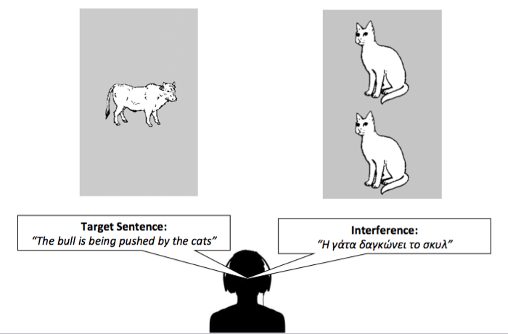
Figure 1: This illustration is an example of what participants heard simultaneously in both ears, namely, a target sentence and interference. Interference could be verbal, an utterance in English or in Greek (a language that was unknown to all participants), and non-verbal. Non-verbal interference could be the sound of the animal agent in the sentence (congruent), the sound of the animal object in the sentence (incongruent) or an unrelated sound (e.g., airplane, train, etc.) The participants' task was to ignore the interference and identify the "animal is doing the bad action” by pressing a button in the direction of the selected animal (right or left).

Design
This was a mixed-design study in which the between-subject factor was Language Group (Monolinguals, Multilinguals) and the within-subject factors were the verbal and non-verbal interference conditions. Ability measures were obtained for the background task: BPVS III, Raven’s and Digit span and response time and accuracy for the auditory-motor task. Accuracy scores were calculated for the sentence interpretation task.

Results

We have adopted two analytical approaches. For consistency with other publications in this field, we first carried out traditional statistics (i.e., t-test, analyses of co-variance). The second approach was based on cluster analysis.

Traditional statistics
First, the results of the background measures, including SES, and auditory-motor task are reported. We then report the results of the sentence interpretation task by examining the role of linguistic experience and chronological age in the control of verbal and non-verbal interference.

Background measures
Age-group score comparisons between monolingual and multilingual children are reported in Table 2. Independent t-tests indicated that both groups had equivalent non-verbal reasoning and working memory skills. Socio-economic status was also statistically equivalent in the two groups suggesting that the two groups were similar in terms of parental education, parental employment and household income.

Table 2: Group scores, standard deviations and t-test results in non-verbal reasoning (Raven's), English vocabulary knowledge (BPVS), short-term and working memory, digit span forward and backward and auditory-motor task(accuracy and response time).

Measure | Monolinguals | SD | Multilinguals | SD | p
Age | 9.5 | 1.2 | 9.4 | 1.4 | p=.36
Raven's Ability scores | 6.8 | 2.4 | 6.4 | 2.6 | p=.26
BPVS Ability scores | 134 | 15.7 | 129 | 20.0 | p=.10*
Digit Span Forward Ability scores | 8.3 | 1.7 | 8.4 | 1.8 | p=.54
Digit Span Backward Ability scores | 5.0 | 1.7 | 5.3 | 2.0 | p=.35
Auditory task Percent correct | 92% | 0.1 | 90% | 0.1 | p=.39
Auditory Task Response time (ms) | 625 | 206 | 629 | 191 | p=.89
Socio-Economic status | 3.0 | 0.8 | 3.2 | 0.7 | p=.12

* Equal variances not assumed (Levene's p=.005).

Sentence interpretation task

Is there a multilingual advantage in comprehending non-canonical (difficult) sentences in the presence of verbal and non-verbal interference. If so, when will this advantage emerge through development?

Means for accuracy and standard deviations for overall performance (including canonical sentences) are reported in Table B in Appendix 1.

We first performed two mixed-factor omnibus ANOVAs for verbal and for non-verbal interference. In both ANOVAs Group was the between-subject factor (monolinguals/multilinguals). The within-group factor, Interference, had three levels (English/Greek/Control) for verbal interference analyses and four factors for non-verbal interference analysis (Congruent/Incongruent/Unrelated/Control).

Control of verbal interference
ANOVA revealed a highly significant main effect of Interference F(2,207)=.138.684, p<.001, η_{p}²⁼.401. To explore this interaction, Bonferroni corrected pair-wise comparisons indicated that both groups were affected by verbal interference as opposed to the control condition without interference (p<.001). The 11.5% mean difference in performance between the English and Greek interference conditions was also significant (p<.001), indicating that the familiar language negatively affected comprehension more than the unfamiliar language.
However, ANOVA did not reveal any statistically significant result for Group differences, F(1,207)=.055, p=.815, η_{p}²<.001, and no reliable interaction between Interference and Group, F(2,206)=.526, p=.591, η_{p}²=.003. These results indicate that both monolingual and bilingual children exhibited comparable performance when comprehending non-canonical sentences in the presence (or absence) of verbal interference.

Control of non-verbal interference
ANOVA revealed a highly significant main effect of Interference F(3,207)=.23.722, p<.001, η_{p}²⁼.103, indicating that both groups were affected by non-verbal interference as opposed to the control condition without interference. Bonferroni-corrected pair-wise comparisons again confirmed best performance in the control condition (average + 6% accuracy, p<.001). All other comparisons were non-significant (p>.05)
ANOVA did not reveal any statistically significant result for Group differences, F(1,207)=.520, p=.472, η_{p}²=.003, and no reliable interaction between Interference and Group, F(3,207)=1.299, p=.274, η_{p}²=.006.
Taken together, the results for both verbal and non-verbal interference indicate that monolingual and bilingual children had comparable performance in all experimental conditions. Consistent with these findings, Bayesian independent t-tests comparing each verbal and non-verbal interference condition across groups indicated that the data were more than five times less likely to occur under the alternative hypothesis than the null hypothesis (BF₁₀ < .19) in all conditions except the unrelated interference condition (BF₁₀ = .49).

The role of age in controlling verbal and non-verbal interference
To explore the role of age between monolinguals and multilingual children in controlling interference, their individual accuracy scores for verbal and non-verbal interference were regressed against their chronological age (Figures 2-6). All trajectories were checked for outliers with Cook’s distance (Cook, 1977) to determine whether a particular data point disproportionately affected regression estimates. No data points approached or exceeded a Cook’s distance of 1, indicating that the models were not unduly influenced by outliers.
The regression analyses revealed that age significantly contributed to predicting comprehension in the presence of all types of verbal and non-verbal interference (p<.001 for both monolingual and bilingual children in all interference conditions).
Fisher r-to-z analysis for comparison between correlation coefficients for each group indicated that the children's developmental trajectories were comparable. All results, including Fisher r-to-z analyses, are reported in Appendix I, Table C.
In summary, ANOVAs revealed that verbal and non-verbal interference affect sentence comprehension performance in all children and there is no statistically significant indication that multilingualism may confer a specific advantage in filtering out irrelevant auditory verbal or non-verbal information. The performance of all children, regardless of their linguistic experience, improves steadily through development showing a comparable pattern in both groups.
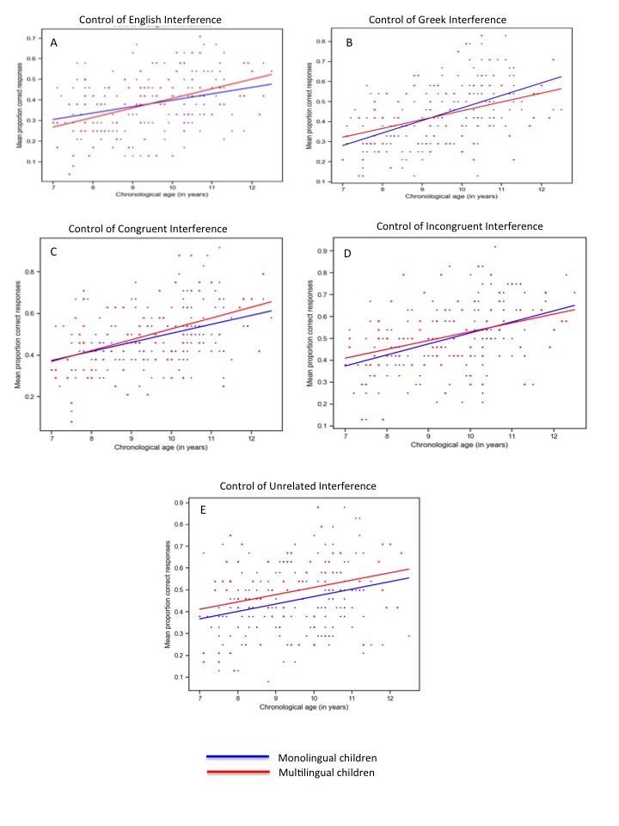
Figure 2: Developmental trajectories for the comprehension of non-canonical sentences in the presence of: A=English interference; B=Greek interference; C=Congruent interference; D=Incongruent interference; E=Unrelated interference. On the y-axis we report mean proportion correct and on the x-axis chronological age (from 7 to 12 years old) .
Cluster Analysis

Are there other factors that can explain possible differences in the children's performance regardless of their linguistic experience?

We employed cluster analysis to explore clustering within our data. Cluster analysis is a descriptive, multivariate statistical technique that aims to group individuals according to their performance characteristics (Mooi & Sarstedt, 2011).
We calculated z-scores for each interference variable prior to analysis to ensure that differences in measurement scales did not influence the results. We used an agglomerative hierarchical clustering approach (Ward’s method, using Euclidean distances) to determine the number of optimal clusters. This approach groups the individuals into clusters so that the variance within a cluster is minimised (based on the distance between individuals’ results). In this bottom-up approach, clusters start from a single individual and are recursively merged to achieve minimal Euclidian distance and the optimal number of clusters.

Control of Verbal Interference
As described in the Methods section, verbal trials were administered using non-canonical sentences comprehension in the presence of English and Greek interference. The clustering analysis revealed three clusters (Table 4 and Figure 3a) from the highest performers to the lowest performers across all variables, respectively. This denotes very consistent performance from the individuals in each group who, on average, performed similarly on all the different variables in the analysis.
Each cluster is represented by a colored spiderweb, where same-color line(s) join the points related to the average experimental results (left chart) or background measures and SES (right chart) for each given cluster. When the spiderweb lines of the different clusters do not overlap or cross with each other, then it means the clusters are fully ordered on the base of their average results.

Table 4: Cluster analysis by mean and standard deviation (in brackets) for the comprehension of non-canonical sentences in the presence of English and Greek interference. The columns Monolinguals and Multilinguals indicate the total number of children from each group that form the cluster. The percentage in brackets is derived from the total number of children in each linguistic group (i.e., monolinguals= 132, multilinguals=77)

Clusters | Tot. Children | Monolinguals | Multilinguals | English Interference | Greek Interference
1 | 56 | 36 (27%) | 20 (26%) | 54% (7%) | 60% (10%)
2 | 108 | 66 (50%) | 41 (53%) | 36% (9%) | 42% (10%)
3 | 47 | 30 (23%) | 16 (21%) | 23% (7%) | 26% (6%)

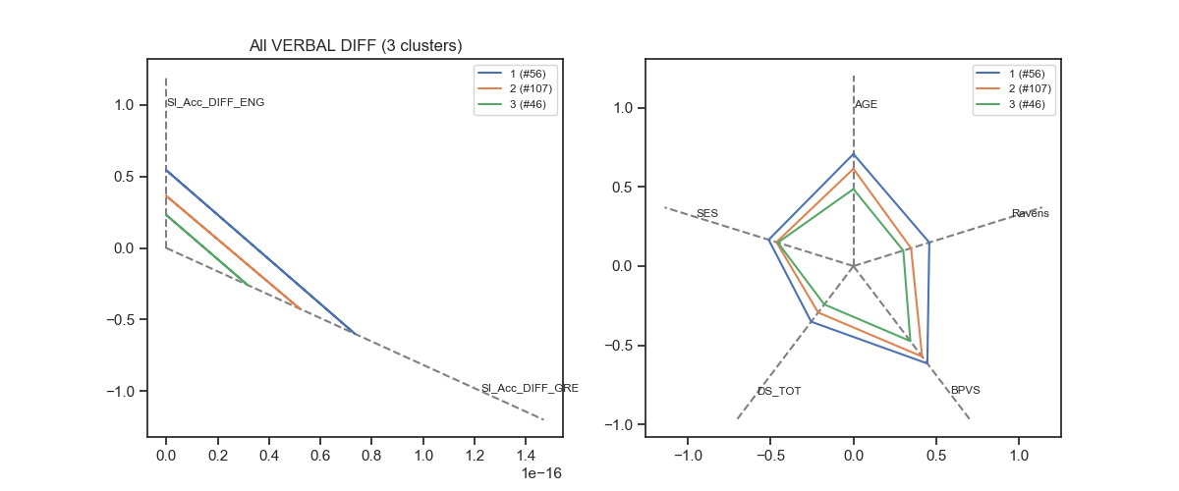
A B
Figure 3: a) Mean Cluster results in the comprehension of non-canonical sentences in the presence of English and Greek interference; b) Mean Clusters among background measures and SES.

Background measures of nonverbal fluid intelligence (Raven's Matrices), working memory (digit span backward and forward – DS_TOT), English vocabulary knowledge (BPVS) and socio-economic status (SES) were calculated for the different clusters (Table 5). As illustrated in Figure 3b the full ordering 1, 2, 3 is maintained for all background measures and for SES variables.

Table 5: Mean values for background variables and SES for the clusters obtained on the results of Cluster analysis for comprehension of non-canonical sentences in the presence of English and Greek interference.

Cluster | Age (years) | Raven's | BPVS | Digit Span | SES
1 | 10.2 | 8 | 138 | 15 | 3.2
2 | 9.5 | 6.5 | 133 | 13 | 3.0
3 | 8.4 | 6 | 121 | 12 | 3.0

Control of Non-Verbal interference
Non-verbal experimental trials were administered using non-canonical sentence comprehension in the presence of Congruent, Incongruent and Unrelated non-verbal interference.
Table 6 shows the mean and standard deviations of the three clusters produced in the analysis.
As illustrated in Figure 4a, the resulting clusters were fully ordered with clusters 1, 2, 3 from the highest performers (across all experiments) to the lowest performers, respectively. Once again, this indicates very consistent performance across all the entered tasks by the children in each group.
The calculation of the background and SES measures for the resulting clusters (Table 7 and Figure 4b) clearly indicates that the highest performing group (cluster 2) in the control of non-verbal interference has also highest ability scores in the Raven's, BPVS, digit span and a composite measure of SES.

Table 6: Cluster analysis by mean and standard deviation in brackets for comprehension of non-canonical sentences in the presence of non-verbal Congruent, Incongruent and Unrelated interference. The columns Monolinguals and Multilinguals indicate the total number of children from each group that form the cluster. The percentage in brackets is derived from the total number of children in each linguistic group (i.e., monolinguals= 132, multilinguals=77)

Cluster | Children no. | Monolinguals | Multilinguals | Congruent  Interference | Incongruent  Interference | Unrelated Interference
1 | 71 | 40 (30%) | 30 (39%) | 65% (10%) | 63% (11%) | 61% (11%)
2 | 106 | 73 (55%) | 35 (45%) | 44% (8%) | 48% (8%) | 42% (13%)
3 | 34 | 19 (14%) | 12 (16%) | 31% (9%) | 28% (7%) | 32% (11%)

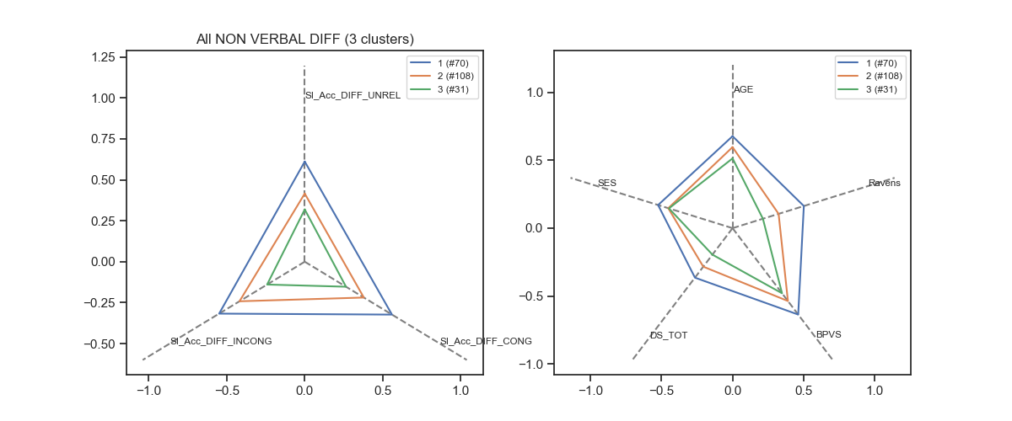
A B
Figure 4: a) Mean Cluster results in the comprehension of non-canonical sentences in the presence of non-verbal interference; b) Mean Clusters’ background measures and SES.

Table 7: Mean values for background variables and SES for the clusters obtained on the results of Cluster analysis for comprehension of non-canonical sentences in the presence of non-verbal Congruent, Incongruent and Unrelated interference.

Cluster | Age | Raven's | BPVS | Digit Span | SES
1 | 9.9 | 8 | 141 | 15 | 3.2
2 | 9.3 | 6 | 129 | 13 | 3.0
3 | 8.7 | 5.41 | 123.68 | 11.47 | 3.06

Control of both Verbal and Non-Verbal interference
When we combine both Verbal and Non-Verbal interference as variables for the clustering exercise, we obtain a total of five conditions, two with verbal and three with non-verbal interference.

The clustering exercise produced a total of 3 clusters, fully ordered by performance, from highest (cluster 1) to lowest (cluster 3). These are represented in Table 8 and Figure 5a.

Table 8: Cluster analysis by mean and standard deviation in brackets for comprehension of non-canonical sentences in the presence of combined verbal and non-verbal interference. The columns Monolinguals and Multilinguals indicate the total number of children from each group that form the cluster. The percentage in brackets is derived from the total number of children in each linguistic group (i.e., monolinguals= 132, multilinguals=77)

Cluster | N | Monolingual | Multilingual | English | Greek | Congruent |  | Incongruent | Unrelated
1 | 59 | 31 (23%) | 28 (36%) | 47% (10%) | 58% (11%) | 65% (11%) | 64% (12%) |  | 63% (11%)
2 | 95 | 63 (48%) | 32 (42%) | 40% (13%) | 42% (12%) | 47% (9%) | 51% (10%) |  | 46% (11%)
3 | 55 | 38 (29%) | 17 (22%) | 26% (10%) | 31% (10%) | 35% (9%) | 35% (9%) |  | 30% (10%)

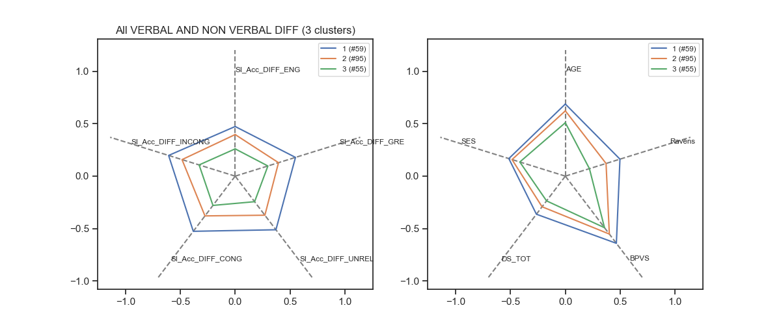
A B
Figure 5: a) Mean Cluster results in the comprehension of non-canonical sentences in the presence of verbal and non-verbal interference; b) Mean Clusters’ background measures and SES.

As shown in Figure 5b, the mean background and SES variables for the children in the clusters revealed how the full ordering 3, 2, 1 is maintained. It should be noted that the highest performers in cluster 3 have also the highest SES composite scores (Table 9).

Table 9: Mean values for background variables and SES for the clusters obtained on the results of comprehension of non-canonical sentences in the presence verbal and non-verbal interference.

Cluster | AGE | Ravens | BPVS | DS_TOT | SES
1 | 10 | 8 | 141 | 15 | 3.2
2 | 9.5 | 7 | 131 | 13 | 3.1
3 | 8.6 | 5 | 124 | 12 | 2.9

Results summary

We carried out two forms of analysis: analysis of co-variance and cluster analysis. We first compared the two groups on background measures, which revealed that monolingual and multilingual children were statistically comparable in terms of non-verbal reasoning, working memory, auditory skills, English vocabulary knowledge and overall scores of socio-economic status, including mother's and father's education and household income. For control of interference, analysis of variance revealed that both monolingual and multilingual children had comparable performance in comprehending non-canonical sentences in the presence of verbal and non-verbal interference, a finding further supported by computed Bayes factors. However, regression analyses have shown that their performance in all interference conditions significantly improved with age but this effect was not modulated by multilanguage acquisition.
Cluster analysis provided a more in-depth understanding of the children's performance in relation to their age, general cognitive skills and socio-economic status. Three main clusters were identified with best performers always being the oldest in age. The children's distribution within each group revealed that monolinguals and multilinguals were equally represented in each cluster.

Discussion

This study sought to investigate control of verbal and non-verbal interference in sample of 211 English monolingual and multilingual children aged 7-12 years old. We controlled for possible confounding variables including non-verbal reasoning, short-term and working memory abilities, English vocabulary knowledge and auditory-motor processing. Measures of socio-economic status, such as parental levels of education were also controlled. As a result, monolinguals and multilingual children were well matched across these candidate alternative explanatory variables.
The main experimental test was a sentence interpretation task in which all children were instructed to identify the agent in a canonical (e.g., active) or non-canonical (e.g., passive) English sentence and ignore competing verbal or non-verbal interference. A control condition without interference was also administered. Sentence comprehension accuracy and processing speed were measured. Overall, all children reliably demonstrated best performance in the control condition without interference. For the verbal interference, we found a significant effect of language familiarity: English interference impaired comprehension more than Greek interference in all children. However, regression and cluster analyses have not indicated a bilingual advantage in control of verbal and non-verbal interference for our cognitively demanding task, the comprehension of non-canonical sentences, with age being a significant factor for improved performance in all experimental conditions and background measures. These findings do not support claims for the hypothesis that multilanguage acquisition directly promotes advantages in cognitive ability, although we note that the adaptive coding model developed by Green and Abutalebi (2013) accommodates no advantage in the specific case of multilinguals who regularly engage in dense code-switching (likely to be a small minority of the multilingual children in the present study).

How are these findings related with previous studies
Overall, the field of bilingualism has always been controversial and research on control of auditory interference has also provided conflicting results. As described in the introduction, studies conducted by Mayo and colleagues (1997) and Shi (2010), have shown a bilingual disadvantage in comprehending speech in noise (see Ouzia & Filippi, 2016, for an extensive review). In contrast, the work of Filippi and colleagues (2012, 2015) has shown the reverse outcome. Multilingual children from different linguistic backgrounds and adults who learned a second language later in life significantly outperformed matched monolingual peers in controlling verbal interference. This finding was consistently observed when the task was more demanding, that is, processing non-canonical sentences. English language predominantly employs a Subject-Verb-Object word order (Bates, McNew, MacWhinney, Devescovi, & Smith, 1982). Thus, canonical sentences were taken to be easier and therefore presenting a low cognitive load (Roland, Dick, & Elman, 2006). Conversely, the non-canonical sentences were taken to be harder and more cognitively demanding (high-load processing). A possible interpretation of this finding was based on the assumption that bilingual speakers must resolve the competition between the known languages and, therefore, resolve additional demands associated with this task. Constant cognitive and demanding "training" in bilinguals could in turn translate to an enhanced ability to screen-out interference and select attention on the targeted task but only when the task incorporates moderate or high levels of complexity.

The current study, which focused on young age, has neither revealed disadvantages nor advantages. This introduces another chapter in the bilingual debate. In the following sections we attempt to resolve these discrepancies in the literature.

Experimental procedure

We followed the same experimental protocol and materials that we had already used in Filippi et al. (2015). Target sentences in English and interference sentences in English and in Greek were the same. The only difference was the addition of non-verbal interference (Congruent, Incongruent and Unrelated). This made the task approximately 8 minutes longer (total of 15-18 minutes per participant),

Socio-economic status
Consistently with Filippi et al. (2015), the majority of children (57%) were drawn from the Cambridge area. The remaining 43% have been tested in London, with particular attention on matching components of socio-economic status such as mother's and father's education, their job status and household income. Statistically, the two groups were comparable in terms of SES.

Sample size
The most notable difference between Filippi et al. (2015) and the current study is the sample size. The previous study was conducted on a small-scale basis. A total of 40 children (half of them bilinguals) aged 7 -12 years old were tested. The current study employed a much larger sample (130 monolinguals and 77 bilinguals) split in 5 age groups with, on average, 42 participants in each group. Many authors have suggested that sample size is particularly important in this line of research (e.g., Paap et al., 2014, 2015). Recent studies employing large samples of children and adults tested with executive function measures have not detected reliable ability differences between monolinguals and bilinguals (e.g., Duñabeitia et al. 2014; Paap et al. 2013) and meta-analyses by Lehtonen et al. (2018) and van den Noort et al. (2019) demonstrate how sample size moderates the size of the reported bilingual advantage in cognitive control. However, as outlined in our introduction, the literature to date has focused almost exclusively on performance in nonverbal tests of general (i.e., domain free) executive function. In contrast, the present findings address language comprehension in the presence of competing auditory input in a large sample of matched monolinguals and bilinguals. The evidence base is virtually silent on this fundamental issue, and the present study, therefore, addresses an important gap in the literature on multilingual cognition.

Statistical Analyses
Along with traditional statistics (t-tests, ANOVA and regression analysis), we used Bayesian methods and cluster analysis. This gave us the opportunity to understand in more detail the key factors predicting control of interference on our task. Consistent with our regression analysis, cluster analysis highlighted a central role of age: for both control of verbal and non-verbal interference, the oldest children have shown the highest levels of accuracy in comprehending non-canonical sentences as well as best performance on the background measures of nonverbal fluid reasoning, working memory and English vocabulary knowledge. Interestingly, higher SES scores appeared more relevant in best performers (cluster 1), but not so in poorer performers (cluster 2 and 3).

Another interesting outcome from cluster analysis is the equal representation of monolinguals and multilinguals in each cluster. This is an indication that linguistic experience may not be a predictive factor for controlling auditory interference, at least at the behavioural level.

What can we draw from these conclusions
It is clear that the debate on the bilingual advantage hypothesis is far from exhausted. Our new findings appear inconsistent with our own earlier research. We have always kept an open mind on possible cognitive advantages conferred by the constant use of two or more languages. We have encouraged study of this phenomenon on a developmental scale across the lifespan, using a convergence of experimental methods (see Filippi et al., 2017, for further discussion). Our future work will extend to adulthood, including older age, to ascertain whether other factors such as age of second language acquisition/exposure or immigration status, can play a role in the control of interference both at behavioral and neurological levels.

References

Abbate, M.S., & LaChapelle, N.B. (1984b). Pictures, please! An articulation supplement. Tucson, AZ: Communication Skill Builders, Inc.

Bates, E., McNew, S., MacWhinney, B., Devescovi, A., & Smith, S. (1982). Functional constraints on sentence processing: A cross-linguistic study. Cognition, 11, 245–299.

Bialystok, E. (2009). Bilingualism: The good, the bad, and the indifferent. Bilingualism: Language and cognition, 12(1), 3-11.

Bialystok, E. (2017). The bilingual adaptation: How minds accommodate experience. Psychological bulletin, 143(3), 233.

Cook, R. D. (1977). Detection of influential observation in linear regression. Technometrics, 15–18.

De Bruin, A., Treccani, B., & Della Sala, S. (2015). Cognitive advantage in bilingualism: An example of publication bias? Psychological Science, 26(1), 99–107.

Dijkstra, T. (2005). Bilingual visual word recognition and lexical access. Handbook of bilingualism: Psycholinguistic approaches, 179-201.

Dunabeitia, J. A., Hernandez, J. A., Anton, E., Macizo, P., Estevez, A., Fuentes, L. J., & Carreiras, M. (2014). The inhibitory advantage in bilingual children revisited. Experimental Psychology, 61(3), 234–251.

Dunn, L. M., Dunn, L. M., Whetton, C., & Burley, J. (1997). The British Picture Vocabulary Scale, nd ed. BPVS-II). London: NFER-Nelson.

Filippi, R., D’Souza, D., & Bright, P. (2018). A developmental approach to bilingual research: The effects of multi-language experience from early infancy to old age. International Journal of Bilingualism, 1367006917749061.

Filippi, R., Leech, R., Thomas, M. S., Green, D. W., & Dick, F. (2012). A bilingual advantage in controlling language interference during sentence comprehension. Bilingualism: Language and Cognition, 15(4), 858-872.

Filippi, R., Morris, J., Richardson, F. M., Bright, P., Thomas, M. S., Karmiloff-Smith, A., & Marian, V. (2015). Bilingual children show an advantage in controlling verbal interference during spoken language comprehension. Bilingualism: Language and Cognition, 18(3), 490-501.

Green, D. W. (1986). Control, Activation, and Resource: A Framework and a Model for the Control of Speech in Bilinguals. Brain and Language, 27, 210-223.

Green, D. W. (1998). Mental control of the bilingual lexico-semantic system.
Bilingualism: Language and Cognition, 1, 67-81.

Green, D. W., & Abutalebi, J. (2013). Language control in bilinguals: The adaptive control hypothesis. Journal of Cognitive Psychology, 25(5), 515-530.

Hilchey, M. D., & Klein, R. M. (2011). Are there bilingual advantages on nonlinguistic interference tasks? Implications for the plasticity of executive control processes. Psychonomic Bulletin and Review, 18(4), 625–658.
Lehtonen, M., Soveri, A., Laine, A., Järvenpää, J., de Bruin, A., & Antfolk, J. (2018). Is bilingualism associated with enhanced executive functioning in adults? A meta-analytic review. Psychological bulletin, 144(4), 394.

Mayo, L. H., Florentine, M., & Buus, S. (1997). Age of second-language acquisition and perception of speech in noise. Journal of speech, language, and hearing research, 40(3), 686-693.

Miyake, A., Friedman, N., Emerson, M., Witzki, A., Howerter, A., & Wager, T. D. (2000). The unity and diversity of executive functions and their contributions to complex “frontal lobe” tasks: A latent variable analysis. Cognitive Psychology, 41, 49 –100.

Mooi E. & Sarstedt M. (2011) A Concise Guide to Market Research: The Process, Data and Methods Using IBM SPSS Statistics. Springer, London.

Morton, J.B., & Harper, S.N. (2007). What did Simon say? Revisiting the bilingual advantage. Developmental Science, 10, 719–726.

Naeem, K., Filippi, R., Periche-Tomas, E., Papageorgiou, A., & Bright, P. (2018). The importance of socioeconomic status as a modulator of the bilingual advantage in cognitive ability. Frontiers in psychology, 9, 1818.

Ouzia, J., & Filippi, R. (2016). The bilingual advantage in the auditory domain. Cognitive control and consequences of multilingualism, 2, 299.

Paap, K. R., & Greenberg, Z. I. (2013). There is no coherent evidence for a bilingual advantage in executive processing. Cognitive Psychology, 66(2), 232–258.

Paap, K. R., Johnson, H. A., & Sawi, O. (2014). Are bilingual advantages dependent upon specific tasks or specific bilingual experiences?. Journal of Cognitive Psychology, 26(6), 615-639.

Paap, K. R., Johnson, H. A., & Sawi, O. (2015). Bilingual advantages in executive functioning either do not exist or are restricted to very specific and undetermined circumstances. Cortex, 69, 265-278.

Peal, E., & Lambert, W. E. (1962). The relation of bilingualism to intelligence. Psychological Monographs: general and applied, 76(27), 1.

Raven, J.C. (1947) Progressive matrices, Lewis, London.
Richardson, F. M., Thomas, M. S., Filippi, R., Harth, H., & Price, C. J. (2010). Contrasting effects of vocabulary knowledge on temporal and parietal brain structure across lifespan. Journal of cognitive neuroscience, 22(5), 943-954.

Roland, D., Dick, F., & Elman, J. L. (2007). Frequency of basic English grammatical structures: A corpus analysis. Journal of Memory and Language, 57, 348–379.

Saer, D. J. (1923). The effect of bilingualism on intelligence. British Journal of Psychology: General Section, 14, 25-38.

Schneider, W., Eschman, A., & Zuccolotto, A. (2007). E-Prime getting started guide. Psychology software tools.

Shi, L. F. (2010). Perception of acoustically degraded Sentencesin bilingual listeners who differ in age of English acquisition. Journal of Speech, Language and Hearing Research, 53, 821–835.

Snodgrass, J.G., & Vanderwart, M. (1980). A standardized set of 260 pictures: norms
for name agreement, familiarity and visual complexity. Journal of Experimental Psychology: Human Learning and Memory, 10, 174–215.

Tao, L., Taft, M., & Gollan, T. H. (2015). The bilingual switching advantage: Sometimes related to bilingual proficiency, sometimes not. Journal of the International Neuropsychological Society, 21(7), 531-544.

Van den Noort, M., Struys, E., Bosch, P., Jaswetz, L., Perriard, B., Yeo, S., ... & Lim, S. (2019). Does the bilingual advantage in cognitive control exist and if so, what are its modulating factors? A systematic review. Behavioral Sciences, 9(3), 27.

Wechsler, D. (2008). Wechsler adult intelligence scale–Fourth Edition (WAIS–IV). San Antonio, TX: NCS Pearson, 22, 498.

APPENDIX I

Table A: Linguistic backgrounds of multilinguals participants. They were all fluent in English plus the languages listed in the table.

Language | No.
Arabic | 1
Cantonese | 1
Czech | 1
Dutch | 3
Finnish | 1
French | 8
Hebrew | 1
Italian | 3
Latvian | 1
Polish | 7
Portuguese | 3
Russian | 8
Somali | 1
Spanish | 3
Swedish | 2
Tamil | 2
Turkish | 3
Urdu | 2
Vietnamese | 1
Albanian/Russian | 2
Arabic/French | 2
Bulgarian/Macedonian | 1
French/Norwegian | 1
French/Italian | 1
German/French | 1
Italian/French | 1
Italian/Finnish | 2
Italian/Spanish | 1
Korean/Japanese | 1
Portuguese/French | 1
Portuguese/Italian | 2
Russian/French | 1
Spanish/French | 2
Spanish/Basq | 1
Spanish/Portuguese | 1
Spanish/Swedish | 1
Urdu/Pashto | 1
Russian/Italian/French | 2
Tot. | 77

Table B: Mean percent correct and standard deviations for monolingual and multilingual children in the sentence comprehension task. This table reports the result in all interference and canonicity conditions.

Condition | Monolinguals | SD | Multilinguals | SD
Canonical sentences - Control | 0.75 | 0.13 | 0.72 | 0.18
Canonical sentences - English Interference | 0.52 | 0.16 | 0.54 | 0.17
Canonical sentences - Greek Interference | 0.64 | 0.15 | 0.61 | 0.17
Non-canonical sentences - Control | 0.54 | 0.16 | 0.55 | 0.16
Non-canonical sentences - English Interference | 0.38 | 0.14 | 0.38 | 0.14
Non-canonical sentences - Greek Interference | 0.44 | 0.15 | 0.43 | 0.16
Canonical sentences - Congruent Interference | 0.72 | 0.13 | 0.74 | 0.16
Canonical sentences - Incongruent Interference | 0.71 | 0.14 | 0.72 | 0.17
Canonical sentences - Unrelated Interference | 0.68 | 0.14 | 0.67 | 0.16
Non-canonical sentences - Control | 0.54 | 0.16 | 0.55 | 0.16
Non-canonical sentences - Congruent Interference | 0.48 | 0.14 | 0.49 | 0.17
Non-canonical sentences - Incongruent Interference | 0.50 | 0.15 | 0.51 | 0.15
Non-canonical sentences - Unrelated Interference | 0.45 | 0.16 | 0.49 | 0.16

Table C: Regression analyses results for monolingual and multilingual children in all interference conditions. Performance was regressed against chronological age and the coefficients were statistically analysed using Fisher r-to-z calculation.

Condition | Monolinguals | Multilinguals

Control of English Interference
- Adjusted R Square | 0.079 | 0.202
- Regression analysis | F(1,131)=12.293, p=.001 | F(1,76)=20.183, p<.001
- Coefficients | 0.031 | 0.046
- Fisher r-to-z | p=.462 (n.s.)

Control of Greek Interference
- Adjusted R Square | 0.285 | 0.147
- Regression analysis | F(1,131)=53.193, p<.001 | F(1,76)=14.054, p<.001
- Coefficients | 0.062 | 0.044
- Fisher r-to-z | p=.452 (n.s.)

Control of Cogruent Interference
- Adjusted R Square | 0.153 | 0.181
- Regression analysis | F(1,131)=24.751, p<.001 | F(1,76)=17.792, p<.001
- Coefficients | 0.043 | 0.052
- Fisher r-to-z | p=.476 (n.s.)

Control of Incogruent Interference
- Adjusted R Square | 0.177 | 0.137
- Regression analysis | F(1,131)=29.245, p<.001 | F(1,76)=13.023, p<.001
- Coefficients | 0.05 | 0.04
- Fisher r-to-z | p=.472 (n.s.)

Control of Unrelated Interference
- Adjusted R Square | 0.066 | 0.073
- Regression analysis | F(1,131)=10.230, p=.002 | F(1,76)=6.981, p=.010
- Coefficients | 0.034 | 0.033
- Fisher r-to-z | p=.496 (n.s.)

