The Role of Uncertainty Measures on the Returns of Gold

Giray Gozgor, Ph.D.
Istanbul Medeniyet University, Turkey
Email: giray.gozgor@medeniyet.edu.tr

Chi Keung Marco Lau, Ph.D.
The University of Huddersfield, Huddersfield, the United Kingdom
Email: c.lau@hud.ac.uk

Xin Sheng, Ph.D.
Anglia Ruskin University, the United Kingdom
Email: xin.sheng@anglia.ac.uk

Larisa Yarovaya, Ph.D.
The University of Southampton, the United Kingdom
Email: l.yarovaya@soton.ac.uk

Abstract
By utilizing Bayesian Graphical Structural Vector Autoregression model, we show that changes in geopolitical risks and the U.S. real effective exchange rate significantly affect Gold returns. These results are consistent across different frequency bands in short, medium, and long terms.

Keywords: gold market; economic policy uncertainty; geopolitical risks; VIX; oil price volatility; the real value of the USD

JEL Codes: Q47; D81; C53

Highlights

- We investigate the role of uncertainty measures on return and volatility of Gold
- We use various uncertainty and risks indices
- We utilize Bayesian Graphical Structural Vector Autoregression model
- Geopolitical risks indices and the U.S. real effective exchange rate significantly affect Gold returns
- The results are also consistent across different frequency bands in different periods

1. Introduction
Finance literature has examined the various functions of gold, where the hedging and safe haven properties attracted particular attention (e.g., Baur and McDermott, 2010; Bredin et al., 2015). The linkages between gold and other assets, such as bonds, exchange rates, oil, and stocks, have been widely explored by Baur and Lucey (2010), Beckmann et al. (2015), Choudhry et al. (2015), Ciner et al., (2013), Gozgor et al. (2016), Ji et al. (2018), Lau et al., (2017), Reboredo, (2013), Selmi et al. (2018), Troster et al. (2019), and Wang et al. (2016), to name but a few.
However, a limited number of studies have investigated the relationship between uncertainty measures, gold returns, and price volatility (O’Connor et al., 2015; Vigne et al., 2017). According to Beckmann et al. (2019), examining a possible linkage between Gold and other markets is not sufficient to provide the evidence for the hedging and safe haven properties of gold. Researchers should directly investigate the relationship between indicators of uncertainty and gold markets and include uncertainty indicators in the empirical models, as they are the significant determinants of the returns and the price volatility of Gold.
In line with these suggestions, we analyzed the impact of the Economic Policy Uncertainty (EPU), Volatility (VIX), and Geopolitical Risks (GPR) indices on the returns and the price volatility of gold. To link this paper to previous studies in this field, we included the price volatility of the Real Effective Exchange Rate (REER) of the United States Dollar (USD) and the price volatility of crude oil. Thus, this paper also contributes to the literature evaluating the hedging properties of gold against the USD and crude oil markets.
Several papers have shown the relationship between uncertainty measures and gold markets. For example, Balcilar et al. (2016) used the daily and monthly data of the EPU and gold returns for the period from January 1985 to November 2015. The authors concluded that there is no significant relationship between the EPU and gold markets since the results are also not robust in changing the data frequency. More recently, Beckman et al. (2019) observed that the EPU is positively related to gold returns, while macroeconomic uncertainty and inflation uncertainty among forecasters is negatively associated with gold returns. Other papers that analyzed the relationships between the EPU and gold are Balcilar et al. (2016), Gao and Zang (2016), Jones and Sackley (2016), Raza et al. (2018), Wu et al. (2019), among others.
Bilgin et al. (2018) used monthly data from the period from January 1997 to May 2017 and analyzed the effects of the EPU, the Partisan Conflict, the Skewness (SKEW), and the VIX indices on the returns of Gold. The authors found that there is a likely increase in the performances of Gold during the times of higher EPU. Baur and Smales (2018) provided the first evidence on the effects of the GPR on Gold returns. The authors discovered that Gold returns are positively associated with changes in the GPR.
Following Baur and Smales (2018), Beckmann et al. (2019), Bilgin et al. (2018), and other recent studies, the current study contributes to the empirical literature by using various indicators of uncertainty; i.e., the indices of the EPU, the VIX, and the GPR. This study examined the temporal causal relationship between uncertainty indicators and the returns and the price volatility of Gold by implementing the Bayesian Graphical Structural Vector Autoregression (BGSVAR) model. We also applied the methodologies proposed by Diebold and Yilmaz (2012) and Barunik and Krehlik (2018) to examine the relationship between Gold returns and volatility with uncertainty measures at different frequency bands.

2. Data and Methodology
2.1. Data
This study considered monthly data for the period from February 1997 to December 2017, and the variables included are gold returns (go_returns), gold volatility (go_volatility), Economic Policy Uncertainty (EPU), Volatility (VI), Geopolitical Risks (GPR) indices, US Real Effective Exchange Rate (US), Crude Oil prices (Oi), Partisan Conflict index (Pc), and SKEW indexes (Sk). Monthly data for the gold price was collected from the Bloomberg terminal. The spot oil price is the Cushing WTI and is provided by the U.S. Energy Information Administration. The real effective exchange rate (REER) was collected from the Bank for International Settlements. The VIX index represents the market's expectation of 30-day forward-looking volatility using data originated at the Chicago Board Options Exchange (CBOE) and used as a proxy for market risk and investors' sentiments. Monthly averages of daily data for the SKEW indexes that measure perceived tail-risk in the S&P 500 used together with VIX to capture the investors’ sentiments and potential risks at financial markets.
Data for Partisan Conflict Index was collected from the Federal Reserve Bank of Philadelphia that tracks the frequency of newspaper articles reporting disagreement among the US politicians. This growth of this index can reflect the increased uncertainty among different market players and thus used as a proxy for uncertainty — geopolitical risk data obtained from the website of Caldara and Iacoviello (2018). Finally, following Baker et al. (2016) we use the global Economic Policy Uncertainty (EPU) index (the purchasing power parity (PPP) - adjusted gross domestic product (GDP) weights). Description of the variables is enclosed in Appendix I, while the results of preliminary tests are provided in Appendix II.
2.2. Bayesian Graphical Structural Vector Autoregressive (BGSVAR)Model
Following Ahelegbey et al. (2016), we also employed the Bayesian Graphical Structural Vector Autoregressive (BSGVAR) to handle problems with misidentification of the system of equations and to avoid implausible restrictions on the assumptions (Aysan et al., 2019; Bouri et al., 2018). The SVAR model defines dependence/causality as follows:
$Y_{t}=B_{0}Y_{t}+\sum_{i=1}^{p}{B_{i}Y_{t-i}+}ε_{t}$ (1)
Where $t=1,…,T,$and p is the maximum lag order. The reduced form of Eq. (1) can be written as:
$Y_{t}=A_{1}X_{t-1}+ . . . A_{p}X_{t-p}+u_{t}$ (2)
Where $A_{0}=(I_{n_{y}}-B_{0})$ is a $(n_{y}×n_{y})$ matrix; $A_{i}=A_{0}^{-1}B_{i}^{*}$, $one≤i≤p$, are $(n_{y}×n)$ the reduced-form lag coefficient matrices; and $u_{t}=A_{0}^{-1}ε_{t}$ is an $(n_{y}×1)$ independently and identically distributed reduced-form vector residual term with zero mean and the covariance matrix $Σ_{u}$.
There is a corresponding relationship between the regression matrices of the SVAR model and a directed acyclic graph (DAG).
$X_{t-s}^{j}⟶X_{t}^{i}⟺B_{s,ij}^{*}≠0, 0≤s≤p$ (3)
Where${ X}_{t-s}^{j}$is the realization of the j-th variable at time t-s. A directed edge from $X_{t-s}^{j}$ to $X_{t}^{i}$ ($X_{t-s}^{j}⟶X_{t}^{i})$ means $X_{t-s}^{j}$casues $X_{t}^{i}$. The estimation of the BSGVAR model produces the posterior probabilities of edges for the temporal causal relationship under the multivariate autoregressive (MAR) structure.
2.3. Forecast-error Variance Decompositions and Spillovers Index
This study also utilized the methodologies proposed by Diebold and Yilmaz (2012) and Barunik and Krehlik (2018) to examine the connectedness of gold returns and volatility with uncertainty measures. Diebold and Yilmaz (2012) introduced the methodology of measuring the connectedness of variables using forecast-error variance decompositions in a generalized vector autoregressive (VAR) framework. Building on the work of Diebold and Yilmaz (2012), Barunik and Krehlik (2018) introduced frequency domain into the measurement of connectedness and proposed a new framework for measuring the connectedness of variables at different frequency bands. Barunik and Krehlik (2018) used the spectral representation of GFEVD to define connectedness measures on a given frequency band.

3. Empirical Results and Analysis
Tables 1 and 2 summarize the results of edge probabilities estimated from the Bayesian Structural Graphical VAR (BSGVAR) model for the temporal (causal) dependence of Gold returns and volatility with uncertainty measures. The results indicate the following causal relationships based on the posterior probability of 0.50 or above. In Table 1, the results show that the highest posterior probabilities for the gold price returns came from the GPR, followed by REER. The lagged values of REER and GPR are more likely to explain the current values of Gold returns (i.e., (GPR_{t-1,} REER_{t-1}) → Gold Returns_{t}). In contrast, the results in Table 2 show that the current gold price volatility only strongly depends on the previous level of its volatility (i.e., Gold Volatility_{t-1}→ Gold Volatility_{t}).
[Insert Tables 1 and 2 About Here]
We present the estimation results for returns and volatility spillovers using both DY (2012) and BK (2018) methods in Tables 3 to 10.
[Insert Tables 3 to 10 About Here]
From the DY (2012) return spillovers results in Table 3, we observed that REER delivers most spillovers to gold returns (15.45%) while skewness delivers the least (0.32%), while the innovations to gold returns contribute to 13.82% of error variance in forecasting REER returns. The estimated contributions to the forecast error variance of Gold returns from various uncertainty measures are relatively small, ranging from 0.6% (from the VIX index) to 2.51% (from the EPU index).
Table 4 presents the BK (2018) return spillovers results in the short term (1 to 5 months). We found that the results are consistent with those reported in Table 3, but the magnitude of return spillovers in the short term is smaller than those from DY (2012). In contrast, Table 6 displays that in the long term (more than 200 months) the value of the total spillover index is high and equals 39.28%. Tables 7 to 10 show that spillovers are essential in both volatility and spillovers, i.e., on average, in the short term, medium-term and long time, return and volatility spillovers are of the same magnitude.
Following the DY (2012) and BK (2018) methods, we analyzed the dynamics of return and volatility spillovers over time using 100-month rolling samples. In Figures 1 and 2, we present the time-varying behavior of overall spillovers and net spillovers during the period from June 2005 to December 2017 for returns and volatility, respectively.
[Insert Figures 1 and 2 About Here]
We found that the overall spillovers for both returns and volatility increase dramatically during the 2007-2008 Global Financial Crisis and the European Debt Crisis. However, it is notable that the net spillovers for Gold returns are below zero during and after the 2007-2008 Global Financial Crisis at the short-term frequency, indicating that Gold returns act as a net receiver of spillovers from various uncertainty measures in the short frequencies.

4. Conclusion
We employed the Bayesian graphical VAR (BGVAR) model of Ahelegbey et al. (2016) to study the dynamic lagged dependence of Gold returns and volatility with several uncertainty measures. We obtained evidence that the lagged values of the US Real Effective Exchange Rate (REER) returns and the Geopolitical Risks (GPR) index are more likely to explain the current values of Gold returns. In contrast, the current Gold price volatility only strongly depends on the previous level of its volatility.
Application of Diebold and Yilmaz (2012) and Barunik and Krehlik (2018) frameworks revealed that spillovers are essential in both volatility and returns. Mainly, REER delivers most spillovers to Gold returns, while the estimated contributions to the forecast error variance of Gold volatility are mostly from its innovations. These results are consistent across different frequency bands in the short-, medium- and long- terms. Finally, the results show that overall spillovers for both returns and volatility increased sharply during the 2007-2008 Global Financial Crisis and the European Debt Crisis periods. The findings contribute to hedging and safe haven properties of gold.

References
Ahelegbey, D.F., Billio, M., & Casarin, R. (2016). Bayesian Graphical Models for Structural Vector Autoregressive Processes. Journal of Applied Econometrics, 31 (2), 357–386.
Aysan, A.F., Demir, E., Gozgor, G. & Lau, C.K.M. (2019). Effects of Geopolitical Risks on the Bitcoin Returns and Volatility. Research in International Business and Finance, 47, 511–518.
Baker, S.R, Bloom, N., & Davis, S.J. (2016). Measuring Economic Policy Uncertainty. Quarterly Journal of Economics, 131 (4), 1593–1636.
Balcilar, M., Gupta, R., & Piedzioch, C. (2016). Does Uncertainty Move the Gold Price? New Evidence from a Nonparametric Causality-in-Quantiles Test. Resources Policy, 49, 74–80.
Baruník, J., & Křehlík, T. (2018). Measuring the Frequency Dynamics of Financial Connectedness and Systemic Risk. Journal of Financial Econometrics, 16 (2), 271–296.
Baur, D.G., & Lucey, B.M. (2010). Is Gold a Hedge or a Safe Haven? An Analysis of Stocks, Bonds and Gold. Financial Review, 45 (2), 217–229.
Baur, D.G., & McDermott, T.K. (2010). Is Gold a Safe Haven? International Evidence. Journal of Banking and Finance, 34, 1886–1898.
Baur, D.G., & Smales, L.A. (2018). Gold and Geopolitical Risk. Available at SSRN, Paper No. 3109136.
Beckmann, J., Berger, T., & Czudaj, R. (2019). Gold Price Dynamics and the Role of Uncertainty. Quantitative Finance, 19 (4), 663–681.
Beckmann, J., Czudaj, R., & Pilbeam, K. (2015). Causality and Volatility Patterns between Gold Prices and Exchange Rates. The North American Journal of Economics and Finance, 34, 292–300.
Bilgin, M.H., Gozgor, G., Lau, C.K.M. & Sheng, X. (2018). The Effects of Uncertainty Measures on the Price of Gold. International Review of Financial Analysis, 58, 1–7.
Bouri, E., Gupta, R., Hosseini, S., & Lau, C.K.M. (2018). Does Global Fear Predict Fear in BRICS Stock Markets? Evidence from a Bayesian Graphical Structural VAR Model. Emerging Markets Review, 34, 124–142.
Bredin, D., Thomas, C., & Potì, V. (2015). Does Gold Glitter in the Long-Run? Gold as a Hedge and Safe Haven across Time and Investment Horizon. International Review of Financial Analysis, 41, 320–328.
Caldara, D., & Iacoviello, M. (2018). Measuring Geopolitical Risk. International Finance Discussion Papers, No. 1222, Board of Governors of the Federal Reserve System: Washington, DC.
Choudhry, T., Hassan, S.S., & Shabi, S. (2015). Relationship between Gold and Stock Markets during the Global Financial Crisis: Evidence from Nonlinear Causality Tests. International Review of Financial Analysis, 41, 247–256.
Ciner, C., Gurdgiev, C., & Lucey, B.M. (2013). Hedges and Safe Havens: An Examination of Stocks, Bonds, Gold, Oil and Exchange Rates. International Review of Financial Analysis, 29, 202–211.
Diebold, F.X., & Yilmaz, K. (2012). Better to Give than to Receive: Predictive Directional Measurement of Volatility Spillovers. International Journal of Forecasting, 28 (1), 57–66.
Gao, R., & Zhang, B. (2016). How Does Economic Policy Uncertainty Drive Gold–stock Correlations? Evidence from the UK. Applied Economics, 48 (33), 3081–3087.
Gozgor, G., Lau, C.K.M., & Bilgin, M.H. (2016). Commodity Markets Volatility Transmission: Roles of Risk Perceptions and Uncertainty in Financial Markets. Journal of International Financial Markets, Institutions and Money, 44, 35–45.
Ji, Q., Bouri, E., & Roubaud, D. (2018). Dynamic Network of Implied Volatility Transmission among US Equities, Strategic Commodities, and BRICS Equities. International Review of Financial Analysis, 57, 1–12.
Jones A.T & Sackley W.H. (2016). An Uncertain Suggestion for Gold-pricing Models: The Effect of Economic Policy Uncertainty on Gold Prices. Journal of Economics and Finance, 40, 367–379.
Lau, M.C.K., Vigne, S.A., Wang, S., & Yarovaya, L. (2017). Return Spillovers between White Precious Metal ETFs: The Role of Oil, Gold, and Global Equity. International Review of Financial Analysis, 52, 316–332.
O’Connor, F.A., Lucey, B.M., Batten, J.A., & Baur, D.G. (2015). The Financial Economics of Gold – A Survey. International Review of Financial Analysis, 41, 186–205.
Raza, S.A., Shah, N., & Shahbaz, M. (2018). Does Economic Policy Uncertainty Influence Gold Prices? Evidence from a Nonparametric Causality-in-quantiles Approach. Resources Policy, 57, 61–68.
Reboredo, J.C. (2013). Is Gold a Safe Haven or a Hedge for the US Dollar? Implications for Risk Management. Journal of Banking and Finance, 37, 2665–2676.
Selmi, R., Mensi, W., Hammoudeh, S., & Bouoiyour, J. (2018). Is Bitcoin a Hedge, a Safe Haven or a Diversifier for Oil Price Movements? A Comparison with Gold. Energy Economics, 74, 787–801.
Troster, V., Bouri, E., & Roubaud, D. (2019). A Quantile Regression Analysis of Flights-to-Safety with Implied Volatilities. Resources Policy, 62, 482–495.
Vigne, S.A., Lucey, B.M., O’Connor, F.A. & Yarovaya, L. (2017). The Financial Economics of White Precious Metals — A Survey. International Review of Financial Analysis, 52, 292–308.
Wang, G–J., Xie, C., Jiang, Z.Q., & Stanley, H.E. (2016). Extreme Risk Spillover Effects in World Gold Markets and the Global Financial Crisis. International Review of Economics and Finance, 46, 55–77.
Wu, S., Tong, M., Yang, Z., & Derbali, A. (2019). Does Gold or Bitcoin Hedge Economic Policy Uncertainty? Finance Research Letters, 31, 171–178.
Table 1. Results of the MAR Structure for Returns
Variable | go_return | oi | us | Vi | sk | pc | epu | gpr
go_return | 0.267 | 0.175 | 0.536 | 0.138 | 0.132 | 0.325 | 0.177 | 0.560
oi | 0.348 | 0.987 | 0.412 | 0.218 | 0.227 | 0.141 | 0.434 | 0.146
us | 0.149 | 0.212 | 1.000 | 0.172 | 0.153 | 0.158 | 0.200 | 0.157
vi | 0.163 | 0.230 | 0.288 | 1.000 | 0.171 | 0.862 | 0.164 | 0.146
sk | 0.141 | 0.163 | 0.104 | 0.837 | 1.000 | 0.994 | 0.343 | 0.167
pc | 0.114 | 0.265 | 0.185 | 0.541 | 0.697 | 1.000 | 0.994 | 0.175
epu | 0.268 | 0.148 | 0.194 | 0.768 | 0.622 | 0.619 | 1.000 | 0.116
gpr | 0.224 | 0.235 | 0.110 | 0.640 | 0.563 | 0.204 | 0.272 | 1.000
Note: Bold entries represent the selected edges for the MAR structures based on posterior probabilities greater than 0.50; Italic entries indicate posterior probabilities greater than 0.30 but less than 0.50.

Table 2. Results of the MAR Structure for Price Volatility
Variable | go_vol | oi | us | vi | sk | pc | epu | gpr
go_vol | 0.673 | 0.162 | 0.153 | 0.219 | 0.208 | 0.170 | 0.137 | 0.169
oi | 0.103 | 1.000 | 0.978 | 0.862 | 0.133 | 0.170 | 0.121 | 0.269
us | 0.136 | 0.151 | 0.176 | 0.948 | 0.146 | 0.186 | 0.488 | 0.148
vi | 0.242 | 0.216 | 0.169 | 1.000 | 0.139 | 0.884 | 0.172 | 0.175
sk | 0.175 | 0.147 | 0.244 | 0.788 | 1.000 | 0.988 | 0.311 | 0.179
pc | 0.259 | 0.179 | 0.348 | 0.464 | 0.699 | 1.000 | 0.990 | 0.203
epu | 0.133 | 0.136 | 0.227 | 0.836 | 0.659 | 0.641 | 1.000 | 0.125
gpr | 0.125 | 0.137 | 0.149 | 0.670 | 0.590 | 0.187 | 0.245 | 1.000
Note: Bold entries represent the selected edges for the MAR structures based on posterior probabilities greater than 0.50; Italic entries indicate posterior probabilities greater than 0.30 but less than 0.50.

Table 3. Results of Return Spillovers Across Markets and Uncertainty Measures
Variable | go | oi | us | vi | sk | pc | epu | gpr | From Others
go | 74.64 | 2.9 | 15.45 | 0.6 | 0.32 | 1.66 | 2.51 | 1.92 | 28.26
oi | 3.19 | 80.04 | 8 | 3.6 | 0.84 | 0.6 | 2.97 | 0.75 | 19.95
us | 13.82 | 5.89 | 72.15 | 4.97 | 0.21 | 0.78 | 2.08 | 0.1 | 27.95
vi | 0.39 | 4.49 | 5.16 | 76.22 | 2.68 | 2.75 | 6.09 | 2.23 | 26.02
sk | 0.71 | 1.26 | 0.39 | 6.33 | 75.63 | 10.5 | 4.15 | 1.03 | 25.4
pc | 1.28 | 1.19 | 1.9 | 1.11 | 0.49 | 76.67 | 14.47 | 2.9 | 26.24
epu | 0.55 | 0.93 | 6.33 | 26.47 | 1.32 | 2.24 | 60.06 | 2.1 | 39.94
gpr | 0.13 | 0.46 | 0.92 | 10.98 | 1.56 | 2.24 | 9.62 | 74.09 | 35.53
Contribution to others | 20.07 | 17.12 | 38.15 | 65.04 | 7.42 | 20.77 | 41.89 | 11.03 | 26.31%
Contribution including own | 94.710 | 97.160 | 110.300 | 130.280 | 83.050 | 97.440 | 101.950 | 85.120
Notes: *From Others - directional spillover indices measure spillovers from all markets j to market i; **Contribution to others - directional spillover indices measure spillovers from market i to all markets j; ***Contribution including own - directional spillover indices measure spillovers from market i to all markets j, including contribution from own innovations to market i.

Table 4. Results of Volatility Spillovers Across Markets and Uncertainty Measures
Variable | go | oi | us | vi | sk | pc | epu | gpr | From Others
go | 93.23 | 1.1 | 0.77 | 0.61 | 0.24 | 1.95 | 1.89 | 1.92 | 9.58
oi | 0.79 | 59.85 | 23.77 | 9.36 | 0.9 | 2.11 | 1.73 | 0.75 | 39.41
us | 2.33 | 10.46 | 72.66 | 5.8 | 1.72 | 1.19 | 4.73 | 0.1 | 26.43
vi | 0.54 | 4.08 | 2.35 | 78.46 | 2.13 | 2.56 | 7.5 | 2.23 | 23.62
sk | 1.07 | 1.93 | 1.6 | 5.49 | 75.92 | 9.48 | 3.48 | 1.03 | 25.11
pc | 3.87 | 5.58 | 3.33 | 1.59 | 0.48 | 70.97 | 11.87 | 2.9 | 32.52
epu | 0.52 | 0.46 | 0.31 | 30.73 | 1.27 | 1.68 | 62.86 | 2.1 | 37.07
gpr | 0.05 | 0.52 | 0.95 | 9.87 | 1.5 | 2.39 | 8.63 | 74.09 | 32.54
Contribution to others | 9.17 | 24.13 | 33.08 | 73.32 | 8.24 | 21.36 | 39.83 | 11.03 | 26.24%
Contribution including own | 102.400 | 83.980 | 105.740 | 141.910 | 84.160 | 92.330 | 102.690 | 85.120
Notes: *From Others - directional spillover indices measure spillovers from all markets j to market i; **Contribution to others - directional spillover indices measure spillovers from market i to all markets j; ***Contribution including own - directional spillover indices measure spillovers from market i to all markets j, including contribution from own innovations to market i.

Table 5. Return Spillovers Across Markets and Uncertainty Measures at Short Time Domain (1 to 5 Months)
Variable | go | oi | us | vi | sk | pc | epu | gpr | From Others
go | 60.53 | 2.64 | 10.35 | 0.48 | 0.11 | 0.76 | 1.59 | 1.32 | 19.89
oi | 1.47 | 53.79 | 3.38 | 1.78 | 0.37 | 0.41 | 1.22 | 0.48 | 9.11
us | 8.63 | 3.14 | 50.76 | 3.45 | 0.15 | 0.59 | 1.74 | 0.08 | 17.86
vi | 0.27 | 0.35 | 0.93 | 13.91 | 0.25 | 0.36 | 1.57 | 0.11 | 3.95
sk | 0.32 | 0.29 | 0.21 | 1.04 | 34.64 | 0.55 | 0.89 | 0.01 | 3.32
pc | 0.62 | 0.4 | 0.43 | 0.39 | 0.1 | 24.57 | 0.8 | 0.79 | 4.32
epu | 0.34 | 0.12 | 0.77 | 2.84 | 0.27 | 0.64 | 14.6 | 0.73 | 5.71
gpr | 0.1 | 0.23 | 0.15 | 0.09 | 0.87 | 0.77 | 0.41 | 25.94 | 3.03
Contribution to others | 11.75 | 7.17 | 16.22 | 10.16 | 2.12 | 4.08 | 8.22 | 3.52 | 18.46%
Contribution including own | 72.280 | 60.960 | 66.980 | 23.980 | 36.760 | 28.650 | 22.820 | 29.460
Notes: *From Others - directional spillover indices measure spillovers from all markets j to market i; **Contribution to others - directional spillover indices measure spillovers from market i to all markets j; ***Contribution including own - directional spillover indices measure spillovers from market i to all markets j, including contribution from own innovations to market i.

Table 6. Return Spillovers Across Markets and Uncertainty Measures at Medium Time Domain (5 to 200 Months)
Variable | go | oi | us | vi | sk | pc | epu | gpr | From Others
go | 60.53 | 2.64 | 10.35 | 0.48 | 0.11 | 0.76 | 1.59 | 1.32 | 19.89
oi | 1.47 | 53.79 | 3.38 | 1.78 | 0.37 | 0.41 | 1.22 | 0.48 | 9.11
us | 8.63 | 3.14 | 50.76 | 3.45 | 0.15 | 0.59 | 1.74 | 0.08 | 17.86
vi | 0.27 | 0.35 | 0.93 | 13.91 | 0.25 | 0.36 | 1.57 | 0.11 | 3.95
sk | 0.32 | 0.29 | 0.21 | 1.04 | 34.64 | 0.55 | 0.89 | 0.01 | 3.32
pc | 0.62 | 0.4 | 0.43 | 0.39 | 0.1 | 24.57 | 0.8 | 0.79 | 4.32
epu | 0.34 | 0.12 | 0.77 | 2.84 | 0.27 | 0.64 | 14.6 | 0.73 | 5.71
gpr | 0.1 | 0.23 | 0.15 | 0.09 | 0.87 | 0.77 | 0.41 | 25.94 | 3.03
Contribution to others | 11.75 | 7.17 | 16.22 | 10.16 | 2.12 | 4.08 | 8.22 | 3.52 | 31.34%
Contribution including own | 72.280 | 60.960 | 66.980 | 23.980 | 36.760 | 28.650 | 22.820 | 29.460
Notes: *From Others - directional spillover indices measure spillovers from all markets j to market i; **Contribution to others - directional spillover indices measure spillovers from market i to all markets j; ***Contribution including own - directional spillover indices measure spillovers from market i to all markets j, including contribution from own innovations to market i.

Table 7. Return Spillovers Across Markets and Uncertainty Measures at Long Time Domain (>200 Months)
Variable | go | oi | us | vi | sk | pc | epu | gpr | From Others
go | 0.78 | 0 | 0.37 | 0.01 | 0.02 | 0.11 | 0.09 | 0.08 | 0.68
oi | 0.11 | 1.44 | 0.28 | 0.04 | 0.04 | 0 | 0.14 | 0 | 0.61
us | 0.29 | 0.12 | 1.09 | 0.02 | 0.01 | 0.01 | 0.02 | 0 | 0.47
vi | 0 | 0.64 | 0.36 | 7.26 | 0.39 | 0.6 | 0 | 0.39 | 2.77
sk | 0.05 | 0.12 | 0.02 | 0.35 | 3.39 | 1.72 | 0.45 | 0.2 | 3.11
pc | 0.08 | 0.08 | 0.26 | 0.16 | 0.02 | 6.42 | 2.61 | 0.29 | 3.79
epu | 0.02 | 0.14 | 0.72 | 3.4 | 0.19 | 0.2 | 4.63 | 0.03 | 4.7
gpr | 0 | 0.01 | 0.14 | 2.13 | 0 | 0.06 | 1.33 | 4.24 | 5
Contribution to others | 0.55 | 1.11 | 2.15 | 8.24 | 0.67 | 2.7 | 4.64 | 0.99 | 39.28%
Contribution including own | 1.330 | 2.550 | 3.240 | 13.370 | 4.060 | 9.120 | 9.270 | 5.230
Notes: *From Others - directional spillover indices measure spillovers from all markets j to market i; **Contribution to others - directional spillover indices measure spillovers from market i to all markets j; ***Contribution including own - directional spillover indices measure spillovers from market i to all markets j, including contribution from own innovations to market i.

Table 8. Volatility Spillovers Across Markets and Uncertainty Measures at Short Time Domain (1 to 5 Months)
Variable | go | oi | us | vi | sk | pc | epu | gpr | From Others
go | 70.43 | 0.53 | 0.42 | 0.38 | 0.21 | 1.11 | 0.84 | 0.03 | 4.05
oi | 0.35 | 36.17 | 9.78 | 2.03 | 0.48 | 0.87 | 0.42 | 0.52 | 14.45
us | 1.53 | 6.97 | 57.27 | 1.59 | 1.26 | 0.89 | 2.54 | 0.69 | 16.16
vi | 0.11 | 0.61 | 0.47 | 14.49 | 0.23 | 0.36 | 1.85 | 0.13 | 3.89
sk | 0.2 | 0.35 | 0.66 | 0.94 | 34.66 | 0.61 | 0.84 | 0 | 3.6
pc | 0.39 | 0.3 | 0.45 | 0.53 | 0.12 | 24.83 | 0.66 | 0.8 | 4.05
epu | 0.16 | 0.25 | 0.12 | 3.29 | 0.27 | 0.66 | 15.83 | 0.78 | 5.53
gpr | 0.02 | 0.33 | 0.21 | 0.1 | 0.89 | 0.75 | 0.45 | 25.88 | 3.2
Contribution to others | 2.76 | 9.34 | 12.11 | 8.96 | 3.46 | 5.25 | 7.6 | 2.95 | 15.76%
Contribution including own | 73.190 | 45.510 | 69.380 | 23.350 | 38.120 | 30.080 | 23.430 | 28.830
Notes: *From Others - directional spillover indices measure spillovers from all markets j to market i; **Contribution to others - directional spillover indices measure spillovers from market i to all markets j; ***Contribution including own - directional spillover indices measure spillovers from market i to all markets j, including contribution from own innovations to market i.

Table 9. Volatility Spillovers Across Markets and Uncertainty Measures at Medium Time Domain (5 to 200 Months)
Variable | go | oi | us | vi | sk | pc | epu | gpr | From Others
go | 21.22 | 0.49 | 0.28 | 0.23 | 0.03 | 0.7 | 0.93 | 0.14 | 3.29
oi | 0.38 | 21.67 | 12.8 | 6.63 | 0.41 | 0.98 | 1.31 | 0.96 | 23.47
us | 0.71 | 3.13 | 14.26 | 3.86 | 0.44 | 0.26 | 2.18 | 0.34 | 11.26
vi | 0.32 | 2.77 | 1.44 | 56.75 | 1.57 | 1.63 | 5.65 | 1.84 | 17.06
sk | 0.7 | 1.29 | 0.83 | 4.28 | 37.68 | 7.29 | 2.25 | 0.83 | 18.3
pc | 2.92 | 4.45 | 2.46 | 0.77 | 0.31 | 40.28 | 8.93 | 1.3 | 22.44
epu | 0.33 | 0.21 | 0.18 | 23.34 | 0.84 | 0.87 | 42.27 | 1.38 | 27.15
gpr | 0.03 | 0.17 | 0.67 | 7.86 | 0.61 | 1.55 | 7.02 | 45.74 | 24.93
Contribution to others | 5.39 | 12.51 | 18.66 | 54.83 | 4.21 | 13.28 | 28.27 | 6.79 | 32.71%
Contribution including own | 26.610 | 34.180 | 32.920 | 103.720 | 41.890 | 53.560 | 70.540 | 52.530
Notes: *From Others - directional spillover indices measure spillovers from all markets j to market i; **Contribution to others - directional spillover indices measure spillovers from market i to all markets j; ***Contribution including own - directional spillover indices measure spillovers from market i to all markets j, including contribution from own innovations to market i.

Table 10. Volatility Spillovers Across Markets and Uncertainty Measures at Long Time Domain (>200 Months)
Variable | go | oi | us | vi | sk | pc | epu | gpr | From Others
go | 1.59 | 0.08 | 0.07 | 0 | 0 | 0.15 | 0.12 | 0.03 | 0.53
oi | 0.07 | 2.01 | 1.2 | 0.7 | 0.01 | 0.26 | 0 | 0 | 2.24
us | 0.09 | 0.36 | 1.13 | 0.34 | 0.02 | 0.03 | 0.01 | 0.09 | 1.03
vi | 0.12 | 0.7 | 0.44 | 7.22 | 0.33 | 0.57 | 0 | 0.4 | 2.96
sk | 0.17 | 0.29 | 0.11 | 0.26 | 3.57 | 1.58 | 0.4 | 0.21 | 3.23
pc | 0.55 | 0.82 | 0.42 | 0.29 | 0.05 | 5.86 | 2.28 | 0.21 | 4.83
epu | 0.03 | 0 | 0 | 4.11 | 0.16 | 0.14 | 4.76 | 0.01 | 4.45
gpr | 0 | 0.02 | 0.08 | 1.91 | 0 | 0.09 | 1.16 | 4.47 | 4.42
Contribution to others | 1.03 | 2.27 | 2.32 | 9.52 | 0.57 | 2.82 | 3.97 | 0.95 | 41.34%
Contribution including own | 2.620 | 4.280 | 3.450 | 14.830 | 4.140 | 8.680 | 8.730 | 5.420
Notes: *From Others - directional spillover indices measure spillovers from all markets j to market i; **Contribution to others - directional spillover indices measure spillovers from market i to all markets j; ***Contribution including own - directional spillover indices measure spillovers from market i to all markets j, including contribution from own innovations to market i.

Figure 1. Multivariate Autoregressive Model and the Total Linkage

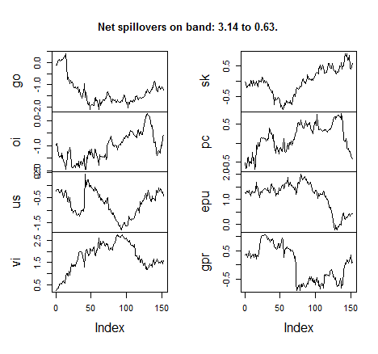
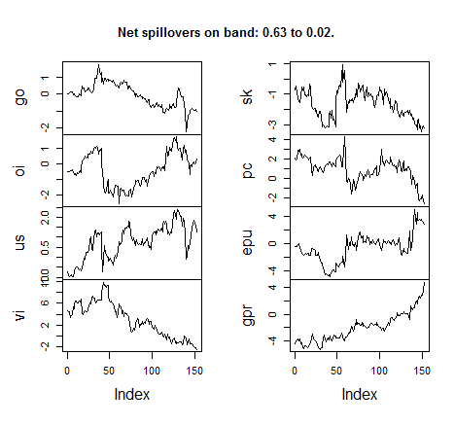
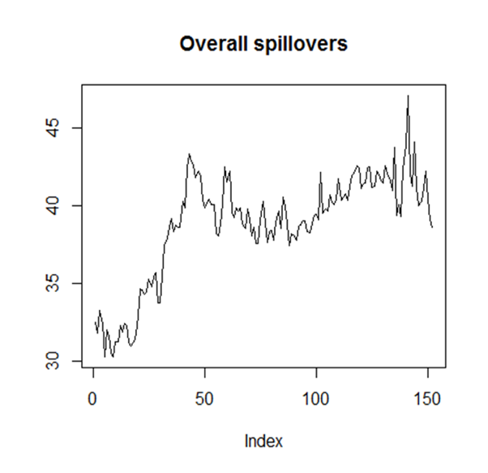
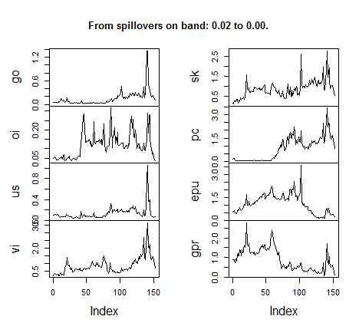

Figure 2. Net Spillover of Returns
Notes: Net spillovers on bands (3.14 to 0.63), (0.63 to 0.02) and (0.02 to 0.00) roughly correspond to spillovers in the short term (1 to 5 months), in the medium term (5 to 200 months) and the long term (more than 200 months).
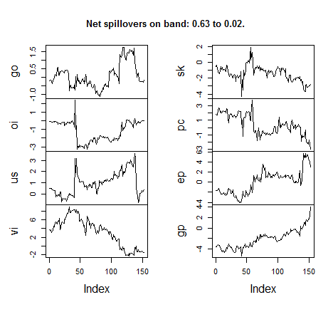
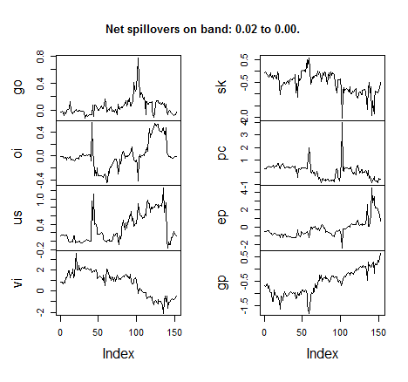
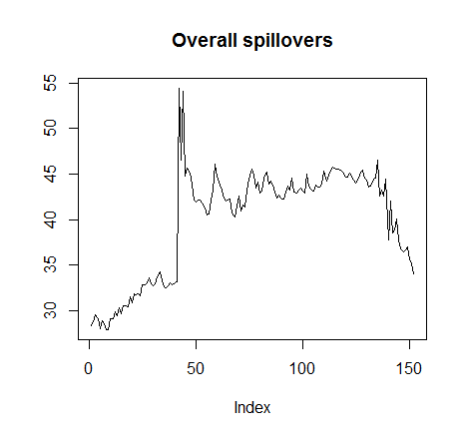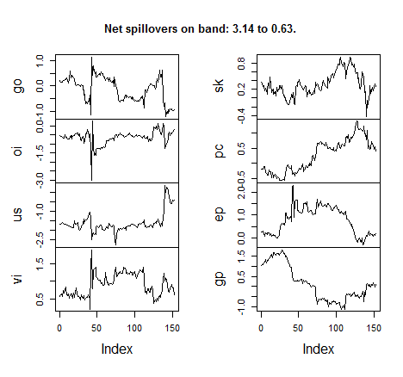
Figure 3. Net Spillover of Price Volatility
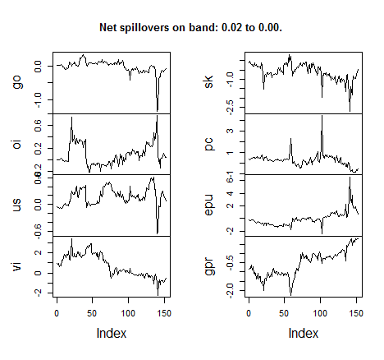
Notes: Net spillovers on bands (3.14 to 0.63), (0.63 to 0.02) and (0.02 to 0.00) roughly correspond to spillovers in the short term (1 to 5 months), in the medium term (5 to 200 months) and the long term (more than 200 months).

Appendix Table I.
Summary of the Descriptive Statistics and the Description of the Variables
Variable | Notations | Unit | Measure | Mean | Standard Deviation | Skewness | Kurtosis
Gold Price Returns | DLNGOLD | Spot Price | Logarithmic Form in First Difference | 0.0051 | 0.0382 | 0.2757 | 4.1894
Price of Oil | DLOIL | Spot Price | Logarithmic Form in First Difference | 0.0033 | 0.0871 | -0.6785 | 4.2554
Real Exchange Rate (2010=100) | DLUSD | USD, Index | Logarithmic Form in First Difference | 0.0002 | 0.0122 | 0.2290 | 4.1411
Global Economic Policy Uncertainty | LNEPU | Index, (PPP-Adjusted GDP Weights) | Logarithmic Form | 4.6201 | 0.3797 | 0.4330 | 2.6478
Geopolitical Political Risks | LNGPR | Index | Logarithmic Form | 4.5879 | 0.1693 | 0.7600 | 4.3786
Partisan Conflict | LNPC | Index | Logarithmic Form | 4.6631 | 0.3233 | 0.5826 | 2.4624
SKEW | LNSKEW | Index | Logarithmic Form | 4.7816 | 0.0584 | 0.5718 | 3.4637
Financial Market Volatility | LNVIX | Index | Logarithmic Form | 2.9579 | 0.3552 | 0.3732 | 2.8482

Appendix Table II.
Results of the Stationarity Test
Variables | ADF - Test statistics |  |  | P-value (ADF)
go_return |  |  | -14.082 | ***
go_volatility |  |  | -13.582 | ***
oi |  |  | -12.0435 | ***
us |  |  | -10.9021 | ***
vi |  |  | -4.838 | ***
sk |  |  | -4.597 | ***
pc |  |  | -4.1136 | ***
epu |  |  | -5.3352 | ***
gpr |  |  | -4.9978 | ***
Note: *** Significant at the 1%, Lag Length based on SIC, probability based on MacKinnon (1996) one-sided p-values.

Acknowledgments: The authors would like to thank the participants to the Commodity Session in INFINITI Conference on International Finance 2019 in Glasgow for useful comments to enhance the merit of the paper. The usual disclaimer applies. Corresponding author. Xin Sheng, Lord Ashcroft International Business School, Anglia Ruskin University, Chelmsford, CM1 1SQ, United Kingdom. Email: xin.sheng@anglia.ac.uk
The details of the calculation of the EPU indexes, visit the website designed by Scott Baker, Nick Bloom, and Steven Davis (http://www.policyuncertainty.com).
For more details about estimation and inference techniques, refer to Ahelegbey et al. (2016) and Bouri et al. (2018).
The details of both methods can be found in Diebold and Yilmaz (2012), Barunik and Krehlik (2018), and for space consideration they are not presented in the paper.
The result is based on posterior probabilities greater than 0.50.

