**Shifting specialized oncological care from hospital- to home-setting: Is there support among patients, specialists and general practitioners?**

**ABSTRACT**

***Purpose*** Oncological home-hospitalization might be a patient-centred approach to deal with the increasing burden of cancer on healthcare facilities and finances. Before implementation into practice its feasibility, costs and support among stakeholders should be evaluated. The purpose of this trial was to examine patients’, specialists’ and general practitioners’ perspectives towards the opportunities of implementing oncological home-hospitalization within the Belgian healthcare system.

***Methods*** A regional cross-sectional survey study was launched in order to investigate the stakeholders’ views on oncological home-hospitalization and the current cancer care focusing on integration of primary care and continuous care.

***Results*** Of the responders, 37 out of 163 patients (27%), 51 of 62 general practitioners (82%) and 10 of 15 specialists (67%) feel positive about the opportunities for oncological home-hospitalization. Nevertheless, 11/15 specialists (73%) and 51/62 general practitioners (82%) feel primary care might currently be (too) little involved in order to ensure continuous care for cancer patients. Opportunities for improved continuous care are seen in better communication between primary care and hospital and more patient contacts for primary care during the cancer treatment process.

***Conclusion*** This survey study demonstrated there is support among different stakeholders groups for the implementation of oncological home-hospitalization. However, some barriers impeding transmural continuous care should be tackled before putting such model into practice.

**Keywords:** Cancer care, Home-hospitalization,Survey, Patients, Oncologists, General Practitioners

**INTRODUCTION**

Currently, societies are confronted with an increasing (financial) pressure on healthcare as result of the ageing population, the growing number of chronical diseases, technological advances and highly personalized medicine (1). As a result, governments are forced to seek new models in order to organize healthcare cost-effectively, without losing the current quality of care (2). Furthermore, whereas current models for healthcare delivery are largely focused on delivering acute care, the challenge is to reorganize healthcare to meet the needs of more chronic care (3). However, providing high-quality chronic care requires multidisciplinary approaches, inevitably bringing new challenges.

In Belgium, the governmental aim of preventing unnecessary hospital admissions and hospital stays has been translated into an action plan in order to provide higher quality and efficiency of care. Transition of hospital care to healthcare actors outside the hospital is part of this action plan and goes along with the emerging need for more transmural and integrated care models guaranteeing continuous care for chronic diseases (4, 5). In light of this action plan, some pilot projects were launched in preparation of a reformation of the healthcare landscape. One of the themes proposed was home-hospitalisation, defined as: ‘providing care at the patients homes that otherwise could only be given at the hospital’ (6).

Since cancer is the second most common disease and characterized by strong progresses and innovation in its therapeutic domain, opportunities for home-hospitalization are seen within this domain of healthcare (7). Oncological home-hospitalisation (OHH) has already been introduced in other countries, however, its quality and effect on healthcare costs is poorly evaluated. Despite the large heterogeneity of the reported models for OHH and methods used for the analyses, in general these trials demonstrated it is a safe, equivalent and acceptable alternative to ambulatory hospital care (7, 8).

As part of a larger project, a model for oncological home-hospitalisation was implemented within the oncology department of the general hospital Groeninge, Kortrijk (Belgium). The introduction of specialized oncological care into the home-setting was dual. For those patients receiving certain subcutaneous cancer drugs, the full administration process was performed at the patients’ homes. For those patients receiving intravenous cancer medication, only the required preparatory steps for therapy administration (i.e. blood collection and IV line access provision, nursing review, toxicity scoring and vital signs monitoring) could be carried out at the patients’ homes, whereas the administration of the anticancer product itself was still executed at the oncology day care unit (DCU) of the hospital.

When investigating the opportunities of oncological home-hospitalization within the Belgian context, it is of interest to examine the practical as well as financial feasibility of such new care model. However, it should also be questioned whether there is general support for such new way of specialized care delivery among the different stakeholders: patients, hospital doctors and general practitioners (GP’s). After successful evaluation of the abovementioned care path for (partial) oncological home-hospitalisation during a pilot study (9), the model was introduced to a local group of patients, cancer specialists and general practitioners in order to evaluate their views on this new concept of care delivery.

The primary aim of this qualitative study was to determine cancer patients’ and healthcare providers’ interest for (partial) oncological home-hospitalisation and who they would recognise as the best healthcare provider to assign these specific tasks to. Secondly, the aim of this study was to explore potential shortages of the current treatment process for cancer patients and how these could be addressed in order to improve the current quality of care.

**METHODS**

A regional cross-sectional survey study was launched to investigate patients’, specialists’ and general practitioners’ views on (partial) oncological home-hospitalisation. This study encloses two study protocols which were both approved by the Ethical Committee of the general hospital Groeninge, Kortrijk. A first protocol focused on the patients’ perspectives and was part of a master’s thesis project (registration number: CME 18001). Another protocol concerned the questioning of healthcare providers (registration number: B396201836643). All activities were carried out in compliance with good clinical practice guidelines.

Study-specific questionnaires were created for each of the stakeholders’ group of interest. The content of the questionnaire was based upon clinical experiences and was presented to a panel of experts from each group of interest in order to check face validity. It was deliberately chosen to compose the questionnaires as concisely as possible in the hope of getting the response rates as high as possible. Nevertheless, all participants had the opportunity to add additional information or reservations to the questionnaire, by using the available free text fields. This study used a convenience sample for the three stakeholder groups.

***Patient Questionnaire***

A self-administrating Dutch-language questionnaire was presented on paper to all patients visiting the oncology day care unit of the general hospital Groeninge, Kortrijk, between the 15th and 23th of February 2018. Patients were excluded for study-participation if they were not able to read Dutch, if they were visiting the DCU for the first time, if they were included in a clinical trial with any investigational medical product or if they were staying in the joint seats hall (for privacy reasons). Eligible patients were informed about the study and if they were willing to participate, a signed informed consent form was collected.

The patient questionnaire included questions on satisfaction with the working of the oncology DCU, the duration of these visits and their perspectives towards partial and full OHH. For those patients who had already experience with the locally implemented model for OHH, some additional questions about their satisfaction with this new practice were presented. The questionnaire used a combination of items with fixed response options and free text fields.

***Specialist Questionnaire***

A self-administrating Dutch-language survey was mailed electronically to physicians specialized in medical oncology or haematology; and who are active within the regional hospital network the general hospital Groeninge takes part in. This network is a partnership between seven neighbouring hospitals covering a region of 40 municipalities. After sending an invitation e-mail, physicians were reminded twice with an interval of two weeks. By completing and returning the questionnaire, the participants agreed upon study participation and data collection. All data was gathered anonymously.

The specialist questionnaire included questions on demographics, experiences with the current collaboration with primary healthcare providers and their perspectives towards oncological home-hospitalization. The questionnaire used a combination of items with fixed or multiple response options and free text fields.

***General Practitioner Questionnaire***

A self-administrating Dutch-language survey was mailed electronically to primary care physicians affiliated to the regional general practitioners group of south-west Flanders, Belgium. This organization gathers the interests of GP’s active within the wide surrounding of the general hospital Groeninge, Kortrijk, where a model for OHH was launched. After sending an invitation e-mail, physicians were reminded twice with an interval of two weeks. By completing and returning the questionnaire, the participants agreed upon study participation and data collection. All data was gathered anonymously.

The general practitioners’ questionnaire included questions on demographics, experiences with the present oncological care and their perspectives towards oncological home-hospitalization. The questionnaire used a combination of items with fixed or multiple response options and free text fields.

***Statistical analysis***

The categorical data gathered during this trial was summarized using descriptive statistics. Frequency distributions were calculated for all variables. The proportional distribution of fixed-response variables were examined for the different demographic characteristics using exact Chi-Square tests. P-values below 0.05 were considered statistically significant (no correction for multiple comparison was done). All statistical analyses were conducted using SPSS Statistics 24.

Qualitative data was coded systematically by one researcher, after which a second researcher was consulted to discuss the results.

**RESULTS**

***Patients***

In the context of this trial, 206 patients were approached whereof 163 completed the study questionnaire (response rate = 79%). 21 patients refused participation and 22 patients were incapable of completing the questionnaire during their stay at the oncology DCU. Of those patients who completed the survey, 36 (22%) already had experience with the new care model for (partial) oncological home-hospitalization. (Table 1)

In total, 37 (27%) participants reported to feel positive about the opportunity of administrating cancer treatment in the home environment; 33 (20%) patients did not have an opinion, whereas 80 (49%) patients expressed to feel negative about this concept (figure 1.a.). Key reasons given for accepting full OHH are the comfort of the own home during treatment (n = 9), the absence of waiting times (n = 3) and saving displacements (n = 2). Key reasons for not favouring full OHH are the preferred presence of a physician or care team (n = 13); the safe environment of the clinic (n = 22); contact with fellow sufferers (n = 4) and preference of keeping home- and hospital-environment separately (n = 4). There was no statistically significant association observed between acceptance or rejection of full OHH and whether or not the patients had already experience with the locally introduced home-hospitalization model (p = 0.484).

Partial oncological home-hospitalization, only including preparation of therapy-administration at the patients home, while treatment itself is administered the next day in hospital, was accepted by a larger group of responders (69/163 or 42%). 33 (20%) patients did not have an opinion about this, whereas 54 (33%) reported not to be in favour. Reason for negation was provided by 40 patients which could be simplified to the following key arguments: patients prefer to concentrate all treatment-related care to one day (n = 7); there are difficulties or discomfort to make time available the day before treatment (n = 7); patients feel more safe in clinic (n = 6); patients prefer to avoid two punctures in two days (n = 5); day of treatment is considered a wasted day anyhow, so it doesn’t matter how long it exactly takes (n = 5) and others (n = 10). 90 patients expressed their views on the most suitable healthcare provider who should be in charge of oncological home-hospitalization, with most patients selecting hospital nurses (n = 75; 83%) (figure 1.b).

In general, 158/163 (91%) patients declared to be satisfied with the current working of the oncology DCU and 110/163 (67%) feels the involved waiting times are acceptable. No differences in distribution were observed for those patients who are already familiar with the home-hospitalization model or not (p = 0.613 and p = 0.093 respectively). All patients who were familiar with the locally implemented model for partial home-hospitalization (36/36) declared to be satisfied with this new care model. (Table 2)

***Specialists***

In total, 15 responses were received from 46 medical oncology / haematology specialist of the local hospital network (response rate = 33%). The responders represented different sex-, age- and speciality categories (table 1). Median number of subspecialties within the domain of oncology reported is 1.

When considering the opportunities of oncological home-hospitalization; 10 out of 15 specialists (67%) declared to feel positive about this concept and believe there are a number of cancer treatments which can be administered at the patients’ homes instead of in the hospital. According to most specialists, home-administration should be performed by hospital nurses (n = 7) or homecare nurses who received special training (n = 7) (figure 1.b.). Coordination of this specialized homecare should be performed by the oncologist (n = 7) or a coordinating person within the hospital (n = 7) (figure 1.c.) The distribution in perspectives towards oncological home-hospitalization was not statistically different for the differences is demographics (all p > 0.05).

When evaluating specialists’ views on the current treatment process for cancer patients, 11 specialists (73%) believe primary healthcare providers might be (too) little involved in order to guarantee continuous care. Those phases of the treatment process most cited are the period between diagnosis and start of treatment (n = 7) and treatment itself (n = 10). Most frequently selected opportunities to improve this involvement are better communication between primary care and hospital (n = 11) and access to the (hospitals’) electronic patients files (n = 10). Five specialists declared primary healthcare providers currently do not have sufficient information in order to provide continuity of care. Most reported missing information according to the specialists is information regarding treatment (n = 4) and pharmacology (n = 4) (figure 2).

***General practitioners***

The general practitioners’ questionnaire was sent to all members of the local association for general practitioners (n = 286), of which 62 responses were received (response rate = 21.7%). Demographic details of the respondents are represented in table 1. 45 general practitioners declared to feel positive about the possibilities for oncological home-hospitalization (73%). According to them, homecare nurses with special oncology training should be responsible for this new type of specialized homecare (n = 37). Coordination should be performed by the oncologist (n = 19), general practitioner (n = 16) or a coordinator within the hospital (n = 12). The distribution in perspectives towards oncological home-hospitalization was not statistically different for the differences is demographics (all p > 0.05).

51 out of 62 responders (82%) feel primary healthcare providers might be (too) little involved to ensure continuous care for cancer patients. According to the general practitioners optimal involvement falls short at the phase between diagnosis and treatment (n = 20), during treatment (n = 39), and during follow-up and/or post-treatment (n = 18). Most GP’s feel involvement can be improved by more patient contacts for primary care during the oncological treatment process (n = 31). Furthermore, 21/62 GP’s (34%) consider they do not have sufficient information to ensure care continuity, which is specified in shortages of information regarding pharmacology (n = 21), treatment (n = 15) and treatment intention (n = 12).

**DISCUSSION**

The primary aim of this regional survey study was to explore the current perspectives towards the concept of oncological home-hospitalization among different stakeholder groups in Belgium. The results of this study demonstrate that the majority of responding physicians (67% of specialists and 73% general practitioners) feel there are opportunities for such care model within the current healthcare delivery system, whereas patients are more reluctant to accept OHH (23%). To our knowledge this was the first survey evaluating patients’, general practitioners’ and specialists’ views on oncological home-hospitalization. A recent Dutch investigation revealed similar numbers for patient preferences on full OHH (10) and recent initiatives on oncological home-hospitalisation (11-15) demonstrate there is interest among a substantial proportion of cancer patients and caregivers. Besides the stakeholders’ perspectives on the implementation of a new care model for home cancer treatment, this survey also revealed some shortcomings and ambiguities within the current cancer care impeding general implementation of such model.

Patients and healthcare providers seem to agree that nurses (from primary or secondary healthcare) are the most suitable healthcare providers for executing specialized oncological procedures at the patients’ homes. Nevertheless, the physicians clearly expressed the importance of hospital experience or a proper training. These expectations are in line with initiatives on OHH described in the available literature, mentioning nurses to be responsible for this specialized homecare (11-13, 15, 16). When evaluating most suitable healthcare professional for coordinating OHH, majority of specialists and general practitioners believe this should be organized by healthcare providers in the hospital, albeit also a considerable number of physicians feel coordination can be performed by the general practitioner. The authors believe the most suitable model for OHH comprises a close collaboration between primary care and the hospital favouring continuous care for cancer patients. This is supported by the finding of this survey and recently, a similar mixed model approach for the organisation and delivery of general home hospitalization was suggested by a group of Belgian stakeholders (6). Furthermore, multidisciplinary integrated care is currently encouraged by global policy makers as it is believed to enhance health outcomes and improve health system performance (17).

This survey demonstrated that healthcare providers, despite high patient satisfaction, also feel some shortcomings within the current ambulatory cancer care impeding transmural and continuous care. Historically, primary healthcare was little involved in the care path of cancer patients which was strongly dominated by technical interventions focusing on treatment (18). As the nature of cancer is evolving; the importance of integrating primary healthcare in cancer care is strongly emphasized (18, 19). Many reports are available defining the GP’s role during cancer diagnosis (20), follow-up post treatment (21) and palliative care (22), but only limited literature is available on GP integration during active cancer treatment (23). However, opportunities for GP involvement are recognized for symptom control and management of toxicities in the home environment which might avoid emergency department visits and hospital admission (18). In addition, GP’s are believed to have in important role in the management of concurrent mental health problems and potential comorbidities (18). The authors believe these opportunities should be encouraged in practice as it will enhance continuous cancer care. Furthermore, this will be crucial when healthcare providers are willing to introduce OHH. Increased involvement of the primary care during cancer therapy will provide more insights into the patients treatment pathway, hence leading to increased quality of care. The results of this survey demonstrate that the aforementioned opportunities are recognised by our local GP’s and specialists. Better communication and more patient contacts for primary care were the most frequently reported areas for improvement. Moreover, a substantial number of physicians (33% of specialists and 34% of GP’s) feel that primary care professionals do not have sufficient information to ensure care continuity. Yet, the authors are convinced that these barriers should be easily overcome given the recent technological advances and growing eHealth opportunities (18, 24).

In addition to better communication, also legislation and financing were expressed as complicating factors for the implementation of OHH in Belgium. Within the standard of care, the treating physician is responsible for therapy prescription and entrusting administration of the product to an expert nurse, while the physician should remain available in case of problems (25). When considering an integrated model approach for OHH, one should face the responsibility shifts coming along with it. Besides, attention should be paid to the fact that nurses with special qualification or equivalent experience are required to administer chemotherapy in an oncology centre according to Belgian law (26). A clear legal framework is needed allowing shared responsibility if a continuous and multidisciplinary care delivery path for oncological home-hospitalization will be implemented. Likewise, as home-hospitalization is currently not recognized by the Belgian health authorities, there are currently no financial resources available.

Despite acceptable response rates, the present survey study was prone to participation bias. Furthermore, due to the local characteristic of this trial the results might not be representable to the Belgian population. And finally, one should be aware that the results of this survey reflect the situation for the Belgian healthcare system. Different systems in other countries may yield different results.

***Conclusion***

Based on the results of this survey study we can conclude that there is support among different stakeholder groups for a model of oncological home-hospitalization. Nevertheless, before implementing such model into practice, some barriers impeding continuous cancer care delivery should be tackled. A number of recommendations, relatively easy to implement into practice; were indicated by the responding physicians.

**ACKNOWLEDGEMENTS**

This work was supported by ‘Kom Op Tegen Kanker’ (Stand up to Cancer), the Flemish cancer society, [registration number: KOTK 0014089]; a non-profit organization stimulating innovative approaches to improve quality of life of cancer patients and their environment. The authors want to thank all participants for their cooperation to this survey study.

**CONFLICT OF INTEREST STATEMENT**

The authors have declared no conflicts of interest. All authors participated in the article preparation and approved the final article for publication.

|  |  |  |  |
| --- | --- | --- | --- |
| **Table 1. Respondent characteristics** | | | |
|  | Patients  *N* = 163 | *Specialists*  *N = 15* | *General practitioners*  *N = 62* |
| No. (%) | No. (%) | No. (%) |
| Gender  Female  Male  Missing | 87 (53.4%)  66 (40.5%)  10 (6.1%) | 7 (46.7%)  7 (46.7%)  1 (6.7%) | 22 (35.5%)  40 (64.5%)  / |
| Age (years)  25 – 34  35 – 44  45 – 54  55 – 64  ≥ 65 | *No information* | 1 (6.7%)  7 (45.7%)  4 (26.7%)  3 (20.0%)  0 (0.0%) | 14 (22.6%)  5 (8.1%)  16 (25.8%)  20 (32.3%)  7 (11.3%) |
| Specialty*  Breast  Dermatology  Digestive  Geriatric  Gynaecology  Haematology  Head & Neck  Neurology  Pulmonology  Urology | *NA* | 3 (20%)  2 (13.3%-  6 (40.0%)  2 (13.3%)  4 (26.7%)  3 (20.0%)  4 (26.7%)  2 (13.3%)  4 (26.7%)  4 (26.7%) | *NA* |
| Practice setting  Solo  Group (≥ 2)  Association  Community health centre  Other | *NA* | *NA* | 26 (41.9%)  33 (53.2%)  1 (1.6%)  1 (1.6%)  1 (1.6%) |

* Percentage given is de percentage of experience within the specialty domain represented in the complete respondents group. Respondents could master several specialty domains.

|  |  |  |  |  |
| --- | --- | --- | --- | --- |
| **Table 2. Patients’ reported satisfaction with the current oncological care** | | | | |
|  | Positive | Negative | Neutral | Missing |
| No. (%) | No. (%) | No. (%) | No. (%) |
| General satisfaction oncology DCU  (*N* = 163) | 158 (96.9%) | 2 (1.2%) | 0 (0%) | 3 (1.8%) |
| Waiting times at oncology DCU  (*N* = 163) | 110 (67.5%) | 15 (9.2%) | 35 (21.5%) | 3 (1.8%) |
| General satisfaction partial OHH*  (*N* = 36) | 36 (100%) | 0 (0%) | 0 (0%) | 0 (0%) |

* Only applicable for those patients who had experience with the locally implemented model for partial oncological home-hospitalization.

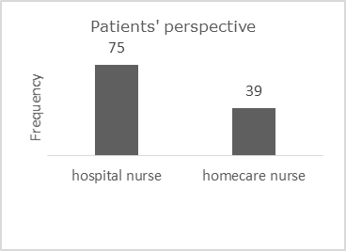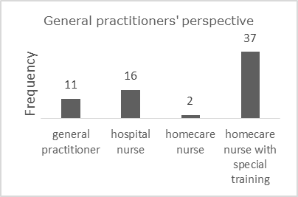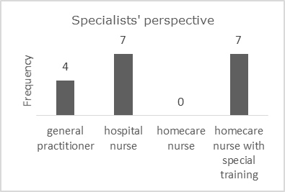

**Figure 1. Perspectives towards oncological home-hospitalization**

c. Most suitable healthcare provider responsible for coordinating oncological home-hospitalization.

b. Most suitable healthcare provider responsible for home administration of cancer therapeutics.

a. Perspectives towards the possibility of oncological home-hospitalization, defined as administrating cancer therapeutics at the patient’s’ homes instead of at the oncology day care unit.

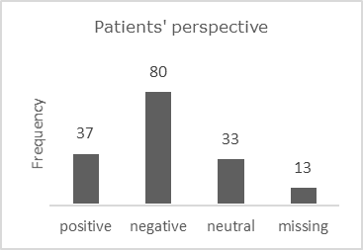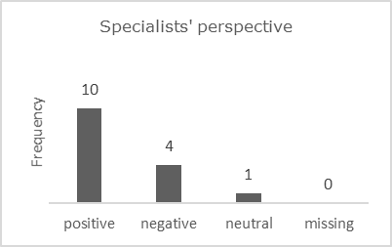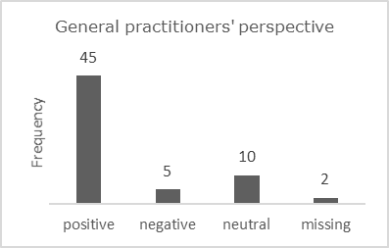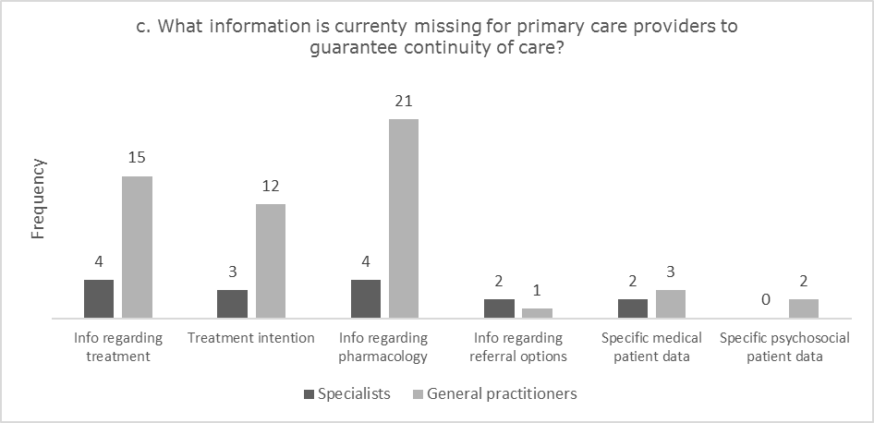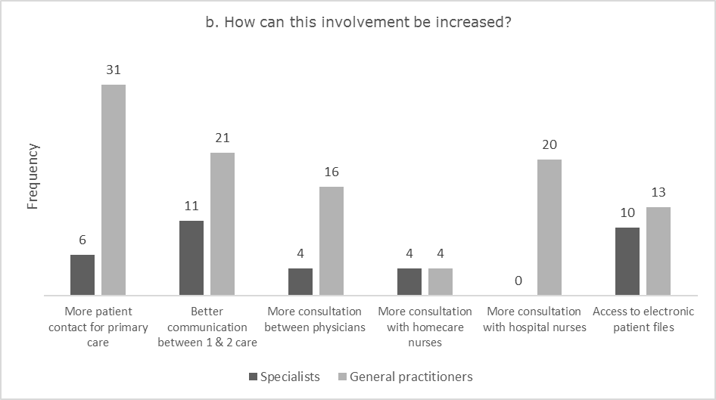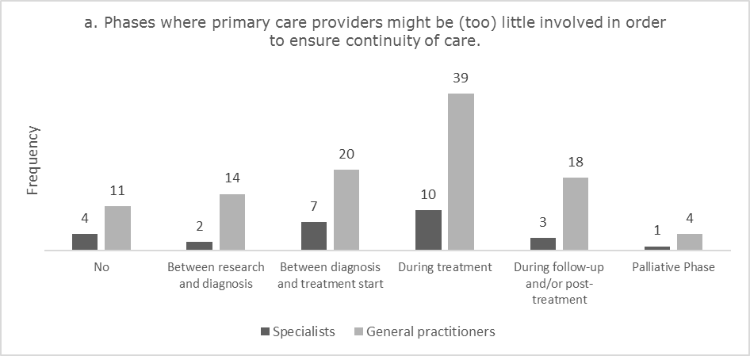

**Figure 2: Specialists’ and General practitioners’ perspectives about the current oncological care**

**REFERENCES**

1. Hurst J. Challenges for health systems in member countries of the Organisation for Economic Co-operation and Development. Bulletin of the World Health Organization. 2000;78(6):751-60.

2. Institute of Medicine Committee on Quality of Health Care in A. Crossing the Quality Chasm: A New Health System for the 21st Century. Washington (DC): National Academies Press (US)

Copyright 2001 by the National Academy of Sciences. All rights reserved.; 2001.

3. Innovative care for chronic conditions: building blocks for action: global report. World Health Organization; 2002.

4. Michel. Regeerakkoord - Accord de Gouvernement. 9 oktober 2014.

5. Volksgezondheid C. Plan van Aanpak. Hervorming ziekenhuisfinanciering. 28 april 2015.

6. Farfan-Portet M-I, Denis A, Mergaert L, Daue F, Mistiaen P, Gerkens S. Thuishospitalisatie: opties voor een Belgisch model. KCE Rapport 250 As; 2015.

7. Van Dyck W, Geldof T. Oncology Horizon Scanning Project. Vlerick HMC Report 2015-1. Brussels - Ghent - Leuven - St. Petersburg: Vlerick Business School - The Business School of Ghent University and KU Leuven; 2015.

8. Cool L, Vandijck D, Debruyne P, Desmedt M, Lefebvre T, Lycke M, et al. Organization, quality and cost of oncological home-hospitalization: A systematic review. Critical Reviews in Oncology/Hematology. 2018;126:145-53.

9. Cool L, Missiaen J, Vandijck D, Debruyne P, Pottel H, Foulon V, et al. An observational pilot study to evaluate the feasibility and quality of (partial) oncological

home-hospitalization. 2018.

10. Gerrits O. Toedienen van immunotherapie in de thuissituatie is voor veel patiënten een volwaardig alternatief.: Medzine; 2018 [

11. Corrie PG, Moody AM, Armstrong G, Nolasco S, Lao-Sirieix SH, Bavister L, et al. Is community treatment best? a randomised trial comparing delivery of cancer treatment in the hospital, home and GP surgery. Br J Cancer. 2013;109(6):1549-55.

12. Touati M, Lamarsalle L, Moreau S, Vergnenegre F, Lefort S, Brillat C, et al. Cost savings of home bortezomib injection in patients with multiple myeloma treated by a combination care in Outpatient Hospital and Hospital care at Home. Support Care Cancer. 2016;24(12):5007-14.

13. Lal R, Hillerdal GN, Shah RN, Crosse B, Thompson J, Nicolson M, et al. Feasibility of home delivery of pemetrexed in patients with advanced non-squamous non-small cell lung cancer. Lung Cancer. 2015;89(2):154-60.

14. Luthi F, Fucina N, Divorne N, Santos-Eggimann B, Currat-Zweifel C, Rollier P, et al. Home care--a safe and attractive alternative to inpatient administration of intensive chemotherapies. Support Care Cancer. 2012;20(3):575-81.

15. Lassalle A, Thomare P, Fronteau C, Mahe B, Jube C, Blin N, et al. Home administration of bortezomib in multiple myeloma is cost-effective and is preferred by patients compared with hospital administration: results of a prospective single-center study. Ann Oncol. 2016;27(2):314-8.

16. Couillerot-Peyrondet A-L, Leclerc S, Hirtzlin I, Rumeau-Pinchon C. Analyse de l'activité de chimiothérapie anticancéreuse en hospitalisation à domicile (HAD) à partir du PMSI-HAD. Santé Publique. 2016;28(3):341-52.

17. Continuity and coordination of care: a practice brief to support implementation of the WHO Framework on integrated

people-centred health services. Geneva: World Health Organization; 2018.

18. Rubin G, Berendsen A, Crawford SM, Dommett R, Earle C, Emery J, et al. The expanding role of primary care in cancer control. Lancet Oncol. 2015;16(12):1231-72.

19. ECCO. Integrated Cancer Care: Bringing Primary Care and Secondary Care Together. ECCO Position Statement. Brussels: European CanCer Organisation; 2017.

20. Green T, Atkin K, Macleod U. Cancer detection in primary care: insights from general practitioners. British journal of cancer. 2015;112 Suppl 1(Suppl 1):S41-S9.

21. Aubin M, Giguere A, Martin M, Verreault R, Fitch MI, Kazanjian A, et al. Interventions to improve continuity of care in the follow-up of patients with cancer. Cochrane Database Syst Rev. 2012(7):Cd007672.

22. Carmont SA, Mitchell G, Senior H, Foster M. Systematic review of the effectiveness, barriers and facilitators to general practitioner engagement with specialist secondary services in integrated palliative care. BMJ Support Palliat Care. 2018;8(4):385-99.

23. Ouwens M, Hulscher M, Hermens R, Faber M, Marres H, Wollersheim H, et al. Implementation of integrated care for patients with cancer: a systematic review of interventions and effects. Int J Qual Health Care. 2009;21(2):137-44.

24. Janssen A, Brunner M, Keep M, Hines M, Nagarajan SV, Kielly-Carroll C, et al. Interdisciplinary eHealth Practice in Cancer Care: A Review of the Literature. International journal of environmental research and public health. 2017;14(11):1289.

25. 18 JUNI 1990. - Koninklijk besluit houdende vaststelling van de lijst van de technische verpleegkundige verstrekkingen en de lijst van de handelingen die door een arts aan beoefenaars van de verpleegkunde kunnen worden toevertrouwd, alsmede de wijze van uitvoering van die verstrekkingen en handelingen en de kwalificatievereisten waaraan de beoefenaars van de verpleegkunde moeten voldoen.

26. 21 MAART 2003. - Koninklijk besluit houdende vaststelling van de normen waaraan het zorgprogramma voor oncologische basiszorg en het zorgprogramma voor oncologie moeten voldoen om te worden erken, (2003).