Decriminalising Ornament: The Pleasures of Pattern: The sympathy of illustration
Nanette Hoogslag
Anglia Ruskin University
Abstract
This article reflects on the research exhibition Decriminalising Ornament: The Pleasures of Pattern held in the Ruskin Gallery in Cambridge in November 2018 in conjunction with the International Illustration Research Conference of the same name. It considers the role of ornament and decoration in the exhibited works and through this the essential presence of the decorative within illustration.
Key is Lars Spuybroek’s concept of sympathy, which he develops based on a premodern understanding of ornamentation. In response to Spuybroek’s exploration of this concept, this article seeks to extend the notion of sympathy as an essential presence within illustration. Sympathy indicates a human-material relationship not just between the illustrator and the creative materials, but also in the readers connection with this decorative act in the reproduced illustration. In illustration sympathy describes the active force used to humanise the information, the ideas
Keywords
illustration research
ornamentation
pattern
decorative
human–material relationship
illustration
sympathy

This article reflects on the research exhibition Decriminalising Ornament: The Pleasures of Pattern held in the Ruskin Gallery in Cambridge in November 2018 in conjunction with the International Illustration Research Conference of the same name. The exhibition focused on the practice, tradition and art forms that emphasize ornamentation and printed pattern as a meaningful part of the illustration and design experience. These ideas were not just embodied in the individual works but through an exhibition design in which visitors were enticed into a carefully calibrated sequence of decorated enclosures in which the works were displayed.
The exhibition sought to foreground its guiding principle that the decorative is no mere trivial adornment but a profound dimension of aesthetic engagement that reveals a material–human relationship, a relationship based on a dialogical interaction between human action and material forces and properties, something the artist, architect and theorist Lars Spuybroek calls sympathy. Spuybroek presents his concept of sympathy as ‘the deep-rooted engagement between us and things, deeper than any aesthetic judgement would allow’ (2016: 107). Through the consideration of the role of the decorative in the exhibited works, this article explores Spuybroek’s concept and makes a case for sympathy not only as a useful term to describe the decorative, but as an inherent, engaging and essential part of illustration.

In his book The Sympathy of Things, Spuybroek (2016) presents sympathy as an essential humanizing quality which can be found in the appreciation of patterns, textures and decoration found on the surface of things. This is something that has been lost over the Modernist decades, but which, he argues, needs to be reconsidered as essential in the appreciation of objects and artefacts.
Although Spuybroek excludes mediated images from the ability to harbour sympathy, as he sees them as disconnected references, he does not specifically direct himself towards illustration. As illustration is often overlooked for its specific expressive qualities, which sets it apart from other image forms, it is therefore important that special attention is paid to the nature of illustration, which I would argue would not only allow illustration to be exempt from Spuybroeks exclusion, but makes the concept of sympathy actually central to illustration. Sympathy describes the fundamental resonance not only through illustration as an artefact but also in the role of the illustration itself within its published context. Through the consideration of the role of the decorative in the works included in the exhibition, this article makes a case for sympathy as an intrinsic, engaging and essential part of illustration.

This exploration first requires a more extensive consideration of the significant presence of texture and pattern within illustration, and how this plays out in the works exhibited in the exhibition. This is followed by an examination of Spuybroek’s idea of sympathy, using his conceptual framework based on ideas shaped by amongst others the pre-modern art critic and naturalist John Ruskin, and the philosophers Theodor Lipp and Henri Bergson. I contextualize this examination through the individual contributions to the show and the artists’ personal descriptions of their work in the exhibition catalogue (Anglia Ruskin University 2018). This leads to a proposition that sympathy could be understood as a fundamental property of illustration and will shine a light on the appreciation of the decorative as part of the role of illustration.

‘[Pattern and ornament] are strategies for thinking and making that have rich histories that can and must be continually re-imagined. They can be used as framing devices or carriers for critical or narrative commentary’ As (the designer and theorist) Daniël van der Velden says, “Playfulness and layers, multiple narratives, embedding history, seeking relations, and also political implications are better expressed in a visual vocabulary less dogmatic and more rich than Modernism” ’. (Twemlow 2005: n.pag.)

The above is the final paragraph of the article The Decriminalisation of Ornament (Twemlow 2005) whose title inspired the name of the conference and exhibition. In the initial article Twemlow points to the slow but steady re-engagement that our culture has with decoration and ornamentation. We could take these words as praise for pattern and ornament, part of a general renewal of interest in current visual culture. But interpreting these words in relation to illustration, highlights the role of pattern and ornament as an essential part of the illustration, as well as pointing to how illustration itself could also be seen as having a decorative function within its published and reproduced context.

In my extensive examination of illustration, I defined the role of illustration as to illuminate ideas and stories through the depiction of an action or narrative, and the creation of a meaningful relationship between the story and its depiction, in order for the audience to become engaged with the story and gain insight into the underlying messages and ideas (Hoogslag 2015, 2019). But this relational definition of the illustration is not about presenting a mere visualization of the narrative. What is typical, striking and indeed essential, is the aesthetic and playful quality of the visual language used and the wide variety of the illustrator’s personal marks, visible in lines, patterns and decorative elements that define the surface of the image. Whilst of course these marks can play a role in placemaking and signification, as socio-historic and symbolic signage or symbols, it is important to restrain a desire to automatically deconstruct the marks as meaningful signifiers.
Much of the overt presence of texture, marks and decorative elements are not necessarily essential to the visualization of a narrative, but it is through the expressive application and use of the material properties that the illustrator makes him or herself present, and articulates a personal connection with the artwork itself. The playfulness of these marks and textures demonstrate that the illustrated image is not a mechanical reproduction of an indexical image such as a photograph, or a technical drawing with the sole purpose of clarification. The illustration should be seen as a relational artwork where the decorative act is an act of engagement. On the one hand, it shows the engagement of the illustrator with the materials through crafting in the creative process, which is a deliberate and aesthetic human–material relationship. On the other, in the final reproduced state of the illustration, the decorative reveals this relationship to the audience and, in doing so, allows the audience to see and enjoy the care and play in the creative process and connect with the illustrator; an empathetic process of material mediation between human creator and audience.

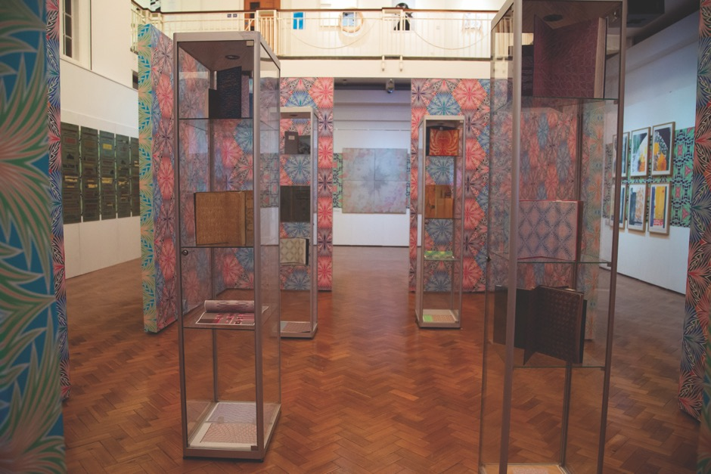

Figure 1: Exhibition overview, Decriminalising Ornament: The Pleasures of Pattern,. Ruskin Gallery, 2018, Cambridge.
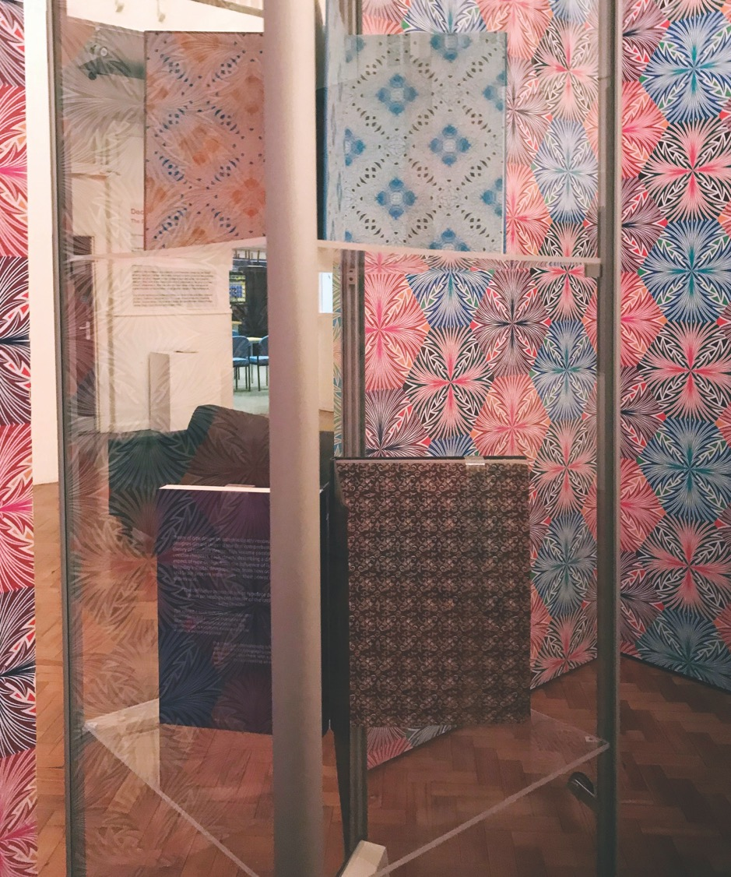Figure 2: Exhibition overview, Decriminalising Ornament: The Pleasures of Pattern, Ruskin Gallery, 2018, Cambridge. Various endpapers within the inner space contextualized by Pattern September 2018, variant 3. Photograph by Neuza d’Almeida, 2018.
These aesthetic and empathetic values of illustration lie at the heart of the exhibition (Figures 1 and 2). The artworks submitted, selected and presented within the context of practice-based research within the field of illustration and, more specifically, the exploration of the role and nature of pattern and ornament within these practices. This means that although narrative, meaning and intertextual relationships are present, they are not our key concern that is instead the critical exploration of material expression.
Coming from their own practice and research interests, each of the artists reflected on their own particular relationship to the decorative. Moreover collectively they presented a series of over-arching directions that can be summarized in the following four strands: (1) the expressive human–material relationship present in the works through the decorative; (2) the visible presence of the creative process in the artwork; (3) the development of the human–material relationship through digital computation; and (4) the decorative as a critique on current practices and understanding. Each of these strands revealed aspects of the qualities of sympathy whilst together they show how sympathy is inherent in the expressive dimension of illustration.
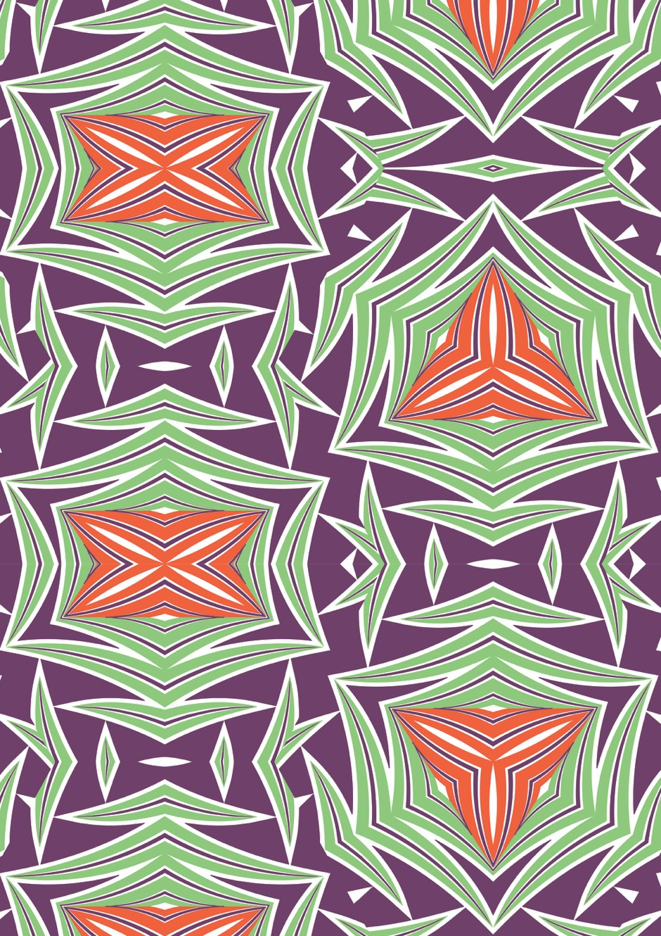
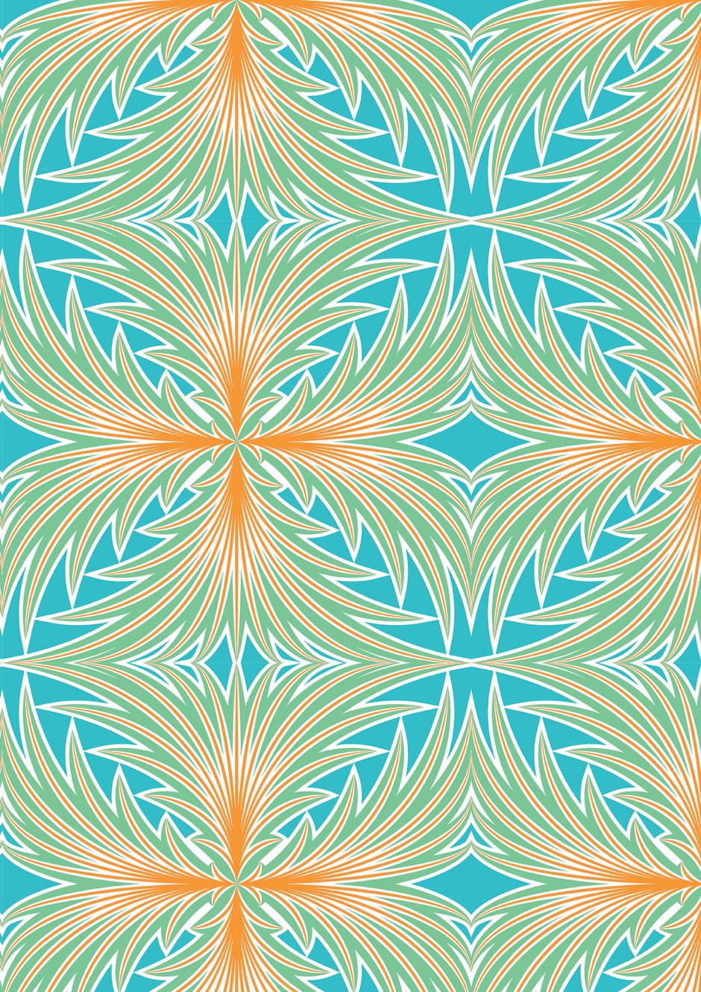Figure 3: Pattern outside wall, Hansje van Halem, Pattern September 2018, 2018. Printed vinyl. Ruskin Gallery, Cambridge School of Art. Image courtesy of the artist.

Figure 4: Pattern outside inner space, Hansje van Halem, Pattern September 2018, 2018. Printed vinyl. Ruskin Gallery, Cambridge School of Art. Image courtesy of artist.
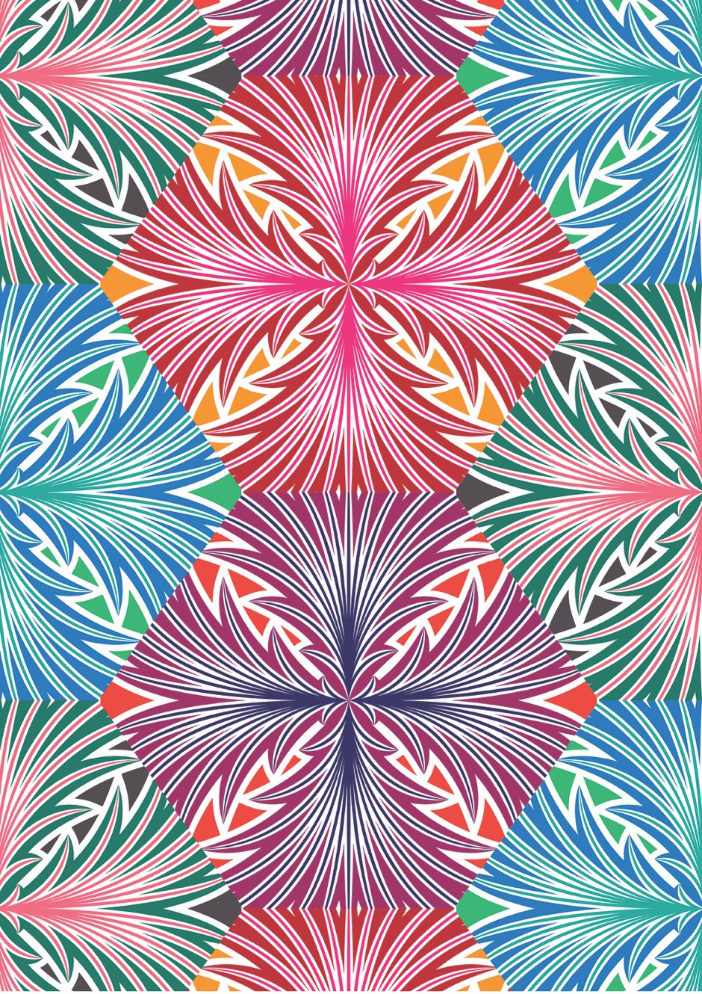
Figure 5: Pattern inside inner space, Hansje van Halem, Pattern September 2018, 2018. Printed vinyl. Ruskin Gallery, Cambridge School of Art. Image courtesy of artist.
The exhibition displayed a selection of works from current international art and design research practices by illustrators, artists and designers Irene Albino and Ellen Jonsson, Jo Berry, Mattson Gallagher, Amy Goodwin, Ameet Hindocha, Charlotte Hodes, Danica Maier, Christine McCauley, Michael Kirkham, Robyn Phillips, Teresa Rego and Lucy Renton.
Dominating the exhibition space were three variations and a screen presentation of the creative process of Pattern September 2018 (2018), a work especially commissioned for the show by the designer Hansje Van Halem in collaboration with Jan de Jong, masterprinter, publisher and bibliophile. The work, echoing the vibrant patterns of pre-modern designers such as William Morris, consisted of a bold tessellated repeating pattern based on the mirroring and rotating of a central stylized shape, in strong contrasting colours, with each variant, in both construction and colour scheme, strongly differentiation from the other. Van Halem’s contribution was threaded throughout the exhibition operating in a dialogical relationship to the individual works of the other artists. The design on the outer walls of the gallery the pattern (Figure 3) functioned as wallpaper, framing and foregrounding the work of the other artists displayed on top. Here it created a supporting background to works as delicate as the ceramic plates of Hodes or the collection of small typographic prints of Gallegher. In the middle of the Ruskin Gallery, a set of panels squared of a more intimate space, which carried two further variants of the Van Halem’s design (Figures 4 and 5). Inside this space, the pattern was placed in a direct dialogical relationship to a selection of endpapers from Jan de Jong’s bibliographic collection. The endpapers, presented within their original context, came from an eclectic mix of old and new books, selected for their aesthetic qualities, and also included a range of endpapers designed by van Halem and printed by de Jong.
It is through these endpapers that the long-standing working relationship between van Halem and de Jong is clarified and illuminated. Van Halem’s design was always seen by de Jong as an open-ended instruction. The trust and flexibility between designer and master printer, in the consideration of the properties of printing press, papers, colours and inks, not only enabled a high-quality product, but a creative range of outcomes vitalizing the final printed production. This open collaboration between designer and printer lead to a range of experimental books presenting pattern collections, such as Sketch Cahier (van Halem 2014) and the even more elaborate Sketchbook (van Halem 2013).
These books and the variation of Pattern September 2018 not only demonstrated how placement, material, size and colour play a central role in shaping perception, but also how Van Halem’s explicit intuitive approach (van Halem 2019) can be iterated through technological processes and allow for an extraordinary range of expressive variability.
The international appreciation of van Halem’s work is evidence to support the idea that we are emerging from a long period that emphasized the modernist virtues of necessity or deconstruction within architecture, art and design, an era in which the decorative was seen as superfluous, sentimental and disguising construction. Adolf Loos, architect and author of the modernist manifesto Ornament and Crime (1910) would go so far as to assert that decoration represented ‘backwardness’ ([1929] 1971: n.pag.). These stripped back values set the tone, even within the field of illustration, ironically itself often dismissed based on a similar rationale, in which decoration was frequently disdained and perhaps only tolerated within a historicized context as meaningful or ironic commentary. Ornament and pattern have simply not been given the serious consideration required to recognize their own intrinsic qualities or even as a necessary presence.

This position of neglect was in some part driven by the ideology dictated by modernists such as Loos, but also by the dominance of mechanical manufacturing processes that demand economies of scale and uniformity, processes in themselves informed by the same ideology.
With this quest for purity, and the focus on function and intent as design qualities, it could be argued that it has become harder for individuals to relate to the products and environments we created around us. What has been cast aside is a sensory and humanizing relationship with materials and environments that can be viewed in the marks, texture and more deliberate the decorative surfaces. The artist Richard Wentworth, in discussion with Amica Dall and Giles Smith around mass-production and the way this has defined the relationship with the material world, described this as a loss of readability of our surroundings, a process of dehumanization and the creation of loneliness (Wentworth 2019).
Lars Spuybroek sees the same need for recuperation of this essential connection with the material world and pleads for re-establishing the explicit connection with the objects and artefacts we create. He notes that this connection is most clearly visible in the careful crafting of patterns and ornamentation on the surface of things. These decorated objects reveal the creative engagement of the maker in response to the material, based on texture, form and the forces that are already present in the material, either visibly or in potential. Spuybroek states: ‘Ornament and its close relative texture, share the traces of being-made, or being-in-the-making’ (2016: 234) and as such ornamentation is not something applied onto the surface, but something that comes from within. To Spuybroek this reveals a human–material relationship, where material and the shapes created made by human hand are interdependent on the particular qualities held within the material and form. It is on the surface that we experience such connection and for this reason he presents surface decoration, through ornamentation, textures and patterns as an explicit space of humanized connection.

The matter of ornament
A key source for Spuybroek’s ideas of ornamentation as the result of the interplay of materials and internal and external forces, originate in the ideas of John Ruskin, in particular Ruskin’s The Nature of Gothic (Ruskin and Morris 1892) in which Ruskin observes the natural forces at play in the formation of the Alps and in particular the creation of the Wall Veil. These are the textures and patterns of sediment, rocks, streams and vegetation that encrust the face of the mountain, which is described as ‘self-adornment’ (Spuybroek 2016: 57). This fundamental ‘intertwinement of matter, massing and texture’ (Spuybroek 2016: 63) follows the logic of nature between the mountain and the elements and is the result of a generative self-structuring relationship between the quality of material, forces from within, as well as from the outside onto the material. Together, and over time, they shape the patterns on the surface.
Ruskin sees this intertwining as also present in Gothic architecture. He observes that the shapes of the vaulted buildings present a natural patterning and sense or ornamentation, which comes from the need to carry and distribute weight, as well as the responsive interpretation of the design by the individual stonemason, based on skills and sensitivity. Rigidity, Changefulness and Savageness are three of the six characteristics of the Gothic, which Ruskin translated from nature to construction (Ruskin and Morris 1892). These characteristics can be understood as elements of a pre-modern form of thinking, placing feeling above thinking, according to Spuybroek, which is ‘especially present in aesthetics, meaning that it specifically acknowledges mental, but not psychological, and a bodily, though not sensual, reciprocity between us and the thing’ (2016: 107).
What Spuybroek takes from Ruskin’s description of Gothic is its relational and organic essence, but also the digital quality in execution. With this he refers to the potential for endless configuration of material forms, based on a principle template and design that in execution could flourish organically through a human–material interaction.

Spuybroek’s use of the word digital is not accidental, he points to the fractal quality at the level of configurational that lies within the Gothic nature of construction. Where digitization has perhaps mistakenly been associated with automated systematization and the reductive or a loss of human agency, Spuybroek sees a more ‘ecological relation’ present in digital computation. It is the algorithm, coded by the human maker to can enable variability, in turn allowing the computer and its material affordances, to respond with continual variations and iterations, both expected and unexpected.
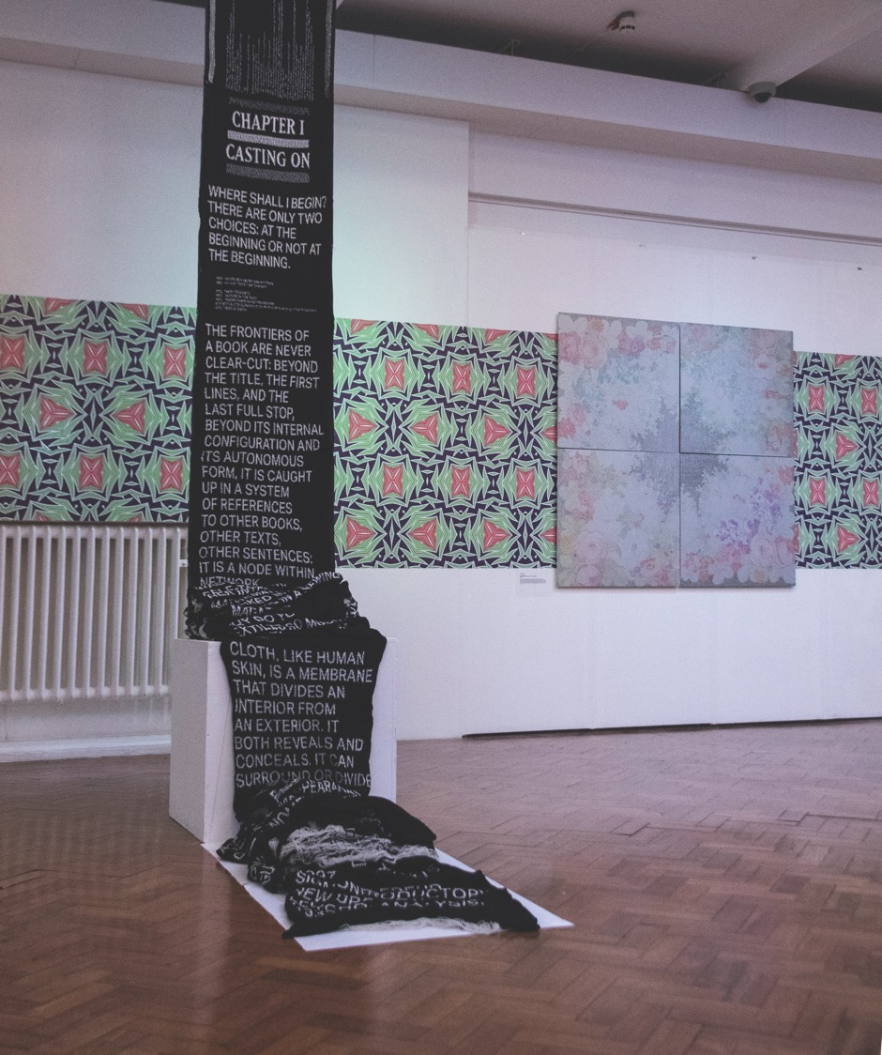
Figure 6: Exhibition overview, Decriminalising Ornament: The Pleasures of Pattern. Ruskin Gallery, 2018, Cambridge. On the left Albino and Johnsson, </unravel;>, 2018. Knitterd textiles. On the right Danica Maier, Four Glory Holes, 2007. Pencil drawing on Mylar. Photograph by Neuza d’Almeida, 2018.
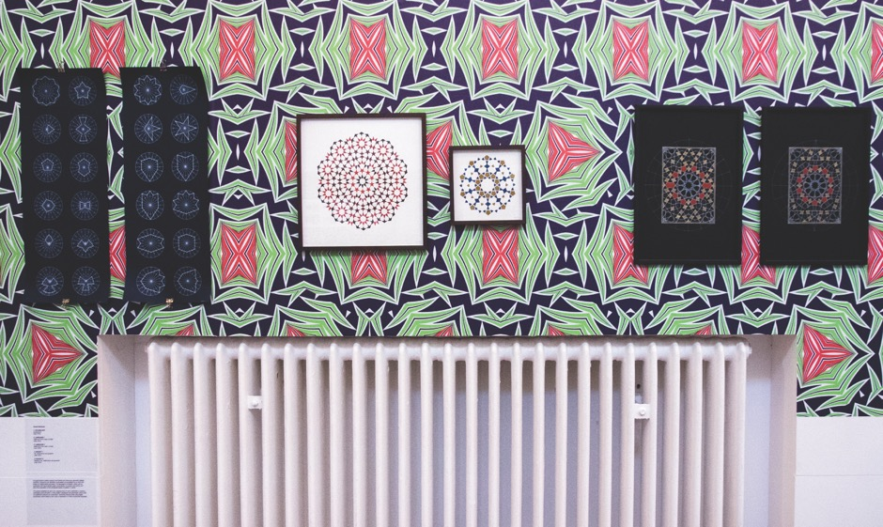
Figure 7: Exhibition overview, Decriminalising Ornament: The Pleasures of Pattern, Ruskin Gallery, 2018, Cambridge. All works by Ameet Hindocha, Vocabulary, 2018, Language, 2016, Dialect 1, 2018, Dialect 2, 2018. Photograph by Neuza d'Almeida, 2018.
Such understanding of the digital and in particular the human–computer relationship allows for a variable modulation that is not only obvious in the intuitive approach of van Halem in her use of a vector-based image manipulation programme, but also in the way the artists in the exhibition, Albino and Johnsson, describe their approach to their knitted manifesto </unravel;> (2018) (Figure 6). Unravel is a 25-metre knitted banner, for which they hacked a knitting machine and programmed it to knit a hypothetically never-ending display of texts and black and white patterns. Albino and Johnsson used the binary quality of a simple bitmapped typeface, black and white treads and the reprogrammed machine to create an automated binary structure in which they could fit a large series of typographic statements of varying lengths.
Similar play with code and machines can be seen in the work of Jo Berry, sequence compilation.ai, 2018 that explores the inherent creative potential of scientific advanced imaging technologies and microscopy. These computer-based technologies are used to visualize scientific data normally destined for research, but equally with the inherent variability that is part of the algorithm, they can used for aesthetic exploration and iteration of the same material.
In Hindocha’s series of work, Vocabulary (2018), Language (2016), Dialect 1 (2018) and Dialect 2 (2018) (Figure 7) the computer does not produce a final product but enables a more complex development within an otherwise analogue process. Drawing on the geometric Persian and Moroccan design traditions, Hindocha seeks to use and extend these traditional methods of construction, deploying digital techniques with the clear intention of exploring the aesthetic potential that comes from the materials and their application. Hindocha states: ‘The language of ornament which can be expressed with these simple shape vocabularies is complex and infinite, allowing me to explore the archetypal beauty of pattern in nature’ (Anglia Ruskin University 2018: n.pag.). But acknowledging how this process is based on a human–material interaction, he further states:

Drawing geometric patterns by hand and the printmaking process both involve repetition, but the active meditative state this process creates allows the practitioner to develop a deeper insight into what they are doing and why. They are immersive and reflective processes which encourage thinking through doing. (Anglia Ruskin University 2018: n.pag.)
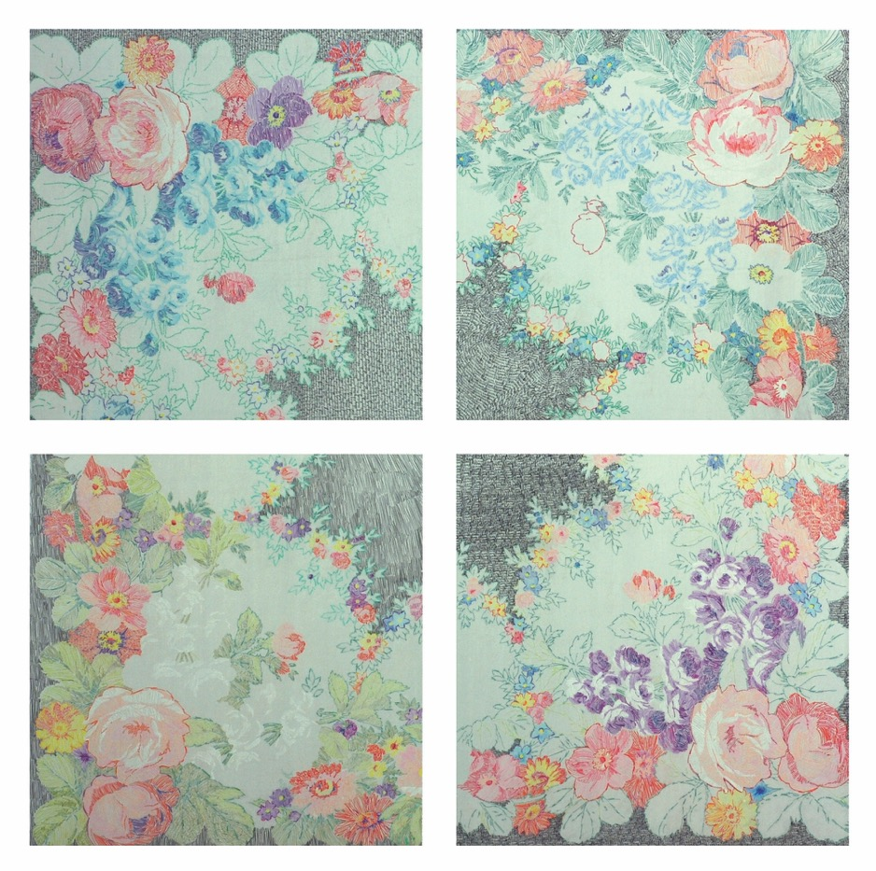
Figure 8: Danica Maier, Four Glory Holes, 2007. Pencil drawing on Mylar, mounted on aluminium. Image courtesy of artist.
Understanding the decorative
The principle of ornamentation as a process coming from within and ‘thinking through doing’ is central in the creative process and visible in the majority of the works in the exhibition are perhaps most literally explored in the work by Micheal Kirkham, The Drawings That Happen While We're Thinking About Other Things (2018). This photocopied booklet presents a collection of ‘doodles’, ‘drawings which were made whilst primarily engaged in tasks such as meetings or phone calls’ (Anglia Ruskin University 2018: n.pag.). The resulting drawings were not commissioned or based on desire to draw something explicit, rather they were an ‘unselfconscious and instinctive responses’ to material circumstances, ‘rhythmic, ornate and seemingly miraculous in their conception’ (Anglia Ruskin University 2018: n.pag.). More deliberate in its conception is Danica Maier’s Four Glory Holes (2007) (Figure 8) based on a repeated and rotated redrawing of a historical floral pattern. The delicacy of the drawn texture created from a stich line and writing pattern as well as the responsiveness of every line to the organic pattern of which it is part, reveal both the relation between the materials as well as driving material force to which Maier response is an example of what Spuybroek describes as ‘traces of being-made or being-in-the-making’ (2010: 234).
A similar sentiment can be seen in the patterns of Hoodie by Robyn Phillips-Pendleton (2018) (Figure 9). The large portrait of a young black male embedded in swirls of line and pattern, surrounding him like a decorative halo. Pendleton describes the ornamentation as playing a supporting yet competitive role, where it can translate

[…] a deeper meaning through subtle or distinct parts of the narrative, sometimes seeking comfort in pattern, and perhaps rhythm, repeating like a cadence over and over within a composition. It can engage the viewer in a visual dance, sweeping them into a deeper spatial courtship in addition to the lure of main image, and sometimes taking center stage with visual emphasis on its own solo. Using ornament to suggest roots in a historical period and or culture through its combination of shapes or forms, lines, color, and other elements of design, strategically gives that portion of the image an alternate language while simultaneously complementing the whole. (Anglia Ruskin University 2018: n. pag.)
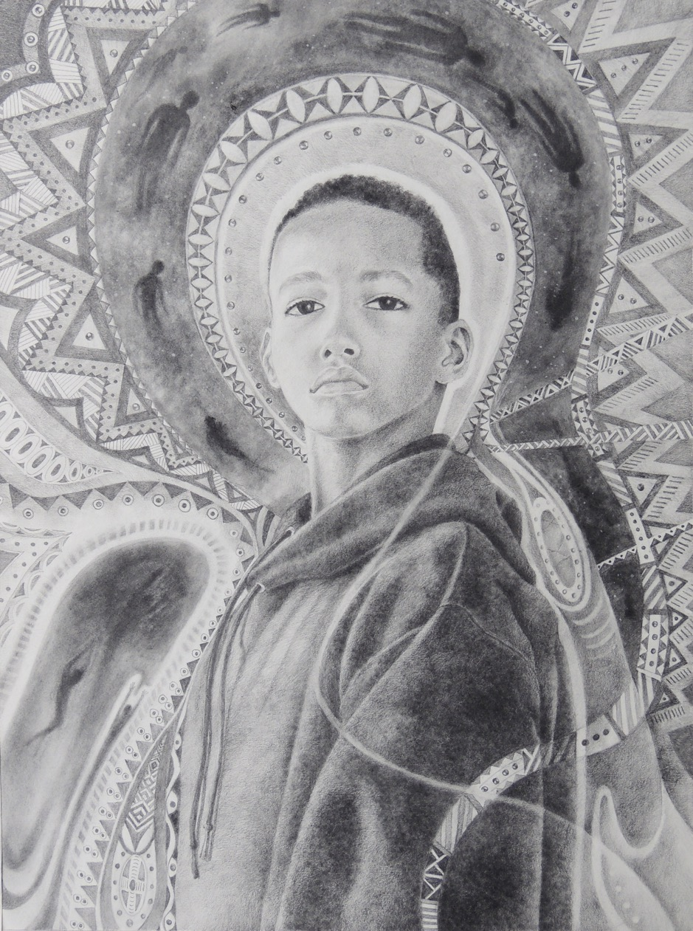
Figure 9: Robyn Phillips-Pendleton, Hoodie, 2018. Graphite pencils and powder on Stonehenge White. Image courtesy of artist.
In her description of the use of ornament Pendleton points both to Ruskin’s ideas of intertwinement and her active desire to create an engagement, not based on a deconstruction of the image, but drawing on a more subconscious level, a connection described by Wilhelm Worringer and Theodor Lipps, as an aesthetic resonance or Einfühlung, a German term literally translated as ‘feeling-into’ (Lipps 1965), but most often translated as empathy. Empathy, however, is a feeling that reveals itself between humans, whereas what Pendleton sees, and what is present in all the other works in the exhibition, is a more profound form of Einfühlung, which resonates between materials, and material and humans. Something Spuybroek presents as beyond perceived experience, a far more fluid and subconscious knowledge based on Henri Bergson’s idea of intuition ([1946] 2012). Intuition refers to the acknowledgement that how we see things is based on a dual and iterative process of knowing. This process consists of analytical thinking, gaining relative knowledge through looking at the object. But importantly this analysis is placed in a framework of equally developing holistic knowledge, an absolute knowledge grasping the totality and uniqueness of each object from within. According to Bergson ‘by intuition is meant the kind of intellectual sympathy by which one places oneself within an object in order to coincide with what is unique in it and consequently inexpressible.’ (Bergson in Bennett 1916: 7)

Bergson’s intuition should not be seen as a form of analytical deconstruction but an active aesthetic thinking, which is an understanding beyond expression. Intuition is concerned with grasping the entirety of an idea, how matter and form interact and shape. This points to an essential and deep human consideration of material and aesthetic expression.
Decorative expression is a human response to the forces within the material and Spuybroek presents the decorative as a materialization of our innate and intuitive connection with objects and artefacts. Spuybroek warns that this has nothing to do with taste, but everything to do with relational understanding of matter and humanity. This interaction, in its conception and expression is what he calls sympathy.

Such Intuition is notable in the artists book Forgotten Women, by Christine McCauley (2018), which has been made with a high level of detailed attention given to its material construction. The sensorial and aesthetic quality of the materials and the personal attention and involvement of the printing and binding processes do not necessarily signify the story. You could argue that it echoes the level of empathy she seeks for the book’s subject; the British women buried at South Park Street Cemetery in India two and a half centuries ago. But if so, this link is not expressed in direct symbols or clearly interpretable symbolic usage of materials. Rather, McCauley establishes a sympathetic, intuitive connection through her careful dedication to the material, and how these allow for expression.
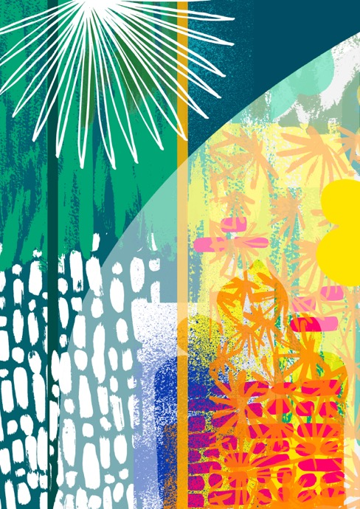
Figure 10: Theresa Rego, Nature & Buildings Interaction – Case Study St. Dunstan Church in the East, 2018. Screenprint. Image courtesy of artist.

Terasa Rego’s six screen prints Nature & Buildings Interaction – Case Study St. Dunstan Church in the East (2018) (Figure 10) shows how sympathy is a principle within what she calls a genuine approach towards the expression of an experienced space, in this case St. Dunstan Church. Rego notes how ‘throughout the seasons and in different corners of the construction’ (Anglia Ruskin University 2018: n.pag.) certain elements reoccur in a range of variations. These are what she calls ‘patterns of identity’ (Anglia Ruskin University 2018: n.pag.) and which she uses not to create a naturalistic representation of the building and garden, but to ‘represent an articulation between nature and human construction’ (Anglia Ruskin University 2018: n.pag.) and to capture the feeling of stability and change shaped by the seasons.

A more critical exploration of the decorative is the site-specific work of Lucy Renton, A Bit of Skirt (2018) a decorative frilly plastic skirting border edging around a plain white partition wall. This work ‘explores “skirt” and “skirting’ as terms that are active and passive, gendered and neutral, decorative and functional’ (Anglia Ruskin University 2018: n.pag.). It questions how decoration is used to cover up or draw the attention away. According to Renton ‘A Bit of Skirt hint[s] at an excess of patternation, and the human compulsion to decorate apertures and borders’ (Anglia Ruskin University 2018: n.pag.). But rather than undermining Spuybroek’s concepts on decoration, the work reinforces his position. If decoration is to be valid, it should be a dialogical expression of the natural properties and forces harboured within an object’s material and form, rather than an attention seeking concealment.
Charlotte Hodes too is suspicious of a certain understanding of ornamentation in particular the seminal indexation or ornamental structures in the Grammar of Ornament by Owen Jones ([1868] 1972). In a series of related prints and enamel transfers on china plates that are all named after the original 37 propositions by Jones, Hodes presents a feminist critique on the patriarchal and hierarchical order in which Owen has categorized the examples that originate from ‘the grand and lofty iconography of architecture and classic design’ (Anglia Ruskin University 2018: n.pag.), omitting the decorative which is traditionally part of domestic environments. Hodes presents a series of papercuts with a filigree of both decorative and figurative elements set against structured patterns of paper tiles and surfaces. Playful and intuitive this filigree breaks with rules applied to decoration that Jones seeks to define. Spuybroek (2011) rejects Jones’ rigid categorization, which he sees as leading towards a modernist purified and ordered notion of the object. Instead he proposes the approach that can be found in William Morris’ vine system, based on ideas of ‘entangling, interlacing something not “in order” […] but with an undefined “felt” beauty to it’. Sympathy is not about decoration per sé, it is about the process and intent that shapes it.

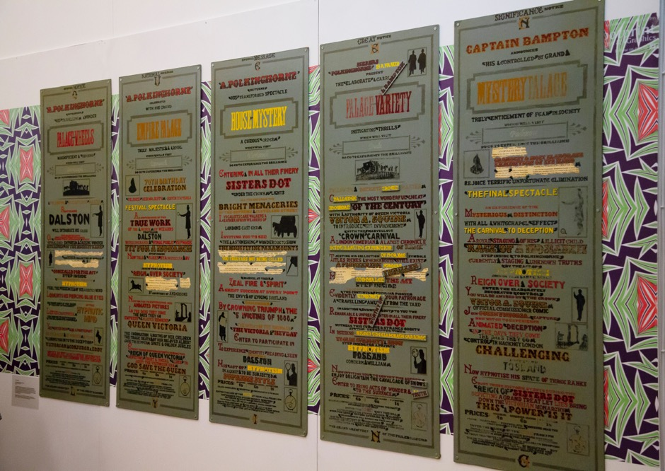
Figure 11: Exhibition overview, Decriminalising Ornament: The Pleasures of Pattern, Ruskin Gallery,2018, Cambridge. Goodwin, A., The Travelling Showman’s Descent, 2014. Enamel paint on wood. Photograph by Neuza d'Almeida, 2018.
Mattson Gallagher in his prints Rules, Borders, Ornaments: An Ornament Alphabet (2018) constructs letterforms through the use of the typographic ornament. Amy Goodwin’s hand-painted signs The Travelling Showman’s Descent (2014) influenced by her background within fairground tradition, present a fragmented narrative through the use of ‘typography and ornament; colour; illustrative silhouettes and symbols; palimpsest and patina’ (Anglia Ruskin University 2018: n.pag.). Both artists play with the changed perception of traditional methods, the letterpress and fairground sign writing. For both artists the choice of their medium and its expression is significant in the way it allows a discussion around historic weight and current ideas of nostalgia. This however does not eliminate the emphasis placed on the creative material process and aesthetic expression with which they are deeply involved. This intertwinement of conceptual signification, aesthetic expression and material play is often inseparable in the way illustration works. Material expression can both drive the decorative and the personal, as well as humanizing the understanding of the concept. Signification and aesthetic materiality might be two different approaches, they form two layers of the same work and both perform an essential function. They are both needed in order to complete the potential of the illustration. Narrative and meaning anchor the illustration, material play enables the visibility of a human creator as a connection with the creative process and through this establishes an engagement with its audience. In this the illustration functions like any of Spuybroek’s things, creating a continual open human–material relationship, based on sympathy.

Illustration and sympathy
One discussion is important to come back to, as Spuybroek specifically states that sympathy cannot materialize through mediated images, and rejects mediated images as fixed, crystallized and detached by definition: ‘nothing but a psychological residue of what originally lay at the heart of all relations within the realms of the animate and the inanimate’ (Spuybroek 2016: 128). Images, according to Spuybroek, are specific references that present an idea or event in isolation and lack the essential development of a material relationship that plays out on a level of intuitive abstraction. Though Spuybroek does not categorize specifically what he means by mediated images, a popular notion of illustration might easily place illustration with-in this group. After all, illustration is most generally seen as an image and most often destined to be reproduced within a media context, It is therefore important to stress what I argued in earlier publications (Hoogslag 2015, 2017, 2019), that illustration within its reproduced state is, not fixed, but procedural in its development of meaning and interpretative relationship with the reader. The published illustration is never just a duplicate of an artwork existing elsewhere. The artwork of an illustration is specifically created for a final manifestation in its published form. This means that certain colours, forms and spatial relations will only come into being once the illustration is reproduced. Further, within its destined context, completion of the illustrational experience is not fixed in the act of publication, whether this is in print or screen. The engagement of the illustration, that is essential to its role, originates from the aesthetic experience and time-based perception at the point of interaction with the reader. It is here that the reader connects with the essence of the illustration, not just through the reading of the visual narrative, but through the appreciation of the intricacy of texture, pattern and line, the presence of the illustrator through his or her marks, who in turn has created these in response to the materials and forces present in the artwork and in anticipation of these in reproduction. Sympathy is not just present, in illustration it is an active force used to humanize the information, the ideas and stories that need to be told.

References
Anglia Ruskin University (2018), Decriminilising Ornament: The Pleasures of Pattern, Exhibition Catalogue, Cambridge: Anglia Ruskin University.

Bennett, C. A. (1916), ‘Bergson’s doctrine of intuition’, The Philosophical Review, 25: 1, pp. 45–58.

Bergson, H. ([1946] 2012), The Creative Mind: An Introduction to Metaphysics, Kindle ed., New York: Dover Publications.

Burns, T. (2016), Theodor Lipps (1851-1914): l&#39;oeuvre, son contexte et sa postérité. Une perspective interdisciplinaire (eds D. Romand and S. Tchougounnikov), Besançon: Presses Universitaires de Dijon.

Halem, Hansje van (2013), Sketchbook, Amsterdam: de Buitenkant.

____ (2014), Sketch Cahier 3, Amsterdam: de Buitenkant.

____ (2019), ‘Home page’, https://www.hansje.net. Accessed 8 May 2019.

Hoogslag, N. (2015), ‘On the Persistence of a Modest Medium, the Role of Editorial Illustration in Print and Online Media’, Ph.D. thesis, London Royal College of Art.

____ (2017), ‘Shaping expression: The influence of material signification on editorial illustration’, in L. Friant-Kessler (ed.), Illustration and Intermedial Avenues, Nancy: Presses Universitaires de Nancy, pp. 163–78.

____ (2019), ‘How illustration works’, in A. Male (ed.), A Companion to Illustration, New Jersey: John Wiley & Sons, pp. 275–304.

Jones, O. ([1868] 1972), The Grammar of Ornament, London: Van Nostrand Reinhold.

Kalderon, M. E. (2017), Sympathy in Perception, Cambridge: Cambridge University Press.

Lipps, T. (1965), ‘Empathy and aesthetic pleasure’, in K. Aschenbrenner & A. Isenberg (Eds.), Aesthetic theories: studies in the philosophy of art. Englewood Cliffs, NJ: Prentice Hall. Pp. 148-196.

Loos, A. ([1929] 1971), ‘Ornament and Crime’, in Conrads Ulrich (Ed), Programs and Manifestos on 20th-Century Architecture, Cambridge, Massachusetts: MIT Press.

McCauley, Christine (2018), Forgotten Women: South Park Street CEmetry Calcutta : McCauley.

Ruskin, J. (1960), The Stones of Venice, New York: Da Capo.

Ruskin, J. and Morris, W. (1892), The Nature of Gothic: A Chapter of the Stones of Venice, Hammersmith; London and Orpington: William Morris at the Kelmscott Press: George Allen.

Spuybroek, L. (2010), ‘The Matter of Ornament’, in J. Brouwer, A. Mulder and L. Spuybroek (eds), The Politics of the Impure, Rotterdam: V2 Publishing, NAI Publishers. pp. 232-267.

____ (2011), ‘V2_ Lab for the unstable media’, Lars Spuybroek on Ornaments, YouTube, n.d., www.youtube.com/watch?v=jmiZ5lrrTOQ. Accessed 21 May 2019.

____ (2016), The Sympathy of Things: Ruskin and the Ecology of Design, London: Bloomsbury Academic.

Wenthworth, William (2019) interviewed by Amica Dall and Giles Smith, The Sympathy of Things, BBC Radio 4, London 28 January.

Twemlow, A. (2005), ‘The Decriminalisation of Ornament’, Eye Magazine, Winter. http://www.eyemagazine.com/feature/article/the-decriminalisation-of-ornament-full-text.
Accessed 18 November 2018.

Worringer, W. (1927), Form in Gothic,London: Putnam’s Sons Ltd..

Contributor details
Contact:
Nanette Hoogslag
Cambridge School of Art
Anglia Ruskin University
East Rd,
Cambridge
CB1 1PT

E-mail:
Nanette.hoogslag@anglia.ac.uk
https://orcid.org/0000-0003-3242-4986

Notes

As a traditional part of bookbinding, endpapers are used to keep the cover connected to the inside pages. They are glued to the inside of the front and back cover and the first and last inside pages and function as a protective, fortifying and aesthetic ‘joining page’. Practically, endpapers enhance the sturdiness and quality of the book, but as the ‘entrée to a book’ they are also a location to enhance the reading experience. In high-quality publications and in particular children’s books, they have been used as a place for mood setting, expression and experimentation. Over more than 300 years, as part of book printing traditions, endpapers have gained a district role and appearance. With the revival of the book as object, there is a renewed interest in the end paper by current designers and illustrators. Based on traditional ideas and patterning a new development, with current visual languages and digital (algorithmic) techniques the end paper is continued and finding new forms.
‘The nature of Gothic’ is a chapter in The Stones of Venice (volume 2) a three-volume richly illustrated publication (1851, 1853) in which Ruskin described the Venetian architecture in detail (Ruskin 1960). This chapter has later been published independently with a preface by William Morris (1892).
Ruskin named six close-related characteristics of Gothic building, namely Savageness: the imperfection that comes from the hand of the artisan-builder; Changefulness: sense of variety in design; Naturalism: the ‘intense affection’ for foliage and vegetation; Grotesequeness: the love for imaginary figures in the form of grotesques; Rigidity: an active form of the support and the transfer of loads; and Redundance: the love of the ornament (Ruskin and Morris 1892).
The materials used for the book are fully described in the catalogue as: three- and two-colour risograph on Zerkall paper; interleaved with glassine; single section, hardback binding in ‘antique’ buckram; sewn with carmine linen thread; foil blocked in pink; endpapers in pink Hahemuhle, Bugra Butten; Edition of 36 (Anglia Ruskin University, in McCauley 2018).
In the exhibition the following selection of the project ‘Grammar of Ornament’ was shown: proposition nineteen Field of Squares II, hand-cut painted and printed papers (2014); Proposition 19 Network, enamel transfer on china (2014), Proposition 25 Lethargy, hand-cut painted and printed papers (2014); Proposition 25 Lethargy, enamel transfer on china (2014).

