Joint range of motion entropy changes in response to load carriage in military personnel

Morrison, A. ª Andrew.morrison@anglia.ac.uk (Corresponding Author)
Hale, J. ^{b} Jackman.hale@yahoo.co.uk
Brown, S. ^{b} Su.brown@napier.ac.uk

ªCambridge Centre for Sport and Exercise Sciences, Anglia Ruskin University, East Road, Cambridge, UK
^{b}School of Applied Sciences, Edinburgh Napier University, Sighthill Campus, Sighthill, Edinburgh, UK

Abstract
Background
Overuse accounts for 82% of injuries in military personnel, and these occur predominantly in the spine and low limbs. While non-linear analyses have shown changes in overall stability of the movement during load carriage, individual joint contributions have not been studied. The concept of entropy compensation between task, organism and environmental constraints is studied at a joint level.

Research Question
The aim of this study was to investigate whether using different methods of loading by military personnel would have an effect on the sample entropy of the joint ranges of motion.

Methods
Eleven male reserve infantry army soldiers (age: 22 ± 2 years; height: 1.80 ± 0.06 m; mass: 89.3 ± 14.4 kg) walked an outdoor, 800m course under 5 load conditions: unloaded, 15kg backpack, 25kg backpack, 15kg webbing and backpack and 25kg webbing and backpack. Kinematic data was recorded at 240Hz using the Xsens motion capture system. The ranges of motion (ROM) of the spine, hips and knee were calculated for each gait cycle. Mean ROM, coefficient of variation of the ROM and the sample entropy of the ROM were compared between conditions.

Results
Spine side flexion ROM decreased significantly from the control condition in all loaded conditions, while sample entropy of the spine side flexion ROM increased in some conditions with no significant change in Coefficient of Variation (CV). Conversely, the hip flexion ROM increased significantly from the control, while sample entropy of the hip flexion ROM decreased.

Significance
These results suggest that entropy compensation may propagate at a joint level. Understanding that a decrease in certainty with which a joint angle is selected, may be accompanied by an increase at a neighbouring joint. This could be significant in monitoring injuries as a result of environmental or task constraints.

Keywords
Military; load carriage; gait; sample entropy; non-linear

- Introduction
Military personnel are required to carry heavy loads during training and combat. This occurs in the most challenging environments, for extended periods of time, and the consequences of injury can be deadly (Knapik, Reynolds, & Harman, 2004). Overuse in military personnel accounts for 82% of all injuries, with the knee/lower leg (22%) and lumbar spine (20%) the most common sites (Hauret, Jones, Bullock, Canham-Chervak, & Canada, 2010). Therefore, it is important to better understand the changes that occur at the joints to impose these injuries.

Studies into gait changes with external load have investigated a variety of measures. Stride width was found to increase with unstable loads, and stride width variance was found to increase with both stable and unstable loads (Walsh, Low, & Arkesteijn, 2018). This suggests load carriage requires greater stability demands, which the participants attempted to overcome with an increase in stride width. Local dynamic stability of the body movement has been measured more directly using non-linear analyses such as the Lyapunov Exponent. Local dynamic stability of the torso velocity has been found to decrease with increased load (Liu & Lockhart, 2013; Qu, 2013) and with more challenging carrying methods, such as unilateral (Rodrigues et al., 2018). Changes in the base of support and local dynamic stability of torso movement both suggest that increased loads and their locations can affect the control of the CoM negatively during locomotion.

The variability in stride width and CoM movement give important indications of overall movement stability and control of the CoM. However, as overuse is the leading cause of injury in military personnel, changes at the joint level should also be considered. Kurz and Stergiou (2003) suggest that investigating the entropy in range of motion (ROM) can give an indication of the certainty with which the system finds a stable gait pattern. Entropy can be conceptualised as a measure of “randomness” (Yentes, 2016). More specifically, it refers to a lack of correlation between different configurations, or the likelihood that a pattern will be followed by another similar pattern (Rodrigues et al., 2018). Understanding the control that is exerted at a joint over multiple cycles could help to inform injury mechanisms.

Research into changes in joint ROM with load carriage have mainly focussed on the magnitude of the ROM or a linear measure of variability such as variance. Hip flexion ROM has been found to increase with load (Attwells, Birrell, Hooper, & Mansfield, 2006; LaFiandra, Wagenaar, Holt, & Obusek, 2003; Qu & Yeo, 2011; Smith, Roan, & Lee, 2010), while hip flexion variance did not change significantly (Walsh et al., 2018). Trunk forward lean position increased with load, but with no change in ROM over the gait cycle (Attwells et al., 2006), or a decrease in ROM (LaFiandra et al., 2003). Knee ROM has been found both to increase (Attwells et al., 2006) and decrease (Qu & Yeo, 2011) with load. However, to-date, no study has investigated the non-linear changes in the range of motion of key joints as a result of load carriage. As the joint level is where alteration in gait patterns are made to adapt to external perturbances (Latash et al., 2002), this may elucidate the mechanisms of overuse injuries.

As well as certainty in joint ROMs selection, the interaction between joints is also of interest. LaFiandra et al. (2003) found that along with a decrease in pelvis ROM, came an increase in hip flexion ROM. They suggested that this increase in hip ROM was used to maintain equivalent stride lengths, with a reduced contribution from pelvis rotation. With a change in the task constraints affecting the organism degrees of freedom, this agrees with Newell’s model of constraints (Newell, 1986). According to this model, human movement is a result of the confluence of the task, organism and environment. More specifically, it has been suggested that between these factors, entropy is conserved. To illustrate, Hong (2007) used the example of walking through a room. By switching the lights off, the entropy of the environment increased, in that the path is no longer predictable. Smaller, more cautious steps are now taken to avoid bumping into objects. The joint movements are now stiffer to achieve this cautious gait. Hong and Newell (2008) used a finger force production task to test this theory. They found that if the entropy of the environment was increased by reducing feedback, the entropy of the organism – the force output entropy - decreased. From the perspective of load carriage, changes in the task difficulty may elicit changes in the entropy of the organism, and possibly with differing effects across the joints.

The aim of this study was to investigate whether different methods of loading by military personnel would have an effect on the sample entropy of the joint ROM of the spine, hips and knees. It was hypothesised that the decrease in ROM of the spine found in previous studies will be accompanied by an increase in sample entropy. Furthermore, it was also hypothesised that the increased hip flexion ROM found in previous studies will be accompanied by a decrease in entropy, in line with the theory of entropy compensation. Finally, it was hypothesised that the higher CoM associated with the backpack only condition would elicit higher entropy levels in the spine, as would the higher load magnitude.

- Methods
  - Participants
Eleven male reserve infantry army soldiers (age [mean ± standard deviation]: 22 ± 2 years; height: 1.80 ± 0.06 m; mass: 89.3 ± 14.4 kg) volunteered for this study. Participants confirmed that they had no musculoskeletal injuries in the past 3 years and gave informed consent to take part in the study. The study was approved by the University’s research ethics panel and conformed to the Declaration of Helsinki.

  - Procedure
Participants completed five, outdoor, 800m walking trials under different loaded conditions. The route chosen was an unmade track near the army barracks that was regularly used in the training of load marches. The route followed an approximate inverted L shaped trajectory with around a ninety-degree left turn. For the purpose of analysis, only data from the straight trajectory components was extracted to ensure no influence which could be accounted for by the transition in direction. The gait speed of 1.8 m/s was set based on the required load march time of the British Army Annual Fitness Test (MOD, 2018). This pace was maintained using a GPS tracker (Garmin 235, Garmin Ltd, Olathe, Kansas, USA) monitored by the tester. Participants took 5-minute breaks between loaded conditions.

The five load conditions consisted of a control trial with no load, 15kg (BP15) and 25kg (BP25) backpack trials, and 15kg (WBP15) and 25kg (WBP25) webbing and backpack trials. Load was made up of sealed sand bags. For the combined webbing and backpack trials, the load was distributed 5:10 and 10:15 for the webbing to backpack ratios.

Kinematic data was captured using Xsens MVN motion capture system (Version 4.2.4, Xsens Technologies BV, Enschede, Netherlands) at 240Hz. The system comprised 17 inertial sensors positioned on body segments (Appendix A) and has previously been validated for gait capture (Peng et al., 2016; Seel, Raisch, & Schauer, 2014). Anthropometric measurements were taken, and a N-pose was captured to build the model of the body, as per the manufacturer’s guidelines. The Xsens MVN software automatically generated the joint angle and segment velocity data required for the data analysis.

  - Data analysis
Unlike laboratory-based gait analysis, the direction of travel – both vertically and horizontally – of the participant during their gait cycle was not constant through all trials and varied relative to the global coordinate axes. In order to define the heel strike events for the gait cycle, the anterior-posterior foot velocity was used (Zeni, Richards, & Higginson, 2008). The anterior-posterior direction of travel was determined from the horizontal velocity of the pelvis sensor, smoothed using moving average filter of 2000 frames (approximately 4 stride pre and post). Gait cycles of heel strike to heel strike were created for left and right sides. ROM within each gait cycle was calculated for knee flexion/extension, hip ab/adduction, hip flexion/extension and 3 rotation axes of the spine. The spine was defined using the difference in relative rotation of the thorax sensor and the pelvis sensor, expressed as a Cardan angle (ZYX; flexion, side flexion, axial rotation) (Ha, Saber-Sheikh, Moore, & Jones, 2013). The thigh and shank segments were defined as per the XSens MVN software (Appendix B). Again, Cardan angles were used to represent the joint angles with a rotation sequence of ZXY (flexion, axial rotation, abduction). These were calculated for respective left and right gait cycles, and for both in the case of the spine.
Three dependent variables were created for each kinematic variable: mean ROM, coefficient of variation (CV) of the ROM, and Sample Entropy (SampEn) of the ROM. A variety of algorithms have been used to estimate entropy (Yentes, 2016). Sample entropy has been found to be more consistent with shorter data sets, i.e. those approaching N=200. In the current study, a single data point was created for each stride and, therefore, the number of data points was considerably reduced with the shortest data set being 261 strides. Sample entropy has also been shown to be more consistent with different length. The length of the data sets in the current study varied from 261 to 417 strides. Sample entropy has also been found to be more consistent across varying input parameters; namely m (vector length) and r (tolerance radius). In the current study m = 2 and r = 0.2 x standard deviation of the data. All data analysis was carried out in MATLAB (R2017b, The Mathworks Inc., Natick, MA, USA). Sample entropy code available from PhysioNet (PhysioNet.org).

  - Statistical Analysis
To avoid increasing the chances of a Type I error, three MANOVAs were conducted on the mean ROM, CV and SampEn across the 5 load conditions. Sphericity was checked using Mauchly’s test of Sphericity. If significant differences were found in the MANOVAs, subsequent repeated measures ANOVAs were conducted for each variable with the 5 load conditions as the independent variable. The 12 subsequent ANOVAs were also corrected using the Bonferroni correction, resulting in an alpha value of 0.0042. Planned contrasts were carried out for control versus each of the other 4 loaded conditions. Further 2x2 repeated measures MANOVAs were conducted for the load (15kg vs 25kg), the load type (Backpack vs Webbing and Backpack) and the interaction effect between the two. Similarly, for significant MANOVAs, subsequent ANOVAs were conducted with alpha levels set to 0.0042. All statistical analysis was carried out in SPSS (Release 24, IBM).

- Results

  - Range of Motion (ROM)
The 2x2 MANOVA for mean ROM was found not to be significant for load (𝛬 = 0.092, F(1,8) = 1.24, p = 0.61, η² = 0.91) and load type (𝛬 = 0.015, F(1,8) = 8.40, p = 0.26, η² = 0.99), but was significant for the interaction effect (𝛬 = 6.6x10⁻⁵, F(1,8) = 1880, p = 0.018, η² = 1.00). However, subsequent Bonferroni corrected ANOVAs were not significant.
The MANOVA across the 5 load conditions was found to be significant (𝛬 = 0.039, F(56,76) = 1.77, p = 0.010, η² = 0.56). Subsequent ANOVAs found significant differences in the left spine side flexion (p < 0.0042, η² = 0.79) and right spine side flexion (p < 0.0042, η² = 0.79), left hip flexion (p < 0.0042, η² = 0.65) and right hip flexion (p < 0.0042, η² = 0.58), and left knee flexion (p < 0.0042, η² = 0.52).
For the left and right spine side flexion, planned contrasts found all four loaded conditions to be significantly lower than the control condition. Conversely, for left hip flexion all 4 conditions were found to be significantly higher than the control condition. For right hip flexion, the BP25 and WBP25 conditions were found to be significantly higher from the control condition. Finally, only BP15 condition was found to significantly differ from the control for left knee flexion. All other comparisons were non-significant (table 1).

  - Coefficient of Variation (CV)
The MANOVA conducted on the CV of the ROM across the 5 load conditions was found not to be significant (𝛬 = 0.055, F(56,76) = 1.50, p = 0.05, η² = 0.52). Likewise, the 2x2 MANOVA for load (𝛬 = 0.037, F(1,8) = 3.30, p = 0.40, η² = 0.96), load type (𝛬 = 0.115, F(1,8) = 0.97, p = 0.66, η² = 0.89) and the interaction effect (𝛬 = 0.55, F(1,8) = 0.010, p = 0.99, η² = 0.45) was also non-significant.

  - Sample Entropy (SampEn)
The 2x2 MANOVA for SampEn was found not to be significant for load type (𝛬 = 0.474, F(1,8) = 0.14, p = 0.97, η² = 0.53) and the interaction effect (𝛬 = 0.114, F(1,8) = 0.97, p = 0.66, η² = 0.89), but was significant for the load (𝛬 = 1.3x10⁻⁶, F(1,8) = 96276, p = 0.002, η² = 1.00). However, subsequent Bonferroni corrected ANOVAs were not significant.
Conversely, the MANOVA across the 5 load conditions was found to be significant (𝛬 = 0.031, F(56,76) = 1.96, p = 0.003, η² = 0.58). Subsequent ANOVAs found significant differences in the right spine axial rotation (p < 0.0042, η² = 0.40), left spine side flexion (p < 0.0042, η² = 0.52) and right spine side flexion (p < 0.0042, η² = 0.44), and left hip flexion (p < 0.0042, η² = 0.53) and right hip flexion (p < 0.0042, η² = 0.38).
For the right spine axial rotation, planned contrasts only found WBP15 to be significantly different from the control condition, showing an increase in SampEn. Likewise, BP25, WBP15 and WBP25 showed a significant increase in the left spine side flexion SampEn. BP25 and WBP25 were also found to be significantly higher than the control for right spine side flexion (table 1).
For left hip flexion SampEn, BP15, BP25 and WBP25 were all found to be significantly lower than the control condition. Likewise, right hip flexion SampEn for BP25 was also found to be significantly lower than the control (table 1).

- Discussion
The aim of this study was to investigate if changing the loading conditions of military personnel would affect the SampEn of the ROM of the joints. It was hypothesised that a decrease in spinal range of motion would be accompanied by an increase in SampEn. This was partially accepted in the spine side flexion. It was also hypothesised that an increases in hip ROM would be accompanied by a decrease in SampEn. This hypothesis was based on the ROM finding of LaFiandra et al. (2003), and the theory of entropy compensation (Hong & Newell, 2008), and this hypothesis was also partially accepted for hip flexion.

  - Spine
The spine side flexion ROM was found to decrease significantly from the control condition in all loaded conditions. Although there was no effect of load magnitude (15kg vs 25kg), the addition of the load from the control condition clearly had an effect on the spine ROM. LaFiandra et al. (2003) found a similar decrease in the ROM between pelvis and thorax with load. The variability of the ROM in the spine has been less well research for comparison. The current study found no change in the magnitude of variability (CV), while the structure of the variability (SampEn) increased in “randomness” across multiple conditions. Kurz and Stergiou (2003) suggested that increased entropy of the joint angle ROM implies a lack of certainty in the selection of a joint angle. This increase in entropy of joint ROM has been found in the elderly and suggested to be as a result of the diminished capacity of the elderly neuromuscular system (Kurz & Stergiou, 2003). This is an interesting finding, as it could suggest that the addition of a load diminished the control the participant had over their spine angle.

  - Lower Limbs
In contrast to the spine, the hip flexion ROM was found to increase with the addition of load. The literature has greater consensus on this finding, with increases in hip ROM found in a multitude of studies (Attwells et al., 2006; LaFiandra et al., 2003; Qu & Yeo, 2011; Smith et al., 2010). LaFiandra et al. (2003) suggest that this increase in hip flexion ROM is due to the decrease in spine axial rotation. In order to maintain equivalent stride lengths with a reduced pelvis rotation, the hip must extend more. However, no change in the spinal axial rotation was found in the current study.

Regarding the variability of the hip flexion ROM, again there is minimal existing research for comparison. Of interest, again there were no changes in the magnitude of variability (CV). Conversely, there was a decrease in the SampEn in the higher load and the webbing and backpack condition, indicating a more regular or predictable pattern. This re-emphasises the importance of regarding the structure of variability as well as the magnitude (Stergiou, 2016). In contrast to the spine, the decrease in hip flexion ROM SampEn may have been due to the necessary increase in the ROM of the hip. With a greater excursion of lower limbs required, the neuromuscular system may not have had the capacity to maintain functional variability, and this degree of freedom may have been constrained. Interestingly, although the hip would also have experienced the increased load, the SampEn was affected differently.

  - Significance
The significance of these results lies with the theory of entropy compensation (Hong & Newell, 2008). Hong and Newell (2008) suggested that as entropy increases in either the task or environment then a compensatory decrease in the organism entropy is observed. The addition of a load onto the participants’ backs appeared to increase the entropy of the task. A load high up the body, increasing the CoM height making the task more challenging. Previous studies showed an increase in entropy of the torso velocity (Rodrigues et al., 2018), and also increase in divergence of the movement pattern (Qu, 2013; Walsh et al., 2018). This is reflected in the spinal ROM here which appeared to be directly influenced by this increase in task entropy, with an increase in the entropy in the spinal ROM. This increase in task entropy many have resulted in the central nervous system constraining the degrees of freedom of the movement and reducing the ROM of the spine. Conversely, the decrease in ROM in the spine necessitated an increase in the hip flexion ROM to maintain gait speed. This reduction in the hip degrees of freedom constraint, may have had the opposite effect on the entropy at that joint, with a decrease in hip flexion ROM entropy evident. This suggests that entropy compensation may propagate at a joint level.

From a practical perspective, tracking changes in the entropy of joint movements as a result of injury could help to benchmark recovery from injury or monitor deterioration. Further research should be carried out investigating the inter-joint changes in ROM entropy to further clarify if this phenomenon persists with other task, organismic or environmental constraints.

  - Limitations
Capturing this data in an ecologically valid environment may have contributed to a number of limitations. Identifying gait events without force plate data is challenging, in particular in an outdoor setting. For this, authors here have used a validated method.

- Conclusions
Entropy changes with load carriage in military personnel was investigated at the joint level. Between non-loaded and loaded conditions, the entropy of spinal side flexion ROM increased while the spinal side flexion ROM itself decreased. Conversely, the hip flexion ROM increased, while the entropy in hip flexion ROM decreased. This interaction between the task and the organism suggests that entropy compensation is present at a joint level. When adding load to individual segments of the body, consideration should be given to the alteration in the certainty of joint movements in neighbouring joints.

Acknowledgements
None.
Funding
This research did not receive any specific grant from funding agencies in the public, commercial, or not-for-profit sectors.

- References
Attwells, R. L., Birrell, S. A., Hooper, R. H., & Mansfield, N. J. (2006). Influence of carrying heavy loads on soldiers’ posture, movements and gait. Ergonomics, 49(14), 1527–1537.
Ha, T.-H., Saber-Sheikh, K., Moore, A. P., & Jones, M. P. (2013). Measurement of lumbar spine range of movement and coupled motion using inertial sensors – A protocol validity study. Manual Therapy, 18(1), 87–91. https://doi.org/10.1016/j.math.2012.04.003
Hauret, K. G., Jones, B. H., Bullock, S. H., Canham-Chervak, M., & Canada, S. (2010). Musculoskeletal Injuries. American Journal of Preventive Medicine, 38(1), S61–S70. https://doi.org/10.1016/j.amepre.2009.10.021
Hong, S. L. (2007). Entropy compensation in human motor adaptation (PhD). Pennsylvania State University, PA.
Hong, S. L., & Newell, K. M. (2008). Entropy compensation in human motor adaptation. Chaos: An Interdisciplinary Journal of Nonlinear Science, 18(1).
Knapik, J. J., Reynolds, K. L., & Harman, E. (2004). Soldier load carriage: historical, physiological, biomechanical, and medical aspects. Military Medicine, 169(1), 45–56.
Kurz, M. J., & Stergiou, N. (2003). The aging humans neuromuscular system expresses less certainty for selecting joint kinematics during gait. Neuroscience Letters, 348(3), 155–158. https://doi.org/10.1016/S0304-3940(03)00736-5
LaFiandra, M., Wagenaar, R. C., Holt, K. G., & Obusek, J. P. (2003). How do load carriage and walking speed influence trunk coordination and stride parameters? Journal of Biomechanics, 36, 87–95.
Latash, M. L., Scholz, J. P., & Schöner, G. (2002). Motor control strategies revealed in the structure of motor variability. Exercise and Sport Sciences Reviews, 30(1), 26–31.
Liu, J., & Lockhart, T. E. (2013). Local Dynamic Stability Associated with Load Carrying. Safety and Health at Work, 4(1), 46–51. https://doi.org/10.5491/SHAW.2013.4.1.46
MOD. (2018, April 10). Military Annual Training Test (MATT 2) and Workplace Induction Programme. Ministry of Defense, UK.
Newell, K. M. (1986). Constraints on the development of coordination. In M. Wade & H. T. A. Whiting (Eds.), Motor Development in Children: Aspects of Coordination and Control. Dordrecht: Martinus Nijhoff.
Peng, F., Li, H., Ivanov, K., Zhao, G., Zhou, F., Du, W., & Wang, L. (2016). Quantitative analysis of spine angle range of individuals with low back pain performing dynamic exercises. Presented at the IEEE 13th International Conference on Wearable and Implantable Body Sensor Networks, San Francisco, CA. https://doi.org/10.1109/BSN.2016.7516247
Qu, X. (2013). Effects of cognitive and physical loads on local dynamic stability during gait. Applied Ergonomics, 44(3), 455–458. https://doi.org/10.1016/j.apergo.2012.10.018
Qu, X., & Yeo, J. C. (2011). Effects of load carriage and fatigue on gait characteristics. Journal of Biomechanics, 44(7), 1259–1263. https://doi.org/10.1016/j.jbiomech.2011.02.016
Rodrigues, F. B., Magnani, R. M., Lehnen, G. C., Souza, G. S. de S. e, Andrade, A. O., & Vieira, M. F. (2018). Effects of backpack load and positioning on nonlinear gait features in young adults. Ergonomics, 61(5), 720–728. https://doi.org/10.1080/00140139.2017.1413213
Seel, T., Raisch, J., & Schauer, T. (2014). IMU-Based Joint Angle Measurement for Gait Analysis. Sensors, 14(4), 6891–6909. https://doi.org/10.3390/s140406891
Smith, B., Roan, M., & Lee, M. (2010). The effect of evenly distributed load carrying on lower body gait dynamics for normal weight and overweight subjects. Gait & Posture, 32(2), 176–180. https://doi.org/10.1016/j.gaitpost.2010.04.007
Stergiou, N. (2016). Nonlinear Analysis for Human Movement Variability. Taylor & Francis Group LLC.
Walsh, G. S., Low, D. C., & Arkesteijn, M. (2018). Effect of stable and unstable load carriage on walking gait variability, dynamic stability and muscle activity of older adults. Journal of Biomechanics, 73, 18–23. https://doi.org/10.1016/j.jbiomech.2018.03.018
XSens. (2017, March). MVN User Manual: Document MV0319P Revision T. XSens Technologies B.V.
Yentes, J. M. (2016). Entropy. In N. Stergiou (Ed.), Nonlinear analysis for Human Movement Variability (pp. 173–260). Boca Raton, FL: Taylor & Francis Group LLC.
Zeni, J. A., Richards, J. G., & Higginson, J. S. (2008). Two simple methods for determining gait events during treadmill and overground walking using kinematic data. Gait & Posture, 27(4), 710–714. https://doi.org/10.1016/j.gaitpost.2007.07.007

Appendix A

Table A Description of XSens sensor locations (XSens, 2017)
Sensor | Location
Foot (Left & Right) | Middle of bridge of foot
Lower Leg (Left & Right) | Flat on the shin bone (medial surface of the tibia)
Upper Leg (Left & Right) | Lateral side above knee
Pelvis | Flat on sacrum
Sternum | Flat, in the middle of the chest
Shoulder (Left & Right) | Scapula (shoulder blades)
Upper Arm (Left & Right) | Lateral side above elbow
Forearm (Left & Right) | Lateral and flat side of the wrist
Hand (Left & Right) | Back of hand
Head | Forehead

Appendix B

Table B Segment axes definitions (XSens, 2017)
Segment | Axis | Definition
Thorax | X | Pointing forwards
 | Y | Line from L1T12 joint to T9T8 joint, pointing up
 | Z | Perpendicular to X and Y
Pelvis | X | Perpendicular to Y and Z
 | Y | Line from mid-point between hip joint centers to the L5S1 joint, pointing up
 | Z | Line from left to right hip joint center, pointing
Right Thigh | X | Perpendicular to Y and Z
 | Y | Line from right knee to right hip joint point up
 | Z | Medial to lateral pointing right
Left Thigh | X | Perpendicular to Y and Z
 | Y | Line from right knee to right hip joint point up
 | Z | Lateral to medial pointing right
Right Shank | X | Perpendicular to Y and Z
 | Y | Line from ankle joint knee joint, pointing up
 | Z | Medial to lateral pointing right
Left Shank | X | Perpendicular to Y and Z
 | Y | Line from ankle joint knee joint, pointing up
 | Z | Lateral to medial pointing right

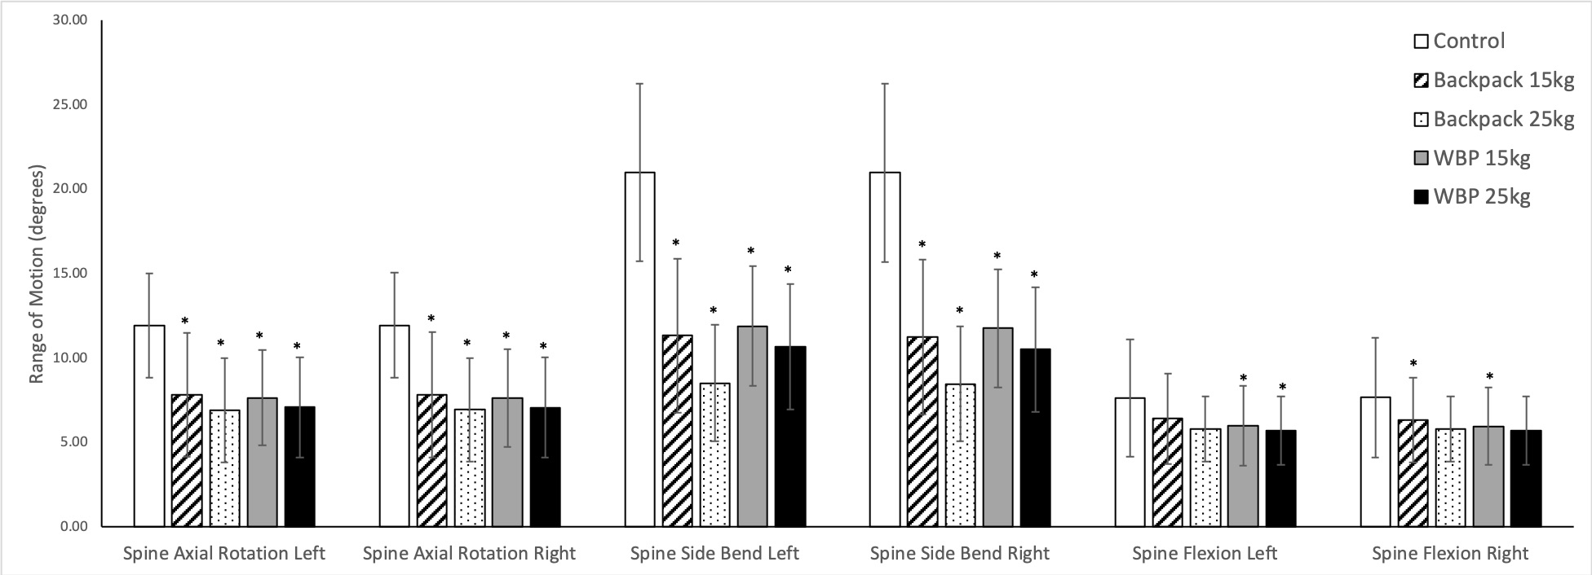
Figure 1. Mean ranges of motion (±SD) of the spine side bending for the control and 4 loaded conditions. Ranges of motion are across the left or right gait cycles (WBP – webbing and backpack, * - significantly different from control condition (p<0.0042))

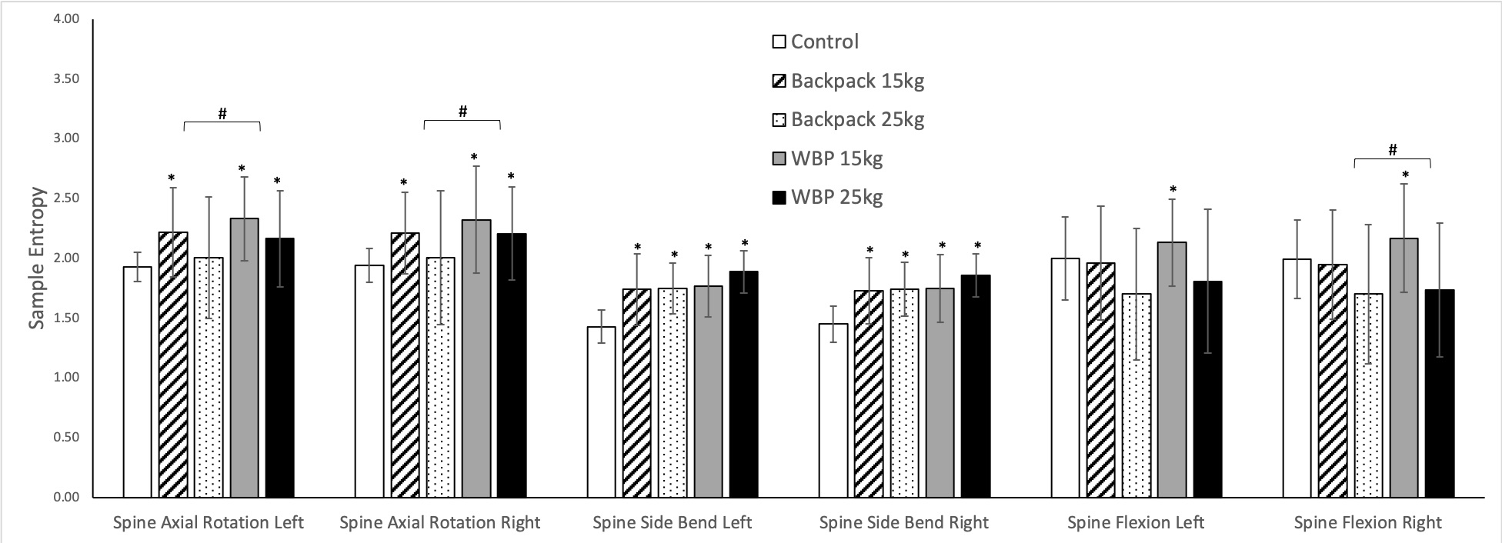
Figure 2. Sample entropy (±SD) of the spine side bending range of motion for the control and 4 loaded conditions. Ranges of motion are across the left or right gait cycles (WBP – webbing and backpack, * - significantly different from control condition (p<0.0042))

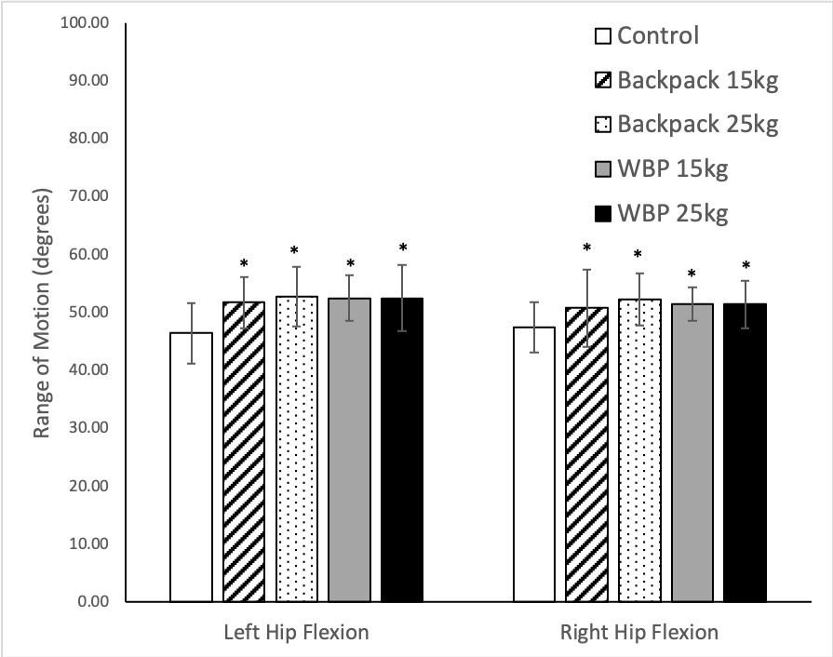
Figure 3. Mean ranges of motion (±SD) of hip flexion for the control and 4 loaded conditions. Ranges of motion are in the left or right limbs across the associated gait cycles (WBP – webbing and backpack, * - significantly different from control condition (p<0.0042))

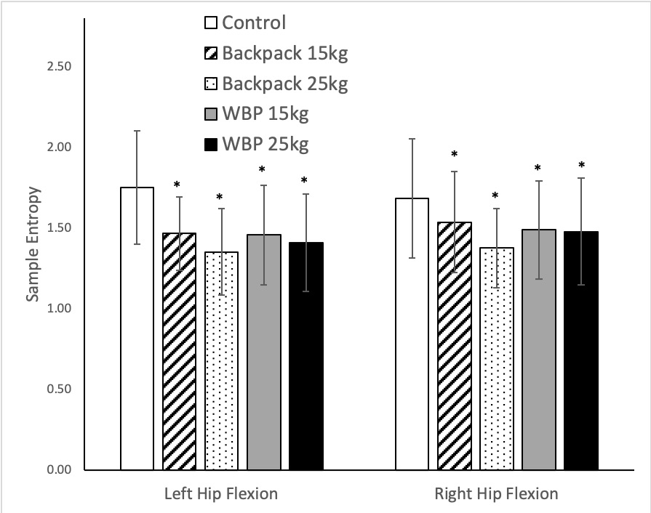
Figure 4. Sample entropy (±SD) of hip flexion range of motion for the control and 4 loaded conditions. Ranges of motion are in the left or right limbs across the associated gait cycles (WBP – webbing and backpack, * - significantly different from control condition (p<0.0042))

Table 1. Mean ranges of motion (ROM), coefficient of variation of the ROM and sample entropy of the ROM for control and 4 loaded conditions (* - significant difference from the control condition (p<0.0042), Partial η² effect sizes included for main effect of the univariate ANOVAs and planned contrasts where differences were significant)
 | Stride side | Control |  |  | Backpack 15kg |  |  | Planned contrast effect (Partial η²) |  | Backpack 25kg |  |  | Planned contrast effect (Partial η²) |  | Webbing & Backpack 15kg |  |  | Planned contrast effect (Partial η²) |  | Webbing & Backpack 25kg |  |  | Planned contrast effect (Partial η²) |  | Main effect (Partial η²)
Mean ROM
Spine axial rot. | Left | 11.9 | ± | 3.1 | 7.8 | ± | 3.7 |  |  | 6.9 | ± | 3.1 |  |  | 7.7 | ± | 2.8 |  |  | 7.1 | ± | 3.1
 | Right | 12.0 | ± | 3.1 | 7.8 | ± | 3.7 |  |  | 7.0 | ± | 3.1 |  |  | 7.6 | ± | 2.9 |  |  | 7.1 | ± | 3.1
Spine side flexion | Left | 21.0 | ± | 5.2 | 11.3 | ± | 4.6 | * | 0.87 | 8.5 | ± | 3.5 | * | 0.84 | 11.9 | ± | 3.6 | * | 0.92 | 10.7 | ± | 3.7 | * | 0.88 | 0.79
 | Right | 21.0 | ± | 5.3 | 11.3 | ± | 4.6 | * | 0.87 | 8.5 | ± | 3.4 | * | 0.84 | 11.8 | ± | 3.5 | * | 0.92 | 10.5 | ± | 3.6 | * | 0.88 | 0.79
Spine flexion | Left | 7.6 | ± | 3.5 | 6.4 | ± | 2.7 |  |  | 5.8 | ± | 1.9 |  |  | 6.0 | ± | 2.4 |  |  | 5.7 | ± | 2.1
 | Right | 7.7 | ± | 3.5 | 6.3 | ± | 2.5 |  |  | 5.8 | ± | 1.9 |  |  | 6.0 | ± | 2.3 |  |  | 5.7 | ± | 2.1
Hip flexion | Left | 46.5 | ± | 5.4 | 51.7 | ± | 4.5 | * | 0.77 | 52.8 | ± | 5.1 | * | 0.83 | 52.5 | ± | 3.9 | * | 0.76 | 52.9 | ± | 5.7 | * | 0.68 | 0.65
 | Right | 47.5 | ± | 4.3 | 50.8 | ± | 6.6 |  |  | 52.4 | ± | 4.5 | * | 0.92 | 51.5 | ± | 2.9 |  |  | 52.7 | ± | 4.1 | * | 0.93 | 0.58
Hip abduction | Left | 29.5 | ± | 5.1 | 27.7 | ± | 5.1 |  |  | 26.4 | ± | 5.2 |  |  | 27.8 | ± | 5.1 |  |  | 27.7 | ± | 5.5
 | Right | 28.2 | ± | 4.5 | 27.9 | ± | 4.4 |  |  | 26.6 | ± | 4.5 |  |  | 27.3 | ± | 4.8 |  |  | 28.0 | ± | 5.5
Knee flexion | Left | 73.7 | ± | 5.3 | 72.1 | ± | 5.1 | * | 0.78 | 71.3 | ± | 4.4 |  |  | 72.6 | ± | 5.2 |  |  | 71.6 | ± | 5.1 |  |  | 0.52
 | Right | 73.6 | ± | 4.0 | 72.0 | ± | 3.1 |  |  | 70.8 | ± | 3.4 |  |  | 72.2 | ± | 3.6 |  |  | 71.4 | ± | 3.6
CV of ROM
Spine axial rot. | Left | 0.11 | ± | 0.03 | 0.13 | ± | 0.03 |  |  | 0.19 | ± | 0.11 |  |  | 0.11 | ± | 0.03 |  |  | 0.14 | ± | 0.04
 | Right | 0.11 | ± | 0.03 | 0.13 | ± | 0.02 |  |  | 0.19 | ± | 0.11 |  |  | 0.12 | ± | 0.04 |  |  | 0.14 | ± | 0.03
Spine side flexion | Left | 0.10 | ± | 0.02 | 0.15 | ± | 0.04 |  |  | 0.18 | ± | 0.07 |  |  | 0.13 | ± | 0.04 |  |  | 0.13 | ± | 0.03
 | Right | 0.10 | ± | 0.03 | 0.15 | ± | 0.05 |  |  | 0.19 | ± | 0.07 |  |  | 0.13 | ± | 0.05 |  |  | 0.14 | ± | 0.03
Spine flexion | Left | 0.17 | ± | 0.07 | 0.20 | ± | 0.06 |  |  | 0.26 | ± | 0.10 |  |  | 0.18 | ± | 0.05 |  |  | 0.23 | ± | 0.09
 | Right | 0.17 | ± | 0.07 | 0.20 | ± | 0.07 |  |  | 0.25 | ± | 0.12 |  |  | 0.17 | ± | 0.06 |  |  | 0.24 | ± | 0.10
Hip flexion | Left | 0.03 | ± | 0.01 | 0.04 | ± | 0.01 |  |  | 0.04 | ± | 0.01 |  |  | 0.04 | ± | 0.01 |  |  | 0.04 | ± | 0.01
 | Right | 0.03 | ± | 0.01 | 0.04 | ± | 0.01 |  |  | 0.04 | ± | 0.01 |  |  | 0.04 | ± | 0.01 |  |  | 0.04 | ± | 0.01
Hip abduction | Left | 0.07 | ± | 0.02 | 0.08 | ± | 0.02 |  |  | 0.08 | ± | 0.02 |  |  | 0.08 | ± | 0.02 |  |  | 0.08 | ± | 0.02
 | Right | 0.06 | ± | 0.01 | 0.07 | ± | 0.02 |  |  | 0.08 | ± | 0.02 |  |  | 0.07 | ± | 0.02 |  |  | 0.07 | ± | 0.03
Knee flexion | Left | 0.03 | ± | 0.00 | 0.03 | ± | 0.00 |  |  | 0.03 | ± | 0.01 |  |  | 0.03 | ± | 0.01 |  |  | 0.03 | ± | 0.01
 | Right | 0.02 | ± | 0.00 | 0.03 | ± | 0.01 |  |  | 0.03 | ± | 0.01 |  |  | 0.03 | ± | 0.01 |  |  | 0.03 | ± | 0.01
SampEn of ROM
Spine axial rot. | Left | 1.93 | ± | 0.12 | 2.22 | ± | 0.37 |  |  | 2.01 | ± | 0.51 |  |  | 2.33 | ± | 0.35 |  |  | 2.16 | ± | 0.42
 | Right | 1.94 | ± | 0.14 | 2.21 | ± | 0.34 |  |  | 2.01 | ± | 0.56 |  |  | 2.32 | ± | 0.45 | * | 0.80 | 2.21 | ± | 0.41 |  |  | 0.40
Spine side flexion | Left | 1.43 | ± | 0.14 | 1.74 | ± | 0.30 |  |  | 1.75 | ± | 0.21 | * | 0.67 | 1.77 | ± | 0.26 | * | 0.79 | 1.89 | ± | 0.18 | * | 0.89 | 0.52
 | Right | 1.45 | ± | 0.15 | 1.73 | ± | 0.28 |  |  | 1.74 | ± | 0.22 | * | 0.66 | 1.75 | ± | 0.29 |  |  | 1.86 | ± | 0.19 | * | 0.87 | 0.44
Spine flexion | Left | 2.00 | ± | 0.35 | 1.96 | ± | 0.47 |  |  | 1.70 | ± | 0.55 |  |  | 2.13 | ± | 0.36 |  |  | 1.81 | ± | 0.62
 | Right | 1.99 | ± | 0.33 | 1.95 | ± | 0.46 |  |  | 1.70 | ± | 0.58 |  |  | 2.17 | ± | 0.45 |  |  | 1.74 | ± | 0.58
Hip flexion | Left | 1.75 | ± | 0.35 | 1.47 | ± | 0.23 | * | 0.67 | 1.35 | ± | 0.27 | * | 0.70 | 1.46 | ± | 0.31 |  |  | 1.41 | ± | 0.30 | * | 0.74 | 0.53
 | Right | 1.68 | ± | 0.37 | 1.54 | ± | 0.31 |  |  | 1.38 | ± | 0.25 | * | 0.77 | 1.49 | ± | 0.30 |  |  | 1.48 | ± | 0.33 |  |  | 0.38
Hip abduction | Left | 1.50 | ± | 0.26 | 1.45 | ± | 0.28 |  |  | 1.45 | ± | 0.29 |  |  | 1.49 | ± | 0.24 |  |  | 1.49 | ± | 0.26
 | Right | 1.62 | ± | 0.20 | 1.47 | ± | 0.31 |  |  | 1.45 | ± | 0.30 |  |  | 1.57 | ± | 0.33 |  |  | 1.54 | ± | 0.32
Knee flexion | Left | 1.56 | ± | 0.22 | 1.52 | ± | 0.19 |  |  | 1.39 | ± | 0.29 |  |  | 1.44 | ± | 0.25 |  |  | 1.47 | ± | 0.18
 | Right | 1.60 | ± | 0.17 | 1.53 | ± | 0.26 |  |  | 1.47 | ± | 0.33 |  |  | 1.47 | ± | 0.26 |  |  | 1.51 | ± | 0.24

