Title: The metabolic and physiological responses to scootering exercise in a field-setting
Running head: Physiological responses to scootering
Manuscript type: Original Article
Keywords: scooter, physical activity, active transport, field-settings, physiological responses,
Authors:
Ashley G.B. Willmott¹², Neil S. Maxwell¹
Address for Authors:
¹Environmental Extremes Laboratory, University of Brighton, Eastbourne, UK
²Cambridge Centre for Sport and Exercise Sciences, Anglia Ruskin University, Cambridge, UK
Details for the Corresponding Author:
Ashley Willmott – Ash.Willmott@anglia.ac.uk
Abstract Word Count: 200
Text-Only Word Count: 3043

Highlights:
- These findings are the first to investigate metabolic and physiological responses during a range of scootering speeds in a field-setting.
- Scootering is a mode of active transport and meets recognised criteria for moderate-intensity exercise.
- Scootering is an alternate form of exercise that may be included in the latest Compendium of Physical Activities guidelines.
- Rating of perceived exertion enables scooter users to gauge exercise intensity for cardiorespiratory fitness (11 to 13 [‘Light’ to ‘Somewhat Hard’])

Figure Captions:
Figure 1. Schematic overview of the experimental protocol.
Figure 2. Photo of breath-by-breath analysis during scootering along seafront promenade.
Figure 3. Mean ± SD EE and HR across a range of scooter speeds (* denotes a significant difference between scooter speeds [P<0.05]) for; a: 6.0 km/hr, b: 7.5 km/hr, c: 9.0 km/hr, d: 10.5 km/hr and e: 12.0 km/hr).

Abstract
Background: This study quantified the metabolic and physiological responses towards a range of scootering speeds in a field-setting. Methods: Ten participants (eight male, two female; mean ± standard deviation [SD] age: 21 ± 1 years; peak oxygen uptake [V̇O_{2peak}]: 51.5 ± 6.0 mL/kg/min) completed a cycling V̇O_{2peak} test and a 30-min scootering protocol. Energy expenditure (EE), metabolic equivalents (METs) and heart rate (HR) were recorded throughout. Results: Mean ± SD EE and METs increased (P<0.001) linearly when scootering at; 6.0 km/hr (4.3 ± 1.9 kcal/min, 4.1 ± 0.4), 7.5 km/hr (5.2 ± 2.7 kcal/min, 4.7 ± 0.5), 9.0 km/hr (6.4 ± 2.6 kcal/min, 5.2 ± 0.6), 10.5 km/hr (6.9 ± 2.8 kcal/min, 5.8 ± 0.6) and 12.0 km/hr (8.2 ± 1.7 kcal/min, 6.3 ± 0.8), respectively. When scootering at these speeds, mean ± SD percentage of maximal HR were 51 ± 11%, 55 ± 7%, 60 ± 9%, 64 ± 11% and 71 ± 9%. Conclusions: Scootering speeds of 6.0-10.5 km/hr meet the criteria for moderate-intensity exercise (3.0-5.9 METs). Scootering is an alternate form of exercise and mode of active transport, which may be included in the latest Compendium of Physical Activities guidelines and improve cardiorespiratory fitness if undertaken regularly.
1. Introduction
Riding a non-motorised scooter or “scootering” is an alternate form of exercise used by children, adolescents and young adults, for recreational purpose as well as a mode of active transport. Participation in scootering exercise has increased in popularity over the past two decades (Kijima et al., 2001, 2007) and may contribute to physical activity (PA) guidelines (e.g. 150-mins of moderate-intensity, 75-mins of vigorous-intensity or a combination thereof per week [O’Donovan et al., 2010; Departments of Health, 2011]), potentially improving cardiorespiratory fitness if scootering speeds (e.g. exercise intensity) provide sufficient physiological stimulus (e.g. >65% of heart rate maximum [HR_{max}]) (Pollock et al., 1998; Kijima et al., 2001, 2007; Arimoto et al., 2002). However, active transport is reportedly declining internationally in children (Tremblay et al., 2014; Ridley and Olds, 2016) and the prevalence of sedentary lifestyles and physical inactivity among adolescents and young adults is increasing (Rey-López et al., 2008; Hallal et al., 2012). Given this, quantifying the metabolic responses (i.e. energy expenditure [EE] and metabolic equivalents [METs]) while scootering across a range of speeds will allow for this mode of exercise to be assessed as a form of PA and determine if it conforms to current exercise prescription guidelines (e.g. MET classification: Light = 1.6–2.9, Moderate = 3.0–5.9, and Vigorous ≥6 [Jette and Blumchen, 1990; Ainsworth et al., 2000, 2011]). This information may benefit researchers and public health care professionals, who could add scootering into the current Compendium of Physical Activities (Ainsworth et al., 2011) and/or PA guidelines (O’Donovan et al., 2010; Departments of Health, 2011) due to its affordability, portability and recreational simplicity.
Alternate forms of active transport, similar to that of scootering (e.g. long-board [Board and Browning, 2014] and traditional skateboarding [Hetzler et al., 2011]), report linear increments in EE as exercise intensity (e.g. speed) increases, and METs of 5.0 (Moderate) to 6.5-8 (Vigorous). Of the limited literature regarding the metabolic and physiological changes during scootering, Arimoto et al. (2002) report heart rate (HR) responses while scootering for 6-mins at three self-selected speeds (‘slow’, ‘ordinary’ and ‘with considerable effort’) equating to 54%, 66% and 91% of HR_{max}. Subsequently, scootering ‘with considerable effort’ was suggested to exceed the threshold to improve cardiorespiratory fitness (e.g. >65% of HR_{max} [Pollock et al., 1998; Arimoto et al., 2002]), yet a suitable area which permits users to reach higher speeds is required and may be outside of the busy city environment (e.g. park or seafront promenade). Moreover, specific and incremental scootering speeds are required to quantify the metabolic responses in association with current PA guidelines. Consequently, Kijima et al. (2007) reported the EE (67-85 cal/kg/min) and METs (3.9-5.0) for 10-mins scootering at speeds ranging 4.8-8.4 km/hr, and found these values correspond to moderate-intensity exercise for most healthy adults (O’Donovan et al., 2010; Departments of Health, 2011). However, whilst faster scootering speeds may help improve cardiorespiratory fitness, little ecological validity exists as current research regarding scootering has been confined to a motorised-treadmill, where differences in energetic cost may occur between laboratory and outdoor conditions (Jones and Doust, 1996), and thus further investigation is required.
Therefore, ecologically valid field-research is required to assess the physiological responses towards a range of scootering speeds to understand the potential use of this alternate form of exercise and mode of active transport. Consequently, the primary aim of this study was to quantify the metabolic (i.e. EE and METs) and physiological responses (i.e. HR) during scootering across a range of speeds in a field-setting. A secondary aim was to ascertain whether the intensity of these scootering speeds meet ‘moderate’ criteria (i.e. 3.0–5.9 METs) and could contribute to current PA guidelines for cardiorespiratory improvements.
2. Methods:
2.1 Participants:
Ten moderately-trained participants (eight male, two female; mean ± standard deviation [SD] age: 21 ± 1 years; peak oxygen uptake [V̇O_{2peak}]: 51.5 ± 6.0 mL/kg/min and 3.71 ± 0.75 L/min; body mass: 71.6 ± 10.8 kg; height: 175 ± 8 cm; body fat: 15 ± 5%; body mass index [BMI]: 23.3 ± 2.0 kg/m²) volunteered after providing written informed consent. This study was in accordance with the Declaration of Helsinki (2013) and approved by the Institution’s Research and Ethics Committee. Participants refrained from caffeine (2-h), alcohol intake and prolonged strenuous activity (both 24-h) prior to testing and arrived in a hydrated state (Sawka et al., 2007).
2.2 Experimental design:
Participants visited the laboratory for: a V̇O_{2peak} cycling test in temperate conditions (18°C, ~50% relative humidity [RH]), a health assessment (pre-testing body mass, height, body fat percentage, lung function, blood pressure and hydration status) and a presentation to outline the field-study. The main trial was completed on a seafront promenade within temperate conditions (14.2 ± 0.9°C, 53 ± 4% RH and 2.7 ± 0.4 m/s wind speed [“Light breeze”]). Participants completed scootering at five speeds for 5-mins, starting at 6.0 km/hr, with a 1.5 km/hr increment per stage to 12.0 km/hr (Figure 1).
****Figure 1 near here****
2.3 V̇O_{2peak} cycling test:
Cycling V̇O_{2peak} tests were completed on an SRM ergometer (High Performance model, GmbH, Julich, Germany) starting at 80 W and subsequently increasing 20 W/min at 80 rpm until volitional exhaustion (Hayes et al., 2014). Gas data was continuously collected using an online breath-by-breath system (Metamax 3x, Cortex, Leipzig, Germany) and subsequently analysed following the trial as a mean for the final 30-s of each stage. HR was continuously monitored and recorded at 45-s of each stage alongside rating of perceived exertion (RPE).
2.4 Scooter exercise:
All scootering exercise was performed using a Micro® flex scooter (Micro Mobility Systems, Kusnacht, Switzerland) (Figure 2). These models weigh 4.2 kg and have two wheels of 160 mm in diameter, a narrow board to stand on of 130 mm width and 330 mm length, in addition to an adjustable, 850 mm high, steering handle. Before the participants exercised, the height of the handle was adjusted individually to the height between the greater trochanter and iliac crest. The five scootering speeds chosen were: 6.0, 7.5, 9.0, 10.5 and 12.0 km/hr, which equated to 100, 125, 150, 175 and 200 m/min in line with previous study methods and recommendations of faster speeds (Kijima et al., 2007). The participants completed scootering around a 100 m oval circuit, where experimenters provided pacing times for each stage of the trial. Participants were familiarised to the scootering protocol 2-h prior to the main trial by completing laps of the oval circuit at self- and experimenter-selected speeds for 30-mins. Time and assistance was permitted for familiarity to the chosen speeds and pacing adjustments required for the main trial. No incidence of injury or falls occurred throughout the protocol.
****Figure 2 near here****
2.5 Physiological measures:
Body mass (Adam Equipment Co LTD., Milton Keynes, UK) and height were measured (Detecto Scale Company, USA), and used to calculate BMI (DuBois and DuBois, 1916). Body fat percentage was estimated using skinfold calipers (Harpenden, Baty International, West Sussex, UK) across four standard sites (Durnin and Womersley, 1974).
Hydration status was determined from: urine colour (U_{col}), osmolality (U_{osm}) (Osmocheck, Vitech Scientific Ltd, Japan) and specific gravity (U_{sg}) (Hand Refractometer, Atago, Tokyo, Japan), where: U_{col} <3 on the 8 point colour scale, U_{osm} <700 mOsmol/kgH₂O and U_{sg} <1.020 demonstrated a hydrated state (Sawka et al., 2007).
HR was continually monitored using a Polar 810i monitor (Polar Electro, Kempele, Finland) strapped to the chest. Blood pressure (BP) (Boso Medicus PC, Cranlea & Company, UK) and lung function (forced vital capacity [FVC], forced expiratory volume in 1 second [FEV₁] and FEV₁/FVC ratio [%]) (Vitalograph handheld spirometer, UK) were recorded 15-mins before and after exercise.
EE and METs were estimated from a known volume of oxygen uptake (V̇O₂) and respiratory exchange ratio (RER) during the last minute of each stage of scootering. Each participant was fitted with the online breath-by-breath Metamax 3x (Cortex, Leipzig, Germany). The gas data was sent wirelessly to a laptop, stored and analysed afterwards. EE (kcal/min) was calculated from the kcal equivalent for the known RER during the final minute of each stage, this was then multiplied by the V̇O₂ (4.9 kcal per 1.00 L of O₂ [McArdle, Katch, and Katch, 2009]). METs were calculated by dividing V̇O₂ (mL/kg/min) by 3.5 mL/kg/min.
2.6 Perceptual measures:
The participants’ perceived mood and exertion were assessed using a feeling scale from +5 (Very good), 0 (Neutral) to -5 (Very bad) (Hardy and Rejeski, 1989) and RPE scale between 6 (No exertion) and 20 (Maximal exertion) (Borg, 1992), respectively. Participants were familiarised to the scales upon their first visit and were recorded at the end of each stage during the trial.
2.7 Environmental conditions:
Ambient temperature and RH were recorded using a heat stress meter (HT30, Extech instruments, New Hampshire, USA), while wind speed was recorded using an airflow anemometer (LCA 6600, Buckinghamshire, UK).
2.8 Statistical analyses:
All data are presented as mean ± SD and were assessed for normality and sphericity prior to statistical analyses. One-way repeated measure ANOVAs were used on the physiological and perceptual measures across each scootering speed. Where appropriate, Bonferroni-corrected pairwise comparisons were used to identify where significant differences occurred. Data were analysed using SPSS (Version 22.0) with significance set at P<0.05. Paired samples t-tests were used for pre- and post-exercise health measures. Pearson's product moment correlation coefficient (r) and regression equations were used for scooter speed, EE and HR.
3. Results:
3.1 Scootering exercise:
As scootering speeds increased, significant main effects were found for mean EE (F_{(4,36)}=42.7, P<0.001, np²=0.8), METs (F_{(2,18)}=31.6, P<0.001, np²=0.7), HR (F_{(4,36)}=43.9, P<0.001, np²=0.8), RPE (F_{(4,32)}=22.9, P<0.001, np²=0.7) and feeling scale (F_{(4,32)}=5.3, P<0.001, np² =0.4).
EE, HR (Figure 3), METs and RPE increased (P<0.001) as scootering speeds progressed from 6.0 to 12.0 km/hr (Table 1). Whereas, feeling scale decreased from 4 (6.0-10.5 km/hr) to 3 (12.0 km/hr, P<0.05). Significant increments (P<0.05) in EE (4.3 ± 1.9 to 8.2 ± 1.7 kcal/min) and METs (4.1 ± 0.4 to 6.3 ± 0.8) were observed as scootering speed increased from 6.0 to 12.0 km/hr, respectively (Table 1). The relative intensity for scootering speeds from 6.0 to 12.0 km/hr increased (P<0.05), as highlighted by the percentage of V̇O_{2peak} (28 ± 7%, 32 ± 8%, 37 ± 9%, 41 ± 8% and 45 ± 9%) and HR_{max} (51 ± 11%, 55 ± 7%, 60 ± 9%, 64 ± 11% and 71 ± 9%), respectively. The regression equations for scootering speed (X, km/hr) and: HR (Y, b/min) and; EE (Y, kcal/min) were Y=7.4X+54.2 (r = 0.984) and; Y=0.6467X+0.4 (r = 0.993), respectively (Figure 3).
****Figure 3 and Table 1 near here****
3.2 Pre- to post-exercise:
No changes from pre- to post-exercise were observed for: FVC (4.92 ± 1.07 to 4.72 ± 1.07 L/min, t=1.9, P=0.08), FEV₁ (4.26 ± 0.73 to 4.14 ± 0.63 L/min, t=2.2, P=0.06), FEV₁ / FVC ratio (88 ± 8% to 88 ± 10%, t=1.8, P=0.11), systolic BP (126 ± 12 to 132 ± 11 mmHg, t=1.2, P=0.27), or diastolic BP (68 ± 7 to 72 ± 9 mmHg, t=1.4, P=0.20).

4. Discussion
The aim of this study was to quantify the metabolic (EE and METs) and physiological responses (HR) associated with scootering across a range of speeds in a field-setting. The results present a range of significant linear increments in EE (4.3-8.2 kcal/min) and METs (4.1-6.3) as scootering speed increases from 6.0 to 12.0 km/hr. Likewise, the percentage of V̇O_{2peak} and HR_{max} ranged from 28% and 51% at 6.0 km/hr to 45% and 71% at 12.0 km/hr, respectively, and as expected, strong correlations were found between speed and HR (r=0.98), and EE (r=0.99). These findings are the first to investigate metabolic and physiological responses during scootering in the field and may contribute to PA prescription guidelines to help improve cardiorespiratory fitness in a young, healthy population.
4.1 Metabolic responses:
The METs found in this study (Table 1) agree with previous findings for self-selected scootering (5.0 ± 2.3 [Aull et al., 2008]), and fixed speeds of; 4.8 km/hr (3.9 ± 0.6), 6.6 km/hr (4.4 ± 0.5), 8.4 km/hr (5.0 ± 0.4) (Kijima et al., 2007) and 9 km/hr (6.3 ± 1.6) (Ridley and Olds, 2016). Scootering at speeds of 6.0-10.5 km/hr and 12.0 km/hr can be classified as moderate (3.0-5.9 METs) and vigorous exercise intensities (>6.0 METs), respectively (Jette and Blumchen, 1990; Ainsworth et al., 2000, 2011). In practice, our findings advocate the use of scootering if regularly undertaken instead of sedentary-transport options, which may encourage cardiorespiratory fitness improvements and/or reductions in premature mortality risk associated with chronic disease (Haskell et al., 2009; De Nazelle et al., 2011). The METs found for scootering at 6.0 km/hr (~4.3) are very similar to those found when walking (5.0-7.0 km/hr) or cycling (<16.0 km/hr) for leisure or to work and school, and also, comparable to alternate exercises such as drumming and tai chi (all ~4.0 METs [Jette and Blumchen, 1990; Ainsworth et al., 2000]). The METs while scootering at 7.5-9.0 km/hr (~4.7 to 5.2) are similar to playing golf (4.5) and kayaking (5.0) (Ainsworth et al., 2000). The MET responses (~5.8 to 6.3) during the faster scootering speeds (10.5 and 12.0 km/hr) are similar to walking at 7.2 km/hr and cycling at 16.0-19.0 km/hr, in addition to general jogging, dancing and horseback riding activities (range 6.0-7.0 METs [Ainsworth et al., 2000; Beale et al., 2015). These findings provide novel data for a range of scootering intensities and comparisons with typical daily exercises and PA recommendations.
As suggested by Kijima et al. (2007), scooter speeds of >8.4 km/hr would likely conform to current PA guidelines (O’Donovan et al., 2010; Departments of Health, 2011) and provide alternate forms of moderate- or vigorous-intensity exercise. Therefore, our findings confirm previous recommendations (Kijima et al., 2007) and suggest scootering could now be included in the latest Compendium of Physical Activities, as well as being promoted as an alternate mode of exercise and active transport option by public health professionals. Sufficient scootering speeds can be achieved when commuting in the suburbs and/or exercising in the park and along seafront/river promenades, and although higher speeds may be challenging in a busy city centre, scootering offers an active mode of transport when paths and/or cycle lanes are available and protective equipment is worn to limit injury risk (Unkuri et al., 2018).
The EE results were higher in this study (Table 1) compared to previous literature for self-selected (~4.4 kcal/min [Aull et al., 2008]) and fixed-scootering speeds of; 4.8 km/hr (~3.8 kcal/min), 6.6 km/hr (~4.1 kcal/min) and 8.4 km/hr (~4.7 kcal/min) (Kijima et al., 2007). As also displayed by the MET classification, the EE during scootering speeds of 6.0-10.5 km/hr are classified as moderate (5.0-7.4 kcal/min) and speeds of 12.0km/hr as vigorous exercise intensities (>7.5-9.9 kcal/min) (Jette and Blumchen, 1990). To achieve the recommended 800-1200 kcal weekly EE (O’Donovan et al., 2010), scootering for 60 mins/day on 5 days/week at any speed equal to, or greater than 6.0 km/hr would be required. This is due to a linear relationship in EE as scootering speed increases from 6.0 to 12.0 km/hr, when extrapolating EE from the 5-min exercise period. Moreover, this target of weekly EE could be achieved if scootering exercise was completed at: >7.5 km/hr for 30-mins/day 5 days/week, or 12.0 km/hr for 30-mins/day 3 days/week. Furthermore, shorter, yet more frequent bouts of scootering may be beneficial, purporting its efficacy as an alternate mode of active transport, which can be used throughout the day.
4.2 Physiological responses:
In field-settings, the scootering speeds from 6.0 to 12.0 km/hr presented HR_{max} data of 51% to 71%, which agrees with Arimoto et al. (2002) for self-selected intensities. The ‘ordinary’ intensity in Arimoto et al. (2002) equated to 66% of HR_{max}, which in this study was observed for scootering speeds at ~10.5 km/hr (~64%). However, the 91% HR_{max} found during the ‘with considerable effort’ trial in Arimoto et al. (2002) exceeded that of 12.0 km/hr (71%) in this study, which is likely due to the higher self-selected speeds and differences in the participants’ aerobic capacity (e.g. 44.7 [Arimoto et al. 2002] vs. 51.5 mL/kg/min). These differences in aerobic capacity may also explain the lower %V̇O_{2peak} found during higher scootering speeds in our study (6.0-12.0 km/hr = 28-45%), compared to those within Kijima et al. (2007) (4.8-8.4 km/hr = 35-45% for males). Nonetheless, the heightened level of exercise intensity as identified with a high % of HR_{max} in Arimoto et al. (2002), is unlikely to be continued for an extended period of time, whereas, 12 km/hr may provide an upper limit for realistic scootering speeds during 30-60-mins of daily aerobic exercise, which also conforms to exercise intensity guidelines for cardiorespiratory benefits (e.g. >65% HR_{max}) (Pollock et al., 1998). Furthermore, as no adverse consequences were identified in blood pressure or lung function measures during scootering, this mode of exercise may be beneficial to other populations (e.g. elderly and/or clinical) but requires further investigation. If wishing to use the scooter as part of an alternate form of exercise or active transport option and individuals are unable to use HR monitors, the linear relationship between HR and RPE (r = 0.984) for the range of scootering speeds may enable commuters and/or exercisers to gauge intensity from their perceived effort to ensure the threshold of physiological stimulus is achieved (>65% HR_{max} = 11 to 13 RPE [‘Light’ to ‘Somewhat Hard’]) (Arimoto et al., 2002).
4.3 Limitations and future direction:
The limitation of the current study include a small sample size of young, moderately-trained individuals, especially females where sex differences may be prevalent (Kijima et al., 2007), thus findings cannot be generalised for a wider population. Moreover, the speeds were only achievable in a larger area outside of the city environment and MET values were estimated for all individuals from breath-by-breath analysis (Byrne et al., 2005). Future studies should investigate the ecological validity of children, adolescents and adults who regularly use a scooter for recreational and/or active transport and assess the long-term health-related benefits of this alternate mode of exercise.
4.4 Conclusion
This study provides novel data on the metabolic and physiological responses while scootering at a range of speeds in a field-setting, presenting speeds of 6.0-10.5 km/hr meet the criteria for moderate-intensity physical activity (3.0-5.9 METs). Therefore, this alternate form of exercise and mode of active transport, may now be included in the latest Compendium of Physical Activities guidelines and contribute to cardiorespiratory improvements if undertaken regularly.
5. Acknowledgments:
The author would like to thank the participants for volunteering for this study.
6. Conflict of interest:
This study was supported by Micro® scooter. The representatives of Micro® scooter were not involved in the planning, implementation, data collection, analysis or write up of the study and were only provided with data once this process had been completed.
7. References:
Ainsworth, B. E., Haskell, W. L., Herrmann, S. D., Meckes, N., Bassett Jr, D. R., Tudor-Locke, C., ... & Leon, A. S. 2011 Compendium of Physical Activities: a second update of codes and MET values. Medicine & science in sports & exercise, 2011; 43(8), 1575-1581.
Ainsworth, B. E., Haskell, W. L., Whitt, M. C., Irwin, M. L., Swartz, A. M., Strath, S. J., ... & Jacobs, D. R. Compendium of physical activities: an update of activity codes and MET intensities. Medicine and science in sports and exercise, 2000; 32(9; SUPP/1), S498-S504.
Arimoto, M., Kijima, A., & Muramatsu, S. Heart rate response and perceived exertion in college students during riding a scooter. Journal of physiological anthropology and applied human science, 2002; 21(4), 189-193.
Aull, J.L., Rowe, D.A., Hickner, R.C., Malinauskas, B.M., & Mahar, M.T. Energy expenditure of obese, overweight, and normal weight females during lifestyle physical activities. International Journal of Pediatric Obesity. 2008;3(3):177-85.
Beale, L., Maxwell, N. S., Gibson, O. R., Twomey, R., Taylor, B., & Church, A. Oxygen cost of recreational horse-riding in females. Journal of physical activity and health, 2015; 12(6), 808-813.
Board, W. J., & Browning, R. C. Self-selected speeds and metabolic cost of longboard skateboarding. European journal of applied physiology, 2014; 114(11), 2381-2386.
Borg, G. Psychophysical bases of perceived exertion. Medicine and Science in Sports and Exercise, 1982; 14 (5), pp. 377-381.
Byrne, N., Hills, A., Hunter, G., Weinsier, R., & Schutz, Y. Metabolic equivalent: one size does not fit all. Journal of Applied Physiology. 2005; 99(3):1112–1119.
De Nazelle, A., Nieuwenhuijsen, M. J., Antó, J. M., Brauer, M., Briggs, D., Braun-Fahrlander, C., ... & Hoek, G. (2011). Improving health through policies that promote active travel: a review of evidence to support integrated health impact assessment. Environment international, 37(4), 766-777.
Department of Health. Physical activity guidelines in the UK: review and recommendations. London: Department of Health; 2011.
DuBois, D. & DuBois E. A formula to extimate the approximate surface area in height and weight are known. Arch Intern Med, 1916; 17, 863-871.
Durnin, J., & Womersley, J. Body fat assessed from total body density and its estimation from skinfold thickness: measurement on 481 men and women aged from 16 to 72 years. British Journal of Nutrition, 1974; 32, 77–97.
Hallal, P.C., Andersen, L.B., Bull, F.C., et al. Global physical activity levels: surveillance progress, pitfalls, and prospects. Lancet, 2012; 380:247e257.
Hardy, C. J., & Rejeski, W. J. Not what, but how one feels: The measurement of affect during exercise. Journal of Sport and Exercise Psychology, 1989; 11(3), 304-317.
Haskell, W.L, Blair, S.N., & Hill, J.O. Physical activity: health outcomes and importance for
public health policy. Prev Med 2009;49:280–2.
Hayes, M., Castle, P.C., Ross, E.Z., & Maxwell, N.S. The influence of hot humid and hot dry environments on intermittent-sprint exercise performance. International journal of sports physiology and performance. 2014;9(3):387-96.
Hetzler, R. K., Hunt, I., Stickley, C. D., & Kimura, I. F. Selected metabolic responses to skateboarding. Research quarterly for exercise and sport, 2011; 82(4), 788-793.
Jette, M., Sidney, K., & Blümchen, G. Metabolic equivalents (METs) in exercise testing, exercise prescription, and evaluation of functional capacity. Clinical cardiology. 1990;13(8):555-65.
Jones, A. M., & Doust, J. H. A 1% treadmill grade most accurately reflects the energetic cost of outdoor running. Journal of sports sciences, 1996; 14(4), 321-327.
Kijima, A., Arimoto, M., & Muramatsu, S. Metabolic Equivalents during Scooter Exercise. Journal of physiological anthropology, 2007; 26(4), 495-499.
Kijima, A., Arimoto, M., Muramatsu, S., & Homma. I. Cardiorespiratory Responses to Scootering in Comparison with Walking, Running and Cycling. The Showa University Journal of Medical Sciences. 2001;13(4):247-57.
McArdle, W. D., Katch, F. I., & Katch, V. L. Sports and exercise nutrition. Lippincott Williams & Wilkins; 2009.
O’Donovan, G., Blazevich, A.J., Boreham, C., et al. The ABC of physical activity for health: a consensus statement from the British Association of Sport and Exercise Sciences. Journal of sports sciences. 2010; 28(6):573–591.
Pollock, M. L., Gaesser, G. A., Butcher, J. D., Després, J. P., Dishman, R. K., Franklin, B. A., & Garber, C. E. (1998). ACSM position stand: the recommended quantity and quality of exercise for developing and maintaining cardiorespiratory and muscular fitness, and flexibility in healthy adults. Medicine & Science in Sports & Exercise, 30(6), 975-991.
Rey-López, J.P., Vicente-Rodríguez, G., Biosca, M., & Moreno, L.A. Sedentary behaviour and obesity development in children and adolescents. Nutrition, metabolism and cardiovascular diseases, 2008; 18(3):242–251
Ridley, K., & Olds, T. The energy cost of household chores, rollerblading, and riding scooters in 9-to 14-year-old children. Journal of physical activity and health. 2016;13(6 Sup1):S75-7.
Sawka, M., Burke, L., Eichner, E., Maughan, R., Montain, S., & Stachenfeld, N. American College of Sports Medicine position stand. Exercise and fluid replacement. Medicine and Science in Sports and Exercise, 2007; 39, 377-390.
Tremblay, M. S., Gray, C. E., Akinroye, K., Harrington, D. M., Katzmarzyk, P. T., Lambert, E. V., ... & Prista, A. Physical activity of children: a global matrix of grades comparing 15 countries. Journal of physical activity and health, 2014; 11(s1), S113-S125.
Unkuri, J. H., Salminen, P., Kallio, P., & Kosola, S. Kick scooter injuries in children and adolescents: minor fractures and bruise. Scandinavian journal of surgery, 2018; 1-6.
World Medical Association. World Medical Association Declaration of Helsinki: ethical principles for medical research involving human subjects. The Journal of the American Medical Association. 2013;310(20):2191.
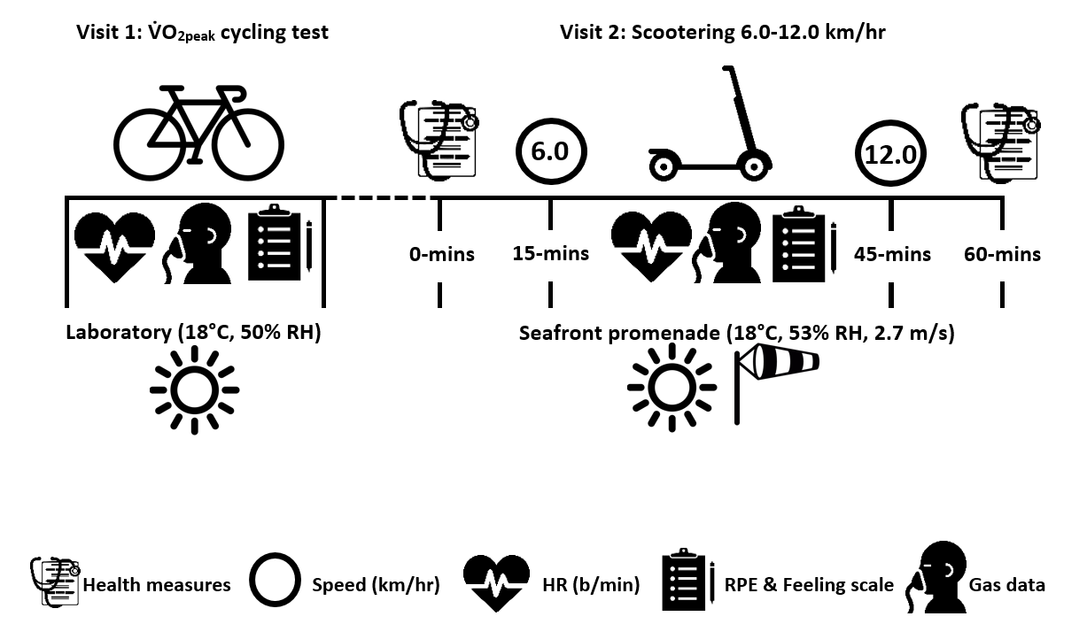

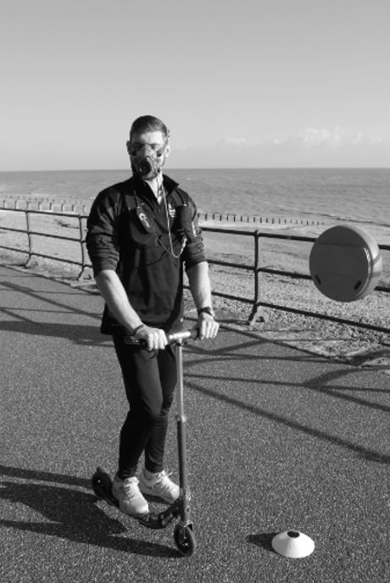

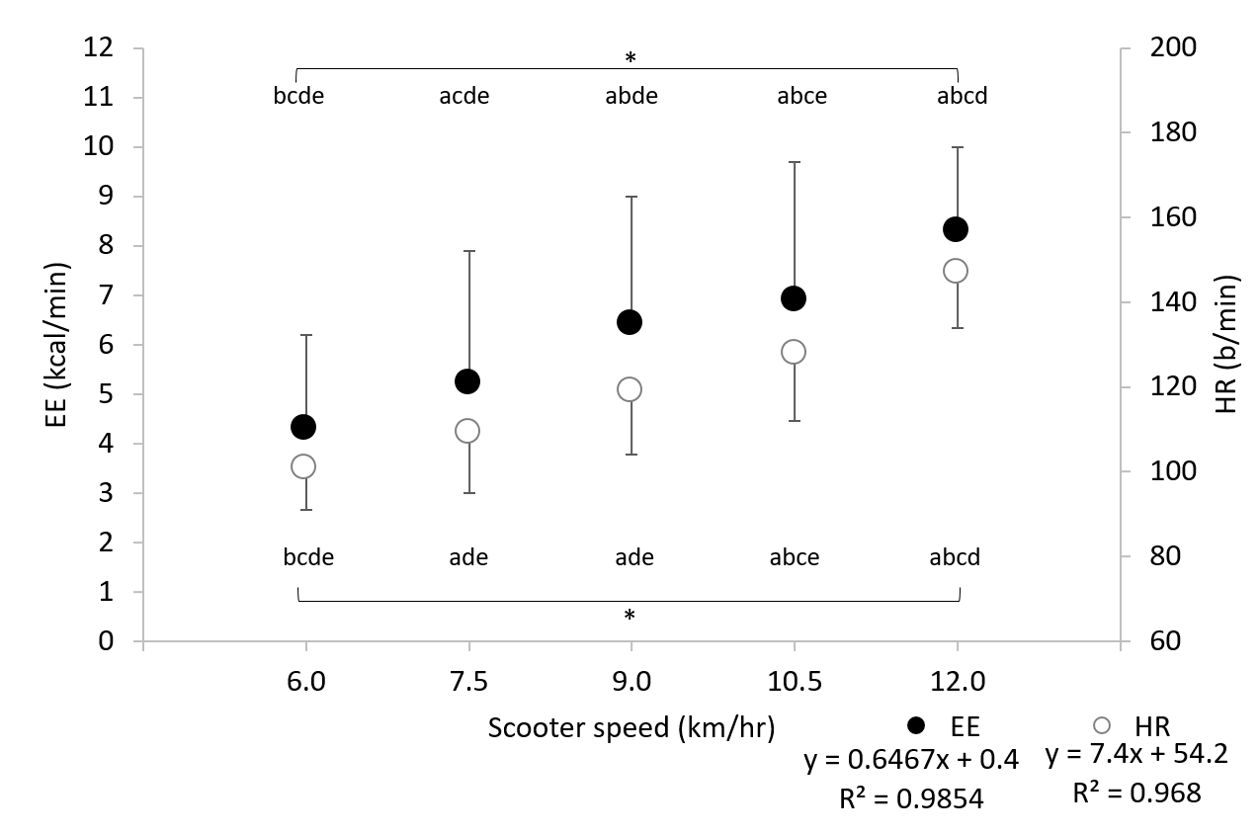

Table 1. Mean ± SD metabolic, physiological and perceptual responses to a range of scootering speeds.
Time  (mins) | Speed  (km/hr) | Distance covered  (m) | Heart Rate  (b/min) | Energy Expenditure  (kcal/min) | METs | RPE | Feeling scale
5 | 6.0 | 500 | 101 ± 10^{bcde} | 4.3 ± 1.9^{bcde} | 4.1 ± 0.4 | 7 ± 1 | 4 ± 2
10 | 7.5 | 1125 | 109 ± 14^{ade} | 5.2 ± 2.7 ^{acde} | 4.7 ± 0.5 ^{acde} | 8 ± 1 | 4 ± 2
15 | 9.0 | 1875 | 119 ± 15^{ade} | 6.4 ± 2.6^{abde} | 5.2 ± 0.6 ^{abde} | 9 ± 2 ^{abde} | 4 ± 2
20 | 10.5 | 2750 | 128 ± 16 ^{abce} | 6.9 ± 2.8 ^{abce} | 5.8 ± 0.6 ^{abce} | 10 ± 2^{abce} | 4 ± 2
25 | 12.0 | 3750 | 147 ± 13 ^{abcd} | 8.2 ± 1.7 ^{abcd} | 6.3 ± 0.8 ^{abcd} | 11 ± 2 ^{abcd} | 3 ± 2 ^{abcd}
Significant differences (P<0.05) between scootering speeds are denoted by; a: 6 km/hr, b: 7.5 km/hr, c: 9 km/hr, d: 10.5 km/hr and e: 12 km/hr. METs: metabolic equivalents; RPE: rating of perceived exertion.

