The relationship between Polypharmacy and Trajectories of Cognitive Decline in People with Dementia: a large representative cohort study

Pinar Soysal^{1,2}, Gayan Perera¹, Ahmet Turan Isik³, Graziano Onder⁴, Mirko Petrovic⁵, Antonio Cherubini⁶, Stefania Maggi⁷, Hitesh Shetty⁸, Mariam Molokhia⁹, Lee Smith¹⁰, Brendon Stubbs^{1,8}, Robert Stewart^{1,8}, Nicola Veronese ^{7, 11#}, Christoph Mueller^{1,8#}

# joint senior author

¹ King’s College London, Institute of Psychiatry, Psychology and Neuroscience, London, UK
²Department of Geriatric Medicine, Bezmialem Vakif University, Faculty of Medicine, Istanbul, Turkey
³ Unit for Aging Brain and Dementia, Department of Geriatric Medicine, Faculty of Medicine, Dokuz Eylul University, Izmir, Turkey.
⁴ ﻿Fondazione Policlinico Universitario Agostino Gemelli IRCCS, Università Cattolica del Sacro Cuore, Rome, Italy.
⁵ Department of Internal Medicine, Section of Geriatrics, Ghent University, Ghent, Belgium
⁶ ﻿Geriatria, Accettazione geriatrica e Centro di ricerca per l'invecchiamento, IRCCS INRCA, Ancona, Italy.
⁷ National Research Council, Neuroscience Institute, Aging Branch, Padova, Italy
⁸ South London and Maudsley NHS Foundation Trust, London, UK
⁹ King's College London, Department of Primary Care and Public Health Sciences, London, UK
¹⁰ The Cambridge Centre for Sport and Exercise Sciences, Department of Life Sciences, Anglia Ruskin University, Cambridge, UK.
¹¹ Department of Geriatric Care, Orthogeriatrics and Rehabilitation, E.O. Galliera Hospital, National Relevance & High Specialization Hospital, Genoa, Italy.

Corresponding author: Christoph Mueller, MD; King’s College London, Institute of Psychiatry, Psychology and Neuroscience (IoPPN), De Crespigny Park, London, SE5 8AF, United Kingdom; email: christoph.mueller@kcl.ac.uk; phone: +44 207 848 0626

Key findings/Relevance: Polypharmacy as defined by the number of drugs does not appear to predict cognitive decline in a large naturalistic cohort of patients with dementia and more sophisticated tools are needed to evaluate cognitive outcomes in this patient group.

Word count: 2794

Declarations of interest:
RS has received research funding from Roche, Pfizer, Janssen, Lundbeck and In-Silico-Bioscience. All other authors declare no conflicts of interest.

Funding:
CM, GP and RS receive salary support from the National Institute for Health Research (NIHR) Biomedical Research Centre at South London and Maudsley NHS Foundation Trust and King's College London, and RS is an NIHR Senior Investigator. BS is supported by Health Education England and the National Institute for Health Research HEE/NIHR ICA Programme Clinical Lectureship (ICA-CL-2017-03-001). The views expressed are those of the author(s) and not necessarily those of the NHS, the NIHR or the Department of Health and Social Care.

Highlights:

- Polypharmacy (> 5 medications) was present in 39% of patients at the time of dementia diagnosis
- Exposure groups (0-4; 5-9; >10 medications) did not differ in mean MMSE score at diagnosis
- All groups showed a slight increase in MMSE score in the 6 months after dementia diagnosis
- No significant differences were detected between the exposure groups in short- and long-term cognitive decline

The relationship between Polypharmacy and Trajectories of Cognitive Decline in People with Dementia: a large representative cohort study

Abstract

Polypharmacy, defined through the number of medications prescribed, has been linked to a range of adverse health outcomes in people with dementia. It is however unclear whether a numerical threshold of concurrently prescribed drugs is a suitable predictor for cognitive decline. We aimed to test associations between polypharmacy and both short-term (six months) and long-term (three years) cognitive trajectories in patients with incident dementia. Data from a large mental health and dementia care database in South London a cohort of 12,148 patients (mean age =80.7 years, 61.1% female, mean MMSE =18.6) clinically diagnosed with dementia was identified. We determined the number of medications prescribed at dementia diagnosis and defined two exposure groups: polypharmacy (5-9 medication) and excessive polypharmacy (> 10 medications), with 0-4 medications as reference group. All Mini Mental State Examination (MMSE) scores between one year before and three years after dementia diagnosis were ascertained. Effects of polypharmacy on cognitive decline were studied using Generalized Additive Models for Location, Scale and Shape and Linear Mixed Estimation Models. At the time of dementia diagnosis polypharmacy was present in 3,503 (28.8%) patients and excessive polypharmacy in 1,235 (10.2%) patients. In all three groups MMSE scores initially improved after dementia diagnosis and further decline was detected in the time interval from six months to three years after dementia diagnosis. No significant differences to the control group were found in relation to polypharmacy or excessive polypharmacy, neither in the initial cognitive improvement nor long-term decline. In conclusion, polypharmacy defined by the number of drugs does not appear to predict cognitive decline in a naturalistic cohort of patients with dementia. More sophisticated tools, considering appropriateness of prescribing and the clinical picture, might be better placed to evaluate cognitive outcomes in dementia and to make practice and research recommendations.

Key words: polypharmacy; cognition; cognitive decline; dementia; community care

Highlights:

- Polypharmacy (> 5 medications) was present in 39% of patients at the time of dementia diagnosis
- Exposure groups (0-4; 5-9; >10 medications) did not differ in mean MMSE score at diagnosis
- All groups showed a slight increase in MMSE score in the 6 months after dementia diagnosis
- No significant differences were detected between the exposure groups in short- and long-term cognitive decline

- Introduction

Polypharmacy, defined as the concurrent use of five or more medications, and multimorbidity are more common in people with dementia than in those without the condition (Clague and others 2016). More than half of patients with dementia are subject to such a high level of prescribing, whereby one or two agents are applied to directly address symptoms of dementia, including cognitive decline (Clague and others 2016; Lau and others 2010). Polypharmacy has been linked to increased hazards of emergency department attendance, hospitalisation, and mortality in this patient group (Mueller and others 2018). While research in general older populations has shown that polypharmacy is related to both deficits in cognitive functioning and a higher likelihood of developing dementia (Park and others 2017; Rawle and others 2018), studies on the effects of polypharmacy in patients with an established diagnosis of dementia are sparse. In this group, multimorbidity has been linked to worse cognition in cross-sectional (Doraiswamy and others 2002) but not longitudinal study designs (Melis and others 2013). Longitudinal research restricted to nursing home residents, about half suffering from dementia, suggested a decline in cognitive functioning associated with polypharmacy over one year (Vetrano and others 2018), but no studies are available assessing the cognitive effects of polypharmacy in incident dementia. Since polypharmacy is associated with worse cognition in the general older adults population (Maher and others 2014) and that high proportions of people with dementia are subject to polypharmacy (Clague and others 2016), there is an urgent need to understand if polypharmacy may be a risk factor for cognitive decline in this population.

Given these gaps in the literature, we aimed to evaluate the relationship between polypharmacy and both six-months and three-year cognitive decline in a large cohort of patients with a first diagnosis of dementia in South East London.

- Methods

2.1 Study population:
Data for this study were obtained from the South London and Maudsley NHS Foundation Trust (SLaM) Clinical Record Interactive Search (CRIS) application. CRIS provides research access to more than 300,000 de-identified health records from SLaM, one of Europe’s largest healthcare providers for dementia and other mental disorders, serving a population of over 1.3 million residents (Perera and others 2016; Stewart and others 2009). CRIS has received ethical approval as an anonymized data resource (Oxford Research Ethics Committee C, reference 08/H0606/71+5) and was used to extract records of patients who received a first dementia diagnosis according to ICD-10 criteria (World Health Organisation 2010) from SLaM services within the period between 1st Jan 2007 and 30th July 2016. Dementia diagnosis date and other data of interest were extracted either from structured fields in the source record or from clinical documents through natural language processing algorithms using the General Architecture for Text Engineering (GATE) software (Cunningham 2002; Perera and others 2016).

2.2 Polypharmacy
The GATE-supported natural language processing algorithm was used to ascertain the number of medications recorded in text fields (case notes, clinical correspondence) in a 6-month window around the dementia diagnosis (Mueller and others 2018; Perera and others 2016). This serves as a measure for prevalent polypharmacy as patients’ medication might not be recorded in electronic health records at the same time as the diagnosis, and has been shown to be predictive of hospitalisation and mortality in a cohort from the same source population (Mueller and others 2018). In line with the current literature we defined polypharmacy as concurrent use of 5-9 medications and excessive polypharmacy as prescription of 10 or more medications (Vetrano and others 2013; Vetrano and others 2018), whereby prescription of 0-4 medications served as reference condition.

2.3 Covariates
A range of potential confounders were ascertained at the time of dementia diagnosis, including socio-demographic variables (age, gender, marital status, ethnicity (dichotomized to White and Non-White), and a neighbourhood-level index of multiple deprivation (Noble and others 2007)). From structured fields and free-text documents we ascertained the dementia subtype diagnosis (Alzheimer’s disease (including mixed-type), vascular dementia, Lewy body dementias, unspecified dementia) according to WHO ICD-10 criteria (World Health Organisation 2010).
To measure general physical health, we applied the ‘Problems related to physical illness or disability’ subscale of the Health of the Nation Outcome Scales (HoNOS65+) instrument and ascertained whether the patient had been hospitalised in the year prior to dementia diagnosis using an established linkage to national hospitalisation data (Hospital Episode Statistics, available until 31st March 2016 (NHS Digital)). Previous hospitalisation has been linked to earlier mortality in this patient group (Mueller and others 2017) and serves as a proxy measure for patients at risk of accelerated physical decline. The HoNOS65+ is a standard measure of patient welfare used by UK mental health and dementia services (Burns and others 1999) and subscales are each rated 0 (no problem) to 4 (severe or very severe problem). Besides physical illness, we included subscales measuring mental health symptom severity and functional status closest to dementia diagnosis. To ease interpretation, we dichotomised subscales to ‘minor or no problem’ (scores of 0 and 1) and ‘mild to severe problems’ (scores 2 to 4) (Mueller and others 2017). Lastly, we determined whether patients were prescribed acetylcholinesterase inhibitors within the first 6 months after dementia diagnosis, as these medications have a direct influence on cognitive trajectories (Perera and others 2014).

2.4 Cognitive decline and statistical methods
Level of cognitive impairment as measured by Mini-Mental State Examination (MMSE) (Folstein and others 1975) was ascertained between one year before and within three years after first dementia diagnosis date, and the analysed sample was restricted to patients with at least two MMSE score points in the time period between January 2006 and December 2016.

To determine rate of cognitive decline, we initially used Generalized Additive Models for Location, Scale and Shape (GAMLSS) (Rigby RA 2005) to visualise the shape of MMSE score trajectories for the three cohorts (0-4 medications; 5-9 medications; > 10 medications). GAMLSS is not restricted to the linearity assumption and thereby allows the use of non-parametric smoothing functions in modelling of the parameters of the distribution as functions of explanatory variables. Although GAMLSS output provides a helpful way of visualising the pattern of cognitive decline within the observation window, it does not permit analyses of predictive covariates, confounding and effect modification. Building on previous experience using these models (Fazal and others 2017; Perera and others 2014) and by inspecting the curves derived from GAMLSS, we concluded that it would be appropriate to use parametric methodology in the form of a three-piecewise linear mixed model to estimate cognitive change and its predictors. As in previous analysis of these outcomes in this data source (Perera and others 2014) we examined the three time components: 12 months prior to the dementia diagnosis (segment 1); from dementia diagnosis to 6 months post diagnosis (segment 2; short-term follow-up); 6 to 36 months post diagnosis (segment 3; long-term follow-up). Slopes and slope differences were obtained using Linear Mixed Estimation (LME) methodology. Three-piece wise model estimates were adjusted for the following covariates: age, gender, ethnicity, marital status, deprivation score, dementia subtype, HoNOS65+ symptoms scores (agitation, hallucinations and/or delusions, self-injury, substance use, depressed mood, physical illness), HoNOS65+ functional problem scores (activities of daily living, living conditions, occupational/recreational activities, social relationships), hospitalisation prior to dementia diagnosis, and AChEI prescription. We further used the STATA 13 software (Stata Corp LP, College Station, TX, USA) to examine baseline differences in the study population across the three levels of prescribing (0–4, 5–9, >10 medications) through linear and logistic regression models.

- Results

We identified 15,441 patients diagnosed with dementia in South London and Maudsley NHS Foundation Trust services within the observation period. We excluded 3,293 (21.3%) case records due to insufficient MMSE scores within the time window from one year before to three years after dementia diagnosis and the final sample consisted of 12,148 people with incident dementia.

Mean age (SD) of this cohort was 80.7 (±8.7) years, mean MMSE (SD) at diagnosis 18.6 (±6.4) and 61.1% of the sample were female. In terms of subtype diagnoses, 7,640 (62.9%) were diagnosed with Alzheimer’s disease, 2,214 (18.2%) with vascular dementia, 494 (4.1%) with a Lewy body dementia and 1,800 (14.8%) with unspecified or other forms of dementia. According to the MMSE scores, most patients were diagnosed in the mild (43.0%) to moderate (47.8%) stage of dementia, with only a minority (9.2%) in the severe stage.

The majority of patients (n=7,410; 61.0%) were on 0-4 medications, while polypharmacy (5-9 medications) was detected in 3,503 (28.8%) and excessive polypharmacy in 1,235 (10.2%) patients.

Patient characteristics according to polypharmacy status are presented in Table 1. Compared to those taking 0-4 medications, those subject to polypharmacy (5-9 medications) and excessive polypharmacy (> 10 medications) were more likely to be male, from a Non-White ethnicity background, live in a more deprived areas, less likely to suffer from Alzheimer’s disease, but more likely to be diagnosed from with vascular or a Lewy body dementia. In addition, the group were more likely to suffer from neuropsychiatric symptoms as agitation, psychosis or depression, and further had higher occurrence of physical health problems and previous hospitalisation, as well as more functional difficulties. Only those with excessive polypharmacy were significantly younger, less likely to be married or cohabiting, and more likely to present with substance use or self-injury when compared to the control population. Of note, no differences across groups were detected in MMSE scores at dementia diagnosis and proportions of those diagnosed in the severe stage of dementia (MMSE < 9). Patients prescribed > 10 medications were least likely to be started on an acetylcholinesterase inhibitor.

For patients taking 0-4 medications 21,760 individual MMSE scores (mean 2.9 per person) were available for analysis, for those subject to polypharmacy 11,137 individual MMSE scores (mean 3.2 per person), and for patients with excessive polypharmacy 4,671 individual MMSE scores (3.8 per person). An initial visual inspection of the non-parametric GAMLSS curves for MMSE scores in the three groups (Figure 1) showed a decline in cognitive function during the one year prior to the dementia diagnosis, followed by an increase in cognitive function for around 6 months after the dementia diagnosis, which was then followed by a steady subsequent decline. In this unadjusted model, no clear differences were noted between the three groups.
This result was confirmed through the application of a parametric Linear Estimation Model (see Figure 2 and Table 2 for slope coefficients and interaction terms), which adjusted for eighteen potential confounders (described in Table 1). All three groups improved MMSE scores improved after a diagnosis of dementia was established (0.59 points per year in 0-4 medications; 0.17 points per year in 5-9 medications; 0.91 points per year in >10 medication). Although the group subject to excessive polypharmacy had the steepest slope coefficient when comparing 12 months prior to the 6 months post dementia diagnosis (slope difference 4.36), the interaction (-1.22; 95% CI -2.83 to 0.38; p<0.05) term was not significant compared to the control group. In the same time period, patients taking 5-9 medications had a lower slope coefficient (2.53) than those taking 0-4 (3.14), but again the interaction term (0.61; 95% CI -0.23 to 1.45; p>0.05) was not significant. All three groups showed a slower decline in the time period 6 – 36 months (-2.02 points per year in 0-4 medications; -1.76 points per year in 5-9 medication; -1.69 points per year in >10 medications) than in the 12 months leading to dementia diagnosis, but no significant differences in slopes and interaction terms between the control and the polypharmacy groups were detected.

- Discussion

In this study of more than 12,000 patients diagnosed with dementia, including close to 40.000 individual MMSE score points, the prevalence of polypharmacy and excessive polypharmacy at first dementia diagnosis was 29% and 10% respectively. Patients with polypharmacy and excessive polypharmacy were more likely to be diagnosed with vascular or Lewy body dementia, more liable to suffer from neuropsychiatric symptoms, physical ill health and functional problems. Over the short (6 months) and long term (3 years) follow-up we noted no significant differences in cognitive status according to baseline polypharmacy levels.

The effect of polypharmacy on cognition has to the best of our knowledge not been studied in community samples of people with clinically diagnosed dementia. Data from a multicenter cohort (SHELTER) study suggested that both polypharmacy and excessive polypharmacy were associated with a worsening of cognitive function over one year in more than 3,000 nursing home residents as measured by the cognitive performance scale. Half of the participants in this study had a diagnosis of dementia and, although this is likely to be an underestimation of dementia prevalence in the population (Cherubini and others 2012), residents without neurodegenerative disorder were included. Clearly this nursing home resident population is not only substantially smaller than ours, but the inclusion of people without dementia and different setting makes comparing the results difficult. In the SHELTER nursing home cohort, patients with lower levels of prescribing had worse cognition and functioning, contrary to our population in which higher levels of prescribing were related to more frequent functional impairment and no differences were detected in baseline cognitive performance. In contrast to community-dwelling older adults, nursing home residents are usually ‘frail’ and more commonly present with geriatric syndromes, multiple comorbidities, a high rate of functional and cognitive impairment, and polypharmacy (Onder and others 2012). Hence, they are more likely than community-dwelling populations to be prescribed anticholinergic and potentially inappropriate medications such as proton pump inhibitors, bladder antispasmodics and psychotropic drugs, which may cause cognitive impairment or worsen existing dementia (Bishara and others 2017; Fox and others 2014; Onder and others 2012). The higher proportion of these drugs contribution to polypharmacy might explain its harmful effect on cognition in this population.

Our study is unique as it uses a broad patient sample with an incident diagnosis of dementia. This might have led to the proportion of patients subject to polypharmacy being slightly lower than reported in primary care (Clague and others 2016) or nursing home (Vetrano and others 2018) prevalence data. An interesting finding from our study is that patients with highest category polypharmacy were less likely to be prescribed acetylcholinesterase inhibitors, AChEIs compared to categories 0-4 and 5-9 medications, but not subject to a faster cognitive decline. The lower proportion of patients on acetylcholinesterase inhibitors could be partly explained by clinicians’ reluctance to prescribe acetylcholinesterase inhibitors in the context of multimorbidity and pre-existing polypharmacy (Bohlken and others 2018). Further, a recent meta-analysis of trial data has shown that patients on these medications have a greater annual cognitive decline than those not taking them (Kennedy and others 2018), which was not necessarily attributed to inefficacy, but rather confounding by indication, which leads to prescribing in patients perceived as doing worse.

Although we cannot directly infer this from our data, there are a number of potential mechanisms which may explain the absence of an association between polypharmacy and cognitive decline. Polypharmacy may be appropriate to treat a patient with multiple comorbid conditions, in particular cardiovascular disease, which has been shown to prevalent in all forms of dementia (Clague and others 2016). Although evidence from larger scale randomized controlled trials is lacking (Valenti and others 2014), observational research has suggested that treatment of vascular risk factors is related to a slower cognitive decline in Alzheimer’s disease (Deschaintre and others 2009). Another factor leading to polypharmacy could be drug treatment of neuropsychiatric symptoms such as depression, agitation, hallucinations, aberrant motor activity, delusions in patients with dementia (Isik and others 2018). The evidence on the influence of psychotropic prescribing on cognitive decline is mixed, with the majority suggesting accelerated cognitive decline in relation to antidepressants and antipsychotics (Baker and others 2017; Rosenberg and others 2012; Vigen and others 2011), while others didn’t identify significant associations (Rocca and others 2007; Tormalehto and others 2017). It is thereby possible that successful treatment of neuropsychiatric symptoms could lead to better performance on cognitive testing. Lastly, cognitive decline has been associated with accelerated physical decline (Fabbri and others 2016), and appropriate prescribing to alter the course of multi-morbid long-term conditions might have a positive effect on cognition.

Strengths of the current study include a naturalistic sample of the main provider of dementia care for the source population, the wide range of potential confounders adjusted for and the large numbers of cognitive function recordings obtained, as well as the long follow up for 3 years after dementia diagnosis, which is a considerably greater period than most previous studies.
The use of routinely collected data also has a number of limitations. First, polypharmacy was assessed based on drugs used at the baseline assessment and we did not take into consideration changes in drug regimens occurring during the study period. Second, cognitive functions were evaluated by only MMSE, which has several limitations, such as ceiling effects when used in individuals with high education, probability of false negativity for different dementia subtypes, as well as floor effects in those with severe dementia (Monroe and Carter 2012). However, less than 10% of out sample had an MMSE score of less than ten, and these were equally distributed across exposure groups. Third, comorbidity was ascertained through hospitalisation prior to dementia diagnosis and the HoNOS65+ physical illness subscale. Although the HoNOS65+ physical illness subscale is relatively brief without details on the specific long-term conditions defining its score, it has been shown to a have useful predictive validity of adverse outcomes in this patient population (Mueller and others 2018; Mueller and others 2017). Fourth, guideline from the National Institute for Health and Care Excellence states that those with mild-to-moderate dementia should be given the opportunity to take part in a structured group cognitive stimulation programme and independence should be promoted trough interventions as ADL skill training facilitated by occupational therapists (National Institute for Health and Care Excellence (NICE) 2006). Although patients this sample are under the care of a specialist provider of mental health and dementia care, we are unable to ascertain which of our patients were offered these interventions and this might have influenced our results. Fifth, other potential risk factors for cognitive decline such as health behaviours or level of education are not directly captured and only approximated through an index of neighbourhood-level socio-economic deprivation (Noble and others 2007). Last, the results may also be affected by residual confounders which we were unable to adjust for, including medication adherence.
4.1 Conclusions
Although polypharmacy has been related to concrete adverse outcomes as mortality or hospitalisation in people with dementia (Mueller and others 2018), categorical classification of polypharmacy does not appear to predict MMSE measured cognitive decline. Optimal drug treatment for older people with dementia is complex and may lead to appropriate polypharmacy, since comorbid medical conditions such as cardiovascular diseases and neuropsychiatric symptoms are common. These comorbidities do not only lead to functional decline and difficulties in the management of the dementia leading, but also to prescribing of medications bound to worsen cognition. Conversely, potential prescribing omissions might also have adverse effects on cognitive performance. Therefore, in order to predict cognitive decline, the use of more detailed scales, e.g. scales measuring anticholinergic burden (Bishara and others 2016; Landi and others 1999), might be more helpful than purely numeric thresholds.

References:

Baker, E.; Iqbal, E.; Johnston, C.; Broadbent, M.; Shetty, H.; Stewart, R.; Howard, R.; Newhouse, S.; Khondoker, M.; Dobson, R.J.B. Trajectories of dementia-related cognitive decline in a large mental health records derived patient cohort. PLoS One. 12:e0178562; 2017
Bishara, D.; Harwood, D.; Sauer, J.; Taylor, D.M. Anticholinergic effect on cognition (AEC) of drugs commonly used in older people. Int J Geriatr Psychiatry; 2016
Bishara, D.; Harwood, D.; Sauer, J.; Taylor, D.M. Anticholinergic effect on cognition (AEC) of drugs commonly used in older people. Int J Geriatr Psychiatry. 32:650-656; 2017
Bohlken, J.; Jacob, L.; van den Bussche, H.; Kostev, K. The Influence of Polypharmacy on the Initiation of Anti-Dementia Therapy in Germany. J Alzheimers Dis. 64:827-833; 2018
Burns, A.; Beevor, A.; Lelliott, P.; Wing, J.; Blakey, A.; Orrell, M.; Mulinga, J.; Hadden, S. Health of the Nation Outcome Scales for elderly people (HoNOS 65+). Br J Psychiatry. 174:424-427; 1999
Cherubini, A.; Ruggiero, C.; Dell'Aquila, G.; Eusebi, P.; Gasperini, B.; Zengarini, E.; Cerenzia, A.; Zuliani, G.; Guaita, A.; Lattanzio, F. Underrecognition and undertreatment of dementia in Italian nursing homes. J Am Med Dir Assoc. 13:759 e757-713; 2012
Clague, F.; Mercer, S.W.; McLean, G.; Reynish, E.; Guthrie, B. Comorbidity and polypharmacy in people with dementia: insights from a large, population-based cross-sectional analysis of primary care data. Age Ageing; 2016
Cunningham, H. GATE, a general architecture for text engineering. Comput Hum. 36:223-254; 2002
Deschaintre, Y.; Richard, F.; Leys, D.; Pasquier, F. Treatment of vascular risk factors is associated with slower decline in Alzheimer disease. Neurology. 73:674-680; 2009
Doraiswamy, P.M.; Leon, J.; Cummings, J.L.; Marin, D.; Neumann, P.J. Prevalence and impact of medical comorbidity in Alzheimer's disease. J Gerontol A Biol Sci Med Sci. 57:M173-177; 2002
Fabbri, E.; An, Y.; Zoli, M.; Tanaka, T.; Simonsick, E.M.; Kitner-Triolo, M.H.; Studenski, S.A.; Resnick, S.M.; Ferrucci, L. Association Between Accelerated Multimorbidity and Age-Related Cognitive Decline in Older Baltimore Longitudinal Study of Aging Participants without Dementia. J Am Geriatr Soc. 64:965-972; 2016
Fazal, K.; Perera, G.; Khondoker, M.; Howard, R.; Stewart, R. Associations of centrally acting ACE inhibitors with cognitive decline and survival in Alzheimer's disease. BJPsych Open. 3:158-164; 2017
Folstein, M.F.; Folstein, S.E.; McHugh, P.R. "Mini-mental state". A practical method for grading the cognitive state of patients for the clinician. J Psychiatr Res. 12:189-198; 1975
Fox, C.; Smith, T.; Maidment, I.; Chan, W.Y.; Bua, N.; Myint, P.K.; Boustani, M.; Kwok, C.S.; Glover, M.; Koopmans, I.; Campbell, N. Effect of medications with anti-cholinergic properties on cognitive function, delirium, physical function and mortality: a systematic review. Age Ageing. 43:604-615; 2014
Isik, A.T.; Soysal, P.; Solmi, M.; Veronese, N. Bidirectional relationship between caregiver burden and neuropsychiatric symptoms in patients with Alzheimer's disease: A narrative review. Int J Geriatr Psychiatry; 2018
Kennedy, R.E.; Cutter, G.R.; Fowler, M.E.; Schneider, L.S. Association of concomitant use of cholinesterase inhibitors or memantine with cognitive decline in alzheimer clinical trials: A meta-analysis. JAMA Network Open. 1:e184080; 2018
Landi, F.; Gambassi, G.; Lapane, K.L.; Sgadari, A.; Mor, V.; Bernabei, R. Impact of the type and severity of dementia on hospitalization and survival of the elderly. The SAGE Study Group. Dementia & Geriatric Cognitive Disorders. 10:121-129; 1999
Lau, D.T.; Mercaldo, N.D.; Harris, A.T.; Trittschuh, E.; Shega, J.; Weintraub, S. Polypharmacy and potentially inappropriate medication use among community-dwelling elders with dementia. Alzheimer Dis Assoc Disord. 24:56-63; 2010
Maher, R.L.; Hanlon, J.; Hajjar, E.R. Clinical consequences of polypharmacy in elderly. Expert Opin Drug Saf. 13:57-65; 2014
Melis, R.J.; Marengoni, A.; Rizzuto, D.; Teerenstra, S.; Kivipelto, M.; Angleman, S.B.; Fratiglioni, L. The influence of multimorbidity on clinical progression of dementia in a population-based cohort. PLoS One. 8:e84014; 2013
Monroe, T.; Carter, M. Using the Folstein Mini Mental State Exam (MMSE) to explore methodological issues in cognitive aging research. Eur J Ageing. 9:265-274; 2012
Mueller, C.; Molokhia, M.; Perera, G.; Veronese, N.; Stubbs, B.; Shetty, H.; Codling, D.; Huntley, J.; Stewart, R. Polypharmacy in people with dementia: Associations with adverse health outcomes. Experimental Gerontology; 2018
Mueller, C.; Perera, G.; Hayes, R.D.; Shetty, H.; Stewart, R. Associations of acetylcholinesterase inhibitor treatment with reduced mortality in Alzheimer's disease: a retrospective survival analysis. Age Ageing:1-7; 2017
Noble, M.; McLennan, D.; Wilkinson, K.; Whitworth, A.; Exley, S.; Barnes, H.; Dibben, C.; McLennan, D. The English indices of deprivation 2007. 2007
Onder, G.; Liperoti, R.; Fialova, D.; Topinkova, E.; Tosato, M.; Danese, P.; Gallo, P.F.; Carpenter, I.; Finne-Soveri, H.; Gindin, J.; Bernabei, R.; Landi, F.; Project, S. Polypharmacy in nursing home in Europe: results from the SHELTER study. J Gerontol A Biol Sci Med Sci. 67:698-704; 2012
Park, H.Y.; Park, J.W.; Song, H.J.; Sohn, H.S.; Kwon, J.W. The Association between Polypharmacy and Dementia: A Nested Case-Control Study Based on a 12-Year Longitudinal Cohort Database in South Korea. PLoS One. 12:e0169463; 2017
Perera, G.; Broadbent, M.; Callard, F.; Chang, C.K.; Downs, J.; Dutta, R.; Fernandes, A.; Hayes, R.D.; Henderson, M.; Jackson, R.; Jewell, A.; Kadra, G.; Little, R.; Pritchard, M.; Shetty, H.; Tulloch, A.; Stewart, R. Cohort profile of the South London and Maudsley NHS Foundation Trust Biomedical Research Centre (SLaM BRC) Case Register: current status and recent enhancement of an Electronic Mental Health Record-derived data resource. BMJ Open. 6:e008721; 2016
Perera, G.; Khondoker, M.; Broadbent, M.; Breen, G.; Stewart, R. Factors associated with response to acetylcholinesterase inhibition in dementia: a cohort study from a secondary mental health care case register in london. PLoS One. 9:e109484; 2014
Rawle, M.J.; Cooper, R.; Kuh, D.; Richards, M. Associations Between Polypharmacy and Cognitive and Physical Capability: A British Birth Cohort Study. J Am Geriatr Soc. 66:916-923; 2018
Rigby RA, S.D. Generalized additive models for location, scale and shape. Applied Statistics:507–554; 2005
Rocca, P.; Marino, F.; Montemagni, C.; Perrone, D.; Bogetto, F. Risperidone, olanzapine and quetiapine in the treatment of behavioral and psychological symptoms in patients with Alzheimer's disease: preliminary findings from a naturalistic, retrospective study. Psychiatry Clin Neurosci. 61:622-629; 2007
Rosenberg, P.B.; Mielke, M.M.; Han, D.; Leoutsakos, J.S.; Lyketsos, C.G.; Rabins, P.V.; Zandi, P.P.; Breitner, J.C.; Norton, M.C.; Welsh-Bohmer, K.A.; Zuckerman, I.H.; Rattinger, G.B.; Green, R.C.; Corcoran, C.; Tschanz, J.T. The association of psychotropic medication use with the cognitive, functional, and neuropsychiatric trajectory of Alzheimer's disease. Int J Geriatr Psychiatry. 27:1248-1257; 2012
Stewart, R.; Soremekun, M.; Perera, G.; Broadbent, M.; Callard, F.; Denis, M.; Hotopf, M.; Thornicroft, G.; Lovestone, S. The South London and Maudsley NHS Foundation Trust Biomedical Research Centre (SLAM BRC) case register: development and descriptive data. BMC Psychiatry. 9:51; 2009
Tormalehto, S.; Martikainen, J.; Bell, J.S.; Hallikainen, I.; Koivisto, A.M. Use of psychotropic medications in relation to neuropsychiatric symptoms, cognition and functional performance in Alzheimer's disease over a three-year period: Kuopio ALSOVA study. Int Psychogeriatr. 29:1723-1733; 2017
Valenti, R.; Pantoni, L.; Markus, H.S. Treatment of vascular risk factors in patients with a diagnosis of Alzheimer's disease: a systematic review. BMC Med. 12:160; 2014
Vetrano, D.L.; Tosato, M.; Colloca, G.; Topinkova, E.; Fialova, D.; Gindin, J.; van der Roest, H.G.; Landi, F.; Liperoti, R.; Bernabei, R.; Onder, G.; Study, S. Polypharmacy in nursing home residents with severe cognitive impairment: results from the SHELTER Study. Alzheimers Dement. 9:587-593; 2013
Vetrano, D.L.; Villani, E.R.; Grande, G.; Giovannini, S.; Cipriani, M.C.; Manes-Gravina, E.; Bernabei, R.; Onder, G. Association of Polypharmacy With 1-Year Trajectories of Cognitive and Physical Function in Nursing Home Residents: Results From a Multicenter European Study. J Am Med Dir Assoc. 19:710-713; 2018
Vigen, C.L.; Mack, W.J.; Keefe, R.S.; Sano, M.; Sultzer, D.L.; Stroup, T.S.; Dagerman, K.S.; Hsiao, J.K.; Lebowitz, B.D.; Lyketsos, C.G.; Tariot, P.N.; Zheng, L.; Schneider, L.S. Cognitive effects of atypical antipsychotic medications in patients with Alzheimer's disease: outcomes from CATIE-AD. Am J Psychiatry. 168:831-839; 2011
World Health Organisation. International Statistical Classifications of Diseases and Related Health Problems. 10th Revision Vol 2 Instruction Manual. Geneva: World Health Organisation; 2010
World Health Organization. International statistical classification of diseases and health related problems (The) ICD-10. World Health Organization; 2004

Tables & Figures

Table 1: Characteristics of patients with dementia classified according to medication usage

Table 2: Analysis of MMSE change from one year prior to three years after dementia diagnosis

Figure 1: Comparison of longitudinal change in MMSE in the samples using non-parametric GAMLSS methodology (not adjusted for co-variates)

Figure 2: Comparison of non-parametric Linear Mixed Models of the rate of cognitive decline allowing adjustment for co-variates
Tables & Figures

Table 1: Characteristics of patients with dementia classified according to medication usage

Risk factors | 0-4 medications  (n=7,410) | 5-9 medications  (n=3,503) | ≥10 medications  (n=1,235) | P¹ (5-9 vs 0-4) | P¹ (≥10 vs 0-4)
Socio-demographic status and cognitive function²
Mean age at dementia diagnosis (SD) | 81.0 (8.5) | 81.0 (8.2) | 78.0 (10.4) | 0.966 | <0.001
Female gender (%) | 62.8% | 59.7% | 54.5% | 0.002 | <0.001
Non-White ethnicity (%) | 22.8% | 27.4% | 28.4% | <0.001 | <0.001
Married or cohabiting status (%) | 34.0% | 34.9% | 30.1% | 0.394 | 0.008
Mean index of deprivation (SD) | 26.5 (11.3) | 28.1 (10.8) | 29.6 (10.2) | <0.001 | <0.001
Mean MMSE score at diagnosis (SD) | 18.6 (6.4) | 18.7 (6.3) | 18.4 (6.4) | 0.570 | 0.181
Mild (MMSE > 21) | 43.2% | 44.0% | 39.2% | 0.445 | 0.006
Moderate (MMSE 10-20) | 47.4% | 47.4% | 51.5% | 0.972 | 0.014
Severe (MMSE < 9) | 9.4% | 8.6% | 9.3% | 0.189 | 0.904
Dementia subtype
Alzheimer’s disease | 65.8% | 62.1% | 47.2% | <0.001 | <0.001
Vascular dementia | 15.9% | 21.1% | 24.3% | <0.001 | <0.001
Lewy body dementias (Dementia with Lewy bodies or Parkinson’s disease dementia) | 2.8% | 4.9% | 9.1% | <0.001 | <0.001
Unspecified or other dementia | 15.4% | 11.9% | 19.4% | <0.001 | <0.001
HoNOS65+ symptoms/disorders (%)²
Agitation | 14.7% | 19.7% | 34.7% | <0.001 | <0.001
Hallucinations and/or delusions | 10.5% | 15.4% | 30.7% | <0.001 | <0.001
Non-accidental self-injury | 1.0% | 1.2% | 4.6% | 0.342 | <0.001
Substance use | 3.1% | 3.6% | 5.7% | 0.247 | <0.001
Depressed mood | 11.7% | 18.0% | 27.8% | <0.001 | <0.001
Physical illness or disability | 47.9% | 59.6% | 72.1% | <0.001 | <0.001
HoNOS65+ functional problems (%)²
Activities of daily living | 55.8% | 60.7% | 70.5% | <0.001 | <0.001
Living conditions | 12.1% | 12.5% | 20.3% | 0.517 | <0.001
Occupational / recreational activities | 29.0% | 33.8% | 46.0% | <0.001 | <0.001
Social relationships | 13.9% | 17.7% | 31.7% | <0.001 | <0.001
AChEI prescription³ | 25.8% | 27.5% | 20.5% | 0.062 | <0.001
Hospitalization prior to dementia diagnosis⁴ | 47.6% | 55.1% | 72.2% | <0.001 | <0.001

¹ Using linear regression for continuous and logistic regression for ordinal variables
² Closest to the time of dementia diagnosis
³ Whether patient was prescribed an Acetylcholinesteraseinhibitor within 6 months of dementia diagnosis
⁴ Whether the patient was admitted to an acute hospital in the 1 year prior to dementia diagnosis from Hospital Episode Statistics
Table 2: Analysis of MMSE change from one year prior to three years after dementia diagnosis

MMSE slopes and differences | 0-4 medications |  | 5-9 medications |  | ≥10 medications
 | (n=7410) |  | (n=3503) |  | (n=1235)
MMSE slope 12 - 0 months before dementia diagnosis | -2.55 |  | -2.35 |  | -3.44
MMSE slope 0 - 6 months after dementia diagnosis | 0.59 |  | 0.17 |  | 0.91
MMSE slope 6 - 36 months after dementia diagnosis | -2.02 |  | -1.76 |  | -1.69
MMSE slope difference between 0 - 6 months after and 12 - 0 months before dementia diagnosis | 3.14 (3.67, 2.62) |  | 2.53 (3.32, 1.73) |  | 4.36 (5.71, 3.01)
Interaction term of slope differences (0-4 vs. 5-9) (0-4 vs. ≥10) |  | 0.61 (-0.23 to 1.45 ) |  | - 1.22 (-2.83 to 0.38)
MMSE slope difference between 6 - 36 months after and 12 - 0 months before dementia diagnosis | 0.53 (0.90, 0.17) |  | 0.59 (1.15, 0.03) |  | 1.76 (2.67, 0.84)
Interaction term of slope differences (0-4 vs. 5-9) (0-4 vs. ≥10) |  | - 0.06 (-0.65 to 0.54) |  | - 1.23 (-3.22 to 0.74)

Slope differences and interactions are adjusted for the following co-variates: Age, gender, ethnicity, deprivation score, dementia subtype, HoNOS65+ symptom/disorder and functional problem scores, AChEI prescription and previous hospitalisation.

Figure 1: Comparison of longitudinal change in MMSE in the samples using non-parametric GAMLSS methodology (not adjusted for co-variates)

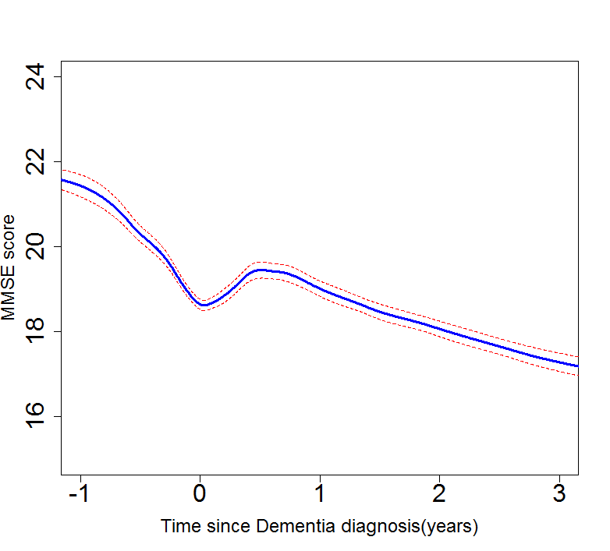 | 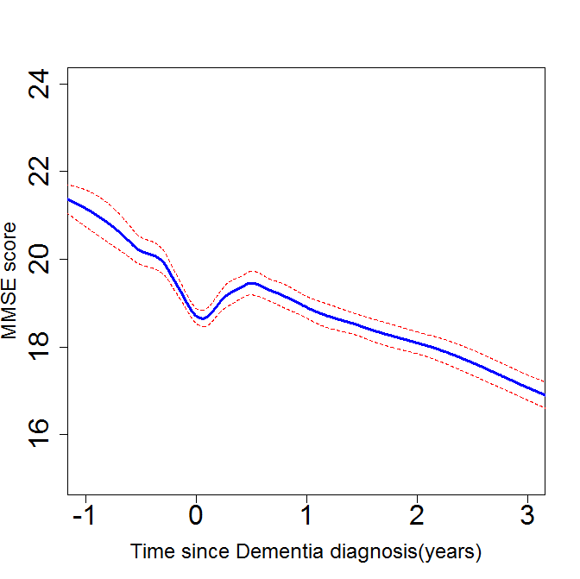 | 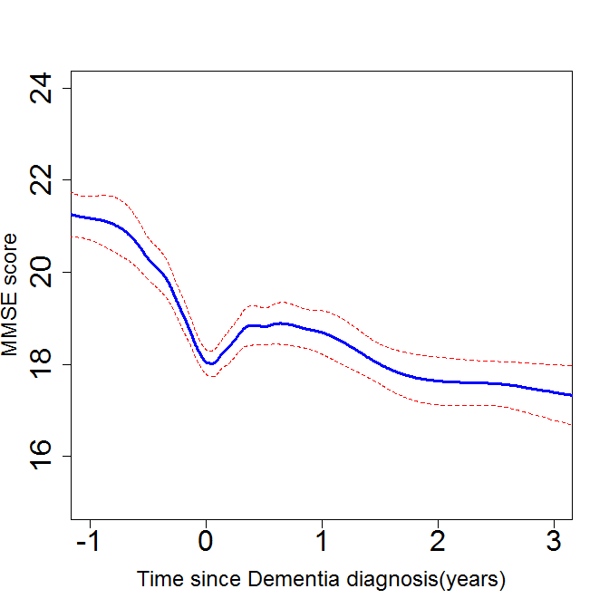
0-4 medications (n=7,410) | 5-9 medications (n=3,503) | ≥10 medications (n=1,235)

Figure 2: Comparison of non-parametric Linear Mixed Models of the rate of cognitive decline allowing adjustment for co-variates

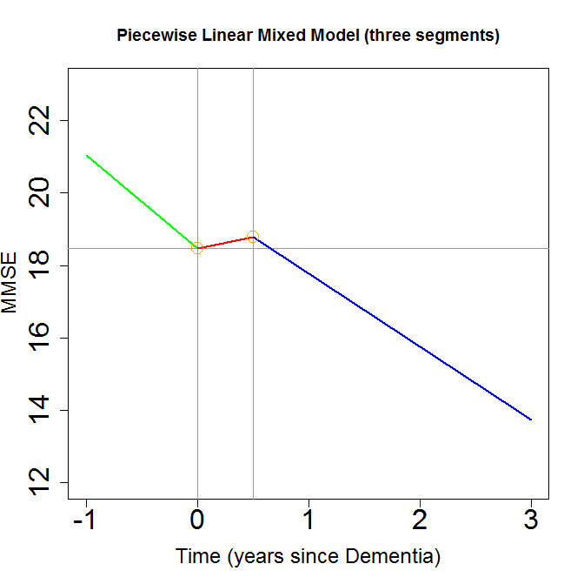 | 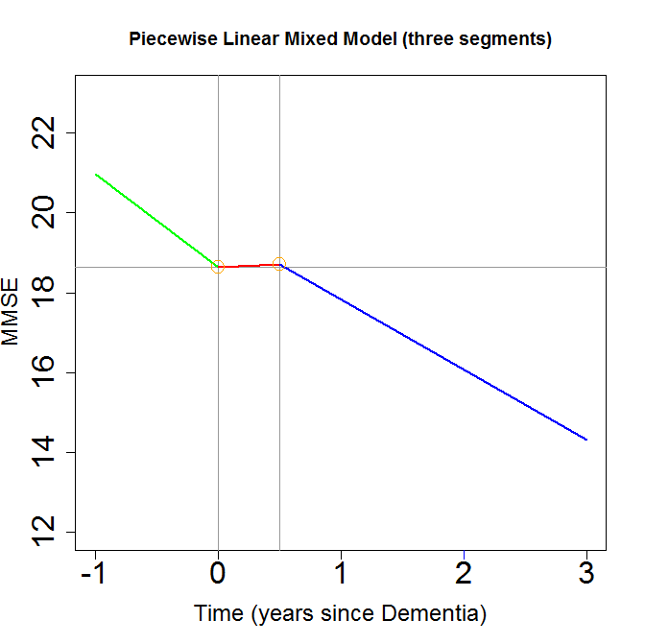 | 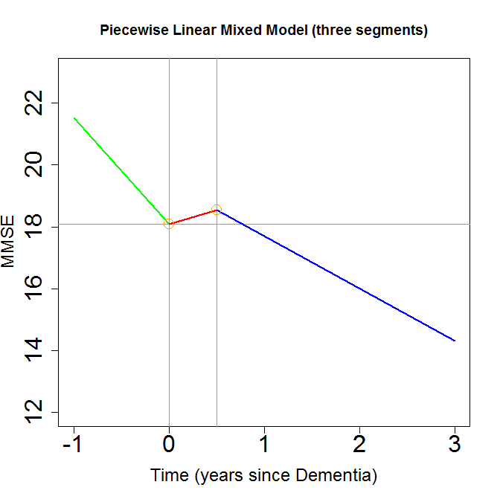
0-4 medications (n=7410) | 5-9 medications (n=3503) | ≥10 medications (n=1235)

Slopes are adjusted for the following co-variates: Age, gender, ethnicity, deprivation score, dementia subtype, HoNOS65+ symptom/disorder and functional problem scores, AChEI prescription and previous hospitalisation.

