The flammability of textiles when contaminated with paraffin base products
S. Hall,^{a,*} L. Franklin,^{b} J. Bull,^{b} A. Beard,^{b} G. Phillips,^{b} and J. Morrissey,^{a,*}
ª Forensic and Investigative Sciences Research Group, Department of Biomedical and Forensic Sciences, Faculty of Science and Technology, Anglia Ruskin University, Cambridge, UK. ^{b} Department of Biomedical and Forensic Sciences, Faculty of Science and Technology, Anglia Ruskin University, Cambridge, UK.
* Corresponding authors. Forensic and Investigative Sciences Research Group, Department of Biomedical and Forensic Sciences, Faculty of Science and Technology, Anglia Ruskin University, East Road, Cambridge. UK. CB1 1PT. Email address: sarah.hall@anglia.ac.uk and joanne.morrissey@anglia.ac.uk)
Keywords: flammability; contaminated textiles; fire risk; skin emollients; paraffin-based products
Abstract
Several fire related deaths have been reported and linked with the use of paraffin base skin creams/emollients. However, no scientific research has been published on the flammability of textiles when contaminated with such products. Therefore, this paper presents initial flammability tests results to assess the difference in burn potential when textiles are contaminated to provide a better understanding of the fire risk. Tests were conducted on 100% cotton and 52% polyester/48% cotton when contaminated with two paraffin-based products. The time to ignition (ignition time), the flame time and once self-extinguished, the glowing combustion were measured, using a non-direct contact ignition source. The ignition time when the textiles were contaminated were significantly decreased i.e. 100% cotton sheeting ignition time was 68.0 ± 29.6s and when contaminated for 24hrs with 27.1% paraffin based cream reduced to 6.0 ± 0.7s (p = 0.001). The glowing combustion time for the 52% polyester/48% cotton sheeting of 96.4 ± 23.9s when contaminated with 27.1% paraffin based cream for 24 hrs, increased to 173 ± 27.4s (p <0.001). Therefore, the results show that there is a significant decrease in ignition time of textiles when contaminated with paraffin based products and suggest that the underlying textile structure behaves as a wick to increase volatility for quicker ignition. This could impact on the time that someone is able to react when they accidently expose their contaminated clothing to a flame. Glowing combustion time also increased when the textiles were contaminated, which subsequently could increase the likelihood of severe skin burns.
1. Introduction
Since 2010, there have been more than 37 fire deaths in the UK where the contamination of clothing with paraffin base products has been a contributory factor. This figure was generated by a British Broadcasting Corporation (BBC) Freedom of Information Act request (FOIA) sent to 53 Fire Services in the UK [1]. Only six replied to this appeal, therefore it is highly likely that the number of fire deaths and injuries is seriously underreported [2]. Initial fire reports often do not contain all of the data necessary to ascertain the involvement of these skin care products and this also leads to an additional element of the underreporting of the problem. The reporting system used by Fire and Rescue Services is not always completed to include all of the relevant data in relation to contributory factors in burn injury and fatality cases. This is also reflected in hospital admission data where burn injuries may not be attributed to the use of skin care products. The lack of inclusion of this data may be due to patients not be asked for the information or ignorance of the risks involved by those reporting.
It is reported that 1 in 5 children and 1 in 12 adults suffer from eczema at some point in their lives and that 2-3% of the population suffer from psoriasis [3]. This is a significant percentage of the population and the most vulnerable groups including the young, elderly and immobile, are disproportionately represented in this. Therefore, when using skin creams that contain a paraffin base there could be a potential fire hazard, with other research additionally reporting a higher risk of burn injury with older people and a further increase when linked with dementia [4].
The National Patient Safety Agency (NPSA) issued their Rapid Response Report 4, entitled Fire Hazard with Paraffin-based Skin Products, in November 2007, in response to research that commissioned the Health and Safety Executive to conduct on their behalf. This research had been prompted by a patient fatality in a care setting. The report highlighted the fire safety risk in relation to emollients and the use of naked flames, such as matches and lighters [5]. Guidance was also published by the Medicines and Healthcare Products Regulatory Agency [6] and in addition, the British National Formulary has now included warnings on certain medicines. The NHS has also produced guidelines which include warnings such as ‘skin products containing white soft paraffin and emulsifying ointment are easily ignited with a naked flame or a cigarette’, however, the number of fire deaths and injuries remains high [7].
One recent communication discussed the most effective methods of conveying the safer use of such products and highlighted the problem that 58% of patients were unaware of the risks despite observing posters and leaflets [8]. This highlights the importance of rigorous scientific research to identify the fire risk factors including; the effect of the type of textile; the type of skin product; the paraffin content; and how the contamination affects the inherent flammability of a textile.
There is an abundance of research on the flammability of textiles [9-11]; however, there is little in relation to the effect of contamination on clothing that has had no special flame-retardant treatment [12]. There has been some research conducted into the flammability of topical preparations and surgical dressings during surgery but these were not specific to paraffin base products or just report observational results [13-15]. A very recent editorial has raised the issue of the fire risk relating to paraffin-based ointments and has provided guidance on how to reduce the risk, but no research was carried out to support the advice or detailing the risk of different paraffin content [16]. This again highlights, that the problem is recognised but there is no research into the effect of different fabric or product types, and no analysis on how significant the risk is [17].
It is worth noting that the use of a skin cream itself is not a hazard and that they are not readily ignitable on their own. The contamination of clothing with paraffin base products and the subsequent contact with heat from a naked flame, as well as a direct flame is the issue of concern. It is important that users of emollients are not deterred from using these products as they have well known positive effects [18,19] but the risks should be more clearly defined and communicated to users and those who prescribe the products.
The aims of this initial research was to conduct repeated measurements to compare the burn behaviour of commonly available textiles when contaminated with paraffin based products and compare the ignition time, the flame spread and the smouldering times. The initial results presented here, have informed further tests that are to be or being carried out by the authors, as commented on later in the conclusions.
2. Materials and Methodologies
The method presented in this paper is adapted from a vertical flammability testing method published by the US Federal Aviation Administration (FAR 24.853) [20] using a Bunsen burner, which after preliminary tests and consultation [21,22] was considered to be the most appropriate standard method for this contaminated textile research. The method was modified by increasing the number of repeats from 3 to 5 and altering ignition from direct/impinged flame on the lower edge of the front face of a test specimen to 7cm below (see section 2.2). This was to enable the ignition time to be measured more accurately and effective comparisons to the blank controls to be undertaken. Adapting the method allowed the measurement of ignition times and flame and smouldering burn times. The ignition times were based on the time between the placement of the lit Bunsen burner below the textile specimen and observation of the ignition of the textile to facilitate comparison and statistical interpretation. The frame was also modified by including two extra side arms to improve the fixing of the textile sample within the frames (fabricated by Mackays Metals, Cambridge). The textiles were chosen to represent those in common use. The textiles (all white) were 100% cotton (180 thread count, 111 ± 3 gm² ) sheeting purchased from Tesco PLC, 100% cotton t-shirt (128 ± 5 gm²) purchased from Primark and 52% polyester/48% cotton blend (144 thread count, 113 ± 3 gm²) sheeting purchased from ASDA. The two contaminants were a 27.1 % paraffin base cream (14.5% white soft paraffin/12.6% light liquid) manufactured by Reckitt and Benckiser and a < 85% petrolatum (petroleum jelly) decongestant product manufactured by Procter and Gamble.
2.1 Textile specimen preparation
The textile strips were cut to 75mm by 305mm specimen size and weighed (table 1). The contaminant was then applied using a spatula (when level equating to 1.25mL or 0.25 tsp) along the bottom of the textile strip and then rolled up the strip using a fingerprint roller (WA products LTD, a distributer of forensic science equipment). After reweighing (so the mass of contaminate could be calculated as shown in table 1) the strip was then pinned out onto a board vertically to dry for either 24hrs or 48hrs. With the double application of paraffin base cream, one application was added to the strip, left for 24hrs and then a second application was added and left for a further 24 hrs.
2.2 Vertical flammability testing
The prepared strips were reweighed and then placed between two clamped specimen holders. The specimen holder (Fig. 1) was then suspended (Fig. 2) using laboratory retort stands, with the bottom of the textile strip 15cm above the head of the Bunsen burner (Humboldt H-5885; flame height set at 7.0 ± 0.6 cm). All burns were carried out in a bespoke burn cabinet made by LAB designs (1600 x 1800mm, 0.5 m/s flow, with damper). Ignition (time to flame ignition), flame time and smouldering combustion time (after the flame had self-extinguished but smouldering/glowing combustion was present) was measured. All tests carried out included blank textile (i.e. uncontaminated) for comparison and all tests were repeated 5 times.
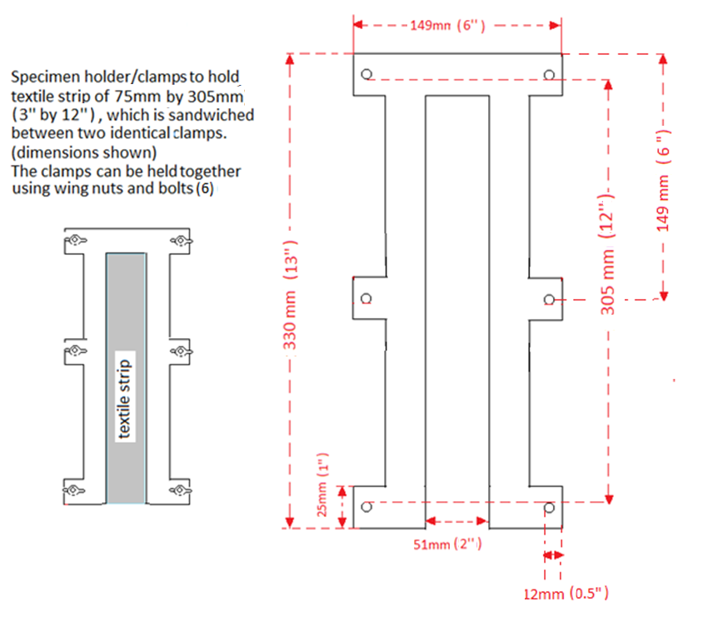
Fig 1. Specimen holder (FAR 25.583) used for contaminated textile flammability test [1].

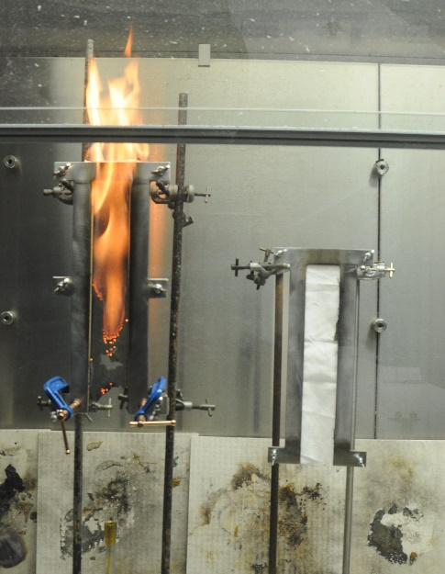

Fig 2. Example of a vertical flammability test (FAR 25.583) of 100% cotton (2.224 ± 0.06g) contaminated with 14.5% white soft paraffin/12.6% light liquid paraffin base cream (1.389 ± 0.07g) and left for 24hrs.

2.3 Statistical Analysis
All statistical tests were carried out using SPSS (IBM SPSS statistics 20) and significance of the means was carried using ANOVA post-hoc Tukey test method. The significance of variance was determined using the Levene’s test. Differences between the means and the variance were deemed to be significantly different when p < 0.05 (95% confidence intervals).

3. Results
Table 1 shows the results of 1) ignition time: measured once a flame was observed after the Bunsen burner had been placed under the specimen holder; 2) how long the flame was present once ignited (Bunsen burner removed on ignition) and 3) glowing/smouldering combustion time after the flame had self-extinguished. For each of the 9 tests (Fig. 3-11) n = 5, except n = 4 for the blank control 52% polyester/48% cotton sheeting; outliers were removed using Dixon’s Q-test. These tests were designed to answer initial research questions i.e. if contaminating various common textiles with such products did decrease the time to ignition and whether leaving the products for 24hr and 48hrs or a double application affected this behaviour further. Therefore, the design was to compare the blanks/control to the contaminated textiles rather than including all these factors to each textile as initial research.
The mass of the textile strip was taken three times, before the addition of the contaminant; once added and just before the flammability test. The mass of contaminant (Table 1) had low variability within all the tests and the percentage weight loss when soaked into the textile strips and left for 24 hrs (in laboratory conditions of 20ºC and approximately 70% relative humidity) was calculated as 63.4 ± 1.9% for the 27.1% paraffin base cream and 13.6 ± 1.0 % for the petroleum jelly based decongestant rub.
Both the mean and variability of time measurements have been used in the interpretation of measurements to take in to account the unpredictable nature of a flame and hence flammability tests. Such variability includes the flame height and movement; airflow; textile structure; fuel etc. Statistical analysis of the comparison of all means and variance of ignition times, flame time and glowing combustion time (Table 1) of the contaminated textiles and blank controls are all included in Tables A.1-A.3 in the appendices.
Table 1 Test results of ignition, flame and glowing time of three textiles contaminated with paraffin base products.
Textile and contaminant for flammability test | mass of  contaminant ª /g | mass of  textile ^{b} /g | ignition time ^{c} /s | p value ^{d} | flame time ^{e} /s | p value ^{f} | glowing time ^{g} /s | p value ^{h}
Contaminated 100% cotton sheet
single application of paraffin cream ^{i} left for 24hrs | 1.389 ± 0.07 (4.9%) | 2.224 ± 0.06 (2.6%) | 6.0 ± 0.7 (11.7%) | 0.001 | 17.6 ± 3.4 (19.3%) | 0.990 | 71.4 ± 11.6 (16.2%) | 0.073
double application of paraffin cream ^{i} left for 48hrs | 2.643 ± 0.10 (3.8%) | 2.537 ± 0.11 (4.4%) | 9.6 ± 1.1 (11.4%) | 0.003 | 24.4 ± 6.7 (27.5%) | 0.851 | 49.8 ± 14.0 (28.1%) | 0.918
Contaminated 52% polyester/48% cotton sheet
single application of paraffin cream ^{i} left for 24hrs | 1.576 ± 0.05 (3.3%) | 3.110 ± 0.04 (1.2%) | 12.2 ± 2.8 (23.0%) | <0.001 | 19.2 ± 2.9 (15.1%) | 0.908 | 173 ± 27.4 (15.8%) | <0.001
single application of paraffin cream ^{i} left for 48hrs | 1.572 ± 0.03 (2.2%) | 3.297 ± 0.05 (1.5%) | 13.4 ± 1.7 (12.7%) | <0.001 | 22.0 ± 1.6 (7.3%) | >1.00 | 144 ± 33.8 (23.3%) | 0.007
Contaminated 100% cotton t-shirt
single application of decongestant ^{j} left for 24hrs | 1.438 ± 0.06 (3.9%) | 3.579 ± 0.14 (4.0%) | 10.0 ± 1.9 (19.0%) | 0.007 | 27.0 ± 2.4 (8.9%) | 0.092 | 21.6 ± 10.2 (47.2%) | >1.00
single application of decongestant ^{j} left for 48hrs | 1.392 ± 0.10 (7.1%) | 3.680 ± 0.04 (1.0%) | 20.0 ± 7.6 (38.0%) | 0.052 | 26.1 ± 2.3 (8.8%) | 0.197 | 26.6 ± 5.6 (21.1%) | >1.00
Blank control 100% cotton sheet | none | 2.288 ± 0.14 (6.3%) | 68.0 ± 29.6 (43.5%) |  | 20.2 ± 8.8 (43.6%) |  | 34.0 ± 13.7 (40.3%)
Blank control 52% polyester/48% cotton sheet | none | 2.484 ± 0.17 (6.8%) | 336 ± 60.2 (17.9%) |  | 23.0 ± 2.4 (10.4%) |  | 96.4 ± 23.9 (24.8%)
Blank 100% cotton t-shirt | none | 3.471 ± 0.11 (3.1%) | 65.6 ± 17.9 (27.3%) |  | 18.8 ± 4.0 (21.3%) |  | 21.2 ± 9.0 (42.5%)
All tests were carried out following the adapted (FAR 24.853) vertical flammability test using a Humboldt H-5885 Bunsen burner flame height set at 7.0 ± 0.6 cm below the lower edge of the front face of a test specimen. Statistical tests were carried out using SPSS (IBM SPSS statistics 20) and significance of the means was carried using ANOVA post-hoc Tukey test method and the significance of variance was determined using the Levene’s test.

ª approximately 1.25mL for one application ^{b} 75mm by 305mm (3" by 12" textile strips) ^{c} time taken to ignite ^{d} when compared to the mean ignition time of the respective blank control ^{e} once ignited, the time that the flame was present ^{f} when compared to the mean flame time of the respective blank control ^{g} time of glowing/smouldering combustion (no flame) ^{h} when compared with the mean of the glowing time of the respective blank control ^{i} 14.5% white soft paraffin/12.6% light liquid paraffin base cream ^{j} decongestant petroleum jelly base product, <85% petrolatum (% relative standard deviation).

3.1 Ignition times (Fig. 3-5)
Comparing the mean ignition times (Table A.1 in the appendix) of test (a) with both (b) and (c) (Fig. 3a-3c) shows they are significantly different (p = 0.001 and p = 0.003 respectively); comparing (d) with both (e) and (f) (Fig. 4a-4c) shows significant difference (both; p = <0.001). Also comparing (g) with (h) (Fig. 5a-5b) shows a significant difference (p = 0.007) and (g) with (i) (Fig. 5a 5c) is very near to being significantly different (p = 0.052). The comparison of the equality of variance (Table A.1 in the appendix) of (a) with both (b) and (c) is significantly different (p = 0.021 and 0.023 respectively) (d) with both (e) and (f) is significantly different (p = 0.039 and p = 0.043) and comparing (g) with both (h) and (i) also shows significant difference between the variability of the ignition times (p = 0.003 and p = 0.039)
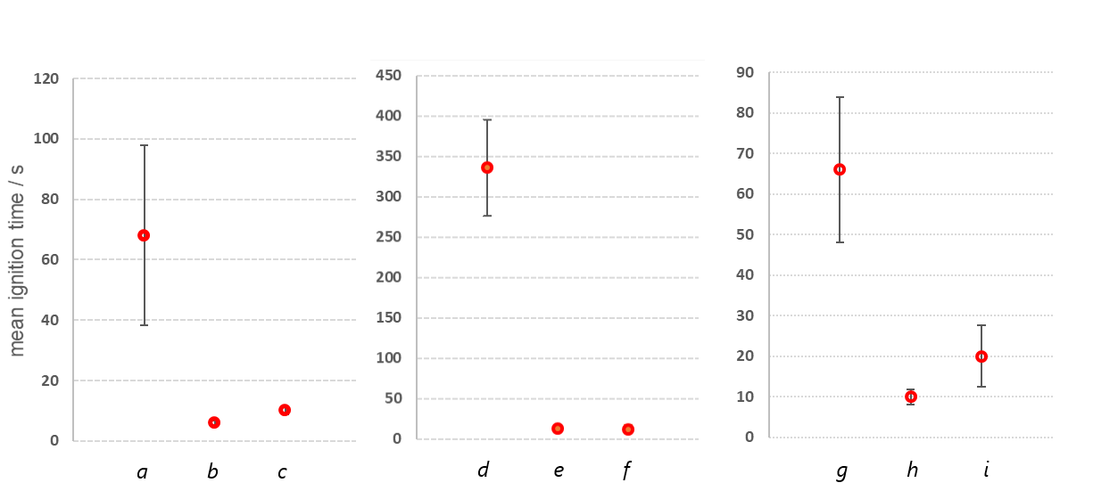
Fig 4.
Fig 5.
Fig 3.
Fig 3. mean time recorded for (a) ignition of blank (control) of 180 thread count 100% cotton sheeting; (b) with one application of 27.1% paraffin base cream left of 24hrs; (c) with two applications of 27.1% paraffin base cream, one after 24 hrs and one after a further 24hrs Fig 4. mean time recorded for (d) ignition of blank (control) of 144 thread count 52% polyester/48% cotton sheeting; (e) with one application of 27.1% paraffin base cream left of 24hrs; (f) with one application 27.1% paraffin base cream left for 48hrs. Fig 5. mean time recorded for (g) ignition of blank (control) of 100% cotton t-shirt; (h) with one application <85% petroleum jelly decongestant rub left for 24hrs; (i) with one application <85% petroleum jelly decongestant rub left for 48hrs. All tests were carried out following the adapted (FAR 24.853) vertical flammability test using a Humboldt H-5885 Bunsen burner flame height set at 7.0 ± 0.6 cm below the lower edge of the front face of a test specimen

3.2 Flame times (Fig. 6-8)
The comparison of all means and variance of the flame times (Table A.2 in the appendix) show no significant difference when comparing the blank textiles to when contaminated.
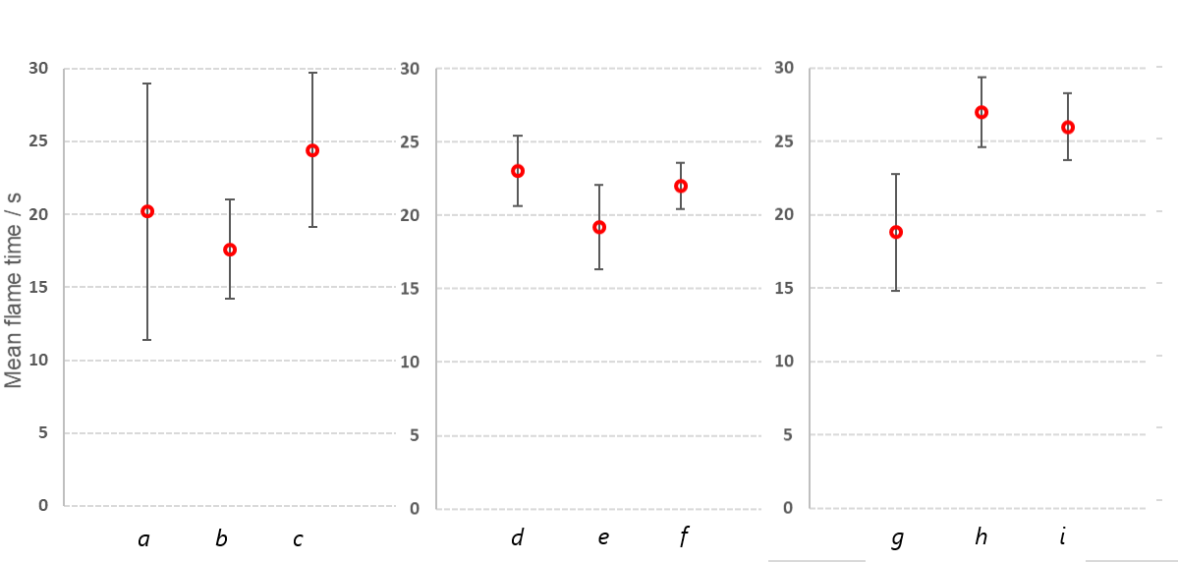
Fig 8.
Fig 7.
Fig 6.
Fig 6. mean of (a) flame time of blank (control) of 180 thread count 100% cotton sheeting (b) with one application of 27.1% paraffin base cream left of 24hrs (c) with two applications of 27.1% paraffin base cream one after 24 hrs and one after a further 24hrs Fig 7. mean of (d) flame time of blank (control) of 144 thread count 52% polyester/48% cotton sheeting (e) with one application of 27.1% paraffin base cream left of 24hrs (f) with one application 27.1% paraffin based cream left of 48hrs . Fig 8. mean of (g) flame time of blank (control) of 100% cotton t-shirt (h) with one application <85% petroleum jelly decongestant rub left for 24hrs (i) with one application <85% petroleum jelly decongestant rub left for 48hrs. All tests were carried out following the adapted (FAR 24.853) vertical flammability test using a Humboldt H-5885 Bunsen burner flame height set at 7.0 ± 0.6 cm below the lower edge of the front face of a test specimen

3.3 Glowing/smouldering combustion time (Fig. 9-11)
Comparing the means glowing/smouldering combustion times (Table A.3 in the appendix) of test (a) with both (b) and (c) (Fig. 9a-9c) shows there is no significant difference (p = 0.073 and p = 0.918 respectively); comparing (d) with both (e) and (f) (Fig. 10a-10c) shows there is a significant difference (p = <0.001 and p = 0.007). Comparing (g) with both (h) and (i) (Fig. 11a-11c) shows no significant difference (both p = >1.00). However, the comparison of the equality of variance of (a) with both (b) and (c) (p = 0.870 and p = 0.591) and (d) with both (e) and (f) (p = 0.539 and p = 0.312 respectively) and (g) with both (h) and (i) (p = 0.406 and p = 0.544) all showed no significant difference between the variability of the glowing/smouldering combustion time.
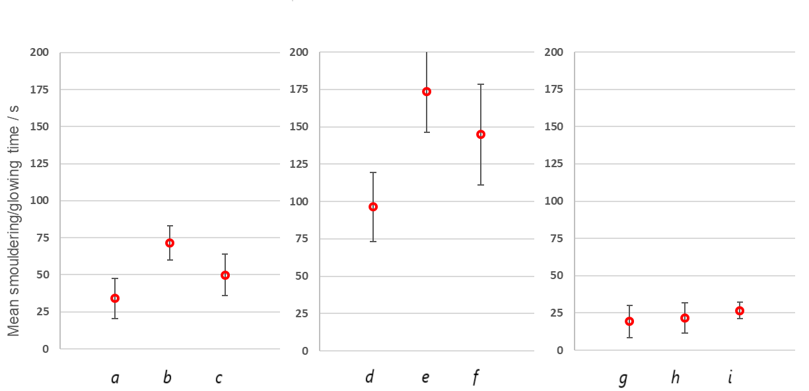
Fig 11.
Fig 10.
Fig 9.
Fig 9. mean of (a) glowing/smouldering combustion time of blank (control) of 180 thread count 100% cotton sheeting; (b) with one application of 27.1% paraffin base cream left for 24hrs; (c) with two applications of 27.1% paraffin base cream one after 24 hrs and one after a further 24hrs Fig 10. mean of (d) glowing/smouldering combustion time of blank (control) of 144 thread count 52% polyester/48% cotton sheeting; (e) with one application of 27.1% paraffin base cream left 24hrs; (f) with one application 27.1% paraffin base cream left for 48hrs. Fig 11. mean of (g) glowing/smouldering combustion time of blank (control) of 100% cotton t-shirt; (h) with one application <85% petroleum jelly decongestant rub left for 24hrs; (i) with one application <85% petroleum jelly decongestant rub left for 48hrs. All tests were carried out following the adapted (FAR 24.853) vertical flammability test using a Humboldt H-5885 Bunsen burner flame height set at 7.0 ± 0.6 cm below the lower edge of the front face of a test specimen

4. Discussion
During the vertical burn tests, increased flame heights [21] and vertical flame spread when the textiles were contaminated were observed and this is commented on within the conclusions, as further work. Flashes were also observed on the contaminated textile burns, before ignition [13,14] which were less evident in the blank control burns. Specific measures were taken in this research to reduce the variability of data. These include the use of a standard method; an improved specimen holder; a consistent textile cutting method and better distribution of the contaminant. However, as shown in Table 1 we still found high variability of blank control burns, mostly down to movement of the uncontaminated textile strip via convection as the Bunsen burner was placed underneath.

4.1 Comparison of ignition time when textile is contaminated
The ignition times of all 3 fabrics when contaminated are significantly different and lower, when compared to the respective fabric blank controls, as shown in Figures 3-5 (Table A.1 in the appendix supporting information). The largest difference in ignition time was between the blank 52% polyester/48% cotton sheeting (335.8 s ± 18%) and when contaminated with 27.1% paraffin base cream for 24hrs (12 ± 23%) as shown in Fig. 4a-4b. Video S.1 Flammability test of 100% cotton sheeting (blank control) in the supporting material, shows ignition of 100% cotton sheeting and in comparison, Video S.2 Flammability test of 100% cotton sheeting contaminated for 24hrs with 27.1% paraffin base cream, shows a much quicker ignition when the sheeting is contaminated with 27.1% paraffin base cream. These results indicate a potential fire risk from contaminated bed sheets, nightwear and dressings made of blended fabrics, such as those used in hospitals and other care settings. [13-15 and 17].
When comparing the mean ignition times of the two 100% cotton textiles there is no significant difference, but there is a significant difference when comparing both to the 52% polyester/48% cotton sheeting (Table A.1 in the appendix, both p=<0.001). These results are to be expected, as it is extensively reported that the ignitability of cotton [11, 23] is different and lower when compared to synthetic textiles and cotton blends of the same densities, as used in these tests. However, it is important to note, as the results show, that when contaminated, even if a textile is less ignitable in nature, all textiles tested in this paper have much quicker and similar ignition times as shown in Fig. 3-5 (as an example 100% cotton sheeting compared to the 52% polyester/48% cotton sheeting when contaminated with 27.1% paraffin base cream shows no significant difference in the mean of ignition; p = >1.00). It is important to stress that these contaminants are not flammable on their own, but are likely to have been absorbed by the cotton-based textile, which is acting as a wick [24] and producing more volatiles to accelerate a quicker ignition time.
When comparing mean ignition times in relation to the effect of time left after application (24 and 48hrs) of both contaminants, all tests showed no significant difference. These results suggest that the ignition times and flammability are similar even when the contaminated textiles have been left for a further 24hrs.
4.2 Comparison of flame time with contamination
The statistical analysis (Table A.2 in the appendix) of the flame time, once the textiles had been ignited (Table 1 and Fig. 6-8) show no significant difference of the means when compared to their respective blank textile controls. This suggests that the total fuel value of the blank fabric and when contaminated are similar, which is not the case in this research considering the amount of contaminant added (i.e. for single application of 27.1% paraffin base cream left for 24hrs, 1.39g was added to a 2.22g textile strip, which equates to 63% additional mass on average). Therefore, these results are more likely to be indicating that the contaminated fabrics are burning more intensely, as commented further in the conclusions as future research.
4.3 Comparison of smouldering/glowing combustion time with contamination
The last measurement taken during the flammability tests was the smouldering/glowing combustion time, which is combustion when there is not enough fuel to support a flame, but enough fuel for glowing combustion. Fig. 9-11 appear to show an increase in glowing combustion time when the textile is contaminated. The statistical analysis of the variance of data does not support this for all the tests. However, there is a significant difference in glowing combustion when comparing the means of 52% polyester/48% cotton sheeting blank control (Fig. 10a) to when contaminated with one application of the 27.1% paraffin base cream left for 24hrs (Fig.10b) and 48hrs (Fig. 10c) (p = <0.001 and 0.007). This shows that when the textile is a cotton blend that the glowing time is longer when contaminated with the 27.1% paraffin base cream. This is important as not only does it have a much quicker ignition as described above, but may remain smouldering for some time. The mean of the smouldering combustion is also very close to being significant when 100% cotton sheeting (Fig. 9a) when contaminated with the paraffin base cream (Fig. 9b) for 24hrs, but the effect is more pronounced for the cotton and polyester blend sheeting. Therefore, the results show that there is possibility of severe burns when a textile is contaminated with a paraffin based cream as it continues to burn without a flame.
5. Conclusion
The flammability tests have shown the ignition time of textiles are significantly quicker when contaminated with paraffin base products, even when the fabric type is known to be less flammable in nature. These results may contribute to the investigation of deaths relating to the use of skin creams that has been described by research collaborators. With such quick ignition times it is unlikely that victims would have been unable to react quickly enough once they had exposed their clothing to a source of ignition. Further tests are being carried out on different cotton densities; flame retardant fabrics and different paraffin base products, including non-paraffin types to investigate further the fire behaviour reported in this paper. Other tests to be carried out in the future include measuring the temperature of ignition and also the identification of the volatile products using gas chromatography-mass spectrometry and head space extraction.
These results show that the ignition time is not significantly different when the contaminant is left on the textile for an additional 24hrs so the risk of flammability is not reduced with time. Therefore, re-wearing contaminated clothing presents a fire risk. Further tests are currently being carried out on longer contamination time and the effect on ignition. Future tests to also be carried out include the investigation of the best laundering method to remove such contaminates from fabrics. which may lead to safer advice on the use of skin care products and their removal from clothing and sheeting.
The flame times when analysed statistically were not significantly different even with the additional fuel of the paraffin base products. The results suggest that when contaminated, fabrics burned more intensely and therefore future tests will be carried out using a microcombustion calorimeter. These tests will provide a further understanding of the heat generated and consequently the potential severity of burns. In addition, current work is being carried out using video software to investigate the vertical flame spread and height, which should also contribute to the understanding of the intensity of burn when fabrics are contaminated with paraffin base products.
The results also show an increase in glowing/smouldering combustion time particularly when a cotton blend textile is contaminated. Therefore, not only are quicker ignition times evident, but with no flame present, burning still continues, which shows that there is possibility of severe burns as the contaminated clothing continues to burn next to the skin.
There is an obvious effect of a cotton-based textile, as it acts as wick, to facilitate an increase in volatility of the paraffin base products to produce an ignitable fuel. The results shown in this paper are initial tests with other tests currently being carried out to investigate the burn behaviour reported and the authors welcome any collaborative research or feedback from other researchers and experts in this field.

Funding Sources
No external funding was used in support of the reported research within this paper.
Declaration of Interest
None
Acknowledgements
We would like to thank our collaborators, Essex County Fire and Rescue Service (especially Andre Turner for all of his support), West Yorkshire Fire and Rescue Service, the London Fire Brigade, BOC (especially Gary Lydford) and also the British Burns Association and the British Association of Dermatologists for their support. We also thank Professor Horrocks from the Institute for Materials Research and Innovation, University of Bolton for his advice.
We would also like to thank other students and technical staff, particularly Caroline Bugg for her continuing help with this research.

References
[1] British Broadcasting Company. Skin creams containing paraffin linked to fire deaths. Available at: http://www.bbc.co.uk/news/uk-39308748. (accessed 20/07/2018)
[2] The Daily Telegraph. Paraffin-based skin creams may be linked to hundreds of deaths, senior firefighter warns. February 2018. Available at: https://www.telegraph.co.uk/news/2018/02/11/paraffin-based-skin-creams-may-linked-hundreds-deaths-senior/ (accessed 25/07/2018)
[3] British Association of Dermatologists, Patient Information leaflets. Available at http://www.bad.org.uk/for-the-public/patient-information-leaflets (last accessed 23/07/2018)
[4] L. Harvey, R. Mitchell, H. Brodaty et al., Dementia: A risk factor for burns in the elderly. Burns, 42 (2016) 282-290.
[5] National Patient Safety Agency. Fire Hazard with Paraffin-based Skin Products. Rapid Response Report 4, National Patient Safety Agency, NHS, November 2007. Available at http://www.nrls.npsa.nhs.uk (accessed 24/07/2018)
[6] Medicines and Healthcare products Regulatory Agency. Paraffin-based skin emollients on dressings or clothing: fire risk. April 2006. Available at: https://www.gov.uk/drug-safety-update/paraffin-based-skin-emollients-on-dressings-or-clothing-fire-risk (last accessed 13/06/2018)

[7] Oxford University Hospitals NHS Trust, Dermatology Department, the Churchill. Emollients: information for patients. 2012 Available at: https://www.ouh.nhs.uk/patient-guide/leaflets/files/120521emollients.pdf (last accessed 20/06/2018)

[8] F. Al-Niaimi, S. Manickam, N.H. Cox, Flammability of paraffin-based products : an under-recognized hazard and methods to reduce it . Br. J. Dermatol. 162 (2010) 887-908.

[9] A.R. Horrocks, S. Nazaré, B. Kandola, The particular flammability hazards of nightwear. Fire Safety Journal, 39 (4) (2004) 259-276.
[10] I.S. Wichman, Material flammability, combustion, toxicity and fire hazard in transportation. Prog. in Energy & Comb. Sci. 29 (3) (2003) 247-299.
[11] C.Q. Yang, H. Quingliang, R.E. Lyon, et al. Investigation of the flammability of different textile fabrics using micro-scale combustion calorimetry. Poly. Degrad. & Stability, 95 (2) (2010) 108-115.
[12] A.R. Horrocks, B.K. Kandola, P.J. Davies, et al. Developments in flame retardant textiles – a review. Poly Degrad & Stability, 88 (1) (2005) 3-12.

[13] K. Arefiev, M. Warycha, D. Whiting, et al. Flammability of topical preparations and surgical dressings in cutaneous and laser surgery: A controlled simulation study. J. Am. Acad. Dermatol. 67 (4) (2012) 700-705.

[14] E.L. Jones, D.M. Overbey, B.C. Chapman, et al. Operating Room Fires and Surgical Skin Preparation. J. Am. Coll. Surg. 225 (1) (2017) 160-165.

[15] Health and Safety Laboratory, Fire Hazards associated with contamination of dressings and clothing by paraffin based ointments. FS/06/12 NRLS-1028E-HSL-report-paraffin, 11 (1) (2006).

[16] K. Shokrollahi, Paraffin-based ointments and fire hazard: understanding the problem, navigating the media and currently available downloadable patient information. Scars, Burns & Heal, 3 (2017) 1-2.
[17] S.J.R. Allen and M.J. Tidman, Dermatology dressings: an incendiary potential. B. J. Dermatol. 144 (2001) 628-650.

[18] C. Holden, J. English, C. Hoare, et al. Advised best practice for the use of emollients in eczema and other dry skin conditions. J. Dermatol. Treat. 13 (2002) 103–106.
[19] G. Moncrieff, M. Cork, S. Lawton, et al. Use of emollients in dry‐skin conditions: consensus statement. Clin. & Exp. Dermatol. 38 (2013) 231–238.
[20] A. Horner, Aircraft Materials Fire Test Handbook. U.S. Depart Trans, Fed Av Admin, Fire Safety Section 2000; AAR-422, DOT/FAA/AR-00/12.
[21] C. Leal C, S. Hall, D. Hadjicostas, Investigation of burns from cigarettes and naked flames on different substrates impregnated with white soft paraffin, (2013) 9th National FORREST conference.
[22] A.R. Horrocks, Institute for Materials Research and Innovation, University of Bolton, private communication.
[23] N.K. Kim, S. Dutta, D. Bhattacharyya. A review of ﬂammability of natural ﬁbre reinforced polymeric composites. Compos. Sci. & Tech. 162 (2018) 64-78.
[24] H. He, Z. Yu, Evaluation of Transfer Wicking Behaviour of Fibrous Material Ensembles Used by Wildland Firefighters. Key Eng. Materials. 730 (2017) 595-600.

Supporting material
Appendix
Table A.1 Statistical analysis of ignition times using the Levene’s test and ANOVA post-hoc tukey test (IBM SPSS 20). Differences between the means and the variance were deemed to be significantly different when p < 0.05 (95% confidence intervals).
Table A.2 Statistical analysis of flame times using the Levene’s test and ANOVA post-hoc tukey test (IBM SPSS 20). Differences between the means and the variance were deemed to be significantly different when p < 0.05 (95% confidence intervals).
Table A.3 Statistical analysis of glowing/smouldering combustion times using the Levene’s test and ANOVA post-hoc tukey test (IBM SPSS 20). Differences between the means and the variance were deemed to be significantly different when p < 0.05 (95% confidence intervals).

Video S1. Flammability test of 100% cotton sheeting (blank control)
Video S2. Flammability test of 100% cotton sheeting contaminated for 24hrs with 27.1% paraffin base cream.

