Assessing the Quality and Readability of Online Tinnitus Information Using Standardised Tools
Richard M. McKearney, MSc ^{1,2,4} (Corresponding Author)
Robert C. MacKinnon, PhD ^{3,1,2}
Mark Smith, MSc ²
Richard Baker, PhD ¹
¹ School of Psychological Sciences, University of Manchester, UK
² Audiology Department, Addenbrooke’s Hospital, Cambridge University Hospitals NHS Foundation Trust, UK
³ Department of Vision and Hearing Sciences, Anglia Ruskin University, Cambridge, UK
⁴ Audiology Department, Guy’s and St Thomas’ NHS Foundation Trust, UK

Title: Assessing the Quality and Readability of Online Tinnitus Information Using Standardised Tools
Short running title: Assessing Online Tinnitus Information
Correspondence Address:
Audiology Department, Guy’s Hospital, London, SE1 9RT, UK
Email: richard.mckearney@nhs.net

Abstract

Objective:
To assess, using standardised tools, the quality and readability of online tinnitus information which patients are likely to access.
Methods:
The study is a standardised review of websites related to tinnitus and its management. Each site was scored using the DISCERN instrument and the Flesch Reading Ease scale.
Results:
Twenty-seven unique websites were evaluated. The mean DISCERN score of the websites was 34.5/80 (SD 11.2). This would be considered ‘fair’ in quality. Variability in DISCERN score between websites was high (range 15-57: ‘poor’ to ‘very good’). Website readability was poor with a mean Flesch Reading Ease score of 52.6 (SD 7.7) considered ‘difficult’ to read.
Conclusion:
In general, the quality of tinnitus websites is fair and the readability is poor with substantial variability in quality between websites. The Action on Hearing Loss and the British Tinnitus Association websites were identified as providing the highest quality information.

Key words
Internet
Tinnitus
Health Literacy
Information Dissemination

Introduction
Tinnitus is a common health condition which for some individuals has a marked impact upon their quality of life .¹ Tinnitus affects approximately 10 percent of the UK population, with four out of ten sufferers considering the condition to be moderately or severely annoying .² Patients attending an Ear, Nose and Throat (ENT) clinic will commonly use the internet to research their condition but little is known about the quality of the information available or its readability.³ Patients who access online health information are unlikely to use academic or medical databases, but rather online search engines. Despite the notable use of online health information by ENT patients, entering the term ‘tinnitus’ into the most widely used internet search engine, Google, currently produces 5.62 million search results (February 2018). Some patients place significant credence in the online information they find ,⁴ and do not necessarily discuss this information with their clinician.⁵ It is therefore clearly important for clinicians to be aware of the types and quality of information that patients may access and its quality. The present study aims to assess the quality and readability of tinnitus information accessible to patients on the internet.

The percentage of UK households with internet access has increased from 10 percent in 1998, to 90 percent in 2017, with 80% of adults using it daily or almost daily.⁶ The internet is used by some individuals to access online information related to health. Diaz et al.⁵ conducted a survey of 1,000 randomly selected primary care patients. Of the 512 respondents, fifty-four percent reported having accessed online health information. Of these, sixty percent reported that they considered the online information to be equal to or surpass the information provided by their general practitioner (GP). Notably, fifty-nine percent of respondents did not discuss this online information with their GP. The impact of patients utilising online healthcare information is not fully known, although it is possible to speculate over the potential advantages and limitations. Potential benefits include enabling patients to take a more active role in managing their health, promoting autonomy and enabling them to make more well-informed decisions regarding their treatment .⁷ The internet can provide support to patients through online fora and through the provision of details of group support meetings.⁸ Information of poor quality may misinform patients, potentially leading to anxiety, stress and unnecessary visits to their GP.^{9,10} Despite these limitations, it is postulated that online health information can serve patients in a positive manner, especially if its use is guided by clinicians.¹¹

Patients with ENT complaints have been shown to readily access online health information prior to attending appointments. Tassone et al.³ surveyed 535 ENT outpatients prior to their clinic appointment. Sixty-four percent (n=344) had internet access, and of those eighteen percent had accessed the internet to seek information about their condition. In a similar study of parents of children visiting an ENT specialist,⁴ 30 percent of the 501 respondents had accessed online health information prior to their appointment, twenty-six percent of which reported that the online information accessed influenced their management decisions regarding their child’s care. Despite the notable use of online health information by ENT patients, much remains unknown about the quality of the information available and its readability. One study by Pothier measured the readability of online information in relation to ‘glue ear’ using the Flesch Reading Ease (FRE) score.¹² The FRE score is an objective quantitative test of readability (how easy a text is to read).^{13,14} Pothier found the level of readability of the material to be ‘difficult’ to ‘very difficult’, placing it above the reading age of the average UK adult.¹²

A study by Kieran et al.¹⁵ sought to evaluate the accountability and quality of online information about tinnitus. The assessment of accountability comprised four criteria which contributed to an Accountability Score: ‘authorship, attribution, disclosure, and currency’. A sample of 90 websites (30 from three separate search engines) were identified using the search term ‘tinnitus’. The authors used their own 10-point ‘Tinnitus Information Value’ (TIV) scale to assess the 39 websites they identified. Kieran et al.¹⁵ found the mean TIV score to be 5/10. The accountability score of the websites was very low (2/7) with 27/39 websites omitting the name of the author of the information. The TIV scale is not validated and its narrow range may cause it to have a ceiling and/or floor effect, making differentiation between website quality at the ends of the scale less meaningful.

Assessing the quality of websites used by patients is challenging, not least because of the lack of consensus on how this task is best achieved. A systematic review by Eysenbach et al.¹⁶ identified 79 studies whereby the authors systematically searched for online healthcare information and assessed it quantitatively. Eysenbach et al. considered the best studies to be ones which used demonstrably reliable evaluation tools. Two of the studies evaluated used the DISCERN instrument to evaluate online information.¹⁷ The DISCERN instrument is a standardised assessment tool created by an expert panel including clinicians and leaders in health information to assess the quality of written health information. It has been shown to have a high degree of validity and suitable inter-observer agreement.^{18,19}

With a significant proportion of patients likely to be accessing online health information and using it to inform their treatment decisions, it is important for clinicians to be aware of what information is available to patients online in order to better counsel them and guide them towards resources of known quality.^{3,5} Whilst the DISCERN instrument has been used to examine the quality of tinnitus information accessed by GPs online,²⁰ no study to date appears to have used a validated assessment tool, such as the DISCERN instrument, to carry out an in-depth assessment of the quality of online health information that would be typically accessible to patients on the subject of tinnitus and its management. The present study used a standardised method with validated tools to identify and examine websites likely to be accessed by patients with tinnitus.

Materials and Methods
Systematic search
Websites containing information on tinnitus and its management were systematically identified. The three most commonly used search engines on desktops, tablets and consoles are: Google (https://www.google.co.uk), Bing (https://www.bing.com/?cc=uk), and Yahoo (https://uk.yahoo.com/), which have a combined market share of 96.6%.²¹ These three search engines were used to identify the websites for review. In order to find a representative sample of websites which patients with tinnitus might access, the first 15 websites were taken from each search engine using both the search terms ‘tinnitus’ and ‘noise in ears’, giving a total of 90 potential websites for analysis. This approach was expected to capture at least ninety five percent of any ‘click throughs’ to websites in the results whilst keeping the sample constrained.²² The online searches were carried out on 12th August 2015. The information quality and readability assessments were conducted over the subsequent month.

Links which were sponsored advertisements were excluded because these are unlikely to be used.²³ Other websites excluded from analysis included: websites inaccessible to the general public, non-English language websites, and websites containing no written content or content irrelevant to the subject of the management of tinnitus.

Information quality assessment
The quality of the information provided by each website was assessed using the DISCERN instrument which is available without charge online.¹⁷ It consists of 16 separate criteria, each assessing a different aspect of quality considered an essential feature of good quality information and includes a score for overall quality. Each of these criteria are rated on a scale from 1-5 (except question 2 whose scale is 0-5) and the scores are summed. This gives a total score range of 15 (poor) to 80 (very good). The DISCERN instrument is divided into three main sections assessing: the reliability of the information, information related specifically to treatment choices, and the assessor’s global rating of the publication as a whole. Detailed instructions for how to accurately score each criterion are provided by the DISCERN handbook to promote consistency between assessors.¹⁷

To assess the inter-observer reliability of the website assessments using the DISCERN instrument, a random sample of 15 websites was selected for a blinded second assessor to score independently. The level of inter-observer reliability was then assessed.

Readability assessment
The level of readability for each website was assessed using the Flesch Reading Ease (FRE) score.¹³ This was calculated in Microsoft Word using the formula shown in Figure 1.
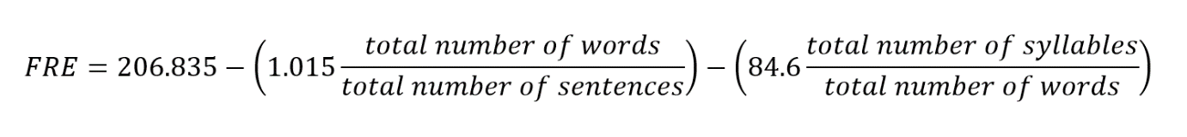
Figure 1. The Flesch Reading Ease (FRE) score, as calculated by word processing software Microsoft Word. The formula provides a method of objectively assessing the readability of a text. Adapted from Flesch.¹³

The FRE score takes factors such as the number of words per sentence and the number of syllables per word into account to give a score from 0-100, with a high-scoring text being more easily understood than one with a low score. A text with a score of 71-100 is considered ‘easy’ to read, with the average 11-year-old able to read it with ease. A score of 61-70 is considered ‘standard’ difficulty, with children aged 13-15 being able to read it clearly. A text with a score of 60 or below is considered ‘difficult’ to read.²⁴

Statistical methods
A priori statistical tests were performed using IBM SPSS v24. The effect of the search term used (‘tinnitus’ or ‘noise in ears’) on DISCERN and FRE scores was assessed by an independent samples two-tailed Student’s t-test on results not duplicated between search terms. The effect of website ranking in the search engine results list, and of correlation between DISCERN and FRE scores, were assessed by calculation of Spearman’s rank correlation coefficients. Inter-observer reliability between assessors for the DISCERN instrument was assessed by calculating Cohen’s kappa with quadratic weighting for a random sample of 15 websites rated blindly and independently by a second assessor, in a manner similar to the DISCERN instrument’s validation study.¹⁸

Results and analysis
Websites analysed
Of the initial sample of 90 results (15 for each of the two search terms, giving 30 from each of the three search engines), 35 unique websites were identified. The remaining 55 results were duplicates of the 35 unique websites and were excluded. A further eight of the 35 remaining unique websites were excluded from analysis because they did not contain any information related to tinnitus management (3 online newspaper articles, 2 online magazine articles, 2 standard webpages and 1 webpage with no written information), leaving 27 unique relevant websites remaining for analysis (Figure 2).
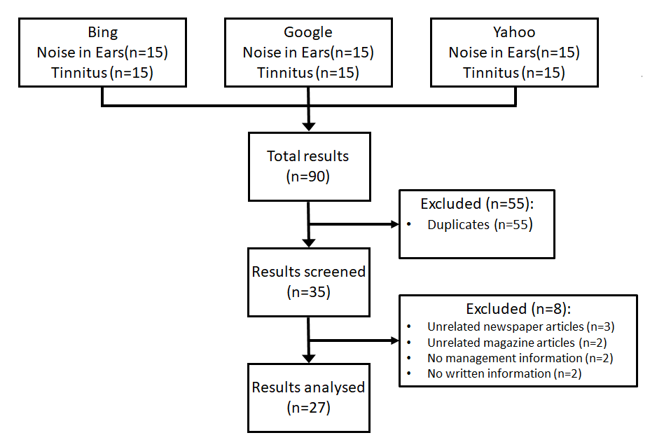
Figure 2. Flow chart of search results, showing steps of excluding duplicate and irrelevant results.

Information Quality – DISCERN Score
The mean DISCERN score of the 27 unique websites was 34.5 (range 15-57, SD=11.2) (Figure 3). Based on a pre-existing categorisation of scores,^{25,26} the mean DISCERN score of 34.5 would be considered ‘fair’ information quality. Of the 27 websites: nine websites had a ‘poor’ score (15-28), 12 websites had a ‘fair’ score (29-41), four websites had a ‘good’ score (42-54), two websites had a ‘very good’ score (55-67), and no websites had an ‘excellent’ score (68-80).

Readability – Flesch Reading Ease scores
The mean FRE score was 52.6 (SD 7.7). Using a pre-existing categorisation of scores,²⁴ text of this score would be considered ‘difficult’ to read. The range of FRE scores was 35.7-64.2, ranging from ‘difficult’ to ‘standard’ reading ease.

A Summary table of DISCERN and FRE scores for the 27 websites analysed is shown in Table 1 and in box-and-whisker plots in Figure 3.
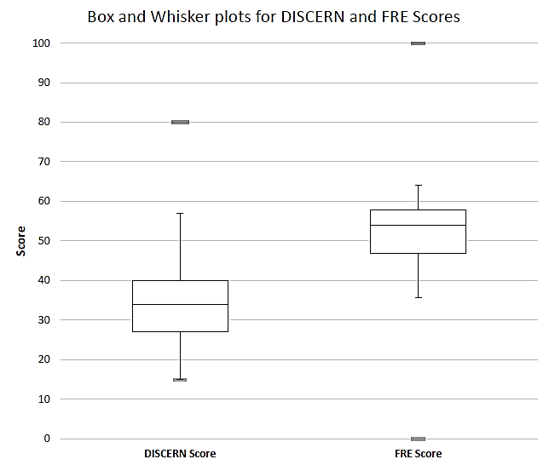
Figure 3. Box-and-whisker plots for DICSERN and FRE scores for the 27 websites included in the analysis.

Association between DISCERN (information quality) and FRE (readability) scores
No statistically significant correlation was found between information quality (DISCERN) and readability (FRE) scores (Spearman’s r =.24, p =.24). A scatter plot of DISCERN score against FRE score is shown in figure 4.

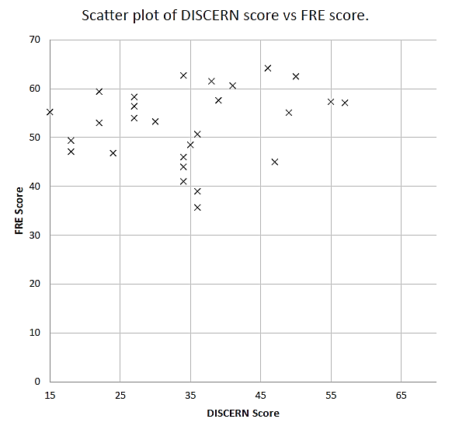
Figure 4. Scatter chart of DISCERN score against FRE Score. No significant correlation was detected (Spearman’s r =.24, p =.24).

Inter-observer reliability (DISCERN)
Quadratic-weighted kappa showed moderate agreement between two independent raters (κ =0.69, 95% CI=0.50-0.88). This is slightly greater than that reported by Charnock et al.¹⁸ for an expert panel when validating the DISCERN instrument (κ =0.53, 95% CI =0.48-0.59), and is greater than their stated level for acceptable agreement (κ =0.4). This finding gives reassurance that the DISCERN instrument has been used in a reliable manner.

Search term used
Of the 27 unique websites 11 appeared using both search terms, and 16 appeared for one search term only. The mean DISCERN score when using the search term ‘tinnitus’ was 36.8 (SD 10.2) and for ‘noise in ears’ was 29.9 (SD 9.8). The mean FRE score for ‘tinnitus’ was 51.8 (SD 8.5) and for ‘noise in ears’ was 53.2 (SD 7.7). Comparing websites produced using each search term, excluding duplicates, there was no statistically significant difference in DISCERN score (t(14)=1.004, p =.33) or FRE score (t(14)=1.085, p =.29).

Discussion
Online tinnitus information likely to be accessed by patients is most commonly and on average “difficult” to read and only of “fair” information quality, as assessed by standardised tools.^{13,17} The information ranged from “standard” to “difficult” in terms of readability, and “poor” to “very good” in terms of information quality. Readability was not significantly correlated with information quality. These factors are of potential significance to clinicians discussing and guiding patient access to online health information related to tinnitus.

Kieran et al.¹⁵ used their own TIV scale to rate the websites on the subject of tinnitus. The mean score was 5 (range 0-10), the midpoint of the range of possible scores. This score appears potentially slightly higher than the websites evaluated in this study using the DISCERN instrument, with the mean score of 34.5 being lower than the midpoint (47.5) of the possible range of DISCERN scores (15-80). However, as the two evaluative tools used differ considerably, with the DISCERN instrument being a universal health information assessment tool and the TIV being non-validated and tinnitus-specific, a direct comparison is difficult to make. Similarly to Kieran et al.¹⁵ this study found that the quality of information between websites was highly variable.

The DISCERN tool has previously been used to evaluate information accessed by GPs relating to tinnitus. Fackrell et al.²⁰ assessed the quality of online information sources used by GPs to guide their management decisions and help counsel patients. They used the DISCERN instrument to evaluate the top ten information sources used by GPs to read about tinnitus, as previously identified by El-Shunnar et al.²⁷ The mean DISCERN score of these ten websites was 47.0 (extrapolated from the average score per question provided by the authors). This score is unsurprisingly greater than the mean DISCERN score of the publically-accessible websites identified using search engines in this study (34.5) as the websites assessed by Fackrell et al. were identified as being the sources of information on tinnitus most commonly consulted by GPs.²⁷ However, a score of 47.0 would still only be considered ‘good’ and suggests that information quality could be improved further to allow sources to reach the ‘very good’ and ‘excellent’ score categories.

Many other studies have assessed the quality of online patient information within areas of clinical practice other than tinnitus. For example, Som and Gunawardana assessed online patient information related to chemotherapy and obtained a mean DISCERN score of 56.1 (SD 8.8), with a wide range (41-69).²⁸ Cajita et al.²⁹ evaluated online patient information pertaining to heart failure. The mean DISCERN score was 46.0. Both of these studies report a mean DISCERN score higher than that obtained by this study. This could reflect the differences in methodology between studies, or simply chance variation. Alternatively, this finding may represent differences in public awareness and funding for different conditions and associated publically accessible online information. There may also be more commercial websites targeting patients with tinnitus, which have been reported to have lower quality information.¹⁵ Suggestions to improve the quality and readability of patient-accessible information include the award of accreditation by third party organisations.³⁰

Health literacy (the ability to apply one’s literacy skills to health information) varies widely between patients and is a key social determinant of an individual’s health.^{31,32} The present study found that using the search term ‘noise in ears’ produced websites with slightly lower information quality and slightly higher readability than using the search term ‘tinnitus’, but these differences were not statistically significant. The readability of information is a key determinant of how well it is understood. The mean readability of the websites using the FRE score was 52.6 (range 37.5-64.2). This score would be rated as ‘difficult to read’ and equates approximately to the reading standard of a 15-18 year-old. A cross-sectional study of 251 healthcare websites with information on 12 common conditions found the mean FRE score to be 47.5.³³ This suggests that health information text is generally ‘difficult to read’ and has slightly worse readability compared to the websites identified in the present study (52.6). Healthcare information needs to be written in a style which is accessible to the majority of people. With almost a quarter of United States citizens reading at or below the level of a 9-11 year old, the American Medical Association has advised healthcare information providers to write their material at this level or below in order to widen accessibility to healthcare information.³⁴ The readability of health information may act as a barrier to those with less education and further compound the healthcare inequalities already experienced by these members of society. Simple measures to improve the clarity of language, as promoted by the Plain English Campaign,³⁵ will allow greater and fairer access to healthcare information.

Clinical implications
Many patients seek online information to find out more about their health condition and help guide their decisions regarding treatment choices. Clinicians who treat patients with tinnitus should be aware that the quality and readability of online information is highly variable and many patients do not discuss with their clinician the online information that they have read.⁵ Directing patients towards information sources of known quality will help them to make better-informed treatment decisions. The two websites with the highest DISCERN scores in this study were published by Action on Hearing Loss and the British Tinnitus Association.^{36,37} Although both websites had a FRE score of 57 (considered ‘difficult’ to read) they scored higher than the mean FRE score for websites in this study (52.6). Clinicians should be aware of the importance of writing healthcare information in a manner accessible to all patients. Tools to assess readability may be used in conjunction with a clear writing style to ensure that patients of all backgrounds have access to high quality information.

Limitations
As the searches were conducted on a computer with a UK Internet Protocol address, there may be a predisposition for search engines to identify UK-based websites. Additionally, patients and clinicians from other parts of the world may use more localised search engines, potentially limiting the applicability of our findings to those regions. Whilst no non-English-language websites were identified in our English-language searches, information sources exist in a variety of languages, and may not have the same characteristics as those assessed here.

Although the rating of information quality between assessors using the DISCERN instrument has been shown to have a good degree of inter-observer agreement, the scoring process still requires some subjective assessor input.¹⁷ Whilst the DISCERN instrument evaluates a wide variety of factors which contribute towards information quality, ¹⁷ there are factors not considered e.g. the factual content of the information, how current the information is, and readability. Although the FRE formula is able to objectively provide information on readability, its approach of calculating a single value from only the numbers of words, syllables and sentences is a reductionist take on a complex psycholinguistic process, and whilst a suitable proxy, does not capture all dimensions of the readability of a text.

Finally, the internet allows easier access to both publish new information and update pre-existing information compared to print media. Over time, this study’s findings will inevitably become less reflective of currently published information as the information available online gradually changes, but beyond contemporary utility, this study’s results will also serve as a point of comparison for future assessments.

Conclusion
Online tinnitus information likely to be accessed by patients is most commonly and on average “difficult” to read and only of “fair” information quality, as assessed by standardised tools. With most online resources rated as such, there is substantial room for improvement. Both scores were highly variable, reflecting the range of information that can be accessed by tinnitus patients online. Readability was not significantly correlated with information quality.

Clinicians who counsel patients with tinnitus should be aware of these findings, especially in the context of the number of patients who access online information to make decisions regarding their treatment and the likelihood that they may not discuss this information with their clinician.

The two best sources of information identified by this study were published online by Action on Hearing Loss and the British Tinnitus Association. Authors of patient information may use tools to evaluate readability and information quality, such as DISCERN, in order to widen access to quality healthcare information.

Conflicts of Interest and Source of Funding: The authors report no conflicts of interest. This research received no specific grant from any funding agency, commercial or not-for-profit sectors.

References

- Nondahl DM, Cruickshanks KJ, Dalton DS, Klein BEK, Klein R, Schubert CR et al. The impact of tinnitus on quality of life in older adults. J Am Acad Audiol 2007;18:257-66

- Davis A, El Rafaie A. Epidemiology of tinnitus. In: Tyler RS, ed. Tinnitus handbook. San Diego, CA: Singular, Thomson Learning, 2000;1-23

- Tassone P, Georgalas C, Patel NN, Appleby E, Kotecha B. Do otolaryngology out-patients use the internet prior to attending their appointment? J Laryngol Otol 2004;118:34-8

- Glynn RW, O’Duffy F, O’Dwyer TP. Patterns of Internet and smartphone use by parents of children attending a pediatric otolaryngology service. Int J Pediatr Otorhinolaryngol 2013;77:699-702

- Diaz JA, Griffith RA, Ng JJ, Reinert SE, Friedmann PD, Moulton AW. Patients’ use of the Internet for medical information. J Gen Intern Med 2002;17,180-5

- Internet Access – Households and Individuals 2017. Office for National Statistics. In: https://www.ons.gov.uk/peoplepopulationandcommunity/householdcharacteristics/homeinternetandsocialmediausage/bulletins/internetaccesshouseholdsandindividuals/2017 [21 October 2017]

- Gerber BS, Eiser AR. The patient–physician relationship in the Internet age: future prospects and the research agenda. J Med Internet Res 2001;3:E15

- van Uden-Kraan CF, Drossaert CH, Taal E, Seydel ER, van de Laar MA. Participation in online patient support groups endorses patients’ empowerment. Patient Educ Couns 2009;74:61-9

- Eysenbach G, Diepgen TL. Towards quality management of medical information on the internet: evaluation, labelling, and filtering of information. Brit Med J 1998;317:1496-502

- Murray E, Lo B, Pollack F, Donelan K, Catania J, Lee K et al. The impact of health information on the internet on the physician-patient relationship. Arch Intern Med 2003;163:1727-34

- Wald HS, Dube CE, Anthony DC. Untangling the Web – The impact of Internet use on health care and the physician-patient relationship. Patient Educ Couns 2007;68:218-24

- Pothier DD. Patients and the internet: are websites on glue ear readable? Clin Otolaryngol 2005;30:566

- Flesch R. A new readability yardstick. J of Appl Psychol 1948;32:221-33

- Shepperd S, Charnock D, Gann B. Helping patients access high quality health information. BMJ 1999;319:764-66

- Kieran SM, Skinner LJ, Donnelly M, Smyth DA. A critical evaluation of Web sites offering patient information on tinnitus. Ear Nose Throat J 2010;89:E11-4

- Eysenbach G, Powell J, Kuss O, Sa ER. Empirical studies assessing the quality of health information for consumers on the World Wide Web: a systematic review. JAMA 2002;287:2691-700

- Charnock D. The DISCERN handbook. Oxford: Radcliffe Medical Press, 1998. Available at: http://www.discern.org.uk

- Charnock D, Shepperd S, Needham G, Gann R. DISCERN: an instrument for judging the quality of written consumer health information on treatment choices. J Epidemiol Commun H 1999;53:105-11

- Ademiluyi G, Rees CE, Sheard C. Evaluating the reliability and validity of three tools to assess the quality of health information on the Internet. Patient Educ Couns 2003;50:151-5

- Fackrell K, Hoare DJ, Smith S, McCormack A, Hall DA. An evaluation of the content and quality of tinnitus information on websites preferred by General Practitioners. BMC Med Inform Decis Mak 2012;12:1-13

- 2015 Top 5 desktop, tablet & console search engines from June 2014 to June 2015. StatCounter Global Stats. In: http://gs.statcounter.com/#search_engine-ww-monthly-201406-201506/ [22 July 2015]

- 2014 Google organic CTR study. Advanced Web Ranking. In: https://www.advancedwebranking.com/google-ctr-study-2014.html [15 July 2017]

- Evaluating the UK search marketing landscape infographic. GroupM UK. In: http://www.mecmanchester.co.uk/evaluating-the-uk-search-marketing-landscape-infographic/ [7 March 2016]

- D'Alessandro DM, Kingsley P, Johnson-West J. The readability of pediatric patient education materials on the World Wide Web. Arch Pediatr Adolesc Med 2001;155:807-12

- Daraz L, MacDermid JC, Wilkins S, Gibson J, Shaw L. The quality of websites addressing fibromyalgia: an assessment of quality and readability using standardised tools. BMJ Open 2011;1:e000152

- Hargrave DR, Hargrave UA, Bouffet E. Quality of health information on the Internet in pediatric neuro-oncology. Neuro-oncol 2006;8:175-82

- El-Shunnar SK, Hoare DJ, Smith S, Gander PE, Kang S, Fackrell K et al. Primary care for tinnitus: practice and opinion among GPs in England. J Eval Clin Pract 2011;17:684-92

- Som R, Gunawardana NP. Internet chemotherapy information is of good quality: assessment with the DISCERN tool. Br J Cancer 2012;107:403

- Cajita MI, Rodney T, Xu J, Hladek M, Han HR. Quality and health literacy demand of online heart failure information. J Cardiovasc Nurs 2016;32:156-64

- Wilson P. How to find the good and avoid the bad or ugly: a short guide to tools for rating quality of health information on the internet. BMJ 2002;324:598-602

- Graham S, Brookey J. Do patients understand? Perm J 2008;2:67-9

- Nutbeam D. Health literacy as a public health goal: a challenge for contemporary health education and communication strategies into the 21st century. Health Promot Int 2000;15:259-67

- Cheng C, Dunn M. Health literacy and the Internet: a study on the readability of Australian online health information. Aust NZ J Public Health 2015;39:309-14

- Safeer RS, Keenan JK. Health literacy, the gap between physicians and patients. Am Fam Physicia 2005;72:463-68

- Plain English Campaign. In: http://www.plainenglish.co.uk/ [20 March 2016]

- Tinnitus. Action on Hearing Loss. In: https://www.actiononhearingloss.org.uk/your-hearing/tinnitus.aspx [30 March 2016]

- Get support. British Tinnitus Association. In: http://www.tinnitus.org.uk/for-health-professionals [28 January 2015]

Summary
- Patients commonly use the internet to research their health condition.
- This study evaluated the quality and readability of information that patients with tinnitus are likely to access.
- Generally, the quality of the websites assessed was fair, and the readability was poor.
- Information quality varies substantially between websites.

Tables

Table I. Summarised DISCERN and FRE scores.
DISCERN Score | Poor | Fair | Good | Very Good | Excellent
 | (15-28) | (29-41) | (42-54) | (55-67) | (68-80)
Number of sites | 9 | 12 | 4 | 2 | 0
FRE Score |  | Difficult | Standard | Easy
 |  | (0-60) | (61-70) | (71-100)
Number of sites |  | 22 | 5 | 0

Summary table of scores from websites analysed, using previously published categorisations for DISCERN scores and FRE scores.^{24,25,26}

