NATIONAL SURVEY: DEVELOPING A COMMON APPROACH TO GRADING OF PRACTICE IN PRE-REGISTRATION MIDWIFERY

Word count of article, including abstract, key words, in-text references and bibliographic reference list = 5986 (meeting 22nd September 2018 author guidelines)

KEYWORDS

assessment; grading; practice; midwifery

Declarations of interest: none

ACKNOWLEDGEMENTS

The research team would like to thank the members of the Lead Midwife for Education United Kingdom Executive (LME-UK) for their support as ‘gatekeepers’ to the survey and ongoing contributions throughout this national project. We are also grateful to all those midwifery and nursing colleagues and students who took the time to respond to the survey and test our proposed tools – adding valuable insights to the pool of evidence around assessment and grading of practice in the UK and beyond.

ABSTRACT

Aim: To develop a generic framework for grading practice in pre-registration midwifery programmes, enhancing standardisation while enabling flexibility in application of current and new educational standards.
Background: This is the final phase of a national project exploring grading of practice in programmes leading to registration as a midwife in the United Kingdom.
Methods: A mixed method on-line survey considered existing practice assessment tools, factors contributing to robust and reliable assessment and perceptions of two assessment tools developed by the research team: a ‘Lexicon Framework’ and ‘Rubric’, which were tested through scenarios.
Findings: Participants included 170 midwifery and nursing academics, clinicians and students, representing 20 universities in the UK. Seven key themes emerged, from which an ‘Evidence Based Model for Professional Practice Assessment’ was developed. The proposed tools were overall positively evaluated and demonstrated a good level of reliability. Scope for transferability to nursing was identified.
Recommendations: A national tool to standardise midwifery practice assessment is recommended. Key stakeholders should engage in development of practice assessment documentation. The professional purpose of grading practice should be central to the process. A set of key principles for assessing practice is presented.

[Word count: 188]

HIGHLIGHTS

- A national tool to standardise midwifery practice assessment is recommended
- Key stakeholders should engage in development of practice assessment documentation
- The professional purpose of grading practice should be central to the process
- Key principles and an evidence based model for assessing practice are presented
- A toolkit of generic resources supporting practice assessment is near completion

1. INTRODUCTION

This paper presents the findings from the third and final phase of a national project conducted by and on behalf of the Lead Midwife for Education United Kingdom Executive (LME-UK), comprising a group of senior midwife academics appointed by each of the 55 universities in the UK delivering pre-registration midwifery education – a requirement of the regulatory body, the Nursing and Midwifery Council (NMC, 2017a). Our five-year project has explored grading of practice in educational programmes leading to qualification as a midwife (LME-UK Executive, 2018), using a cyclical participatory action research process in which collaboration is key to achieving the end-goal (O’Brien, 1998). The first two phases have previously been published in this journal (Authors, 2017a; 2017b). This final phase comprised an on-line survey of midwifery and nursing students, clinicians and academics across the UK.

Our findings and recommendations contribute to the evidence-base informing new standards for pre-registration midwifery education in the UK (NMC, 2017b). They have resonance in nursing and internationally for academics and clinicians who develop assessment documentation, facilitate learning or determine students’ progress in professional practice settings.

2. BACKGROUND

2.1 The professional context for grading of practice:
Globally, both the World Health Organisation (WHO, 2009) and International Confederation of Midwives (ICM, 2013) stipulate a balance of theory and practice to ensure that essential competencies for basic midwifery practice are achieved, and the UK and other 27 members of the European Union, Australia and New Zealand have adopted these standards (Australian Nursing and Midwifery Accreditation Council, 2014; European Parliament, 2005; Midwifery Council of New Zealand, 2018).

Grading of practice, contributing to degree classification, is currently mandatory in UK pre-registration midwifery programmes (NMC, 2009), but this is not the case in nursing (NMC, 2010; 2018a). The education standards specific to midwifery are currently under review (NMC, 2017b), and it is unknown whether grading will continue to be stipulated by the regulatory body or become optional.

Midwifery practice in the UK must currently be assessed by registrants who have received specific preparation, annual updates and have worked on a regular basis with the student – termed ‘sign-off mentors’ (NMC, 2008). Roles for those supporting and assessing midwifery and nursing students in practice will, however, soon be changing. ‘Practice supervisors’ from the same or another profession will support and facilitate learning in the relevant setting, recording the student’s progress. A suitably prepared ‘practice assessor’, from the same profession as the student, will determine achievement based on this evidence (NMC, 2018c). For the purposes of this paper, its international readership and the current educational context, the terms ‘mentor’ and ‘assessor’ are used interchangeably to reflect the person accountable for judging performance in practice.

Application of the standards set by the NMC is the responsibility of the individual academic teams in collaboration with clinical colleagues and subject to their higher education institution’s regulations. In 2013, the LME-UK Executive identified that a wide range of approaches and interpretations of the NMC (2009) standards for pre-registration midwifery education was evident across the UK, reflecting experiences in other health professions (Lauder et al, 2008; Mallik and McGowan, 2007). The group sought to reduce these variations, focusing on achieving greater consistency in grading practice across educational programmes leading to qualification as a midwife. A ‘National Grading of Practice in Pre-registration Midwifery Project’ (Figure 1) has therefore been undertaken by a team of previous and current LMEs with a common interest in practice assessment (LME-UK Executive, 2018).

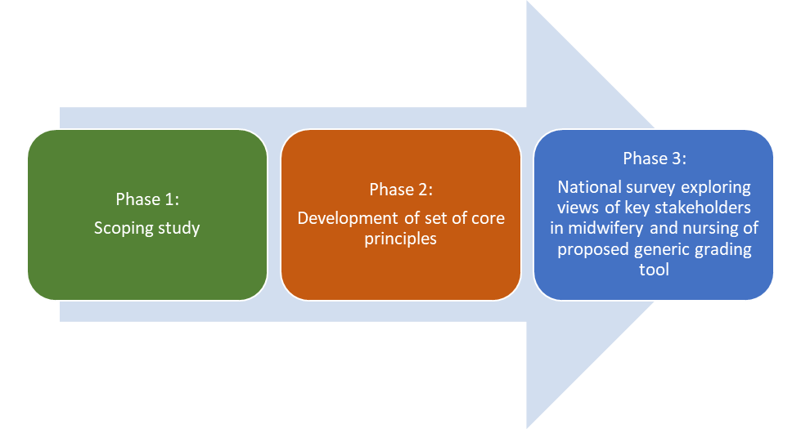
Figure 1: National Grading of Practice in Pre-registration Midwifery Project

2.2 Rationale for the final phase:
The complexity of ensuring consistency, reliability and validity in practice assessment tools and approaches is challenging (Dalton et al, 2009; Fisher et al, 2011; Seldomridge and Walsh, 2006), and Maxted et al (2004) has identified a need to develop robust new methods with greater predictive power and authenticity.

The findings from the scoping study in the first phase of our project (Figure 1) supported a move to reducing variations in approach to practice assessment, thus strengthening the rigour of the process (Authors, 2017a).

In the second phase, a Mini-Delphi process (Green et al, 2007) achieved consensus on a set of 11 core principles drawn from these findings (Authors, 2017b). One has led to the third and final phase of our project:
“A common set of grading criteria comprising qualitative comments which would attract different types of scoring (eg: %, mark, A-F etc depending on institutional requirements and programme preferences) will be developed to enhance standardisation of the measure of competence/ performance in midwifery practice across the UK” (Authors, 2017b, p58).

3. METHODS

3.1 Aim:
The aim of the final phase of our project was to develop a generic framework for grading practice in pre-registration midwifery, enhancing standardisation while enabling flexibility regarding the awarding of specific grades or broader indicators of levels of attainment. This would accommodate variations and future-proof against changes to regulatory requirements, or institutional preferences, for graded or non-graded practice assessment.

It was proposed that the framework would be suitable for use throughout all midwifery programmes nationally and with any practice assessment tool, with potential to adapt it to other professions or countries.

3.2 Study design:
This descriptive study comprised a mixed method on-line survey exploring participant views of their existing practice assessment tool, consideration of factors contributing to a robust and reliable assessment process and perceptions of two proposed assessment tools developed by the research team: a ‘Lexicon Framework’ and ‘Rubric’. Although the primary aim was to explore their application to midwifery, the research team decided to include nursing participants so that potential for transferability could be determined. Information about professional registration and stakeholder categories of academics, clinicians and students was identified at the start of the survey.

3.3 Development of the assessment tools – Lexicon Frameworks and Rubrics:
Twenty-eight practice assessment documents were received from the LMEs, representing 37 of the 55 universities (67.2%) as common regional assessment tools were used in Yorkshire and Humberside and ‘PAN London’ institutions (Authors, 2017a; Gillman, 2014;). Terminology used was collated into a matrix for each academic level and the range of level descriptors for performance. The UK Quality Code for Higher Education (QAA, 2014) defines level descriptors as “A statement of the generic characteristics of outcomes of learning at a specific level of a qualifications framework” (p1). These frameworks provide international comparability of academic standards and are used by professional regulatory bodies (such as the NMC) to recognise qualifications; they are, however, deliberately broad to enable flexibility for awarding institutions. There are two parallel frameworks for higher education qualifications – one for Scotland and one for the rest of the UK. Academic levels for pre-registration midwifery qualifications are distinguished as levels 4-7 for England, Wales and Northern Ireland, equating to Scottish Credit and Qualifications Framework (SCQF) 7-10/11 (QAA, 2014). Table 1 shows the range of scoring systems used in the documentation provided by the LMEs, and the generic categorisation adopted by the research team for the new assessment tools, using terms such as ‘fail’, ‘good’, ‘excellent’ for the level descriptors.

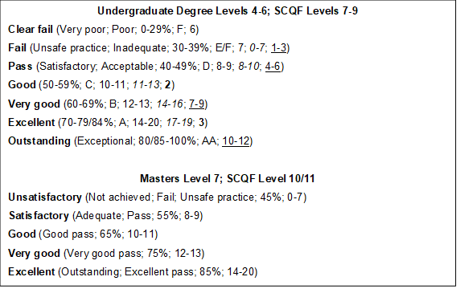
Table 1: Categorisation according to scoring systems in midwifery across UK universities

A visual representation of the frequency words appeared in each category was initially created in ‘Wordles’ or ‘Word-clouds’ (Feinberg, 2014) - see Figure 2. They were next ranked using ‘Word Count Tool’ (Word Counter, 2017), with each word collated into its root form and derivatives. Those with highest frequency were transferred to a ‘Lexicon Framework’ and categorised according to their parts of speech: nouns (further segregated into their relevance to knowledge, skills, attitudes or ‘other’), adjectives, verbs, adverbs and prepositions. A pragmatic approach was taken to categorisation when derivatives could be used in different contexts; the most common category of usage was applied, ensuring that this was consistent within and between academic levels. Key words were identified in a banner above each part of speech if they appeared in at least six of the seven level descriptors (Levels 4-6/ SCQF 7-9) or all five of the descriptors in Level 7 (SCQF 10/11).
Figure 2: ‘Wordle’ depicting frequency of words used in the category ‘Outstanding’ for Level 5 (SCQF 8)

The sets of words in the Lexicon Frameworks were then converted to a generic range of statements relevant to ‘Knowledge’, ‘Skills’ and ‘Attitudes’ appropriate to the descriptor levels within each academic level, forming the ‘Rubrics’, for example: “Student demonstrates very good communication skills to underpin professional care and team-work” (‘Skills’, level 5/ SCQF 8, ‘Very good’).

The sets of Lexicon Frameworks and Rubrics were uploaded to the project website for participants to access during the survey.

3.4 Participants and ethical considerations:
The survey was approved for national implementation by the ethics committee at the host university. It was confirmed that Health Research Authority (2018) approval was not required as clinical representatives were approached via university databases. The approval reference was made available on all survey documentation and the project website.

The LMEs acted as gatekeepers in their institutions across the UK, inviting midwifery and nursing participation from academics, clinicians involved in supporting and assessing learners and pre-registration students.

3.5 Data collection and analysis:
An on-line survey questionnaire using ‘SurveyMonkey’ (Finley and Finley, 1999) included quantitative questions, qualitative comments and application of the Rubrics to grading scenarios.

The survey and assessment tools were piloted and refined with representatives from the stakeholder groups; all pilot data were excluded from the main survey.

Data were filtered according to the stakeholder categories and professions, enabling comparisons to be made within and between groups. Manual cleansing was undertaken where any discrepancies occurred.

Descriptive statistical analysis of quantitative components (giving numbers and percentages) and thematic content analysis of qualitative data was undertaken independently by the research team members and then cross-checked. Codes, themes and key findings were agreed by the full project team at a face-to-face meeting and follow-up email correspondence.

4. FINDINGS

Key findings in each section of the survey are presented, comprising both quantitative and qualitative elements. Where appropriate, participant quotations have been included, and coding of stakeholder categories is identified in Table 2. Detailed findings are available in the full report from the final phase located on the project website (Authors, 2018).
Symbol | Status or area of work | Examples
M | Midwife | RMA6 = Registered midwife employed by the university as a lecturer/ academic member of staff  RNC4 = Registered nurse working in the clinical setting and employed by a hospital or community trust/ government/ private and voluntary sector/ other or is self employed  SM7 = Student undertaking a programme in preparation for registration as a midwife  SN2 = Student undertaking a programme in preparation for registration as a nurse
N | Nurse
R | Registered
S | Student
A | Academic
C | Clinician

Table 2: Key for qualitative codes

4.1 Profile of participants:
There were 170 participants (following data cleansing) from 20 of the 55 higher education institutions and associated practice placements across the UK (36.36% institutional representation). The distribution of participants across England, Scotland and Wales is shown in Figure 3. There were no respondents from Northern Ireland.

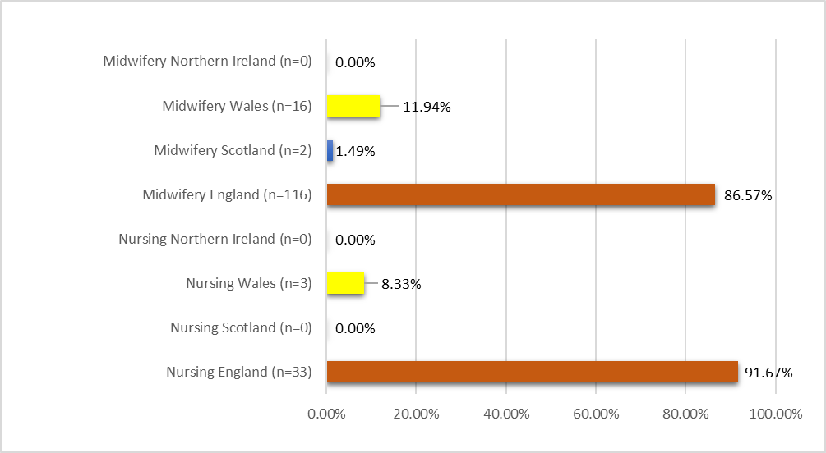

Figure 3: Country in the UK in which participants were practising or studying

There were 134 midwifery and 36 nursing participants. Table 3 depicts the stakeholder categories (N=170).

 | MIDWIFERY (n=134) |  | NURSING (n=36)
Academics | 64 | n=47.76% (37.65% of N) | 15 | n=41.67% (8.82% of N)
Clinicians | 14 | n=10.45% (8.24% of N) | 8 | n=22.22% (4.71% of N)
Students | 56 | n=41.79% (32.94% of N) | 13 | n=36.11% (7.65% of N)

Table 3: Categories of participants

4.2 Main themes:
Seven main themes were identified from the qualitative data. These are mapped to the relevant sections of the survey in Table 4, and comprised:
- Human factors
- Art of mentoring
- Structure of the tool
- Ongoing guidance and support of the assessor
- Other factors
- Purpose of assessment
- Standardisation

MAIN THEMES | SUB-THEMES | Current Assessment Tools | Lexicon Frameworks | Rubrics | Additional Comments
(i) Human factors | Subjectivity | ✔ |  | ✔ | ✔
 | Personal interpretation | ✔ |  | ✔ | ✔
 | Mentor-student relationship | ✔ |  | ✔ | ✔
 | Student’s experience | ✔
(ii) Art of mentoring | Understanding | ✔ | ✔ |  | ✔
 | Application | ✔ | ✔ | ✔ | ✔
 | Accountability of role | ✔ |  |  | ✔
(iii) Structure of the tool | Simplification | ✔ | ✔ | ✔ | ✔
 | Differentiation | ✔ | ✔ | ✔ | ✔
 | Quality assurance | ✔ | ✔ | ✔ | ✔
 | Accessibility | ✔ | ✔ | ✔
(iv) Ongoing guidance and support of the assessor | Clarification and guidance | ✔ | ✔ | ✔ | ✔
 | Preparation | ✔ |  | ✔ | ✔
 | Support | ✔ |  |  | ✔
(v) Other factors | Constraints | ✔ |  | ✔ | ✔
 | Involvement of others | ✔ |  | ✔ | ✔
(vi) Purpose of assessment | Safe practice | ✔ | ✔ | ✔ | ✔
 | What to assess | ✔ | ✔ | ✔ | ✔
 | Learning |  |  | ✔ | ✔
(vii) Standardisation | Transferability |  | ✔ | ✔ | ✔
 | Consistency |  |  | ✔ | ✔

Table 4: Mapping of thematic analysis

4.3 Current assessment tools:
A fairly low level of confidence in the validity and reliability of existing assessment tools was reported, especially the latter. Midwifery participants (48.51%) were more confident in their existing assessment tools than nursing counterparts (27.78%); clinicians in both professions were the most confident and students the least.

Participants were generally positive about the contribution of others to the assessment process, although five midwifery participants suggested that fewer people should be involved. Nursing participants were particularly keen for additional people to contribute to practice assessment.

A total of 55.88% participants agreed with the statement that ‘wording needs to be clearer/ less ambiguous’, however this was rated by more clinicians and students than academics. Of the total participants, 58.82% identified that ‘there needs to be a clearer written explanation of how to award the grade/ identify the level of performance’:
“Reliability can be impaired by individual differences of opinion. In order to improve this, the documentation needs to be more robust with less subjective areas – however, this is difficult as we are dealing with individuals and a lot of potential variables.” (RMA62)

‘More preparation is needed for those who are assessing practice’ was also popular (N= 55.29%), particularly with academics (53.13% midwifery and 80% nursing). It was suggested that constant reinforcement could reduce variations in grading. It was also highlighted that mentors needed to understand the importance of assessing the student’s abilities at that point in their programme and not as a qualified midwife:
“Some mentors are unaware of how the grading criteria should be applied to students’ clinical practice therefore grading students lower in first year thinking they are unable to achieve a high grade.”(SM39)

Factors which may contribute to a more reliable and valid assessment, drawn predominantly from the core principles in the second phase of the project (Authors, 2017b), were ranked as shown in Table 5.
STATEMENTS | OVERALL RANKING | MIDWIFERY | NURSING
The focus should be on objectively assessing the student’s performance in relation to knowledge, skills and personal attributes in the context of professional behaviour against set criteria, rather than just a subjective judgement of the individual | 1 | 1 | 1
A clear set of statements needs to be provided, which is linked to specific grades/ descriptors/ symbols indicating level of performance (ie: a rubric) | 2 | 2 | 4
The same assessment tool should be used nationally so that there is consistency | 3 | 3 | 2
The assessment tool should be developed and reviewed by a team of key stakeholders (e.g.: clinicians, academics, students) | 4 | 3 | 3
Academics should provide support to the clinicians who are responsible for assessing practice | 5 | 5 | 5
Specific grades or symbols should be awarded, rather than pass/ refer | 6 | 8 | 6
Those responsible for assessing students should apply the NMC Code (2015) to the process | 6 | 7 | 7
Students should contribute to their own assessment | 6 | 6 | 8

Table 5: Comparative ranking of factors contributing to robust and reliable assessment

Assessing professional performance against set criteria rather than judgement of the individual was unanimously ranked highest in all stakeholder categories and both professions. Provision of a clear set of statements linked to specific grades, symbols or other descriptors of performance levels was ranked second highest overall and by midwifery participants. Introduction of a national tool was popular in both nursing and midwifery. Involvement of key stakeholders in the development and review of assessment tools was also ranked highly in all categories.

Views on grading of practice were mixed, receiving a particularly low score in midwifery. Some participants suggested that a pass or fail approach may be preferable, and others referred to the tendency towards grade inflation:
“There continue to be problems with mentors ‘failing to fail’ in practice and excessively high marks given when grading is used.” (RNA8)

However, grading was also perceived to assist in identifying a poorly-achieving student:
“When a student is good/ passing mentors decide what grade they want to give without reviewing the criteria. It is only when a student isn’t doing as well as the mentor thinks they should that the criteria comes into focus for them.” (RMA61)

4.4 Lexicon Frameworks:
The majority of participants indicated that there was scope for use of the Lexicon Frameworks. Clinicians were particularly positive about the potential to use them, either as the main tool for grading (80% midwifery) or when writing evidence to support assessment (70% midwifery, 71.43% nursing). Students were similarly positive about using the Lexicon Frameworks either when mentors or they themselves were writing evidence to support assessment of progress (48.74% and 44.68% respectively for midwifery and 50% for each in nursing). Some academics expressed confusion about their purpose, although 77.19% midwifery and 75% nursing academics considered they would be useful when developing new pre-registration programmes. Some participants suggested that the Lexicon Frameworks would ensure a fairer grade and help promote standardisation.

Suggestions were made to improve the Lexicon Frameworks further, including simplification, more discrete terminology for each level descriptor and providing examples. Value was seen in providing these electronically for wider use:
“Transforming the lexicon frameworks into a digital tool which students/assessors can access to evaluate work would be advantageous as this would encourage self-improvement in students and assist assessors in grading consistently.” (SM26)

4.5 Rubrics:
Most participants found the Rubrics easy to use (midwifery 71.42%, nursing 66.66%). They were presented with four scenarios reflecting academic levels 4-7 (SCQF 7-10/11). An example is shown in Figure 4, together with the comparative results from participants’ grading.
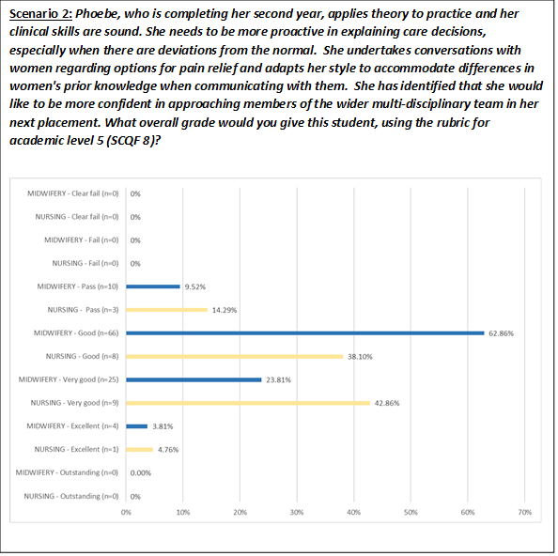
Figure 4: Comparison between midwifery and nursing: Scenario 2 - Phoebe

The majority of participants aligned with the grade intended in the three scenarios for levels 4-6 (SCQF 7-9), demonstrating a good level of validity and inter-assessor reliability overall. Challenges were, however, evident in assessing ‘Alba’ at masters level (level 7; SCQF 10/11), with a wider range of grades being awarded (Figure 5). It was concerning that 11 (19.64%) midwifery students failed to fail student ‘Grace’ at the end of her third and final year (level 6; SCQF 9), despite it being evident that her practice did not meet requirements and was clearly unsafe; one midwifery academic also passed her. ‘Grace’ was, however, failed by 88.57% midwifery and 85.71% nursing participants (Figure 6).
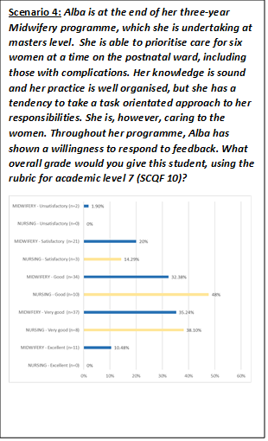
Scenario 3: In her final placement Grace, a third-year student, has forgotten to listen to the fetal heart when admitting women in labour on three separate occasions. The mentor, Tim, has had to remind Grace to undertake this care. On one occasion Grace had not anticipated birth despite changes in the woman's behaviour, and this resulted in a formal complaint. This has made Tim hesitant to leave Grace unsupervised with women. Tim does, however, note that Grace is always kind and compassionate to the women and works well within the team. What overall grade would you give this student, using the rubric for academic level 6 (SCQF 9)?
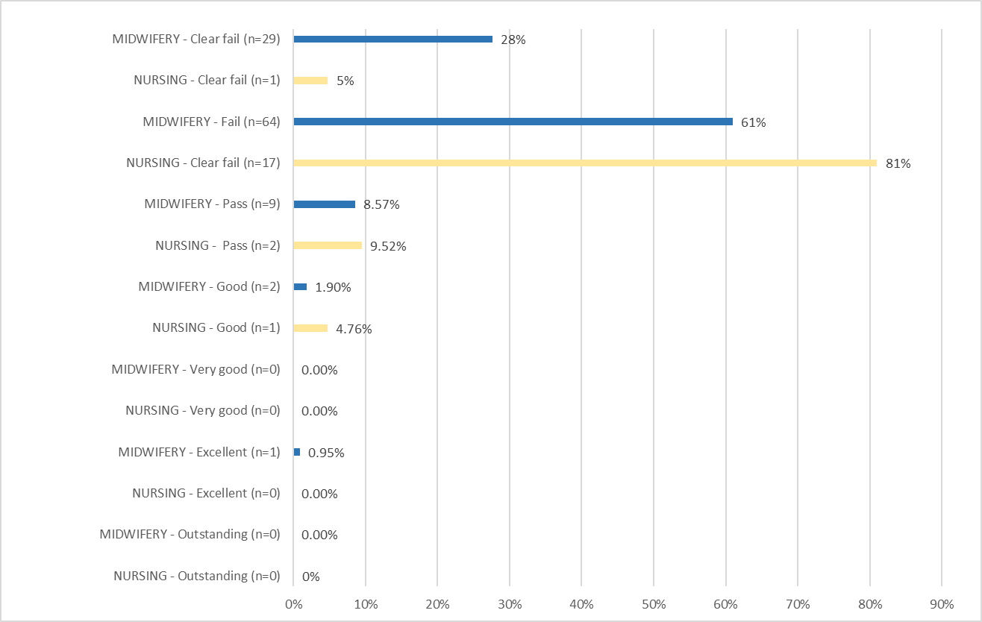

Figure 5: Alba Figure 6: Grace

Findings suggested that grading using the Rubrics could be fairly reliable, even if the assessor had not worked with the student – noting that the scenarios were hypothetical. The distribution of grades was similar in both midwifery and nursing, supporting the potential for other professions to contribute to assessment.

Responses were predominantly positive about the potential for the Rubrics to be used in both midwifery and nursing (see Table 6), particularly their scope for transferability across all institutions or programmes (73.33% midwifery and 71.43% nursing participants).
Potential use of Rubrics… | MIDWIFERY (n=134) |  |  | NURSING (n=36)
 | Yes | Maybe | No | Yes | Maybe | No
As a ‘stand-alone’ practice assessment tool | 45.71% | 35.24% | 19.05% | 52.38% | 28.57% | 19.05%
In combination with existing tool | 65.71% | 26.67% | 7.62% | 66.67% | 28.57% | 4.76%
Across all institutions or programmes | 73.33% | 20% | 2.86% | 71.43% | 1.90% | 0.95%

Table 6: Comparison between midwifery and nursing: Potential use of Rubrics

Participants again expressed an interest in introducing national assessment tools for midwifery and nursing, and positive comments were made about the potential for the Lexicon Frameworks and Rubrics to contribute to these:
“I think that standardisation of the marking procedure is vital. I’m currently on placement in a hospital that takes students from other institutions, and the difference between how we are graded is significant.” (SM37)
“I would be in favour of a standardised national approach to practice assessment and grading as there are so many models and approaches in use that I feel consistency would be beneficial to the profession and hopefully it could be evaluated more easily to ensure that the tool is robust and valid.” (RMA1)
“Both the Rubric and Lexicon Framework appear simple to engage with and would assist in providing more detailed assessments of individual’s practice. I would be happy if my University used these, and ideally it would/ could be used nationally in order to obtain more reliable and valid feedback on individual’s practice.” (SN2)

Suggestions to improve the Rubrics were similar to those for the Lexicon Frameworks, along with practicalities in presentation and guidance on grading when performance fell across different level descriptors for the elements being assessed.

4.6 Additional comments:
Comments reinforced previous themes and sub-themes. The ‘Purpose of assessment’ and appetite for ‘Standardisation’ were particularly apparent. Some comments focused on the proposed tools, while others were more generic.

Most participants were in favour of grading practice, but it was highlighted that its pitfalls could outweigh its advantages and it was important not to become fixated on the grade itself. It was clear that there was a need for explicit assessment tools for which mentors are trained.

The importance of ‘learning’ was emphasised, with both students and mentors needing to understand and recognise performance and achievement in practice.

5. DISCUSSION AND PROJECT OUTPUTS

5.1 Enhancing the rigour of practice assessment:
Engagement of key stakeholders in the development of practice assessment tools and documentation is clearly essential. The views of clinicians or students differed from those of academics in a number of questions; for example, clinicians and students appeared to have a clearer understanding and greater appreciation of the potential for the Lexicon Frameworks to be used to document evidence in practice, while academics seemed less sure about their purpose, although acknowledging that they would be useful when developing new programmes. Similarly, both clinicians and students highlighted the importance of clear wording, whereas academics focused on the need for preparation of those assessing practice. It was interesting that clinicians seemed most positive about the reliability and validity of existing assessment tools, as the people using these in practice. The views of all stakeholders should be considered to avoid assumptions being made on behalf of other groups.

It was significant that the highest ranked factor was to “objectively assess the student’s performance in relation to knowledge, skills and personal attributes in the context of professional behaviour against set criteria, rather than just a subjective judgement of the individual”. The theme of ‘Human factors’ was strong, and the mentor-student relationship could constrain reliability of assessment:
“Some mentors are more harsh when grading students than others. Other mentors have also known some student midwives from when they were maternity assistants and have socialised with them outside of work, they have been known to grade these students very well, and I am not sure whether those students would have received the same grading from a different mentor who they did not know well.” (SM41)

Importantly, participants were responding to hypothetical midwifery scenarios, measured against a criterion-referenced grid; the subjectivity of personalities who knew each other (i.e.: the ‘individual’) was therefore removed. Although a good level of inter-assessor reliability was demonstrated in most of the scenarios, it was interesting that grading by nursing participants was generally more accurate than midwifery. Lack of familiarity with the professional and programme requirements may have enabled nursing participants to be more objective in their measurement of ‘performance’ of the students against the set criteria in the Rubrics. This suggests that involvement of other professionals in contributing to the evidence, as required in the new education standards (NMC 2018b; 2018c), may promote greater reliability in practice assessment in the future. Similarly, separation of the role of mentor into ‘practice supervisor’ and ‘practice assessor’ will mean that those assessing students may not spend as much time working together, thus potentially improving reliability by reducing the impact of ‘Human factors’.

Clear sets of statements “linked to specific grades/ descriptors/ symbols indicating level of performance” were ranked second highest overall and in midwifery (Table 5), justifying introduction of both the Lexicon Frameworks and Rubrics. This aligned with the earlier phases of our project (Authors, 2017a; 2017b) as well as the wider literature which recommends the use of rubrics to enhance reliability and reduce grade inflation (Donaldson and Gray, 2012;Maxted et al, 2004).

Our findings corroborated other research that grading of practice continues to bring both benefits and challenges (Cassidy, 2008; Chenery-Morris, 2014; Doughty et al, 2007; Fisher et al, 2011; Gray and Donaldson, 2009; Heaslip and Scammell, 2012; Johnson, 2008; Oermann et al, 2009; Smith, 2007). Some of the more negative midwifery responses may have reflected concerns about the robustness and fairness of the mandatory grading process in this profession, whereas nursing participants’ greater preference for grading might have been due to the absence of this as an NMC requirement (NMC, 2010; 2018a). The tendency towards grade inflation highlighted in this and other literature (Donaldson and Gray, 2012; Paskausky and Simonelle, 2014; Seldomridge and Walsh, 2006) may be advantageous towards students’ academic profiles but can also be perceived as a negative outcome, reflecting the inconsistencies of individuals and tools. Some participants indicated a preference for pass or refer, although descriptors were deemed valuable in indicating levels of performance, identifying gaps and guiding students’ learning.

The appetite for national ‘Standardisation’ in professional practice assessment was demonstrated across all categories of participants, reinforcing views of the LMEs as well as findings in the wider literature that this would contribute to enhanced rigour of assessment (Authors, 2017a; Cassidy, 2008; Donaldson and Gray, 2012; Gillman, 2014; Maxted et al, 2004). A national tool has been developed for physiotherapy in Australia and New Zealand (Dalton et al, 2009). In the UK, common assessment tools have been developed for midwifery across six sites in Yorkshire and Humberside, and ‘PAN London’ tools are used by eight universities and their practice partners in London (Authors, 2017a; Gillman, 2014); further regional tools are being developed in nursing since publication of the new standards. A number of positive comments were made about the potential for our tools to be transferable across both midwifery and nursing professions and in all categories of participants.

5.2 Development of a conceptual model:
An ‘Evidence Based Model for Professional Practice Assessment’ (Figure 7) was developed to demonstrate the inter-relationship between the themes and sub-themes which emerged (Table 4). This puts the ‘Purpose of assessment’ as central, surrounded by factors which contribute to robust and reliable assessment, but mindful of the ‘Human factors’ and ‘Other factors’ which may have a negative impact.

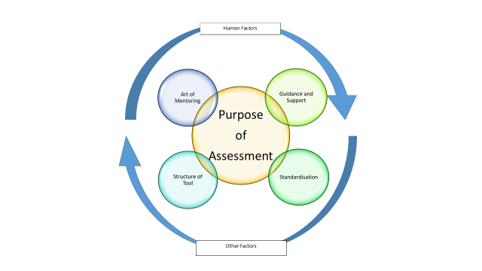

Figure 7: An Evidence Based Model for Professional Practice Assessment

Our study has highlighted that grading tools are very challenging to create. Even if the ‘Structure of the tool’ appears valid, reliability remains an issue. ‘Human factors’ of ‘subjectivity’ and varied ‘personal interpretation’ may compromise reliability and validity, and the ‘mentor-student relationship’ is significant.

The ‘Art of mentoring’ requires ‘understanding’ and correct ‘application’ of the assessment tool and process, with ‘accountability’ a vital aspect of the role. To achieve this, ‘Ongoing guidance and support of the assessor’ is needed.

‘Other factors’ also influence robust and reliable assessment. Although ‘involvement of others’ was generally seen to be beneficial, this could also compromise consistency. Other ‘constraints’ included staffing levels, time together for mentor and student or opportunity for academics to support those responsible for assessment.

Participants in our study were very clear that they wanted greater ‘consistency’, and there was a real appetite for ‘Standardisation’ to enhance quality and reliability of practice assessment. Our proposed tools demonstrated some potential for ‘transferability’.

The ‘Purpose of assessment’ became increasingly important as our study progressed. It was evident that grading of practice – however that may be defined – needs to be part of a meaningful process, and not an end-point in itself. It was clear that ‘learning’ was essential, and that any form of grading should clearly indicate gaps in students’ performance and provide guidance on how to improve this. Fixation on the grade itself should be avoided.

5.3 Strengths and limitations of our study:
A number of respondents only completed the section on demographic information. It is assumed that they did not keep both the survey and website documents open (as per instructions) and therefore exited the survey before these sections could be completed. Exclusion of these participants ensured that the data presented were accurate and meaningful.

Although participant numbers were lower than had been hoped for a national survey, proportions of stakeholder groups were generally representative of the number of institutions delivering pre-registration midwifery programmes in each country. Nearly four times as many midwifery participants responded than nursing, which was understandable due to the title and focus of the survey. Similar proportions of academics and students participated in each of these professions, facilitating descriptive analytical comparisons, although the lower numbers in nursing resulted in a greater impact on percentages (Faber and Fonseca, 2014). The trends when highlighting commonalities and differences were considered more important than the statistics themselves, however. Qualitative components enhanced the findings, with consistency in many of the comments and suggestions strengthening the evidence base as well as facilitating future modification of the assessment tools.

Representation from 20 universities meant that a wide range of experiences of different assessment tools and approaches was reflected. This, as well as inclusion of key stakeholders, enabled some generalisability of findings. Involvement of nursing participants provided objectivity and broadened application.

Despite the average survey completion time of only 14 minutes, participants were clearly thoughtful about their decisions and comments. They were able to evaluate the Lexicon Frameworks and Rubrics within this time-frame, and to demonstrate application of the latter through completion of the scenario assessments. This suggests that the tools were readily understood, increasing transferability.

5.4 Recommended key principles for assessing practice:
The project team recommends the key principles shown in Table 7 for assessing practice, based on the results of this survey.

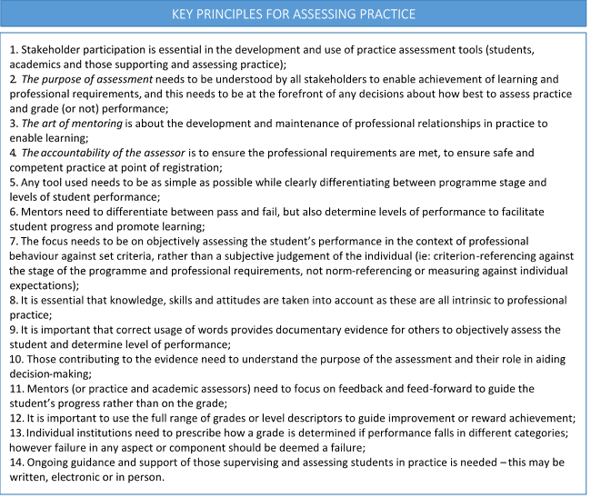

Table 7: Key principles for assessing practice

5.5 Practice Assessment Toolkit:
The project team is in the process of developing a ‘Practice Assessment Toolkit’, including modified Lexicon Frameworks and Rubrics as well as the key principles and model. This is designed to be used flexibly across midwifery programmes, and may be of particular value to teams developing practice assessment tools or individuals providing evidence of student performance – whether the student themselves, their assessor or those contributing to the evidence towards decision-making. The toolkit will enable adaptation to current or future professional requirements, institutional preferences and any approach to awarding specific grades or indicating levels of performance. On completion, it will be uploaded to the project website, which has open access (LME-UK Executive, 2018). Our resources will enable versatility while following common principles of practice assessment, with scope for transferability to other professions or countries.

5.6 Future research:
- It is intended to evaluate use of the ‘Practice Assessment Toolkit’ and application of its constituent elements after the new NMC standards have been implemented across the UK.
- It is recommended that research into the assessment of midwifery practice at masters level is undertaken. This could include the challenges and benefits, how this is defined and differentiated from undergraduate expectations and best educational management.

6. CONCLUSIONS

The results from our survey not only comprehensively covered grading of practice in midwifery at national level, but built on general literature around practice assessment. We have also developed an evidence based model and set of key principles for assessing practice.

We have produced a set of tools which provide consistency in terminology relating to assessment of levels of performance in practice. They have demonstrated potential for recording evidence to support a mentor’s decision or student’s self-assessment, as the main tool for grading or when developing a practice assessment document for a new pre-registration programme. They may be used as the basis for a standardised approach in midwifery which could be modified to align with professional body or institutional requirements. It has also been suggested that they would have the potential to be transferable to nursing. Our findings may therefore contribute to the new pre-registration midwifery education standards and influence programme development across higher education institutions in the UK and beyond.

REFERENCES

Australian Nursing and Midwifery Accreditation Council, 2014. Midwife Accreditation Standards 2014. ANMAC, Canberra. https://www.anmac.org.au/standards-and-review/midwife (accessed 22/9/18)

AUTHORS, 2017a. A scoping study to explore the application and impact of grading practice in pre-registration Midwifery programmes across the United Kingdom. Nurse Education in Practice, 24, p99-105 http://doi.org/10.1016/j.nepr.2016.01.007

AUTHORS, 2017b. Core principles to reduce current variations that exist in grading of Midwifery practice in the United Kingdom. Nurse Education in Practice. 3 (March), p54-60 http://dx.doi.org/10.1016/j.nepr.2017.02.006

AUTHORS, 2018. National Grading of Practice in Pre-registration Midwifery Project: Report on final phase on-line survey (Phase 3). United Kingdom: LME-UK Executive. https://www.plymouth.ac.uk/research/national-grading-of-practice-in-pre-registration-midwifery-project (accessed 22/9/18)

Cassidy, S., 2008. Subjectivity and the valid assessment of pre-registration nurse clinical learning outcomes: Implications for mentors. Nurse Education Today 29 (1), 33-39.

Chenery-Morris, S., 2014. Exploring students’ and mentors’ experiences of grading Midwifery practice. Evidence Based Midwifery 12(3), 101-106. https://www.rcm.org.uk/sites/default/files/EBM%20101-106_0.pdf (accessed 22/9/18)

Dalton, M., Keating, J. and Davidson, M., 2009. Development of the Assessment of Physiotherapy Practice (APP): A standardised and valid approach to assessment of clinical competence in physiotherapy. Australian Learning and Teaching Council (ALTC) Final report.

Donaldson, J. and Gray, M., 2012. Systematic review of grading practice: is there evidence of grade inflation? Nurse Education in Practice 12(2), 101-114. https://www.nurseeducationinpractice.com/article/S1471-5953(11)00156-9/abstract?code=ynepr-site (accessed 22/9/18)

Doughty, R., Harris, T. and McLean, M., 2007. Tripartite assessment of learners during practice placements in Midwifery pre registration programmes. Education and Training 49(3), 227-235. https://www.emeraldinsight.com/doi/abs/10.1108/00400910710749369 (accessed 22/9/18)

European Parliament, Council of the European Union, 2005. Directive 2005/36/EC of the European Parliament and of the Council, Section 6: Midwives. http://eur-lex.europa.eu/legal-content/EN/TXT/?uri=celex:32005L0036 (accessed 22/9/18)

Faber, J. and Fonseca, L.M., 2014. How sample size influences research outcomes. Dental Press Journal of Orthodontics, 19 (4), 27-29. https://www.ncbi.nlm.nih.gov/pmc/articles/PMC4296634/ (accessed 22/9/18)

Feinberg, J., 2014. WordleTM. http://www.wordle.net/create (accessed 22/9/18)

Finley, R. and Finley, C., 1999. SurveyMonkey. SurveyMonkey.com https://www.surveymonkey.co.uk/ (accessed 22/9/18)

Fisher, M., Proctor-Childs, T., Callaghan, L., Stone, A., Snell, K. and Craig, L., 2011. Assessment of Professional Practice: Perceptions and Principles, in: Wergers, C.E. (Ed), Nursing Students and their Concerns. Nova Science Publishers, New York, pp.1-36. https://www.novapublishers.com/catalog/product_info.php?products_id=22965 (accessed 22/9/18)

Gillman, L., 2014. Grading clinical practice in Midwifery, the opportunities and challenges. Maternity, Mother and Baby: Caring through the Science and Art of Midwifery Conference, London.

Gray, M. A. and Donaldson, J., 2009. Exploring issues in the use of grading in practice; literature review. Edinburgh Napier University, Edinburgh.

Green, K.C., Armstrong, J.S. and Graefe, A., 2007. Methods to Elicit Forecasts from Groups: Delphi and Prediction Markets Compared. Munich Personal RePEc Archive. https://repository.upenn.edu/cgi/viewcontent.cgi?article=1168&context=marketing_papers (accessed 22/9/18)

Health Research Authority, 2018. Integrated Research Application System. [Online], Available: https://www.myresearchproject.org.uk/ (accessed 22/9/18)

Heaslip, V. and Scammell, J.M.E., 2012. Failing underperforming students: The role of grading in practice assessment. Nurse Education in Practice 12(2), 95-100. https://www.nurseeducationinpractice.com/article/S1471-5953(11)00144-2/abstract (accessed 22/9/18)

International Confederation of Midwives, 2013. Global Standards for Midwifery Education (2010) Amended 2013. https://internationalmidwives.org/assets/uploads/documents/CoreDocuments/ICM%20Standards%20Guidelines_ammended2013.pdf (accessed 22/9/18)

Johnson, M., 2008. Grading in competence based qualifications – is it desirable and how might it affect validity? Journal of Further and Higher Education 32 (2), 173-184.

Lauder, W., Watson, R., Holland, K., Roxburgh, M., Topping, K., 2008. The national evaluation of fitness for practice curricula: self-efficacy, support, and self-reported competence in pre-registration student nurses and midwives. Journal of Clinical Nursing 17, 1858-1867. https://onlinelibrary.wiley.com/doi/full/10.1111/j.1365-2702.2007.02223.x

LME-UK Executive, 2018. National ‘Grading of Practice in Pre-registration Midwifery’ project. University of Plymouth. https://www.plymouth.ac.uk/research/national-grading-of-practice-in-pre-registration-midwifery-project (accessed 22/9/18)

Mallik, M. and McGowan, B., 2007. Issues in practice based learning in Nursing in the United Kingdom and the Republic of Ireland: Results from a multi professional scoping exercise. Nurse Education Today 27(1), 52-59. https://www.nurseeducationtoday.com/article/S0260-6917(06)00033-5/abstract (accessed 22/9/18)

Maxted, M., Grant, J., Wooding, K. and Norcini, J., 2004. Assessing Healthcare Students in Practice Placements: An overview of the Literature. Association for the Study of Medical Education (ASME), Edinburgh.

Midwifery Council of New Zealand (accessed 2018) What does it take to qualify as a midwife. https://www.Midwiferycouncil.health.nz/professional-standards/what-does-it-take-qualify-midwife (accessed 22/9/18)

Nursing and Midwifery Council, 2008. Standards to support learning and assessment in practice. Nursing and Midwifery Council, London. http://www.nmc-uk.org/Documents/NMC-Publications/NMC-Standards-to-support-learning-assessment.pdf (accessed 22/9/18)

Nursing and Midwifery Council, 2009. Standards for pre-registration Midwifery education. Nursing and Midwifery Council, London. https://www.nmc.org.uk/globalassets/sitedocuments/standards/nmc-standards-for-preregistration-midwifery-education.pdf (accessed 22/9/18)

Nursing and Midwifery Council, 2010. Standards for pre-registration Nursing education. Nursing and Midwifery Council, London. https://www.nmc.org.uk/standards/additional-standards/standards-for-pre-registration-Nursing-education/ (accessed 22/9/18)

Nursing and Midwifery Council, 2017a. The role of lead midwives for education. Nursing and Midwifery Council, London. https://www.nmc.org.uk/education/lead-Midwifery-educators/the-role-of-lead-midwives-for-education/ (accessed 22/9/18)

Nursing and Midwifery Council, 2017b. Reshaping the future of Midwifery education in the UK. Nursing and Midwifery Council, London. https://www.nmc.org.uk/standards/Midwifery/education/ (accessed 22/9/18)

Nursing and Midwifery Council, 2018a. Part 3: Standards for pre-registration Nursing programmes. Nursing and Midwifery Council, London. https://www.nmc.org.uk/standards/standards-for-nurses/standards-for-pre-registration-Nursing-programmes/ (accessed 22/9/18)

Nursing and Midwifery Council, 2018b. Part 1: Standards framework for Nursing and Midwifery education. Nursing and Midwifery Council, London. https://www.nmc.org.uk/standards-for-education-and-training/standards-framework-for-Nursing-and-Midwifery-education/ (accessed 22/9/18)

Nursing and Midwifery Council, 2018c. Part 2: Standards for student supervision and assessment. Nursing and Midwifery Council, London. https://www.nmc.org.uk/standards-for-education-and-training/standards-for-student-supervision-and-assessment/ (accessed 22/9/18)

O’Brien, R., 1998. An Overview of the Methodological Approach of Action Research. http://www.web.ca/~robrien/papers/arfinal.html#_edn1 (accessed 22/9/18)

Oermann, M., Saewert, K., Charasika, M., and Yarbourgh, S., 2009. Assessment and grading practices in Schools of Nursing: National Survey Findings Part 1. Nursing Education Perspectives 30 (5), 274-278.

Paskausky, A., Simonelle, M., 2014. Measuring grade inflation: A clinical grade discrepancy score. Nurse Education in Practice, 374-379. https://www.nurseeducationinpractice.com/article/S1471-5953(14)00014-6/abstract?code=ynepr-site (accessed 22/9/18)

QAA, 2014. The Frameworks for Higher Education Qualifications of UK Degree-Awarding Bodies. UK Quality Code for Higher Education – Part A: Setting and Maintaining Academic Standards. Gloucester: The Quality Assurance Agency for Higher Education. file:///C:/Users/mfisher/Downloads/qualifications-frameworks.pdf (accessed 22/9/18)

Seldomridge, L., Walsh, C., 2006. Evaluating student performance in undergraduate preceptorships. Journal of Nursing Education 45 (5), 169-176.

Smith, J., 2007. Assessing and grading students’ clinical practice: midwives’ lived experience. Evidence Based Midwifery 5 (4), 112-118. http://go.galegroup.com/ps/anonymous?id=GALE%7CA172050738&sid=googleScholar&v=2.1&it=r&linkaccess=fulltext&issn=14794489&p=AONE&sw=w&authCount=1&isAnonymousEntry=true (accessed 22/9/18)

Word Counter, 2017. Word Counter – Word Count Tool. https://wordcounttools.com/ (accessed 22/9/18)

World Health Organisation, 2009. Global standards for the initial education of professional nurses and midwives. WHO, Geneva. www.who.int/hrh/Nursing_Midwifery/hrh_global_standards_education.pdf (accessed 22/9/18)

