**Flexibility, variability and constraint in energy management patterns across vertebrate taxa revealed by long-term heart rate measurements**

Halsey LG*, Green JA, Twiss SD, Arnold W, Burthe SJ, Butler PJ, Cooke SJ, Grémillet D, Ruf T, Hicks O, Minta KJ, Prystay TS, Wascher CAF, Careau V

*l.halsey@roehampton.ac.uk

Keywords: annual cycle, eco-physiology, energy management, energetics, heart rate, metabolic rate

**Running headline:**

Energy management patterns of vertebrates

**Summary**

1. Animals are expected to be judicious in the use of the energy they gain due to the costs and limits associated with its intake. The management of energy expenditure (EE) exhibited by animals has previously been considered in terms of three patterns: the constrained, independent and performance patterns of energy management. These patterns can be interpreted by regressing daily EE against maintenance EE measured over extended periods. From the multiple studies on this topic, there is equivocal evidence about the existence of universal patterns in certain aspects of energy management.
2. The implicit assumption that animals exhibit specifically one of three discrete energy management patterns, and without variation, seems simplistic. We suggest that animals can exhibit gradations of different energy management patterns and that the exact pattern will fluctuate as their environmental context changes.
3. To investigate these ideas, and for possible large-scale patterns in energy management pattern, we analysed long-term heart rate data – a strong proxy for EE – across and within individuals in 16 species of birds, mammals, and fish.
4. Our analyses of 292 individuals representing 46 539 observation-days suggest that vertebrates typically exhibit predominantly the independent or performance energy patterns at the across-individual level, and that the pattern does not associate with taxonomic group. Within individuals, however, animals generally exhibit some degree of energy constraint. Together, these findings indicate that across diverse species, some individuals supply more energy to all aspects of their life than do others, however all individuals must trade-off deployment of their available energy between competing functions. This demonstrates that within-individual analyses are essential for interpretation of energy management patterns.
5. We also found that species do not necessarily exhibit a fixed energy management pattern but rather temporal variation in their energy management over the year. Animals’ energy management exhibited stronger energy constraint during periods of higher EE, which typically coincided with clear and key life cycle events such as reproduction, suggesting an adaptive plasticity to respond to fluctuating energy demands.

**Introduction**

Every biological process of an organism costs energy and animals are therefore limited in their actions by their energy throughput; the amount of energy they consume and use. The limit on their energy throughput may be due to finite food availability in the environment (Stearns 1992; Thomas *et al.* 2001; McNab 2002), or inherent limitations in their capacity to accumulate energy in terms of harvesting, digesting or assimilating it (Drent & Daan 1980; Hammond & Diamond 1997; West, Brown & Enquist 1999; Gearty, McClain & Payne 2018) (fig. 1). Alternatively, animals may have a ceiling on their rate of energy expenditure, perhaps due to limited musculature (Hammond & Diamond 1997), or in order to avoid physiological damage (Piersma 2011) due to, for example, hyperthermia (Speakman & Krol 2010; Nilsson & Nord 2018). Furthermore, energy throughput may be optimised in animals, and any increase in throughput could have fitness consequences such as increased risk of mortality (Daan, Deerenberg & Dijkstra 1996; Santos & Nakagawa 2012), perhaps due to immune suppression (Pontzer 2018) or oxidative stress (Costantini, Dell'Ariccia & Lipp 2008). Although there have been a number of studies about energy management (e.g. Daan, Masman & Groenewold 1990; Ricklefs, Kornazewski & Daan 1996; Pontzer 2015; Portugal *et al.* 2016), the resultant observations have not formed a coherent picture and we presently lack an understanding of whether there are governing principles operating across taxa. It seems possible then that the limiter on an animal’s energy throughput probably varies between species and may vary within species and individuals, across their life histories and seasonally (Speakman & Krol 2010; Careau *et al.* 2013)

*Patterns of energy management*

As previously proposed (e.g. Ricklefs, Kornazewski & Daan 1996), we can consider an animal’s management of energy expenditure in terms of two broad sets of processes. The first broad category includes energy spent on ‘maintenance’ processes required to maintain homeostasis [which can include respiration (Codd *et al.* 2005), immuno-competency (Deerenberg *et al.* 1997), blood circulation, nerve function, thermoregulation (Lewden *et al.* 2017), digestion (Secor 2009), reproductive physiology (Perrigo & Bronson 1983; Perrigo 1987; Ellison 2003; Wiersma & Verhulst 2005), protein turnover (Yu *et al.* 1999) and somatic repair more broadly (Wiersma & Verhulst 2005)]. The second broad category includes energy spent directly on auxiliary processes, which have typically been termed ‘activity’ and assumed to constitute solely active behaviours such as locomotion, mate competition and parental care (Ricklefs, Kornazewski & Daan 1996; Halsey *et al.* 2015; Careau 2017), but can also include inactive behaviours such as maintaining a posture (Levine, Schleusner & Jensen 2000; Ward, Speakman & Slater 2003) and fidgeting (Levine, Eberhardt & Jensen 1999), (see the Supplementary for more information). Presently, the literature recognises three possible models of energy management patterns that animals could follow (Careau & Garland Jr 2015; Mathot & Dingemanse 2015; Careau 2017). The pattern that is often the default assumption of how energy is managed in animals is that the amount of energy spent on activity is not related to the amount of energy spent on maintenance processes. In this ‘independent’ pattern of energy management (Careau & Garland Jr. 2012) overall energy expenditure is not restricted and increases in energy spent on activity do not require a compensatory decrease in energy spent on maintenance. This management pattern is represented by positive, unitary (slope ~ 1) covariation between overall and maintenance energy expenditure (Mathot & Dingemanse 2015) (fig. 2A). Alternatively, an animal could be constrained to maintain its overall energy expenditure within a narrow range (Pontzer 2015), in which case any increase in activity or other auxiliary processes (resulting in increased energy expenditure) must be countered by a decrease in maintenance energy expenditure (Deerenberg *et al.* 1998; Welcker *et al.* 2014) or, vice-versa, increased maintenance necessitates decreases in auxillliary processes. This energy management pattern is termed the ‘constrained’ pattern (Pontzer 2015) and is defined by a lack of covariation between an animal’s overall energy expenditure (often measured as daily energy expenditure) and its maintenance energy expenditure over time (Careau 2017) (fig. 2B). The third energy management pattern, which also does not restrain overall energy expenditure, is defined by an intrinsic link between auxiliary and maintenance energy expenditure, such that an increase in one is associated with an increase in the other: the ‘performance’ pattern of energy management (Careau *et al.* 2008). This can arise when sustaining high levels of activity requires subsequent physical and/or physiological recovery. Alternatively, animals becoming more active may require costly digestive organs to assimilate, and/or increased muscularity to expend, the extra energy associated with that activity (Swanson, McKechnie & Vézina 2017; Yap *et al.* 2017). Consequently, this management pattern is represented by positive covariation between overall and maintenance energy expenditure with a slope gradient greater than 1 (Mathot & Dingemanse 2015) (fig. 2C).

Different energy management patterns may be preferable in different scenarios, although studies to date have not formerly investigated such context-dependency. Animals exhibiting high levels of activity during periods of food scarcity might in particular benefit from reducing maintenance energy expenditure - the constrained pattern - because this approach would prevent their overall energy requirements from increasing, which may enhance survivability. For example, mice exposed to a food shortage, and obliged to work for that food, respond by daily torpor (Hut *et al.* 2011). By contrast, energy expenditure represented by the independent pattern in this scenario would cause an increase in overall energy requirements coinciding with periods when starvation risk is highest (Pontzer 2015). The constrained pattern might also prove advantageous when food is abundant but predation risk is high, because limiting energy requirements would reduce the need to forage, in turn limiting exposure to predators (Mathot *et al.* 2016).

In some situations, however, an uncoupling of the energy expenditure of different organ systems and thus removing constraints on overall energy expenditure (the independent pattern) might be advantageous, providing the animal with energetic flexibility to respond to their changing ecology or life history. While eider ducks are moulting, their cost of feather production appears to increase their maintenance metabolic rate while their activity energy costs remain unchanged (Guillemette & Butler 2012). During periods when food availability is predictably high and an enhanced physical state is required, such as in king penguins foraging at sea after a fast (Gauthier-Clerc *et al.* 2002), animals may benefit from a pattern of energy expenditure described by the performance pattern of energy management. They could take advantage of the copious energy supplies to augment their physical capacity for foraging and to rebuild their fat stores, during which they are expending increased amounts of energy on activity and other auxiliary processes, and also on maintenance energy expenditure due to their increase in body mass, digestive organs, and muscle volume.

The energy management patterns adopted by animals have typically been assessed by looking at the phenotypic correlation between overall and maintenance metabolic rates across individuals (Fyhn *et al.* 2001; Tieleman *et al.* 2008; Careau *et al.* 2013; Portugal *et al.* 2016), resulting in varying conclusions. Fyhn et al. (2001) reported that a population of kittiwakes *Rissa tridactyla* exhibited no correlation between their maintenance and overall metabolic rates, indicating they followed the independent pattern of energy management, while Tieleman et al. (2008) found that maintenance and overall metabolic rates positively correlated in the house wren *Troglodytes aedon*. Across-individual analyses are complicated by the fact that metabolic rates vary as much within individuals as across individuals, as indicated by only moderate repeatability (White, Schimpf & Matthews 2013). Hence, the phenotypic correlation between overall and maintenance metabolic rates can be shaped by processes occurring at both the across- and within-individual levels (Dingemanse & Dochtermann 2013). Investigating the correlation at both these levels is therefore required to fully interpret the covariation present (Careau & Wilson 2017). The across- and within-individual levels of analysis explore different, though related, biological questions: at the across-individuals level we are asking whether individuals that, on average, have high overall energy expenditure also have, on average, higher maintenance energy expenditure. By contrast, at the within-individual level we are asking whether an individual’s changes in overall energy expenditure are correlated with its changes in maintenance energy expenditure.

*Energy management patterns as a fluctuating continuum*

Previous studies considering energy management patterns, including a recent review of those studies by Mathot and Dingemanse (2015), and subsequent single- and multi-species studies (Portugal *et al.* 2016; Careau 2017), have implicitly assumed that species or individuals consistently exhibit one of the patterns discretely. However, there is no reason to suppose that the energy management pattern adopted should be exactly the constraint pattern or exactly the independent pattern, nor that the pattern should be consistent over time. It is more likely that patterns of energy expenditure will typically indicate a blend of patterns. Fig. 3 illustrates how the presence of a threshold constraint on an animal’s energy throughput (such as food intake) could drive the pattern of energy expenditure to be that of a degree of energy constraint (slope =0) when the threshold is consistently being reached or alternatively more predominantly the independent pattern (slope =1) when the threshold is consistently not being reached. In turn, animals that reach this threshold sometimes but not always would have an average slope value less than 1, but not 0, indicating partial constraint of their energy expenditure.

One of the main limitations to testing whether energy management patterns differ at the across- vs within-individual levels, and over time, is that repeated measures of both overall and maintenance energy expenditure must be obtained in multiple individuals. A viable method for obtaining such data is through the biologging of heart rate (*f*H). Heart rate is a robust proxy of metabolic rate, the two positively correlating in every endothermic species and most ectothermic species (cf. Thorarensen, Gallaugher & Farrell 1996) examined to date (Green 2011), in accordance with Fick’s (1870) principle of convection within the cardiovascular system. Accordingly, Portugal et al. (2016) demonstrated that for multiple bird species, for which metabolic rate-*f*H calibrations are available, assessment of energy management patterns does not change when based on metabolic rate estimates compared to *f*H measures. Consequently, *f*H measures can be analysed to investigate the energy management patterns of those animals, where daily mean *f*H represents daily energy expenditure and daily minimum *f*H represents (daily) maintenance energy expenditure. Auxiliary energy expenditure is represented by the difference between daily mean *f*H and daily minimum *f*H.

We assembled a dataset that included a total of 46 539 observation-days on 292 individuals of 16 species of free-ranging birds and mammals, including humans, and also an ectothermic fish species. Such a dataset allowed us to investigate a number of key questions about energy management patterns in free-ranging vertebrates, including:

1. Do the patterns of energy management differ between species and taxonomic groups?
2. Are there systematic differences in energy management patterns between the across- and within-individual levels?
3. Within species, is there variation in the patterns of energy management over time and can this be explained by their daily energy expenditure or ecology?

**Methods**

The current analysis includes heart rate (*f*H)datasets from 9 bird (all water birds), 6 mammal and 1 fish species performing a range of natural behaviours and locomotion modes (Table 1). Some of these datasets have been reported elsewhere; for details of the devices used to measure *f*H and the data collection protocols refer to the citations in Table 1. For most of the species included in our analyses, heart rate was obtained from electrocardiography. For alpine ibex and the red deer in dataset 1, however, heart rate was determined from an accelerometer located in the reticulum, which accurately recorded heart rate when the instrumented animal was stationary and during relatively gentle activity (Signer *et al.* 2010). During high levels of activity, heart rate was not discernible in the recorded acceleration data due to signal noise. However, the accelerometer did successfully record the elevated heart rates of the animals immediately after activity. Heart rate measurements for red deer dataset 2 were obtained from electrocardiograms and had a range (~35 to 85 beats min-1) similar to that of red deer dataset 1 (~35 to 75 beats min-1). The dataset for roe deer also included activity count data that we analyse here (see Supplementary). The datasets for human beings *Homo sapiens*, grey seals *Halichoerus grypus*, and sockeye salmon *Oncorhynchus nerka* have not been published previously; see Supplementary for details of the methods of data collection for these species.

*Calculating variables for analysis*

Daily mean *f*H was calculated for each 24-h period for each individual of every species. Minimum daily *f*H was determined by calculating mean *f*H for consecutive short time intervals (2 to 15 min, depending on the study) throughout the 24-h day and selecting the lowest of these values for each day (Portugal *et al.* 2016).

*Statistical analyses*

We assessed the use of alternative energy management patterns by the study species (along the continua between the full constrained and full independent patterns, and the performance patterns) at both the across- and within-individual levels. This was achieved through visual assessment of the slope and 95% confidence intervals of regression between daily mean *f*H against minimum daily *f*H. These regressions were generated from a single mixed model for each species, including individual identity as a random effect to account for the repeated values representing each individual. Daily mean *f*H is very likely to show temporal autocorrelation (Portugal *et al.* 2016), which we accounted for using lme() in R (nlme package) to fit models that included autocorrelation structure in the residuals.

In situations where the within-individual relationship differs from the across-individual relationship, these relationships can be confounded in a standard mixed model (Van de Pol & Wright 2009). We used the within-subject centring approach (Van de Pol & Wright 2009; Dingemanse *et al.* 2010) to distinguish between alternative energy management patterns at the across- and within-individual levels. This involves fitting minimum daily *f*H both as individual means (*xi*) and deviations from individual means (*xij* - *xj*), where *xij* is a daily observation of minimum *f*H *i* from subject *j*. In simple terms, the across-individuals slope (βA) can be obtained by attributing all observations of minimum daily *f*H in a given individual the same average value (*xi*), whereas the within-individual slope (βW) can be obtained by subtracting the subject’s mean value (*xi*) from each observation value (*xij*). Specifically, we analysed *i* daily observations of average *f*H on subject *j* (*y*ij) as:

*yij* = (β0 + *u*0*j*) + βA*xj* + (βw *+* *u*W*j*)(*xij* - *xj*) + *u*W*j + e*0*ij*

where;

* *yij* is the response variable (daily mean *f*H)
* β0 is the fixed effect of the intercept;
* *u*0*j* is a random intercept associated with individual identity;
* βA*xj* is the across-individuals slope fixed effect (βA) associated with deviations from individual means (*xj*);
* βw(*xij* - *xj*) is the within-individual slope fixed effect (βw) associated with deviations from individual means (*xij* - *xj*);
* *u*Wjis the random slope allowing for individual variation in the within-individual slope;
* and *e*0*ij* is a residual error term modelled with an autoregressive function of order 1 with day of the year (time covariate) fitted within individual identity (grouping factor).

Although we were not specifically interested in *u*W*j* (the individual variance in the slope of the within-individual relationship between mean and minimum daily *f*H), allowing individuals to differ in their within-individual slopes is important for properly estimating uncertainty around the population-level within-individual slope (βW) (Schielzeth & Forstmeier 2008). We did not fit a covariance between *u*0*j* and *u*W*j* because the models would not converge in some species where either the random intercepts or slope variance components were close to zero.

The energy management patterns were assessed by plotting the slope of the regression line between daily mean *f*H and minimum daily *f*H, and its 95% confidence interval (CI), on a horizontal, graded box plot (Careau 2017). The fully constrained pattern is represented by slope=0, the fully independent pattern by slope=1 and the performance pattern by slope>1 (Ricklefs, Kornazewski & Daan 1996; Mathot & Dingemanse 2015; Careau 2017). A slope value between 0 and 1 would suggest a degree of both the constrained and independent patterns, i.e. partial compensation of high maintenance or high auxiliary energy expenditure.

To investigate variation in energy management pattern through the annual cycle and how this relates to daily energy expenditure, we explored changes in the across- and within-individual slopes for each month separately, for red deer dataset 1, alpine ibex, and greylag geese. Each of these datasets included a majority of individuals (14 individuals) with >300 d of heart rate data. Linear regressions formally tested whether variation in the monthly within-individual slopes related to monthly means of daily mean *f*H.

While there is of course some degree of inaccuracy in estimating metabolic rate from heart rate, we assume this noise is overwhelmed by the signal of heart rate changes at the scale we are observing in our analyses.

**Results**

In all species except roe deer, there is strong and statistically significant temporal autocorrelation in the residuals at the within-individual level (Supplementary fig.2; Supplementary Table 1). All of the across- and within-individual slope values presented below were extracted from mixed models that accounted for temporal autocorrelation, individual variation in daily mean *f*H (random intercepts), and individual variation in the slope of the relationship between mean and minimum daily *f*H (random slopes).

The estimated across-individuals slopes are supportive of the pattern of predominantly energy independence (slope =1) and energy performance (slope >1) (fig. 4A and Supplementary Table 2A). The species most clearly following a pattern of energy performance rather than independence are barnacle geese, European shags, macaroni penguins, eider ducks, and sockeye salmon. While there are differences in the degree of energy performance between species, visual inspection of fig. 4A suggests no differences in pattern between birds in general and mammals in general, or the fish species. By contrast, the within-individual slopes are usually most supportive of an element of energy constraint (Supplementary Table 2B; fig. 4B), with the slope being <1 in 12 out of 16 species, and the 95% CI overlapping with slope =1 in only 5 species. Again, there are no apparent differences in the degrees of energy constraint between taxa. Some relationships are similar at the across- and within-individual levels, in particular the Przewalski horse (fig. 5A), and to some degree human beings (fig. 5B). For many of the other species, however, the across- and within-individual slopes are clearly different. For example, eider ducks and sockeye salmon have across-individual slopes that are clearly >1 (indicating a degree of performance pattern) but the within-individual slopes are clearly <1 (energy constraint; fig. 5C-D). In general, there is a decrease in the slope value from the across-individual analysis to the within-individual analysis, summarised by the weighted averages (fig. 4A and B; Supplementary Table 2).

Finally, in those species for which year-round data are available for sufficient individuals (red deer, alpine ibex and greylag geese), there is marked variation in the across- and within-individual slopes. This is most notable at the within-individual level for all three species (fig. 6). Linear regression analyses of mean monthly values of daily mean heart rate against monthly within-individual slope values returned statistically significant, negative relationships for all three species (red deer: r2=0.53, P=0.007 ; alpine ibex: r2=0.72, P=0.000 ; greylag geese: r2=0.49, P=0.011; fig. 6) indicating that animals were more likely to be under energetic constraint during months where their daily energy expenditure was higher.

**Discussion**

For most of the 16 species analysed, there is little or no evidence of any constraint on energy expenditure (a slope value <1) across individuals (fig. 4A). The pattern of energy expenditure is either indicative of predominantly the independent pattern of energy management or to some degree the performance pattern of energy management. Moreover, the pattern does not associate with taxonomic group. For those species exhibiting the independent pattern, for example Przewalski horses and humans (fig. 5 A&B), individuals that exhibit a greater maintenance energy expenditure compared to other individuals also show the same increase in daily energy expenditure. For those species exhibiting the performance pattern, for example eider ducks and sockeye salmon (fig. 5 C&D), individuals that expend relatively high amounts of energy daily are doing so due to both a high maintenance energy expenditure and a high auxiliary energy expenditure. By contrast, the within-individual slope value is lower than the across-individual value in nearly all species, and is typically <1 but >0 (fig. 4B). In general, individual animals across a broad range of species exhibit partial constraint of their energy expenditure, whereby daily increases in auxiliary processes are partially compensated for by decreases in maintenance processes and vice-versa. Together, these findings echo the Y-model in life-history theory proposed by van Noordwijk & de Jong (1986), in that in species universally, some individuals have a greater capacity to supply energy to all aspects of their life than do others – they are able to intake, digest and deploy a greater amount of energy than conspecifics. But, nonetheless, for every individual, rate of energy throughput is finite and thus all individuals trade-off deployment of their available energy between competing functions. These findings support the idea that energy management analyses focussed solely at the phenotypic level may miss potentially interesting processes occurring at the among- and within-individual levels (Careau & Garland Jr 2015; Careau & Wilson 2017). Finally, our analyses also demonstrate that the energy management pattern an animal exhibits is not fixed. This variability documents an important aspect of animal plasticity while also providing an opportunity to explore what contexts may influence the pattern employed.

*Fluctuating energy management patterns*

The slope values presented in figs. 4 and 5 are averages over the time of the *f*H recordings (Supplementary Table 2), and as such may mask temporal variation in the energy management pattern employed (the fallacy of the average; Denny 2017). A slope value close to 1, indicating predominantly the independent pattern, might in fact reflect that part of the time the performance pattern is being exhibited and the rest of the time some degree of the energy constraint pattern. Animals may exhibit the performance pattern specifically during periods when food availability is high and high energy throughput is advantageous, such as king penguins foraging after a fast and increasing both their muscle and lipid stores (Gauthier-Clerc *et al.* 2002). By contrast, under conditions of food scarcity an increase in activity levels or other auxiliary processes by an individual is more likely to elicit a responsive decrease in maintenance energy expenditure – an element of constrained energy management. The salmon in the current study, which exhibited relatively strong energy constraint within individuals (fig. 4b), were experiencing these energy-stressed conditions during the experiments – they were measured during their reproductive periods and experienced little to no nutritional intake and high levels of locomotor activity. Animals exhibiting independent energy management at a given time might be expected to increase their energy expenditure until they reach a constraint on their energy throughput to maximise their energy use (and hence exhibit a degree of energy constraint); alternatively they might in fact be near the threshold and maintaining flexibility in their energy allocation.

These possibilities can be explored most thoroughly by investigating variations in animals’ energy management over the annual cycle, where threshold constraints, whether related to food availability or other factors, may fluctuate predictably due to seasonal effects on the environment or the animal’s ecology. The proposed analysis was possible for red deer, alpine ibex and greylag geese (fig. 6). Over the yearly cycle, we might expect variation in foraging effort for alpine ibex, with typically less food available in the winter months. By contrast, the red deer (dataset 1) were kept inside an enclosure and periodically given supplemental food in addition to the natural forage available (Turbill *et al.* 2011), and the greylag geese received supplementary food consistently (Wascher, Kotrschal & Arnold 2018). Nonetheless, the red deer exhibited variation through the year in their energy management (fig. 6). At the across-individual level, while overall they exhibited energy independence, through late spring into early summer they exhibited some degree of the performance pattern. At this time of year the females (all the individuals in the study population were female) are finishing gestation and birthing their young. Both daily mean *f*H and body mass increase during this period to their yearly peaks; the deer are expending a lot of energy while increasing in size (Clutton-Brock, Guinness & Albon 1982; Turbill *et al.* 2011). The performance pattern exhibited by the deer indicates that at this time some individuals started expending more energy than other individuals both in terms of maintenance processes and auxiliary processes; they were able to achieve a greater energy throughput, supported by supplemental feeding. At the within-individual level, while overall the red deer exhibited a degree of energy constraint, this was strongest around the aforementioned birthing period starting in late spring. Probably, the large energy costs of growth at this time, both of the mother and calf (including pronounced growth of the alimentary organs in the adults; Arnold *et al.* 2015), were supported through a reduction in other energy costs (though not activity; W. Arnould unpublished data).

In contrast to the red deer, the alpine ibex exhibit the greatest degree of energy constraint, i.e. the lowest slope values, during the summer months, both across and within individuals (fig. 6). Thus, despite food being relatively abundant at this time of the year, when the ibex expend large amounts of energy on auxiliary processes such as activity their maintenance energy expenditure is low, and vice-versa. Ibex appear to be constrained by their ability to dissipate heat; on hot summer days they move to higher altitudes and reduce their foraging activity, possibly indicating that the heat increment of feeding exacerbates their reduction in auxiliary energy expenditure (Aublet *et al.* 2009).

The greylag geese exhibit little clear variability over the yearly cycle in their energy management pattern at the across-individual level, due to large confidence intervals around the slope values. At the within-individual level they exhibit a tendency towards some constraint of their energy expenditure during the summer months, as opposed to uncorrelated auxiliary and maintenance energy expenditure (energy independence) during the rest of the year (fig. 6). Energy expenditure was highest in the geese during the summer; in May for females (coinciding with egg incubation and increased body temperature), and in August for males (coinciding with an increase in agonistic interactions in the newly-formed flock) (Wascher, Kotrschal & Arnold 2018). It appears then that, during the summer months, when energy expenditure is highest, the geese constrain their daily energy expenditure by trading off auxiliary and maintenance energy costs. In January, the start of the courtship season, there is a tendency towards the energy performance pattern within individuals - an increase in both auxiliary and maintenance costs. This pattern may be optimal at this time of the breeding cycle, since it is when males in particular are aggressive, and they attempt to secure a nest site and food access for their females in order to maximise reproductive opportunities. The supplemental feeding they receive surely supports this pattern and may exacerbate it.

Studies have usually found that animals obliged to work harder in order to gain a unit of food nonetheless exhibit a limited increase in daily energy expenditure, i.e. they exhibit a degree of energy constraint (Elliott *et al.* 2014; Pontzer 2015). However, data for starlings (Wiersma, Salomons & Verhulst 2005) indicates that maintenance energy expenditure remains constant across experimental conditions resulting in a positive relationship between daily energy expenditure and activity levels. In all of the studies reviewed by Pontzer (2015) that clearly show the maintenance energy expenditure of the subject animals decreasing in response to increases in activity levels, the animals’ daily food intake was also decreasing (Perrigo & Bronson 1983; Tiebout 1991; Bautista *et al.* 1998; Vaanholt *et al.* 2007). By contrast, the aforementioned study on starlings is the only one reporting food intake to increase with increasing activity levels (Wiersma, Salomons & Verhulst 2005). This observation supports the idea that food availability could influence the energy management pattern that animals exhibit.

Without controlled experiments, of course we cannot be sure what factors are driving changes in the energy management pattern exhibited by this study’s red deer, alpine ibex and greylag geese. However, the fact that they all show stronger constrained energy management during months when their energy expenditure is higher (fig. 6C, F and I) is compelling and supports our suggestion that animals constrain their overall energy spend as they approach a threshold (fig. 3). Such a threshold could be due to a limit on an animal’s ability to assimilate energy, or to spend it (fig. 1), or the result of optimising energy throughput in the long term (Daan, Deerenberg & Dijkstra 1996). Furthermore, those periods of high energy expenditure are associated with clear and costly biological processes, suggesting that key aspects of an animal’s ecology and life-cycle drive plasticity in energy management.

*Conclusions and future work*

Understanding what drives constraint in individual animals is the natural next research step. The month-by-month data presented in this study offers some evidence that periods of high energy expenditure are related to increased energy constraint, and that ecological factors can be important influences on energy constraint, and influence the degree of constraint exhibited over time. Variation in levels of constraint between individuals might be explained by sex, age, status in a hierarchy or personality type. However, while the seven Przewalski horses analysed exhibit very similar slopes (fig. 5A), they represent animals of both sexes and a variety of ages. Alternatively, the degree of variation between individuals may be driven predominantly by the degree of similarity in their behaviours and lifestyles (Biro *et al.* 2018). For example, it could be that individual Przewalski horses are more similar to each other behaviourally than are, for instance, eider ducks (fig. 5C), possibly exacerbated by the fact that the horses were maintained in a large but confined area (Kuntz *et al.* 2006).

Comprehensive information on the environment (food availability, temperature, predation pressure), the physiology (age, body condition) and life-stage of free-living animals (moulting, reproducing, lactating, preparing for migration) will be necessary to better understand the variation in energy patterns they exhibit, and to design meaningful experiments to elucidate the underlying mechanisms.

**Authors’ contributions**

Concept development: LGH, VC and JAG. Data collation: LGH helped by VC. Analysis and interpretation: VC, LGH. Unpublished data: SDT, TSP and SJC, KM and LGH. Manuscript writing: LGH and VC led on writing the manuscript, with support on later drafts especially from JAG and SDT, and input from all authors; all authors gave final approval. No funding was received. None of the authors have conflicts of interest.

**Acknowledgements**

None.

**Data accessibility**

Raw data are available on Dryad.

**References**

Arnold, W., Beiglböck, C., Burmester, M., Guschlbauer, M., Lengauer, A., Schröder, B., Wilkens, M. & Breves, G. (2015) Contrary seasonal changes of rates of nutrient uptake, organ mass, and voluntary food intake in red deer (Cervus elaphus). *American Journal of Physiology-Regulatory, Integrative and Comparative Physiology,* **309,** R277-R285.

Aublet, J.-F., Festa-Bianchet, M., Bergero, D. & Bassano, B. (2009) Temperature constraints on foraging behaviour of male Alpine ibex (Capra ibex) in summer. *Oecologia,* **159,** 237-247.

Bautista, L., Tinbergen, J., Wiersma, P. & Kacelnik, A. (1998) Optimal Foraging and Beyond: How Starlings Cope with Changes in Food Availability. *The American Naturalist,* **152,** 543-561.

Biro, P.A., Jr, T.G., Beckmann, C., Ujvari, B., Thomas, F. & Post, J.R. (2018) Metabolic Scope as a Proximate Constraint on Individual Behavioral Variation: Effects on Personality, Plasticity, and Predictability. *The American Naturalist,* **0,** 000-000.

Careau, V. (2017) Energy Intake, Basal Metabolic Rate, and Within-Individual Trade-Offs in Men and Women Training for a Half Marathon: A Reanalysis. *Physiological and Biochemical Zoology,* **90,** 392-398.

Careau, V. & Garland Jr, T. (2015) Energetics and behavior: many paths to understanding. *Trends in Ecology & Evolution,* **20,** 1-2.

Careau, V. & Garland Jr., T. (2012) Performance, Personality, and Energetics: Correlation, Causation, and Mechanism. *Physiological and Biochemical Zoology,* **85,** 543-571.

Careau, V., Reale, D., Garant, D., Pelletier, F., Speakman, J.R. & Humphries, M. (2013) Context-dependent correlation between resting metabolic rate and daily energy expenditure in wild chipmunks. *Journal of Experimental Biology,* **216,** 418-426.

Careau, V., Thomas, D., Humphries, M. & Réale, D. (2008) Energy metabolism and animal personality. *OIKOS,* **117,** 641-653.

Careau, V. & Wilson, R.S. (2017) Of uberfleas and krakens: detecting trade-offs using mixed models. *Integrative and comparative biology,* **57,** 362-371.

Clutton-Brock, T.H., Guinness, F.E. & Albon, S.D. (1982) *Red deer: behavior and ecology of two sexes*. University of Chicago press.

Codd, J., Boggs, D., Perry, S. & Carrier, D. (2005) Activity of three muscles associated with the uncinate processes of the giant Canada goose Branta canadensis maximus. *Journal of Experimental Biology,* **208,** 849-857.

Costantini, D., Dell'Ariccia, G. & Lipp, H.-P. (2008) Long flights and age affect oxidative status of homing pigeons (Columba livia). *Journal of Experimental Biology,* **211,** 377-381.

Daan, S., Deerenberg, C. & Dijkstra, C. (1996) Increased daily work precipitates natural death in the kestrel. *Journal of Animal Ecology***,** 539-544.

Daan, S., Masman, D. & Groenewold, A. (1990) Avian basal metabolic rates: their association with body composition and energy expenditure in nature. *American Journal of Physiology,* **259,** R333-R340.

Deerenberg, C., Arpanius, V., Daan, S. & Bos, N. (1997) Reproductive effort decreases antibody responsiveness. *Proceedings of the Royal Society of London B: Biological Sciences,* **264,** 1021-1029.

Deerenberg, C., Overkamp, G., Visser, G. & Daan, S. (1998) Compensation in resting metabolism for experimentally increased activity. *Journal of Comparative Physiology B: Biochemical, Systemic, and Environmental Physiology,* **168,** 507-512.

Denny, M. (2017) The fallacy of the average: on the ubiquity, utility and continuing novelty of Jensen's inequality. *The Journal of Experimental Biology,* **220,** 139-146.

Dingemanse, N.J. & Dochtermann, N.A. (2013) Quantifying individual variation in behaviour: mixed‐effect modelling approaches. *Journal of Animal Ecology,* **82,** 39-54.

Dingemanse, N.J., Kazem, A.J., Réale, D. & Wright, J. (2010) Behavioural reaction norms: animal personality meets individual plasticity. *Trends in Ecology & Evolution,* **25,** 81-89.

Drent, R. & Daan, S. (1980) The prudent parent: energetic adjustments in avian breeding. *Ardea,* **68,** 225-252.

Elliott, K.H., Vaillant, M., Kato, A., Gaston, A.J., Ropert‐Coudert, Y., Hare, J.F., Speakman, J.R. & Croll, D. (2014) Age‐related variation in energy expenditure in a long‐lived bird within the envelope of an energy ceiling. *Journal of Animal Ecology,* **83,** 136-146.

Ellison, P.T. (2003) Energetics and reproductive effort. *American Journal of Human Biology,* **15,** 342-351.

Fick, A. (1870) Ueber die Messung des Blutquantums in den Herzventrikeln. *Sitz. Physik. Med. Ges,* **2,** 16.

Fyhn, M., Gabrielsen, G.W., Nordøy, E.S., Moe, B., Langseth, I. & Bech, C. (2001) Individual Variation in Field Metabolic Rate of Kittiwakes (Rissa tridactyla) during the Chick‐Rearing Period. *Physiological and Biochemical Zoology,* **74,** 343-355.

Gauthier-Clerc, M., Le Maho, Y., Clerquin, Y., Bost, C.-A. & Handrich, Y. (2002) Seabird reproduction in an unpredictable environment: how king penguins provides their young chicks with food. *Marine Ecology Progress Series,* **237,** 291-300.

Gearty, W., McClain, C.R. & Payne, J.L. (2018) Energetic tradeoffs control the size distribution of aquatic mammals. *Proceedings of the National Academy of Sciences*.

Green, J. (2011) The heart rate method for estimating metabolic rate: Review and recommendations. *Comparative Biochemistry and Physiology, Part A,* **258,** 287-304.

Guillemette, M. & Butler, P. (2012) Seasonal variation in energy expenditure is not related to activity level or water temperature in a large diving bird. *Journal of Experimental Biology,* **215,** 3161-3168.

Halsey, L.G., Matthews, P.G.D., Rezende, E.L., Chauvaud, L. & Robson, A.A. (2015) The interactions between temperature and activity levels in driving metabolic rate: theory, with empirical validation from contrasting ectotherms. *Oecologia,* **177,** 1117-1129.

Hammond, K.A. & Diamond, J. (1997) Maximal sustained energy budgets in humans and animals. *Nature,* **386,** 457-462.

Hut, R.A., Pilorz, V., Boerema, A.S., Strijkstra, A.M. & Daan, S. (2011) Working for food shifts nocturnal mouse activity into the day. *PLoS ONE,* **6,** e17527.

Kuntz, R., Kubalek, C., Ruf, T., Tataruch, F. & Arnold, W. (2006) Seasonal adjustment of energy budget in a large wild mammal, the Przewalski horse (Equus ferus przewalskii) I. Energy intake. *Journal of Experimental Biology,* **209,** 4557-4565.

Levine, J., Eberhardt, N. & Jensen, M. (1999) Role of Nonexercise Activity Thermogenesis in Resistance to Fat Gain in Humans. *Science,* **283,** 212-214.

Levine, J.A., Schleusner, S.J. & Jensen, M.D. (2000) Energy expenditure of nonexercise activity. *The American Journal of Clinical Nutrition,* **72,** 1451-1454.

Lewden, A., Enstipp, M.R., Picard, B., van Walsum, T. & Handrich, Y. (2017) High peripheral temperatures in king penguins while resting at sea: thermoregulation versus fat deposition. *The Journal of Experimental Biology,* **220,** 3084-3094.

Mathot, K. & Dingemanse, N. (2015) Energetics and behavior: unrequited needs and new directions. *TREE,* **30,** 199-206.

Mathot, K.J., Abbey-Lee, R.N., Kempenaers, B. & Dingemanse, N.J. (2016) Do great tits (Parus major) suppress basal metabolic rate in response to increased perceived predation danger? A field experiment. *Physiology & Behavior,* **164,** 400-406.

McNab, B.K. (2002) *The physiological ecology of vertebrates: a view from energetics*. CUP.

Nilsson, J.-Å. & Nord, A. (2018) Testing the heat dissipation limit theory in a breeding passerine. *Proceedings of the Royal Society B: Biological Sciences,* **285**.

Perrigo, G. (1987) Breeding and feeding strategies in deer mice and house mice when females are challenged to work for their food. *Animal Behaviour,* **35,** 1298-1316.

Perrigo, G. & Bronson, F. (1983) Foraging effort, food intake, fat deposition and puberty in female mice. *Biology of Reproduction,* **29,** 455-463.

Piersma, T. (2011) Why marathon migrants get away with high metabolic ceilings: towards an ecology of physiological restraint. *Journal of Experimental Biology,* **214,** 295-302.

Pontzer, H. (2015) Constrained total energy expenditure and the evolutionary biology of energy balance. *Exercise and sport sciences reviews,* **43,** 110-116.

Pontzer, H. (2018) Energy Constraint as a Novel Mechanism Linking Exercise and Health. *Physiology,* **33,** 384-393.

Portugal, S.J., Green, J.A., Halsey, L.G., Arnold, W., Careau, V., Dann, P., Frappell, P.B., Grémillet, D., Handrich, Y. & Martin, G.R. (2016) Associations between Resting, Activity, and Daily Metabolic Rate in Free-Living Endotherms: No Universal Rule in Birds and Mammals. *Physiological and Biochemical Zoology,* **89,** 251-261.

Ricklefs, R.E., Kornazewski, M. & Daan, S. (1996) The relationship between basal metabolic rate and daily energy expenditure in birds and mammals. *The American Naturalist,* **147,** 1047-1071.

Santos, E. & Nakagawa, S. (2012) The costs of parental care: a meta‐analysis of the trade‐off between parental effort and survival in birds. *Journal of Evolutionary Biology,* **25,** 1911-1917.

Schielzeth, H. & Forstmeier, W. (2008) Conclusions beyond support: overconfident estimates in mixed models. *Behavioral Ecology,* **20,** 416-420.

Secor, S.M. (2009) Specific dynamic action: a review of the postprandial metabolic response. *Journal of Comparative Physiology B: Biochemical, Systemic, and Environmental Physiology,* **179,** 1-56.

Signer, C., Ruf, T., Schober, F., Fluch, G., Paumann, T. & Arnold, W. (2010) A versatile telemetry system for continuous measurement of heart rate, body temperature and locomotor activity in free-ranging ruminants. *Methods in Ecology and Evolution,* **1,** 75-85.

Speakman, J.R. & Krol, E. (2010) Maximal heat dissipation capacity and hyperthermia risk: neglected key factors in the ecology of endotherms. *Journal of Animal Ecology,* **79,** 726-746.

Stearns, S.C. (1992) *The evolution of life histories*. Oxford University Press Oxford.

Swanson, D.L., McKechnie, A.E. & Vézina, F. (2017) How low can you go? An adaptive energetic framework for interpreting basal metabolic rate variation in endotherms. *Journal of Comparative Physiology B***,** 1-18.

Thomas, D.W., Blondel, J., Perret, P., Lambrechts, M.M. & Speakman, J.R. (2001) Energetic and Fitness Costs of Mismatching Resource Supply and Demand in Seasonally Breeding Birds. *Science,* **291,** 2598-2600.

Thorarensen, H., Gallaugher, P. & Farrell, A. (1996) The limitations of heart rate as a predictor of metabolic rate in fish. *Journal of Fish Biology,* **49,** 226-236.

Tiebout, H.M. (1991) Daytime energy management by tropical hummingbirds: responses to foraging constraint. *Ecology,* **72,** 839-851.

Tieleman, B.I., Dijkstra, T.H., Klasing, K.C., Visser, G.H. & Williams, J.B. (2008) Effects of experimentally increased costs of activity during reproduction on parental investment and self-maintenance in tropical house wrens. *Behavioural Ecology,* **19,** 949.

Turbill, C., Ruf, T., Mang, T. & Arnold, W. (2011) Regulation of heart rate and rumen temperature in red deer: effects of season and food intake. *The Journal of Experimental Biology,* **214,** 963-970.

Vaanholt, L.M., De Jong, B., Garland, T., Daan, S. & Visser, G.H. (2007) Behavioural and physiological responses to increased foraging effort in male mice. *Journal of Experimental Biology,* **210,** 2013-2024.

Van de Pol, M. & Wright, J. (2009) A simple method for distinguishing within-versus between-subject effects using mixed models. *Animal Behaviour,* **77,** 753-758.

van Noordwijk, A. & de Jong, G. (1986) Acquisition and Allocation of Resources: Their Influence on Variation in Life History Tactics. *The American Naturalist,* **128,** 137-142.

Ward, S., Speakman, J.R. & Slater, P.J.B. (2003) The energy cost of song in the canary, *Serinus canaria*. *Animal Behaviour,* **66,** 893-902.

Wascher, C.A.F., Kotrschal, K. & Arnold, W. (2018) Free-living greylag geese adjust their heart rates and body core temperatures to season and reproductive context. *Scientific reports,* **8,** 2142.

Welcker, J., Speakman, J.R., Elliott, K.H., Hatch, S.A. & Kitaysky, A.S. (2014) Resting and daily energy expenditures during reproduction are adjusted in opposite directions in free‐living birds. *Functional Ecology,* **29,** 250-258.

West, G.B., Brown, J.H. & Enquist, B.J. (1999) The fourth dimension of life: fractal geometry and allometric scaling of organisms. *Science,* **284,** 1677-1679.

White, C.R., Schimpf, N. & Matthews, P.G.D. (2013) The repeatability of metabolic rate declines with time. *Journal of Experimental Biology,* **216,** 1763-1765.

Wiersma, P., Salomons, H.M. & Verhulst, S. (2005) Metabolic adjustments to increasing foraging costs of starlings in a closed economy. *Journal of Experimental Biology,* **208,** 4099-4108.

Wiersma, P. & Verhulst, S. (2005) Effects of intake rate on energy expenditure, somatic repair and reproduction of zebra finches. *Journal of Experimental Biology,* **208,** 4091-4098.

Yap, K.N., Kim, O.R., Harris, K.C. & Williams, T.D. (2017) Physiological effects of increased foraging effort in a small passerine. *The Journal of Experimental Biology,* **220,** 4282-4291.

Yu, Y.M., Tompkins, R.G., Ryan, C.M. & Young, V.R. (1999) The metabolic basis of the increase in energy expenditure in severely burned patients. *Journal of Parenteral and Enteral Nutrition,* **23,** 160-168.

**Table 1.** Heart rate datasets included in this study, collected on free-ranging vertebrates, including 15 endotherms species (9 birds, 6 mammals) and one ectotherm species (salmon). Shown are the number of individuals (*N*ID), the range of total daily observations per individual (range *n*OBS), the average number of daily observations per individual (*n*OBS/ID), the principal mode(s) of locomotion, and the ecological context of the period of data collection.

|  |  |  |  |  |  |  |
| --- | --- | --- | --- | --- | --- | --- |
| Species | *N*ID | Range *n*OBS | *n*OBS/ID | Main locomotion mode(s) | Key ecological factors | Reference |
| Barnacle geese | 6 | 272-361 | 331.8 | Walking, swimming, flying | Year-round | Portugal et al submitted |
| Greylag geese | 22 | 44-527 | 315.6 | Walking, flying | Year-round* | Wascher et al 2018 |
| Great cormorants | 7 | 46-122 | 99.6 | Diving, flying | Over-wintering | Grémillet et al 2005 |
| European shags | 8 | 5-35 | 16.5 | Diving, flying | Breeding, foraging | Hicks et al 2017 |
| Australasian gannets | 6 | 28-237 | 154.3 | Flying | Breeding, foraging | Green et al 2013 |
| Little penguins | 5 | 9-200 | 135.2 | Swimming, diving | Non-breeding season | Portugal et al 2016 |
| King penguins | 6 | 6-30 | 23.8 | Swimming, diving | Foraging, breeding | Halsey et al 2010 |
| Macaroni penguins | 63 | 18-450 | 204.1 | Swimming, diving | Year-round | Green et al 2005 |
| Eider ducks | 13 | 131-219 | 203.4 | Swimming, diving, flying | Moulting | Guillemette et al 2007 |
| Przewalski horses | 7 | 37-264 | 149.9 | Walking | Large enclosure | Arnold et al 2006 |
| Alpine ibex | 20 | 6-647 | 347.9 | Walking | Year-round* | Signer et al 2011 |
| Red deer (dataset 1) | 15 | 278-549 | 441.1 | Walking | Year-round, large enclosure* | Turbill et al 2011 |
| Red deer (dataset 2) | 9 | 11-607 | 203.6 | Walking | Year-round, large enclosure | Arnold et al 2004 |
| Roe deer | 15 | 8-372 | 152.7 | Walking | Year-round, large enclosure | Reimoser 2012 |
| Human beings | 7 | 12-20 | 14.4 | Walking | Daily modern life | This study: KJM and LGH |
| Grey seals | 29 | 6-20 | 10.4 | Body undulation | On land, resting, nursing | This study: SDT |
| Sockeye salmon | 54 | 1-17 | 7.0 | Swimming | Competitive terminal reproduction | This study: TSP and SJC |

*These datasets contain yearlong data for sufficient individuals in order for month-by-month analyses over the annual cycle to be conducted robustly (see main text for further details).

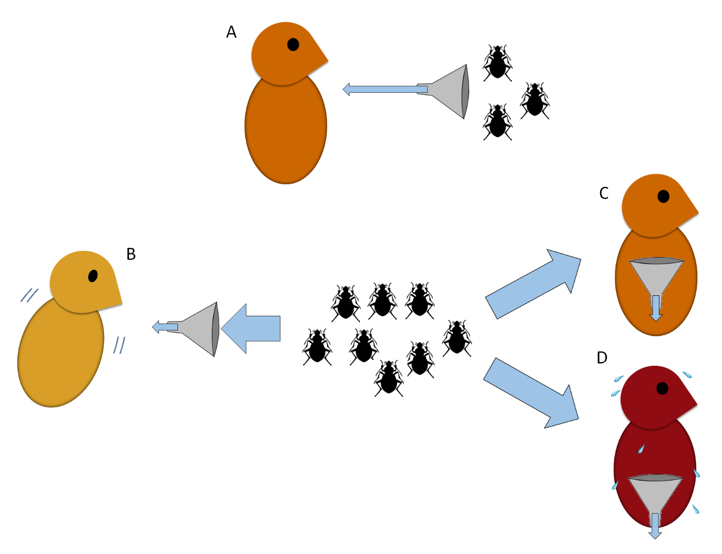

**Figure 1.** Animals have a maximum possible throughput of energy. The constraint can arise from a number of exogenous or endogenous factors: (A) Limited food availability in the environment; (B) limited capacity to harvest effectively limitless food; (C) limited capacity to assimilate food harvested; (D) limited capacity to release heat generated by energy expenditure.

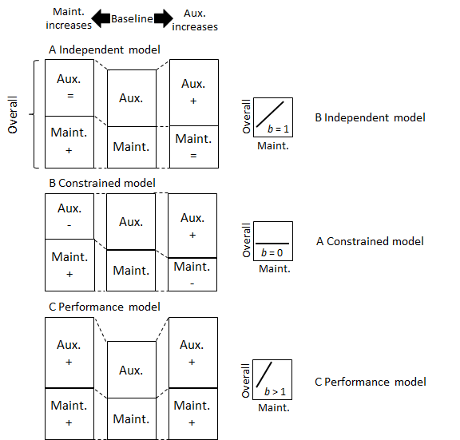

**Figure 2.** Hypothetical representations of three energy management patterns (modified from Careau 2017; refer to that paper for a full explanation). Comparing the middle versus right stacks shows the effect of an increase in auxiliary energy expenditure on daily energy expenditure and maintenance energy expenditure. Comparing the middle versus left stacks shows the effect of an increase in maintenance energy expenditure on daily energy expenditure and auxiliary energy expenditure. The right-hand panel shows the predicted relationship between daily energy expenditure and maintenance energy expenditure, along with the predicted slope (*b*) of the relationship, as suggested by Mathot and Dingemanse (2015). A) The independent pattern, where maintenance and auxiliary energy expenditure are independent of each other. B) The constrained pattern, where increases in maintenance energy expenditure are associated with decreases in auxiliary energy expenditure and vice-versa. C) The performance pattern is defined by increases in maintenance energy expenditure in response to increases in auxiliary energy expenditure, and vice-versa.

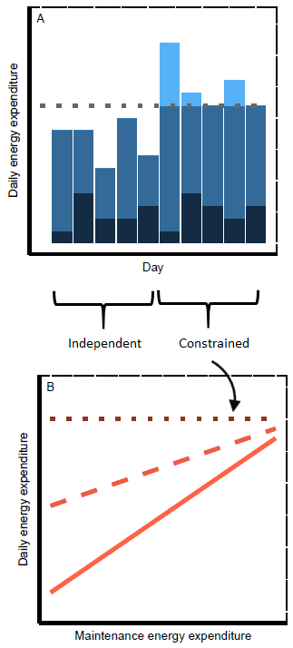

**Figure 3.** Illustration of a hypothesis to explain intra-individual variation in patterns in energy expenditure. During periods when daily energy expenditure is below a threshold (panel A, the first five days), the energy expended on maintenance processes (darkest blue) is unconstrained by the energy expended on auxiliary processes such as activity (medium blue). In a regression of daily energy expenditure against maintenance energy expenditure (panel B), this manifests as a slope value of 1 (light, full red line). By contrast, during periods when auxiliary energy expenditure is high and daily energy expenditure is reaching the threshold (panel A, the second five days), daily energy expenditure is constrained by a reduction in auxiliary energy expenditure (the light blue bars indicate what auxiliary and daily energy expenditure would be without constraint), which manifests as a slope value of zero (dark, dotted red line). Consequently, the slope of the relationship between daily energy expenditure and maintenance energy for the entire 10 d lies between the slope values of the relationships for the first and last five days (medium, dashed red line), and thus has a slope value < 1 > 0, indicating partial energy constraint.

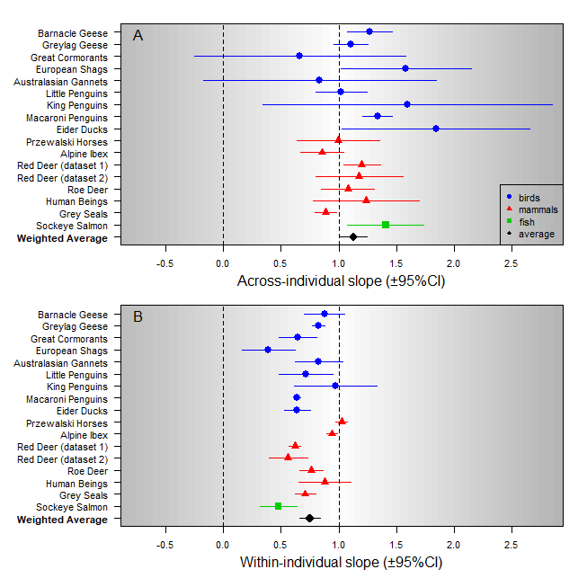

**Figure 4.** Slope (±95% confidence intervals; CI) of the relationship between daily mean heart rate (*f*H, a proxy of daily energy expenditure) and daily minimum *f*H (a proxy of daily maintenance energy expenditure) estimated at the A) across- and B) within-individual levels in 9, 6, and 1 species of free-ranging birds (blue dots), mammals (red triangles), and fish (green squares). The slope and 95% CI can be used to identify the energy management pattern adopted in each species. While complete energetic constraint is represented by a slope of 0, complete energetic independence is predicted by a slope of 1 because of the whole-part correlation (i.e., daily minimum *f*H is included within daily mean *f*H). By contrast, the performance energy pattern is represented by a slope >1 because maintenance energy expenditure increases with auxiliary energy expenditure.

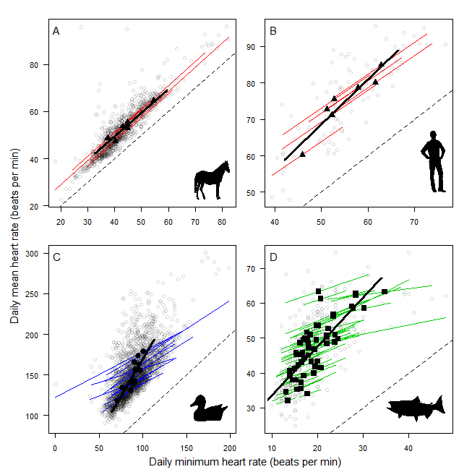

**Figure 5.** Relationship between daily mean heart rate (*f*H) (a proxy of daily energy expenditure) and minimum daily *f*H (a proxy of daily maintenance energy expenditure) in representative species where both the across- and within-individual slopes are close to 1 (A and B), and the across- and within-individual slopes are clearly >1 and <1 (C and D, respectively). In all panels, filled data points represent individual means and unfilled grey circles represent all observations (one data point per individual per day). The across-individual slope is represented by the thick black line and the within-individual slopes are shown by the thinner, coloured lines. The dashed line represents the line of unity.

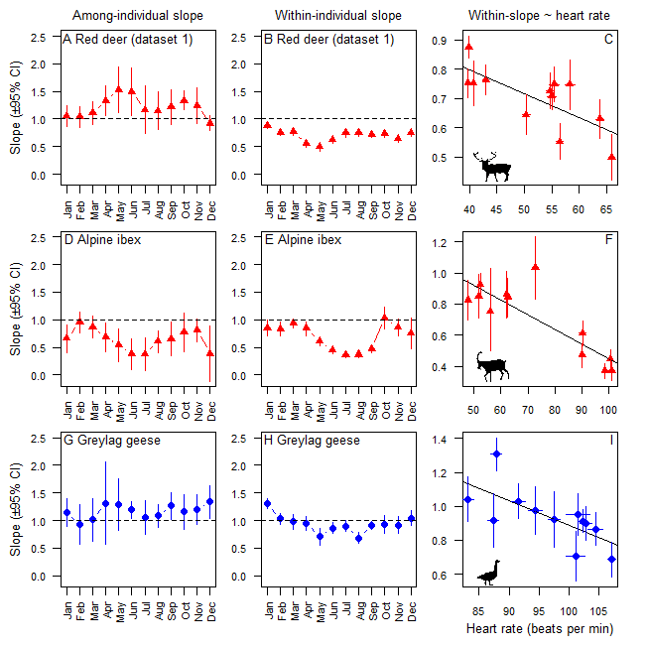

**Figure 6.** Across- and within-individual best-fit slope values for the regression of daily mean heart rate (*f*H)against mean minimum *f*H in A-B) red deer dataset 1, D-E) alpine ibex, and G-H) greylag geese, plotted month-by-month. Vertical lines represent the 95% confidence interval (CI). Within-individual slope values linearly regressed against mean monthly daily mean heart for these three species are also presented (C, F and I).

SUPPLEMENTARY

*Methods for data collection of new datasets*

The dataset on human beings *Homo sapiens* was collected in 2016 and 2017 by K.J.M. and L.G.H. Seven participants wore a Bioharness (v.3; Zephyr Technology) for around a fortnight. This device measured their *f*H at 1 Hz continuously. Occasional periods where *f*H was clearly spuriously low (presumably due to a temporary loss of contact between the electrodes and the skin) were replaced with daily mean values using an automated procedure in Microsoft Excel. Ethical approval was provided by the Department of Life Sciences at the University of Roehampton.

The dataset on lactating (and fasting) adult female grey seals *Halichoerus grypus* was obtained by S.D.T. during the 2015, 2016, and 2017 breeding seasons at the Isle of May (56.1856° N, 2.5575° W)), using modified Firstbeat(TM) *f*H belts (<https://international-shop.firstbeat.com/product/team-pack/>). The transmitter portion of the belt was mounted dorsally between the scapulae, and the belt was replaced with protected cables leading to silver chloride electrodes located immediately posterior of the fore flippers. Inter-beat interval data (in milliseconds) were transmitted to a Firstbeat(TM) Team receiver located between 50 and 100 m away from instrumented seals. Raw data were corrected for artefacts (von Borell *et al.* 2007; Brannan 2017) using Firstbeat(TM) Sports software (v.4.5.0.2) and RHRV (Martínez *et al.* 2017). Heart rate was summarised over discrete 15-minute periods, and traces with >50% of flats and stairs (calculated using bespoke R scripts) were excluded from analyses (Brannan 2017, unpublished data). Heart rate data were collected during daylight hours only. Before further analysis, the dataset was restricted to days with five or more measurement periods and then those animals for which there were data on six or more such days. These procedures conformed to the UK Animals (Scientific Procedures) Act, 1986 and were performed in collaboration with the Sea Mammal Research Unit (University of St. Andrews), operating under UK Home Office project licence #60/4009. All research was approved ethically by the Durham University Animal Welfare Ethical Review Board as well as by the University of St. Andrews Animal Welfare and Ethics Committee.

During the summer of 2016, data were collected on mature sockeye salmon *Oncorhynchus nerka* by T.S.P. and S.J.C. They were dip-netted from the mouth of the Gates Spawning Channel in British Columbia (50.5481°N, 122.4832°W). Fish were electro-sedated using fish handling gloves (Smith-Root, Inc., Washington, USA, http://www.smith-root.com; 10-25mA). They were then instrumented with heart rate and temperature biologgers (DST milli HRT, 13mm x 39.5mm, Star-Oddi, Iceland; http://www.star-oddi.com/) programmed to record heart rate at 100 Hz, and raw electrocardiogram (ECG) every 1.5 hours. Instrumentation involved surgical implantation next to the pericardial membrane via a 3 to 5 cm incision (surgical methods described in (Prystay *et al.* 2017)). The fish were then released into the spawning channel. Sockeye salmon die after spawning, therefore corpses were collected after natural death, at which point the heart rate biologgers were retrieved. This research was conducted in accordance with the Canadian Council on Animal Care Guidelines for Use of Fishes in Research under protocol 102935 issued by Carleton University.

**Supplementary Table 1.** Variance components extracted from univariate mixed models of daily mean heart rate (a proxy of daily energy expenditure) in 16 endotherm species, including variance attributed to random intercepts (*V*intercept), random slopes (*V*slope), and residual variance (*V*residual). Significance of random intercepts and slopes was tested using a log-likelihood ratio test of a full model vs. a reduced model that excluded the variance component of interest. Also shown are total raw variance (*V*total), and autocorrelation structure of order 1, fitted Julian day as a continuous time covariate.

|  |  |  |  |  |  |  |  |  |  |  |  |  |  |  |
| --- | --- | --- | --- | --- | --- | --- | --- | --- | --- | --- | --- | --- | --- | --- |
|  | Variance components | | | | | | | | | |  | Autocorrelation | | |
| Species | Random intercepts | | |  | Random slopes | | |  | *V*residual | *V*total |  |
|  | *V*intercept | *χ*2 | *P* |  | *V*slope | *χ*2 | *P* |  |  | estimate | *χ*2 | *P* | |
| Barnacle geese | 4.45 | 1.17 | 0.28 |  | 0.04 | 49.76 | <0.001 |  | 439.44 | 1885.72 |  | 0.65 | 700.12 | <0.001 | |
| Greylag geese | 6.41 | 198.06 | <0.001 |  | 0.02 | 122.39 | <0.001 |  | 43.17 | 243.80 |  | 0.52 | 1911.06 | <0.001 | |
| Great cormorants | 18.65 | 16.54 | <0.001 |  | 0.03 | 1.73 | 0.19 |  | 114.41 | 160.70 |  | 0.70 | 179.58 | <0.001 | |
| European shags | 15.99 | 0.28 | 0.60 |  | <0.001 | <0.001 | 1.00 |  | 231.43 | 576.98 |  | 0.51 | 10.70 | 0.001 | |
| Australasian gannets | 81.49 | 55.37 | <0.001 |  | 0.06 | 25.91 | <0.001 |  | 483.87 | 948.38 |  | 0.08 | 6.17 | 0.01 | |
| Little penguins | 0.00 | 0.00 | 1.00 |  | 0.06 | 15.85 | <0.001 |  | 290.87 | 1229.27 |  | 0.71 | 245.09 | <0.001 | |
| King penguins | 156.00 | 3.51 | 0.06 |  | 0.11 | 6.79 | 0.01 |  | 132.90 | 732.93 |  | 0.74 | 85.61 | <0.001 | |
| Macaroni penguins | 88.28 | 210.21 | <0.001 |  | 0.01 | 198.21 | <0.001 |  | 310.75 | 1706.17 |  | 0.69 | 5076.61 | <0.001 | |
| Eider ducks | 90.18 | 31.02 | <0.001 |  | 0.03 | 23.44 | <0.001 |  | 350.18 | 833.81 |  | 0.80 | 2177.42 | <0.001 | |
| Przewalski horses | 2.60 | 25.23 | <0.001 |  | <0.001 | 0.001 | 0.98 |  | 18.54 | 100.99 |  | 0.41 | 106.20 | <0.001 | |
| Alpine ibex | 14.18 | 176.02 | <0.001 |  | 0.01 | 115.80 | <0.001 |  | 61.69 | 504.14 |  | 0.46 | 1187.43 | <0.001 | |
| Red deer (dataset 1) | <0.001 | <0.001 | 0.98 |  | 0.01 | 177.74 | <0.001 |  | 27.85 | 147.33 |  | 0.92 | 1560.95 | <0.001 | |
| Red deer (dataset 2) | <0.001 | <0.001 | 1.00 |  | 0.05 | 160.20 | <0.001 |  | 81.46 | 208.05 |  | 0.95 | 1732.36 | <0.001 | |
| Roe deer | 11.37 | 37.63 | <0.001 |  | 0.03 | 77.88 | <0.001 |  | 33.13 | 221.20 |  | 0.63 | 925.98 | <0.001 | |
| Human beings | 4.05 | 1.47 | 0.23 |  | <0.001 | 0.00 | 1.00 |  | 37.64 | 117.13 |  | 0.15 | 1.58 | 0.21 | |
| Grey seals | 4.05 | 7.61 | 0.01 |  | 0.03 | 13.86 | <0.001 |  | 19.73 | 162.98 |  | 0.23 | 5.52 | 0.02 | |
| Sockeye salmon | <0.001 | <0.001 | 1.00 |  | 0.06 | 2.43 | 0.12 |  | 53.61 | 95.92 |  | 0.71 | 94.78 | <0.001 | |

**Supplementary Table 2.** Relationships between daily mean heart rate (*f*H; a proxy of daily energy expenditure) and daily minimum *f*H (a proxy of daily maintenance energy expenditure) estimated at the A) across- and B) within-individual levels in 16 free-ranging endotherms species (9 bird, 6 mammal and a fish species). r2GLMM(m) means marginal r2 estimated for general linear mixed models.

|  |  |  |  |  |  |  |  |  |
| --- | --- | --- | --- | --- | --- | --- | --- | --- |
| Species | A) Among-individual slope | | |  | B) Within-individual slope | | |  |
| estimate | 95%CI | |  | estimate | 95%CI | |  |
| lower | upper |  | lower | upper | r2 GLMM(m) |
| Barnacle geese | 1.27 | 1.08 | 1.46 |  | 0.88 | 0.70 | 1.05 | 0.71 |
| Greylag geese | 1.11 | 0.96 | 1.26 |  | 0.83 | 0.77 | 0.88 | 0.76 |
| Great cormorants | 0.66 | -0.25 | 1.58 |  | 0.64 | 0.48 | 0.81 | 0.24 |
| European shags | 1.58 | 1.02 | 2.15 |  | 0.39 | 0.16 | 0.62 | 0.61 |
| Australasian gannets | 0.84 | -0.17 | 1.84 |  | 0.83 | 0.62 | 1.04 | 0.40 |
| Little penguins | 1.02 | 0.80 | 1.25 |  | 0.72 | 0.48 | 0.95 | 0.71 |
| King penguins | 1.60 | 0.34 | 2.85 |  | 0.98 | 0.62 | 1.34 | 0.61 |
| Macaroni penguins | 1.34 | 1.21 | 1.46 |  | 0.64 | 0.61 | 0.67 | 0.72 |
| Eider ducks | 1.84 | 1.03 | 2.66 |  | 0.64 | 0.53 | 0.75 | 0.40 |
| Przewalski horses | 1.00 | 0.64 | 1.35 |  | 1.03 | 0.98 | 1.08 | 0.77 |
| Alpine ibex | 0.86 | 0.67 | 1.05 |  | 0.94 | 0.89 | 0.99 | 0.83 |
| Red deer (dataset 1) | 1.20 | 1.04 | 1.36 |  | 0.62 | 0.57 | 0.67 | 0.69 |
| Red deer (dataset 2) | 1.18 | 0.80 | 1.56 |  | 0.56 | 0.39 | 0.73 | 0.45 |
| Roe deer | 1.08 | 0.85 | 1.31 |  | 0.76 | 0.66 | 0.87 | 0.74 |
| Human beings | 1.24 | 0.78 | 1.70 |  | 0.88 | 0.65 | 1.11 | 0.64 |
| Grey seals | 0.89 | 0.79 | 0.98 |  | 0.71 | 0.62 | 0.80 | 0.83 |
| Sockeye salmon | 1.41 | 1.08 | 1.74 |  | 0.48 | 0.32 | 0.64 | 0.39 |
| Weighted average | 1.13 | 1.01 | 1.25 |  | 0.75 | 0.66 | 0.84 | 0.62 |

Coefficient of determination (r2) values were calculated for each model using sem.model.fits() in the piecewiseSEM package (Nakagawa & Schielzeth 2013). We checked the validation of the models by visually assessing plots of the residuals against the fitted values, and against minimum *f*H (Zuur, Hilbe & Ieno 2013).

*Investigating auxiliary energy expenditure*

The constrained pattern of energy expenditure is associated with lower maintenance energy expenditure during periods when ‘energetically costly behaviours’ are higher, or vice-versa (Mathot & Dingemanse 2015). For roe deer the slope of the relationship between daily mean heart rate (*f*H; a proxy for daily energy expenditure)and daily minimum *f*H (a proxy for daily maintenance energy expenditure) within individuals is substantially less than 1 (fig. 3B), which is assumed to indicate that during periods when energetically costly behaviours are performed, maintenance energy expenditure attenuates, or vice-versa. This relationship can be illustrated by a scatterplot of the negative relationship between daily minimum *f*H and daily activity *f*H, where the latter is calculated as the difference between daily mean and minimum *f*H (Portugal *et al.* 2016) (Supplementary fig. 1A; p < 0.001 for the within-subject effect slope).

The roe deer dataset analysed in the present study also includes activity measures, enabling further interrogation of this aspect of the constrained energy pattern. A tilt switch implanted in the neck measured whether the animal’s head was up or down, while changes in signal strength recorded by the antenna that received information from the collar transmitter on each animal indicated locomotion (Arnold *et al.* 2004; Reimoser 2012). Combining these two measures, along with heart rate, enabled classification of each minute of measurement as either ‘active’ or ‘not active’. Activity per day was then calculated as the percentage of minutes active. While there is a positive relationship between daily mean *f*H and activity levels (Supplementary fig. 1B; p < 0.001 for the within subject effect slope), the regression relationship between daily minimum *f*H and activity levels within each individual does not follow the prediction of the constrained pattern since there is no evidence that daily minimum *f*H covaries negatively with activity level (Supplementary fig. 1C; p=0.26 for the within-subject effect slope). The explanation for this is that daily activity *f*H is not represented exclusively by the energy costs of activity. This is evidenced by the lack of a relationship between daily activity *f*H and activity levels (Supplementary fig. 1D; p=0.33 for the within-subject effect slope). Rather, daily activity *f*H also includes important other energy costs; we suggest it is better termed daily auxiliary *f*H. At least some of these auxiliary energy costs, which are not activity per se, are low when activity levels are high. These non-activity auxiliary energy costs, reduced in compensation for activity energy costs, could be associated with low intensity behaviours such as reductions in levels of fidgeting (Levine, Eberhardt & Jensen 1999) or changes in body posture (Levine, Schleusner & Jensen 2000; Ward, Speakman & Slater 2003). Evidence for this possibility comes from an across-school study of children, in which the amount of physical activity the children undertook at school did not relate to their levels of physical activity over the entire day (Mallam *et al.* 2003), and a study of elderly participants who exhibited no increase in daily activity levels during periods of physical training (Meijer, Westerterp & Verstappen 1999). Garland et al. (2011) report data showing that in young adults, daily energy expenditure is not as high as expected on days when physical activity is high. Furthermore, a meta-analysis by Wing et al. (1999) found that only 2 out of 13 studies reported statistically significant differences in weight loss for participants both dieting and undertaking exercise versus participants who were dieting only. Finally, Westerners have similar daily energy expenditures to the more physically active Hadza people of Tanzania (Pontzer *et al.* 2012). Thus for roe deer at least, rather than maintenance energy expenditure decreasing in response to high levels of energy spent on activity, maintenance energy expenditure does not systematically change; specific auxiliary costs decrease instead (resulting in the lack of relationship between daily auxiliary daily activity *f*H and activity levels (Supplementary fig.1D). These specific auxiliary costs decrease sufficiently so that the relationship between daily mean activity *f*H and daily minimum daily activity *f*H is less than 1 indicating an element of the energy constrained pattern (fig. 3B).

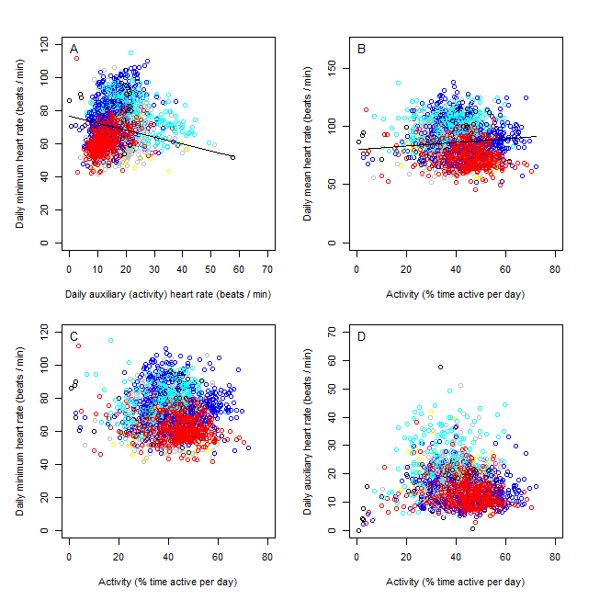

**Supplementary Figure 1.** Relationships within individual roe deer between (A) minimum daily heart rate (*f*H; a proxy for daily maintenance energy expenditure) and daily auxiliary (activity) *f*H (a proxy for activity energy expenditure). The relationship is negative, indicating some degree of energy constraint is exhibited by this species. (B) daily mean *f*H (a proxy for daily mean energy expenditure) and daily activity levels. The relationship is positive. (C) minimum daily *f*H and daily activity levels. There is no evidence for a relationship. (D) daily auxiliary (activity) *f*H and daily activity levels. There is no evidence for a relationship. Individual animals are represented by different colours. All observations included in this study’s analysis are presented in these panels but a large number are obscured due to data points overlapping. The presented lines of best-fit represent the overall within-individual relationships. They were calculated from mixed models that were input within-subject centred values of minimum daily *f*H, and also accounted for temporal autocorrelation. To calculate the intercept of these particular best-fit lines correctly, the data had to be centred on x=0 for the mixed model, and then the resultant intercept adjusted to account for the true x values.

*Autocorrelation functions in the data*

In all species except roe deer, there was strong and statistically significant temporal autocorrelation across successive daily measurements at the within-individual level (Supplementary fig.2; Table 2).



**Supplementary Figure 2.** Autocorrelation functions fitted in the residual structure of univariate mixed models of daily mean heart rate (a proxy of daily energy expenditure) in 9 species of free-ranging birds (blue dots), 6 species of free-ranging mammals (red triangles) and an ectothermic species of fish. The autocorrelation values are calculated using pairs of residuals at the within-individual level within each species. The strong significance of the autocorrelation term in most models indicates that some important explanatory variables determining daily mean heart rate (*f*H) are missing, particularly those operating at scales of approximately 2-20 d. Presumably, if the relevant variables were available (e.g. temperature, food availability, breeding status etc.), their inclusion in the model would reduce the amount of autocorrelation in the residuals.

**References**

Arnold, W., Ruf, T., Reimoser, S., Tataruch, F., Onderscheka, K. & Schober, F. (2004) Nocturnal hypometabolism as an overwintering strategy of red deer (Cervus elaphus). *American Journal of Physiology-Regulatory, Integrative and Comparative Physiology,* **286,** R174-R181.

Brannan, N. (2017) Investigating the physiological underpinnings of proactive and reactive behavioural types in grey seals (Halichoerus grypus): Trial deployment of a minimally invasive data logger for recording heart rate and heart rate variability in a wild free-ranging breeding pinniped species. Master of Science, Durham University.

Garland, T., Schutz, H., Chappell, M.A., Keeney, B.K., Meek, T.H., Copes, L.E., Acosta, W., Drenowatz, C., Maciel, R.C. & Van Dijk, G. (2011) The biological control of voluntary exercise, spontaneous physical activity and daily energy expenditure in relation to obesity: human and rodent perspectives. *The Journal of Experimental Biology,* **214,** 206-229.

Levine, J., Eberhardt, N. & Jensen, M. (1999) Role of Nonexercise Activity Thermogenesis in Resistance to Fat Gain in Humans. *Science,* **283,** 212-214.

Levine, J.A., Schleusner, S.J. & Jensen, M.D. (2000) Energy expenditure of nonexercise activity. *The American Journal of Clinical Nutrition,* **72,** 1451-1454.

Mallam, K.M., Metcalf, B.S., Kirkby, J., Voss, L.D. & Wilkin, T.J. (2003) Contribution of timetabled physical education to total physical activity in primary school children: cross sectional study. *BMJ,* **327,** 592-593.

Martínez, C.A.G., Quintana, A.O., Vila, X.A., Touriño, M.J.L., Rodríguez-Liñares, L., Presedo, J.M.R. & Penín, A.J.M. (2017) *Heart Rate Variability Analysis with the R Package RHRV*. Springer.

Mathot, K. & Dingemanse, N. (2015) Energetics and behavior: unrequited needs and new directions. *TREE,* **30,** 199-206.

Meijer, E.P., Westerterp, K.R. & Verstappen, F.T. (1999) Effect of exercise training on total daily physical activity in elderly humans. *European Journal of Applied Physiology and Occupational Physiology,* **80,** 16-21.

Nakagawa, S. & Schielzeth, H. (2013) A general and simple method for obtaining R2 from generalized linear mixed-effects models. *Methods in Ecology and Evolution,* **4,** 133-142.

Pontzer, H., Raichlen, D.A., Wood, B.M., Mabulla, A.Z.P., Racette, S.B. & Marlowe, F.W. (2012) Hunter-Gatherer Energetics and Human Obesity. *PLoS ONE,* **7,** e40503.

Portugal, S.J., Green, J.A., Halsey, L.G., Arnold, W., Careau, V., Dann, P., Frappell, P.B., Grémillet, D., Handrich, Y. & Martin, G.R. (2016) Associations between Resting, Activity, and Daily Metabolic Rate in Free-Living Endotherms: No Universal Rule in Birds and Mammals. *Physiological and Biochemical Zoology,* **89,** 251-261.

Prystay, T.S., Eliason, E.J., Lawrence, M.J., Dick, M., Brownscombe, J.W., Patterson, D.A., Crossin, G.T., Hinch, S.G. & Cooke, S.J. (2017) The influence of water temperature on sockeye salmon heart rate recovery following simulated fisheries interactions. *Conservation Physiology,* **5**.

Reimoser, S. (2012) Influence of anthropogenic disturbances on activity, behavior and heart rate of roe deer (Capreolus capreolus) and red deer (Cervus elaphus). *Context of their Daily and Yearly Patterns. In: Cahler, AA, Marsten, JP (Eds): Deer-Habitat, Behavior and Conservation. Hauptgage. Nova Publishers*.

von Borell, E., Langbein, J., Després, G., Hansen, S., Leterrier, C., Marchant-Forde, J., Marchant-Forde, R., Minero, M., Mohr, E. & Prunier, A. (2007) Heart rate variability as a measure of autonomic regulation of cardiac activity for assessing stress and welfare in farm animals—a review. *Physiology & Behavior,* **92,** 293-316.

Ward, S., Speakman, J.R. & Slater, P.J.B. (2003) The energy cost of song in the canary, *Serinus canaria*. *Animal Behaviour,* **66,** 893-902.

Wing, R.R. (1999) Physical activity in the treatment of the adulthood overweight and obesity: current evidence and research issues. *Medicine and Science in Sports and Exercise,* **31,** S547-552.

Zuur, A.F., Hilbe, J. & Ieno, E.N. (2013) *A Beginner's Guide to GLM and GLMM with R: A Frequentist and Bayesian Perspective for Ecologists*. Highland Statistics.