Effectiveness and Experiences of Team-Based Learning (TBL) in Undergraduate Nurse Education Programs: A mixed methods systematic review protocol

Review objectives/questions
The objective of this mixed methods systematic review is to develop an integrated synthesis of quantitative and qualitative research evidence on Team-Based Learning (TBL) in undergraduate nurse education programs to inform active learning strategies among students.
More specifically, the objectives are:
1. For the quantitative component, to identify the effectiveness of TBL on improving academic performance and team skills following participation in TBL activities.
2. For the qualitative component, to identify students’ experiences of engagement in TBL.

Background
Nurse education curricula have increasingly adopted a constructivist framework in the design and delivery of educational programs.¹ The emergence and wide acceptance of adult learning pedagogies has been influential in a shift from a traditional teacher-centred and content focused classroom activities approach towards more student-centred teaching and learning strategies. Nurse education has been responsive to advancing sciences and technologies by integrating traditional teaching methods with innovative methodologies. Increasingly, the goals of professional education and training have placed greater emphasis on learning and teaching that facilitate the development of learning in groups, lifelong learning and professional skills through methods that enable students to actively seek knowledge and engage in activities that promote deep learning and knowledge application in solving ‘real-world’ problems.² Thus, nursing education curricula have adopted active learning approaches to enhance students’ learning experiences through involvement and participation in activities designed to promote skills development and application of knowledge. Several active learning approaches, primarily teacher-led and resource intensive have been widely adopted in nurse education programs. These approaches include Simulation Based Learning (SBL),^{3,4} Problem-Based Learning (PBL),^{5,6} Self-Directed Learning,⁷ Enquiry or Inquiry-Based Learning (EBL/IBL)⁸ and Cooperative Learning.⁹ A more recent active learning strategy introduced in health professional education programs is TBL.¹⁰
Team-Based Learning has certain features in common with other active learning strategies, however, it differs in the organization and execution of content delivery, the structure of small groups and the processes students engage in when participating in the structured activities.¹¹ The underlying distinction suggested is that when implemented properly, TBL ‘is a comprehensive instructional system that…achieves an increasingly interlocking synergy and amplifies students’ social and intellectual capacities over time.’^{12(p.43)} Thus, when TBL is implemented with all the phases included in its design and delivery of content, it aims to maximize student active learning by engaging students in activities that shift the focus from lecturer-led sessions to student participating in interactive learning in small groups, and development of cognitive and practical skills.
Team-Based Learning derives its theoretical underpinning from the constructivist approach to learning, teaching and assessment.¹³ Team-Based Learning places responsibility and accountability of learning squarely on students.^{12,14} Michaelsen et al.¹⁴ initially identified four principles central to TBL. These are: 1. Large groups are divided into small groups and must be properly formed and managed; 2. Students must be accountable and responsible for their individual and group work, pre-class and in classroom learning activities; 3. Students must receive frequent and timely feedback, and 4. Group assignments must promote both learning and team development. The first principle is concerned with strategically dividing large groups into smaller teams. For instance, large groups of students undertaking the same course (>100 students) are divided into intermediate class size groups (<25 students). This entire student group (<25) is then sub-divided into small teams of 5-7 students.^{14,15}
The second principle concerned with student assuming accountability and responsibility for their learning. Students have a responsibility to review the knowledge content material and resources prior to the classroom time, a process that is aimed at enabling students to prepare for meaningful and deeper discussion of the topic in class time. Thus, prior exposure to the content learning material allows for enhanced interaction with their peers and cooperative learning during classroom sessions. Students are accountable for their contribution for their own learning and in how they engage with team members in contributing to team performance during structured activities.^{14,15}
Frequent and immediate feedback to students and among students form the third principle of TBL. Students receive formative and summative feedback from the instructor. Students are also encouraged to interact with each other in peer evaluation, to give and receive feedback to each other.¹² For example, they rate each other on aspects of individual pre-class preparation, attendance and contribution to group discussion and team performance. Feedback is deemed critical to content learning and retention, critical thinking and team skills development.^{14,15}
The last principle is about group assignments and carefully designed learning activities that bring about transformation in students’ learning through knowledge construction, application, analysis and evaluation. Learning activities are designed by instructors to provide opportunities for collaborative learning, application of knowledge in solving ‘real world problems’, contributing to development of team skills and critical reasoning in decision making.^{14,15}
For the purpose of implementation of TBL, Michaelsen and Sweet¹¹ recommend that the four principles described should be included in the design of learning activities. In addition, the design of TBL instructional activity for a unit of learning should incorporate a 3-phase process known as Readiness Assurance Process (RAP). For each unit of learning, the first phase is the out of preparation phase where students engage in class pre-reading and review of material set by the instructor. Thus, students individually read and review the knowledge content in readiness for the classroom discussion and engage in learning processes. The second phase, Readiness Assurance (RA), involves activities to test knowledge and provide feedback in the classroom environment. The first activity involves students participating in a test designed to assess the individual student’s understanding of concepts and knowledge with a short test (iRAT). Individual scores are calculated. In the subsequent activity the small group take the same test as a team (tRAT). Conferring and discussion is allowed. A team test score is calculated. Teams are allowed to submit a written Appeals when they believe a question was ambiguous, presenting clear argumentative statements and evidence from the preparation materials. The tutor then provides feedback and clarifies any misconceptions and facilitates discussion involving all the teams. The third phase is referred to as 4S application-oriented activities, when the team practice the application of knowledge to solve problems (tAPP). These activities are designed to address significant problems, teams are required to make specific choice from possible clear alternative statements, work on the same problem and report decisions simultaneously.^{11,16} Thus, teams work on complex ‘real world problems’ aimed at developing their critical thinking through constantly engaging in discussion, team work, exploring alternatives and making choices and decisions in actively seeking solutions based on evidence.
Team-Based Learning has been adopted across several healthcare disciplines including nursing.¹⁷ Studies have reported effectiveness of TBL as a teaching strategy with improved learner engagement and attitudes¹⁷, positive student perceptions of TBL irrespective of grades,¹⁸ improvement in students’ comprehension, retention of information and critical thinking¹⁹ and dynamic experiences of learning in teams.²⁰ Studies reporting qualitative evidence suggest that students like the opportunities to learn from their peers, enjoy team discussions, better understand content but found the amount of pre-class reading too much.²¹
Nurse education programs have constantly adopted innovative learning and teaching strategies, responsive to technological and advancing knowledge in the health, medical and related sciences. Team-Based Learning is recognized as an innovative educational strategy with the potential to enhance learning by engaging nursing students in small structured teams and advocated as a model for professional nursing education.¹⁶ The exact date of when nurse education curricula began to adopt TBL is not certain. However, the earliest writing on the implementation of TBL in nurse education was by Clark²² in 2007 followed by a paper by Clark et al.¹⁷ in 2008. The implementation of TBL in nursing education was further advanced by Andersen et al.²³
A scoping search of the literature revealed two systematic reviews on TBL applied as a teaching and learning strategy in nurse education. The first of these systematic reviews by Sisk²⁴ in 2011, examined ‘the effect of applying TBL as an active learning strategy on educational outcomes. The educational outcomes were not clearly stated at the outset of the report but were described as emerging from the review of the literature. This review included 17 studies, mostly from medicine (10) and only two on undergraduate nursing students. The review pointed out that none of the studies were randomized controlled trials, most were descriptive and reported on three educational outcomes of TBL, namely, student satisfaction, student engagement and examination scores. These three educational outcomes were considered typical variables commonly studied in TBL research.²⁴ The second systematic review by Eti²⁵ aimed to find the research evidence of the use and effectiveness of TBL application exercises as implemented in nurse education. Application exercises form an important design feature in TBL where students participate in solving real world problems through application of knowledge in teams. Given that application exercises are an important step in the implementation of TBL activities, Eti also set out to examine the literature for any gaps in the use of TBL application exercises. The reported review included 49 studies published between 2006 and 2015. The review reported primarily on the effect of using concept mapping and case study as tools in the design and execution of TBL application exercises. The findings of this review suggested that concept mapping and case study were useful tools in the design of application exercises to implement the use of application exercises to facilitate group problem solving. However, the review also reported that there were gaps in the use of application exercises in the studies reviewed, that is not all studies included in the review demonstrated clearly the use of application exercises as part of TBL implementation or simply did not report clearly enough on the type of application exercises used. Eti concluded that these constituted gaps in the design and delivery of TBL when an important step in knowledge application was not clearly implemented. The review by Sisk²⁴ was limited in providing substantial evidence of the use and benefits of TBL in nursing education. It included only two studies. The review by Eti²⁵ focused on application exercises, an important part of the TBL activities and confined itself to reporting on the use of specific tools, concept mapping and case study as strategies to facilitate learning. As can be seen from the summaries of the two systematic reviews, the aim of the present proposed mixed methods systematic review is very different in comparison.
A scoping search of the literature has revealed increasing interest in use of TBL in nurse education programs with a number of studies reporting findings from primary research.²⁶⁻²⁹ A preliminary search was carried out to find out whether any systematic reviews were being currently conducted or registered. The databases searched were PROSPERO, Cochrane Library and the JBI Database of Systematic Reviews and Implementation Reports. Aside from the reviews^{24, 25} already described above, the search revealed no systematic review on TBL in undergraduate nurse education programs presently registered and in the process of being conducted.
The focus of the present proposed review is different to those of the reviews described above.^{24,25} In the present review all studies reporting the use of TBL in undergraduate nurse education programs will be included. The rationale to focus on undergraduate nursing education programs was supported by the literature on implementation of TBL in nursing curricula.^{16,23} At any given time undergraduate nursing cohorts represent the largest number among students and undergraduate programs are the longest in duration compared to other nursing education programs for nurses. Research evidence about the effectiveness of TBL in delivering quality education can inform undergraduate nursing curriculum development and implementation with innovative learning and teaching strategies to enrich students’ learning experiences. Undergraduate programs provide innumerable opportunities to test the usefulness of TBL in creating and delivering meaningful learning outcomes for professional practice. Hence, evidence from reviewing research conducted with undergraduates will inform not only curricula matters but also generate further research ideas.
The quantitative component will focus on the effectiveness of TBL as measured by academic outcomes and teamwork skills. The reported experiences of students participating in TBL will be included as the qualitative component of this review. The qualitative evidence will be in the form of subjective expressions and opinions about satisfaction with engagement in the processes and learning activities, quality of learning through interpersonal interactions, empowerment in learning and perceived benefits and barriers of TBL.
For the purpose of this mixed methods review, the implementation of TBL in a whole undergraduate educational programme or part of it will be considered. To explain, undergraduate nurse education programs are made up of a number of modules, each module contributing to the learning outcomes and overall content of usually a three-years programme of study and practice placements which must satisfy the regulatory bodies awarding the degree and professional registration. The initial search of the literature revealed that studies reporting on the implementation of TBL in a single module of the undergraduate programs is common. Therefore, studies reporting findings based on the implementation of TBL in a single module in an undergraduate nurse education programme, whatever the subject content of the module, will be considered.
The findings of this review will help inform learning and teaching practice, make recommendations for nursing education programs and guide future research on the use of TBL.
Inclusion Criteria
Types of Participants
The quantitative component of this review will consider studies that include nursing students undertaking undergraduate nurse education programs leading to registration in established fields of nursing at this level, these being adult nursing, mental health nursing, children’s nursing, learning disabilities nursing and community nursing. It is understood that the characteristics of nursing students enrolled on educational programs will vary across countries. Variations may be reflected in what the undergraduate nurse education programs and qualifications are called which may be identified as specific to the educational or institutional context of the country, examples being bachelor degrees and baccalaureate provisions. However, to be included studies should describe participants as students undertaking an undergraduate nursing program of study, although terms such as ‘student nurses’, ‘nursing students’ or ‘nurse learners’ are found in the literature. Studies describing students in terms of a cross sectional sample, for example, as ‘first year’, ‘second year’ or ‘third year’ will be included without any restrictions. Gender and age of participants will not be specified as it is not intended to set any restrictions on grounds of age and gender or geographical origins of research studies.
The qualitative component of this review will consider participants the same as described under the quantitative component above. Consideration will be given to the terms used in studies originating from different countries, the diverse healthcare and nurse education systems to ensure that criteria for nursing student status is satisfied.
Studies reporting on the use of TBL in postgraduate and continuing education programs will be excluded.
Types of Intervention(s)/phenomena of interest
The quantitative component of this review will consider studies that evaluate the effectiveness of TBL implemented in undergraduate nurse education programs. The processes involved in the implementation of TBL should be clearly identifiable and reported. Three phases as described by Michaelsen and Sweet¹¹ are the pre-classroom learning, the readiness assurance process, application of knowledge. The interventions should include clear setting of pre-classroom activities and should include measures to ascertain student accountability, classroom activities to promote active learning, teamwork skills, professional skills development and elements in generating student interaction and engagement.
To be included in the review, studies should demonstrate that all the principles and phases of TBL have been considered in the design and delivery of TBL and the processes clearly identified and described. Where studies have not included all these aspects of TBL in their design and delivery, often referred to in the literature as Modified’ TBL, these studies will be excluded.
The qualitative component of this review will consider studies that explore the experiences of nursing students and reported in terms of their level of participation, engagement and satisfaction with the process and learning. Nursing students’ ability, willingness and motivation to participate in TBL will be identified phenomena of interest as well as the expressions of positive and negative attitudes and satisfaction with the entire experiential processes of being in a team, working with and collaborating with peers. The qualitative analysis and presentation of findings on likes and dislikes, personal preferences and experience of learning in groups will be considered.
Comparator(s)
The quantitative component of this review will consider studies that compare TBL with other teaching and learning strategies which include traditional teaching strategies and methods such as lectures, demonstrations, as well as active methods such as problem-based learning, simulation based learning and collaborative learning.
Types of Outcomes
This review will consider studies that include the following outcomes: academic performance as measured by scores on tests such as multiple-choice questions (MCQs) and examination (written); individual and group assessment scores. Team-Based Learning is an educational strategy that has features of active learning as underpinned by the principles and implementation phases described by Michaelsen and Sweet.¹² Students actively engaging in activities such as reading, communicating their ideas with others, sharing their knowledge, reasoning and thinking critically about the knowledge content, and participating in classroom activities to seek answers to problems are but only a few examples of what may be considered outcomes of active learning. Therefore, outcomes of learning or learning process engaged by students as measured by the Active Learning Inventory Tool³⁰ or similar standardized instrument for measuring active learning skills; teamwork skills as measured by level of interaction and support among students, sharing of knowledge and solutions to problems, taking responsibility for team outcomes. The Team-Based Learning Student Assessment Instrument (TBL-SAI)³¹ is a validated standardized instrument for measuring teamwork. Whilst some of these outcomes will be measurable with the use of standardized tools, it is possible that outcomes may also be assessed through observational and informal tools devised for the specific purpose of a study, with the reliability and validity discussed. Examples of standardised tools used in data gathering in TBL studies included the Measures for Classroom Engagement which measures student engagement during classroom activities and the Value of Teams survey which measures students’ appreciation of learning within a small group.¹⁷
Context
The qualitative component of this review will consider studies that investigate students’ experiences of participating in TBL implemented in undergraduate nurse education programs. Experiences of engaging in TBL activities designed and implemented adhering to the principles of TBL will be considered as the aim is to inform and guide the learning processes and the goals of professional nursing education. It is possible that the context of learning may be diverse across studies, reflecting the influences of educational, cultural and professional nursing practice in the country where the study was undertaken, specific settings or specialties of nursing. The influences of the qualities of the learning environment on student learning experiences will be provide new insight into professional values and practices.
Study Types
The quantitative component of this review will consider both experimental and quasi-experimental study designs including randomized controlled trials, non-randomized controlled trials, before and after studies and interrupted time-series studies. In addition, analytical observational studies including prospective and retrospective cohort studies, case-control studies and analytical cross-sectional studies will be considered for inclusion. This review will also consider descriptive observational study designs including case series, individual case reports and descriptive cross-sectional studies for inclusion.
The qualitative component of the review will consider studies that focus on qualitative data including, but not limited to, designs such as phenomenology, grounded theory, ethnography, qualitative description, action research, narrative and feminist research. Studies adopting a mixed methods approach where data and findings of a qualitative nature are reported will be included in this review. Equally, in mixed methods where quantitative data and results are reported for the quantitative component, these will be included in the integration of findings.

Search Strategy
The search strategy will aim to find both published and unpublished studies. A three-step search strategy will be utilized for each component of this review. An initial limited search of MEDLINE, CINAHL, ERIC and PsycINFO will be undertaken followed by analysis of the text words contained in the title and abstract, and of the index terms used to describe TBL concepts in the article. A second search using all identified keywords and index terms will then be undertaken across all included databases. Thirdly, the reference list of all identified reports and articles will be searched for additional studies. Studies published in English language will be considered for inclusion in this review. Studies published since 2005 will be considered for inclusion in this review. The preliminary searches did not yield any study in nursing education prior to 2005.
For the quantitative component of the review:
The databases to be searched include:
MEDLINE, CINAHL, ERIC and PsycINFO
The search for unpublished studies will include:
Google Scholar, Open Grey, ProQuest Dissertations & Theses and MedNar
The trial registers will be searched exclusively for quantitative studies and will include:
PROSPERO, ISRCTN
For the qualitative component of the review:
The databases to be searched include:
MEDLINE, CINHAL, ERIC and PsycINFO
The search for unpublished studies will include:
Google Scholar, Open Grey, ProQuest Dissertations & Theses and MedNar
A search strategy is attached (Appendix I)
Study Selection
Following the search, all identified citations will be collated and uploaded into RefWorks (ProQuest LLC, Ann Arbor, USA) and duplicates removed. Titles and abstracts will then be screened by two independent reviewers for assessment against the inclusion criteria for the review. Studies that meet or could potentially meet the inclusion criteria will be retrieved in full and their details imported into the Joanna Briggs Institute System for the Unified Management, Assessment and Review of Information (JBI SUMARI).³² The full text of selected studies will be retrieved and assessed in detail against the inclusion criteria. Full text studies that do not meet the inclusion criteria will be excluded and reasons for exclusion will be provided in an appendix in the final systematic review report. Included studies will undergo a process of critical appraisal. The results of the search will be reported in full in the final report and presented in a PRISMA flow diagram. Any disagreements that arise between the reviewers will be resolved through discussion, or with a third reviewer.
Assessment of Methodological Quality
Quantitative papers selected for retrieval will be assessed by two independent reviewers for methodological validity prior to inclusion in the review using standardized critical appraisal instruments from the Joanna Briggs Institute Meta-Analysis of Statistics Assessment and Review Instrument (JBI SUMARI)³² (Appendix II). Any disagreements that arise between the reviewers will be resolved through discussion, or with a third reviewer.
Qualitative papers selected for retrieval will be assessed by two independent reviewers for methodological validity prior to inclusion in the review using Critical Appraisal Checklist for Qualitative Research from the Joanna Briggs Institute (JBI SUMARI)³² (Appendix II).
Following critical appraisal, studies that do not meet a certain quality threshold will be excluded. This decision will be based on lack of congruity between any of steps in the reported study as assessed against the criteria set out in JBI SUMARI. Any disagreements that arise between the reviewers will be resolved through discussion, or with a third reviewer. The results of critical appraisal will be reported in narrative form and in a table.
Data Extraction
Data will be extracted from quantitative papers included in the review using the standardized data extraction tool available in JBI SUMARI (Appendix III) by two independent reviewers.^{32,33} The data extracted will include specific details about the interventions, populations, study methods and outcomes of significance to the review question and specific objectives. Any disagreements that arise between the reviewers will be resolved through discussion or with a third reviewer. Authors of papers will be contacted to request missing or additional data where required.
Qualitative data will be extracted from papers included in the review using the standardized data extraction tool from JBI SUMARI (Appendix II) by two independent reviewers. The data extracted will include specific details about the populations, context, culture, geographical location, study methods and the phenomena of interest relevant to the review question and specific objectives. Findings and their illustrations will be extracted and assigned a level of credibility.^{32,33}
Data Synthesis
Quantitative papers will, where possible be pooled in statistical meta-analysis using JBI SUMARI.³² All results will be subjected to double data entry. Effect sizes will be expressed as either odds ratios (for dichotomous data and weighted (or standardized) mean differences (for continuous data) and their 95% confidence intervals will be calculated for analysis. Heterogeneity will be assessed statistically using the standard chi-squared and I squared tests. The choice of model will be the fixed effects and analysis will be based on guidance set out by Tufanaru et al.³⁴ Sensitivity analyses will be conducted to test decisions made regarding selection of groups and publication bias where appropriate. Where statistical pooling is not possible the findings will be presented in narrative form including tables and figures to aid in data presentation where appropriate. A funnel plot will be generated to assess publication bias if there are 10 or more studies included in a meta-analysis. Statistical tests for funnel plot asymmetry (Egger test, Begg test, Harbord test) will be performed where appropriate.³⁴
Qualitative research findings will, where possible be pooled using JBI SUMARI with the meta-aggregation approach.^{32, 35} This will involve the aggregation or synthesis of findings to generate a set of statements that represent that aggregation, through assembling the findings (Level 1 findings) rated according to their quality, and categorizing these findings on the basis of similarity in meaning (Level 2 findings). These categories will then be subjected to a meta-synthesis in order to produce a single comprehensive set of synthesized findings (Level 3) that can be used as a basis for evidence-based practice. Where textual pooling is not possible the findings will be presented in narrative form.
The findings of each single-method synthesis included in this review will be integrated using the JBI Mixed Methods Approach.³⁶ This will involve the configuration of the findings to generate a set of statements that represent that integration through coding any quantitative to attribute a thematic description to all quantitative data; assembling all of the resulting themes from quantitative and qualitative syntheses; and the configuration of these themes to produce a set of synthesised findings in the form of a theoretical framework, set of recommendations or conclusions.
Assessing Confidence
A Summary of Findings will be created using GRADEPro GDT software.³⁷ The Grading of Recommendations Assessment, Development and Evaluation (GRADE) approach for grading the quality of evidence will be followed. The Summary of Findings will present the following information where appropriate: absolute risks for treatment and control, estimates of relative risk, and a ranking of the quality of the evidence based on study limitations (risk of bias), indirectness, inconsistency, imprecision and publication bias.
The final synthesized findings will be graded according to the ConQual approach for establishing confidence in the output of qualitative research synthesis and presented in a Summary of Findings.³⁸
Conflicts of Interest
None

Acknowledgements
We would like to thank Kari Morley, Specialist Librarian, for her suggestions and support with the search strategy.

References
1. Brandon AE, All AC. Constructivism theory analysis and application to curricula. Nurs Educ Pers 2010; 392(2):89-92.
2. Nursing Midwifery Council, UK. (NMC) Competencies. Internet. Available from: http://standards.nmcuk.org/PreRegNursing/statutory/competencies/Pages/Competencies.aspx.
3. Berragan L. Learning nursing through simulation: A case study approach towards an expansive model of nursing. Nurs Educ Today 2014;34(8):1143-8.
4. Cant RP, Cooper SJ. Use of simulation-based learning in undergraduate nurse education: An umbrella systematic review. Nurs Educ Today 2017;49(20):63-71.
5. Woods S. Views of the effectiveness of problem-based learning. Nurs Times 2006;102(21):34-8.
6. Shin I-S, Kim J-H. The effect of problem-based learning in nursing education: a meta-analysis. Adv Health Sci Educ 2013;18(5):1103-20.
7. Lovett-Jones TL. Self-directed learning: Implications and limitations for undergraduate nursing education. Nurs Educ Today 2005;25(5):363-8.
8. Bebb H, Pittman G. Inquiry-based learning as a 'whole-curriculum approach': the experiences of first-year nursing students. Learning in Health and Social Care 2004;3(3):141-53.
9. Smith-Stoner M, Molle ME. Collaborative Action Research: Implementation of Cooperative Learning. J Nurs Educ 2010;49(6):312-8.
10. Michaelsen LK, Knight AB, Fink D. Team-Based Learning: a transformative use of small groups in college teaching. Sterling, VA: Stylus Publishing, 2004.
11. Michaelsen LK, Sweet M. Fundamental principles and practices of team-based learning. In: LK Michaelsen, DX Parmelee, KK McMahon, RE Levine, eds. Team-based learning for health professions education: A guide to using small groups for improving learning. Sterling, V.A.: Stylus Publishing, 2008.
12. Michaelsen LK, Sweet M. Team-based learning. New Directions for Teaching and Learning 2011;128:41–51.
13. Hrynchak P, Batty H. The educational theory basis of team-based learning. Med Teach 2012;34: 796-801.
14. Michaelsen LK, Parmelee D, McMahon KK, Levine RE, (Eds). Team-based learning for health professions education: A guide to using small groups for improving learning. Sterling, V.A: Stylus Publishing, 2008.
15. Parmelee, D. Michaelsen, LK. Cook, S. Hudes, PD. Team-based learning: A practical guide. AMEE guide no. 65. Med Teach 2012;34(5):e275-87.
16. Mennenga HA, Smyer T. A Model for Easily Incorporating Team-Based Learning into Nursing Education. Int J Nurs Scholarsh 2010;7(1): Article 4.
17. Clark MC, Nguyen HT, Bray C, Levine RE. Team-Based Learning in an Undergraduate Nursing Course. J Nurs Educ 2008;47(3):111-7.
18. Vasan NS, DeFouw DO, Compton S. A Survey of Student Perceptions of Team-Based Learning in Anatomy Curriculum: Favorable Views Unrelated to Grades. Anat Sci Educ 2009;2(4):150-5.
19. Mcinerney MJ, Fink LD. Team-Based Learning enhances long-term retention and critical thinking in an undergraduate microbial physiology course. Microbiol Educ 2003;4(1):3-12.
20. McMullen I, Cartledge J, Levine R, Iversen A. Team-based learning for psychiatry residents: a mixed methods study. BMC Med Educ 2013;13:124.
21. Remington TL, Bleske BE, Bartholomew T, Dorsch MP, Guthrie SK, Klein KC, Tingen JM, Wells TD. Qualitative Analysis of Student Perceptions Comparing Team-based Learning and traditional Lecture in a Pharmacotherapeutics Course. Am J Pharm Educ. 2017;81(3). Article 3.
22. Clark MC. Using team-based learning as a substitute for lectures in a required undergraduate nursing course. In Michaelsen LK, Parmelee DX, McMahon KK, Levine RE, (Eds). Team-based learning for health professions education. Sterling, VA: Stylus Publishing, 2007;151-60.
23. Andersen EA, Strumpel C, Fensom I, Andrews W. Implementing Team Based Learning in Large Classes: Nurse Educators’ Experiences. Int J Nurs Educ Scholarsh 2011;8(1). Article 28.
24. Sisk RJ. Team-Based Learning: Systematic Research Review. J Nurs Educ 2011;50(12):665-9.
25. Eti DU. Team-Based Learning Application Exercises in Nursing Education: A Review of Literature. J Educ Res Rev 2016;2(6): 59-66.
26. Branney J, Priego-Hernández J. A mixed methods evaluation of team-based learning for applied pathophysiology in undergraduate nursing education. Nurse Educ Today. 2018;61(1):127-133.
27. Lee KE. Effects of Team-Based Learning on the Core competencies of Nursing Students: A Quasi-Experimental Study. J Nurs Res 2018;62(2):88-96
28. Cheng CY, Liou SR, Hsu TH, Pan MY, Liu HC, Chang CH. Preparing Nursing Students to be Competent for Future Professional Practice: Applying the Team-Based Learning-teaching Strategy. J Prof Nurs. 2014;30(4):347-56.
29. Miles JM, Larson KL, Swanson, M. Team-Based Learning in a Community Health Nursing Course: Improving Academic Outcomes. J Nurs Educ. 2017;56(7):425-9.
30. Van Amburgh JA, Devlin JW, Kirwin JL, Qualters DM. A tool for measuring Active Learning in the classroom. Am J Pharm Educ 2007;71(5): Article 85.
31. Branson S, Boss L, Fowler Dl. Team-based learning: Application in undergraduate nursing education. J Nurs Educ Prac 2016;6(4): 59-64.
32. The Joanna Briggs Institute. Joanna Briggs Institute Reviewers’ Manual: 2017 edition [Internet]. Australia: The Joanna Briggs Institute:2017.
33. Munn Z, Tufanaru C, Aromataris E. Data extraction and synthesis. AJN 2014;114(7):49-52.
34. Tufanaru C, Munn Z, Stephenson M, Aromataris E. Fixed or random effects meta-analysis? Common methodological issues in systematic reviews of effectiveness. Int J Evid Based Healthc 2015;13(3): 196-207.
35. Munn Z, Porritt K, Lockwood C, Aromataris E, Pearson A. Establishing confidence in the output of qualitative research synthesis: the ConQual approach. BMC Med Res Method 2014;14:108 Available from: http://www.biomedcentral.com/1471-2288/14/108/
36. The Joanna Briggs Institute. Methodology for JBI Mixed Methods Systematic Reviews. In: Joanna Briggs Institute Reviewers’ Manual: 2014 edition [Internet] Australia: The Joanna Briggs Institute:2014; [cited 2016 Oct 2] Available from: http://joannabriggs.org/assets/docs/sumari/ReviewersManual_Mixed-Methods-Review-Methods2014-ch1.pdf.
37. GRADEPro GDT: GRADEPro Guidelines Development Tools. Available from: www.gradepr.org.
38. Lockwood C, Munn Z, Porritt K. Qualitative research synthesis: methodological guidance for systematic reviewers utilizing meta-aggregation. Int J Evid Based Healthc 2015;13(3):179 -187.

Appendix I: Search Strategy
Effectiveness and Experiences of Team-Based Learning (TBL) in Undergraduate Nurse Education Programs: A Mixed Methods Systematic Review Protocol
SEARCH STRATEGY IN CINHAL Plus
The search strategy will focus on the population student nurses undertaking undergraduate programme of study. The intervention is team-based learning as a teaching and learning strategy. The comparators are any other methods of teaching or facilitation. The outcomes are student academic performance, teamwork and teamwork skills, experiences of engagement with team-based learning. A systematic search of the literature will be undertaken. The searches will include published and unpublished studies. Studies reported from January 2006 to present will be included.
The database that will used in the search will be:
CINAHL Plus
Search terms have been derived from the concepts central to the population, intervention, comparators and outcomes outlined above.
A search strategy in CINHAL:
Database and years searched | Search file
CINHAL Plus | Search terms
(2000 – | 1 team-based learning OR team based learning OR “TBL” OR Team learning  2 Teaching strategy* OR teaching method* OR “Instruction method*”  3 1 AND 2  4 nurs* educat* OR nurs* educat* program*  5 nursing curricul*  6 4 AND 5  7 student engagement OR student participation  8 student satisfaction OR student experiences  9 7 AND 8  10 knowledge application OR academic performance OR Grade improvement OR improved score* OR test result* OR exam score*  11 Teamwork OR Teamwork skills OR Team performance OR Team support  12 Critical reasoning OR critical thinking OR decision making  13 3 AND 6 AND 9 AND 10 AND 11 AND 12

Appendix II: Appraisal instruments
MAStARI Appraisal instrument

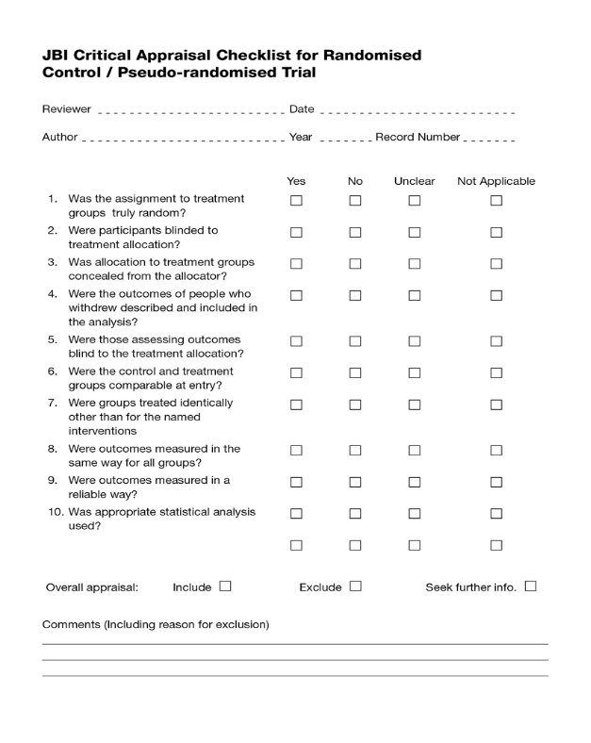

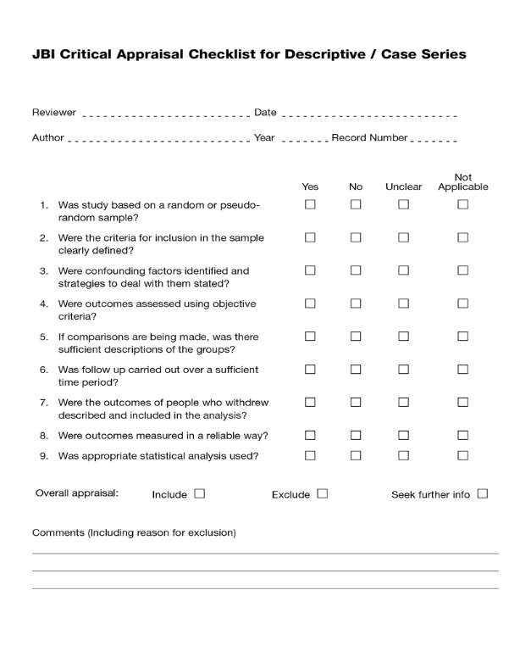

QARI Appraisal instrument

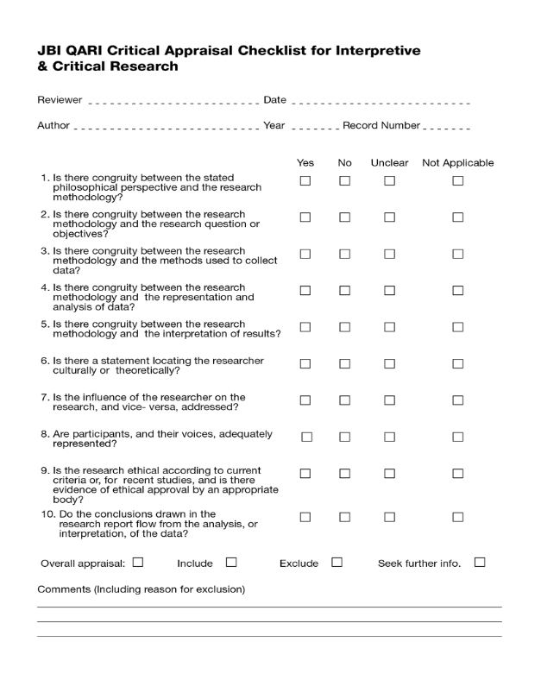

Appendix III Data extraction instruments

MAStARI data extraction instrument
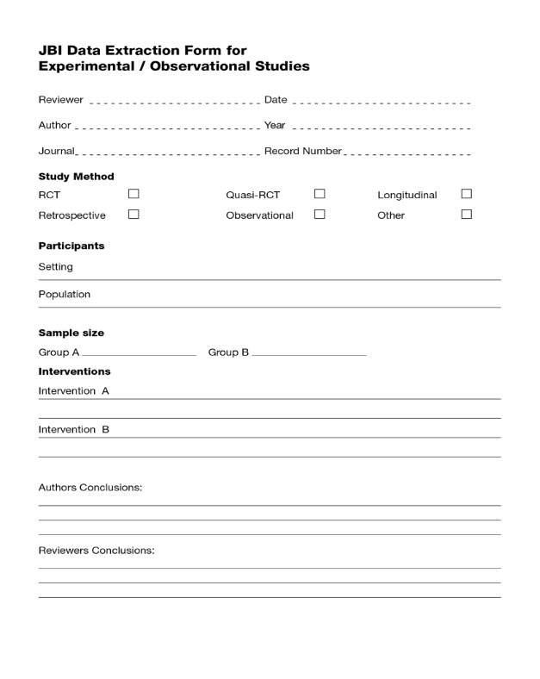

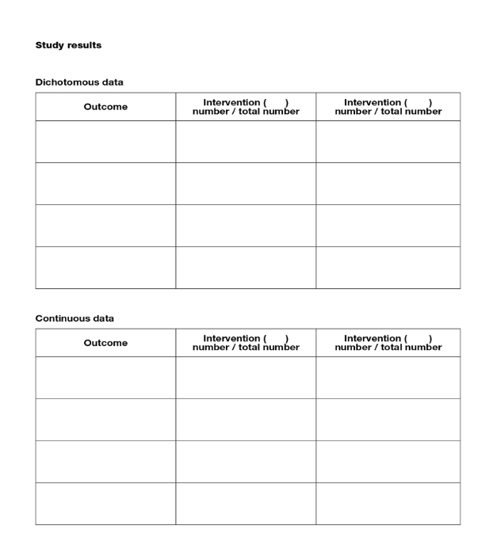

QARI data extraction instrument
