FANCY REPOSITORIES:
THE ARCADES OF LONDON'S WEST END IN THE NINETEENTH CENTURY

In 1900, Ralph Blumenfeld, the American journalist based in London, noted an intriguing West End phenomenon:
Shopkeepers in the Burlington Arcade are again complaining about the obstruction caused at the Piccadilly entrance by the young bloods from Tufnell Park and Acton and Tooting Bec, who congregate there after five o'clock in the afternoon, all dressed up in frock coats, highly polished hat and lavender gloves. They stand tightly wedged together leaning on their gold and silver-mounted sticks, looking bored and imagine that they give the impression to passers-by that they are all heirs to peerages and great estates and are just out for an airing. This afternoon I saw young X., one of our clerks, in the languid group. Now I know why he is always so anxious to get away before five. A strange fad.

What were these young men (drawn from the lower middle-class suburbs) doing dressed up and hanging about in the Burlington Arcade? It is difficult to say. Perhaps they responded to the way in which the arcade was a setting not only for consumption but also for display and emulation. Perhaps the arcade made them feel like blasé young toffs. Perhaps they hoped to attract women or perhaps this was more about male camaraderie and even queer encounter. Perhaps all of the above -- though they were clearly also acting out the figure of the Gent, an aspirational, lower-middle class social type (with an appetite for dandyish flourish) identified from the 1840s onwards as a common figure on the London scene. Just listing some of the possibilities opens up the identities conferred by the Burlington Arcade and London's West End more generally.
In the course of the nineteenth century, the area of central London stretching roughly from Oxford Street in the north to the Strand became the capital's pleasure district. The West End went from being a playground for the elite of Mayfair and St James's to one that provided curiosities and delights to a wider public. By 1900, it offered a constellation of theatres, music halls, restaurants and exhibition centres. It became a laboratory of entertainment and mass culture, setting templates for fashion and style in the modern city. In the West End, centres of entertainment and retail were not just linked by proximity. They contributed to the cultural work of the district. The material culture of the West End helped provide it with a discourse. Money talked. The West End generated constructions of luxury and consumer pleasure which had a dynamic effect on the culture. This is why it has become the subject of a range of important cultural histories which employ it to understand changes in consumerism, sexuality, gender, performativity and identity.
This article concerns the world of the West End arcades and their contribution to turning the area into a pleasure district. They stood for luxury but also for the vicarious pleasures of window shopping and urban spectatorship. Here were spaces to explore what was in fashion and to strut and parade. Buildings have meanings and what I call a psychic charge; they help spectators feel things. West End shops hail viewers by telling them that they are potential consumers, pleasure-seekers, investigators of curiosities, discriminating patrons, bon viveurs. This article seeks to unpack them as cultural statements. In arcades, goods possessed a form of charisma because they described a lifestyle. Thus even window shopping (for those who could not afford the goods) had some satisfactions. They were part of the same cultural project that saw the West End become shaped by monumental theatres. Arcades and the objects they displayed enjoyed a theatricality of their own which complemented West End stages.
Arcade building was a common feature of urban life in the nineteenth century throughout Britain, Europe and beyond. This article will consider the three main arcades built in the West End in the nineteenth century: the Royal Opera Arcade, the Burlington Arcade and the Lowther Arcade. These were different kinds of spaces which helped open the district to differing kinds of publics. The discussion of the Royal Opera and Burlington arcades looks particularly at the period from 1815-1860 (which is under-studied in terms of the history of the consumption). My analysis of the Lowther Arcade takes in this period but moves into the later Victorian period as well. I argue that the first London arcades were an extension of shops aimed at High Society but, with the construction of the Lowther Arcade in 1831, we see the West End opening up to the middle classes. Whilst the Royal Opera Arcade was targetted at male shoppers, the Burlington and Lowther arcades were open to both sexes, creating the conditions for female flâneurie but also for children's consumerism.
As in Paris, arcades offered an experience based upon what H. Hazel Hahn calls 'fleeting impressions, associated with commercial allure'. The kaleidoscopic forms of distraction offered by multiple different shops with different products in arcades helped create a form of metropolitan living based upon the psychological stimulation of capitalist abundance. The urban shopping landscape in the early nineteenth century was diverse including street markets, warehouses, bazaars and auction houses. Arcades were also the products of a distinctly metropolitan experience (found particularly in pleasure districts) based on distraction and the rapid processing of different images.
Fancy goods, formerly the preserve of the aristocracy, could now be afforded by a wider public. This article draws attention to an unstudied form of retail, fancy repositories, which sold knick-knacks and cheap ornaments. Shops with apparently trivial, 'fancy' goods were part of what made pleasure districts pleasurable and marked a new development in popular consumerism.
The literature on consumption is currently in flux. It had been common to see the mid-nineteenth century as a turning point with improved living standards allowing for greater disposable income and hence the construction of a consumer society, evident in the development of department stores. Scholars of the early modern period, however, point to the existence of shopping and consumer culture in the seventeenth and eighteenth centuries. Claire Walsh has shown that many of the features of London retail, once thought to commence in the nineteenth century, were evident as early as the later seventeenth century; for example, the use of elaborate window displays, fixed prices rather than barter, shopping as a cultural activity, the role of shop design in selling and the emergence of spaces exclusively for retail. Upmarket London shops ceased to be workshops with a counter but became focussed on display rather than manufacture or warehousing. Arcades were originally aimed at the bon ton (the Burlington Arcade offered similar services to Old and New Bond Street close by). Their shops made a virtue of their smallness which conveyed exclusivity whilst benefiting from the spectacle of their built environment. Arcades were therefore not entirely new but their project was to feel new and to celebrate the experience of novelty.
What is an arcade? It is a slippery term (a translation of the French word 'passage') and, in the nineteenth century, words such as 'piazza', 'exchange' and 'bazaar' could also be employed to describe these spaces. At a basic level it is a building containing a series of linked arches. The most useful definition comes in architectural historian Johann Geist's magisterial work on the subject: '...a glass-covered passageway which connects two busy streets and is lined on both sides with shops'. The glass roof, in particular, was distinctive, offering the benefits of natural light (alongside gas and oil lamps) for the display of goods. The glass in the shop windows allowed for a clear viewing experience but also reflected the image of consumers in pursuit of goods or just loitering and enjoying the spectacle. The purpose of arcades was straightforward. They allowed consumers relief from poor weather and the inevitable dirt of London streets together with a space where it was possible to enjoy a range of goods and services that were beyond the capacity of any one shop. This made them an important draw for the district during the daytime. They were respectable but, as we will find, contained elements of unrespectable behaviour.
In contrast to London's piecemeal and chaotic urban development, shopping arcades were consciously designed spaces, the work of a single architect's imagination. It was the spectacular nature of its built environment (particularly the glass roof) which made arcades a step forward from early modern shops. By its very nature, each arcade was built at the same time and the shops then leased. Shopping arcades proved amongst the first major buildings created on a monumental scale for the emerging consumer society. For that reason, Walter Benjamin notoriously saw them not only as the dreamworlds of modern capitalism but as building blocks of modernity. Whilst more conventional forms of shop also emerged, arcades were distinctive in appealing to discerning (in other words, elite) consumers, in settings that emphasised individual customer service, deference and respectability. Whilst arcade construction largely came to an end in the 1920s, the building type offered a template for the department stores of the later nineteenth century and the shopping malls and amusement arcades of the twentieth. Moreover, they have been hailed as models for the development of the railway station precinct, the prison and, most obviously, the Great Exhibition.
The arcades were threshold spaces. The gent, the flâneur, the voyeur, the middle-class hostess and shopper: all these types could find something in the arcades. Arcades were contradictory forms of street in that they were not out of doors. Charles Dickens, Henry Mayhew and George Augustus Sala described them as 'arcadian'. They were being ironic. The bustle and noise of arcades was the antithesis of rural simplicity and contentment. However, the image of the 'arcadian' captures something of their appeal. Arcades were (and are) easy to miss and offered a relief from the teeming streets of the metropolis. They therefore flattered a metropolitan notion of being 'in the know' (recognising that all sort of delights lie hidden away down an obscure passage). Their shops offered the feeling of privacy and the delights of the miniature. Arcades had the appeal of the dolls house. They contained the utopian promise of a city in miniature. The shops felt provisional and were often described as 'bays' not buildings. One can link this focus on the miniature to a particular stimulation of desire through creating the simulacrum of a shop. They seemed to reference the fact that shops were usually larger. At the same time, they may also have had a nostalgic feel, containing a folk memory of the early modern shop which was often very small. They managed to combine this sense of privacy and intimacy with what should be its antithesis: conspicuous consumption (objects for display). Geist captures the spatial complexity of arcades: like all shops, they were 'public space on private property'. Shoppers often found they developed a personal relationship with some shops (including those in the arcades) which possessed the authority of providing high quality products and services that recognised social distinctions and hierarchy. Arcades replicated conventional notions about the importance of class.
The arcades were not entirely new. They were a development of the 'exchanges' (such as the Royal Exchange) from the late sixteenth century onwards and the craze for 'bazaars' which started with the one in Soho Square launched in 1816 and the Western Exchange at 10 Old Bond Street in 1819. They also have their roots in spaces for elite promenades such as Vauxhall Gardens. Their nineteenth-century form was inspired by the Parisian passages, memorably described by Walter Benjamin as radiating France's capital city 'like grottoes' from the late eighteenth century onwards. They helped, in his view, to make Paris the 'capital of the nineteenth century'. The arcades should be seen as part of a wider Anglo-French conversation in which new technology and cultural forms criss-crossed the channel in the age of revolution: panoramas, fashionable dress, restaurants, melodrama, the gothic, the serialised novel. The West End arcades were part of a cosmopolitan space that styled itself as enjoying sophistication through offering the best that Paris had to offer. The Parisian imprimatur became a badge of luxury not only in the arcades but in the shops of Regent Street. This was part of the larger process of making London a world city, shaped by international networks of taste, fashion and finance.
But it would be a mistake to describe the arcades as static buildings. Their existence was predicated on the rapid flow of people going in and out: shopping, window shopping, loitering, courting. They constructed shopping as ultimately a pedestrian activity. Shops themselves did not stand still; their displays constantly being reassembled, the seasons bringing new kinds of goods, the shop assistants sometimes changing. If the arcades were emblems of modernity. as Benjamin held them to be, it was partly because of this fluidity and their kaleidoscopic appeal. They were paradigms of the new market economy: invitations to perpetually consume, to gaze at what was new over and over again.
This analysis relies upon contemporary descriptions of the arcades that were part of a wider literature of urban spectatorship, including the work of Mayhew and Sala and the authors of guides to London. All have insights but need to be situated in context. These authors created a distinctive way of seeing the city based in part on their persona as men about town, ready to unravel the mysteries of the city for middle-class readers. This accounts for the lipsmacking tone that creeps in as they describe objects and shopping rituals. These authors were writing about spaces that came to be inhabited by the middle classes and particularly by women. Their ironic tone therefore had the whiff of bohemian condescension coupled with an undeniable male gaze. In their view, arcades were significant urban spectacles but also frivolous. Mayhew's work on shops, in particular, has not been employed nearly as much as London Labour and the London Poor (1851-2). Despite a tone of undeniable boosterism, it tells a different story about the capital's streets from London Labour though it lacks the latter's pathos. It deals with the creation of consumer identities in the metropolis and the delight in shopping that made the metropolitan experience so exhilarating. In contrast to what he accomplished in London Labour, we do not get the voices of shopworkers themselves.
It should be said that there were a number of other West End arcades built in the nineteenth century (but not discussed here for reasons of space). The Royal Arcade connected Old Bond Street to Albermarle Street from 1879 onwards. There was the New Exeter Change which was built in 1842 off the Strand but which only lasted for twenty years. A case can also be made for Covent Garden Market as an arcade but this had a different atmosphere and clientele from the spaces discussed here.

The Royal Opera Arcade

The first West End arcade (and the first in Britain) was almost an accident. It was a by-product of the construction of Regent Street, the dramatic attempt to modernise the centre of London by the Prince Regent and the architect John Nash. It confirmed the centre of London as the centre for the retail of luxury products. The arcades became part of this project. The Royal Opera Arcade was derived from the changes to the King's Theatre (now Her Majesty's Theatre) on the Haymarket. In 1816-18, it was rebuilt to connect the building architecturally with Regent Street. A doric colonnade was built around the block but this created a space that was unfilled at the back of the theatre. The Royal Opera Arcade (designed by Nash and George Repton) was the result in 1817, linking Pall Mall with Charles II Street and running parallel to the Haymarket. It offered a long corridor with eighteen bays of shops on just one side of the passage (which means that, technically, it does not fit with Geist's definition which insists on the importance of shops on both sides of the passage). It later acquired shops on both sides. Circular skylights provided illumination. Accommodation was provided on the upper floors accessed by a staircase at the back of the shops. The link with theatre was important. There was an entrance to the King's Theatre from the arcade (which existed up to 1892) and it offered shops where opera glasses and programmes could be purchased and coats could be deposited. Providing an opportunity to enter the theatre by a special entrance meant that it had a select and exclusive feel. More generally, it began to serve the needs of clubland London in St James's close by. For this reason it was known locally as 'Fop's walk'.
Although it has survived to the present, the arcade was never very successful in commercial terms. In the nineteenth century there were between ten and fourteen shops including wine merchants, tailors, a newsagent and a fishing tackle manufacturer (from where, oddly, it seems to have been possible to buy theatre programmes). A study of London Post Office directories between 1841 and 1901 shows the arcade became quickly identified with bootmakers. In 1901, for example, there were twelve firms listed in the arcade of which six were bootmakers. Only in 1851 was there a moment when, out of thirteen shops, just three were occupied by bootmakers. The vast majority of shopkeepers were male and the arcade clearly serviced a variety of male needs. Gladstone, for example, bought his ties from John Mann English's hosiery shop. Mayhew captured the doleful aspect of the passage, considering it narrow and badly lit. He also noted an intriguing feature of many arcades:

You rarely see anybody walking in this arcade, and to find a person in any one of the shops is a still greater novelty. When strolling up this cheerful alley a few days ago, and looking in at the shop windows, we found ourselves quite an object of curiosity--like strangers in a country town--and caught glimpses of shopmen eyeing us furtively from over the tops of blinds or from behind doors.

This suggests that the arcade was part of an older world of exclusive consumption that had characterised the eighteenth-century West End. It contrasts with the developing nineteenth-century shopping experience: the crowd. Customers in the arcade were scrutinised to see if they were the right sort. Mayhew drew attention to one important detail: a hairdresser's (probably Robert Burgess's establishment) with a 'Brobdignagian shaving-brush in the window'. The deployment of the outsize shaving brush was a form of advertising but this use of Swiftian imagery captures the complexities of scale involved in the arcade (when discussing cacti in Covent Garden, Mayhew calls them 'Liliputian'). They combined miniaturism and gigantism. A comparison of Post Office Directories reveals that only a few shops were enduring. Robert Burgess's hairdresser (listed in 1841) still existed in 1901; having been based initially in number 15, it expanded and took over numbers 14 and 16. Two different bootmakers, James Currie (at number 5) and Patrick Rouse (at number 13) were listed both in 1851 and in 1901. Assorted tailors, chemists, stationers and even (in 1841) a circulating library came and went. London's first arcade appealed to a world of masculine consumption but never really established itself as an iconic space in contrast to the next two arcades under discussion.

The Burlington Arcade

Opening a year after the Royal Opera Arcade, the Burlington Arcade's origins were to some extent accidental and also reflected the creation of Regent Street. There was a need for stately urban development to benefit the bon ton. Lord George Cavendish, owner of Burlington House on Piccadilly, was annoyed that an avenue on the western side of his property was being used by passers-by to throw oyster shells and rubbish into his garden. He therefore decided to enclose the space and commissioned the architect Samuel Ware to turn it into an arcade on the Parisian model with shops. We should see this as an important moment in the creation of luxury shopping. The Western Exchange (built in Tudor style) was erected round the corner at 10 Old Bond Street at about the same time. Piccadilly, like Hyde Park, was an important location for the Mayfair aristocracy to parade and the arcade, launched in 1819, promptly established itself as a venue for the beau monde.
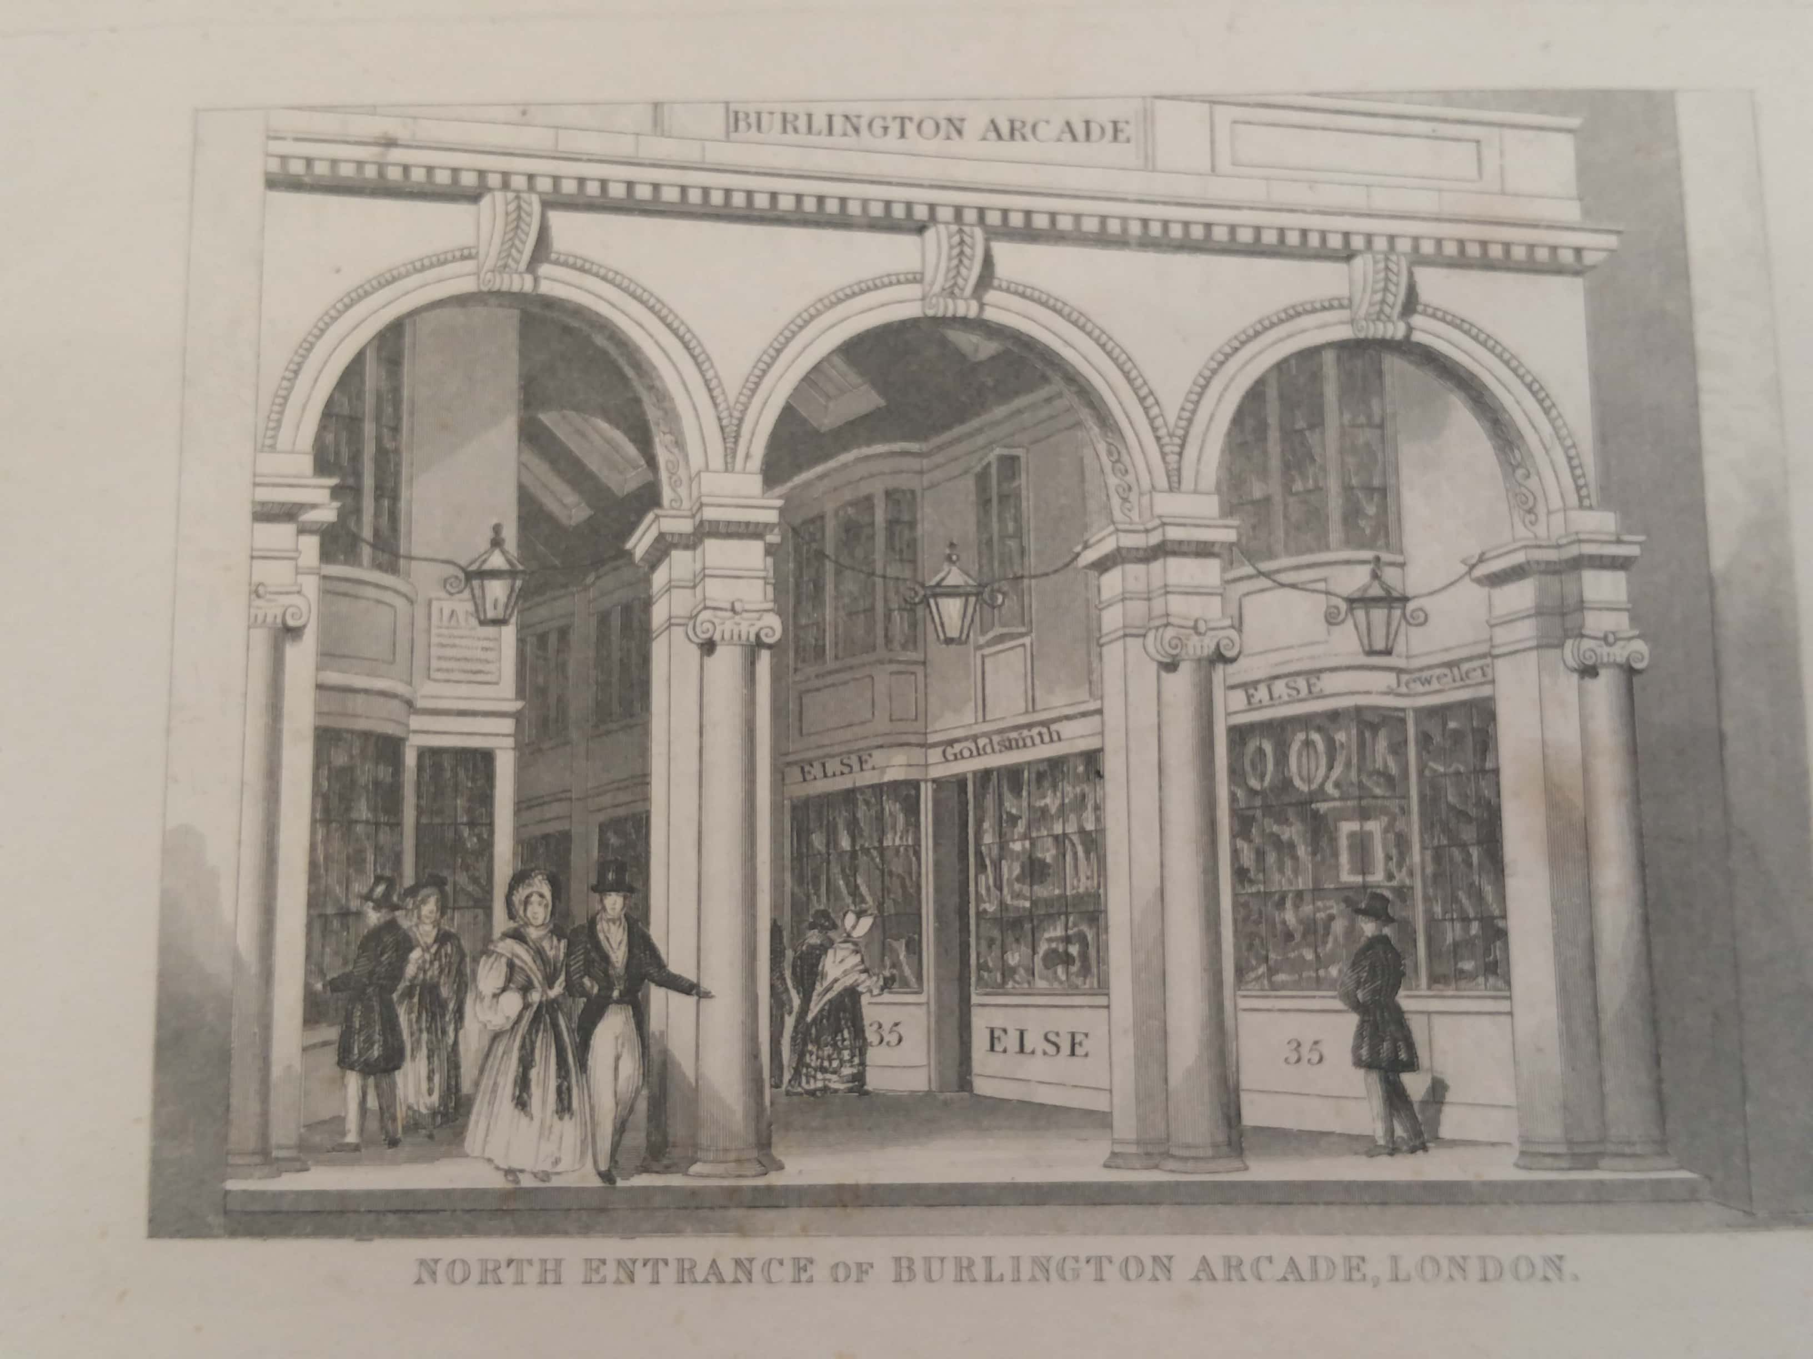
Burlington Arcade
(permission: City of Westminster Archives Centre)
At 585 feet, the Burlington Arcade remains the longest arcade in Britain with entrances on Piccadilly and Burlington Gardens. It also became the prototype of the double-sided passageway (unlike the Royal Opera Arcade) and employed transverse arches, large skylights and flattened bow windows for the shop fronts, a style in vogue during the Regency period. The narrowness of the passage meant that customers could easily view the goods on display and take everything in. It was an instant success and the seventy two units offered for rent were immediately taken up. The smallness of the bays meant that they offered an intimate, even domestic, atmosphere while the beadles on the gates proclaimed that this was a place of safety. With its prime location on Piccadilly it proved a commercial success and inspired the building of refined arcades throughout Britain. Such was its impact that Eliza Vestris recreated it on stage in 1832 for the play The Conquering Game, evidence that it had become a landmark.
Like Regent Street, the Burlington Arcade was intended for luxury. For example, in 1861 it boasted four jewellery shops. In 1849, Perry the hairdresser was paying £175 a year in rent for his two shops. As overseen by the trust that ran it, not anyone could set up shop there. Journalist and man about town, George Augustus Sala noted that its shops 'sold no articles of positive necessity: the useful arts were repellent to Burlingtonian notions of industry: and luxury was almost exclusively purveyed for. Burlington...was intensely aristocratic'. He resorted to list form to convey the impact of shopping in the arcade:

The staple manufactures of this Arcade have been in turns jewellery, fans, feathers, French novels, pictorial albums, annuals, scrap-books, caricatures, harps, accordians, quadrille music, illuminated polkas, toys, scents, hair-brushes, odoriferous vinegar, Rowlands' Macassar Oil, zephyr paletots, snuff-boxes, jewelled whips, clouded canes, lemon-coloured gloves, and false whiskers. Scarcely a fashionable vice, an aristocratic frivolity, or a Belgravian caprice, but had (and has) a representative in the Burlington Arcade.

Mayhew described 'shops for every description of expensive knick knacks' in the Burlington Arcade. This was not entirely true. If we examine the shops that existed many of these offered clothing and hairdressing, which, whilst no doubt high end, went beyond mere knick knacks. What is true is that the clothing sold always went beyond the merely functional. Sala acknowledged that 'Boots and shoes and gloves were certainly sold; but they fitted only the most Byronically small and symmetrical hands and feet; none but the finest and most odoriferous leathers were employed in their confection, and none but the highest prices charged for them'.
Mayhew evoked the scene:

Just pause for a moment before this ladies' shoe shop, and note the varieties of marvellous coverings for the female foot here displayed. How ravishing are those bronze bottines with the patent leather tips; how coquettish those little slippers with the blue rosettes! Look at those Balmorals with the small military heels, so suggestive of 'across country', and just a 'leetle' fast. Sigh for a moment over those tiny boots of white kid, which call to mind many a dazzling deux temps. At any rate, we can see that the damsels of Arcadia go bien gantée et bien chausée, even for the fastidious eye of Paul de Kock.

Mayhew's description contained an implicit reference to the sex workers who frequented the arcade (of which more below). The allusion to the French novelist Paul de Kock, whose slightly racy tales were sold in the arcade, enhanced the atmosphere of Parisian sophistication. William Jeffs's bookshop at number fifteen specialised in the sale of French literature in the mid-Victorian years (so did Frederick Horocastle at number fifty). His shop became a meeting place for French emigrés, often attracted by the supply of books from Paris but also by the anti-Napoleon III propaganda that could be found in the shop. Jeffs sold Balzac, Dumas, Sand and Hugo at a time when popular and literary taste was heavily shaped by France. Lounge lizards from clubland and the London intelligentsia all bought from Jeffs. It was in Jeffs's shop in 1851 that George Eliot met her partner George Henry Lewes.
Some of the visual impact was not just shaped by the distinctive yellow covers of French novels but by the print shops which offered other comparable forms of diversion: 'photographs of celebrities, the highly-coloured prints, the caricatures, and those unaccountable little sketches of ballet girls on tinted paper, which are principally distinguished for intense impudence of face, brevity of petticoat, and development of leg'. The heroine of Mary Elizabeth Braddon’s Lady Audley’s Secret buys French novels from the arcade, a sign that .she would prove to be a femme fatale.
Thomas Babington Macaulay mused in a letter that he was becoming so conceited about his appearance that he found himself 'meditating on the expediency of having my hair cut in the Burlington Arcade, rather than in Lamb's Conduit Street'. Whilst male sartorial elegance was key to the arcade's appeal, it was clearly a more female-friendly area than the Royal Opera Arcade. Post Office Directories reveal that roughly one third of shops were listed under a female name. For example, in 1841, of the fifty three shops listed in the directories, thirty three gave male names, fifteen gave female names (and five gave an initial so that the gender of the owner is unclear). In 1881, of the firms where we can identify the owner's gender, twenty six gave male names and ten gave women's names. There was, however, a decline of women shopkeepers by the end of the century. In 1901, twenty five firms were in male names and just three were female (though eight shops are difficult to identify). Many of the shops were clearly catering to female customers. In 1841, William Mintram at number seven specialised not only in hairdressing but headdresses. Paul Hase at numbers forty and forty one sold ladies shoes and there were a range of milliners, florists, hosiers and specialists in baby linen.
At the same time there was much to please the man about town including shirt makers, tobacconists and men's hairdressers. The arcade was also close to Savile Row which developed its reputation for men's tailoring from the 1840s onwards. Mayhew described the world of men's hairdressing in this way:

you will be assailed by a whiff of perfume, and you will perceive it issues from a hairdresser's, in whose window are displayed the glossiest ivory-backed brushes in the world, looking-glasses, essences for making the hair grow, cunning devices for removing it if superfluous, pots of pomade Hongroise, and bottles of hair oil. Should you be tempted to walk inside you may go upstairs, and be cut, curled, shampooed, oiled, and have your moustachios 'ciréd' to needle-like sharpness.

Mayhew's tone illustrates the conflicted relationship that men had with consumerism and fashion.
The arcade was a controlled space, policed by beadles who enforced regulations. Smoking was forbidden; so was whistling, singing, playing musical instruments and, more surprisingly, the carrying of parcels. Perambulators were not allowed partly because they were pushed by servants who often became the target of soldiers wanting to chat them up.
At another level, the Arcade was an uncontrolled space, which catered to the requirements of the beau monde in less respectable ways. Some French novels and prints were considered pornographic or, at least, not fit for polite society. In the early 1870s, the cross-dressers Ernest Boulton and Frederick Park were frequently seen there in women's clothing. Notoriously, the Burlington Arcade became a location for prostitution, particularly in the later afternoon. Mayhew’s assistant Bracebridge Hemyng found that ‘cyprians of the better sort’ would frequent the arcade and employ a ‘friendly bonnet shop’ to meet men. Hemyng referred to their feet as ‘bien chaussée’; their elegant footwear blending in with the arcade and possibly purchased there. Sex workers relied upon the ‘Paphian intricacies’ of the arcades and employed a series of signals to solicit custom. Respectable men often avoided the arcade in the later afternoon for fear that it might be thought they were looking for prostitutes. The connection with prostitution emerged almost as soon as the arcade came into being. In 1846, the New Swell’s Night Guide to the Bowers of Venus noted that higher class prostitutes would meet in a circumspect way with the bucks of the town. Shopgirls were often ogled by men fresh from their clubs and allegedly were considered as potential sex workers as well. Shop girls by virtue of their gender were deemed a commodity to be traded.
The Burlington Arcades was a performance space. Consumerism, fashion, performance, courtship and spectacle were the stock in trade of the West End. This is why it was crucial in identity formation. The combination of respectable and unrespectable elements meant that arcades exemplified the peculiar atmosphere that the West End came to make its own. At one level, it expressed the values of luxury and decorum. At another level, it stood for the continuation of an eighteenth-century world of aristocratic vice and frivolity, unchallenged by the rise of Victorianism.

The Lowther Arcade

The Lowther Arcade was a very different kind of space although it also owed its origins in part to the architect John Nash; in this case his improvements to reduce traffic congestion on the West Strand in 1829-31. The Lowther Arcade was created as part of a shopping block in 1831 (using a Nash design), a move designed to counter the shift of West End custom further north. It took its inspiration from the Parisian arcades such as the Passage des Panoramas. It was named after Lord Lowther, the former Chief Commissioner of Woods and Forests, and offered twenty five shops and six out on the Strand which it connected with William IV Street. Dickens frequented it. In Conan Doyle's 'The Final Problem', Dr. Watson uses the passage to avoid the henchmen of Professor Moriarty. The arcade lasted till 1901 when Coutts Bank (which is still there) took over the site. The Lowther Arcade differed from the other two arcades because it was in the Strand and hence not so focussed on aristocratic consumption. It provided architectural magnificence while operating as a site open to the middle classes and (importantly) their children.
Not only did it offer shops but it contained early on the National Gallery of Practical Science (also known as the Royal Adelaide Gallery). The Gallery of Practical Science claimed that it was '...established for the practical illustration of general science, and for the reception of works of art, and specimens of the rare production of nature'. Its lower gallery included fossil remains and John Adcock's condensing steam engine whilst the upper floor featured works of art including John Martin's painting of the Fall of Nineveh. This centre of culturally improving works was not a success and was replaced in 1846 by the Casino, one of the first interior dance halls aimed at a non-elite audience. A fifty piece orchestra was conducted by Emile Laurent and admission was one shilling. The Gallery was then taken over by Gatti's restaurant, which became a well known West End landmark.
The Lowther Arcade anticipated the modern shopping mall. In contrast to the Burlington Arcade, this arcade pursued a far more middle-class clientele, a sign of how the West End was changing after the 1830s, no longer seeking to simply please the elite but constructing more democratic forms of pleasure. A contemporary acclaimed its tasteful design (its pendentive cupolas were much admired) but noted: '...the Lowther as far surpasses the Burlington Arcade in its architectural appearance, as it falls short of it in the degree of favour and patronage it receives from the public'.
In its early days, the Lowther Arcade offered a variety of shops. In 1840, there was a tailor, two milliners, a hosier, a perfumier and a hairdresser. However, as early as the 1840s, it became associated with the toy industry. The litterateur Edmund Yates recalled eating buns as a child at Miss Ehrhardt's, the confectioner, and buying toys from John Binge, who combined the toy business with singing tenor in the Cyder Cellars nearby on Maiden Lane. Not only did shops sell toys but there were stalls as well which seemed to take over every inch of the arcade. The Lowther Arcade became such a landmark in the geography of the middle-class child that it generated a children's poem in 1883 that captured the sprawling abundance of goods on display:
Toys are hanging up on strings
Toys are laid in tempting rows
And each shop with pretty things
Is so crammed it overflows.

Punch complained in 1846 that 'It is not pleasant, as you are walking along, to put your foot into a drum, or to fall at full-length upon a tea-tray of children's tea things. The toymakers should be told to take their shops indoors'. Punch's po-faced views were not acted upon.

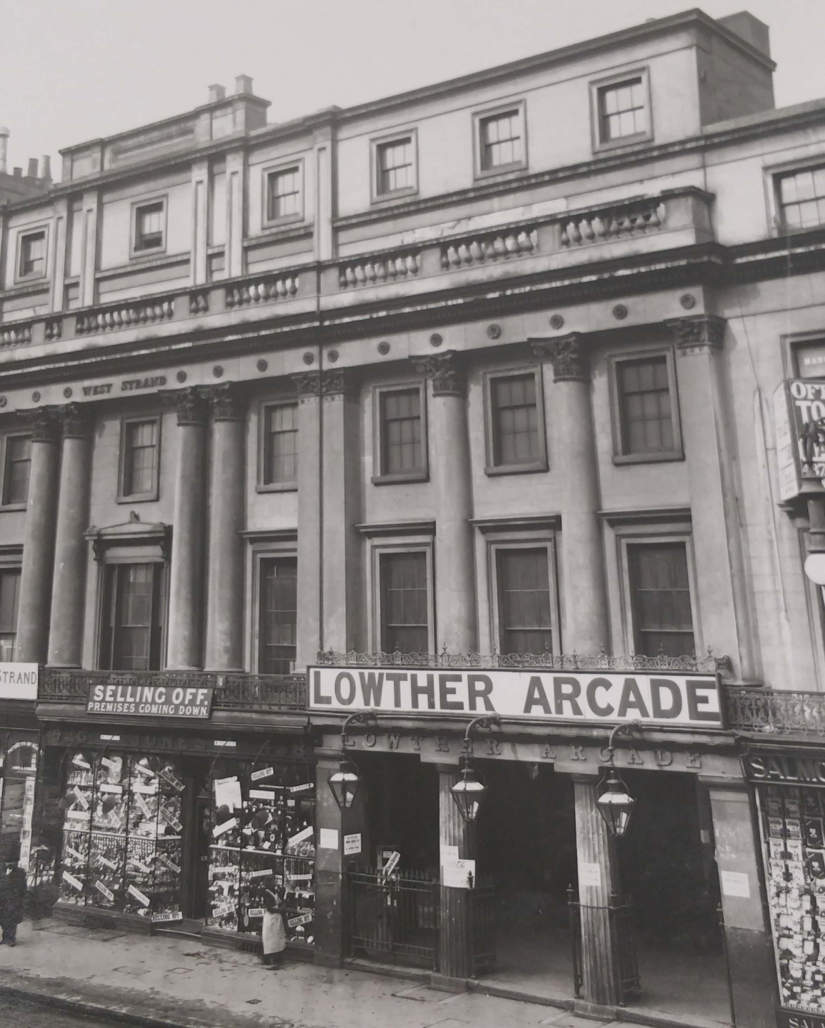

The Lowther Arcade c.1900 (permission: City of Westminster Archives Centre).
The Lowther Arcade became the home of what were called 'fancy repositories'. These often sold toys but would specialise in a variety of knick knacks and other goods including embroidery, pincushions, paper flower making kits and a variety of goods to satisfy people with hobbies. An ngram search reveals that the use of the term 'fancy repository' spiked dramatically in the 1860s. In 1861, of the nineteen shops listed in the Post Office Directory, eleven called themselves 'fancy repositories'. Twenty years later, in 1881 of the eighteen shops listed, fourteen employed this term. The term 'fancy' is significant as a form of self presentation in retail. It carries implications about the delights of arbitrary caprice, of fantasy, of the ornate, of the unusual, the special and the entertaining. The term was used by many shops throughout Britain (especially those appealing to the tourist trade). However, the term helped develop the discourse of the West End as a pleasure district, containing as it did the possibilities of the exotic. Mayhew recalled the prevalence of purses, cheap Bohemian glass and vases of flowers under glass cases. He reflected:
'These trinkets are much affected by the modern Arcadians, and have this advantage, that they are very cheap and do not last long'.

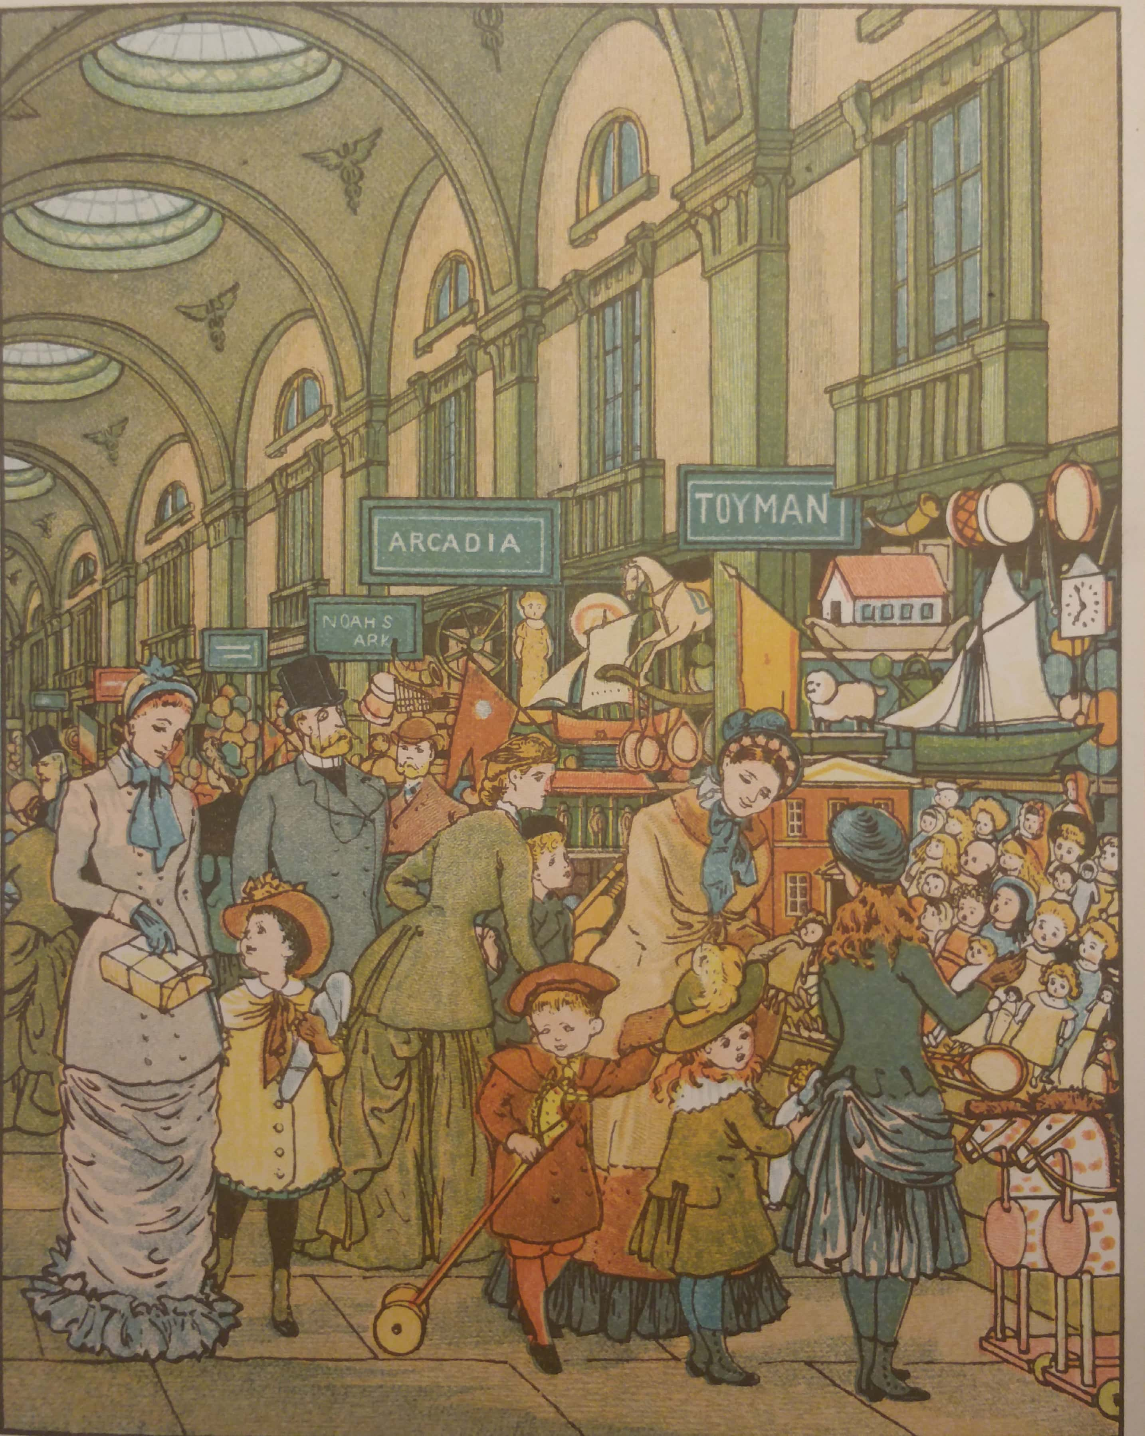

The Lowther Arcade (from Thomas Crane and Ellen Houghton, London Town (London: Marcus Ward, 1883) (author collection)
The Lowther Arcade helped open up the West End to children (or, more precisely, the children of the middle classes). Indeed, one way the West End drew middle-class people in was through their children. In the 1830s, childhood was a category still (in a sense) denied to the children of the poor because of immiseration and the need to work. Working-class children in London were almost as likely to manufacture and sell toys as to play with them in the early Victorian years. The Lowther Arcade significantly emerged at the same time as the pantomime became increasingly directed at children and helped endow the West End with a peculiar kind of enchantment and iconic register. At Christmas, there would be additional toy stalls and the whole place would be lit in a magical way to make a comforting and enticing space for children. Frederick Willis recalled visiting it as a child in the 1890s when it 'was one of the sights of London, and at Christmas time a veritable children's paradise'. What was particularly appealing about the arcade was its tactile quality: Willis remembered that the shopgirls would allow children to handle all the toys. It was a space based on pester power. The world of the toy often represents an adult view of what children want. At the same time, memories of the arcade suggest that the arcade was based on a negotiation between adult and child. The adult did the purchasing while desperately trying to please a child or to construct their preferences. One contemporary remembered 'the youngsters with their parents and guardians on the self-same errand as my own, to buy something for a boy or a girl, and the difficulty of choosing the right thing. It was a much easier task for me to select a wedding present for my dear Dick's mother...'. This was an important space for the creation of children's consumerism.
London was unusual in having toy shops as early as the later eighteenth century (Hamley’s began as a shop on High Holborn in 1760 before moving to Regent Street in 1881). The British toy market was heavily dominated by goods made in France, Germany and Switzerland. The toys sold in the arcade were notoriously cheap (so cheap that the arcade was never seen as a huge retail success). Spending Christmas at Lady Ashburton's in 1851, Jane Welsh Carlyle found she was able to buy presents for the forty eight children at the gathering for just two pounds twelve shillings and sixpence at the arcade which she called 'the most rubbishy place in London'. Sala was more charmed, constructing an elaborate list of the plenitude available to children:

'French toys, fierce toys, warlike toys, smelling of Young France, and glory, and blood--such as minature cannon, lancers, sabretasches, war steamers armed en flute, sabres, muskets, shakos, and tri-coloured flags surmounted by the resucitated Eagle of France. German toys, which like everything else coming from Deutschland, are somewhat quaint, and somewhat eccentric, and a touch misty: for example, queer old carved men and women, in queer attitudes, and animals whose anatomy is likewise of the queerest kind, and yet who have a queer expression of life and animation about them. Tortuous game, played with hammers and dice, and bells, and little men, which remind you somehow, you know not why, of Rhine Schlosses, and Gnomes and Undine and Albert Durer's mailed knights.... And who but the Germans too, would make long panoramas and dioramas opening in the accordion and collapsing manner, and strange monsters in boxes? An infinity of other jou-joux, such as India-rubber balls, whips of all shapes and capacities for chair or cock-horse flagellation, skipping ropes, flutes, spades, rakes and hoes: all these are to be found in the toy department of the Lowther Arcade'.

Sala’s description of the German toys suggest that they were examples of a popular gothic aimed at children. France was also often associated with mechanical toys. Mayhew had similar memories:

Here and there, scattered about in this chaos of toydom, may be seen angular and unyielding Dutch dolls, ninepins, Jews'-harps, money-boxes, destined to be often locked and so soon broken open, teetotums, shilling Noah's arks, with the dove so very large that you always have to turn it sideways to get it out, boxes of dominoes, and the magnet and duck, which, by the way, is the only scientific toy we can tolerate.

Toys on religious themes were significant. The original name for Hamley’s was Noah’s Ark.
Toys were aimed at the senses; hence the number of musical instruments. One contemporary remembered 'the hum and music of it; the toy trumpets, the accordions, the strips of melodious glass that you played upon with a little hammer'. The appeal of Lowther Arcade toys was their simplicity. These were 'real old-fashioned toys--none of your costly models of scientific contrivances, which require a course of physics and pneumatics before you can understand them'. Images of war, history, the domestic, the homely and the natural world represented adult strategies to imagine childhood. They often represent adults' nostalgia and memories of their own childhood. At the same time, toys and the places where toys were bought were vital in character formation, providing children with a kind of education and emotional vocabulary. They stimulated desires and helped turn young people into consumers.
The arcade's smell of sawdust and lavender was a persistent memory for those who shopped there. At the same time, the fancy repositories also offered cheap items for the adult market: Bohemian glass, gaudy vases of flowers under glass cases, pins, rings and brooches. These were jewels and ornaments for a wider public not shaped by the rigours of elite taste.
On the opposite side of the Strand from the Lowther Arcade was the Lowther Bazaar. This complemented the arcade but offered cheap spectacle informed by what seems to have been an orientalist aesthetic. There were stalls but also a magic cave, a water fountain, a Chinese pagoda, a Parisian saloon with a revolving ceiling showing signs of the zodiac. The owners claimed between five and six thousand visitors a day.
The iconic nature of the Lowther Arcade can be measured by its presence in pantomime and popular song. In 1866, Astley's offered Hush-a-by Baby on the Tree Top; Or, Harlequin Fortunio, Prince Heydiddle, Princess Olivebranch, King Frog of Frog Island, and the Magic Toys of Lowther Arcadia. It offered children the exquisite fantasy of the toys coming to life. In 1880 the Drury Lane pantomime, Mother Goose and the Enchanted Beauty, featured a magical visit to the Lowther Arcade (at the other end of the Strand from the theatre), the occasion for a ballet of toys and dolls. In 1891, Drury Lane's Humpty Dumpty featured a princess summoning the dolls and toys from the Lowther Arcade to come and dance before her. The creators were obviously confident that the arcade was part of children's geography, a location they all recognised. A popular music hall number was 'The Tin Gee Gee' (alternative title: 'The Lowther Arcade') composed by Fred Cape in 1891. It was particularly popular at the Gaiety Theatre round the corner but survived in the repertoire of music hall. It was presented through the words of a man strolling through the arcade encountering a talking tin soldier who complains:

There's a pretty little dolly-girl over there,
and I'm madly in love with she
But now that I'm only marked one-and-nine
she turns up her nose at me.

The man puts a label marked two and three on the soldier and immediately the doll perks up and shows an interest. One could read it as an infantilised version of the courtship rituals between soldiers and young women that regularly took place in the West End. The switching of the labels was expressed as a naughty but pardonable misdemeanour to make sure that the path of true love conquered all. The singer then reveals:
And it's so in this world, for I'm in love
with a maiden of high degree
But I'm only marked one-and-nine,
and the other chap's two-and-three
And a girl never looks at a one-and-nine
with a possible two-and-three.

The ongoing popularity of this song may have been part of the increasing sentimentality about the innocence of childhood in the late Victorian years. However, the lyrics suggest that the toys of the Lowther Arcade had other meanings as well. They provided metaphors for courtship, for consumerism and for class.

Conclusion

This article has shown that arcades were an important part of the making of the Victorian West End. They were also integral to the development of consumer society, nursing desires and shaping an appetite for commodities. The Royal Opera Arcade came to service the male elite of St James's but the Burlington Arcade proved a more public space, providing luxuries for elite men and women as well as a place to be seen. The Lowther Arcade, however, represented a widening appeal to the middle class which it accomplished partly through its children. It contrasted with the other two because the West End itself was changing as middle-class people were able to access its goods and services.
We have considered two kinds of objects: the high end luxury goods provided in the Burlington Arcade as well as the Royal Opera Arcade (a combination of skilled workmanship and snob value) and the cheap knick knacks of the Lowther Arcade. Both epitomised the range of goods that drew people to the West End. Sala caught something of the low rent appeal offered by Lowther Arcade jewellery: ‘The Lowtherian brilliants may not be of a water so fine as those of Regent Street or Cornhill; but the jewellery of my Arcade is as sparkling and as showy, as gay and variegated, as any assemblage of gems you like to mention...’. The Lowther Arcade offered ‘sparkle’ and colour even though the sub-text of Sala’s remarks are that they offended against developing notions of taste.
The fancy repository is an unstudied form of retail and yet clearly marked an important moment in the development of consumer culture. It would be replaced by the conventional toy shop and by shops aiming to provide goods for tourists and hobbyists. Nevertheless, it was a site for the sale of cheap goods that appealed to the growing middle class.
Arcades were, however, a transitional form. They would be eclipsed by the department store from the mid-nineteenth century onwards. In any case they never became as common in London as they were in Paris. Where they survived, it was partly because of their nostalgic feel. As we have seen, the arcades were places made from social distinction and varying forms of cultural capital, branding the West End as a site for conspicuous consumption. Ultimately, it was the aristocratic arcades (Royal Opera and Burlington) that survived. The more middle-class Lowther Arcade did not though it enjoyed a prime site on the Strand opposite Charing Cross Station As was observed above, it had never been hugely profitable. By the time of its demise, department stores were becoming a more attractive alternative.
The fantasies offered by the arcades also helped make the area into one offering a form of enchantment that contrasted with the domestic sphere. The objects sold were loaded with prestige and notions of luxury. They offered the opportunity for less well off people to come and observe the rich and to emulate them. This is what may have drawn in young 'bloods' from all over London to parade in the Burlington Arcade. Arcades enjoyed multiple forms of cultural impact, dissolving boundaries between different parts of London whilst also creating new forms of social distinction.

Ralph D. Blumenfeld, R.D.B.'s Diary, 1887-1914 (London: Heinemann, 1930), 110. My thanks to Kelly Boyd, Richard Dennis, Matthew Ingleby, Alastair Owens, the two referees and the City of Westminster Archives Centre for assistance. Geolocation: 51°30'33.3"N 0°08'25.0"W (Burlington Arcade).
Albert Smith, The Natural History of the Gent (London: D. Bogue, 1847).
For key recent cultural histories that include the West End, see Christopher Breward, The Hidden Consumer: Masculinities, Fashion and City Life, 1860-1914 (Manchester: Manchester University Press, 1999); Lynda Nead, Victorian Babylon: People, Streets and Images in Nineteenth Century London (London: Yale University Press, 2000); Erika Diane Rappaport, Shopping for Pleasure: Women in the Making of London’s West End (Princeton, NJ: Princeton University Press, 2000); Matt Houlbrook, Queer London: Perils and Pleasures in the Sexual Metropolis, 1918-1957 (Chicago: University of Chicago Press, 2005); Frank Mort, Capital Affairs: London and the Making of the Permissive Society (London: Yale University Press, 2010); Jacky Bratton, The Making of the West End Stage: Marriage, Management and the Mapping of Gender in London, 1830-1870 (Cambridge: Cambridge University Press, 2011); Julia Laite, Common Prostitutes and Ordinary Citizens: Commercial Sex in London, 1885-1960 (Basingstoke: Palgrave Macmillan, 2012); Judith R. Walkowitz, Nights Out: Life in Cosmopolitan London (London: Yale University Press, 2012).
Johann Friedrich Geist, Arcades: The History of a Building Type (Cambridge, MA: The MIT Press, 1983); Margaret MacKeith, Shopping Arcades: A Gazeteer of Extant British Arcades (London: Mansell, 1985); Margaret MacKeith, The History and Conservation of Shopping Arcades (London: Mansell, 1986); David L. Pike, Metropolis on the Styx: The Underworlds of Modern Culture, 1800-2001 (Ithaca: Cornell University Press, 2007), 238-243; Michael Hollington, 'Dickens, Sala and the London Arcades', Dickens Quarterly, 28 (2011), 273-284.
H. Hazel Hahn, Scenes of Parisian Modernity: Culture and Consumption in the Nineteenth Century (Basingstoke: Palgrave Macmillan, 2009), p. 46.
Thomas Richards, The Commodity Culture of Victorian England: Advertising and Spectacle, 1851-1914 (London: Verso, 1990); Lori Anne Loeb, Consuming Angels: Advertising and Victorian Women (New York: Oxford University Press, 1994); Rappaport, Shopping for Pleasure.
Linda Levy Peck, Consuming Splendour: Society and Culture in Seventeenth-Century England (Cambridge: Cambridge University Press, 2005); John Styles, The Dress of the People: Everyday Fashion in Eighteenth Century England (London: Yale University Press, 2008). An up-to-date analysis of consumption history can be found in Peter Gurney, The Making of Consumer Culture in Modern Britain (London: Bloomsbury, 2017).
Claire Walsh, 'Shop Design and the Display of Goods in Eighteenth Century London', Journal of Design History, vol. 8 no. 3 (1995), pp. 157-176; See also Hoh-Cheung Mui and Lorna H. Mui, Shops and Shopkeeping in Eighteenth-Century England (Kingston: McGill-Queen's University Press, 1989). Much of this literature is informed by Neil McKendrick, John Brewer and J.H. Plumb, The Birth of a Consumer Society: The Commercialisation of Eighteenth Century England (London: Europa, 1982).
Geist, Arcades, 4.
Walter Benjamin, The Arcades Project (trans. Howard Eiland and Kevin McLaughlin) (Cambridge, MA: Harvard University Press, 1999).
Alison Adburgham, Shops and Shopping, 1800-1914: Where, and in what Manner the Well-dressed Englishwoman Bought her Clothes (London: Barrie and Jenkins, 1989 [1964]); Kathryn A. Morrison, English Shops and Shopping: An Architectural History (New Haven and London: Yale University Press, 2003).
Geist, Arcades, vii, 28, 54.
Charles Dickens, 'Arcadian London' in Charles Dickens, Reprinted Pieces: The Uncommercial Traveller and other Stories (London: The Nonesuch Press, 1938), 444-452; Henry Mayhew (ed.), The Shops and Companies of London and the Trades and Manufactories of Great Britain (London: Strand, 1865), 100-2; [George Augustus Sala], 'Arcadia', Household Words, 7 (1853), 376-382.
Susan Stewart, On Longing: Narratives of the Miniature, the Gigantic, the Souvenir, the Collection (Baltimore: John Hopkins University Press, 1984).
Geist, Arcades, 4.
See Rohan McWilliam, ‘The Bazaars of London’s West End in the Nineteenth Century’ in Kate Lister and Helen Kingstone (eds.), Paraphernalia!: Victorian Objects (London: Routledge, 2018), 17-36; Morrison, English Shops and Shopping, 93-4.
Benjamin, Arcades Project, 874.
See Katharina Boehm and Josephne McDonagh (eds.), 'New Agenda: Urban Mobility: New Maps of Victorian London', Journal of Victorian Culture 15 (2010), 194-267.
The Pictorial Handbook of London (London: Henry G. Bohn, 1854), 264.
Geist, Arcades, 318.
The Post Office London Directory (London: Frederick Kelly, 1901), 713.
The Post Office London Directory (London: Frederick Kelly, 1851), 419.
Geist, Arcades, 318.
Mayhew, Shops, 101.
Mayhew, Shops, 102.
'Domestic Occurrences' Gentleman's Magazine, 87 (Sept 1817), 272.
Morrison, English Shops and Shopping, 94
Morrison, English Shops and Shopping, 43,
Jane Rendell, 'Gendered Space: Encountering Anthropology, Architecture and Feminism in the Burlington Arcade', Architectural Design, 66 no. 11/12 (1996), 60-63; Jane Rendell, 'Subjective Space: A Feminist Architectural History of the Burlington Arcade' in Duncan McCorquodale, Sarah Wigglesworth and Katerina Ruedi (eds.), Desiring Practices: Architecture, Gender and the Interdisciplinary (London: Black Dog, 1997), pp. 216-233.
Sybil Rosenfeld, A Short History of Scene Design in Great Britain (Oxford: Basil Blackwell,1973), 112-3.
Peter Cunningham, A Handbook for London, Past and Present (London: John Murray, 1849), vol. I, 153.
[Sala], 'Arcadia', 376-7.
Mayhew, Shops, 101.
[Sala], 'Arcadia', 376.
Mayhew, Shops, 101.
Juliette Atkinson, 'William Jeffs, Victorian Bookseller and Publisher of French Literature', The Library: The Transactions of the Bibliographical Society, seventh series, 13 (2012), 258-278.
Mayhew, Shops, 101.
George Otto Trevelyan (ed.), The Life and Letters of Lord Macaulay (London: Longman, 1908), p. 229.
Mayhew, Shops, 101; see also [Sala], 'Arcadia', 377.
Juliette Atkinson, French Novels and the Victorians (Oxford: Oxford University Press, 2017)
Neil McKenna, Fanny and Stella: The Young Men who shocked Victorian England (London: Faber and Faber 2014).
Henry Mayhew, London Labour and the London Poor (New York: Dover, 1968 [1861-2]) Vol. 4, 217, 222.
Pike, Metropolis on the Styx, 239.
Jane Rendell, ‘”Industrious Females” & “Professional Beauties”, or, Fine Articles for Sale in the Burlington Arcade’ in Iain Borden et al (eds.), Strangely Familiar: Narratives of Architecture in the City (London: Routledge, 1996); Jane Rendell, ‘Thresholds, Passage and Surfaces: Touching, Passing and Seeing in the Burlington Arcade’ in Alex Coles (ed.) The Optics of Walter Benjamin (London: Black Dog, 1999), 168-91.
Gillian Piggott, Dickens and Benjamin: Moments of Revelation, Fragments of Modernity (Farnham: Ashgate, 2012), 152.
Examiner, 25 May 1834, 329.
National Gallery of Practical Science, Blending Instruction with Amusement: Catalogue for 1833 (London: J. Homes, 1833).
Standard, 6 October 1846, p.1; Edmund Yates, Recollections and Experiences (London: Richard Bentley, 1884), vol. 1, 137. On the Adelaide Gallery, see Jo Briggs, 'Gavarni at the Casino: Reflections of Class and Gender in the Visual Culture of 1848', Victorian Studies, 53 (2011), 639-664.
Lloyd's Weekly London Newspaper, 2 April 1848, p. 6.
'Ralph Redivivus', 'The Lowther Arcade', The Civil Engineer and Architect's Journal, vol. 2, March 1839, 83.
Robson's London Directory (London: William Robson, 1840), 201.
Edmund Yates, Recollections and Experiences (London: Richard Bentley, 1884) vol.1, 135; Lewis Melville, The Life of William Makepeace Thackeray (ed. Richard Pearson) (London: Routldge, 2016 ), 106.
Thomas Crane and Ellen Houghton, 'The Lowther Arcade', London Town (London: Marcus Ward, 1883), 52.
Punch, Or the London Charivari, 11 (1846), 96.
Linda Cluckie, The Rise and Fall of Art Needlework: Its Socio-Economic and Cultural Aspects (Bury St Edmunds: Arena Books, 2008), 68.
https://books.google.com/ngrams/graph?content=fancy+repository&year_start=1800&year_end=2000&corpus=15&smoothing=3&share=&direct_url=t1%3B%2Cfancy%20repository%3B%2Cc0 (accessed 10 April 2015).
Post Office London Directory (London: Kelly, 1861), 451; Post Office London Directory (London: Kelly, 1881), 452.
Mayhew, Shops, 101.
Dennis Denisoff, 'Small Change: The Consumerist Designs of the Nineteenth-Century Child' in Dennis Denisoff (ed.), The Nineteenth Century Child and Consumer Culture (Aldershot: Ashgate, 2008), 9, 10.
Frederick Willis, A Book of London Yesterdays (London: Phoenix House, 1960), 59.
J. Holden MacMichael, The Story of Charing Cross and its immediate neighbourhood (London: Chatto and Windus, 1906), 119.
Denisoff, 'Small Change', 1-25.
Kenneth D. Brown, The British Toy Business: A History since 1700 (London: Hambledon, 1996).
Jane Welsh Carlyle to Helen Welsh, 27 December 1851: Charles Richard Sanders (ed.), The Collected Letters of Thomas and Jane Welsh Carlyle (Duke, NC: Duke University Press, 1970-), vol. 26, 280-81.
[Sala], 'Arcadia', 380
Mayhew, Shops, 101
MacMichael, The Story of Charing Cross, 119.
Mayhew, Shops, 100
J. Holden MacMichael, The Story of Charing Cross, 119.
J. Holden MacMichael, The Story of Charing Cross, 119-20. On the Lowther Bazaar, see Rohan McWilliam, ‘The Bazaars of London’s West End in the Nineteenth Century’.
Era, 23 December 1866, 10 (my thanks to Peter Yeandle for drawing this to my attention).
Jeffrey Richards, The Golden Age of Pantomime: Slapstick, Spectacle and Subversion in Victorian England (London: I.B. Tauris, 2014), 336, 370.
Leslie Daiken, Children's Toys Throughout the Ages (London: Spring Books, 1963), 172
'The Tin Gee Gee': http://monologues.co.uk/musichall/Songs-T/Tin-Gee-Gee.htm (accessed 8 April 2015).
[Sala], 'Arcadia', 380.

