Tensile lap-shear and flexural behaviour of aluminium metal foil parts made by composite metal foil manufacturing

ABSTRACT
This paper deals with the production and experimental investigation of very thin aluminium 1050 grade foil products. Single lap joints and samples for flexural testing were made using Composite Metal Foil Manufacturing (CMFM) using a special brazing paste. The effect of test speeds, material thickness and lap lengths on aluminium 1050 single lap joints was analysed. The test results showed that all the samples failed within the parent metal and the bond created during the process remained intact. Two distinct modes of failure were observed for the single lap joints. Microstructural analysis was carried out to analyse the efficacy of the paste in terms of creating a strong bond between the metal foils. Comparative three-point flexural testing was conducted using a part made by conventional machining method and another made by CMFM. The results showed that the part made by CMFM has 7.7% higher load values compared to the part made by the machining method. Both the samples exhibit similar elastic and plastic regions but CMFM part also shows higher strength. The results validate the effectiveness of CMFM and demonstrate its capabilities in terms of repeatability, reproducibility and strength.

Keywords: brazing; lap shear test; three-point flexural test; microstructure; metal foils

Introduction
Additive Manufacturing (AM) encompasses several methods capable of delivering products in a wide variety of materials. Their popularity is largely based on their ability to produce complex shapes and geometries that are very difficult or sometimes impossible to make using traditional subtractive/machining techniques. AM has managed to create a stronghold across several industrial sectors including aerospace, medical, automotive, defence etc., by manufacturing products from varied materials such as polymers, metals, ceramics and composites (metal/metal and metal/plastic), to name a few [1-5]. Over time, the focus has shifted from prototypes to mass scale production of parts that can be used in the real world. For that reason, the methods dealing with the production of metal parts have been at the centre of cutting edge research for years and will continue to do so in the future as well. Although the research has proved to be effective and has managed to minimise several limitations related to the manufacture of metal parts using AM methods, there has always been an inclination towards the development of new processes. It is partly because the existing methods have been widely researched and there is not a lot of room for improvements in terms of processing capabilities [6-10]. In addition to that, the metal AM methods are expensive to work with; from the cost of raw materials (metallic powder and metal wire) to the maintenance and running of machines [11, 12]. This has led to the development of processes that don’t make use of powdered metal (or metal wire) but a cheaper alternative i.e., metal foils. Two notable methods making use of metal foils to offer cost-effective alternatives are Ultrasonic Consolidation (UC) and Composite Metal Foil Manufacturing (CMFM). These methods have been undergoing a great deal of research at Loughborough University and Anglia Ruskin University respectively. They have managed to produce satisfactory results despite making use of sheet metal [13, 14]. UC is a hybrid method of manufacturing as it employs both additive and subtractive methods to produce parts. However, the biggest challenge for this process is the optimization of its operational parameters – weld speed, weld pressure and sonotrode oscillation amplitude to achieve successful bonding of the metal foils [15]. CMFM on the other hand is a purely additive method that makes use of a special brazing paste for joining purposes [16, 17].
For this research work, two distinct types of products were produced and tested. The first were the single lap joints because they form the starting step in analysing the strength of the joints formed by CMFM. The primary function of a joint is to transfer load from one structural member to another. Therefore, knowing the load that could be transferred is important before producing a functional component. In this study, we report on lap-shear testing of aluminium 1050 single lap joints at various cross-head speeds, foil thickness and lap lengths. The test results were compared to the work done by Kong, Soar and Dickens to analyse the effectiveness of the two processes to produce aluminium single lap joints [18]. Microstructural analysis of two layers brazed together helps to analyse the proportion of bonded to un-bonded area. Flexural testing samples were produced using conventional machining method and CMFM method. The composite sample made by CMFM is a multi-layer product with brazing on both sides of the foil which will help in an in-depth analysis of the bond strength.

Materials and Manufacturing Process
In this research work, aluminium 1050 grade foils with a H14 ½ hard temper of varying thicknesses (50 microns, 100 microns and 200 microns) were used to produce single lap joints and flexural testing samples (50 microns). The foils were cut and tested based on the dimensions and parameters indicated in British and International standards. The foils were coated with 80% zinc and 20% aluminium brazing paste (operational temperature 410-470 °C) and then sandwiched between two stainless steel plates fitted with nuts and bolts. A torque wrench was utilized to ensure uniform thickness (100 microns) of the paste between the testing samples. The foils did not receive any surface treatment to help the removal of the oxide layer and enhance the bond strength. The foils coated with paste between stainless steel plates were inserted in a chamber furnace (Carbolite CWF1200 that contains two side mounted, free radiating elements to ensure rapid heat up) and heated for a fixed amount of time. Afterwards, the plates were removed from the furnace and allowed to cool so that the sample could be taken out. Several single lap joints were made with different foil thicknesses and lap lengths. A couple of flexural testing samples were also made, one using the principles of CMFM and the other from conventional machining methods.

Experimental Methodology

Tensile Lap-Shear Test
For tensile lap-shear testing, INSTRON 5582 Universal Testing Machine was used and BS EN 1465: 2009 [19] was referred. Single lap joints of various foil thicknesses and lap lengths were made. The machine was operated at various speeds (10mm/min, 50mm/min and 100mm/min) until the samples were fractured. The dimensions of the single lap joints are shown in Fig. 1.
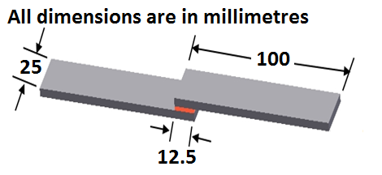
Figure 1: Dimensions of lap-shear testing sample

Microstructural Analysis
The aim of this test was to examine the effectiveness of the paste by analysing the proportion of bonded to unbounded area in a sample. This implies that if the proportion of the brazed zone is high then the bond created between the foils will be stronger and vice versa. It was important to examine the cross-section of the single lap joints; therefore, samples were cut from the brazed area which is only 12.5mm in length and 25mm in width. The samples were taken approximately 3mm from the brazed edges of the foils as shown in Fig. 2. The samples were then mounted one by one on the platform of the scanning electron microscope (SEM) for analysis.
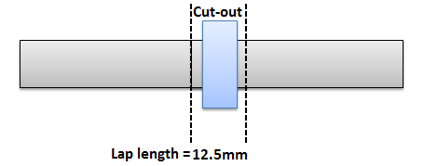
Figure 2: Cut-out of the lap-shear testing sample for SEM analysis

Three Point Flexural Test
A three-point flexural test sample was made using the principle of CMFM by following BS EN ISO 7438-2016 [20]. The composite sample made by CMFM was tested and then compared to the same shaped sample machined out of a solid aluminium block. The schematic of the flexural test is shown in Fig. 3. The test was carried out using one former and two supports (20mm diameter). The composite sample was made up of 20 metal foils and 19 paste layers arranged one after the other so that apart from the first and last foils, all the other metal foils will have a layer of paste on both sides. The sample was 100mm in length, 25mm in width and 3.9mm in thickness.
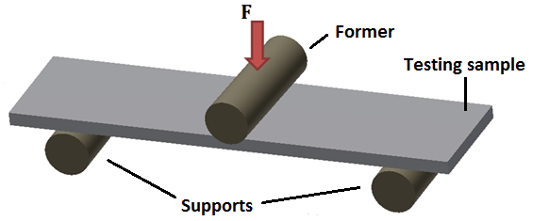
Figure 3: Schematic of the flexural test

Results and Discussion

Results from tensile lap-shear test
The lap-shear test was conducted to study the effect of three parameters on the aluminium 1050 single lap joints:
- Test Speed: Samples at an overlap length of 12.5mm subjected to cross-head speeds of 10mm/min, 50mm/min and 100mm/min.
- Material Thickness: Samples of 50 microns, 100 microns and 200 microns thickness at an overlap length of 12.5mm subjected to a speed of 10mm/min.
- Lap Length: 10mm thick samples were subjected to cross-head speed of 100mm/min at overlap lengths of 3mm, 6mm and 12mm.

Effect of test speed
The single lap joints made from 100 microns thick aluminium foils were tested. The samples fractured within the parent metal and not at the brazed region. It shows that the joint made by CMFM is stronger than the metal itself which is understandable as in tensile testing, samples failed at locations with minimum cross-sectional area. Factors such as lap joint length, gauge length and asymmetric loading were taken into consideration and appropriate precautions were taken to ensure consistent results were achieved. BS EN ISO 10365:1995 [21] was used to record the failure modes of the samples. The failure pattern was always substrate failure (SF). Fig. 4 shows the test results of the single lap joints carried out at different speeds.

Figure 4: Tensile lap-shear test results carried out at different speeds: a) 10mm/min; b) 50mm/min; c) 100mm/min
Two failure mode categories were observed from the tested samples and their behaviour is shown in Fig. 5a.

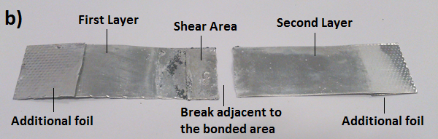
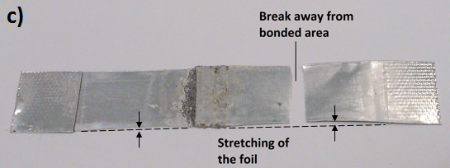
Figure 5: Failure Modes: (a) Force vs. displacement curve showing two failure modes of Al 1050; (b) First mode of failure, F1; (c) Second mode of failure, F2

The two failure modes were:
- Where there was a break at the base metal adjacent to the bonded area shown in Fig. 5b as F1. Such a failure is characterised by a smaller displacement range to failure as exhibited by most of the samples (S1, S2, S4, S5, S6, S7, S9, S11, S12 and S14). It is the inherent property of aluminium to have a distinct plastic region and the same can be observed by the test results.
- Where a break occurs away from the bonded area shown in Fig. 5c as F2. In this case, the foil has been stretched on both ends of the brazed region resulting in a larger displacement as in the case of S3, S8, S10, S13 and S15. In these results, aluminium is being true to its nature and showing a prominent plastic region with the brazed area holding the two foils together and not allowing the bond to break before the fracture of the parent metal.
It is important to note that all the testing speeds yielded equivalent results and the fracture was always due to substrate failure. All the samples fractures outside the brazed region demonstrating that the bond has higher strength compared to the parent metal. This test shows that the single lap joints are not affected by the cross-head speeds and this is consistent with the work done by Silva et al., [22]. The samples failed at values approaching the tensile strength of the metal (100 MPa) as shown in Fig. 6.

Figure 6: Tensile lap-shear test results at different speeds

The test results show similar pattern as compared to the work done by Kong, Soar and Dickens using UC to produce aluminium single lap joints [18]. They used aluminium 3003-H18 foils (tensile load=570N) that were 100 microns thick and this research was carried out using aluminium 1050 H14 ½ hard temper foils (tensile load=250N) of the same thickness. In case of UC, as contact force (pressure) and amplitude were increased, the level of deformation became significant resulting in weld failure at lower loads showing that as the process parameters increase (weld speed and pressure), the failure measurements became more and more faulty (Fig. 7). The samples were tested at the same speed of 2mm/min but based on the decrease in failure measurements as the process parameters were increased, the researchers had to abandon the lap shear test. This goes to show that UC is not capable of producing high quality lap joints without optimising its process parameters and hence the samples produced at high speed and pressure cannot sustain their material properties when subjected to testing. The results fell from force values of 570N to around 300N showing the inconsistency at higher process parameters. On the other hand, CMFM is fully capable of producing consistent lap joints and does not need optimization studies for better results. All the lap joints were produced under same conditions and yielded similar values while testing at different speeds without compromising the integrity of the material properties. A good cluster of breaking force values was observed ranging from 233N to 248N showing consistency of results. In addition to the experimental results, major differences lie in the actual processes as well. UC relies heavily on the optimization of the amplitude, weld speed and contact pressure whereas CMFM is a straight forward process as it does not require optimization in terms of its control parameters. UC requires milling operations to achieve the required geometry and surface finish whereas CMFM produces parts after cutting them into shape as there is no need for any post-processing operation to enhance the surface finish.
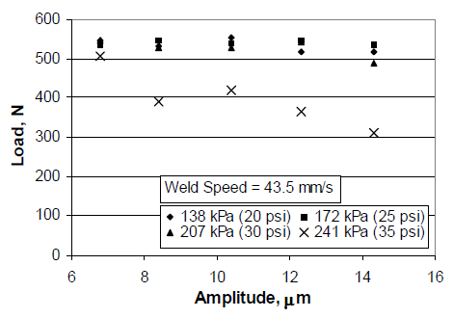
Figure 7: Comparison of tensile lap-shear results between CMFM and UC

Effect of material thickness
After analysing the effect of testing speed with 100-micron thin Aluminium 1050 foils, the effect of material thickness was investigated. These tests were carried out at a cross-head speed of 10mm/min as more consistent results were obtained previously at this speed. The failure modes were similar to the previous tests and the type of failure was substrate failure. Fig. 8 and 9 shows the test results for 200 micron and 50-micron thin metal foils respectively.

Figure 8: Tensile lap-shear test results of 200-micron foil

Figure 9: Tensile lap-shear test results of 50-micron foil

Upon comparing the three different thickness values from Fig. 4a, Fig. 8 and Fig. 9, an almost linear relationship is observed. For 50 micron, the force values are approaching 125N, for 100 micron, they are approaching 250N and for 200 micron, they are approaching 500N. Therefore, the force values are almost doubled as the thickness is doubled. This goes to show that with increase in the thickness of the material, the breaking force needed for failure also increases. This can be easily explained by the fact that as the thickness increases, the resistant area is also increased, and thus more force is required to cause failure. Furthermore, it is important to note that the breaking force values in all the cases are still approaching the tensile strength values for a particular cross-sectional area as shown in Fig. 10.

Figure 10: Comparison of tensile lap-shear test results for different thickness values

Effect of lap length
The above test results are for very thin Aluminium 1050 foils and the effect of lap length would not be evident from them as they would result in substrate failure. Hence, thick plates of the same grade metal were utilized. Aluminium plates of 10mm thickness were bonded together in lap lengths of 12mm, 6mm and 3mm. The reason being the fact that foils and plates with a thickness of less than 10mm had resulted in substrate failure. To fully investigate this effect, cohesion failure was observed for the samples. Cohesion bond failure resulted in fracture of the bond and is characterised by the clear presence of brazing paste on the matching faces of both plates as shown in Fig. 11.
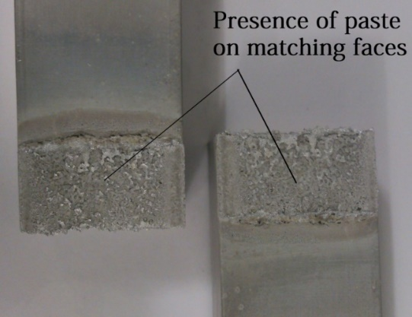
Figure 11: Cohesion failure on aluminium plates showing the presence of paste
A comparison of the breaking forces for the different lap lengths is shown in Fig. 12. It is evident that the joint strength increases almost linearly with overlap. The overlap is the factor that has the biggest impact in the joint strength. This is because when the overlap length is increased then the force must overcome more bonded area which results in a much higher breaking force value. The breaking forces for 12mm lap lengths are around 16kN whereas the ones for 6mm lap length are around 8kN showing that almost half the force is needed when lap length is decreased by the same factor. However, the same linear relationship cannot be observed for 3mm lap length and 6mm. The reason being the fact that now the difference between the two lengths is not large enough to provide linearity but the breaking forces of around 6kN still give a pretty good picture of the effect of lap length. It is clear from the results that lap length has significant impact on the joint strength as the breaking force values increase with increase and decreases with decrease in lap length.

Figure 12: Comparison of tensile lap-shear test results at different lap lengths

Results from Microstructural Analysis
This test helped in analysing the effectiveness of the paste while creating a bond with the metal foil. Aluminium is a highly reactive with atmospheric oxygen and immediately forms an oxide layer upon encountering air which hinders the production of a bond on the surface of the metal. This property makes aluminium favourable for several applications but also makes it a poor braze-able metal that does not allow metallurgical joining with similar or dissimilar metals. Fig. 13 shows a single foil of aluminium deposited with the special brazing paste. An intermetallic bond at the surface of aluminium can be observed which a good thing in the current context, as it shows that the paste can penetrate the oxide layer and thus will allow aluminium to be joined to another foil of the same material.
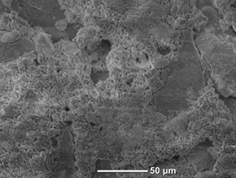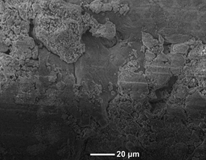
Figure 13: SEM analysis of aluminium foil surface coated with brazing paste at x500 and x700
A single lap joint has a very small brazed region (12.5mm) and hence the presence of an intermetallic bond is essential for the metal foils to stay bonded together. Fig. 14 shows a sample with a smooth and uniform layer of brazing paste sandwiched between the two 1050 aluminium foils. Such uniformity is very important product development with multiple foils.
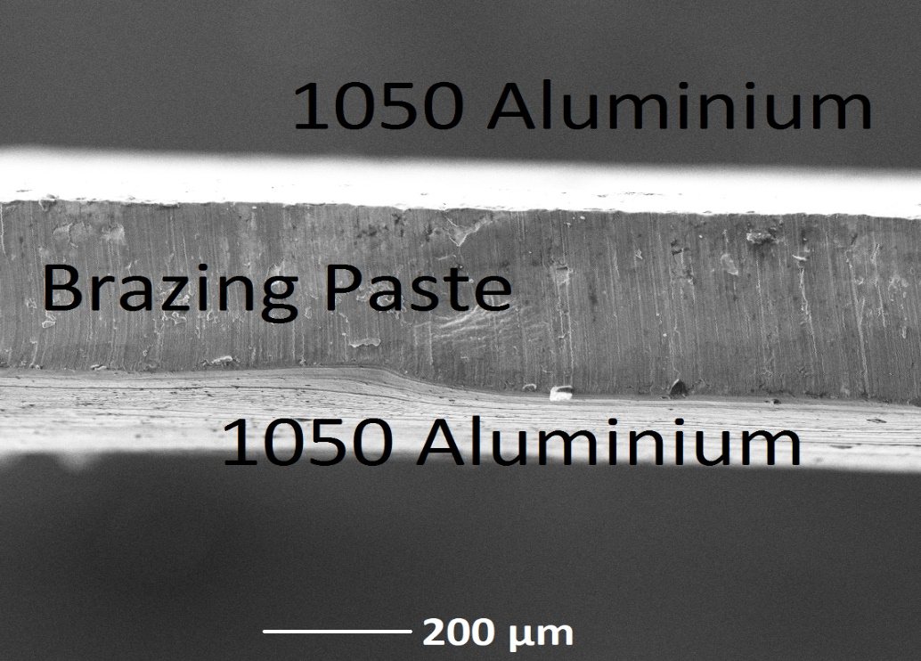
Figure 14: SEM image showing layers of the single lap joint
Figure 15: SEM analysis of the single lap joint: a) Paste layer showing cracks; b) Enhanced image of the crack in the paste layer

The layer of paste is not completely uniform as a closer inspection revealed the presence of cracks as shown in Fig. 15a. These cracks can lead to areas that the paste was unable to bond which would compromise the integrity of the bond created by CMFM. The crack in the current case is about 29 μm wide (Fig. 15b) and cracks of similar dimensions were observed in some places along the length of the sample. The presence of cracks points to an issue that would require a more detailed analysis with more than two foils bonded together. This test, however, presented a clear picture of the bond strength and showed that the presence of cracks in the paste layer did not affect the overall results. The failure was always a result of the parent metal fracture and not the bond between the metal foils.

Results from Three Point Flexural Test
Three-point flexural test was performed to examine the bond strength created by the process of CMFM by subjecting the sample to flexural loading. A multi-layered structure with 20 layers of metal foil stacked on top of each other and layers of brazing paste on both sides was produced. The composite CMFM sample behaved in the same way as the parent metal sample did in terms of bending all the way through. Both the samples show a prominent elastic as well as plastic region. The bending mode of the CMFM sample is shown in Fig. 16 and Fig. 17 shows the comparison curves of the two samples.
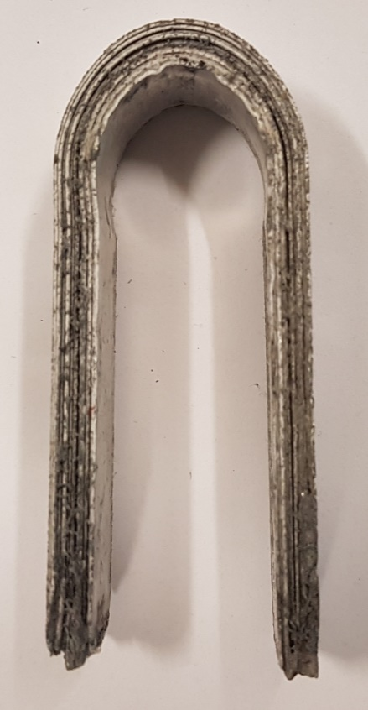
Figure 16: Bending mode of the composite sample

Figure 17: Comparative flexural test results for composite and parent metal
The CMFM sample showed a maximum bend load value of 827.9N whereas the parent metal sample showed a value of 768.8N. This shows that the composite sample is almost 7.7% stronger than the parent aluminium and demonstrates the capability of CMFM to produce metal parts with better flexural properties. We have observed comparable results with tensile testing [23-25] of aluminium samples made by CMFM where the composites have higher strength compared to the parent metal. The reason is the presence of an intermetallic bond that stops the metal atoms from slipping when stress is applied and thus prohibiting any dislocations.
Bending tests are used for determining mechanical properties of unidirectional composite materials. The samples made by CMFM are composites of metal and brazing paste bonded together. The three-point flexural test shows the effect of shear loading across the interface of the bonded sample due to the way it is performed. The difference is not very significant in terms of the curve path for the two samples. The bonded interface of the composite sample behaved in the same way as the solid metal sample and provided higher strength. CMFM has shown very good results in comparison with other competing methods. In addition to working with similar materials, the process can also work with dissimilar materials and show better mechanical properties of the composites produced [26-28]. This feature adds versatility to the process as it does not require any additional machinery to make composites of dissimilar materials and the results do not vary significantly from those obtained from similar materials.

Conclusions
The paper shows the experimental testing of aluminium 1050 single lap joints and flexural samples made by the process of CMFM. All the samples were made and tested in accordance to British and International standards. The tests were designed specifically to analyse the effect of tensile and flexural loading on the samples made by CMFM. The results demonstrated that CMFM has the capability to compete with rival metal AM methods (Section 4.1.1) and can also produce high strength products (Section 4.3) compared to traditional machining techniques. This presents a feasible alternative to existing metal AM methodologies and can be utilised for the manufacture of products that require better tensile and flexural properties. The biggest advantage of CMFM is that the feed-stock is lower in price compared to its competitors. Direct Metal Laser Sintering (DMLS), Electron Beam Melting (EBM); two of the most common metal AM methods make use of metallic powder and depending upon the type of material, the cost varies. The price of the powder is a function of the grain size and required mechanical properties of the final products as well. Such requirements and the recommendation of large companies such as EOS and Arcam to buy their powder for their machines increase the cost of the raw material considerably. EBM can also make use of wire that costs less than powder but is still more expensive in comparison to the price of metal foils. For a single build, the cost ($Cost_{B}$) can be estimated by the following formula proposed by Ruffo, Tuck and Hague [29]:
$Cost_{B}=Cost \left(t_{B}\right)+ Cost (m_{B})$
where,
$Cost \left(t_{B}\right)= \frac{direct_Cost}{mass_unit}$ $m_{B}$ (1a)
$Cost \left(m_{B}\right)= \frac{\sum{indirect_Costs}}{working_time}$ $t_{B}$ (1b)
The time and material used during the build (t_{B} and m_{B} respectively) are the main variables of the costing model. Time refers to how long the machine works for the build and part mass (or volume) is an index of the raw material used. CMFM is a lot faster than conventional metal AM methods majorly because of complete process automation and minimal post-processing (Eq. 1a). Waste is also considerable less because only the geometry to be joined is cut out from the metal sheet (Eq. 1b). These significant cost benefits along with superior mechanical properties make CMFM an attractive option for metal prototyping.
The presented work has led to the following conclusions:
- CMFM can produce high quality samples that show consistency while testing for their mechanical properties.
- The fracture load values of the single lap joints were only affected by the foil thickness and the lap length.
- Single lap joints were not affected by the test speeds and are better in terms of quality compared to joints produced by Ultrasonic Consolidation.
- Microstructural analysis of the single lap joints yielded a good proportion of bonded area which is necessary for product development.
- Comparative flexural test showed that the composite sample produced by CMFM is 7.7% stronger than a solid part machined out of 1050 aluminium block.

Acknowledgement
The authors would like to thank their affiliation institution for the resources.
Conflict of Interest
On behalf of all authors, the corresponding author states that there is no conflict of interest.

References
[1] Bartolai J, Simpson TW, Xie R (2018) Predicting strength of additively manufactured thermoplastic polymer parts produced using material extrusion. Rapid Prototyping Journal, 24(2), 321-332.
[2] Atzeni E, Salmi A (2012) Economics of additive manufacturing for end-usable metal parts. The International Journal of Advanced Manufacturing Technology, 62(9-12), 1147-1155.
[3] Chevalier J, Gremillard L (2009) Ceramics for medical applications: A picture for the next 20 years. Journal of the European Ceramic Society, 29(7), 1245-1255.
[4] Tian L, Anderson I, Riedemann T, Russell A (2014) Modeling the electrical resistivity of deformation processed metal–metal composites. Acta Materialia, 77, 151-161.
[5] Butt J, Shirvani H (2018) Experimental analysis of metal/plastic composites made by a new hybrid method. Additive Manufacturing, 22, 216-222.
[6] Sames WJ, List FA, Pannala S, Dehoff RR, Babu SS (2016) The metallurgy and processing science of metal additive manufacturing. International Materials Reviews, pp.1-46.
[7] Gu DD, Meiners W, Wissenbach K, Poprawe R (2012) Laser additive manufacturing of metallic components: materials, processes and mechanisms. International materials reviews, 57(3), pp.133-164.
[8] Körner C (2016) Additive manufacturing of metallic components by selective electron beam melting—a review. International Materials Reviews, pp.1-17.
[9] Matthews MJ, Guss G, Khairallah SA, Rubenchik AM, Depond PJ, King WE (2016) Denudation of metal powder layers in laser powder bed fusion processes. Acta Materialia, 114, pp.33-42.
[10] Zhao C, Fezzaa K, Cunningham RW, Wen H, Carlo F, Chen L, Rollett AD, Sun T (2017) Real-time monitoring of laser powder bed fusion process using high-speed X-ray imaging and diffraction. Scientific reports, 7(1), p.3602.
[11] King WE, Anderson AT, Ferencz RM, Hodge NE, Kamath C, Khairallah SA, Rubenchik AM (2015) Laser powder bed fusion additive manufacturing of metals; physics, computational, and materials challenges. Applied Physics Reviews, 2(4), p.041304.
[12] Ding D, Pan Z, Cuiuri D, Li H (2015) Wire-feed additive manufacturing of metal components: technologies, developments and future interests. The International Journal of Advanced Manufacturing Technology, 81(1-4), pp.465-481.
[13] Kelly GS, Just MS, Advani SG, Gillespie JW (2014) Energy and bond strength development during ultrasonic consolidation. Journal of Materials Processing Technology, 214(8), pp.1665-1672.
[14] Butt J, Mebrahtu H, Shirvani H (2014) A novel rapid prototyping process for the production of metal parts. In Proceedings of the Second International Conference on Advances in Civil, Structural and Mechanical Engineering-CSM, Birmingham, United Kingdom (pp. 26-29).
[15] He XH, Shi HJ, Zhang YD, Yang ZG, Wilkinson CE, Neal AL, Norfolk M (2015) Mechanical properties and microstructure of Al/Al laminated structure produced via ultrasonic consolidation process. Materials Science and Technology, 31(15), pp.1910-1918.
[16] Butt J, Mebrahtu H, Shirvani H (2016) Rapid prototyping by heat diffusion of metal foil and related mechanical testing. The International Journal of Advanced Manufacturing Technology, 84(9-12), 2357-2366.
[17] Butt J (2016) A novel additive manufacturing process for the production of metal parts (Doctoral dissertation, Anglia Ruskin University).
[18] Kong CY, Soar RC, Dickens PM (2002) August. An investigation of the control parameters for aluminum 3003 under ultrasonic consolidation. In Proceeding 13th Solid Freeform Fabrication Symposium (pp. 199-211).
[19] BS EN 1465: 2009. Adhesives—Determination of tensile lap-shear strength of bonded assemblies.
[20] BS EN ISO 7438:2016, Metallic materials — Bend Test.
[21] BS EN ISO 10365:1995. Adhesives—Designation of main failure patterns.
[22] Da Silva LF, Carbas RJC, Critchlow GW, Figueiredo MAV, Brown K (2009). Effect of material, geometry, surface treatment and environment on the shear strength of single lap joints. International Journal of Adhesion and Adhesives, 29(6), pp.621-632.
[23] Butt J, Mebrahtu H, Shirvani H (2015) Peel and tensile test investigation of aluminium 1050 foil parts made with a new additive manufacturing process. International Journal of Rapid Manufacturing, 5(1), 95-115.
[24] Butt J, Mebrahtu H, Shirvani H 2016 Strength analysis of aluminium foil parts made by composite metal foil manufacturing. Progress in Additive Manufacturing, 1(1-2), pp.93-103.
[25] Butt J, Mebrahtu H, Shirvani H (2018) Numerical and experimental analysis of product development by composite metal foil manufacturing. International Journal of Rapid Manufacturing, 7(1), 59-82.
[26] Butt J, Mebrahtu H, Shirvani H (2016) Microstructure and mechanical properties of dissimilar pure copper foil/1050 aluminium composites made with composite metal foil manufacturing. Journal of Materials Processing Technology, 238, 96-107.
[27] Butt J, Mebrahtu H, Shirvani H (2015) Thermo-mechanical analysis of dissimilar al/cu foil single lap joints made by composite metal foil manufacturing. World Acad Sci Eng Technol Int J Mech Aerospa Ind Mech Manuf Eng, 10(1), 41-46.
[28] Nammi SK, Butt J, Mauricette JL, Shirvani H (2017, December) Numerical Analysis of Thermal Stresses around Fasteners in Composite Metal Foils. In IOP Conference Series: Materials Science and Engineering (Vol. 280, No. 1, p. 012016). IOP Publishing.
[29] Ruffo M, Tuck C, Hague R (2006) Cost estimation for rapid manufacturing-laser sintering production for low to medium volumes. Proceedings of the Institution of Mechanical Engineers, Part B: Journal of Engineering Manufacture, 220(9), pp.1417-1427.

