**European universities seeking entrepreneurial paths: the moderating effect of contextual variables on the entrepreneurial orientation-performance relationship**

Angelo Riviezzo [1], Francisco Liñán [2],[3], Susana C. Santos [4],

Maria Rosaria Napolitano a, Floriana Fusco [5]

**Abstract.** This study explores the relationship between the entrepreneurial orientation of university departments and their entrepreneurial performance, in terms of academic entrepreneurship (spin-offs) and knowledge transfer (patents) outcomes. Moreover, we investigate how internal and external contextual variables interact in this relation. Using survey data from 294 heads of university departments in four different European countries (Italy, Spain, UK and Portugal), we found that entrepreneurial orientation is positively related to the number of spin-offs generated and that this relation is positively moderated by the departments’ age and size, as well as the country GDP per capita and R&D expenditure. Surprisingly, entrepreneurial orientation is negatively associated with the number of patents. We further explore the moderating role of contextual variables, discussing our results.

**Key-words.** Entrepreneurial universities; entrepreneurial orientation; spin-offs; patents; contextual variables; European countries.

**1. Introduction**

In the knowledge-based society universities are increasingly considered initiators of local development, as they may play a key role not only for knowledge production, but also for its dissemination and exploitation towards commercial ends (Etzkowitz, 1983, 2004, 2013; Clark, 1998; Jacob, Lundqvist and Hellsmark, 2003; Wright, Birley and Mosey, 2004; Guerrero and Urbano, 2012; Guerrero, Cunningham and Urbano, 2015). However, the commitment of universities to the economic and social progress should not be limited to the “capitalisation of knowledge” (Etzkowitz, 1998), as they could act as local agents supposed to trigger “entrepreneurship capital” (Audretsch, 2014), by promoting “entrepreneurial thinking, actions and institutions” (Guerrero, Urbano and Fayolle, 2016; p. 106). And this is considered even more important, as the presence of entrepreneurial capabilities may impact on local development more than, for instance, the availability of natural or financial resources (Klofsten, Jones-Evans, 2000). Thus, the new mission of the “entrepreneurial university” (Etzkowitz, 1983) should be focused on contributing to social development and economic growth, going beyond the traditional missions of research and teaching.

Research on entrepreneurial universities has increased steadily over the years (Leih and Teece, 2016; Schmitz et al., 2017), expanding to various interconnected topics, such as entrepreneurship education or academic entrepreneurship (Fayolle and Redford, 2014). Part of the literature has also questioned the ideological underpinnings of the entrepreneurial university, for instance, talking about “McUniversity” (Hayes and Wynyard, 2002) or “academic capitalism” (Slaughter and Leslie, 1997) because of the “commercialization” of university’s mission it involves.

What scholars seem to agree on is that if the university aspires to evolve towards the entrepreneurial model it must necessarily change its strategy in a radical way. In fact, “entrepreneurial universities need to become an entrepreneurial organization, their members need to become entrepreneurs, and their interaction with the environment needs to follow an entrepreneurial pattern” (Urbano and Guerrero, 2013; p. 43). Without a clearly defined strategy, a university cannot contribute to the goals of society and the economy (Clark, 1998), since the presence of a local university “may be necessary, but not sufficient, to guarantee that knowledge-based economic development takes place” (Bercovitz and Feldman, 2006; p. 175). To this aim, an entrepreneurial orientation should be incorporated into the university’s mission (O’Shea et al., 2005; Van Looy et al., 2011; Urbano and Guerrero, 2013).

The entrepreneurial orientation (Miller, 1983; Covin and Slevin, 1991; Lumpkin and Dess, 1996) is a well-known theoretical construct aiming at assessing the strategic rooting of entrepreneurship values and behaviors within the organizations. While it is widely used in studies focused on profit-oriented firms, the entrepreneurial orientation has been rarely investigated within universities (e.g., O’Shea et al., 2005; Tijssen, 2006; Todorovic, McNaughton and Guild, 2011), especially in the context of European countries (e.g., Riviezzo, Liñán and Napolitano, 2017). This is due to the significant differences in terms of objectives, decision making processes, organization, and governance systems between firms and universities, that make more challenging its evaluation in this specific research setting.

Consequently, there is limited knowledge on the role of entrepreneurial orientation in affecting entrepreneurial performance within universities. Furthermore, in the case of profit-oriented firms, it is widely established that the influence of entrepreneurial orientation is contextual (e.g., Zahra and Covin, 1995; Lumpkin and Dess, 1996, 2001; Wiklund and Shepherd, 2005; Coulthard, 2007; Lomberg et al., 2017). So far, to the best of our knowledge, the impact of contextual variables on the relationship between entrepreneurial orientation and performance within universities has been largely neglected. In addition, prior scholarly work traditionally focused on the university as the unit of analysis and rarely considered the entrepreneurial activities “across campuses or departments” (Guerrero et al., 2018).

Considering these research gaps, the present study aims at exploring the relationship between the entrepreneurial orientation of European university departments and the commercial results of their research, measured in terms of academic entrepreneurship (spin-offs) and knowledge transfer (patents). Furthermore, this study explores the moderating effect of internal and external contextual characteristics on this relationship, trying to shed light on the specific contextual conditions that allow universities to act as effective economic and societal change agents. Being aware of the limitations of the empirical model we used – further analyzed in more details – and thus of the limited possibility to take too much generalizations out of our results, we attempt to address the following research questions: How entrepreneurial orientation impacts on university’s ability to contribute to social development and economic growth? How internal contextual variables influence the impact of entrepreneurial orientation on performance? How external contextual variables influence the impact of entrepreneurial orientation on performance?

Our analysis is based on survey data from 294 heads of European university departments, in four different countries: Italy, Spain, UK and Portugal.

In the following sections, the theoretical background and hypotheses are illustrated; thereafter, the methodology and results are presented; and finally, the implications and limitations are discussed.

**2. Theoretical background and hypotheses development**

A recent bibliometric analysis of the existing literature on innovation and entrepreneurship within universities (Schmitz et al., 2017) shows the increasing interest of scholars towards the topic. Definitions of “entrepreneurial university” abound and there is yet no agreement around a comprehensive model of what exactly constitutes it (Urbano and Guerrero, 2013). In fact, there is high heterogeneity from one case to another. This is because variables such as university’s history, tradition, resources and organizational structure, beside the characteristics of the socio-economic system, have a high impact on its attitudes towards relationships with external partners and on its ability to play a key role in stimulating local development (Etzkowitz, 2004; Powers and Mcdougall, 2005; Bercovitz and Feldman, 2006; Wright et al., 2007; Martinelli, Meyer and von Tunzelmann, 2008; Hussler, Picard and Tang, 2010; Guerrero et al., 2014; Bronstein and Reihlen, 2014; Guerrero, Cunningham and Urbano, 2015). Accordingly, “there is no typical way to be or become an entrepreneurial university” (Martinelli, Meyer and von Tunzelmann, 2008; p. 260).

Yet, several contributions aimed at identifying the different types of innovative and entrepreneurial activities undertaken within universities to develop linkages with industry and the wider society. The most frequently mentioned activities include the generation of spin-offs from faculty members (Jacob, Lundqvist and Hellsmark, 2003; Klofsten and Jones-Evans, 2000; Etzkowitz, 2003; 2013) and students (Pirnay and Surlemont, 2003), and patenting and licensing (Klofsten and Jones-Evans, 2000; Grimaldi et al., 2011; Philpott et al., 2011; Trippl, Sinozic and Lawton Smith, 2015). Less frequently, other activies have been studied: collaborative and/or contracted research (Klofsten and Jones-Evans, 2000; Cohen, Nelson and Walsh, 2002; Levy, Roux and Wolff, 2009); industry training courses, including executive education (Klofsten and Jones-Evans, 2000; Philpott et al., 2011; Guerrero, Cunningham and Urbano, 2015); consulting (Klofsten and Jones-Evans, 2000; Cohen, Nelson and Walsh, 2002; Philpott et al., 2011); mobility of students, academics and industrial collaborators between university and industry (Gibb, 2012); informal networking (Salter and Martin, 2001; Guerrero, Cunningham and Urbano, 2015); and property developments, such as science parks and technopoles, to offer innovative services to external partners (Klofsten and Jones-Evans, 2000; O’Shea et al., 2005; Grimaldi et al., 2011). These activities are distinctive features of the entrepreneurial universities and, at the same time, commonly used metrics to weigh their actual contribution to the dynamics of economic and social development.

In assessing the entrepreneurial university’s behaviors and results, scholars focused on different units of analysis. According to Brennan and McGowan (2006) there are five potential levels of analysis: individual; community of practice (an informal social network of academics); university department; university; and entrepreneurship ecosystem (individuals and corporate actors who interact in a recognisable context to form the infrastructure for entrepreneurship). In this study we focus on specific activities of entrepreneurial universities – namely, spin-offs generation and patenting – at the university department level. More precisely, we analyze the influence of entrepreneurial orientation on the commercial results of European university departments’ research.

*2.1 The Role of Entrepreneurial Orientation*

As mentioned above, universities willing to offer a real contribution to the goals of society and the economy need to pursue a clearly defined strategy. Entrepreneurship should be accepted as part of the “sense” of the university and each of its members should share a common vision. In this regard, van Burg et al. (2008, p. 123) highlight that, in the evolutionary process towards the entrepreneurial model, universities need to “shape a university culture that reinforces academic entrepreneurship by creating norms and exemplars that motivate entrepreneurial behavior”. An entrepreneurial orientation should, therefore, be incorporated into the university’s mission (Urbano and Guerrero, 2013), if the university really wants to act as an effective economic and societal change agent.

In strategic management and entrepreneurship literatures, entrepreneurial orientation (Miller, 1983; Covin and Slevin, 1991; Lumpkin and Dess, 1996) is a widely used construct to assess such strategic rooting of entrepreneurship values and behaviors within the organization. This strategic aim of creating value and opportunities through the continuous search of innovative activities may be pursued also within public and/or not profit-oriented organizations (such as universities). However, the significant differences with profit-oriented firms make it more difficult measuring the entrepreneurial orientation in this specific research context. Thus, the entrepreneurial orientation construct has rarely been used in studies focused on universities.

Trying to address this shortcoming, Todorovic, McNaughton and Guild (2011) developed an operationalization of entrepreneurial orientation to be applied specifically to university departments, the ENTRE-U scale. This measure entails four dimensions: research mobilization, unconventionality, industry collaboration, and university policies. The research mobilization dimension relates to research undertaken in the department in terms of focus and orientation towards external stakeholders. The unconventionality dimension refers to the department’s ability to identify new opportunities outside the traditional academic environment, focusing on unconventional approaches in research funding, problem solving, relationships with external organizations and so on. The industry collaboration dimension assesses the degree of cooperation with industry at individual and organizational levels. The university policies dimension refers to the perception that the department head has about the central university policies and the extent to which they hinder or facilitate the departments in their innovative and unconventional action (Todorovic, McNaughton and Guild, 2011).

In addition to the analysis of the scale’s psychometric properties, the authors found a positive relationship between the entrepreneurial orientation and the number of patents and spin-offs created among Canadian university departments. Therefore, they demonstrate that “the university entrepreneurial orientation is different from entrepreneurial orientation in large private corporations” and they empirically corroborate “the role of entrepreneurial orientation in facilitating commercialization and other entrepreneurial outcomes in university departments” (Todorovic, McNaughton and Guild, 2011, p. 135). This is aligned with other theoretical contributions emphasizing the need of a clearly defined strategic orientation towards entrepreneurship for universities willing to act as agents of regional innovation and entrepreneurial development (e.g., Clark, 1998; O’Shea et al., 2005; Tijssen, 2006; Van Looy et al., 2011; Urbano and Guerrero, 2013).

Building on the previous arguments, we propose that the entrepreneurial orientation of university departments has an impact on their performance, in terms of academic entrepreneurship (spin-offs) and knowledge transfer (patents). Therefore, we put forward the following hypotheses:

***H1a***: Entrepreneurial orientation of university departments is positively associated with the number of patents produced.

***H1b***: Entrepreneurial orientation of university departments is positively associated with the number of spin-offs generated.

In studies about firms, it is established that the effect of entrepreneurial orientation on performance varies depending on the contexts (e.g., Zahra and Covin, 1995; Lumpkin and Dess, 1996, 2001; Wiklund and Shepherd, 2005; Coulthard, 2007; Lomberg et al., 2017). In other words, entrepreneurial orientation needs to be aligned with context for best results. Environmental and organizational variables have to be considered to reduce the potential for misleading inferences about the contribution of entrepreneurial orientation to performance outcomes (Lumpkin and Dess, 1996). In the very few contributions that empirically analyze the entrepreneurial orientation within university departments (e.g., Todorovic, McNaughton and Guild, 2011; Riviezzo, Liñán and Napolitano, 2017) the role of context variables has never been examined in depth. This is an important gap in the literature since, even within universities, this relationship should be contingent on internal and external contextual variables.

*2.2 The Role of Internal Contextual Variables*

As stated before, not all entrepreneurial universities are identical, neither they are in the same stage within the path towards the entrepreneurial model. Literature suggests that the process of development of the university as an entrepreneurial institution “takes considerably time and patience” (Bercovitz and Feldman, 2006; p. 186) and is characterized by different stages, similar to a business life-cycle (Guerrero and Urbano, 2012). For example, authors such as Etzkowitz (2004) or Tijssen (2006) propose an evolutionary process of a research university that is becoming more entrepreneurial through time. In a similar vein, Philpott et al. (2011) highlight that there is a change in the nature of entrepreneurial activities carried out by universities over time, as an evidence of the progress of its evolutionary process towards the entrepreneurial model. Thus, departments have “to learn to walk before they can run” (Philpott et al., 2011, p. 168).

Building on these contributions analyzing the entrepreneurial process within universities, we argue that the age of departments (that is, the number of years of operation) is relevant. Those departments operating longer are more likely to have a widely rooted entrepreneurial orientation and its impact on performance might be even stronger. Previous studies also show the role of age in affecting entrepreneurial performance within universities (e.g., Owen-Smith and Powell, 2003; Fini et al., 2017; Guerrero et al., 2018). Similarly, previous research has shown that university size may be related to entrepreneurial activity: the higher the number of faculty members, the higher the likelihood that some research may be effectively transferred to the market (e.g., Powers, 2004; Powers and McDougall, 2005; Van Looy et al., 2011; Fini et al., 2011; Fini et al., 2017; Guerrero et al., 2018).

Thus, we argue that the role of these internal variables cannot be neglected in the analysis of the relationship between entrepreneurial orientation and performance. Accordingly, we put forward the following hypotheses:

***H2a***: Internal context characteristics – in terms of age (*H2a1*) and size (*H2a2*) of the department – positively moderate the relationship between university departments’ entrepreneurial orientation and the number of patents produced.

***H2b***: Internal context characteristics – in terms of age (*H2b1*) and size (*H2b2*) of the department – positively moderate the relationship between university departments’ entrepreneurial orientation and the number of spin-offs generated.

*2.3 The Role of External Contextual Variables*

As widely accepted in the literature, commercial performance of academic research is shaped by external contexts, since it is conditional on local specificities (e.g., Powers and McDougall, 2005; Hussler, Picard and Tang, 2010; Fini et al., 2011; Guerrero et al., 2014; Bronstein and Reihlen, 2014; Sternberg, 2014; Guerrero, Cunningham and Urbano, 2015; Fini et al., 2017; Kapetaniou and Lee, 2017; Guerrero et al., 2018). In this regard, several contributions explored the reasons why universities in some countries create more spin-offs than others (e.g., Di Gregorio and Shane 2003; Wright, Birley, and Mosey 2004; O’Shea, Chugh and Allen 2008), and the reasons why in some contexts academics are more likely to engage in the commercialization of research than in others (e.g., Bercovitz and Feldman, 2006; Huyghe and Knockaert, 2015). Some specific institutional context variables received greater attention as potentially constraining or facilitating the university’s entrepreneurial activities. These include the level of economic development, measured in terms of GDP per capita (e.g., Hussler, Picard and Tang, 2010; Liñán, Urbano and Guerrero, 2011; Munari et al., 2016; Fini et al., 2017; Shirokova, Tsukanova and Morris, 2018; Guerrero et al., 2018); the innovation culture and government support, measured in terms of investments in R&D (e.g., Klofsten and Jones-Evans, 2000; Powers, 2004; O’Shea, Chugh and Allen, 2008; Hussler, Picard and Tang, 2010; Van Looy et al., 2011; Fini et al., 2011; Autio et al., 2014; Fini et al., 2017); and the social legitimacy of entrepreneurship (Kibler, Kautonen and Fink, 2014; Kibler et al., 2015; Kibler and Kautonen, 2016), measured in terms of self-employment rate (e.g., Autio et al., 2014; Sternberg, 2014; Shirokova, Tsukanova, and Morris, 2018). In fact, in countries with higher entrepreneurship rates, this is a more usual career path and a greater share of individuals is in contact with entrepreneurs and business owners. Thus, academics will be more prone to identify commercial opportunities out of their research and, consequently, generate economic value out of it, be it through patents or spin-offs (Liñán, Urbano and Guerrero, 2011; Guerrero et al., 2014).

To sum up, the university’s contribution to social development and economic growth is shaped by external contextual conditions. Thus, we argue that the role of external variables cannot be neglected in the analysis of the relationship between entrepreneurial orientation and performance. Accordingly, we put forward the following hypotheses:

***H3a***: External context characteristics – in terms of GDP (*H3a1*), R&D expenditure (*H3a2*) and self-employment rate (*H3a3*) – positively moderate the relationship between university departments’ entrepreneurial orientation and number of patents produced.

***H3b***: External context characteristics – in terms of GDP (*H3b1*), R&D expenditure (*H3b2*) self-employment rate (*H3b3*) – positively moderate the relationship between university departments’ entrepreneurial orientation and number of spin-offs generated.

Figure 1 presents our conceptual model.

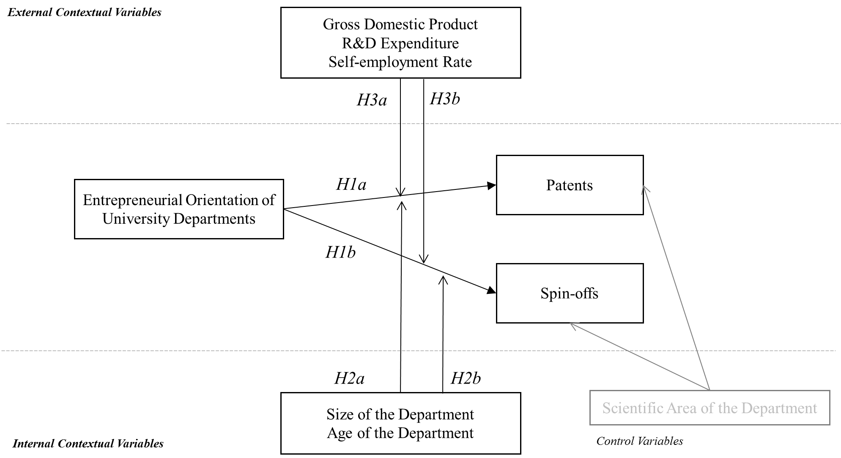

*Figure 1. Conceptual model and hypotheses*

**3. Method**

*3.1 Data collection procedure*

The university department is the unit of analysis in this study and the department head/director is the targeted key-informant. As noted by Todorovic, McNaughton and Guild (2011; p. 131), “department heads or center/institute directors are analogous to middle managers in the private sector”; they have more knowledge about activities of department members than the single faculty member or the rector or any other central university manager. The target population of the survey was identified through two progressive steps. First, we selected the target universities. Then, we detected the single departments to involve in the survey within each university.

Concerning the selection of the universities, in each country we used secondary data sources (e.g., national reports on higher education, national rankings and specialized governmental offices) in order to identify the universities with the best entrepreneurial performance, that is those with a number of spin-offs and patents above the national average. In Italy, we searched for information in the annual report of Netval (Italian Network of Technology Transfer Offices of Universities and Public Research Organizations). In Spain, we used the annual report of RedOTRI (Network of Research-Result Transfer Offices) and information from the Conference of Rectors of the Spanish Universities. In the UK, we consulted the database University Listings - Spinouts UK and the Times Higher Education Awards annual report. Finally in Portugal, we used higher education national governmental reports with entrepreneurship performance indicators, and data from national research institutes (Fundação Manuel dos Santos) and the national statistics institute (Instituto Nacional de Estatística). The questionnaires were administered during the year 2015 in all the four countries. Thus, the secondary data sources we used to identify the target universities referred to the previous year (2014). For instance, in Italy, based on the annual report of Netval 2014, we realized that the average number of patents held by Italian universities was 68,4 and the average number of spin-offs created by Italian universities was 19. Thus, we selected only the universities with a number of patents higher that 68 or a number of spin-offs higher than 19. This criterion led us to identify 32 Italian universities (that means about 33% of the total). We used the same approach in each country, hence selecting 23 universities in Spain (that means about 30% of the total), 33 universities in the UK (that means about 26% of the total), 28 universities in Portugal (that means about 57% of the total).

Concerning the selection of the departments within the universities identified in the first step, we contacted the industrial liaison offices and/or the technology transfer offices of the universities in order to identify the departments most involved in commercial activities. In this case, there wasn’t any precise threshold on the number of departments to involve, and the situation significantly varied from one case to another. In some universities, in fact, most patents and spin-offs belonged to a few departments (even 1 or 2 in some cases). In other universities, however, patents and spin-offs were a widespread phenomenon among all the departments. Therefore, the number of departments identified in each university, on the basis of the information provided by the industrial liaison offices and/or the technology transfer offices, was very variable. Of course, this variety also depended on the different size of the universities. On the whole, we detected and contacted 500 departments in Spain, 399 in the UK, 251 in Italy, and 46 in Portugal. The discrepancy in the number of departments involved is due to the significant difference in the total number of universities in each country and to the dissimilar diffusion of entrepreneurial activities.

We established a telephone contact with each department and, after presenting the project, we sent out the survey to be completed online using the software Qualtrics. The surveys were translated into English, Italian, Spanish and Portuguese, following a rigorous translation and back-translation process. We followed up by email and phone to those department heads who did not answer to the survey on the first attempt, and we re-sent again the email requiring their participation. Department heads were informed that the participation in this study was voluntary and completely anonymous. Thus, we had no chance of relating the single response to a specific university, city or region.

*3.2 Sample*

Our study included a total of 294 university departments from Italy, Spain, UK and Portugal (NItaly=101; NSpain=105; NUK=70; NPortugal=18), corresponding to a response rate of 40% in Italy, 21% in Spain, 17% in the UK and 39% in Portugal (average response rate=29.47%). Table 1 describes the characteristics of the sample: a third of the departments were from Natural Sciences, followed by Engineering (19.8%). There are no significant statistical differences between countries regarding the distribution by scientific area. The size of the department varied between 5 and 600 persons and the age of the department ranged from 0 to 302 years. There are significant differences between the countries in department size (*F*(3;288)=6.96, *p* < 0.0001) and in department age (*F*(3;275)=46.41, *p*<0.0001). More specifically, post hoc tests (Tukey HSD and Scheffé test) revealed significant differences in the size of the department between UK and Italy (Mean differenceSizeDept. UK-IT=42.544, *p*<0.0001), UK and Spain (Mean differenceSizeDept. UK-SP=30.53, *p*<0.01) and UK and Portugal (Mean differenceSizeDept. UK-PT=52.82, *p*<0.02). There are also significant differences in the age of the department between UK and Italy (Mean differenceAgeDept.UK-IT=66.67, *p*<0.0001), UK and Spain (Mean difference AgeDept.UK-SP=58.24, *p*<0.0001) and UK and Portugal (Mean differenceAgeDept.UK-PT=57.25, *p*<0.0001).

Table 1

Descriptive statistics of the sample

|  |  |  |  |  |  |  |
| --- | --- | --- | --- | --- | --- | --- |
|  |  | Total Sample  N=294 | Italy  N=101 | Spain  N=105 | UK  N=70 | Portugal  N=18 |
| Scientific area of the Department | IT Sciences | 46 (15.7%) | 12 (11.9%) | 21 (20%) | 9 (12.9%) | 4 (23.5%) |
| Natural Sciences | 99 (33.8%) | 37 (36.6%) | 34 (32.4%) | 28 (40%) | - |
| Engineering | 58 (19.8%) | 27 (26.7%) | 20 (19%) | 8 (11.4%) | 3 (17.6%) |
| Medical Sciences | 24 (8.2%) | 9 (8.9%) | 7 (6.7%) | 7 (10%) | 1 (5.9%) |
| Management Sciences | 49 (16.7%) | 3 (3%) | 22 (21%) | 17 (24.3%) | 7 (41.2%) |
| Others | 18 (6.1%) | 13 (12.9%) | 1 (1%) | 1 (1.4%) | 3 (16.7%) |
| Size of the Department | | Mean=68.67  S.D.=66.38 | Mean=54.71  S.D.=30.40 | Mean=66.72  S.D.=52.24 | Mean=97.26  S.D.=107.38 | Mean=44.44  S.D.=39.87 |
| Age of the Department | | Mean=36.08  S.D.=45.08 | Mean=17.70  S.D.=11.49 | Mean=26.13  S.D.=13.13 | Mean=84.37  S.D.=73.86 | Mean=27.11  S.D.=27.50 |
| Country-level variables | GDP per capita (thousands of US$) | Mean=31.30  S.D. =7.79 | 30.17 | 25.79 | 44.31 | 19.25 |
| R&D expenditure (%) | Mean=1.38  S.D.= 0.19 | 1.33 | 1.22 | 1.70 | 1.28 |
| Self-employment rate (%) | Mean=19.26  S.D.=3.86 | 24.40 | 17.30 | 15.00 | 18.40 |

*3.3 Measures*

*Independent Variable*

We measured the entrepreneurial orientation of university departments using the ENTRE-U scale (Todorovic, McNaughton and Guild, 2011). This scale contains 23 items comprising the above-cited four dimensions: research mobilization, unconventionality, industry collaboration, and university policy. Table 3 shows the complete list of items – the lists in Spanish, Italian and Portuguese are available from the authors upon request. Respondents indicated on a 7-points scale (1=completely disagree, 7=completely agree) to what extent each item described their department.

*Internal Contextual Variables*

We used self-reported data to asses the size and the age of the department. Concerning the first variable, our informants were asked to indicate the total number of faculty members. Concerning the second variable, department heads referred the number of years the department has operated.

*External Contextual Variables*

In order to account for cross-national differences, we gathered country-level information from secondary sources, specifically the World Bank and the OECD. The Gross Domestic Product per capita (GDPpc) is measured in thousands of current US dollars. The gross domestic expenditure in R&D (R&D Expenditure) is measured as a percentage of GDP, and is defined as the total expenditure (current and capital) on R&D carried out by all resident companies, research institutes, university and government laboratories, etc., in a country. Self-employment rate is measured as a percentage of the employed population who are employers, independent (own-account) workers, members of producers' co-operatives and unpaid family workers. All the external contextual variables data refer to 2015, as the survey with the heads of the department was also conducted during this year. It’s worth to note that we used country-level data, instead of regional or local data, because, as we’ve explained in describing our data collection procedure above, the responses to our questionnaire were completely anonymous in each country, and we could not associate regional-based data about the economic situation to the single university departments in our sample.

*Dependent Variables*

We asked the department heads to indicate the total number of patents held by faculty members and the total number of spin-offs created, that represent the performance indicators we used in this study. Our reliance on self-reported data from single informants introduces the potential of common method variance and endogeneity concerns, further addressed below. However, the results of previous research on entrepreneurial orientation suggest that subjective measures of performance can accurately reflect objective measures (Lumpkin and Dess, 2001). Thus, this method is widely used in literature and it has been already used in previous studies on the entrepreneurial orientation of university departments (Todorovic, McNaughton and Guild, 2011; Riviezzo, Liñán and Napolitano, 2017). On the other hand, we could not rely on objective data, since the responses to our questionnaire were completely anonymous. Consequently, we could not associate secondary data about the entrepreneurial performance to the single university departments in our sample.

*Control Variables*

Informants referred the scientific area of the department (disciplinary-scientific scope of the department, codded in six categories as shown in Table 1), and we used it as a control variable. In fact, the extant literature shows that the scientific scope of the department may affect the proclivity to develop entrepreneurial behaviors (e.g., Powers, 2004; O’Shea et al., 2005; Sine, Shane and Di Gregorio, 2003; Chapple et al., 2005).

3.4. *Measurement model of ENTRE-U: Confirmatory Factor Analysis*

To test the adequacy of ENTRE-U scale to our sample, we used AMOS version 22 to fit a hierarchical series of confirmatory factor analyses (CFA), testing the same models as proposed by Todorovic, McNaughton, and Guild (2011). In Model 1, we computed ENTRE-U as a single factor with the 23 measurement items. Model 2 includes the four first order factors (Factor 1 - Research Mobilization; Factor 2 – Unconventionality; Factor 3 – Industry Collaboration; Factor 4 – University Policies) uncorrelated, meaning that we are assuming that they are not related to each other. Model 3 includes the same four factors, but they are assumed to be correlated. Model 4 includes the four first order factors and one second order factor. Appendix 1 presents a graphical representation on these four models. Alternative models are compared using a selection of goodness-of-fit measures. Model 4 is a special case of Model 3, with the added restriction of structure imposed on the pattern of correlations among the first-order factors (Byrne, 2004).

The adequacy of Model 3 and 4 to the data (see Table 2) is very similar, showing analogous fit indexes. Yet, second-order factors help to provide a higher level of abstraction on this ‘‘general construct’’ (Chen, West and Sousa 2006; p. 90), and to control for multicollinearity issues that could be interfering if the first-order factors would be used on the structural model (Koufteros, Babbar and Kaighobadi, 2009), we consider Model 4 as the preferred. The discriminant validity of the factorial structure is confirmed by the significant difference between Model 4 and Model 1 (∆χ2 (Model 4, Model 1) = 464.466, *df* = 24, *p* < 0.001) (Widaman, 1985).

Table 2

Differences in fit for alternative CFA models for ENTRE-U among the European countries

|  |  |  |  |  |
| --- | --- | --- | --- | --- |
|  | Model 1—one first order factor | Model 2—four first order factors (uncorrelated) | Model 3—four first order factors (correlated) | Model 4—four first order and one second order factor |
| Chi-square (df) | 1115.393 (250) | 1280.114 (230) | 637.669 (224) | 650.927 (226) |
| Chi-square/df | 4.850 | 5.566 | 2.847 | 2.880 |
| NFI | 0.700 | 0.656 | 0.829 | 0.825 |
| PNFI | 0.637 | 0.596 | 0.734 | 0.737 |
| CFI | 0.745 | 0.697 | 0.881 | 0.877 |
| RMSEA | 0.115 | 0.125 | 0.079 | 0.080 |

∆χ2 (Model 4, Model 1) = 464.466, ∆*df* = 24, *p* < 0.001

Notes: NFI = Normal Fit Index; PNFI= Parsimonious Normal Fit Index; CFI= Comparative Fit Index; RMSEA= Root Mean Square Error of Approximation

Table 3 reports the standardized regression coefficients for all the items on Model 4, along with three measures of reliability: Cronbach Alpha (α), construct reliability (CR) and the average variance extracted (AVE) for each one of the first order factors. The thresholds for these reliability indexes are α and CR > 0.70 (Cronbach, 1951; Hair et al., 2006) and AVE > 0.45 (Netemeyer, Bearden, and Sharma, 2003). The regression coefficients should be higher than 0.50 and statistically significant.

According to Table 3, the weights of items RM1 and U8 are below the threshold. As such, we deleted these two items from the reliability analysis (See Table 3). In the case of the Unconventionality factor, the item U1 had the lowest coefficient in the factor (0.555). Thus, since the AVE is also relatively low, we decided to drop this item. The model fit of the second-order confirmatory factor analysis of ENTRE-U with the depurated items (20 items) was acceptable (χ2=514.953; χ2/*d.f.*=3.102; CFI= 0.90; RMSEA=0.085; NFI=0.852; PNFI=0.744) and significantly better than Model 4 (Table 2) ∆χ2=135.974, ∆*df* =60, *p*<0.001. Accordingly, we computed ENTRE-U with 20 items and used them in subsequent analyses.

Table 3

CFA Reliability Analysis of ENTRE-U among the European Countries

|  |  |  |  |  |
| --- | --- | --- | --- | --- |
|  |  | Items | Standardized regression coefficient | Measures of reliability |
| Research mobilization | RM1 | We encourage our graduate students to engage in research with significant implications for industry or society. | 0.204*** | α = 0.650  CR = 0.784  AVE = 0.399  α = 0.816 (without RM1)  CR = 0.815 (without RM1)  AVE = 0.470 (without RM1) |
| RM2 | We encourage our students to seek practical applications for their research. | 0.643*** |
| RM3 | Faculty members in our department emphasize applied research. | 0.620*** |
| RM4 | Compared to other similar departments in our region, our department has a reputation for its contribution to industry or society. | 0.760*** |
| RM5 | Many of our faculty members conduct research in partnership with non-academic professionals. | 0.735*** |
| RM6 | Our faculty members are expected to make substantial contributions to industry or society. | 0.660*** |
| Unconventionality | U1 | Cooperation with organizations outside the university significantly improves our research activities. | 0.555*** | α = 0.822  CR = 0.845  AVE = 0.424  α = 0.889 (without U8)  CR = 0.866 (without U8)  AVE = 0.483 (without U8)  α = 0.862 (without U8 and U1)  CR = 0.865 (without U8 and U1)  AVE = 0.520 (without U8 and U1) |
| U2 | Our faculty members often seek research opportunities outside the traditional university environment. | 0.691*** |
| U3 | We seek significant funding from sources other than public. | 0.710*** |
| U4 | Compared to other similar departments in our region, our faculty members are known as very efficient and productive researchers. | 0.642*** |
| U5 | We try to generate off-campus benefits from research projects. | 0.839*** |
| U6 | Compared to other similar departments in this region, we are good at identifying new opportunities. | 0.747*** |
| U7 | We support our faculty members collaborating with non-academic professionals. | 0.644*** |
| U8 | When we come upon an unconventional new idea, we usually let someone else try it and see what happens. | 0.125* |
| Industry Collaboration | IC1 | We encourage industry involvement in the research activities of our faculty members. | 0.758*** | α = 0.860  CR = 0.862  AVE = 0.568 |
| IC2 | Our department is highly regarded by industry. | 0.912*** |
| IC3 | We are recognized by industry or society for our flexibility and innovativeness. | 0.912*** |
| IC4 | We believe that our department should build relationships with private or public sector organizations. | 0.528*** |
| IC5 | Our graduate students often secure high quality industry positions. | 0.568*** |
| University Policies | UP1 | We feel that university-wide policies at this university contribute substantially towards our department achieving its goals and objectives. | 0.516*** | α = 0.805  CR = 0.821  AVE = 0.542 |
| UP2 | Our university policies are best described as developed “bottom-up” using feedback from all levels of the university. | 0.851*** |
| UP3 | Compared to most other universities, our university is very responsive to new ideas and innovative approaches. | 0.772*** |
| UP4 | Our department is given significant latitude when evaluating faculty members’ performance. | 0.762*** |

*** *p* < 0.001; ** *p* < 0.01, * *p* < 0.05

*3.5 Common method variance analysis and multicollinearity*

Since part of the data collected are self-reported and result from using a single research instrument over the same period of time, it is relevant to analyze common method variance. This tests possible systematic measurement errors and additional bias, which could influence the true relationships and effects among the constructs (Podsakoff et al., 2003). We used structural equation in AMOS to design a model in which all the items collected by our survey (i.e., the 20 items of ENTRE-U and the two dependent variables: patents and spin-offs) were loaded on one factor (common factor) to examine the fit of the confirmatory factor analysis model. The model fit for the single factor for all the items in the survey was poor (*χ2*=1157.676; *df*= 275; *χ2/df* = 4.210; *p*<0.001; *CFI* = 0.75; *RMSEA* = 0.11). These results rule out any significant common method variance and, consequently, it is unlikely to bias the results. In terms of examining the threat of multicollinearity, the highest correlation between any pair of department-level independent variables was 0.50 (see Table 4). Variance inflation factor (VIF) scores referring to ENTRE-U and the internal contextual variables were smaller than 2.3, and referring to the external contextual variables were smaller than 4.7 indicating that multicollinearity is not a significant concern, as each of these results falls within acceptable ranges (Neter et al., 1996; Fox, 1997; Tabachnick and Fidell, 2001).

*3.6 Addressing endogeneity concerns*

There is a potential source of endogeneity in our model, as we collected ENTRE-U and spin-offs and patents in the same moment in time and using the same key informant. It may be that heads of higher performance departments (in terms of spin-offs and patents) are more likely to report higher entrepreneurial orientation in their departments – ENTRE-U (reverse causality). While we also included in our main regression analyses data from other sources, we carefully analyzed the endogeneity of our dataset conducting a two-stage least squares (2SLS) analysis using an instrumental variable. We followed the example on Tang and Wezel (2015), and the procedures described by Stock and Yogo (2004) and Bascle (2008). To test the endogeneity of ENTRE-U we used “fear for failure” (retrieved from GEM APS National Level 2015 dataset) as an instrumental variable (IV). We used Stata 15.1 and the command “ivreg” and “ivendog” (e.g., Baum, Shaffer, Stillman, 2002) to calculate the two-stage least square (2SLS) regressions (Hamilton and Nickerson, 2003), and the Wu-Hausman F-test and the Durbin-W-Hausman test. The 2SLS results on ENTRE-U showed no significant Durbin-Wu-Hausman *F*–tests and chi-squares (predicting patents *χ2*=1.46, *p*=0.23; *F*=1.42, *p*=0.24; predicting spin-offs *χ2*=1.71, *p*=0.20; *F*=1.67, *p*=0.20), suggesting that ENTRE-U is an exogenous variable and that the estimates are unbiased and can thus be reported (Davidson and Mackinnon, 1983).

**4. Results**

Table 4 presents the descriptive statistics and the correlation matrix of the variables of interest in our study. ENTRE-U is negatively correlated with the number of patents (*r*=-0.14**) and positively correlated with the number of spin-offs (*r*=0.21***). GDPpc is positively correlated with the number of patents (*r*=0.13*) and spin-offs (*r*=0.13*), as is the case with R&D expenditure (*r*=0.14\**; r*=0.18***, respectively); whereas the self-employment rate does not show a significant correlation with either the number of patents or spin-offs.

Table 4.

Descriptive statistics and correlation matrix

|  |  |  |  |  |  |  |  |  |  |  |  |  |  |  |  |
| --- | --- | --- | --- | --- | --- | --- | --- | --- | --- | --- | --- | --- | --- | --- | --- |
|  | *M* | *SD* | *1.* | *2.* | *3.* | *4.* | *5.* | *6.* | *7.* | *8.* | *9.* | *10.* | *11.* | *12.* | *13.* |
| *1. ENTRE-U* | 5.21 | 0.97 |  |  |  |  |  |  |  |  |  |  |  |  |  |
| *2. Size Department* | 68.67 | 66.38 | 0.15*** |  |  |  |  |  |  |  |  |  |  |  |  |
| *3. Sc. area - IT.* | 0.16 | 0.36 | 0.02 | 0.01 |  |  |  |  |  |  |  |  |  |  |  |
| *4. Sc. area – Nat.* | 0.34 | 0.47 | 0.00 | -0.07 | -0.31*** |  |  |  |  |  |  |  |  |  |  |
| *5. Sc. area – Eng.* | 0.20 | 0.40 | 0.25*** | 0.01 | -0.21*** | -0.35*** |  |  |  |  |  |  |  |  |  |
| *6. Sc. area - Med.* | 0.08 | 0.27 | -0.05 | 0.24*** | -0.13* | -0.21*** | -0.15*** |  |  |  |  |  |  |  |  |
| *7. Sc. area – Mng.* | 0.17 | 0.37 | -0.21*** | -0.04 | -0.19*** | -0.32*** | -0.22*** | -0.13*** |  |  |  |  |  |  |  |
| *8. Sc. area - Others* | 0.06 | 0.24 | -0.07 | -0.10 | -0.11 | -0.18*** | -0.13* | -0.08 | -0.11* |  |  |  |  |  |  |
| *9. Age Department* | 36.08 | 45.08 | -0.05 | 0.18*** | -0.15*** | 0.23*** | -0.07 | 0.08 | -0.03 | -0.13* |  |  |  |  |  |
| *10. GDPpc* | 31.30 | 7.79 | 0.03 | 0.22*** | -0.07 | 0.12* | -0.08 | 0.05 | 0.01 | -0.08 | 0.51*** |  |  |  |  |
| *11. R&D Exp.* | 1.38 | 0.19 | 0.02 | 0.22*** | -0.06 | 0.08 | -0.09 | 0.04 | 0.06 | -0.05 | 0.53*** | 0.96*** |  |  |  |
| *12. Self-Emp.* | 19.26 | 3.86 | 0.08 | -0.20*** | -0.05 | 0.01 | 0.14* | 0.01 | -0.25*** | 0.21*** | -0.42*** | -0.36*** | -0.41*** |  |  |
| *13. Patents* | 17.90 | 118.01 | -0.14*** | 0.08 | -0.02 | -0.05 | -0.02 | 0.18*** | -0.03 | -0.02 | -0.01 | 0.13* | 0.14* | -0.09 |  |
| *14. Spin-offs* | 3.46 | 8.65 | 0.21*** | 0.32*** | 0.08 | -0.08 | 0.17*** | -0.06 | -0.09 | -0.03 | 0.08 | 0.13* | 0.18*** | -0.10 | 0.07 |

*** *p* < 0.001; ** *p* < 0.01, * *p* < 0.05

Notes: Sc. area = Scientific area; IT=Information technology; Nat.=Natural sciences; Eng.=Engineering; Med.=Medical; Mng.=Management; GDPpc = GPD per capita; R&D Exp.= R&D Expenditure; Self-Emp.=Self-Employment rate.

We tested our hypothesis using PROCESS macro for SPSS (Hayes, 2017), version 3, Model 1. We bootstrapped 5000 samples to obtain 95% bias-corrected confidence intervals (BC-CIs). In the first step of the regression, we included the predictor variable (ENTRE-U), in the second step we included the control variables (five dummy variables for scientific area, using “IT sciences” as the reference category, as indicated by Dawson, 2014), and in the third step we included the internal contextual variables (size and age of the department). Next, the external contextual variables (GDPpc, R&D expenditure, and self-employment rate) were included. Finally, we computed the interaction terms between ENTRE-U and each one of the internal and external contextual variables at a time.

Table 5 presents the results of our models considering the number of patents as a dependent variable, controlling for the scientific area of the department. ENTRE-U has a negative significant effect on the number of patents (b=-20.03, Model 2), rejecting *H1a*.

Coming to the interaction effects of the internal contextual characteristics in the relation between ENTRE-U and the number of patents, the age of the department has no significant interaction (b=0.23, n.s., Model 6), rejecting *H2a1*. The size of the department shows a negative significant interaction (b=-0.51, Model 5). Specifically, the relation between ENTRE-U and number of patents is more negative for departments with sizes on the average of our sample (Effect=-18.07, Table 6) and above the average of our sample (1 S.D. above the average, larger size department) (Effect=-42.10, Table 6). The first plot on Figure 2 depicts the interaction effect of the size of the department between ENTRE-U and the number of patents. These results reject *H2a2*.

Coming to the moderation effect of the external context characteristics, our results show that the GDP per capita has a significant negative interaction in the relation between ENTRE-U and the number of patents (b=-127.04, Model 7). Specifically, in countries with higher GDP (1 S.D. above the average) (Effect =-67.45, Table 6) the relation is more negative. The second plot in Figure 2 shows this interaction effect. Overall, these results reject *H3a1*. The interaction effect of the R&D expenditure between ENTRE-U and the number of patents is also negative (b=-230.52, Model 8), leading us to reject *H3a2*. Particularly, when the R&D expenditure is higher (1 S.D. above the average), the relation becomes more negative (Effect=-70.96, Table 6). The third interaction plot on Figure 2 shows this negative effect. Finally, the interaction effect of the self-employment rate on the relation between ENTRE-U and the number of patents was positive and significant (b=140.59, Model 9). Specifically, lower (1 S.D. below the average) (Effect=-53.60, Table 6) and average self-employment rates (Effect=-33.54, Table 6) correspond to a negative relation between ENTRE-U and the number of patents. The fourth plot on Figure 2 shows this interaction effect. These results support *H3a3*.

Table 5

Results of hierarchical regression analysis predicting number of patents – Unstandardized regression coefficients

|  |  |  |  |  |  |  |  |  |  |  |
| --- | --- | --- | --- | --- | --- | --- | --- | --- | --- | --- |
| **DV: Patents** | | | | | | | | | | |
|  | *Model 1* | *Model 2* | *Model 3* | *Model 4* | *Model 5* | *Model 6* | *Model 7* | *Model 8* | *Model 9* |
|  | *b(SE)* | *b(SE)* | *b (SE)* | *b (SE)* | *b (SE)* | *b (SE)* | *b (SE)* | *b (SE)* | *b (SE)* |
| *Control Variables* |  |  |  |  |  |  |  |  |  |
| Sc. area – Nat. | -2.31 (22.00) | -3.40 (27.79) | 2.13 (22.36) | 8.07 (22.31) | 4.86 (21.76) | 8.32 (22.27) | 4.01 (21.62) | 2.49 (21.59) | -1.05 (21.89) |
| Sc. area – Eng. | 1.42 (24.22) | 10.21 (24.23) | 12.42 (24.25) | 21.86 (24.16) | 20.17 (23.58) | 21.86 (24.12) | 18.37 (23.42) | 17.24 (23.36) | 11.42 (23.72) |
| Sc. area – Med. | 83.92** (31.43) | 78.37** (31.19) | 75.45** (31.61) | 86.25** (31.40) | 88.26** (30.62) | 85.96** (31.35) | 75.05* (30.53) | 71.93* (30.51) | 82.56* (30.65) |
| Sc. area - Mng. | -5.09 (25.86) | -15.47 (25.92) | -13.63 (25.95) | -20.67 (25.81) | -31.26 (25.31) | -21.54 (25.78) | -30.37 (25.10) | -29.30 (25.01) | -32.79 (25.38) |
| Sc. area – Various | -1.67 (34.36) | -6.76 (34.07) | -2.69 (34.14) | 4.37 (34.49) | 10.21 (33.65) | 2.45 (34.46) | 16.31 (33.52) | 6.65 (33.32) | 2.62 (33.65) |
| **ENTRE-U** |  | -20.03*** (7.84) | -22.50*** (7.95) | -24.29*** (7.86) | -26.56*** (7.68) | -24.91*** (7.86) | -19.14* (7.70) | -19.40* (7.66) | -19.95* (7.75) |
| *Internal Contextual Variables* | |  |  |  |  |  |  |  |  |
| Size Dep. |  |  | 0.21 (0.13) | 0.14 (0.13) | 0.41** (0.14) | 0.12 (0.13) | 0.19 (0.13) | 0.19 (0.12) | 0.17 (0.12) |
| Age Dep. |  |  | -0.14 (0.17) | -0.54*** (0.20) | -0.54** (0.19) | -0.50* (0.20) | -0.58** (0.19) | -0.58** (0.19) | -0.57** (0.20) |
| *External Contextual Variables* | |  |  |  |  |  |  |  |  |
| GDP pc |  |  |  | -11.86 (85.87) | -29.18 (81.80) | -11.78 (83.65) | -28.62 (81.25) | -14.19 (80.94) | -16.63 (81.73) |
| R&D Exp. |  |  |  | 146.08 (115.35) | 234.80 (158.45) | 204.28 (162.06) | 226.30 (157.31) | 203.68 (156.82) | 218.39 (158.37) |
| Self-Emp. |  |  |  | -3.09 (2.27) | 234.81 (158.45) | -66.65 (44.44) | -82.02 (43.22) | -80.97 (43.09) | -79.76 (43.51) |
| *Interaction Terms Internal Contextual Variables* | | |  |  |  |  |  |  |  |
| ENTRE-U *Size Dep. |  |  |  |  | -0.51*** (0.13) |  |  |  |  |
| ENTRE-U * Age Dep. |  |  |  |  |  | 0.23 (0.17) |  |  |  |
| *Interaction Terms External Contextual Variables* | | |  |  |  |  |  |  |  |
| ENTRE-U*GDP pc |  |  |  |  |  |  | -127.04** (29.52) |  |  |
| ENTRE-U*R&D Exp. |  |  |  |  |  |  |  | -230.52*** (51.61) |  |
| ENTRE-U* Self-Emp. |  |  |  |  |  |  |  |  | 140.59*** (36.82) |
| R2 | 0.04 | 0.059 | 0.07 | 0.111 | 0.40 | 0.34 | 0.41 | 0.42 | 0.40 |
| F | *F*(5; 272)= 2.07 | *F*(6;271)= 2.85** | *F*(8;269)=2.54*** | *F*(11;266)=  3.01*** | *F*(12;265)=  4.14*** | *F*(12;265)=2.92 | *F*(12:265)=  4.48*** | *F*(12;265)=  4.61*** | *F*(12;265)=  4.11*** |
| *Δ*R2 |  | 0.023  *F*(1;271)=  6.52*** | 0.011  *F*(2;269)=  1.56 | 0.041  *F*(3;266)=  4.04*** |  |  |  |  |  |
| *Δ*R2 for the interaction term for the simple moderation model | |  |  |  | 0.05  *F*(1;265)=  14.91*** | 0.006  *F*(1;265)=1.83 | 0.06  *F*(1;265)=  18.51*** | 0.06  *F*(1;265)=  19.95*** | 0.05  *F*(1;265)=  14.58*** |

a IT Sciences as Reference Category; ***, *p* < 0.001, **, *p* < 0.01, *, *p*<0.05

Table 6.

Conditional effects of internal and external interaction variables in the relation between ENTRE-U and number of patents

|  |  |  |  |  |  |  |
| --- | --- | --- | --- | --- | --- | --- |
|  | Effect | S.E. | *t* | *p* | LLCI | ULCI |
| Smaller Size Department  *(1 S.D. below the average)* | -6.48 | 8.94 | -0.73 | 0.47 | -24.01 | 11.12 |
| Average Size Department | -18.07 | 7.82 | -2.31 | 0.021 | -33.47 | -2.66 |
| Larger Size Department  *(1 S.D. above the average)* | -42.10 | 8.94 | -4.71 | 0.000 | -59.70 | -24.50 |
|  |  |  |  |  |  |  |
| Lower GDP pc  *(1 S.D. below the average)* | 1.30 | 9.65 | 0.13 | 0.89 | -17.71 | 20.32 |
| Average GDP pc | -18.63 | 7.72 | -2.41 | 0.02 | -33.84 | -3.43 |
| Higher GDP pc  *(1 S.D. above the average)* | -67.45 | 12.59 | -5.36 | 0.00 | -92.24 | -42.65 |
|  |  |  |  |  |  |  |
| Lower R&D Exp.  *(1 S.D. below the average)* | 5.52 | 10.11 | 0.55 | 0.59 | -14.38 | 25.42 |
| Average R&D Exp. | -14.37 | 7.91 | -1.82 | 0.07 | -29.95 | 1.20 |
| Higher R&D Exp.  *(1 S.D. above the average)* | -70.96 | 12.91 | -5.50 | 0.00 | -96.39 | -45.52 |
|  |  |  |  |  |  |  |
| Lower Self-Employment  *(1 S.D. below the average)* | -53.60 | 10.85 | -4.95 | 0.00 | -74.96 | -32.25 |
| Average Self- Employment | -33.54 | 8.04 | -4.17 | 0.00 | -49.37 | -17.72 |
| Higher Self- Employment  *(1 S.D. above the average)* | 14.80 | 12.79 | 1.15 | 0.25 | -10.38 | 39.98 |

*Note*: S.E. = Standard Error; S.D. = Standard Deviation; LLCI= Lower level confidence interval 95%; ULCI=Upper level confidence internal 95%

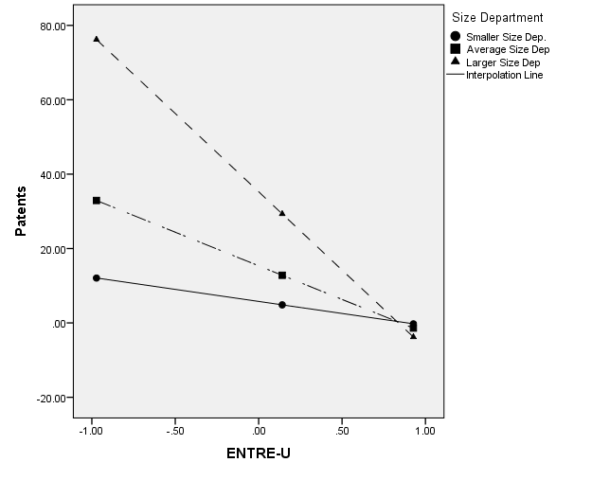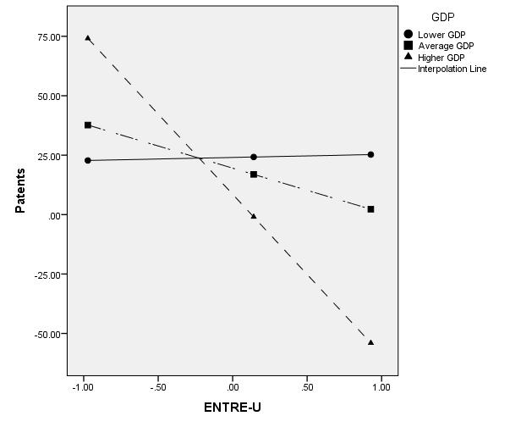 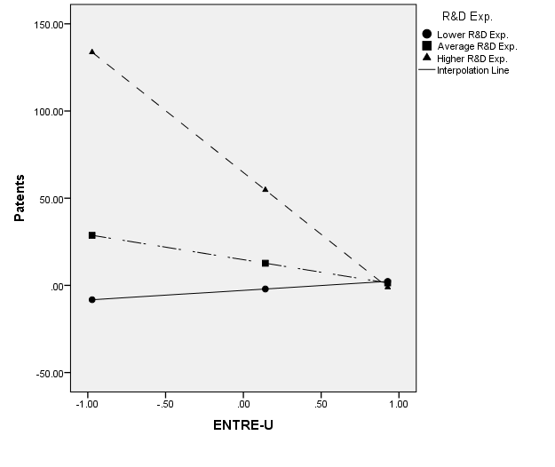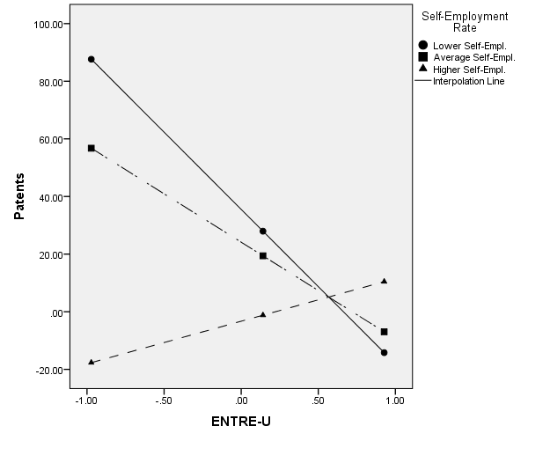

Figure 2. Interaction plots of ENTRE-U and internal contextual characteristics (size of the department) and external context characteristics (GDP pc, R&D expenditures and self-employment rate) on number of patents

Table 7 presents the results of our models considering the number of spin-offs as a dependent variable. ENTRE-U has a positive effect on the number of spin-offs (b=1.60, Model 2), supporting *H1b*.

Coming to the interaction effects of the internal contextual characteristics in the relation between ENTRE-U and the number of spin-offs, the age of the department has a significant positive interaction (b=0.03, Model 6). More specifically, for older departments (1 S.D. above the average in our sample), the effect of ENTRE-U on the number of spin-offs is significantly more positive (Effect=1.16, Table 8), compared with younger (1 S.D. below the average) and average age departments. The first plot in Figure 3 shows this interaction effect. Overall, these results support *H2b1*. The size of the department also shows a positive significant interaction (b=0.04, Model 5). Specifically, the relation between ENTRE-U and number of spin-offs is more positive for larger departments (1 S. D. above the average) (Effect=2.43, Table 8), when compared with smaller (1 S.D. below the average) and average departments. The second plot on Figure 3 depicts this interaction effect. These results support *H2b2*.

Concerning the moderation effect of the external context characteristics, our results show that the GDP per capita has a significant positive interaction in the relation between ENTRE-U and the number of spin-offs (b=6.03, Model 7). Specifically, in countries with higher GDP (1 S. D. above the average) (Effect=3.00, Table 8) the relation between ENTRE-U and the number of spin-offs is significantly more positive. The third plot (Figure 3) shows this interaction effect. Overall, these results support *H3b1*. The interaction effect of the R&D expenditure between ENTRE-U and the number of spin-offs is also significant and positive (b=11.65, Model 8). Particularly, when the R&D expenditure is higher (1 S.D. above the average), the relation becomes more positive (Effect=3.31, Table 8). The fourth plot on Figure 3 shows this effect. These results support *H3b2*. Finally, the interaction effect of the self-employment rate is negative and significant (b=-6.47, Model 9). Specifically, when the self-employment rate is lower (1 S.D. below the average) (Effect=2.30, Table 8) and average (Effect=1.38, Table 8) the relation between ENTRE-U and the number of spin-offs is positive, but when the self-employment rate is larger (1 S.D. above the average) (Effect=-0.85, Table 8) this relation is negative and significantly different from the other two. The fifth plot in Figure 3 shows this interaction effect. These results reject *H3b3*.

Table 7

Results of hierarchical regression analysis predicting number of spin-offs– Unstandardized regression coefficients

|  |  |  |  |  |  |  |  |  |  |
| --- | --- | --- | --- | --- | --- | --- | --- | --- | --- |
| **DV: Spin-Offs** | | | | | | | | | |
|  | *Model 1* | *Model 2* | *Model 3* | *Model 4* | *Model 5* | *Model 6* | *Model 7* | *Model 8* | *Model 9* |
|  | *b(SE)* | *b(SE)* | *b (SE)* | *b (SE)* | *b (SE)* | *b (SE)* | *b (SE)* | *b (SE)* | *b (SE)* |
| *Control Variables* |  |  |  |  |  |  |  |  |  |
| Sc. area – Nat. | -2.07 (1.59) | -1.98 (1.57) | -4.99 (3.08) | 7.22 (11.21) | -1.31 (1.46) | -1.31 (1.45) | -1.38 (1.49) | -1.30 (1.49) | -1.15 (1.50) |
| Sc. area – Eng. | 1.97 (1.75) | 1.27 (1.75) | -2.03 (1.51) | -1.57 (1.51) | 1.87 (1.57) | 1.72 (1.63) | 1.89 (1.62) | 1.96 (1.62) | 2.20 (1.63) |
| Sc. area – Med. | -3.09 (2.27) | -2.65 (2.25) | 1.32* (1.64) | 1.72* (1.64) | -4.34* (2.05) | -4.2* (2.11) | -3.63 (2.11) | -3.45 (2.10) | -4.00 (2.11) |
| Sc. area - Mng. | -2.74 (1.87) | -1.92 (1.87) | -4.59 (2.14) | -4.17 (2.13) | -1.78 (1.69) | -2.75 (1.74) | -2.20 (1.73) | -2.22 (1.72) | -2.10 (1.74) |
| Sc. area – Various | -2.20 (2.49) | -1.80 (2.46) | -2.01 (1.76) | -2.66 (1.75) | -1.22 (2.25) | -0.93 (2.33) | -1.30 (2.31) | -0.84 (2.30) | -0.65 (2.31) |
| **ENTRE-U** |  | 1.60** (0.57) | 1.10* (0.54) | 0.95 (0.53) | 1.14 (0.52) | 0.89 (0.53) | 0.71 (0.53) | 0.71 (0.53) | 0.75 (0.53) |
| *Internal Contextual Variables* |  |  |  |  |  |  |  |  |  |
| Size Dep. |  |  | 0.05*** (0.01) | 0.05*** (0.01) | 0.03** (0.00) | 0.05*** (0.01) | 0.05*** (0.01) | 0.05*** (0.01) | 0.05*** (0.01) |
| Age Dep. |  |  | 0.01 (0.01) | -0.01 (0.01) | -0.01 (0.01) | -0.01 (0.01) | -0.01 (0.01) | -0.01 (0.01) | -0.01 (0.01) |
| *External Contextual Variables* |  |  |  |  |  |  |  |  |  |
| GDP pc |  |  |  | -12.50* (5.83) | -10.62* (5.47) | -12.15* (5.65) | -11.28* (5.61) | -11.96* (5.58) | -11.86* (5.62) |
| R&D Exp. |  |  |  | 23*** (7.83) | 29.58** (10.60) | 32.43** (10.95) | 31.14** (10.86) | 32.21** (10.82) | 31.54** (10.90) |
| Self-Emp. |  |  |  | 0.02 (0.15) | -0.43 (2.90) | -0.38 (3.00) | 0.11 (2.98) | 0.10 (2.97) | -0.01 (2.99) |
| *Interaction Terms Internal Contextual Variables* | | |  |  |  |  |  |  |  |
| ENTRE-U *Size Dep. |  |  |  |  | 0.04*** (0.01) |  |  |  |  |
| ENTRE-U * Age Dep. |  |  |  |  |  | 0.03* (0.01) |  |  |  |
| *Interaction Terms External Contextual Variables* | | |  |  |  |  |  |  |  |
| ENTRE-U*GDP pc |  |  |  |  |  |  | 6.03** (2.04) |  |  |
| ENTRE-U*R&D Exp. |  |  |  |  |  |  |  | 11.65** (3.56) |  |
| ENTRE-U* Self-Emp. |  |  |  |  |  |  |  |  | -6.47** (2.53) |
| R2 | 0.042 | 0.070 | 0.189 | 0.22 | 0.29 | 0.24 | 0.25 | 0.26 | 0.24 |
| F | *F*(5;272)  =2.4* | *F*(6;271)=  3.38** | *F*(8;269)=  7.84*** | *F*(11;266)=  6.9*** | *F*(12;265)=  8.77*** | *F*(12;265)=  6.75*** | *F*(12;265)=  7.24*** | *F*(12;265)=  7.45*** | *F*(12;265)=  6.99*** |
| *Δ*R2 |  | 0.027  *F*(1;271)=  7.96** | 0.12  *F*(2;269)=  19.80*** | 0.33  *F*(3;266)=  3.76** |  |  |  |  |  |
| *Δ*R2 for the interaction term for the simple moderation model |  |  |  |  | 0.06  *F*(1;265)=  23.07*** | 0.01  *F*(1;265)=  4.12* | 0.03  *F*(1;265)=  8.75* | 0.03  *F*(1;265)=  10.70** | 0.02  *F*(1;265)=  6.53*** |

a IT Sciences as Reference Category; ***, *p* < 0.001, **, *p* < 0.01, *, *p*<0.05

Table 8.

Conditional effects of internal and external interaction variables in the relation between ENTRE-U and number of spin-offs

|  |  |  |  |  |  |  |
| --- | --- | --- | --- | --- | --- | --- |
|  | Effect | S.E. | *t* | *p* | LLCI | ULCI |
| Smaller Size Department  *(1 S.D. below the average)* | -0.53 | 0.60 | -0.88 | 0.37 | -1.71 | 0.64 |
| Average Size Department | 0.43 | 0.52 | 0.82 | 0.40 | -0.59 | 1.46 |
| Larger Size Department  *(1 S.D. above the average)* | 2.43 | 0.60 | 4.06 | 0.00 | 1.25 | 3.61 |
|  |  |  |  |  |  |  |
| Younger Age Department  *(1 S.D. below the average)* | 0.21 | 0.64 | 0.33 | 0.74 | -1.05 | 1.47 |
| Average Age Department | 0.63 | 0.55 | 1.13 | 0.25 | -0.45 | 1.71 |
| Older Age Department  *(1 S.D. above the average)* | 1.16 | 0.54 | 2.15 | 0.03 | 0.09 | 2.22 |
|  |  |  |  |  |  |  |
| Lower GDP pc  *(1 S.D. below the average)* | -0.26 | 0.67 | -0.40 | 0.69 | -1.57 | 1.05 |
| Average GDP pc | 0.68 | 0.53 | 1.28 | 0.20 | -0.37 | 1.73 |
| Higher GDP pc  *(1 S.D. above the average)* | 3.00 | 0.87 | 3.45 | 0.01 | 1.29 | 4.71 |
|  |  |  |  |  |  |  |
| Lower R&D Exp.  *(1 S.D. below the average)* | -0.55 | 0.70 | -0.79 | 0.42 | -1.92 | 0.82 |
| Average R&D Exp. | 0.45 | 0.55 | 0.82 | 0.41 | -0.62 | 1.53 |
| Higher R&D Exp.  *(1 S.D. above the average)* | 3.31 | 0.89 | 3.72 | 0.00 | 1.55 | 5.06 |
|  |  |  |  |  |  |  |
| Lower Self- Employment  *(1 S.D. below the average)* | 2.30 | 0.75 | 3.08 | 0.00 | 0.83 | 3.77 |
| Average Self- Employment | 1.38 | 0.55 | 2.49 | 0.01 | 0.29 | 2.46 |
| Higher Self- Employment  *(1 S.D. above the average)* | -0.85 | 0.88 | -0.96 | 0.33 | -2.58 | 0.89 |

*Note*: S.E. = Standard Error; S.D. = Standard Deviation; LLCI= Lower level confidence interval 95%; ULCI=Upper level confidence internal 95%

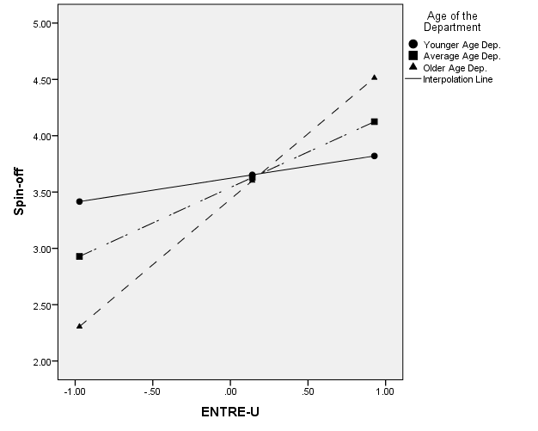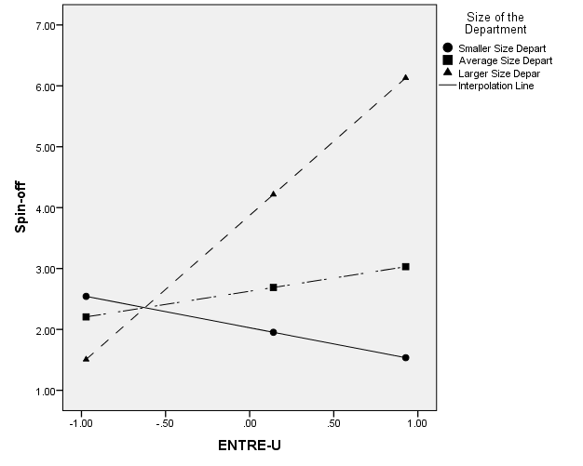

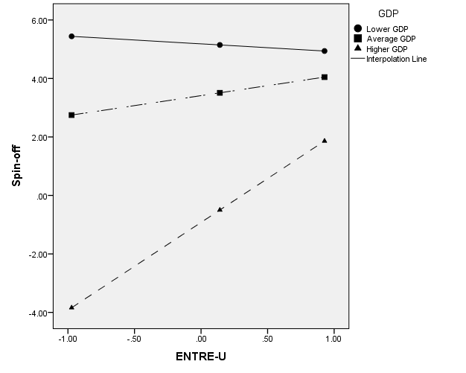 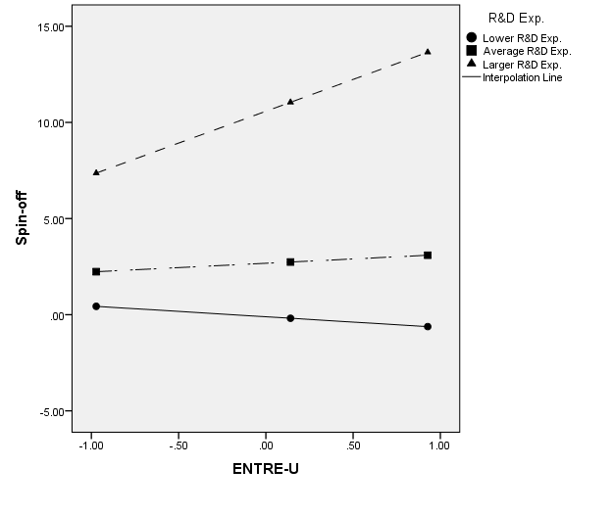

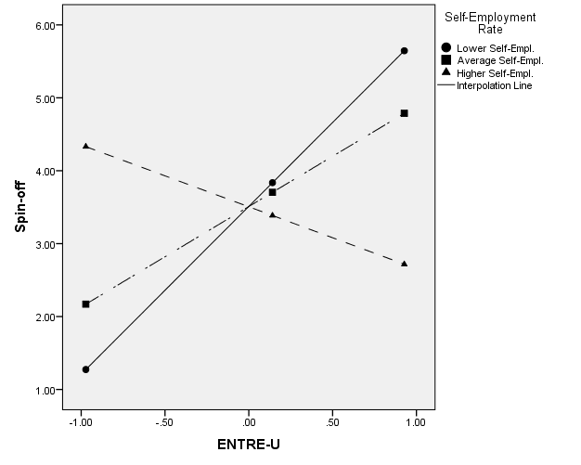

Figure 3. Interaction plots of ENTRE-U and internal contextual characteristics (age and size of the department) and external context characteristics (GDP pc, R&D expenditures and self-employment rate) on number of spin-offs

**5. Discussion**

Despite the growing academic interest towards entrepreneurial universities and their contribution to local development (Leih and Teece, 2016; Schmitz et al., 2017), entrepreneurial orientation within universities has been rarely examined (e.g., Tijssen, 2006; Todorovic, McNaughton and Guild, 2011; Riviezzo, Liñán and Napolitano, 2017). Borrowing an approach typically used in studies on profit-oriented firms, this paper focuses on the entrepreneurial orientation of university departments in four European countries, aiming to investigate its relationship with departments’ ability to generate patents and spin-offs from research. Moreover, we examine how internal and external contextual variables interact in this relation.

Even considering that it is not possible to make many generalizations out of our results, in view of the limitations further illustrated below, some interesting points emerge from our study. First, our results show a significant and positive impact of entrepreneurial orientation on academic entrepreneurship performance outcomes (i.e., the number of spin-offs generated from research), while this relationship is negative with knowledge transfer performance outcomes (i.e., the number of patents). Such evidence is quite surprising, since previous studies showed that academic entrepreneurship has experienced lower levels of knowledge commercialization through spin-offs compared to patents (e.g., Siegel, Waldam and Link, 2003; Shane, 2004; Geuna and Nesta, 2006; Verspagen, 2006; Wright et al., 2007; Van Looy et al., 2011; Urbano and Guerrero, 2013; Fini et al., 2017). In fact, “universities’ strategies have traditionally focused on licensing as the predominant mode of technology transfer and the general body of research has reflected this emphasis” (Wright, Birley and Mosey, 2004; p. 236).

One possible explanation for this unexpected result is found in the contextual conditions, supporting our assumption that context matters in the investigation of the relationship between entrepreneurial orientation and performance. Several variables can influence the choice among different forms and mechanisms of knowledge transfer and exploitation, such as the nature and level of the research funding, research intensity of the faculty, university’s reward systems, university’s culture, and characteristics of the region in which the university is located (e.g., O’Shea et al., 2005). In European countries, legal, economic and policy conditions may have influenced the major attention that universities traditionally have posed on spin-offs instead of patents. While the well-known Bayh-Dole Act of 1980 provided a mechanism for universities in the United States to retain title to patents derived from federally funded research, resulting in an increase in university patenting (e.g., Feldman et al., 2001; Powers and McDougall, 2005; Lerner, 2005; Bercovitz and Feldman, 2006), among European countries the so-called “professor privilege” conventionally gave the faculty members this right (Färnstrand Damsgaard and Thursby, 2013). Therefore, at the organizational level, patenting is probably perceived as an activity less dependent on university strategy but more on the will and personal interest of individuals. In this regard, over the years, several European countries have been proactive in introducing policies to foster technology transfer activities by academics, even abolishing the “professor privilege” (Fini et al., 2017). The effects of such reforms will be probably seen in the near future.

One more possible explanation for this result is found in the literature. Previous studies focused on the relationships between different knowledge transfer mechanisms, emphasizing potential trade-offs, in such a way that “focusing on one transfer mechanism might yield detrimental effects for other mechanisms” (Van Looy et al., 2011; p. 555). Specifically, higher levels of spin-off activity may coincide with lower levels of patent activity (and vice versa), with a substitutive relation prevailing over the complementary one (e.g., Wright et al., 2008; Van Looy et al., 2011). Thus, it may be that the entrepreneurial efforts within the investigated departments are focused more on one specific knowledge transfer mechanism (spin-offs) than the other (patents). However, the investigation of the relationship between different entrepreneurial performance outcomes was not among the aims of this study, and we do not have empirical support for this argument.

This result also raises another point, related to the use of appropriate metrics and methods to assess the impact of entrepreneurial universities’ activities (Guerrero, Cunningham and Urbano, 2015). Using few and very specific indicators may prevent a consistent assessment of the economic and social externalities created by entrepreneurial universities and associated with their impact on “demography, economy, infrastructure, culture, mobility, education, and society” (Guerrero, Cunningham and Urbano, 2015; p. 752). Thus, assessment indicators should present a balanced picture of university’s performance across all the entrepreneurial activities (Kapetaniou and Lee, 2017), by adopting a more “holistic approach that examines the main channels that bind universities to the rest of society” (Molas-Gallart et al., 2002; p. IV).

Our results also show a significant interaction effect of contextual variables in the relation between entrepreneurial orientation and performance. This effect is positive or negative depending on the context variables and performance variables considered. In any case, it is an effect that significantly affects the relationship and cannot be neglected. Scholars have largely discussed how contextual conditions influence the university proclivity to behave entrepreneurially (e.g., Feldman et al., 2001; Etzkowitz, 2004; Powers and Mcdougall, 2005; Bercovitz and Feldman, 2006; Wright et al., 2007; Urbano and Guerrero, 2013; Guerrero et al., 2014; Guerrero, Cunningham and Urbano, 2015). As noted by Urbano and Guerrero (2013; p. 51), “each entrepreneurial university is a function of its history and past successes and includes specific factors (environmental and internal) that could generate relevant conditions to explain interuniversity variation in entrepreneurship within their missions (teaching, research, and entrepreneurial activities)”. Therefore, even if in most countries they face similar challenges and share comparable historical backgrounds, economic conditions, cultural and social structures, “entrepreneurial universities remain distinct from one another by their arrangements, traditions and characteristics unique to each organization” (p. 46). The value added of this study is to empirically explore the moderating role of specific contextual variables (both internal and external to the university) in the relationship between entrepreneurial orientation and performance. That is, not only we considered the “direct” impact of context on entrepreneurial performance – largely discussed in literature –, but also the “indirect” impact, through the interaction with entrepreneurial orientation. At least to the best of our knowledge, this is a pioneer study to provide such empirical investigation within universities.

On the whole, our results seem to show that it is not possible to “generalize” the role of context variables, since it differs based on the performance indicator considered. Probably, it would be necessary to consider different entrepreneurial university types, as suggested by some scholars (e.g., Armbruster, 2008; Guerrero et al., 2014; Bronstein and Reihlen, 2014), based on their different characteristics, strategies, objectives, and evolutionary stage. Then, the analysis of relationships between variables under investigation in this study should take into proper consideration these differences. As noted above, the development of a clear strategic orientation towards entrepreneurship is a distinguishing feature of universities that are further ahead in the evolutionary process (Urbano and Guerrero, 2013) and that have deliberately chosen to play a leading role in the dynamics of local development. Our results show that such process is probably still “in progress” within European universities and, of course, it does not affect all the universities in the same way. As noted by Etzkowitz (2002), the transition from research university to the entrepreneurial university started in the United States during the late 19th century mostly as a consequence of the lack of a formal research funding system. The American entrepreneurial university emerged “bottom up” in contrast to Europe, where the introduction of academic entrepreneurship is a recent “top down” phenomenon, mostly influenced by pressures exerted by policy makers and public opinion to play a role in the local development (Etzkowitz, 2002). As a result of such policy commitment, the diffusion of entrepreneurial activities among the European universities is growing fast over the last years, but still there is a long way to run before we can say that the entrepreneurial university is a widely consolidated model in Europe.

**6. Limitations, future research and conclusions**

This study is not without limitations. First, we used a structured questionnaire to collect perceived data from key informants. Even if this method has been proved to be effective, it could lead to biased reporting. In the future, we recommend the use of factual and secondary data on performance measures. Second, our focus on the “best performer departments” could have biased the results as well. Third, we focused our research on academic entrepreneurship (spin-offs) and knowledge transfer (patents). Beyond these, it would be of great interest for future research to integrate performance data with additional variables addressing different aspects of universities contribution to local development and social innovation (such as the number of joint research projects with firms, the number of graduates employed, the presence in the educational offering of entrepreneurship courses, etc.). Similarly, it would be interesting to supplement the data on the actual level of entrepreneurship within the university departments (considering, for example, the weight assigned to entrepreneurship activities in the strategic documents of universities and departments, such as statutes, regulations, mission statements etc.). Future research would also benefit from longitudinal data, analyzing how the process unfolds over time, and thus adding more value to the proposed framework. Furthermore, in order to verify to what extent the external contextual conditions can affect the results and the relationships between the investigated variables – as it would appear from the results of this study – it would be particularly interesting to perform a comparative analysis among other European countries, comparing Mediterranean, Anglo-Saxon, Central Europe, Nordic and Eastern Europe countries. Moreover, using regional-based data about the economic situation, and not national-based data, would increase the value of the study, since knowledge spillovers are at least partly dependent on local proximity.Similarly, in order to deepen the role of internal contextual variables, specific studies focused on each scientific area of departments could also offer interesting results. Finally, a more specific investigation of the relationship between different entrepreneurial performance outcomes would be really valuable, in order to understand if any substitutive relation really exists. To this aim, a different approach to data analysis would be needed, by using, for instance, structural equation modeling.

We hope that the above-mentioned points may represent interesting directions for future avenues of research to expand the present study. However, even considering its limitations and reminding its exploratory nature, we do believe that it makes an interesting contribution, emphasizing that context matters in the evolutionary process of a university towards the entrepreneurial model. The results of the efforts made by the university that intends to act as an effective economic and societal change agent in creating an entrepreneurial orientation and culture are conditioned by the characteristics of the context. Thus, internal and external conditions cannot be neglected in studies focused on the university’s strategic orientation. Furthermore, our study revealed that the university-level analysis is not enough to really understand how and why an institution is (or is not) an entrepreneurial university. Research in this field needs to focus on a lower level of analysis (the university department, or even the research group). This line of research could provide a better understanding of the elements making some departments entrepreneurial, with clear implications also in terms of managerial priorities and organizational design in order to create a common vision among all the members. In this regard, the present study provides a clear guidance for the enhancement of the entrepreneurial orientation of European university departments, by identifying what university managers need to do in order to improve the openness of their departments to relationships with the business world and society. The evaluation of specific organizational features may facilitate the strategic intervention aiming at fostering the entrepreneurial posture of university departments. Following this line of research would allow also for the implementation of more effective measures of entrepreneurial performance.

**REFERENCES**

Armbruster, C. (2008). Research universities: Autonomy and self-reliance after the entrepreneurial university. *Policy Futures in Education*, 6(4), 372-389.

Audretsch, D. B. (2014). From the entrepreneurial university to the university for the entrepreneurial society. *The Journal of Technology Transfer*, 39(3), 313-321.

Autio, E., Kenney, M., Mustar, P., Siegel, D., & Wright, M. (2014). Entrepreneurial innovation: The importance of context. *Research Policy*, 43(7), 1097-1108.

Bascle, G. (2008). Controlling for endogeneity with instrumental variables in strategic management research. *Strategic Organization, 6*(3), 285-327.

Baum, C. F., Schaffer, M. E., & Stillman, S. (2002). *IVENDOG: Stata module to calculate Durbin-Wu-Hausman endogeneity test after ivreg*. Boston: Boston College Department of Economics.

Bercovitz, J. and Feldman, M. (2006). Entrepreneurial universities and technology transfer: A conceptual framework for understanding knowledge-based economic development. *Journal of Technology Transfer*, 31, 175–188.

Brennan, M. C., & McGowan, P. (2006). Academic entrepreneurship: an exploratory case study. *International Journal of Entrepreneurial Behavior & Research*, 12(3), 144-164.

Bronstein, J., & Reihlen, M. (2014). Entrepreneurial university archetypes: A meta-synthesis of case study literature. *Industry and Higher Education*, 28(4), 245-262.

Byrne, B. M. (2004), “Testing for multi-group invariance using AMOS graphics: A road less travelled”, *Structural Equation Modeling,* *11* (2), 272–300.

Chapple, W., Lockett, A., Siegel, D., Wright, M., (2005). Assessing the relative performance of U.K. university technology transfer offices: parametric and nonparametric evidence. *Research Policy*, 34 (3), 369–384.

Chen, F. F., West, S. G., & Sousa, K. H. (2006). A comparison of bifactor and second-order models of quality of life. *Multivariate Behavioral Research*, 41(2), 189-225.

Clark, B. R. (1998). *Creating Entrepreneurial Universities.* *Organisational Pathways of Transformation*. Pergamon Press, New York.

Cohen W.M., Nelson R.R., Walsh J.P. (2002), Links and impacts: the influence of public research on industrial R&D, *Management Science*, 48(1), 1-23.

Coulthard, M. (2007). The role of entrepreneurial orientation on firm performance and the potential influence of relational dynamism. *Journal of global business and technology*, 3(1), 29.

Covin, J. G., & Slevin, D. P. (1991). A conceptual model of entrepreneurship as firm behavior. *Entrepreneurship: Critical perspectives on business and management*, 3, 5-28.

Cronbach, L.J. (1951). Coefficient alpha and the internal structure of tests. *Psychometrika*, *16*(3), 297–334.

Davidson, R., & Mackinnon, J. (1983). *Estimation and interference in economics*. Oxford University Press, New York, USA.

Dawson, J. F. (2014). Moderation in management research: What, why, when, and how. *Journal of Business and Psychology*, 29(1), 1-19.

Di Gregorio, D., & Shane, S. (2003). Why do some universities generate more start-ups than others?. *Research policy*, 32(2), 209-227.

Etzkowitz, H. (1983). Entrepreneurial scientists and entrepreneurial universities in American academic science. *Minerva*, 21,198-233.

Etzkowitz, H. (2002). Incubation of incubators: innovation as a triple helix of university-industry-government networks. *Science and Public Policy*, 29(2), 115-128.

Etzkowitz, H. (2003). Research groups as ‘quasi-firms’: the invention of the entrepreneurial university. *Research policy*, 32(1), 109-121.

Etzkowitz, H. (2004). The evolution of the entrepreneurial university. *International Journal of Technology and Globalisation*, 1(1), 64-77

Etzkowitz, H. (2013). Anatomy of the entrepreneurial university. *Social Science Information*, 52(3), 486-511.

Färnstrand Damsgaard, E., & Thursby, M. C. (2013). University entrepreneurship and professor privilege. *Industrial and Corporate Change*, 22(1), 183-218.

Fayolle, A., & Redford, D. T. (2014). *Handbook on the entrepreneurial university*. Edward Elgar Publishing, Northampton, MA, USA.

Feldman, M. P., Feller, I., Bercowitz, J. E. L., & Burton, R. M. (2001). Understanding evolving university-industry relationships, In M. P. Feldman and A. N. Link (Eds.), *Innovation Policy in the Knowledge Based Economy*, Boston, MA: Kluwer Academic Publishers, pp. 171–188

Fini, R., Fu, K., Mathisen, M. T., Rasmussen, E., & Wright, M. (2017). Institutional determinants of university spin-off quantity and quality: a longitudinal, multilevel, cross-country study. *Small Business Economics*, 48(2), 361-391.

Fini, R., Grimaldi, R., Santoni, S., & Sobrero, M. (2011). Complements or substitutes? The role of universities and local context in supporting the creation of academic spin-offs. *Research Policy*, 40(8), 1113-1127.

Fox J. (1997). *Applied Regression, Linear Models, and Related Methods*. Sage: Thousand Oaks, CA.

Geuna, A., & Nesta, L. J. (2006). University patenting and its effects on academic research: The emerging European evidence. *Research policy*, 35(6), 790-807.

Gibb, A. (2012). Exploring the synergistic potential in entrepreneurial university development: towards the building of a strategic framework. *Annals of Innovation & Entrepreneurship*, 3(1), 1642.

Global Entrepreneurship Monitor Consortium. (2018). Fear of failure rate, retrieved from <http://www.gemconsortium.org/data> (accessed 09 March 2018)

Grimaldi, R., Kenney, M., Siegel, D. S., & Wright, M. (2011). 30 years after Bayh–Dole: Reassessing academic entrepreneurship. *Research Policy*, 40(8), 1045-1057.

Guerrero, M., & Urbano, D. (2012). The development of an entrepreneurial university. *The journal of technology transfer*, 37(1), 43-74.

Guerrero, M., Cunningham, J. A., & Urbano, D. (2015). Economic impact of entrepreneurial universities’ activities: An exploratory study of the United Kingdom. *Research Policy*, 44(3), 748-764.

Guerrero, M., Urbano, D., & Fayolle, A. (2016). Entrepreneurial activity and regional competitiveness: evidence from European entrepreneurial universities. *The Journal of Technology Transfer*, 41(1), 105-131.

Guerrero, M., Urbano, D., Cunningham, J. A., & Gajón, E. (2018). Determinants of Graduates' Start‐Ups Creation across a Multi‐Campus Entrepreneurial University: The Case of Monterrey Institute of Technology and Higher Education. *Journal of Small Business Management*, 56(1), 150-178.

Guerrero, M., Urbano, D., Cunningham, J., & Organ, D. (2014). Entrepreneurial universities in two European regions: A case study comparison. *The journal of technology Transfer*, 39(3), 415-434.

Hair, J.F., Black, W.C., Babin, B.J., Anderson, R.E., Tatham, R.L., (2006). *Multivariate Data Analysis*, sixth ed. Pearson-Prentice Hall, Englewood Cliffs, NJ.

Hamilton, B. H., & Nickerson, J. A. (2003). Correcting for endogeneity in strategic management research. *Strategic Organization, 1*(1), 51-78.

Hayes D., Wynyard R., (eds.), (2002). *The McDonaldization of higher education*. Bergin & Garvey, Westport, USA.

Hayes, A. F. (2012). *Process: A versatile computational tool for observed variable mediation, moderation, and conditional process modeling* [White paper]. Available at http://www.afhayes.com/ public/process2012.pdf (accessed 8 March 2017).

Hussler, C., Picard, F., & Tang, M. F. (2010). Taking the ivory from the tower to coat the economic world: regional strategies to make science useful. *Technovation*, 30(9), 508-518.

Huyghe, A., & Knockaert, M. (2015). The influence of organizational culture and climate on entrepreneurial intentions among research scientists. *Journal of Technology Transfer*, 40(1), 138–160.

Jacob, M., Lundqvist, M., & Hellsmark, H. (2003). Entrepreneurial transformations in the Swedish University system: the case of Chalmers University of Technology. *Research Policy*, 32(9), 1555-1568.

Kapetaniou, C., & Lee, S. H. (2017). A framework for assessing the performance of universities: The case of Cyprus. *Technological Forecasting and Social Change*, 123, 169-180.

Kibler, E., & Kautonen, T. (2016). The moral legitimacy of entrepreneurs: An analysis of early-stage entrepreneurship across 26 countries. *International Small Business Journal*, 34(1), 34-50.

Kibler, E., Fink, M., Lang, R., & Muñoz, P. (2015). Place attachment and social legitimacy: Revisiting the sustainable entrepreneurship journey. *Journal of Business Venturing Insights*, 3, 24-29.

Kibler, E., Kautonen, T., & Fink, M. (2014). Regional social legitimacy of entrepreneurship: Implications for entrepreneurial intention and start-up behaviour. *Regional Studies*, 48(6), 995-1015.

Klofsten M., & Jones-Evans D. (2000), “Comparing Academic Entrepreneurship in Europe-The Case of Sweden and Ireland”, *Small Business Economics*, 14(4), 299-310.

Koufteros, X., Babbar, S., & Kaighobadi, M. (2009). A paradigm for examining second-order factor models employing structural equation modeling. *International Journal of Production Economics*, 120(2), 633-652.

Leih, S., & Teece, D. (2016). Campus leadership and the entrepreneurial university: A dynamic capabilities perspective. *The Academy of Management Perspectives*, 30(2), 182-210.

Lerner, J. (2005). The university and the start-up: lessons from the past two decades. *The Journal of Technology Transfer*, 30(1), 49-56.

Levy, R., Roux, P., & Wolff, S. (2009). An analysis of science–industry collaborative patterns in a large European University. *The Journal of Technology Transfer*, 34(1), 1-23.

Liñán, F., Urbano, D., & Guerrero, M. (2011). Regional variations in entrepreneurial cognitions: Start-up intentions of university students in Spain. *Entrepreneurship and Regional Development*, 23(3-4), 187-215.

Lomberg, C., Urbig, D., Stöckmann, C., Marino, L. D., & Dickson, P. H. (2017). Entrepreneurial orientation: the dimensions' shared effects in explaining firm performance. *Entrepreneurship Theory and Practice*, 41(6), 973-998.

Lumpkin, G. T., & Dess, G. G. (1996). Clarifying the entrepreneurial orientation construct and linking it to performance. *Academy of management Review*, 21(1), 135-172.

Lumpkin, G.T., & Dess G. G., (2001), Linking Two Dimensions of Entrepreneurial Orientation to Firm Performance: The Moderating Role of Environment and Industry Life Cycle, *Journal of Business Venturing*, 16 (5), 429–451.

Martinelli, A., Meyer, M., & Von Tunzelmann, N. (2008). Becoming an entrepreneurial university? A case study of knowledge exchange relationships and faculty attitudes in a medium-sized, research-oriented university. *The Journal of Technology Transfer*, 33(3), 259-283.

Miller, D. (1983). The correlates of entrepreneurship in three types of firms. *Management science*, 29(7), 770-791.

Molas-Gallart, J., Salter, A., Patel, P., Scott, A., & Duran, X. (2002). Measuring third stream activities. *Final report to the Russell Group of Universities. Brighton: SPRU, University of Sussex*.

Munari, F., Rasmussen, E., Toschi, L., & Villani, E. (2016). Determinants of the university technology transfer policy-mix: A cross-national analysis of gap-funding instruments. *The Journal of Technology Transfer*, 41(6), 1377-1405.

Netemeyer, R.G., Bearden, W.O., Sharma, S., (2003). *Scaling Procedures: Issues and Applications*. Sage Publications, Thousands Oak, CA.

Neter J., Kutner, M. H., Nachtsheim, C. J., Wasserman, W. (1996). *Applied Linear Statistical Models*. Irwin: Chicago, IL.

O’Shea, R. P., Allen, T. J., Chevalier, A., & Roche, F. (2005). Entrepreneurial orientation, technology transfer and spinoff performance of US universities. *Research policy*, 34(7), 994-1009.

O’Shea, R. P., Chugh, H., & Allen, T. J. (2008). Determinants and consequences of university spinoff activity: a conceptual framework. The Journal of Technology Transfer, 33(6), 653-666.

OECD (2018), Gross domestic spending on R&D (indicator). doi: 10.1787/d8b068b4-en (Accessed on 09 March 2018)

OECD (2018), Self-employment rate (indicator). doi: 10.1787/fb58715e-en (Accessed on 09 March 2018)

Owen-Smith, J. and W. W. Powell (2003). The expanding role of university patenting in the life sciences: assessing the importance of experience and connectivity. *Research Policy*, 32(9), 1695–1711.

Philpott, K., Dooley, L., O'Reilly, C., & Lupton, G. (2011). The entrepreneurial university: Examining the underlying academic tensions. *Technovation*, 31(4), 161-170.

Pirnay, F., & Surlemont, B. (2003). Toward a typology of university spin-offs. *Small business economics*, 21(4), 355-369.

Podsakoff, P.M., MacKenzie, S.M., Lee, J., Podsakoff, N.P. (2003). Common method variance in behavioral research: A critical review of the literature and recommended remedies. *Journal of Applied Psychology,* *88* (5), 879-903.

Powers, J. B. (2004). R&D funding sources and university technology transfer: What is stimulating universities to be more entrepreneurial?. *Research in Higher Education*, 45(1), 1-23.

Powers, J. B., & McDougall, P. P. (2005). University start-up formation and technology licensing with firms that go public: a resource-based view of academic entrepreneurship. *Journal of business venturing*, 20(3), 291-311.

Riviezzo, A., Liñán, F., & Napolitano, M. R. (2017). Assessing the Entrepreneurial Orientation of University Departments. A Comparative Study Between Italy and Spain. In: Peris-Ortiz M., Gómez J. A., Merigo J. M., Rueda-Armengot C. (Editors)  *Entrepreneurial Universities* (pp. 35-46). Springer International Publishing.

Salter, A.J., Martin, B.R., 2001. The economic benefits of publicly funded basicresearch: a critical review? *Research Policy*, 30, 509–532.

Schmitz, A., Urbano, D., Dandolini, G. A., de Souza, J. A., & Guerrero, M. (2017). Innovation and entrepreneurship in the academic setting: a systematic literature review. *International Entrepreneurship and Management Journal*, 13(2), 369-395.

Shane, S. (Ed.). (2004). *Academic entrepreneurship –University spinoffs and wealth creation (New horizons in entrepreneurship).* Cheltenham: Edward Elgar Publishing Inc.

Shirokova, G., Tsukanova, T., & Morris, M. H. (2018). The Moderating Role of National Culture in the Relationship Between University Entrepreneurship Offerings and Student Start‐Up Activity: An Embeddedness Perspective. *Journal of Small Business Management*, 56(1), 103-130.

Siegel, D., Waldam, D., & Link A. (2003). Assessing the impact of organisational practises on the relative productivity of university transfer offices: An exploratory case. *Research Policy*, 32(1), 27–48

Sine, W., Shane, S., Di Gregorio, D., (2003). The halo effect and university technology licensing. *Management Science*, 49 (4), 478–497.

Slaughter S., Leslie L.L. (1997). *Academic capitalism: Politics, policies, and the entrepreneurial university*. Johns Hopkins University Press, Baltimore, USA.

Sternberg, R. (2014). Success factors of university-spin-offs: Regional government support programs versus regional environment. *Technovation*, 34(3), 137-148.

Stock, J., & Yogo, M. (2005). *Testing for Weak Instruments in Linear IV Regression*. In: Andrews DWK Identification and Inference for Econometric Models (pp. 80-108). Cambridge University Press, New York, USA.

Tabachnick, B. G., Fidell, L. S. (2001). *Using Multivariate Statistics*. Allyn and Bacon: Boston, MA.

Tang, Y., & Wezel, F. C. (2015). Up to standard? Market positioning and performance of Hong Kong films, 1975-1997. *Journal of Business Venturing, 30*(3), 452-466.

Tartari, V., Perkmann, M., & Salter, A. (2014). In good company: The influence of peers on industry engagement by academic scientists. *Research Policy*, 43(7), 1189-1203.

Tijssen, R. J. (2006). Universities and industrially relevant science: Towards measurement models and indicators of entrepreneurial orientation. Research Policy, 35(10), 1569-1585.

Todorovic W.Z., Mcnaughton R.B., Guild P.D. (2011), “ENTRE-U: An entrepreneurial orientation scale for universities”, *Technovation*, 31, 128-137.

Trippl, M., Sinozic, T., & Lawton Smith, H. (2015). The role of universities in regional development: conceptual models and policy institutions in the UK, Sweden and Austria. *European Planning Studies*, 23(9), 1722-1740.

Urbano, D., & Guerrero, M. (2013). Entrepreneurial universities: Socioeconomic impacts of academic entrepreneurship in a European region. *Economic Development Quarterly*, 27(1), 40-55.

Van Burg, E., Romme, A. G. L., Gilsing, V. A., & Reymen, I. M. (2008). Creating University Spin‐Offs: A Science‐Based Design Perspective. *Journal of Product Innovation Management*, 25(2), 114-128.

Van Looy, B., Landoni, P., Callaert, J., Van Pottelsberghe, B., Sapsalis, E., & Debackere, K. (2011). Entrepreneurial effectiveness of European universities: An empirical assessment of antecedents and trade-offs. *Research Policy*, 40(4), 553-564.

Verspagen, B. (2006). University research, intellectual property rights and European innovation systems. *Journal of Economic surveys*, 20(4), 607-632.

Widaman, K.F. (1985). Hierarchically nested covariance structure models for multitrait–multimethod data. *Applied Psychological Measurement*, 9(1), 1-26.

Wiklund, J., & Shepherd, D. (2005). Entrepreneurial orientation and small business performance: a configurational approach. *Journal of business venturing*, 20(1), 71-91.

World Bank (2018). GDP per capita, retrieved from https://data.worldbank.org/indicator/NY.GDP.PCAP.CD?end=2016&start=2015&view=chart (accessed on 09 March 2018)

Wright, M., Birley, S., & Mosey, S. (2004). Entrepreneurship and university technology transfer. *The Journal of Technology Transfer*, 29(3), 235-246.

Wright, M., Clarysse, B., Lockett, A., Knockaert, M., 2008. Mid-range universities’ linkages with industry: knowledge types and the role of intermediaries. *Research Policy*, 37 (8), 1205–1223.

Wright, M., Clarysse, B., Mustar, P., Lockett, A. (2007). *Academic Entrepreneurship in Europe*. Edward Elgar Publishing, MA, USA.

Zahra, S. A., & Covin, J. G. (1995). Contextual influences on the corporate entrepreneurship-performance relationship: A longitudinal analysis. *Journal of business venturing*, 10(1), 43-58.

**Authors Biography**

**Angelo Riviezzo** is Professor of Business Strategy and Business Planning, University of Sannio, Benevento (Italy). He holds a PhD in Management and his main research interests include competitive strategies, with particular focus on SMEs, and entrepreneurship, with particular focus on corporate and academic entrepreneurship. He has authored about 70 publications on these topics, including articles in peer-reviewed journals, books and book chapters and conference proceedings. He is active member of the European University Network on Entrepreneurship (ESU), the Italian Management Society, and the Italian Marketing Association.

**Francisco Liñán** (PhD, University of Seville) is Professor of entrepreneurship and innovation at Anglia Ruskin University (UK), and University of Seville (Spain). Francisco’s main research interests include entrepreneurship as a process, entrepreneurial intentions, entrepreneurship education and culture’s role in entrepreneurship. He has published over 25 articles in international journals and a similar number of chapters in edited books. He has led/participated in research projects for the EU, OECD, national and regional governments. Prof. Liñán is member of the coordination committee at the ESU Network in Entrepreneurship.

**Susana C. Santos** is an Assistant Professor at Rowan University (USA). She completed her Ph.D. at ISCTE-IUL, Instituto Universitário de Lisboa (Portugal) and completed her post-doctoral program at the University of Florida. Her main research interests are focused on the cognitive and psychosocial processes of entrepreneurship, at individual and team level. Susana has authored several articles in peer-reviewed journals and edited books.

**Maria Rosaria Napolitano** is Professor of Marketing and Corporate Strategy, University of Sannio, Benevento (Italy). Her research focuses mainly on place marketing, heritage marketing and corporate strategy. She is author of several publications in these fields of study. She lectures at Department of Law, Economics, Management and Quantitative Methods. She is a senior member of the Italian Marketing Association, the Italian Management Society and the European University Network on Entrepreneurship.

**Floriana Fusco** isa Post-Doctoral Research Fellow in Business Administration at University of Milan (Italy). Previously, she got a PhD in “Management and Local Development” at University of Sannio in Benevento (Italy). Her main research fields include co-production and co-creation of value in public services, social responsibility and sustainability reporting in public sector, third mission and entrepreneurial orientation in public universities.

Appendix 1. Graphic representations on the four alternative CFA models for ENTRE-U

|  |  |
| --- | --- |
| Model 1—one first order factor | Model 2—four first order factors (uncorrelated) |
|  |  |
| Model 3—four first order factors (correlated) | Model 4—four first order and one second order factor |
|  |  |

Notes: RM= Research mobilization; U=Unconventionality; IC=Industry Collaboration; UP=University Policies

1. Universitá degli Studi del Sannio
2. Universidad de Sevilla
3. Anglia Ruskin University
4. Rowan University
5. Universitá degli Studi de Milano