A Validated Low Carbon Office Building Intervention Model based on Structural Equation Modelling

Mafimisebi, I., Blessing* ª; Jones, Keith ª; Sennaroglu, Bahar ^{b} and Nwaubani, Sunday ^{c}

ªDepartment of Engineering and the Built Environment, Anglia Ruskin University, Chelmsford, UK
^{b}Department of Industrial Engineering, Marmara University, Istanbul, Turkey
^{c}School of Civil and Environmental Engineering, University of the Witwatersrand, Johannesburg, South Africa

Corresponding Author: Mafimisebi, I., Blessing*
Mobil: +44(0)7494338293
Email Address: MAFIMISEBI@BTC.ac.uk

Abstract
Building energy performance in existing stocks via facilities management interventions for low carbon building has become expedient and relevant in global climate change discourse. It has raised the consciousness for the need for a unified decision-support model for Facilities Managers and Owners, which could be used for office buildings across countries in achieving cleaner building energy production and use. This paper aimed at examining the factors that affect office Building Energy Performance; their interdependencies; and identify the critical path for interventions. It filled this gap by presenting a combination of interrelated processes (operations, tactics, and strategies) needed to improve building energy performance, reduce costs and greenhouse gas emissions in buildings for organizations. An online questionnaire survey was used in gathering data on current study model variables from participants of case study office buildings in Nigeria and the UK. Structural Equation Modelling technique was used to examine the factors that contribute to improving the energy performance of heterogeneous office buildings in both countries. The result established a strong correlation among observed variables and constructs and high covariance between constructs. This indicates that dependency and interdependency relationships exist amongst constructs, and in between construct and indicators. The finding reveals that an organization needs Sustainability Policy, Facilities Management and Energy Management as a sub-set of Strategic policy incorporated into its core management policy and operations energy management to achieve low carbon building. It also reveals the most critical pathway in the overall model with Strategic Facilities Management discovered to underpin the optimal performance for office buildings.

Keywords
Strategic Sustainability, Management Policy, Building Performance, Energy Efficiency, Greenhouse Gas emissions, Structural Equation Modelling.

Nomenclature used in the paper
- Analysis of Moment Structures (AMOS)
- Average Variance Extracted (AVE)
- Built Asset Management (BAM)
- Building Energy Efficiency (BEE)
- Building Energy Performance (BEP)
- Building Energy Management (BEM)
- Building Technologies (BEMTechs)
- Building Energy Use Intensity (BEUI)
- Building Energy Performance Model (BEP_Model) sub-construct
- BEP indicator-Climate (BEP.Model_Climate)
- BEP indicator-Barrier & Drivers (BEP.Model_BAR.DRI)
- BEP indicator-LZC solutions (BEP_LZC Soln.)
- BEP indicator-Operations (BEP.Model_OP)
- BEP indicator-Regulatory policy framework (BEP.Model_Policy.Frmwk,
- BEP indicator-SBM via BAM (BEP.Model_SBM.BAM),
- Chi-square (χ²)
- Climate Change (CCH)
- Comparative Fit Index (CFI)
- Chi-square/ degree-of-freedom (CMIN/dof)
- Confirmatory Factor Analysis (CFA)
- Construct Reliability (CR)
- Correlation (r)
- Covariance (cv)
- Data Acquisition System (DAS)
- Driver-Building Energy Management Technologies (DRI_ BEMTechs)
- Driver-Renewable Technologies (DRI_RETOs)
- Driver-Performance Metrics/ Key Performance Indicators (DRI_PMs.KPIs)
- Driver-Strategic Energy Management (DRI- SEM)
- Driver-Strategic Energy Management and Strategic Facilities Management (DRI_SEM.SFM)
- European Standards for Energy Management System (EN16001standards)
- Energy Efficiency (EE)
- Energy Efficiency Performance (EEP)
- Energy Performance Certificates (EPCs)
- European Union (EU)
- Exploratory Factor Analysis (EFA)
- Facilities Management (FM)
- Facilities Managers (FMs)
- Factor loading (FL)
- Goodness-of-fit (GOF)
- Greenhouse Gas Emission (GHG)
- Heating, ventilation and air conditioning (HVAC)
- Incremental fit index (IFI)
- International Standard Organization (ISO 14001)
- Management Policy (Mgt_Policy)
- Management Policy-Strategic Energy Management (Mgt_SEM)
- Management Policy-Strategic Facilities Management (Mgt_SFM)
- Management Policy-Strategic Sustainability Policy and Strategic Facilities Management (Mgt_SSP.SFM)
- Management Policy-Strategic Sustainability Policy (Mgt_SSP)
- Maximum Likelihood (ML)
- Normed fit index (NFI)
- Operational-Energy Audit (OP_Enrgy.Audit)
- Operational-Assessment (Assmnt)
- Operational- Model Usage (OP_Model.use)
- P-values (PCLOSE)
- Parsimony Ratio (PRATIO)
- Parsimony Normed Fit Index (NFI)
- Parsimony Comparative Fit Index (PCFI)
- Parsimony Goodness-of-fit Index (PGFI).
- Photovoltaic (PV)
- Principal Component Analysis (PCA)
- Principal Axis Factoring (PAF)
- Relative Fit Index (RFI)
- Renewable Technologies (RETOs)
- Root Mean Squared Error of Approximation (RMSEA)
- Squared Multiple Correlation (SMC)
- Strategic-Drivers (STRATEGIC_DRI)
- Structural Equation Modelling (SEQM)
- Strategic Energy Management (SEM)
- Sub-Saharan African (SSA)
- Strategic Sustainability Policy (SSP)
- Strategic Facilities Management (SFM)
- Trucker-Lewis Index (TLI)

Introduction
Global efforts to mitigate the effects of climate change (CCH) by improving building energy performance (BEP), has yielded more success in the developed countries compared to developing countries (Haapio, Viitaniemi 2008, Dascalaki, Balaras et al. 2012). Although the numerous factors that account for this disparity are well established in extant literature (Li, Hong et al. 2014, Ole Fanger 2006), it is how these factors interact with one another that is explored in this study. Thus, a review of energy savings in existing building stocks via Facilities Management (FM) interventions is expedient and relevant for achieving low carbon buildings. This study examines the factors that affect the BEP and their interdependencies through structural equation modelling (SEQM).

In the UK and other developed countries, integrated approaches such as established regulatory frameworks (building energy codes, policies, institutional control and enforcement), have been successful in stabilizing their GHG emissions (Delia D’agostino, Zangheri et al. 2017). The same cannot be said of sub-Saharan African (SSA) countries, as traditional approaches used in the region have been unsuccessful compared to developed countries (UN-HABITAT 2011). Although, most SSA countries have building regulations, in most instances, these codes lack fuel efficiency and carbon reduction regulations. Also, despite the relative gains from energy efficiency (EE) standards globally, EE has been compromised by unintended consequences such as: poor working performance of installed systems and controls; complicated and fragmented procurement and management process; and perceived needs of present-day occupant incurring more energy inputs through better ventilation, more air-conditioning and lighting etc., (Cohen and Bordmass, 2015).

The roles of Facilities Managers (FMs) in office buildings’ energy consumption, monitoring and controls management are now important worldwide (Cohen, Bordass 2015). FM is one of the fastest growing professions in the UK. Its market is worth more than 106.3 billion, with a growth rate of between 2% and 3% till the year 2012 (Elmualim, Shockley et al. 2010). UK’s operational FM is fully developed and underpinned with sustainable policy (SP). Whereas, Nigeria’s FM industry is in its infancy phase compared to the maturity of the UK’s FM industry. Facility owners and organizations lack the will to incorporate strategic sustainability policy (SSP) and strategic facilities management (SFM) into their built asset management (BAM) portfolio. Also, most commercial buildings are operated by non-professionals who lack the required FM skills and know-how.

Existing buildings formed a clear majority of building stocks globally. Almost one-half of existing building stocks were built before modern energy efficiency standards, and new construction is only 1% per year of existing building stocks. Hence, retrofit has the potential to significantly contribute towards energy policy development commitment through energy reduction and achieving 80% CO₂ emissions reduction by 2050 (Albatici, Gadotti et al. 2016). Also, across Europe, buildings account for about 40% of total primary energy consumption and about 36% of GHGs emission (Albatici, Gadotti et al. 2016). A recent study (Lu, Zheng et al. 2016), confirmed that energy consumption per unit area of a public building is 10 times that of domestic building, and office building typology accounts for over 50% of total energy consumption of public building excluding domestic buildings. Thus, a building is a viable target for adaptation to extreme weather and CCH in reducing harmful impacts (Linnenluecke, Griffiths et al. 2015).

There is the need for unified decision-support model for FMs and owners that could be used for all type of office buildings and across countries in achieving cleaner building energy production and use. This paper presents the first known application of SEQM to understand how the BEP model as a decision-making tool can be used to achieve low carbon solution for office buildings. Also, it reveals a BEP model can be better utilized with other measures like management policy, operational procedure, and strategic drivers; and the critical path for its optimization. The SEQM aided in calculating both the direct and indirect effect of factors that explain EE in office buildings. Also, the tool helps to evaluate a combination of interrelated processes (operations, tactics, and strategies), and established the absolute value of strategic drivers as a mediator in the use of decision-making for improving BEP.

Theoretical Framework
Building energy performance is dependent on several intrinsic factors that determine its energy use (Li, Hong et al. 2014, Ole Fanger 2006). Particularly, a climate zone has been confirmed as a factor that affects BEP. A simulation thermal analysis study (Shibuya, Croxford 2016) indicated that the total BEU for cooling and heating in office buildings in three Japanese climate regions will increase in global warming at a different rate depending on location.

Globally, buildings are sustainable if they are efficient to operate and satisfy the purpose for their use (Yudelson 2009). Retrofits of existing buildings, adaptive reuse, incorporation of renewable, green roof, and fuel switching including efficient equipment are mitigation measures (IPCC AR5th syr, 2014) that could improve building sustainability. Also, design guidance, environmental and energy assessments and legislation are used to drive the sustainability of buildings (Haapio, Viitaniemi 2008). Building energy codes and performances assessment guidance are regulatory policy tools for improving BEP worldwide (Dascalaki, Balaras et al. 2012).

The advent of sustainability and EE ushered in technological innovations in building energy management (BEM). It led to increasing research focus on green building technologies (BEMTechs) for BEM, and a corresponding shift in public and private sectors’ strategic direction and perception of smart building technologies (Tanneja 2014). The adoption of installation of intelligent building’s technology as BEE intervention is now the norm worldwide. Building energy management system (BEMS), are deployed to help monitor and control installed HVAC equipment in modern buildings. Also, trending is the adoption of renewable technologies (RETOs) and low carbon interventions as cleaner energy production in commercial buildings (Yumldella 2012). The use of solar photovoltaic (PV) panel in a building may not reduce its energy use but could reduce its CO₂ emissions. Past studies (Bugaje, 2006; Olawuyi, 2013) demonstrated the usefulness of low-zero carbon (LZC) interventions as the best methods of GHGs emission reduction, improves BEP, guaranteed energy access and security, and climate change mitigation.

The uptake of environmental management system (ISO 14001), EN16001standards and energy management system (ISO 15001; 2011) by organizations, demonstrated management commitment and action towards effective management policy intervention (Rudberg, Waldemarsson et al. 2013). Effective energy management tool and methodology supports the strategic decision-making process of selecting the best EE interventions (Doukas, Nychtis et al. 2009). Likewise, organizations now developed sustainability policies as integral part of a company’s corporate social responsibilities due to increasing awareness and legislation on BEE. Thus, Facilities managers are saddled with the responsibilities of SSP formulation, implementation and monitoring within the organization (Elmualim, Valle et al. 2012).

Past studies (Elmualim, Shockley et al. 2010, Abigo, Madgwick et al. 2012), advances SP and FM as separate drivers for improving BEP. Cohen and Bordmass (2015), confirmed that the responsibility of energy consumption rest on operations and facilities managers, who are often not members of the organization management team that set the strategic direction for an organization. Whilst, Abigo et al., (2012) found that regulations and targets by the UK government have aided the implementation of SFM in the management of public buildings, therefore, advocates the adaptation of UK government actions including regulations/ legislations for Nigeria. However, SFM evolved recently in parallel with the overarching concept of sustainable development; and the growing appreciation of the scale of predicted climate change (Elmualim, Shockley et al. 2010). It includes scanning for future external change (new techniques, ideas or legislation), affecting FM; and providing a policy framework as the basis of decision-making within the FM department (Barrett, Baldry 2003).

Too, earlier study (Greensfelder, E., Fried, et al. 2010) confirmed that the use of PMs and KPIs aided BEP improvement and resulted in energy savings. The use of standardised PMs and KPIs as a systematic method of building energy performance evaluation, have also been linked to energy saving and improvement in BEP in a previous study (Wang, Yan et al. 2012). Still, there exist barriers to office BEP such as lack of regulatory framework, building energy codes, energy management policy etc., which often confronts owner and facilities managers (Strachan and Banfill 2017). Also, lack of human and institutional capacities to encouragement management decisions, lack of management focus on energy efficiency, lack of energy use and consumption data, lack of technical skills for identifying, developing and implementing EE measures etc., (Mckane A, Therkelsen P et al. 2016) are identified barriers to BEP.

Operational procedure for an energy assessment and benchmarking, including modelling and certification, is linked to BEP improvement (EU CEN EPBD 2002, CIBSE 2006). The use of decision-support models as management intervention has recorded success worldwide (Ma, Cooper et al. 2012, Altan 2010). Decision-support models have been useful for: life cycle cost assessment, cost-benefit analysis, identification and evaluation of interventions, evaluation of energy savings, etc. (Juan, Gao et al. 2010, Doukas, Nychtis et al. 2009).

The current paper BEP framework is informed by the BAM model that hinges maintenance decision-making on its impact on organization’s critical success factors. It prioritizes condition survey as a central decision-making process; and is underpinned by the process of: use of policy/ strategy, need identification, establishes cause, action statement, development of solution (model development), and solution evaluation (Wordsworth, 2001; Jones and Sharp, 2007). Also, the current study framework is informed by the interactions between strategic business planning and operational asset management used in Then’s (1999) integrated proactive management model. There is the dearth of such adaptive model for SSA office buildings.

2.1. Research Hypothesis
This paper used operational energy assessment, management policy, strategic drivers and BEP model as a decision-making framework for improving BEP (Figure 1). The integrated BEP framework is underpinned by theoretical prior knowledge as explained. It helps to evaluate the critical elements that could be used as technical, operational and management decision-making tool for improving BEP.

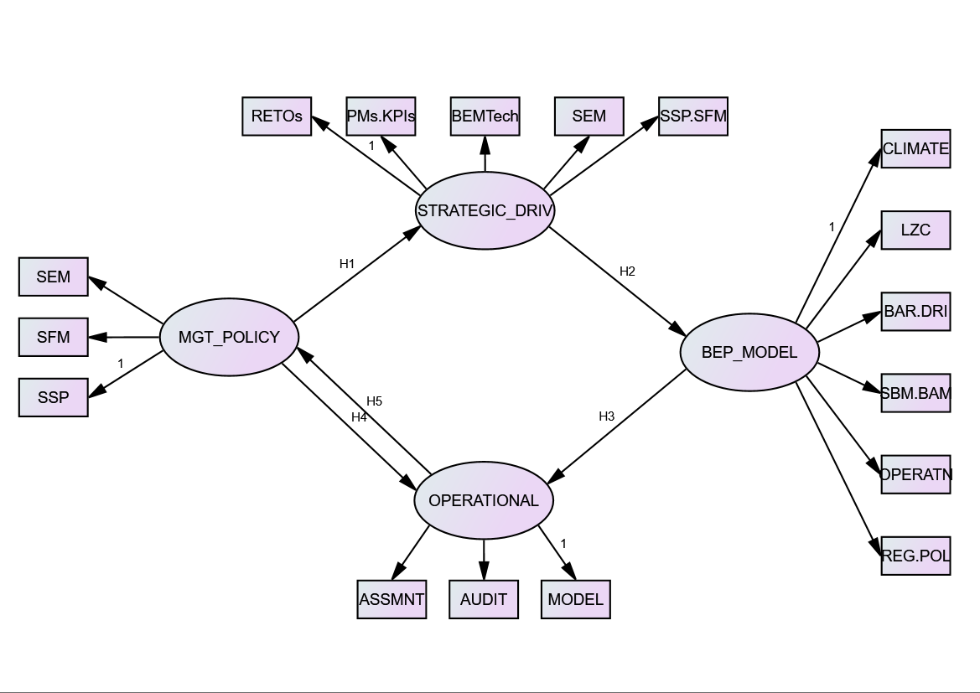
Figure 1: Study's Theoretical BEP Model

In the current paper, the hypothesized model presumes that: firstly, the BEP sub-model is broken as endogenous variables (climate, LZC-intervention, barrier-driver, sustainable-BAM, operations and regulatory policy) that explains BEE in the adoption of practices for improving BEP. Secondly, the BEP sub-model cannot be used alone as a decision-making tool for maximizing the desired result; rather, organization’s management policy, strategic drivers and operations are influencing factors (constructs) for the overall effectiveness of the BEP framework for improving office BEP. Hence, the BEP sub-model is treated as an independent construct before the merger with other constructs.

The hypothesized paths (H1, H2, H3, H4 and H5) are based on the premise that proactive management of BEP demands clear strategic direction from management via policy enactment and a clear measurable deliverable from operational management based on the BEP framework (Then, 1999). Here, operational assets are propelled by strategic drivers as the mediator between management policy and the BEP sub-model for improving BEP. It explains the use of the whole BEP framework as an integrated effective decision-making tool for improving BEP. The Objective is to determine the relationship and interdependency between factors that affect BEP and identify the critical path for interventions.

The observed variables are known as measured or indicator variables are observations with which data were collected and are represented by rectangles in the current model (figure1). The unobserved variables (BEP sub-model, management policy, strategic drivers and operational interventions) are the latent factors measured indirectly through individual’s reflective indicators. These latent factors, or constructs depicted by oval shapes, are derived from the literature review, from which the observed variables were derived and tested. Whilst, the small circles are measurement errors in the observed variables or disturbance in equations, and they are the variances in the responses that are not explained by the latent factors. Also, the relationship (correlation), effects and direction between variables are represented by single or double-arrow heads. The single arrows (paths) represent directional effects from one variable to another and dual-head arrows represent a correlation or relationship (Schreiber, 2008).

The current paper theorized that a strategic scheme for driving BEP such as: renewable energy technologies (RETOs), performance metrics and key performance indicators (PMs/KPIs), building energy management technologies (BEMTechs), SEM and SSP/SFM, based on physical structures and staffing are needed to implement organization’s management policies on BEE. Application of management theory for SEM has been advanced in extant literature (Ates, Durakbasa 2012, Rudberg, Waldemarsson et al. 2013). A combination of interrelated processes (operations, tactics, and strategies) is needed to reduce building energy usage, cost and carbon emissions in an organization. While, a policy driver like SSP/SFM in the form of integration of FM roles into strategic management level in an organization, has been found to underpin the organization’s commitment to BEU reduction and low carbon emissions from facilities (Ikediashi, Ogunlana et al. 2014). Operational sub-model involves the strategic team carrying out the implementation and monitoring of interventions based on BEP model results and other information sources (objective and subjective) for diagnosis. This helps track, monitor and detect an abnormality in BEP (Deru, Torecellini 2005). A combination of these factors has not been tested in past studies as being advanced in the current paper.

Materials and Methods
This paper is part of a wider research work on validation of the structural relations between study’s constructs and their variables. A multiple-case study approach via the quantitative method of data collection and analysis as its research design has been used. This is based on the consideration that: the factors influencing BEP of study’s buildings are the contextual and not historical phenomenon; the researcher has no influence on participant’s behaviour and perspective; and that the research questions are about “what” and “how” as its foundation, informed the decision.

An in-depth exploration of the complexity and uniqueness of case BEP, organizations’ policy, and intervention programmes as systems in a real-life context based on multiple perspectives informed the choice of research design. The study tackled case buildings in Nigeria and the UK as two separate multiple-holistic cases. The cases within each location were treated as multiple-embedded cases. This helped account for the variance in the heterogeneous nature of the study. It aids the development of a holistic model for assessing critical factors impacting BEP across cases and in comparing Nigeria to the UK.

3.1. Survey Process
The strategy of enquiry involves extensive literature review was undertaken in obtaining prior knowledge on factors impacting BEP. These factors formed the framework variables upon which the current study’s theoretical model is formulated and tested. It considered the selection of sample frame from which existing office building stock was chosen as the study population. Five office buildings in Nigeria, members of the FM professional body in Nigeria, and five office buildings in the UK were used as sample frame based on accessibility and convenience. This helped to achieve rigor and robust in data collection. Also, it helped in mitigating against sampling’s limitations such as unit non-response error due to the use of a web-based survey; and difficulties of contacting potential respondents (Bryman, 2016). Such anticipated risks were avoided by this strategic choice (organization’s staff and FM professional body). It used an online survey questionnaire via the survey-monkey platform for obtaining data collection. Whilst, case study sample selection is based on access to the buildings and their occupants as study’s participants, building’s energy consumption data, Climate and locations, building’s HVAC system.

The selected users’ profile represents the dominant types of domestic and commercial/ educational buildings used as office buildings in both cities, and more especially Lagos, Nigeria. The Nigeria buildings were not installed with BEMS, whereas, the UK’s buildings were installed with BEMS with data Centre. The energy consumption data and comparison of how their HVAC system affects BEP do not form part of the current paper. The scope of the current study covered only participants’ perception of factors influencing BEP as contemporary variables (not historical phenomenon) as surveyed.

3.2. Survey Design
The self-administered questionnaire (Appendix A) captured respondents’ perception based on a 5-point Likert scale, while, collected data was analyzed using SEQM techniques. The 5-point scale design help to embed cognitive sophistication as, it recognized that the participants are educated, but some might not be well learned on the subject matter. Past study (Weng and Cheng, 2000) had shown that cognitive sophistication is relevant to response order-effects on ranking data; and could affect the response-order ratings on Likert-type scales. The relevance of cognitive sophistication is important for complex technical questions on BEE in achieving an accurate data (Choi and Pak, 2005). Also, the 5-point Likert scale is considered better when validity is paramount, and higher reliability based on objective measures of original stimuli is desired (Preston and Colman 2000).

About 180 questionnaires were sent out and a response of 120 was received. The Cronbach’s alpha result indicates Alpha of 0.798 and 0.886 on N (87) standardized items, which showed an acceptable strong reliability level at the acceptable alpha value of 0.70. The Demographics result indicates about 68.9% of respondents (n = 119) lived in Nigeria, while 31.1% resided in the United Kingdom. Most of the respondents (about 55.8%; valid N= 120) are staff of various organizations (within the Nigeria construction industry) and postgraduate students and staff (Engineering & the Built Environment department) of the case-study University; all within case buildings in both countries. A third (24.2%; n = 29) of them are scholars. Whilst, about a tenth of the participants are professional facilities /property managers (10.8%; n = 13) and MDs/Owners (9.2%; n = 11).

The theoretical model used in the study requires discerning cognitive sophistication in understanding the interrelationships between variables. Hence, the level of education of respondents is considered significant. The result revealed about 91.6% (n = 119) respondents are educated up to B.Sc. Degree level. It translated to about 44.4% of the participant being educated up to B.Sc. Level, and 42.2% being of master’s degree levels. Likewise, 2.5% of the respondents (n =3) are educated up to PhD level. About 5.9% (n = 7) have professional certifications; 5.9% of them have GCE certificate, whilst, 3.4% of the respondents (n = 4) have other specialized degrees.

3.3. Structural Equation Modelling Technique
These factors that affect that BEP were derived based on prior knowledge from the extant literature review. These factors consist of constructs (latent) and their variables (indicators) that were measured as observed variables via the self-administered questionnaire survey; and obtained data were analyzed using SEQM, hence, very significant as factors that affect office BEP. The SEQM technique examined how these factors contribute to improving BEP of heterogeneous office building stocks in Nigeria and the UK. It attempted to quantify the causal relationships between factors in the BEP model to explain BEE.

The study adopted the procedure outlined by Blunch (2008) and Gaskin (2012) for the confirmatory factor analyses for measurement model and model evaluation. It used Confirmatory Factor Analysis (CFA), for the measurement of constructs and indicators, and the model-fit assessment via SEQM. The same data set from both countries (Nigeria and UK) was used for the modelling. It’s aimed at using a single model as a tool that could account for the variances in the data collected. Also, the same data used for model fit is used for validation purpose. Here, validation is the process of using CFA model fits criteria to evaluate model criterion as a fitted measurement model.

3.3.1. Exploratory Factor Analysis
The Exploratory factor analysis (EFA) was performed to check for correlation of observed variables, their expected combined loadings, and criteria for validity and reliability are being met (Blunch 2008, Hair, Black et al. 2010). The correlation (r) is the strength of association between two variables, whilst, covariance (cv) is the strength of associations between two variables and their variability, which is, the measure of how two variables vary together. EFA helps to identify individual factors that can be used to represent relationship amongst sets of study multiple interrelated variables (Chan, Lam et al. 2010). Past studies have illustrated the difference between principal component analysis (PCA), principal axis factoring (PAF), and maximum likelihood (ML). Gaskin (2012), explained that PCA reflects all the common and unique variances; PAF consider only common variances, and ML make best use of differences between factors and provide a model best-fit estimate. The ML factoring method was used in the current study, it helps to account for the differences in data collected within country and across countries. It makes use of, and accounted for the variances between all factors, as, it used their variances for models’ best fit. Also, the current study used ML for EFA, because is aligned with the method used in AMOS software for CFA and SEQM (Blunch 2008, Gaskin 2012).

Confirmatory Factor Analysis via Model Fit Indices
The study used the application of confirmatory factor analysis (CFA) procedure for study measurement models. The CFA is used to determine the degree of model fit and overcome the gap of the fitted model with modification indices (MI) (Jenatabadi, Ismail 2014). Previous studies (Le Zhang, Miao et al. 2014, Hou, Al-Tabbaa et al. 2014) have suggested both the procedure and the tests required for an acceptable and compatible model fit.

The two acceptable criteria required for a valid model fit were used in this study. The measurement model validity level of Goodness-of-fit (GOF); and construct validity are applied (Hair, Black et al. 2010). Some authors classified the GOF into four namely (Le Dang, Li et al. 2014): Chi-square test; the absolute fit (baseline fit measure); incremental fit indices; and parsimonious fit indices. The rule of thumb is to use Chi-square and at least one index from each other group (Hair, Black et al. 2010).

Blunch (2008), affirms that fit indices are various techniques used in expressing the distance between the sample covariance matrix S and the estimated implied covariance matrix Ʃ (θ), which is a function of residual matrix S- Ʃ (θ). According to Schreiber (2008), the premise is to determine if the theorized model is supported by the data collected. Therefore, the covariance matrix of the observed variables and that of the reproduced covariance matrix (based on mathematical equations derived from the theoretical model) are compared. Model fit is judged based on the criteria that, the more the deviation of the reproduced covariance matrix from the observed covariance matrix, the less the theoretical model fit data collected.

Several studies (Hair, Black et al. 2010, Gaskin 2012) have a different threshold for model best fits. The recommended threshold by Blunch (2008) conforms to these authors’ fit criteria hence, adopted for this paper. The absolute fit tests are: model χ² test and its p-value indicates that the model fit the population, χ² with p-value > 0.05 indicates good fit. The degrees of freedom (dof) measures the degree to which the model is overidentified and is the calculated number of distinct sample moment minus distinct sample parameters (Kelly, 2011). The χ² can be affected by sample size hence, it can be normalized by dividing CMIN with dof. CMIN is the minimum value of C (C = [n-1] F), where F is the fit function to be minimized and CMIN is the result of the minimization process; and CMIN/dof (normed χ²) ~ close to 1.0 is a good fit.

Goodness-of-Fit index (GFI) measures the difference between the observed and estimated covariance matrices. GFI ~ value between 0 and 1, with value > 0.95 is a good fit; Adjusted goodness-of-fit index (AGFI) have value between o and 1, but ~ > 0.95 is acceptable, and RMR usually calculated manually, however RMR (based on correlations) < 0.05 is a good fit (Blunch 2008). The relative fit measures include: Comparative fit index (CFI) ~ value > .95 is acceptable; Normed fit index (NFI) with a value > 0.90 is acceptable; Relative fit index (RFI) ~ value > 0.90 is acceptable; Incremental fit index (IFI) ~ value >0.90 is acceptable; and Trucker-Lewis index (TLI) (Tucker, Lewis 1973) ~ close to 1.0 is a good fit (Blunch 2008).

The parsimony fit measures include PRATIO, which is the factor by which you can modify fit indices to take account of parsimony (James, Mulaik et al. 1982). All parsimony-based fits (PNFI, PCFI and PGFI) with value > 0.60 are acceptable and satisfying (Blunch 2008). Fit measures based on the non-central chi-square distribution include: ‘Root Mean Squared Error of Approximation (RMSEA) measures error of approximation (acceptable <0.10; good fit < 0.05); and the P-values (PCLOSE) for the test of null hypothesis that is RMSEA is < 0.05.

Standardized factor loading (FL), average variance extracted (AVE) and construct reliability (CR) were used for construct validity. The FL size of observed variables indicate their strength on the associated constructs. FL represents the relationship between a factor and its indicator. FL below 0.50 is considered weak and unacceptable. AVE is the mean extracted variances of indicator loadings on construct and a value > 0.50 suggests adequate convergence (Hair, Black et al. 2010). CR indicates the internal consistency of indicators in a construct that specifies convergent validity. A CR at 0.70 and above point to a good reliability (Le Dang, Li et al. 2014).

Results and Discussion

4.1. Model Fitting and Evaluation
The relationship amongst the four latent constructs is investigated based on this study hypothesis that significant causal relationship exists between constructs. The constructs are the single-sub BEP model for BEP and the constructs of strategic drivers, managerial policy and operational solutions (Figure 1). A four-path initial structural model-1 (Figure 2) is created to represent the causality (Ko, Stewart 2002) and their evaluation. The objective is to know how much each construct and respective variables explain the performance of the BEP model in improving BEP.

The first hypothesized path is the relationship between the construct of management policy and strategic drivers (H1). The second path is that of strategic drivers and BEP sub-model (H2). The third path is the link between BEP sub-model and operational solutions (H3). While the fourth path is the connection between constructs of operational solutions and management policy (H4) as depicted in structural model-1 and model-2 (Figure 3). A third structural model-3 (Figure 4) is created by the reversal of the directional arrow in path H4 as solution model-3 labelled H5 based on the theoretical model.

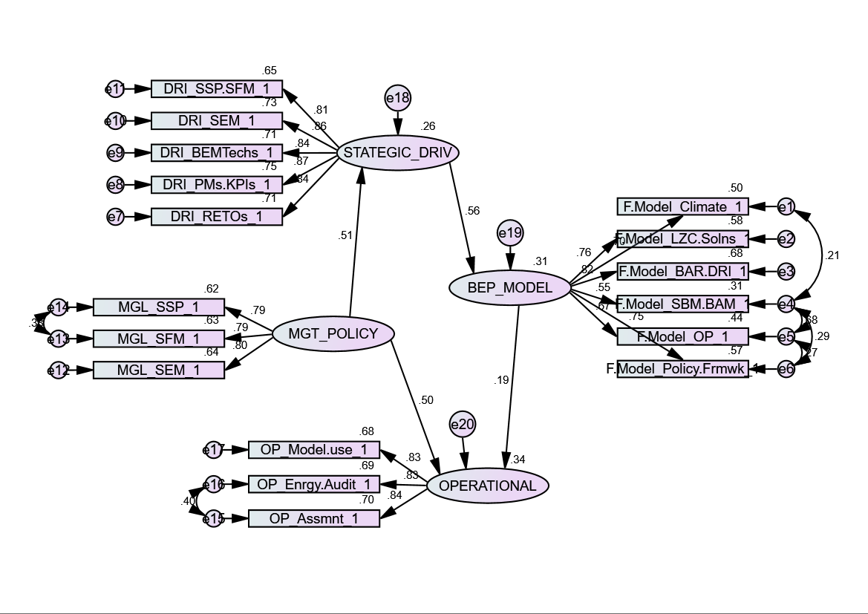
Figure 2: Initial Structural Model-1

4.1.1. EFA
The EFA result of initial model-1 paths’ correlation indicates an acceptable strong correlation between observed variables and constructs that are significant with z ≥ 1.96 at 0.05 significance level. Most construct to construct correlation levels are strong and significant: STRATEGIC_DRIV and MGT_POLICY (0.439), BEP_Model and STRATEGIC_DRIV (0.439), OPERATIONAL and MGT_POLICY (0.570). However, the path correlation between BEP_Model and Operational construct (0.218) is not significant (z = 1.85 ≤ 1.96) at p = 0.064 ≥ 0.05 significance level.

The EFA result confirms that energy assessment, energy audit and use of model are indicators of an effective organization’s operational energy management procedure, hence, high FL (1.000, 0.920 and 0.914 respectively) with the Operational construct. They are highly correlated with one another and with the Operational construct, having z ≥ 1.96 at < 0.01 significance level. All indicators measured the effectiveness of operational procedure for BEP. Energy audit and assessment were covaried as they both help to achieve improved BEP. Existing literature (Ruparathna, Hewage and Sadiq, 2016) confirms that regular energy audit, assessment and benchmark are critical factors for reducing BEU and improving BEP.

It also, established that strategic energy management, strategic facilities management, strategic sustainable policy are compulsory sub-sets and indicators of an effective organization’s energy management policy, hence, the high FL (1.000, 0.920 and 0.914 respectively) with Management policy. It reinforced a linkage between strategic energy policy to tactical and operational levels. The result confirms existing management theory (Reza Arababadia, et al, 2017) that reinforced the need to bridge the gap between operational and strategic level for energy policy and interventions assessment, for local solutions to scale up to global issues on climate mitigation. Also, SPP and SFM exhibit strong covariance indicating the integration of SFM into organization’s SSP to reinforced BEP plan.

Strategic drivers construct (STRATEGIC_DRI) and its indicators: DRI_RETOs (renewable technologies), PMs.KPIs (performance metrics/ key performance indicators), DRI_BEMTechs (building energy management technologies), DRI_SEM (strategic energy management), and DRI_SEM.SFM (strategic energy management/ strategic facilities management) obtained high FL (0.883, 1.000, 0.835, 0.908, and 0.984 respectively). The result shows that the indicators measured STRATEGIC_DRI construct and established convergent reliability. These strategic drivers are operational assets (internalized structure and staffing) dedicated for optimizing BEP, utilizing an organization’s energy management policy and operational procedure. The result supports the advocates (Vanags and Butane, 2013) of investment in strategic management, energy efficiency and conservation-focused refurbishment, and carbon management principle in buildings.

The EFA result established six critical factors for the BEP construct as a sub-model. They are organization’s consideration for climate change issue based on building mitigation and adaptation measures preparedness (Wilkinson 2012); sustainable building management (SBM) policy based on BAM plan (Jones, Helen et al. 2013); operations FM (Elmualim, Shockley et al. 2010); instituted EE drivers and prevailing barriers (Parfomak, Sissine et al. 2009); regulations and standards as externalities (Gabe 2016); and existing LZC intervention installations (Olawuyi 2013, Ma, Cooper et al. 2012). All measured variables have high FL with the BEP_Model construct: BEP.Model_Climate (0.914), BEP.Model_BAR.DRI, (0.883), BEP.Model_SBM.BAM (0.629), BEP.Model_OP (0.766), BEP.Model_LZC.Solns, (0.908), and BEP.Model_Policy.Frmwk (1.000). The measured indicators established convergent validity without an issue of cross loading. Current literature has established strong theoretical links between these factors hence, they were covaried.

4.1.2. CFA
The CFA result (Table 1-Appendix B), however, indicates that model-1 chi-square statistics and other fits are not highly acceptable. Maximum modification index was used to improve model-1 (Figure 3 and Figure 4). Therefore, the initial model-1 was transformed into model-2 (diagnostic) and model-3 (solution). AMOS modification was used to covary error variances of: DRI_SSP-SFM (e11) to Climate (e1), DRI_SSP-SFM (e11) to LZC (e2), and DRI_SSP-SFM (e11) to BAR.DRI (e3). Also, MGL_SFM (e13) to DRI_RETOs (e7); and MGL_SFM (e13) to DRI_PMs/KPIs (e8) were covaried to transform initial model-1 into model-2. This is supported by extant literatures that have confirmed strong associations between SSP/SFM and Climate change (Elmualim, Shockley et al. 2010), SSP/SFM and use of LZC (Olawuyi, 2013), SSP/SFM and EE barriers/ drivers (Elmualim, Shockley et al. 2010), SFM and RETOs (Tanneja 2014), and SFM and PMs/KPIs (Deru, Torecellini 2005).

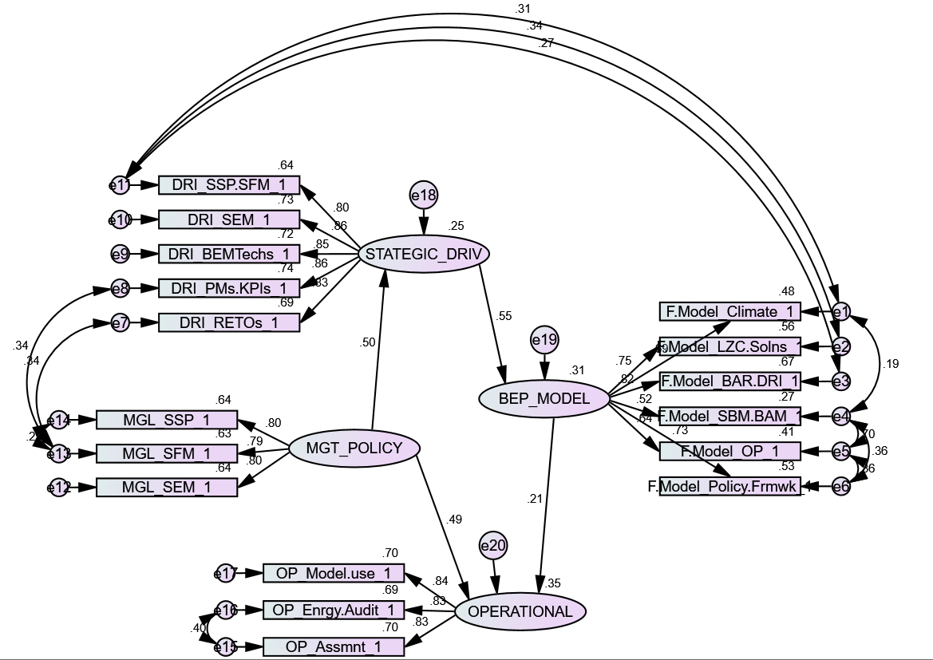
Figure 3:Diagnostic Phase Model-2

Evaluation of the new model-2 indicates an acceptable fit index for all model fit statistics (Table 1-Appendix B). There is a significant difference between model-1 and model-2 (diagnostic) with a decrease in chi-square statistics (χ² (114) = 126.892; p-value = 0.114). The differences between model-1 and model-2 is very significant (∆χ² (3) = 27.940; ∆dof = 3, ∆p-value = 0.133). Also, its Bollen-Stine bootstrap (∆p-value = 0.945 > than 0.896); and standardized RMR ∆= 0.063 < than 0.069), which indicates an acceptable overall hypothesized model. Hence, the diagnostic model-2 is accepted as an improved model and best for testing the hypotheses. Other fit indices: CMIN/dof = 1.143; p-value = 0.144; RMR = 0.032; GFI = 0.893; PGFI = 0.648; CFI = 0.988; RMSEA = 0.035; Pclose = 0.817; IFI = 0.998; and PCFI = 0.806 are within the acceptable threshold of good model fit indices. Particularly, management policy construct accounts for the largest share (41.0%) of the variances of the entire diagnostic model-2 process. Also, BEP sub-model (31.0%), operations (35.0%), and drivers (25.0%) accounts for a significant share of the model-2 divisions. The implication is that management policy plays a crucial role in BEP, therefore, energy audit and assessment should include diagnosis of organization policy for identifying problems.

Model-3 is created as a feedback mechanism from the diagnostic phase to solution implementation phase. To ensure the structure of the structural model is not altered, the path correlation coefficient from management policy → operational (H4) is reversed as operational → management policy (H5), for testing hypotheses (Figure 4).

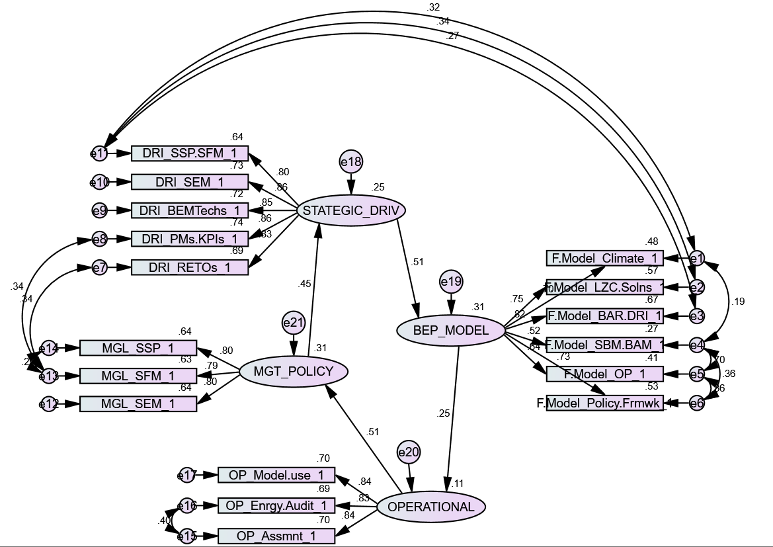
Figure 4: Solution Phase Model-3

The resultant model-3 is also good and not significantly different from model-2, as both have almost the same acceptable fit indices (Table 1-Appendix B). However, the BEP sub-model (31.0%) and management policy (31.0%) now have the largest share of the variances of the model-3 process. Also, strategic drivers construct (25.0%) and operational (11.0%), accounts for substantial shares. Operational share of model-3 variances is the least because of its role was taken over by the BEP sub model. Overall, the constructs had the bulk of the share variances of the entire model compared to variations due to their error terms (2.0%). This implies that the entire solution model will account for the majority (about 98.0%) of identified critical factors that affect BEP than other unknown factors due to chance (about 2.0%).

Results of observed variable-construct and inter-constructs correlations evaluation for both models (Table 2 and Table 3 -Appendix B) indicates strong significant correlations. The relationship between the constructs of BEP_Model and Operational became very significant with z = 2.17 ≥ 1.96 at 0.05 significance level. Similarly, the result (Table 3 -Appendix B) of inter-items correlation and squared multiple correlation (SMC), shows strong inter-items correlation for most observed variables and constructs with high FL, indicating good reliability. Operational energy assessment having the highest correlation with energy audit (0.81) and Model_use (0.68). It confirms the importance of the use of energy modelling and auditing for assessment of BEP. The SMC for items are high, with strategic drivers and its variables (PMs. KPIs = 0.74; SEM = 0.73; and BEMTechs = 0.72) having the highest FL. Construct-construct reliability is good except that between management policy and operations that indicate zero for the diagnostic model-2 but increased to 0.25 in the solution model-3. The difference explains the rationale of the negligible role of management policy input during actual operational energy assessment of BEP exercise. However, management policy becomes a critical success factor in the choice, planning and implementation of interventions for improving BEP.

The evaluation also reveals the most critical pathway in the BEP Framework. The new models established strong covariance (cv.) for: SSP-SFM to Climate (0.27); SSP-SFM to LZC (0.34); and SSP-SFM to BAR.DRI (0.31). Also, critical, are the paths from SFM to RETOs (0.34); SFM to PMs/KPIs (0.34); and energy assessment to audit (0.40). This is very significant for EE diagnosis and intervention purposes.

4.2. Discussion
Findings indicate dependency and interdependency relationships exist amongst constructs, and in between construct and indicators in the measurement variables. The interrelations between constructs are discussed as follows:

- BEP construct
Previous studies (Gujba, Mulugetta and Azapagic, 2011; Wilkinson, 2012), have established CCH adaptation and mitigation measures as possible strategies for improving existing BEP. For instance, findings established that an organization operational issues are highly associated with its SBM-BAM policy and plan. Its operations have an interdependent relationship with the country’s regulatory policy framework. The relationships between its operations and the external climate; the company’s operations and available low-zero carbon (LZC) interventions; and her operations and prevailing barriers/ drivers are strongly associated and interdependent (Wilkinson 2012). Also, there exists strong affiliation between a country’s regulations (policy/ frameworks) and an organization SBM/BAM policy and plans. The country’s regulations affect the types of LZC interventions an organization will adopt. A country’s regulation could dictate the type of internal and external EE barrier/ drivers that an organization could handle. Whilst, a country’s regulation and climate weather are correlated. This relationship also has an impingement on an organization’s adaptation and mitigation standards and hence, it’s BEP.

The study also established strong associations between SBM/BAM and the climate. The implication is that organization SBM/BAM policy and programs should be hinged along the country’s climate change profile. The company’s BAM policy should recognize prevailing EE barriers and drivers, and clearly state methods of getting rid of barriers and adoption of drivers. A climate resilience and high energy performing building is the nucleus of an SBM policy and BAM plan. Therefore, the choice of LZC solution is highly related to the local climate weather variability, which underpinned the founded relationship.

- Management Policy construct
Three management policies are established in the study model: strategic sustainability policy (SSP), strategic facilities management (SFM) and strategic energy management (SEM). These policies are fundamental to SBM and low carbon buildings for an organization and are found to be critical to improving the overall BEP model (Pitt, Hinks 2001, Ikediashi, Ogunlana et al. 2014). An organization needs SSP, SFM and SEM as sub-set of policy incorporated into its core management policy to improve its BEP. Additionally, findings revealed that strong correlation and covariance exists between SSP and SFM policies; SFM and SEM to achieve BEP improvement. Also, across constructs, SFM was found to influences strategic drivers such as PMs/KPIs (cv. = 0.34) and RETOs (cv. = 0.34). It has a strong covariance relationship in the efficient working of the BEP model. This indicates that SFM (amongst the three policies), underpinned the optimal performance of the BEP model.

- Operational construct
Findings also established the use of modelling (Model use) for energy monitoring and control; energy assessment (Assmnt); and energy audit (Enrgy.Audit) as critical operational factors for improving BEP. The result indicated an energy assessment and audit (r = 0.81; cv. = 0.58), are highly associated, and equally exhibits strong correlations with the use of models. An energy assessment can only be fully optimized when combine with modelling (r = 0.69; cv. = 0.50). Similarly, energy audit cannot achieve its wide potential of aiding to improve BEP, except when use in junction with a model (r = 0.65; cv. = 0.44) as operational solutions for BEP improvement. This suggests that the three components are vital components of BEP improvement measure for an office building. Operational factors (assessment, audit and use of model), are used for diagnostic and feedback loop purposes. They cannot directly influence BEU reduction and improve BEP but can influence management decisions (policy formulation), and aid instituted strategic drivers in achieving BEU reduction and BEP. Hence, operations have greater indirect effects on the BEP sub-model than its direct effects.

- Strategic driver construct
The use of combined SSP and SFM, standardized performance metrics (PMs) and key performance indicators (KPIs); installations of renewable technologies (RETOs), engaging strategic energy management as strategic function; and installation of building energy technologies (BEMTechs) are well founded as critical factors for improving BEP (Agha-Hossein, El-Jouzi et al. 2013). Also, studies have established that installation of RETOs and BEMTechs initiatives have resulted to about 58-100% level of successes, and different energy saving rates of about 5-46% in the past (Ma, Cooper et al. 2012, Altan 2010). The role of these strategies provides a theoretical foundation for the relationship between BEP sub-model, policy and operations.

There exists a very strong positive relationship between combined SSP and SFM with BEP sub-model variables. The relationships between SSP.SFM and: LZC (r = 0.516; cv. = 0.27); climate (r = 0.510; cv. = 0.28); barriers/drivers (r = 0.455; cv. = 0.21); operational FM (r = 0.439; cv. = 0.22); and that of SBM.BAM (r = 0.411; cv. = 0.20), are the strongest amongst variables across constructs. It explains how combined SSP.SFM could be used to mitigate against climate change, minimize EE barriers and optimize EE drivers, use of low carbon interventions for facilities energy management, and its critical role in organization BAM plan on BEP. This implied that strategic drivers interact with factors of BEP; and combined SSP.SFM has the greatest influences on BEU reduction and hence, improving BEP as a system.

Conclusion
The main finding identified low carbon solutions for BEP that fits into a structural model based on the current study theoretical model. The EFA and CFA results have significant implication to FMs, owners, researcher and policymaker as its offer a list of BEP determinants, their relationship, and the interdependency between them to BEE practitioners. For example, the result of the test of structural relationships (hypotheses) amongst model paths indicated causality and mediations for the structural paths. Strategic driver construct was established as the only mediator between management policy and the BEP constructs, and it has causal effects on the overall BEP framework. This is important as it established the absolute value of the strategic driver in the use of BEP framework as a decision-making tool for improving BEP.

This paper identified the critical path in the overall BEP model for improving energy performance. It established strong interdependent relationships between factors across the four constructs in the mannequin. There is strong covariance between SSP-SFM and Climate; SSP-SFM and LZC; and SSP-SFM and BAR.DRI, demonstrated across the constructs of strategic drivers and BEP. Similarly, critical, is the paths from SFM (in management policy construct) to RETOs (in strategic drivers construct); and SFM to PMs/KPIs (in strategic drivers construct). A further strong covariance is established within the operational construct, between energy assessment and audit. The implication is that it reveals the interdependency of factors impacting office BEP. For instance, the entire BEP framework outlined a critical route, which suggest that combined SSP.SFM plan should be localized and built upon factors influencing Climate variability. It should take advantage of existing LZC interventions and uptake of existing EE drivers to minimize EE barriers. Additionally, it should use organization policy to set up an internal structure that oversees the daily running of installed RETOs and use of standardized PMS/KPIs for facilities energy assessment and audit to achieve improve BEP. It is the most critical pathway in the overall BEP Framework, specifying how a decision-making tool could be used to achieve low carbon solution for office buildings.

Appendices

Appendix A

VALIDATION SURVEY ON STRATEGIES FOR REDUCING ENERGY CONSUMPTION OF EXISTING BUILDING STOCKS BY BLESSING MAFIMISEBI

QUESTIONNAIRE FOR FACILITIES' MANAGERS, USERS AND OWNERS

Welcome to the validation survey on the energy use of existing office buildings in Nigeria and United Kingdom. The aim of this validation study is to serve as a confirmatory study on the quantitative data gathered on the energy efficiency performances of these buildings.

Your participation is voluntary, and you are not under any form of compulsion to respond to all or any of these questions and the entire survey.

All information given is for academic purpose and will be treated with strict confidentiality.
Thank you for your participation.

Please indicate the most applies to you.
BUILDING STOCKS BY BLESSING MAFIMISEBI
- Please indicate your country of residence
- Nigeria
- United Kingdom

- Please indicate your corporate status below:
- Facilities / Property managers
- MD/ CEO/ Owners
- Staff
- Student

- Please, kindly indicate your academic qualification
- GCE Level
- First Degree /H.N. D
- Master Degree
- PhD
- Qualified professional Certification
- Other (please specify)

- Please rank the following operational solutions as propelling factors for reducing building energy use:
Very weak; Weak; Neutral; strong; Very strong

- Management's use of Energy consumption model
- Regular facility's energy audit
- Regular Assessment & Benchmarking

- Please rank the following technical solutions as propelling factors for reducing building energy use:
Very weak; Weak; Neutral; strong; Very strong

- Strategic Sustainability Policy
- Strategic Energy Management
- Built asset management

- Embedded sustainability policies combined with Strategic facilities management has been found as propelling factors for reducing building energy use, please rank your opinion as follows:
- Strongly disagreed
- Disagreed
- Neutral
- Agreed
- strongly agreed

- Building energy Assessment & Benchmarking tool that incorporate building's portfolios (sustainability policy, strategic FM, technology & low-zero carbon option) based ranking will help inform better performance.

- Strongly disagreed
- Disagreed
- Neutral
- Agreed
- Strongly agreed

- Regulatory Policy framework (institutional framework, building codes and standards, labelling are effective drivers for building energy performance. Please rank your agreement or disagreement by using a scale of 1 (strongly disagreed) to (strongly agree):

- Strongly disagreed
- Disagreed
- Neutral
- Agreed
- Strongly Agreed

- Facilities management (FM) is a useful tool for reducing building energy use. Please indicate your agreement or disagreement by using 1 (being strongly disagreed) to 5 (being strongly agreed):

- Strong disagreed
- Disagreed
- Neutral
- Agreed
- Strong agreed

- The following is perceived drivers to building energy use efficiency. Please rank your agreement or disagreement base on a scale of 1 (being strongly disagreed) to 5 (being very strongly agreed):

Strongly disagreed; Disagreed; Neutral; Agreed; strongly agreed

- Embedded Sustainability Policy & Strategic Facilities Management
- Energy performance Metrics & Indicators for Assessment & Benchmark
- Renewable energy technology option
- Strategic Energy management
- Building Energy Management Technologies

- Please rank the importance of the following variables as issues affecting the commercial building's energy use, using a scale of 1 (very unimportant) to 5 (being very important).

Very unimportant; Unimportant; Neutral; Important; Very important

- Climate- building mitigation & adaptation and weather
- Strategic building Management-BAM
- Operational Framework: Technology, Skill, Metrics & indicators, strategic FM,
- Cultural context: Beliefs, norms, attitude, intention & Behaviour
- Barriers & driver’s context: Sustainability, FM., Market forces, asset value
- Regulatory Policy context
- Business Practices context: Ethos, Corruption, supply chain
- Low-zero carbon option: Solar PV, Solar thermal, micro-wind turbine,

Appendix B
Table 1: SEQM Models Result- Appendix B
SEQM MODEL FIT RESULTS
MODEL FIT METRICS Structural Model-1 Diagnostic Model-2 Solution Model-3 Recommended Acceptability
Chi-Square X2 154.832 126.892 127.247 Nil
dof (Degree of Freedom) 117 114 111 > 1.0 Good
Chi-Square/dof (CMIN/dof) 1.323 1.143 1.146 < 3.0 Good
P-Value for the Model 0.011 0.144 0.139 > .05 Good
RMR (Root-Mean-Square- Residual) 0.034 0.032 0.031 < .05 Good
CFI (Comparative Fit Index) 0.972 0.988 0.988 > .95 Good
GFI (Goodness of Fit) 0.876 0.893 0.892 > .95 Acceptable
AGFI (Adjusted Goodness of Fit) 0.837 0.852 0.851 > .95 Acceptable
PGFI 0.670 0.648 0.647 >.50 Good
RMSEA 0.052 0.035 0.035 < .05 Good
PCLOSE 0.422 0.817 0.812 > .05 Good
NFI (Normed Fit Index) 0.895 0.914 0.913 > .92 Acceptable
RFI (Relative Fit Index) 0.877 0.894 0.894 > .90 Acceptable
IFI (Increment Fit Index) 0.972 0.988 0.988 > .90 Good
TLI (Trucker Lewis Index) 0.967 0.985 0.985 close to 1.00 Good
PRATIO 0.860 0.816 0.816 Values > .60 Good
PCFI 0.836 0.806 0.806 Values > .60 Good
SRMR 0.063 0.069 0.058 Values < .08 Good
Bollen-Stine Bootstrap 0.896 0.945 0.945 > .50 < 1.0 Good

Table 2: Improved Diagnostic Model-2 Regression Estimate- Appendix B
Final Improved Diagnostic Model-2: Regression Estimate
Variables Estimate S.E. C.R. P Label
STATEGIC_DRIV <--- MGT_POLICY .423 .084 5.029 *** H1
BEP_MODEL <--- STATEGIC_DRIV .625 .106 5.898 *** H2
OPERATIONAL <--- MGT_POLICY .561 .116 4.830 *** H4
OPERATIONAL <--- BEP_MODEL .257 .118 2.175 .030 H3
BEP.Model_Climate <--- BEP_MODEL .908 .092 9.855 *** W1
BEP.Model_LZC.Solns <--- BEP_MODEL .908 .092 9.855 *** W1
BEP.Model_BAR.DRI <--- BEP_MODEL .889 .063 14.007 *** W2
BEP.Model_SBM.BAM <--- BEP_MODEL .612 .094 6.514 *** W3
BEP.Model_OP <--- BEP_MODEL .763 .090 8.489 *** W4
BEP.Model_Policy.Frmwk <--- BEP_MODEL 1.000
DRI_RETOs_ <--- STATEGIC_DRIV .889 .063 14.007 *** W2
DRI_PMs.KPIs <--- STATEGIC_DR 1.000
DRI_BEMTechs <--- STATEGIC_DRIV .864 .068 12.676 *** W7
DRI_SEM_ <--- STATEGIC_DRIV .930 .073 12.831 *** W8
DRI_SSP.SFM <--- STATEGIC_DRIV .996 .088 11.303 *** W9
MGL_SEM <--- MGT_POLICY 1.000
MGL_SFM <--- MGT_POLICY .912 .062 14.769 *** W10
MGL_SSP_ <--- MGT_POLICY .929 .077 12.001 *** W11
OP_Assmnt <--- OPERATIONAL 1.000
OP_Enrgy.Audit <--- OPERATIONAL .912 .062 14.769 *** W10
OP_Model.use_ <--- OPERATIONAL .929 .077 12.001 *** W11

Table 3: Diagnostic Model-2: Inter-Item Correlations, SMC, Mean and STD- Appendix B
Diagnostic Model-2: Correlations, Squared Multiple Correlation (SMC), Mean and Standard Deviation (STD)
Items 1 2 3 4 5 6 7 8 9 10 11 12 13 14 15 16 17 SMC MEAN STD
1 OP_Model.use 1.00 0.70 3.69 0.83
2 OP_Enrgy.Audit 0.65 1.00 0.69 3.90 0.81
3 OP_Assmnt 0.68 0.81 1.00 0.70 3.71 0.88
4 MGL_SSP 0.45 0.43 0.44 1.00 0.64 3.94 0.73
5 MGL_SFM 0.34 0.33 0.31 0.77 1.00 0.63 4.01 0.75
6 MGL_SEM 0.32 0.35 0.38 0.64 0.69 1.00 0.64 4.07 0.81
7 DRI_SSP.SFM 0.24 0.21 0.10 0.34 0.35 0.17 1.00 0.64 3.99 0.68
8 DRI_SEM 0.28 0.29 0.32 0.35 0.41 0.28 0.67 1.00 0.73 4.01 0.64
9 DRI_BEMTechs 0.23 0.22 0.24 0.38 0.35 0.26 0.67 0.73 1.00 0.72 4.14 0.59
10 DRI_PMs.KPIs 0.22 0.22 0.23 0.45 0.51 0.29 0.71 0.75 0.73 1.00 0.74 4.12 0.59
11 DRI_RETOs 0.30 0.28 0.24 0.42 0.50 0.31 0.68 0.74 0.71 0.71 1.00 0.69 4.13 0.55
12 BEP.Model_Policy.Frmwk 0.24 0.15 0.11 0.19 0.15 0.18 0.41 0.29 0.38 0.28 0.29 1.00 0.53 3.92 0.80
13 BEP.Model_OP 0.22 0.18 0.15 0.30 0.22 0.14 0.44 0.37 0.41 0.43 0.37 0.65 1.00 0.41 4.02 0.72
14 BEP.Model_SBM.BAM 0.22 0.13 0.07 0.29 0.26 0.13 0.41 0.31 0.35 0.36 0.34 0.58 0.80 1.00 0.27 4.09 0.73
15 BEP.Model_BAR.DRI 0.28 0.23 0.21 0.14 0.10 0.08 0.46 0.26 0.34 0.31 0.36 0.62 0.51 0.41 1.00 0.67 4.00 0.67
16 BEP.Model_LZC.Solns 0.30 0.15 0.17 0.22 0.19 0.19 0.52 0.30 0.38 0.38 0.39 0.61 0.47 0.39 0.65 1.00 0.57 4.01 0.84
17 BEP.Model_Climate 0.20 0.13 0.11 0.24 0.29 0.18 0.51 0.32 0.32 0.36 0.41 0.48 0.50 0.52 0.58 0.51 1.00 0.48 4.00 0.76
19 MGT_POLICY 0.00 4.01 0.76
20 STRAT_DRIV 0.25 4.08 0.61
21 BEP_MODEL 0.31 4.01 0.75

References
ABIGO, A., MADGWICK, D., GIDADO, K. and OKONJI, S., 2012. Embedding Sustainable Facilities Management in the Management of Public Buildings in Nigeria, Embedding Sustainable Facilities Management in the Management of Public Buildings in Nigeria, 10-11 September 2012, EPPM.
AGHA-HOSSEIN, M., EL-JOUZI, S., ELMUALIM, A.A., ELLIS, J. and WILLIAMS, M., 2013. Post-occupancy studies of an office environment: Energy performance and occupants' satisfaction. Building and Environment, 69, pp. 121-130.
ALBATICI, R., GADOTTI, A., BALDESSARI, C. and CHIOGNA, M., 2016. A Decision-Making Tool for a Comprehensive Evaluation of Building Retrofitting Actions at the Regional Scale. Sustainability, 8(10), pp. 990.
ALTAN, H., 2010. Energy efficiency interventions in UK higher education institutions. Energy Policy, 38(12), pp. 7722-7731.
ARABADADI, R., MOSLEHI, S., ASMAR, ME, HAAVALDSEN, T., AND PARRISH, K. 2017. Energy Policy Assessment at Strategic, Tactical and Operational Levels: Case Studies of EU 20-20-20 and US. Executive Order 13514. Elsevier, Energy Policy 109, pp520-538.
ATES, S.A. and DURAKBASA, N.M., 2012. <br /> Evaluation of Corporate Energy Management Practices of Energy Intensive Industries in Turkey. Elsevier. Energy, 45((0)), pp. 81-91.
BARRETT, P. and BALDRY, D., 2003. Facilities management: towards best practice. 2nd / Peter Barrett & David Baldry edn. Oxford; Osney Mead, Oxford, OX; Malden, MA: Blackwell Science.
BLUNCH, N., 2008. Introduction to Structural Equation Modelling Using SPSS and Amos. London: SAGE Publications; DOI: 10.4135/9781446249345.
BRYMAN, A., 2016. Social research methods. Fifth ed. Oxford University Press.
Bugaje, I. M., 2006. Renewable energy for sustainable development in Africa: a review (Author abstract). Renewable and Sustainable Energy Reviews, [e-journal] 10 (6), pp.603.
CHAN, A.P.C., LAM, P.T.I., CHAN, D.W.M., CHEUNG, E. and KE, Y., 2010. Critical success factors for PPPs in infrastructure developments: Chinese perspective (public-private sector partnerships) (Author abstract) (Report). Journal of Construction Engineering and Management, 136(5), pp. 484.
CHOI, B.C.K., AND PAK, A.W.P., 2005. A Catalogue of Biases in Questionnaires. Preventing Chronic Disease. Public Health Research, Practice, and Policy; volue2: No1, January. < www.cdc.gov/pcd/issues/2005/jan/04_0050.htm >
CIBSE, 2006. Energy assessment and reporting method. CIBSE TM22: 2006. 2nd edn. 222 Balham High Road. London SW12 9BS: the Chartered Institution of Building Services Engineers.
COHEN, R. and BORDASS, B., 2015. Mandating transparency about building energy performance in use. Building Research & Information, , pp. 1-19.
DASCALAKI, E.G., BALARAS, C.A., GAGLIA, A.G., DROUTSA, K.G. and KONTOYIANNIDIS, S., 2012. Energy performance of buildings—EPBD in Greece. Energy Policy, 45, pp. 469-477.
DELIA D’AGOSTINO, ZANGHERI, P. and CASTELLAZZI, L., 2017. Towards Nearly Zero Energy Buildings in Europe: A Focus on Retrofit in Non-Residential Buildings. Energies, 10(1), pp. 117.
DERU, M. and TORECELLINI, P., 2005. Performance Metrics Research Project- Final Report. Technical Report NREL/TP=550-38700. 1617 Cole Boulevard, Golden, Colorado 804013393303-275-300.: National Renewable Energy Laboratory, Under US Department of Energy.
DOUKAS, H., NYCHTIS, C. and PSARRAS, J., 2009. Assessing energy- saving measures in buildings through an intelligent decision support model. Building and Environment, 44(2), pp. 290-298.
ELMUALIM, A., SHOCKLEY, D., VALLE, R., LUDLOW, G. and SHAH, S., 2010. Barriers and commitment of facilities management profession to the sustainability agenda. Building and Environment, 45(1), pp. 58-64.
ELMUALIM, A., VALLE, R. and KWAWU, W., 2012. Discerning policy and drivers for sustainable facilities management practice. International Journal of Sustainable Built Environment, 1(1), pp. 16-25.
EU CEN EPBD, 2002. Energy Performance of Building Directives. 2002/01/EC, EU standard (CEN) PG-N37Energy Performance of Building Directives. 2002/01/EC, EU standard (CEN) PG-N37. European Standard.
GABE, J., 2016. An empirical comparison of voluntary and mandatory building energy performance disclosure outcomes. Energy Policy, 96, pp. 680-687.
GASKIN, J., 2012-last update, 'Univariate: Detecting Univariate Outliers'; Data Screening'; 'EFA, CFA, and SEM'; and 'Example Analysis'. Available: http://statwiki.kolobkreation.com/index.php?title=Cluster_Analysis.
Greensfelder, E., Fried, H. and Crow E. 2010. Building Performance Tracking in Large Commercial Buildings: Tools and Strategy. A California Commissioning Collaborative Subtask 4.4 Research Report: Characterisation of Building Performance Metrics Tracking.
Gujba, H., Mulugetta, Y. and Azapagic, A., 2011. Power generation scenarios for Nigeria: An environmental and cost assessment. Energy Policy, [e-journal] 39 (2), pp.968-980.
HAAPIO, A. and VIITANIEMI, P., 2008. A critical review of building environmental assessment tools. Environmental Impact Assessment Review, 28(7), pp. 469-482.
HAIR, J.F.J., BLACK, W.C., BABIN, B.J. and ANDERSON, R.E., 2010. Multivariate data analysis. Seventh edn. Uppper Sadle River, NJ: Prentice Hall.
HOU, D., AL-TABBAA, A., CHEN, H. and MAMIC, I., 2014. Factor analysis and structural equation modelling of sustainable behaviour in contaminated land remediation. Journal of Cleaner Production, 84, pp. 439-449.
IKEDIASHI, D. I., OGUNLANA, S.O. and UJENE, A.O., 2014. An investigation on policy direction and drivers for sustainable facilities management practice in Nigeria. Journal of Facilities Management, 12(3), pp. 303-303.
JAMES, L.G., MULAIK, S.A. and BRETT, J.M., 1982. Causal Analysis, Models and Data. Beverly Hills, USA: Sage.
JENATABADI, H.S. and ISMAIL, N.A., 2014. Application of structural equation modelling for estimating airline performance. Journal of Air Transport Management, 40, pp. 25-33.
JONES, K., HELEN, B., FAUD, A. and JUSTINE, C., 2013. Assessing Vulnerability, Resilience and Adaptive Capacity of a UK Social Landlord. International Journal of Disaster Resilience in the Built Environment. Emerald, Emerald Group Publishing Limited 1759-5908, 4(3), pp. 287-296.
Jones, K. and Sharp, M., 2007. A new performance- based process model for built asset maintenance. Facilities, [e-journal] 25 (13), pp.525-535.
JUAN, Y., GAO, P. and WANG, J., 2010. A hybrid decision support system for sustainable office building renovation and energy performance improvement. Energy & Buildings, 42(3), pp. 290-297.
Kelly, S., 2011. Do homes that are more energy efficient consume less energy? A structural equation model of the English residential sector. Energy, [e-journal] 36 (9), pp.5610-5620.
KO, D. and STEWART, W.P., 2002. A structural equation model of residents’ attitudes for tourism development. Tourism Management, 23(5), pp. 521-530.
LE DANG, H., LI, E., NUBERG, I. and BRUWER, J., 2014. Understanding farmers' adaptation intention to climate change: A structural equation modelling study in the Mekong Delta, Vietnam. Environmental Science and Policy, 41, pp. 11.
LI, C., HONG, T. and YAN, D., 2014. An insight into actual energy use and its drivers in high- performance buildings. Applied Energy, 131, pp. 394-410.
LINNENLUECKE, M., GRIFFITHS, A. and MUMBY, P., 2015. Executives’ engagement with climate science and perceived need for business adaptation to climate change. Climatic Change, 131(2), pp. 321-333.
LU, S., ZHENG, S. and KONG, X., 2016. The performance and analysis of office building energy consumption in the west of Inner Mongolia Autonomous Region, China. Energy & Buildings, 127, pp. 499-511.
MA, Z., COOPER, P., DALY, D. and LEDO, L., 2012. Existing building retrofits: Methodology and state-of-the-art. Energy & Buildings, 55, pp. 889.
MCKANE A, THERKELSEN P, SCODEL A, RAO P, AGHAJANZADEH A, HIRZEL S, et al., 2017. Predicting the quantifiable impacts of ISO 50001 on climate change mitigation. Energy Policy 2017; 107:278–88. doi: 10.1016/j.enpol.04.049.
OLAWUYI, D., 2013. Renewable Energy Sources - Legal Barriers and Potential -. Environmental Policy and Law, 43(4), pp. 233-238.
OLE FANGER, P., 2006. What is IAQ? Indoor air, 16(5), pp. 328-334.
PARFOMAK, P., SISSINE, F. and FISCHER, E.A., 2009-last update, Energy Efficiency in Buildings: Critical Barriers and Congressional Policy. Congressional Research Service Report for US Congress 7- 5700 June 24th, 2009. Available: www.crs.gov R40670.
PITT, M. and HINKS, J., 2001. Barriers to the operation of the facilities management: property management interface. Facilities, 19(7), pp. 304-308.
PRESTON, C.C., AND COLMAN, A.M., 2000. Optimal number of response categories in rating scales: reliability, validity, discriminating power, and respondent preferences. Elsevier, Acta Psychologica 104; pp. 1-15.
RUDBERG, M., WALDEMARSSON, M. and LIDESTAM, H., 2013. Strategic perspectives on energy management: A case study in the process industry. Applied Energy, 104(0), pp. 487-496.
RUPARATHNA, R., HEWAGE, K. AND SADIQ, R., 2016. Improving the energy efficiency of the existing building stock: A critical review of commercial and institutional buildings. Renewable and Sustainable Energy Reviews, [e-journal] 53, pp.1032-1045.
SHIBUYA, T. and CROXFORD, B., 2016. The effect of climate change on office building energy consumption in Japan. Energy & Buildings, 117, pp. 149-159.
Schreiber, J.B., 2008. Core reporting practices in structural equation modelling. Science Direct. Research in Social and Administrative Pharmacy, [e-journal] 4 (2), pp.83-97. doi :10.1016/j.sapharm.2007.04.003.
STRACHAN ME, BANFILL PF, 2017. Energy-led refurbishment of non-domestic buildings: ranking measures by attributes. Facilities; 35:286–302. doi:10.1108/F-04-2016-0036.
TANNEJA, 2014. An approach to Improved Indoor Air Quality and Operations of Buildings: Adopt Smart Buildings Technologies and Train Operations and Maintenance Staff for Required Competence. Published on ASHRAE Papers CD: 2014 ASHRAE Winter Conference.
Then, S.S.D., 1999. An integrated resource management view of facilities management. Facilities, [e-journal] 17 (12), pp.462-469.
TUCKER, L.R. and LEWIS, J.C., 1973. A reliability coefficient for maximum likelihood factor analysis. Psychometrika, 38(Pschometrika), pp. 1-10.
UN-HABITAT, 2011. A big boost for energy efficient building in East Africa. Being a programme funded by The Global Environment Facility (GEF) for a joint UN-HABITAT / UNEP project to promote energy efficiency in the East African building sector. [Homepage of UN-HABITAT and UNEP], [Online]. Available: <http://www.unhabitat.org/categories.asp>.
VANAGS, J. AND BUTANE, I., 2013. Major Aspects of Development of Sustainable Investment Environment in Real Estate Industry. Procedia Engineering, [e-journal] 57, pp.1223-1229.
WANG, S., YAN, C. and XIAOL, F., 2012. Quantitative energy performance assessment methods for existing buildings. Elsevier. Energy and Buildings, 55, pp. 873-888.
WENG, L.J, AND CHENG, C.P., 2000. Effects of Response Order on Likert-Type Scales. Sage Publication. Educational and Psychological Measurement, Vol.60 No.6 December, pp. 908-924.
WILKINSON, S., 2012. Adaptation patterns in premium office buildings over time in the Melbourne CBD. Journal of Corporate Real Estate, 14(3), pp. 157-170.
Wordsworth, P., 2001. Lee's building maintenance management. [E-book] 4th ed. Oxford: Blackwell Science.
YUDELSON, J., 2009. Green building trends: Europe. 2nd edn. Washington, D.C.; London: Island Press 20090601.
YUMLDELLA, K.Y., 2012. Sustainable Energy for All; 77889, V.3: Global Tracking Framework. IEA Organization Publications.
ZHANG, J., MIAO, D., SUN, Y., XIAO, R., REN, L., XIAO, W. and PENG, J., 2014. The Impacts of Attributional Styles and Dispositional Optimism on Subject Well-Being: A Structural Equation Modelling Analysis. Social Indicators Research, 119(2), pp. 757-769.

