Experimental analysis of metal/plastic composites made by a new hybrid method

Javaid Butt (Corresponding Author)
javaid.butt@anglia.ac.uk

Hassan Shirvani
hassan.shirvani@anglia.ac.uk

Anglia Ruskin University, Chelmsford, CM1 1SQ, Essex, United Kingdom

Abstract

The purpose of this paper is to identify the key elements of a new hybrid process to produce high quality metal/plastic composites. The process is a combination of Fused Deposition Modelling (FDM), vacuum forming and CNC machining. The research aims to provide details of the proposed hybrid process, equipment used, and the experimental results of the composites produced. The research has been separated into three study areas. In the first, the hybrid process has been defined as a whole whereas the second area deals with the breakdown of steps to produce the metal/plastic composites. The third area explains the varied materials used for the production and testing of the composites. Composites have been made by joining copper (99.99% pure) mesh with ABS (acrylonitrile butadiene styrene). Strain measurement has been carried out on Cu/ABS sample to analyse the effect of metal mesh and to verify the effectiveness of the hybrid process. The resulting composites (Cu/ABS) have also been subjected to tensile loading with different layers of metal mesh, followed by microstructural analysis and comparative studies to serve as a proof of the methodology. The results show that the proposed hybrid process is very effective in producing metal/plastic composites with lower strain values compared to the parent plastic indicating a lower level of deformation due to interlocking of the metal and plastic layers. This effect has been reinforced by the tensile testing where the composites showed higher fracture load values compared to the parent plastic. Microstructural analysis shows the layer of metal mesh sandwiched between ABS layers indicating the existence of a bond holding the layers of metal and plastic together. These results demonstrate the capabilities and effectiveness of the proposed process that has shown promising results under tensile and static loading.
Keywords: ABS; Copper mesh; Plastics; Fused deposition modelling; Tensile test; Strain measurement; Hybrid process; Composite; Vacuum forming

Introduction
Plastics are widely used in engineering applications due to the various advantages that they offer including low cost, high elastic modulus, low weight, designing freedom, thermal and electrical insulation (Katayama and Kawahito, 2008). These factors have steered technological research into their direction so that they can be combined with metals to get the benefits of both materials. Metals albeit capable of providing excellent mechanical properties (impact resistance, strength, stiffness etc.), are significantly heavier than plastics (Callister and Rethwisch, 2013). Therefore, the combination of plastics with metals provides a cost effective, high strength and lightweight alternative to the conventional products. Such metal/plastic composites are widely used in aerospace and automotive industries without compromising features such as performance, safety, weight and energy costs reduction (Amancio‐Filho and Dos Santos, 2009). Joining metals and plastics is not an easy endeavour and a considerable amount of research is still required to fully understand their integration due to their vastly different properties. From an engineering standpoint, it is imperative to have a material that can be made into complex geometries with ease and which also possess good mechanical properties to maximise its usage in engineering applications.
In view of these functionality gains, a few methods joining methods showed reliable results for a composite joint between metals and plastics. They include adhesive bonding, mechanical fastening and welding (Šercer and Raos, 2010). Adhesive bonding suffers from long processing times, surface pre-treatments, difficulty of disassembly, environmental degradation due to humidity, temperature and moisture, uncertainty regarding long term durability and unreliable non-destructive testing methodologies (Hartshorn, 2012). Mechanical fastening requires clamping and the use of screws and rivets for bonding which is acceptable for some joints but is not appropriate for product development. The method is simple and can join various plastics with metals, but the practices add weight, thickness and stress concentration on the structure which is a big problem (Abibe et al., 2013). Welding techniques, such as laser welding, ultrasonic welding and friction spot joining, have been exploited to create high quality joints between metals and plastics of various kinds. Laser welding can work with aluminium, steel and titanium. It has some advantages like fast welding times, small heat input and high adaptability but is limited by setting several welding parameters such as laser power, welding speed, pulse mode and beam quality that adversely affect the quality of the final joint (Jung, 2013). Ultrasonic welding has shown high joint strengths while working with aluminium and carbon reinforced plastics but is limited to small components (Balle et al., 2009). The benefits of friction spot joining include short welding times, operational simplicity, commercial equipment availability and good mechanical performance of the joints (Amancio-Filho, 2011). Its disadvantages are limited joint configurations, use of low melting point materials and inability to work with thicknesses greater than 2mm (Yusof et al., 2012).
All the aforementioned methods have their limitations and should be used based on their suitability to the joining materials. It is also clear from the literature that new joining techniques to produce high quality and reliable metal/plastic composites are required. Therefore, this paper presents a new hybrid process for the production of high quality composites that offer simplicity and ease of operation. It is based on the principles of Fused Deposition Modelling (FDM) for plastic part and vacuum forming for placing metal mesh to create a layered metal/plastic composite. ABS and PLA are two of the most commonly used material for 3D printing. ABS has been chosen for this research work because of its unique properties including high mechanical strength, rigidity, good long-term load carrying ability, dimensional stability, good chemical and heat resistance. The chosen metal mesh is of 99.99% pure copper. The next section explains the new hybrid process is detail.

Metal/Plastic Hybrid Process Design

2.1. Process Details
The main components of the process are two filaments of thermoplastic material (one for support material and the other for build material), an extrusion head for deposition of the material, a feed mechanism that advances a sheet of metal mesh over a build platform, a vacuum pump to remove the air from under the metal mesh and sucking it in order to have a layer of mesh on top of the part being built, a CNC machine to cut the outline of the part in each layer of the metal mesh and a chemical bath for the removal of the support material. Fig. 1 shows the conceptual model of the machine based on the principle of metal/plastic hybrid process. The process is a prime example of a hybrid method where the part is being built by adding layers of plastic and metal mesh followed by removal/subtraction of the additional mesh from the sides of the part to get the final product.
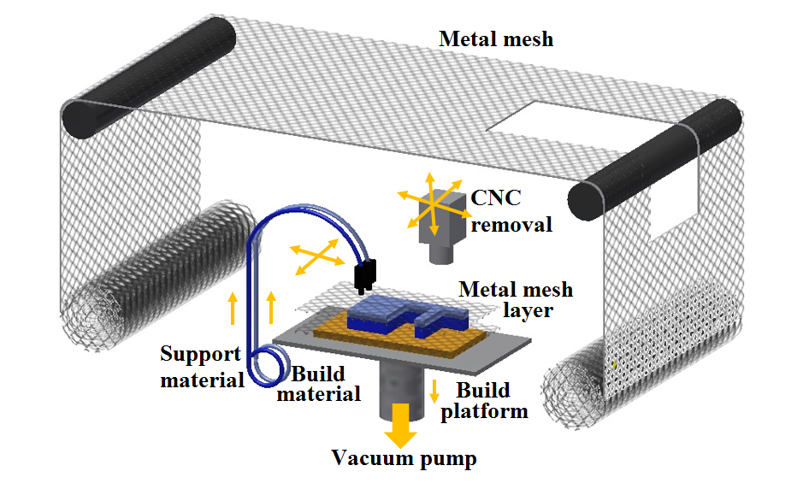
Figure 1: Metal/plastic hybrid process
The proposed process starts with the 3D CAD model of the part being transferred, using the Slic3r software, to a set of layer data according to the geometry of the part. There are several open-access slicing software options available which have the capability to be modified according to customized applications. Slic3r has been chosen because it is free to use and enable easy bespoke additions to the firmware which are required for this process. The 3D CAD file has been set up with pauses where the metal mesh needs to be added to the part being built. Once the machine receives the layer data then it controls the building process. The extruder starts to heat up to initiate the building operation. In the meantime, the base plate is levelled on the build platform so that an accurate part can be printed. After the appropriate temperature has been achieved (depending on the material), the printing process starts with a base of support material to allow for easy removal after the build. The layers of metal mesh have been programmed after set intervals so that the part being built would get the advantages of thermoplastic as well as the metal. When it is time to add a layer of metal mesh, the extruder head depositing the thermoplastic material moves to a side and the vacuum pump gets activated. It creates a partial vacuum that pumps out all the air beneath the metal mesh sheet. Atmospheric pressure above the mesh sheet pushes it down on the part being built. The mesh wraps around the part according to its profile and then the vacuum pump is switched off. The CNC machine can either be used at this stage or at the end of the build to remove the mesh on the sides of the part as it is not required. This process is very similar to vacuum forming but the difference lies in the fact that instead of using a plastic sheet and heating it, the current method employs metal mesh and does not require any heat treatment. The metal mesh gets added to the plastic part by virtue of the amorphous plastic being deposited by the extrusion head. The plastic adheres to the mesh layer and runs through the holes of the mesh to create a strong bond between the plastic and metal. The process does not require any additional bonding mechanism other than the principles of FDM which saves cost on expensive adhesives. The process is repeated until the part has been built according to the layer data. The part is then removed from the base plate and placed in a chemical bath to remove the support material (if any). The process is simple and does not require high degree maintenance of the components. The flow chart of operation is shown in Fig. 2.

3D CAD Model

Slicing into cross-sections

Printing support layers
Printing build material

Layer by layer construction

PAUSE
Stacking
Vacuum generation
NO
YES
Metal mesh placement
Layer by layer construction resumes

CNC machining

Metal-Plastic Hybrid Part

Figure 2: Flow chart of operation
The above explanation describes the process as a whole but the research was carried out by breaking down the process into independent steps that were performed to produce the testing samples. The next section explains that breakdown and the practices utilized to prove the process.

Materials and Manufacturing Process
The process is complex and needed to be broken down into simple steps for practicality, thus an experimental setup was created to demonstrate the capability of the process. It was important to ensure that the process utilizes minimum resources as one of the objectives is to make this process as cost effective as possible.
ABS and copper mesh sheets (99.99% pure) of varying thicknesses (30 microns, 60 microns and 150 microns) were used to build samples for tensile testing. The testing samples were built and tested according to British and International standards. A standard desktop 3D printer from RS Components was used with a working envelope of 150mm x 150mm x 140mm as shown in Fig. 3. The 3D CAD model of the part to be built was sent to the 3D printer which began the build operation by laying down the support material base for the part. The part was built at a speed of 30mm/s with a layer thickness of 0.2mm (Fig. 4a) with the set temperature being 220 °C. The metal mesh was added manually to the part as it was being built by pausing the build operation and then resuming it (Fig. 4b). The support material in this case was easily snapped off as the testing sample was a rectangular piece with no need for any additional support other than the base. The mesh was used without any surface treatment and was added carefully after set intervals to obtain good bonding with the plastic. After the build operation, the support material was snapped off and the part was ready to be tested.

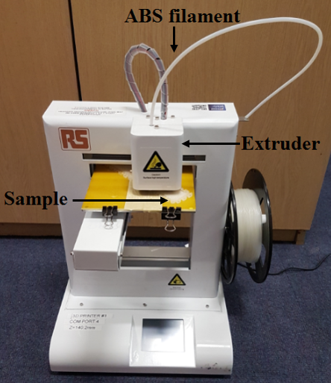
Figure 3: 3D printer in operation
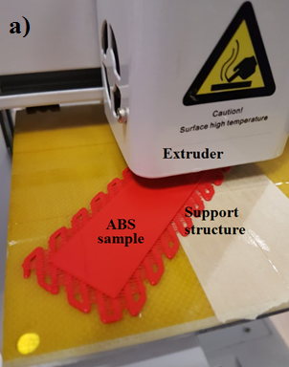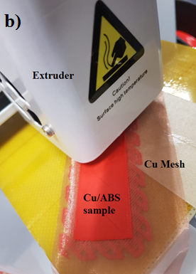
Figure 4: Production of samples: a) ABS sample; b) Cu/ABS sample

Experimental Methodology

Strain Measurement
This test was important to investigate the deformation a sample would experience due to an applied bending force. Two samples were made according to BS EN ISO 178-2010; one from ABS and the other being a composite of Cu/ABS, to measure strain as a static load is applied on them. The samples were 100mm long, 25mm wide and 3mm thick. Two metallic strain gauges were bonded to both sides of the samples in a half bridge configuration because it instils more sensitivity by measuring both tensile (positive) and compressive strain (negative). The strain gauge used is a product of VPG Corporate with a grid resistance of 12 ± 0.3% ohms, gauge factor of 2.14 at 24 °C and a transverse sensitivity of 0.8 ± 0.2%. It was attached to the surface of the sample to be tested with cyanoacrylate adhesive and then the leads of the gauge were soldered as shown in Fig. 5, to obtain an output as a function of the deformation. As the sample deform upon the application of load, the strain gauge changes its resistance which is then expressed in terms of an electrical signal. The signal is recorded using HBM Data Acquisition System QuantumX MX 1615B running catman DAQ (data acquisition) software with half bridge configuration.
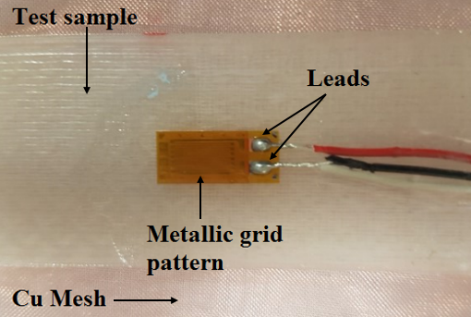
Figure 5: Strain gauge bonded to the testing sample

Tensile testing
Metal/plastic composites (Cu/ABS) and pure ABS samples were made according to BS EN ISO 527-5-2009. The samples were 150mm long, 25mm wide and 3.5mm thick. ABS is one of the most commonly used material for 3D printing and its utilization could help in understanding the bond strength the newly proposed hybrid method can produce. The tested samples were made according to the following configurations while keeping the overall thickness to 3.5mm ± 0.1mm (precision of the printer):
- Cu/ABS: Samples were made with varying thickness of the copper mesh (30 microns, 60 microns and 150 microns).
- Cu/ABS: Samples were made with increasing layers of copper mesh (1, 2, 3 and 4).
- Pure ABS: Samples were made with ABS for comparison with the respective metal/plastic composite samples.

Microstructural Analysis
A scanning electron microscope (SEM) was utilized to observe the fractured surfaces of Cu/ABS and pure ABS samples. The aim was to establish the presence of a bond between the layers of plastic and the metal mesh. It was important to understand the effect of the metal mesh on the structural integrity of the sample. The samples were cut so that they can fit on the platform of the SEM with ease and were observed without any surface treatment.

Results and Discussion

5.1. Results from Strain Measurement
Strain is a crucial factor in determining the material properties. Since a new hybrid process is being used to produce metal/plastic composites, it was essential to investigate whether or not the process is capable of achieving good results or not otherwise there will be no real-world applications for such a method. Two 120-ohm strain gauges were bonded to an ABS sample and Cu/ABS sample to measure strain upon the application of load at room temperature. The samples were placed on two rollers of 10mm diameter and a static load was applied as shown in Fig. 6. The values were recorded as the load increased from 100g to 200g and then 300g. The ABS sample was 100mm long, 25mm wide and 3.5mm thick. The Cu/ABS sample had the same dimensions with one layer of copper mesh (30 microns thick wire) in the middle. The leads of the upper and lower strain gauges were connected to channels 1, 6 of the HBM QuantumX MX 1615B system for ABS sample and channels 1, 5 for the Cu/ABS sample. The upper strain gauge recorded the compressive strain whereas the lower gauge measured the tensile strain as the load is being applied in the middle of the sample where the gauges are bonded.
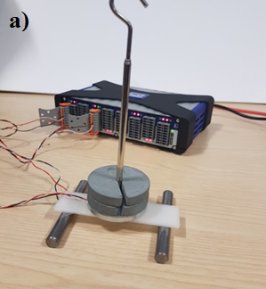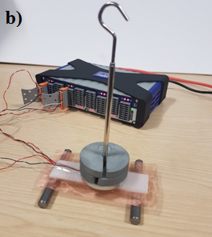
Figure 6: Strain measurement: a) ABS sample; b) Cu/ABS sample
The samples were subjected to static load and the strain values were recorded as shown in Table 1. It is evident that the ABS sample exhibit higher values for strain as compared to the composite meaning that the composite showed lower deformation. The reason is the presence of a metal mesh layer that is bonded at the middle of the sample. It provides resistance to dislocations as the load is being applied and hinders the movement of molecules. At an operating temperature of around 220 °C, ABS is being extruded as layers that adhere to each other and the metal mesh to create a strong bond for a high-quality metal/plastic composite. There are several factors that could affect the value of strain and needs further investigation. They include the size, thickness and number of the metal mesh layers used, placement of the strain gauges, configuration of plastic layers, ambient noise and temperature. However, this initial test proved the capability of the new hybrid process which will be examined further by building samples with different metal mesh layers and thickness in the next section.
Table 1: Strain measurements for the two samples
Materials | ABS |  |  | Cu/ABS
Load (g) | 100 | 200 | 300 | 100 | 200 | 300
Cumulative strain (μm/m) | 320 | 500 | 620 | 290 | 485 | 600

5.2. Results from Tensile Testing
The tensile test was carried out on a Universal Testing Machine (UTM) at a cross-head speed of 5mm/min. This test was important to investigate the bond strength in different scenarios as outlined in Section 4.2 after validation from the strain measurement that good bonding has been achieved by the new hybrid process. The tensile test results of the 150mm long, 25mm wide and 3.5mm thick samples with a single metal mesh layer of 30 microns, 60 microns and 150 microns are shown in Fig. 7. The Cu/ABS samples when compared to a pure ABS sample show high load values that increase with an increase in thickness of the mesh used. This clearly demonstrate the effectiveness of the process while working with different thicknesses. It is to be noted that the thickness of the layers being extruded play a key role in the bonding process and should be chosen according to the geometry of the part being printed. Some 3D printers have more settings that can control the layer thickness but in this case, a layer thickness of 0.2mm was used that worked well for the configurations printed but an in-depth analysis is required to investigate and validate a layer thickness for optimal bonding. It is also common practice to use a lower resolution to obtain stronger inter-layer bonds, but it will take more time, therefore, a balance must be struck between strength required and processing time.

Figure 7: Tensile test results with metal mesh layers of varying thickness
The tensile test results of Cu/ABS composites having one, two, three and four metal mesh layers (30 microns thick) at equal intervals are shown in Fig. 8. It is to be noted that the metal mesh was placed at 50% completion with one mesh layer, at 40% and 80% completion with two mesh layers, at 30%, 60% and 90% completion with three layers, 20%, 40%, 60% and 80% completion with four metal mesh layers. It is to obtain consistent results and allow for symmetrical load distribution during testing. These results clearly indicate a proportional increase in load values with number of layers showing that a far superior composite product can be made by adding a few layers of metal mesh to a plastic part at a relatively simpler and cost-effective manner. This is a testament to the flexibility of the new hybrid process that can work with different metals without the need for appropriate adhesives or joining practices that would be time consuming and can affect the structural integrity of the final product.

Figure 8: Tensile test results with increasing number of metal mesh layers

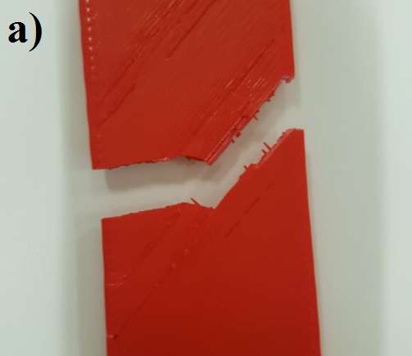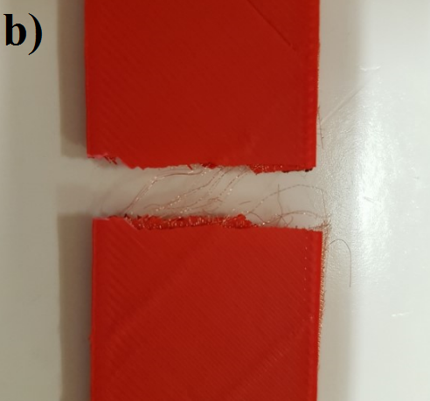
Figure 9: Fracture modes: a) ABS sample; b) Cu/ABS sample
The fracture modes of the pure ABS sample and a sample with one metal mesh layer are shown in Fig. 9. It clearly shows the metal mesh stretching between the layers of ABS rather than just being there with no bonding with the surrounding areas. A closer look at microscopic level to analyse how the metal mesh is bonded to the plastic layers is shown in Section 5.3. It is to be noted that even though the results validate the effectiveness of the new hybrid process for producing high quality metal/plastic composites, there are a few factors at play that could help in getting a better strength from the parts. They are mostly associated with how 3D printing is done and the way in which shells (the number of layers on the outside of the print), infill (internal structure of the print), top as well as bottom layers are set for a product. However, these settings are determined based on the type of application and can make an enormous difference in terms of the product strength. In the current work, the printer recommended settings were used with two shells and rectangular infill (25%) geometry for the build as these are the quickest and utilizes less material. Increasing the number of shells will take more time and material but will also increase the strength of the part. Same goes for infill percentage with an increase from 25% to 50% will provide more strength and hence more contact/bonding points for the metal mesh as shown in Fig. 10. In addition to the rectangular infill, there are a few other commonly used shapes (triangular, wiggle and honeycomb) for infill that have their own advantages and are used according to the type of product and its application.
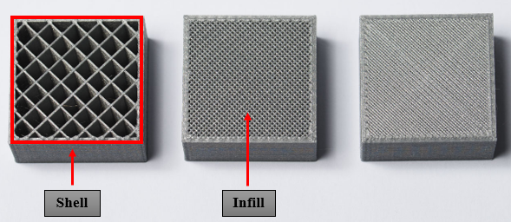
Figure 10: Infill percentage: 75% on the right, 50% in the centre and 25% on the left (with shell identification)
From the freedom of design considerations such as shells, infill, top and bottom layers, 3D printing also can produce complex and intricate geometries with the prime example being that of lattice structures. Using the proposed hybrid method and integrating the features of lattices in the composite structures adds to the versatility and efficiency of the products that can be produced. 3D printing will easily allow for the production of complex lattice structures inside the composites to provide excellent performance. They are key tools in component light-weighting, and can also boost heat transfer, energy absorption, insulation and joining performance. Careful lattice design and number of metal mesh layers can introduce precisely tailored properties into the resulting composites which are essential for many engineering industries.

5.3. Results from Microstructural Analysis
The fractured modes of the ABS and Cu/ABS samples were examined under the SEM as shown in Fig. 11. ABS being an amorphous material is more susceptible to effects related to anisotropy and inhomogeneity caused by voids and pores (Fig. 11a). These could lead to layers that are not fully bonded to each other and hence result in fracture as shown in Fig. 11c. The layer of metal mesh can be seen clearly sandwiched between two ABS layers (Fig. 11b) indicating the existence of a bond holding the layers of metal and plastic together.
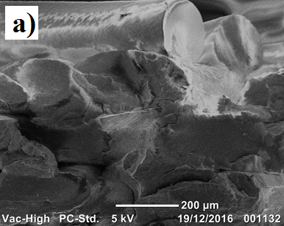
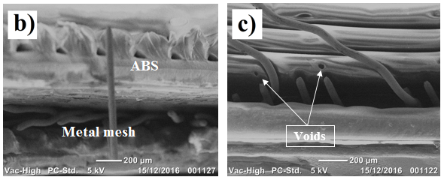
Figure 11: Microstructural analysis: a) ABS sample at x130; b) Cu/ABS sample at x70; c) Cu/ABS sample at x80

Conclusions
The paper has presented a new hybrid method for the production of high quality metal/plastic composites. The step-by-step procedure has been discussed followed by the practices utilized to produce ABS and copper mesh composites. Strain gauges were used in half bridge configuration to measure strain in the composites made by the new process and showed lower values compared to the parent plastic indicating lower deformation rates due to the presence of the metal mesh layer both in the positive (tension) and negative direction (compression). This proved that the process can create a strong bond based on the principles of FDM without using expensive and time-consuming adhesives or other joining methodologies. The next set of tests further reinforced the effectiveness of the new process by showing consistent results. Tensile test with different number of metal mesh layers and varying thickness demonstrate the capability of the process to produce strong metal/plastic composites. Microstructural analysis revealed the presence of a bond that is holding the layers of plastic and metal mesh together to form an efficient product. The benefits of 3D printing, such as design freedom and ease of complex geometry manufacture, adds flexibility to the process and make it a strong candidate for the production of high quality plastic/metal composites with tailored properties for specialized applications in automotive and aerospace industries.

References
Abibe, A.B., Amancio-Filho, S.T., Dos Santos, J.F. and Hage, E., 2013. Mechanical and failure behaviour of hybrid polymer–metal staked joints. Materials & Design, 46, pp.338-347.
Amancio‐Filho, S.T. and Dos Santos, J.F., 2009. Joining of polymers and polymer–metal hybrid structures: recent developments and trends. Polymer Engineering & Science, 49(8), pp.1461-1476.
Amancio-Filho, S.T., Bueno, C., Dos Santos, J.F., Huber, N. and Hage, E., 2011. On the feasibility of friction spot joining in magnesium/fiber-reinforced polymer composite hybrid structures. Materials Science and Engineering: A, 528(10), pp.3841-3848.
Balle, F., Wagner, G. and Eifler, D., 2009. Ultrasonic metal welding of aluminium sheets to carbon fibre reinforced thermoplastic composites. Advanced Engineering Materials, 11(1‐2), pp.35-39.
Callister, W.D. and Rethwisch, D.G., 2013. Fundamentals of materials science and engineering (Vol. 21). New York: Wiley.
Hartshorn, S.R. ed., 2012. Structural adhesives: chemistry and technology. Springer Science & Business Media.
Jung, K.W., Kawahito, Y. and Katayama, S., 2013. Laser direct joining of carbon fibre reinforced plastic to stainless steel. Science and Technology of Welding and Joining.
Katayama, S. and Kawahito, Y., 2008. Laser direct joining of metal and plastic. Scripta Materialia, 59(12), pp.1247-1250.
Šercer, M. and Raos, P., 2010. Joining of Plastics and Composites. In Welding Engineering and Technology. Eolss Publishers (under the Auspices of the UNESCO).
Yusof, F., Miyashita, Y., Seo, N., Mutoh, Y. and Moshwan, R., 2012. Utilising friction spot joining for dissimilar joint between aluminium alloy (A5052) and polyethylene terephthalate. Science and Technology of Welding and Joining, 17(7), pp.544-549.

