(1) BAPRAS and BAAPS Scientific Meetings: Are we sticking our noses up at rhinoplasty?

Word count: 756

(2) Zeeshaan Arshad (ZA)¹, Tasneem Pope (TP)¹, Raina Zarb-Adami (RZ)², Charles M Malata (CMM)^{2, 3, 4}
1) University Cambridge School of Clinical Medicine, University of Cambridge, Cambridge, UK
2) Department of Plastic and Reconstructive Surgery, Addenbrooke’s Hospital, Cambridge University Hospitals NHS Foundation Trust, Cambridge CB2 0QQ, UK
3) Cambridge Breast Unit, Addenbrooke’s Hospital, Cambridge University Hospitals NHS Foundation Trust, Cambridge CB2 0QQ, UK
4) Anglia Ruskin University School of Medicine, Chelmsford & Cambridge, UK

(4) Name and address of the department or institution to which the work should be attributed - Department of Plastic and Reconstructive Surgery, Addenbrooke’s Hospital, Cambridge University Hospitals NHS Foundation Trust, Cambridge CB2 0QQ, UK

Corresponding author:
Zeeshaan Arshad
University of Cambridge School of Medicine, University of Cambridge, Cambridge, UK
Cambridge, CB2 2QQ, UK.
Phone: 01592 570865
Email: za272@cam.ac.uk

Dear Sir,

The aim of this study was to ascertain how well the topic of rhinoplasty has been represented at the meetings of the two prominent plastic surgery organizations in the UK - BAPRAS (British Association of Plastic, Reconstructive, and Aesthetic Surgeons) and BAAPS (British Association of Aesthetic Plastic Surgeons). This was to ascertain whether an important area of plastic surgery training and practice is adequately represented or not.

Methods

A search for all abstracts presented at BAPRAS and BAAPS Meetings in the last five years (2013-2017) was conducted. The search for abstracts was limited to five years as abstracts from BAAPS meetings could only be sourced from 2013 onwards. In addition, the EPRAS (European Society of Plastic, Reconstructive, and Aesthetic Surgery) meeting of 2014 was included as it was a joint event between BAPRAS and ESPRAS. To ensure we included work that was representative of British surgeons, we only included abstracts from the EPRAS meeting if the presenting author had an affiliation with the UK. Abstracts for the Winter and Summer BAPRAS meetings were sourced from the BAPRAS official website¹, whilst those from the Annual BAAPS meetings were sourced through email communication with the organization’s secretariat.

Subsequently, abstracts were reviewed, and the total number of abstracts (both for free papers and posters), and the number pertaining to rhinoplasty were recorded. The number of hours devoted to rhinoplasty in the formal agenda was noted as well. Another author (TP) independently verified all data that was collected.

Results

In total, the abstracts from ten BAPRAS Summer/Winter Scientific Meetings were analyzed (Figure 1). Only five free paper abstracts out of 884 (0.5%), and a three poster abstracts out of 914 were related to rhinoplasty (0.3%). Half of meetings had no abstracts pertaining to rhinoplasty (n=5). 2.5 out of 216 hours of meeting time was devoted to rhinoplasty both from invited lectures and key note talks (1%).

Five years of BAAPS meeting abstracts were analyzed (Figure 2). One abstract pertaining to rhinoplasty was presented at each of the annual scientific meetings between 2014-2017. Two were presented at the Annual meeting in 2013. This was from a total of 125 abstracts (2.4%). 10.5 out of 120 hours of meeting time was devoted to rhinoplasty both from invited lectures and key note talks (9%).

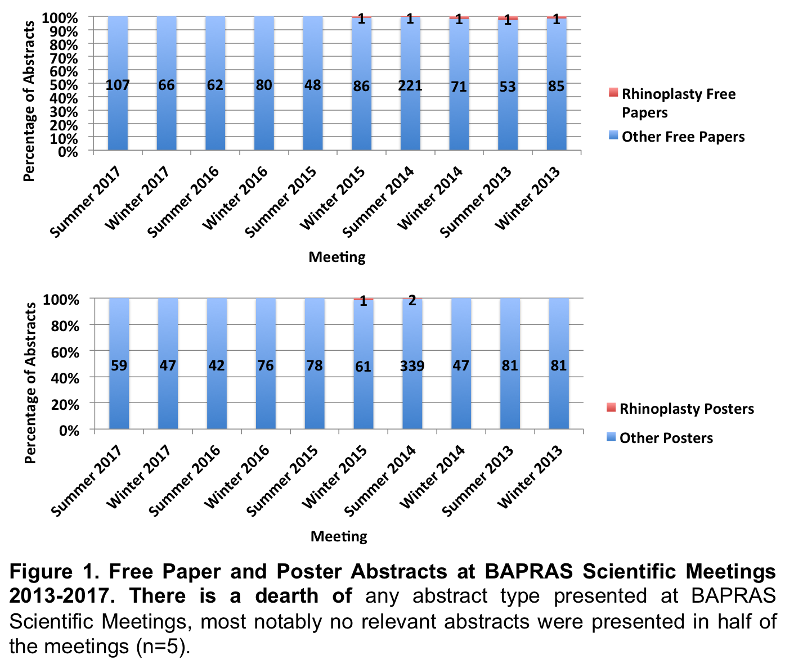
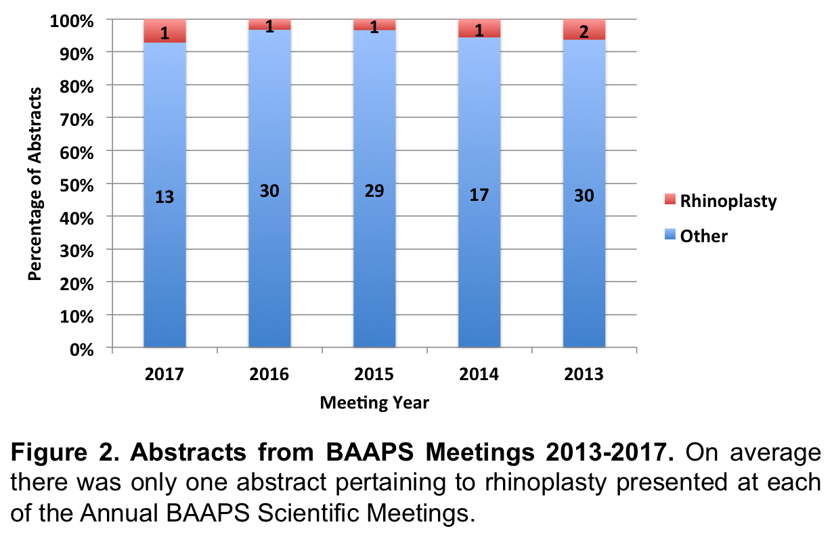
Discussion

The results of this study highlight the severe lack of time devoted to the topic of rhinoplasty at BAPRAS and BAAPS Scientific Meetings. Less than 1% of abstracts presented over five years at ten BAPRAS Scientific Meetings were related to rhinoplasty. On average, only a single relevant abstract was presented at each annual BAAPS meeting.

Rhinoplasty is one of the most commonly performed cosmetic procedures in the UK: being carried out 2,703 times in the year 2016 alone.² Aside from this, plastic surgeons often cite it as one of the most complex procedures to be performed in cosmetic surgery. As a result, rhinoplasty is associated with a high litigation rate.

In the US, it has been identified as an area of practice that newly qualified attendings remain less comfortable with^{3,4}. A survey 397 senior residents found that facial aesthetic procedures, including rhinoplasty, remained challenging to residents³. If they had the opportunity to undergo additional training, 60.9% of trainees said they would devote the time to rhinoplasty³.

Although such data are lacking for the UK, the paucity of abstract presentations at BAAPS and BAPRAS Scientific Meetings represents a lack of UK trainee exposure in the area of rhinoplasty be it reconstructive, aesthetic or both. This could be a result of the decline in exposure to rhinoplasty despite its important place in the postgraduate plastic surgery training curriculum. Since 2008 there has also been a reduction of low priority aesthetic procedures that can be accessed on the NHS – thereby limiting trainee exposure to these procedures. It also reflects competition from related specialties such ENT (ear, nose, and throat) and maxillofacial surgery.

Given the complexity and demand for procedures, such as rhinoplasty, septoplasty and septorhinoplasty, it is essential that plastic surgery trainees are competent in performing them. To allow this, we advise that plastic surgery trainees, deaneries and the plastic surgery SAC take an active role to ensure future generations of plastic surgeons trainees gain adequate exposure to rhinoplasty. This could be done through structured teaching sessions, roadshows, attendance at private practices, attachment to ENT departments, and of course fellowships in rhinoplasty specifically and cosmetic surgery in general. It would also be helpful if there were SAC mandated minimum number of operations that need to be performed to gain a CCT.

References

1. Home | BAPRAS [Internet]. [cited 2018 Jan 29]. Available from: http://www.bapras.org.uk/
2. THE BUST BOOM BUSTS | The British Association of Aesthetic Plastic Surgeons [Internet]. [cited 2018 Jan 29]. Available from: https://baaps.org.uk/media/press_releases/29/the_bust_boom_busts
3. Oni G, Ahmad J, Zins JE, Kenkel JM. Cosmetic Surgery Training in Plastic Surgery Residency Programs in the United States: How Have We Progressed in the Last Three Years? Aesthetic Surg J. 2011 May 1;31(4):445–55.
4. Morrison CM, Rotemberg SC, Moreira-Gonzalez A, Zins JE. A Survey of Cosmetic Surgery Training in Plastic Surgery Programs in the United States. Plast Reconstr Surg. 2008 Nov;122(5):1570–8.

