Music as an aid for postoperative recovery in adults: a systematic review
Authors: Miss Jenny Hole¹, Dr Martin Hirsch² MBBS, Miss Elizabeth Ball^{1,2} PhD, Dr Catherine Meads³ PhD

1. Barts and The London School of Medicine and Dentistry, QMUL, University of London
2. BartsHealth NHS Trust
3. Health Economics Research Group, Brunel University.

Corresponding author Elizabeth Ball
Emails: Eball69@gmail.com
Elizabeth.ball@bartshealth.nhs.uk,
Tel: +44 77 459 404 32
.
Abstract
Background
Music is a relatively non-invasive, safe and inexpensive intervention that can be delivered easily and successfully. This systematic review evaluated music to improve postoperative recovery after surgical procedures.
Methods
Randomised controlled trials (RCTs) in any language of adults undergoing surgical procedures excluding central nervous system or head and neck were included. Any form of music initiated before, during or after surgery was compared to standard care or other non-drug interventions. Medline (1946-Oct 2013), Embase (1947-Oct 2013), CINAHL (1960-Oct 2013), and Cochrane Central (1898-Oct 2013) were searched, using MESH and keyword terms: music, music therapy, surg*, operat*, recovery, recuperation, rehabilitation, convalescence, post-op*. Inclusions, data-extraction and quality-assessment were in duplicate. Meta-analysis with RevMan (5.2), with standardised mean differences (SMD) and random-effects models, and STATA for meta-regression were used. (Prospero-CRD42013005220).
Results
Searches found 4261 titles and abstracts, 73 RCTs were included, with size varying between 20–458 participants. Choice of music, timing and duration varied. Comparators included routine care, headphones with no music, white noise and undisturbed bed-rest. Postoperatively music reduced pain (SMD -0.77 (95% confidence intervals (95%CI) -0.99 to -0.56), anxiety SMD -0.68 (95%CI -0.95 to -0.41), and analgesia use SMD -0.37 (95%CI -0.54 to -0.20) and increased patient satisfaction SMD 1.09 (95%CI 0.51 to 1.68) but there was no difference in length of stay (MD -0.11 (95%CI -0.35 to +0.12)). Music reduced 10cm scale pain scores by 2.3cm compared to placebo. Subgroup analyses on choice and timing made little difference. Meta-regression found no causes of heterogeneity in eight variables evaluated. Music was effective even when patients were under general anaesthetic.
Conclusions
There is now evidence to demonstrate that music should be available to all undergoing operative procedures. Patients should choose the type of music, from personal choice or playlists. Timing and delivery may be adapted to individual clinical settings and medical teams.

Introduction
Most people undergo a surgical procedure at some point in their lives, over 51 million operative procedures are performed annually in the United States of America (USA)¹ and 4.6 million hospital admissions lead to surgical care in England.² There is an emerging trend towards the conduct of surgical procedures without general anaesthesia, for example hysteroscopy and Caesarean section. Whether anaesthesia is used or not, the postoperative period is a difficult time for patients. The term ‘postoperative recovery’ has not been precisely defined. It is clinically based and includes the restoration of the patient’s cerebral and motor function. Current surgical recovery strategies, such as Enhanced Recovery³⁻⁵ recommend numerous successful perioperative interventions within this package.⁶ Some preoperative strategies, such as patient education and nutritional additives, have been seen to reduce postoperative pain requirements and improve satisfaction levels⁷⁻⁹ but not all potentially useful interventions have yet been evaluated or incorporated.

The use of music to improve patients’ hospital experience has a long foundation in medical care, including by Florence Nightingale.¹⁰ Music was first described being used to help patients during operations by Kane in 1914.¹¹ There is abundant research investigating music’s impact on the emotions and neurophysiology.¹²⁻¹⁴ Pre-recorded music, used through headphones, musical pillows or background sound systems can be a non-invasive, safe and inexpensive intervention, compared to pharmaceuticals, that can be delivered easily and successfully in a medical setting.¹⁵ Music has frequently been investigated in the context of recovery from operative procedures and numerous RCTs have demonstrated positive effects on patients’ postoperative recovery.^{16,17} This use of music is different from music therapy, which is a cognitive rehabilitation method.¹⁸

Previous systematic reviews have investigated music and its role in specific surgical procedures such as colonoscopy^{19,20} or only one aspect of patient experience in isolation, such as preoperative anxiety²¹, or postoperative pain.^{22,23} Cepeda (2010) investigated music for pain relief in both surgical and non-surgical settings.²⁴ Nilsson (2008) comprehensively reviewed 60 articles on music in the perioperative period but did not perform a meta-analysis.²⁵ None have provided a comprehensive overview with meta-analyses and meta-regression.

Music is not currently being used routinely during episodes of surgery. General issues around lack of uptake include ignorance and scepticism of professionals as to clinical usefulness of music, and lack of: budget, research dissemination and integration of the intervention in daily practice.²⁶

Despite the wealth of relevant studies the implementation of music as a therapeutic tool in everyday surgical practice is lacking because the information demonstrating effectiveness has not been synthesised and universally disseminated. This systematic review evaluates the effectiveness of music to improve postoperative recovery incorporating all available RCTs, reviewing the impact of music on common outcome measures for postoperative care: pain, analgesia requirements, anxiety and length of stay and exploring a number of relevant subgroups – patient choice of music, timing of the intervention and whether general anaesthesia was used.

Methods
We developed and registered a protocol for this systematic review (Prospero registration number CRD42013005220). The pre-defined inclusion criteria were RCTs in any language with adult patients undergoing any form of surgical procedure (with or without sedation or anaesthesia) to any part of the body excluding the central nervous system or head and neck (because of potential hearing impairment). Any form of music initiated before, during or after surgery was compared to standard care or any other non-drug interventions such as massage, undisturbed rest or relaxation. Outcomes of interest were: postoperative pain, analgesia requirement, anxiety, infection rates, wound healing, costs, length of stay, and satisfaction with care. Analgesia use included any opioids or non-steroidal anti-inflammatory drugs (NSAIDs). If both were reported, opioid use was used in the meta-analyses. The outcomes were measured up to six weeks postoperatively. We investigated subgroups of pain before and after four hours postoperatively, timing of the intervention pre, intra and postoperatively, general anaesthetic versus none and patient choice of music. We recorded if music given intraoperatively was started after induction of anaesthesia.

The following databases were searched: Medline (1946-Oct 2013), Embase (1947-Oct 2013), Cumulative Index to Nursing and Allied Health Literature (CINAHL) (1960-Oct 2013), and Cochrane Central (1898-Oct 2013). The following search terms were used; music, music therapy, surg*, operat*, recovery, recuperation, rehabilitation, convalescence, post-op*. Both MESH terms and keywords were used. Reference lists of relevant reviews were checked for additional studies. All relevant titles and abstracts were transferred to Endnote Web for assessment.

Two reviewers (JH and MH) checked study eligibility. Both independently extracted data from studies using a standardised, pre-designed extraction form in Microsoft Excel 2007. Disagreements were resolved through discussion or referral to a senior reviewer (CM). Quality of included studies was assessed using criteria set by The York Centre for Reviews and Dissemination²⁷; focussing on randomisation, allocation concealment, presence of blinding, explanation of withdrawals and presence or absence of intention-to-treat analysis.
We tabulated the characteristics and results of all the included studies; analysis was quantitative. Where standard errors or ranges were provided, standard deviations were calculated using standard formulae. Review Manager (version 5.2, The Cochrane Library) was used for meta-analyses. We used random effects models because of heterogeneity of participants and interventions. All outcomes were continuous measures and we used standardised mean differences (SMD) where the outcomes had differing measurement scales. Risk of publication bias was assessed using funnel plots. In addition to presenting SMD, which can be difficult to interpret clinically, we conducted back transformations of two outcomes used in the included RCTs. These were calculated using Excel and were performed on the pain outcome, using a mean of control group standard deviations from the RCTs measuring pain using a VAS, and for the anxiety outcome, using a mean of control group standard deviations from RCTs measuring anxiety with STAI. To further investigate heterogeneity, meta-regressions were conducted using STATA version 12.
Role of the funding source
There was no funding source for this study. The corresponding author had full access to all the data in the study and had final responsibility for the decision to submit for publication.

Results
Searches found 4261 titles and abstracts. After removing duplicates 3876 remained for screening, of which 3616 were irrelevant. Full papers for 260 articles were assessed for inclusion (238 from database searches and 22 from reference lists) (see figure 1). There were 73 RCTs included in the qualitative synthesis and 72 RCTs in quantitative syntheses, including a Japanese study that was translated. It is unlikely that there will be much effect from publication bias (see figure 2).

Characteristics of included studies are in table 1. The size of the studies varied between 20 – 458 participants, and they underwent a variety of different surgical procedures ranging from minor endoscopic interventions to transplant surgery. Most studies only included elective procedures. Choice of music could be by patient or researcher. Patients chose a wide variety of styles. Researchers determined single types of music such as Chinese classical music, or gave patients’ choice from a list of six or more styles. Most were of a soothing quality. Delivery could be by headphones or music pillows for patients only to hear, or loudspeakers which could also be heard by the medical team. When music was delivered by headphones, it was often at a sufficiently low level that patients could still communicate easily. Timing could be pre, intra or postoperative, or a combination. The music could be played when patients were awake or anesthetised. Duration of music varied between a few minutes to repeated episodes over several days. Comparator descriptions varied, and included routine care, headphones with no music, white noise, and undisturbed bed rest. Duration and timing was normally similar to the interventions. Outcomes included postoperative pain, analgesia requirement, anxiety, length of stay, and satisfaction with care. None of the RCTs measured infection rates, wound healing or costs. Some outcomes were measured during or just after the procedure, others were measured at multiple times during the hospital stay.

A variety of outcomes were measured (see Table 2). Pain was usually measured with visual analogue scales (VAS) or numerical rating scales (NRS). An indirect measure of pain was the consumption of analgesia, which varied considerably between the studies including opioid-based drugs such as pethidine, fentanyl, and morphine, and non-steroidal anti-inflammatories such as diclofenac, ibuprofen, and paracetamol.

Quality of included studies varied (see table 3) but a number of the studies gave insufficient details to assess all aspects of quality. An intervention such as this cannot be blinded to the patient unless they are under general anaesthesia, but blinding of investigators and outcome assessment would be possible but was not stated in many of the studies. Where music was delivered when the patient was under anaesthesia it was unclear whether the patient knew beforehand to which group they were allocated.

The results showed that postoperatively music reduced pain (45 RCTS, SMD -0·77 (95%CI-0·99 to -0·56)), anxiety (43 RCTS, SMD -0·68 (95%CI -0·95 to -0·41)), and analgesia use (34 RCTS, SMD -0·37 (95%CI-0·54 to -0·20)) and increased patient satisfaction (16 RCTS, SMD 1·09 (95%CI 0·51 to 1·68)) but there was no difference in length of stay (7 RCTs, SMD -0·11 (95%CI-0·35 to +0·12)) (see figure 3). Pain and anxiety SMD outcomes were back-calculated into specific measurements most used in the RCTs. Pain results (using the 10cm VAS) suggested that music reduced pain scores by 2.3cm on average, compared to placebo. Anxiety results (measured by STAI) were reduced by 6.4 units on average, compared to placebo.

Heterogeneity was high for pain, anxiety and analgesia use, with I² varying between 75-92%, for length of stay it was 0%. No RCTs reported wound healing rates, costs, wound infections or serious adverse events. A subgroup analysis by type of control (routine care vs control with attention) made little difference to the effectiveness of music. Univariate meta-regression analysis to explain heterogeneity did not show a significant impact of any of the eight variables on the main result (variables investigated were patient choice, timing of music, general anaesthetic, use of VAS to measure pain v other pain measures, routine care v other comparisons, endoscopy type procedures v surgery, allocation concealment, and blinding of outcome assessment). Because there were no significant outcomes found on univariate meta-regression, multivariate meta-regression was not conducted.

Postoperative pain was pragmatically categorised as being measured between zero and four hours and more than four hours. There was no difference between pain measured at the early versus later time categories (-0·79 (95%CI-1·06 to -0·52) and -0·76 (95%CI-1·19 to -0·33) respectively). For individual subgroup meta-analyses – see Web Appendix figures W2 – W12.

When patients were allowed to choose the music (from personal choice or from a playlist) there was a slightly greater but non-significant reduction in pain compared to when there was no choice (SMD -0·86 (95%CI-1·14 to -0·57) vs -0·70 (95%CI-1·01 to -0·39). Similarly, there was a slightly greater but non-significant reduction in analgesia use with patient choice (SMD -0·53 (95%CI-0·84 to -0·23) vs -0·15 (95%CI-0·29 to -0·02) but a slight but non-significant worsening in anxiety SMD -0·54 (95%CI-0·82 to -0·27) vs -0·89 (95%CI-1·42 to -0·36).

There was a trend for pain to be less if music was played preoperatively compared to postoperatively (preoperatively SMD -1·28 (95%CI-2·03 to -0·54), intraoperatively SMD -0·89 (95%CI-1·20 to -0·57) postoperatively SMD -0·71 (95%CI-1·03 to -0·39). A similar pattern was seen with analgesia use and anxiety. Results for analgesia use were preoperatively SMD -0·43 (95%CI-0·67 to -0·20), intra-operatively SMD -0·41 (95%CI-0·70 to -0·12), post-operatively SMD -0·27 (95%CI-0·45 to -0·09) and for anxiety were pre-operatively SMD -1·12 (95%CI-2·05 to -0·19), intra-operatively SMD -0·83 (95%CI-1·19 to -0·47) and postoperatively (SMD -0·50 (95%CI-0·96 to -0·04).

Even under general anaesthetic music still reduced pain, but a larger effect on pain was found intra-operatively where patients were conscious compared to where patients heard the music whilst under general anaesthetic (SMD -1·05 (95%CI-1·45 to -0·64) vs SMD -0·49 (95%CI-0·74 to -0·25). A similar effect was found with analgesia use (SMD -0·58 (95%CI -1·05 to -0·11) vs -0·26 (95%CI-0·44 to -0·07) and anxiety (SMD -0·91 (95%CI-1·33 to -0·48) vs -0·48 (95%CI-0·91 to -0·05).

None of the included studies reported side effects. However, some reported that they ensured that the low volume delivered permitted communication with medical teams.

Discussion
Statement of principal findings
The results of this systematic review suggest that playing music in the perioperative setting can reduce postoperative pain, anxiety and analgesia requirements, and improve patient satisfaction. Fewer studies measured length of stay and no difference was found. None of the studies investigated the effects of music on infections, wound healing rates, or costs.

Strengths and weaknesses
We used wide inclusion criteria in order to make the results more generalisable to clinical practice. It could be argued that we should not have combined very heterogeneous studies because of the clinical differences. For example, is it useful to meta-analyse studies reporting different analgesics used? Stronger pain tends to be alleviated with stronger analgesia whereas milder pain responds to weaker analgesia. Therefore the relative reduction in pain would be of interest. We took the pragmatic decision that combining all studies reporting analgesia use would be more useful clinically than grouping specific types of analgesics. This was also extended to other aspects of clinical heterogeneity such as age groups, types of interventions and also whether the intervention was conducted awake or under general anaesthesia. The measures of heterogeneity within the meta-analyses indicated that there was a large amount of statistical heterogeneity in the main analyses for pain, analgesia use and anxiety. To mitigate this we used random effects meta-analyses. It is acknowledged that this only partially removes the impact of heterogeneity²⁸ Nevertheless we considered that combining data would provide a more clinically useful result than including a narrower range of homogenous studies. The implication of combining clinically heterogeneous studies is that we cannot be sure whether music applies equally to all clinical scenarios. However, we investigated a number of clinically relevant subgroup analyses such as general anaesthesia vs. none, and timing and choice of music and also conducted meta-regression. The heterogeneity remains unexplained so to fully investigate this an IPD meta-analysis would be the next step.

It is surprising that the largest RCT recruited only 458 participants and one could argue that it would be interesting to discover whether a very large RCT would generate similar results to this systematic review. However, there were so many small trials showing positive effects of music in helping patients with surgical procedures, that a large trial may not now be needed. These small RCTs were hard to find in lesser-known journals, which illustrates the benefits of systemic reviews and meta-analysis. One aspect that a large RCT would additionally address would be the issues around heterogeneity.

Prediction intervals could have been calculated as this would have given a more comprehensive picture of the potential effect of music in individual settings. However, prediction intervals tend to be wider than 95% confidence intervals and, because of clinical heterogeneity, it is unclear as to how the calculation of prediction intervals would help to guide individual clinicians on the implementation of music.

Strengths and weaknesses in relation to other systematic reviews including any differences in results
One strength of this systematic review is the large number of included studies compared to previous systematic reviews. The most comprehensive previous systematic review used a vote-counting approach to summarise results only.²⁵ Some of the previous systematic reviews only investigated one outcome, such as anxiety or pain, whereas we report all relevant clinical outcomes. We believe this is the most comprehensive systematic review to date on the use of music in the perioperative setting, including 6902 patients. Our results are similar to Cepeda (2010) in magnitude of effect size.²⁴. We found no side effects reported, as did a recent Cochrane review.²⁹

Meaning of the study: possible mechanisms and implications for policymakers
The general findings on the beneficial effects of music on the wellbeing of patients are consistent with expectations and the public’s perception of music. There are a number of potential mechanisms that could help to explain the effects of music, from the patient’s and the medical team’s perspective. Modern theories of pain suggest that pain experience is affected by physical and psychological factors. Cognitive activities such as listening to music can influence perceived intensity and unpleasantness of pain, allowing for a reduced pain sensation by the patient.³⁰ Another potential mechanism could be a reduction in autonomic nervous system activity such as reduced pulse and respiration rate and lower blood pressure.³¹ For those undergoing general anaesthesia there is some RCT evidence that parts of the brain involved in hearing may sometimes remain perceptive during general anaesthetic.³² For approximately one in a thousand people undergoing general anaesthesia, unwanted intraoperative awareness during the anaesthetic is a risk factor for post-traumatic stress³³. It is unclear at the moment whether intraoperative music might have prevented this by reducing anxiety levels.

Other primary studies and systematic reviews have found that, for medical teams, carers may be more relaxed and attentive³⁴ where there is music playing that they enjoy, but its use may be inappropriate in certain settings. The medical team may be distracted if music is audible from the patient’s headphones. Music may impede communication with patients, particularly during an awake procedure. If patients need to be able to communicate with healthcare workers bilateral headphone use may be an obstacle. Music and noise have the potential to obstruct other interventions through negatively affecting the surgeon’s performance. Because of this, music should not be imposed on the medical team, particularly during the procedure. If medical teams intend to introduce music into the perioperative setting care needs to be taken that music does not interfere with the communication between the medical team.^{35,36}

Unanswered questions and future research
Music is a non-invasive, safe and inexpensive intervention that can be delivered easily and successfully in a hospital setting. We consider that there now appears sufficient research to demonstrate that music should be available to all undergoing operative procedures. Patients should be able to choose the type of music they would like to hear, but it is unclear currently whether this should be of their own choice or from a playlist. However, some might prefer for religious reasons to listen to recitations or natural sounds. The timing of music does not make much difference to outcomes so may be adapted to the individual clinical setting and medical team. For example some may want to implement intraoperative music whereas other may prefer the patient to listen to their own electronic musical device, such as an MP3 player, before the procedure or as soon as they arrive back onto the ward. The appropriate volume to be used in different settings is also currently unclear. Whether other distracting stimuli might have a similar effect, such as watching videos or listening to talking books, is also unclear. There is some experimental evidence that distraction using video gaming can reduce experimentally-induced pain in adults³⁷ but no evidence examining the effectiveness of talking radio or talking books during surgery in the adult population.
One type of research needed now would be around barriers to implementation in the clinical setting, such as copyright and intellectual property issues. On a local scale encouraging patients to listen to music could be introduced into patient information leaflets and hospital guidelines and its use then audited. This audit would need to be published to inform wider circles of decision-makers.

Declaration of interest
None of the authors had any financial or personal relationships with other people or organisations that could bias the present paper.

Acknowledgements
We would like to acknowledge the help of Ewelina Rogozinska with conducting the meta-regression.
References
- Centers for Disease Control and Prevention. FastStats: Inpatient surgery. http://www.cdc.fastat (accessed May 28, 2014).
- The Royal College of Surgeons. Surgery and the NHS in numbers. http://www.rcseng.ac.uk/media/media-background-briefings-and-statistics/surgery-analysis (accessed April 23, 2013)
- Kehelet H, Wilmore DW. Evidence-based surgical care and the evolution of fast-track surgery. Annals of Surgery 2008;248(2):189–98
- Kehelet H. Fast track colorectal surgery. Lancet 2008;371:791–3
- Kehelet H. Multimodal approach to postoperative recovery. Current Opinion in Critical Care 2009;15:355–8
- Adamina M, Kehelet H, Tomlinson GA, Senagor AJ, Delaney CP. Enhanced recovery pathways optimise health outcomes and resource utilisation: A meta-analysis of randomised controlled trials in colorectal surgery. Surgery 2011;149:830–40
- The Association of Anaesthetists of Great Britain and Ireland. Preoperative Assessment and Patient Preparation. The Role of the Anaesthetist. AAGBI Safety Guideline. London:AAGBI;2010
- Egbert LD, Battit GE, Welch CE, Bartlett MK. Reduction of postoperative pain by encouragement and instruction of patients. New England Journal of Medicine 1964;207:825–7
- NHS improvement. Enhanced recovery partnership project report. London. Department of Health. 2011
- Nightingale F. Notes on Nursing: What It Is, and What It Is Not. London. Harrison, 1859
- Kane E. The phonograph in the operating room. Journal of the American Medical Association 1914;62:1829–30
- Dobek CE, Beynon ME, Bosma RL, Stroman PW. Music Modulation of Pain Perception and Pain-Related Activity in the Brain, Brain Stem, and Spinal Cord: A Functional Magnetic Resonance Imaging Study. 2014;15, (10),1057–1068
- Croom, A.M, Music, neuroscience and the psychology of wellbeing. Frontiers in Psychology.2012;2:1-15
- Salimpoor, V.N, Benovoy, M, larcher, K, Dagher, A, Zatore, RJ, Anatomically distinct dopamine release during anticipation and experience of peak emotion to music. Nature Neuroscience 2011; 14 (2):257-62
- McCaffrey R, Locsin R. Using music listening in nursing: A symphony of practice. Journal of Holistic Nursing Practice 2002;16(3):231–40.
- McCaffrey, R., Good, M. The lived experience of listening to music while recovering from surgery. Journal of Holistic Nursing, 2000;18 (4): 378–90.
- Ullmann Y, Fodor L, Schwarzberg I, Carmia N, Ullmann A, Ramon Y. The sounds of music in the operating room. Injury, International. Journal of Care of the Injured 2008;39:592–7.
- Zarghi A., Zali A., Ashrafi F., Moazezi S., Assessment of Brain Function in Music Therapy. American Journal of Applied Psychology, 2014 2 (3), pp 66-68.
- Bechtold ML, Puli SR, Othman MO, Bartalos CR, Marshall JB, Roy PR. Effect of music on patients undergoing colonoscopy: a meta-analysis of randomised controlled trials. Digestive Disease Science 2009;54:19–24
- Tam WW, Wong EL, Twinn SF. Effects of music on procedure time and sedation during colonoscopy: a meta-analysis. World journal of Gastroenterology 2008;14(34):5336–43
- Brandt J, Dileo C, Shim M. Music interventions for pre-operative anxiety. Cochrane Database of Systematic Reviews 2013, Issue 6.
- Engwall M, Sorenson Duppils G. Music as a nursing intervention for postoperative pain: a systematic review. Journal of PeriAnesthesia Nursing 2009;24(6):370–83
- Economidou E, Klimi A, Vivilaki VG, Lykeridou K. Does music reduce post-operative pain? A review. Health Science Journal 2012;6(3):365–77
- Cepeda MS, Carr DB, Lau J, Alvarez H. Music for pain relief. The Cochrane Database of Systematic reviews 2010, issue 8.
- Nilsson U. The anxiety and pain reducing effects of music interventions: a systematic review. AORN Journal 2008;87(4):780–807
- Hupkens S. Implementation of complementary interventions in the Netherlands: Experiences of pioneers. Patient Education and Counseling. 2012;89(3)411–6.
- Centre for Reviews and Dissemination. Systematic Reviews: CRD's guidance for undertaking systematic reviews in health care. York, University of York 2009
- Khan KS, Kunz R, Kleijnen J, Antes G. Systematic reviews to support evidence-based medicine. (2nd Ed) . London, Hodder and Stoughton, 2011.
- Bradt J, Dileo C, Shim M. Music interventions for preoperative anxiety. Cochrane Database of Systematic Reviews 2013, Issue 6. Art. No.: CD006908. DOI: 10.1002/14651858.CD006908.pub2.
- Melzack R, Casey KL. Sensory, motivational and central control determinants of chronic pain: A new conceptual model. In: Kenshalo DR. The skin senses: Proceedings of the first International Symposium on the Skin Senses, held at the Florida State University in Tallahassee, Florida 1968
- White JM. Effects of relaxing music on cardiac autonomic balance and anxiety after acute myocardial infarction. American Journal of Critical Care 1999;8(4):220–30
- Evans C, Richardson PH. Improved recovery and reduced postoperative stay after therapeutic suggestions during general anaesthesia Lancet. Aug 27, 1988; 2(8609): 491–493
- Avidan MS, Mashour GA. The incidence of intraoperative awareness in the UK: under the rate or under the radar? Br J Anaesth (2013) 110 (4): 494–497
- Allen K, Blascovitch J. Effects of Music on Cardiovascular Reactivity Among Surgeons. JAMA 1994;272:882–884
- Way TJ Long A, Weihing J, Ritchie R, Jones R, Bush M, et al. Effect of noise on auditory processing in the operating room. Journal of The American College of Surgeons 2013;216(5):933–8
- Moris DN, Linos D. Music meets surgery: two sides to the art of “healing”. Surgery and Endoscopy 2013;27:719–23
- Jameson E, Trevena J, Swain N. Electronic gaming as pain distraction. Pain Research and Management. 2011;16(1):27–32.

Figure 1. PRISMA flow diagram
Potentially eligible trials identified through literature search.
n = 4261
Excluded n = 3616

Excluded n = 187
- Not RCT n = 80
- No usable outcomes n = 39
- Combined interventions/outcomes n = 2
- No data on group numbers n = 5
- Multiple publications n = 10
- Head/Neck/CNS surgery n = 5
- Systematic review n = 15
- Not published studies n = 10
- No operation n = 6
- No music n = 1
- Control also given music n = 1
- Unable to access at British Library n = 13

Number of studies included in qualitative synthesis (Meta-analysis)
n = 72
Number of studies included in qualitative synthesis
n = 73
Number of full-text articles assessed for eligibility
n = 260
Number of records screened
n = 3876
Number of records after duplicates removed
n = 3876

Figure 2. Funnel plot using pain outcome
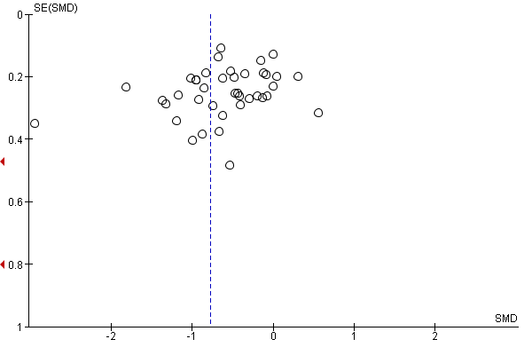

Figure 3. Summary forest plot
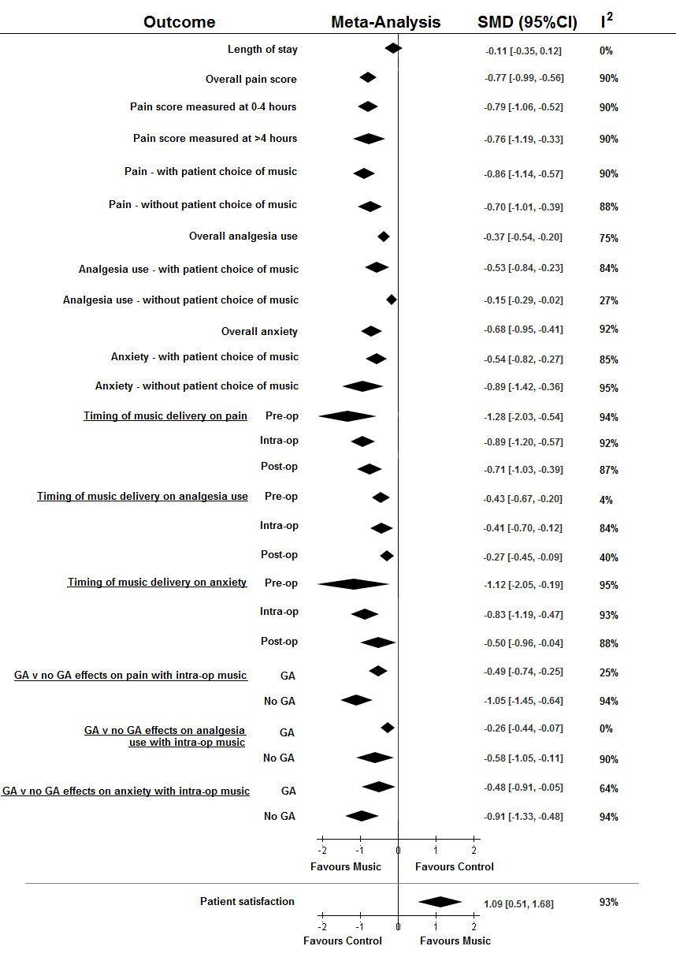

Table 1 Study characteristics
Study | Number of Participants  Intervention Control |  | Comparison Groups | Procedure | General Anaesthetic? | Music Type | Patient Choice |  | Timing of delivery | Duration of music
Agwu & Okoye 2006 | 50 | 50 | 1. Routine Care | Hysterosalping-ography | No | Patient’s own |  |  | Intra-operatively | Duration of procedure
Allred 2010 | 39 | 39 | 1. Rest Period | Knee Arthroplasty | NS | Easy listening |  |  | Post-operatively | 20 minutes
Andrada 2004 | 63 | 55 | 1. Routine Care | Colonoscopy | No | Classical |  |  | Pre & Intra-operatively | Duration of procedure
Angioli et al 2013 | 185 | 187 | 1. Routine Care | Hysteroscopy | No | Patient Choice |  |  | Intra-operatively | Duration of procedure
Argstatter et al 2006 | 1. music (28)  2. music & coaching (28) | 27 | 1. Routine Care | Intra-cardiac Catheterisation | No | Relaxation |  |  | Intra-operatively | Duration of procedure
Ayoub 2005 | 31 | 1. 28  2. 31 | 1. Operating room noise  2. White noise | Urological procedures | No | Urological procedure |  |  | Intra-operatively | Duration of procedure
Bally 2003 | 58 | 55 | 1. Routine Care | Coronary Angiography | No | Patient’s own |  |  | Pre, Intra & Post-operatively | -
Barnason 1995 | 1. music (33)  2. music & visual imaging (29) | 34 | 1. Undisturbed bed rest | CABG | Yes | Soothing |  |  | Post-operatively | 30 minutes
Bechtold 2006 | 85 | 81 | 1. Routine Care | Colonoscopy | No | Watermark by Enya |  |  | Pre & Intra-operatively | Duration of procedure
Binns-Turner et al 2011 | 15 | 15 | 1. Blank iPod | Mastectomy | Yes | Various |  |  | Pre & Intra-operatively | Duration of procedure
Blankfield et al 1995 | 1. music (32)  2. music & therapeutic suggestion (34) | 29 | 1. Blank Cassette tape | CABG | Yes | Dream flight 2 |  |  | Intra& Post-operatively | Duration of procedure
Chan 2003 | 112 | 108 | 1. Routine Care | Colposcopy | No | Slow rhythmic |  |  | Intra-operatively | Duration of procedure
Chan 2007 | 35 | 35 | 1. Undisturbed bed rest | C-clamp post PCI | No | Slow & soft |  |  | Intra-operatively | 45 minutes
Chlan 2000 | 30 | 34 | 1. Routine Care | Sigmoidoscopy | No | Various |  |  | Intra-operatively | Duration of procedure
Colt 1999 | 30 | 30 | 1. Headphones only | Bronchoscopy | No | Soft piano |  |  | Intra-operatively | Duration of procedure
Costa et al 2010 | 56 | 53 | 1. Mute headphone | Colonoscopy | No | Various |  |  | Pre & Intra-operatively | Duration of procedure
Cutshall 2011 | 49 | 51 | 1. Bed rest | Cardiac surgery | Yes | Relaxing |  |  | Post-operatively | 20 minutes
Danhauer 2007 | 56 |  | 1. Routine Care (58)  2. Guided imagery (56) | Colposcopy | No | Relaxing |  |  | Intra-operatively | Duration of procedure
Ebneshahidi 2008 | 38 | 39 | 1. No music, headphones | Caesarean-section | NS | Patient choice |  |  | Post-operatively | 30 minutes
Fredriksson 2009 | 1. Mu-OS-Mu (25)  2. OS-Mu-OS (25) |  |  | Various | NS | Musicure |  |  | Post-operatively | 30 minutes per sound
Ghetti 2011 | 1. music (9)  2. music & discussion (11) | 9 | 1. Routine Care | Transplant surgery | Yes | Instrumental |  |  | Post-operatively | 30-40 minutes
Good 1995 | 1. music (21)  2. music & relaxation (21) |  | 1. Routine Care (21)  2. Jaw relaxation (21) | Abdominal surgery | Yes | Sedative |  |  | Post-operatively | 2 minutes & whenever else they liked
Good 1999 | 1. music (122)  2. music & jaw relaxation (109) |  | 1. Routine Care (111)  2. Jaw relaxation (116) | Abdominal Surgery | Yes | Sedative |  |  | Post-operatively | Pre, during and after ambulation.
Gravesen 2013 | 40 | 35 | 1. Routine Care | Laparascopic cholecystectomy | Yes | Soft music |  |  | Pre, Intra & Post-operatively | Until patient discharge
Guerrero 2011 | 54 | 47 | 1. Routine Care | MVA abortion | No | Patient choice |  |  | Intra-operatively | Duration of procedure
Harikumar et al 2006 | 38 | 40 | 1. No music, headphones | Colonoscopy | No | Various |  |  | Intra-operatively | Duration of procedure
Hook et al 2008 | 51 | 51 | 1. Routine Care | General Abdominal | Yes | Various |  |  | Post-operatively | 8 x 30 minutes
Iblher 2011 | 1. early post-op music (25)  2. late post-op music (24) |  | 1. No music, headphones early post-op (25)  2. No music, headphones late post-op (27)  3. Routine care (25) | Open cardiac surgery | Yes | Baroque |  |  | Post-operatively | 60 minutes
Ikonomidou 2004 | 29 | 26 | 1. White noise, headphones | Lap Sterilization | Yes | Pan flute music |  |  | Pre & Post-operatively | 30 minutes
Jafari 2012 | 30 | 30 | 1. No music, headphones | CABG/Valve repair | Yes | 60-80bpm |  |  | Pre & Post-operatively | 30 minutes
Jimenez 2013 | 20 | 20 | 1. Routine Care | Varicose vein surgery | No | Classical |  |  | Intra-operatively | Duration of procedure
Johnson 2012 | 43 | 43 | 1. No music, headphones | Gynaecological surgery | Varies | Various |  |  | Pre-operatively | -
Kliempt 1999 | 1. music (25)  2. hemisync (25) | 26 | 1.No music, headphones | General surgery | Yes | Classical |  |  | Intra-operatively | Duration of procedure
Lee et al 2002 | 1. music & PCA (55)  2. music & requested analgesia (55) | 55 | 1. Routine Care & PCA | Colonoscopy | No | Various |  |  | Intra-operatively | Duration of procedure
Lepage et al 2001 | 25 | 25 | 1. Routine Care | Ambulatory surgery | No | Various |  |  | Pre & Post-operatively
Li 2012 | 30 | 30 | 1. relaxation | LSCS | No | Chinese classical |  |  | Pre-operatively | 30 minutes
Maeyama 2009 | 29 | 29 | 1. Routine Care | Various | No | Classical |  |  | Intra-operatively | Duration of procedure
McCaffrey 2006 | 62 | 62 | 1. Routine Care | Lower limb orthopaedic | Yes | Various |  |  | Post-operatively | Minimum 4 hours daily
Migneault 2004 | 15 | 15 | 1. No music, headphones | Open gynaecological | Yes | Various |  |  | Intra-operatively | Duration of procedure
Mullooly 1988 | 14 | 14 | 1. Routine care | Hysterectomy | Yes | Instrumental |  |  | Post-operatively | 10 minutes
Nilsson 2001 | 1. music (30)  2. music & therapeutic suggestion (31) | 34 | 1. music sound of operating room | Hysterectomy | Yes | Soothing |  |  | Intra-operatively | Duration of procedure
Nilsson 2003a | 1. music (62)  2. music & therapeutic suggestion (57) | 63 | 1. Blank tape, headphones | Hernia / varicose vein surgery | Yes | Soft instrumental |  |  | Post-operatively | Patient requests cessation
Nilsson 2003b | 1. intra-op music, white noise post-op (51)  2. post-op music, intra-op white noise (51) | 49 | 1. white noise | Hernia / varicose vein surgery | Yes | Instrumental |  |  | Intra-operatively | Duration of procedure & 1 hour post-operatively
Nilsson 2005 | 1. intra-op music (25)  2. post-op music (25) | 25 | 1. No music, headphones | Hernia repair | Yes | Relaxing |  |  | Intra& Post-operatively | Duration of the procedure
Nilsson 2009a | 121 | 119 | 1. Routine Care | Coronary angiography | No | Relaxing |  |  | Intra-operatively | Duration of procedure
Nilsson 2009b | 28 | 30 | 1. Bed rest | Open CABG/Valve replacement | Yes | Relaxing |  |  | Post-operatively | 30 minutes & 30 minutes rest
Nilsson 2009c | 20 | 20 | 1. Routine Care | Open CABG/Valve replacement | Yes | Relaxing |  |  | Post-operatively | 30 minutes
Nilsson 2012 | 34 | 34 | 1. Routine Care | Coronary angiography | No | MusiCure |  |  | Intra-operatively | Duration of procedure
Ovayolu 2006 | 30 | 30 | 1. Routine Care | Colonoscopy | No | Turkish Classical |  |  | Pre & Intra-operatively | 30 minutes
Palakanis 1994 | 25 | 25 | 1. Routine Care | Sigmoidoscopy | No | Various |  |  | Intra-operatively | Duration of procedure
Reza et al 2007 | 50 | 50 | 1. White noise, headphones | Elective c-section | Yes | Spanish guitar |  |  | Intra-operatively | Duration of procedure
Salmore 1999 | 1. OGD (15)  2. colonoscopy (15) | 33 | 1. Routine Care | OGD & Colonoscopy | No | Relaxing |  |  | Pre & Intra-operatively | Duration of procedure
Sen et al 2009 | 30 | 30 | 1. No music, headphones | Urological procedures | No | Patient choice |  |  | Intra-operatively | Duration of procedure
Sen 2010 | 35 | 35 | 1. Routine Care | pfannenstial LSCS | Yes | Patient choice |  |  | Post-operatively | 1 hour
Sendelbach 2006 | 50 | 36 | 1. Bed rest | Cardiac surgery | Yes | Easy listening |  |  | Post-operatively | 20 minutes twice daily for 3 days
Shabanloei 2010 | 50 | 50 | 1. Routine Care | Bone marrow biopsy | No | Relaxing |  |  | Intra-operatively | Duration of procedure
Simcock 2008 | 15 | 15 | 1. White noise, headphones | Knee arthroplasty | No | Patient choice |  |  | Intra-operatively | Duration of procedure
Smolen 2002 | 16 | 16 | 1. Routine Care | Colonoscopy | No | Patient’s own |  |  | Pre & Intra-operatively | Duration of procedure
Szmuk 2008 | 20 | 20 | 1. No music, headphones | Laparascopic hernia repair / Cholecystectomy | Yes | Various |  |  | Intra-operatively | Duration of procedure
Taylor-Piliae 2002 | 15 | 15 | 1. Information on procedure | Cardiac catheterisation | No | Patient choice |  |  | Pre-operatively | 15-20 minutes
Triller 2005 | 93 | 107 | 1. Routine Care | Bronchoscopy | No | Relaxation |  |  | Intra-operatively | Duration of procedure
Tsivian 2011 | 31 | 28 | 1. Routine Care | Prostate biopsy | No | Classical |  |  | Intra-operatively | Duration of procedure
Twiss 2006 | 42 | 44 | 1. Routine Care | CABG / Valve surgery | Yes | Prescriptive |  |  | Intra & Post-operatively | Duration of procedure & 3 days post-op
Vachiramon 2013 | 50 | 50 | 1. Routine Care | MOHS | No | Patient choice |  |  | Pre & Intra-operatively | Duration of procedure
Voss 2004 | 20 | 21 | 1. Sat out talking | Open heart surgery | Yes | Sedative |  |  | Post-operatively | 30 minutes
Weeks & Nilsson 2011 | 1. music-loudspeaker (30)  2. music–pillow (34) | 34 | 1. Routine Care | Coronary angiogram / PCI | No | Musicure |  |  | Intra-operatively | Duration of procedure
Wu, F 2013 | 26 | 14 | 1. Routine Care | Hand surgery | No | Patient choice |  |  | Pre & Intra-operatively | Not stated
Wu, J 2012 | 13 | 13 | 1. Routine Care | Termination of Pregnancy | No | Patient choice |  |  | Intra-operatively | Duration of procedure
Xiao-Mei 2011 | 60 | 60 | 1. Routine Care | Breast surgery | Yes | Patient choice |  |  | Post-operatively | 30 minutes twice daily
Yeo 2012 | 35 | 35 | 1. No music, headphones | Cystoscopy | No | Classical |  |  | Intra-operatively | Duration of procedure
Zengin 2013 | 50 | 50 | 1. Routine Care | Catheter placement | No | Turkish classical |  |  | Intra-operatively | Duration of procedure
Zhang 2005 | 55 | 55 | 1. No music, headphones | Hysterectomy | Yes | Calming |  |  | Intra-operatively | Duration of procedure
Zimmerman 1996 | 1. music (32)  2. music and video (32) | 32 | 1. Routine care and rest | CABG | Yes | Patient choice |  |  | Post-operatively | 30 minutes

Table 2. Outcomes reported
Study | Pain Score | How reported? | Analgesia Use | How reported? | Anxiety Score | How reported? | Length of Stay | How reported? | Other Outcome | How reported?
Agwu & Okoye 2006 |  |  |  |  |  | STAI |  |  | Physiological parameters | HR/BP
Allred 2010 |  | VAS |  |  |  | VAS
Andrada 2004 |  |  |  |  |  | SAI & TAI **
Angioli et al 2013 |  | VAS |  |  |  | STAI
Argstatter et al 2006 |  |  |  |  |  | STAI & VAS ** |  |  | Physiological parameters | HR/BP
Ayoub 2005 |  |  |  | mg per drug |  |  |  | PACU admission length
Bally 2003 |  | VAS |  | mg per drug |  | STAI
Barnason 1995 |  |  |  |  |  | STAI
Bechtold 2006 |  | 100mm VAS ** |  | mg per drug ** |  |  |  |  | Procedural Time & Difficulty | Questionnaire
Binns-Turner et al 2011 |  | VAS |  |  |  | SAI |  |  | Physiological parameters | HR/MABP
Blankfield et al 1995 |  |  |  | (mg) drug post-op |  |  |  | Total and ICU total | Depression Score & ADLs
Chan 2003 |  | VAS |  |  |  | STAI
Chan 2007 |  | UCLA tool
Chlan |  | NRS |  |  |  | STAI
Colt 1999 |  |  |  |  |  | STAI
Costa et al 2010 |  | VAS |  | Midazolam requests ** |  |  |  |  | Patient Satisfaction | Likert Scale
Cutshall 2011 |  | VAS ** |  | mg per drug |  | VAS ** |  |  | Patient Satisfaction | VAS **
Danhauer 2007 |  | VAS |  |  |  | STAI
Ebneshahidi 2008 |  | VAS |  | mg per drug |  | VAS
Fredriksson 2009 |  |  |  |  |  |  |  |  | Patient wellbeing * | Likert Scale
Ghetti 2011 |  | NRS |  |  |  |  |  |  | Length of ambulation & Patient Satisfaction | PANAS
Good 1995 |  | Pain sensation & distress |  | mg per drug |  | STAI
Good 1999 |  | VAS
Gravesen 2013 |  | VAS
Guerrero 2011 |  | VAS |  |  |  | STAI |  |  | Physiological parameters | HR/BP
Harikumar et al 2006 |  | VAS |  | Midazolam requests |  |  |  | Recovery time
Hook et al 2008 |  | VAS PSD * |  | Morphine equi-analgesic dose |  | STAI & VAS *
Iblher 2011 |  | ANP |  | mg per drug
Ikonomidou 2004 |  | VAS |  | mg per drug |  |  |  |  | Patient Wellbeing | VAS
Jafari 2012 |  | NRS
Jimenez 2013 |  |  |  |  |  | VAS
Johnson 2012 |  |  |  |  |  | STAI |  | Time spent in PACU **
Kliempt 1999 |  |  |  | mg per drug
Lee et al 2002 |  | VAS |  | PCA use & requests |  |  |  | Recovery time * | Patient satisfaction | VAS
Lepage et al 2001 |  |  |  | Midazolam requests |  | STAI & VAS
Li 2012 |  | VAS |  |  |  | Zung self-rated score
Maeyama 2009 |  |  |  | mg per drug |  | STAI-SA
McCaffrey 2006 |  | VAS |  | mg per drug |  |  |  |  | Patient Satisfaction | NRS
Migneault 2004 |  |  |  | mg per drug
Mullooly 1988 |  | VAS |  |  |  | Likert Scale
Nilsson 2001 |  | VAS |  | mg per drug |  |  |  | Mobilisation time | Patient wellbeing & Nausea | 5 grade scale
Nilsson 2003a |  | VAS |  | mg per drug |  | STAI
Nilsson 2003b |  | NRS |  | mg per drug |  | Questionnaire * |  |  | Patient Satisfaction ** | NRS
Nilsson 2005 |  | NRS |  | mg per drug |  | NRS
Nilsson 2009a |  | NRS |  | mg per drug |  | STAI
Nilsson 2009b |  | NRS |  | mg per drug |  | NRS **
Nilsson 2009c |  |  |  | mg per drug |  |  |  |  | Relaxation | NRS
Nilsson 2012 |  |  |  | mg per drug |  | NRS |  |  | Positive Sound Experience | NRS
Ovayolu 2006 |  | VAS |  | mg per drug |  | STAI |  |  | Patient Satisfaction | VAS
Palakanis 1994 |  |  |  |  |  | STAI ** |  |  | Physiological parameters | HR/MABP
Reza et al 2007 |  | VAS |  | mg per drug |  | VAS |  |  | Vomiting
Salmore 1999 |  |  |  | mg per drug ** |  |  |  | Recovery time to d/c
Sen et al 2009 |  |  |  | mg per drug |  |  |  | Recovery time * | Patient Satisfaction | VAS
Sen 2010 |  | VAS |  | mg per drug |  |  |  |  | Patient Satisfaction | VAS
Sendelbach 2006 |  | NRS ** |  | mg per drug |  | State Personality Inventory **
Shabanloei 2010 |  | VAS |  |  |  | STAI
Simcock 2008 |  | VAS |  |  |  |  |  |  | Patient Satisfaction | 5-point scale
Smolen 2002 |  |  |  | mg per drug |  | SAI
Szmuk 2008 |  | VAS |  |  |  |  |  | Time to eye opening
Taylor-Piliae 2002 |  |  |  |  |  | STAI |  |  | Patient Satisfaction | Various
Triller 2005 |  |  |  |  |  |  |  |  | Patient Feeling | VAS
Tsivian 2011 |  | VAS |  |  |  | STAI **
Twiss 2006 |  |  |  |  |  | STAI
Vachiramon 2013 |  |  |  |  |  | STAI
Voss 2004 |  | VAS |  |  |  | VAS
Weeks & Nilsson 2011 |  |  |  | mg per drug |  | NRS |  |  | Patient wellbeing* | Questionnaire
Wu, F 2013 |  |  |  |  |  | VAS **
Wu, J 2012 |  | NRS ** |  |  |  | NRS **
Xiao-Mei 2011 |  | VAS/ PRI/ PPI
Yeo 2012 |  | VAS |  |  |  | STAI |  |  | Patient Satisfaction | VAS
Zengin 2013 |  | VAS |  |  |  | STAI
Zhang 2005 |  |  |  |  |  |  |  |  | Patient Satisfaction | VAS
Zimmerman |  | NRS
*Not included in data analysis (due to incomplete data or unusable format) **Not included in numerical meta-analysis result due to absence of SD,
ADL – activities of daily living, ANP = Anesthesiological Questionnaire for patients after anesthesia HR – heart rate, ICU – intensive care unit, MABP – mean arterial blood pressure, NRS – numerical rating scale, PANAS – positive and negative affect schedule, PPI – present pain intensity, PRI – pain-rated index, PSD - pain, sensation and distress, STAI – state trait anxiety inventory. SAI state anxiety inventory, TAI trait anxiety inventory. UCLA - University of California at Los Angeles universal pain assessment tool, VAS – visual analogue scale.

Table 3. Study quality
Study | Method of Randomisation | Allocation Concealment | Blinding of Participants | Blinding of Investigators | Blinding of Outcome Assessment
Agwu & Okoye 2006 | Even/Odd wrapped numbers | Not Stated |  | Not Stated | Not Stated
Allred 2010 | Sealed Envelope System |  |  | Not Stated | Not Stated
Andrada 2004 | Coin Toss |  |  |  | Not Stated
Angioli et al 2013 | Computer Generated | Not Stated |  |  | Not Stated
Argstatter et al 2006 | Permuted Block randomization | Not Stated |  |  | Not Stated
Ayoub 2005 | Not stated
Bally 2003 | Randomly generated group numbers |  |  | Not Stated | Not Stated
Barnason 1995 | Drawing Lots | Not Stated |  | Not Stated | Not Stated
Bechtold 2006 | Opaque envelopes music/no music
Binns-Turner et al 2011 | Drawing numbers from bag | Not Stated
Blankfield et al 1995 | Not stated | Not Stated |  |  | Not Stated
Chan 2003 | Computer generated |  |  |  | Not Stated
Chan 2007 | Random digit randomizer | Not Stated
Chlan 2000 | Coin Toss |  |  |  | Not Stated
Colt 1999 | Random number tables
Costa et al 2010 | Computer Generated
Cutshall 2011 | Randomized using blocks |  |  | Not Stated | Not Stated
Danhauer 2007 | Random assignment slip | Not Stated |  | Not Stated | Not Stated
Ebneshahidi 2008 | Not stated | Not Stated |  | Not stated | Not Stated
Fredriksson 2009 | Random envelopes | Not Stated |  | Not Stated | Not Stated
Ghetti 2011 | Random number table | Not Stated |  |  | Not Stated
Good 1995 | Not stated | Not Stated |  | Not Stated | Not Stated
Good 1999 | Computer Generated | Not Stated |  |  | Not Stated
Gravesen 2013 | Random envelope |  |  |  | Not Stated
Guerrero 2011 | Random number tables |  |  | Not Stated | Not Stated
Harikumar et al 2006 | Computer generated | Not Stated |  |  | Not Stated
Hook et al 2008 | Random envelopes | Not Stated |  | Not Stated | Not Stated
Iblher 2011 | Drawing Lots | Not Stated
Ikonomidou 2004 | Not stated |  |  |  | Not Stated
Jafari 2012 | Not stated | Not Stated
Jimenez 2013 | Computer generated | Not Stated |  |  | Not Stated
Johnson 2012 | Not stated | Not Stated |  | Not Stated | Not Stated
Kliempt 1999 | Computer generated
Lee et al 2002 | Computer generated | Not Stated |  |  | Not Stated
Lepage et al 2001 | Not stated | Not Stated |  |  | Not Stated
Li 2012 | Computer generated
Maeyama 2009 | Not Stated | Not Stated |  |  | Not Stated
McCaffrey 2006 | By room availability |  |  |  | Not Stated
Migneault 2004 | Not stated | Not Stated |  |  | Not Stated
Mullooly 1988 | Not stated | Not Stated |  | Not Stated | Not Stated
Nilsson 2001 | Computer generated | Not Stated |  | Not Stated | Not Stated
Nilsson 2003a | Computer generated |  |  |  | Not Stated
Nilsson 2003b | Computer generated | Not Stated |  | Not Stated | Not stated
Nilsson 2005 | Computer generated | Not Stated |  |  | Not Stated
Nilsson 2009a | Computer generated |  |  |  | Not Stated
Nilsson 2009b | Computer generated | Not Stated
Nilsson 2009c | Computer generated | Not Stated
Nilsson 2012 | Computer generated | Not Stated |  | Not Stated | Not Stated
Ovayolu 2006 | Computer generate random numbers |  |  |  | Not Stated
Palakanis 1994 | Coin Toss | Not Stated |  | Not Stated | Not Stated
Reza et al 2007 | Computer generated
Salmore 1999 | Not stated | Not Stated |  |  | Not Stated
Sen et al 2009 | Computer generated | Not Stated |  |  | Not Stated
Sen 2010 | Computer generated | Not Stated |  |  | Not Stated
Sendelbach 2006 | Coin Toss | Not Stated |  | Not Stated | Not Stated
Shabanloei 2010 | Random number table | Not Stated |  |  | Not Stated
Simcock 2008 | Sealed envelopes |  |  |  | Not Stated
Smolen 2002 | Not stated |  |  |  | Not Stated
Szmuk 2008 | Not stated |  |  |  | Not Stated
Taylor-Piliae 2002 | Drawing slip of paper | Not Stated
Triller 2005 | Not stated | Not Stated |  | Not Stated | Not Stated
Tsivian 2011 | Adapted Coin Toss |  |  |  | Not Stated
Twiss 2006 | Drawing slip of paper | Not Stated |  | Not Stated | Not Stated
Vachiramon 2013 | Randomised number table | Not Stated |  |  | Not Stated
Voss 2004 | Varied block size |  |  |  | Not Stated
Weeks & Nilsson 2011 | Sealed envelopes |  |  |  | Not Stated
Wu, F 2013 | Concealed envelopes |  |  |  | Not Stated
Wu, J 2012 | Computer generated
Xiao-Mei 2011 | Computer generated | Not Stated |  | Not Stated
Yeo 2012 | Block randomized |  |  | Not Stated | Not Stated
Zengin 2013 | Computer generated | Not Stated |  | Not Stated | Not Stated
Zhang 2005 | Computer generated | Not Stated |  | Not Stated | Not Stated
Zimmerman 1996 | Not stated | Not Stated |  | Not Stated | Not Stated

Web Appendix figures

Figure W1 Search strategy 3
Figure W2 Forest plot of patient satisfaction 3
Figure W3. Pain at zero to four hours vs four or more hours postoperatively subgroup analysis 4
Figure W4. Patient choice of music subgroup analysis using pain outcomes 5
Figure W5. Patient choice of music subgroup analysis using analgesia use outcomes 6
Figure W6. Patient choice of music subgroup analysis using anxiety outcomes 7
Figure W7. Timing of music subgroup analysis using pain outcomes 8
Figure W8. Timing of music subgroup analysis using analgesia use outcomes 9
Figure W9. Timing of music subgroup analysis using anxiety outcomes 10
Figure W10. General anaesthesia vs none subgroup analysis using pain outcomes 11
Figure W11. General anaesthesia vs none subgroup analysis using analgesia use outcomes 12
Figure W12. General anaesthesia vs none subgroup analysis using anxiety outcomes 13

References to included studies p15

Figure W1. Search Strategy
1. Music Therapy/ or Music/
2. surg*.mp. [mp=title, abstract, original title, name of substance word, subject heading word, keyword heading word, protocol supplementary concept, rare disease supplementary concept, unique identifier]
3. operat*.mp. [mp=title, abstract, original title, name of substance word, subject heading word, keyword heading word, protocol supplementary concept, rare disease supplementary concept, unique identifier]
4. recovery.mp. [mp=title, abstract, original title, name of substance word, subject heading word, keyword heading word, protocol supplementary concept, rare disease supplementary concept, unique identifier]
5. recuperation.mp. [mp=title, abstract, original title, name of substance word, subject heading word, keyword heading word, protocol supplementary concept, rare disease supplementary concept, unique identifier]
6. rehabilitation.mp. [mp=title, abstract, original title, name of substance word, subject heading word, keyword heading word, protocol supplementary concept, rare disease supplementary concept, unique identifier]
7. convalescence.mp. [mp=title, abstract, original title, name of substance word, subject heading word, keyword heading word, protocol supplementary concept, rare disease supplementary concept, unique identifier]
8. post-op*.mp. [mp=title, abstract, original title, name of substance word, subject heading word, keyword heading word, protocol supplementary concept, rare disease supplementary concept, unique identifier]
9. 2 or 3 or 4 or 5 or 6 or 7 or 8 10. 1 and 9

Figure W2 Forest plot of length of stay
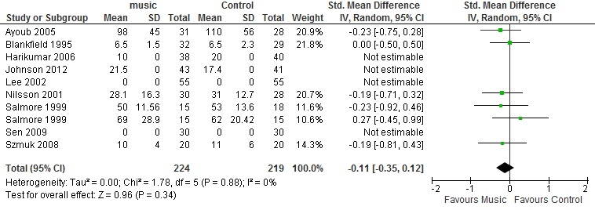

Figure W3 Forest plot of patient satisfaction
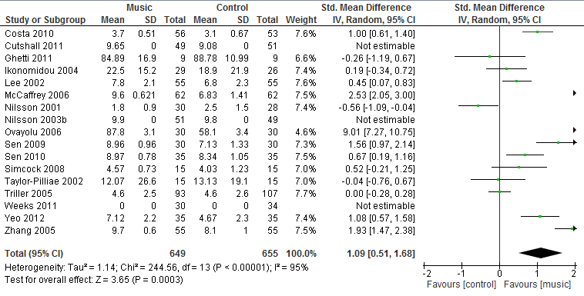

Figure W4. Pain at zero to four hours vs four or more hours postoperatively subgroup analysis
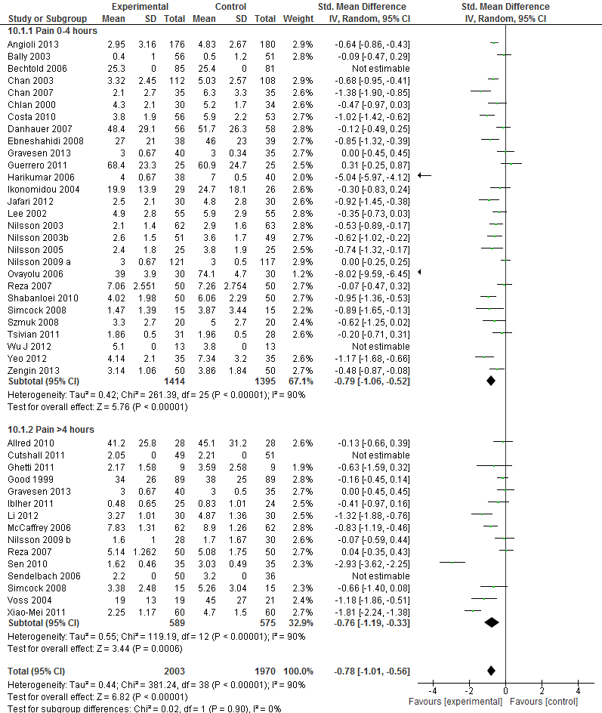

Figure W5. Patient choice of music subgroup analysis using pain outcomes
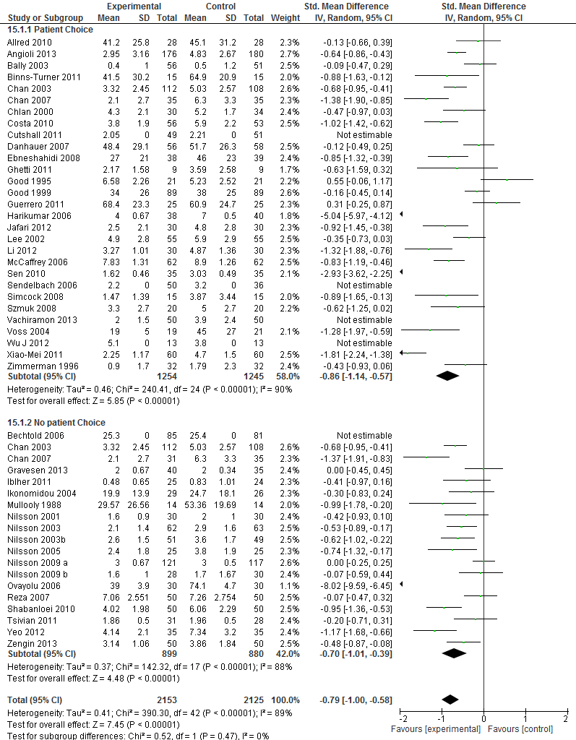

Figure W6. Patient choice of music subgroup analysis using analgesia use outcomes
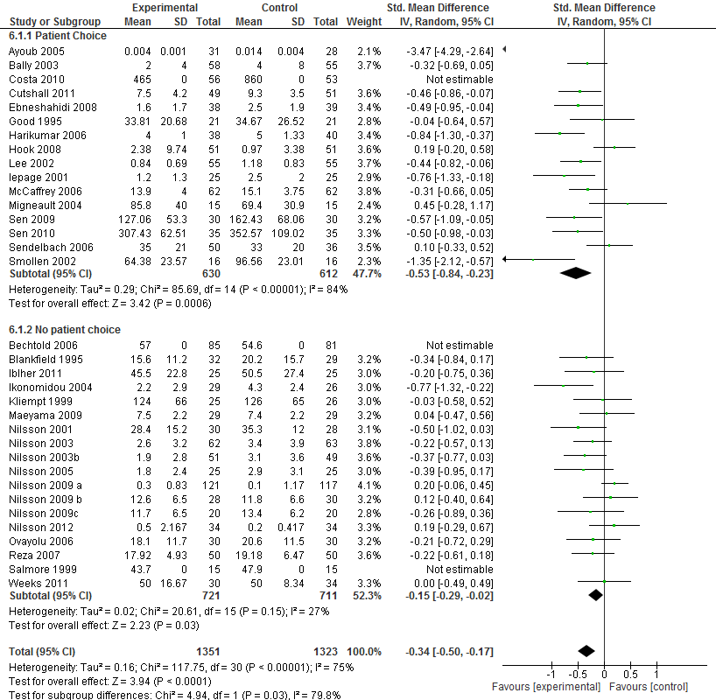

Figure W7. Patient choice of music subgroup analysis using anxiety outcomes
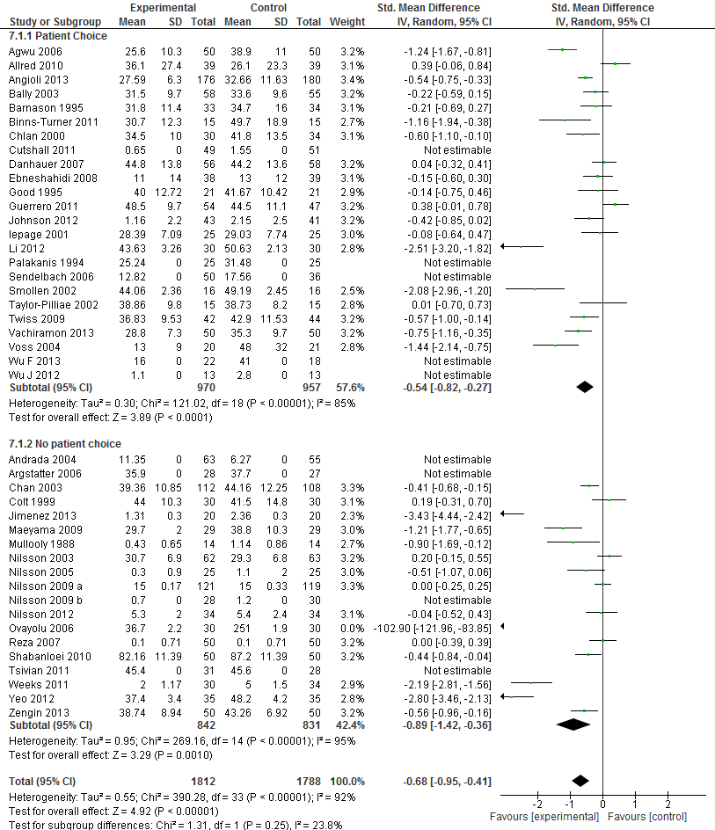

Figure W8. Timing of music subgroup analysis using pain outcomes
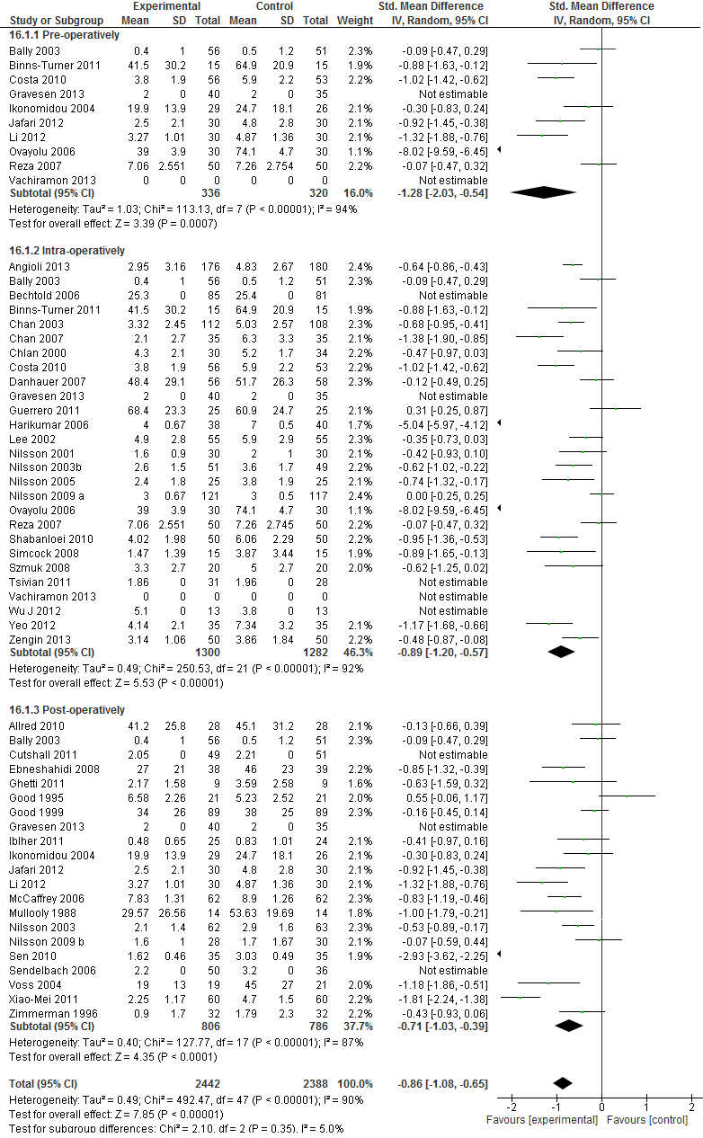
Figure W9. Timing of music subgroup analysis using analgesia use outcomes
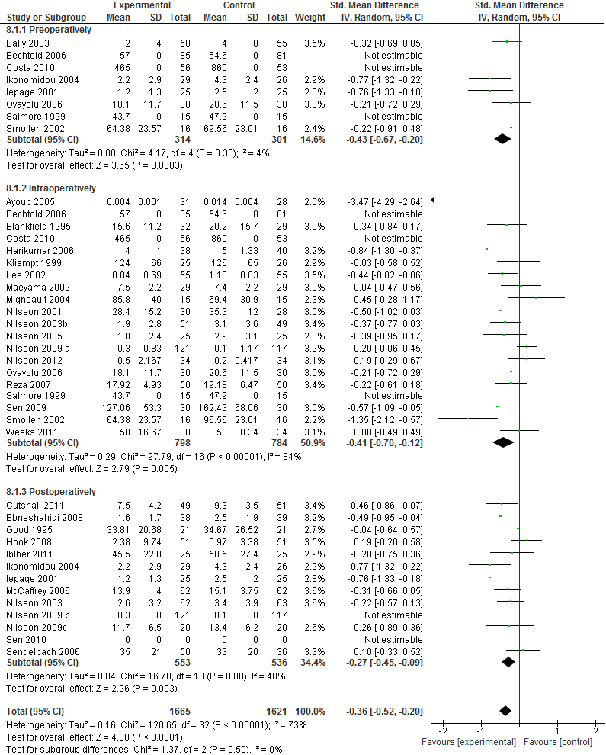

Figure W10. Timing of music subgroup analysis using anxiety outcomes
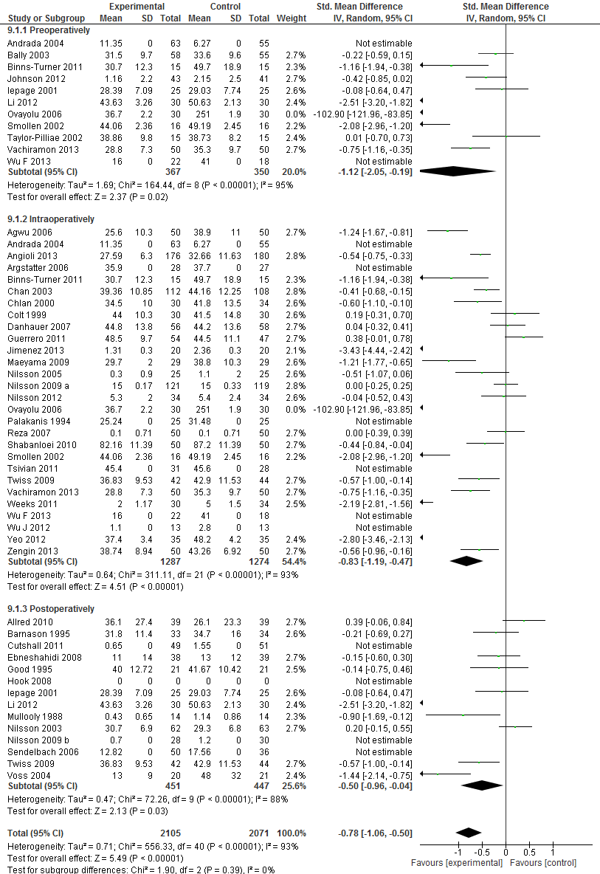
Figure W11. General anaesthesia vs none subgroup analysis using pain outcomes
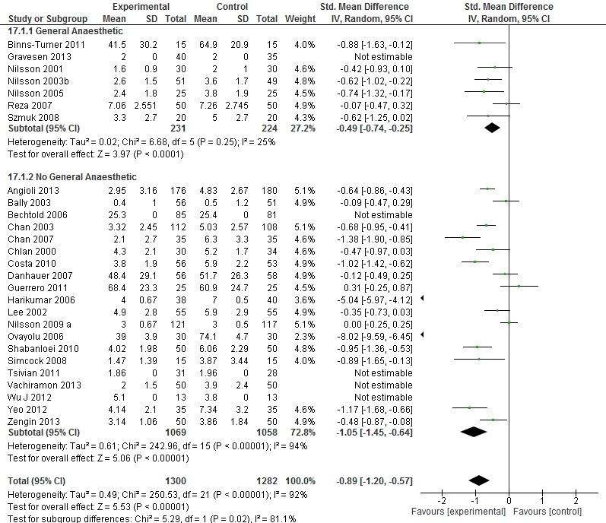

Figure W12. General anaesthesia vs none subgroup analysis using analgesia use outcomes
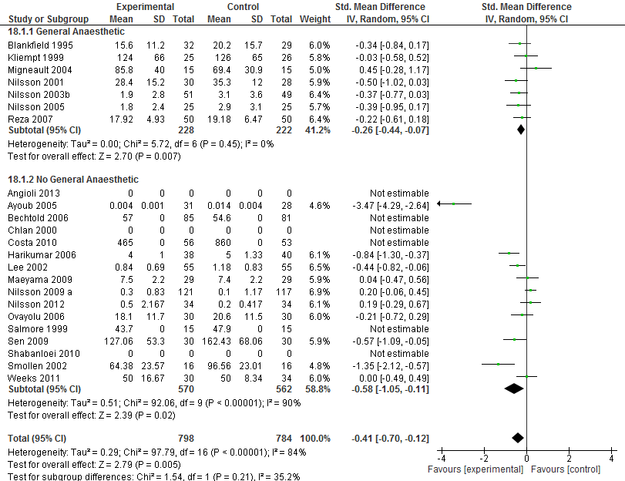

Figure W13. General anaesthesia vs none subgroup analysis using anxiety outcomes
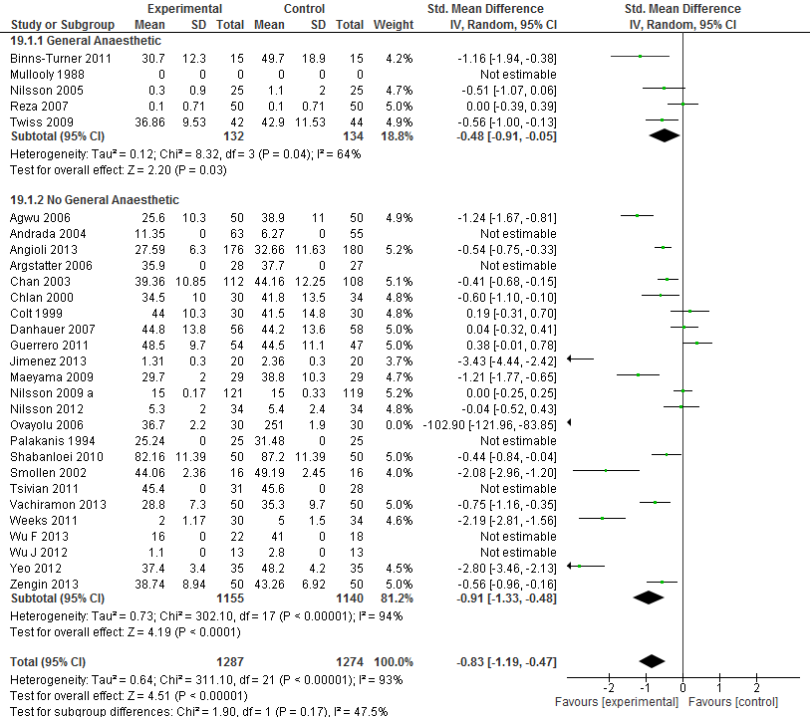

References to included studies
1. Agwu KK, Okoye IJ. The effect of music on the anxiety levels of patients undergoing hysterosalpingography. Radiography, 2007. 122–5
2. Allred KD, Byers JF, Sole ML. The effect of music on postoperative pain and anxiety. Pain management nursing : official journal of the American Society of Pain Management Nurses, 2010. 15–25
3. Angioli R, De Cicco Nardone C, Plotti F, et al. Use of Music to Reduce Anxiety during Office Hysteroscopy: Prospective Randomized Trial. Journal of Minimally Invasive Gynecology 2013.
4. Argstatter H, Haberbosch W, Bolay HV. Study of the effectiveness of musical stimulation during intracardiac catheterization. Clinical research in cardiology : official journal of the German Cardiac Society, 2006. 514–22
5. Ayoub CM, Rizk LB, Yaacoub CI, Gaal D, Kain ZN. Music and ambient operating room noise in patients undergoing spinal anesthesia. Anesthesia & Analgesia 2005; 100(5): 1316–9, table of contents.
6. Bally K, Campbell D, Chesnick K, Tranmer JE. Effects of patient-controlled music therapy during coronary angiography on procedural pain and anxiety distress syndrome. Crit Care Nurse, 2003. 50–8
7. Barnason S, Zimmerman L, Nieveen J. The effects of music interventions on anxiety in the patient after coronary artery bypass grafting. Heart & lung : the journal of critical care, 1995. 124–32
8. Bauer BA, Cutshall SA, Anderson PG, et al. Effect of the combination of music and nature sounds on pain and anxiety in cardiac surgical patients: a randomized study. Alternative Therapies in Health & Medicine 2011; 17(4): 16–23.
9. Bechtold ML, Perez RA, Puli SR, Marshall JB. Effect of music on patients undergoing outpatient colonoscopy. World Journal of Gastroenterology, 2006. 7309–12
10. Binns-Turner PG, Wilson LL, Pryor ER, Boyd GL, Prickett CA. Perioperative Music and Its Effects on Anxiety, Hemodynamics, and Pain in Women Undergoing Mastectomy. AANA Journal 2011; 79(4 Suppl): S21–7.
11. Blankfield RP, Zyzanski SJ, Flocke SA, Alemagno S, Scheurman K. Taped therapeutic suggestions and taped music as adjuncts in the care of coronary-artery-bypass patients. American Journal of Clinical Hypnosis 1995; 37(3): 32–42.
12. Chan MF. Effects of music on patients undergoing a C-clamp procedure after percutaneous coronary interventions: a randomized controlled trial. Heart & lung : the journal of critical care, 2007. 431–9
13. Chan YM, Lee PW, Ng TY, Ngan HY, Wong LC. The use of music to reduce anxiety for patients undergoing colposcopy: a randomized trial. Gynecologic oncology, 2003. 213–7
14. Chlan L, Evans D, Greenleaf M, Walker J. Effects of a single music therapy intervention on anxiety, discomfort, satisfaction, and compliance with screening guidelines in outpatients undergoing flexible sigmoidoscopy. Gastroenterology nursing : the official journal of the Society of Gastroenterology Nurses and Associates, 2000. 148–56
15. Colt HG, Powers A, Shanks TG. Effect of music on state anxiety scores in patients undergoing fiberoptic bronchoscopy. Chest, 1999. 819–24
16. Costa A, Montalbano LM, Orlando A, et al. Music for colonoscopy: A single-blind randomized controlled trial. Digestive and liver disease : official journal of the Italian Society of Gastroenterology and the Italian Association for the Study of the Liver, 2010. 871–6
17. Danhauer SC, Marler B, Rutherford CA, et al. Music or guided imagery for women undergoing colposcopy: a randomized controlled study of effects on anxiety, perceived pain, and patient satisfaction. Journal of lower genital tract disease, 2007. 39–45
18. Ebneshahidi A, Mohseni M. The effect of patient-selected music on early postoperative pain, anxiety, and hemodynamic profile in cesarean section surgery. Journal of Alternative & Complementary Medicine 2008; 14(7): 827–31.
19. Fredriksson AC, Hellstrom L, Nilsson U. Patients' perception of music versus ordinary sound in a postanaesthesia care unit: a randomised crossover trial. Intensive & Critical Care Nursing 2009; 25(4): 208–13.
20. Ghetti CM. Active music engagement with emotional-approach coping to improve well-being in liver and kidney transplant recipients. Journal of Music Therapy 2011; 48(4): 463–85.
21. Good M. A comparison of the effects of jaw relaxation and music on postoperative pain. Nursing research, 1995. 52–7
22. Good M, Stanton-Hicks M, Grass JA, et al. Relief of postoperative pain with jaw relaxation, music and their combination. Pain 1999; 81(1-2): 163–72.
23. Graversen M, Sommer T. Perioperative music may reduce pain and fatigue in patients undergoing laparascopic cholecystectomy. Acta Anaesthesiologica Scandinavica 2013; 57: 1010– 6.
24. Guerrero JM, Castano PM, Schmidt EO, Rosario L, Westhoff CL. Music as an auxiliary analgesic during first trimester surgical abortion: a randomized controlled trial. Contraception 2012; 86(2): 157–62.
25. Harikumar R, Raj M, Paul A, et al. Listening to music decreases need for sedative medication during colonoscopy: a randomized, controlled trial. Indian Journal of Gastroenterology 2006; 25(1): 3–5.
26. Hook L, Sonwathana P, Petpichetchian W. Music therapy with female surgical patients: effect on anxiety and pain. Thai Journal of Nursing Research 2008; 12(4): 259–71.
27. Iblher P, Mahler H, Heinze H, Huppe M, Klotz KF, Eichler W. Does music harm patients after cardiac surgery? A randomized, controlled study. Applied Cardiopulmonary Pathophysiology 2011; 15(1): 14–23.
28. Ikonomidou E, Rehnström A, Naesh O. Effect of music on vital signs and postoperative pain. AORN journal, 2004. 269–74
29. Jafari H, Zeydi AE, Khani S, Esmaeili R, Soleimani A. The effect of preferred music on pain intensity after open heart surgery. Iranian journal of nursing and midwifery research, 2012. 1–8
30. Jiménez-Jiménez M, García-Escalona A, Martín-López A, De Vera-Vera R, De Haro J. Intraoperative stress and anxiety reduction with music therapy: a controlled randomised clinical trial of efficacy and safety. Journal of Vascular Nursing 2013; 31(3): 101–6.
31. Johnson B, Raymond S, Goss J. Perioperative music or headsets to decrease anxiety. Journal of PeriAnesthesia Nursing 2012; 27(3): 146–54.
32. Kliempt P, Ruta D, Ogston S, Landeck A, Martay K. Hemispheric-synchronisation during anaesthesia: A double blind randomised trial using audiotapes for intra-operative nociception control. Anaesthesia 1999; 54(8): 769–73.
33. Lee DW, Chan KW, Poon CM, et al. Relaxation music decreases the dose of patient-controlled sedation during colonoscopy: a prospective randomized controlled trial. Gastrointestinal Endoscopy 2002; 55(1): 33–6.
34. Lepage C, Drolet P, Girard M, Grenier Y, DeGagne R. Music decreases sedative requirements during spinal anesthesia. Anesthesia & Analgesia 2001; 93(4): 912–6.
35. Li XM, Yan H, Zhou KN, Dang SN, Wang DL, Zhang YP. Effects of music therapy on pain among female breast cancer patients after radical mastectomy: results from a randomized controlled trial. Breast Cancer Research & Treatment 2011; 128(2): 411–9.
36. Li Y, Dong Y. Preoperative music intervention for patients undergoing cesarean delivery. International Journal of Gynaecology & Obstetrics 2012; 119(1): 81–3.
37. López-Cepero Andrada JM, Amaya Vidal A, Castro Aguilar-Tablada T, et al. Anxiety during the performance of colonoscopies: modification using music therapy. European journal of gastroenterology & hepatology, 2004. 1381–6
38. Maeyama A, Kodaka M, Miyao H. [Effect of the music-therapy under spinal anesthesia]. Masui - Japanese Journal of Anesthesiology 2009; 58(6): 684–91.
39. McCaffrey R, Locsin R. The effect of music on pain and acute confusion in older adults undergoing hip and knee surgery. Holistic Nursing Practice 2006; 20(5): 218–24; quiz 25–6.
40. Migneault B, Girard F, Albert C, et al. The effect of music on the neurohormonal stress response to surgery under general anesthesia. Anesthesia & Analgesia 2004; 98(2): 527–32, table of contents.
41. Mullooly VM, Levin RF, Feldman HR. Music for postoperative pain and anxiety. The Journal of the New York State Nurses' Association 1988; 19(3): 4–7.
42. Nilsson U. Soothing music can increase oxytocin levels during bed rest after open-heart surgery: a randomised control trial. Journal of clinical nursing, 2009. 2153–61
43. Nilsson U. The effect of music intervention in stress response to cardiac surgery in a randomized clinical trial. Heart & Lung 2009; 38(3): 201–7.
44. Nilsson U. Effectiveness of music interventions for women with high anxiety during coronary angiographic procedures: a randomized controlled. European journal of cardiovascular nursing, 2012. 150–3
45. Nilsson U, Lindell L, Eriksson A, Kellerth T. The effect of music intervention in relation to gender during coronary angiographic procedures: a randomized clinical trial. European journal of cardiovascular nursing : Journal of the Working Group on Cardiovascular Nursing of the European Society of Cardiology, 2009. 200–6
46. Nilsson U, Rawal N, Enqvist B, Unosson M. Analgesia following music and therapeutic suggestions in the PACU in ambulatory surgery; a randomized controlled trial. Acta Anaesthesiologica Scandinavica 2003; 47(3): 278–83.
47. Nilsson U, Rawal N, Uneståhl LE, Zetterberg C, Unosson M. Improved recovery after music and therapeutic suggestions during general anaesthesia: a double-blind randomised controlled trial. Acta anaesthesiologica Scandinavica, 2001. 812–7
48. Nilsson U, Rawal N, Unosson M. A comparison of intra-operative or postoperative exposure to music--a controlled trial of the effects on postoperative pain. Anaesthesia 2003; 58(7): 699–703.
49. Nilsson U, Unosson M, Rawal N. Stress reduction and analgesia in patients exposed to calming music postoperatively: a randomized controlled trial. European Journal of Anaesthesiology 2005; 22(2): 96–102.
50. Ovayolu N, Ucan O, Pehlivan S, et al. Listening to Turkish classical music decreases patients' anxiety, pain, dissatisfaction and the dose of sedative and analgesic drugs during colonoscopy: a prospective randomized controlled trial. World journal of gastroenterology : WJG, 2006. 7532–6
51. Palakanis KC, DeNobile JW, Sweeney WB, Blankenship CL. Effect of music therapy on state anxiety in patients undergoing flexible sigmoidoscopy. Diseases of the Colon and Rectum 1994; 37(5): 478–81.
52. Reza N, Ali SM, Saeed K, Abul-Qasim A, Reza TH. The impact of music on postoperative pain and anxiety following cesarean section. Middle East Journal of Anesthesiology 2007; 19(3): 573–86.
53. Salmore RG, Nelson JP. The effect of preprocedure teaching, relaxation instruction, and music on anxiety as measured by blood pressures in an outpatient gastrointestinal endoscopy laboratory. Gastroenterology Nursing, 2000. 102–10
54. Sen H, Ates F, Sizlan A, et al. Effect of music on sedation during local urological surgeries. Anatolian Journal of Clinical Investigation, 2009. 131–5
55. Sen H, Yanarates O, Sizlan A, Kilic E, Ozkan S, Dagli G. The efficiency and duration of the analgesic effects of musical therapy on postoperative pain. Agri Dergisi 2010; 22(4): 145–50.
56. Sendelbach SE, Halm MA, Doran KA, Miller EH, Gaillard P. Effects of music therapy on physiological and psychological outcomes for patients undergoing cardiac surgery. Journal of Cardiovascular Nursing 2006; 21(3): 194–200.
57. Shabanloei R, Golchin M, Esfahani A, Dolatkhah R, Rasoulian M. Effects of music therapy on pain and anxiety in patients undergoing bone marrow biopsy and aspiration. AORN journal, 2010. 746–51
58. Simcock XC, Yoon RS, Chalmers P, Geller JA, Kiernan HA, Macaulay W. Intraoperative music reduces perceived pain after total knee arthroplasty: a blinded, prospective, randomized, placebo-controlled clinical trial. The Journal of Knee Surgery 2008; 21(4): 275–8.
59. Smolen D, Topp R, Singer L. The effect of self-selected music during colonoscopy on anxiety, heart rate, and blood pressure. Applied nursing research : ANR, 2002. 126–36
60. Szmuk P, Aroyo N, Ezri T, Muzikant G, Weisenberg M, Sessler DI. Listening to music during anesthesia does not reduce the sevoflurane concentration needed to maintain a constant bispectral index. Anesthesia & Analgesia 2008; 107(1): 77–80.
61. Taylor-Piliae RE, Chair SY. The effect of nursing interventions utilizing music therapy or sensory information on Chinese patients' anxiety prior to cardiac catheterization: a pilot study. European journal of cardiovascular nursing : journal of the Working Group on Cardiovascular Nursing of the European Society of Cardiology, 2002. 203–11
62. Triller N, Erzen D, Duh S, Petrinec Primozic M, Kosnik M. Music during bronchoscopic examination: the physiological effects. A randomized trial. Respiration; international review of thoracic diseases, 2006. 95–9
63. Tsivian M, Qi P, Kimura M, et al. The effect of noise-cancelling headphones or music on pain perception and anxiety in men undergoing transrectal prostate biopsy. Urology 2012; 79(1): 32–6.
64. Twiss E, Seaver J, McCaffrey R. The effect of music listening on older adults undergoing cardiovascular surgery. Nursing in Critical Care 2006; 11(5): 224–31.
65. Vachiramon V, Sobanko JF, Rattanaumpawan P, Miller CJ. Music reduces patient anxiety during Mohs surgery: an open-label randomized controlled trial. Dermatologic Surgery 2013; 39(2): 298–305.
66. Voss JA, Good M, Yates B, Baun MM, Thompson A, Hertzog M. Sedative music reduces anxiety and pain during chair rest after open-heart surgery. Pain 2004; 112(1-2): 197–203.
67. Weeks BP, Nilsson U. Music interventions in patients during coronary angiographic procedures: a randomized controlled study of the effect on patients' anxiety and well-being. European journal of cardiovascular nursing : journal of the Working Group on Cardiovascular Nursing of the European Society of Cardiology, 2011. 88–93
68. Wu F, Shahid M, Waldram M. Audiovisual distraction as an adjunct to anxiety relief in hand surgery with regional anaesthesia. Journal of Hand Surgery (European Volume) 2013; 0(0): 1–2.
69. Wu J, Chaplin W, Amico J, et al. Music for surgical abortion care study: a randomized controlled pilot study. Contraception 2012; 85(5): 496–502.
70. Yeo JK, Cho DY, Oh MM, Park SS, Park MG. Listening to music during cystoscopy decreases anxiety, pain, and dissatisfaction in patients: A pilot randomized controlled trial. Journal of Endourology 2013; 27(4): 459–62.
71. Zengin S, Kabul S, Al B, Sarcan E, Dogan M, Yildirim C. Effects of music therapy on pain and anxiety in patients undergoing port catheter placement procedure. Complementary Therapies in Medicine 2013.
72. Zhang XW, Fan Y, Manyande A, Tian YK, Yin P. Effects of music on target-controlled infusion of propofol requirements during combined spinal-epidural anaesthesia. Anaesthesia 2005; 60(10): 990–4.
73. Zimmerman L, Nieveen J, Barnason S, Schmaderer M. The effects of music interventions on postoperative pain and sleep in coronary artery bypass graft (CABG) patients. Scholarly Inquiry for Nursing Practice 1996; 10(2): 153–70; discussion 71-4.

