Chapter 29

Digital Forms
Nanette Hoogslag and Whitney Sherman
Since the 1990s, digital technologies have developed rapidly, placing the computer in all its forms at the center of daily communication. These continuously developing technologies affect the appearance and reproduction of illustration to a great extent. Not only do they make distribution of images possible on a large scale and give individual illustrators direct access to global audiences, but the aesthetics and technical structures of new media also have given rise to radically new forms of digitally based illustration. Not only are these moving, interactive, and programmed images (experienced on the web, in apps, and in game environments) shaped and influenced by the abilities of the computer, but they also shape and influence how we understand technology in return.
This chapter investigates what is new in new media illustration through examples that document a wide range of creative expression and digital resources. It also explores how digital technologies have stimulated new commercial relationships that have revitalized artisanship and thus shaped current illustration practices.

New Media
The term new media describes computer-based media in which the computer is used for both distribution and presentation. This means that the expressive capabilities of these media are set by the limits and capabilities of the computer. But beyond its technological nature, new media should be understood for its transformative impact on culture and communication, just as the way we read has been defined by print technology over the last five hundred years (see Chapter 24, Theme Box 46, “McLuhan: Media Theory”). Illustrations reproduced in books or in other printed publications did not move, change, or make sounds—they were fundamentally contemplative or decorative visual experiences often considered in close relationship with written texts. New media illustration continues many of the inherent qualities of print-based illustration, such as the aesthetic experience, but it has also gradually adopted the expressive possibilities of digital technology. The language of illustration is remediating: converging with other media traditions and technologies, adjusting or discontinuing existing practices, and transforming into new hybrid forms. This adaptation is shifting the ways we use illustration as a communication tool and changing the way we comprehend its role and its qualities.
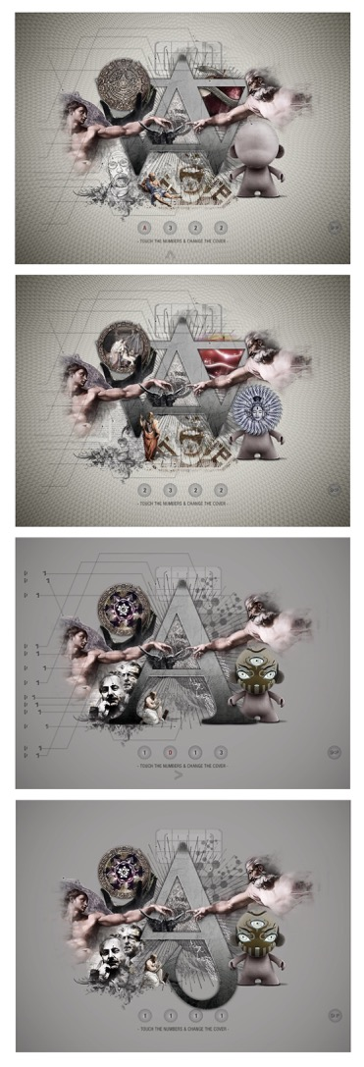
An example is the tablet-magazine Adam, which adheres to the printed periodical tradition with its magazine-like structure based on a series of articles. But these articles are presented in a wide variety of multimedia, navigated by swiping, pinching, and tapping. Furthermore, the cover, designed by Fefè Projects and creative director Luigi Vernieri, consists of an interactive illustration in which the user can mix and match image components. This cover does not present a single fixed image, but rather the experience of more than 2,500 possible combinations (Figures 29.1a-d). It invites readers to playfully create new combinations of images in a way that constantly alters the gist of the illustration.
Caption: Fefè Projects and Luigi Vernieri, cover variations, Adam, “Alphabet-Digital-Art-Magazine,” 2012. Screenshots by Nanette Hoogslag. The changeable image presents traditional and new media qualities of illustration, where user interaction, movement, and play make individualized, expressive meanings.

The Structure of New Media
A new media illustration such as the magazine cover for Adam comes from an understanding and implementation of the capabilities and processes founded on digitization, multimedia, and computer networks. These elements are the fundamental building blocks of new media communication as first described by media theorist Lev Manovich, who defined the fundamental interrelationship for new media communication (see Theme Box 55, “Manovich: The Language of New Media”). Beyond the static visuals of print illustration, new media illustration expresses through movement, audio and tactile experiences put together with the capabilities of interaction, automation, and a networked connection. This makes way for very different kinds of communication and narration and extends the notion of illustration, as explored in this chapter.

Theme Box 55
“Manovich: The Language of New Media
Nanette Hoogslag

In the book The Language of New Media (2001), Lev Manovich defines “new media” as capabilities and processes founded on digitization, multimedia, and computer networks. The first systematic and rigorous theorization of the topic, Manovich’s book analyzed new media’s major forms, conventions, and design patterns.
Digitization means that whatever is represented through a computer is built from tiny interchangeable units: digits. Based on the available information, these units can be programmed to create expression through any medium available within a computer network. The computer network does not only refer to the screen, scanner, and audio speakers integrated or directly connected to a computer, but it refers to the entire global network of (mobile) computers, connected through the Internet, with access to all their available information.
Manovich presents new media as the coming together of three older media cultures—print, cinema, and information technology—in a human-computer interface, a system in which human understanding and computer logic meet. These “older” media cultures can still be recognized in the way text, images, and video are presented. But it is in their synthesis and the continued influence and acceptance of new ways of interacting with information that new digitally native forms are generated. Two of these digitally native forms are of particular significance: hypertext—text (or other kinds of content, such as images) that is linked to other information in nonhierarchical and associative ways; and the database—an archive of digitized information that can be accessed by search queries.
Manovich identifies five fundamental principles of how new media objects—for instance, a digital image or a text file—are structured:
1. Numerical: A new media object is numerical and can be described mathematically. This means it can be programmed.
2. Modular: A new media object is built from small discrete parts: pixels, vowels, characters, or bits of script. When these parts are assembled into larger recognizable media objects, each basic module keeps its discrete identity. This mean that the smallest components (such as pixels) not only can be modified without disturbing the whole media object but also can be stored independently in databases.
3. Automated: The numeric nature and modular structure together allow the principle of automation: the execution of computer programs without human intervention.
4. Varied: The computer can create many variations based on the same original data files.
5. Transcoded: A new media object has two interrelated aspects that Manovich calls the “cultural layer” and the “machine-readable layer.” The cultural layer is the experience that makes sense to us humans—for instance, the text and images we can see on the screen. The machine-readable layer is the part of the computer file that only the computer can read, the code that instructs and interacts with other computer files. Transcoding is the term for translating one layer into the other.
The invisible interactions of the machine-readable layer influence how we create and what we create, and are fundamental in shaping the resulting message. However, the relationship between human and computer is a two-way street because the machine and the code it uses to interact with are the result of human invention. It is this logic of interrelation between computer and human that defines the “language” of new media.
Although there is an ongoing discourse on whether Manovich’s influential vision is complete in the light of the ongoing developments, key concepts such as fundamental programmability and transcoding are still relevant for understanding the material construction and functionality of new media objects, including digital illustration.

Movement
Animation, or the use of sequential drawings to create an illusion of movement, is best known for its use in time-based visual narratives. But animation can also be used to enhance particular aspects of the image by providing minor movements within an otherwise nonmoving context. The illustration “No Country for Slow Broadband” by Stephan Vuillemin (France, b. 1986) (Figure 29.2) appears as a fixed image, but it has elements showing continual subtle movements. The flapping of Superman’s cape, the vapor rising gently from the coffee, and the lazy typing of the man slouched on the sofa effectively extend the moment of engagement. They enhance and define a present tense, with each motion suggesting a different nuance in the meaning of the illustration.
The illustration created by Vuillemin is a referred to as an animated GIF (Graphics Interchange Format), which consists of a single image file that encodes multiple frames that allow for animated movement to appear. Animated GIFs have been part of the web since 1987 and have become popular due to their small file size, software compatibility across multiple platforms, and ease of creation. In the beginning, they were often used to create animated logos, buttons, and banners, but over the years the animated GIF has become a popular form of expression in its own right.
Figure 29.2
Caption: Stephan Vuillemin, “No Country for Slow Broadband,” New York Times, 2013. Animated GIF. Courtesy of Stephan Vuillemin. Animated GIFs have found a place as illustrations within online editorial publications such as the New York Times and the New Yorker.

Interaction and Multimedia
Pull-down menus, clickable icons, buttons, and hypertext links are just some of the possibilities for interaction that deepen the media experience. Ubiquitous in the navigation of websites and apps, interactive options help direct a user’s behavior and provide ways of navigating and organizing information, to make the total sum of the available information more manageable. But for illustration, interaction (often in combination with multimedia) can be an effective tool for nonlinear storytelling because it can engage through multiple senses and offer prolonged engagement through play. Interaction allows the presence of multiple storytelling options and moments of surprise.
One of the earlier multimedia and software platforms used for creating such interactive applications was Adobe Flash (formerly Macromedia Flash), which became popular in the early 2000s. Flash was attractive to nonprogrammers because it combined vector drawing, animation, and interaction within a software package that did not require high-end coding skills. Illustrator and animator Han Hoogerbrugge (Dutch, b. 1963) is one of the early pioneers of Flash animation, which he explores for its expressive possibilities of interaction and as a meaningful component of illustration. In Modern Living (1998–2001), a series of offbeat existentialist sketches, Hoogerbrugge invites the user to play with the elements of the illustration (Figure 29.3).
He choreographs the user’s behavior by careful design of particular triggers that suggest potential interaction, and through the use of imagery, sound effects, repetition, and surprise. Only if the user acts in a certain way does the illustration reveal its full narrative plot.
Hoogerbrugge explored these mechanisms more extensively in one of the earliest interactive online graphic novels, Hotel (produced by Submarine Channel, 2004). It presents a surrealistic ten-part story that is part animation, part game, and part graphic novel that takes place in continually changing and responsive settings.
This key work showcases numerous effective applications of digital technologies to create not just multiple parallel storylines and engaging aesthetics, but also meaningful interactive and sound-based experiences. Hoogerbrugge carefully considered the particular properties of digital media, such as multimedia, automation, dynamic navigation, and direct response, but did so alongside traditional visual and narrative methods.
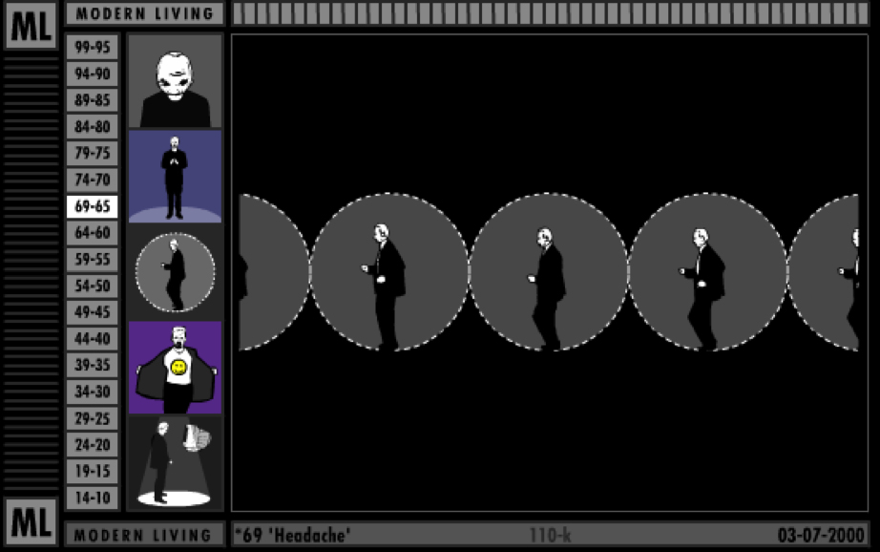
Figure 29.3
Caption: Han Hoogerbrugge, Modern Living, 1998–2001. Flash animation. Screenshot by Nanette Hoogslag. Hoogerbrugge uses approximately one hundred Flash-based images to present various kinds of interaction, animation, and sound effects that invite the user to play with the elements of the illustration. It is through play that the narrative is revealed. These interactive images were first published online at the end of the last century. Due to the limits of broadband connection speed, the images had to be small and in the lowest possible resolution in order to be viewed properly. The original images were no more than 500 pixels wide with a resolution of 72 dpi.
A next step in visual and audio experiences, and importantly, the extension of direct interaction through touch, came with the introduction of the tablet computer, particularly the Apple iPad (2010). In the development of the tablet, more priority was given to the overall sensation as part of the user experience. The enhanced screen resolution and color saturation, the full-screen experience of an application, and in particular, the ability to directly touch the screen triggers made for a far more immersive interactive experience. The software application (or app) Numby (2012) is an example of a programmed image that benefitted from this type of intense interaction. Numby is a musical counting game for children (Figure 29.4a-c) that fuses sound, spoken and written text, image, touch, automation, and interaction into a total experience. Numbers automatically relate to sounds and colors; touch can trigger a tune, a voice, or short animated sequences. For children, for whom fingers are primary tools of investigation, there seems no need to explain how Numby works. Direct touch comes naturally, and children intuitively engage with an illustrated robot that can respond to their actions.
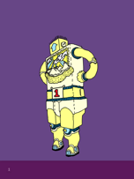
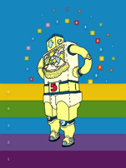
Figure 29.4a-c
Caption: Amit Pitaru and James Paterson, Numby, 2013. Flash animation. Screenshots by Nanette Hoogslag. Numby is a counting app for children. This interactive narrative presents a visual experience first and foremost; game and play only come into existence through interaction.

Networked Connections
The Internet, the global network connecting computers (see Theme Box 57, “Information Sharing: An Online Community Grows”), has made publishing and information easily available for large numbers of people worldwide, leading to new ways of communicating through and with images. Stimulated by the easy and plentiful options with which to (re)distribute images and the availability of image manipulation tools, as well as portable computer devices such as mobile smartphones, individual creators can instantly reach a global audience with their new work. Using social media, they can publish to selected groups or to everybody on the Net—from sending a temporary image on Snapchat (a device-to-device sharing program in which the content becomes unavailable after a short amount of time) to posting entire collections of work on huge, indexed repositories of personal and public information such as YouTube or Facebook.
Posting and reposting images have become normal practice. Other than as part of official media productions, illustrations can now be published and circulated as independent popular offerings and responses. For instance, through postings on the website Twitter, illustrators and other makers have the option to direct their work at selected communities through regular tweets (a single Twitter posting) that connect artists to a community far beyond one’s own country.
While the Internet has given illustrators greater professional independence, it equally has created insecurity around professional practice and authorship, and fostered global competition, including from nonprofessional makers. Copyright is very hard to maintain within this open environment (see Theme Box 56, “Copyright: An Abbreviated History”).

Theme Box 56
Copyright: An Abbreviated History
Linda Joy Kattwinkel
Artists have always copied each other’s works. Until relatively recently in human history, artists were trained in their craft through apprenticeships that involved slavish copies of their mentor’s works and styles. Many early engravings were copies of paintings. Legal theories of copyright did not arise until the fifteenth century, after Gutenberg’s movable type printing press made mechanical reproduction of books possible on a mass economically viable scale. As the new printing industry developed, legal systems had to determine who was entitled to profit from it—the authors who created the literary value or the publishers who invested time and resources into publishing it? Two different theories of copyright emerged: the inherent rights theory in mainland Europe and the economic incentive theory in England. In mainland Europe, artists and authors were thought to enjoy inherent “natural rights” to own the fruits of their labor as soon as they created their works. Printers had to pay authors to publish their texts.
In England, in contrast, authors initially had no publishing rights: the crown (and its favored publishers) controlled and benefited from the printing industry. This changed when the British Parliament passed the Statute of Anne in 1710, which granted reproduction rights for two fourteen-year terms, but only to authors of literary works, and only if they registered their writings. In 1734, the Hogarth Act extended this limited copyright to engravings. Instead of inherent natural rights, in Great Britain the rationale for copyright became to promote progress of the arts for the public’s benefit by providing an economic incentive to authors to create new works, in the form of a limited monopoly on reproduction rights.
As a young country, the United States adopted Great Britain’s economic incentive approach. The first federal copyright act, in 1790, mirrored the Statute of Anne. It granted limited terms of copyright to authors of maps, charts, and books. Subsequent amendments added protection for other types of works, including engravings in 1802; photographs in 1865; and finally, paintings, drawings, and statuary in 1870. To ensure the widest possible reproduction and dissemination of works, U.S. law made it particularly difficult to obtain copyright protection. Authors had to comply with a rigid copyright registration system and other formalities, such as prescribed forms of copyright notice. If formalities were not met, the works were considered public domain. Initially, works by foreign authors received no protection at all. The formalities system successfully met Congress’s goal of making works widely available. In the first ten years, of over 13,000 titles published in the United States, only 556 were registered for copyright protection.
Various amendments to the federal copyright law extended the term and the scope of copyright protection as new types of works and exploitation developed. U.S. and foreign “authors” (now defined as anyone who creates works entitled to copyright, including visual artists) could control not only mechanical reproduction of their works, but also public displays and performances, substantially similar copies made by hand, and adaptations for “derivative works” (for example, motion pictures based on books). In accordance with the First Amendment’s guarantee of uncensored public debate, courts developed a robust “fair use” doctrine, providing exemptions from infringement when works were used for commentary, criticism, or educational purposes.
Meanwhile, European nations were developing their own copyright laws. Reflecting the inherent natural rights philosophy, copyright protection was automatic upon creation of a work. Additional “moral rights” were codified to protect the integrity of artworks and authors’ rights of accreditation, even if they no longer owned the copyright. International treaties were also developed. The Berne Convention, enacted in 1886 (after intense lobbying by writer Victor Hugo), required member countries to protect copyrights of foreign authors the same as their own authors, set minimum copyright terms, and forbade member countries from imposing formalities.
In the United States, Congress continued to revise copyright law. In 1976, a major overhaul extended copyright protection to unpublished works and codified much copyright doctrine that had been developing in the courts, including the fair use doctrine. Formalities were still required, but the copyright term was changed to life of the author plus fifty years. It took another twelve years for the United States to accept the European view of inherent copyright. In 1988, the United States passed the Berne Convention Implementation Act. U.S. copyright law was revised to comply with the treaty, establishing U.S. copyright protection upon creation of a work. Mandatory formalities were eliminated (although U.S. citizens must still obtain a registration before bringing an infringement lawsuit). Moral rights were adopted, but only for certain one-of-a-kind works of visual arts (not reproductions like printed illustrations or digital files). Subsequent amendments in 1994 restored copyright for certain foreign works and in 1998 extended the copyright term to life plus seventy years (to match the current standard term in Europe).
As new technologies develop, Congress and U.S. courts continue to adjust copyright law. Digital and online copying present significant challenges. The ease of digital copying, the pervasive online culture of social media sharing, and website models that encourage and monetize the posting and sharing of other people’s content have created expectations that content found online should be free for the taking. The “copyleft” movement and Creative Commons licensing systems support a culture of free sharing of content. Advocates want copyright terms reduced and formalities restored. Under increasing pressure from both nonprofit archival institutions and for-profit corporate interests, the U.S. Copyright Office is pushing for orphan works legislation. While the intent is to safeguard those who use old and apparently abandoned works, the proposal would allow unlicensed use of works whenever the copyright owner cannot be located, even if such works are not likely to be “orphaned.”
Allowing unfettered use of difficult-to-trace material is of particular concern to visual artists because copies of their works often do not contain accreditation and are not easily searchable in word-based systems. The perceived value of illustration is already diminishing in today’s online environment. Social media sites impose terms and conditions on their users that allow such sites unfettered free use of their content. Online stock imagery and design sites, especially those based on bidding, are driving down fees, creating expectations among consumers that images are fungible cheap commodities. Contests for art services are prevalent, in which the only award is public recognition and “exposure” (even, ironically, by the 2012 Obama campaign for posters promoting his job creation program). All of these pressures make it increasingly difficult for authors to earn a livelihood from their works.
The Digital Millennium Copyright Act of 1998 attempted to address rampant copying online, including a new “DMCA take-down procedure” to facilitate removal of infringing content by website hosts. In the courts, decisions are trending toward allowing extensive digital copying for applications perceived as beneficial to consumers. The fair use concept of “transformative” works has been stretched to include reproduction of low-resolution images in search engine results, and to allow Google to scan entire libraries without paying or getting permission from authors. The situation with social media is murkier. Whether copying from online social posting sites will be considered infringement depends on the wording of the site’s terms and conditions. In 2013, Haitian photo-journalist Daniel Morel won his infringement claims against news agencies who copied his photos of the 2010 Haiti earthquake from his TwitPic account and sold them to other agencies and stock services. When Morel complained, the agencies filed suit against him. The court held that Twitter’s particular terms, while allowing Twitter itself and Twitter users to freely copy Morel’s photos, did not allow the agencies to do so. The news agencies’ decision to aggressively litigate their alleged entitlement to such free use, however, is troubling for artists—as is the court’s inherent ruling that social media user terms are enforceable contracts (including provisions that allow social media sites to monetize user content themselves and allow others to do so).
Unauthorized copying that violates contractual terms or does not fit fair use parameters remains infringement, but as a practical matter, is difficult to stop in an environment where online copies can go viral instantly—outpacing enforcement efforts. If copiers ignore take-down requests, litigation is the only recourse, but the expense of bringing suit makes that option unavailable to most artists (Morel, for example, was supported by pro bono and contingency counsel). National limits of copyright law add to the dilemma. Artists who post their portfolios online can expect to see their images reproduced not just on blogs and social media, but also in books and on merchandise, through foreign websites where U.S. laws, including DMCA take-down notices, have no effect.
The inherent rights and economic incentive theories of copyright law share a basic premise that artists must be able to earn revenues, if not a livelihood, from their works. Whether copyright law can overcome the culture of free online content is uncertain. In the United States, the Copyright Office has recommended that Congress create a copyright small claims court to make it easier for authors to prosecute infringement, and, as of this writing, two bills have been introduced to do so. The U.S. Department of Commerce has formed working groups of academics, lawyers, artists, and content users to envision solutions that will preserve authors’ economic interests but also support industries that enable widespread public access to copyrighted works. There is no consensus, but most participants agree that in addition to legal remedies, we need new technologies, such as image marking and tracking, and automated licensing and billing processes to effectively protect our copyrights online. International cooperation for handling online infringement, perhaps even new treaties, may also be necessary.

Memes
Internet memes—viral images, movie or sound clips, GIF animations, and texts that are circulated around social media platforms—have a special place in image-based network communication. Typical memes are blatant parodic mutations of an original source, created by anonymous makers. In this way, each meme becomes part of a family of related images. These related images all use the elements of the original image to create responses that often mock the original source, while referring equally to new events and to other memes in the same strand.
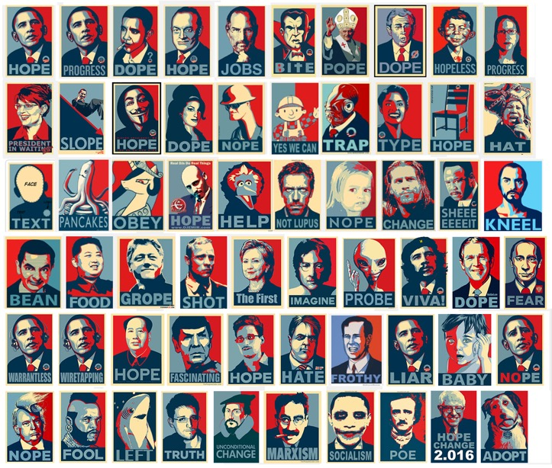
Figure 29.5
Caption: A variety of Obama Hope memes, 2008–2016. Screenshot by Nanette Hoogslag. This collation shows only a fraction of the various memes within this strand that are present online. The two top-left images are the original ones created for the election campaign for U.S. President Barack Obama in 2008, by Shepard Fairey, based on a photograph by Mannie Garcia for Associated Press. Note the image in the top right is the image of the author, created through a meme-generator Obama-me.com, which automatically transforms an image into the language of the “Obama-Hope” image. Fairey joined his “own” ongoing meme with an image created on behalf of adoptapet.com, positioned at the bottom right.

One well-known Internet meme is the collection of images based on Obama Hope, the unofficial election poster created for the presidential election campaign of Barack Obama in 2008 by Shepard Fairey (American, b. 1970), based on a photograph by Mannie Garcia for Associated Press (the right to use the photo was later contested in court) (Figure 29.5). The effectiveness of the poster image and the proliferation of this image both offline and online sparked visual responses in social media almost instantly. These responses use the basic visual grammar of the blue and red central portrait and text banner and then alter a few core components. Although the content of the messages within the Obama Hope meme has changed over time, many express some kind of political commentary or engagement. Brought together, these memes create an expanded public discussion around (American) politics, Obama as president, leadership, and world events. What is interesting is that Obama Hope iterations are found in print as well as online, and in mainstream editorial channels as well in social media, with each iteration sparking new lines of discussion many years after the first image.

New Forms
Picture Book Apps
Since 2005 the markets for e-books (books and magazines in digital formats) have been rapidly expanding with the introduction of e-readers and tablets, small portable computers with touchscreen displays. Specifically designed for media consumption, tablets allow the user to carry hundreds of searchable books and other media productions on their person. The development of these devices gave rise to new forms of interactive storytelling and, with it, the creation of book apps, computer applications installed on the tablet or device, available via download from protected shopping portals such as iTunes.
Moonbot Studios, founded by illustrator, animator, and children’s book author William Joyce (American, b. 1957), was one of the first large studios dedicated to creating book apps. The studio’s first production, The Fantastic Flying Books of Mr. Morris Lessmore, is an example of how expressive book apps could be. Released in 2011, it is based on an animated film and uses a mixture of 3-D modeling and stop-motion animation to translate short storylines as well as nonmoving scenes for digital delivery (Figure 29.6). With its synthesis of written and spoken text, interaction, and touch navigation, the production brings together aspects of books, animation, and playing. Each “page” presents a static setting and animated story fragments, and solicits interactive exploration of central elements. For example, a swiping movement can activate the wind, and a virtual piano keyboard invites the reader to play a tune (Figure 29.7).
More recently, Joyce took the tablet experience a step further by creating an augmented reality edition of Morris Lessmore that combines a physically printed book with a screen-based experience (Figure 29.8). The augmented reality consists of a live recording of the physical book made through the camera lens of a mobile device. The user views the book on the screen of the device. Cues on each page of the physical book trigger the responsive software of the book app, which automatically maps virtual imagery onto the live recording. The imagery matches the dimensions of the real book and the space around it, taking the distortions of the camera angle into account. Augmented reality blends the physical world and computer information, blurring boundaries between real and virtual, enabling a new kind of imaginative visualization in storytelling.
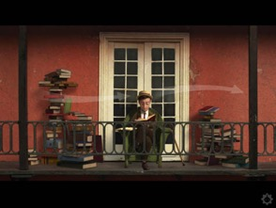
Figure 29.6
Caption: Moonbot Studios, The Fantastic Flying Books of Mr. Morris Lessmore, 2011. Screenshot by Nanette Hoogslag. The arrows encourage readers to swipe the screen; this action creates a sensation of blowing wind.
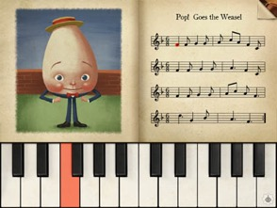
Figure 29.7
Caption: Moonbot Studios, The Fantastic Flying Books of Mr. Morris Lessmore, 2011. Screenshot by Nanette Hoogslag. The virtual keyboard invites readers either to play the score or to create their own tune.
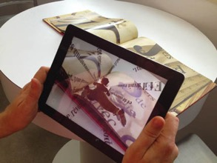
Figure 29.8
Caption: Moonbot Studios, The Fantastic Flying Books of Mr. Morris Lessmore, augmented reality edition, 2012. Courtesy of Moonbot Studios. The sensation of augmented reality is created when the tablet is held in proximity to the printed book, where on the screen of the tablet visual content is added to the live-recorded image of the book in real time.

An e-textbook is another type of electronic publication that is growing in use, particularly in the areas of science and education. For instance, e-textbooks can present 3-D rendered models created by medical illustrators, offering virtual instruction in 360 degrees on objects and processes such as complicated surgical procedures or new medical techniques (Chapter 28). These e-textbooks are designed to interact in complex and varied ways that combine the hybridity of graphic narratives with text and (moving) images online. They are particularly effective in teaching the approximately 65 percent of people deemed to be visual learners.
But the production costs of a book app or an e-textbook can be prohibitive because of the integration of additional animation, video, and programming. Further complications arise because not all applications and devices are mutually compatible, while the rapid rate at which hardware and software changes requires continuous updating. Particularly in the commercial publishing market, this has slowed uptake for high-end visual productions—but near continual drops in the price of hardware and software and the expanding growth of tablet use, particularly in educational environments, could permit for expansion of the e-book market.

Illustration for Games
Illustration is indispensable in the domain of computer games, particularly adventure games set in simulated worlds with narrative plots. Until 1980, such games were text-only. Mystery House (Figure 29.9), designed and illustrated by Roberta Williams and programmed by her husband, Ken Williams, for Apple II, was the first graphic adventure game. Based on the classic structure of Agatha Christie’s murder mysteries, seventy vector drawings conjured up an old Victorian mansion and its various rooms. Although necessarily crude due to technological limitations, these simple line drawings made visual communication an essential part of the game experience by locating the written game instructions in virtual space, leading the player through the game narrative, and engaging him or her more immersively than ever before.
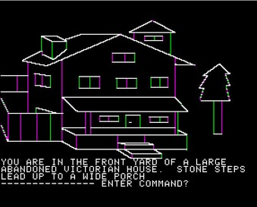
Figure 29.9
Caption: Roberta Williams, Mystery House, video game, On-Line Systems (later known as Sierra On-line), 1980. Screenshot of the game running on Apple II, courtesy of Laine Nooney. Mystery House was the first adventure game using computer graphics. The color white was created by combining green and purple light in RGB colorspace. The bleeding of the two colors shows on the edges and vertical lines.
Many adventure games and role-playing games are characterized by open-ended, user-defined plots, avatars with moral makeups and talents, and multiplayer collaborative game play. Users have come to expect rich aesthetic and narrative experiences in sophisticated character movements, actions, and plots. Game and 3-D design software applications such as Maya, ZBrush, and Unity satisfy such expectations with highly naturalistic rendering with dynamic lighting and interactivity. Popular combat, driving, or action adventure games such as Call of Duty, Grand Theft Auto, or Rise of the Tomb Raider (Figure 29.10), for example, emulate a cinematic realism from a first- or third-person perspective that places the player within the action.
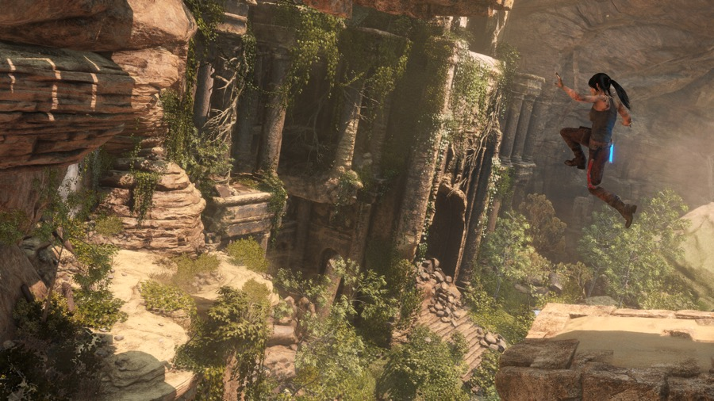
Figure 29.10
Caption: Rise of the Tomb Raider, video game, 2015. Image courtesy of Crystal Dynamics. A high level of realism contributes to the immersive quality of video games such as Rise of the Tomb Raider, an action-adventure game in which players control the heroine, who must survive the dangers of extreme environments while tracking clues and avoiding attacks by assailants.
Though this new form of narrative realism may seem to be dominating the immersive game genres, more experimental games using alternative visual languages have made significant contributions to the industry as well. For instance, Sir Benfro’s Brilliant Balloon (2013) by Tim Fishlock (British, b. 1963) is a narrative game that requires the player to keep the protagonist moving along a twisting narrow course strewn with various obstacles, often in the shape of wriggling magical creatures. The rising difficulty of the pathway may create the gaming “hook,” but it is the visual narrative’s particular aesthetic quality that carries the game. The scenery and characters are whimsical and created in multiple drawing styles that incorporate historical illustration and ephemera. To emphasize the narrative component, the game app includes backstories of all the individual creatures, making it both game and picture book.
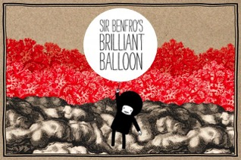
Figure 29.11
Caption: Tim Fishlock, Sir Benfro’s Brilliant Balloon, video game, 2013. Courtesy of Tim Fishlock. With a timeless quality, Sir Benfro draws on a playful visual quality reminiscent of Push Pin Studio’s use of Victorian engravings in the 1950s and ’60s.
Another, more complex, narrative game is Sword & Sworcery EP (2011), designed and developed by Superbrothers and produced by Capybara Games (both Canadian, 2003) (Figure 29.12). Sword & Sworcery EP has the player join the quest of a mysterious warrior journeying through various landscapes. Game clues are hidden in the landscapes, and interaction encompasses various actions, including written dialogue. The player can trigger changes such as switching between “dream” and “real” worlds, while other actions are driven by real time-based events such as the position of the moon.
With a visual language emulating the pixelation and jagged movements of early console games like SuperMario (Nintendo, 1985), Sword & Sworcery EP refers to the history of computer graphics as an established cultural environment, with its own traditions. In both Sword & Sworcery EP and Sir Benfro, the overtly stylized visual languages are important narrative components that constitute an alternative understanding of what game experience can be, in contrast to the drive toward immersive hyperreality found in the majority of narrative games.
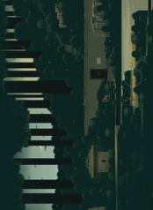
Figure 29.12
Caption: Superbrothers and Capybara Games Inc., Sword & Sworcery EP, 2011. Screenshot by Nanette Hoogslag. This game deliberately uses pixilation as its aesthetic experience, referring to the already rich history of visual styles of computer graphics.

Games as Illustration
In the preceding examples, illustration is an essential part of game design. Conversely, game design and game experience themselves can be used to illustrate something, where virtual experiences delivered in a game-like format clarify instructions, explore complex problems, or give insight into sociopolitical ideas. One such game is The Best Amendment (referring to the American constitutional right to bear arms) by Molleindustria (Paolo Pedercini, Italian, b. 1981). Created soon after the 2012 mass killing at Sandy Hook Elementary School (Newtown, Connecticut), The Best Amendment is a satirical “shoot ’em up” game that, akin to a political cartoon, presents critical commentary on the proliferation of gun use and the staunch defense of gun ownership by the American National Rifle Association (Figure 29.13a-e). At first, the game action and cartoon aesthetic invite the player to think of shooting as just a bit of fun, but then the player gradually realizes, in the process of playing, that this trigger-happy attitude is actually the source of the unwinnable arms race unleashed in the game. The Best Amendment can be played on the website Games for Change, a nonprofit organization that facilitates the creation and distribution of social impact games as critical tools to stimulate sociopolitical awareness.
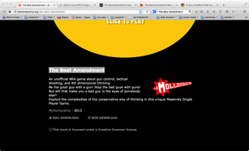
Figure 29.13a
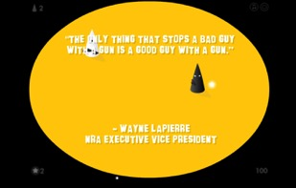
Figure 29.13b
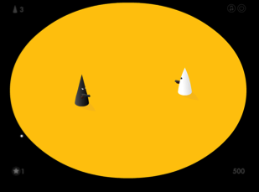
[[FN]]Figure 29.13c
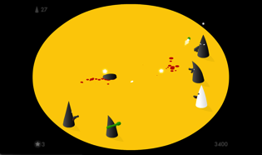
Figure 29.13d
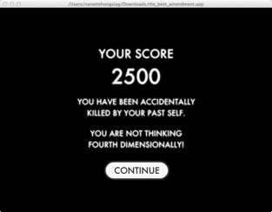
Figure 29.13e
Caption: Paolo Pedercini for Molleindustria, The Best Amendment, 2013. Screenshots by Nanette Hoogslag. The download screen on the website Molleindustria explains and contextualizes the game (a). The opening screen of the game then quotes the 2013 executive vice president of the National Rifle Association, USA (b). The opening sequence of the game continues (c). Further into the game, more adversaries carry larger guns (d). The final screen shows the player’s score and points out negative behavior that actually caused the demise of the player (e).

Theme Box57
Information Sharing: An Online Community Grows
Whitney Sherman
While the Internet was introduced for public use in the late 1980s in the form of chat rooms and electronic mail, it was not until about 1993 that websites began to be widely established and consulted. But venues for illustrators to show or sell original art directly to the public were initially limited by slow bandwidth and other technical restrictions. By the late 1990s, email accounts could transmit substantial image data, and global promotion became possible through portfolio websites and web portals. Marketing online soon followed with a website owner’s ability to add preprogrammed payment systems known as widgets to sites. Then blogs (a term coined from web log in 1999 by programmer Peter Merholz) gave an easy way to post new content and to speak directly to the public daily about one’s work and thoughts (Figure TB29.55.1).
Figure TB57.1
Caption: James Gurney’s blog Gurney Journey, August 30, 2007. Screenshot by Jaleen Grove. Illustrators such as James Gurney (American, b. 1958) took advantage of the weblog format as a public forum through which to communicate directly with an online audience.
The transition to a digital world had significant impact on how editorial and corporate information was delivered to the public, and on how illustrators were hired and paid. Direct access to production outlets such as web publishing gave the illustrator greater autonomy over authorship and production. Among the benefits of web-based resources was the ability for isolated freelance illustrators to seek each other out to address shared concerns.
An online community grew from basic websites with message boards to ones permitting marketing and other interactions between illustrators, clients, and the public. Over time, websites such as The iSpot (Gerald & Cullen Rapp artists’ representative); Drawger (Bug Logic); Illustration Friday (Penelope Dullaghan); Today’s Inspiration (Leif Peng); Illustration Art (David Apatoff); Drawn! (John Martz), 100 Years of Illustration (Paul Giambarba); Illustration Daily (Pawel Pokutycki and Babette Wagenvoort); Illustration Mundo (Nate Williams); The Comics Journal (Timothy Hodler and Dan Nadel); Escape from Illustration Island (Thomas James); and BibliOdyssey (Paul “peacay”) came into being, each with its own constituency, objectives, and identity giving insight into the makers and the context for which their work was made.
Importantly, online groups could discuss industry issues that emerged or were exacerbated by the Internet. These included gauging fees in the uncharted web environment and protecting one’s work from unwarranted usage, including appropriation under the guise of the orphan works designation (where authorship is uncredited or deemed impossible to trace); and exploitation by digitally based stock houses (businesses set up to manage and sell previously created illustration for resale to new customers), which undercut the valuation illustrators placed on their own stock or “reuse” sales.
The proliferation of business models that encouraged image rights violations and devaluations prompted the foundation of the Illustrator’s Partnership of America (IPA) by Brad Holland, Cynthia Turner, Ken Dubrowski, Brian Leister, and David Lesh. The IPA fought for intellectual property rights (see Theme Box 56, “Copyright: An Abbreviated History”) and founded the first Illustrators’ Conference (ICON) in collaboration with numerous sympathetic individuals and related businesses, to bring illustrators together to discuss important topics relating to the business of illustration that had been affected by the Internet.

New Media in the Evolving Marketplace: The Illustrator as Author and Entrepreneur
Digitization: On-demand Printing and Online Publishing
Digital resources for creation and distribution via the web have profoundly enlarged illustrators’ purview and impacted the relationships between illustrators and their clients. Illustrators today can make images and products using on-demand print services that provide the artists with high levels of creative control and that allow them to get directly in touch with their audience. The impetus for making and the ability to sell are therefore often driven by the creator’s own urges rather than by client commission.
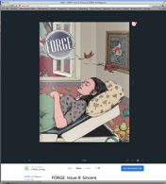
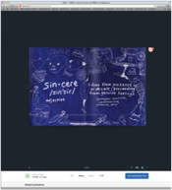
Digitization has not meant the disappearance of the printed artifact, as has been often predicted. On the contrary, it has enabled new printing processes that have made the production of small editions or even single copies possible and affordable, as well as enabled the automatic adaptation of a print design to allow for bespoke printed objects. Print-on-demand (PoD) is a technology and business process using fast laser or inkjet printers to fulfill consumer orders of a single copy of a publication quickly (Figure 29.14a-b). It has democratized the publishing of picture books, portfolios, and magazines by empowering creators to determine their publications’ aesthetics and editions; and within given parameters, to set their own price points and royalties too. Besides saving printing and shipping costs and reducing paper waste, there is no risk of having unsold copies returned. Participating PoD vendors can also print and ship projects locally.

Figure 29.14a, b
Caption: Maria Torres, online art magazine cover, FORGE, no. 8, distributed by www.issuu.com, 2015 (a); Matthew James-Wilson (Editor-in-Chief), Kendra Yi (illustrator), and Kira Aszman (illustrator), interior page collaboration for “Sin-cere,” FORGE, 2015 (b). Screenshots by Susan Doyle. Print-on-demand platforms enable self-publishers to update a publication as needed, track usage through analytics, customize the user experience, and promote their publications through linked social media.

Initially, PoD books were looked upon with skepticism because they lacked the endorsement of established publishers. Over time, this attitude has changed as the print quality and the prevalence of well-designed publications have increased. Many established traditional publishers now embrace e-publications, and institutions such as the National Gallery in London and the Rijksmuseum in The Netherlands use print-on-demand to provide materials for museum visitors. At the Dutch theme park De Efteling (which opened in 1952), guests can create their own customized fairytale book through Efteling’s web application, using images by illustrator Job van Gelder (Dutch, b. 1971) (Figure 29.15).
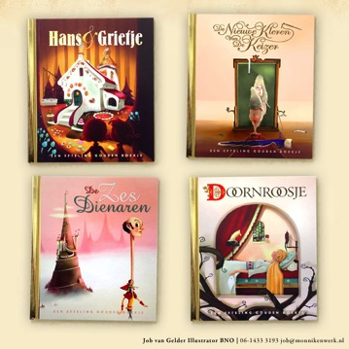
Figure 29.15
Caption: Job van Gelder, covers, Hansel and Gretel, The Emperor’s New Clothes, The Six Servants, and Sleeping Beauty, 2015. {{AU: I revised order of titles to reflect the order left-right, top-bottom, shown here. Okay?}} Screenshots by Job van Gelder composed by Whitney Sherman. Illustrations Job van Gelder, ©Rubenstein, publisher. Customizable personalized books are available to visitors of the Dutch theme park Efteling in collaboration with the Dutch publisher Rubenstein.

Digital Art and Art Objects
Some see digitization processes as threatening the sense of agency of the maker in the creation of a unique and original physical art object. Meanwhile, archivists in libraries and museums are grappling with what it means to make an “original” digital illustration. Because electronic devices and presentation software change rapidly and can quickly become obsolete, questions about how digital forms can be preserved and conserved have arisen.
In what may be interpreted as a reaction to the ubiquitous presence of digital media, renewed appreciation of things handmade emerged in the DIY (do-it-yourself) movement—and with it came a resurgence of traditional media such as oil, acrylic, gouache, and ink; and time-honored methods such as hand painting and collage. Woodcut, linoleum block, and letterpress printing have also rebounded in popularity. The giclée print, a high-quality inkjet print made as an art print in often limited editions, is a hybrid of old and new media that somewhat satisfies the desire for a tangible and durable object from a digital file.
All these changes in creative methods and media have had an impact on the illustrator’s professional identity, whereby individual entrepreneurship has at times become more aligned with fine-art practice. New marketplaces, online web shops, pop-ups, and brick-and-mortar galleries focus on the emergence of illustration as art and artifact. Galleries celebrate the object and create environments that encourage production of illustration outside the mandate of a commission. Sometimes responding to countercultural aesthetics or made at physical scales far larger than the printed page, illustration in this context fuses conventions of high and low art (see “Lowbrow and Pop Surrealism” in Chapter 27), and challenges the traditionalist values and methods descended from the narrative realism of the “Golden Age”—long the benchmark of twentieth-century American illustration (see Chapter 18).

Illustrator as Entrepreneur
With on-demand printing, illustrators have established cottage industries, applying their design and illustration skills to products such as apparel, stickers, tote bags, postage stamps, and fabrics produced in limited quantities (Figure 29.16).
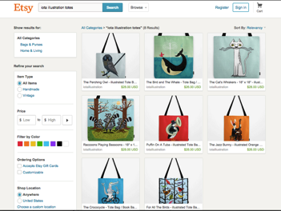
Figure 29.16
Caption: Oliver Lake/Iota illustration, custom-designed tote bags made of digitally printed canvas, 2015. Screenshot of Etsy online shop page by Whitney Sherman. Specialized tote bags and other custom items such as 3-D printed ceramics, scarves, or custom graphics on apparel are easily created and sold through online marketplaces like Etsy, which promotes artisan goods. Several manufacturing vendors also provide marketplaces on their sites for makers.

Many creators cross-market items sold at both craft fairs and in online shops (B2C: business-to-consumer), which allows consumers to look and touch first, then buy later from home. The fairs bring together an audience of like-minded consumers looking for unique, artisanal work, while the online shops jump past the middle-man—retail “brick-and-mortar” shops—to reach consumers directly. Online shopping sites such as the popular site Etsy are built to streamline the process of setting up a storefront with visually attractive pages, providing a dedicated search engine, a guaranteed payment system, and links to networks and communities. Entrepreneurial artist websites or social media pages such as Tumblr and personal blogs have become important for marketing products and for self-promotion. For example, the Chinese microblog Weibo (“microblog/ing” in Mandarin, launched 2009) has also served as a platform for illustrators’ product sales.
Beyond relatively small artisan production and sales, illustrators and other makers seek new ways of financing more ambitious projects outside the support of traditional funding models. Peer-to-peer financing systems, so-called crowdfunding systems, can connect creative project developers with noninstitutional funders through specifically designed web environments such as Kickstarter (launched 2009). Sites like these can help find backing for a venture by raising relatively small monetary contributions from a large number of people.
Directly and indirectly, these online delivery systems can be considered as part of prosumerism, a term coined by futurologist Alvin Toffler in 1980 to describe the involvement of individuals in designing or improving the goods and services of the marketplace. “Prosumers” take part in the production process by specifying or influencing design, similar to the way affluent clients have collaborated with architects or dressmakers.
The highly communicative and applied nature of illustration, as well as its close links with decorative arts, made it a natural step for many illustrators to explore the creation and sale of artisan and decorated products. Critics have questioned whether this trend is a legitimate part of illustration, dismissing it as an opportunistic, trendy scramble for income that once came from important editorial commissions that often engaged with serious issues. But artisanal illustrated products may also lead to thought-provoking or socially apt visual commentary, taking illustration away from the page into a wider world, extending the power of the illustration in new directions.

Theme Box 58
Why Does Critical Theory Matter for Illustration?
Sheena Calvert and Jaleen Grove
“The best way to predict the future is to design it.” —Buckminster Fuller
To be an illustrator is not simply a question of learning aesthetic styles and technical skills. To participate in the shaping of the discipline and of culture, and not to simply be a passive witness, it is essential to critically reflect on what we do and to build the necessary confidence and thinking skills to take an active role in both the development of the field and of society. The need is pressing because of rapid technological changes and diversifying audiences, which each demand shrewd and sensitive handling in order to minimize harm, speak effectively, and remain socially relevant and economically viable. In what ways do technology and complex social systems require new modes of illustration?

Responding to Technology
Technology is transforming how work is produced and disseminated, and moving image, sound-based work, and hybrid forms now coexist alongside traditional modes of practice. Work that is relational and social and which happens in space and time, rather than simply in two dimensions, is becoming more frequent, and so closer collaboration between the previously separated disciplines of art, design, and computer science is required. Challenges and opportunities abound—if we can foresee them. Predictions such as those of Marshall McLuhan (see Chapter 24, Theme Box 46, “McLuhan: Media Theory”) based on what happened after the invention of moveable type can help us anticipate the impact of these new media.
As Henry Jenkins reminds us, a key trait of the new digital environment is its propensity for collaboration and audience feedback (Chapter 16, Theme Box 34, “Jenkins: Media Convergence”). In the writings of Roland Barthes (Chapter 22, Theme Box 44, “Barthes: Mythologies and Death of the Author”) and Karl Marx (Chapter 15, Theme Box 33, “Marx: Modes of Production”), authorship and production come under scrutiny. Who is the author of a work that has many contributors? Is the originator the person who supplies a work’s final meaning or the viewer? Marx’s and Theodor Adorno’s ideas (Chapter 21, Theme Box 43, “Adorno: Subjectivity, Objectivity, and the Culture Industries”) continue to have relevance, since they ask us to reflect on the politics of production, the (arguably) lost sense of ownership we have over mass-reproduced works, and the general commodification of our practice when we create works for commercial rather than social purposes. Analyses by the likes of McLuhan and Jenkins help us understand the advantages and pitfalls of contemporary corporate control, and remind us that social and commercial priorities are not so easily separated.

Forming Representation
Various chapters in this book show how illustrations of the past were usually made for a specific audience, and when purportedly made for a North American or European “mass,” they still had a specific audience implicitly in mind: in general, white and socioeconomically well-off. Critical theory helps us identify how images are rhetorical and carry underlying messages and meanings. People such as Benedict Anderson (Chapter 3, Theme Box 8, “Nationalism”), Edward Said (Chapter 4, Theme Box 10, “Orientalism”), Stuart Hall (Chapter 7, Theme Box 13, “Hall: Encoding, Decoding, Transcoding”), Judith Butler (Chapter 26, Theme Box 48, “Judith Butler: Gender and Queer Studies”), and Donna Haraway (Chapter 28, Theme Box 54, “Haraway: Crossing Boundaries”) help us rethink how conventional depictions concerning identity, race, gender, and species operate—tropes that were once thought unproblematic. We would think very carefully nowadays about illustrating using the kinds of stereotypical images once commonly accepted. A complication that critical theory might help us address is: how does one give visibility to a group without stereotyping?
In previous theme boxes, we have seen how the status of images is always in question. From Plato onward, thinkers have challenged pictures because their claims to represent “truth” are problematic. Theorists such as Hall, Michel Foucault (Chapter 10, Theme Box 19, “Discourse and Power”), Roland Barthes (Chapter 22, Theme Box 44, “Barthes: Mythologies and Death of the Author”), and Jacques Derrida (Chapter 27, Theme Box 50, “Derrida: Deconstruction and Floating Signifiers”) show us how hidden narratives of culture and society embedded in illustration reinforce power structures, but also how the slipperiness of meaning can be subverted to suggest other messages.
The large body of critical inquiry provides a rich trove of ideas for illustration practice, allowing us to reflect on narrative, imagination, and the act of depicting more generally. What is the role of self-expression versus work that has a public and practical function? “Illustrators” have been making work for thousands of years that addresses specific practical and functional needs but has also been an integral part of a broader search for meaning, for human expression, and part of the compulsion to “picture” the world. Is this in a lesser position with respect to fine art? Critics such as Clement Greenberg (Chapter 19, Theme Box 40, “Greenberg: Avant-Garde and Kitsch”), William Morris (see “William Morris, Edward Burne-Jones, and the Kelmscott Press” in Chapter 15), and Walter Benjamin (Chapter 13, Theme Box 27, “Benjamin: Aura, Mass Reproduction, and Translation”) have each had an impact on art and media production with the force of their theories relating to this and similar questions.

The Practical Intellectual
Critical theory gives practitioners a way to reflect on their own conditions of creation and consumption. It allows us to cope with rapid changes and to be more than just “pairs of hands.” Illustrators of the future need to be “practical intellectuals,” fully grappling with the key questions of our time while flexing our “making” muscles, by understanding the histories of the subject, and maintaining a deep curiosity about all the possibilities that new technologies, cultures, and intellectual ideas bring to the practice of illustration.
Critical theory is not a negative form of criticality, but one that is productive and analytical in nature, asking us to place our work in a broader context: the history of ideas. Any form of creative practice automatically brings us into contact with history, politics, philosophy, sociology, ethnography, anthropology, new and old technologies, and more. To undertake critical theory is to acknowledge that what we do as illustrators is as intellectual as it is technical; that practice needs to respond to the particular moment in history in which it is made; and to its place at the intersection between other forms of knowledge.
Finally, illustration is participatory. We illustrate with and not for. A traditional model that has been challenged is the idea that illustrators simply interpret on behalf of others, a concept that renders invisible their own authorship. It also reinforces the erroneous fine-art model of the sole practitioner. A different model is to see audiences as coparticipants in a process: they shape, cocreate, and feed back, while illustrators facilitate this process through thoughtful visual problem solving. Illustration and society; social responsibility, ethics, and sustainability come to the fore in this process—illustration is not just a question of aesthetics and form making by individual illustrators, but of understanding the importance of strategies, systems, and global networks.

Conclusion
While we continue to value the physical artifact and the agency of the individual maker, computer technologies have fundamentally changed the creation, distribution, and reception of images. Digitization has offered new ways of engaging with traditions while generating wholly new creative outlets. New media illustration and all the possibilities that have opened up through digital technologies are just the latest steps to extend long-existing methods and media of illustration. Increasingly, online communication networks along with new media are pivotal to the illustration of ideas, stories, and experience of play.
New media technology questions the permanency of traditional methods and values, while we as makers and consumers in turn question the value of technological developments. New media brings full circle a discussion—held through practice and critical dialogue—of what we actually wish to understand as illustration. If illustrations can be both material and immaterial, and can take the form of books, book apps, animation, and games, how do we qualify its methods? If illustration can be sold as independent artifacts in web shops or can be placed without context on a social media site, then what does it illustrate? If everyone can instantly create and upload a picture, meaningful within one’s own milieu, what is the added value of a professionally made illustration? How can we speak of creative authorship or copyrights if an image is easy to appropriate by corporations and individuals alike, once it is available online?
With these questions open for debate, it is worth going back to a principle of illustration that does not seem to have been affected by all these changes. Perhaps what we can say about illustration is that it is pictorial communication that is designed to give insight, clarification, commentary, and reflection on ideas, information, and narratives. Illustration can be made using any method or medium, and is vital in helping us make sense of the world through meaningful images that engage with individuals and groups within the context of a larger cultural dialogue.

Bibliography
Anonymous, Exclusive Interview with William Joyce on “The Fantastic Flying Books of Mr. Morris Lessmore,” Amazon Books [online], 2012. Available from https://www.youtube.com/watch?v=3FacOqWgd3o&feature=youtube_gdata_player.
BBC, “School Shooting: How It Happened.” BBC [online], December 18, 2012. Available from http://www.bbc.co.uk/news/world-us-canada-20738998.
Beiguelman, Giselle, “For an Aesthetics of Transmission,” First Monday, 2006. {{AU: What type of source is this? Journal, newspaper, online source?}}
Bennett, Richard, “No Country for Slow Broadband,” New York Times [online], June 15, 2013. Available from http://www.nytimes.com/2013/06/16/opinion/sunday/no-country-for-slow-broadband.html.
Bolter, Jay David, and Richard. Grusin, Remediation: Understanding New Media, 1st ed. (Cambridge, Mass.: The MIT Press, 2000).
Capybara Games and Superbrothers, Sword & Sworcery [online], 2011. Available from http://www.swordandsworcery.com/.
Cashmore, Pete, Why 2013 Is the Year of Responsive Web Design [online], 2012. Available from http://mashable.com/2012/12/11/responsive-web-design/.
Crow, D, Visible Signs: An Introduction to Semiotics in the Visual Arts, 2nd ed. (Lausanne; Worthing: AVA Publishing, 2010).
Deloumeau-Prigent, Kaelig, “Mobile-First Responsive Web Design and IE8,” Guardian [online], October 14, 2013. Available from http://www.theguardian.com/info/developer-blog/2013/oct/14/mobile-first-responsive-ie8.
Donahoo, Daniel, The Fantastic Flying Books of Mr. Morris Lessmore Is a Game-Changing eBook App, GeekDad, Wired.com, May 31, 2011.
Fishlock, Tim, Sir Benfro’s Brilliant Balloon [online], 2013. Available from http://sirbenfro.com/.
Fuller, Matthew., Software Studies: A Lexicon )Cambridge: MIT Press, 2008).
Galloway, Alexander R., The Interface Effect (Cambridge: Polity Press, 2012).
Gitelman, Lisa, Always Already New: Media, History, and the Data of Culture (Cambridge: MIT Press, 2008).
Hayles, N. Katherine, My Mother Was a Computer: Digital Subjects and Literary Texts, new ed. (Chicago: University of Chicago Press, 2005).
Hoogslag, Nanette. On the Persistence of a Modest Medium (thesis, RCA, in press). {{AU: At what university is this thesis being presented? In what city?}}
Infinity Ward, Call of Duty [online], Infinity Ward, 2003. Available from http://www.callofduty.com/uk/en/.
Joyce, William E., The Fantastic Flying Books of Mr. Morris Lessmore (London: Simon & Schuster Children’s Books, 2012).
Kittler, Friedrich, Gramophone, Film, Typewriter, Translation by G. Winthrop-Young and Michael Wutz (Stanford: Stanford University Press, 1999).
Kress, Gunter, and Theo van Leeuwen, Multimodal Discourse: The Modes and Media of Contemporary Communication (London: Arnold Publishers, 2001).
———, Reading Images: The Grammar of Visual Design, 2nd ed. (Routledge, 2006).
Male, Allan, Illustration: A Theoretical and Contextual Perspective. (AVA Publishing, 2007).
Manovich, Lev, The Language of New Media. (Cambridge: MIT Press, 2002).
———, Software Takes Command (Bloomsbury academic, 2008).
Molleindustria, The Best Amendment [online], 2013. Available from http://www.molleindustria.org/the-best-amendment/.
Pitaru, Amit, and James Paterson, Numby [online], 2012. Available from https://itunes.apple.com/gb/app/numby/id499958256?mt=8.
Rockstar Games, Grand Theft Auto IV [online], 2013. Available from http://www.rockstargames.com/IV/.
Salen, Katie, and Eric Zimmerman, Rules of Play: Game Design Fundamentals [online], 2004. MIT Press. {{AU: What is the URL for this online source?}}
Segel, Edward, and Jeffrey Heer, “Narrative Visualization: Telling Stories with Data,” Visualization and Computer Graphics, IEEE Transactions, vol. 16, no. 6, 2010, 1139–1148.
Thatgamecompany, Journey [online], 2012. Available from http://thatgamecompany.com/games/journey/.
Ustwo, Monument Valley [online], 2014. Available from http://monumentvalleygame.com.
Vlaanderen, Remco, Interview with Han Hoogerbrugge, 2009.
Wark, McKenzie, Gamer Theory (Cambridge: Harvard University Press, 2007).

