Assessment of visual acuity in children using crowded Lea symbol charts

Ananth Sailoganathan¹ PhD, Leong Xin Rou¹ BSc Optom, Kenny Anak Buja¹ BSc Optom, John Siderov²* MScOptom, PhD, FAAO

National Institute of Ophthalmic Sciences¹, Tun Hussein Onn National Eye Hospital, Lorong Utara B, 46200, Petaling Jaya, Selangor Darul Ehsan Malaysia; Anglia Vision Research, Department of Vision and Hearing Sciences², Anglia Ruskin University, Cambridge CB1 1PT, United Kingdom

*Author to whom correspondence should be addressed: Department of Vision and Hearing Sciences, Anglia Ruskin University, Cambridge CB1 1PT, United Kingdom
Phone +44 (0) 1223 698695
Email: john.siderov@anglia.ac.uk

Word count: 2532
Figures: 3

Accepted for publication in Optometry and Vision Science June 2018
Abstract
Significance: Vision charts comprising single Lea symbols surrounded either by flanking bars or flanking Lea symbols are available for measurement of visual acuity in children. However, the results obtained with such charts may not be interchangeable due to potential differences in the crowding effect. Purpose: To compare habitual visual acuity in a sample of young children using two versions of the single Lea symbols charts with different crowding features. Methods: Monocular habitual visual acuity was measured in a sample of 77 young children aged between 4 and 6 years using crowded Lea Symbols charts with either flanking bars separated from the central symbol by 0.5 optotype width or flanking Lea optotypes separated from the central symbol by 1.0 optotype width. Results: Mean visual acuity was higher (i.e. lower logMAR) with the Lea symbols crowded using flanking optotypes, equivalent to about 1.5 optotype difference. Visual acuity measured with the 2 charts was significantly correlated; however, the 95% limits of agreement were larger than expected from repeatability studies using Lea symbols. Conclusions. Lea symbols with flanking optotypes resulted in higher visual acuity than the Lea symbols with flanking bars, probably as a result of differences in the crowding effect. The two charts showed insufficient agreement and we do not recommend their use interchangeably. We recommend using the Lea symbols with flanking bars because of the closer flanker-target separation.

Key words. Lea symbols, crowding, contour interaction, children, visual acuity

The measurement of visual acuity in pre-literate children can present a challenge to the clinician, in part, because of the plethora of children’s visual acuity charts available but also due to differences inherent in vision chart design that can affect measured acuity, such as differences in optotype legibility, non-uniform changes in optotype size and differences in crowding features.¹⁻⁴ The Lea symbols series of visual acuity charts were designed to overcome some of these issues and are recommended for testing young children.^{5, 6} The charts comprise optotypes in the form of simple shapes, familiar to young children, of a circle, a square, an apple, and a house. The symbols are calibrated against the recognized international standard,⁷ they can be presented in a logarithm of the minimum angle of resolution (logMAR) format,⁸ and importantly are available in crowded versions.⁹
Lea symbol charts have good testability when compared to the HOTV charts⁹⁻¹¹ or Sheridan Gardiner letters¹² and may be even better than the HOTV charts for younger children aged 3 years.¹³ Some studies have reported slightly better visual acuity with Lea symbol charts when compared with the Early Treatment Diabetic Retinopathy Study (ETDRS) chart, ¹⁴ Bailey-Lovie¹⁵ or HOTV^{9, 16} charts. This may be the result of differences in the testing methodology used. For example, there are only 4 Lea symbols compared to the 10 possible response options available using the ETDRS chart, which could make the ETDRS chart more difficult (although this reasoning does not apply for the HOTV chart). Another possible reason for differences may be due to differences in the chart formats. Studies have used single unflanked Lea symbols,¹² single Lea symbols flanked with bars,¹⁶ single Lea symbols flanked with Lea symbols,¹⁷ and Lea symbols constructed in line formats.^{8, 14, 18-21} It is well established that presentation of single unflanked optotypes will overestimate visual acuity in young children and although single unflanked Lea symbols may improve testability for very young children,¹⁸ employing such test charts leads to overestimates of visual acuity^{17, 19} and their use should be avoided.²² Recommendations for testing visual acuity in children include the use of Lea symbol charts with crowding features although no distinction is made as to the type of crowding feature (i.e. bar or optotype flankers) or the flanker-target separation,⁵ which could be important factors.³
There is a growing body of evidence showing that crowding in children differs from that in adults, displaying a larger critical spacing,^{23, 24} and a magnitude that is dependent on both the type of flanker and the flanker-target separation.^{3, 25, 26} For young children (aged 4-6 years), the magnitude of foveal crowding using single flanked optotypes is significantly greater for ‘letter’ flankers compared with ‘bar’ or ‘box’ flankers at a fixed flanker-target separation (0.5 optotype width).^{26, 27} This result suggests differences exist in children between what may be a simpler contour interaction, evident using bar flankers, and a more complex crowding effect evident with optotype flankers.²⁸ In addition, reducing the flanker-target separation when testing children may be important and could also improve test outcomes.^{25, 29, 30} Together, these results may help to explain some of the discrepancies reported when Lea symbol charts have been compared to other acuity charts, as different versions of the respective charts with different flanking features have been used.^{9, 10, 13, 16}
The Lea symbols charts are proving important in the assessment of visual acuity in children; however, different test designs may lead to discrepancies in measured visual acuity as a result of differential effects of crowding. In order to determine whether different crowding features in Lea charts would produce differences in acuity outcomes in young children, we measured visual acuity in a sample of young children using 2 common versions of the single Lea symbols charts with different flanker types (bars or Lea symbols) and different flanker-target separations (0.5 or 1.0 optotype widths).
Methods
Participants
A sample of young children, aged from 4 to 6 years, was recruited from kindergartens in the Seremban and Petaling-Jaya regions, near Kuala Lumpur, Malaysia. Children were selected as part of a more general vision screening activity, from different groups of classes in the kindergartens. Written informed consent from the parent or guardian and verbal assent from the teachers and children was obtained before any data were collected. Only those children who completed the consent process were invited to participate in the study. Children were pre-screened to rule out strabismus and general developmental conditions that may have hampered testing. If the children had been prescribed spectacles they were worn during data collection. No other exclusion criteria were employed. A total of 77 subjects across the age range participated in the study (16 four year olds, 29 five year olds and 32 six year olds). The overall sample size was sufficient to obtain a power of 80% at the 5% level (two-tailed) for an effect size of 0.05 logMAR. Approval of the study protocol was given by the institutional research ethics committee and the study followed the tenets of the Declaration of Helsinki.
Visual Acuity Tests
Two commercially available versions of the Lea symbols charts (Good-Lite Company, Elgin, Illinois, USA) were used in the study. The Lea symbols with crowding bars booklet presented high contrast black on white, single Lea symbols flanked by 4 bars of equal contrast and 0.2 optotype width in thickness and 1.0 optotype width in length. The bars were positioned above, below, to the right and left of the central symbol and were separated from it by an edge-to-edge separation of 0.5 optotype width. The Lea symbols crowded symbol booklet presented high contrast black on white, single Lea symbols flanked by 4 Lea symbols of equal contrast and size above, below, to the right and left of the central symbol and separated from it by an edge-to-edge separation equal to 1 optotype width (Fig. 1).
Insert Fig 1 about here
Protocol
The assessments were all carried out by trained examiners under adequate illumination in classrooms provided by the kindergartens. Prior to data collection, the children were familiarized with the Lea symbols and the chart formats. All testing occurred at 6m with the children seated and viewing the charts directly. Distance habitual visual acuity was measured monocularly. Testing began with children viewing one of the charts, selected at random, with their right eye while the left eye was covered with an opaque occluder. Their right eye was then covered while the left eye was tested. The second chart was then used and testing occurred in the same eye order (i.e. right eye then left eye). For each chart, testing began with the largest symbol size and each of the 4 symbols, chosen in a pseudo-random fashion to avoid repetition of a symbol, was presented at each acuity level. Children were asked to name the central symbol at each presentation. If required, they could also point to a response card to indicate the symbol. Pointing to the symbols by the examiner was not used under any test condition. Testing continued using smaller and smaller optotype sizes, in logarithmic progression, until 2 or more optotypes at one acuity level were named incorrectly. Participants were encouraged throughout the testing to do their best. Results were scored in a spreadsheet in logMAR format taking into account the 6m test distance. Each correctly identified optotype was assigned a score of 0.025. Each child was assessed in a single session which lasted about 10-15 minutes in total. All 77 participants completed testing.
Although visual acuity data were obtained for both eyes (as part of the vision screening), only data for the right eye are presented. Analysis of results from the left eye were not substantially different. Linear regression to determine the correlation between the test measurements was performed. Data were also analyzed using paired t-tests to compare differences between charts (Statistica, Statsoft, Tulsa, OK). In addition, the limits of agreement (LoA) which defined the interval in which 95% of the measurements were found such that the 95% LoA = mean difference ±1.96 x standard deviation of the differences between the two charts was also determined.³¹ IGOR Pro (Wavemetrics, Lake Oswego, OR) was used for the data fitting and figures.
Results
The mean logMAR (and standard deviation) for the sample was -0.05 (±0.12) for the Lea symbols crowded chart and -0.01 (±0.14) for the Lea symbols bar chart. Although our sample included children ranging from 4 to 6 years of age, analysis of differences in visual acuity as a function of age was not performed due to the relatively low and unequal numbers in each age group. Overall logMAR was lower (i.e. higher visual acuity) for the Lea symbols crowded chart by 0.04 logMAR, equivalent to about 1.5 optotypes. The mean difference between the two charts was significant (two-sample paired t(76) = 3.11; P = .003). However, there was no significant difference between their variances (F test, P = 0.29).
A comparison between the 2 charts is shown in Figure 2, where logMAR for the Lea symbols crowded chart is plotted against logMAR for the Lea symbols bar chart. The solid line in the figure represents the linear regression fit to the data and the associated equation is also shown. The calculated correlation coefficient, r of .61 (r² of .38) was significant (P < .01).
Insert Fig 2 about here
Figure 3 shows the Bland-Altman³¹ analysis where the difference in logMAR between the 2 test charts is plotted against their average logMAR, across the 77 subjects participating in the study. The solid line represents the mean difference between the Lea symbols crowded chart and Lea symbols bar chart results, while the broken lines represent the 95% limits of agreement. The mean difference between the tests and the 95% limits of agreement were 0.04 logMAR and ± 0.23 logMAR, respectively.
Insert Fig 3 about here
Discussion
Although we did not screen for refractive error, the level of habitual visual acuity in our sample of young children is consistent with previously published age norms³² and consistent with previous studies that have used Lea symbols to measure acuity in young children.¹⁸ The principle finding from our study is that visual acuity measured using the Lea symbols with flanking optotypes is higher (i.e. lower logMAR) than the corresponding acuity measured with the Lea symbols with flanking bars. The mean difference in logMAR between the 2 charts was 0.04 equivalent to about 1.5 optotypes. Although this result was statistically significant, it is a relatively small difference and may not be clinically important.
Not surprisingly, the visual acuity measured with the 2 charts was significantly correlated, although there is a noticeable spread in the data (Fig 2). Analysis following the method of Bland and Altman³¹ and determining the 95% limits of agreement is more revealing. The calculated 95% limits of agreement were ±0.23 logMAR, which represents agreement greater than measurements of repeatability of visual acuity in children using the ETDRS chart³³ or similarly formatted Lea symbols charts,³⁴ although in both of these studies the age range of the children tested included older children which may have contributed to the repeatability found.
Previous work has shown that visual acuity measured using optotypes flanked by other optotypes induces more crowding in children compared with optotypes flanked by bar flankers,^{25, 26} consistent with a suggestion by Flom²⁸ that crowding optotypes with other surround optotypes involves processes in addition to simple contour interaction and includes effects of poor or immature fixation and divided attention. On this basis, we may have expected our results to show the opposite effect; that is, the Lea symbols with flanking optotypes should have resulted in lower acuity values not higher, than the Lea symbols with flanking bars. In contrast to our results, a previous study from the Vision in Preschoolers (VIP) group found visual acuity measured with single HOTV letters surrounded by bar flankers was higher than acuity measured using Lea symbols in a line format (similar to ETDRS formatting).⁹ The VIP study compared HOTV letters surrounded by bar flankers at a separation of 0.5 optotype width (the same flanker-target separation in the Lea symbols with flanking bars chart) and a Lea symbols line chart with an inter-optotype separation of 1.0 optotype width (the same flanker-target separation in the Lea symbols with flanking optotypes). So why are our results using identical flanker-target separations different to the VIP results? The likely reason lies in the other difference in chart format. Line acuity has been shown to invoke more crowding in children than either single optotypes flanked by bars or single optotypes flanked by other optotypes at the same flanker-target separation.²⁶ The underlying mechanisms are unclear but, as Flom originally suggested,²⁸ may involve immature fixation³⁵ or under-developed attention.^{26, 36} So the use of a Lea symbol chart in a line format will be more crowded, particularly for younger children, despite the larger flanker-target separation, resulting in lower levels of acuity. However, as the present results show, the same cannot be said for single optotypes. Our results as well as previous reports,^{3, 25, 30} suggest that when using single flanked optotypes for testing visual acuity in children, flanker-target separation may be more important in determining the amount of crowding and may override the effect of flanker type (although see Atkinson²⁷). Differences due to differential effects of flanker-target separation have also previously been used to explain discrepancies in acuity measurements comparing Lea symbols with the Landolt C.¹⁹
Comparing measurements of visual acuity using charts with varying crowding features is not ideal even, as we have shown, when the same target optotypes are used. In general, Lea symbols have good testability with young children and are a popular test chart, but what format should be used and what is the ideal flanker-target separation? Although Lea symbol charts in a line format may more closely reflect adult testing, such formats may also reduce testability especially with young children.¹⁸ A widely recommended protocol developed for use in amblyopia treatment studies uses single optotype presentation (HOTV) with flanking bars set at a flanker-target separation of 0.5 optotype width,³⁷ a separation that has previously been recommended²² and is also supported by our results.
In summary, our study has shown that logMAR measured using 2 versions of the single Lea symbols charts with different flankers and flanker-target separations differed, on average, by only a small amount, equivalent to about 1.5 optotypes. Such a difference is unlikely to be clinically significant. Future research could investigate closer flanker-target separations with the single Lea symbols surrounded by symbols; however, although optotype flankers may induce more crowding for closer flanker-target distances,²⁷ such configurations may also be more confusing and could impede testability especially for younger children.¹⁸ More problematic was that the limits of agreement between the 2 versions of the charts we used was ±0.23 logMAR, larger than expected based on repeatability studies. In conclusion, the results of our study showed that Lea symbols with flanking optotypes resulted in higher visual acuity (i.e. lower logMAR) than the Lea symbols with flanking bars, probably as a result of differences in the crowding effect. The two charts showed insufficient agreement and we cannot recommend their use interchangeably. We recommend using the Lea symbols with flanking bars because of the closer flanker-target separation and the potential for greater crowding.

References
1. Anstice NS, Thompson B. The Measurement of Visual Acuity in Children: An Evidence‐Based Update. Clin Exp Optom 2014;97:3-11.
2. Fern KD, Manny RE. Visual Acuity of the Preschool Child: A Review. Am J Optom Physiol Opt 1986;63:319-45.
3. Norgett Y, Siderov J. Crowding in Children's Acuity Tests: Effect of Test Design and Age. Optom Vis Sci 2011;88:920-9.
4. Simons K. Visual Acuity Norms in Young Children. Surv Ophthalmol 1983;28:84-92.
5. Hartmann EE, Dobson V, Hainline L, et al. Preschool Vision Screening: Summary of a Task Force Report. Pediatrics 2000;106:1105-16.
6. Hyvarinen L, Nasanen R, Laurinen P. New Visual Acuity Test for Pre-School Children. Acta Ophthalmol (Copenh) 1980;58:507-11.
7. Graf MH, Becker R. Comparison of Lea Single Symbols and Landolt Single Optotypes. Klin Monatsbl Augenheilkd 1999;215:86-9.
8. Bertuzzi F, Orsoni JG, Porta MR, et al. Sensitivity and Specificity of a Visual Acuity Screening Protocol Performed with the Lea Symbols 15-Line Folding Distance Chart in Preschool Children. Acta Ophthalmol (Scand) 2006;84:807-11.
9. Vision in Preschoolers (VIP) Study Group. Threshold Visual Acuity Testing of Preschool Children using the Crowded HOTV and Lea Symbols Acuity Tests. J AAPOS 2003;7:396-9.
10. Vision in Preschoolers (VIP) Study Group. Effect of Age Using Lea Symbols or HOTV for Preschool Vision Screening. Optom Vis Sci 2010;87:87-95.
11. Kvarnström G, Jakobsson P. Is Vision Screening in 3-Year-Old Children Feasible? Comparison Between the Lea Symbol Chart and the HVOT (LM) Chart. Acta Ophthalmol (Scand) 2005;83:76-80.
12. Omar R. Comparison of Lea Symbols Chart and Sheridan Gardiner Chart in Assessing Vision Screening Among Pre-School Children: A Malaysia Perspective. J Med Assoc Thai 2012;95:412-7.
13. Hered RW, Murphy S, Clancy M. Comparison of the HOTV and Lea Symbols Charts for Preschool Vision Screening. J Pediatr Ophthalmol Strabismus 1997;34:24-8.
14. Dobson V, Clifford-Donaldson CE, Miller JM, et al. A Comparison of Lea Symbol vs ETDRS Letter Distance Visual Acuity in a Population of Young Children with a High Prevalence of Astigmatism. J AAPOS 2009;13:253-7.
15. Dobson V, Maguire M, Orel-Bixler D, et al. Visual Acuity Results in School-Aged Children and Adults: Lea Symbols Chart Versus Bailey-Lovie Chart. Optom Vis Sci 2003;80:650.
16. Ruttum MS, Dahlgren M. Comparison of the HOTV and Lea Symbols Visual Acuity Tests in Patients with Amblyopia. J Pediatr Ophthalmol Strabismus 2006;43:157-60.
17. Inal A, Ocak OB, Aygit ED, et al. Comparison of Visual Acuity Measurements via Three Different Methods in Preschool Children: Lea Symbols, Crowded Lea Symbols, Snellen E Chart. Int Ophthalmol 2017:1-7.
18. Becker R, Hubsch S, Graf MH, Kaufman H. Examination of Young Children with Lea Symbols. Br J Ophthalmol 2002;86:513-6.
19. Graf MH, Becker R, Kaufmann H. Lea Symbols: Visual Acuity Assessment and Detection of Amblyopia. Graefe's Arch Clin Exp Ophthalmol 2000;238:53-8.
20. Vision in Preschoolers (VIP) Study Group. Visual Acuity Results in School-Aged Children and Adults: Lea Symbols Chart Versus Bailey-Lovie Chart. Optom Vis Sci 2003;80:650-4.
21. Vision in Preschoolers (VIP) Study Group. Preschool Visual Acuity Screening with HOTV and Lea Symbols: Testability and Between-Test Agreement. Optom Vis Sci 2004;81:678-83.
22. Repka MX. Use of Lea Symbols in Young Children. Br J Ophthalmol 2002;86:489.
23. Jeon ST, Hamid J, Maurer D, Lewis TL. Developmental Changes During Childhood in Single-Letter Acuity and its Crowding by Surrounding Contours. J Exp Child Psychol 2010;107:423-37.
24. Semenov LA, Chernova ND, Bondarko VM. [The Measurement of Visual Acuity and the Crowding Effect in Children from the Age of 3 to 9]. Fiziol Cheloveka 2000;26:21-6.
25. Lalor SJ, Formankiewicz MA, Waugh SJ. Crowding and Visual Acuity Measured in Adults Using Paediatric Test Letters, Pictures and Symbols. Vis Res 2016;121:31-8.
26. Norgett Y, Siderov J. Foveal Crowding Differs in Children and Adults. J Vis 2014;14:23.
27. Atkinson J. Review of human visual development: Crowding and dyslexia. In: Stein JF, ed. Dyslexia. Boca Raton: CRC Press; 1991:44-57.
28. Flom M. Contour Interaction and the Crowding Effect. Probl in Optom 1991;3:237-57.
29. Formankiewicz MA, Waugh SJ. The Effects of Blur and Eccentric Viewing on Adult Acuity for Pediatric Tests: Implications for Amblyopia Detection. Invest Ophthalmol Vis Sci 2013;54:6934-43.
30. Song S, Levi DM, Pelli DG. A Double Dissociation of the Acuity and Crowding Limits to Letter Identification, and the Promise of Improved Visual Screening. J Vis 2014;14:3.
31. Bland JM, Altman DG. Statistical Methods for Assessing Agreement Between Two Methods of Clinical Measurement. Lancet 1986;1-8476:307-10.
32. Sonksen PM, Wade AM, Proffitt R, et al. The Sonksen Logmar Test of Visual Acuity: II. Age Norms from 2 Years 9 Months to 8 Years. J AAPOS 2008;12:18-22.
33. Manny RE, Hussein M, Gwiazda J, Marsh-Tootle W. Repeatability of ETDRS Visual Acuity in Children. Invest Ophthalmol Vis Sci 2003;44:3294-300.
34. Chen SI, Chandna A, Norcia AM, et al. The Repeatability of Best Corrected Acuity in Normal and Amblyopic Children 4 To 12 Years Of Age. Invest Ophthalmol Vis Sci 2006;47:614-9.
35. Regan D, Giaschi DE, Kraft SP, Kothe AC. Method for Identifying Amblyopes Whose Reduced Line Acuity is Caused by Defective Selection and/or Control of Gaze. Ophthalmic Physiol Opt 1992;12:425-32.
36. Leat SJ, Li W, Epp K. Crowding in Central and Eccentric Vision: the Effects of Contour Interaction and Attention. Invest Ophthalmol Vis Sci 1999;40:504-12.
37. Holmes JM, Beck RW, Repka MX, et al. The Amblyopia Treatment Study Visual Acuity Testing Protocol. Arch Ophthalmol 2001;119:1345-53.

Figure Legends
Figure 1: Image of the two Lea charts used in the study, the Lea symbols with crowding bars booklet (left) and the Lea symbols crowded symbol booklet (right) are shown. Note the difference in flanker-target spacing between the two charts.
Figure 2: Scatterplot showing logMAR for the Lea symbols crowded chart (Lea symbols) against logMAR for the Lea symbols with crowding bars chart (Lea bars) for the 77 subjects used in the study. The straight line represents the linear regression fit to the data. The corresponding regression equation and r² are also shown. Although the correlation was significant, the data are spread out, consistent with the relatively low r².
Figure 3: Bland and Altman³¹ plot showing the difference in logMAR between the Lea symbols crowded (Lea symbols) and Lea symbols with crowding bars (Lea bars) charts used in the study against the average logMAR (of the 2 charts) for the 77 subjects. The dashed lines represent the 95% limits of agreement and the solid line the mean difference. The limits of agreement are wider than that found in test-retest repeatability studies of visual acuity in children.

Fig 1
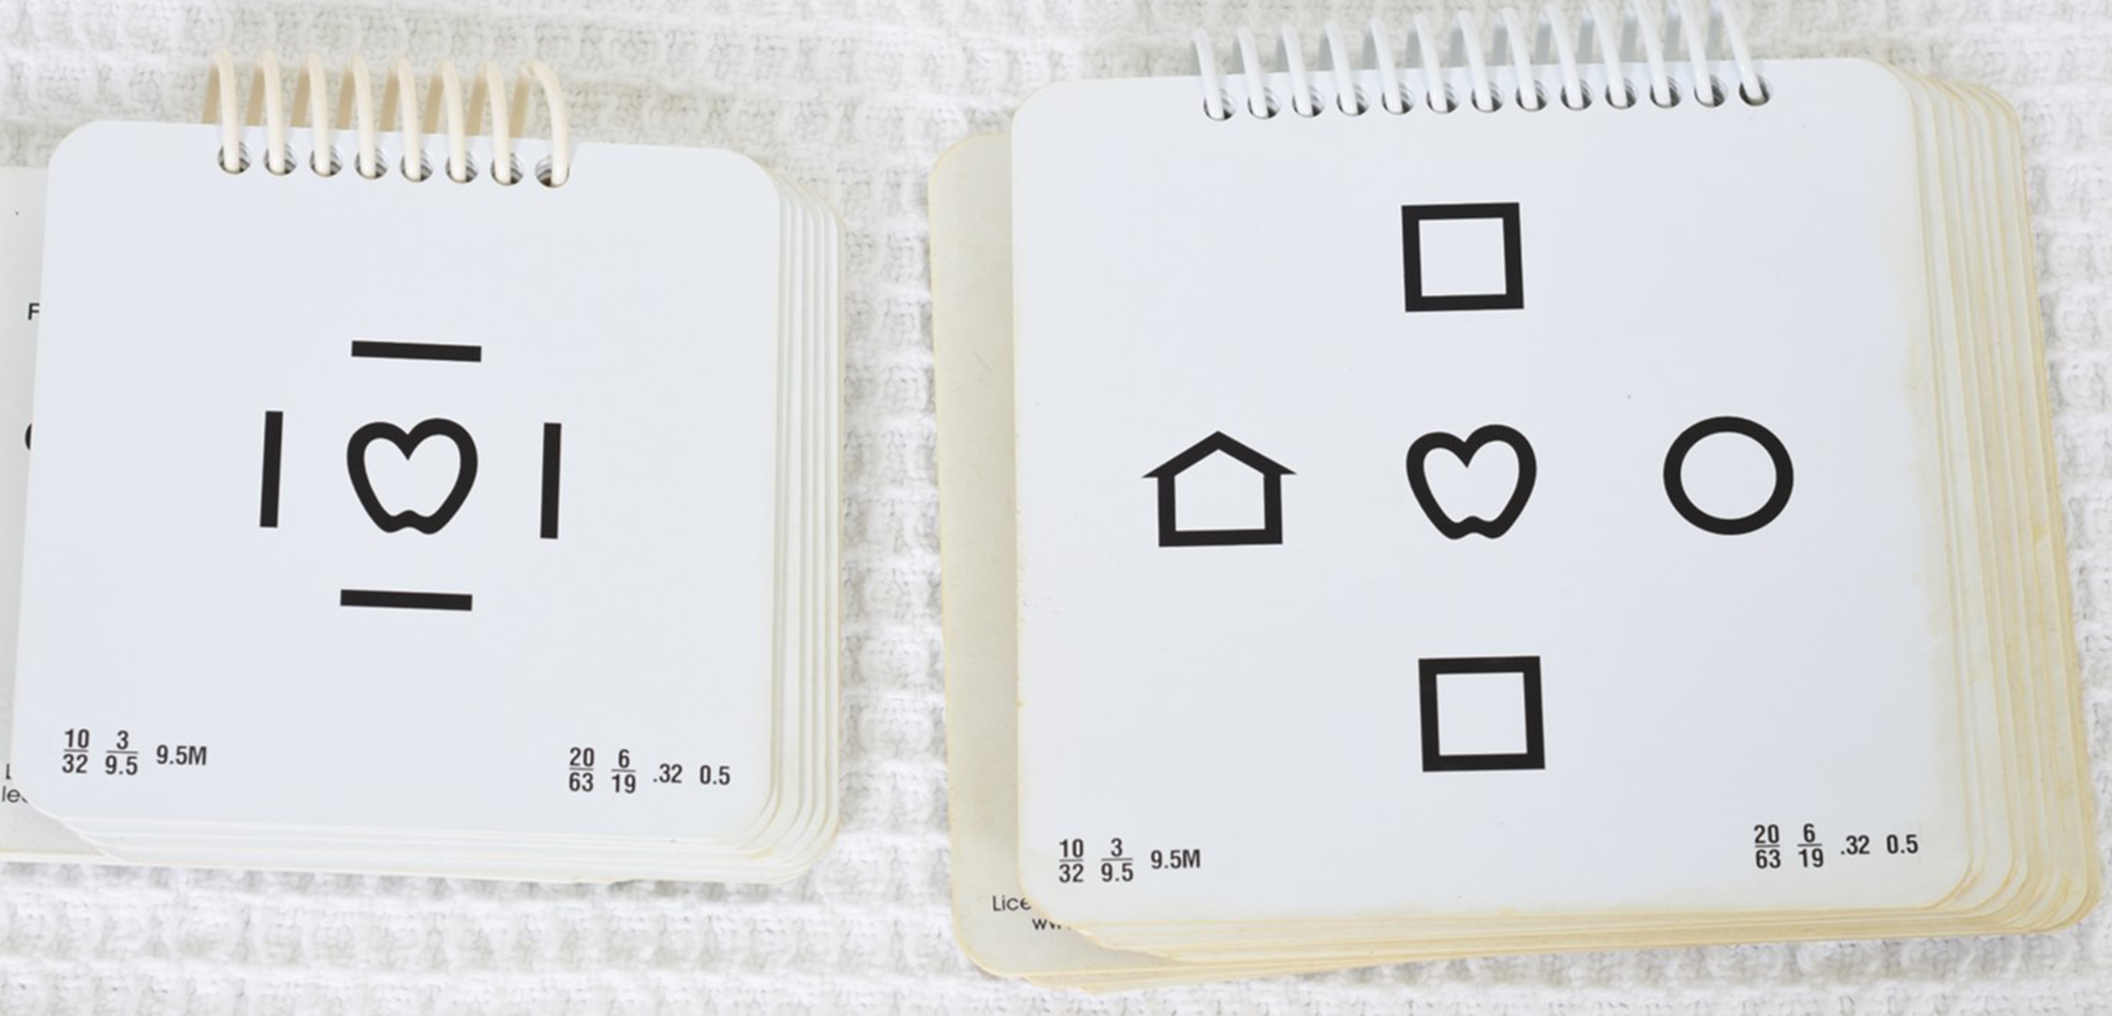
Fig 2
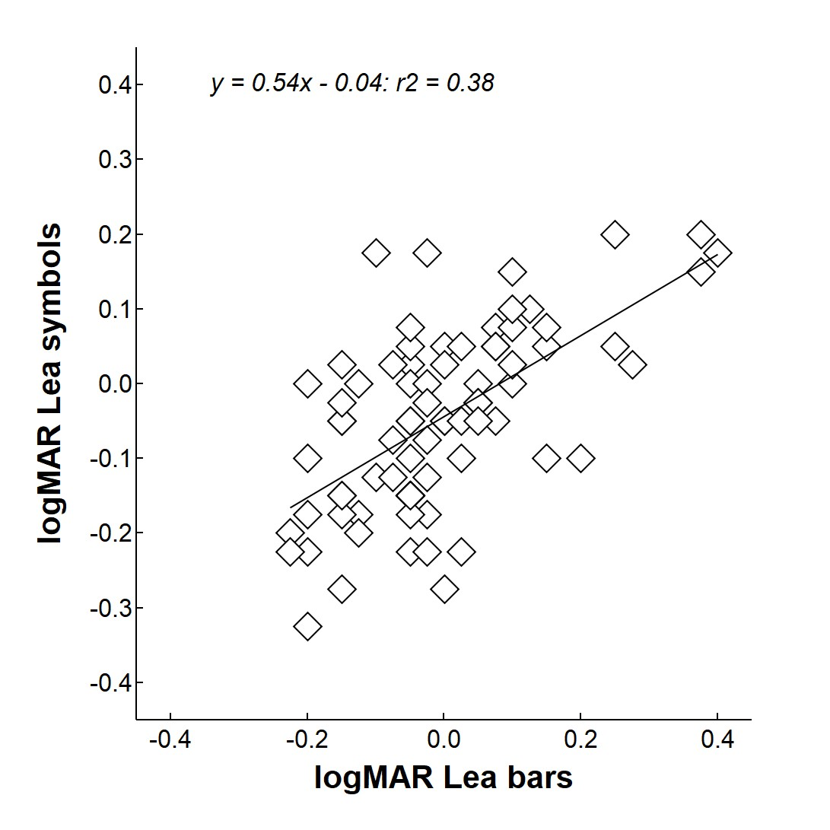
Fig 3
