Out with the Old, in with the New: How Changes in Cricket Helmet Regulations Affect the Vision of Batters
Luke Wilkinsª, David Mann^{b,c}, Stephen John Dain^{d}, Thomas Hayward^{e} and Peter Allen^{e,f}

ª Institute of Neuroscience, Newcastle University, U.K.
^{b} Department of Human Movement Sciences, Vrije University, The Netherlands
^{c} Amsterdam Movement Sciences & Institute Brain and Behaviour Amsterdam, The Netherlands
^{d} School of Optometry and Vision Science, University of New South Wales, Australia
^{e} Department of Vision and Hearing Sciences, Anglia Ruskin University, U.K.
^{f} Vision and Eye Research Unit, Anglia Ruskin University, U.K.

Corresponding author: Luke Wilkins (e: lukealexandarwilkins@gmail.com)
Out with the Old, in with the New: How Changes in Cricket Helmet Regulations Affect the Vision of Batters
The International Cricket Council recently introduced new regulations for helmets in cricket. Amongst other changes, these regulations limit batters from adjusting the gap between the peak and the grille, resulting in some controversy over whether the new helmet design reduces visibility of the ball. This study compared the visual field of individuals when wearing an old helmet that does not conform to the new regulations, and the equivalent replacement which does. The visual field of 10 male participants was tested whilst wearing an old and new helmet. The new helmet resulted in a significant reduction in the visual field of the wearer (M = 66.1 out of 76 points seen in the new helmet vs. 74.8 seen with the old helmet), with the restriction predominantly confined to the superior visual field. The new regulations do appear to restrict the visual field of batters, confirming the anecdotal reports of players. However, the majority of this restriction occurs in the superior field, suggesting that the impact on batting performance may be limited. The importance of considering the impact that new helmet regulations can have on vision, batting performance, and player safety is discussed.
Keywords: helmet; visual field; cricket; batting

Introduction
New international regulations have been introduced that are intended to improve the protection provided by cricket helmets when batting. From January 2017, all helmets worn in international matches must comply with British Standard BS7928:2013 (ICC, 2016), which, among other changes, now limits the ability of the user to alter the size of the gap between the peak and the grille of the helmet. This is an important feature from a player safety perspective, because research has found that 29% of head injuries suffered by batters are due to the ball penetrating this gap (Ranson, Peirce, & Young, 2013). This has inevitably led to the introduction of new helmets which feature a reduction in the size of the gap when compared to the older helmets. Moreover, within the standard there is no consideration of the minimum or maximum extent to which the helmet should or can obstruct a player’s field of vision (ECB, 2017). The new regulations have led to complaints from several high-profile figures in cricket (Boycott, 2016), and is perhaps best exemplified by the thoughts of ex-England captain Alistair Cook: “I feel as though I don’t see the ball as well in these new helmets, the gap is smaller and I see more of the grille than I did with the old one” (Westerby, 2016). Anecdotally then, it seems that the visual field is reduced with the new helmets, yet no study to date has tested this hypothesis.

An appreciable amount of research has demonstrated the important role of vision in cricket batting (Land & McLeod, 2000; Mann, Spratford, & Abernethy, 2013; Muller et al., 2009; Renshaw & Fairweather, 2000; Sarpeshkar, Abernethy, & Mann, 2017), with the obvious implication being that any loss of visual function can have substantial consequences for performance. In particular, research has shown that when hitting a cricket ball, rather than tracking the ball with their central vision, batters employ two strategies: i) they couple their head movements with the ball and thus rotate their head downwards at the same rate as the ball (Mann, Spratford, & Abernethy, 2013), and ii) they often use predictive saccades that move the eyes downwards between 10 and 20 degrees in advance of the head direction to predict where the ball will bounce, and then often where bat-ball contact will occur (Land & McLeod, 2000; Mann, Spratford, & Abernethy, 2013; Sarpeshkar, Abernethy, & Mann, 2017). The predictive saccades and head-ball coupling have been reported to contribute towards skill in batting, with elite batters found to rely on more consistent predictive eye movement strategies compared to lesser skilled batters (Mann, Spratford, & Abernethy, 2013). Consequently, any obstruction of the visual field, particularly in the area 10-20 degrees below the direction of the head, could potentially reduce a batter’s ability to keep the ball within view when making these head rotations and saccadic eye movements.

The anecdotal reports of cricketers who have worn the new helmets suggest that the changes to the helmets have resulted in a restriction in their visual field. The visual field reflects the extent of the external world that can be seen (Erickson, 2007). The visual field afforded by a helmet should be of particular interest for cricketers because, unlike other sports such as baseball, cycling, and motor racing, in cricket the helmets are designed such that parts of the central and inferior visual field are obscured by the grille that protects the face. Given the importance of the inferior field to a batter’s downward saccadic eye movements, it would be logical to assume that any regulations which affect the view of the inferior field could have a significant impact on batting performance. An equivalent restriction in the superior field (such as that expected with a lower peak of the helmet) may be less detrimental to batting performance because the gaze behaviour of batters does not tend to extend to this area of the visual field, except perhaps when facing spin bowlers who often release the ball using a higher arcing trajectory.

It is important that new safety equipment should avoid introducing new risks to players, such as those that would result from impaired vision (Dain, 2016). The paradoxical idea that helmet use may increase the risk of head injury is supported by Daneshvar et al., (2011). In their review of protective head equipment in sport, they state that the use of a half rather than full-shield helmet in ice hockey could impair a player’s vision and result in an increase in both the number of injuries and in the severity of those injuries. Similar concerns with regards to the restriction of vision have been expressed about the use of headgear in American football (Levy et al., 2004; Schneider, & Antine, 1965) and squash (Finch & Vear, 1998), whilst research has also suggested that helmet use may encourage greater risk-taking behaviour in skiing (Evans, Gervais, Heard, Valley, & Lowenstein, 2009). Therefore, it remains vital to evaluate the impact of new safety measures to ensure that they achieve the desired effect of increasing player safety.

In the case of the new regulations in cricket, research is required to identify whether the new regulations, in attempting to reduce the direct risks of injury to batters, have inadvertently introduced a new indirect risk by restricting the visual field. That is, whilst the new helmets may reduce the severity of any injury as a result of ball-to-helmet impact (direct risk), it is possible that a reduction in the batter’s visual field could lead to an increase in the incidence of impacts with the helmet and/or other body parts (i.e., indirect risks).

The aim of the present study was to investigate whether there is a reduction in visual field when wearing a helmet designed to meet the new international regulations in cricket. It was hypothesised that the visual field of participants would be significantly reduced when wearing a new style, post-British-standard cricket helmet when compared with the old style, pre-British-standard cricket helmet. Given the limited existing literature, this prediction was based largely on the anecdotal reports such as that from Alistair Cook (Westerby, 2016). It was also hypothesised that any significant differences in the size of the field would be most pronounced in the vertical rather than the horizontal meridian, given that the main design change in the helmets related to the spacing between the peak and the grille.

Methods

Participants
Ten male participants took part in the study. All participants played amateur cricket. The average age of the participants was 24.7 years (S.D. = 5.5; range 20-37 years). All participants who required a refractive correction wore soft contact lenses and had visual acuity of logMAR 0.0 (6/6 or 20/20) or better in each eye. Participants who didn’t require a correction had monocular vision of logMAR 0.0 or better. Because we were able to access only one particular size of the old and new helmet, we included only those participants for whom the helmet was a comfortable fit. Eight potential participants were excluded for this reason. In addition, time was taken to carefully adjust the helmet for each participant. The experimental procedure conformed to the ethical standards of the Declaration of Helsinki and was approved by the Faculty Research Ethics Panel of Anglia Ruskin University. Participants were informed about the nature of the study and gave informed consent prior to testing.

Instrumentation and Procedure
Visual field testing was performed monocularly on both eyes of each participant using a Humphrey Visual Field Analyser (VFA) with a suprathreshold 76-point 30 degree (60 degree total field) visual-field pattern (Zeiss, Oberkochen, Germany). The VFA measures the visual field using a hemisphere-shaped bowl onto which light stimuli are presented on its inner surface. Participants sat in a darkened room and placed their head on a chinrest within the hemisphere. Throughout the test participants maintained fixation on a central fixation point. Quality of fixation was assessed throughout the test (Heijl Krakau technique) alongside false negative and false positive responses to check for reliability. Stimuli were presented at different positions within the participant’s peripheral vision throughout the 60-degree visual field (Figure 1). Every light stimulus seen was confirmed with the press of a response button.

The suprathreshold program measured whether the participant could detect in specific locations in their visual field a light which was 6 dB brighter than that which an average age-matched control could detect. 76 points were presented throughout the visual field of each eye at 6 degree intervals (Figure 1).

Monocular testing was chosen because we wanted to check whether there was an asymmetry in any field loss in the two eyes. This was of particular interest because the impact of the field restriction on batting could theoretically be greater if the restriction was larger in the ‘dominant’ rather than ’non-dominant’ eye (Mann, Runswick & Allen, 2016). To estimate the binocular visual field, we used an established method that combines the two monocular fields and records each point in the visual field as ‘seen’ if it were seen by at least one of the two eyes (Nelson-Quigg, Cello, & Johnson, 2000). We return to this point shortly.

Figure 1 here

In order to allow the participants to position themselves appropriately within the perimeter whilst wearing each of the helmets, the front of the Visual Field Analyser was adapted by removing the original front of the field screener and replacing it with an adapted front that had the chin rest located lower within the viewing aperture. An opaque patch was placed over the eye not being tested.

The visual field of each participant was tested using both the new and the old- style helmet. For the ‘new’ helmet, participants wore a helmet that conformed to the new British-standard regulations (Masuri Vision Series Test; M-VSTSSN), whilst the ‘old’ model was the equivalent model that did not meet the new regulations (Masuri Titanium Test Elite; CS:1-2012). Participants were asked to place the helmet on their head and adjust it so that it was both comfortable and secure. Participants confirmed they could clearly see the fixation spot. If this was not the case the position of the participants was adjusted to ensure that they were in the correct viewing position. A spirit level was placed on the side of the helmet to make sure that the participants were not leaning forwards or backwards (so the spirit-level bubble was positioned in the central portion of the level). Participants performed the test seated, but were asked to adopt a head posture that would be used when batting, that is, so that both eyes had an unobstructed view of the target. The visual field tests were conducted on the right eye, followed by left eye, for each of the helmet designs, with the order of presentation of the two helmets allocated in a randomised order.

The monocular visual field plots for each helmet were combined to form an integrated binocular plot (Nelson-Quigg et al., 2000). Using the best location method for combination, all corresponding points from the right and left eye were numbered and compared (Figure 1). For the binocular plot, each point in the visual field was determined as being ‘seen’ if at least one of the two eyes could see the light in that corresponding direction. In addition to this, the visual field was broken down into five sections in order to investigate whether any areas were differentially affected by the introduction of the new helmet. These five sections were defined as the superior visual field (consisting of visual field points 1 to 20), upper central visual field (points 21-56), central visual field (points 57-96), lower central visual field (points 97-132), and inferior visual field (points 133-152).

Although batters move their head while batting (Mann, Spratford & Abernethy, 2013), this means that so too does any visual field restriction imposed by a helmet. In order to establish the extent of any visual field restriction, it is imperative for participants to keep their head still in a consistent position during the test. If participants were to move their head during the test, but kept their gaze directed towards the central target, then the position of any visual field restriction would move commensurate with the head movements. By adopting the batting posture during the test, the demands of batting were replicated as closely as possible while also ensuring sufficient experimental control by using the gold-standard clinical paradigm for measuring the extent of the visual field.

Statistical Analyses
Data were analysed using SPSS Statistics version 23. Paired samples t-tests were used to investigate the difference in the number of points seen on the visual field test between the old and new helmet. Further paired-samples t-tests were conducted for each individual visual field point in order to identify the location of any potential differences in visual field visibility between the two helmets. An alpha level of p = .05 was used to indicate significance.

Results
The size of the binocular visual field was clearly compromised when wearing the new helmet, with only M = 66.1 out of 76 points seen when compared to M = 74.8 out of 76 points with the old helmet (t(9) = 7.18, p < 0.001, d = 2.91, 95% CI for difference [5.96, 11.44]). Analyses of the monocular visual field data for each eye revealed a similar pattern, with 60.9 points seen in the left eye with the new helmet vs. 72.3 points in the old helmet (t(9) = 16.23, p < 0.001, d = 3.66, 95% CI [9.81, 12.99]). An average of 61.5 points were seen with the right eye in the new helmet, compared to 70.5 points in the old helmet (t(9) = 3.92, p = 0.004, d = 1.79, 95% CI [3.81, 14.19]). The Cohen’s effect size values suggest a large difference between the two helmets when comparing both binocularly and monocularly. The discrepancy between the old and new helmet did not differ between the left and right eye (p = 0.265). The total number of points seen by each participant (Table 1) shows that in only one instance did the new helmet afford a larger visual field than the old helmet, specifically increasing the size of the visual field in only the right eye of Participant 4.

Table 1 here

An analysis of the locations in which the visual field was restricted revealed that most changes occurred in the superior visual field. The heatmaps (Figure 2) show that all ten participants experienced a restriction to their superior visual field whilst wearing the new helmet, whereas considerably fewer participants (up to three) experienced any restriction to their inferior field. Figure 3 confirms the extent of the superior and inferior field losses.

When each individual point in the monocular visual field plots was compared, it was only those points in the superior field for which there was a significant decrease in the number of batters who could see when wearing the new helmet (Table 2). The differences between all other points (i.e. 11-76) were non-significant (p > 0.05).

Table 2 here

Figure 2 here

Figure 3 here

Finally, a post-hoc analysis of batting averages using publicly available statistics was conducted to compare the performance of English county batters prior to the introduction of the new helmet regulations to that following the new regulations. Only players who batted in a minimum of 16 first class innings for the same English county team in both the seasons before and after the introduction were included (2015 and 2016 seasons respectively). Additionally, players from teams that changed divisions (due to promotion/relegation) between these seasons were also excluded from analysis. 76 players fit these criteria and thus were used in the analysis. A paired-samples t-test found there to be a significant difference in batting average between 2015 (M = 31.76, S.D. = 10.41) and 2016 (M = 36.19, S.D. = 14.41); t(75) = -3.11, p = 0.003, d = -0.36, 95% CI [-7.28, -1.59]. Perhaps surprisingly, batting performance improved in the season following the new helmet regulations, with the Cohen’s effect size value suggesting a small-to-moderate difference in batting average. Incidentally, Alistair Cook’s test batting average has dropped from 47.05 runs per innings before the regulation, to 43.49 since the new regulation was introduced (as of February 1st, 2018).

Discussion
An abundance of literature has demonstrated the importance of vision for cricket bat- ting performance (Land & McLeod, 2000; Mann, Spratford, & Abernethy, 2013; Muller et al., 2009; Renshaw & Fairweather, 2000; Sarpeshkar, Abernethy, & Mann, 2017), and thus, examining whether a reduction in visual field occurs with the new helmet regulations is an important issue. The results of this study show that the new style, post-British-standard cricket helmet produces a large and significant reduction in the extent of the visual field when compared to the old style, pre-British-standard cricket helmet. It was also found that the primary restrictions occurred in the superior field of view. Some decreases in vision occurred in the inferior visual field, though these were restricted to only a few participants. In addition, an analysis of batting averages found a significant, small-to-moderate improvement in performance following the introduction of the new regulations.

The restriction to the superior visual field may help to largely explain the perception of batters – such as Alistair Cook – that vision is worse with the new-style helmet. However, a loss in superior vision should not profoundly influence batting performance, and this is supported by the data of batting averages (except for Cook’s own average!). A restriction of the superior field should not influence performance because, when batting, the ball generally moves down in the visual field (except perhaps when facing spin bowlers), with batters using fast saccadic eye movements to rotate gaze downwards to predict (i) where the ball will bounce, and (ii) where they will make contact with the ball (Mann, Spratford, & Abernethy, 2013; Sarpeshkar, Abernethy, & Mann, 2017).

This then leads us to the perhaps the most important question to address, and that is whether the new helmets increase any restriction to the inferior field of view. The requirement to decrease the gap between the grille and peak of the helmet means that the grille may have in many cases moved upwards, and closer to the line of sight of the batter. The results of this study show that the new helmet did impair the inferior field of view for three of the ten participants when wearing the new helmet. This may be because the location of the face grille coincided with the location of the visual field test points in the inferior field of those batters, whereas the test lights fell in between the grille for the other participants. Given that this occurred more when wearing the new-style helmet, this does suggest that, when making predictive saccades downwards, vision is more likely to be obscured by the position of the grille. In support, these restrictions occurred 10-30 degrees below the participant’s line-of-sight, meaning that it is certainly possible that some if not many batters are noticing the grille more when moving their eyes downwards to predict the future location of the ball (at bounce and contact). Whilst batting averages do not seem to have been negatively impacted by the new regulations, a more controlled examination of changes in batting performance comparing the old and new helmet is warranted. Future studies may also wish to take advantage of eye-tracking technology during batting performance in-situ to investigate this.

The new regulations introduced by the International Cricket Council extend beyond a requirement for the helmet to be used only by batters, including also all instances where a helmet is worn in international cricket. Accordingly, the helmets worn by fielders such as the wicketkeeper, and those at silly point or short leg, will also need to conform to the new standard (note, the wearing of a helmet is optional, but if worn it must meet the new regulations). Consequently, it is possible that decreases in performance may be found with the new helmets in these scenarios. Indeed, given that the ball would be likely to follow an upwards trajectory for part of its flight in many instances when fielding – and therefore eye gaze would enter into the newly reduced superior field – decreases in fielding performance may be expected. This may be worth investigating in future work.

It is important for future work to establish how widely these results generalise across all of the helmets that meet the new regulations. Currently the Masuri Vision helmet is one of 13 different brands recognised by the ECB as meeting the new British Standard (ECB, 2017). And whilst the new regulations are likely to have the same design implications for all models (i.e. it is unlikely that one model manages to accommodate the requirements without reducing the gap between the peak and the grille), it is possible that the exact areas in which the restriction occurs may vary. That said, given that Masuri have partnerships with numerous cricket teams at both an international and club level (including the Australian and New Zealand national sides), it is reasonable to assume that many players have experienced the specific visual restrictions found in this study.

It is quite possible that batters who feel that the new helmets restrict their vision may, consciously or subconsciously, alter their stance in order to overcome any deficiencies. This presents an interesting dilemma, because such an alteration should not, in theory, be necessary when facing most types of bowling, yet the comfort of an athlete should be of prime importance when performing in their sport. This issue warrants further investigation, as if it is found that batters are modifying their stance, then the implications from a coaching perspective are considerable.

Practical Implications
- The findings of the present study substantiate claims made by players such as Alistair Cook that the new helmet regulations reduce the visual field of cricket batters.
- However, an analysis of batting averages suggests the impact on batting performance may be minimal; a view supported by research showing that superior vision (the area predominantly affected) is less important than inferior vision.
- Given the likely differences in gaze behaviour between batters and fielders, it is possible that the new helmet regulations could have a negative effect on performance when performing other roles that require a helmet (e.g. wicketkeeper, silly point, and short leg). Consequently, it may be beneficial for helmet regulations and helmet designs to vary according to the role (i.e. batter or fielder).

Conclusion
Given the high-profile injuries that have occurred in recent years, it is understandable that cricket’s governing bodies have responded quickly to these safety concerns by introducing new helmet regulations. However, it is important that these changes also take into account the role that vision plays in cricket. This study demonstrates that the new regulations do restrict the visual field of individuals, but that this restriction is largely confined to the superior field which, from a performance perspective, is likely to be less important than a restriction to the inferior field of view. These findings may explain both the complaints made by players, as well as the lack of effect on performance as indicated by batting averages. Despite this, given the substantial research demonstrating the importance of vision in cricket (Land & McLeod, 2000; Mann, Spratford, & Abernethy, 2013; Muller et al., 2009; Renshaw & Fairweather, 2000; Sarpeshkar, Abernethy, & Mann, 2017), it is important that future regulations take into consideration visual requirements when developing and introducing new regulations.

Disclosure Statement
No potential conflict of interest was reported by the authors.

References

1. Boycott, G. (2016). This cissy society forcing Alistair Cook to wear an approved helmet is modern-day bureaucracy gone mad. The Telegraph. Retrieved from http://www.telegraph.co.uk/cricket/2016/04/19/this-sissy-society-forcing-alastair-cook-to-wear-an-approved-hel/.
2. Dain, S.J. (2016). Sports eyewear protective standards. Clinical and Experimental Optometry, 99(1), pp. 4-23.
3. Daneshvar, D.H., Baugh, C.M., Nowinski, C.J., McKee, A.C., Stern, R.A., & Cantu, R.C. (2011). Helmets and mouth guards: The role of personal equipment in preventing sport-related concussions. Clinics in Sports Medicine, 30(1), pp. 145-163.
4. ECB (2017). ECB and PCA Guidance: Head Protectors/Helmets. Retrieved from www.ecb.co.uk/concussion-in-cricket/helmets.
5. Erickson, G. (2007). Sports vision: Visual care for the enhancement of sports performance. Missouri, USA: Butterworth Heinemann, Elsevier.
6. Evans, B., Gervais, J.T., Heard, K., Valley, M., & Lowenstein, S.R. (2009). Ski patrollers: Reluctant role models for helmet use. International Journal of Injury Control and Safety Promotion, 16(1), pp. 9-14.
7. Finch, C., & Vear, P. (1998). What do adult squash players think about protective eyewear? British Journal of Sports Medicine, 32, pp. 155-161.
8. International Cricket Council (2016). Clothing and Equipment Rules and Regulations – Effective 22 September 2016. Retrieved from www.icc-cricket.com/about/cricket/rules-and-regulations/playing-conditions.
9. Land, M.F., & McLeod, P. (2000). From eye movements to actions: how batsmen hit the ball. Nature Neuroscience, 3(12), pp. 1340-1345.
10. Levy, M.L., Ozgur, B.M., Berry, C., Aryan, H.E., & Apuzzo, M.L.J. (2004). Birth and evolution of the football helmet. Neurosurgery, 55, pp. 656-662.
11. Mann D.L., Runswick O.R., & Allen P.M. (2016). Hand and eye dominance in sport: Are cricket batters taught to bat back-to-front? Sports Medicine, 46(9), 1355-63.
12. Mann, D.L., Spratford, W., & Abernethy, B. (2013). The head tracks and gaze predicts: how the world's best batters hit a ball. PLOS One, 8(3), e58289.
13. Muller, S., Abernethy, B., Reece, J., Eid, M., McBean, R., Hart, T., & Abreu, C. (2009). An in-situ examination of the timing of information pick-up for interception by cricket batsmen of different skill levels. Psychology of Sport and Exercise, 10(6), pp.644-652.
14. Nelson-Quigg, J.M., Cello, K., & Johnson, C.A. (2000). Predicting binocular visual field sensitivity from monocular field results. Investigative Ophthalmology & Visual Science, 41(8), pp. 2212-2221.
15. Ranson, C., Peirce, N., & Young, M. (2013). Batting head injury in professional cricket: a systematic video analysis of helmet safety characteristics. British Journal of Sports Medicine, 47(10), pp. 644-648.
16. Renshaw, I., & Fairweather, M.M. (2000). Cricket bowling deliveries and the discrimination ability of professional and amateur batters. Journal of Sports Science, 18(12), pp. 951-957.
17. Sarpeshkar, V., Abernethy, B., & Mann, D.L. (2017). Visual strategies underpinning the development of visual-motor expertise when hitting a ball. Journal of Experimental Psychology: Human Perception and Performance, 43(10), pp. 1744-72.
18. Schneider, R.C., & Antine, B.E. (1965). Visual-field impairment related to football headgear and face guards. The Journal of the American Medical Association, 192(7), pp. 616-618.
19. Westerby, J. (2016). Cook: I still can’t see ball in my new helmet. The Times. Retrieved from www.thetimes.co.uk/edition/sport/cook-i-still-cant-see-ball-in-helmet-7fzk7xdg3.

Table 1. Number of points seen (out of 76) by each participant using the old style, pre-British-standard helmet (‘Old’) and the new style, post-British-standard helmet (‘New’).

Participant | Binocular |  | Left Eye |  | Right Eye
 | Old | New | Old | New | Old | New
1 | 75 | 57 | 70 | 53 | 70 | 53
2 | 76 | 67 | 73 | 62 | 66 | 62
3 | 76 | 68 | 76 | 65 | 75 | 63
4 | 74 | 70 | 74 | 65 | 55 | 64
5 | 76 | 67 | 73 | 63 | 75 | 65
6 | 72 | 62 | 71 | 59 | 71 | 59
7 | 76 | 67 | 74 | 64 | 73 | 59
8 | 76 | 67 | 72 | 62 | 75 | 62
9 | 72 | 66 | 71 | 59 | 72 | 64
10 | 75 | 70 | 69 | 57 | 73 | 64

Table 2. Analysis of each individual location in the visual field plot (binocular). Only the points which significantly differed between the old and new helmet are included. Points 11-76 were non-significant.

Visual Field Plot Point | Old  Mean (S.D.) | New  Mean (S.D.) | Paired samples t-test
1 | 0.7 (0.483) | 0.2 (0.422) | t(9) = 3.000, p = 0.015
2 | 0.8 (0.422) | 0.4 (0.516) | t(9) = 2.449, p = 0.037
3 | 0.7 (0.483) | 0.1 (0.316) | t(9) = 3.674, p = 0.005
4 | 0.7 (0.483) | 0.1 (0.316) | t(9) = 3.674, p = 0.005
5 | 1.0 (0.000) | 0.1 (0.316) | t(9) = 9.000, p < 0.001
6 | 1.0 (0.000) | 0.3 (0.483) | t(9) = 4.583, p = 0.001
7 | 1.0 (0.000) | 0.3 (0.483) | t(9) = 4.583, p = 0.001
8 | 1.0 (0.000) | 0.2 (0.422) | t(9) = 6.000, p < 0.001
9 | 1.0 (0.000) | 0.1 (0.316) | t(9) = 9.000, p < 0.001
10 | 1.0 (0.000) | 0.2 (0.422) | t(9) = 6.000, p < 0.001

Figure 1. The locations of stimuli presented to the right eye (A) and the left eye (B). The monocular visual field plots for each helmet were combined to form an integrated binocular plot. Numbers represent a point on the visual field and are paired together such that the respective odd number in the right eye corresponds with even number above it in the left eye, e.g. numbers 1 & 2 correspond to the same point on the visual field, but for the right eye and left eye respectively.

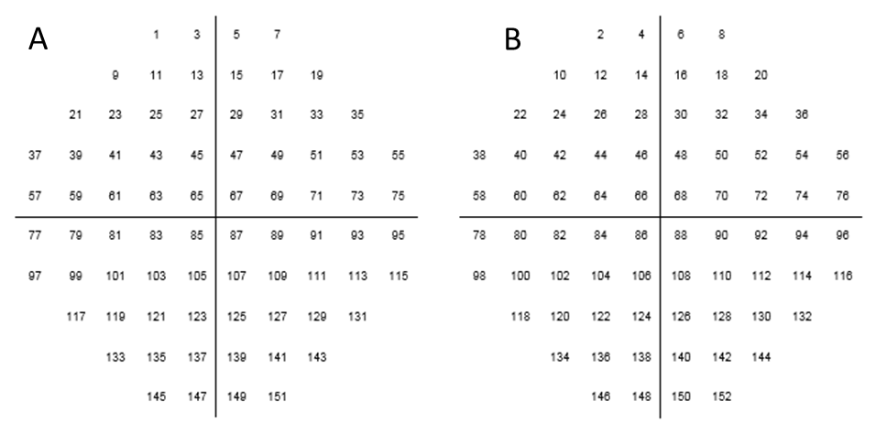

Figure 2. Visual fields with the old and new style cricket helmets. The first two columns show heatmaps which demonstrate the percentage of participants who saw the suprathreshold stimulus (6dB above age norms) in each of the 76 points tested within the central 30 degrees of visual field. The heatmaps in the third column compare vision with the old and new helmet by subtracting the percentage of participants who saw each stimulus in the old helmet from the percentage with the new helmet. Values greater than zero (up to 100%) indicate that vision was better with the new helmet whereas values less than zero (to -100%) indicate that vision was worse with the new helmet.

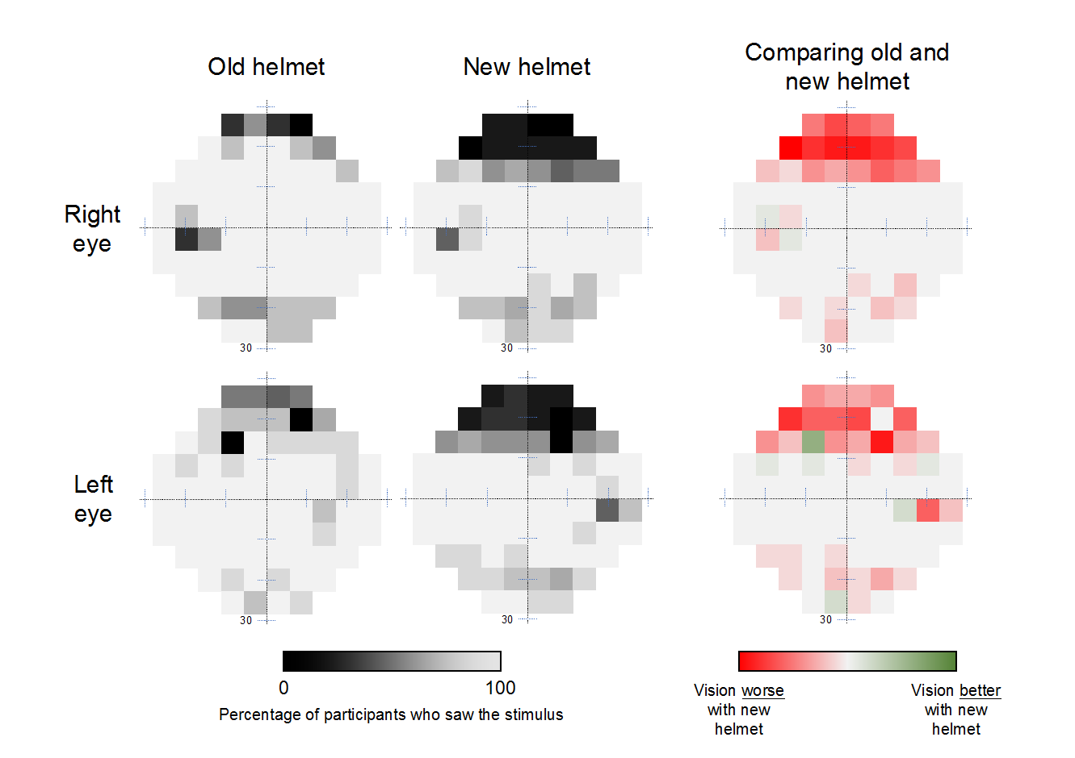

Figure 3. Breakdown of the percentage of plot points seen by all participants across different sections of the visual field. The superior section includes points 1-20, upper central section includes points 21-56, central section includes points 57-96, lower central section includes points 97-132, and inferior section includes points 133-152.

