Feasibility study of human corneal endothelial cell transplantation using an in vitro human corneal model
Kostadin Rolev, PhD ^{a, c}, Dominic G O’Donovan, MBChB, FRCPath ^{d}, Peter Coussons, PhD ª, Linda King, PhD ª, Madhavan Rajan, MD FRCS FRCOphth ^{a, b}

Conflict of interest statement: none.

- Anglia Ruskin University,
Department of Biomedical and Forensic Sciences
and the Vision & Eye Research Unit
Cambridge, Cambridgeshire, UK, CB1 1PT

e-mail: k.rolev@imperial.ac.uk
e-mail: madhavan.rajan@addenbrookes.nhs.uk
e-mail: peter.coussons@anglia.ac.uk
e-mail: linda.king@anglia.ac.uk

- Department of Ophthalmology, Cambridge University Hospitals,
Hills Road, Cambridge, Cambridgeshire, UK, CB2 0QQ

e-mail: madhavan.rajan@addenbrookes.nhs.uk

- Present address:

Imperial College London
Department of Bioengineering
Royal School of Mines,
Prince Consort Rd, South Kensington,
London, UK SW7 2BP

e-mail: k.rolev@imperial.ac.uk

- Dept. of Histopathology
Cambridge University Hospitals,
Hills Road, Cambridge, Cambridgeshire, UK, CB2 0QQ

e-mail: dominic.odonovan@addenbrookes.nhs.uk

Abstract
Purpose: To test the feasibility of a cell-therapy approach to treat corneal endothelial (CE) disorders using an in vitro model of human corneal decompensation.
Materials and Methods: A CE decompensation model was established by removal of the DM/Endothelium complex from human cadaveric corneas in an air-interface organ culture system (Group 2) and compared to normal corneas (Group 1). The posterior stroma of decompensated corneas was seeded with immortalized human corneal endothelial cells (HCEC-12) in Group 3 and passage 0 primary human corneal endothelial cells (hCECs) in Group 4 corneas. Functional effects on stromal thickness were undertaken with histological analysis 3-10 days post-cell therapy treatment.
Results: The removal of the DM/Endothelium complex in Group 2 corneas resulted in a stromal thickness of 903 ± 86 μm at 12 hours in comparison to 557 ± 72 μm in Group 1 corneas. The stromal thickness reduced from 1218 ± 153 μm to 458 ± 90 μm (63 ± 6 %, p=0.001) post cell transplantation in Group 3) and from 1100 ± 86 μm to 489 ± 94 μm (55 ± 7 %, p=0.00004 in Group 4 respectively. Post-transplantation histology demonstrated the formation of a monolayer of corneal endothelium attached to the posterior stromal surface.
Conclusion: Direct transplantation of cultured hCECs and immortalized HCEC-12 to bare posterior corneal stroma resulted in the formation of an endothelial monolayer and restoration of stromal hydration to physiological thickness, demonstrating the feasibility of cell therapy in the treatment of corneal endothelial decompensation in a human in vitro model.
Keywords: Corneal endothelium – Human corneal endothelial cell culture – Corneal endothelial cell transplantation – cell therapy approach.
Abbreviations: CE – corneal endothelial, DM – Descemet’s membrane, Optical coherence tomography (OCT), human corneal endothelial cells (hCECs)

Introduction
The human corneal endothelial cells lack self-renewal potential due to being arrested in G1 phase of the cell cycle^{1, 2}, which is mediated by TGF-β and contact inhibition^{3, 4}. Therefore, current treatments for corneal endothelial disorders rely on human cadaveric donor corneal transplantation for visual rehabilitation.⁵ Newer techniques in corneal transplantation had resulted in lowering of visual thresholds for surgical intervention with consequent increase in demand on eye bank services across the world. Consequently cell therapy research had gained popularity to explore solutions to replace corneal organ transplantation in the rehabilitation of patients with severe corneal endothelial disorders. Cell therapy approach for treating corneal blindness had been undertaken in a variety of animal models, such as rabbit⁶⁻¹³, rat^{14,15}, primate^{16,17}, feline¹⁸⁻²⁰ or ex vivo porcine eye.²¹ The rabbit and the rat have been documented as species whose corneal endothelium has the capacity to renew itself through proliferation^{22, 23}, whereas primates and cats seem to possess limited self-renewal potential similar to humans^{22, 24}. Since the human corneal endothelium lacks proliferative capacity it would be more beneficial to use a model, which will make any data generated with it more clinically relevant.
A number of studies have also explored the potential of human corneal endothelial cell (hCEC) seeding directly on human cadaveric corneas²⁵⁻³¹ or have investigated the use of decellularized human corneal stroma³² or human stromal lamellae as carriers for hCEC transplantation³³ and showed positive effects on diminishing corneal oedema and restoring normal corneal thickness. In addition, if such research is undertaken on cadaveric human corneas, it could partly overcome the species bias inherent in using animal models. Thus, in this study we have established an in vitro human model of CE decompensation by surgically removing the DM/Endothelium complex from human cadaveric donor corneas. These decompensated corneas were then used as a test model for cell transplantation of primary and in vitro cultured human corneal endothelial cells to the posterior corneal stroma.

Materials and Methods
Cadaveric human donor corneas. Human donor corneas (n=22, see Table 1) for this study were procured from the national eye banks UK with consent for research and the project was approved by Anglia Ruskin University Research Ethics committee (RESC080). The experiments were undertaken in Human Tissue Authority (HTA) approved research facility. The study adhered to the principles in the Declaration of Helsinki. None of the tissue donors were from a vulnerable population and all donors or next of kin provided written informed consent for use of corneas for research purposes. The corneas were stored in Eagle’s Minimum Essential Medium (MEM) supplemented with 2 % foetal bovine serum (FBS) at 37ºC. The age of all the donor corneas ranged between 29 – 89 years with a mean age of 63 ± 16 years. The period in storage prior to experimentation for all corneas ranged from 29 – 60 days with a mean of 43 ± 12 days.

Table 1 – Human donor corneas used in this study.
Human donor corneas | Group 1 | Group 2 | Group 3 | Group 4 | P value
Number of corneas | 6 | 5 | 6 | 5 | -
Age +/- SD | 67 ± 20 (range - 29-89) | 52 ± 22 (range – 29-76) | 60 ± 13 (range 46-78) | 66 ± 12 (range – 46-76) | 0.598
Sex (M/F) | 2:4 (Male to Female) | All female | 3:3 (Male to Female) | All female | -
Post mortem time (days +/- SD) | 39 ± 13 (range 29-57) | 31 ± 3 (range - 29-35) | 47 ± 13 (range 30-60) | 51 ± 7 (range 44-60) | 0.055
Endothelial density | 2002 ± 357 (range - 1670-2500) | N/A | N/A | N/A | -
Descemet’s membrane | Intact | Removed | Removed | Removed | -
Type of cells | Normal Endothelium | Removed | HCEC-12 | Primary hCECs | -
Cell seeding density | N/A | N/A | 310,000 cells/200μl | 260,000 cells/200μl | -

Corneal endothelial decompensation model. Removing the DM/Endothelium complex was undertaken as follows in Group 2 corneas to establish corneal stromal decompensation. The corneas were placed with the endothelial side facing upwards on a trephine base (Coronet, Network medical Ltd, UK) and were stained for 30 seconds with 0.05% trypan blue (TB; ALCHIMIA S.r.l, Austria). Subsequently, the corneal endothelium was washed with un-supplemented basal culture medium F99 (mixture of Ham’s F12 and Medium 199 in 1:1 ratio) or OptiMEM-I (Invitrogen by Life Technologies). The corneas were placed endothelial side up on corneal holders and 0.5 ml basal culture medium were added in order to keep the endothelium moist. The peripheral DM and trabecular meshwork margin were identified under a surgical microscope (Zeiss Lumera 300) and scored 360 degrees circumferentially using a Sinsky hook. Subsequently, the edge of the DM was lifted off the posterior corneal stroma and manually peeled off centripetally with non-toothed surgical tissue holding forceps. Care was taken not to disturb the underlying stroma whilst scoring the Descemet’s membrane. The stroma was wiped with a sterile spear to ensure all remaining Descemet’s membrane was completely removed. Human corneas with intact DM/Endothelium complex were used as a positive control for normal CE function (Group 1). The corneal endothelial cell density for Group 1 (normal corneas) provided by the eye bank ranged from 1670 – 2200 cells/mm² with a mean of 2002 ± 357 cells/mm².
In vitro air-interface corneal organ culture. Eye bank corneas were received in immersion organ culture conditions. However, for the experiments during which the corneal endothelial function was assessed all corneas were kept at 37ºC, 5% CO₂ humidified incubator in in vitro air-liquid interface organ culture, which allowed the corneas to be cultured in conditions that mimic normal physiological conditions where the epithelial side of the cornea maintains contact with the air (air-liquid interface). A Barron artificial anterior chamber was used, which consists of three parts: a base, a tissue holder and a locking ring (See Fig. 1). The model allowed exchanging of the culture medium by injection of fresh medium through the port connectors and also allowed controlled moisturizing of the epithelial side of the cornea.
Normal human corneas with intact DM/Endothelium complex (Group 1), decompensated human corneas (Group 2) and the cell therapy treated Groups 3 and 4 were cultured using the in vitro set-up described above. Fresh pre-warmed to 37ºC culture medium was injected into the Barron artificial anterior chamber and the epithelial side of the corneas was moistened with 200 μl of medium every hour and maintained in incubator at 37 degrees Celsius (ºC) and 5% carbon dioxide (CO₂) in humidified environment. The central corneal thickness was measured using anterior segment optical coherence tomography (OCT) (Zeiss Visante Germany) on an hourly basis for 12 hours and recorded for analysis. The corneas devoid of DM/Endothelial complex were similarly mounted on chambers and corneal thickness measured over 12 hours.
Culture of an immortalized human corneal endothelial cell line HCEC-12
The HCEC-12 cell line, established in 1996 from normal corneal endothelial cells of a 91-year-old Caucasian woman transformed with the early region of the Simian virus 40 (SV40) genome including genes encoding large T-antigen and small t-antigen, was obtained from the Leibniz Institute DSMZ (German collection of Microorganisms and Cell Cultures). HCEC-12 cells were cultured using F99 (mixture of Ham’s F12 and Medium 199 in 1:1 ratio), 10% FBS in a humidified incubator with 5% CO₂ at 37ºC. The medium was changed every 2 days. Confluent cultures were split 1:2 to 1:4 every 4-5 days using 0.05% trypsin/EDTA. A cell seeding density of 310,000 cells in 200μl per cornea was used for transplantation (Group 3).
Immunocytochemistry HCEC-12 cells were cultured on chambered coverslips using F99 (Ham's F12/Medium 199 1:1 mixture), 8% FBS. 10 % Paraformaldehyde (PFA) solution was used to fix the cells for 10 minutes at room temperature followed by a phosphate-buffered saline (PBS) wash. Blocking solution (10% FBS, 0.1% TritonX-100 in PBS) was added and the cells were incubated for 1 hour at room temperature. Primary antibodies against Na⁺/K⁺ ATPase and Zonula occludens-1 (ZO-1) (Abcam, Cambridge, UK) were diluted in blocking solution in a 1:100 dilution. The cells were incubated with the primary antibodies overnight at 4ºC followed by a PBS wash. The secondary antibodies were diluted in blocking solution with Hoechst deoxyribonucleic acid (DNA) stain and were incubated for 1 hour at room temperature. DAKO mounting medium was used to mount a coverslip.
Primary human corneal endothelial cell isolation and transplantation
The DM/Endothelium complex from normal cadaveric human corneas (n=5, mean age - 66 ± 12 years; mean post-mortem time - 51 ± 7 days) was peeled as described in section ‘Corneal endothelial decompensation model’. After the DM was peeled off it was placed in a T25 tissue culture flask with 1 ml 0.05% Trypsin/EDTA (Sigma Aldrich, T3924). Primary human corneal endothelial cells were isolated by incubating for 15-20 minutes at 37ºC, 5% CO₂ in a humidified incubator. The cell detachment was facilitated by gently tapping the flask periodically. After the cells were completely dissociated from the Descemet’s membrane 20 ml of OptiMEM-I supplemented with 8% foetal bovine serum (FBS), 5 ng/ml epidermal growth factor (EGF), 20 μg/ml ascorbic acid, 200 mg/L calcium chloride, 0.08% chondroitin sulfate and 50 μg/ml gentamicin were added to dilute and inhibit the trypsin/EDTA. The cells were then briefly peletted by centrifugation and were then immediately seeded to the posterior stroma of Group 4 donor corneas devoid of DM at a cell seeding density of 260,000 cells/200μl per cornea (Group 4).
Transplantation procedure. Briefly, corneas devoid of DM were held in 50 ml centrifuge tubes with posterior surface facing up and the primary and in vitro cultured hCECs were delivered to the posterior concavity in 200μl of F99, 8% FBS (Group 3), or OptiMEM-I supplemented with 8% foetal bovine serum (FBS), 5 ng/ml epidermal growth factor (EGF), 20 μg/ml ascorbic acid, 200 mg/L calcium chloride, 0.08% chondroitin sulfate and 50 μg/ml gentamicin (Group 4) at defined seeding density. This set up was left undisturbed for a period of 2 hours following which the corneas were immersed in 20 ml F99 (Group 3) and OptiMEM-I (Group 4) and incubated for 3 and 10 days respectively. The proliferative capacity of primary CE cells were slower than that of the HCEC-12 and this was confirmed in in vitro culture in the observation of confluence intervals. Accordingly, experiments were tailored to allow sufficient time for Primary CE’s to adhere and stabilise to the new substrate with 10 days compared to 3 days for HCEC-12 transplanted corneas. Following this, the treated corneas were removed from the 50 ml centrifuge tubes and were mounted on the air-liquid interface model with epithelial surface facing up and endothelial surface was perfused with medium. The corneal thickness measurements were undertaken in the air-interface set up and recorded in regular intervals for analysis.
Evaluation of corneal thickness using anterior segment Optical Coherence Tomography. Zeiss Visante Optical Coherence Tomography (OCT) was used to scan the corneas and to acquire a cross-section image at specific orientations, ranging between 0º-180º, 45º-225º, 90º-270º, 135º-315º. For each cornea 7 individual measurements across a 6 mm diameter in the 4 above-mentioned orientations were completed. A total of 28 measurements were performed for each cornea at regular time intervals and the average calculated for analysis. All corneal thickness assessment was performed in the air-interface set up.
Histology. Following each experiment the human corneas were fixed in 10% formalin for 10 min at room temperature and were stored at 4ºC for histological processing and hematoxylin and eosin (H&E) staining.
Statistical analysis. Single factor ANOVA test was used for statistical analysis to determine differences in corneal thickness measurements between corneal groups 1, 2, 3 and 4. Post hoc t tests (Bonferroni corrected) were used to compare the corneal thickness of the different groups of corneas at specific time points throughout the incubation period. The error bars in graphs and bar charts represent the mean ± standard deviation (SD).

Results
In vitro cultured human corneal endothelial cells.
Prior to the cell transplantation phase, the HCEC-12 cells were tested for corneal endothelial cell markers and showed positive Na⁺/K⁺ ATPase and Zonula occludens 1 (ZO-1) expression (See Fig. 2).
Validation of the in vitro human model of corneal endothelial decompensation model. Immediately after transfer into air-interface organ culture the initial thickness at time 0 for the normal corneas (n=6) was 1092 ± 108 μm and 1128 ± 98 μm for the decompensated corneas (there was no statistically significant difference between the two groups at time point 0). After 12 hours in air-interface organ culture the normal corneas experienced a thickness decrease of 48 ± 9 % from their initial value and reached a thickness of 557 ± 72 μm. The thickness of the decompensated corneas (Group 2), however, decreased only by only 19 ± 10 % from their initial thickness and maintained an edematous phenotype with a mean thickness of 903 ± 86 μm throughout the entire incubation period. Post hoc t test revealed that there was no statistically significant difference between the two groups at time point 0. However, there was a statistically significant difference between all other time points (See Fig. 3).
Post-transplantation evaluation of corneal thickness. Decompensated corneas underwent cell therapy and were cultured for a period of 3-10 days. The initial corneal thickness measurements at time 0 for Group 3 and Group 4 corneas were 1218 ± 153 μm and 1100 ± 86 μm – respectively (p<0.0001). At the end of the 12-hour incubation Group 3 had an average thickness of 458 ± 90 μm (63 ± 6 % decrease), and group 4 had a thickness of 489 ± 94 μm (55 ± 7 % decrease from its initial thickness). Stromal thickness had reduced significantly following cell therapy in decompensated corneas from baseline thickness (Group 3 p<0.0001, and Group 4, p<0.0001) and there was no significant difference between Group 3 and Group 4 corneas in relation to stromal thickness at their corresponding endpoints (See Fig. 3).
Endothelial cell attachment and formation of cell monolayer following cell transplantation. In corneas treated with hCECs and HCEC-12 (Groups 3 and 4) the transplanted cells had formed a monolayer on the posterior stromal surface with cell attachment and the donor epithelium was present in all corneas and care was taken to avoid any trauma or abrasion during experimentation and in the artificial anterior chamber where regular lubrication was provided to the corneal surface (See Fig. 4). At seeding density of 310,000 cells/200μl and 260,000 cells/200μl per cornea for the HCEC-12 cells and the primary hCECs respectively and achieved a post-transplantation endothelial cell density of 1925 ± 178 cells/mm² and 2000 ± 212 cells/mm².

Discussion
It has been demonstrated experimentally that a Na⁺/K⁺ ATPase performs the active transport in the CE^{34, 35}, whereas tight junctions (TJs) and adherens junctions (AJs) play a role in its barrier function, which limits the paracellular fluid leak from the aqueous to the stroma. The integrity of the barrier and pump function of the CE helps maintain the stroma in a dehydrated state³⁶. Since the corneal endothelial barrier and pump function could not be directly tested corneal de-swelling and thickness change were used as a surrogate measure of corneal endothelial barrier and pump function combined with histological evaluation of cell attachment.
Studies that used human donor corneas with intact DMs for hCEC transplantation testing reported that at seeding densities of 50,000, 150,000 and 700,000 cells/cornea, an endothelial cell density of 1800 – 2200 cells/mm² was attainable, additionally, 20 days after transplantation the corneas showed a significant decrease in thickness, and maintained near-physiological thickness of around 700 μm after perfusion culture over an incubation period of 8 – 24 hours.²⁵⁻²⁸ Another study that tested hCEC transplantation using in vitro cultured human donor corneas denuded of their native endothelium, but still with intact DM reported that at seeding densities of between 250,000 and 500,000 cells, a post-transplantation average cell density of 1895 ± 178 cells/mm² was reached 7-14 days after transplantation. ²⁹
In our study all recipient corneas had their DM removed from the edge of the Schlemm’s canal and we used a seeding density of 310,000 cells/200μl and 260,000 cells/200μl per cornea for the HCEC-12 cells and the primary hCECs respectively and achieved a post-transplantation endothelial cell density of 1925 ± 178 cells/mm² and 2000 ± 212 cells/mm² and thicknesses of 458 ± 90 μm and 489 ± 94 μm after a 12-hour air-interface organ culture incubation period.
Figure 4 shows the transplanted corneal endothelial cells attached to the posterior corneal stroma in the absence of Descemet’s membrane. The focal detachment and vacuolation of the corneal endothelial cells may represent degenerative changes occurring in the culture medium and /or as a result of histological processing. Likewise, although the epithelium is adherent, the lack of multi-layered epithelium is a limitation seen in the in-vitro models. However, the evaporation from the anterior surface of the cornea is likely to have contributed to the overall reduction in stromal thickness observed in our study. The dehydration effect was observed in Group 2 corneas as well as the study group (Group 3 and 4). However, the corneas that had endothelial cell therapy demonstrated recovery to physiological thickness compared to Group 2 that lacked the endothelial cell layer, highlighting the importance of a functioning endothelial cell layer in the maintenance of corneal thickness and transparency in our model. It is worth noting that HCEC-12 being an immortalized cell line would not be directly applicable for clinical therapy.
In our study after transplantation the corneal endothelium was cultured in F99, 8% FBS (for group 3) or OptiMEM-I supplemented with 8% FBS, 5 ng/ml EGF, 20 μg/ml ascorbic acid, 200 mg/L calcium chloride, 0.08% chondroitin sulfate and 50 μg/ml gentamicin (for group 4). Since experiments for testing the corneal endothelial cell function were done over a short period of time of 12 hours this protocol was used for consistency and to minimize change of culture medium from cell culture to the transplant model. This, however, would have acted as a stimulant for further CE proliferation, which is not desirable if excessive post-transplantation. Therefore, we would aim to reconsider this protocol for future experiments and in planning in vivo human clinical trials.
In addition, refinement to in vitro culture of hCECs, methods of delivery and longer-term studies related to cell fate and proliferation post-transplantation would be vital to add to the translational value of cell based therapy in corneal disorders. The short-term nature of the observation and lack of immunity related factors are the limitations of this in vitro set up. Nevertheless, the results are encouraging and we were able to demonstrate the functional potential of cell-based approach in the controlled environment used in our experiments. The results of this study corroborated previously reported results²⁵⁻³⁰ and demonstrated that after hCEC transplantation directly to the corneal stroma similar results were obtained in comparison with hCEC transplantation to the DM.
In conclusion, this study tested the stromal hydration behavior of normal and decompensated human corneas in air-liquid interface organ culture. The edematous phenotype of corneas denuded of their DM/Endothelium complex established an experimental corneal decompensation model. Using this in vitro model it was demonstrated that direct transfer of primary hCECs and cultured HCEC-12 to the posterior corneal stroma could result in a functional endothelial cell monolayer similar to normal corneas, thus demonstrating the feasibility of cell based approach to treating corneal endothelial disorders in humans.
Acknowledgements
We would like to thank Bristol Eye Bank and Manchester Eye Bank for providing the human donor corneas for this study and we would like to acknowledge the tissue services at Cambridge University Hospitals for providing technical assistance with corneal tissue processing. The Human Research Tissue Bank is supported by the NIHR Cambridge Biomedical Research Centre. We thank Dr Wanfeng Zhao for histology.
Funding Sources
The author was supported by a PhD studentship from Anglia Ruskin University and the Vision and Eye Research Unit REF2014 QR fund. The funders did not participate in the work or data processing.
References
      - Joyce, N.C., Navon, S.E., Roy, S. et al. Expression of cell cycle-associated proteins in human and rabbit corneal endothelium in situ. Invest ophthalmol vis sci. 1996; 37:1566-1575.

      - Chen, K.H., Harris, D.L. and Joyce, N.C. TGF-beta2 in aqueous humor suppresses S- phase entry in cultured corneal endothelial cells. Invest ophthalmol vis sci. 1999; 40:2513-2519.

      - Joyce, N.C. and Zieske, J.D. Transforming growth factor-beta receptor expression in human cornea. Invest ophthalmol vis sci, [e-journal]. 1997; 38:1922-1928.

      - Joyce, N.C., Harris, D.L. and Mello, D.M. Mechanisms of mitotic inhibition in corneal endothelium: contact inhibition and TGF-beta2. Invest ophthalmol vis sci, [e-journal]. 2002; 43:2152-2159.

      - Rajan M, S. Surgical strategies to improve visual outcomes in corneal transplantation. Eye. 2014; 28:196-201.

      - Jumblatt, M.M., Maurice, D.M. and McCulley, J.P. Transplantation of tissue- cultured corneal endothelium. Invest Ophthalmol Vis Sci. 1978; 17:1135-1141.

      - Gospodarowicz, D., Greenburg, G. and Alvarado, J. Transplantation of Cultured Bovine Corneal Endothelial Cells to Rabbit Cornea: Clinical Implications for Human Studies. Proc Natl Acad Sci U S A. 1979:76:464-468.

      - Mimura, T., Yamagami, S., Yokoo, S., et al. Cultured human corneal endothelial cell transplantation with a collagen sheet in a rabbit model. Invest Ophthalmol Vis Sci. 2004; 45:2992-2997.

      - Mimura, T., Yamagami, S., Yokoo, S., et al. Comparison of rabbit corneal endothelial cell precursors in the central and peripheral cornea. Invest Ophthalmol Vis Sci. 2005; 46:3645-3648.

      - Ishino, Y., Sano, Y., Nakamura, T., C, et al. Amniotic membrane as a carrier for cultivated human corneal endothelial cell transplantation. Invest Ophthalmol Vis Sci. 2004; 45:800-806.

      - Sumide, T., Nishida, K., Yamato, M., et al. Functional human corneal endothelial cell sheets harvested from temperature- responsive culture surfaces. FASEB J. 2006; 20:392-394.

      - Liang, Y., Liu, W., Han, B., et al. An in situ formed biodegradable hydrogel for reconstruction of the corneal endothelium. Colloids Surf. B, 2011; 82:1-7.

      - Zhang, K., Pang, K. and Wu, X. Isolation and transplantation of corneal endothelial cell- like cells derived from in- vitro- differentiated human embryonic stem cells. Stem Cells Dev. 2014; 23:1340-1354.

      - Mimura, T., Amano, S., Usui, T., et al. Transplantation of corneas reconstructed with cultured adult human corneal endothelial cells in nude rats. Exp Eye Res. 2004; 79:231-237.

      - Ju, C., Gao, L., Wu, X. and Pang, K. A human corneal endothelium equivalent constructed with acellular porcine corneal matrix. Indian J Med Res. 2012; 135:887-894.

      - Koizumi, N., Sakamoto, Y., Okumura, N., et al. Cultivated corneal endothelial cell sheet transplantation in a primate model. Invest ophthalmol vis sci. 2007; 48:4519-4526.

      - Okumura, N., Sakamoto, Y., Fujii, K., et al. Rho kinase inhibitor enables cell-based therapy for corneal endothelial dysfunction. Sci rep. 2016; 18; 6:26113.

      - Bahn, C.F., MacCallum, D.K., Lillie, J.H., et al. Complications associated with bovine corneal endothelial cell- lined homografts in the cat. Invest ophthalmol vis sci. 1982; 22:73-90.

      - Proulx, S., Bensaoula, T., Nada, O., et al. Transplantation of a tissue- engineered corneal endothelium reconstructed on a devitalized carrier in the feline model. Invest ophthalmol vis sci. 2009; 50:2686-2694.

      - Bostan, C., Thériault, M., Forget, K.J., et al. In Vivo Functionality of a Corneal Endothelium Transplanted by Cell- Injection Therapy in a Feline Model. Invest ophthalmol vis sci. 2016; 57:1620-1634.

      - Levis, H.J., Peh, G.S.L., Toh, K., et al. Plastic Compressed Collagen as a Novel Carrier for Expanded Human Corneal Endothelial Cells for Transplantation. PLoS One. 2012; 7:e50993.

      - Van Horn, D.L., Sendele, D.D., Seideman, S. et al. Regenerative capacity of the corneal endothelium in rabbit and cat. Invest ophthalmol vis sci. 1977; 16:597-613.

      - Tuft, S.J., Williams, K.A. and Coster, D.J. Endothelial repair in the rat cornea. Invest ophthalmol vis sci. 1986; 27:1199-1204.

      - Van Horn, D.L. and Hyndiuk, R.A. Endothelial wound repair in primate cornea. Exper eye res. 1975; 21:113-124.

      - Engelmann, K., Drexler, D., Draeger, J. et al. Endothelial cell transplantation in a model. Ophthalmologe. 1993; 90:166-170.

      - Engelmann, K., Drexler, D. and Böhnke, M. Transplantation of adult human or porcine corneal endothelial cells onto human recipients in vitro. Part I: Cell culturing and transplantation procedure. Cornea. 1999; 18:199-206.

      - Böhnke, M., Eggli, P. and Engelmann, K. Transplantation of cultured adult human or porcine corneal endothelial cells onto human recipients in vitro. Part II: Evaluation in the scanning electron microscope. Cornea. 1999; 18:207-213.

      - Aboalchamat, B., Engelmann, K., Böhnke, M., et al. Morphological and Functional Analysis of Immortalized Human Corneal Endothelial Cells after Transplantation. Exper eye res. 1999; 69:547-553.

      - Chen, K.H., Azar, D. and Joyce, N.C. Transplantation of adult human corneal endothelium ex vivo: a morphologic study. Cornea. 2001; 20:731-737.

      - Patel, S.V., Bachman, L.A., Hann, C.R., et al. Human corneal endothelial cell transplantation in a human ex vivo model. Invest ophthalmol & vis sci. 2009; 50:2123-2131.

      - Joyce, N.C., Harris, D.L., Markov, V., et al. Potential of human umbilical cord blood mesenchymal stem cells to heal damaged corneal endothelium. Mol Vis. 2012; 18:547-564.

      - Choi, J.S., Williams, J.K., Greven, M., et al. Bioengineering endothelialized neo- corneas using donor- derived corneal endothelial cells and decellularized corneal stroma. Biomaterials. 2010; 31:6738-6745.

      - He, Z., Forest, F., Bernard, A., et al. Cutting and Decellularization of Multiple Corneal Stromal Lamellae for the Bioengineering of Endothelial Grafts. Invest ophthalmol vis sci. 2016; 57:6639-6651.

      - Dikstein, S. and Maurice, D.M. The metabolic basis to the fluid pump in the cornea. Journal physiol, [e-journal] 1972; 221:29-41.

      - Geroski, D.H., Kies, J.C. and Edelhauser, H.F. The effects of ouabain on endothelial function in human and rabbit corneas. Curr eye res, [e-journal] 1984; 3:331-338.

      - Srinivas, P., S. Dynamic Regulation of Barrier Integrity of the Corneal Endothelium. Optom Vis Sci, [e-journal] 2010; 87:E239-E254.
Figure Legends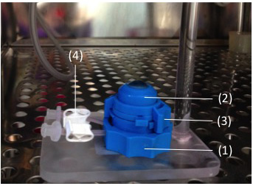
Fig. 1. An in vitro set-up used for air-interface corneal organ culture. All experiments were performed at air-liquid interface OC using Barron artificial anterior chamber consisting of a base (1), tissue retainer (2), a locking ring (3) and pinch clamps (4) for opening and closing the perfusion tubes (purchased from Barron Precision Instruments) with a 12.5 mm opening, which allows the epithelial side of the cornea to be in contact with the air during organ culture in a humidified incubator at 37ºC, 5% CO₂.

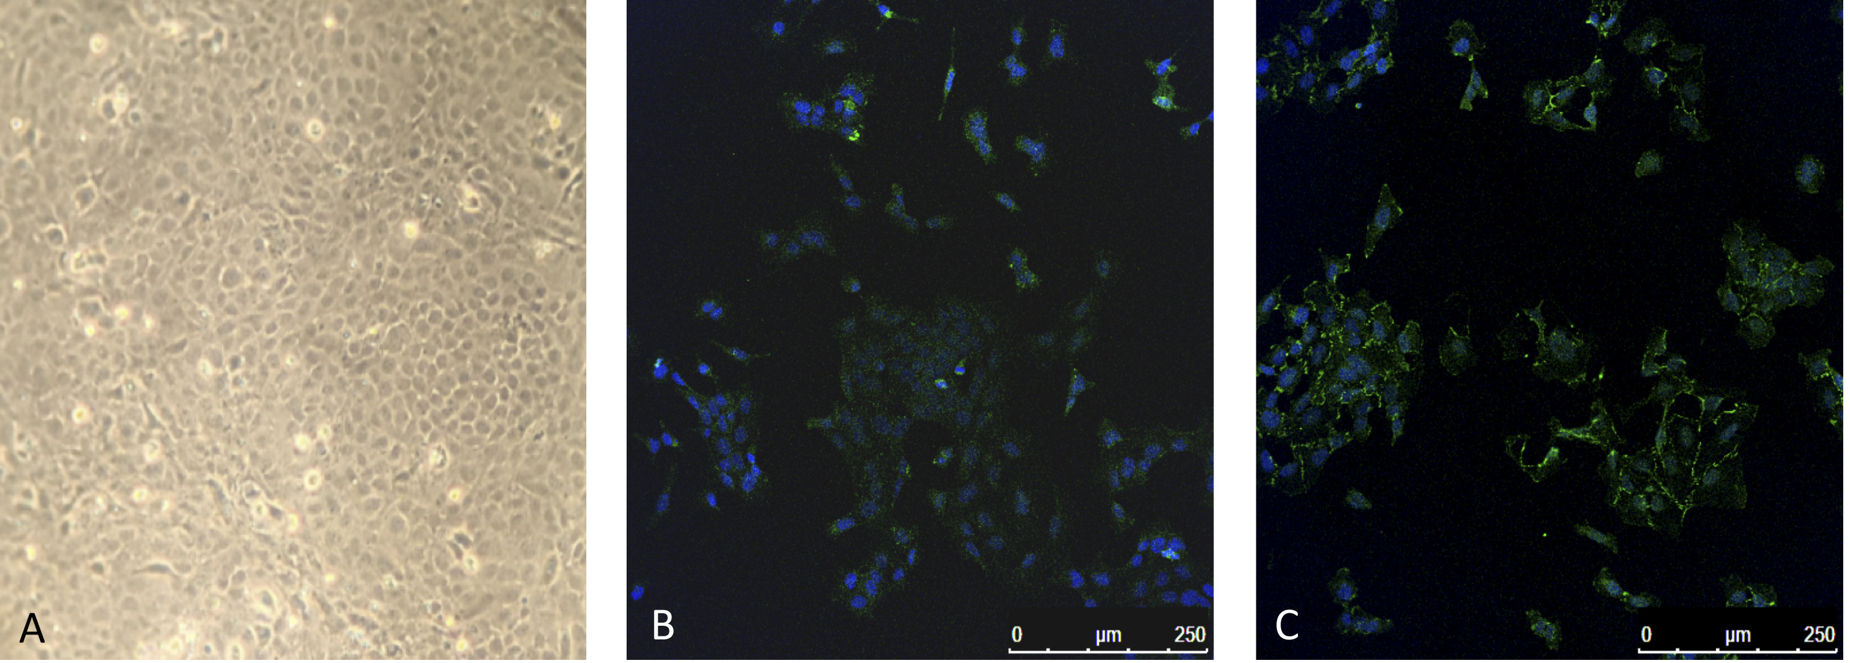
Fig. 2. In vitro cultured human corneal endothelial cells. A. Cultured HCEC-12 [Phase-contrast: x200], B. Na+/K+ ATPase positive cells and C. Zonula occludens 1 (ZO-1) expression by cultured endothelial cells [Confocal microscopy: x100].

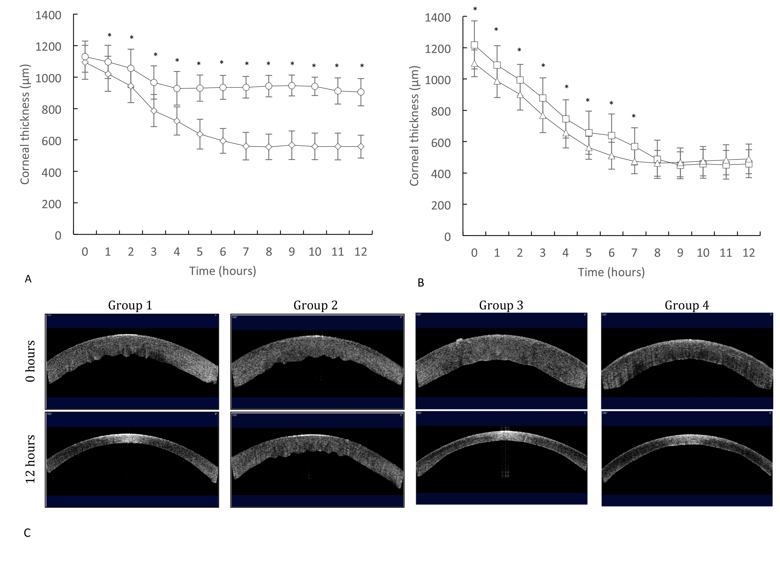
Fig. 3. Stromal hydration behavior of human corneas in air-interface organ culture after 12 hours of incubation. Group 1 - Normal corneas with endothelial cell density (ECD) 2002 ± 357 cells/mm² (n=6) [] maintained a normal physiological thickness of 557 ± 72 μm whereas Group 2 - the decompensated corneas (n=5) [] were severely oedematous with thickness of 903 ± 86 μm (A). Group 3 (n=6) [☐], and Group 4 (n=5) [] reached thicknesses of 458 ± 90 μm and 489 ± 94 μm respectively (B). Optical coherence tomography revealed that both cell-therapy Groups 3 and 4 appeared similar in thickness to the normal corneas (Group 1) and were significantly thinner compared to the decompensated corneas (Group 2).
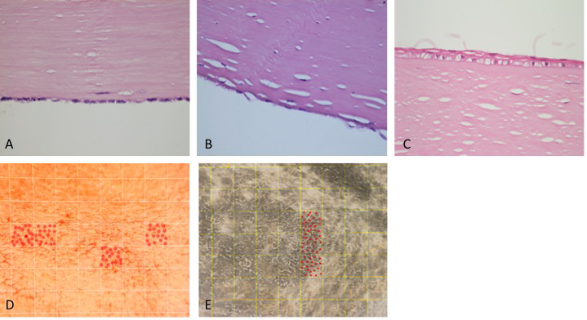
Fig. 4. Histology of human corneal endothelial cell transplantation to posterior corneal stroma of cadaveric human corneas. In Group 3, a corneal endothelial cell monolayer was present 3 days after transplantation (A) [H&E staining; x400]. In Group 4, a corneal endothelial cell monolayer was seen established at 10 days with primary human corneal endothelial cells (B). The donor epithelium was intact in all corneas and both control and study corneas underwent the same management for corneal epithelial protection (C) [Haematoxylin and eosin (H&E) staining; x400]. Group 3 and Group 4 had an average cell density of 1925 ± 178 cells/mm² and 2000 ± 212 cells/mm² respectively (D) [Alizarin red staining; x200], (E) [Phase-contrast; x200]. The area of each individual square in D and E is 0.01 mm² and the red dots represent the cell number in each square.

