SEEDS International Conference
The Development of an Energy Index to Assess Energy Reduction
Dr Carlos Jimenez-Bescos¹
¹ Anglia Ruskin University, Department of Engineering and the Built Environment, Chelmsford, CM1 1SQ, United Kingdom.
Keywords: Energy Consumption, Energy Efficiency, Energy Reduction.
Abstract
This short paper presents a methodology to allow the easy comparison of energy consumption between different flats, during different seasons and at different locations, while keeping a low budget perspective for the work. This methodology develops an energy index to normalise and evaluate the heating energy performance of different properties.
The energy index is based on the energy consumption in kWh, internal temperature and outdoor conditions by the use of degree days. Degree days are calculated based on the location of the property and the internal temperature as base temperature for the calculation. The degree days will be generated according to the period for the meter reading, allowing meter reading to be variable in length but it I advisable to do so on roughly four weeks period. The normalised energy index is finally generated by combining the meter reading in kWh and the degree days for the reading period.
The energy index methodology is applied to four flats located in East Anglia. Results show that the behaviour changing was effective in reducing energy use and allow to understand energy consumption during different seasons and sudden weather changes.
The use of the energy index methodology presented in this paper should allow energy professionals, tenants and social housing providers to monitor and evaluate the energy use across seasons and locations, the effectiveness of new retrofitted technology and/or the application of behaviour change strategies, while keeping a low budget approach to the data captured and analysis

INTRODUCTION
This short paper presents a methodology to allow the easy comparison of energy consumption between different flats, during different seasons and at different locations, while keeping a low budget perspective for the work. This methodology develops an energy index to normalise and evaluate the heating energy performance of different properties.
The methodology was used by the author during the ‘SmatLIFE Retrofit for Business’ ERDF project to evaluate the energy consumption of several tenants occupying flats in three different blocks. The main purpose of the analysis was to compare the performance of the introduction of new technology and the effect of a behaviour change strategy. The behaviour change strategy was not only based on the provision of information via environmental education but focused on developing a positive identity associated with engagement in energy saving and green behaviours to achieve energy reductions.
As in any project happens, budget restrictions do not allow the purchase of expensive smart meter equipment, so low budget alternatives are the next option. The adoption of a low budget alternative smart meters generate several issues experienced by the author, such as data lost due to signal drop-offs, long period unsupervised and/or unplugging of equipment.
Degree days has been around for quite a while and calculation methodologies are well explain in other texts, such as CIBSE (2006) and Krarti (2012), and has been used to forecast energy demand (Hong, 2013).
Degree days takes into account the outdoor conditions depending on location and base temperature.
According to DegreeDays.net, it can be hard to transform degree-days calculations into actionable task with the intention to reduce energy consumption. This is the main purpose of the energy index presented, to allow an easy evaluation while taking into account a low budget approach to the project.
RESEARCH METHODS
The approach for the development of the normalised energy index is based on the following inputs:
- Energy consumption in kWh taking from direct meter readings.
- Internal temperature in degree centigrade.
- Outdoor conditions depending on location, taking as degree days for the particular location.
Meter reading to capture energy consumption are independent on the reading interval as this will be normalised by the use of degree days.
Internal temperature of the property is captured by means of a temperature data logger, such as LogTag temperature data logger. The internal temperature is used as the based temperature to calculate the degree day for the particular location.

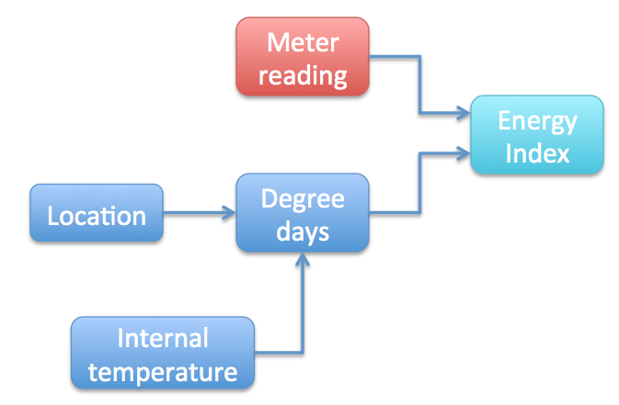
Figure 1. Energy index normalisation methodology
Figure 1 shows the methodology to generate the normalised energy index. Degree days are calculated based on the location of the property and the internal temperature as base temperature for the calculation. The degree days will be generated according to the period for the meter reading, allowing meter reading to be variable in length but it was advisable to do so on roughly four weeks period. The normalised energy index is finally generated by combining the meter reading in kWh and the degree days for the reading period.
By using Degree days based on the location of the flat or property to monitor, allow us to generate an energy index, which can compare energy consumptions between different projects at different locations. For example a flat in Glasgow and a house in Southampton, it is expected to use more energy in Glasgow due to the colder weather but the energy index normalised by the degree days allows us to compare like for like both properties as the weather conditions are taking into account. It is colder a higher degree day is used and if warmer, a smaller degree day is obtained. Furthermore, the degree days are based on the base temperature, by using the internal temperature in the energy index as based temperature, provides a tool to understand when a flat has been reducing energy consumption due to savings by changing behaviour or just by not using the heating system, for which the internal temperature will have been lower than normal and affecting the degree day value and ultimately the energy index for comparison. In other situation, an overheating flat will have used a higher amount of energy, not due to the weather conditions but due to the higher internal temperature and this effect will be capture in the energy index.

RESEARCH RESULTS
The above methodology was used to assess the energy consumption of four flats located in East Anglia.
Meter reading for energy consumption were collected on a rough interval of every four weeks, from October 2013 to June 2014, according to the periods shown in Table 1.
Internal temperature measurements were collected on a 20 minutes interval for each flat. An average internal temperature for the whole collection period was used as based temperature to calculate the required degree days for every period. A calculation of degree days based on daily internal temperature was performed to assess the validity of a whole period internal temperature average and it was found a different of less than 1% in the calculated degree days value.
Table 1. Meter reading collection periods
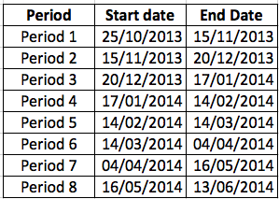
Figure 2 shows the energy consumption for the four flats according to the eight periods of data collection.
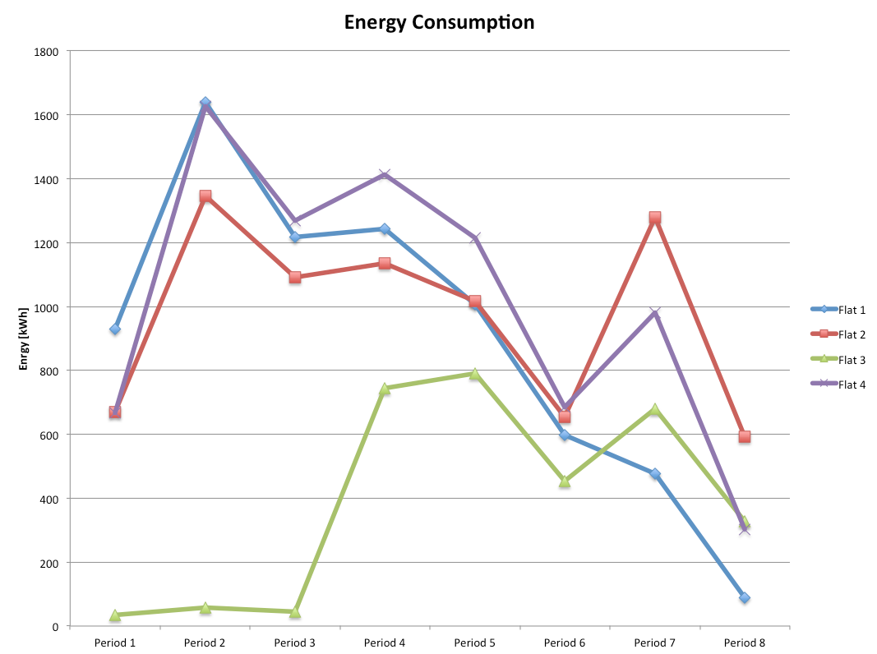
Figure 2. Energy consumption in kWh
According to Figure 2, flat 4 has the higher energy consumption, very closely follow by flat 1. Flat 3 is vacant for the first three periods of data collection. All the flats seem to reduce energy consumption as expected form approaching the spring and summer period. An increased on energy consumption is seen in period 7 during the April-May data collection.
Following the application of the energy index methodology, Figure 3 presents the normalised energy index values for the same four flats. Taking into account the normalised energy index allows us to understand the effect of weather and user behaviour on the energy consumption data presented in Figure 2.
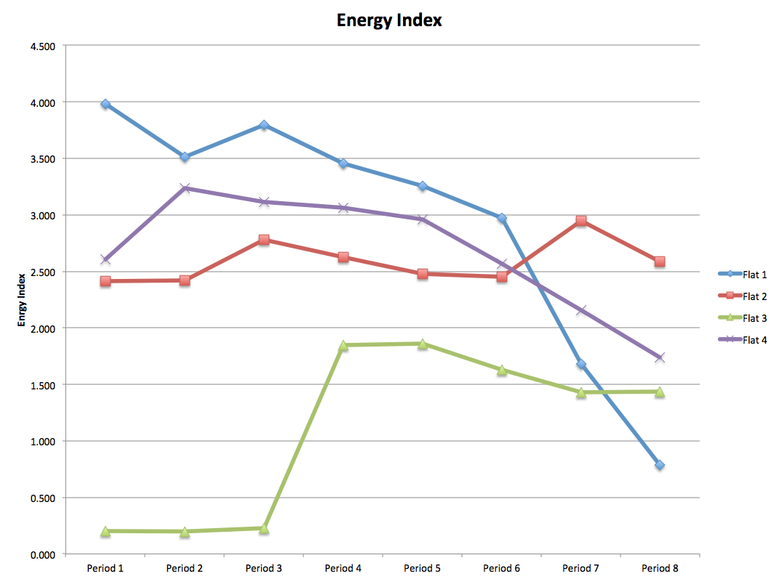
Figure 3. Energy index
It can be observed form Figure 3 that mostly all the flat were reducing energy consumption showing that the behaviour change strategy had been effective in changing the user approach to use energy. Contrary to the observation in Figure 2, flat 1 is the one with the higher energy use but at the same time, it is the flat achieving the highest energy reduction. The sudden energy consumption increase during period 7 was due to period of cold weather as it is normalised in the energy index graph and actually three out of the four flats reduce their energy consumption during that period.

DISCUSSION
According to the energy consumption form Figure 2, it is expected that the energy consumption will be reducing as the spring-summer period is approaching. While by comparing the energy indexes presented in Figure 3, the energy indexes for every period can be compares to each other regardless of comparing winter months to summer moths as the weather conditions are taking into account via the degree day. The observer of the energy index graph can assess if a property has being reducing energy consumption, change energy use behaviour or if a newly install technology is effective in comparison with previous technologies. Furthermore, the use of the energy index will normalise the energy consumption data to appreciate the behaviour of occupants under heating or overheating their properties.
The use of the energy index methodology provides and easy to use value to be able to numerically or graphically compare the heating energy performance of different properties for non professional people and to make initial judgements on performance.
CONCLUSION
In conclusion, the use of the energy index methodology presented in this paper should allow energy professionals, tenants and social housing providers to monitor and evaluate the energy use across seasons and locations, the effectiveness of new retrofitted technology and/or the application of behaviour change strategies, while keeping a low budget approach to the data captured and analysis.
ACKNOLEDGEMENT
This research was funded by the European Regional Development Fund (ERDF) for the SmartLIFE Retrofit for Business project.

REFERENCES
CIBSE. (2006). TM41 Degree-days: theory and application. CIBSE Publications.
Degree Days.net. Custom degree day data [Online]. Available from: < http://www.degreedays.net> [Accessed 27 May 2015].
Hong,W. (2013). Intelligent energy demand forecasting. Springer
Krarti, M. (2012). Weatherization and energy efficiency improvement for existing homes – an engineering approach. CRC Press.

