Dear Sir

Coloured filters and visual stress

The editorial by Elliot & Wood¹ makes some interesting points about visual stress and coloured filters. We agree with the authors that there are several factors that are likely to influence the choice of colour in this subjective process, especially with children. Our review² included a diagram (Figure 1) illustrating the potential reasons why children might choose a coloured overlay which clinicians should consider.
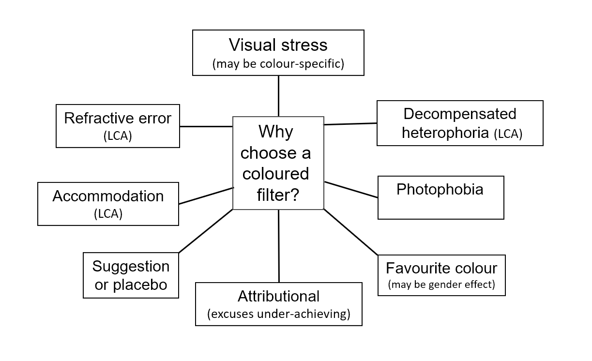
Figure 1: Schematic diagram to illustrate potential reasons why children might choose a coloured overlay on first testing. Reproduced from Evans and Allen.²
Elliot & Wood argue that the Conway et al study³ reflects a “gender-based preference when a colour is worn on the face”. It is important not to confuse association with causality. Whilst noting a significant (p=0.037) effect of gender on the choice of lenses, the Conway et al study cautioned that over half of the males chose a colour that is not a stereotypical male colour and over half of females chose a colour that is not a stereotypical female colour. This led the authors of the research to conclude that “gender makes a relatively minor contribution”. This point is not clear from the Elliot & Wood editorial.

We agree that practitioners should carefully consider the potentially confounding factors that may influence colour choice (Figure 1). This includes the influence of “favourite colour” and gender effects, but we would extend the point made by Elliot & Wood. Clinicians encounter children who find the colour(s) that alleviate(s) symptoms unacceptable (e.g., pink for some boys) and this, or indeed wearing any coloured glasses, can sometimes cause embarrassment and make a child unhappy at school. Modern digital devices allow the user to change screen background. For example, since iOS 10 Apple© have included as standard a “colour tint” facility for selecting and using an appropriate coloured background on their tablet and smartphone devices. For many children with visual stress, this is a more acceptable option than using coloured filters.

As Elliot & Wood note, it is important to carefully consider the possibility of a placebo effect and this has been highlighted to practitioners since the earliest use of the Intuitive Colorimeter in 1994.⁴ It was also noted in 1994 that, although the original research with the Intuitive Colorimeter indicated that for maximum symptomatic relief some patients require precision in the selection of colour, this does not mean that this is the case for every person with visual stress.⁴ This is well known to practitioners who use the Intuitive Colorimeter. Of course, a clinical system should provide the precision required by the most demanding patient, not the least. Nonetheless, it has long been recognised that the precision that is required is unlikely to be as specific that claimed by the Irlen organisation.⁵ Some new experimental work on the degree of precision required has been submitted for publication.

Elliot and Wood cite two reviews to support their viewpoint that improvements with coloured filters are due to non-intervention and placebo effects. Both included research of people who were not selected as having visual stress, and therefore that would be unlikely to detect a benefit from coloured filters. In our view, much research in this field starts with an inappropriate hypothesis that coloured filters are a treatment for reading disabilities (typically, dyslexia). It is widely accepted that the major causal factor in dyslexia is a phonological deficit and therefore coloured filters are unlikely to cure reading difficulties. A recent review of studies using the Intuitive system to investigate people with visual stress found that most studies support treatment of the symptoms of visual stress (but not dyslexia) with coloured filters, but that visual stress may affect only circa 20% of people with reading difficulties.² This review called for a new, large randomised controlled trial, and a recent diagnostic algorithm for visual stress should assist in the selection of participants with the target condition.⁶ This algorithm should further reduce the likelihood of precision tinted lenses being prescribed for non-genuine reasons. We share Elliot & Wood’s concerns that precision tinted lenses sometimes may be prescribed in cases where their benefit is likely to be attributable to placebo effects. The recent claim that as many as 15% of people are affected by “Irlen syndrome”,⁷ in our opinion is not supported by the literature and adds weight to such concerns and to the need for a more conservative approach.⁶

Elliot & Wood accept that there could be a subgroup of patients who genuinely have visual stress. The conclusions of our review support the existence of such a subgroup and responsible clinicians working in this field engage fully with the challenging task of disentangling genuine benefits from placebo effects and other confounders (Figure 1). The cases that are most convincing are those that reluctantly accept a coloured filter or coloured background that they find unattractive, those that continue with colour for many years, and those that return unprompted for new coloured filters when their current ones are lost. We share the concern that those who do not need coloured lenses should not receive them, but this needs to be balanced against the risk that those who do need coloured filters are not receiving them.

We hope that the recent controversy on this issue will lead to an expansion of research and our understanding of how to best help children with reading difficulties who report symptoms when they read. Finally, we would reiterate that children who report visual symptoms when reading should in the first instance seek optometric eyecare to search for a conventional cause of their symptoms and that visual factors should not be considered to be a cause of dyslexia.

Bruce JW Evans
Neville Chappell Research Clinic, Institute of Optometry, London, UK; admin@ioo.org.uk

Peter M Allen
Department of Vision and Hearing Sciences and Vision and Eye Research Unit, Anglia Ruskin University, Cambridge, UK

Financial disclosure: The authors have no financial interests in manufacturers of coloured filter systems used to treat visual stress.

Conflicts of interest: BE and PA have received honoraria for lectures on this topic. BE is an unpaid committee member and secretary of the not-for-profit Society for Coloured Lens Prescribers (www.s4clp.org). BE is Director of Research at the Institute of Optometry, an independent charity that receives donations from i.O.O. Sales Ltd which sells, amongst other products, Intuitive Overlays, the Pattern Glare Test, and the Wilkins Rate of Reading Test. BE, and the Institute of Optometry, use coloured filters in clinical practise.

References
1. Elliot DB, Wood JM. Coloured filters show gender differences and poor repeatability. Ophthalmic Physiol Opt. 2017;37:635-639.
2. Evans BJW, Allen, P.M. A systematic review of controlled trials on visual stress using Intuitive Overlays or the Intuitive Colorimeter. Journal of Optometry. 2016;9:205-218.
3. Conway ML, Evans BJW, Evans JC, Suttle CM. Does Gender Influence Colour Choice in the Treatment of Visual Stress? PLoS ONE. 2016;11:e0163326.
4. Evans BJW. The Intuitive Colorimeter: Part 1. Optician. 1994;207:18-22.
5. Evans BJW, Drasdo N. Tinted lenses and related therapies for learning disabilities - a review. Ophthal. Physiol. Opt. 1991;11:206-217.
6. Evans B, PM A, AJ W. A Delphi study to develop practical diagnostic guidelines for visual stress (pattern-related visual stress). Journal of Optometry. 2017;10:161-168.
7. Gildley S. Call for more Irlen Syndrome specialists in Schools. In: News B, ed. Wales: BBC News; 2017.

