Constructing Banglatown: Linguistic landscapes in London’s East End

- Introduction
With more than 81,000 members (Census 2011), the Bangladeshi community in the east London borough of Tower Hamlets is one of the largest in the United Kingdom. Over 50 per cent of all people of Bangladeshi origin living in England reside in the Greater London area (Census 2011; see table 1), and within London, 37 per cent of all Bangladeshis live in the borough of Tower Hamlets, located to the east of the City of London (ibid.), making the community one of the largest in the Bangladeshi diaspora. The area around Brick Lane, renowned for its numerous Bengali restaurants and curry houses, has become synonymous with the Bangladeshi community, so much so that the electoral ward's official name is Spitalfields and Banglatown. With close to 3900 people, a proportion of 37.4 per cent of the ward's population, Bangladeshis form the largest ethnic group in the ward, followed by 2666 'White; English/Welsh/Scottish/ Northern Irish/British' people (25.9 per cent).
 |  | Spitalfields and  Banglatown | Tower Hamlets | London | England
All Usual Residents | Count | 10,286 | 254,096 | 8,173,941 | 53,012,456
Asian/Asian British; Bangladeshi | % | 37.4 | 32 | 2.7 | 0.8
 | Count | 3,852 | 81,377 | 222,127 | 436,514
White; English/Welsh/Scottish/Northern Irish/British | % | 25.9 | 31.2 | 44.9 | 79.8
 | Count | 2,666 | 79,231 | 3,669,284 | 42,279,236
White; Other White | % | 17.6 | 12.4 | 12.6 | 4.6
 | Count | 1,814 | 31,550 | 1,033,981 | 2,430,010
Table 1: Ethnic groups by geographic area (Census 2011)

Banglatown, however, is more than the sum of its of population and curry houses: building on the work on linguistic landscapes and geosemiotics (Scollon & Scollon, 2003), this paper explores the linguistic landscape of the area, with particular reference to the visual prevalence of the Bengali language at the heart of Spitalfields. It suggests that Banglatown as a social product is constructed not only by its people, but by its semiotic and linguistic landscape and the interaction within it, making it not only a physical space in the material world, but a 'representational space' (Lefebvre, 1991, p. 39): 'space as directly lived through its associated images and symbols, and hence the space of "inhabitants" and "users"' (ibid., original emphasis).
Banglatown, I argue, is constructed as a social space where multiple layers of linguistic and other semiotic practices interact in 'meaningful symbolic behaviour' (Blommaert, 2005, p. 2); it is, in the words or Jaworski and Thurlow, a semiotic landscape (Jaworski and Thurlow, 2010). To that end, this paper focuses on the exploration of four interrelated and layered Goffmanian frames, or 'contextual schemes' (Blommaert, 2005, p. 252): a civic frame, comprising mainly topographic signs that serve to clearly demarcate Banglatown linguistically and symbolically; a commercial frame, in which linguistic and other symbolic practices serve to create Banglatown as a semiotic landscape; a community frame, which creates a sense of community and community identity at both linguistic and symbolic level; and a visual frame, which transcendes the linguistic and in which other visual elements, including colour and icons, contribute to the overarching semiotic landscape.

- Urban landscapes, urban spaces and urban discourses
The concepts of space and place are at the heart of research into urban geography and environmental psychology: Spaces – geographical locations and territories – are transformed into places – socially constructed environments – through social practice (Knox & Pinch, 2000). Lefebvre argues that '(social) space is a (social) product' (1991, p. 30); space, he suggests, is not simply a 'container' but the product of social and semiotic interaction. The ‘non-container’-metaphor is a popular one: Rodman, for example, argues for a conceptualisation of places as ‘anthropological constructions’ (1992, p. 640) that are ‘politicized, culturally relative, historically specific, local and multiple constructions’ (ibid: 641).
In their study of multicultural and multiethnic council estates in Vienna, Austria, Permoser and Rosenberger (2012) illustrate the interdependence of ethnic and cultural heterogeneity, identity, belonging and materiality. Lepine et al. (2007, p. 2) define neighbourhoods as ‘complex, dynamic, multidimensional and subjective constructs’ which both form and are formed by the identity of their inhabitants (Sullivan & Taylor, 2007). A key argument I adopt in this paper is that Banglatown is exactly that: a dynamic social construct, whereby multiple, intertwined symbolic practices create Banglatown as a semiotic landscape.
Comparatively recently, the emergence of linguistic landscapes as a field of study in linguistics has shifted the focus of attention to linguistic signs and language within the urban landscape. Linguistic landscapes, ‘the visibility and salience of language on public and commercial signs in a given territory or region’ (Landry & Bourhis, 1997, p. 23) form an integral part of the modern cityscape. The last ten years have seen a proliferation of research exploring the linguistic landscapes of large cities such as Tokyo (Backhaus, 2006, 2007), Bangkok (Huebner, 2006), Jerusalem (Ben-Rafael et al., 2006), Hong Kong (Lai, 2013), or Antwerp (Blommaert, 2013). Landry and Bourhis (1997) discuss the influence the linguistic landscape has on the vitality of a minority ethnolinguistic group, and with previous research (Rasinger, 2007, 2013) having shown comparatively high levels of ethnolinguistic vitality within East London’s Bengali community, there is, ostensibly, a potential relationship between the linguistic landscape in the ward and ethnolinguistic vitality.
The approach taken in this paper, however, goes beyond the original idea of linking ethnolinguistic vitality with linguistic landscape. Lou in her discussion of the LL of Chinatown in Washington D.C. argues that ‘in performing its symbolic function, a linguistic landscape conveys meta-linguistic information about the relative power and status of the respective ethnolinguistic group’ (Lou, 2012, p. 37). What I suggest here is that Banglatown forms a semiotic landscape, an 'interplay between language, visual discourse and the spatial practices and dimensions of culture' (Jaworski & Thurlow, 2010, p. 1). It is, as such, a reflection of the community and groups that inhabit and visit it. Garret, Coupland and Bishop (2005) illustrate how visual representations and iconicity serve diasporic communities in retaining a sense of identity and can create 'nostalgia for the 'lost' homeland' (Jaworski & Thurlow, 2010, p. 8). If Banglatown is more than a tourist attraction, we would expect this level of representation to present, too. Along similar lines, Kallen and Ni Dhonnacha (2010, p. 22) argue that ‘urban environments [...] are especially conducive to the development of signage that reflects debates of nationhood and national identity’. Within the ‘representational space’, language is present in a myriad of ways, making a physical space a place: ‘real material and symbolic spaces in which people anchor a dense complex of symbolic and material practices’ (Blommaert, Collins, & Slembrouck, 2005, p. 206), or, as Stroud and Mpendukana put it, ‘place is constituted through the language used in signage’ (2009, p. 364). Banglatown, as I will suggest, is as much a physical space and a symbolic place, constructed by a variety of interrelated layers of linguistic and other semiotic practices.
- Setting: East London
Following the decline of the shipping industry and subsequent of period socioeconomic deprivation, London's East End saw a wave of regeneration efforts throughout the 1990s: the development of Canary Wharf in 1991 has made the Isle of Dogs the centre of Britain’s financial sector. A few miles to the north-west, the ward of Spitalfields, and particularly the area around Brick Lane, has seen dramatic regeneration and rebranding as a tourist destination and cultural quarter over the last three decades (Shaw, Bagwell, & Karmowska, 2004). This regeneration included the extensive use of the symbolic repertoire of the Bangladeshi community, which had centred around the area since the 1960s; a development that culminated in the re-branding and renaming of the ward into Spitalfield and Banglatown in 1997 (Glynn, 2010).
The iconic status of Brick Lane as the centre for the Bangladeshi community is not without its problems: Banglatown as a tourist destination based on extensive place marketing (Glynn, 2010) is also the place 'for a broader set of struggles around ethnicity, community and nation, multiculturalism and its imagined limits, and the politics of representation' (Alexander, 2011, p. 203). A symbolic space for multilingualism, it is also a space of ethnic segregation, with contemporary views often considering it to be a 'ghetto' (Alexander, 2011).
The aim of the current paper is to suggest that Banglatown, the tourist hub where ‘the real Bengali world is never far’ (Glynn, 2010, p. 1003) is more than a physical space: it is a social, or representational space, or place, with its own distinct semiotic landscape.

- Methodological framework
A key aim of the data collection and analysis process was to provide a dataset that allows for a discussion of Banglatown beyond the tourist hotspots and commercial areas around Brick Lane and Commercial Road, and to show how Banglatown as a social and representational space is constructed across the ward as a place that is deeply anchored in the geography and the people inhabiting it. As such, the methodological framework adopted was a qualitative one, and the current work focuses on identifying key patterns in the LL by examining different linguistic and other semiotic practices and the way these practices create Banglatown as a larger, multi-layered semiotic landscape.
Data was collected along a route of 1.5 miles/2.3 kilometres in length, which included the commercial areas of Brick Lane and Whitechapel Road on the one hand, and the more residential streets around Vallance Road and Buxton Street on the other. Using a digital camera, around 300 pictures were taken; a high sign density means that more than 1500 individual signs were recorded digitally.
In what Amos (2016) aptly calls a ‘methodological battleground’ (2016, p.131), research into linguistic landscapes has seen a plethora of analytic frameworks being employed. Yet, there is no uniform approach to the analysis of LLs, particularly for qualitative studies. The analytic framework employed in the current paper draws on two related approaches: the Goffmanian notion of frames (Goffman, 1986), an approach also used in Kallen's study of Dublin's linguistic landscapes (Kallen, 2010) and more recently by Rasinger in an exploration of bilingual German-Slovene landscapes in southern Austria (Rasinger, 2014), and that of geosemiotics, as proposed by Scollon and Scollon (2003).
The concept of frames, or ‘definitions of reality’ (Scott, 2007, p. 117), allows for an analysis of social life as ‘the interaction of humans via the use of symbols’ (Jones, Le Boutillier, & Bradbury, 2011, p. 105); unlike a more rigid hierarchical categorisation of signs, frames are based on the creation of meaning in context. Put simply, frames are the answer to the question: ‘What is going on?’ (Hill, 2014), or, in Goffman’s words, ‘the organization of experience’ (Goffman, 1986, p. 11). In their discussion of LLs of Welsh Patagonia, Coupland and Garrett (2010, p.15) introduce frames as ‘sense-making resources’ which ‘organize the metacultural meanings and values of texts’ (ibid., p.30). The use of frames, then, allows for an analysis of signs of a similar type based on meaning and/or purpose, and their relationship with their consumer. Moreover, as suggested by Kallen, a linguistic landscape can be conceptualised as a ‘confluence of systems’ (Kallen, 2010, p. 42), with multiple frames operating both autonomously and interdependently.
Aspects of Goffman’s work have found their way into Scollon and Scollon’s concept of geosemiotics, ‘the study of the social meaning of the material placement of signs in the world’ (Scollon & Scollon, 2003, p. 110). In particular their use of the notion of interaction order derives from Goffman’s work: the fact that ‘we live our lives within elaborate socially constructed world of discourse and social interaction’ (ibid: p.16). The ‘what is going on’, that is, the frame, is then closely linked to the way in which different interlocutors (or sign producers and consumers) interact with each other and the sign. Scollon and Scollon use the concept of ‘layering’ (2003, p. 137) to describe instances where signs have been extended through the addition of new elements, and these additional layers create an element of ‘new-ness’. In this paper, I expand the notion of layering: not only are layers part of individual signs, giving them multiple meanings, but signs themselves create multiple levels of meaning. As such, signs are not simply part of a single frame, but may span across several frames, resulting in a complex interplay of several frames.
With frames functioning as overarching organisational units, I will focus in particular on three of Scollon and Scollon’s (2003) principles: first, code-preference, indicating the relationship between two or more languages in a multilingual sign; second, inscription, ‘the physical materiality of language’ (Scollon and Scollon, 2003, p. 212), which includes elements such as fonts, material and layering (ibid, 130); and third, emplacement, the meaning of a sign being activated through, and by, its physical placement.

- Constructing Banglatown
  - The civic frame: Demarcating Banglatown
The symbolic value of bilingual street signs has been extensively discussed in LL studies (see, inter alia, Jordan, 2004; Sloboda et al., 2012): bilingual street signs serve as outward emblems, providing a visible – and visual – demarcation of a community’s presence. Street signs, in particularly those with topographic information, are generally the responsibility of local or other governmental authorities – in short, the ‘state’ in its widest sense. It is this governmental regulatory nature of those signs that make them part of what I, in line with others, call the ‘civic frame’ (also see Kallen, 2010; Rasinger, 2014). The creation and ‘sense-making’ of these signs is a ‘top-down’ process, in which ‘the state’ interacts with ‘the people’ through linguistic and other symbolic practices. The presence of bilingual street signs in Banglatown, such as those in figures 1 and 2, acts as a visual territorial marker that indicates the salience of the Bangladeshi community in the ward.
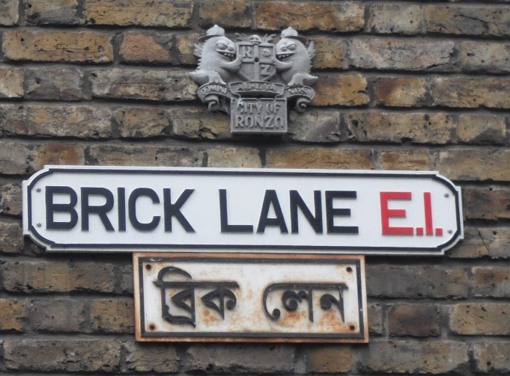
Figure 1: bilingual toponymic sign; two physical objects

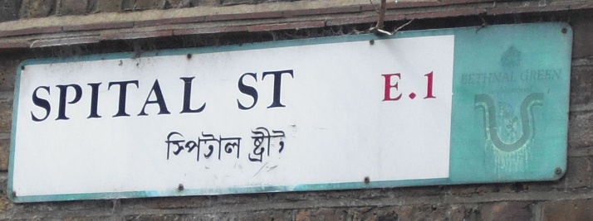
Figure 2: bilingual toponymic sign; one physical object

Physically, this marking takes two forms: figure 1 shows both languages, English and Bangla, both in their own script, on two separate physical entities, yet forming a semantic unit. In the sign in figure 2, both languages share the same physical object. The signs show, in Scollon and Scollon’s (2003) terms, different types of inscription, that is, differences in their materiality, and this difference is not without interest: figure 1 type signs are generally older, and it seems that the Bangla signs have been added later, suggesting what Scollon and Scollon call ‘layering’ (2003, p. 137). While it is difficult to ascertain which physical element (the English or the Bangla one) was present first, the very presence of both still points to them being meaningful and purposeful, that is, the result of deliberate action – in this case, as a clear indicator of a diasporic community.
Figure 2 type signs are generally newer, indicating planning at the design stage; with street signs typically falling under the responsibility of the council, this suggests that figure 2 signs are part of a deliberate language policy. The creation of Banglatown, as outlined above, has a strong background of deliberate urban planning, and the argument I will make throughout this paper is that Banglatown is constructed as a symbolic space that penetrates multiple semiotic layers. The presence of the two sign types – semantic versus physical unity – adds a strong diachronic element to the landscape. Drawing on Scollon and Scollon’s (2004) work, Blommaert refers to the idea that physical objects are historically grounded (Blommaert, 2013). While the aspect of physical layering as displayed in figure 1 type signs, it is absent in figure 2 type signs. This suggests multiple, temporal layers in the linguistic and semiotic landscape: the newer figure 2 type signs are a deliberately planned addition to the landscape with the aim to indicate the presence of the Bangladeshi community. Banglatown, in this respect, is actively constructed through symbolic and linguistic demarcation of its physical space.
The importance of bilingual signage in the ward is not to be underestimated: while the presence of Bangla serves a strong commercial purpose, as will be discussed below, bilingual signs occur across the ward and also away from the main tourist area that is Brick Lane: Spital Street (fig.2), for example, is a residential area, yet retains its bilingual make-up in its street signage. To this end, bilingual signs such as those in figure 2 in the residential parts of the ward are as much for the community as they are about it.
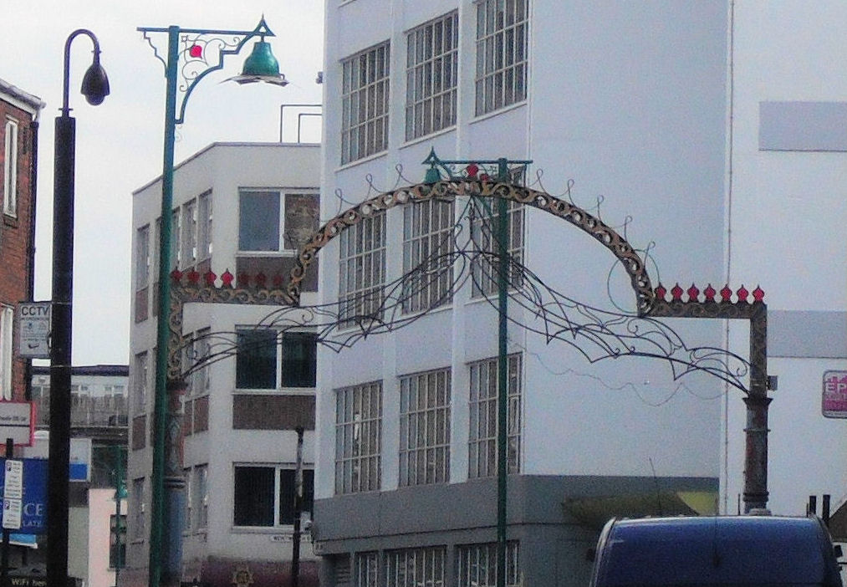
Figure 3: Brick Lane Arch at the southern end of Brick Lane

The linguistic demarcation is, to a smaller extent, supported through a physical one: at the southern end of Brick Lane stands Brick Lane arch (figure 3). While not a physical barrier per se, the arch performs the function of a portal into what is considered the very heart of Banglatown. This type of physical ‘entry point’ is not unusual and can also be observed in London’s Chinatown a few miles to the West. The arabesque patterns and onion-shaped ornaments of the arch give it an ‘exotic’ or ‘foreign’ flair – an aspect that is commonly used and will be discussed later on. Brick Lane arch, together with the change in linguistic practices through street signs and other signs, forms a clear visual boundary that helps to index the presence of the Bangladeshi community, and the creation of the Banglatown landscape.
5.2 The commercial frame: Commodification, marketplace, and ‘selling’ Bangla
In the discussion of the ‘commercial’ frame, I will focus on signs that pertain to the processes that aim at constructing Bangla as a ‘brand’. The use of language and bilinguality in advertising has long been established: Da Silva, Mclaughlin and Richards (2007), for example, discuss how linguistic variation closely associated with national identity is used in sales contexts.
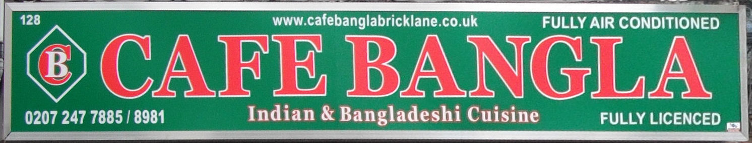
Figure 4: monolingual English sign advertising eatery

Figure 5: bilingual English/Bangla sign advertising eatery

The signs in figures 4 and 5, both signs on eateries, show multiple linguistic and semiotic practices and are exemplary for a myriad of similar signs in the area: both refer to both their function (the selling of food) and their Bangladeshi character (‘Bangla Oven’, ‘Cafe Bangla’). The linguistic choice in these signs is particularly intriguing because of the explicit reference to their ethnic character. While it is of course common for ‘ethnic’ restaurants to use names that indicate their nature, including the use of typical ‘ethnic’ names or phrases (the Turkish restaurant across the street from my office indicates the nature of its cuisine by using the name ‘Merhaba’, as does the Korean ‘Little Seoul’ a few hundred metres down the road), it is comparatively uncommon to find such explicit labelling the way we see it in those two examples. In the examples in figures 4 and 5, the Bangladeshi nature of the restaurants is clearly and explicitly referred to by the signs, which function as outward markers of their character.
The sign in figure 5, not unlike the street signs discussed above, appears bilingually in English/Roman script and Bangla/Bengali script. That is, both signs show different code-preferences (Scollon and Scollon, 2003) at the level of their inscription, that is their physical materiality, including their use of fonts. Figure 5, and similar signs of this nature, adds an additional layer, or extension, to the meaning of the sign, with the Bengali script taking on a symbolic function for the majority of consumers: few people outside the Bangladeshi community will be able to read Bangla, but the Bengali script makes the sign – and the associated establishment – ‘look’ Bangladeshi. Located in the middle of the tourist centre that is Brick Lane, it is reasonable to suggest that the use of Bangla here serves less to attract the local Bangladeshi community, but to create a sense of the foreign and exotic in an attempt to attract patrons.
This type symbolic layering goes beyond the use of language: the sign in figure 4 depicts red writing on a green background, resembling the colours of the Bangladeshi national flag; as such, the sign is both indexical, indicating the nature of the establishment through its use of language, and symbolic through its inscription, relating to what is not present (Scollon and Scollon, 2003, p.133). The two semiotic layers – the linguistic layer with monolingual English and the symbolic layer through the use of colour – are in a dialogical relationship and form what Scollon and Scollon call a ‘semiotic aggregate’ (2003, p.12). Both signs, then, move from the pure linguistic to the semiotic, and are, in Blommaert’s terms, ‘emblematic […] signalling a complex of associative meanings’ (Blommaert, 2010, p. 29). They serve, as Urry puts it, as instances of ‘symbolic branding’ (Urry, 2005, p. 23): multiple layers of linguistic and other symbolic practices create Bangla as a ‘brand’.
This phenomenon transcends language and colour schemes: figure 6 is the sign for a gift shop on Whitechapel Road. While on the linguistic layer it employs, besides the name, English language and Roman script, the main part of the sign is flanked on either side, as an extension or additional layer, by images depicting items clearly associated with Islam: prayer rug, taqiyah (cap) and other religious paraphernalia on the left, traditional Islamic clothing for women on the right. This use of icons, signs that look ‘like the object it refers to’ (Scollon and Scollon, 2003, p. 211) creates a close link between ethnic (and religious) identity, neighbourhood and the sphere of commerce.
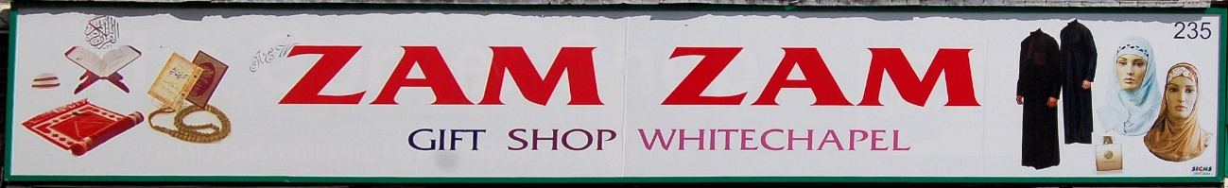
Figure 6: monolingual English shop sign with non-linguistic symbols
This concept is not new: Leeman and Modan (2009) in their study of Washington’s D.C.’s Chinatown illustrate how language is linked to ‘Chinese-ness’ and the symbolic function each language – English and Chinese – has. Linguistic choice, they argue, leads to a ‘commodification of ethnicity’ (2009, p.333) with the use of the minority language deployed to ‘exotify’ the landscape (2009, p.358). This ‘exotification’ for commercial purposes, where Bangla is commodified, is prevalent throughout the linguistic and semiotic landscape in the ward, too. This process of commodification is created through the concurrent use of the different kind of semiotic resources available: indices, symbols and icons (see Scollon and Scollon, 2003, pp.26-27).
Considerable work in the area of visual semiotics has focused on the relative positioning of items to each other, and while this paper by no means attempts a detailed visual analysis, the organisation of different elements and layers within signs is worth a brief exploration. In the majority of bilingual ‘commercial Bangla’ signs, such as the ones in figure 5, English language parts (‘Bangla Oven’) are either in centre position or towards the right of the centre, or English on top of Bangla. In Kress and van Leuwwen’s (1996) framework of visual semiotics, centre or right placement puts English in the category of ‘new’ or ‘real’ information (also see Scollon & Scollon, 2003, p. 92). As such, in terms of advertising, it puts the emphasis on English – the main market – while Bangla appears in the periphery of the sign. As before, assuming that the majority of patrons do not speak or read Bangla, the use of the Bangla name and script serve to underline the ‘exotic-ness’ of the establishment. I argue that in these instances, the use of Bangla language, despite being ostensibly indexical, is in fact symbolic in its function. Both Bangla language and script in those signs primarily act as extensions of the sign, rather than a core part of it, with a key purpose of attracting business.
While this commercial ‘Bangla-ness’ may not come as a surprise when it comes to Brick Lane, it is also present in more subtle ways. Off Brick Lane on Hanbury Street, surrounded by several residential estates, are several shops with signs similar to the one in figure 7:
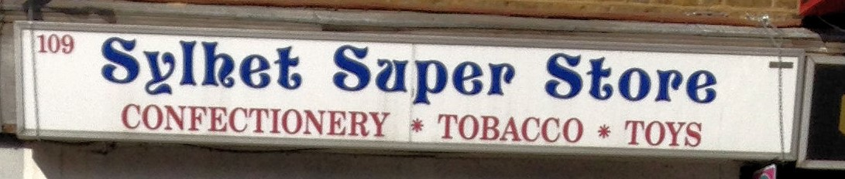
Figure 7: monolingual English shop sign with reference to ‘homeland’

While the sign does not refer to Bangladesh as explicitly as the previously discussed signs, it makes reference to Sylhet – the district in northeast Bangladesh from where most of Britain’s and London’s Bangladeshis originate. This is not without interest: the socio-historical and socio-political development of Sylhet within Bangladesh’s history is complex, and Kershen (2002) and Chalmers (1996) suggest a comparatively strong sense of Sylheti as opposed to Bangladeshi identity, with interviews conducted in Rasinger’s (2007) study suggesting the same. To this end, the reference to Sylhet in figure 7 acts as a reference to the ‘homeland’; as outlined above, an important aspect in retaining a sense of identity in the diaspora. As such, it is symbolic; yet, the code-preferences, at least with regard to the writing system, remains English. Arguably, figure 7 is also an illustration of emplacement in the wider sense: if a sign’s meaning is constructed through its placement in the physical world, it could be argued that the ‘true’ meaning – the ‘homeland’ reference – derives from its particular location within the area; the assumption here is that comparatively few people, particularly those with knowledge of the Bangladeshi diaspora, will be able to make connection.
Figure 7 type signs are, then, less about the commercialisation of Bangla to the ‘external’ world, that is, outside the community for pure commercial purposes, but to appeal to those from within; and the location off the tourist track reinforces this interpretation. Ben-Rafael and Ben-Rafael (2010, p. 327) discuss the use of linguistic and other symbolic markers within diasporas and suggest an element of ‘hybridisation’: the mixing of symbolic resources of different origin. ‘Sylhet’ in figure 7, while in English by inscription and code-preference (choice of language and writing system), is a clear linguistic, and to some extent symbolic, marker of origin and identity. It can be argued that the sign in figure 7 falls within both the commercial frame and also the community frame, which is discussed in the following section.

5.3 The community frame: ethnic presence and identity
In the previous two sections, we have seen how linguistic and other semiotic practices are used to establish Banglatown as a semiotic entity: a clear demarcation through street signs as well as the linguistic and semiotic landscape of commerce construct, through linguistic and other semiotic choices, Banglatown as a semiotic space – or place. The linguistic landscape is employed to create Banglatown as the multicultural, multiethnic, and multilingual space that it is, with a strong sense of commercial motivation behind it.
In this section, I move the discussion to a theme already touched on above: that is, that Banglatown is not merely a construct that serves tourism and commerce, but also its community; and these community discourses are reflected in the linguistic and semiotic landscape, too. To an extent, this has been demonstrated in figure 7, where the sign references the ‘homeland’. The sign in figure 8 is located at the corner of Brick Lane and Hopetown Street, in the centre of the tourist area. Yet, both its design and function are markedly different from the ones discussed so far. The sign advertises a money exchange and transfer company which ‘is committed to deliver remittances from Bangladeshi expatriates in UK to each and every corner of Bangladesh swiftly and safely with best competitive exchange rate.’ (www.pblexchange.co.uk; accessed 10 July 2016). As such, despite its physical location in the touristic centre, the company’s services are aimed specifically, if not exclusively, at the Bangladeshi community. This is reflected in the make-up of the sign: the code-preference is clear, with Bangla being the most prominent language, both in terms of size, quantitative distribution and its top and central location on the sign, with English relegated to the very bottom, in small font, to provide the company’s web address. For the casual, non-Bangla speaking observer, the nature of the business remains obscure, although the web address might provide a hint.
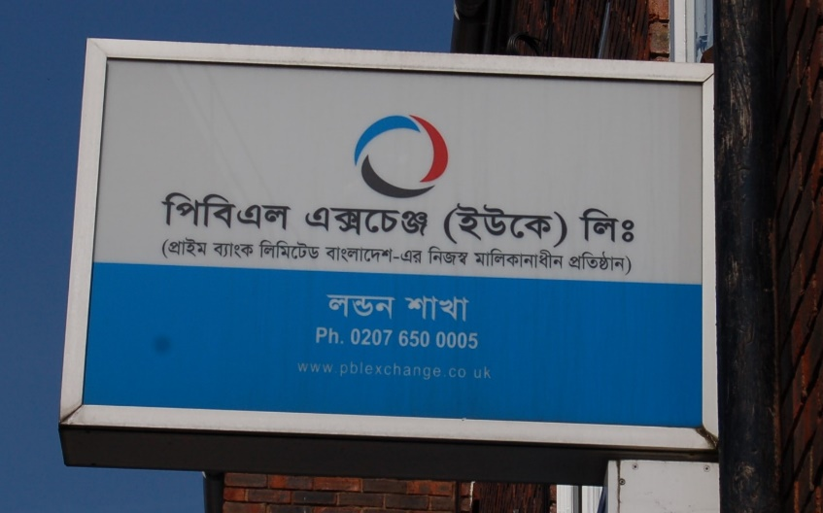
Figure 8: predominantly monolingual Bangla sign

This is no isolated example: figure 9 shows the sign for Sonali Bank, a state-owned Bangladeshi bank (http://www.sonali-bank.com; accessed 10 July 2016). While, unlike figure 8, the sign here is bilingual, it is Bangla that is in the top (‘ideal’) position, with English in the bottom or ‘real’ position (Kress & van Leeuwen, 1996). As with the figure 8 example, the institution caters specifically for the local Bangladeshi community, and this is reflected in its signage. As a result, signs such as those in figures 8 and 9 serve a dual purpose: on the one hand, they are targeted specifically at the local community as a version of a community frame; on the other hand, linguistic and other semiotic practices contribute to the construction of the much wider discourse of the ‘exotic’, ‘foreign’ or ‘other’.
Figure 9: bilingual Bangla/English sign

The semiotic practices constructing ‘Bangla’ or the ‘foreign’ or ‘exotic’ also takes more nuanced forms: figure 10 is one of many examples of travel agencies and tour operators offering package travel to umrah – the pilgrimage to Mecca, considered the holiest city in Islam. The signs in figure 10, both the larger on the right and the smaller ones on the left, are monolingually English (the use of umrah aside) and use exclusively Roman script, with the larger one on the right being dominated by a picture of the Masjid al-harām – the Grand Mosque in Mecca. I suggest here that this is part of the wider inscription of the sign, whereby meaning is complemented through non-linguistic, visual extensions, forming part of the material properties of the sign. While there is no explicit link to the Bangladeshi community – indeed the borough of Tower Hamlets is also home to a predominantly Muslim Somali community – it is in what Scollon and Scollon (2003) describe as ‘emplacement’, a sign’s meaning that is derived by the location of a physical sign in its context, far from tenuous to suggest who the targeted ‘consumers’ of the signs, and the services it advertises, are. While the linguistic practices are English, the semiotic ones yet again point to the presence of the other communities in the borough.
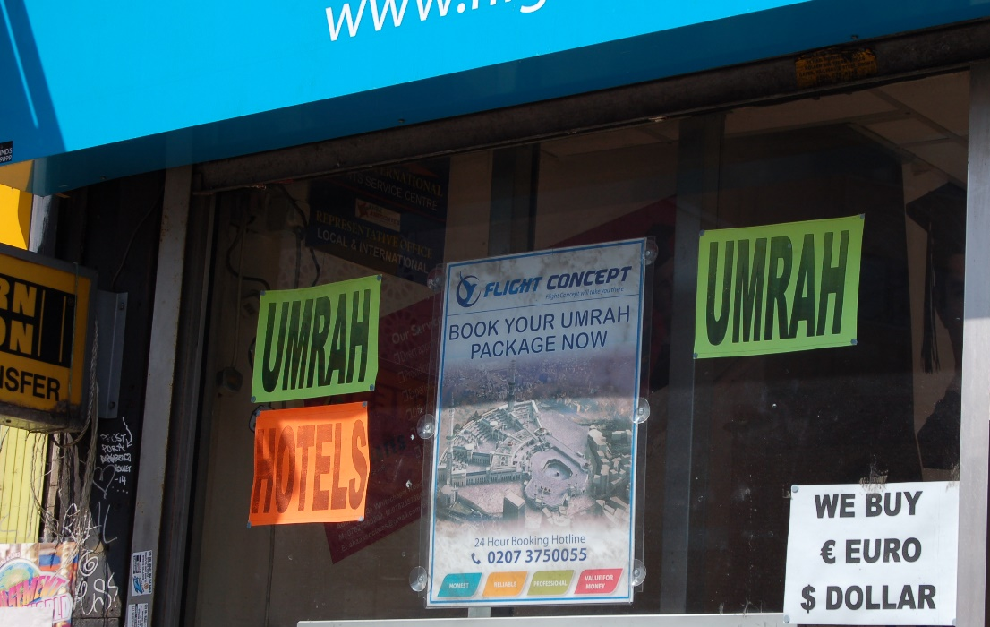
Figure 10: monolingual English sign, ‘Islamic’ imagery

The fact that these linguistic and semiotic practices take place in the middle of London is aptly illustrated in figure 11: the ‘East West Halal Super Store’ juxtaposes the two cultural spheres of the ‘East’ and the ‘West’. It is striking that ‘East’ and ‘West’ obtain their meaning through their location is their physical context as well as the co-text: ‘halal’ indicates the link to the predominantly Muslim community, the group targeted as customers. The indexicality of ‘halal’, together with the emplacement of the sign (and shop) makes it clear that ‘East’ refers to the South Asian community, and not, for example, a community from Eastern Europe. The location of the shop in London’s East End adds yet another layer of meaning: the shop is both in and for ‘the East’, but the inclusion of ‘West’ opens it to the wider community, too. ‘East’ and ‘West’ share the same physical object (that is, the sign), just as different communities share the same physical space – the borough – but this juxtaposition is also reflected in the inscription of the sign: East, white with a black outline on orange background is mirrored by West, with its black text with an orange outline on grey background. Font type and size remain identical, and the language is English throughout. Figure 11 is, to an extent, the physical portrayal of the borough it is located in: where East and West meet, sharing the same space, similar in make-up, yet markedly different.
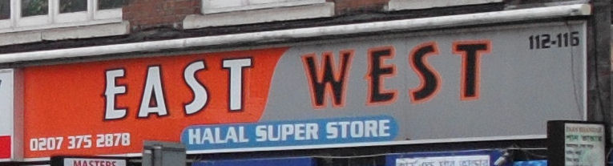
Figure 11: monolingual shop sign indicating East-West dichotomy

5.4 The visual frame: visual creation of the ‘exotic’
With the majority of signs being multimodal, using both linguistic and other semiotic systems, the final section of this paper moves beyond the pure linguistic towards other semiotic practices in an attempt to add an additional, purely visual layer to the analysis. I have alluded earlier to the crimson red and green colour scheme of some of the signs discussed, symbolic for the Bangladeshi national flag; and the colour scheme, in various combinations, is highly prevalent in the area. Lamp-posts along Brick Lane (figure 12) appear in green and red, and like Brick Lane arch, use the onion-dome motif.
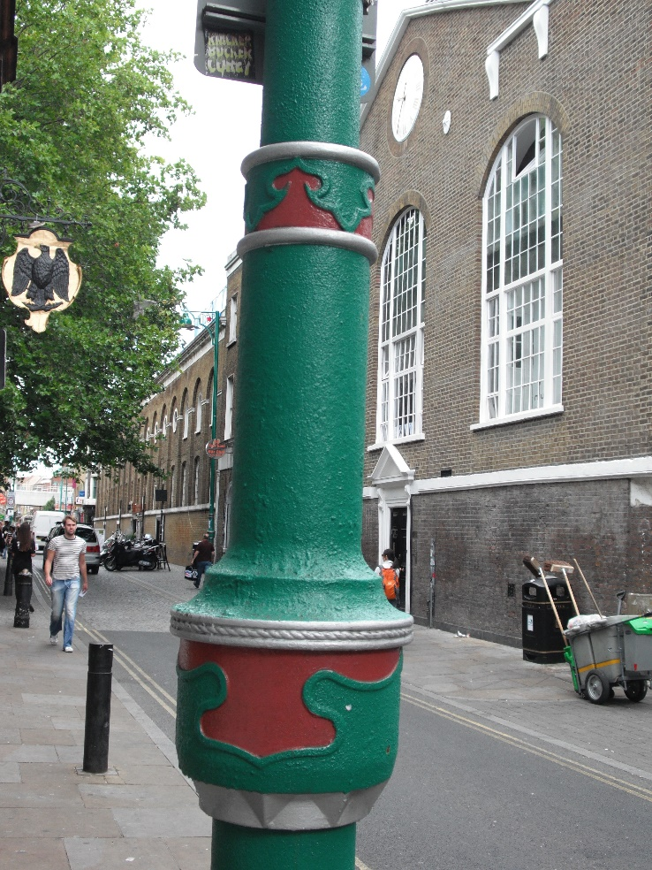
Figure 12: lamppost with onion-dome motif and red/green colour scheme

In the discussion of figure 6, we have already seen how imagery contributes to the overall construction of meaning of a sign. Figure 13 bears a strong resemblance to the sign in figure 6: monolingually English, the reference to ‘Islamic’ provides a clear indexical label for the character of the shop; yet, it is the icons on the right of the sign (Islamic dress and prayer accessories) – the ‘new’ (Kress & van Leeuwen, 1996) – which contributes to the sign’s overall meaning. Indeed, it is arguably the imagery alone which proves a reasonably good explanation of the nature of the shop.
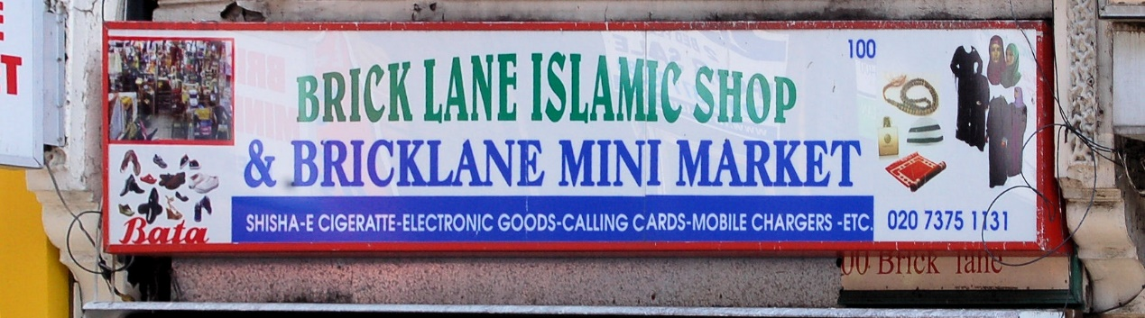
Figure 13: monolingual English shop sign with non-linguistic symbols

As discussed above, the sign in figure 11 juxtaposes the East and the West. Figure 14, the logo of Spitalfield Housing Association, a non-profit organisation which provides accommodation for those struggling to afford housing on the free market, visually combines the essence of the borough.
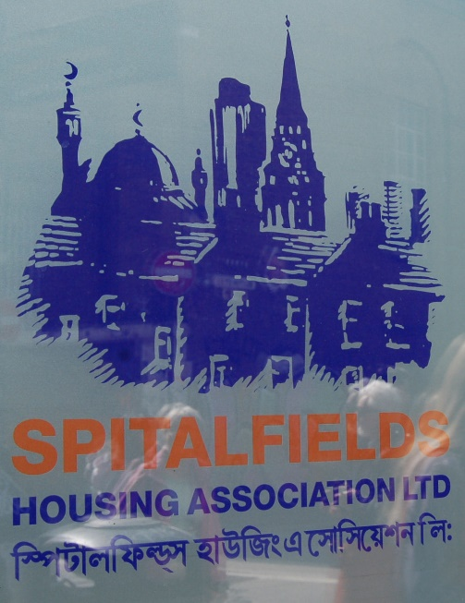
Figure 14: bilingual English/Bangla sign with ‘merged’ identity in the imagery

To the left of the logo is the silhouette of the East London mosque, one of the Muslim religious centres of the area on Whitechapel Road, with its dome, minarets and crescent; towards the centre, the logo shows the outline of the spire of Christ Church Spitalfields on Commercial Street. Like the ‘East - West’ sign in figure 11, the logo combines the different facets of the ward, in this case by the juxtapositioning of the main religious buildings of the area; Christianity and Islam share the same physical and representative space. The building between mosque and church is ambiguous. It may represent a residential tower block, hence indexing the nature of the organisation. Or it may show the chimney of the Old Truman Brewery, located on Brick Lane in the centre of the ward, and hence providing a symbolic link to the history of the ward.
The final example is shown in figure 15: a sign advertising a restaurant, the establishment’s name provides an instant indication of the nature of the fare. Yet, it is the image below the writing that is of interest here: the stylised picture of an oil lamp, easily associated with the ‘magic lamp’ in the Aladdin tale. The lamp as much symbolises the tale – well-known not at least through the extensive Disney franchise – as it does the ‘exotic’ and the ‘East’. The icon of the lamp, then, contributes as much to the construction of the business’s character than the textual reference does.

Figure 15: monolingual sign with ‘exotic’ imagery

- Conclusion
This paper set out to discuss Banglatown as a social product, constituted not only by its people but by its linguistic and semiotic landscape. Using the concept of frames, the analysis has shown that different linguistic and other semiotic practices construct Banglatown as a ‘representational space’ (Lefebvre, 1991), whereby multiple layers of linguistic and other semiotic practices interact with a variety of users – residents and visitors alike – forming multiple levels of meaning. The analysis of a wide set of signs has shown that Banglatown is, to reiterate Lepine et al.’s wording (2007, p. 2) a ‘complex, dynamic, multidimensional and subjective construct[s]’, and its linguistic and semiotic landscape plays a fundamental role in this construction.
The physical demarcation of the area through the use of bilingual street signs forms the top and outermost layer that provides Banglatown with a recognisable identity. Banglatown is a distinct symbolic entity, and this is reflected in the bilingual character of its toponymy. Part of the civic frame, street signs serve as clear markers of the community, visible immediately on entering the area. The official/governmental nature and planned-ness of street signs adds an element of legitimacy: they form part of the official recognition of the community by the local authority or the state.
In parallel to this sit two distinct frames with their own discourses: within the commercial frame, Banglatown is constructed as a touristic centre, with ‘Bangla-ness’ used for commercial purposes and hence being commodified (Heller, Pujolar and Duchene, 2014): a range of signs appear in monolingual English but clearly index the Bangladeshi nature of the establishment; to this end, the commodification of the ‘Bangla-ness’ takes place through a clear code preference for English, while the actual value of the linguistic items is symbolic and indexical. Bilingual signs, while making use of both English and Bangla, often have no inherent content value that justifies their bilinguality, that is, their bilingual character is not necessary to convey content – arguably, the Bangla linguistic items could just as well be random and semantically empty – but they play a key part in building the overall character of the ‘exotic’ and the ‘foreign’ in the middle of London. While signs may use Bangla, their key purpose is to ‘look’ Bangladeshi, reducing the Bangla language to a purely symbolic function. As such, the main interlocutors, or users, of those signs are visitors to the area, as opposed to the local Bangladeshi population.
Beside this commercial frame, with its discourse of the ‘foreign’ and ‘exotic’, sits a frame where the LL is interacting with the local Bangladeshi community: monolingual and bilingual signs which target local Bangladeshis, advertising goods and services. Superficially, signs in this frame strongly resemble those in the commercial frame in terms of their materiality and inscription, and as with the commercial frame, they contribute to the ‘exotic flair’ of the ward. Yet, the linguistic and symbolic practices in this frame are more nuanced. Linguistic practices give more prevalence to Bangla and are meaningful on a linguistic-semantic level (as opposed to the ‘symbolic’ use in the commercial frame), and the discourse constructed here operates in parallel to the ‘touristic’ one: it is one that is located within the social practices of the Bangladeshi community, involving institutions and organisations that clearly operate for the community. In many cases, the meaning operates on a layer that is perceptible only to those with in-depth knowledge of the community, be it through reference to the homeland or other symbolic practices. In those cases, we have also found overlaps in both the commercial and community frames: a sign can by virtue of its inscription both be commercial – selling in the broadest sense – and about the community itself.
All three of the main frames – civic, commercial and community – are supported by a frame that does not use linguistic but visual practices: imagery and colour schemes are used to support the commercial attractiveness but, at the same time, add layers of authenticity: like the linguistic practices, the visual ones are emblems of the overall character of the ward. While these visual practices are part of the inscription of the signs (Scollon and Scollon, 2003), I suggest that they form part of an additional and separate visual frame, which works alongside, and intersects with, the other frames: Lamp posts and the Brick Lane arch, for example, as part of the street furniture, are the responsibility of local authority, which will need to authorise their erection, and are hence part of the civic frame, but their materiality with design and colour contribute to the creation of the overall semiotic landscape. Colour schemes and the use of imagery with clear cultural denotations and connotations are present in both the commercial and the community frame, serving in both frames to underline the pertaining message of Bangla-ness, and creating a strong sense of visible identity.
The discussion has also reiterated the inherent complexities of the analysis urban linguistic and semiotic landscapes. While Goffmanian frames offer a useful approach to exploring in some detail the ‘what is going on?’, frames themselves are multi-layered and intersecting constructs, constructing multiple intersecting meanings, and I suggest that any analysis of complex landscapes needs to take this into consideration.

References
Alexander, C. (2011). Making Bengali Brick Lane: claiming and contesting space in east London. The British journal of sociology, 62(2), 201-220.
Amos, H. W. (2016). Chinatown by numbers. Linguistic Landscape, 2(2), 127-156.
Backhaus, P. (2006). Multilingualism in Tokyo: A look into the linguistic landscape. International Journal of Multilingualism, 3(1), 52-66.
Backhaus, P. (2007). Linguistic landscapes: A comparative study of urban multilingualism in Tokyo (Vol. 136). Clevedon: Multilingual Matters.
Ben-Rafael, E., Shohamy, E., Hasan Amara, M., & Trumper-Hecht, N. (2006). Linguistic landscape as symbolic construction of the public space: The case of Israel. International Journal of Multilingualism, 3(1), 7-30.
Ben-Rafael, E., & Ben-Rafael, M. (2010). Diaspora and Returning Diaspora: French-Hebrew and Vice-Versa. In E. Shohamy, E. Ben-Rafael, & M. Barni (Eds.), Linguistic Landsacpe in the City (pp. 326-343). Bristol: Multilingual Matters.
Blommaert, J. (2005). Discourse: a critical introduction. Cambridge: Cambridge University Press.
Blommaert, J. (2010). The sociolinguistics of globalization. Cambridge: Cambridge University Press.
Blommaert, J. (2013). Ethnography, Superdiversity and Linguistic Landscapes: Chronicles of Complexity. Bristol: Multilingual Matters.
Blommaert, J., Collins, J., & Slembrouck, S. (2005). Polycentricity and interactional regimes in ‘global neighborhoods’. Ethnography, 6(2), 205-235.
Chalmers, R. (1996). Sylheti: A Regional Language of Bangladesh. European Network of Bangladesh Studies.
Coupland, N., & Garrett, P. (2010). Linguistic landscapes, discursive frames and metacultural performance: the case of Welsh Patagonia. International journal of the sociology of language, 205, 7-36.
Coupland, N., Garrett, P., & Bishop, H. (2005). Wales underground: Discursive frames and authenticities in Welsh mining heritage tourism events. In A. Jaworski & A. Pritchard (Eds.), Discourse, communication and tourism (pp. 199-222). Clevedon: Channel View Publications.
Da Silva, E., McLaughlin, M., & Richards, M. (2007). Bilingualism and the globalized new economy: The commodification of language and identity. In M. Heller (Ed.), Bilingualism: A social approach (pp. 183-206). Basingstoke: Palgrave.
Garrett, P., Coupland, N., & Bishop, H. (2005). Globalization and the Visualization of Wales and Welsh America Y Drych, 1948–2001. Ethnicities, 5(4), 530-564.
Glynn, S. (2010). Playing the ethnic card: politics and segregation in London’s East End. Urban studies, 47(5), 991-1013.
Goffman, E. (1986). Frame analysis: an essay on the organization of experience. Boston: Northeastern University Press.
Heller, M., Pujolar, J. & Duchêne, A. (2014) Linguistic commodification in tourism. Journal of Sociolinguistics 18(4), 539-566.
Hill, M. R. (2014). ''Bomb Talk' and Erving Goffman's Frame Analysis. SAGE Research Methods Cases. London: SAGE.
Huebner, T. (2006). Bangkok's linguistic landscapes: Environmental print, codemixing and language change. International Journal of Multilingualism, 3(1), 31-51.
Jaworski, A., & Thurlow, C. (2010). Introducing semiotic landscapes. In A. Jaworski & C. Thurlow (Eds.), Semiotic Landscapes: Language, Image, Space (pp. 1-40). London: Continuum.
Jones, P., Le Boutillier, S., & Bradbury, L. (2011). Introducing social theory (2nd ed. ed.). Cambridge: Polity.
Jordan, P. (2004). Ortsnamen als Kulturgut. Die symbolische Wirkung von geographischen Namen auf Ortstafeln und in Karten. In M. Panel, M. Polzer-Srienz, M. Polzer, & Reginald Vospernik (Eds.), Ortstafelkonflikt in Kaernten: Krise oder Chance? (pp. 216-229). Wien: Braumueller.
Kallen, J. L. (2010). Changing landscapes: language, space, and policy in the Dublin linguistic landscape. Semiotic Landscapes: Language, Image, Space (pp. 41-48). London: Continuum.
Kallen, J. L., & Ni Dhonnacha, E. (2010). Language and Inter-language in Urban Irish and Japanese Linguistic Landscapes. In E. Shohamy, E. Ben-Rafael, & M. Barni (Eds.), Linguistic landscape in the city. (pp. 19-36). Bristol: Multilingual Matters.
Kershen, A.J. (1997). Hugenots, Jews and Bangladeshis in Spitalfields and the Spitir of Capitalism. In A.J. Kershen (Ed.), London, the promised land? The immigration experience in a capital city. (pp.11-38). Aldershot: Avebury.
Kershen, A. J. (2002). Mother Tongue, assimilation and the Bangladeshi community in Tower Hamlets. Paper presented at the Bangladeshis in Britain: Changes and choices, configurations and perspectives., London, Guildhall University.
Knox, P. L., & Pinch, S. (2000). Urban social geography : an introduction (4th ed. / Paul Knox and Stephen Pinch. ed.). Harlow: Prentice Hall.
Kress, G. R., & van Leeuwen, T. (1996). Reading images: the grammar of visual design. London: Routledge.
Lai, M. L. (2013). The linguistic landscape of Hong Kong after the change of sovereignty. International Journal of Multilingualism, 10(3), 251-272.
Landry, R., & Bourhis, R. Y. (1997). Linguistic Landscape and Ethnolinguistic Vitality An Empirical Study. Journal of Language and Social Psychology, 16(1), 23-49.
Leeman, J., & Modan, G. (2009). Commodified language in Chinatown: A contextualized approach to linguistic landscape. Journal of sociolinguistics, 13(3), 332-362.
Lefebvre, H. (1991). The production of space. Oxford: Blackwell.
Lepine, E., Smith, I., Sullivan, H., & Taylor, M. (2007). Introduction: of neighbourhoods and governance. In I. Smith, E. Lepine, & M. Taylor (Eds.), Disadvantaged by where you live?: Neighbourhood governance in contemporary urban policy (pp. 1-20). Bristol: Policy Press.
Lou, J. (2012). Chinatown in Washington, DC: The bilingual landscape. World Englishes, 31(1), 34-47.
Permoser, J. M., & Rosenberger, S. (2012). Die Politik der Zugehörigkeit: Ein sozialwissenschaftlich/künstlerisches Projekt im Wiener Gemeindebau. Österreichische Zeitschrift für Politikwissenschaf, 41(2), 201-209.
Rasinger, S. M. (2007). Bengali-English in East London: a study in urban multilingualism. Oxford: Peter Lang.
Rasinger, S. M. (2013). Language shift and vitality perceptions amongst London's second-generation Bangladeshis. Journal of Multilingual and Multicultural Development, 34(1), 46-60.
Rasinger, S. M. (2014). Linguistic landscapes in Southern Carinthia (Austria). Journal of Multilingual and Multicultural Development, 35(6), 580-602.
Rodman, M. C. (1992). Empowering place: multilocality and multivocality. American anthropologist, 94(3), 640-656.
Scollon, R., & Scollon, S. B. K. (2003). Discourses in place: language in the material world. London: Routledge.
Scollon, R., & Scollon, S. W. (2004). Nexus analysis: Discourse and the emerging internet: Routledge.
Scott, S. (2007). Erving Goffman. In J. Scott (Ed.), Fifty Key Sociologists. The Contemporary Theorists. (pp. 113-119). London: Routledge.
Shaw, S., Bagwell, S., & Karmowska, J. (2004). Ethnoscapes as spectacle: reimaging multicultural districts as new destinations for leisure and tourism consumption. Urban studies, 41(10), 1983-2000.
Sloboda, M., Šimičić, L., Szabó Gilinger, E., & Vigers, D. (2012). The policies on public signage in minority languages and their reception in four traditionally bilingual European locations. Media and Communication Studies, 63, 51-88.
Stroud, C., & Mpendukana, S. (2009). Towards a material ethnography of linguistic landscape: Multilingualism, mobility and space in a South African township. Journal of Sociolinguistics, 13(3), 363-386.
Sullivan, H., & Taylor, M. (2007). Theories of'neighbourhood'in urban policy. In I. Smith, E. Lepine, & M. Taylor (Eds.), Disadvantaged by where you live?: Neighbourhood governance in contemporary urban policy (pp. 21-41). Bristol: Policy Press.
Urry, J. (2005). The 'consuming' of place. In A. Jaworski & A. Pritchard (Eds.), Discourse, communication and tourism (pp. 19-27). Clevedon: Channel View Publications.

There is, interestingly, no reference to the historically very prominent Jewish community in the area; see Kershen (1997) for a discussion.

