**A renewed approach to conservation policy of Historical Gardens in Iran**

In Iran, due to political and economic challenges, historical gardens are not celebrated as an important part of the country’s heritage. The issue of garden conservation is widely neglected and up to now, and there has been no record of its own history. This paper retrospectively re-examines the changes in the perception of cultural heritage through the lens of historical gardens in twentieth century Iran. The data have been collected from unexamined and much-overlooked primary resources such as memos and letters that are rarely interpreted in the context of garden history. Through a critical review of the stories of the historical gardens in each political era in chronological order, this paper offers new insights and understandings of garden treatment in Iran, to better inform policy makers regarding their conservation in contemporary times.

*Keywords:* Historical gardens; Conservation; Political context; Iran

**Introduction**

The growing interest in cultural heritage among scholars has started to generate research on the conservation of architectural heritage in Iran, but in contrast no significant attempt has been made to address or criticise the issues surrounding the conservation of Iran’s historical gardens and instead attention is largely directed towards cities and the built environment in terms of cultural heritage. With respect to historical gardens, the majority of current thinking develops from Western studies that tend to focus almost on the similarities of concept and common themes such as the Qur’anic Paradise symbolism of *chaharbagh*, with a primary concern for the Safavid era (1501–1736). Little attention has been given to the iranina socio-cultural and more intangible aspects of gardens, for example, the rituals of piety or regality associated within them. Furthermore, the uncertainty of what is important within historical gardens, due to a limited understanding of the considerable changes that have occurred to such gardens over the course of time; all make the problems of garden conservation more complicated. These unchallenged issues, drive this study to search for socio-political aspects of gardens. This study may also be seen as an examination of the complex political shifts before and after the Revolution, and the pros and cons of the various approaches towards cultural heritage, as explored through the lens of historical gardens in present-day century Iran. In this sense, the first part of the paper reviews the treatment of gardens during the 18th century and in the second part discusses how the governments have conserved or destroyed suites of gardens, consistent with political ideology in 20th century Iran.

**Research methods and Source of data**

This study is a pioneering attempt to analyse the impact of political shifts on historical gardens and has consequently employed a qualitative research strategy, ([Stake, 2000](#_ENREF_42)) to compensate for the lack of data ([Gillham, 2000](#_ENREF_10); [Marshall & Rossman, c1999](#_ENREF_24)). This research has benefitted from relatively unknown and previously unexamined materials that have had restricted access, and have either seldom or never been scrutinized in the context of garden history. The primary sources and supporting textual references, either in English or Farsi languages, have been gathered from libraries mainly in Iran, the UK and the USA. In Iran, five major libraries and archives were visited. In order to trace the impact of the perceptions of enlightened thinkers or influential members of the National Relic Society (NRS) towards built heritage generally, and Qajar’s edifices in particular, the letters, books, speeches, and memoirs of these men have been referred to in this paper, with careful consideration given to their conflicting viewpoints against the Qajar era (1785-1925). Moreover, the books and memoirs left behind by the members of the Pahlavi Family, such as Farah Pahlavi, have been sourced to explore heritage through the lens of the ruling powers. The old official newspapers and news accounts such as *Dolat Elieh* (1860-1862) and *Etelaat* (from 1924 to 1978), and the Royal Periodical Calendar (from 1921 to 1977)have been also referred to in this research.

Whilst the scope of this documentary investigation was limited to address the period before and after the Islamic Revolution, in order to assess the weaknesses and limitations in current conservation approaches and to put this into perspective, fourteen structured interviews were also conducted through two main fieldwork trips in 2011 (from July to January) and 2013 (from August to September). Since there are no specific organisations, research centres, specialist or engineering consultancies responsible for the conservation of historical gardens in Iran, these interviews were conducted with key stakeholders whose decisions regarding, or involvement in, cultural heritage affairs had or have influenced historical gardens before and after the Islamic Revolution of 1979. Out of 14 interviewees, three interviews were undertaken with the former Head of the Cultural Heritage Organisation, and the Head of ICOMOS in Iran, three with the former Head of the ICHO in Branch of Tehran and Fars; and the rest with individuals having empirical experience of management of gardens.

These interviewees could be also considered the ‘elite’ ([Smith, 2006](#_ENREF_38)), as many of them were or still are in high positions in Iranian cultural heritage affairs. The interview process (planning and conducting) ([Mason, 2002](#_ENREF_25)) with key people in senior political positions in Iran is not a simple task. It is a very time and effort consuming process, as asking the individual’s opinion is not yet a common approach or research method in Iran. To obtain access to the interviewees and make an appointment, having personal contact or interpersonal relations also played an important part.

Depending on the available time of the interviewees and their knowledge, the length of these interviews, which were conducted in Farsi, generally ranged from 30 min to 70 min. The primary data gained from the interviews was helpful in this study, to highlight the problems that have been threatening gardens (generally their material dimension). Having sought to gain different perspectives, the interview questions were designed to obtain the personal viewpoint and insight of officials in terms of weakness, strength and threats facing cultural heritage in general and historical gardens in particular, and to explore the main practical ways to tackle the problems in the future.

**Treatment of Historical Gardens during the Nineteenth century in Iran**

The Florence Charter, based on Venice Charter theories of 1964, was produced by the ICOMOS-IFLA in 1982. This Charter was a turning point in terms of conservation of historic gardens as it considered the gardens an independent category ([ICOMOS-FILA, 1982](#_ENREF_16)). The Charter was adopted by ICOMOS in 1987, and ‘led subtly to a shift by the heritage profession’ and through which for the first time heritage practitioners were concerned with “a place where character was defined by plants” ([Lennon, 2012](#_ENREF_22)). However, within Europe, the attention towards historic gardens and park started earlier than the Florence Charter. For example, in Italy, the main concern regarding conservation of historic gardens and parks was raised in 1912, and State law was provided for their protection with historic interest ([Visentini & Scazzosi, 1987](#_ENREF_43)). In the UK, the attempts was made in late 1950s and early 1960s, by the National Trust “with re-created layouts at Pitmedden, near Aberdeen” ([Sales, 1995, p. 4](#_ENREF_32)) and in 1965 Garden History Society introduced an organized guideline for understanding garden history; ([Pendlebury, 1997](#_ENREF_29)) and in Germany, in 1921, ‘the first guideline for conservation of the former princely gardens was published’ while it was only in 1992 that the list of historical gardens was provided ([Gröning, 2000](#_ENREF_13)).

In Iran there is no documented record pertaining to history of garden conservation. However, it is possible to identify the changes in the treatment of the court gardens in the Qajar era (1785-1925). During Nasser al-Din Shah’s reign (1848-1896), the fourth Qajar King, approximately ten new gardens were created, since the king was always on the move between summer and winter peri-urban gardens, in response to the nomadic lifestyle of Qajars. These gardens which were mostly constructed outside the new barrier of Tehran were Ishrat Abad (1874), Sahebgharanieh, Qasr-e Yaqut, Qasr-e Firuze, Aish Abad (1890), Shahrestanak and Sorkh-e Hesar (insert Figure 1 about here).

With the rise of suburban gardens and due to their importance for Nasser al-Din Shah, in about 1873 the Office of Royal State Gardens was established ([Sotudeh, 1992, p. 491](#_ENREF_41)) and Mohammad Hasan Khan Etemad al-Saltane was appointed as the Head of the Office. Assisted by Haj Mirza Mohammad Beig Baghbanbashi and Mirza Mehdi Sareshedar as the Head Gardeners, this Office was the first Iranian institution, responsible for maintaining and managing the royal gardens superintendents planting trees; restoring the traditional underground irrigation system, *qanat;* and repairing the pavilions and kiosks. In *Maser al-Asar*, the historical textual source written by Etemad al-Saltaneh in about 1889, the names of six men who managed the Royal Gardens, six *qanat* finders, in addition to nine traditional master builders called *Memarbashi* were recorded. Etemad al-Saltaneh also reported that 500 servants and gardeners maintained the gardens of Dooshan Teppeh, Eshrat Abad and Qasr-e Qajar ([Saltaneh, 1889, pp. 22-29](#_ENREF_33)).

However, with the exception of the royal gardens under the supervision of the Office Royal State Gardens, other gardens belonging to the earlier kings did not receive attention. Curzon in 1889, drew the attention to this fact and said that “the abounded palaces and deserted gardens, in whose unsightly decay the dignity of the reigning monarch appears to find a vengeful solace at the expense of his predecessors” ([Curzon, 1966, p. 449](#_ENREF_8)). By the end of the Qajar era, a time associated with differnt political upheavals, many of Nasser al-Din Shah’s gardens were on the edge of neglect.

**Gardens Treatment during Reza Shah Pahlavi’s Era (1925-1941)**

In 1925, Reza Shah,with the support of enlightened thinkers, founded the Pahlavi dynasty. With the promise of bringing prosperity to Iran, he proclaimed his ambition to eliminate foreign influences through a unified army, abolition of the system of “capitulations,” the enhancement of patriotism ([Wilber, 1975, p. 49](#_ENREF_44)), and the modernisation of Iran. These political reforms also were manifested in the destiny of heritage including gardens.

Through the efforts of enlightened thinkers, who benefited from a state-sponsored education in Europe, in 1922 upon the proposition of Foroughi, the semi-government organization known as the National Relic Society (NRS) was established. By focusing on “primordial Aryan origin” and pre-Islamic traditions ([Cole, 1996, pp. 35-56](#_ENREF_6)), the NRS was responsible for building mausoleums for Iranian poets, heroes and philosophers, constructing the National Library, registering the historical sites in to bring a brighter future. In 1927, France renounced their monopoly of the 1900 convention over the archaeological excavation rights in Iran and this was conditioned by offering the directorship of the Antiquities Museum and Library in Tehran for thirty years to the French. André Godard, the French archaeologist and architect, was nominated, in exchange of Ernst Emil Herzfeld, German Professor of Oriental studies, as the first person to take the position.

Supported by Foroughi, and with the help of Godard, for the first time in 1930 laws and regulations were established to protect historical monuments and sites. The Antiquities Law was partly based on a translation of European law and following that, surveys and studies were carried out to recognize key historical buildings. Godard was also responsible for registering the important buildings and sites. Of the 247 buildings which had been nominated as historic monuments by the end of 1932, 82 were pre-Islamic ([Avery, 1965, p. 287](#_ENREF_3)), representing a wholesale return to pre-Islamic Iran ([Yaghmai, 1971](#_ENREF_45)). Based on the published List ([Afsar & Mousavi, 1977, p. 86](#_ENREF_2)), it could be seen that six royal gardens were also recorded by Godard in 1931. The Fin garden in Kashan, Chehel Sotun in Isfahan, Pasargadae and Bagh-e Hafttan in Shiraz, were the first historical gardens to be acknowledged and were designated as one of the first National Properties (*Asar-e Melli*) on the List between 1931 and 1932.

The members of the NRS and Iranian reformists during Reza Shah’s reign focused on the importance of pre-Islamic heritage, particularly Archamenid palatial architecture. In contrast they portrayed the Qajar era as a “shameful age of dogmatism, fanaticism and rampant clericalism,” which “pulled the country backward” ([Wilber, 1975, p. 180](#_ENREF_44)).From the political point of view, this resentment toward the Qajar kings and demand for rapid reforms was manifested in the first Iranian conservation law of 1931: the Antiquities Law. The first Article of that Law proscribed that only historical monuments that had been constructed by the end of the Zand dynasty (1794) were considered as National Properties. This meant that any cultural heritage constructed during the previous 130 years of the Qajar era (from 1796 to 1925) was excluded from the List.

Moreover, the humiliation of the 19th century Iranian architecture by Western Orientalists accelerated the rate of destruction of the Qajar edifices. For instance, the American art historian Arthur Upham Pope (1881-1969), believed that the Masjed-Madreseh of Madar Shah in Isfahan belonging to the Safavid dynasty (1501-1736) was the last valuable building, and that Iranian architectural continuity was essentially broken during the eighteenth century. He considered the Qajar edifices without “good taste ” ([Pope, 1971](#_ENREF_30)). Similarly to Pope, Godard also did not appreciate the Qajar’s architecture ([Godard, Godard, & Siroux, 1989, p. 465](#_ENREF_11)). Both of them agreed that blind imitation of Western architecture was one of the main reason behind the decline of Persian art during the Qajar era. In this sense, a biasedview towards the Qajars, and the handpicking of historical monuments based on the first article of the Antiquities Law, accelerated the arbitrary process of destruction of edifices constructed under the Qajar’s leadership.

Some of the demolished buildings often were substituted by new construction; however, most of the sites remained vacant ([Ehlers & Floor, 1993, p. 258](#_ENREF_9); [Marefat, 1988, p. 76](#_ENREF_23)), because of the demand for wider streets and open spaces. In 1933, the “Street Widening Act” was approved for extension or widening the old streets, “any and all buildings — residential, monumental, historical or whatever” were demolished to keep new streets straight ([Katouzian, 1981, pp. 110-111](#_ENREF_19)). Targeted by the newly appointed mayor of Tehran, mansions, gardens and old trees were all eliminated to accelerate the urban renewal, as they were no longer considered as of great importance. In 1939, following cutting down trees for widening the streets and rapid urban reform, the proposal of Hekmat, the Minister of Public Instructions forbade the felling of trees with more than one hundred years old in any place including the government gardens, municipalities, mosques or religious places. However, according to Hekmat’s diary this law was abolished shortly after in 1941 ([Hekmat, 1976, p. 268](#_ENREF_14)), and thus the demolition of gardens and the felling of trees continued.

Although there is no statistical record on the destruction of the Qajar gardens during the modernizsation schemes of Reza Shah, it is likely that more than half of the important gardens of the Nasseri era — such as the Amin al-Doleh, Moair al-Mamalek, Dushan Tappeh, Kamranieh, Aish Abad, Ilkhani, Behjat Abad, Zell al-Soltan’s park and Hasan Abad gardens, as well as thirty houses of the Ishrat Abad garden — were demolished completely or reduced in size. Moreover, under Reza Shah’s reign, many suburban gardens that had responded to the nomadic tradition of the Qajars, were deliberately destroyed since they now fell within the city and were thus in the way of the new urban programme. Other surviving gardens of the Qajars were considered for Military use by Reza Shah, as he was Commander in Chief of the army during the late Qajar era and was of martial character.

Many Qajar gardens were thus converted into urban military organization such as officers’ colleges, administrative centers, or prisons from the coup d’état of 1921 and subsequent political chaos. The gardens that were used for the military purposes included: Eshrat Abad, Saltanat Abad, Dushan Tappeh, Jalalieh, Amirieh in Tehran, Arg-e Karim Khan and Bagh-e Takht in Shiraz ([Meshkuti, 1970, p. 222](#_ENREF_26)). The Qasr-e Qajar, which had a series of elevated and traced open rectangles and gave a varied panorama of multi-storeyed royal quarters ([Avery, Hambly, & Melville, 1991, p. 919](#_ENREF_4)), was changed into the first concentrated prison in Tehran in 1929. Bagh-e Shah, or the garden of the jockey, that was originally designed forthe solemn horse racing ofthe Qajar’s kings and nobility, was destroyed completely and replaced with a square for military troops (insert Figure 2 about here).

To provide grounds for military marching, trees were cut down and women’s quarters were swept away. The systematic and deliberate destruction of women quarter or *harem* in the royal Qajar gardens and other gardens of upper-classes could be perceived as a move towards the ‘de-Islamisation’ of the country. In sharp contrast with the former kings of Iran, whose political power and status was measured by the large size of the women’s quarters, in modern Iran having many wives and a large *harem* were equated with “backwardness.” The idea of separation of the inner area (private space) from the outside view was largely condemned by Reza Shah. This brought about the metamorphosis in the structure of the royal gardens and Iranian houses dominated previously by the *Andaruni* (private sector)and the *Biruni* (publicdomain).

The few gardens that managed to escaped such destruction were reused by the Ministry of Culture. For instance, Masoudieh, the garden of the son of Nasser al-Din Shah, was bought by Reza Khan in 1925 and considered a cultural institution. In 1928 at the proposal of Isa Sedigh, Minister of Culture, the Negarestan garden was also reused as a painting school of Kamal al-Molk ([Soltani, 2007](#_ENREF_40)) and then transformed into an Education Centre. The Ferdows garden was likewise purchased by the Ministry of Culture in 1937 ([Balaghi, 2007, p. 123](#_ENREF_5)), however, its garden was reduced in size.

Under Reza Shah’s leadership, though importance of the pre-Islamic and some Safavid architectural buildings were clear, there was no budget available for the restoration of historical buildings until 1936. “Appreciating the importance of heritage alone does notsave the cultural heritage against wind, rain and sun ([Mostafavi, 1965, p. 43](#_ENREF_27)),” Mostafavi, the Archaeologist Director said. For instance, in 1931 in the *Ettelaat* newspaper an article written by Kazemi drew Iranian attention towards Isfahan and Shiraz, and the dire condition of their historical sites. Showing his fear for the loss of the Hasht Behesht garden in Isfahan due to the lack of budget, he further noted that while it was a royal Safavid garden, now it was a private property that was divided up into plots ([Kazemi, 1932](#_ENREF_20)). This quote vividly exemplifies a lack of attention towards a still- significant royal garden, even by that time.

It was only in 1936 for the first time that funds were allocated in the government budget for repairing monuments: this was at the proposal of Hekmat ([Imdad, 1961](#_ENREF_17)), Minister of Culture and Education during the 1940s and reflected one twentieth of the revenue of bequest supervision rights and the tax of opium. During Reza Shah’s reign, based on the annual Reports of the NRS, it can be seen that between 1921 to 1949 only Chehel Sotun, Ashraf Talar, Fin gardens in Isfahan and the Nazar garden in Shiraz were restored. Moreover, since the annual records of the NRS did not add more gardens on the List, one might assume that during these years not all of the gardens of the Safavid and Zand era were seen as sufficiently important assets to be registered.

**Cultural Heritage Movement during the Second Pahlavi King, Mohammad Reza Shah’s Era (1941-1979)**

In the second half of the 1940s, oil revenue increased dramatically.There was a desire to changing the perceptions of the West towards Iran, who still looked upon Iran as a backward country. In 1960, proposed by Shafa, Mohammad Reza Shah encouraged to hold the 2500th celebration of the founding of the [Iranian](http://en.wikipedia.org/wiki/Iran) monarchy in order to trace his genealogy to Cyrus ([Shafa, 1978, p. 1061](#_ENREF_36)). Mohammad Reza Shah ordered the way to be paved for this festivity, and thus approaches towards cultural heritage were subjected to important changes.

Guided by this viewpoint, the discourse pertaining to build heritage had shifted from emphasizing on only the pre-Islamic one to restoring Iran’s remarkable architectural heritage in its entirety. Especially after the marriage of the Shah with Farah in 1959, who considered herself as an aficionado in art and culture, built heritage received significant increases in its support. In 1967, when the Ministry of Culture and Art was established, Farah took over this Ministry and cultural heritage became an instrument of reform in her hands ([Grigor, 2009, p. 183](#_ENREF_12)).

In this sense, some gardens of the Qajars, which during the 1940s had been deliberately demolished, were bought and reused by the National Relics Society, Farah’s Foundation and the Ministry of Art and Culture. Davoudieh, for example, was transformed into an orphanage and Qasr-e Yaghut was converted into a hospital ([Balaghi, 2007, pp. 138-146](#_ENREF_5)). The garden of Qavam al-Saltaneh (1910-1925), which had been sold to the Egyptian Embassy in 1925, was bought back by Farah’s Foundation and became a museum of ceramics and glassware (Abgineh museum) in 1972. By a “special command”, Farah insisted that every historical monument should serve a cultural purpose — for example, by being transformed into a museum, pedagogical centre and library or lecture hall ([Grigor, 2009](#_ENREF_12)).

In 1965, the Parliament approved a plan to raise 20 *Rial* (approximately US$ 0.30) from a tax on every one ton sack of cement to be given to the NRS ([Hodjat, 1995](#_ENREF_15)). Thus the number of preservation and restoration projects increased substantially. However, from the first Law regarding cultural heritage (1930), it took more than 40 years for all of the valuable Qajar edifices to come under the protection of the Antiquities Law. During these years, many gardens that had been created in different cities during the Qajar era (1785-1925) were demolished completely by the Municipality for urban development.

It was only in 1973, when one legal article was added to the Antiquities Law and approved by the Parliament, that the Ministry of Culture and Art was able to register the immovable relics, which were important from a historical point of view and significant for national identity, regardless of their date or their age.[[1]](#endnote-1)In 1974, following the formation of this protocol, many historical buildings and gardens of the Qajar and the Pahlavi eras such as: Niavaran; Masoudieh; Bagh Melli (National garden); Negarestan garden and Baharestan garden (Parliament) in Tehran; the garden of the Municipality in Behshahr; Hafiz and the Sadi tomb gardens and Monshi Bashi garden in Shiraz, were designated on the List ([Afsar & Mousavi, 1977, p. 359](#_ENREF_2)). Some gardens such as the Monshi Bashi in Shiraz were declared as ‘National Property’ only because Reza Shah stayed there for a while. As it is derived from the annual report of the NRS, in 1976, historical gardens including the Baghcheh Jugh in Macu, Shazdeh in Mahan, Akhavan in Isfahan, Kazeruni in Shiraz, Brojerdiha house in Kashan were all bought by the NRS in order to convert them into museums, galleries or theatre centers ([Afsar & Mousavi, 1977, p. 347](#_ENREF_2)) from their use as privatised public spaces.

The conservation movement was especially manifested in Shiraz’s heritage, the “city of gardens,” due to political calculations. Because of Shiraz’s juxtaposition to Persepolis and Pasargadae, the selected sites for the ‘2500 years Celebration of the Persian Empire, its heritage and gardens demanded further attention. Shiraz was also chosen as the city for holding the annual Arts Festival that was officially inaugurated on 11 September 1967 in Persepolis at the proposal of Queen Farah ([Shafa, 1978, p. 1671](#_ENREF_36)).

The Festival and 2500th anniversary of Persian Empire both had the same political task; that of the survival of the regime by means of the predilection for saving the country’s heritage linked with political propaganda. Both of these events, but in particular the Festival, had a direct bearing on the opening up the private gardens of Shiraz, which later became the engine for changing the future of gardens with architectural importance. The Festival aimed to “enhance Iranian national art,”([Shirin, 2005, p. 80](#_ENREF_37)) together with the presentation of Western Art as linked to the Art of the East, and brought together, “classical and avant-garde arts” ([Salva, 2013, p. 20](#_ENREF_34)). The Festival had a direct bearing on the opening up the private gardens of Shiraz to the public and transformed them from an introverted architecturally formula to an sextroverted one.

Unpublished governmental documents of the National Radio and Television Organization record that 21 historical places and some cinemas were selected for the performance of theatre and music during the Festival. Inspired by the Art Assemblies in the gardens of Lahore in Pakistan, Farah invited famous artists, musicians and theatre directors at exorbitant fees, including Karlheinz Stockhausen, John Cage, Peter Brook, Robert Wilson, and Von Karajan ([Intelligence Ministry, 2003, p. 182](#_ENREF_18)). In Farah’s memoirs, published in 2004, she asserted that from 1972 onwards, performances took place in Shiraz’s garden ([Pahlavi, 2004, p. 105](#_ENREF_28)). The specific gardens that were selected for the performance of theatre and music during the Festival were: Narenjestan; Jahan Nama; Arg; Hafezieh; Kelar Qasr al-Dasht; Nazar; Golshan (Afif Abad); Delgosha; Jennat; Safa gardens; and Farahnaz Park (insert Figure 3 about here). In 1967, the Eram garden also was chosen to serve the Shah and Farah as a residence during the Festival ([Intelligence Ministry, 2003, p. 127](#_ENREF_18)).

In order to welcome Westerners to the Festival, the selected gardens underwent restoration, albeit, restoration restricted to the beautification of the visual appearance of the gardens, particularly their pavilions, and which was not based on available documents or archaeological surveys. While Shiraz’s gardens had been fortunate enough to receive attention as a result of holding the Arts Festival and 2500th anniversary of Persian Empire, the Pahlavi family was not. Both events became one of the reasons for cut off the Monarchy forever. The Festival became problematic in the late Pahlavi era due to the misbehavior which ultimately became one reason for toppling of the Shah’s regime in 1979.

Cu**ltural Heritage and Historical Gardens after the 1979 Islamic Revolution, during the Islaminzation of the Country**

The Islamic Revolution of 1979 brought certain changes in political language that affected the treatment of cultural heritage,

including the historical gardens. After the fall of 2,500 years of imperialism and the establishment of the Islamic Republic in 1979, the hostile approach taken towards the imperial past led to the setting aside of royal heritage. Under the Pahlavi regime, the palace and hunting gardens of the royal family — including Niavaran; Nakhjir; Tash-e Farah; and Golestan garden — were under the supervision of Office of Royal Houses (The First Head of the ICHO, personal communication, December 28, 2011). When Mohammad Reza Shah left Iran forever in 1979, this office was abolished. All of the gardens and royal properties of the Pahlavi family were confiscated by the Republican government. *Ayatollah* Khomeini, the leader of the Revolution, who was also known as the “Leader of the Dispossessed,” had decreed the seizure of the properties of the Shah and all his henchmen, who shared the brutalities with Pahlavi, for the benefit of the poor ([Abrahamian, 1982](#_ENREF_1)).

Only two years after the Revolution, in 1980, the war between Iran and Iraq commenced. Because of the chaos associated with this political turmoil, many problems surrounding cultural heritage arose. For example, the Ministry of Culture and Art was dissolved by the Revolutionary Council because its function and aims were in direct opposition to Islamic values. The Ministry of Culture and Higher Education was erected instead, and cultural heritage affairs subsequently entrusted to it. The 20 *Rial* tax from every sack of cement that was raised for restoration of historical buildings was abolished, and the NRS amassed a large amount of debt and so had to sell the materials which had been bought for repairing buildings ([Society, 1979, p. 9](#_ENREF_39)). In addition, the war conditions forced the authorities to occupy historical buildings and monuments as Revolutionary Institutions. In 1985, the Iranian Cultural Heritage Organization (ICHO) was formed and the archaeological Office and other eight offices from different ministry were merged with it ([Rendi, 2003, p. 127](#_ENREF_31)). Following that statute was enacted in 1988, for defining the duties, aims and pillars relating to the ICHO, and drafting new regulations for registering cultural heritage.

After a decade of oblivion, cultural heritage only came into focus again during the presidency of the reformist president, Khatami, from 1997 to 2005 through the mobilization of the slogan “[Dialogue among Civilizations](http://en.wikipedia.org/wiki/Dialogue_Among_Civilizations)”. In order to portray Islamic-Iran as a civilized country at an international level, greater funds were allocated to the ICHO for re-surveying the history of Iran. Although there is still no definitive list of nationally important historic parks and gardens, it can be derived from the current National List of Properties that the number of designated gardens enjoying architectural monument status has increased dramatically from 24 to approximately 147 gardens during the 2000s, [[2]](#endnote-2) which represents approximately ./05 percent of the total 26,667 inventory ([Meshkuti, 2001](#_ENREF_26)) .

Such political reforms also manifested in increasing the attention towards the historical gardens particularly those under the category of Persian gardens (*Bagh-e Irani*).Scholarly interest in Persian gardens had increased before the 1979 Revolution, following the excavations of the Scottish archaeologist, David Stronach, at the Pasargadae site in 1967, who considered the Pasargadae garden as a earliest known prototype of *chaharbagh* layout. Since then, research has further developed in the related field of Mughal or Islamic garden studies by Western scholars such as Elizabeth Moynihan’s *Paradise as a garden; in Persia and Mughal India,* (1980), Wilber Donald’s *Persian Gardens and Garden Pavilions*, (1962), and Vita Sackville West’s discussion of the Persian Garden, in *The Legacy of Persia,* (1953).

Inside Iran, the Wilber’s book *Persian Gardens and Garden* Pavilions was translated into Farsi in 1986. Furthermore, Ariyanpour, who was neither an architect nor art historian, wrote the first book with respect to Shiraz’s gardens. Both of aforementioned books have been widely referenced by Iranian architects and scholars right up to present times. The gardens with *chaharbagh* layout such as Eram; Afif Abad; Golshan; and Delgosha, are considered to be the peak in the art of gardens making as the icon of Persian self-assertion by the scholars.

The discourse of Persian Gardens has been incorporated into the field of Landscape Architecture, and was added the first time to the curriculum of Shahid Beheshti University in 1997 and later to those of other universities, with one module taught to introduce *Bagh-e-Irani* as an archetype with specific character to Masters Students. This module aims to curb the blind mimicking of western style parks and propose instead good practice for designing new parks based on Iranian-traditional roots.

Accompanied by the search for the Persian Garden, this growing attention, culminated in the first Symposium in 2004, called “Persian garden; Ancient Philosophy, New look.” This symposium was held in collaboration with the ICHO and Tehran Museum of Contemporary Art in Tehran to mark the importance of the Persian garden and its heritage. The increasing awareness of Persian gardens led, in 2010, to the World Heritage Office, Deputy of Cultural Heritage in Iran seeking to register nine of the most outstanding examples of Persian Gardens as World Heritage Sites (WHS) on the World Heritage List. These gardens have been located in eight cities that were designed in various historical periods (Archamenid, Safavid, Zand, and Qajar). The primary concern for registering these gardens as WHS was not for economic revenue, but instead to reclaim the identity of the country through the means of landscape design, to burnish the country’s international image (the Deputy Head of WHS Center in Iran, personal communication, December 1, 2011), to differentiate the Persian Garden from the Western or other Oriental gardens, and finally, to depict the Iranian roots of *chaharbagh* plan to the World. These nine gardens were registered by UNESCO in 2011. According to the UNESCO’s report, these registered gardens may be considered true cultural landscapes in that they reflect an evolutionary process in terms of form and composition. “Now we show Iranian identity to the world [through Persian Gardens] and they know we are rooted in history,” the Deputy Head of World Heritage Sites in Iran said (the Deputy Head of WHS Center in Iran, personal communication, December 1, 2011). The inclusion of nine Persian Gardens as the World Heritage Sites, underscores the primary efforts of the revolutionary government towards conservation of gardens, and raised hopes that these would become exemplary for the rest of the historical gardens. (insert figure 4 about here)

Among the nine WHS gardens, two of Shiraz’s gardens, namely Eram and Pasargadae were nominated, and thus their restoration received further attention. The impetus behind the selection of the Eram garden as a WHS among other gardens of Shiraz was due to the fact that its restoration had been handed over to members of the Agriculture Department of the University of Shiraz, and consequently it was in better condition compared to the others. When the Eram garden was reused as a Botanical Research Centre in 1979, the research department of the University of Shirazbecame responsible foritsmaintenance. In 2008, that department decided to register Eram as one of the main Botanical research centres in Iran. Moreover, its physical ‘authenticity’ and ‘integrity’ still remained intact (insert Figure 5 about here).

The Eram garden is now considered to be the best blueprint of a managed garden, as no other garden in Iran has been able to achieve this kind of maintenance standard. However, there is room for criticism of its conservation. For instance, more than 450 flowering plants species, usually non-native plants, rockeries and trees such as pomegranates, sour oranges, olives, walnuts, and persimmons have been imported from various countries and some other parts of Iran. These imported elements decrease an unrivalled opportunity to see the garden’s original horticultural qualities. Moreover, the addition of rocks planting with sub-tropical plants and an artificial lake in 2005 have threatened the historical essence of the place and have significantly affected its physical ‘authenticity’. Additional green spaces have been designed on a site which was used for a helicopter landing pad during the Pahlavi state, all of which now mean the Eram garden now looks more like modern garden than a historical garden dating back to the 19th century.

With the exception of these nine registered gardens, until now there has been no guidelines or national framework for garden conservation, and most of gardens have been left defenseless. Findings from the interviews with the managers conducted by the author in 2011, also helps in understanding the realities about some related problems regarding the main barriers in current conservation planning. It was a common acceptance that the lack of consciousness of the managers; the absence of guideline and legislative framework; and the absence of professionals with relevant academic backgrounds could all be significant reasons behind the failure of achieving an effective result. The former Head of the ICHO, voiced his frustration about the involvement of unskilled experts in the Organization:

Unfortunately at the moment, the consciousness, sensitivity of the organization in charge of conservation, the ICHO, has decreased … the experts left the organization… due to the paucity of effective policy and strategy in some instances, implementation of conservation left more irreparable damage to the gardens (The second Head of the ICHO, personal communication, November 8,2011).

Regretting that the trees of Fin garden dating back 400 years had been dried out recently, he was critical of the involvement of inexperienced managers at that time (2011). Another interviewee also confirmed the lack of experts in conservation field: “The ICHO now lacked skilled experts... previously the managers had knowledge of the built heritage and in which way to conserve them” (The first Head of ICHO, personal communication, November 5, 2011).

In the absence of specific measures for evaluation of historical gardens, and the lack of landscape architects familiar with garden conservation, most historical gardens are still classified as ‘historic monuments’ on the National List of Properties. Since most gardens in Iran are monumental, gardens without buildings are not deemed worthy of conservation at all if they are not listed. The designation of historical gardens and other cultural heritage depends on criteria given by the ICHO’s experts that are still subjective and vague. According to another interviewee, “gardens are still marginalized and never treated or researched in their own right” (The manager of a historical garden, personal communication, November 20, 2011).

Moreover, the attentions of current researchers have been generally focused on studying those artfully designed gardens usually gathered under the rubric of ‘Persian Gardens’. Therefore, many gardens such as the royal gardens of the Pahlavi family (e.g. Sadabad, Marmar and Niavaran) have not been classified as a ‘Persian Garden’ and so remain under-researched. Having been largely condemned as poor mimics of the Western park, even 30 years after the downfall of the Pahlavi regime, no significant research has been undertaken on the Pahlavi’s gardens. Moreover, still many gardens in Birjand such as Mood while registered on the List, suffer from apathy. The driving force behind Shiraz’s garden conservation in the late Pahlavi era (or in other words, what has ultimately led to their survival) underlines the role of political propaganda that was packaged specifically to legitimise the kingships. This approach — notwithstanding its destructive results that also should be criticised — raises the additional question of whether the scenario of Shiraz’s gardens and the tactic for their survival could not be broadened or applied to other Iranian cities such as Birjand.

**Discussion and Conclusion**

This paper by giving some examples gathered from primary sources, traces the ways in which historical gardens have been treated in Iran. In order to draft any recommendations for policy-makers, it is essential to understand the existing situation, and the ways in which the various dimensions of gardens have been transformed in relation to political context. As addressed above, political situations are highly influential in assisting or derailing the process of heritage conservation, since the practice of heritage, “is an inherently political act” ([Kenny, 2009](#_ENREF_21)). The evidence found in the example of Shiraz’s garden invites us to consider that when the motivation for heritage conservation (e.g. holding the Art Festival) derived from the abstract idea of the authorities in response to their own political ambitions while disregarding the needs of people, it failed to achieve a positive public reception. A repetition of the same situation would cause a similar scenario and can be avoided only if the authorities take the lessons from the past.

As derived from the interviews, at the moment, the legal national framework is the missing factor in the conservation of gardens. There are some laws created by the ICHO, and few by other organizations such as Environmental Conservation Act 1974 or Conservation of green space in urban areas (1980), but these mostly address punishments for those who change and damage registered built heritage. However, the existing legal rules regarding cultural heritage do not specifically address the historical gardens, which have lagged behind of the built heritage. The unfamiliarity of the managers in charge or owner of gardens with even scattered laws, as well as the fragility in their implementation, makes the problems facing gardens worse.

Apart from the many concerns relating to conservation of gardens that some of most relevant mentioned above, what is totally missing from the discourse is that the significance of social and symbolic value of gardens and intangible aspects of gardens (e.g. the rituals of piety or regality). The notion of 'significance' that need to be embedded within the conservation policy framework should be understood as a collective term for the sum of all the social, cultural and symbolic values attached to garden landscape. The traditional attitude, giving priority to the physical restoration and monument-centric approach, has frequently led to overlooking the intangible aspects of these gardens. The conservation planning policy approach should help in systematically considering heritage values of the place that unravels evidence about past human activity, events and aspects of life connected to the present, aesthetics, communal meanings and collective experience and memory.

The historical gardens reflect how some meanings have continued, although many of them have been changed, suppressed or omitted. By the omission and exclusion of the past, conservation schemes will remain imperfect. Therefore, in order for gardens to develop the ability to continue as vibrant ‘living heritage,’ the approach adopted to conservation should firstly move beyond traditional ‘museum-like’ or ‘monument-centric’ approach to a multi-dimensional and holistic approach. Conserving the multiple dimensions of heritage values could offer a more consistent and resilient platform for the process of identity construction.

Figures:

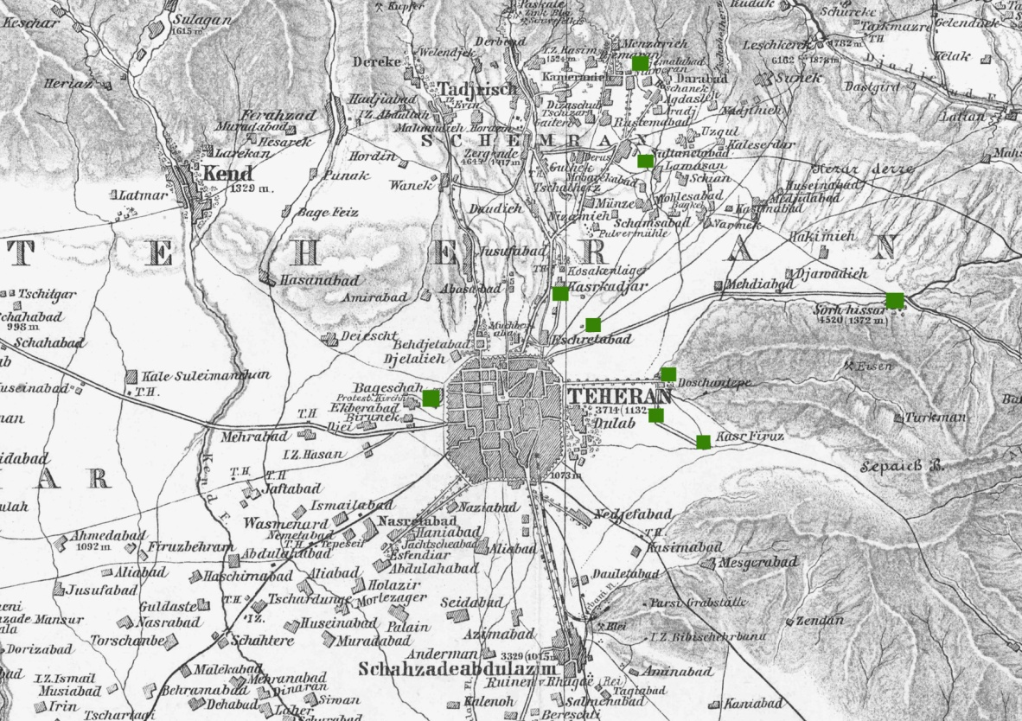

**Key**

**1** Sahebgharnieh (Niavaran)

**2** Saltanat Abad

**3** Eshrat Abad

**4** Sorkhe Hesar (Dooshan teppeh )

**5** Qasr Firoozeh

**6** Qasr Qajar

**7** Suleimanieh

**8** Sorkhe hesar

**9** Bagh-e-Shah

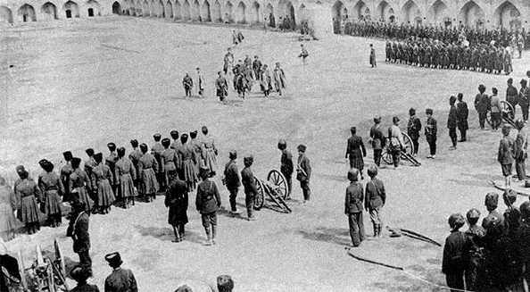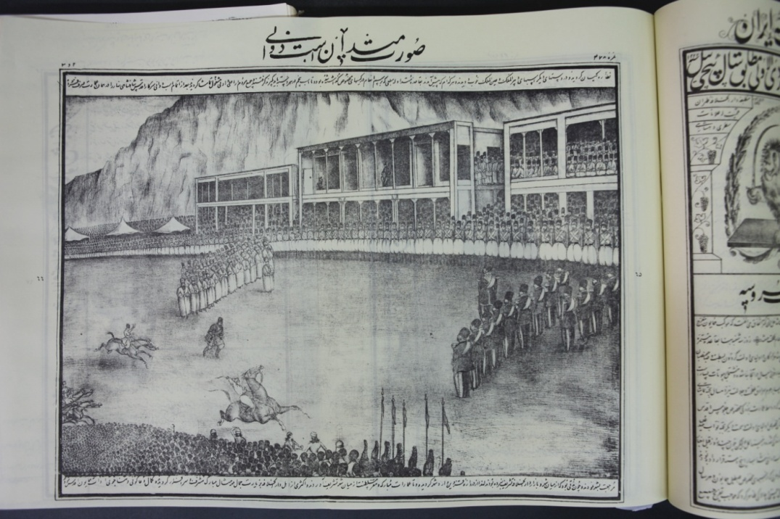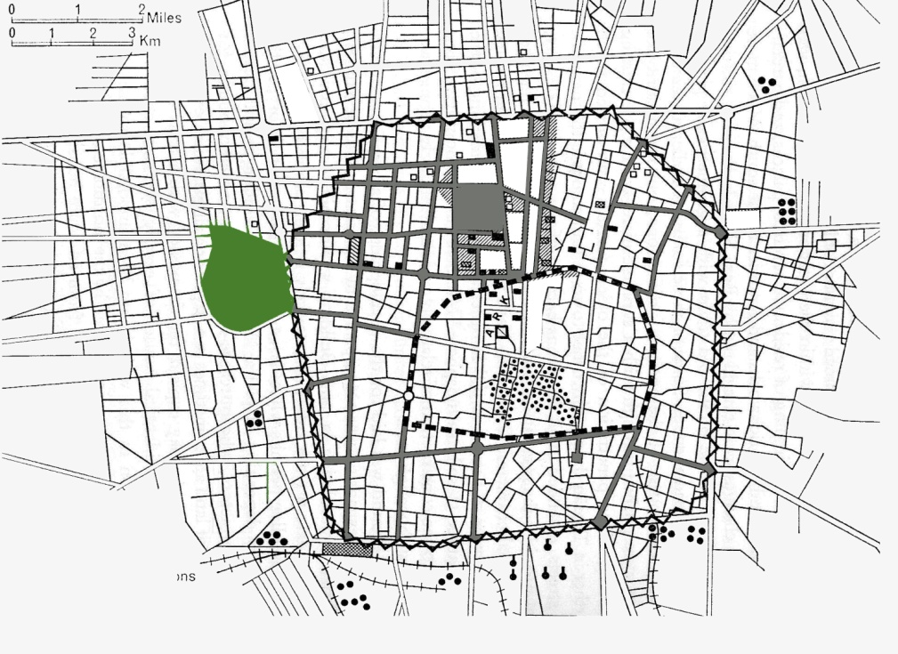

**Figure 1:** Possible locations of Naser al-Din Shah’s garden in Qajar era.(Source: shadow and number added by the author, re-drawn basedon Karte der UMGEGENDvon Tehran von drawn by A.F STAHL in about 1279 AH/1900); Courtesy of the Geography and Map Division, Library of Congress, Washington, D.C)

Figure 2: Above Right: Mashg Square, a drawing published in issue of Dolat Elieh, depicting the royal horse racing. (Source: Dolat Elieh Newspaper, No.478, Archive of Astan Qods), Bellow Right: replacement of Bagh-shah with Masgh square in Pahlavi era, Left: Location of Bagh-e- Sha on the map of Pahlavi era

|  |  |
| --- | --- |
| plan.jpg**F:\sara\bagh\shef uni\scan khansari\pasargadae,.jpgPlan** | **F:\sara\bagh\shef uni\pasargadae\Pasargadae,archive sabt jahani\10.jpg**  **Visual appearance** Garden of **Pasargadae**, Fras/Shiraz, Achaemenid Empire,529  C.249,65(h |
| plan.jpg | F:\sara\bagh\eram\ERAM main\image\IMG_1905.JPGBagh-e **Eram** ,Fars/ Shiraz, Seljukids era,11th century.12,70( ha) |
|  | Picture 096.jpgBagh-e **Chehel Sotun**, Isfahan/ Isfahan, Safavid era,1057 AH,1674. 5,80 (ha) |
| **U:\ManXP\Desktop\14.jpg** | **F:\sara\madarek bagh\bagh fin 5.6.89\DSC03119.JPG**Bagh-e**Fin** ,Safavid and Qajar era, 999 AH/1587 1250s AH/1830s?.Isfahan/ Kashan.7,60 (ha) |

|  |  |
| --- | --- |
| **Plan** | I:\sara\article\landscape research\figure 4 5th abbasabad pic.jpgBagh-e **Abas Abad,** Safavid era,1021 AH/1621.Mazandaran/ Behshahr, 420,20(ha) |
| **F:\sara\bagh\shef uni\scan khansari\p.17 khasnasri.jpgF:\sara\bagh\shef uni\scan khansari\p.17 khasnasri.jpg** | H:\sara\bagh\baghe shazde\PIC_0708.JPGBagh-e***Shazdeh*** ,Kerman/ Mahan, Qajar era,1910s. 5,5(ha) |
|  | http://vefagh.co.ir/img/tourism/54/54.jpgBagh-e**Dolat Abad***,* Yazd/ Yazd, Zand era,1160 AH/1747.8(ha) |
| **I:\sara\article\landscape research\figure 4 8th akbarieh plan.jpg** | I:\sara\article\landscape research\figure 4 8th akbarieh.JPGBagh-e **Akbariyeh** ,Southern Khorasan/ Birjand, Zand and Qajar era,1300-1364AH .3,40(ha) |

**Figure** 4: Plans and pictures of nine Persian Gardens registered as the World Heritage Sites; Photos taken by the author, summer 2015

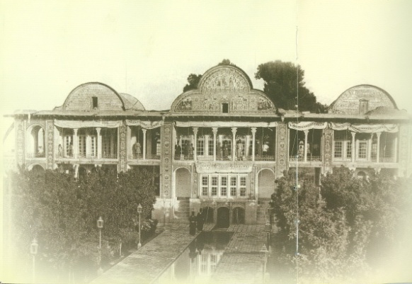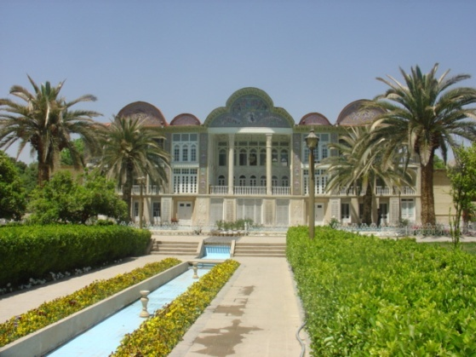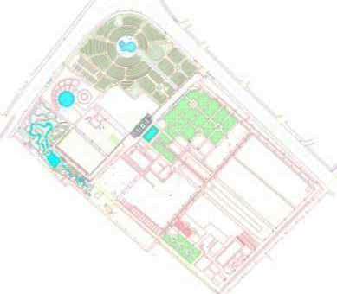

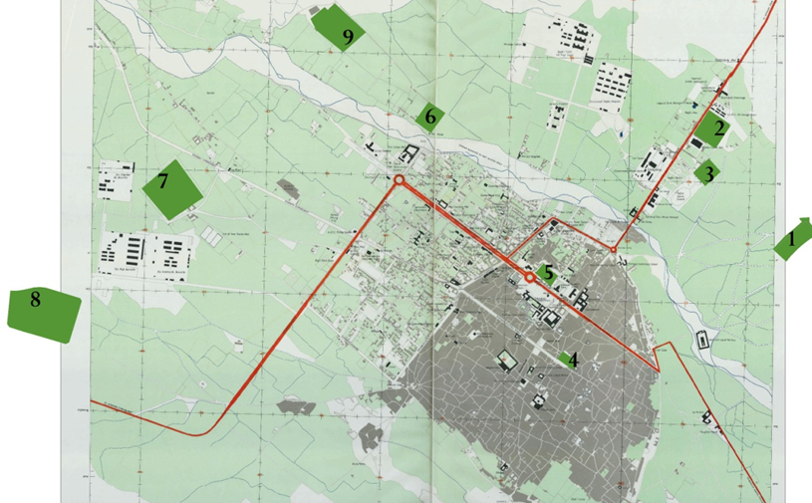

**Figure 5:** Above right: Eram garden in the 1910s, Bellow right: Eram garden in 2013; Left: plan of Eram garden

**Key**

**1** Delgosha

**2** Jahan Nama

**3** Hafezieh

**4** Qavam

**5** Nazar

**6** Safa

**7** Golshan

**8** Jenat

**9** Eram

**10** Farahnaz park

Figure 3: Location of gardens selecting for Festival in Shiraz, (Source: Highlights and numbers added by the author, based the map of Shiraz provided by the Army Map Service, Corps of Engineers, U.S Army, Washington DC, copied from Town Plan of Shiraz, 1952; Courtesy of the Geography and Map Division, Library of Congress, Washington, D.C)

**Notes**

**Abrahamian, E. (1982). *Iran Between two Revolutions*. Princeton, N.J.: Princeton University Press.**

**Afsar, K. A., & Mousavi, S. A. (1977). *Pasdari az Asar-e Bastan dar Asr-e Pahlavi (Guarding of Ancient Relics in Pahlavi era)*. Tehran: Ministry of Art and Culture.**

**Avery, P. (1965). *Modern Iran*. London: Benn.**

**Avery, P., Hambly, G., & Melville, C. (Eds.). (1991). *The Cambridge history of Iran:From Nadir Shah to the Islamic Republic* (Vol. 7). Cambridge: Cambridge University Press.**

**Balaghi, H. (2007). *Gozideye az Tarikh Tehran (Selective History of Tehran)*. Tehran: Mazyar.**

**Cole, J. R. I. (1996). Marking Boundaries, Marking Time: The Iranian Past and the Construction of the Self by Qajar Thinkers. *Iranian Studies, 29*(1/2), 35-56.**

**Creswell, J. W. (c2007). *Qualitative inquiry and research design: Choosing among five traditions* (2nd ed.). Thousand Oaks: Sage Publications.**

**Curzon, G. N. (1966). *Persia and the Persian question* (Vol. 1). London: Frank Cass.**

**Ehlers, E., & Floor, W. (1993). Urban Change in Iran, 1920-1941. *Iranian Studies, 26*(3/4), 251-275.**

**Gillham, W. E. C. (2000). *Case study research methods*. London: Continuum.**

**Godard, A., Godard, Y., & Siroux, M. (1989). *Asar-e-Iran (L'Art DE L'IRAN)* (A. S. Moghaddam, Trans. Vol. 4). Mashad: The Islamic Research Foundation (Astan Quds Razavi).**

**Grigor, T. (2009). *Building Iran: modernism, architecture, and national heritage under the Pahlavi monarchs*. New York: Periscope Publishing, distributed by Prestel.**

**Gröning, G. (2000). Aspects of the Political and Social Context of the Garden Conservation Movement in Twentieth-Century Germany. *Garden History*, 32-56.**

**Hekmat, A. A. (1976). *30 khatere az asr Farkhonde Pahlavi (30 memories of Pahlavi era)*. Tehran: Vahid.**

**Hodjat, M. (1995). *Cultural Heritage in Iran: policies for an Islamic country.* Doctoral Unpublished doctoral thesis, University of York.**

**ICOMOS-FILA. (1982). *Historic Gardens and Landscapes( The Florence Charter)*. Florence: ICOMOS-IFLA.**

**Imdad, H. (1961). *Shiraz: Gozashte va Hal (Shiraz:Past and Present)*. Shiraz: Ethadiye Matboati Fars.**

**Intelligence Ministry, C. o. h. D. (2003). *Jashn Honar be ravayat Asnad SAVAK (The Art Festival in SAVAK documents)*. Tehran: Intelligence Ministry, Centre of historical Documents.**

**Katouzian, H. (1981). *The Political Economy of Modern Iran: Despotism and Pseudo-Modernism, 1926-1979*. London: Macmillan.**

**Kazemi, P. (1932). *Etellat*.**

**Kenny, M. L. (2009). Deeply rooted in the present,Making heritage in Brazilian quilombos. In L. Smith & N. Akagawa (Eds.), *Intangible Heritage* (pp. 151-168). London: Routledge.**

**Lennon, J. L. (2012). Cultural Landscape Management: international influences. In K. Taylor & J. L. Lennon (Eds.), *Managing Cultural Landscapes* (pp. 45-69). London: New York: Routledge.**

**Marefat, M. (1988). *Building to power : architecture of Tehran 1921-1941.* doctoral thesis, Massachusetts Institute of Technology.**

**Marshall, C., & Rossman, G. B. (c1999). *Designing qualitative research* (3 ed.). Thousand Oaks: Sage Publications.**

**Mason, J. (2002). *Qualitative Researching* (2nd ed.). London,Thousand Oaks,New Delhi: SAGE.**

**Meshkuti, N. A. (Ed.). (1970). *Fehrest Banahaye Tarikhi va Amakene Bastani-e- Iran (List of Historical Monuments and ancient buildings of Iran)*. Tehran: NOCHM.**

**Mostafavi, M. (1965). *Iglim Fars: Asar Tarikhi va Amaken Bastani Fars (Climes of Fars:Historical Heritage and Archaeological buildings of Fars)*. Tehran: National Relics Society.**

**Pahlavi, F. (2004). *Kohan Diara;khaterat Farah Pahlavi (Ancient land;Diary of Farah Pahlavi)*. Tehran: Farzad.**

**Pendlebury, J. (1997). The statutory protection of historic parks and gardens: an exploration and analysis of 'structure', 'decoration' and 'character'. *Journal of Urban Design, 2*(3), 241-258.**

**Pope, A. (1971). *The Past and Future of Persian Art*. Tehran: Madrese ALI Khadamat Jahangardi.**

**Rendi, Y. S. (2003). *Mirase Farhangi dar Hogoge Dakheli va Beinol melal (Cultural Heritage in Internal and International Regulations)* (Vol. 1). Tehran: ICHO.**

**Sales, J. (1995). Garden restoration past and present. *Garden History*, 1-9.**

**Saltaneh, E. A. (1889). *Al Maser al Asar*. Tehran: Sanayi.**

**Salva, M. (2013). *Twentieth-century transformations in Iranian Ta'ziyeh: Religion, Modernism, and Revolution.* Unpublished Master thesis, State University of New York at Binghamton.**

**Sedigh, I. (1961). *Yadegar Omr (Memory of life)* (Vol. 3). Tehran.**

**Shafa, S. a.-D. (Ed.). (1978). *Gahname 50 sale Shahanshahi;fehrest rozberoz vaghaye siasi,ejtemayi va eghetsadiIran az 3 Esfand 1299 ta 30 esfand 1355 (Fifty years of the Pahlavi Imperial Calendar: daily political, social and economic events from 1921 to 1977)*. Paris: Soheil.**

**Shirin, F. (2005). *Baziche Shahbanou,Jashn Honar-e-Shiraz (Plaything of Shahbanou, Art Festival of Shiraz)*. Tehran: Islamic Revolution Document Centre.**

**Smith, K. E. (2006). Problematising power relations in elite interviews. *Geoforum, 37*(4), 643-653.**

**Society, N. R. (1979). *Gozaresh faliathaye anjoman Asar Meli(Report book of NRS)*. Tehran: NRS.**

**Soltani, M. (2007). Sheklgiri boostanhaye Shahri Moaser dar Gozar az mafhoom bagh be park (Formation of urban green spaces from garden to park). *Bagh-E-Nazar (Garden of Vision), 8*(4), 48-85.**

**Sotudeh, M. (1992). *Geografiyaye Tehran (Geography of Tehran)*. Tehran: Institute for Cultural Studies and Research.**

**Stake, R. E. (2000). Case studies. In N. K, Denzin & Y. S. Lincoln (Eds.), *Handbook of qualitative research* (pp. 435-453). Thousand Oaks: Sage.**

**Visentini, M. A., & Scazzosi, L. (1987). The conservation of parks and gardens in Italy. *Landscape Research, 12*(2), 3-9.**

**Wilber, D. N. (1975). *Riza Shah Pahlavi*. Hicksville: Exposition Press.**

**Yaghmai, E. (1971). *Karnameh Reza Shah: Bonyangozar-e-Iran-e-novin (Report-book of Reza Shah the great)*. Tehran.**

1. The registration of Qajar edifices (including their gardens) as National Relics, which did not have a public use, was put forward in the fourth International Congress of Art and Archeology in New York. See, ([Sedigh, 1961](#_ENREF_35)) [↑](#endnote-ref-1)
2. This data was gathered by the author through reviewing of the cited reference. [↑](#endnote-ref-2)