The Dynamics of Outsourcing Relationships in Global Value Chains:
Perspectives from MNEs and their Suppliers

GIOVANNA MAGNANI*
Post Doc Research Fellow
Department of Economics and Management
University of Pavia
Via S. Felice 5, 27100 Pavia - IT
Tel. +39 0382-986152
Fax: +39 0382-304226
E-mail: g.magnani@unipv.it

ANTONELLA ZUCCHELLA
Full Professor of Marketing
Department of Economics and Management
University of Pavia
Via S. Felice 5, 27100 Pavia - IT
Tel. +39.0382-986416
Fax: +39 0382-304226
E-mail: antonella.zucchella@unipv.it

ROGER STRANGE
Full Professor of International Business
Department of Business and Management
University of Sussex - UK

Tel. + +44 1273 873531
Fax: +44 1273 873531
E-mail: R.N.Strange@sussex.ac.uk

* Corresponding Author

ACKNOWLEDGEMENTS

Previous drafts of this paper were presented at the AIB 2016 Conference in Dubai, and at the AIB-UKI 2017 Conference in Reading. The Authors would like to thank the three JBR anonymous referees for their insightful and constructive comments.

The Dynamics of Outsourcing Relationships in Global Value Chains:
Perspectives from MNEs and their Suppliers

ABSTRACT

We investigate the dynamics of outsourcing relationships within global value chains, through six case studies of lead firm-supplier dyads, considering these relationships from the perspectives not only of the lead firms but also of their suppliers. We track the evolution of the relationships by identifying the roles played by heterogeneous resources and capabilities, isolating mechanisms, and relationship-specific investments in creating potential resource dependence/power asymmetries in the dyads. In our cross-case analysis, we identify different lead firm-supplier dynamics, key underlying mechanisms, and related degrees of dependence/power asymmetries. We also found evidence of the development of trust and of partnerships in situations of power asymmetry and of power balance. In doing so we contribute to an under-researched area in International Business about the evolution over time of outsourcing relationships within global value chains. We advance a set of propositions to be tested in future research.

Keywords: global value chains; power asymmetries; trust development; isolating mechanisms; outsourcing

INTRODUCTION
Much scholarly attention (e.g. Ellram, 2013; Gereffi & Lee, 2012; Gereffi, 2014; Los, Timmer & Vries, 2015; Ponte, 2014; Yeung & Coe, 2015) is currently being devoted to the nature of global value chains (GVCs) and, in particular, to how they are organised and governed (Gereffi, Humphrey, & Sturgeon, 2005; Gereffi & Lee, 2016; Ponte & Sturgeon, 2014; Suder et al, 2015; Turkina, Van Assche, & Kali, 2016; UNCTAD, 2013).
The aim of this study is to contribute to the International Business (IB) literature on the evolution of outsourcing relationships within GVCs. This is an under-researched area (Denicolai, Zucchella, & Strange, 2015), in which we aim to understand which factors drive the changes in outsourcing relationships over time. We consider these relationships from the perspectives not only of the lead firms but also of their suppliers. In this paper, we contend that lead firm-supplier relationships involve power asymmetries, and that the ability of firms to capture the rents within GVCs depends upon their exploitation of these power asymmetries (Cox, 2001; Hingley, 2005; Strange, 2011; Denicolai et al, 2015). We focus on outsourcing relationships - as a special case of buyer-seller relationships (Dwyer, Schurr, & Oh 1987; Heide & John, 1990) - trying to uncover their dynamics over time, adopting the lens of power asymmetries. We are aware that alternative perspectives on outsourcing relationships are possible, including focusing on the development of trust between lead firms and their suppliers. However, we believe that power asymmetries are a distinctive characteristic of outsourcing relationships (Blois, 1997), and these asymmetries are particularly evident in the international outsourcing of manufacturing activities, which represents the specific object of this study. In addition, since we aim at uncovering the dynamics of outsourcing relationships, the power viewpoint can better explain change in relationships, while the trust perspective is better at explaining stability. Hingley (2005: 849) asserts that, there “appears to be a gap in business relationships literature concerning the role of power and the ability of organizations to manage power imbalance.” In a similar vein, Cuevas, Julkunen, & Gabrielsson (2015: 149) suggest that power “is a central issue in business to business relationships”, but that it is not necessarily an alternative to trust, as the two can be complementary (ibid.; Chicksand, 2015). The development of trust is typically thought to be constrained in asymmetric relationships (Lusch & Brown, 1996), such as frequently are outsourcing relationships, but Cuevas et al. (2015) found that this was not necessarily the case.
Power asymmetries are pivotal in the international buyer–supplier relationships literature (Caniëls & Gelderman, 2007). In this literature, relationship stability can be threatened by the excessive exploitation of power by the stronger party over the weaker (Anderson & Weitz, 1989; Frazier & Rody, 1991; Geyskens et al., 1996; McDonald, 1999; Provan & Gassenheimer, 1994). Within the buyer-supplier relationship literature, power is defined as the ability of the buying firm to influence or control the decisions and behavior of the supplier (Narasimhan et al, 2009). It is seen as a mechanism to control the dynamics of business relationships (Bachmann, 2001) and to “induce desired actions of another firm by either punishment or threatened sanctions, or by providing or withholding rewards.” (Pulles, Veldman, & Schiele, 2014: 18). However, this literature mainly discusses the effects of power on the absolute performance of the buyer, without taking into consideration the impact on the supplier (ibid). Cox et al (2003) consider that power should be at the centre of any study of buyer–seller relationship, whilst Hingley (2005) suggests that the role of power in business-to-business relationships has been either overlooked or its importance has been denied (Williamson, 1995; Cox, 1999). We further argue that power asymmetries evolve over time – either widening or narrowing - and thus buyer-seller relationships are inherently dynamic in nature. Dapiran & Hogarth-Scott (2003) note that firms are always looking for a more favourable power balance: when one party is seen to gain power, the other will act to counterbalance it.
In this paper, we first discuss the underpinnings of organizational interdependence and power asymmetries in lead firm-supplier relationships. We draw upon insights provided by resource dependency theory, transaction cost economics, and the resource-based view of the firm, and propose a conceptual model which captures the determinants of power asymmetries and in turn the dynamics in international supply relationships, which represent an underexplored topic. A second contribution is the adoption of dyads of relationships as unit of analysis: we consider the relationships from the perspectives of both lead firms and suppliers. Third, we discuss how the dynamics of these relationships are driven by the possession of heterogeneous resources and capabilities, isolating mechanisms (IMs), alternative suppliers and/or buyers, and investments in relationship-specific assets.
Our empirical work investigates and contrasts how the relationships established by the three lead firms with, for each firm, two different suppliers have evolved over time, and why. We elaborate on the extant theory by considering six dyads (three MNEs with two each of their suppliers). We contribute to the IB literaturestudies on the dynamics of international outsourcing relationships by focusing on suppliers located in Europe, where these relationships develop in more complex ways than in emerging and developing countries where the exploitation of low labour cost advantages may be paramount.
The paper is structured as follows. We first develop our conceptual model, through a concise analysis of the relevant literature. In the following section, we detail our research approach, outline the selection of the firms for study, provide brief profiles of each firm, and explain the processes of data collection and data analysis. We then report the results of the within-case and cross-case analyses, concluding with some propositions and, discussing the limitations of the study as well as the avenues for future research.

THEORETICAL BACKGROUND
The process of “international fragmentation of production” has made MNEs’ boundaries increasingly porous through the practice of outsourcing. Outsourcing and offshoring evolved from transactional work to that of more core activities (Contractor et al, 2010; Dess, Rasheed, McLaughlin & Priem, 1995), such as manufacturing. Gilley & Rasheed (2000) suggest that outsourcing is often narrowly defined as a discontinuation of internal production by lead firms, and an initiation of procurement from outside suppliers. This substitution-based outsourcing thus involves some vertical disintegration of the lead firms. However, Gilley & Rasheed also point out that outsourcing need not be limited to activities that had previously been undertaken in-house, but suggest that abstention-based outsourcing may arise when a lead firm chooses to purchase goods or services from outside suppliers even though it has the financial and managerial capabilities to internalize the activities. Accordingly, they suggest a broad definition embracing both substitution-based and abstention-based outsourcing. We adopt a similar definition in this paper, and consider outsourcing to be a strategic decision by a lead firm to forego the internalization of an activity (Gilley & Rasheed, 2000: 764) and to buy in intermediate/final products from independent suppliers, even when the lead firm possesses the requisite capabilities to undertake that activity.
Despite the dramatic increase of outsourcing over recent last decades, many issues still need to be better understood and explored. The extant literature has typically focused on the drivers of outsourcing adopting a static viewpoint and without considering how buyer-supplier relationships evolve (e.g. Baraldi et al, 2014; Kaipia & Turkulainen, 2017). Few studies have addressed the issue of outsourcing dynamics (Holcomb & Hitt, 2007; Strange & Magnani, 2017a, 2017b) despite the recent signs of changes in the dynamics of GVCs, with several firms insourcing and/or reshoring manufacturing activities (Albertoni, Elia, Fratocchi, & Piscitello, 2015; Fratocchi, Di Mauro, Barbieri, Nassimbeni, & Zanoni, 2014) as well as the increasing importance of large first-tier suppliers (Azmeh, Raj-Reichert, & Nadvi, 2015).
Outsourcing dynamics have been studied from two main viewpoints. The first is the industry/product-level perspective on the evolution of GVCs - which builds on global value chain theory (Gereffi, 1999) - and which has been primarily interested in thee “upgrading of global value chains” – i.e. moving to higher value activities in GVCs with improved technology, knowledge, and skills (Gereffi, Humphrey, & Sturgeon, 2005). This body of literature looks at strategic upgrading at an aggregate level of analysis, such as industry or clusters (Giuliani, Pietrobelli, & Rabellotti, 2005, Pérez-Luño, Wiklund, & Cabrera, 2011).
The second perspective is found in strategic management studies. This stream of literature (see e.g. Holcomb & Hitt, 2007; Quélin, & Duhamel, 2003; Quinn, 1999) has typically looked at the drivers of outsourcing, but has generally adopted a static viewpoint and has not considered that buyer-supplier relationships evolve, industry conditions change, and so too may firms’ strategic objectives. From this perspective, outsourcing involves an asymmetric power relationship between the lead firm and its supplier(s) (Mudambi & Venzin, 2010).
Overall, the extant literature lacks an in-depth investigation of the dynamics of outsourcing manufacturing activities. In the following sections of the paper we analyse the dynamics of outsourcing relationships in lead firm-supplier relationships, with a focus on the international outsourcing of core activities like manufacturing, with the aim of achieving a better understanding of its drivers and underlying mechanisms. In order to explain the dynamics of the outsourcing, we address the perspective of power relationships between the lead firm and its supplier(s) (Mudambi & Venzin, 2010). The international outsourcing of production, which contributed substantially to the growth in GVCs, seems to pertain to the case in which relationships between MNEs and their (manufacturing) suppliers are dominated by power asymmetries. Yet these processes have been under-investigated in IB studies, especially when suppliers are based in advanced economies and not in developing countries.
The power asymmetry perspective highlights the relationships between the lead firms and their suppliers, and helps in a deeper understanding of their nature and their evolution over time. Power is certainly an elusive construct, about which much remains to be researched and emprically tested. As Cuevas et al (2015) argue, power does not necessarily conflict with trust development, Our empirical analysis will permit us to understand whether, and if so how, asymmetric power relationships may also be associated with mutually beneficial behaviour in the international outsourcing of manufacturing We approach this analysis leveraging on different research streams, viz. a) the resource-based view, which suggests the need to develop and control valuable and inimitable resources, and to build IMs, b) the resource dependence theory, which highlights power asymmetries and their underlying factors, and c) the transaction cost theory, which uncovers the roles of asset specificity and switching costs.
According to the resource-based view (Lippman & Rumelt, 1982; Wernerfelt, 1984; Barney, 1986, 1991; Dierickx & Cool, 1989; Peteraf, 1993; Teece et al, 1997), all firms possess heterogeneous capabilities and resources, some of which may be valuable and thus form the basis for the creation of entrepreneurial rents. But these capabilities and resources will only sustain a competitive advantage if there are ex post limits on their acquisition and/or imitation by potential competitors. These limits are provided by the existence of isolating mechanisms (Rumelt, 1984, 1987). According to Lawson et al (2012), there are four categories of IMs. The first category comprises those mechanisms to protect products or processes and thus involve knowledge protection either through formal property rights (patents, trademarks, licenses) or through reduced knowledge leakage. The second category relates to firm-specific technological knowledge and capabilities, which often derive from cumulative and tacit processes of experiential learning. The third category consists of market-based firm-specific assets (such as marketing capabilities, distribution networks, corporate reputation, brand names). The fourth and last category refers to first-mover advantages associated to “gain pre-emptive access to geographic space, technological space, and client perceptual space” (Lawson, 2012: 422). The stronger are the IMs possessed by a firm, the more the firm will be able to resist the appropriation of its rents.
In the context of disaggregated value chains, the rents will be co-created by lead firms and their suppliers, and this raises the issue of how the rents will be divided up. We take the view that there is no “fair” or “objective” way to determine an appropriate division of the rents, but that their distribution is subject to contestation between lead firms and their suppliers (Cox, 2001; Hingley, 2005; Strange, 2011). Hence, we draw upon resource dependency theory (Cook, 1977; Cook & Emerson, 1984; Pfeffer, 1981; Pfeffer & Salancik, 1978; Ulrich & Barney, 1984), which suggests that resource scarcity generates organizational interdependence in lead firm-supplier relationships. Each party will try to alter its dependence relationships by acquiring control over resources that either minimize its dependence on the other party, or that maximize the other party’s dependence on itself. As Caniëls & Roeleveld (2009: 404) note: “the power of an organization over another is the result of the net dependence of the one on the other. If A depends on B more than B depends on A, then B has power over A… Modifications in power relationships can alter the dependence of a party.” When both parties to an exchange relationship possess scarce resources, they are interdependent. By contrast, if there are many potential suppliers and also many potential buyers no one enjoys any power in the exchange relationship. If the supplier possesses scarce resources whilst at the same time having many alternative clients for its output, then the buyer is in a position of dependence with little power in negotiating the contract terms, and vice versa. Hence the power asymmetries within lead firm-supplier relationships will depend inter alia upon the number of alternative suppliers available to the lead firms, the number of alternative buyers available to the suppliers, and the potential switching costs in each case (Walker & Weber, 1987; Monteverde & Teece, 1992; Burnham et al, 2003; Farrell & Klemperer, 2007). Furthermore, the efficacy of IMs may dissipate over time, as new firms enter imitating the successful strategies and products. This, in turn, may alter the existing power asymmetries in buyer-seller relationships (Hooley et al., 2001). Knowledge protection mechanisms often have limited efficacy in practice, as competitors often “design around” patents (Mizik & Jacobson, 2003; Lawson et al., 2012). Knowledge leakage is difficult to avoid in practice especially in the case of tangible products that can be disassembled and reverse-engineered (Easterby-Smith et al., 2008). Market-based firm-specific assets such as brands and corporate reputation require renewal over time and thus may be fleeting (Page & Fearn, 2005). Last, first-mover advantages may dissipate as followers can learn from pioneers’ mistakes (Lieberman & Montgomery, 1998).
Finally, it is necessary to consider the relative costs of effecting transactions through the market or through a hierarchical relationship. In his seminal exposition of transaction cost economics, Coase (1937) noted that there were various costs involved in using the market to coordinate the provision of goods and services through arm’s length contracts. These costs include not only the direct costs involved in effecting the transactions, but also the indirect costs of measuring and monitoring performance, and of negotiating, monitoring, and enforcing the contracts. But there are also costs involved in the transfer of intermediate products within integrated firms as this requires the functioning of complex organisation structures, internal information communication systems, and accounting systems (Buckley & Strange, 2011). When the market transaction costs for coordinating activities are relatively low – as would be the case in the production/assembly of relatively simple goods and services or where the requisite technology can be easily codified – then some form of arm’s length contractual relationship between the lead firms and their suppliers is likely to be the result. But the market transaction costs for coordinating activities are high, there would be an incentive to internalize the exchange relationships through vertical integration. This might be the case when one party has made investments in assets that are specific to the relationship, and which increase the level of dependence of that party on the another (Gietzmann, 1996; Andrabi et al, 2006; Scherrer-Rathje et al, 2014).
The discussion above suggests that potential power asymmetries depend upon a variety of contextual factors, and that they are likely to change over time as those factors themselves change with consequent effects for the power asymmetries between the parties. The first of these contextual factors will be the nature of the heterogeneous resources and capabilities possessed by each party (lead firm or supplier), and the degree to which these resources and capabilities are imitable and/or substitutable. The second will be nature (if any) and strength of any IM (i.e. knowledge protection, technical knowledge, market-based assets, first-mover advantages) possessed by the parties. The third will be the potential numbers of alternative suppliers/clients, and the associated costs of switching to these alternatives. The fourth will be the degree to which each party has invested in assets that are specific to the relationship with the other party. Taken together these four groups of factors will determine the extent of the dependence of one party (lead firm or supplier) on another, and the power asymmetries between the parties. Moreover, these power asymmetries will in turn determine the choice and dynamics between more internalization (vertical integration) and more externalization (outsourcing) in lead firm-supplier relationships – see the conceptual model in Figure 1.
Our conceptual model will be used as starting point to frame our within-case analyses, according to the contextual factors that we have illustrated above, with the aim to develop further the understanding and theorizing about the dynamics of outsourcing in MNEs.
***** Figure 1 about here *****

METHODOLOGY
In this section, we explain our research approach, detail how the firms are selected for study and provide brief profiles of each firm, outline the data sources used, and finally explain how this information is subjected to within-case and between-case analyses.

Research Approach
Our research approach involves theory elaboration. Theory elaboration ‘seeks situational groundedness using a similar logic as grounded theory, with the exception that it engages in more theoretical abstraction. While categories and concepts are ultimately grounded in the data, this process exhibits less emergence as it is guided by a priori theoretical consideration’ (Ketokivi & Choi, 2014: 236). Thus, we have drawn insights from resource dependence theory, transaction cost economics, and the resource-based view of the firm to identify key concepts that affect the dynamics of lead firm-supplier relationships over time. More specifically, we are guided here by the consideration of the roles played by the possession of heterogeneous resources and capabilities, IMs, alternative suppliers and/or buyers, and investments in relationship-specific assets. Given the nature of our research questions, we opted for a longitudinal case study approach: longitudinal studies have been relatively rare in IB research (Pettigrew 1990; Pereira et al. 2016), yet they are suitable when the aim is to track processes and the underlying dynamics.

Case Selection
Given that our objective was theory elaboration, we did not require a large sample for statistical testing. Rather we used purposeful sampling criteria (Patton, 1990) and selected our case studies (Eisenhardt, 1989; Eisenhardt & Graebner, 2007) to throw light on the key concepts outlined in our model. The first criterion was geographical: we purposefully aimed at analysing dyads of relationships between lead firms and their European suppliers, because we aimed at a better understanding of outsourcing motivations and dynamics in cases in which the power asymmetry in favour of the lead firm could be less evident, compared to other usual outsourcing cases driven by access to cheap labour in developing countries. Accordingly, we first listed a number of MNEs and their suppliers satisfying the geographical choice, utilising ORBIS and Bloomberg data base. We then focused on manufacturing firms, operating in industries which are particularly important in the European economy and have been subject to increasing outsourcing of manufacturing activities. The textile and mechanical engineering industries are both characterized by the widespread use of outsourcing arrangements worldwide (UNCTAD, 2011). We preliminarily contacted the firms by e-mail and by phone and we could notice that manufacturing outsourcing is considered by the firms as a confidential subject of study. Finally, three MNEs with two European suppliers each agreed to be interviewed.
Brief profiles of each of the nine firms are provided below, and Table 1 summarizes some key facts and figures.
***** Table 1 about here *****
Lead Firm 1: LION
LION is controlled by a French multinational in the luxury industry and was founded in 1924, currently has 2800 employees, and has evolved to become a branded clothing company which specializes in high-end, luxury, cashmere and wool products. The firm is one of the largest cashmere manufacturers of the world. LION is structured into two divisions: the Textile Division and the Luxury Goods Division. The Textile Division is responsible for the production of high-quality fabrics and yarns, and operates nine proprietary manufacturing plants (five in Italy, three in the US, and one in Mongolia). The Textile Division produces fabrics for LION’s Luxury Goods Division, which then outsources the final production of cloths to a network of highly-skilled subcontractors (122), that work mainly (but not exclusively) for LION. These suppliers cut the fabric and manufacture the final garments under the careful supervision and quality control of LION.

Supplier 1A: TIGER
TIGER was founded in 1961, and has 40 employees. It is located in an Italian cluster of textile firms, and has increasingly specialized in the manufacture of cashmere garments. The firm has developed innovative technological solutions to treat textiles, and this has enabled it to follow a niche strategy as a key supplier producing high-quality, high-design, and high-performance clothes for leading luxury brands. TIGER has been manufacturing exclusively in Italy since its establishment, and carrying out the whole production process internally. TIGER is able to provide a full-package service, from design all the way through to the manufacture of the finished products. In the late 1990s, TIGER made the strategic decision to move away from supplying many clients with products of varying quality, and to concentrate to a few clients (including LION) producing very high quality garments. In 2010, TIGER launched its own brand but the initiative was terminated the following year, as the firm was unable to establish the brand or to sustain its worldwide distribution. In 2012, TIGER experienced financial problems, in part a consequence of its failed brand launch, and was acquired by LION in 2014.

Supplier 1B: PUMA
PUMA was founded in 1973, and has 26 employees. It is located in a former Italian cluster of fashion goods manufacturers. It supplies highly-sophisticated and customized yarns and finished goods to LION, but also operates as a full-package supplier to other branded knitwear manufacturers. The various phases of processing, design, from virtual computing, to the realization of the finished garment and shipment are done in-house. The firm has also designed and manufactured its own branded garments since 2009, and these are sold in one proprietary shop located next to the factory. PUMA is aware that establishing a brand outside a very local market would require too many resources and divert attention from developing their technological capabilities.

Lead Firm 2: STAR
STAR was founded in 2002, has 1373 employees, and is an engineering firm involved in the design, production, and supply of equipment and components for the oil and gas industry. Its main product is valves for pipeline, and its products have been bought in 107 countries. STAR owns five manufacturing plants (mostly for assembly of components bought from external suppliers), located in Italy, Canada, China, Algeria, and the United Kingdom; five worldwide offices, and three distributors in the United States. STAR has grown quickly since 2002, reaching turnover of almost €500m in 2015. The firm has been undertaking many strategic acquisitions of highly-specialized SMEs to add new business lines in the valves and valve-related sector. STAR also engages with a network of independent suppliers for material processing and production of finished products. Most suppliers are small and medium firms located in North-West Italy, a region recognized worldwide for highly skilled clusters of competences in mechanics and steel manufacturing. These capabilities have also been recognized by STAR’s main competitor (a US firm) which has established a subsidiary in the same area. STAR and its main competitor thus often rely on the same suppliers.

Supplier 2A: MOON
MOON was founded in 1982, and has 10 employees. The firm specializes in the production of customized mechanical components, and its main capabilities relate to its skills in producing components requiring high precision and quality. Originally, the firm concentrated on supplying key local industries (sewing machines and footwear) but, after orders from firms in these industries fell during a crisis period in 2000, it started supplying firms in other industries and especially firms in the valves sector. The firm works under a “goods in process account”: it receives the semi-finished goods from the client and then completes some parts of the product. It supplies both STAR and its main competitor, as well as some other firms.

Supplier 2B: COMET
Founded in 1976, COMET is a medium-sized firm employing 300 people. COMET initially produced forgings for agricultural equipment but, within a short time, developed into one of the most technically-skilled producers of high-quality steel forgings for applications in which extremely high standards of quality and reliability were required (from forgings using simple carbon steel to the most sophisticated alloys used in the offshore exploration industry, in the production of both conventional and nuclear energy, and in other high-technology applications). Production is almost completely undertaken in-house. The firm purchases raw materials and processes them. COMET sells its forgings worldwide. In 2014, COMET acquired its main supplier, a local steelwork factory, which was suffering from some major financial troubles.

Lead Firm 3: EAGLE
Founded in 2012, EAGLE is a Dutch international firm, specialising in the leasing of recycled denim and organic cotton jeans, sweaters and pullovers. Consumers lease the garments for a year, after which they can choose either to keep the jeans, or to lease another garment. EAGLE retains ownership of the raw materials, and they repair, upgrade and recycle the garments. The firm directly employs only 10 people, and outsources manufacturing to a small network of international independent suppliers. EAGLE adheres to the principle of the circular economy, and ensures the sustainability of each stage in their supply chain through numerous certifications, including the FAIRTRADE mark, GOTS, business social compliance initiatives, MVO Nederland (Dutch national CSR knowledge centre and network organization), and SA8000 Standard by Social Accountability International. The firm has had to develop a small network of suppliers, capable of manufacturing under these demanding and innovative standards – many of these suppliers are both bigger and longer-established than EAGLE (the lead firm). EAGLE, like STAR, is an example of a born global firm, which started exporting almost as soon as it was established though shops and its own online store.

Supplier 3A: FALCON
FALCON was founded in 1969, and produces and commercializes innovative yarns for sale to garment firms. The firm is located in the Prato textile district in Italy and, along with other textile firms in the region, had steadily lost market share to cheaper Asian yarns and fabrics since the 1980s. The firm has a ccomplete in-house production cycle form R&D to logistics, quality control, and after-sales assistance to clients. FALCON survived largely due to a niche strategy of developing innovative solutions and client problem-solving capabilities. At the same time, they also started to internationalize and to supply major brand name manufacturers in the fashion industry. The firm employed 40 people in 2016.

Supplier 3B: OWL
OWL was founded in 1960, as a manufacturer of knitwear. More recently, the firm has diversified its production from “tricot” knitwear to jersey, and it has specialized increasingly in producing knitwear for the most important brands (e.g. Armani, Diesel, and WF Corporation) in the high-end sportswear sector. It is focused on the production of sportswear, constantly looking for innovation thanks to an advanced in-house R&D laboratory. After the 2008 economic crisis, the firm started to internationalize to overcome the reduction in domestic orders. It sought European clients with a similar commitment towards innovative products, and established collaborations inter alia with French, Spanish, and Dutch (including EAGLE) firms through which it has developed its manufacturing capabilities and entered new markets (e.g. eco-friendly garments). The firm has manufacturing plants both in Italy and abroad (e.g. Tunisia), and employs 235 people.

Data Sources
Our case studies information was drawn from multiple data sources including: (1) qualitative data from semi-structured interviews; (2) archival data; (3) observations; and (4) e-mails, skype, and phone calls (see Appendix 1).
Nineteen in-depth interviews were undertaken with the firms. Each lasted from 60 to 90 minutes, were made jointly by two researchers, and involved taking field notes and recordings on a digital device. Our respondents were highly knowledgeable (Eisenhardt & Graebner, 2007), and all had played important roles in the strategic aspects of their firms’ relationships with their suppliers/buyers. The interviews were mostly undertaken during 2015-17, and were used to reconstruct retrospectively the initiation and subsequent development of the lead firm-supplier relationships. Our interview protocol followed best practice in retrospective research (Huber & Power, 1985). Specifically, we asked the respondents to indicate the degree of accuracy with which they could recall specific items of information. If the respondent was not confident of being able to recall the information with reasonable accuracy, we asked s/he to check with other employees and/or proprietary records and to provide the validated information when we contacted them the following day. Moreover, we put the respondents “back in time” to minimise retrospective bias (Bingham & Eisenhardt, 2011), and asked them to give a step-by-step chronology of events during the evolution of the lead firm-supplier relationship. The interviews were used to reconstruct retrospectively the outsourcing relationships as well as to track real-time moves and strategies. The collection of interviews over time as well as the retrospective building of the outsourcing arrangements by our key respondents make our case studies longitudinal.
Each interview sought answers to questions regarding: (1) background information on the firm; (2) event chronology for the lead firm-supplier relationships, focusing (for the lead firms) on which activities have been outsourced and to whom; (3) the dynamics of the lead firm-supplier relationships, focusing on the key concepts identified in our model (Figure 1) and on the identification of 2-3 critical events that have shaped the relationship; (4) the firms’ future plans related to the potential increase/decrease in commitment to the relationship, and the negative effects in terms of control and performance. interviews were transcribed within a maximum of 24 hours, and cross-checked by the two researchers to eradicate any discrepancies. If information was missing or unclear, the respondents were contacted to resolve the ambiguities. The final transcripts were sent to the respondents to check their accuracy, and to seek permission to publish the content. Overall, 90 pages of transcripts were generated by the interviews.
We triangulated the primary data gained via interviews with secondary archival data to examine processes (Langley et al, 2013). We collected firm documents provided by the respondents during our interviews, retrieved information from the firms’ websites and from the LexisNexis and ORBIS databases, and consulted a variety of published secondary sources. This triangulation further reduced the likelihood of retrospective bias, as well as highlighting potential ambiguities in the respondents’ narratives and/or confirming their statements.

Data Analysis
Our unit of analysis is the dyadic relationship between a lead firm and one of its suppliers: there were thus six dyadic case studies in total. Our analysis took two forms: a within-case analysis and a between-case analysis. We began by synthesising the chronological evidence for each lead firm-supplier relationship using a process approach (Mohr, 1982), aiming to understand patterns in events (Langley, 1999; Langley et al, 2013; Welch & Paavilainen-Mäntymäki, 2014). In particular, we looked at the events that guided each lead firm-supplier relationship, identifying specific events that triggered changes in the relationship, as reported by our respondents and through triangulation with secondary sources. We made sense of our evidence by using a “visual mapping strategy” (Langley, 1999), where the “sense-making” (Pettigrew, 1997) is provided by the inductive recognition of patterns (see Appendix 2). At the same time, we assembled and discussed the evidence related to the key variables in our conceptual model.
Once we had developed the six individual within-case analyses, we then undertook a cross-case analysis to recognize patterns across the six dyadic cases (Pettigrew, 1992). The cross-case comparison was carried out by synthesizing the evidence in relation to the following dimensions: (a) the key contextual factors in the lead firm-supplier relationships; (b) the extent of the dependence/power asymmetries between the parties; and (c) the dynamics of outsourcing relationship over time (see Table 8). Two researchers individually coded the transcripts and the secondary data material via content analysis (Lindkvist, 1981; McTavish & Pirro, 1990) by looking at the contextual meaning of the text, and developed an efficient number of categories that represent similar meanings (Weber, 1990). The third author did not participate in the coding but, as a check, acted as an “outsider” to verify the coding scheme devised by the two other researchers (Gioia et al, 2013). This systematic comparison of the key dimensions across the six lead firm-supplier dyads enabled abstraction from empirical evidence to theory elaboration.

WITHIN-CASE ANALYSES OF THE LEAD FIRM-SUPPLIER RELATIONSHIPS
Our analysis starts with a consideration of the evolution of the six lead firm-supplier relationships over time. In each case, we structure the analysis around the key components of the conceptual model (i.e. heterogeneous resources and capabilities; IMs; numbers of alternative suppliers/buyers, and associated switching costs; and investments in relationship-specific assets), identify the power asymmetries between lead firms and suppliers, and hence explain the outsourcing relationship dynamics.

The LION-TIGER Relationship

LION outsources its production to a network of 122 subcontractors, yet the finest-end knitwear production concentrates on a smaller number of suppliers located in TIGER’s and PUMA’s region. TIGER was a supplier to two other luxury brands in the 1990s, before becoming one of LION’s key suppliers in 2001. LION soon became TIGER’s main client and was then acquired by LION in 2014. The relationship between the two firms could start thanks to TIGER’s ability to supply highest quality garments, compared to other suppliers, as well as to develop highly-customized solutions. At that time LION’s orders already “covered the 70% of turnover” (TIGER, founder).
TIGER owns unique technological capabilities thanks to accumulated knowledge via learning by doing: “TIGER is one of the most important and strategic suppliers, representing an excellence in research and development as well as in the production of the finest yarns and cloths.” (HoP, TIGER). TIGER’s main IM is technologically-related. This IM allowed the firm to be over time progressively considered as one of LION’s main and key suppliers for high-end production, but at the same time to become progressively more dependent on its orders.

LION possesses highly inimitable and un-substitutable marketing capabilities, and well-established distribution channels: its knitwear, renowned globally, is distributed throughout directly operated stores, speciality stores, showrooms, and franchisees. LION’s main IM is thus based on the strength of its brand and on corporate reputation, the firm being always committed towards reaching excellence of fabrics from the rarest and most valuable raw materials.
In 2010, TIGER tried to develop its own brand, leveraging on the accumulated knowledge via learning by doing since the 1960s. The founder planned to distribute the new brand through agents and showrooms in New York, Tokyo, and Shanghai. Not much later, the entrepreneur understood that the firm did not have enough resources to support and distribute a global brand and, in 2011, decided to end this project because “nowadays you need a lot of investments in marketing and distribution channels if a new brand wants to emerge in such a hypercompetitive industry” (TIGER, founder). This failure led the firm to increasingly concentrate on a few lead clients: from different B2B clients, to a few B2B clients, focusing on the highest quality of cashmere textiles. Since then, and until 2012, TIGER also supplies other firms belonging to the ABC group. By 2012, LION “accounts for 80% of TIGER’s turnover” (TIGER, HoP) indicating higher dependence over LION’s orders “over time, they have been asking for more and more clothing for their seasonal collections.” (TIGER, HoP).
In addition to this, both LION and TIGER have invested increasingly in relationship-specific assets. Since 2001, TIGER has invested in dedicated machinery and dedicated human resources to keep pace with LION’s demand. Straight after the acquisition, also LION begins to invest in the knitwear factory to further enhance the existing technological know-how: “LION has been undertaking a series of important investments to renew the knitwear factory: a complete renewal of the machinery and the introduction of more innovative solutions regarding the treatments of textiles. The aim was to further strengthen our excellence both in terms of R&D and of machinery” (TIGER, HoP). As stressed by the HoP a long-term plan of investment continuity is being implemented by LION. “This has been certainly a successful operation because now our company has a present and a future” (TIGER, HoP). The factory is currently supervised and coordinated by a LION manager “in charge of maintaining close interactions between the two” (TIGER, HoP).
In 2014, when TIGER’s financial problems deriving from the failed launch of its own brand led the firm close to bankruptcy, LION acquired it, given its unique manufacturing capabilities. The relationship between the firms thus evolved towards vertical integration. According to TIGER’s HoP “We were trying every way what we could do but then at some stage, we raise our hands and talked with our largest client, which made 80% of sales. We openly said what the problem was, and our difficulties. The client looked at the situation very carefully, and then said: “rather than running the risk of losing this supplier, we are willing to acquire it”. (TIGER, HoP).

The LION-PUMA Relationship
PUMA is part of LION’s small network of finest-end garments producers, to which TIGER also belongs. PUMA had 3-4 main clients before partnering with LION in 2010 and then becoming one of its key suppliers. PUMA, like TIGER, had developed strong capabilities in manufacturing luxury cashmere textiles and solving technical problems for their lead clients. However, PUMA’s and TIGER’s capabilities are different, because they treat different types of cashmere yarns using different processes and technologies. PUMA firm also sells to final consumers with their own brand, but this is increasingly a marginal part of their activity, for the same reason reported by TIGER. The origins and early evolution of the relationship with LION and the early development of it are closely related to PUMA’s ability to provide ad hoc customized solutions thanks to its problem-solving approach.
With regards to IMs, as in the case of the relationship with TIGER, LION can exert power over PUMA thanks to its brand/reputation related IM. On the other hand, PUMA’s ability to combine design competencies and work on clients’ requests enabled the firm to establish a technologically-related type of IM.

Regarding alternative suppliers and investments in relationship-specific assets, we found similar evidence as in the previous LION-TIGER case. After 2010, PUMA begins establishing a tighter relationship with the lead firm, increasingly committing to invest in dedicated assets and become increasingly dependent on LION, with LION increasing its share of PUMA’s turnover from 30% to 60% by 2015. PUMA’s commitment to the relationship was further strengthened by its 2016 purchase of machinery specifically to produce textiles for LION. The machine was acquired with the financial support of LION through a firm controlled by the latter. PUMA’s CEO stresses that the relationship should be considered a collaboration between two firms, each leading on some competences: “I want to be a collaborator: not a mere supplier! We have bought a specific machine that can produce a specific type of textile for LION. Of course, this machine could be used in the future also for other brands which we supply. Still the investment has been done for LION first.” The relationship between the firms thus evolved as LION became an increasingly dominant partner in the outsourcing arrangement with PUMA. This trend of increasing commitment of the supplier towards the lead firm may be the anticipatory step towards a stronger bilateral dependence, where the lead firm increasingly relies on PUMA’s garments manufactured with customized machineries. At the same time, PUMA increasingly commits to highly relationship-specific investments to satisfy its major client (LION).

The STAR-MOON Relationship

STAR relies on 200 independent suppliers (as of March 2016). MOON started supplying STAR in 2006 after a period of harsh crisis of its main clients (in the sewing machines and footwear machinery, both entering a long run decline). MOON’s main client is STAR, which accounts for a sales percentage ranging from 30 to 45-50%.
STAR possesses unique capabilities in the design, and assembly of equipment and components intended for the oil and gas industry. In a short span of time, the firm became a leading group in its industry also thanks to its ability to develop an established network of key suppliers. From this perspective, as in the words of its HoO, STAR has adopted a quite different business model from its competitors: “I can say this because I spent 17 years working for a competitor who had an industrial strategy focused on verticalisation of the transformation process of this product [i.e. valves].” (HoO). In contrast, MOON is a micro firm, mainly dependent on the personal skills of two family members who own (personal) technological capabilities to manufacture some steel components.
The IM of STAR thus rests on its client relationships worldwide (market-based isolating mechanism), which was the original asset at the firm foundation and has been continually developed along the years. In this industry, market-based IM involve access to global clients (oil companies), based on long term relationships and mutual trust. The firm also acquired some firms in the oil and gas value chain to access market capabilities, relationships, and market power.
On the other hand, MOON does not seem to have developed any IM. From this perspective, the firm is subject to the dependence over STAR and prone to being marginalized as STAR is progressively tightening the control over its suppliers through implementing quality controls and ratings. “Suppliers are constantly monitored by the HQ. They have a general contract setting the basic rules of the cooperation and specific contracts for single deliveries.” The intention for the near future is to try to standardise some components to set standards and to progressively adopt a more formal system to constantly monitor suppliers’ quality: “In the future we think we are going to further develop our current outsourcing strategy. We are going to make the products more standardized. “In the coming years, the Group plans to further develop the business model based on externalization and the possibility of improving the forecast analyses to improve production times. In this context, the company will work to structure a ‘sales operation planning’ and to increase monitoring of suppliers for a strengthened alignment with its KPIs.” (STAR, HoO).
The adoption of standards causes tensions in a small firm because they require investments in technology and human resources and puts in direct competitions an increasing number of potential suppliers. MOON feels highly pressured and fears marginalisation increasingly. As MOON’s respondent told us: “we are not for the moment subject to rating, though we know they tend to monitor our performance. In addition, we must keep track and provide them for every supply of components the “machine forms”, stating exactly what we have done, which standards we adopt, which tolerance for errors etc.” (MOON, MD).
STAR’s main competitor (GALAXY) is also one of MOON’s clients, accounting for a sales percentage that varies from up to25%. MOON also serves a third client in this industry, SATELLITE is more a solutions provider company for different industries including oil and gas. STAR accepts that suppliers work also for its competitors “we do not want them to depend us only, we are happy if they work for others” (STAR, HoO). The power asymmetry though is very clear in this case: MOON depends on STAR which represents the major share of its revenues, while the lead firm does have no dependence on MOON because similar capabilities can be found easily in the network of 200 suppliers. Being one of the smallest and the least-specialized of the suppliers, MOON is increasingly “used” in case of peaks in demand or when components need to be ready with very short notice. “We cannot any longer fight against the evidence that we are a “spare” supplier and we now depend more than other suppliers on the trends in the oil and gas industry”.
Regarding investments in relationship-specific assets, MOON only supplies its clients under a “goods in process account”: it receives the raw materials or work in process and manufactures the components required according to the client requests. In this case, the supplier does not have to buy raw material or work in progress, and thus the financial burden is on STAR, who buys these materials and sends them to the suppliers for transformation. This aspect of MOON’s contracting agreements seems to confirm that GVCs are characterized by processes of increasingly fine slicing of activities, especially in manufacturing. However, this arrangement involves that these activities can be easily internalized again or performed by other suppliers. Moreover, MOON has agreed to pay back STAR a percentage of its business: “our key client (STAR) rules our relationship through a general formal agreement, which sets the ‘rules of the game’. Apart from quality standards and delivery terms, the main issue is that we agree to pay-back STAR with a 5% of the business they provide us (above 300,000 Euros), motivated as a ‘production premium’ or ‘management compensation.” (MOON, MD).

STAR has meanwhile been progressively increasing its influence and control over MOON (and its other suppliers) by introducing quality controls and performance monitoring. The relationship between the firms thus evolved as STAR became an increasingly dominant partner in the outsourcing arrangement, and used its power to exert more and more control over MOON.

The STAR-COMET relationship
The commercial relationship between STAR and COMET initially arose from a personal friendship between the owners of the two family-owned firms, and COMET began supplying forgings in the early 2000s. The relationship with STAR could then establish thanks to COMET’s unique technological capabilities to produce high-quality and highly reliable steel forgings for the oil & gas sector. The two firms are close partners and co-design products. “Our product is critical in the chain; we have for example products employed on offshore platforms. The close relationship with our clients enables us to make them aware of the criticalities and specificities in terms of quality and reliability of our product. With those clients we have the strongest relationships with, such as STAR, we almost co-design products and often we are consulted in the design stage. This has been our key strength in time” (COMET, SD).
COMET could establish a strong technologically-related IM. The constant confirmation that COMET could meet STAR’s expectations on product quality and reliability, have somehow loosened the control by the lead firm over the supplier. “These days what counts the most is product reliability. Think about offshore platforms, think about the Gulf of Mexico disaster... quality, reliability, and safety are key. STAR knows that we do not do crap, we have a very robust quality system which does not tolerate errors, so they can reduce the level of control over what we do. They come to us because they need a high-end product.” (COMET, SD). Amongst its 200 independent suppliers STAR thus developed stronger trust-based relationships with COMET.
After the 2008 oil crisis, COMET went through a process of industry and clients’ differentiation policy, according to which each client could not exceed the 15% of the firms’ total turnover. In 2008 STAR accounted for the 10% of COMET’s turnover. Currently the firm has a 10/90 client concentration ratio (10 clients account for 90% of their sales), but they target an 80/20 ratio as they used to have during the 1990s. The first (global) client in terms of sales volumes is General Electric (15% of total turnover), while STAR is one of their relevant clients, but not as much as it was before. Nonetheless since 2008 the relationship between the two firms further strengthened because some suppliers exited the valves market because of the crisis in the oil & gas sector and COMET became one of STAR’s key suppliers, accounting for 5-6% of COMET’s turnover, but according to our respondent the relationship is tight and will be so in the next years.
According to our respondents, COMET has different relationships that seem to vary according to the client’s corporate governance. When clients are family firms, they have very tight personal trust-based relationships (the case of STAR): “There was a period when STAR required special efforts to its suppliers, especially longer times for invoices payment. Not everyone accepted this, but we did. Since there was mutual respect between the two firms’ owners, when there was this need to give a hand to STAR there was COMET’s willingness.” (COMET, SD). Over time, this trust-based relationship has lead also to product co-design. The other type of client relationship is with managerial firms (public companies with independent management), a case in which relationships are less tight and buying logics are based on tenders and quality/price ratings. “The lack of personal linkages, mutual trust and common views is partially dependent of the short termism of these firms, which only aim at cutting costs and having the cheapest offers, and partly on the continual rotation of managers in charge of buying and of managing suppliers’ relationships. These managers have little or no specific background and thus only look at the prices offered by the different suppliers. The introduction of standards and rating systems may further increase this approach.”
In contrast to MOON, high quality requirements are strengthening the relationship with STAR because they are not perceived as a threat, but an opportunity to raise barriers to entry and to stay in their market. “Higher industry standards help us to threaten potential new entrants and to be accredited by a larger number of clients” as COMET HoO declares. We did not find any investments in relationship-specific assets.

The EAGLE-FALCON Relationship
Both EAGLE and FALCON are small firms (in terms of employment), but both have distinctive market niches. Neither is particularly dependent upon the other, and the relationship between the two is distinctly arm’s length notwithstanding recent joint efforts to obtain internationally-recognized certification.
EAGLE has developed a unique value proposition based on leasing recycled jeans. Even if relatively young, the firm could develop successful marketing practices thanks to the close relationship with social media and engaged clients. It has become a popular brand also amongst vegans, which are increasing the client base, as their jeans have no leather in them. EAGLE’s main IM is based on the first-mover advantage in its industry, being one of the first firms in venturing a business model based on leasing recycled jeans.
FALCON is capable to guarantee highest quality garments, owning unique capabilities in research and development of yarns, where tradition, development, and experimentation fuse together. The many innovations made by this firm are possible because of their focus in the research and development and in the continuous investments for the most advanced machineries: “we have invested increasingly in those machineries characterized by having a productive specialization. That is, we no longer speak of big productions etc., but of small lots and many variations, on one hand to shorten the production cycle, and on the other going to produce innovation. With our equipment manufacturers, have invented a machine that allows us to do a certain type of product.” (FALCON, CEO). Furthermore, FALCON is capable of accommodating economic and technological evolutions and changes in clients’ styles, and thus is able to provide continual problem-solving to client-specific demands. This capability is critical to EAGLE, which works under a demand-based system. During the early 2000s, many of the firms belonging to the textile district were losing share in international markets. But FALCON was able to innovate, and could go through the crisis successfully, being one of the first firms in the district to produce a recycled type of denim: “Historically, we treat long and fine fibres…but we needed to do something new…so we had the idea of making a recycled yarn, but with a certain appeal [for the client] … so we went for the recycled denim.” (FALCON, CEO). FALCON, being capable of going through repeated crises thanks to high innovativeness and excellent production processes, could establish a strong technologically-related IM. Further the firm could over time develop many relationships with renowned brands in the textile industry, enhancing its reputation.
The relationship with EAGLE began in 2012 thanks to the supplier’s reputation in the field. FALCON began supplying recycled denim to EAGLE in 2012. “I was disappointed with a first supplier I found because when I visited the factory I was not able to see the whole production chain, but then I found FALCON…” (EAGLE, CEO). According to FALCON’s CEO: “it is a fact that the relationship was born thanks to our reputation. At that time, we had no certification yet. But we had a reputation”. FALCON’s research, quality, and identity have represented the basis for building the relationship with EAGLE, notwithstanding the fact that the former did not have certification at the very beginning.
EAGLE partners with a small network of five international independent suppliers. One Tunisian factory (owned by an Italian company) stitches and laundries jeans, while one another fabrics certified sweaters. In Italy one independent supplier is devoted to stitch the jeans and supply the latter Tunisian factory with a recycled denim yarn. The Egyptian factory mills the denim; two Spanish suppliers recycle the returned jeans, spin and dye them. The quality control and the marketing are undertaken in-house. The factories with which the firm partners are “fair factories”. EAGLE consciously sources raw materials in factories located in the European area, in order to be able to visit them frequently and ensure transparency, fair wages, and good working conditions (for instance in the Tunisian factory they guarantee above average living wages, as stated in the audit report provided by the firm).
FALCON, on the other hand, serves many clients. These can be grouped into two main types: big international textile brands, and knitwear factories (amongst which Chinese-owned factories represent its biggest clients in terms of turnover). Since 2012, the relationship between the two firms has showed the power balance to be on the supplier side. As FALCON’S CEO explained us, EAGLE represents only a very small portion of turnover. Nonetheless, she said that clients like EAGLE serve as a sort of “stimulus” that pushes the boundaries of the firm’s innovative capability. “Look, we have ‘stimulus’ clients like EAGLE, but that at the same time represent a small part of our turnover, and then we have clients who do not represent a ‘stimulus’ but that are important from the point of view of the weight on the turnover” (FALCON, CEO).
Regarding investments in relationship-specific assets, EAGLE asked FALCON in 2012 to join a project to produce an own certification system in the recycled denim, but after some time, notwithstanding the high investments made by EAGLE, the project failed. Among the many reasons, this was because FALCON thought they needed internationally-recognized certification. So, in 2016, FALCON sought the internationally-recognized RCS (Recycle Clean System) - ICEA certification. The partnership also required investments in R&D for FALCON but – as mentioned above - the supplier believes that this may open the door to new clients and new businesses in the growing sustainable fashion market.
Since the inception of the relationship, EAGLE has only ever accounted for about 1% of FALCON’s turnover. Even if EAGLE does not represent a key client in terms of turnover, the relationship is set to continue in the future because as in the words of FALCON’s CEO “they are important for us to go ahead and innovate in this sector [i.e. recycled yarns] and to have high visibility on foreign markets, especially with young final clients that have an attention on sustainable production processes.”

The EAGLE-OWL Relationship
OWL was born as a cutting-edge knitwear factory for the medium-high range of sportswear. The firm has its own R&D laboratory with highly specialized machinery working constantly on product innovation, also oriented towards environmental sustainability. Their internal R&D laboratory is key for the firm to establish strong technological capabilities. From EAGLE’s point of view, OWL was the perfect partner, thanks to its commitment towards transparent production processes, innovation, and forward-looking on circular economy issues. “For us there’s no half and half way. Either they understand what we are doing, or nothing. We do not work with people that lie with us, or cheat us, or these kinds of things…It is just not possible. We are transparent about everything, that’s why you can find whom you are working (EAGLE, CEO).
In 2012 OWL becomes one of the selected EAGLE’s suppliers. OWL works for many international clients. Since 2008, the firm has established close partnerships with French, Spanish, and Dutch clients (amongst which, EAGLE) to progressively develop its know-how, particularly with respect to circular production processes. OWL sources the recycled denim fibres from FALCON, and then process them in their Tunisian factory to obtain jeans. The firm is also EAGLE’S exclusive manufacturer for sweaters. EAGLE, as in the case of FALCON, represents only 1% of OWL’s turnover. In this relationship, OWL has a leading role in promoting innovative solutions. The firm enjoys IMs related to its highly-specialized technological know-how and innovation capabilities, and has fostered a strong brand reputation over time.
As in the EAGLE-FALCON relationship, the two firms have invested in relationship-specific assets: the supplier had been involved in EAGLE’s project for the realization of an own certification, but “the project then failed due to too high costs” (OWL, PCS). As for certifications – which for EAGLE represent a strategic asset from the marketing point of view - OWL took a different approach. For this company, quality of the production process it crucial, but it is not tied to satisfy each client’s specific certification requirements. The Italian headquarters are certified ISO9001, while the Tunisian subsidiary “has been implementing best practices for working conditions, the cleaning, and the waste disposals, which otherwise would not have been required by the Tunisian authorities. But we did so, because our philosophy is to run factories the best way that we can, especially with a low impact on the environment, and from this we know we have gains…we have gains from employees’ productivity and happiness, but also from clients. We are ready to have any audit our clients request us. And each time they came to do an audit, we were successful.” (OWL, PCS).
Recently, EAGLE has invested in the Tunisian factory, and this further points to the fact that the outsourcing choice was not done for cost motivations. “We have invested in the latest and most advanced washing techniques together with their partner in Tunisia. We focus on the use of Laser technique and on Ozone processes, which both dramatically reduce the impact on the environment in jeans manufacturing” (EAGLE, CEO).
It is not clear who is the lead firm in the EAGLE-OWL relationship, as OWL discovered EAGLE at a trade fair in the Netherlands in 2012 during its post-2008 internationalization initiatives. OWL is also a much bigger firm than EAGLE in terms of employment.

CROSS-CASE ANALYSIS OF THE LEAD-FIRM SUPPLIER RELATIONSHIPS
In this section, we compare the evolution of the six lead firm-supplier dyads with reference to the drivers for outsourcing, the evolutionary path of the power asymmetries/degree of dependence between the parties, and the relationships’ key underlying mechanisms (see Table 2), and advance a set of propositions. Further representative quotes are provided in Appendix 3.
****** Table 2 about here******

In our cases, the outsourcing of manufacturing has been a key strategic decision. For the two born global multinationals (STAR AND EAGLE), outsourcing has represented a way to fast growth, leveraging on competences developed and investments made by a network of suppliers. For the large and long-established luxury multinational (LION), it has represented the way to access to highly-skilled labour and manufacturing processes embedded in local systems. In this latter case, we found only one case of vertical integration (acquisition of a supplier), but these decisions were “forced” by the risk of default of the supplier. This seems to confirm that suppliers with unique and inimitable competences are key to the multinational firm success. Apart this extreme case, the evolution of outsourcing relationships between the MNEs and their European suppliers mostly evolves towards either bilateral dependence or partnership.
In all our six dyads, each party increasingly specializes in complementary capabilities and IMs (client relationship and market based IMs for the lead firms, manufacturing capabilities and technological IMs for the suppliers). This evolution seems to balance power in relationships, but we could also notice that lead firms tend to alter this situation at their advantage, either through relationship-specific investments or through the introduction of standards. Suppliers which lack of resources and capabilities to follow these patterns, are soon marginalized, as it happens with MOON. Also, suppliers try to alter the power balance at their advantage, by further enhancing their technological IMs (protection against competitors) and diversifying their clients (protection against buyer power). Thus, our empirical evidence highlights some aspects of both the “light side” and the “dark side” of the relationships (Fang, Chang, & Peng, 2011). Our focus on the power asymmetries provides important insights on the dynamics of these outsourcing relationships, whilst but we also uncover instances of trust development (Cuevas et al, 2015; Chicksand, 2015).
Below we briefly discuss each group of dyads.
LION shows the traits of the global factory as discussed by Buckley (2009) and Buckley & Ghauri (2004): it is in fact a global brand owner, orchestrating a network of manufacturing suppliers. At the same time, outsourcing decisions are neither driven by lower manufacturing costs, nor by fixed costs reduction and by the need to shift investments on suppliers. Though they still retain some manufacturing activities in-house, they have increasingly pursued access to highly distinctive manufacturing competences, in the highest value-added finished goods and/or parts of the manufacturing process. The more the lead firm focuses on luxury markets, demanding client experience and global branding, the more they need to partner with highly-specialized suppliers. Interestingly, these capabilities are located in narrow geographical areas and are partially embedded in clusters with highly-skilled labour forces, located in developed countries. The lead-firm supplier relationship is thus a partnership, which evolves progressively into a sort of bilateral dependence (Strange, 2011; Denicolai et al, 2015). This is confirmed by the fact that the lead firm increasingly commits resources to the further development of suppliers’ capabilities: the suppliers are asked to provide technical solutions to innovative design, and the lead firm contributes to the buying of the most advanced machinery for the suppliers. The power asymmetry is thus evolving and also increasingly nuanced, showing reciprocal dependence on the capabilities side and supplier dependence on the financial one.
The trust perspective comes into play to complement the power view: We can observe the development of trust and hence partnerships.between the lead firm and its key suppliers. The goal congruence between the two parties shows how trust can develop even when there are power asymmetries, confirming the evidence from Cuevas et al (2015). We also uncover the role of complementarity in IMs. IMs become increasingly differentiated and complementary: both suppliers achieve unique mastery in their respective manufacturing skills, developing increasingly strong IMs based on technological capabilities (Lawson et al., 2012), resulting from idiosyncratic combinations of tacit knowledge, learning by doing, and client technical problem-solving. The lead firm develops progressively luxury client knowledge, design and branding competences (market-based IMs). Both suppliers try to establish their own brands, in order to have higher margins and to achieve more independence from lead clients, but one failed and the other struggles. This seems to suggest that continuing to improve the existing IMs, largely based on tacit knowledge and local skills, and to exploit interdependence instead of independence is a less uncertain strategic choice, though not the only one.
This also suggests that upgrading of suppliers does not necessarily entail independence through their own brand (Gereffi, 1999, Tokatli, 2007), but also achieving superior manufacturing skills. This paves the way to a fruitful partnership based on collaboration and reciprocal trust, instead of one based on competition. Power asymmetry evolves into competences asymmetry (or better, complementarity) and long-term cooperation, guided by goals congruence. Power is balanced via interdependent collaboration and evolves into stable partnerships (Chicksand, 2015).
STAR is a case of global start-up in the Oviatt & McDougall (1994) taxonomy: i.e. a firm that from the beginning coordinates multiple activities in its value chain across a number of countries. This case confirms that outsourcing can be a key strategy for fast global growth. In the oil and gas industry, the competitive advantage rests on capacity do deliver the needed components and to manage key global client relationships. The founder could establish the latter during his former experience in the industry but had no productive capacity. Fast growth was necessary to establish reputation via manufacturing credibility, and outsourcing was the solution. According to Salimath et al (2008: 360) “matching the entrepreneurial firm’s configuration of organizational characteristics with an outsourcing strategy can be of crucial importance to the firm’s continued existence”. This motivation for outsourcing has not been sufficiently explored, as the authors suggest. Also in this case, the MNE looked for its suppliers in a narrow geographical area, in which it was possible to find a number of small and medium-sized firms highly specialized in working metals in different stages of the manufacturing process. STAR pursues the idea of an integrated system of suppliers: they need to respect standards of quality in production, in delivery of goods, in procedures. STAR increasingly refers to its own firm-specific standards and to industry standards, thus increasing substitutability among suppliers and reducing its switching costs. As Ponte & Gibbon (2005: 1) argue “lead firms have been able to embed complex quality information into widely accepted standards and codification and certification procedures”. The smaller suppliers like MOON, who only work under the goods in account system, fear increasing marginalisation. The larger suppliers of highly-specialized components, like COMET, are much less affected. They feel they have always been partners of STAR from the beginning, sharing technical problems and finding solutions, helping STAR to achieve fast growth and delivering the needed quantity and quality when it was necessary for STAR credibility and survival. At the same time, we do not observe a situation of bilateral dependence. STAR looks for diversifying its key suppliers as COMET pursues a policy of client diversification, both to avoid dependence. COMET reports that, in the oil & gas sector, the supply relationships are moving from personal ties to “managerial” logics, driven by tenders, prices, and quality standards.
This finding suggests that a long-standing relationship, previously based on the personal linkages between the founders and their reciprocal trust, can evolve into a system of “impersonal” ties in which standards matter more than (or even substitute for) trust. This system generates a competitive environment, as opposed to a collaborative one, in which the different suppliers have to invest in complying with industry standards and – once they are compliant - they are all formally equal from the buyer’s point of view. Therefore, COMET increasingly pursues diversification also in terms of industries served. They leverage on unique manufacturing capabilities in some phases of the steel component production process and invest resources in their continual upgrading, and can apply these competences in different industries. On the other hand, MOON struggles in extracting any rent from client relationships, and has to compete on prices and delivery times. They did not invest either in improving their competences or in complying with standards, for the lack of financial resources and because the main skills are in the founder, who has not been capable to build a learning organisation around himself (Le Breton-Miller & Miller, 2006). COMET instead pursued successfully this way and is now one of the leaders in its narrow world market niche. They invested substantial resources in technology, in staff training, and in integrating vertically (high-quality steel production). This two-sided story of supply relationships speaks of the role of investing continually in nurturing key capabilities, which then feed IMs. According to Le Breton-Miller & Miller (2015: 397) “Resource-based scholars have focused on the properties of resources and the isolating mechanisms that sustain their rents in the face of competition. Unfortunately, they have devoted far less attention to the sources of vulnerability of many of these resources.”
The latter two dyads of the textile sector (EAGLE/FALCON and EAGLE/OWL) provide a perspective on the early stages of an international new venture (like STAR), but in its inception phase. We receive confirmation of the role of outsourcing as a strategy to pursue fast international growth and access to highly-skilled manufacturing competences, which are embedded in local clusters. The relationships between suppliers and EAGLE are based on a mutual engagement in innovation. Co-innovation is an issue that we found in almost all the previous cases (apart from the weak relationship between MOON and STAR) but here it is the interpretative key of the story. EAGLE cannot be considered a “lead firm”, because it is much smaller than its suppliers and only represents a very minor percentage of their business. EAGLE can rely on the supplier’s highly-advanced manufacturing capabilities developed over time with key MNEs of the apparel industry. The suppliers rely on technology-based IMs, highly similar to those owned by TIGER, PUMA and COMET, but starting from a stronger power position. They see EAGLE as a window on emerging innovative models of business and manufacturing in the textile industry. To them, EAGLE is “an experiment” worth being followed, and a potential partner for innovation and for curatorship of their IMs.
At this stage, EAGLE does not have clear IMs of its own, though it seems the firm targets an increasing reputation in the circular economy and among sustainability-sensitive “Millennial” consumers. This is certainly a fast-developing marketing capability, though it is still unclear whether it can represent a market-based IM. The firm introduced an innovative model of business and is gaining rents from first-mover advantage, which is considered among the possible types of IMs by Lawson et al. (2012), particularly with reference to “pre-emptive access to client perceptual space” (ibid: 422). It is, however, a model easy to imitate, though they are creating a community of users through jeans renting and recycling, which is supposed to be a loyal client base.
The EAGLE case study also helps in defining better the issue of the geographic location of suppliers, which we have repeatedly found to be a critical matter in outsourcing decisions. For EAGLE, proximity of suppliers is key to the purpose of a circular economy business: they need to have direct frequent contacts with suppliers to share good and sustainable practices and to control the conditions in which manufacturing occurs. This restricts the area of potential suppliers to Southern Europe. Then, the choice of specific suppliers is driven by accessing highly-skilled competences in narrower geographic areas, like clusters. For these suppliers, EAGLE is an opportunity to learn new and emerging practices and avoid lock-in, “as isolating mechanisms often have a dark side that renders resources more vulnerable” (Le Breton-Miller & Miller, 2015: 397).
The two lead firms in the textile industry, though in very different segments, suggest that - in an industry in which the competitive advantage of lead firms is increasingly on marketing capabilities and rents are protected via market-based IMs - the suppliers are required to provide those highly-specialized manufacturing capabilities which nurture the market power of lead firms. As such, lead firms and their suppliers represent a unique mix of perfectly complementary capabilities, with each player developing IMs which protect them against substitutes. However, the two lead firms adopt different approaches in managing the relationships with suppliers. LION commits resources to enhance further the capabilities of its suppliers, acting as “curator” and increasing bilateral dependence. EAGLE tries to introduce a proprietary standard (an own system of certification) and – only after the failure of this project - they move towards the adoption of industry standards. Lately, EAGLE is also trying to pursue an investment in relationship specific assets in Tunisian suppliers, to enhance their manufacturing capabilities. The adoption of a mix of lead firm-specific and industry standards is observable in STAR case, as mentioned above. Standards compliance is burdensome and potentially marginalising for MOON, while COMET – in its strategy of continual upgrading of capabilities - already goes beyond standards compliance and sees them an entry barrier in their industry.
Our cases thus offer a dynamic perspective of IMs in dyads of firms. We observe two main instances: a bilateral dependence, in which the lead firm commits resources both in developing its own IMs but also contributes to the improvement of the capabilities of its suppliers. The second instance is a supplier achieving power in the relationship through curation of its own (manufacturing) capabilities (Le Breton-Miller & Miller, 2015) and developing a partnership with the client (though not exclusive and without reciprocal dependence). Those suppliers (such as MOON) who do not correspond to these instances are destined to marginalisation.
The three lead firms show superior “location capabilities”. Andersson et al (2016) have suggested that MNEs differ in their “location capability” i.e. “making the most of the location bound advantages in a given location […] to organize their activities for balancing the exploitation of their current knowledge base and the exploration of new knowledge bases”. (ibid: 154). From these perspective, our cases question the organisational boundaries of those key resources and capabilities, which support IMs. Suppliers are frequently embedded in local systems, in which they leverage on highly-skilled labour forces and on other firms involved in complementary activities. The latter enable suppliers to develop their own supply chains.
We also found evidence of lead firms investing in the improvement of their own suppliers’ key capabilities, which again questions the organisational boundaries of key resources development. In his extended resource-based view of the firm, Lavie (2006: 639) states that “an interconnected firm can extract value from resources that are not fully-owned or controlled by its internal organization.” Also, Dyer & Singh (1998) have advanced the relational view as a complement to the RBV, and have argued that critical resources may span firm boundaries and that firms earn also relational rents in their relationships, which are related to complementarities in assets and resources.
We can observe from all our cases that – in contrast with Tokatli (2007) and the literature on suppliers upgrading via independent brands - it is very difficult for suppliers to achieve independence via access to final clients and developing their own brands. This requires developing a new type of key capabilities that diverts resources from the curating of the original ones and exposes the firm to high risk of survival. It is less risky to curate existing capabilities, and establish systems of sellers and buyers in which there is high complementarity, leading to either bilateral dependence (LION) or strong but open partnerships (STAR and COMET; EAGLE and its suppliers).
The case of EAGLE also questions the usefulness of the concept of “lead firm” versus the supposedly “non-leading” suppliers: it is unclear who leads who, EAGLE is an opportunity window on innovative practices and its stronger and bigger suppliers experiment the latter through EAGLE. Both the EAGLE and STAR cases suggest that, in the appropriation of rents in these relationships, certifications and standards also play a role. They represent an entry barrier in the industry, may marginalize the weaker suppliers who cannot comply with them, strengthening the position of those who can. At the same time, standards, and suppliers’ ratings, can enable the lead firm to dictate the rules of the game, with two possible consequences. First, they embed progressively suppliers in their system (bilateral dependence), then reduce their power over time (this is the case of proprietary/lead firm-specific standards. Second, standards introduce competition among suppliers who comply with the required standards (this is the case of industry standards) and – at the same time - raise barriers to entry in the industry, thus protecting the existing compliant firms. Building on the above discussion and on the patterns emerging from the cross-case analysis, we formulate the following propositions.
Proposition 1. The relationships between lead firms and their suppliers, rests upon complementarities in rare, valuable and difficult to imitate capabilities. In addition to the well-known capabilities of lead firms (e.g. brand, reputation, distribution, client relationships), location capabilities (i.e. the capacity to find the most suitable suppliers and geographic clusters of suppliers which can further enhance their market-based IMs) are also important.

Proposition 2. The more lead firms aim to strengthen their own market-based isolating mechanisms, the more they increase their dependence on those suppliers which develop highly-inimitable technological (manufacturing) capabilities. The relationship can evolve towards either:
  - a bilateral dependence, characterised by increasing relationship-specific investments from both sides,
or
  - a partnership, characterised by co-development and joint problem-solving, but open to diverse partners on both sides.

Proposition 3. In order to enhance/reduce their dependence on suppliers, lead firms can act either as:
3.1 a “curator” by progressively committing resources in relationship-specific assets with the supplier, further increasing the inter-dependence between the two firms.
or
3.2 a “standard setter” requiring the respect of production standards, which raise compliance costs and potentially weaken the power of suppliers. If standards are lead firm-specific, they increase the suppliers’ substitutability (higher switching costs for the seller and lower for the buyer). If standards are industry-specific, they counterbalance higher substitutability of the supplier with an increase in the entry barriers into the industry.

CONCLUDING REMARKS
Our objective in this paper has been to elaborate on the extant theory to investigate the dynamics in lead firm/supplier outsourcing relationships contributing to International Business studies on the dynamics of outsourcing relationships within GVCs. We have argued that lead firm-supplier relationships involve power asymmetries between the lead firms and their suppliers, and that the ability of firms to capture the rents within disaggregated value chains depends upon their exploitation of these power asymmetries. We have further argued that these power asymmetries depend inter alia upon the possession of heterogeneous resources and capabilities. The outsourcing relationships analysed involve suppliers located in Europe and not in developing countries, and thus enable a more complex view of power asymmetries and their evolution. In particular, the development of unique capabilities emerges as the crucial variable in dictating the dynamics of the outsourcing relationship. Both seller and buyers’ IMs are developed, building on these reciprocal (complementary) capabilities. On these grounds, the outsourcing relationships between multinationals and their suppliers evolve towards either bilateral dependence or partnership. Bilateral dependence can be enhanced by investments in relationship-specific assets. Partnership instead leaves both parties open to diverse suppliers and buyers, is based on joint-development and problem-solving. Lead firms may try to gain/regain power through the adoption of standards, which imposes costs on suppliers and may affect positively the switching costs of the buyer, as opposed to the seller.
We have explored these ideas using primary data from six lead firm-supplier dyadic relationships. Our contributions are threefold. First, most prior studies of outsourcing relationships adopt a static perspective, and focus on the initial decisions by lead firms – and on the firm-specific circumstances that promote the decision. But we focus on the ongoing dynamics of the relationships. Second, we consider the relationships not only from the perspectives of the lead firms, but also from the perspectives of the suppliers. Most extant studies consider suppliers as completely subordinate, with homogeneous resources and capabilities – but (as our cases show) this is not necessarily the case. Third, power and power asymmetries are notoriously difficult concepts to define and operationalize (Reimann & Ketchen, 2017): we have not provided a precise definition, but we believe we have identified some key factors that may contribute to a better understanding of power in value-chain relationships.
Our explicit assumption throughout this paper has been that the relationships between lead firms and their suppliers are characterised by power asymmetries, and hence that the parties are effectively in competition for the capture of the rents generated in the value chains. An alternative perspective would view the lead firms and their suppliers enjoying relationships based on mutual interest and trust, with the objective of jointly maximising the rents – and then distributing them in an equitable manner (MacDuffie, 2001; Zaheer & Kamal, 2011). In a similar vein, Kano et al (2015: 328) view the lead firm as a joint value orchestrator in a network of relationships of suppliers within the value chain. This perspective implies a trust-based assumption as the lead firm ‘may need to create network awareness among partners, conveying and reinforcing each partner’s dependence on others, including the lead firm itself. Doing so can aid in safeguarding against bounded reliability as each partner will view its well-being as dependent on other partners’ success’. Such an assumption of the lead firm as a joint value orchestrator will clearly have quite different implications for relationship dynamics. We think that these two perspectives are complementary and together they can shed light on the nature and dynamics of outsourcing relationships. Our data allow us to discuss how lead firms and their suppliers will generally be in competition for the capture of the rents generated in the value chains in an evolution mostly shaped by power asymmetries. In some case we found evidence of the development of partnerships in which elements of reciprocal trust are intertwined with power dynamics. Indeed, it might be appropriate to adopt a more nuanced view such as that advanced by Dirks et al (2009: 74), ‘As a relationship becomes multiplex or multifaceted, it can simultaneously involve trust and distrust ... A complex relationship can at the same time be positive in some facets and negative in others.’
In our exploration of the dynamics of international outsourcing relationships, we found evidence of both the “light side” and the “dark side” of relationships (Fang et al, 2011), and of the complex dynamics of power, which is not always asymmetric, not always in favour of the buyer, and not always necessarily exercised (Cox et al, 2001). We found evidence of the development of trust and the development of partnerships, of firms exercising curatorship towards their suppliers, in situations of power asymmetry and of power balance.
The paper is not without limitations. First and foremost, we have a limited number (6) of dyadic case studies and these case studies are limited to just two industries (textiles and mechanical engineering). Our findings may or may not be generalizable to other firms, and to firms in different industries. Second, the time periods covered by our case studies are relatively short, therefore it would be highly profitable to track changes in the internalization/externalization balance over longer periods of time. Third, we have focused on the dynamics of particular lead firm-supplier dyads to the exclusion of the other relationships which the lead firms and suppliers have with other suppliers/buyers, clients, and competitors. A comprehensive analysis would also include consideration of these relationships, their interactions and juxtaposition, and of changing market conditions. But this would be an enormous task, and beyond the scope of this paper. Our hope is that we have provided some insights into the dynamics of outsourcing relationships, but clearly much more needs to be done.

REFERENCES
Anderson, E. & Weitz, B. (1989). Determinants of continuity in conventional industrial channel dyads. Marketing Science, 8(4): 310-323.
Albertoni, F., Elia, S., Fratocchi, L. & Piscitello, L. (2015). Returning from offshore: What do we know? AIB Insights, 15(4): 9-12.
Andersson, U., Dasí, À., Mudambi, R. & Pedersen, T. (2016). Technology, innovation and knowledge: the importance of ideas and international connectivity. Journal of World Business, 51(1): 153-162.
Andrabi, T., Ghatak, M. & Khwaja, A.I. (2006). Subcontractors for tractors: theory and evidence on flexible specialization, supplier selection, and contracting. Journal of Development Economics, 79(2): 273-302.
Azmeh, S., Raj-Reichert, G. & Nadvi, K. (2015). Who is running the show in global value chains? Rethinking the role of large trans-national first-tier suppliers in the garments and electronics industry. Paper presented at the 2015 SASE Conference, LSE.
Bachmann, R. (2001). Trust, power and control in trans-organizational relations. Organization Studies, 22(2): 337-365.
Baraldi, E., Proença, J. F., Proença, T. & De Castro, L. M. (2014). The supplier’s side of outsourcing: taking over activities and blurring organizational boundaries. Industrial Marketing Management, 43(4), 553-563.
Barney, J.B. (1986). Strategic factor markets: expectations, luck and business strategy. Management Science, 32(10), 1231-1241.
Barney, J.B. (1991). Firm resources and sustained competitive advantage. Journal of Management, 17(1), 99-120.
Bingham, C.B. & Eisenhardt, K.M. (2011). Rational heuristics: the ‘simple rules’ that strategists learn from process experience. Strategic Management Journal, 32(13), 1437-1464.
Blois, K.J. (1999). Trust in business to business relationships: an evaluation of its status. Journal of Management Studies, 36(2), 197-215.
Buchanan, L. (1992). Vertical trade relationships: the role of dependence and symmetry in attaining organizational goals. Journal of Marketing Research, 29(1), 65-75.
Buckley, P. J. (2009). The impact of the global factory on economic development. Journal of World Business, 44(2), 131-43.
Buckley, P.J. & Strange, R. (2011). The governance of the multinational enterprise: insights from internalisation theory. Journal of Management Studies, 48(2), 460-470.
Buckley, P.J. & Strange, R. (2015). The governance of the global factory: location and control of world economic activity. Academy of Management Perspectives, 29(2), 237-249.
Burnham, T.A., Frels, J.K. & Mahajan, V. (2003). Consumer switching costs: a typology, antecedents, and consequences. Journal of the Academy of Marketing Science, 31(2), 109-126.
Caniëls, M.C. & Gelderman, C.J. (2007). Power and interdependence in buyer-supplier relationships: a purchasing portfolio approach. Industrial Marketing Management, 36(2), 219-229.
Caniëls, M.C. & Roeleveld, A. (2009). Power and dependence perspectives on outsourcing decisions. European Management Journal, 27(6), 402-417.
Child, J. & Möllering, G. (2003). Contextual confidence and active trust development in the Chinese business environment. Organization Science, 14(1), 69-80.
Chicksand, D. (2015). Partnerships: the role that power plays in shaping collaborative buyer–supplier exchanges. Industrial Marketing Management, 48(1), 121-139.
Coase, R.H. (1937). The nature of the firm. Economica, 4(16), 386-405.
Cook, K.S. (1977). Exchange and power in networks of interorganizational relations. Sociological Quarterly, 18(1), 62-82.
Cook, K.S. & Emerson, R.M. (1984). Exchange networks and the analysis of complex organizations. Research in the Sociology of Organizations, 3(4), 1-30.
Corley, K.G. & Gioia, D.A. (2004). Identity ambiguity and change in the wake of a corporate spin-off. Administrative Science Quarterly, 49(2), 173-208.
Cox, A. (1999). Power, value and supply chain management. Supply Chain Management: an International Journal, 4(4), 167-175.
Cox, A. (2001). Understanding buyer and supplier power: a framework for procurement and supply competence. Journal of Supply Chain Management, 37(1), 8-15.
Cox, A. (2004). The art of the possible: relationship management in power regimes and supply chains. Supply Chain Management: an International Journal, 9(5), 346-356.
Cox, A., Sanderson, J. & Watson, G. (2001). Supply chains and power regimes: toward an analytic framework for managing extended networks of buyer and supplier relationships. Journal of Supply Chain Management, 37(1), 28-35.
Cox, A., Lonsdale, C. & Watson, G. (2003). The role of incentives in buyer–supplier relationships: industrial cases from a UK study. In Proceedings from the 19th Annual IMP Conference: 4th–6th September.
Cuevas, J.M., Julkunen, S. & Gabrielsson, M. (2015). Power symmetry and the development of trust in interdependent relationships: the mediating role of goal congruence. Industrial Marketing Management, 48(1) 149-159.
Dapiran, G.P. & Hogarth-Scott, S. (2003). Are co-operation and trust being confused with power? An analysis of food retailing in Australia and the UK. International Journal of Retail & Distribution Management, 31(5): 256-267.
Das, T.K. & Teng, B.S. (1998). Between trust and control: developing confidence in partner cooperation in alliances. Academy of Management Review, 23(3), 491-512.
Denicolai, S., Strange, R. & Zucchella, A. (2015). The dynamics of the outsourcing relationship. In R. Van Tulder, A. Verbeke, & R. Drogendijk (Eds.), Multinational enterprises and their organizational challenges, pp. 341-364. Progress in International Business Research, vol.10. Bingley, UK: Emerald.
Dess, G.G., Rasheed, A., McLaughlin, K. & Priem, R. (1995). The new corporate architecture. Academy of Management Executive, 9(3), 7–20.
De Vita, G., Tekaya, A. & Wang, C.L. (2011). The many faces of asset specificity: a critical review of key theoretical perspectives. International Journal of Management Reviews, 13(4), 329-348.
Dierickx, I. & Cool, K. (1989). Asset stock accumulation and sustainability of competitive advantage. Management Science, 35(12): 1504-1511.
Dirks, K.T., Lewicki, R.J. & Zaheer, A. (2009). Repairing relationships within and between organizations: building a conceptual foundation. Academy of Management Review, 34(1), 68-84.
Dwyer, F.R., Schurr, P.H. & Oh, S. (1987). Developing buyer-seller relationships. Journal of Marketing, 51(2), 11-27
Dyer, J.H., & Singh, H. (1998). The relational view: cooperative strategy and sources of interorganizational competitive advantage. Academy of Management Review, 23(4), 660-679.
Easterby-Smith, M., Lyles, M.A. & Tsang, E.W.K. (2008). Inter-organizational knowledge transfer: current themes and future prospects. Journal of Management Studies, 45(4), 677-690.
Eisenhardt, K.M. (1989). Building theories from case study research. Academy of Management Review, 14(4), 532-550.
Eisenhardt, K.M. & Graebner, M.E. (2007). Theory building from cases: opportunities and challenges. Academy of Management Journal, 50(1), 25-32.
Ellram, L.M., Tate, W.L., & Petersen, K.J. (2013). Offshoring and reshoring: an update on the manufacturing location decision. Journal of Supply Chain Management, 49(2), 14-22.
Fang, S.R., Chang, Y.S., & Peng, Y.C. (2011). Dark side of relationships: a tensions-based view. Industrial Marketing Management, 40(5), 774-784.
Farrell, J. & Klemperer, P. (2007). Coordination and lock-in: competition with switching costs and network effects. In M. Armstrong & R.H. Porter (eds), Handbook of industrial organization, pp. 1967-2072, (Vol. 3). Amsterdam: North Holland.
Fratocchi, L., Di Mauro, C., Barbieri, P., Nassimbeni, G. & Zanoni, A. (2014). When manufacturing moves back: concepts and questions. Journal of Purchasing and Supply Management, 20(1), 54-59.
Frazier, G.L., & Rody, R.C. (1991). The use of influence strategies in interfirm relationships in industrial product channels. Journal of Marketing, 55(1), 52-69.
Gereffi, G. (1999). International trade and industrial upgrading in the apparel commodity chain. Journal of international economics, 48(1), 37-70.
Gereffi, G. (2014). Global value chains in a post-Washington Consensus world. Review of International Political Economy, 21(1), 9-37.
Gereffi, G., Humphrey, J. & Sturgeon, T. (2005). The governance of global value chains. Review of International Political Economy, 12(1), 78-104.
Gereffi, G. & Lee, J. (2012). Why the world suddenly cares about global supply chains. Journal of Supply Chain Management, 48(3), 24-32.
Gereffi, G., & Lee, J. (2016). Economic and social upgrading in global value chains and industrial clusters: Why governance matters. Journal of Business Ethics, 133(1), 25-38.
Geyskens, I., Steenkamp, J.B.E., Scheer, L.K. & Kumar, N. (1996). The effects of trust and interdependence on relationship commitment: a trans-Atlantic study. International Journal of Research in Marketing, 13(4), 303-317.
Gietzmann, M.B. (1996). Incomplete contracts and the make or buy decision: governance design and attainable flexibility. Accounting, Organizations and Society, 21(6), 611-626.
Gilley, K.M. & Rasheed, A. (2000). Making more by doing less: An analysis of outsourcing and its effects on firm performance. Journal of Management, 26(4), 763-790.
Gioia, D.A., Corley, K.G. & Hamilton, A.L. (2013). Seeking qualitative rigor in inductive research: notes on the Gioia methodology. Organizational Research Methods, 16(1), 15–31.
Giuliani, E., Pietrobelli, C. & Rabellotti, R. (2005). Upgrading in global value chains: lessons from Latin American clusters. World Development, 33(4), 549-573.
Heide, J.B. & John, G. (1990). Alliances in industrial purchasing: the determinants of joint action in buyer-supplier relationships. Journal of Marketing Research, 27(1), 24-36.
Hingley, M.K. (2005). Power to all our friends? Living with imbalance in supplier–retailer relationships. Industrial Marketing Management, 34(8), 848-858.
Holcomb, T.R. & Hitt, M.A. (2007). Toward a model of strategic outsourcing. Journal of Operations Management, 25(2), 464-481.
Hooley, G., Greenley, G., Fahy, J. & Cadogan, J. (2001). Market-focused resources, competitive positioning and firm performance. Journal of Marketing Management, 17(5/6), 503-520.
Huber, G.P. & Power, D.J. (1985). Retrospective reports of strategic-level managers: guidelines for increasing their accuracy. Strategic Management Journal, 6(2): 171-180.
Ireland, P. (2004). Managing appropriately in construction power regimes: understanding the impact of regularity in the project environment. Supply Chain Management: An International Journal, 9(5), 372-382.
Kaipia, R. & Turkulainen, V. (2017). Managing integration in outsourcing relationships: the influence of cost and quality priorities. Industrial Marketing Management, 61: 114-129.
Ketokivi, M. & Choi, T. (2014). Renaissance of case research as a scientific method. Journal of Operations Management, 32(5), 232-240.
Langley, A. (1999). Strategies for theorizing from process data. Academy of Management Review, 24(4), 691-710.
Langley, A., Smallman, C., Tsoukas, H. & Van de Ven, A.H. (2013). Process studies of change in organization and management: unveiling temporality, activity, and flow. Academy of Management Journal, 56(1), 1-13.
Lavie, D. (2006). The competitive advantage of interconnected firms: an extension of the resource-based view. Academy of Management Review, 31(3), 638-658.
Lawson, B., Samson, D. & Roden, S. (2012). Appropriating the value from innovation: inimitability and the effectiveness of isolating mechanisms. R&D Management, 42(5): 420-434.
Le Breton-Miller, I. & Miller, D. (2006). Why do some family businesses out-compete? Governance, long‐term orientations, and sustainable capability. Entrepreneurship Theory and Practice, 30(6), 731-746.
Le Breton-Miller, I. & Miller, D. (2015). The paradox of resource vulnerability: considerations for organizational curatorship. Strategic Management Journal, 36(3): 397-415.
Lieberman, M.B. & Montgomery, D.B. (1998). First-mover (dis) advantages: retrospective and link with the resource-based view. Strategic Management Journal, 19(12), 1111-1125.
Lindkvist, K. (1981). Approaches to textual analysis. In K.E. Rosengren (Ed.), Advances in content analysis, pp. 23-41. Beverly Hills, CA: Sage.
Lippman, S.A. & Rumelt, R.P. (1982). Uncertain imitability: an analysis of interfirm differences in efficiency under competition. Bell Journal of Economics, 13(2), 418-438.
Los, B., Timmer, M.P. & Vries, G.J. (2015). How global are global value chains? A new approach to measure international fragmentation. Journal of Regional Science, 55(1), 66-92.
Lusch, R.F. & Brown, J.R. (1996). Interdependency, contracting, and relational behavior in marketing channels. The Journal of Marketing, 60(4): 19-38.
McDonald, F. (1999). The importance of power in partnership relationships. Journal of General Management, 25(1), 43-59.
MacDuffie, J.P. (2011). Inter-organizational trust and the dynamics of distrust. Journal of International Business Studies, 42(1): 35-47.
McTavish, D.G. & Pirro, E.B. (1990). Contextual content analysis. Quality and Quantity, 24(3), 245-265.
Meehan, J. & Wright, G.H. (2012). The origins of power in buyer–seller relationships. Industrial Marketing Management, 41(4), 669-679.
Mizik, N. & Jacobson, R. (2003). Trading off between value creation and value appropriation: the financial implications of shifts in strategic emphasis. Journal of Marketing, 67(1), 63-76.
Mohr, L.B. (1982). Explaining organizational behavior. San Francisco: Jossey-Bass.
Monteverde, K. & Teece, D.J. (1982). Supplier switching costs and vertical integration in the automobile industry. Bell Journal of Economics, 13(1): 206-213.
Mudambi, R. & Venzin, M. (2010). The strategic nexus of offshoring and outsourcing decisions. Journal of Management Studies, 47(8), 1510-1533.
Narasimhan, R., Nair, A., Griffith, D. A., Arlbjørn, J. S., & Bendoly, E. (2009). Lock-in situations in supply chains: A social exchange theoretic study of sourcing arrangements in buyer–supplier relationships. Journal of Operations Management, 27(5), 374-389.
Oviatt, B.M., & McDougall, P.P. (1994). Toward a theory of international new ventures. Journal of International Business Studies, 25(1), 45-64.
Page, G. & Fearn, H. (2005). Corporate reputation: what do consumers really care about? Journal of Advertising Research, 45(3), 305-313.
Patton, M.Q. (1990). Qualitative evaluation and research methods (2nd ed). Newbury, CA: Sage.
Pereira, V., Munjal, S. & Nandakumar, M.K. (2016). Reverse dependency: a longitudinal case study investigation into headquarter-subsidiary relationship in the context of an emerging economy. International Studies of Management & Organization, 46(1), 50-62.
Pérez-Luño, A., Wiklund, J. & Cabrera, R.V. (2011). The dual nature of innovative activity: How entrepreneurial orientation influences innovation generation and adoption. Journal of Business Venturing, 26(5), 555-571.
Peteraf, M.A. (1993). The cornerstones of competitive advantage: a resource-based view. Strategic Management Journal, 14(3), 179-191.
Pettigrew, A.M. (1990). Longitudinal field research on change: theory and practice. Organization Science, 1(3), 267-92.
Pettigrew, A.M. (1992). The character and significance of strategy process research. Strategic Management Journal, 13(S2), 5-16.
Pettigrew, A.M. (1997). What is a processual analysis? Scandinavian Journal of Management, 13(4), 337-48.
Pfeffer, J. (1981). Power in organizations. Marshfield, MA: Pitman Publishing.
Pfeffer, J. & Salancik, G.R. (1978). The external control of organisations. New York: Harper & Row.
Ponte, S. (2014). The evolutionary dynamics of biofuel value chains: from unipolar and government-driven to multipolar governance. Environment and Planning A, 46(2), 353-372.
Ponte, S. & Gibbon, P. (2005). Quality standards, conventions and the governance of global value chains. Economy and society, 34(1), 1-31.
Ponte, S., & Sturgeon, T. (2014). Explaining governance in global value chains: A modular theory-building effort. Review of International Political Economy, 21(1), 195-223.
Provan, K.G. & Gassenheimer, J.B. (1994). Supplier commitment in relational contract exchanges with buyers: a study of interorganizational dependence and exercised power. Journal of Management Studies, 31(1), 55-68.
Pulles, N.J., Veldman, J. & Schiele, H. (2014). Identifying innovative suppliers in business networks: an empirical study. Industrial Marketing Management, 43(3), 409-418.
Quélin, B. & Duhamel, F. (2003). Bringing together strategic outsourcing and corporate strategy: outsourcing motives and risks. European Management Journal, 21(5): 647-661.
Quinn, J.B. (1999). Strategic outsourcing: leveraging knowledge capabilities. Sloan Management Review, 40(4), 9-10.
Reimann, F. & Ketchen Jr., D.J. (2017). Power in supply chain management. Journal of Supply Chain Management, 53(2): 3-9.
Rothaermel, F.T., Hitt, M.A. & Jobe, L.A. (2006). Balancing vertical integration and strategic outsourcing: effects on product portfolio, product success, and firm performance. Strategic Management Journal, 27(11): 1033-1056.
Rumelt, R.P. (1984). Towards a strategic theory of the firm. In R. Lamb (Ed.), Competitive strategic management, pp.566-570. Englewood Cliffs, NJ: Prentice Hall.
Rumelt, R.P. (1987). Theory, strategy and entrepreneurship. In D.J. Teece (Ed.), The competitive challenge: strategies for industrial innovation and renewal, pp.137-158. Cambridge, MA: Ballinger.
Salimath, M.S., Cullen, J.B. & Umesh, U.N. (2008). Outsourcing and performance in entrepreneurial firms: contingent relationships with entrepreneurial configurations. Decision Sciences, 39(3), 359-381.
Sanderson, J. (2004). Opportunity and constraint in business-to-business relationships: insights from strategic choice and zones of manoeuvre. Supply Chain Management: An International Journal, 9(5), 392-401.
Scherrer-Rathje, M., Deflorin, P. & Anand, G. (2014). Manufacturing flexibility through outsourcing: effects of contingencies. International Journal of Operations & Production Management, 34(9), 1210-1242.
Strange, R. (2011). The outsourcing of primary activities: theoretical analysis and propositions. Journal of Management & Governance, 15(2), 249-269.
Strange, R. & Magnani, G. (2017a). Outsourcing, offshoring and the global factory. In G. Cook & F. McDonald (eds), The Routledge companion on international business and economic geography. London: Routledge.
Strange, R. & Magnani, G. (2017b). The performance consequences of manufacturing outsourcing: review and recommendations for future research. In T. Pedersen, A. Camuffo, T. Devinney & L. Tihanyi (Eds.), Breaking up the global value chain: opportunities and challenges. Advances in International Management. London: Emerald.
Suder, G., Liesch, P.W., Inomata, S., Mihailova, I. & Meng, B. (2015). The evolving geography of production hubs and regional value chains across East Asia: trade in value-added. Journal of World Business, 50(3), 404-416.
Teece, D.J., Pisano, G. & Shuen, A. (1997). Dynamic capabilities and strategic management. Strategic Management Journal, 18(7): 509-533.
Tokatli, N. (2007). Asymmetrical power relations and upgrading among suppliers of global clothing brands: Hugo Boss in Turkey. Journal of Economic Geography, 7(1), 67-92.
Turkina, E., Van Assche, A. & Kali, R. (2016). Structure and evolution of global cluster networks: evidence from the aerospace industry. Journal of Economic Geography, 16(6), 1211-1234.
Ulrich, D. & Barney, J.B. (1984). Perspectives in organizations: resource dependence, efficiency, and population. Academy of Management Review, 9(3), 471-481.
UNCTAD. (2013). World investment report 2013. Global value chains: investment and trade for development. New York & Geneva: UNCTAD.
Walker, G. & Weber, D. (1987). Supplier competition, uncertainty, and make-or-buy decisions. Academy of Management Journal, 30(3), 589-596.
Weber, R.P. (1990). Basic content analysis. Beverly Hills, CA: Sage.
Welch, C. & Paavilainen-Mäntymäki, E. (2014). Putting process (back) in: research on the internationalization process of the firm. International Journal of Management Reviews, 16(1), 2-23.
Wernerfelt, B. (1984). A resource-based view of the firm. Strategic Management Journal, 5(2), 171-180.
Williamson, O.E. (1995). Hierarchies, markets and power in the economy: an economic perspective. Industrial and Corporate Change, 4(1), 21-49.
Yeung, H.W.C., & Coe, N. (2015). Toward a dynamic theory of global production networks. Economic Geography, 91(1), 29-58.

TABLES AND FIGURES

Figure 1: The Conceptual Model
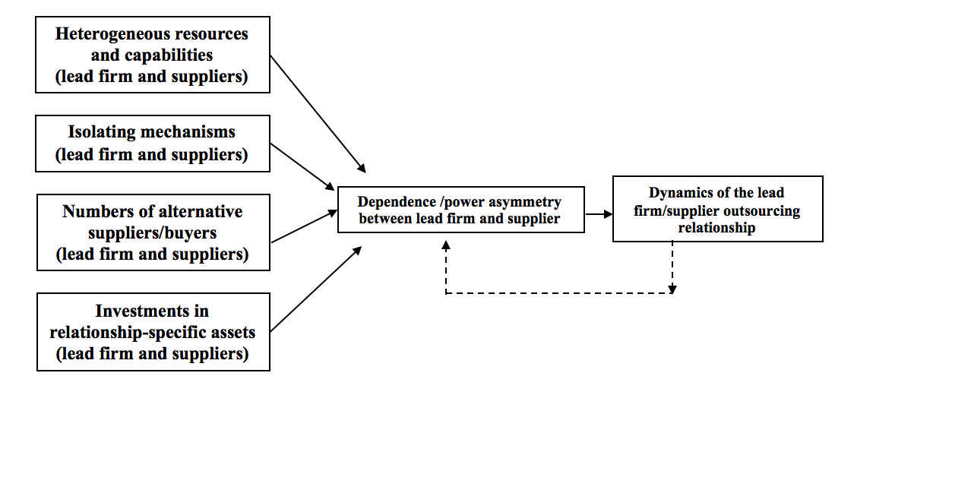

Table 1: The Firms’ Key Facts and Figures

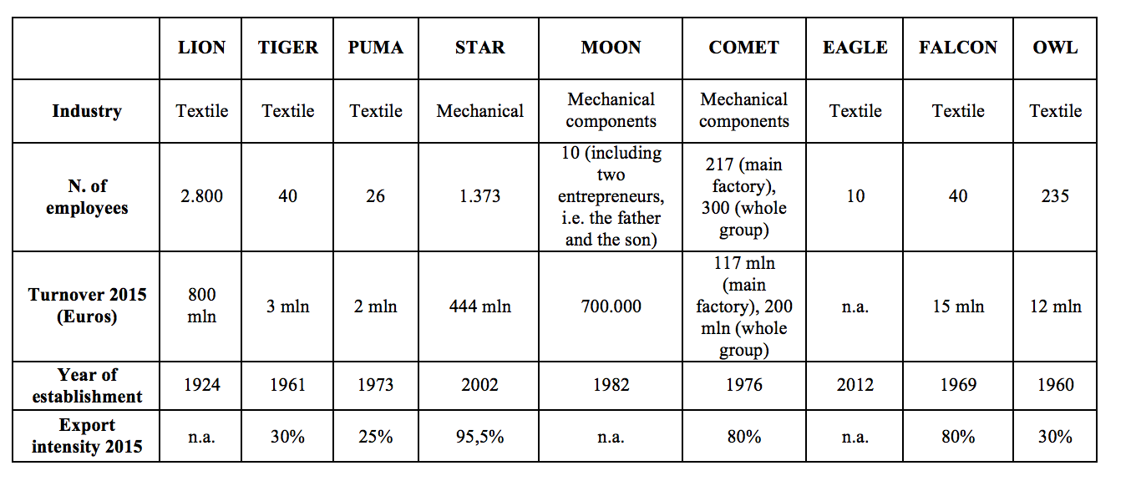

Table 2: Cross-Case Analysis of the Six Lead Firm-Supplier Relationships

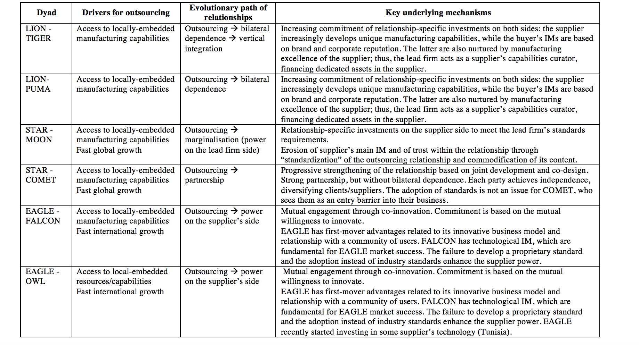

APPENDIX 1: Data Sources
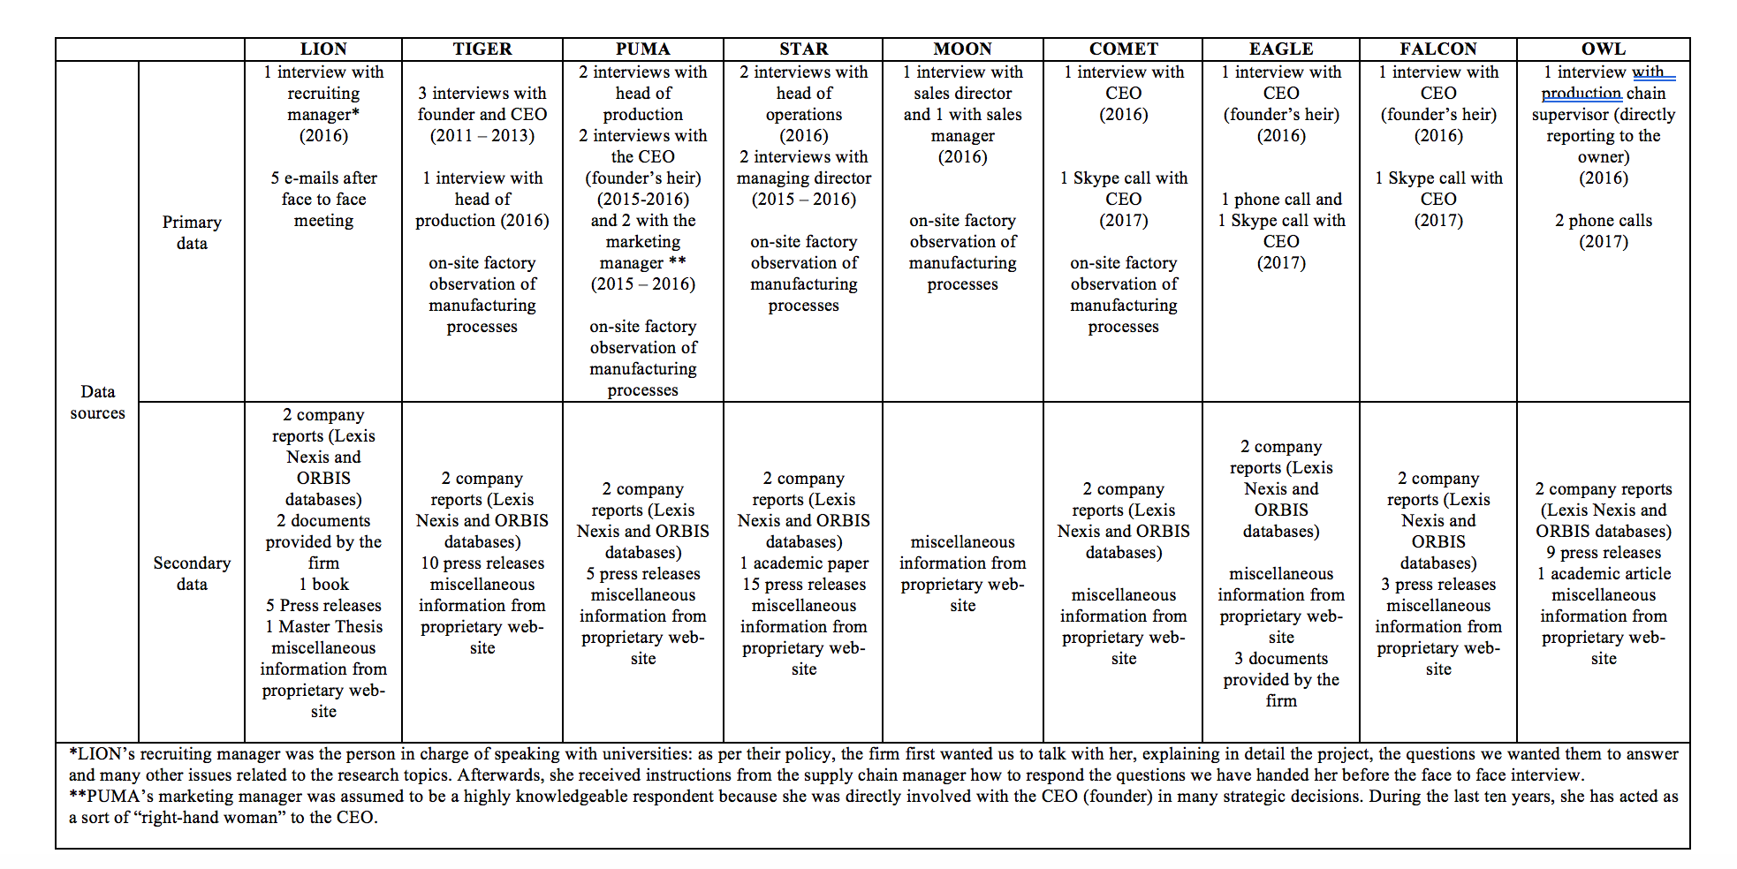

APPENDIX 2: Chronological Evolutions of the Lead Firm-Supplier Relationships

Figure 2: The Chronological Evolution of the LION-TIGER Relationship

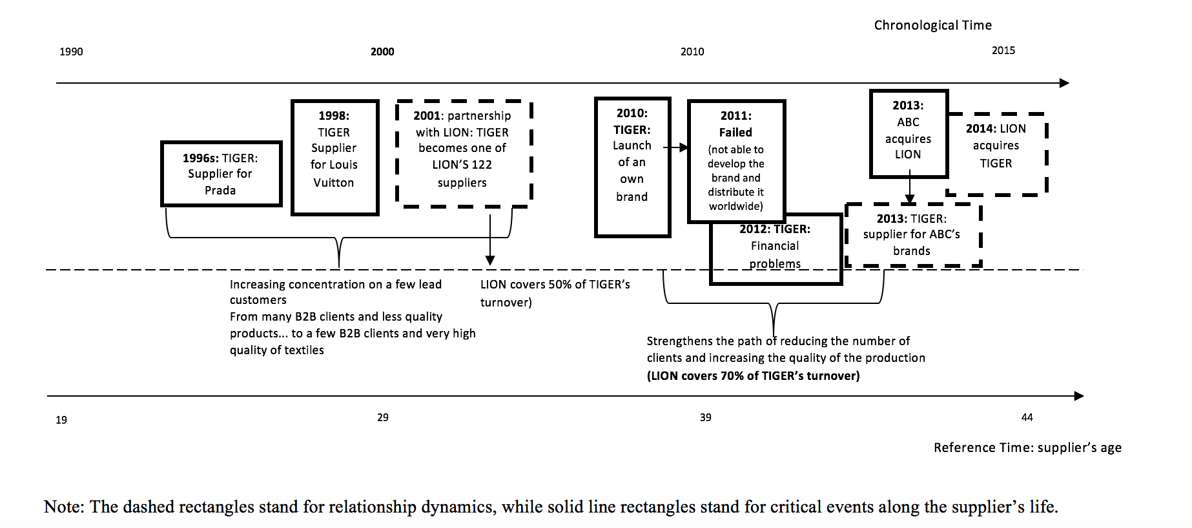

Figure 3: The Chronological Evolution of the LION-PUMA Relationship
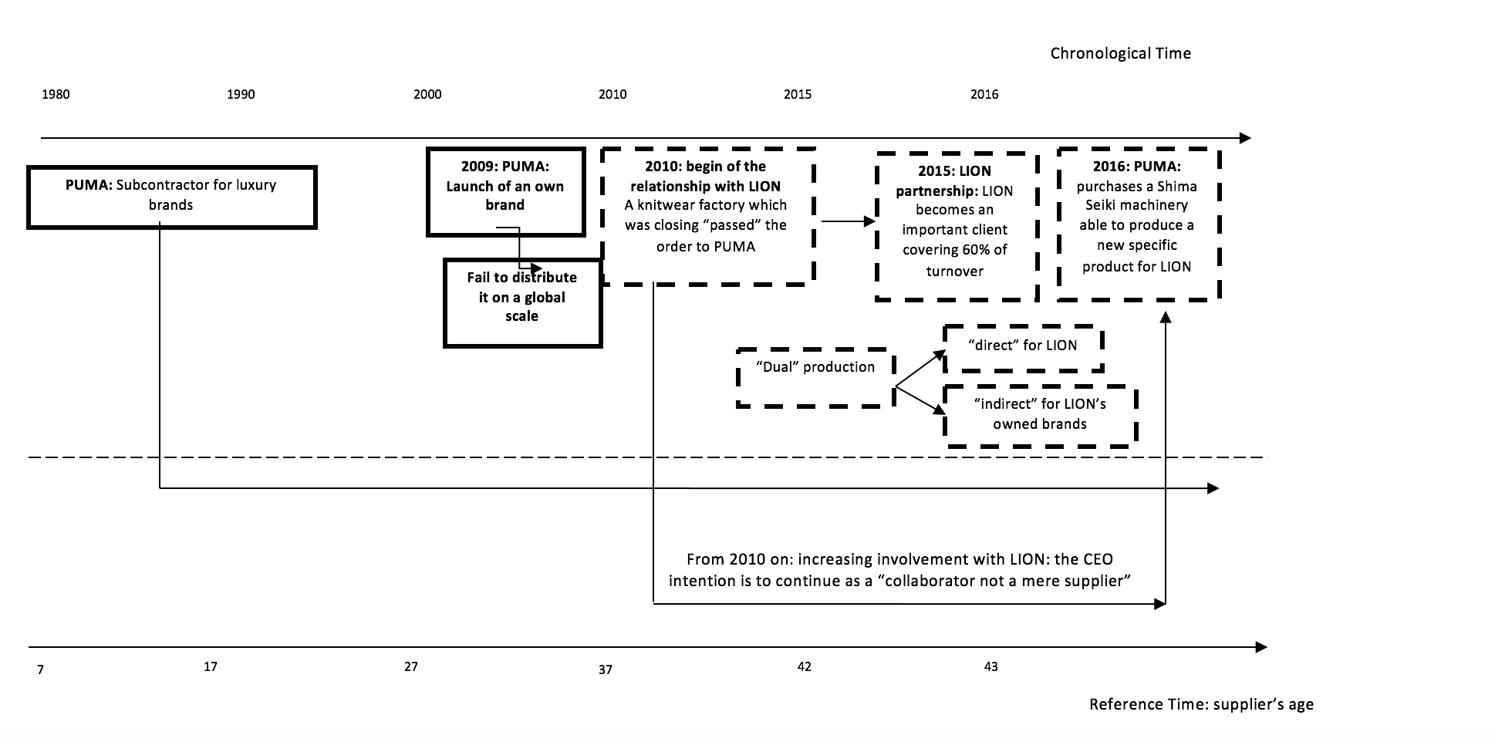

Figure 4: The Chronological Evolution of the STAR-MOON Relationship
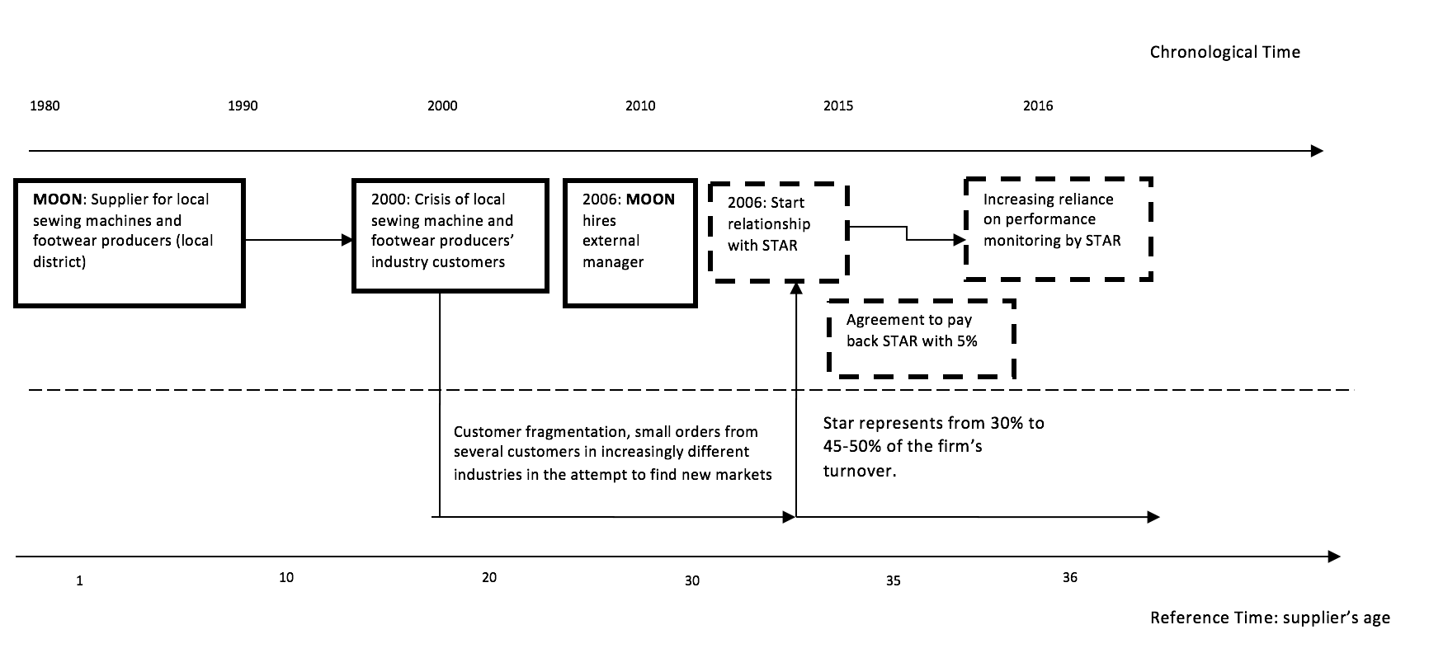
Figure 5: The Chronological Evolution of the STAR–COMET Relationship

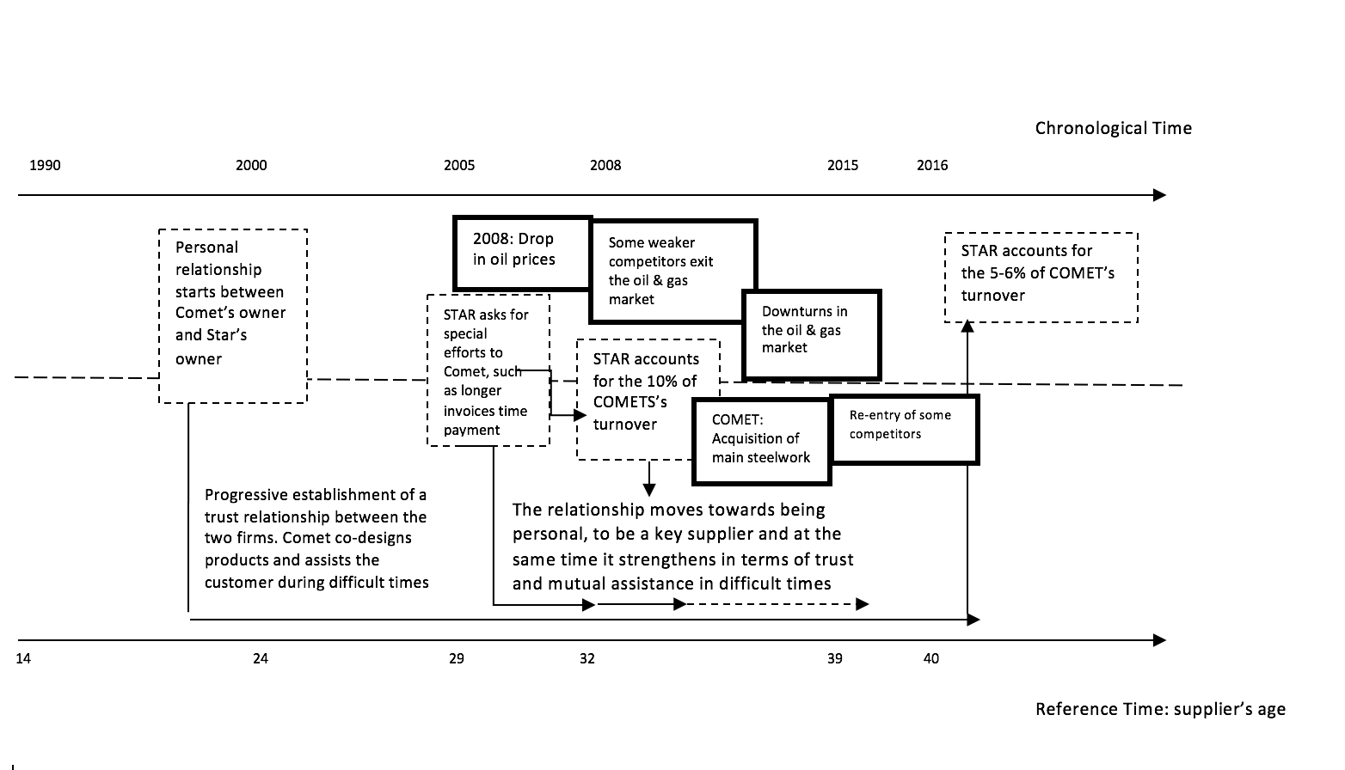

Figure 6: The Chronological Evolution of the EAGLE–FALCON Relationship
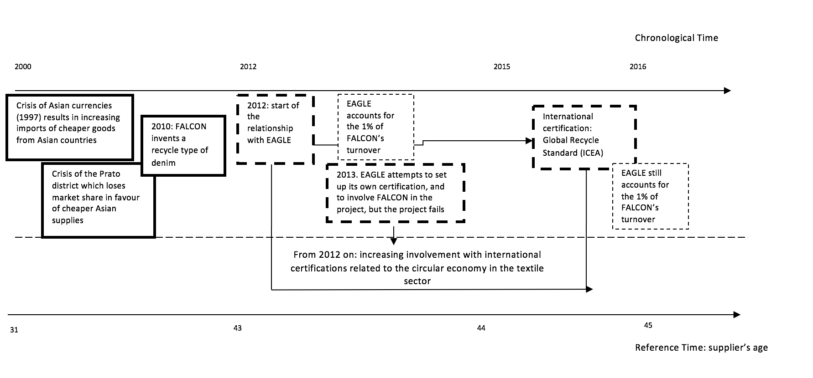
Figure 7: The Chronological Evolution of the EAGLE–OWL Relationship

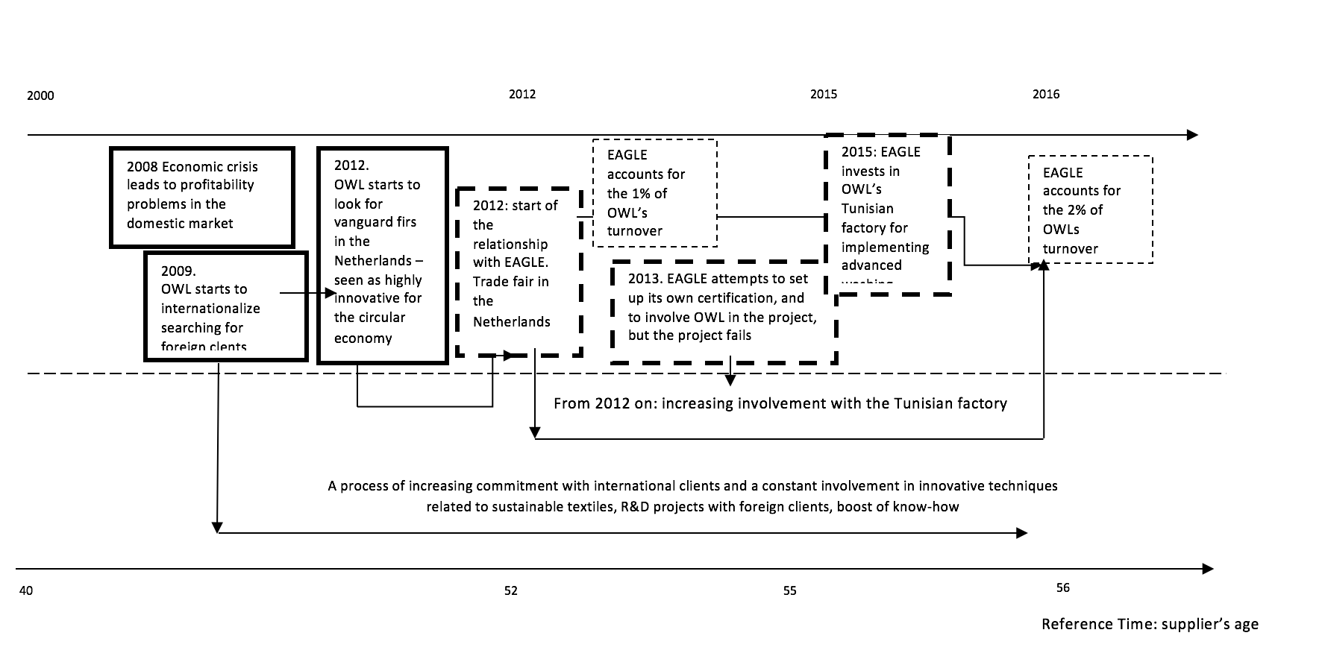

APPENDIX 3: Quotes from the Interviews*
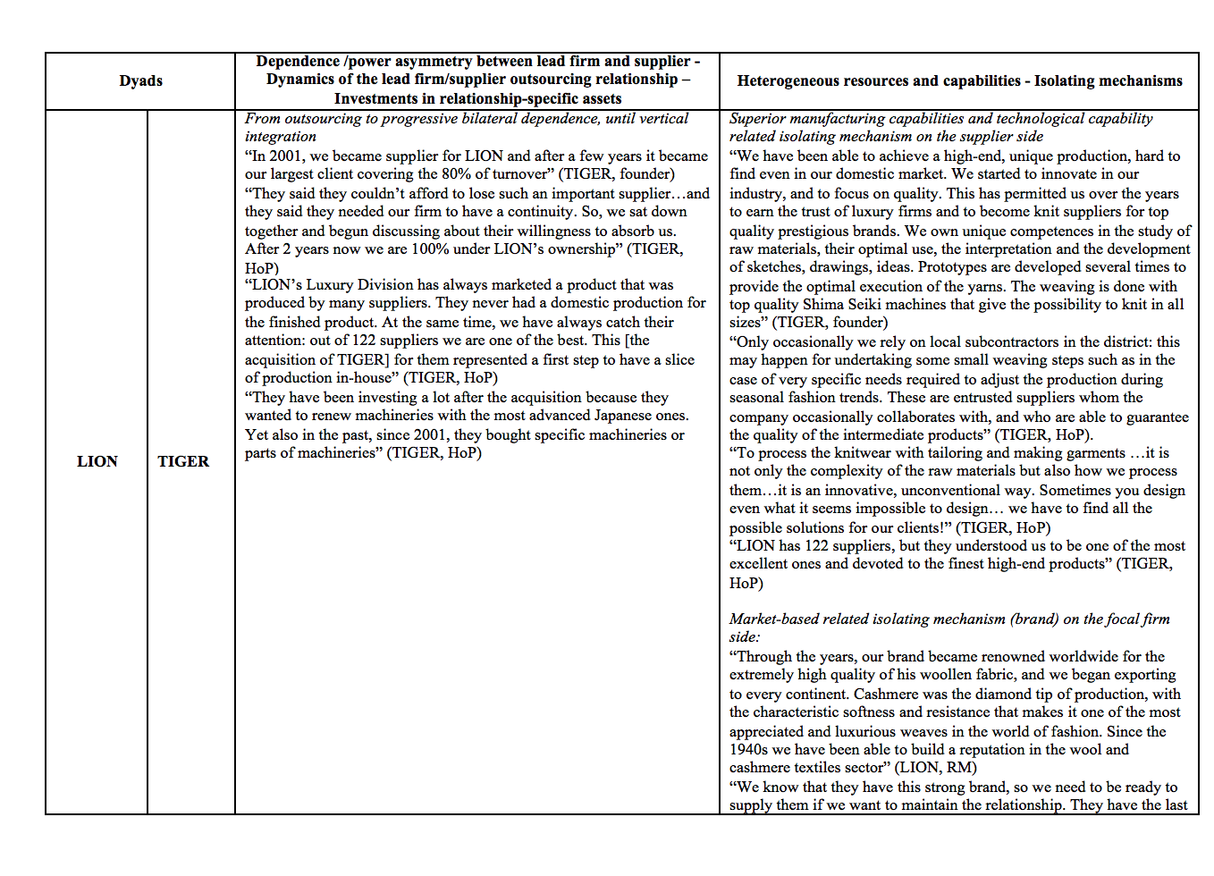
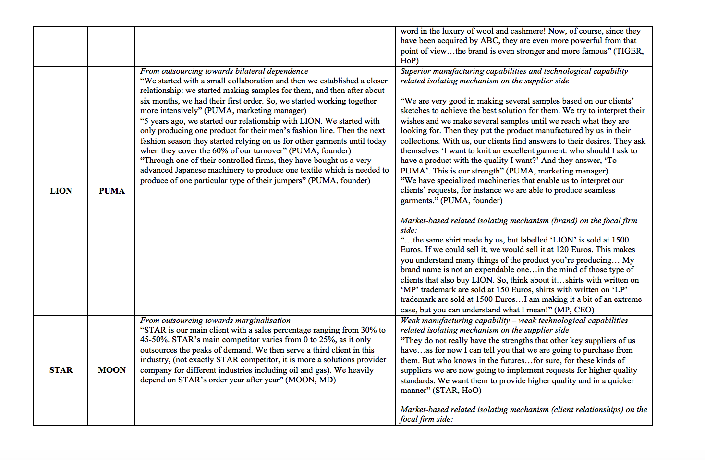
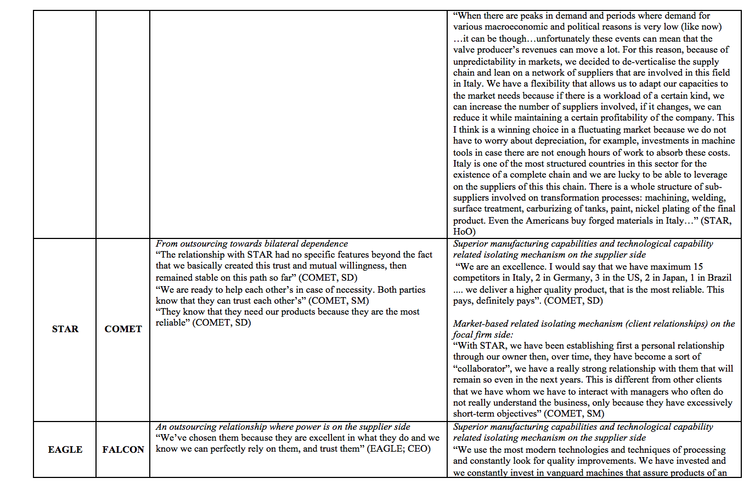

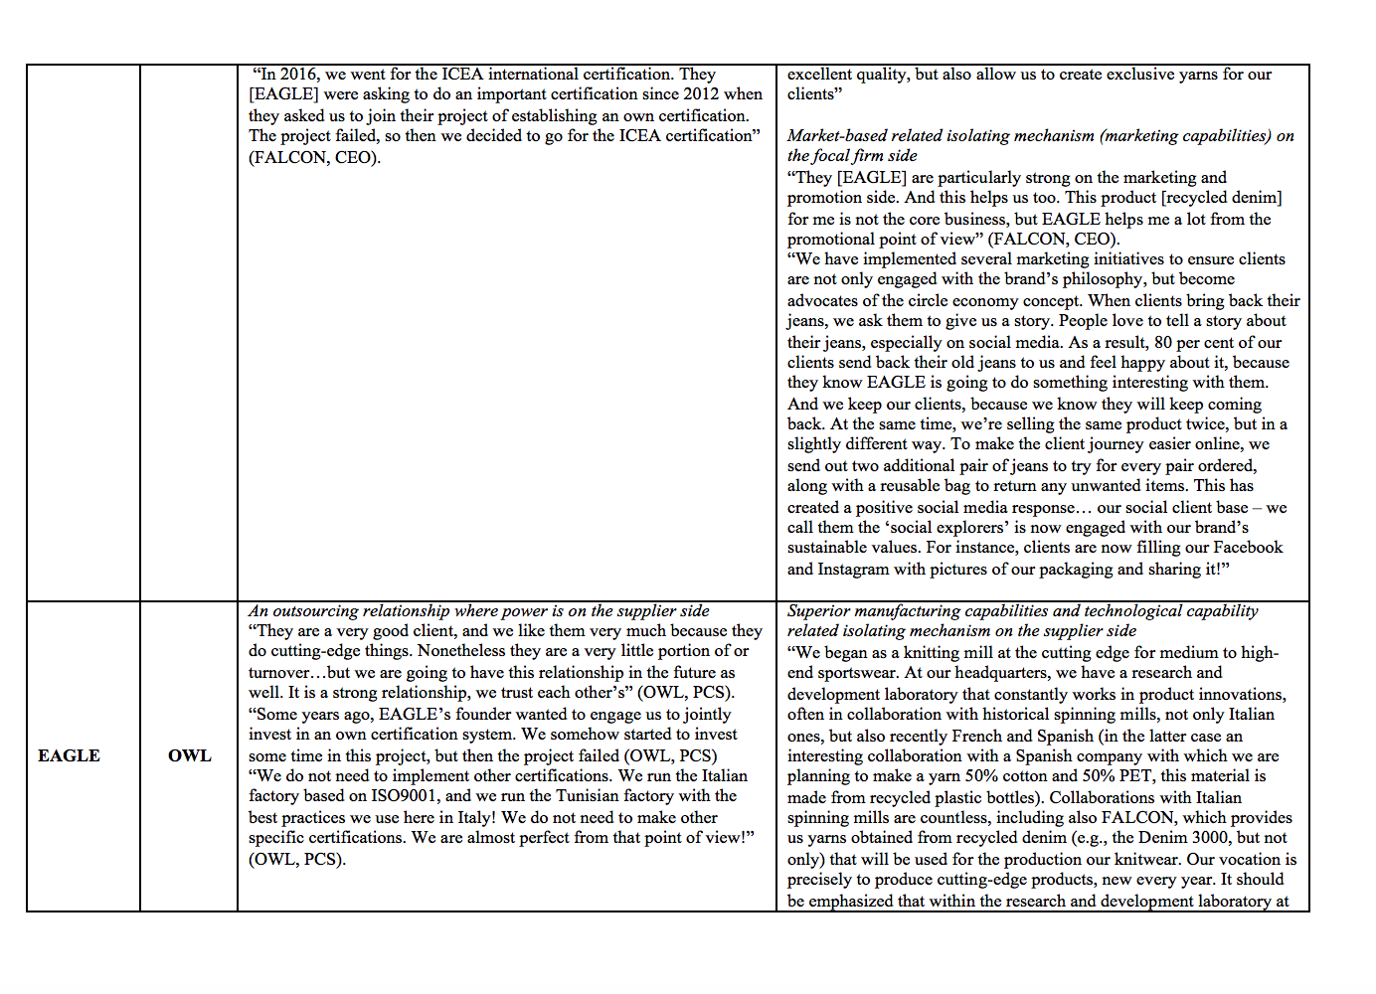
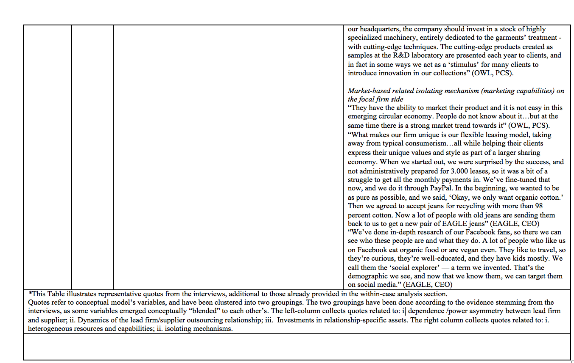

We acknowledge that there are other perspectives on power in the context of buyer-supplier relationships, but these are largely consistent with our theoretical perspective. Power Regime Theory has been developed within the supply management literature (Cox, 1999; Cox, 2004; Cox, Sanderson, & Watson, 2001; Ireland, 2004; Sanderson, 2004), and views power in inter-organizational relationships as a property of an organization and uses a so-called exchange power matrix to classify the dependencies of the buyer–seller relationship, viz.: buyer dominant, supplier dominant, independent, or interdependent (see Meehan & Wright, 2012). The power asymmetry perspective has been investigated by scholars within the international buyer–supplier relationships literature (see Caniëls & Gelderman, 2007). A situation of so-called “symmetrical interdependence” exists when parties are equally dependent on each other (ibid). High levels of symmetry are usually related to cooperative long-term relationships characterized by mutual trust and mutual commitment (Geyskens et al, 1996). In asymmetric relationships, the most independent partner dominates the exchange (Buchanan, 1992). When an “interdependence asymmetry” emerges, the independent partner experiences high power and attempts to exploit it (Anderson & Weitz, 1989; Frazier & Rody, 1991; Geyskens et al., 1996), leading to a potential erosion of the weaker party’s power and the extinction of the partnership (McDonald, 1999; Provan & Gassenheimer, 1994).
We have disguised the firms’ names to protect the respondents’ identities.
It should be noted that this theoretical insight may be somehow context-dependent as it emerged from the analysis of suppliers located in specific geographical areas/clusters where superior manufacturing excellence and ad hoc customer problem solving could grow, incrementally, over time.
We are grateful to one of the reviewers for pointing out this alternative perspective.
Our graphical representations (Figures 2 - 7) include chronological reproductions of the main critical events that have characterized the lead firm-supplier relationship dynamics (represented as rectangles with dashed lines) and some key events that have occurred along the growth path of the suppliers before and after the start of the relationship with the lead firms (represented as rectangles with solid lines).

