Submission for the special issue of Additive Manufacturing in the journal of Engineering published by Elsevier

A desktop 3D printer with dual extruders for the production of customised electronic circuitry

Javaid Butt (Corresponding Author)
javaid.butt@anglia.ac.uk

Dominic Adaoiza Onimowo
dominic.onimowo@pgr.anglia.ac.uk

Mohammed Gohrabian
mohammed.gohrabian@pgr.anglia.ac.uk

Tinku Sharma
tinku.sharma@student.anglia.ac.uk

Hassan Shirvani
hassan.shirvani@anglia.ac.uk

Anglia Ruskin University, Chelmsford, CM1 1SQ, Essex, United Kingdom

Abstract
3D printing has opened new horizons for the manufacturing industry in general and 3D printers have become the tools for technological advancements. There is a huge divide between the pricing of industrial and desktop 3D printers with the former being on the expensive side capable of producing excellent quality products and latter being on the low-cost side with moderate quality results. However, there is a larger room for improvements and enhancements for the desktop systems as compared to the industrial ones. In this paper, a desktop 3D printer called Prusa Mendel i2 has been modified and integrated with an additional extruder so that the system can work with dual extruders and produce bespoke electronic circuits. The communication between the two extruders has been established by making use of the ICSP (In-Chip Serial Programming) port on the Arduino Uno controlling the printer. The biggest challenge is to control the flow of electric paint (to be dispensed by the new extruder) and CFD (Computational Fluid Dynamics) analysis has been carried out to ascertain the optimal conditions for proper dispensing. The final product is a customised electronic circuit with the base of plastic (from the printer’s extruder) and electronic paint (from the additional extruder) properly dispensed to create a live circuit on a plastic platform. This low-cost enhancement to a desktop 3D printer can provide a new prospect for the production of multiple material parts where the additional extruder can be filled with any material that can be properly dispensed from its nozzle.
Keywords: 3D printing; Arduino Uno; Extruder; Multiple materials; Electronic Circuits; Customisation, CFD analysis

Introduction
3D printing is a form of additive manufacturing (AM) technology where a three dimensional object is created by laying down successive layers of material using a computer aided design (CAD) data. This technology is not only capable of producing massively varied parts but it has also eradicated the use of conventional tools, with no milling or moulding. The wastage of material is reduced and parts can be produced much more quickly by simply sending a file from the computer to the printer. It works in the same way as a conventional printer that prints out paper with the click of a button on a computer. The difference is not only the final product but also the way in which the product is created. A 3D printer works by taking a virtual design from a CAD software. The design could be in STL file format (stereolithography) or a g-code file. RepRap (short for replicating rapid prototyper) host software, Repsnapper, Pronterface and Slicer are some of the widely used options when it comes to interfacing a 3D printer with a computer. On receiving a file, a 3D printer transforms the design into several cross-sections and then start making successive layers until a three dimensional object is formed. The reason for the immense popularity of 3D printing stems from its ability to provide design freedom as it is capable of manufacturing intricate and complex geometries with ease. The realm of applications for 3D printing extends from metal casting and prototyping to health care and medical fields including organ printing, bio-printing and tissue engineering.
The machines used for 3D printing are known as 3D printers. They are generally faster, cheaper and easier to use as compared to other AM technologies. The major disadvantage of these systems is the difference in price between commercial and desktop versions. Commercial 3D printers are capable of producing excellent quality products but they are expensive and are limited in terms of further enhancements. On the other hand, desktop versions offer a large degree of customization and are more affordable to general public while producing moderate quality products. 3D printing and various other AM methods have existed for decades but have been protected by patents, copyrights and trademarks. Recently those patents expired and due to the increased interest in this area, small companies and especially hobbyist communities begin manufacturing items for personal use, for non-profit distribution, or for sale. This has given rise to a number of very interesting developments and open source platforms like Reprap [1] as well as Fab@Home [2] are the finest examples that allow personalized approach to manufacturing, where bespoke parts can be produced according to the requirements of an individual. In addition to that, other printers such as MakerBot [3], Stratasys [4] etc., have turned this technology into a low-risk and low-cost business satisfying the market needs. With the passage of time, innovative and unique methodologies have been employed in order to get the maximum output from this technology. One of the more ambitious ideas is the production of bespoke electronics. This research has been well documented over the years with the prototyping of signal conditioning circuits and high voltage wiring boards and power electronics using lithium polymer, copper wires and ferrite magnetic components respectively [5-7]. More challenging materials have also been incorporated for 3D printing electronics such as graphene [8] and bioactive carbon based ink [9]. The research has yielded high quality products but the practices required to 3D print electronics are difficult, time-consuming and expensive. There is a need for a simple and cost-effective solution which is a challenging objective and can be achieved by integrating a new extruder to an already established desktop based 3D printer.
In this paper, an additional extruder filled with electric paint has been integrated with a 3D printer, called Prusa Mendel i2, by establishing communication between the two extruders for the production of customised electronic circuits. The ON/OFF time of the paint extruder has been controlled by modifying the original source code for the 3D printer. Both the extruders work as a single cohesive unit and the ICSP port of the Arduino Uno has been used to establish communication between them. CFD analysis has also been carried out to determine the optimal conditions for proper dispensing of the electric paint. This low-cost approach will make way for many engineering applications where an electronic circuit could be printed embedded inside a plastic chip. The manufactured parts will have the elements of optimal electrical circuit characteristics within the 3D printed model. By using printing technology, several process steps required with the traditional electronics production will be substituted with a single step procedure comprising of adding material to the substrate.

Integration of the additional extruder
The purpose of integrating an additional extruder to Prusa Mendel i2 is to give the system the capability to produce multiple material parts by making use of the dual extruders. Since the new extruder will be dispensing electrical paint, it is important to understand the mechanics behind fluid dispensing. This technique has been extensively used in other AM methods [10] as well as in electronics circuit creation and small scale electro-mechanical products. In these applications, minute volumes of fluids are dispensed precisely. Syringe dispensing technique identifies with the positive displacement driven method with the stepper motor to provide the linear movement of the piston to force the fluid out of the syringe for extruding the displaced amount of fluid through the outlet. The benefit of this technique is that the amount of fluid dispensed is dependent only on the linear movement of the piston. The extruder consists of a number of plastic parts (printed from the Prusa Mendel i2), a 10ml syringe and a stepper motor for moving the plunger as shown in Fig. 1. An open source user interface called Pronterface was utilized for controlling the 3D printer.
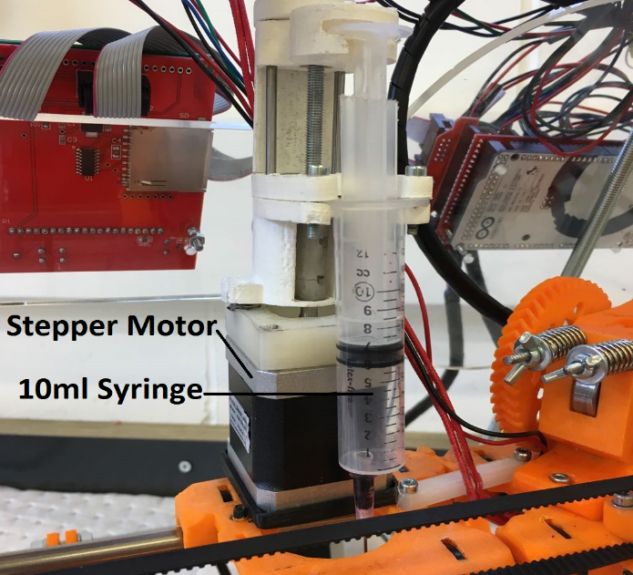
Figure 1: Additional extruder for dispensing electric paint

Digital signal for the paint extruder
ICSP port was used for communication between the two extruders as the digital signal required for the additional extruder was programmed to come from it. It has 6 pins in total and just one pin was toggled high and low in order to get the required digital signal for the paint extruder. Fig. 2 shows the pins of the ICSP port.
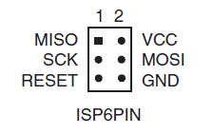
Figure 2: Pins of ICSP port
The MISO (Master-In Slave Out) and MOSI (Master-Out Slave In) pins were the two options available that could be utilized as they were not used for anything else during the operation of the printer. Therefore, the MISO pin was declared as output in the main code of the printer and new g-codes were introduced into the program that toggled the MISO pin high and low whenever they were sent by Pronterface.
#define miso 6 //define MISO
The new g-codes were defined in the following format:
case 100:
pinMode(miso, OUTPUT); //set pin as output
digitalWrite(miso, HIGH);
break;
According to this newly added code, whenever G100 would be sent by Pronterface to the printer, the MISO pin would turn HIGH and in terms of the paste extruder, it meant that it would be ON.
case 101:
pinMode(miso, OUTPUT); //set pin as output
digitalWrite(miso, LOW);
break;
In the same way, whenever G101 would be sent by Pronterface to the printer, the MISO pin would turn LOW and the paste extruder would be OFF.

Experimental Setup
The 3D printer used for the work is called Prusa Mendel iteration 2 suitable for a filament of 1.75mm diameter with a build volume of 200 x 200 x 200 mm and a minimum layer height of 100 microns. The original C++ code for running the printer was downloaded from open source RepRap forum. The code was then modified and uploaded to the Arduino Uno board and the additional extruder was attached to the 3D printer as shown in Fig. 3. The distance between the printer’s extruder nozzle and the nozzle of the extruder dispensing paint was measured and noted to ensure that there were no issues during printing of either plastic or paint. PLA (Polyactic Acid) plastic was printed out based on the CAD file sent to the system. The CAD file was created in Autodesk Inventor and was a square block with space to hold a 9V battery and grooves of 200 micron depth. The grooves were to be dispensed by electric paint so that an LED can be powered by the battery. The printer itself was controlled by a computer running Pronterface which has the capability of sending CAD files off to print. After the printing of plastic by the printer, electric paint was dispensed by the additional extruder in the grooves.
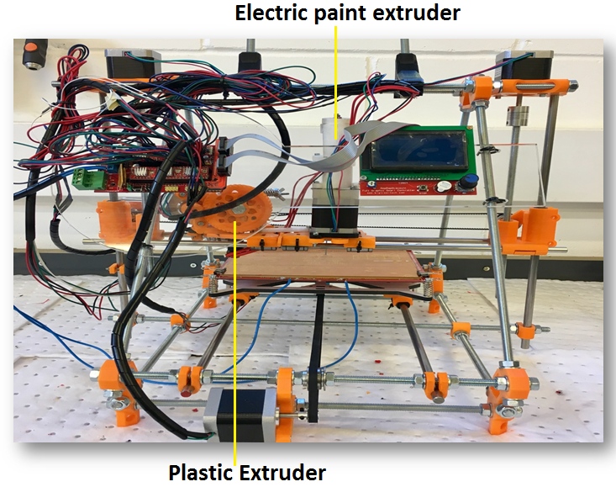
Figure 3: Prusa Mendel i2 printer integrated with the paint extruder
The paint is a product of Bare Conductive and is water soluble as well as non-toxic. It has a surface resistivity of approximately 55 ohms/sq. in. at 50 micron layer thickness; these properties make it perfect for low-voltage electronics. It can work on a variety of surfaces, for example glass, paper, plastics etc. It has the ability to acquire its shape well on each of the substrates, without running or smudging which is helpful as it allow for better control of flow. The biggest challenge is controlling the flow of the paint as it is a highly viscous non-Newtonian fluid. This is achieved by making use of CFD analysis where pressure and velocity contours have been generated to analyse the optimal operating conditions. Prior to using the electrical conductive paint directly on the three dimension model, it was tested on a piece of paper to analyse its capabilities. A small amount of paint was dispensed and then an LED was placed at one end with the other ends connected to a 9V battery as shown in Fig. 4. The LED operates at a very low voltage so resistors are generally used in circuits with LEDs to avoid them from burning off. In this case, there is no need for a separate resistor with the LED even though it is directly connected to 9V battery as the electric paint offers resistance to the flow of voltage and this resistance change as the thickness of paint is increased or decreased.
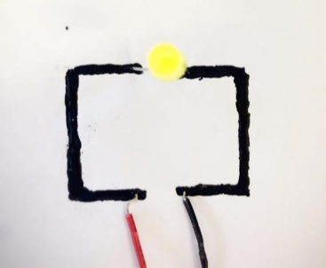
Figure 4: Conductivity test for the electric paint

Results and analysis

CFD analysis for the additional extruder
A 3D model has been created in ANSYS 17.2 (Fig. 5) with a 10ml syringe that acted as the additional extruder for dispensing electric paint. A flow field was created with the dimensions of 240 x 350 x 240 mm to examine the flow under a pressure of 45 psi [11] exerted by the plunger. The diameter of the syringe nozzle is 1.5mm and the paint has a density of 1160 kg/m³ with a viscosity of 2.4 kg/m-s. The paint is thixotropic in nature which means that the viscosity is dependent on time and undergoes shear thinning. For the purposes of the analysis and the actual dispensing, the paint was stirred once before the syringe was filled up and then it was allowed to flow under the pressure applied by the plunger. The pressure value was set to be 45 psi (3.1 bar or 6894.76 Pa) and then resulting pressure and velocity contours were analysed. These two parameters are of the utmost importance as non-uniformity in these contours would indicate improper dispensing of the paint which would result in non-conductivity for the electronic circuit. A 3D model was developed to analyse the pressure and velocity contours at the output of the syringe as a result of the applied pressure. The analysis can be used to investigate fluid flow under different pressure values.
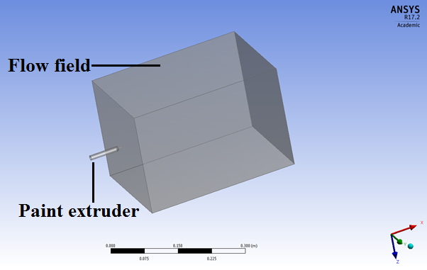
Figure 5: Model for the paste extruder
As is evident from Figs. 6 and 7, there are no abrupt changes throughout the body of the syringe and the flow field for pressure contours which shows that if a pressure of 45 psi is applied to the plunger of the syringe then the resulting flow will be uniform thus indicating that proper dispensing of the electric paint will take place. The same goes for the velocity contours in Figs. 8 and 9. The velocity increases as the fluid is coming out of the nozzle due to reduced area but becomes uniform in the flow field which would result in a smooth operation without any turbulence.
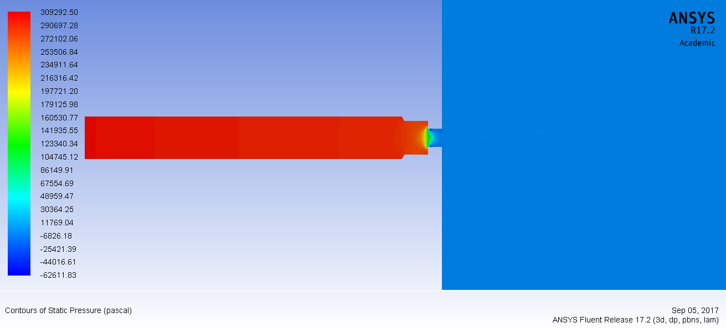
Figure 6: Pressure contours for the paint extruder
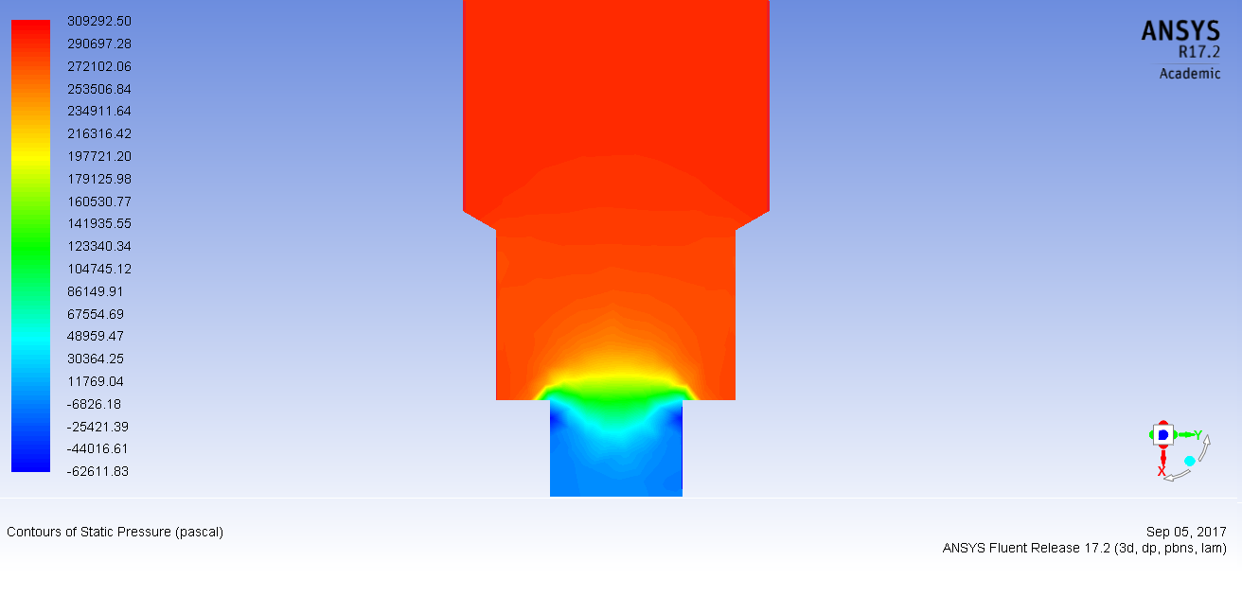
Figure 7: Closer look at the pressure contours for the paint extruder
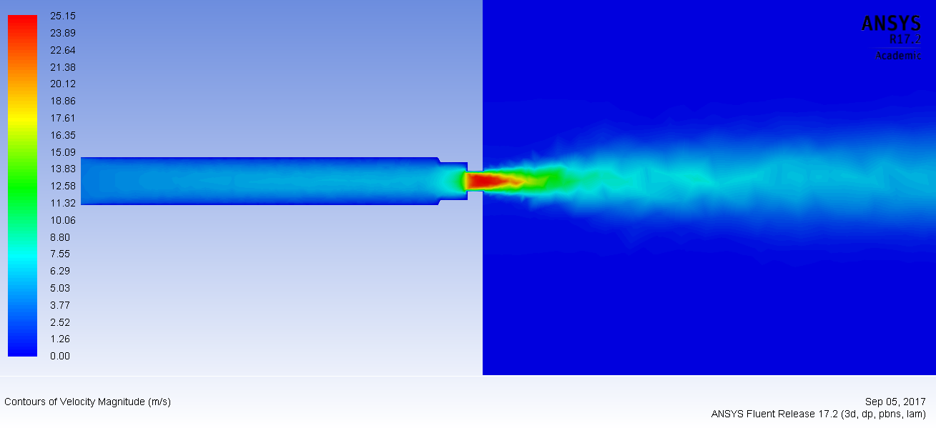
Figure 8: Velocity contours for the paint extruder
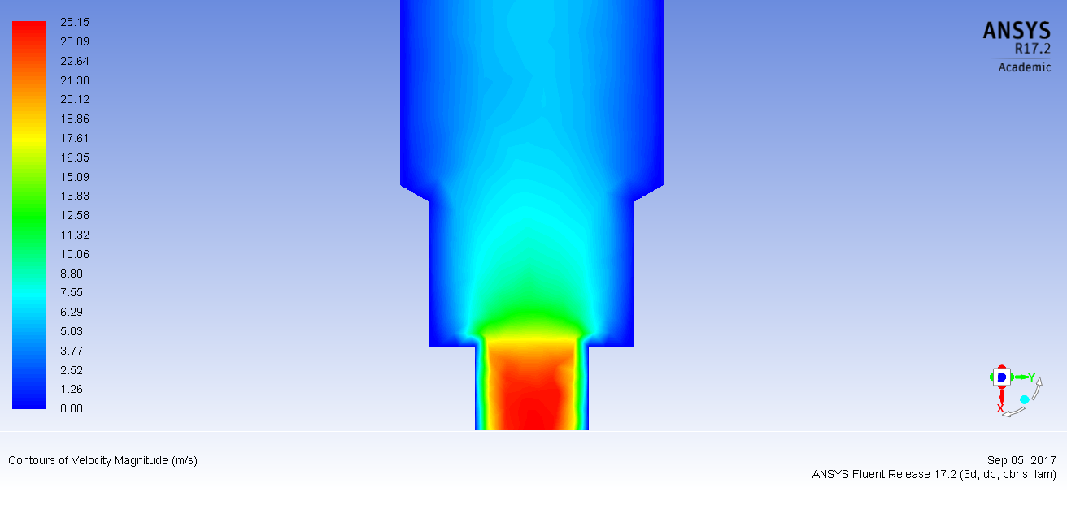
Figure 9: Closer look at the velocity contours for the paint extruder

Production of electronic circuitry
The 3D printer (Prusa Mendel i2) was assembled and programmed so that it can easily print plastic parts when a CAD file is sent to it. The quality of the plastic part became very important because another material had to be dispensed on it that needed to adhere to the surface without any additional processing. Therefore, parameters like infill percentage, pattern, density and surface finish need to be adjusted so that the electric paint can easily stick to the plastic part without any issues. A part was made in Autodesk Inventor (50 x 40 x 10 mm) with two arms extended outward to hold a 9V battery and grooves of 200 micron depth where the paint would be dispensed. The file was saved in .STL format and sent to Pronterface for printing purposes.
The part was completed in approximately fifteen minutes. The software (Pronterface) converts the cross-sections for the part to be printed into g-codes because the printer only responds to them. The user could view the g-codes from the software to understand how they are written for printing. In this setup, there are two printing heads; the plastic extruder is printing in plastic and the paint extruder is dispensing the electric paint. Once the plastic part was printed then customized g-codes according to the electronic circuit in the part were sent to the printer. The code was first tested in an open source g-code simulator to make sure that it was correct and then sent to the printer for the dispensing of electric paint in the defined circuit. The newly defined g-codes i.e., G100 (paint extruder ON) and G101 (paint extruder OFF) were sent in the regular g-code format for a 3D printer so that the paint extruder would know when to turn ON and when to turn OFF because the electric paint dispensed outside the defined circuit would be of no use. After dispensing the paint, a bespoke electronic circuit chip was ready with a base of plastic and a layer of electric paint dispensed into the electronic circuit defined in the part. Fig. 10 shows the part before and after the deposition of the paint alongside a LED that lights up when the circuit is connected to a 9V battery. The finished part could be used for a number of engineering applications ranging from customised electronic circuit printed chips all the way to creative industries at a low-cost and without any further post-processing.
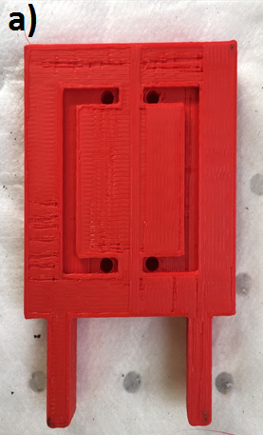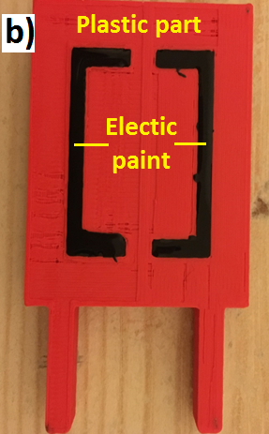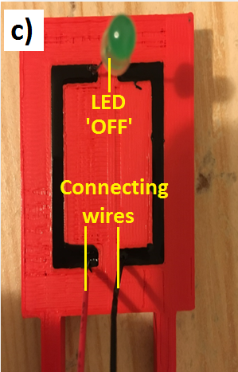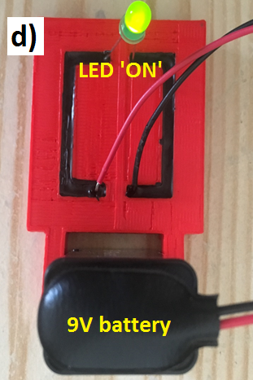
Figure 10: Electronic chip: a) Plastic part; b) Plastic part after dispensing paint; c) LED and wire connections on the part; d) Electronic circuit on a plastic platform
The newly developed low-cost desktop 3D printer can easily manufacture small circuit boards and bespoke electronic chips. It is, however, limited in terms of its capabilities. At any given time only 10ml of electric paint can be dispensed which makes it more suited to printing one-off circuits. Integrating a large syringe could help with that but it will also greatly reduce the print area as the paint dispenser is attached to the side of the conventional plastic extruder. In addition to that, the nature of the electric paint (especially viscosity) or any other type of ink would greatly affect the flow and there is a chance of the nozzle getting blocked if it has not been in continuous use which would result in regular maintenance and cleaning.

Conclusions
The results show the capability of a desktop 3D printer called Prusa Mendel i2 in terms of integrating additional extruders for the production of bespoke electronic circuit chips. The newly added extruder worked in complete harmony with the inherent extruder of the printer. It was achieved by making use of the ICSP port of the Arduino Uno platform controlling the 3D printer. The modified printer is now fully capable of dispensing plastic and electric paint on demand with the click of a button. CFD analysis showed the optimal working conditions for proper dispensing of the electric paint. It can be used for analysing various parameters in the future as well with materials other than the electrical paint used for this work. The setup made by this work allows for the production of multiple material parts with electronic circuitry using a low-cost desktop 3D printer without the need for complex processes and expensive equipment. It is clearly evident that there is a great potential for modifying existing technologies to obtain different and better results. It is expected that the work will open new horizons for affordable and bespoke electronic chip production.

References
[1] Jones, R., Haufe, P., Sells, E., Iravani, P., and Oliver, V. 2011. RepRap – the replicating rapid prototyper, Robotica 29: 177–191.
[2] Malone, E., and Lipson, H. 2007. Fab@Home: The personal desktop fabricator kit. Rapid Prototyping J 13: 245–255.
[3] Borenstein, G. Making Things See: 3D Vision with Kinect, Processing, Arduino, and MakerBot. Canada: O'Reilly Media, Inc., 2012. Print.
[4] El-Gizawy, A.S., Corl, S., and Graybill, B. 2011. Process-induced Properties of FDM Products. Proceedings of The ICMET, International Conference on Mechanical Engineering and Technology Congress & Exposition, ICMET 2011-40936, July25-29, 2011, Paris, France.
[5] Macdonald, E., Salas, R., Espalin, D., Perez, M., Aguilera, E., Muse, D. and Wicker, R.B., 2014. 3D printing for the rapid prototyping of structural electronics. IEEE Access, 2, pp.234-242.
[6] MacDonald, E., Wicker, R., Espalin, D., Kwas, A. and Kief, P.R.C., 2016. 3D Printing of High Voltage Printed Wiring Boards. Additional Papers and Presentations, 2016(DPC), pp.000542-000565.
[7] Liu, L., Ge, T., Yan, Y., Ngo, K.D.T. and Lu, G.Q., 2017, April. UV-assisted 3D-printing of soft ferrite magnetic components for power electronics integration. In Electronics Packaging (ICEP), 2017 International Conference on (pp. 447-450). IEEE.
[8] Tölle, F.J., Fabritius, M. and Mülhaupt, R., 2012. Emulsifier‐Free Graphene Dispersions with High Graphene Content for Printed Electronics and Freestanding Graphene Films. Advanced Functional Materials, 22(6), pp.1136-1144.
[9] Shin, S.R., Farzad, R., Tamayol, A., Manoharan, V., Mostafalu, P., Zhang, Y.S., Akbari, M., Jung, S.M., Kim, D., Comotto, M. and Annabi, N., 2016. A Bioactive Carbon Nanotube‐Based Ink for Printing 2D and 3D Flexible Electronics. Advanced Materials, 28(17), pp.3280-3289.
[10] Butt, J., Mebrahtu, H. and Shirvani, H., 2016. Microstructure and mechanical properties of dissimilar pure copper foil/1050 aluminium composites made with composite metal foil manufacturing. Journal of Materials Processing Technology, 238, pp.96-107.
[11] Butt, J., 2016. A novel additive manufacturing process for the production of metal parts (Doctoral dissertation, Anglia Ruskin University).

