Supportive environments for physical activity in deprived communities in the United Kingdom: a qualitative study using photo elicitation

Alexia Sawyer ª* [Email: alexia.sawyer@ucl.ac.uk; Tel: 020 7679 1736]; Marcella Ucci ^{b} [Email: m.ucci@ucl.ac.uk]^{b}; Russell Jones ^{c} [Email: Russell.Jones.2@glasgow.ac.uk]; Lee Smith ^{d} [Email: Lee.Smith@anglia.ac.uk]; Abi Fisher ª [Email: abigail.fisher@ucl.ac.uk]
ª Research Department of Behavioural Science and Health, 1-19 Torrington Place, University College London, Gower Street, London, WC1E 6BT, United Kingdom.
^{b} UCL Institute for Environmental Design and Engineering, The Bartlett Faculty of the Built Environment, Central House, University College London, 14 Upper Woburn Place, London, WC1H 0NN, United Kingdom.
^{c} Glasgow Centre for Population Health, The Olympia Building, University of Glasgow, Glasgow, G12 8QQ, United Kingdom.
^{d} The Cambridge Centre for Sport and Exercise Sciences, Dept. of Life Sciences, Anglia Ruskin University, Cambridge, United Kingdom.
*Corresponding author

Abstract
The health benefits of regular physical activity are substantial and well-established. However, population activity levels are insufficient to obtain health benefits in the United Kingdom (UK), and strategies to increase activity, particularly in income-deprived communities, are sought. Socioecological models of physical activity posit that activity levels are influenced by social, physical and wider environmental factors. In line with a growing evidence base, there is a need to understand the factors that contribute to an activity-supportive neighbourhood within deprived settings within the UK. This study used photo-elicitation qualitative interviews to explore environmental facilitators and barriers to neighbourhood-based, outdoor physical activity in 23 adults living in two income-deprived neighbourhoods in Glasgow, UK. Data were collected between June and October, 2015, and were explored using thematic analysis.
Five themes were identified: ‘diversity of destinations in the neighbourhood’, ‘provision of services to support healthy environments’, ‘ownership of public space and facilities to encourage physical activity’, ‘collective control of public space to prevent disorder’ and ‘perceived value of the neighbourhood’. Findings highlighted the close interaction between these themes and more broadly between social and physical facets of neighbourhood environments that were unsupportive of physical activity. Discourse about economic aspects was pervasive and emerged as deeply affecting characteristics of the social and physical environment and upstream influences on physical activity. This study supports evidence that multi-faceted interventions addressing aspects of the social, physical and economic environment may be needed to support outdoor physical activity in deprived communities.
Keywords: UK; socioecological models; physical activity; active living; social environment; physical environment; deprivation; place effects

Introduction
Participation in physical activity is associated with numerous physical and psychosocial health benefits, yet population activity levels in developed nations remain low (Allender et al., 2007; Mueller et al., 2015; Reiner et al., 2013; World Health Organisation, 2014). In the United Kingdom (UK) levels of inactivity (not meeting national physical activity guidelines (Chief Medical Office, n.d.) are particularly high among socioeconomically deprived groups. Data from the 2013 Active People Survey in England revealed that levels of self-reported physical inactivity were almost 10% higher in local authorities with the highest levels of socioeconomic deprivation compared with authorities with the lowest levels (UK Active, 2014). Education has also been found to be inversely related to objectively-measured physical activity in a population-based cohort in England (Hamer et al., 2012). Increasing levels of activity, even slightly, could lead to substantial health benefits. A European cohort study including 334,161 adults estimated that moving individuals from inactivity to moderate activity (equivalent to a daily 20-minute walk) produced reductions in all-cause mortality by 7.35%, a significant amount at population level (Ekelund et al., 2015). Walking in particular has been identified by the National Institute for Health and Care Excellence (NICE) as a key mechanism to increase physical activity in adults in the UK as it is low-cost, accessible and achievable for individuals in deprived communities (National Institute for Health and Care Excellence, 2012).
Intervening to promote physical activity using environmental rather than individual strategies offers the opportunity to create sustainable change in large numbers of people. Socioecological frameworks of physical activity, which posit that individual factors (e.g. attitudes, beliefs), social factors (e.g. relationships, safety), physical factors (e.g. facilities, aesthetics) and political factors (e.g. transport investment, urban planning policies) have independent and interactive influences on activity, support interventions which target multiple levels of environmental influence on activity (Sallis et al., 2006). Socioecological influences on activity are conceptualised in Kumanyika et al.’s (2012) framework of influences on physical activity and diet for ethnic minority groups. This framework reflects the prominent role of social and cultural influences, highlighting the multiple levels of the environment (social, cultural, physical, historical and political) which work together to encourage, or discourage, healthy lifestyles. Understanding the social and physical environmental factors that constrain or support physical activity, particularly in populations with the lowest activity levels, could inform the development of interventions to increase physical activity, and is therefore a public health priority.
Physical environments encompass natural environments, such as green and blue space, and indoor and outdoor built environments, including the function, structure, condition or aesthetics of residential or commercial buildings, public open space and streets or walkways (Sallis, Floyd, Rodriguez and Saelens, 2012). Physical metrics such as land use mix, connectivity, residential density (Saelens and Handy, 2008) and aesthetics (Neckerman et al., 2009; Thornton et al., 2016) have been found to be associated with neighbourhood walkability and activity. The social environment captures constructs such as social networks, social control, safety and social cohesion (Moore and Kawachi, 2017). Recent quantitative studies and reviews suggest that environments with high levels of social control, social cohesion, trust and reciprocity between neighbours and a sense of community are related to increased levels of physical activity (McNeill et al., 2006; Samuel et al., 2014). Perceived safety has also been found to have an effect on activity, although the relationship is inconsistently reported (Foster and Giles-Corti, 2008).
Qualitative research provides a richer understanding of associations, highlighting the simultaneous role of social and physical factors in creating activity-supportive environments. For example, a myriad of physical, social and cultural environmental factors influenced physical activity in a sample of 35 adults living in four neighbourhoods in Canada, reinforcing broad, socioecological approaches to physical activity (Belon et al., 2014). A recent meta-synthesis of ten qualitative studies examining environmental influences on adults’ walking identified four key themes: ‘safety and security’, ‘environmental aesthetics’, ‘social relations’ and ‘convenience and efficiency’ (Dadpour et al., 2016). However, only one of these focused on deprived settings (Burgoyne et al., 2007). This study involved focus groups including 53 adult residents, and found that social barriers such as anti-social behaviour and perceived neglect of the area by local authorities prevailed over physical facilitators of using a new walking route in the neighbourhood. The findings reflected those obtained by Seaman et al.’s study of urban greenspace in two deprived neighbourhoods in Glasgow, UK (Seaman et al., 2010). Similar to Burgoyne et al., this study was specific to use of a particular amenity (walking route and greenspace, respectively), not physical activity per se; authors reported that social cohesion and integration could mitigate negative social factors such as anti-social behaviour and bolster physical accessibility of greenspace.
A growing international literature examines how the wider neighbourhood environment can support or discourage physical activity within a deprived setting. A concept mapping study with 59 adults in Atlanta, USA, identified ‘pride in the neighbourhood’ and ‘safety’ as key targets for a housing initiative in low-income communities (Dulin Keita et al., 2016). Social factors including safety and social networks were also perceived as central to increasing levels of physical activity in African American adults living a low-income neighbourhood in South Carolina (Griffin et al., 2008). However, there remains a need to examine these influences in deprived contexts in the UK.
The aim of this study was to explore perceived environmental factors contributing to the creation of an activity-supportive neighbourhood in a deprived setting in the UK. Findings will inform further conceptualisation of independent and interactive neighbourhood influences on neighbourhood-based, outdoor physical activity in deprived communities, as posited by socioecological models (Sallis et al., 2006), and identify possible levers for intervention.

Methods
Participant photography was used in face-to-face, semi-structured photo-elicitation interviews. Photo-elicitation interviews have advantages over other interview styles in inviting participants to take a more active role in both data collection and the interview process by informing the direction of the interview with participant-produced photography. Such techniques can provide a deeper insight into the lived experiences of the participant (Wang and Burris, 1997) and have been used successfully to explore neighbourhood effects on physical activity in other contexts (Belon et al., 2014; Mahmood et al., 2012).
Informed written consent for participation in the study and publication of participant photography was obtained from all participants.

Setting and participants
Two neighbourhoods in Glasgow, UK, were selected for recruitment: Govan, situated approximately 4 kilometres west of the city centre; and Drumchapel, situated approximately 9 kilometres northwest of the city centre. These neighbourhoods were both classified as having high levels of deprivation but has different physical environment characteristics (e.g. access to blue space, predominant built form). Both neighbourhoods had been involved in previous research and the researchers could use existing contacts with community organisations to facilitate recruitment. Neighbourhoods were matched in terms of income deprivation (i.e. percentage of residents receiving income-related state benefits): 42% and 43% of the population were classed as income-deprived, respectively, higher than averages for Glasgow (25%) and Scotland (14%) (Crawford and Walsh, 2010).
Participants were recruited by the lead researcher ([Anonymous]) approaching members of community organisations (e.g. arts groups, community well-being hubs and residents’ associations) and through advertisements displayed in community facilities (e.g. libraries, sports centres, churches). Participants were eligible if they were aged ≥16 years, had lived in the neighbourhood for ≥12 months and lived in accommodation provided by a local housing association (not-for-profit organisations providing low-cost social housing). An approximately equal distribution of participants across neighbourhoods was sought with at least 10 participants from each neighbourhood.

Photo-elicitation process and interview framework
At an initial meeting participants completed a self-report questionnaire capturing sociodemographic characteristics and were given a photography briefing and a disposable, 27-exposure camera. The photography briefing asked participants to consider what got them ‘out and about’ in the neighbourhood and to take photographs of facilitators and barriers to physical activity. Guidance on safe photography practice, e.g. not putting oneself in dangerous situations, was included. Neighbourhood boundaries were self-defined by the participant. The researcher verbally explained the purpose of the study and that the neighbourhood environment could include natural or manmade physical environments and social environment constructs such as relationships, networks and resources shared by community members. Physical activity was described as any outdoor structured (e.g. planned exercise) or unstructured (e.g. part of daily living) activity, including recreational or functional activities of daily life such as walking, gardening or shopping. Two participants were permitted to use a digital instead of a disposable camera, due to personal preference. Participants were given 7 days to take photographs of their neighbourhood, after which they returned the camera (or digital photographs) to the research centre. The lead researcher developed the photographs and arranged a face-to-face photo-elicitation interview using the participant’s photographs as aids. Interviews typically lasted 45-60 minutes. Interviews were conducted by ([Anonymous]), a researcher with training in interview techniques and qualitative research. Data were collected between June and October, 2015.

Data analysis
Interviews were digitally recorded and transcribed verbatim. Thematic analysis was conducted to derive themes from the data (Braun and Clarke, 2008). Although socioecological models of activity informed a research question examining how features of the environment operate independent and interactively to support physical activity (or not), there is no overarching conceptualisation of neighbourhood effects on physical activity specific to deprived settings. Therefore, an inductive, data-driven approach was used for analysis. Codes were organised within a coding hierarchy of primary, secondary and tertiary codes, which was presented using Microsoft Excel. Codes and the coding hierarchy were independently examined in detail by two researchers ([Anonymous] and [Anonymous]). The codes, coding hierarchy and interpretation of codes were agreed by the researchers ([Anonymous]) and ([Anonymous]) through discussion. All interviews were coded by ([Anonymous]) and a random sample of 3 interviews were double coded by ([Anonymous]); inter-coder agreement was deemed to be excellent at >95% agreement following discussion. The research team discussed emerging themes during analysis to ratify and deliberate on the interpretation of the data and the integrity of themes. Themes obtained from the data were labelled by the authors. A brief case study from each neighbourhood was used to illustrate the interplay between themes in a specific neighbourhood context.
Data were stored and managed in NVivo 11. The consolidated criteria for reporting qualitative research (COREQ) checklist informed data collection, management and reporting (Tong et al., 2007).

Results
Table 1 presents participant characteristics for our sample of 23 adults. Participants were split between the two neighbourhoods (Govan: n=12; Drumchapel: n=11). There were slightly more females than males (females: n=13, males: n=10) and ages ranged from 16-77 years but were fairly evenly distributed across age groups (16-24 years: 21.7%; 25-39 years: 26.1%; 40-60 years: 30.4%; >60 years: 21.7%). The sample was predominantly White British (91.3%).
[Insert Table 1 here]

Identified themes
Participants discussed physical activity as a broad construct including structured and unstructured outdoor activity. Rather than being descriptive in terms of where participants did or did not perform activity, data described upstream factors that could contribute to an activity-supportive neighbourhood. As presented in Figure 1, two categories of attributes characterised activity-supportive neighbourhoods: i) diverse and physically accessible places in which to be active and ii) safe, orderly and inviting places where individuals want to be active. Five themes were drawn from the data which conceptualised the environmental conditions needed to achieve these attributes: ‘diversity of destinations in the neighbourhood’, ‘provision of services to support healthy environments’, ‘ownership of public space and facilities’, ‘collective control of public space to prevent disorder’ and ‘perceived value of the neighbourhood’. These themes were perceived as interrelated.
[Insert Figure 1 here]
Diversity of destinations in the neighbourhood
A diversity of destinations in the neighbourhood created places in which to be active. Social and economic deprivation in the neighbourhoods was seen to create a lack in diversity of destinations which acted as a barrier to physical activity.
“Long ago… Everything you needed was in Govan. There was numerous fish shops, butchers, fruit shops, shoe shops, various fashion shops, furniture shops, everything... You could come down to Govan on a Saturday and spend the afternoon in Govan. You can’t now. Ten minutes and [claps] you’ve seen it.” Female, >60 years, Govan.
Participants noted that diversity in neighbourhood destinations was characterised by diversity in destination functions (e.g. shopping, recreational), operating hours (night- vs day-time), user groups (e.g. across ages and needs) and structure of activity (e.g. specified and non-specified functions). Streets that lacked diversity of destinations could manifest as mono-functional spaces that could be perceived as unwelcoming or unsafe and therefore discourage activity.
“I think it probably does impact on some people’s behaviour because like they don’t want to be going out until late at night... I don’t think it’s good that it’s only pubs that are open at night and that creates like a different atmosphere about the place. It feels like a really safe place to be during the day.” Male, 25-39 years, Govan.
It was acknowledged that destinations needed to respond to needs in the community by providing opportunities for low-cost physical activity facilities for young people and places where different resident groups could integrate to promote social cohesion. Participants noted several contributors to a lack of diversity in neighbourhood destinations, including a weak local economy and social problems in the area.
“Before [the children would] all climb over the fence, so we created a pay-a-pound for a walk-on ticket and they get their ticket and they go on [the football pitch], in a safe environment and not climbing fences” Female, 40-60 years, Drumchapel.
“[The reason there are no seating areas in cafes] is probably just because the people who would tend to sit in would be the undesirables I would imagine, during the day aye, it’s the people that are not workin’ will be the people that they don’t really want in your business.” Male, 25-39 years, Drumchapel.
Although diversity of destinations was seen as central to an activity-supportive environment, it was also noted that provision of destinations was not sufficient; individual factors such as motivation were also important.
“When I’ve gone up there with the dogs I’ve never ever bumped into anybody and I think this is beautiful here and they just don’t use it, I feel like chappin’ on doors ‘come on, come on out running in the fields!’” Female, 25-39 years, Drumchapel (Figure 2).

[Insert Figure 2 here]

Provision of services to support healthy environments
Public and private services were important in i) providing physical access to places within and beyond the neighbourhood in which to be active and ii) maintaining orderly environments in which one wanted to be active (i.e. lower levels of social and physical disorder). Well-serviced environments that encouraged and supported activity were characterised by adequate street lighting, punctual bin collection, good roads and pathways and reliable, extensive and affordable transport.
“They’ve put a lot of thought into the new kind of scheme there, they’ve got this like thoroughfare right the way through it and it’s also a cycle path as well. It takes you from the library right into Govan. It’s pretty nice and you’re just away from traffic and stuff.” Male, 25-39 years, Govan.
“I think the ferry is only ever on free during the school holidays and then it goes off. So to go on the underground to go to that it’s quite costly... So I think the ferry and that should be free… it cannae cost that much [to fund]!” Female, >60 years, Govan (Figure 3).
[Insert Figure 3 here]
Community organisations were viewed as a key service-provider, offering destinations for activity and opportunities to strengthen social networks and social cohesion. They were also a valuable resource for signposting individuals to existing opportunities for activity.
“I think a lot of people stay in the house a lot. ‘Cause like the weather’s so bad though. And they just like sit and watch telly too much but that’s because there isn’t much to do, even as adults. That’s why people should get to this place [community garden and hub] because I come here nearly every day, it gets me out of the house.” Female, 16-24 years, Govan.
“Unity had a bike workshop down, just very close to Govan Cross. And like it’s free to sort of like go in and just work on your bike.” Male, 25-39 years, Govan.

Ownership of public space and facilities
A sense of ownership of space was supportive to physical activity by i) creating an inviting setting for activity where all residents felt they were allowed to use public spaces and ii) maintaining orderly public space with functional facilities by discouraging physical disorder or disrepair. Participants felt that within their neighbourhoods, certain groups (e.g. young people) felt a greater sense of ownership over public space than other groups, creating an imbalance that could lead to physical and social disorder. Collective ownership of public space was perceived as crucial and could be encouraged by shared use of areas and facilities.
“It’s only the river Clyde but I mean it’s quite a nice… it also lets you go out and walk, wi’ the pram and meet people and sit and have a gab ‘cause they’ve got all these wee seatin’. We don’t want it to be somewhere fae young people to go doon and drink. So if we don’t keep walkin’ along these, that’s what’s going to happen because it’s going to be a place where young people can hide.” Female, >60 years, Govan.
“Young people who don’t have much respect [kept damaging the polytunnel] but people who work there, they just keep patching it up…[the gardener] was like ‘oh, come on in’, he was just being inviting to like make [the young people] feel welcome… it hasn’t happened since so I think it has worked. Because the main thing is that it is for everybody, it’s for the community.” Female, 16-24 years, Govan (Figure 4).
[Insert Figure 4 here]
As the sample lived in social-rented accommodation, housing associations were important agents in bestowing a sense of ownership of property and surrounding space to residents. Permitting or funding tenants to repair or update their housing was suggested as a way to improve housing conditions and reduce physical disorder (e.g. litter, disrepair, untidy gardens). Some participants also noted that resident attitudes towards renting accommodation were important as they could lead to individuals relinquishing responsibility for the condition of the housing and surrounding area in a way one might not do if they owned their accommodation. The local socioeconomic environment was also believed to influence the use and appearance of the environment.
“If you own it, you want to keep it clean, if you’re just renting, you don’t pay for anything like that, a lot of them just think someone else will do it... they should take some sort of responsibility and keep their own area clean.” Male, >60 years, Govan.
“The housing situation, y’know, if you’re not happy in your surroundings, I think you wouldn’t bother with the outside.” Female, 40-60 years, Govan.

Collective control of public space to prevent disorder
Collective control of public space supported physical activity by i) engendering a perception of safety through collective management of social disorder and ii) creating orderly places in which to be active through social norms around physical disorder. Participants noted that within the neighbourhoods there remained certain places that were perceived to be under the control of specific groups, often loitering or drinking. Such territoriality was noted as a barrier to free movement around the neighbourhood by creating hostile environments where individuals outside of that group felt unwelcome or unsafe.
“There’s a drinking culture down there... Elderpark, it’s a beautiful park, during the day it’s well-used with people walking their dogs, doing bits and pieces… everything starts to change as the young ones come out of school, they’ve gone into the park, they’re running about with this gang, and then it becomes eh, not safe… They’ve spent this money putting a nice play park in and a nice wee kind of gymnasium for people to do things, you know what I mean, but if you’re scared or intimidated to go to these places then you tend just to stay away.” Male, 40-60 years, Govan.
Collective control wielded by community members was seen as a way to combat this; it had a separate purpose to formal policing.
“When you’ll have other people sticking together to stand up against these ones that are causing all the hassle and they’ll get ousted… If they cannae get away with it there, they’ll want to go somewhere else.” Male, 40-60 years, Govan.
Physical cues of social disorder (e.g. empty alcohol bottles), lack of street lighting and reputation was sufficient to deter activity by evoking perceptions of an unsafe environment. However, social cues such as informal interactions or shared supervision of children could mitigate feeling of unsafety and demonstrate social cohesion and strong social networks and support.
“I mean obviously Govan has a bad reputation for that kind of thing but I do feel quite safe. Yeah I guess when you see people chatting to each other on the street you kind of feel a sense of people look out for each other.” Male, 25-39 years, Govan.
“[Housing association] schemes are the only place you’ll find toddlers running about. Where’s the adults? ‘Cause nothing ever happens to the kids, they trust them and they trust people to look after them. You never see it anywhere else… that’s a scheme thing.” Female, 40-60 years, Drumchapel.
Collective control was perceived as arising from factors embedded in the local economic, political and cultural context. For example, social norms of appropriate behaviour and social cohesion generated through traditionally living closely with neighbours in tenement buildings (traditional apartment block with a shared stairwell) and socialising within neighbourhoods. A community that was perceived to be disempowered and poorly integrated was a barrier to the implementation of social norms. This was particularly important in Govan, where the resident population had undergone dramatic change in a short period through the closure of the shipyards, resulting in families leaving the area, and a perceived increase in immigrants housed in the area. Owing to an increasingly diverse population, integration was important in creating a cohesive and empowered community.

Perceived value of the neighbourhood
The perceived value of the neighbourhood impacted on physical activity through the creation of places in which to be active and the development of places in which one would want to be active because they were i) orderly and well-maintained and ii) inviting and desirable rather than oppressive. Perceived value was expressed by both those in authority (landowners, service-providers) and by residents. The extent to which those in authority were perceived to value the neighbourhood was expressed in poor maintenance or dereliction of space and facilities and a lack of inward investment into the neighbourhood; this contributed to negative external reputations of the area. Perceptions that the neighbourhood was not valued by residents were created through physical disorder such as litter, fly-tipping, dog foul and vandalism, which reinforced negative internal reputations of the neighbourhood as somewhere good to live. The extent to which the neighbourhood was valued by those in authority was thought to influence residents’ valuations of the neighbourhood, and vice versa.
“I think that influences on how Drumchapel is looked at on a whole, ‘cause they see all the run-down buildings like the old police station, all of our waste land and think oh it must be a bad, dingy place to live when it’s not, we just need a new face.” Female, 16-24 years, Drumchapel.
“If [residents] do care, they should be like showing some respect, listening to other people, tidying up after themselves but I think none of them cares about it… they don’t care about the place ‘cause it’s already dirty, it’s already damaged.” Male, 16-24 years, Govan.
In comparison, positive cues such as well-maintained gardens were perceived as manifestations of residents’ pride in their neighbourhood. Cues indicating positive and negative valuations of the neighbourhood operated reciprocally with individual behaviour, reinforcing norms around physical disorder and social interaction by indicating whether it was acceptable behaviour sanctioned by local residents.
“Because if you’ve got a broken-down area, you’ll have broken-down people, simple as that. Have a nice area, have nice people. I’ll give you an example: yesterday morning, stood out in my back garden have a cup of coffee and a cigarette. And this guy walks up to me… he says ‘it’s nice to see somebody’s taking pride in their area’. I said ‘ah, I worked on it, I like doing it, I don’t just do it for myself’.” Male, >60 years, Govan (Figure 5).

[Insert Figure 5 here]
Visible investment in the area through improvement works also discouraged disorder.
“That whole street has had like a facelift… Before [the shops] were sort of like a bit tatty or just a bit crap really. I mean, it’s just a really nice street now. And it is just like an aesthetic thing but it makes a big difference, that street’s really pleasant to walk down and it’s like, suddenly there’s less dog shit on the street and stuff, people don’t want to ruin it… It lifts people’s like pride in the place if they see stuff like that going on.” Male, 25-39 years, Govan.
“What happens is there's less anti-social behaviour. Err, like, if someone's littering, y'know, years ago, away back before the improvement works happened, they wouldn't think nothing of just dropping their papers on the ground. Where’s now, you know, they feel slightly guilty about it...'Oh, I shouldn't have done that’.” Male, 16-24 years, Drumchapel (Figure 6).

[Insert Figure 6 here]
Comparisons with neighbouring areas emphasised a lack of value in the local neighbourhood. Participants used such comparisons to discuss how negative external reputations held by service-providers, landowners and individuals living outside of the neighbourhood could manifest in the physical condition of the neighbourhood.
“If this was in a different housing area they’d be a bin there. But the vandals come down… they think it’s funny just to get your bins off. That was like that for I don't know how long before a new bin goes on... If this was in a different place like Bearsden [affluent neighbourhood] you wouldn’t get that.” Female, 40-60 years, Drumchapel (Figure 7).

[Insert Figure 7 here]
“In another area that [path] would be all trimmed and all cut back and quite a nice wee walk, but because of where it is in Drumchapel, they just leave it… It should be nice and clean and tidy to encourage people to walk up it but a lot of folk won’t walk up there because it’s litter, it smells, you don’t know what you’re gonna encounter up there.” Female, 40-60 years, Drumchapel.
The impact of cues indicating a lack of value (e.g. derelict space, physical disorder) was greater when the site was physically or culturally prominent as it indicated low valuation of the community as a whole, characterising it as a post-industrial or deprived community with unmet social and economic needs.
“North of the city they seem to get the money to do things easier than here… And what’s around here is the graving docks, the dry docks… it’s all weed-infested. So, there’s nothing there… to me that is a perfect site for a shipping museum.” Male, >60 years, Govan (Figure 8).

[Insert Figure 8 here]
Using cultural or symbolic environmental features to create a sense of place was seen as a valuable opportunity to engender pride in the neighbourhood, thereby making more appealing places be active and inviting individuals to spend time in the neighbourhood.
“You know you’re in Drumchapel when you see the water tower. It’s part of it, it’s like the finishing cran, or it’s like sort of the Eiffel tower.” Female, 40-60 years, Drumchapel.
Case studies demonstrating interactions of the physical and social environments
Participants very rarely discussed themes in isolation, rather they were viewed as being interrelated, operating simultaneously to create environments that supported or discouraged physical activity. As illustrated in Figure 1, themes cut across different factors contributing towards an activity-supportive environment. A case study from each of the neighbourhoods was selected because it was discussed by nearly all participants and demonstrated the interdependency between themes.

Drumchapel shopping centre
[Insert Figure 9 here]
Drumchapel shopping centre (Figure 9) is the main collection of shops in Drumchapel and is located close to other amenities (library, greenspace, health centre and transport hubs). Shops are collected around an uncovered, outdoor precinct with pedestrianised streets. Although the shopping centre should have been a place in which individuals could be active, all of the participants in this neighbourhood noted that it was not a place in which one wanted to be active and was therefore an unsupportive environment for physical activity. The centre comprised a cluster of destinations including the job centre, an off-licence and a public house, which were perceived to exclusively serve individuals who were out of work and potentially had alcohol or drug-related issues. There were a number of empty shops and few good shopping or recreational destinations, therefore other residents often went to more desirable areas for shopping and leisure-time and performed activity in these destinations rather than in the neighbourhood. The lack of diversity in visitors to the shopping centre perpetuated the perception that a single group had ownership of the space. Therefore, problems with individuals loitering outside the public house weren’t combated by collective control enforcing certain forms of behaviour. Despite a police presence (the police station was nearby), individuals still felt intimidated by perceived territoriality of a single group.
“I don't feel safe, because there’s so many people that just walk out of it just look at you as if... ‘What the hell are you doing here?’ ‘You don't... you’re not supposed to be here. You’re not a regular member of The Butty [pub]’…It’s quite a hostile environment.” Female, 16-24 years, Drumchapel.
“They need a bomb on it! It’s horrible! They’ve no’ got enough shops. The shops are closing down, I think it’s the rates and everything are too high now. And how it used to be was marvellous but that’ll no’ come back ‘cause with everything else they’ve no’ got the money. You don’t want to go down to the shopping centre ‘cause there’s always alcoholics or somebody passing ‘have you got a fag? have you got a fag? 50 pence?’.” Female, >60 years, Drumchapel.
“The problem with the shopping centre is you've got the off-sales obviously, then you’ve got the chemists, the Job Centre so they’re the 3 places where they’re gravitating towards.…You see if there were more shops you’d probably find an increase in people going, not just the alcoholics or the addicts.” Male, 16-24 years, Drumchapel.
The run-down buildings and facilities may have created the impression that service-providers and landowners did not value the space in the neighbourhood. Furthermore, appearance and social disorder contributed to a negative external reputation of the neighbourhood. All these factors dissuaded residents from spending time and being active there.
“They want to leave it to rot so they can knock it down... they’re not doing any repair works on it, which they really should do. Repair works to make it look more welcoming because then it’ll make a nicer image of Drumchapel.” Female, 40-60 years, Drumchapel.

The Lyceum in Govan
[Insert Figure 10 here]
The former Lyceum Cinema (Figure 10) is a listed building, originally opened as a cinema in 1938 on the site of the Lyceum Music Hall, opened in 1898. It was later converted to a cinema and bingo hall, closing in 2006. It stands on the main road through Govan and is currently in a state of dereliction and disrepair. All but one participant from Govan discussed the Lyceum as an environment that did not support activity because it did not provide a destination for activity and created a streetscape in which one did not want to be active. Participants viewed the building as an indication that the authorities weren’t investing in the community and its historic assets. Participants had a degree of attachment to the building as it symbolised the popularity of Govan during a period of successful industry. They therefore wanted the building to be used as a community resource, for multiple user groups and to serve the whole community rather than stoke divisions or for the financial gain of housing developers.
“And it’s a shame it’s lying there rotting… it’s such a massive resource and it’s been sittin’. They paid £8000 for that banner… to hide [that] it’s derelict, it’s really bad, smashed windows. It was all art deco windows I think, they’re all smashed. So this was to make Govan look good? I went ‘why didn’t you add another couple of noughts and actually just clean the building. Rather than a bandage, put a bandage over it’... If I won the lottery I would have loved to have made that a big social building for every age.” Female, >60 years, Govan.
“I heard they were gonna open it up as a mosque... That’s just poking a hornet’s nest with a stick. So to me I was like that, if anything I can see a developer going in, just some big cats with money gonna go in and make even more money. We don’t need more houses there; we need more things for people to do… They’re not going outside, they’ve not got any education… I’m actually quite a wee bit passionate about it.” Male, 40-60 years, Govan.

Discussion
Participants living in two deprived communities in Glasgow, UK, identified several important environmental factors that could contribute to a neighbourhood setting that is supportive of neighbourhood-based, outdoor physical activity. These were labelled: ‘diversity of destinations in the neighbourhood’, ‘provision of services to support healthy environments’, ‘ownership of public space and facilities’, ‘collective control of public space to prevent disorder’ and ‘perceived value of the neighbourhood’. These themes were thought to act together to create environments that were supportive of physical activities across ages and demographics. However, within this deprived setting, these factors largely acted to deter physical activity in an unsupportive environment. To our knowledge, this is the first study using qualitative methods to explore social and physical environmental influences of the wider neighbourhood on physical activity in adults living in a deprived setting in the UK.
Themes presented here relate to those identified in previous qualitative research in other settings which also identified the impact of safety, physical appearance, accessibility, social relations and cohesion on physical activity or use of health-promoting facilities such as greenspace (Belon et al., 2014; Dadpour et al., 2016; Seaman et al., 2010). ‘Perceived value of the neighbourhood’ was a novel and cross-cutting theme identified in this context, perceived by participants as an upstream factor to creating orderly, inviting places to be active and driving diversity of destinations. This theme expanded on Burgoyne et al.’s discussion around the concept of perceived neglect of the local area by authorities (Burgoyne et al., 2007); in the current study we noted how external and internal reputations recursively influenced each other and affected physical disorder in the local area. The theme also relates to Dulin Keita et al.’s (2016) concept of ‘pride in the neighbourhood’, identified as as important prospective outcome for a housing initiative in a low-income neighbourhood in the USA. The pervasiveness of the local economic environment across themes revealed how the manifestation of environmental influences could not be separated from the local context, highlighting the merits of context-specific analysis of environmental effects on physical activity. For example, a challenge in providing a diversity of destinations was a weak local economy with too few employment opportunities and residents with lower levels of disposable income for leisure or recreational opportunities. Social problems such as anti-social behaviour also shaped the physical environment, for example, by restricting seating in cafés in order to deter loitering.
The use of case studies helps to demonstrate how aspects of the themes are interdependent and reinforce one another in creating an unsupportive environment for activity. Findings build upon previous quantitative research in the same setting, providing further insight into the manifestation of interactive effects of environmental factors. For example, quantitative research reported an effect of cohesion and safety (conceptually similar to collective control) and physical disorder on walking and a measure of moderate physical activity which included gardening and use of physical activity facilities ([Anonymous], submitted for publication). Case studies also demonstrated that although specific environments in the two neighbourhoods were perceived as unsupportive for activity, common themes acted upon these environments, manifesting in different ways depending on the local context. For example, perceived value of the local environment was a salient theme for both case studies, however it manifested as perceived lack of value for historical assets in Govan but a perceived lack of value for current local infrastructure in Drumchapel. An implication for policy could be to engage the community to identify these ‘hot spots’ which deter physical activity, and then evaluate interdependent upstream influences which underpin environmental barriers and can be targeted through intervention. Engagement with the community throughout the process of identifying targets for intervention to intervention implementation is supported by Dulin Keita et al. (2016) and Marinescu et al. (2013) who highlight the importance of developing culturally-sensitive interventions. A difficulty policy-makers face in this situation is firstly, ensuring adequate representation from the community during engagement and secondly, balancing private and public interests in the community (for example, through the management of local rental rates - pertinent to the Drumchapel shopping centre, and ownership of local assets - pertinent to the Lyceum in Govan). In line with suggestions arising from Kumanyika et al.’s (2012) framework, specific routes to interventions for policy-makers identified as potentially effective in this context could include providing affordable public transport, ensuring urban design enhances the social and cultural environment and funding community organisations which help to generate social cohesion and networks which underpin informal social control.
As noted, although different contexts were discussed in the two neighbourhoods, perceptions of facilitators and barriers of activity were strikingly similar across neighbourhoods and participant characteristics. This is surprising in light of previous evidence of sex differences in the perceived influence of safety at night on physical activity in low-income communities (Bennett et al., 2007). However, it does reflect the lack of reported sex differences in the influence of safety during the day (Bennett et al., 2007). This suggests fairly universal barriers to activity in this sample.
The themes identified in this study can be understood in relation to constructs within the built environment and planning literature. For example, the ‘three Ds’ framework has been used to illustrate features of pedestrian-oriented planning. The three Ds are density (population and employment), diversity of land use and design (street layout and sidewalk design) (Cervero and Kockelman, 1997). ‘Diversity in neighbourhood destinations’ and ‘provision of services to support heathy environments’ elucidate the impact of diversity of land use and design of street layout upon physical activity within this context. Although not a separate theme, density of employment opportunities was encapsulated in discussion of the role of the economic environment throughout the themes. Additionally, ‘diversity of destinations in the neighbourhood’ and ‘collective control of public space to prevent disorder’ relate to Jane Jacob’s conceptualisation that diverse land uses increase the diversity of users and ‘eyes on the street’ which encourages collective control of space with reduced levels of social disorder (Jacobs, 1961). Findings can also substantiate frameworks of place effects on health originating in the public health literature. Kumanyika et al.’s (2012) framework of influences on physical activity and diet in ethnic minority groups can be applied and substantiated in this context, acknowledging the social, cultural, physical, historical and political factors implicated in creating activity-supportive neighbourhood environments. Findings presented here help to operationalise the multifaceted effects of such constructs on neighbourhood-based physical activity.
Participants predominantly spoke about unstructured physical activity embedded in daily living, rather than structured exercise. This could be attributable to the lower costs associated with unstructured outdoor activity compared with structured exercise which might require equipment or use of unaffordable facilities (Panter, Jones, Hillsdon, 2008). A lack of discussion around structured activity also reflects low levels of physical activity in this population. In the 2016 Scottish Health Survey, 29% of adults living in the most deprived areas obtained less than 30 minutes of moderate physical activity over a typical week, compared with 13% in the least deprived areas (ScotCen Social Research, 2017). Findings from this study suggest that multiple barriers exist in deprived communities which deter even unstructured physical activity such as walking which is accessible to individuals on very low incomes. Identifying opportunities to increase activity as part of daily living is beneficial for populations with low levels of activity, although it should be noted that different barriers and facilitators might influence structured physical activity.
The use of participant photography was a strength of the study. Previous authors have noted the benefit of participant photography in facilitating insider perspectives by enriching verbal interviews with visual data (Guell and Ogilvie, 2015). The 7-day photography period was advantageous in encouraging participants to consider the research questions over a prolonged period of time – when compared with one-off interviews or focus groups, informing perspectives into the research question that might not have been available otherwise and identifying thoughts that might otherwise have remained implicit (Rose, 2016). The method also helped to redress the balance of power between interviewer and interviewee as the participant was able to co-direct the interview and bring personal data and insights to the interview. Proponents of such participatory methods have previously emphasised this as a key strength (Wang and Burris, 1997), which is reflected in growing interest in engaging residents to act as observers or “citizen scientists” to gather data about their neighbourhood and inform the research process (Rosas et al., 2016).
However, this method also has potential limitations. It is possible that not all individuals approached to participate felt able to take on the role of an observer in their neighbourhood. Vulnerable individuals may feel uncomfortable or too conspicuous in this role; therefore, their voice might be missing from the current study. In addition, it is possible that individuals who were very rarely active in the neighbourhood would not have been targeted during recruitment or would not have opted to take part in the study which involved photography of the neighbourhood. These data do not represent special populations such as those who are socially isolated. Such populations may have different perceptions and experiences of the neighbourhood; this possibility requires further investigation.
There were no discernible differences in the number or content of photographs taken by the two participants who opted to use digital cameras, suggesting digital and disposable cameras were used by participants in an equivalent manner. Specific to this study, the act of photography may have biased data collection if it was restricted to certain areas in the neighbourhood. For example, one participant noted that they felt unsafe taking photographs in certain contexts: “It’s not very nice down there… I was going to take the camera down with me but I didn’t want to take it down in case somebody tried to steal it” (Female, 25-39 years, Drumchapel). Additionally, while participants spoke about differences in day- and night-time neighbourhood environments, no participants took photographs at night. This could have been due to the rudimentary disposable cameras prohibiting high-quality night-time photography or because participants did not go out at night, potentially due to safety reasons. Moreover, because data collection took place from early-Summer to mid-Autumn, seasonal differences in the experience of being active in the neighbourhood may not have been captured. Therefore, it was necessary to use the interview to interrogate photographs that might not have been taken, in addition to those that were, and consider this potential limitation when interpreting the data. Finally, it is important to acknowledge that participants self-defined the neighbourhood shape and size. Participant photographs were taken predominantly within administrative boundaries for the neighbourhoods, suggesting self-defined boundaries were not larger than administrative ones, although it is possible that had administrative boundaries been used, participants might have identified additional influences on their activity.

Conclusions
In conclusion, this study provided evidence of several interdependent social and physical environmental aspects that were perceived to have substantive influence on neighbourhood-based, outdoor physical activity in a deprived setting in the UK. The value of context-specific investigation of factors that impact upon activity settings was evident in overarching discussion of the socioeconomic context. Findings underline the value of a broad ecological approach to the study of neighbourhood-based physical activity and suggest that multi-faceted interventions addressing aspects of the social, physical and economic environment may be needed to support physical activity in deprived settings.

Conflicts of interest: None.

References
Allender, S., Foster, C., Scarborough, P., Rayner, M., 2007. The burden of physical activity-related ill health in the UK. J. Epidemiol. Community Health 61, 344–8. doi:10.1136/jech.2006.050807
Belon, A.P., Nieuwendyk, L.M., Vallianatos, H., Nykiforuk, C.I.J., 2014. How community environment shapes physical activity: Perceptions revealed through the PhotoVoice method. Soc. Sci. Med. 116, 10–21. doi:10.1016/j.socscimed.2014.06.027
Bennett, G.G., McNeill, L.H., Wollin, K.Y., Duncan, D.T., Puleo, E., Emmons, K.M., 2007. Safe to walk? Neighbourhood safety and physical activity among public housing residents. PLOS Med. 4, e306. doi: 10.1371/journal.pmed.0040306
Braun, V., Clarke, V., 2008. Using thematic analysis in psychology. Qual. Res. Psychol.
Burgoyne, L., Coleman, R., Perry, I.J., 2007. Walking in a city neighbourhood, paving the way. J. Public Health 29, 222–9. doi:10.1093/pubmed/fdm027
Cervero, R., Kockelman, K., 1997. Travel demand and the 3Ds: density, diversity and design. Transp. Res. 2, 199–219.
Chief Medical Office, n.d. UK physical activity guidelines - Publications - GOV.UK. Retrieved from: https://www.gov.uk/government/publications/uk-physical-activity-guidelines (Accessed March 2016).
Crawford, F., Walsh, D., 2010. The wider relevance of GoWell to other urban areas in Scotland. Retrieved from: http://www.gowellonline.com/publications/104_the_wider_relevance_of_gowell_to_other_urban_areas_in_scotland (Accessed February 2016).
Dadpour, S., Pakzad, J., Khankeh, H., 2016. Understanding the influence of environment of adults’ walking experiences: a meta-synthesis study. Int. J. Environ. Res. Public Health 13, 731.
Dunlin Keita, A., Hannon, L., Buys, D., Casazza, K., Clay, O., 2016. Surrounding community residents' expectations of HOPE VI for their community, health and physical activity. Journal of Community Practice 24, 18-36.
Ekelund, U., Ward, H.A., Norat, T., Luan, J., May, A.M., et al., 2015. Physical activity and all-cause mortality across levels of overall and abdominal adiposity in European men and women: the European Prospective Investigation into Cancer and Nutrition Study (EPIC). Am. J. Clin. Nutr. 1–6. doi:10.3945/ajcn.114.100065
Foster, S., Giles-Corti, B., 2008. The built environment, neighborhood crime and constrained physical activity: an exploration of inconsistent findings. Prev. Med. 47, 241–51. doi:10.1016/j.ypmed.2008.03.017
Guell, C., Ogilvie, D., 2015. Picturing commuting: photovoice and seeking well-being in everyday travel. Qual. Res. 15, 201–218. doi:10.1177/1468794112468472
Hamer, M., Kivimäki, M., Steptoe, A., 2012. Longitudinal patterns in physical activity and sedentary behaviour from mid-life to early old age: a substudy of the Whitehall II cohort. J. Epidemiol. Community Heal. 66, 1110–1115.
Jacobs, J., 1961. The death and life of great American cities. Random House, New York.
Kumanyika, S., Taylor, W.C., Grier, S.A., et al., 2012. Community energy balance: a framework for contextualising cultural influences on high risk of obesity in ethnic minority populations. Prev. Med. 55, 371-381.
Mahmood, A., Chaudhury, H., Michael, Y.L., Campo, M., Hay, K., Sarte, A., 2012. A photovoice documentation of the role of neighborhood physical and social environments in older adults’ physical activity in two metropolitan areas in North America. Soc. Sci. Med. 74, 1180–1192. doi:10.1016/j.socscimed.2011.12.039
Marinescu, L.G., Sharify, D., Krieger, J., Saelens, B.E., Calleja, J., Aden, A., 2013. Be active together: supporting physical activity in public housing communities through women-only programs. Progress in Community Health Partnerships: Research, Education, and Action 7, 57-66.
McNeill, L.H., Kreuter, M.W., Subramanian, S. V, 2006. Social environment and physical activity: a review of concepts and evidence. Soc. Sci. Med. 63, 1011–22. doi:10.1016/j.socscimed.2006.03.012
Moore, S., Kawachi, I., 2017. Twenty years of social capital and health research: a glossary. J. Epidemiol. Community Heal. 71, 513–517.
Mueller, N., Rojas-Rueda, D., Cole-Hunter, T., de Nazelle, A., Dons, E., et al., 2015. Health impact assessment of active transportation: A systematic review. Prev. Med. 76, 103–114. doi:10.1016/j.ypmed.2015.04.010
National Institute for Health and Care Excellence, 2012. Physical activity: walking and cycling: Guidance and guidelines. NICE, London.
Neckerman, K.M., Lovasi, G.S., Davies, S., Purciel, M., Quinn, J., Feder, E., Raghunath, N., Wasserman, B., Rundle, A., 2009. Disparities in urban neighborhood conditions: evidence from GIS measures and field observation in New York City. J. Public Health Policy 30 Suppl 1, S264-85. doi:10.1057/jphp.2008.47
Panter, J., Jones, A., Hillsdon, M., 2008. Equity of access to physical activity facilities in an English city. Prev. Med. 46, 303-307.
Reiner, M., Niermann, C., Jekauc, D., Woll, A., 2013. Long-term health benefits of physical activity--a systematic review of longitudinal studies. BMC Public Health 13, 813. doi:10.1186/1471-2458-13-813
Rosas, L.G., Salvo, D., Winter, S.J., Cortes, D., Rivera, J., Rodriguez, N.M., King, A.C., 2016. Harnessing Technology and Citizen Science to Support Neighborhoods that Promote Active Living in Mexico. J. Urban Heal. 93, 953–973. doi:10.1007/s11524-016-0081-6
Rose, G., 2016. Visual Methodologies, An Introduction to Researching with Visual Materials, fourth ed. SAGE Publications, London.
Saelens, B.E., Handy, S.L., 2008. Built environment correlates of walking: a review. Med. Sci. Sport. Exerc 40, S550-66. doi:10.1249/MSS.0b013e31817c67a4
Sallis, J.F., Cervero, R.B., Ascher, W., Henderson, K.A., Kraft, M.K., Kerr, J., 2006. An ecological approach to creating active living communities. Annu. Rev. Public Health 27, 297–322. doi:10.1146/annurev.publhealth.27.021405.102100
Sallis, J.F., Floyd, M.F., Rodriguez, D.A., Salens, B.E., 2012. Role of built environments in physical activity, obesity, and cardiovascular disease. Circulation 125, 729-37.
Samuel, L.J., Commodore-Mensah, Y., Himmelfarb, C.R.D., 2014. Developing Behavioral Theory With the Systematic Integration of Community Social Capital Concepts. Health Educ. Behav. 41, 359–75. doi:10.1177/1090198113504412
Seaman, P.J., Jones, R., Ellaway, A., 2010. It’s not just about the park, it’s about integration too: why people choose to use or not use urban greenspaces. IJBNPA. 7, 78.
Thornton, C.M., Conway, T.L., Cain, K.L., Gavand, K.A., Saelens, B.E., Frank, L.D., Geremia, C.M., Glanz, K., King, A.C., Sallis, J.F., 2016. Disparities in pedestrian streetscape environments by income and race/ethnicity. SSM - Popul. Heal. 2, 206–216. doi:10.1016/j.ssmph.2016.03.004
Tong, A., Sainsbury, P., Craig, J., 2007. Consolidated criteria for reporting qualitative research (COREQ): a 32-item checklist for interviews and focus groups. Int. J. Qual. Health Care 19, 349–57. doi:10.1093/intqhc/mzm042
UK Active, 2014. Turning the tide of inactivity. UK Active, London.
Wang, C., Burris, M.A., 1997. Photovoice: concept, methodology, and use for participatory needs assessment. Health Educ. Behav. 24, 369–87.
World Health Organisation, 2014. Global status report on noncommunicable disease. World Health Organisation, Geneva.

Figure captions

Figure 1
Solid arrows indicate contribution of themes to attributes of an activity-supportive neighbourhood. Dotted arrows indicate interrelationship between themes

Tables

Table 1: Participant characteristics
Characteristic | Total  N (%) | Govan  N (%) | Drumchapel  N (%)
Sex  Male  Female | 10 (43.5)  13 (56.5) | 7 (58.3)  5 (41.7) | 3 (27.3)  8 (72.7)
Age category  16-24  25-39  40-60  >60 | 5 (21.7)  6 (26.1)  7 (30.4)  5 (21.7) | 2 (16.7)  3 (25.0)  3 (25.0)  4 (33.3) | 3 (27.3)  3 (27.3)  4 (36.4)  1 (9.1)
Ethnicity  White British  Non-British | 21 (91.3)  2 (8.7) | 10 (83.3)  2 (16.7) | 11 (100)  0 (0)
Household  Single-person  Adult only  Family  No answer | 9 (39.1)  5 (21.7)  7 (30.4)  2 (8.7) | 7 (58.3)  1 (8.3)  3 (25.0)  1 (8.3) | 2 (18.2)  4 (36.4)  4 (36.4)  1 (9.1)

Figures (to appear in colour on online version only)
Figure 1: Identified themes relating to the two categories of attributes of an activity-supportive neighbourhood
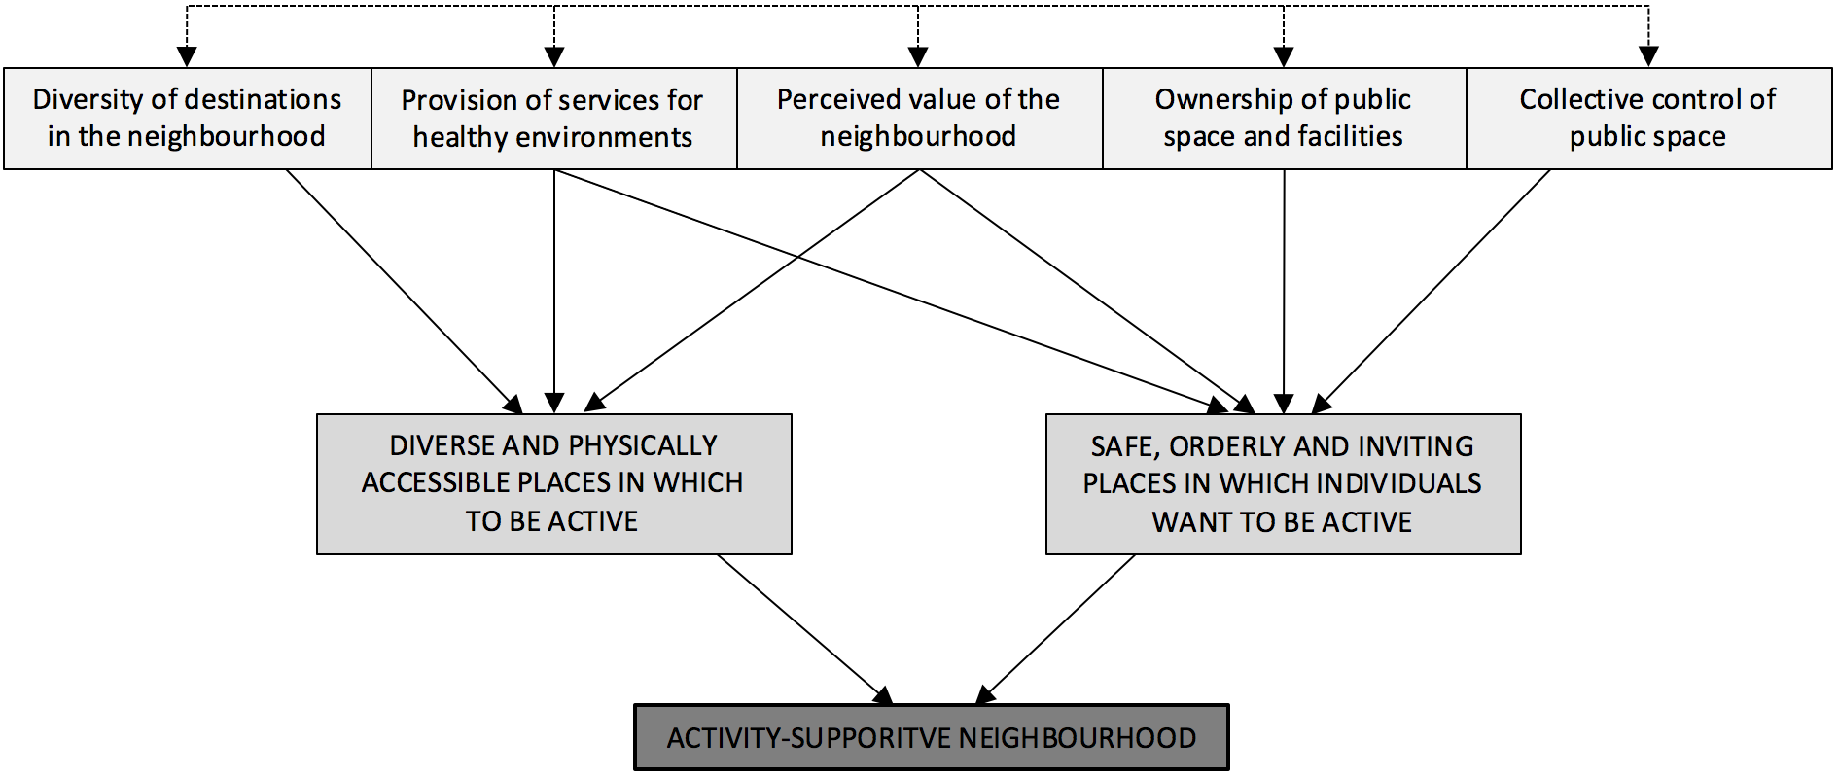

Figure 2: Participant photograph of greenspace in Drumchapel
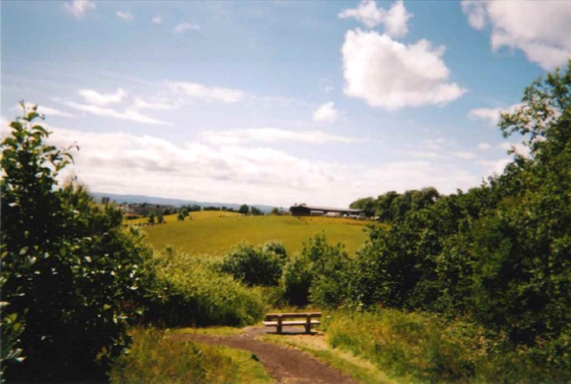

Figure 3: Participant photograph of the ferry in Govan
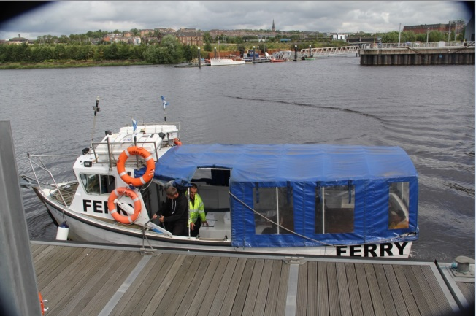

Figure 4: Participant photograph of greenhouse in community garden in Govan
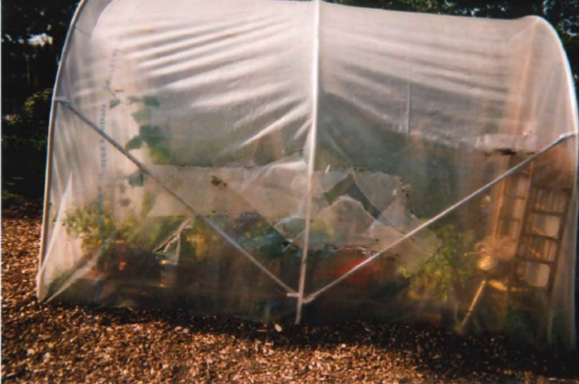

Figure 5: Participant photograph of their garden in Govan
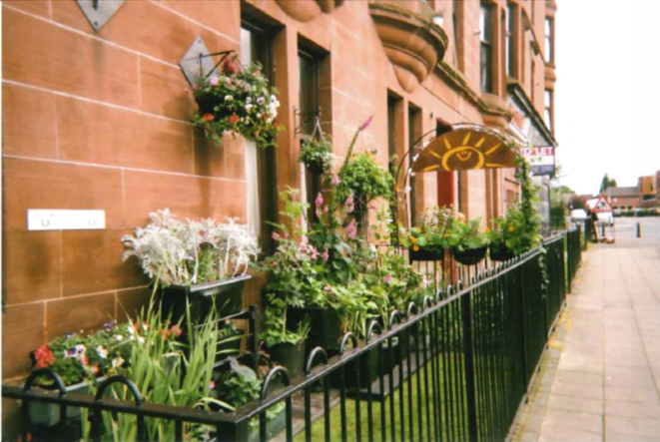

Figure 6: Participant photograph of housing improvements in Drumchapel
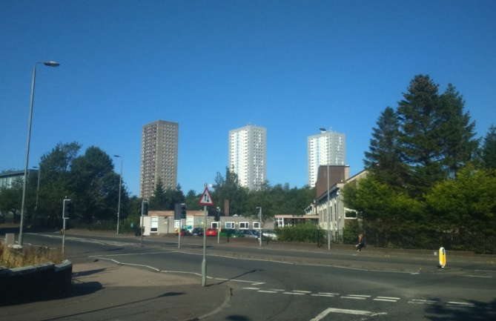

Figure 7: Participant photograph of dog waste bin in Drumchapel
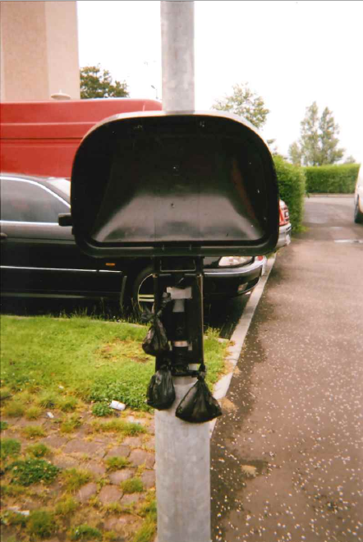

Figure 8: Participant photograph of dry docks in Govan
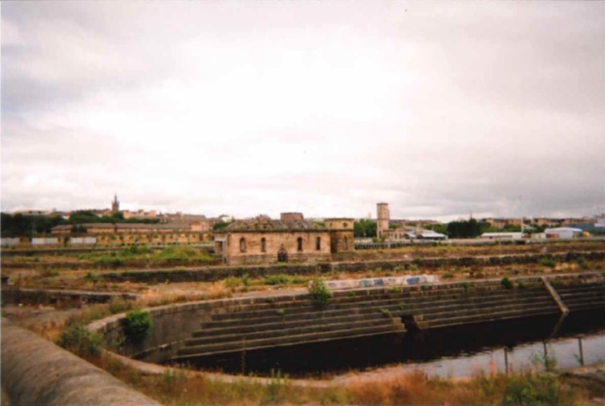

Figure 9: Participant photograph of the shopping centre in Drumchapel
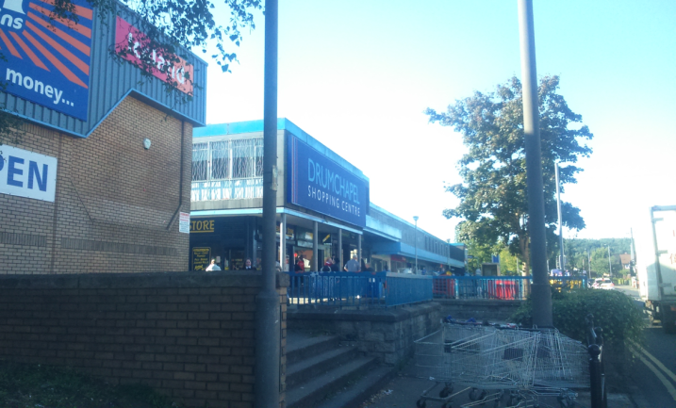

Figure 10: Participant photograph of the Lyceum in Govan
