Variability in angle k and its influence on higher-order aberrations in pseudophakic eyes

Authors : Annette Harrer, MD, Nino Hirnschall, MD, PhD, Juan Tabernero, PhD, Pablo Artal, PhD, Petra Draschl, MD, Sophie Maedel, MD, Oliver Findl, MD, MBA

Affiliations: Vienna Institute for Research in Ocular Surgery (Harrer, Hirnschall, Draschl, Maedel, Findl), a Karl Landsteiner Institute, Hanusch Hospital, Vienna, Austria; Laboratorio de Optica (Tabernero, Artal), Universidad de Murcia, Spain; the Vision and Eye Research Unit (Tabernero), Anglia Ruskin University, Cambridge and Moorfields Eye Hospital NHS Foundation Trust (Findl), London, United Kingdom.

ABSTRACT
Purpose: To observe the variability in angle k in pseudophakic patients and assess its correlation with optical biometry measurements and higher-order aberrations (HOAs).
Setting: Hanusch Hospital, Vienna, Austria.
Design: Prospective case series.
Methods: This study included patients who had cataract surgery 3 months to 1 year before study recruitment. In all cases, Purkinje meter images were taken. In addition, partial coherence interferometry measurement (IOLMaster) of the axial intraocular lens (IOL) position was performed. In a subgroup of patients, an additional Hartmann-Shack sensor measurement was taken to assess HOAs (WASCA).
Results: This study comprised 395 eyes of 349 patients. The mean age of the 210 women and 139 men was 74.1 years +/- 8.6 (SD) (range 44 to 91 years). The mean tilt (pupillary axis) and decentration were 3.9 +/- 2.3 degrees (range 0.2 to 16.2 degrees) and 0.4 +/- 0.2 mm (range 0.0 to 1.7 mm), respectively. The mean angle k was 5.2 +/- 2.6 degrees (range 0.3 to 13.9 degrees), and the mean orientation of this modulus was 189.5 +/-53.2 degrees (range 25.3 to 339.7 degrees).
Conclusion: The variability in the angle k was high.

INTRODUCTION
Tilt and decentration of intraocular lenses (IOLs) have a negative impact on the eye’s optical perfor-mance, especially for aspheric, toric, and multifocal IOLs.(1) For example, compared with spherical IOLs, decen-tration and tilt of aspheric IOLs induce asymmetric aber-rations that in severe cases of misalignment can decrease optical quality. Tilt and decentration of toric IOLs lead to a less predictable astigmatism outcome after surgery. With some multifocal IOLs, decentration can result in a different light distribution between the distance focus and near focus.
Although IOL tilt and decentration have been discussed extensively in the literature, they are often not clearly defined. Tilt and decentration are always measured in relation to an axis, either the line of sight or the pupillary axis. The angular distance between these axes is called the angle k.(2) Unfortunately, the definition of angle k is not always the same in the literature. Furthermore, different authors focus on different reference axes. Therefore, comparison of different studies can be difficult. Chang and Waring (3) described a clinically defined reference marker, the subject-fixated coaxially sighted corneal light reflex that can be a clinically useful reference marker and avoids the shortcom-ings of current ocular axes for clinical application. It also might lead to a greater consensus and improved patient out-comes. In addition, Tchah et al. (4) found that a large angle k and a large pupil center shift between mesopic conditions and photopic conditions increase the risk for glare. Different angle k values in each patient can interact differently with a particular IOL’s tilt, decentration, or both.
The aim of this paper was to observe the variability in angle k in pseudophakic patients and to assess its correla-tion with optical biometry measurements and higher-order aberrations (HOAs).

PATIENTS AND METHODS
This prospective study included patients who had cataract surgery 3 months to 1 year prior to study recruitment. Exclusion criteria were any opacities of the cornea, posterior capsule opacification, or a visual acuity below 0.3 Snellen. All the research and measurements followed the tenets of the Declaration of Helsinki and were approved by the local ethics committee. All patients provided written informed consent before the measurements were performed.
In all cases, Purkinje meter images (Purkinje meter prototype developed by J.T. and P.A., Murcia, Spain) (5) were taken after tropicamide 0.5% eyedrops (Minims) were instilled and a waiting period of approximately 30 minutes. In addition, a partial coherence interferometry (IOLMaster, Carl Zeiss Meditec AG) measurement of axial IOL position was taken. In a subgroup of patients, an additional Hartmann-Shack sensor measurement to assess HOAs (WASCA, Carl Zeiss Meditec AG) was taken.
Measurements
The Purkinje meter uses light reflectionsdthe Purkinje imagesdthat originate at ocular surfaces to evaluate ocular alignment. (6– 10) It is based on the principle that light is re-flected at all interfaces of media with a difference in refractive index. The Purkinje meter used in this study (3) has been shown to be highly reproducible. (11)
By definition, angle k is the angular distance in the object space between the pupillary axis (the line perpendicular to the cornea that intersects the center of the entrance pupil) and the principal line of sight.(12) In general, the displacement of the first Purkinje image with respect to the pupil center was measured as a function of the fixation angle of the eye when it observes a target.(13) Therefore, a semicircular arrange-ment of infrared light-emitting diodes (LEDs) placed at a fixed axial distance from the ocular entrance pupil was projected into the eye to generate the corneal reflex. However, in this study an improved setup was used. Whereas in a previous setup the eye sequentially fixated on a series of stimuli, the modified Purkinje meter required the eye to fixate on a single central stimulus and a picture of the anterior pupil plane with the first Purkinje image of the array of LEDs was recorded to estimate angle k.(9) Image analysis was performed as in previous studies.(14–16) Angle k was assessed as the extrapolated angle that overlapped the center of the pupil and the corneal reflex.

Statistical Analysis
For statistical analysis, Excel for Mac software (2011, Microsoft Corp.) with a Statplus:mac plug-in (version 5.8.3.8, AnalystSoft) and an Xlstat plug-in (2012, Addinsoft) were used. For missing data, observations were excluded from analysis.
Descriptive data are shown as the mean +/- SD and range. Partial least squares regression was performed with Xlstat 2012. Advantages of partial least squares regression have been explained. (17) The variable importance in projection method measures the importance of an explanatory variable to explain the dependent variable (more precisely, not the dependent variables but the t scores that contain compressed explanatory variables). More relevant for clinicians are the suggested thresh-olds of the variable importance in projections, which are as follows: a variable importance in projection of 0.8 to 1.0 indicate that the explanatory variable moderately influences the model and values of 1.0 or more indicate that it highly influences the regression model. To evaluate the regression model, a bootstrap method was used to estimate the weighting of each explanatory variable. The results of this bootstrap method are then shown as standardized coefficient (ie, b coefficients) plots. For interpretation purposes, the larger the absolute value of a coefficient, the larger the weight of the variable and if the confidence interval (whiskers) includes 0, the weighting of the variable is not significant. The eyes to be included were randomized using randomization software.

RESULTS
The study comprised 395 eyes of 349 patients. For analysis, only 1 eye per patient was included and the additional 46 second eyes were used for an additional intrapatient analysis only. The mean age of the 210 women and 139 men patients was 74.1 years +/- 8.6 (SD) (range 44 to 91 years). For the 1-eye-only analysis, 182 right eyes and 167 left eyes were included. Table 1 shows the optical biom-etry results. A Tecnis 3-piece IOL was used in 105 cases, a Tecnis 1-piece IOL (ZA9003 or ZCB00, both Abbott Medical Optics, Inc.) in 94 cases, an Akreos Adapt IOL (Bausch & Lomb, Inc.) in 56 cases, a Superflex IOL (Rayner Intraoc-ular Lenses Ltd.) in 51 cases, and other IOL types in 43 cases.
The mean tilt (pupillary axis) and decentration were 3.9 +/- 2.3 degrees (range 0.2 to 16.2 degrees) and 0.4 +/- 0.2 mm (range 0.0 to 1.7 mm), respectively. The mean angle k was 5.2 +/- 2.6 degrees (range 0.3 to 13.9 degrees), and mean orientation of this modulus was 189.5 +/- 53.2 degrees (range 25.3 to 339.7 degrees). A few patients had k values in the other direction (Figures 1 and 2).
Figure 3 shows the predictive power of different descriptive parameters on angle k. The only parameter that was found to be relevant was age, with an increase in k by 0.03 degrees per year (Figure 4). The correlation between axial length (AL) and angle k was be weak (r = 0.02); how-ever, short eyes (AL <21.0 mm; n = 4 eyes) were more likely to have a small angle k (mean 3.6 +/- 2.3 degrees; range 2.5 to 7.0 degrees). Table 2 shows the variability in HOAs. Angle k was had a significant influence for the 4th-order of astigmatism only. These correlations were confirmed in a partial least squares regression model (Figure 5).
In the intrapatient analysis of both eyes of 46 patients, the mean vector difference in angle k between the 2 eyes was 3.0 +/- 1.6 degrees (range 0.5 to 7.0 degrees). Figure 6 shows the correlation of the modus k between the 2 eyes of each patient.

DISCUSSION
In this study, a large number of patients were measured and the variability of angle k was found to be high. Similarly, large variability, but on average a smaller angle k, was observed in a previous study. (1) However, the sample in the previous study was significantly smaller and was based on phakic volunteers rather than on pseudophakic patients.
The influence of different parameters on the angle k was weak in almost all cases. A significantly high regression coefficient was found for age only; in a model, an increase in angle k of 0.03 degrees per year was found. However, the interpatient deviation was high and the correlation low. Although we included only a small group of very short eyes, there was a trend toward angle k being higher than in normal or long eyes. These findings correlate well with previous unpublished findings by 2 of the authors (J.T., P.A.). However, in a regression model including all cases, the effect of AL on angle k was weak in this study because the number of very short eyes was small. Other factors, such as corneal radii, white-to-white distance, preoperative anterior chamber depth, and sex were not found to have a relevant influence on angle k.
In general, the correlation between tilt and coma was low (r2 = 0.04). In cases with more than 10-degrees of tilt, coma was more than 0.3 in 40% of the cases. This value increased slightly when correcting for k.
Although HOAs were generally correlated weakly with the amount of angle k, a significant correlation was observed for astigmatism of the 4th-order. A pupil diameter of 6.0 mm was preset for the HOA measurements. These findings were unexpected because we thought that other HOAs, such as coma, would be more likely to be influenced by angle k. Artal et al.(12) and Berrio et al.(13) measured optical aberrations in young eyes and elderly eyes. An increase in HOAs was described to be age related, especially from the fourth decade onward.(17) This increase is assumed to be the result of age-related modifications of the cornea and its architec-ture and geometry. Lenticular factors were also described but were not relevant for our study because all patients were pseudophakic. However, a particular and rather complex coupling between the aberration of the cornea and the IOL might also occur. This would depend on the IOL geometry (shape factor) and the patient’s angle k.(18)
Hashemi et al.(19) measured the distribution of angle k in healthy eyes that never had surgery. In their study, the mean angle k was similar to our results. They also showed that angle k’s were larger in the hyperopic population than in the myopic population. Compared to our study, the effect of AL on angle k was weak because the number of very short eyes was small.
Prakash et al.(20) observed that taking angle k into account when calculating and implanting a multifocal IOL could improve patient satisfaction. Park et al.(21) showed that considering angle k could also reduce the risk for glare in refractive laser surgery. Moshirfar et al.(22) confirmed these findings. In addition, Tchah et al.(4) found that a large angle k and a large pupil center shift between mesopic and photopic conditions increased the risk for glare. Furthermore, Karhanova et al.(23) found that temporal decentration is associated with the greatest risk in multifocal IOL implantation, particularly in cases with a higher angle k. They concluded that patients with a high angle k should be excluded from multifocal IOL implantation because of a higher risk for postoperative photic phenomena.
This present study found that the variability in angle k was large in the pseudophakic population and it appeared to be dependent on age and AL; however, the interpatient deviation was large and predicting the amount of angle k uncertain. Therefore, angle k should be measured and IOL tilt and decentration should be considered together with angle k.
REFERENCES
1. Tabernero J, Piers P, Benito A, Redondo M, Artal P. Predicting the optical performance of eyes implanted with IOLs to correct spherical aberration. Invest Ophthalmol Vis Sci 2006; 47:4651–4658. Available at: http://iovs.arvojournals.org/article.aspx?articleidZ2124955. Accessed May 14, 2017
2. Tabernero J, Benito A, Alcon E, Artal P. Mechanism of compensation of ab-errations in the human eye. J Opt Soc Am A Opt Image Sci Vis 2007; 24:3274–3283
3. Chang DH, Waring GO IV. The subject-fixated coaxially sighted corneal light reflex: a clinical marker for centration of refractive treatments and devices. Am J Ophthalmol 2014; 158:863–874
4. Tchah H, Nam K, Yoo A. Predictive factors for photic phenomena after refractive, rotationally asymmetric, multifocal intraocular lens implantation. Int J Ophthalmol 2017; 10:241–245. Available at: https://www.ncbi.nlm.nih.gov/pmc/articles/PMC5313547/pdf/ijo-10-02-241.pdf. Accessed May 14, 2017
5. Tabernero J, Benito A, Nourrit V, Artal P. Instrument for measuring the misalign-ments of ocular surfaces. Opt Express 2006; 14:10945–10956. Available at: https://www.osapublishing.org/oe/viewmedia.cfm?uriZoe-14-22-10945 &seqZ0. Accessed May 14, 2017
6. Auran JD, Koester CJ, Donn A. In vivo measurement of posterior chamber intraocular lens decentration and tilt. Arch Ophthalmol 1990; 108:75–79
7. Kirschkamp T, Dunne M, Barry J-C. Phakometric measurement of ocular surface radii of curvature, axial separations and alignment in relaxed and accommodated human eyes. Ophthalmic Physiol Opt 2004; 24:65–73
8. de Castro A, Rosales P, Marcos S. Tilt and decentration of intraocular lenses in vivo from Purkinje and Scheimpflug imaging; validation study. J Cataract Refract Surg 2007; 33:418–429
9. Rosales P, Marcos S. Phakometry and lens tilt and decentration using a custom-developed Purkinje imaging apparatus: validation and measure-ments. J Opt Soc Am A Opt Image Sci Vis 2006; 23:509–520
10. Novak J, Peregrin J, Svĕrak J, Kindernay S. [A method for determining per-operative centering and monitoring the development of postoperative de-centration of intraocular lenses]. [Czechoslovakian] Cesk Oftalmol 1992; 48:247–255
11. Nishi Y, Hirnschall N, Crnej A, Gangwani V, Tabernero J, Artal P, Findl O. Repro-ducibility of intraocular lens decentration and tilt measurement using a clinical Purkinje meter. J Cataract Refract Surg 2010; 36:1529–1535. Available at: http://lo.um.es/panel/secciones/noticias/adjuntos/14.pdf. Accessed May 14, 2017
12. Artal P, Berrio E, Guirao A, Piers P. Contribution of the cornea and internal surfaces to the change of ocular aberrations with age. J Opt Soc Am A Opt Image Sci Vis 2002; 19:137–143
13. Berrio E, Tabernero J, Artal P. Optical aberrations and alignment of the eye with age. J Vis 2010; 10:1–17. Available at: http://www.journalofvision.org /content/10/14/34.full.pdf. Accessed May 14, 2017

14. Phillips P, Perez-Emmanuelli J, Rosskothen HD, Koester CJ. Measurement of intraocular lens decentration and tilt in vivo. J Cataract Refract Surg 1988; 14:129–135
15. Crnej A, Hirnschall N, Nishi Y, Gangwani V, Tabernero Artal P, Findl O. Impact of intraocular lens haptic design and orientation on decentration and tilt. J Cataract Refract Surg 2011; 37:1768–1774
16. Findl O, Drexler W, Menapace R, Hitzenberger CK, Fercher AF. High preci-sion biometry of pseudophakic eyes using partial coherence interferometry. J Cataract Refract Surg 1998; 24:1087–1093
17. Guirao A, Redondo M, Artal P. Optical aberrations of the human cornea as a function of age. J Opt Soc Am A Opt Image Sci Vis 2000; 17:1697–1702
18. Hirnschall N, Amir-Asgari S, Maedel S, Findl O. Predicting the postoperative intraocular lens position using continuous intraoperative optical coherence to-mography measurements. Invest Ophthalmol Vis Sci 2013; 54:5196–5203. Available at: http://iovs.arvojournals.org/article.aspx?articleidZ2127773. Ac-cessed May 14, 2017
19. Hashemi H, Khabaz Khoob M, Yazdani K, Mehravaran S, Jafarzadehpur E, Fotouhi A. Distribution of angle kappa measurements with Orbscan II in a population-based survey. J Refract Surg 2010; 26:966–971
20. Prakash G, Prakash DR, Agarwal A, Kumar DA, Agarwal A, Jacob S. Pre-dictive factor and kappa angle analysis for visual satisfactions in patients with multifocal IOL implantation. Eye 2011; 25:1187–1193. Available at: http://www.ncbi.nlm.nih.gov/pmc/articles/PMC3178249/pdf/eye2011150a.pdf. Accessed May 14, 2017
21. Park CY, Oh SY, Chuck RS. Measurement of angle kappa and centration in refractive surgery. Curr Opin Ophthalmol 2012; 23:269–275
22. Moshirfar M, Hoggan RN, Muthappan V. Angle kappa and its importance in refractive surgery Oman. J Ophthalmol 2013; 6:151–158. Available at: http://www.ncbi.nlm.nih.gov/pmc/articles/PMC3872563 /?reportZprintable. Accessed May 14, 2017
23. Karhanova M, Maresova K, Pluhacek F, Mlcak P, Vlacil O, Sín M. [The importance of angle kappa for centration of multifocal intraocular lenses]. [Czechoslovakian]. Cesk Slov Oftalmol 2013; 69:64–68

FIGURES

Figure 1
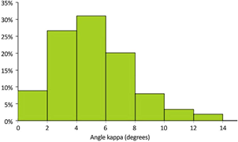

Figure 2
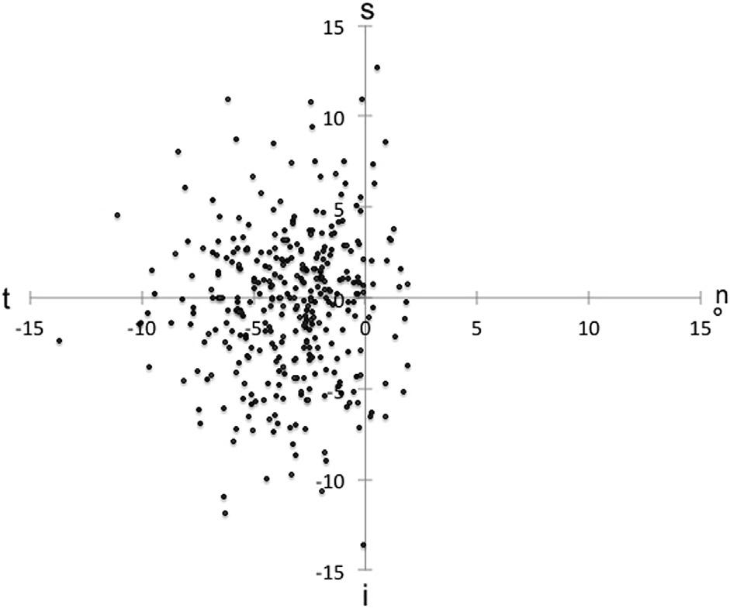
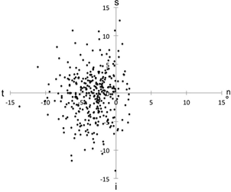

Figure 3

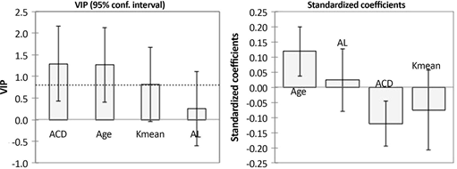

Figure 4

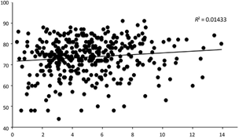

Figure 5

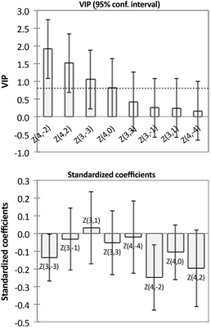

Figure 6

