[1]

Comparison of electrohysterogram characteristics during uterine contraction and non-contraction at labor*

Zhihui Liu, Dongmei Hao, Lei Zhang, Juntao Liu, Xiya Zhou, Lin Yang, Yimin Yang, Xuwen Li, Song Zhang, and Dingchang Zheng

*Abstract*— Uterine contraction is one of the most important indication in the labor progression. Electrohysterogram (EHG) is a promising method for monitoring uterine contraction and discriminating efficient and inefficient contractions. This study aims to analyze the difference of EHG signals between two groups. EHG signals are recorded with abdominal electrodes from 20 pregnant women, including 10 in term labor group and 10 in non-labor group. Typical linear and nonlinear characteristics of EHG signals, including root mean square (RMS), peak frequency (PF), median frequency (MDF), mean frequency (MNF), parameters from wavelet decomposition (W4, W5) and time reversibility (Tr) are extracted. These characteristics are compared between contraction and non-contraction in term labor group and non-labor group. The result shows that RMS, W4 and W5 of contraction are significantly larger than non-contraction both within term labor group and between two groups (all p<0.001). However, MDF and MNF are significantly smaller (all p<0.05). Furthermore, all characteristics of non-contraction show no significant difference between two groups, except MNF. The variability of RMS, W4, W5 and Tr of contraction are significantly larger than non-contraction both within term labor group and between two groups (all p<0.05, with p<0.001 for W5 and Tr). However, the variability of MDF, PF and MNF are significantly smaller (all p<0.05). Moreover, the variability of all characteristics of non-contraction shows no significant difference between two groups, except MNF. We have shown that characteristics of EHG signals and their variability during contraction are quite different from non-contraction. Therefore, it is feasible to separate uterine contractions and monitor uterine activity with EHG signals.

# INTRODUCTION

Uterine contraction (UC) activity is commonly used as a diagnostic tool during both pregnancy and labor. It is essential to assess progress of labor and reflects the adequacy of uterine activity [1]. External tocodynamometry (TOCO) and intra-uterine pressure catheters (IUPC) are currently methods for measuring uterine contraction. TOCO provides contraction frequency and approximate duration of labor contractions, but suffers frequent signal dropout necessitating re-positioning by a nurse, and may fail in obese patients [2]. IUPC is able to provide reliable information of uterine contractions. However, it is limited by its invasiveness and suffers from ruptured membranes and infection [1], [3]. Electrohysterogram (EHG) signal is obtained non-invasively by using surface electrodes attached to pregnant woman’s abdomen. It represents the electrical activity triggering the mechanical contraction of the myometrium and has been demonstrated to be representative of the uterine electrical activity recorded internally [4]. It has been indicated that EHG can be measured as early as 19 weeks of gestation [5] and therefore, EHG signals might provide useful information for monitoring pregnant women [6]. Various types of linear and non-linear characteristics have been extracted from the EHG [7]. Slow and fast waves can be distinguished in the EHG signals by low-pass filter. The slow wave can be considered as a contraction curve from which the amplitude, duration and frequency of contractions could be estimated to recognize the contraction patterns [8]. The fast wave follows the instantaneous amplitude change of action potentials and is expected to describe the electrophysiological properties of the uterine muscle. Power spectrum density (PSD), median frequency and peak frequency are calculated as the spectral parameters of contractions. Besides, nonlinear approaches, including sample entropy, time reversibility and Lyapunov exponent have been used to describe nonlinear characteristics of EHG signals [9], [10]. Velocity, directionality and synchronization of EHG signals reflect the propagation information of labor contraction which can be used to monitor and predict the progress of pregnancy.

Previous studies investigated characteristics of the extracted contractions, and then divided these contractions into classes of different physiological terms. They focused on feature extraction, feature selection and discriminant analysis [3], to show an evolution of the contractions during pregnancy. In this direction by estimating different parameters of uterine electrical activity already produced promising results. However, the changes of EHG signals characteristics are still not clear in term labor group and non-labor group. Therefore, the comprehensive analysis of EHG characteristics is very important. We chose some linear and non-linear EHG characteristics in order to discriminate contraction and non-contraction. To our best knowledge, there is little research on discriminating difference of characteristics between contraction and non-contraction periods in term labor group and non-labor group, especially study with the variability of characteristics has not been reported.

The aim of this study is therefore to analyze and compare typical EHG characteristics and their variability between contraction and non-contraction in term labor group and non-labor group.

# records

## A. Subjects and EHG recordings

20 women with singleton pregnancy were recruited at the Department of Gynecology and Obstetrics, Peking Union Medical College Hospital, Beijing. 10 women were at term labor with regular UC (38-40 weeks of gestation), 10 women were at non-labor without UC (34-39 weeks of gestation). All pregnant women had signed informed consent. The study protocol was performed under the Code of Ethics of the World Medical Association (Declaration of Helsinki) and approved by the Research Ethics Committee of Department of Gynecology and Obstetrics, Peking Union Medical College Hospital.

EHG signals were recorded for 30 minutes on the surface of pregnant woman’s abdomen by using Monica AN24 (Monica Healthcare Ltd. Nottingham, UK). The sampling frequency was 20Hz and bandwidth was from 0.2Hz to 1Hz.

## B. Selecting contraction and non-contraction periods

For the term labor group, the contraction period was determined by referring the burst of EHG signals and clinical experience. The contraction period consisted of 10 seconds before and after the peak of burst, totally was 20 seconds. The non-contraction period was also 20 seconds which was selected in the middle between the adjacent contractions with its amplitude less than the preset threshold. Fig.1 gives one example of the selection of contraction and non-contraction periods from a subject in term labor group.

For non-labor group, there was no contraction period in this group and every 20 seconds was selected manually as one non-contraction period.

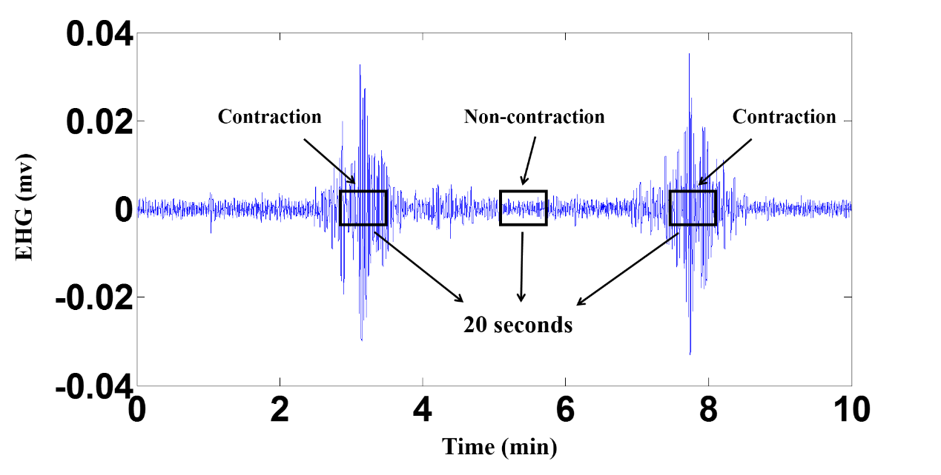

1. Example of the selection of contraction and non-contraction periods from a subject in term labor group

# Methods

EHG characteristics in contraction and non-contraction including RMS, PF, MDF, MNF, Tr, W4 and W5 [6], [7] are calculated, respectively. The application of time reversibility on uterine electromyography signals shows very good performance in classifying pregnancy and labor signals.

## EHG Characteristics

EHG characteristics including root mean square (RMS), peak frequency (PF), median frequency (MDF), mean frequency (MNF), parameters from wavelet decomposition (W4, W5) and time reversibility (Tr) [6], [7] were calculated respectively during uterine contraction and non-contraction. They provided amplitude-based features, spectral features, time-frequency features and non-linear features of EHG signals.

## C. Variability of EHG signal characteristics

In order to understand the variability of UC, the standard deviations of EHG characteristics were calculated respectively among multiple contractions and non-contractions for each subject, then the average value in term labor group and non-labor group were obtained.

## D. Statistical analysis

The means and standard deviations(SD) of characteristics of contraction and non-contraction periods were calculated. The data accord with Gaussian Expression. Multivariate analysis of variance was performed by software SPSS 18 (SPSS Inc.) to assess the effect of subject, contraction or non-contraction, term labor or non-labor on EHG characteristics. The post hoc Fisher’s least significant difference test was used to make individual comparison between means. *P*-value below 0.05 was considered statistically significant.

# results

## Comparison of EHG signals characteristics

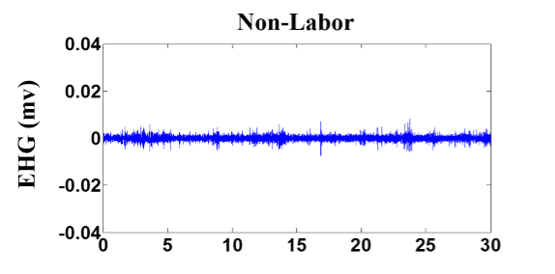

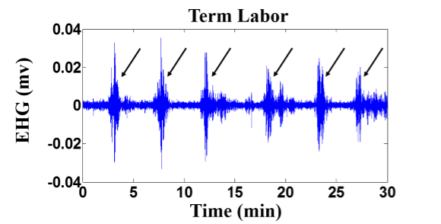

1. Example of EHG signals one example in non-labor group without contraction (recorded in the 36th week); one example in term labor group with contraction (recorded in the 40th week). Contractions are marked by arrows.

7 characteristicsof EHG signal were compared between contraction and non-contraction in term labor group and non-labor group. Fig.3 shows an example of EHG analysis for characteristics relating to amplitude and frequency (MDF, MNF and PF). Fig.4 shows comparison of the typical amplitude and frequency characteristics (RMS and MNF). Table 1 summarizes the result of comparison for all characteristics.

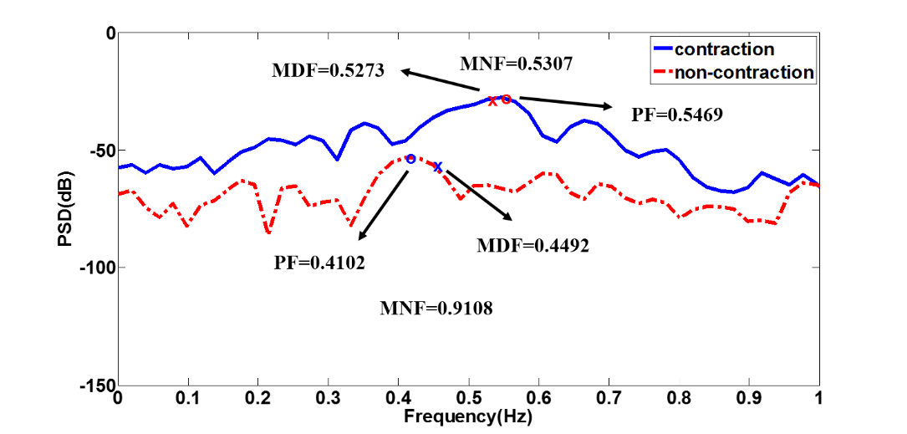

1. Example of EHG analysis a period of EHG signal in 20 seconds; PSD of EHG signal analysis, MDF and PF were marked.

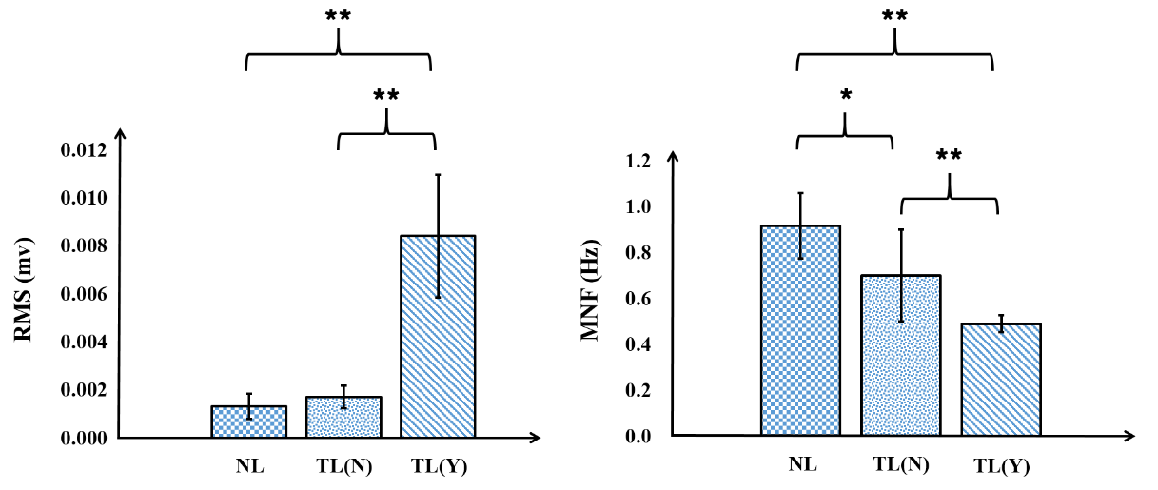

1. Comparison of RMS and MNF within term labor group and between term labor group and non-labor group. TL(Y): term labor with UC; TL(N): term labor without UC; NL: non-labor without UC. **p<0.001; *p<0.05
2. EHG features in term labor group and non-labor group (mean ± SD)

| Feature | Non-labor  Non-contraction | Term labor  Non-contraction | Term labor  Contraction |
| --- | --- | --- | --- |
| RMS | 0.0014 ± 0.0005 | 0.0017 ± 0.0005 | 0.0084 ± 0.0026 a🞴🞴/ b🞴🞴 |
| MDF | 0.54 ± 0.07 | 0.50 ± 0.07 | 0.46 ± 0.04a🞴/ b🞴 |
| PF | 0.48 ± 0.08 | 0.48 ± 0.11 | 0.46 ± 0.05 |
| MNF | 0.92 ± 0.14 | 0.70 ± 0.20 b🞴 | 0.40 ± 0.04 a🞴🞴/ b🞴🞴 |
| W4 (E-07) | 3.98 ± 3.71 | 4.60 ± 3.02 | 62.7 ± 43.2 a🞴🞴/ b🞴🞴 |
| W5 (E-08) | 4.53 ± 3.87 | 5.42 ± 2.94 | 67.0 ± 29.4 a🞴🞴/ b🞴🞴 |
| Tr (E-11) | 3.69 ± 8.39 | 0.11 ± 4.10 | -1.65 ± 14.1 |

*Note*: a🞴🞴 *p*<0.001, a🞴 *p*<0.05 between contractions and non-contractions within term labor group. b🞴🞴 *p*<0.001, b🞴 *p*<0.05 between term labor group and non-labor group.

Fig.4 and Table 1 indicate RMS, W4 and W5 of term labor contraction were significantly larger than non-contraction within term labor and between two groups (all p<0.001). However, MDF and MNF were significantly smaller (all p<0.05). PF and Tr were not significantly different between term labor contraction and non-contraction within term labor or between two groups (p>0.05). Besides, all characteristics of non-contraction period had no significant difference (p>0.05) between two groups, except MNF (p<0.05).

## B. Comparison of variability of EHG signal characteristics

The variability of EHG signal characteristics were compared between contraction and non-contraction in term labor group and non-labor group. Fig.5 shows comparison of variability of typical amplitude and frequency characteristics RMS and MNF. Table 2 summarizes the result of comparison of variability of all characteristics.

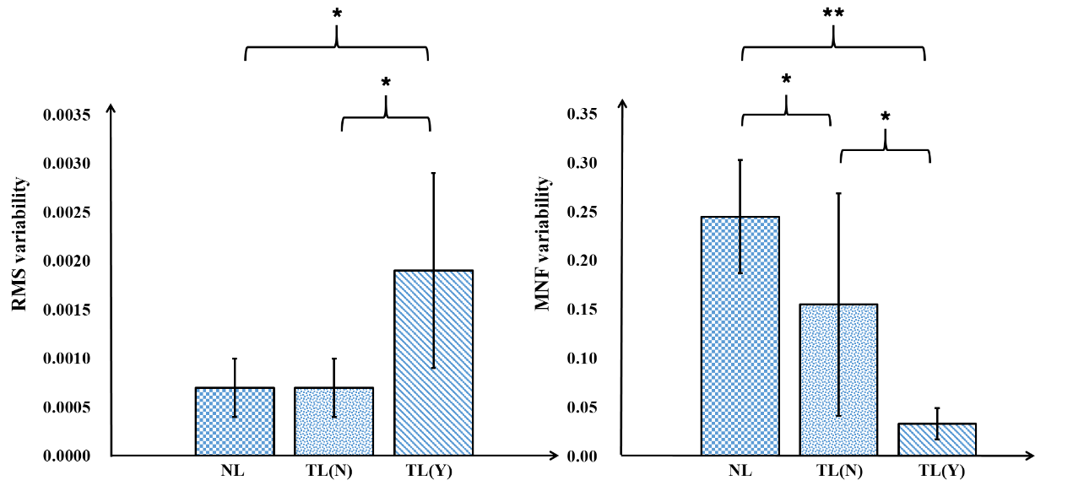

1. Comparison of variability of RMS and MNF within term labor group and between term labor group and non-labor group. TL(Y): term labor with UC; TL(N): term labor without UC; NL: non-labor without UC. **p<0.001; *p<0.05
2. Variability of EHG features in term labor group and non-labor group(mean ± SD)

| Variability of  Feature | Non-labor  Non-contraction | Term labor  Non-contraction | Term labor  Contraction |
| --- | --- | --- | --- |
| RMS | 0.0007±0.0003 | 0.0007±0.0003 | 0.0019±0.001 a🞴/ b🞴 |
| MDF | 0.11±0.06 | 0.11±0.07 | 0.04±0.02 a🞴/ b🞴 |
| PF | 0.19±0.1089 | 0.15±0.11 | 0.05±0.03 a🞴/ b🞴 |
| MNF | 0.24±0.0578 | 0.16±0.11 b🞴 | 0.03±0.02 a🞴/ b🞴🞴 |
| W4 (E-07) | 6.34±5.76 | 3.87±3.28 | 47.3±48.4 a🞴/ b🞴 |
| W5 (E-08) | 6.60±5.18 | 6.13±5.28 | 67.2±39.8 a🞴🞴/ b🞴🞴 |
| Tr (E-11) | 3.94±3.61 | 1.68±0.78 | 41.1±26.9a🞴🞴/ b🞴🞴 |

*Note*: a🞴🞴 *p*<0.001, a🞴 *p*<0.05 between contractions and non-contractions within term labor group. b🞴🞴 *p*<0.001, b🞴 *p*<0.05 between term labor group and non-labor group.

Fig.5 and Table 2 indicate that the variability of RMS, W4, W5 and Tr of term labor contraction were significantly larger than non-contraction within term labor group and between two groups (all p<0.05, with p<0.001 for W5 and Tr). However, variability of MDF, PF and MNF were significantly smaller (all p<0.05). Furthermore, all variability of characteristics of non-contraction periods had no significant difference between two groups. except MNF (p<0.05).

# Conclusion

The uterine contraction is an important characteristic for labor, which becomes from irregular, weak strength to regular, strength gradually. The mechanical contraction of the uterus is the direct consequence of propagation of spontaneous electrical activity through the myometrial cells. We analyzed characteristics of EHG signals and their variability which has showed prospect of monitoring uterine activity.

In our study, EHG signals in non-labor group and term labor group are recorded and their linear and non-linear characteristics are extracted and compared within term labor group and between two groups. RMS of contraction periods are significantly larger than non-contraction periods within term labor group which is consistent with previous work [3]. Amplitude of EHG signal will enlarge when delivery is approaching as a result of the myometrial activity becomes more positive.

MDF and MNF shift to lower frequency when going from non-contraction to contraction. This result is different from [7], who found a shift of the EHG content towards higher frequency when going from pregnancy to labor. This difference occurred because we investigated EHG from non-contraction to contraction within term labor not from pregnancy to labor. PF had no significant difference between contraction and non-contraction although it has been considered as the most predictive of true labor [3] for identifying women with preterm contractions. However, this result is agreed with the study by Moslem et al [11]. The EHG characteristics of non-contraction have no significant difference between term labor group and non-labor group. It indicates that non-contraction of EHG signal has similar characteristics in this two groups.

W4, W5 and Tr have been studied to identify common characteristics which are relevant to contraction classification [6]. However, they did not compare contraction and non-contraction. Tr indicates the nonlinear property of a time series. The time irreversibility of non-contraction is larger than that of contraction, which is consistent with the previous study [6].

We also compare the variability of all EHG signal characteristics. The variability of RMS, W4, W5 and Tr of contraction periods are significantly larger than those of non-contraction periods, while the variability of MDF, PF and MNF of contraction are significantly smaller than those of non-contraction period. The results indicate that UCs change more in amplitude, but less in frequency when compares to non-contraction. We have not found other studies reporting the variability of EHG characteristics.

The UC marked by pregnant women could be inaccurate and incomplete in clinical, while combing with burst and clinical experience could improve the accuracy of recognition for UC. However, manual identification of UC is time-consuming. Besides, uterine electrical activity mainly occurs within 1 Hz. we only consider band frequency from 0.2 to 1Hz.

In further study, we intend to collect more data samples and choose more different frequency band. In practical, the movement of pregnant women often has a negative effect to the data collection. We will consider to use an accelerometer as reference to avoid such possible confusion in our later experiments. It is noted that the amount of samples was not large enough in this study. In order to extend the database, more subjects at different gestational weeks with different states, including induced labor and preterm labor should be recruited. Moreover, EHG spatial characteristics including conduction velocity or direction combined with clinical symptoms will be investigated to discriminate and monitor various uterine contraction efficiently. We will also consider to use ROC curve in our next research.

In summary, this study analyzed characteristics of EHG signals and their variability may be applied to monitor uterine contraction.

Acknowledgment

This research was sponsored by Bill & Melinda Gates Foundation (OPP1148910) and partially sponsored by Grand Scientific Research Promotion Program of Beijing University of Technology (No. 015000514316006).

References

1. B. C. Jacod, EM. Graatsma, E.V. Hagen, and G.H. Visser, “A validation of electrohysterography for uterine activity monitoring during labour,” *J MATERN-*FETAL*NEO M*, vol. 23, pp. 17-22, 2009.
2. T.Y. Euliano, M.T. Nguyen, S. Darmanjian, S.P. McGorray, N. Euliano, A. Onkala, and A.R. Gregg, “Monitoring uterine activity during labor: a comparison of three methods,” *Am J Obstet Gynecol*, vol. 208, pp. 1-6, 2013.
3. M. Vinken, C. Rabotti, S. Oei, and M. Mischi, “Accuracy of frequency-related parameters of the electrohysterogram for predicting preterm delivery: a review of the literature,” *Obstet Gynecol Surv*, vol. 64, pp. 529-541, 2009.
4. H. Alvarez, and R. Caldeyro, “Contractility of the human uterus recorded by new methods,” *Obstet Gynecol Surv.* vol. 91, pp. 1-13, 1950.
5. J. Gondry, C. Marque, J. Duchene, and D. Cabrol, "Electrohysterography during pregnancy: preliminary report,” *Biomed Instrum Technol.* vol. 27, pp. 318-324, 1993.
6. D. Alamedine, M. Khalil, and C. Marque. “Comparison of different EHG feature selection methods for the detection of preterm labor,” *COMPUT MATH METHOD M*, vol. 2013, pp. 1-9, 2013.
7. D. Alamedine, M. Khalil, and C. Marque. “Parameters extraction and monitoring in uterine EMG signals. Detection of preterm deliveries,” *IRBM*, vol. 34, pp. 322-325, 2013.
8. J. Jezewski, K. Horoba, A. Matonia, and J. Wrobel. “Quantitative analysis of contraction patterns in electrical activity signal of pregnant uterus as an alternative to mechanical approach,” *Physiol. Meas*, vol. 26, pp. 753–767, 2005.
9. G. Fele-Žorž, G. Kavšek, Ž. Novak-Antolič, and F. Jager. “A comparison of various linear and non-Linear signal processing techniques to separate uterine EMG records of term and preterm delivery groups,” *MED BIOL ENG COMPUT*, vol. 46, pp. 911-922, 2008.
10. M. Hassan, J. Terrien, C. Muszynski, A. Alexandersson, C. Marque, and B. Karlsson. “Better pregnancy monitoring using nonlinear correlation analysis of external uterine electromyography,” *IEEE T BIO-MED ENG*, vol. 60, pp. 1160-1166, 2012.
11. B. Moslem, B. Karlsson, M.O. Diab, M. Khalil, and C. Marque. “Classification performance of the frequency-related parameters derived from uterine EMG Signals,” *IEEE EMBS*, 2011, pp. 3371-3374.

1. *Research supported by Bill & Melinda Gates Foundation, by Bill & Melinda Gates Foundation (Investment ID：OPP1148910) and Beijing Natural Science Foundation (7172015).

   Z. Liu, D. Hao*, L. Yang, Y. Yang, X. Li, S. Zhang are with the Department of Biomedical Engineering, Beijing University of Technology, Beijing, China (e-mail: [liu_jason@163.com](mailto:liu_jason@163.com), [haodongmei@bjut.edu.cn](mailto:haodongmei@bjut.edu.cn), [yanglin@bjut.edu.cn](mailto:yanglin@bjut.edu.cn), [yym@bjut.edu.cn](mailto:yym@bjut.edu.cn), [lixuwen@bjut.edu.cn](mailto:lixuwen@bjut.edu.cn), [zhangsong@bjut.edu.cn](mailto:zhangsong@bjut.edu.cn). *corresponding author, phone: 86-010-67392010).

   L. Zhang is with Beijing Yes Medical Devices Co., Ltd, Beijing, China (e-mail: [leizhang1002@163.com](mailto:leizhang1002@163.com), zhouxiya@pumch.cn).

   J. Liu and Xiya Zhou are with Peking Union Medical College Hospital, Beijing, China (e-mail: tao_aus@hotmail.com).

   D. Zheng is with Health and Wellbeing Academy, Anglia Ruskin University, Chelmsford, UK (e-mail: dingchang.zheng@anglia.ac.uk).