NOT SO SIMILAR AFTER ALL:

EXPLORING THE DIVERSITY OF

STRATEGIC ORIENTATIONS FOR INNOVATION

Abstract

Innovation has gained growing attention in the strategic management field, and - as a strategic orientation - it has been predominantly considered as a homogenous class of differentiated strategic mindsets. This contribution aims at distinguishing different sub-typologies of innovation strategies and validating their profiles and consistency. It explores approaches discussed in the mainstream literature as well as the possibility that other orientations could exist.
A cluster analysis outlines four strategic orientations showing differences in terms of competitive drivers, value creation architectures, outsourcing and alliances policies, and managerial processes.
Findings offer scholars and practitioners a better understanding of strategic alternatives in pursuing innovation through the identification of systems of consistency among managerial variables - e.g. configuration of the supply chain - thus fostering uniqueness and sustainability of the competitive advantage, and driving managers' decision. In particular, what really characterized the different innovation strategies here shown is the way they deal with the value chain structure, meaning a key part of the business model.

Keywords: strategic orientation; innovation; knowledge-based view; firm value chain.

INTRODUCTION
'Innovation', as we know it, is not a strategy. More precisely, we argue that innovation represents a bundle of different strategies, rather than a unique mindset driving firms’ decisions.
Innovation has been cited as the main raison d'être for companies in the contemporary economy as well as one of the most important sources of competitiveness (McGrath et al., 1996, Lengnickhall, 1992, Martin, 2012). For example, a number of contributions discussed the argument suggesting that strategic orientation towards innovation has become a key priority for top managers (Yang et al., 2012, Chou and Yang, 2011). This is becoming more and more relevant at the global level, not just in developed countries. For instance, China’s real gross domestic expenditure on R&D in 2008 was equivalent to 13.1% of the total, up from around 5% in 2001. Recently, culture for innovation and companies’ ability to change have become crucial for the majority of contemporary companies (Zhou et al., 2005).
This led scholars to start a lively debate about the “innovation orientation” decades ago (e.g. Manu, 1992; Siguaw et al., 2006, Jeong et al., 2006). The latter has been viewed as a relatively homogeneous alternative to more traditional strategic orientations, i.e. cost orientation (Kortmann, 2015), customer orientation (Dhewanto and Sohal, 2015) and market orientation (Bader and Enkel, 2014). Here we push forward the idea that, by contrast, innovation is rather a diversified umbrella of strategic orientations, showing high diversity among them. Strategy is the way by which companies differentiate themselves from others: if innovation is actually a shared priority among the majority of contemporary companies, do we have to assume they are all pursuing the same strategy? In our view, this appears highly unlikely.

This study aims to discuss and demonstrate that firms’ innovation orientation covers heterogeneous chain structures. The goal is to outline the presence of recurrent strategies in driving firms’ decision frames for the development of new processes and products. In particular, the focus is on the knowledge structure of the firm, as it consists of managerial processes, learning culture and beliefs that guide actions and promote innovative thinking (Siguaw et al., 2006). Research questions arise as follows: Does 'innovation orientation' represent a homogenous class of strategies? Or do different types of strategic orientations toward innovation exist? Which dimensions highlight such a diversity? After an in-depth literature review, we address these issues through an exploratory empirical analysis using a sample of 168 firms and data gathered through questionnaires. The study takes into account extant definitions of innovation orientations already discussed in the literature, together with emerging taxonomies previously overlooked by scholars.
The argument is relevant for both academics and practitioners. Scholars recognized how breakthrough products and services are related to strategic types and environmental conditions (Manion and Cherion, 2009, Hong et al., 2012). A better understanding of the construct ‘innovation orientation’ and the identification of its variations is fundamental for further studies with regards to contingency theories, complementary effects, dynamic capabilities and strategic positioning (Eisenhardt and Martin, 2000, Zhou and Li, 2010). Moreover, a fine-grained picture about the portfolio of options in pursuing innovation offers guidance to managers in setting strategic architectures and processes consistently with competitive drivers.
This survey differs from previous contributions, as instead of focusing on innovation performance (the outcome), the work investigates the ways in which firms innovate (the process). We believe that antecedents and factors affecting innovation performance should be reconsidered taking into consideration the peculiarities of diverse innovation orientations. Our work investigates managerial consistency of strategic types and the differences among them, remitting the study of their conditions of efficacy (performance) to further research.
This contribution is structured as follows. First, a literature review highlights a research gap in the field. The overview returns five dimensions to assess diverse strategies according to knowledge-based view of the firm. Then, an exploratory survey runs a cluster analysis and outlines four types of orientations. The selected sample largely refers to Italian companies. The choice of the context was driven by two characteristics: Italy’s rooted entrepreneurial culture and the emergence of the fierce crisis that begun in 2008, which has emphasized - more than in other European countries - the distinction between conservative and breakthrough companies. These circumstances facilitate the observation of clear-cut orientations. A control group of non-Italian firms was added to validate results. Finally, implications and directions for future research are discussed in the concluding section.

STRATEGIC ORIENTATIONS TOWARDS INNOVATION: KEY CONSTRUCTS AND LITERATURE REVIEW
Strategic orientation is a cognitive understanding of both firm resources and competitive environment (Hitt et al., 1997, Hakala, 2011). It drives the decision process, defines the priority of resource allocation through managerial processes, and stimulates the development of capabilities and value chains. The topic has received much attention in strategic management field: a strategic orientation is understood as the critical instrument for firms to survive and prosper in a competitive environment (Hagen et al., 2012) and it is described by different research streams along alternative dimensions. Though there is large consensus in assigning a central role, the argument is understudied in extant literature with regard to its foundations and features (Lau et al., 2008, Spanjol et al., 2012).
Literature claims ‘Innovation’ as one of the basic types of strategic orientation, together with market orientation (Narver and Slater, 1990, Kohli and Jaworski, 1990, Bader and Enkel, 2014, Li et al., 2010), selling orientation (Kotler, 2002), product orientation (Noble et al., 2002, Brownlie, 1987), entrepreneurial orientation (Lumpkin and Dess, 1996, Alegre and Chiva, 2013, Fernandez-Mesa and Alegre, 2015), just to quote some of the most commonly used constructs (for a survey see Hagen et al. (2012)). As a such, innovation orientation is strategic (Amabile, 1997; Manu, 1992; Worren et al., 2002), since it concerns determined plan and/or strategic intent (Worren et al., 2002) that provides direction toward faster innovations, profit and success.
The strategic orientation of the firm may also consist of a complex pattern where more than one of the above options coexists (Mohr and Sarin, 2009, Hakala, 2011). Literature recognizes this possibility, although it kept looking at basic types of strategic orientations as taken alone: in the design of theoretical frameworks, by discussing case studies, as options for questions in questionnaires, and so on. The underpinning assumption of this stream is that the variance among basic types of orientations – product, selling, market, entrepreneurial, innovation - is much higher than the diversity among the variations of each single orientation. Nevertheless, this statement is taken for granted in academia, whilst there is little empirical evidence about it. Literature is rather scarce - if not absent - in terms of surveys explicitly aimed at addressing this issue.
In short, there is no doubt that innovation orientation is strategic. However, the fact that innovation orientation can be still regarded as just one class of homogeneous strategies is questionable. We surmise that possible variations of innovation orientation may be so different from each other that they can be considered as many strategic orientations per se. To this aim, we first review in the next section, definitions and theoretical foundations of the construct “innovation orientation”. We then discuss the extant taxonomies of firm strategies for innovation, discussing implications and limitations of current propositions. Finally, as third pillar of our theoretical analysis, we explore literature looking for those dimensions that permit a better appraisal of differences among innovation orientations, and ensure to maximize the magnitude of such a diversity. This poses the roots for the empirical analysis.

Innovation orientation: definition, foundations and features
'Innovation orientation' is a firm's proclivity to develop new products, services and processes that diverge from the traditional way of approaching business (Gatignon and Xuereb, 1997, Hurley and Hult, 1998, Siguaw et al., 2006, Jeong et al., 2006, Chou and Yang, 2011). The seminal article was developed by Franklyn Manu (1992). He argues that innovation orientation feeds the portfolio of novel projects and it provides direction in dealing with markets, thus it is strategic by nature. Berthon et al. (1999) developed the issue and discussed its sources of competitive advantage by introducing the need to combine both technology push and market pull trajectories.
After the contribution of Manu, several scholars leveraged on this strategic orientation (Berthon et al., 1999; Siguaw et al., 2006; Stock & Zacharias, 2011; Yang et al., 2012; Zobel et al., 2017). What these contributions have in common is the reference to recurrent characteristics. Innovation orientation supports quick learning, the discovery of novel ideas and latent opportunities, the implementation of organizational processes and architectures that enhance firm efficiency and the management of new product development from design to commercialization. A strong innovation orientation is embedded in the organization as a whole, not only in the R&D function (Siguaw et al., 2006). Notably, the concept of 'orientation' refers to a 'convinced intention to be continually innovative', not necessarily a superior performance in that sense (Siguaw et al., 2006).
Analogies with entrepreneurial orientation are found: both orientations embrace a strong risk-taking attitude, coupled with the ability to mobilize a suitable pool of resources (Lumpkin and Dess, 1996). Recent studies consider innovation orientation as a moderator between entrepreneurial orientation and firm’s performance. Entrepreneurial mindset is shaped by firms’ propensity towards new ideas and technological novelties - innovation orientation - and firms’ organizational ability to learn and integrate innovation to enhance their performance (Alegre and Chiva, 2013, Fernandez-Mesa and Alegre, 2015).
The review of these studies reveals the popularity of the topic and how it is regarded as a relatively homogenous construct. Only a handful of studies deepen the foundations of this strategic orientation, whist the possibility of variations has been largely overlooked by scholars. This gap is further emphasized by the lack of empirical evidence.
The contribution of Siguaw et al. (2006) is particularly relevant to the goal of our study. These authors conceptualize the construct by defining innovation orientation as "A multidimensional knowledge structure composed of a learning philosophy, strategic direction, and trans functional beliefs that, in turn, guide and direct all organizational strategies and actions, including those embedded in the formal and informal systems, behaviors, competencies, and processes of the firm to promote innovative thinking and facilitate successful development, evolution, and execution of innovations" (Siguaw et al., 2006). This definition raises three key issues. First, innovation orientation is a multidimensional construct: as such, it spans across different managerial choices and variables. This condition is likely to define clusters of strategic combinations in terms learning culture, competences and processes towards innovation. If these combinations tend to cluster into one or few internally consistent pattern(s) or not, it is still an open point in literature, due to the lack of empirical evidence (Kamal et al., 2016; Zobel et al., 2017). Second, the knowledge-based view is the best candidate as theoretical framework to identify the key dimensions of this multi-faceted construct. Innovation orientation is grounded on a knowledge structure which may differ from the organizational structure, overcome firm boundaries, and cover external partners (Denicolai et al., 2016) and customers (Fidel et al., 2015). Third, innovation orientation is peculiar compared to other strategic types, since it emphases the need for high consistency between strategic direction and firm business model, especially when it comes to value chain architecture, processes and execution.
In a nutshell, whilst mainstream literature has addressed innovation orientation as a relatively homogeneous class, there are also strong arguments to support that vice versa companies are highly diversified in their strategies to pursue change and innovation, especially as innovation is becoming more and more open in the recent years. So, our next step is twofold: first, we discuss extant attempts to disentangle different strategic types for innovation. Then, we adopt the abovementioned knowledge-based view to define key dimensions for the appraisal of differences and similarities among innovation orientations.

Strategic types for innovation: Extant taxonomies
Contributions aimed at defining different strategies towards innovation are scarce. In most cases, they are analogous to innovation magnitude classifications of incremental and radical novelties. Freeman (1974) outlines six strategies based on time entrance frames into new markets: offensive innovation, defensive, opportunistic, dependent strategy, imitative and traditional. Those strategies compile with different degrees of innovation, but only 'offensive' strategy represents an innovative orientation in the strict sense. Miller and Friesen (1982) distinguish between Conservative and Entrepreneurial firms. The former outlines a strategic behavior that suggests pursuing innovation only in case of direct competitive threat or in presence of high turbulent environments. These studies support a better understanding of the company’s abilities and processes to change. However, overlaps between innovation orientation and innovation outcome are noticeable. Similarly, the taxonomy proposed by Drucker focuses on innovative projects and their outcomes, not on firm’ strategic orientations in the long run (Drucker, 1985).
Keith Pavitt (1984) provides a fundamental contribution in the field. He describes the behavior of innovating companies to predict their actions and suggested a framework for policy analysis. In its original formulation, Pavitt’s taxonomy was composed of four typologies: supplier-dominated firms, specialized suppliers, scale-intensive firms and science-based firms. In a subsequent revision, Tidd, Bessant and Pavitt in 2001 added the information-intensive firms as a fifth typology (Tidd et al., 2001). This line of research was a cornerstone in the field, since it defined alternative patterns to innovation instead of focusing on innovation degrees. The survey conducted by these Authors classifies innovative firms, although some scholars argue this is controversial: the latter suggest that Pavitt's taxonomy outlines industry-specific patterns of innovation, more than firm-specific strategies (Archibugi, 2001). In particular, data is grouped at industry level. Pavitt himself refers to a taxonomy aimed at classifying different 'sectoral patterns of technical change'. Many scholars quote Pavitt's taxonomy to classify business sectors and to explore deviations across industries (Freel, 2003). Revisions and adaptations share similar features (de Jong and Marsili, 2006).
Srholec and Verspagen (2012) adopt an evolutionary view and outline five innovation orientations differentiated in terms of 'strategic ingredients': High profile, User-driven, Externally-sourced, Opportunistic and Low profile. This study demonstrates that firms may adopt transversal approaches when innovating. However, previous studies focus on innovation degree – ‘high profile’ vs ‘low profile’, whilst limited attention is given to outlining diverse patterns of change. This study aims at filling this gap.
Paswan et al. (2009) discuss how service innovation typologies vary according to three contextual dimensions: strategic orientation, market orientation, and environmental uncertainty. The Authors outlined the strategic drivers of different types of service innovation and explained their relevance.
Berthon et al. (1999) put forward a strategic matrix aimed at clarifying the drivers of firms’ change. The combination of two dimensions - innovation and market - define four models: Isolate, Follow, Shape and Interact. This contribution helps in overcoming the dichotomy between 'market pull' and 'technology push'. However, there is only a limited distinction among innovation strategies, since the authors consider only the extent by which firms adopt different market orientations. As with Hakala (2011), the study considers innovation as a sort of cross-orientation - or meta-orientation - coupled with other types, namely product-, market- and sales-orientations. This approach limits the research domain to extant categories.

Jensen, Johnson and Lorenz (Jensen et al., 2007) described two modes of innovation: 'Science, Technology and Innovation', based on the production and use of codified scientific and technical knowledge, and 'Doing, Using and Interacting' mode, rooted on informal processes of learning and experience-based know-how. This contribution discusses intriguing implications for innovation systems and policies, but the two modes are far from being considered strategic orientations as defined above.

The survey developed by Stock and Zacharias (2011) is perhaps one of closest to our study in terms of aims and methodology. The authors run a cluster analysis outlining four innovation strategies that firms may adopt: 'Internally Driven Preservers', 'Proactive Customer-Oriented Innovator', 'Integrated Innovator', and 'Top-Down Innovator'. The work leverages on extant orientations in the assessment of cluster profiles. Still, innovation orientation is listed as an a priori pattern composed by the well-known types (market, customer, …), thus excluding the existence of new categories. Moreover, the contribution of Stock and Zacharias says very little about strategic foundations and processes underlying the patterns that emerged from the cluster analysis.
A common trait shared by extant taxonomies for strategic orientations is that they classify firms’ strategy according to either ex ante conceptual arguments and ex post empirically derived groupings. Even our study adopts the same logic. This approach has been considered as very compelling in business research - since it overcomes many narrative constraints – and has been adopted as the convention in the strategic management field (Morgan and Strong, 2003, Katsikeas et al., 2000).

In short, the review of extant taxonomies brings attention to the abovementioned research gap: despite the relevance of the innovative orientation in the contemporary economy, scholars continue to consider innovation as a relatively homogeneous class of strategic orientations.

We argue that the identification of different innovation orientation strategies should be driven by a multidimensional analysis emerging from the spectrum of the knowledge-based-view of the firm. Such taxonomies should – at the same time - describe orientations in the long run and at the firm level, avoid overlaps with organizational outcomes - innovation as a new product/process - and put aside the intensity of innovation as a discriminant variable.

PROFILE AND CONSISTENCY OF THE INNOVATION ORIENTATION
This section discusses some dimensions and variables aimed at designing a proper research setting to investigate innovation orientations, as baseline for data gathering and empirical analysis. Dimensions and variables are here selected considering four criteria. First, it is the outcome of an in-depth literature review concerning those characteristics depicting an innovation orientation more than others. Second, knowledge-based view serves the purpose of establishing a consistent framework among variables and with the abovementioned goal (Kogut and Zander, 1992, Galunic and Rodan, 1998, Ferraresi et al., 2012). Third, we try to overcome some limits of extant taxonomies. Finally, dimensions have been selected in order to maximize the spectrum of covered topics and - at the same time - to reduce overlaps among them.
This conceptual investigation led to the identification of five dimensions reported in table 1 and discussed in the following section. Other contributions adopted a similar procedure (e.g. Morgan and Strong, 2003, Hagen et al., 2012, Paswan et al., 2009).

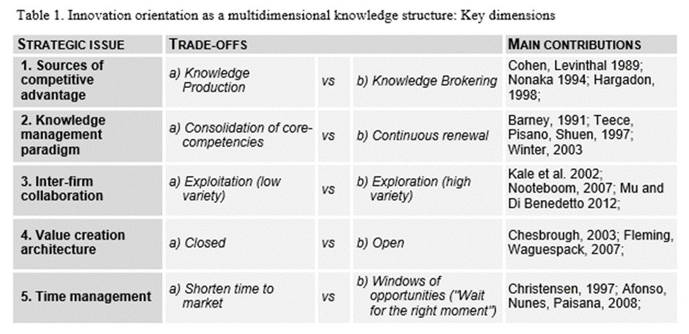
This research settings support robustness checks over the empirical analysis. We test the reliability of findings through the assessment of the impact of the emerging strategic types on value creation architecture and on managerial processes (Leonardbarton, 1992, Onetti et al., 2010): if emerging innovation orientations are significantly different, then even the configurations in terms of value chains and managerial practices will be divergent. We also take into account data about firm profile and reference industries as control variables.

Exploring the diversity among innovation orientations: Key dimensions

Sources of Competitive Advantage (1)
Mainstream literature in the field stresses the need for new knowledge as a source of innovation (Hessels and van Lente, 2008, Nonaka, 1994, Harabi, 1995). Investments in R&D and protection of intellectual property are some of the most frequently cited topics (Harabi, 1995). Organizations leverage on rare, inimitable and non-tradable assets which create strategic rents as well as barriers against imitation (Barney, 1991). In recent years, many studies highlight alternative paradigms, such as 'knowledge brokering' (Hargadon, 1998, Kim et al., 2011, Ramos et al., 2009, Silva and Ramos, 2011): here, the strategic focus shifts to creative combinations among dispersed pieces of knowledge provided by independent agents at the global level. Internal development of knowledge is no longer a priority. Hence, value is no longer embedded into a handful of distinct elements, but is rather created at the system level. This archetype has recently gained importance thanks to the increased global interconnection among people, places and opportunities (Oliver et al., 2008). Organizations systematically operate in multiple markets and exploit technologies by applying extant knowledge in domains where such knowledge is unknown. The aim is to find - at the global level - the emerging players with the right knowledge base to solve a specific problem or to exploit opportunities.
The focus on 'internal development' vs 'external brokering' of knowledge is the first key dimension considered by our study.

Knowledge Management paradigm (2)
The Resource-Based View posits the consolidation of intangible assets and core-competences is a crucial issue for innovation (Barney, 1991, Martin, 2012, Stieglitz and Heine, 2007, Camelo-Ordaz et al., 2003). When facing emerging knowledge and environmental uncertainty, organizations may follow three strategies: anticipate the market, proactively integrate the novelty in their structure, or follow their existing strategy and react in later stages (Teixeira and Werther, 2013). Intangible resources and complementarities protect against imitation and generate strategic rents. A partially different view emphasizes the need for dynamic capabilities (Teece et al., 1997, Villar et al., 2014). Dynamic capabilities represent the ability to continuously renew the firm’s own competences to cope with a changing environment. They represent something more than the usual evolution of the firm: dynamic capabilities put discontinuities in the organizational life cycle, forcing firms to pursue continuous renewal of their sources of competitive advantage (Teixeira and Werther, 2013). Some authors suggest that a 'dynamic' capability is a contradiction in terms: continuous renewal creates the risk of dissolving core ideas and the strength of capability building (Schreyogg and Kliesch-Eberl, 2007). Renewal weakens the potential of core-competencies as a driver of sustainable and inimitable competitive advantage according to resource-based view. This dichotomy - consolidation versus renewal - reflects the distinction between Ricardian rents and Schumpeterian rents. The former are based on inimitable resources and exploitation of intellectual property, while the latter are grounded on novelty and first-mover advantage (Teece et al., 1997). These approaches represent the second key dimension of our study.

Inter-firm Networking and Strategic alliances (3)
The relation between innovation and inter-firm networking is widely recognized in literature (Nooteboom et al., 2007, Kale et al., 2002, Powell et al., 1996, McGuire et al., 1988). This survey takes into account diverse types of inter-firm cooperation instead of the extent by which the company collaborates with external agents – i.e. customers and suppliers (Lii and Kuo, 2016). Hence, we put forward a distinction between networks for exploration and networks for exploitation (Nooteboom et al., 2007) as a third key dimension. The distinction allows to identify the role of inter-firm collaboration in the innovation process. Exploration networks leverage on weak ties and diversity of cognitive schemes among partners in order to stimulate disruptive value propositions or to discover latent opportunities (Chen et al., 2013). Conversely, companies in exploitation networks develop few strong ties to increase the absorptive capacity of each partner, thus improving both implementation of innovations and consolidation of shared knowledge bases.

Openness of Supply Chain and Value Creation Architecture (4)
Chesbrough (2003) introduced the notion of 'open innovation' as a strategic orientation towards innovation. This paradigm is a step forward in the field of inter-firm collaboration for innovation. The focus goes on the maximization of the benefit generated through inward and/or outward flows of knowledge (openness of the value creation architecture). In the early phases of the innovation process, the open company introduces a significant base of knowledge from outside to feed the pipeline of innovative projects. In later stages, the company accepts knowledge spillovers and develops technology commercialization mechanisms if these activities assure some returns. This view argues that value creation architecture has to be as open as possible in order to seek complementarities and intersections with external opportunities (Terwiesch and Xu, 2008). By contrast, strategies based on closed architectures assume control of the entire innovation process: if the company has developed a new product, then the same organization must be engaged in its commercialization. Firm’s degree of openness – closed versus open - is the fourth dimension we use to investigate the innovation orientation.

Time Management (5)
A short 'time to market' exploits innovation potential as a whole. Shortening the marketing time frame allows companies to achieve 'first-mover advantage', allowing to anticipate competitors and to feed the reputation as innovator / trend setter (Datar et al., 1997, Afonso et al., 2008, Laforet, 2008). Dedicated routines, tacit knowledge and superior capabilities are fundamental to achieve this goal (Blazevic et al., 2003). However, literature also shows alternative views. Consider the so called 'overshooting effect' (Christensen, 1997): technological evolution and need of consumers follow two separate pathways, with different growth rates. Thus, they are aligned only for a short extent of time: before this period, the technology is inadequate, whilst after the level of technology is beyond expectations and the market looks for the easiest or lowest-cost solution. This phenomenon generates windows of opportunities, which enhance earnings from innovation. In other words, sometimes 'waiting for the right moment' is better than 'shorten the time to market as much as possible' (Tyre and Orlikowski, 1994, Langerak et al., 2008). Absorptive capacity and firm’s knowledge portfolio are crucial to find and exploit these opportunities (Christensen, 1997, Fornahl et al., 2012). The fifth key dimension of our study relies on this trade-off.

Effects of the innovation orientation on value creation architecture and supply chain
We expect that innovation orientation - described by the five dimensions above discussed - impacts firms’ choices in terms of value creation architecture (Jacobides et al., 2006, Burke et al., 2007, Onetti et al., 2010). Strategic management literature deepens how firms create value and achieve a competitive advantage. Porter's value chain provides a framework to assess internal activities and core-competences. A more fine-grained comprehension of innovation processes should embrace both the whole supply chain and the value created outside of organizational boundaries (Gereffi et al., 2005), thus addressing the extent of firms’ strategic orientation towards supply chain integration and combinative capabilities (Lii and Kuo, 2016). Extended value chains tend to be fragmented into discrete pieces, each one governed through different options: internally controlled, outsourced to independent agents, or embedded into strategic alliances. Dietl, Royer and Stratmann (2009) explore the construct of 'Value Creation Architecture', meaning structure and relationships of all the value-adding activities carried out by various departments, agents and companies in order to deliver a product or service to market. The design of the value creation architecture implies strategic decisions about two dimensions (Amit and Schoemaker, 1993, Onetti et al., 2010):
- Focus: activities that absorb the main effort of the company. The business strategy leverages above all on these areas of competence;
- Modus: governance policies for each activity ('modus'). Three options are available: internally performed, outsourced, and co-managed with strategic partners.
These two dimensions - modus and focus - are expected to be consistent with the firm strategy and should differ accordingly to different innovation orientations.

Effects of innovation orientation on managerial processes

Execution processes play a fundamental role in putting strategic orientation into practice (Whitley, 1988, Bititci et al., 2011, O'Cass and Sok, 2013). Innovation-oriented firms differ from others in terms of managerial processes and knowledge management practices (Teece et al., 1997, Castanias and Helfat, 1991, Coombs and Hull, 1998). Extant literature does not provide a conventional terminology to this construct, since terms like managerial processes, managerial practices, organizational routines for managerial purposes are often used as substitutes. On the other hand, managerial cognition and practices are recognized as a critical dimension for the identification of each type of strategic orientation (Kahn et al., 2012, Childe et al., 1994). Firm success stems upon the capabilities - rooted in both operational and support activities - but it is only shaped by the form of the managerial processes, which determines the ability to develop and sustain firms’ competitive advantage in the long term.

In this context, processes for the management of inter-firm relationships - partner selection, contract negotiation, appraisal of alliance performance, and so on - are relevant, together with the governance of internal routines. The importance of network/alliance capabilities for innovation is well recognized in literature (Mu and Di Benedetto, 2012, Kale et al., 2002).

METHODOLOGY
We developed an exploratory analysis to outline different innovation orientation models at the firm level. Data collection has been performed in 2010 through a structured questionnaire consisting of four sections: firm profile, innovation orientation, value creation architecture, managerial processes. The profiling of strategic orientations considers the five dimensions above discussed (see table 1). Five pairs of statements have been presented to participating companies by applying the principles of semantic theories (Katz and Jerry, 1963).

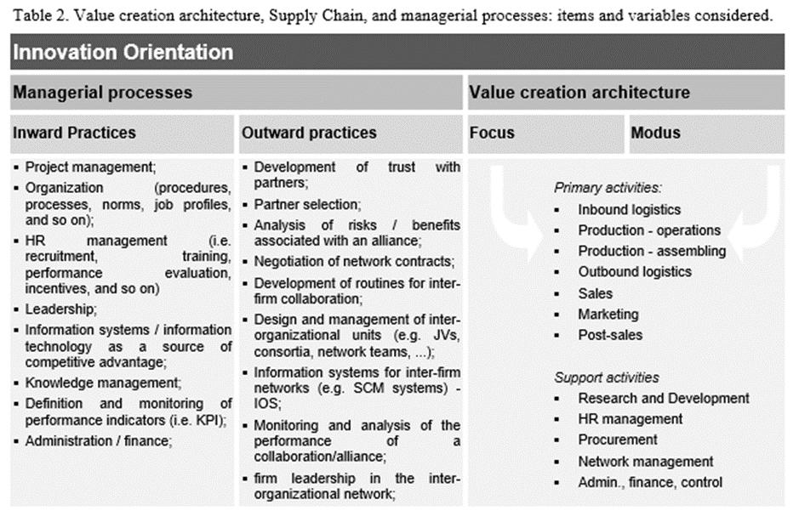
Respondents were asked to choose which of the two proposed options - briefly called "A" and "B" - better expressed the strategic orientation implemented by the company. According to the theoretical framework, the impact of the innovation orientation has been analyzed considering the configuration of 'value creation architecture' and by surveying key 'managerial processes' of respondent companies. A list of firm activities and managerial practices has been designed according to the extant literature (Kahn et al., 2012, Childe et al., 1994) and validated through a focus group with firm executives. Activities of value creation architecture refer to organizational competences. Managerial processes relate to best practices sorted at the individual level. Table 2 shows all items reported in the questionnaire. We introduced control variables to ensure the consistency of findings, viz.: firm size, age, turnover, industry. Figure 1 summarizes the entire research model.
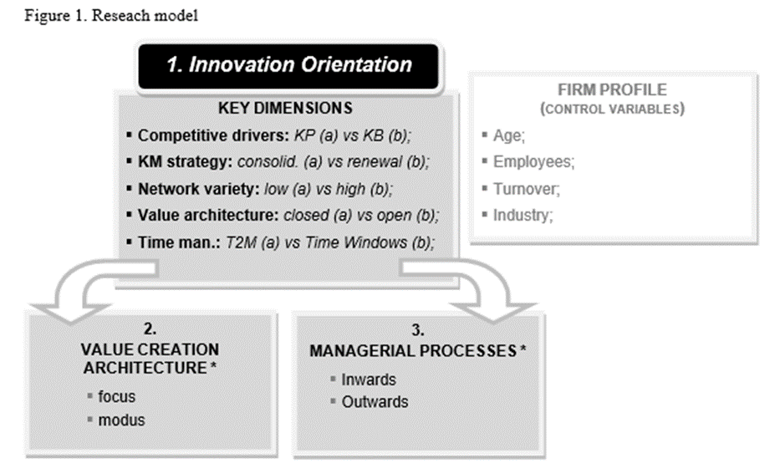

Context and Sample
The survey was performed in the Italian context. Italian market represents a fruitful field of research according to the goal of our study for multiple reasons. First, entrepreneurship, creativity and innovation are well rooted in the business culture of the country. Secondly, the fierce crisis that began in 2008 has dramatically increased the gap among high potential ventures and stagnant companies, as well as among innovative and non-innovative firms, highlighting a more clear-cut the difference between strategic orientations based on disruptive value propositions and conservative behaviors. On the other hand, Italian economy presents a significant heterogeneity in terms of industries, firm size, corporate strategies and performance (Giannakourou, 2005). This aspect is crucial to run a reliable cluster analysis (Girish and Stewart, 1983). In light of this context, a single country study is acceptable.
Official checklists about the most innovative companies in Italy are not available. We used Lexis-Nexis database, carrying out multiple rounds of search using keywords related to innovation in order to identify a balanced sample of 1,000 firms declaring an innovation orientation according to the mission/vision. Prior surveys adopted the same method (Chesbrough and Crowther, 2006, Chiaroni et al., 2011). In addition, we also introduced a limited number of foreign firms as control group.
We received responses from 168 firms, leaving a response rate of 16.8%. The rate is acceptable (Harzing, 2000) and comparable to other studies (Gatignon and Xuereb, 1997, Frambach et al., 2003). Prior surveys about strategic orientations showed similar samples in terms of observations (Wright et al., 1995, Salomo et al., 2008, Acworth, 2008, Mu and Di Benedetto, 2012, Mu and Di Benedetto, 2011). Armstrong and Overton’s (1977) procedure of comparing early versus late respondents was developed to assess non-response bias.
Figure 2, 3 and 4 describe the sample in terms of firm size (number of employees), firm's age and industrial specialization. Specifically, 28% of companies’ headquarters are located inside clusters, such as industrial districts or technology and science parks.

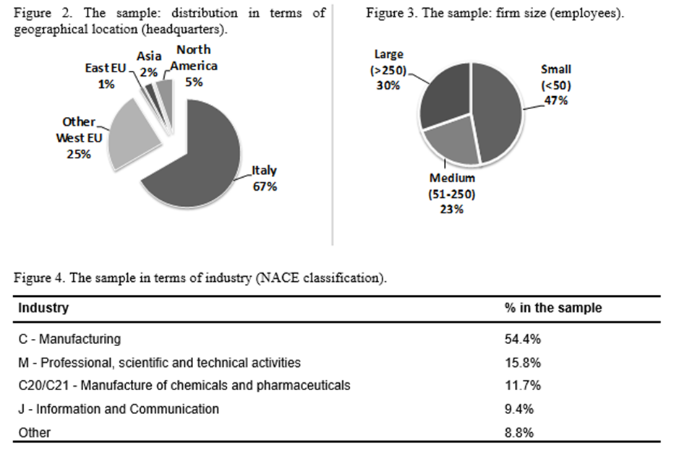

Cluster analysis
Cluster analysis is a consistent method for empirical analysis regarding strategic orientations. The method was adopted in prior research (Girish and Stewart, 1983, Hagen et al., 2012, Srholec and Verspagen, 2012).

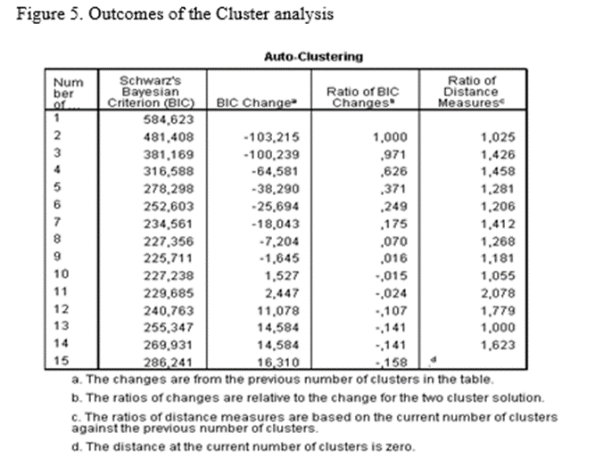

Clustering concerns the five variables about innovation orientation (section 1 in figure 1). We performed a three-stage analytical procedure: first, we ran a hierarchical cluster analysis based on Ward's measure of distance to identify the number of clusters. This step suggested that '4' is the optimal number of clusters. The Schwarz's Bayesian Criterion validates this output.
In the second stage, we used the K-Means method to assign observations to clusters. To do so, we performed multiple runs using different order of cases to obtain a reliable solution. In order to assess the stability of the cluster solution, we also cross-validated the cluster assignments using the procedure suggested by Cannon (1992).
Finally, in the third stage, we investigated the variance of the variables which were initially excluded from the clustering procedures (external validation), i.e. the ones describing key managerial processes and value creation architecture.
The outcome of the procedure confirms that some recurrent strategic orientations exist. Specifically, we identified four managerial patterns. The procedure is accepted in literature and used in other managerial studies (Stock and Zacharias, 2011, Denicolai et al., 2010, Yang et al., 2012).

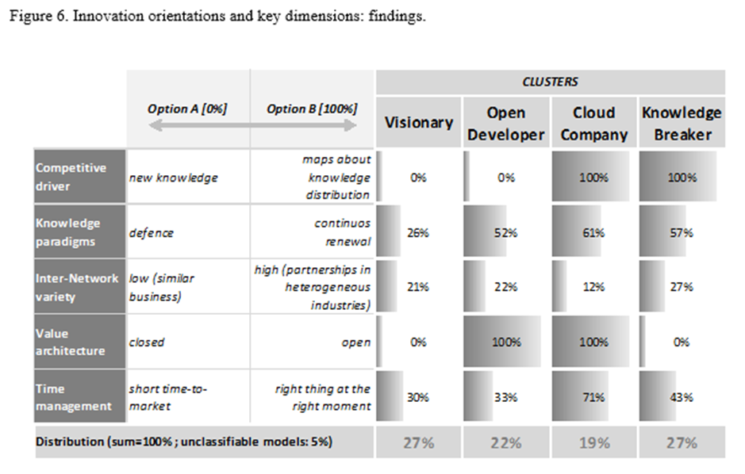

FINDINGS: CLUSTER PROFILES

Figure 6 outlines strategic profiles of clusters in terms of firm orientation towards the options 'A' or 'B' (see table 2). We assigned four labels to them - 'Visionary', 'Open developer', 'Cloud Company', and 'Knowledge Broker' – to highlight the peculiarities of each cluster and facilitate the discussion. Two variables - out of five - are more relevant than others: 'Competitive Driver' and 'Openness Degree of the Value Creation Architecture'. The remaining three variables - 'Knowledge management paradigm', 'Inter-firm variety' and 'Time management' – have a more limited impact.

The first two clusters rely on the development of new knowledge as a key driver for innovation. They differ in terms of openness of the strategic architecture. 'Visionary' companies leverage on closed architecture: such firms prioritize IP protection and tend to avoid knowledge spillovers. Companies that rely on internal R&D activities and on the continuous development and control of knowledge belong to this cluster. They imagine their strategic positioning in the upcoming future, aspiring to create new markets/needs and thinking that the 'do-it-alone' is the best way to achieve such goal. This innovation orientation is frequent in industries where patents and other forms of intellectual property protection are diffused, although they may be present in every sector. Consider the case of the Italian company "Riso Scotti" in the food and beverage industry. They produce and sell a commodity product like rice, but they constantly enrich their product portfolio, introducing innovative foods every year. For instance, they introduced a line of rice-based vegetable drinks, in an attempt to to offer a valid alternative to dairy- and soya-based drinks in a world which is more and more attracted by healthy lifestyle and natural ingredients. The campaign has been a great success, increasing from 196.000 litres sold in 2012 to more than 4 million litres in 2016.

Conversely, 'Open developer' represents a variation to the well-known open innovation model (Chesbrough, 2003). It develops knowledge through joint initiatives and co-R&D projects. The Oil & Gas Company ENI is a good example of such an innovation orientation. After decades of focus on internal R&D activities, in 2006 the company started a strategic repositioning maneuver, and now ENI is known as a great example of open innovation, which is also simultaneously grounded on some key internally-developed and controlled knowledge assets. Company reports state that "to achieve true technological breakthroughs the main keys are the interaction between internal and external research and cross fertilization among different scientific disciplines". For instance, cross-fertilization among physics, organic and inorganic chemistry, optics and electronic engineering was fundamental to the development of the first solar cells that use organic materials synthesized by ENI.

The third and fourth orientation dimensions are two variations of the knowledge broker class. They leverage on inter-firm ties, although in a different manner. The difference with the two abovementioned models is remarkable: each knowledge base is per se replaceable since the competitive advantage is at the systemic level (Ulrich, 1995, Sanchez and Mahoney, 1996). These firms operate as innovation intermediaries, by enabling links between customers' need and market opportunities through creative architectures (Hargadon, 1998, Jenkin et al., 2013). We list two variations of such strategic mindset. The 'Knowledge Broker' approach uses scouting techniques to connect pieces of knowledge dispersed in different domains, although it adopts a rather closed approach to innovation. The innovation process is governed internally (through a closed architecture). This approach breaks cognitive schemes within static domains and turns on innovative projects by introducing outside knowledge bases into contexts where they are unknown. ‘Alessi’ is an interesting case for this kind of innovation orientation. The company produces household goods, but it sees itself as an ‘Italian Design Lab’ more than a manufacturing company. Industrial design and creativity of its products are recognized as the core-competences of Alessi. However, Alessi employees about 330 people and none of them are designers: Alessi operates as a knowledge broker among a wide network of independent designers at the worldwide level, looking for the best idea which fits with promising market trends. Notably, this is not a pure case of open innovation. Alessi orchestrates its network trying to mitigate knowledge sharing among partners, to control the process as much they can, to make ‘the Alessi touch’ highly recognizable and capture a significant portion of created value. The organizational structure, routines and execution processes are continuously designed and renewed to support this orientation.

Finally, a metaphor inspires the fourth orientation, named 'Cloud Company'. In its original meaning, cloud computing is a global infrastructure where shared assets, such as facilities or software, represent available building blocks that are used by different digital devices as utility services - like an electricity grid - through web-based platforms. The 'Cloud Company' moves this technological paradigm at the strategic level and develops a global architecture where dispersed pieces of knowledge - as well as other firm resources - are used as building blocks into different inter-firm projects. The network of ties feeds the internal pipeline of innovative projects by introducing externally generated knowledge (inflows). At the same time, knowledge spill-overs (outflows) are also acceptable if they generate earnings. According to this orientation, key elements for innovation are available in the "cloud", meaning they are provided by the network of partners/suppliers. Accenture in our sample – similarly to other consultancy company – is an inspiring example for this innovation orientation. This global management consulting firm is a knowledgeable implementer of emerging technologies, which are identified through continuous scouting and thanks to several partnership relationships with key agents. This advanced form of brokerage and open innovation supports clients in the selection and implementation of IT solutions provided by independent suppliers. The company generates value through finding and integrating the right technologies and knowledge bases to cope with complex problems expressed by the client.

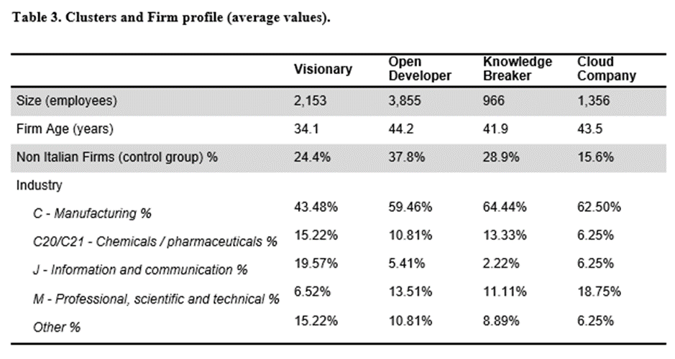

Table 3 shows the firm profile of each cluster. Companies showing a relevant R&D activity - 'Visionary' and 'Open Developer' - are large-sized organizations. 'Visionary' firms are widespread in IT industries, where Intellectual Property protection and continuous development of new technologies are crucial. 'Cloud Companies' are common - above all - within knowledge intensive services and complex domains. However, overall findings show that firm profile is a secondary dimension for cluster profiling. Evidence suggests that these clusters represent strategic postures, rather than stages in the firm lifecycle or business-specific effects. Further evidence is needed to confirm this assumption.

Diverse value creation architectures

Findings confirm that innovation orientation affects the configuration of value creation architecture. Table 4 shows the strategic focus of each orientation. Values indicate the percentage of firms which have selected the activity as a core-competence. R&D is fundamental for closed architectures such as 'Visionary' and 'Knowledge Broker' clusters. Open approaches are more diversified in terms of key activities. Components assembling, governance of the value chain at the global level and customer service are crucial aspects for the 'Cloud Company'. This evidence is consistent with its orientation, based on achieving competitive advantage at the systemic level. The 'Open Developer' approach, conversely, has a broader strategic focus.

Table 5 explores the way in which firms conceive boundaries of the value creation architecture (modus). The main difference is between 'Open Developers' and 'Cloud Companies', thus supporting that 'open innovation' is a broader construct, which encloses different sub-orientations. 'Open developer' has a lower outsourcing intensity compared to other clusters, but it considers core-competencies as activities which may be externalized, based on make-or-buy choices. This form of strategic outsourcing is recognized in literature (Quinn and Hilmer, 1994).

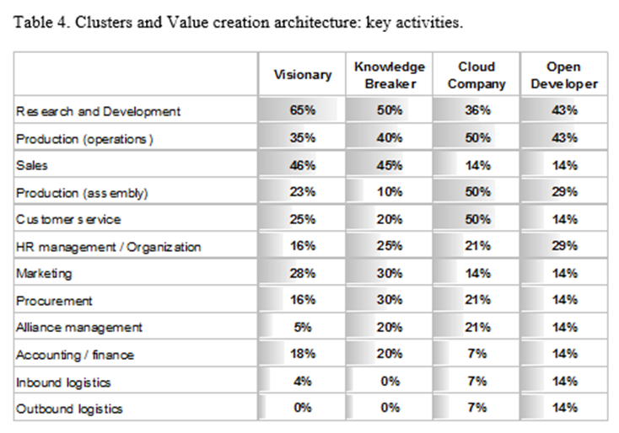

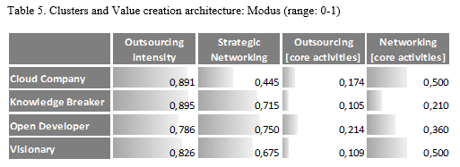

The 'Cloud Company' prefers creating numerous weak ties than over a few strategic alliances. Thus, it supports the firm’s adaptation to a complex, dynamic, and highly interconnected scenario. Cloud companies show superior abilities in incorporating multiple technologies into new products, co-creating products and services with customers and partners, and exploiting scientific and technical knowledge in different sectors (Quinn and Hilmer, 1994).

'Knowledge broker' companies have a good attitude for both outsourcing and creating strategic alliances, but mostly regarding their non-core activities. According to Rost (2011), this orientation shows that, in the presence of strong ties, weak and wide networks leverage on the strength of strong ties in stimulating innovation.

Inter-firm relationships - especially strategic alliances - are also relevant for the 'Visionary Company'. Briefly, findings confirm that the development of ties with independent agents stimulates innovation (Nooteboom et al., 2007, Kale et al., 2002, Powell et al., 1996). This evidence is consistent across the four clusters.

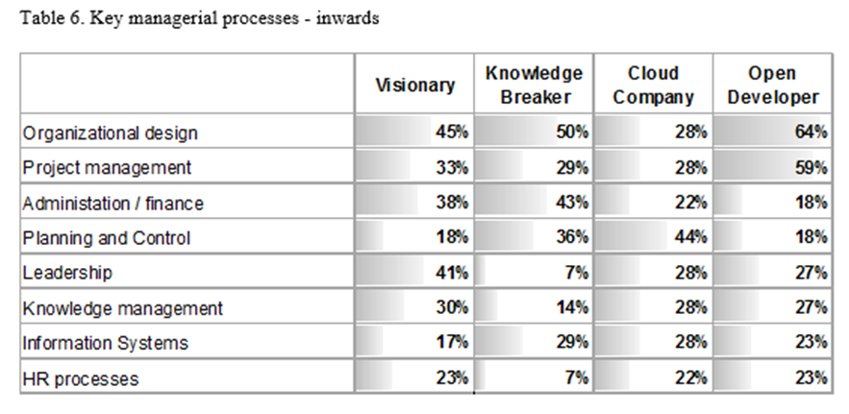

Managerial processes

Innovation orientation also affects managerial processes. Table 6 summarizes inward practices, while table 7 focuses on outward ones. The key ability for 'Visionary' orientation is leadership: it generates consensus towards breakthrough innovations (Kim and Mauborgne, 2004). At the inter-firm level, negotiation of formal contracts with external partners is fundamental. The evidence is consistent with this orientation, which aims at avoiding knowledge spillovers (Thum, 1994).

The 'Knowledge Broker' shows a dual approach: formal governance for internal processes - like administration, finance, IT - and, simultaneously, social mechanisms for the management of inter-firm ties: trust development, inter-organizational leadership and reputation. We believe this is an intriguing finding, still poorly discussed in literature. Indeed, scholars tend to focus on internal dynamics or on inter-firm relationships. This study contributes to the debate by considering both dimensions, suggesting that inter-firm social ties may be coupled with an emphasis on formal procedures within the firm boundaries.

Critical processes in case of 'Open Developers' are the following: organizational design, project management and the development of inter-organizational units (e.g. network teams). The view is consistent with so called 'project-based organizations' (Sydow et al., 2004). These organizations create temporary knowledge system units in order to achieve complex objectives, by mobilizing resources according to the specific needs, instead of referring to general-purpose routines.

The managerial intelligence of the 'Cloud Company' concerns above all the governance of a plethora of interfirm ties. In particular, inter-firm routines foster the inter-organizational competitive advantage through relation-specific assets and knowledge-sharing processes (Dyer and Singh, 1998). Efficient partner selection mitigates the risk of opportunistic behaviors of allies, thus opening up the value architecture (Li et al., 2008).

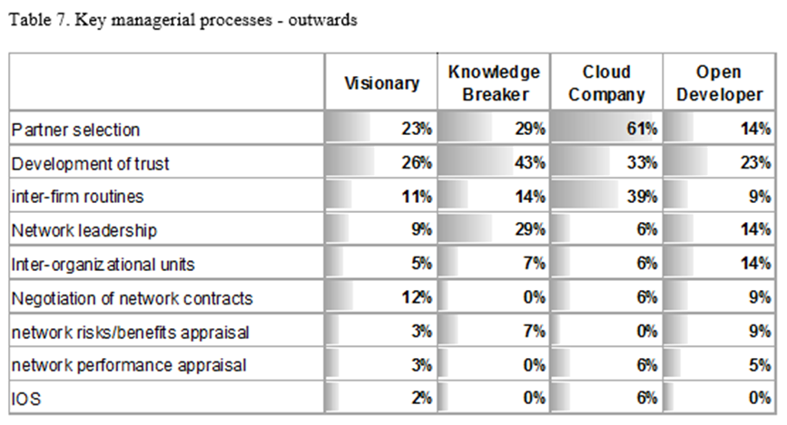

DISCUSSION AND CONCLUSIONS
Innovation is one of the types of strategic orientation. Academic literature still considers it as a relatively homogeneous class, even though innovation has become a top priority for a large number of companies in every sector: it is highly unlikely that all these companies are sharing the same strategy. Moreover, scholars argued that innovation has not been clearly defined under a knowledge perspective (Quintane et al., 2011). This study sheds a new light on this argument and rejects the idea that innovation orientation is a 'monolithic' managerial pattern. Our findings show that innovation is rather a class of different orientations, highly different from each other. These postures are strategic in nature since they influence managerial choices cut across industries and firm profiles. Innovation-oriented firms significantly diverge in terms of strategic mindset, value creation architecture, resource allocation priorities, outsourcing and alliance policies and in the development of capabilities and managerial processes.

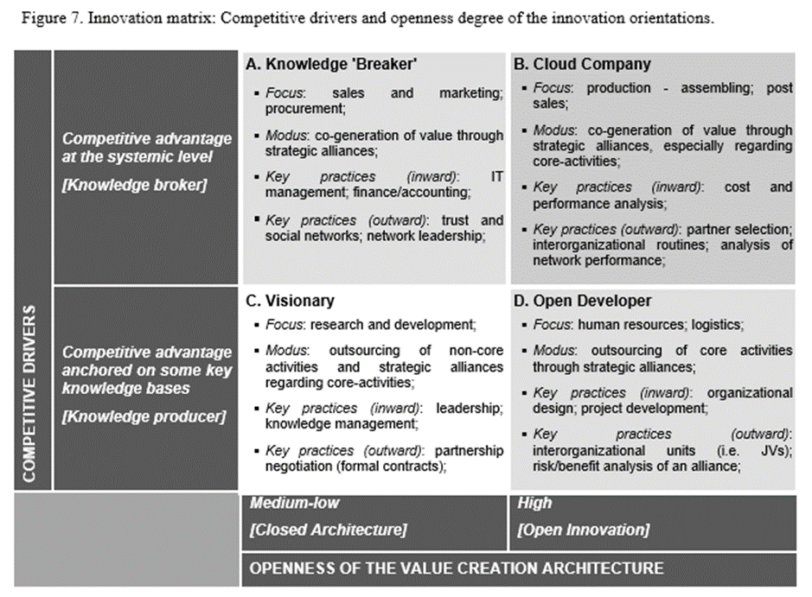

Our study highlights four strategic orientations for innovation. Figure 7 summarizes their features. This taxonomy is a step forward in the field, since it differentiates among strategic types regardless of the degree of innovation (intensity) and independently from the sector, meaning that all four may appear in every industry. In addition, the proposed models stem from the innovation management framework instead of being composite patterns among other strategic orientations. Some of these clusters refer to paradigms already discussed in literature, namely the so called Open Innovation (Chesbrough, 2003) and Knowledge Brokering (Hargadon, 1998). Finally, we also highlight new paradigms currently overlooked by extant literature.
From a theoretical point of view, the implications are twofold. First, the identification of different strategies for innovation calls for further research aimed at investigating optimal conditions in which managerial choices lead to superior performance. Secondly, the modelling of strategic orientations for innovation clarifies analogies and differences among open innovation, knowledge brokering and other forms of inter-firm collaborations, since the boundaries of these constructs were controversial. This study contributes to the literature debate, for it reveals two kinds of open innovators and two kinds of knowledge brokers, highlighting an overlap in the case of the 'Cloud Company'. Openness degree and competitive drivers have emerged as independent dimensions: we noticed cases of 'Open Innovation', with firms engaged in continuous development of new knowledge ('Open Developer'), as well as - at the opposite (see figure 7) - 'Knowledge Brokers' showing a closed value architecture ('Knowledge Broker'). Briefly, Open innovation and Knowledge brokering reflect different strategic orientations, although they may coexist. As such, we highlight three strategic options (A, B and D in figure 7). The fourth innovation orientation - ‘Visionary’ (C) - is rather different from the other three, since it is based on a closed architecture.
From a managerial perspective, this study has several implications for decision makers. The four clusters describe systems of internal consistency that support managers in the appraisal and design of interactions and complementarities among strategic dimensions (Porter and Siggelkow, 2008, Jayaram and Malhotra, 2010), namely: corporate culture, value creation architecture and managerial processes. This, in turn, makes the competitive advantage more focused, unique and sustainable.
Due to its exploratory nature, the study has some limitations. The limited number of observations does not allow for generalization of findings, while the geographical distribution of firms could generate country-specific bias. The survey does not consider firm performance and the contingent factors which lead to success the four orientations. However, this study offers promising insights, setting directions for further research.

REFERENCES
ACWORTH, E. B. 2008. University-industry engagement: The formation of the Knowledge Integration Community (KIC) model at the Cambridge-MIT Institute. Research Policy, 37, 1241-1254.
AFONSO, P., NUNES, M., PAISANA, A. & BRAGA, A. 2008. The influence of time-to-market and target costing in the new product development success. International Journal of Production Economics, 115, 559-568.
ALEGRE, J. & CHIVA, R. 2013. Linking Entrepreneurial Orientation and Firm Performance: The Role of Organizational Learning Capability and Innovation Performance. Journal of Small Business Management, 51, 491-507.
AMABILE, T. M. 1997. Motivating Creativity in Organizations: On Doing What You Love and Loving What You Do. California Management Review 40, 1: 39–58
AMIT, R. & SCHOEMAKER, P. J. H. 1993. STRATEGIC ASSETS AND ORGANIZATIONAL RENT. Strategic Management Journal, 14, 33-46.
ARCHIBUGI, D. 2001. Pavitt’s taxonomy sixteen years on: a review article. Economic Innovation and New Technology, 10, 415–425.
ARMSTRONG, J. S. A. T. S. O. 1977. Estimating Nonresponse Bias in Mail Surveys, Journal of Marketing Research, 14 (May), 396.
BADER, K. & ENKEL, E. 2014. Understanding a firm's choice for openness: strategy as determinant. International Journal of Technology Management, 66, 156-182.
BARNEY, J. 1991. Firm Resources and sustained competitive advantage. Journal of Management, 17, 99-120.
BERTHON, P., HULBERT, J. M. & PITT, L. F. 1999. To serve or create? Strategic orientations toward customers and innovation. California Management Review, 42, 37-+.
BITITCI, U. S., ACKERMANN, F., ATES, A., DAVIES, J., GARENGO, P., GIBB, S., MACBRYDE, J., MACKAY, D., MAGUIRE, C., VAN DER MEER, R., SHAFTI, F., BOURNE, M. & FIRAT, S. U. 2011. Managerial processes: business process that sustain performance. International Journal of Operations & Production Management, 31, 851-887.
BLAZEVIC, V., LIEVENS, A. & KLEIN, E. 2003. Antecedents of project learning and time-to-market during new mobile service development. International Journal of Service Industry Management, 14, 120-147.
BROWNLIE, D. T. 1987. The strategic management of technology - a new wave of market-led pragmatism or a return to product orientation. European Journal of Marketing, 21, 45-65.
BURKE, G. J., CARRILLO, J. E. & VAKHARIA, A. J. 2007. Single versus multiple supplier sourcing strategies. European Journal of Operational Research, 182, 95-112.
CAMELO-ORDAZ, C., MARTIN-ALCAZAR, F. & VALLE-CABRERA, R. 2003. Intangible resources and strategic orientation of companies - An analysis in the Spanish context. Journal of Business Research, 56, 95-103.
CANNON, T. 1992. Basic marketing: principles and practice, London, Cassel.
CASTANIAS, R. P. & HELFAT, C. E. 1991. MANAGERIAL RESOURCES AND RENTS. Journal of Management, 17, 155-171.
CHEN, Y. M., YANG, D. H. & LIN, F. J. 2013. Does technological diversification matter to firm performance? The moderating role of organizational slack. Journal of Business Research, 66, 1970-1975.
CHESBROUGH, H. & CROWTHER, A. K. 2006. Beyond high tech: early adopters of open innovation in other industries. R & D Management, 36, 229-236.
CHESBROUGH, H. W. 2003. The era of open innovation. Mit Sloan Management Review, 44, 35-41.
CHIARONI, D., CHIESA, V. & FRATTINI, F. 2011. The Open Innovation Journey: How firms dynamically implement the emerging innovation management paradigm. Technovation, 31, 34-43.
CHILDE, S. J., MAULL, R. S. & BENNETT, J. 1994. Frameworks for understanding business process reengineering. International Journal of Operations & Production Management, 14, 22-34.
CHOU, C. & YANG, K.-P. 2011. The interaction effect of strategic orientations on new product performance in the high-tech industry: A nonlinear model. Technological Forecasting and Social Change, 78, 63-74.
CHRISTENSEN, C. 1997. The Innovator’s Dilemma: When New Technologies Cause Great Firms to Fail, Boston, Harvard Business School Press.
COOMBS, R. & HULL, R. 1998. 'Knowledge management practices' and path-dependency in innovation. Research Policy, 27, 237-253.
DATAR, S., JORDAN, C., KEKRE, S., RAJIV, S. & SRINIVASAN, K. 1997. New product development structures and time-to-market. Management Science, 43, 452-464.
DE JONG, J. P. J. & MARSILI, O. 2006. The fruit flies of innovations: A taxonomy of innovative small firms. Research Policy, 35, 213-229.
DENICOLAI, S., CIOCCARELLI, G. & ZUCCHELLA, A. 2010. Resource-based local development and networked core-competencies for tourism excellence. Tourism Management, 31, 260-266.
DENICOLAI, S., RAMIREZ, M. & TIDD, J. 2016. Overcoming the false dichotomy between internal R&D and external knowledge acquisition: Absorptive capacity dynamics over time. Technological Forecasting and Social Change, 104, 57-65.
DHEWANTO, W. & SOHAL, A. S. 2015. The relationship between organisational orientation and research and development/technology commercialisation performance. R & D Management, 45, 339-360.
DIETL, H., ROYER, S. & STRATMANN, U. 2009. Value Creation Architectures and Competitive Advantage: Lessons From the European Automobile Industry. California Management Review, 51, 24-+.
DRUCKER, P. F. 1985. THE DISCIPLINE OF INNOVATION. Harvard Business Review, 63, 67-72.
DYER, J. H. & SINGH, H. 1998. The relational view: Cooperative strategy and sources of interorganizational competitive advantage. Academy of Management Review, 23, 660-679.
EISENHARDT, K. M. & MARTIN, J. A. 2000. Dynamic capabilities: What are they? Strategic Management Journal, 21, 1105-1121.
FERNANDEZ-MESA, A. & ALEGRE, J. 2015. Entrepreneurial orientation and export intensity: Examining the interplay of organizational learning and innovation. International Business Review, 24, 148-156.
FERRARESI, A. A., QUANDT, C. O., DOS SANTOS, S. A. & FREGA, J. R. 2012. Knowledge management and strategic orientation: leveraging innovativeness and performance. Journal of Knowledge Management, 16, 688-701.
FIDEL, P., SCHLESINGER, W. & CERVERA, A. 2015. Collaborating to innovate: Effects on customer knowledge management and performance. Journal of Business Research, 68, 1426-1428.
FORNAHL, D., HASSINK, R., KLAERDING, C., MOSSIG, I. & SCHRODER, H. 2012. From the Old Path of Shipbuilding onto the New Path of Offshore Wind Energy? The Case of Northern Germany. European Planning Studies, 20, 835-855.
FRAMBACH, R. T., PRABHU, J. & VERHALLEN, T. M. M. 2003. The influence of business strategy on new product activity: The role of market orientation. International Journal of Research in Marketing, 20, 377-397.
FREEL, M. S. 2003. Sectoral patterns of small firm innovation, networking and proximity. Research Policy, 32, 751-770.
FREEMAN, C. 1974. The Economics of Industrial Innovation, Baltimore, MD, Penguin.
GALUNIC, D. C. & RODAN, S. 1998. Resource recombinations in the firm: Knowledge structures and the potential for Schumpeterian innovation. Strategic Management Journal, 19, 1193-1201.
GATIGNON, H. & XUEREB, J. M. 1997. Strategic orientation of the firm and new product performance. Journal of Marketing Research, 34, 77-90.
GEREFFI, G., HUMPHREY, J. & STURGEON, T. 2005. The governance of global value chains. Review of International Political Economy, 12, 78-104.
GIANNAKOUROU, G. 2005. Transforming spatial planning policy in Mediterranean countries: Europeanization and domestic change. European Planning Studies, 13, 319-331.
GIRISH, P. & STEWART, D. W. 1983. Cluster Analysis in Marketing Research: Review and Suggestions for Applications. Journal of Marketing Research, 20 (May), 134-38.
HAGEN, B., ZUCCHELLA, A., CERCHIELLO, P. & DE GIOVANNI, N. 2012. International strategy and performance-Clustering strategic types of SMEs. International Business Review, 21, 369-382.
HAKALA, H. 2011. Strategic Orientations in Management Literature: Three Approaches to Understanding the Interaction between Market, Technology, Entrepreneurial and Learning Orientations. International Journal of Management Reviews, 13, 199-217.
HARABI, N. 1995. Appropriability of technical innovations - An empirical analysis. Research Policy, 24, 981-992.
HARGADON, A. B. 1998. Firms as knowledge brokers: Lessons in pursuing continuous innovation. California Management Review, 40, 209-+.
HARZING, A. W. 2000. Cross-national industrial mail surveys - Why do response rates differ between countries? Industrial Marketing Management, 29, 243-254.
HESSELS, L. K. & VAN LENTE, H. 2008. Re-thinking new knowledge production: A literature review and a research agenda. Research Policy, 37, 740-760.
HITT, M. A., DACIN, M. T., TYLER, B. B. & PARK, D. 1997. Understanding the differences in Korean and US executives' strategic orientations. Strategic Management Journal, 18, 159-167.
HONG, J., SONG, T. H. & YOO, S. 2012. Paths to Success: How Do Market Orientation and Entrepreneurship Orientation Produce New Product Success? . Journal of Product Innovation Management.
HURLEY, R. F. & HULT, G. T. M. 1998. Innovation, market orientation, and organizational learning: An integration and empirical examination. Journal of Marketing, 62, 42-54.
JACOBIDES, M. G., KNUDSEN, T. & AUGIER, M. 2006. Benefiting from innovation: Value creation, value appropriation and the role of industry architectures. Research Policy, 35, 1200-1221.
JAYARAM, J. & MALHOTRA, M. K. 2010. The Differential and Contingent Impact of Concurrency on New Product Development Project Performance: A Holistic Examination. Decision Sciences, 41, 147-196.
JENKIN, T. A., CHAN, Y. E., SKILLICORN, D. B. & ROGERS, K. W. 2013. Individual Exploration, Sensemaking, and Innovation: A Design for the Discovery of Novel Information. Decision Sciences, 44, 1021-1057.
JENSEN, M. B., JOHNSON, B., LORENZ, E. & LUNDVALL, B. A. 2007. Forms of knowledge and modes of innovation. Research Policy, 36, 680-693.
JEONG, I., PAE, J. H. & ZHOU, D. S. 2006. Antecedents and consequences of the strategic orientations in new product development: The case of Chinese manufacturers. Industrial Marketing Management, 35, 348-358.
KAHN, K. B., BARCZAK, G., NICHOLAS, J., LEDWITH, A. & PERKS, H. 2012. An Examination of New Product Development Best Practice. Journal of Product Innovation Management, 29, 180-192.
KALE, P., DYER, J. H. & SINGH, H. 2002. Alliance capability, stock market response, and long-term alliance success: The role of the alliance function. Strategic Management Journal, 23, 747-767.
KAMAL, E. M., YUSOF, N. & IRANMANESH, M. 2016. Innovation creation, innovation adoption, and firm characteristics in the construction industry. Journal of Science and Technology Policy Management, 7, 43-57.
KATSIKEAS, C. S., LEONIDOU, L. C. & MORGAN, N. A. 2000. Firm-level export performance assessment: Review, evaluation, and development. Journal of the Academy of Marketing Science, 28, 493-511.
KATZ, J. & JERRY, A. 1963. The Structure of a Semantic Theory. Language, 39.
KIM, S., SUH, E. & JUN, Y. 2011. Building a Knowledge Brokering System using social network analysis: a case study of the Korean financial industry. Expert Systems with Applications, 38, 14633-14649.
KIM, W. C. & MAUBORGNE, R. 2004. Blue ocean strategy. Harvard Business Review, 82, 76-+.
KOGUT, B. & ZANDER, U. 1992. Knowledge of the firm, combinative capabilities, and the replication of technology. Organization Science, 3, 383-397.
KOHLI, A. K. & JAWORSKI, B. J. 1990. Market Orientation - the Construct, Research Propositions, and Managerial Implications. Journal of Marketing, 54, 1-18.
KORTMANN, S. 2015. The Mediating Role of Strategic Orientations on the Relationship between Ambidexterity-Oriented Decisions and Innovative Ambidexterity. Journal of Product Innovation Management, 32, 666-684.
KOTLER, P. 2002. Torment your customers? Harvard Business Review, 80, 122-122.
LAFORET, S. 2008. Size, strategic, and market orientation affects on innovation. Journal of Business Research, 61, 753-764.
LANGERAK, F., HULTINK, E. J. & GRIFFIN, A. 2008. Exploring mediating and moderating influences on the links among cycle time, proficiency in entry timing, and new product profitability. Journal of Product Innovation Management, 25, 370-385.
LAU, C. M., YIU, D. W., YEUNG, P. K. & LU, Y. 2008. Strategic orientation of high-technology firms in a transitional economy. Journal of Business Research, 61, 765-777.
LENGNICKHALL, C. A. 1992. Innovation and competitive advantage - what we know and what we need to learn. Journal of Management, 18, 399-429.
LEONARDBARTON, D. 1992. Core capabilities and core rigidities - a paradox in managing new product development. Strategic Management Journal, 13, 111-125.
LI, D., CHAU, P. Y. K. & LAI, F. 2010. Market Orientation, Ownership Type, and E-Business Assimilation: Evidence from Chinese Firms. Decision Sciences, 41, 115-145.
LI, D., EDEN, L., HITT, M. A. & IRELAND, R. D. 2008. Friends, acquaintances, or strangers? Partner selection in R&D alliances. Academy of Management Journal, 51, 315-334.
LII, P. & KUO, F.-I. 2016. Innovation-oriented supply chain integration for combined competitiveness and firm performance. International Journal of Production Economics, 174, 142-155.
LUMPKIN, G. T. & DESS, G. G. 1996. Clarifying the entrepreneurial orientation construct and linking it to performance. Academy of Management Review, 21, 135-172.
MANION, M. T. & CHERION, J. 2009. Impact of Strategic Type on Success Measures for Product Development Projects. Journal of Product Innovation Management, 26, 71-85.
MANU, F. A. 1992. Innovation orientation, environment and performance - a comparison of united-states and european markets. Journal of International Business Studies, 23, 333-359.
MARTIN, B. R. 2012. The evolution of science policy and innovation studies. Research Policy, 41, 1219-1239.
MCGRATH, R. G., TSAI, M. H., VENKATARAMAN, S. & MACMILLAN, I. C. 1996. Innovation, competitive advantage and rent: A model and test. Management Science, 42, 389-403.
MCGUIRE, J. B., SUNDGREN, A. & SCHNEEWEIS, T. 1988. Corporate social-responsibility and firm financial performance. Academy of Management Journal, 31, 854-872.
MILLER, D. & FRIESEN, P. H. 1982. Innovation in conservative and entrepreneurial firms - 2 models of strategic momentum. Strategic Management Journal, 3, 1-25.
MOHR, J. J. & SARIN, S. 2009. Drucker's insights on market orientation and innovation: implications for emerging areas in high-technology marketing. Journal of the Academy of Marketing Science, 37, 85-96.
MORGAN, R. E. & STRONG, C. A. 2003. Business performance and dimensions of strategic orientation. Journal of Business Research, 56, 163-176.
MU, J. F. & DI BENEDETTO, A. 2012. Networking Capability and New Product Development. Ieee Transactions on Engineering Management, 59, 4-19.
MU, J. F. & DI BENEDETTO, C. A. 2011. Strategic orientations and new product commercialization: mediator, moderator, and interplay. R & D Management, 41, 337-359.
NARVER, J. C. & SLATER, S. F. 1990. The effect of a market orientation on business profitability. Journal of Marketing, 54, 20-35.
NOBLE, C. H., SINHA, R. K. & KUMAR, A. 2002. Market orientation and alternative strategic orientations: A longitudinal assessment of performance implications. Journal of Marketing, 66, 25-39.
NONAKA, I. 1994. A dynamic theory of organizational knowledge creation. Organization Science, 5, 14-37.
NOOTEBOOM, B., VAN HAVERBEKE, W., DUYSTERS, G., GILSING, V. & VAN DEN OORD, A. 2007. Optimal cognitive distance and absorptive capacity. Research Policy, 36, 1016-1034.
O'CASS, A. & SOK, P. 2013. Exploring innovation driven value creation in B2B service firms: The roles of the manager, employees, and customers in value creation. Journal of Business Research, 66, 1074-1084.
OLIVER, J. L. H., GARRIGOS, J. A. & PORTA, J. I. D. 2008. External ties and the reduction of knowledge asymmetries among clusters within global value chains: The case of the ceramic tile district of Castellon. European Planning Studies, 16, 507-520.
ONETTI, A., ZUCCHELLA, A., JONES, M. V. & MCDOUGALL-COVIN, P. 2010. Internationalization, Innovation and Entrepreneurship: Business Models for New Technology-based Firms. Journal of Management and Governance.
PASWAN, A., D'SOUZA, D. & ZOLFAGHARIAN, M. A. 2009. Toward a Contextually Anchored Service Innovation Typology. Decision Sciences, 40, 513-540.
PAVITT, K. 1984. SECTORAL PATTERNS OF TECHNICAL CHANGE - TOWARDS A TAXONOMY AND A THEORY. Research Policy, 13, 343-373.
PORTER, M. & SIGGELKOW, N. 2008. Contextuality within activity systems and sustainability of competitive advantage. Academy of Management Perspectives, 22, 34-56.
POWELL, W. W., KOPUT, K. W. & SMITHDOERR, L. 1996. Interorganizational collaboration and the locus of innovation: Networks of learning in biotechnology. Administrative Science Quarterly, 41, 116-145.
QUINN, J. B. & HILMER, F. G. 1994. Strategic Outsourcing. Sloan Management Review, 35, 43-55.
QUINTANE, E., CASSELMAN, R. M., REICHE, B. S. & NYLUND, P. A. 2011. Innovation as a knowledge-based outcome. Journal of Knowledge Management, 15, 928-947.
RAMOS, I., CARDOSO, M., CARVALHO, J. V. & GRACA, J. I. 2009. An Action Research on Open Knowledge and Technology Transfer. Information Systems - Creativity and Innovation in Small and Medium-Sized Enterprises, 301, 211-223.
ROST, K. 2011. The strength of strong ties in the creation of innovation. Research Policy, 40, 588-604.
SALOMO, S., TALKE, K. & STRECKER, N. 2008. Innovation field orientation and its effect on innovativeness and firm performance. Journal of Product Innovation Management, 25, 560-576.
SANCHEZ, R. & MAHONEY, J. T. 1996. Modularity, flexibility, and knowledge management in product and organization design. Strategic Management Journal, 17, 63-76.
SCHREYOGG, G. & KLIESCH-EBERL, M. 2007. How dynamic can organizational capabilities be? Towards a dual-process model of capability dynamization. Strategic Management Journal, 28, 913-933.
SIGUAW, J. A., SIMPSON, P. M. & ENZ, C. A. 2006. Conceptualizing innovation orientation: A framework for study and integration of innovation research. Journal of Product Innovation Management, 23, 556-574.
SILVA, C. & RAMOS, I. 2011. Knowledge Repository Framework for Crowdsourcing Innovation Intermediary: A Proposal. Enterprise Information Systems, Pt 1, 219, 371-379.
SPANJOL, J., MUEHLMEIER, S. & TOMCZAK, T. 2012. Strategic Orientation and Product Innovation: Exploring a Decompositional Approach. Journal of Product Innovation Management, 29, 967-985.
SRHOLEC, M. & VERSPAGEN, B. 2012. The Voyage of the Beagle into innovation: explorations on heterogeneity, selection, and sectors. Industrial and Corporate Change, 21, 1221-1253.
STIEGLITZ, N. & HEINE, K. 2007. Innovations and the role of complementarities in a strategic theory of the firm. Strategic Management Journal, 28, 1-15.
STOCK, R. M. & ZACHARIAS, N. A. 2011. Patterns and performance outcomes of innovation orientation. Journal of the Academy of Marketing Science, 39, 870-888.
SYDOW, J., LINDKVIST, L. & DEFILLIPPI, R. 2004. Project-based organizations, embeddedness and repositories of knowledge: Editorial. Organization Studies, 25, 1475-1489.
TEECE, D. J., PISANO, G. & SHUEN, A. 1997. Dynamic capabilities and strategic management. Strategic Management Journal, 18.
TEIXEIRA, E. D. O. & WERTHER, W. B., JR. 2013. Resilience: Continuous renewal of competitive advantages. Business Horizons, 56, 333-342.
TERWIESCH, C. & XU, Y. 2008. Innovation contests, open innovation, and multiagent problem solving. Management Science, 54, 1529-1543.
THUM, M. 1994. NETWORK EXTERNALITIES, TECHNOLOGICAL-PROGRESS, AND THE COMPETITION OF MARKET CONTRACTS. International Journal of Industrial Organization, 12, 269-289.
TIDD, J., BESSANT, J. & PAVITT, K. 2001. Managing Innovation, JohnWiley and Sons.
TYRE, M. J. & ORLIKOWSKI, W. J. 1994. Windows of opportunity - temporal patterns of technological adaptation in organizations. Organization Science, 5, 98-118.
ULRICH, K. 1995. The role of product architecture in the manufacturing firm. Research Policy, 24, 419-440.
VILLAR, C., ALEGRE, J. & PLA-BARBER, J. 2014. Exploring the role of knowledge management practices on exports: A dynamic capabilities view. International Business Review, 23, 38-44.
WHITLEY, R. 1988. The management sciences and managerial skills. Organization Studies, 9, 47-68.
WORREN, N., MOORE, K. & CARDONA, P. 2002. Modularity, strategic flexibility, and firm performance: a study of the home appliance industry. Strategic Management. Journal, 23: 1123–1140.
WRIGHT, P., KROLL, M., PRAY, B. & LADO, A. 1995. Strategic orientations, competitive advantage, and business performance. Journal of Business Research, 33, 143-151.
YANG, Y., WANG, Q., ZHU, H. Y. & WU, G. S. 2012. What Are the Effective Strategic Orientations for New Product Success under Different Environments? An Empirical Study of Chinese Businesses. Journal of Product Innovation Management, 29, 166-179.
ZHOU, K. Z. & LI, C. B. 2010. How strategic orientations influence the building of dynamic capability in emerging economies. Journal of Business Research, 63, 224-231.
ZHOU, K. Z., GAO, G. Y., YANG, Z. L. & ZHOU, N. 2005. Developing strategic orientation in China: antecedents and consequences of market and innovation orientations. Journal of Business Research, 58, 1049-1058.

Source: Organization for Economic Co-operation and Development (OECD), 2011.
See RIIR Report 2010.
Some authors consider also the localization of activities composing the value creation architecture (Onetti, Zucchella, Jones, McDougall, 2010). According to aims and theoretical framework, our study focuses solely on the 'focus' and 'modus' dimensions.
An overview about entrepreneurship and innovation in Italy see also: 'Entrepreneurship in the EU and beyond' 2012 and 'Report on Innovation in Italy and its regions' (RIIT) 2010.
Meaning of labels becomes clearest considering the discussion of findings as a whole.

