PLACE-ATTACHMENT AND SOCIAL LEGITIMACY: REVISITING THE SUSTAINABLE ENTREPRENEURSHIP JOURNEY

Introduction
Recent research on sustainable entrepreneurship highlights the role of social norms in prompting alternative paths for the development of sustainable ventures (Muñoz and Dimov, 2014). The authors demonstrate that early-stage sustainable venturing emerges either under a supporting social environment, characterized by the presence of social legitimacy, or against an establishment that is not conducive to sustainability ideals, characterized by the absence of social legitimacy. Both paths rely on the social legitimacy and support as a stimulus to develop sustainability ideas, actions and exchange relationships, either reacting to it (insurgent) or simply using it as an enabler (conformist). Although the authors open up the black box of sustainable venturing by emphasizing the pivotal role of social legitimacy, we argue that further opening is needed by bringing in an explicit territorial dimension.
In this paper, we explore the distinct journeys of two high-growth sustainable ventures. They belong to the same industry and were located in the same community at the time of founding. The journey, however, was different. In order to understand these variations, we examine both high-growth venturing paths in light of the critique of the ‘placeless’ character of enterprise sustainability research (Shrivastava and Kennelly, 2013). Therefore, we aim at tackling the question of how place attachment matters in explaining alternative development paths of the sustainable ventures?
The study’s main rationale is that sustainable social practice by definition is linked to place (Seghezzo, 2009) and that ‘place-based enterprises’ are more likely to engage in sustainable value creation, as they explicitly mobilize place-bound norms (e.g. solidarity, autonomy, traditions) for their entrepreneurial operations (Lang et al., 2014). In addition, as their core resource bases and production activities are anchored in a particular locality, such enterprises also aim at environmental protection and social justice, i.e. sustainability (Shrivastava and Kennelly, 2013).
Our core findings suggest that, alongside challenges of placed-based social legitimacy, the emotional and instrumental place-attachment of sustainable entrepreneurs is decisive in explaining the sustainable venture journey. Conformists and insurgents do exist as dominant sustainable venturing paths, yet these paths change depending on the entrepreneur’s place-attachment and received social support in the operating place. Subsequently, we revisit our knowledge of the sustainable entrepreneurship journey by introducing a ‘place-based’ path model based on the interplay between emotional and instrumental place attachment and place-based norms of legitimacy.

Background literature
Sustainable ventures are commercially viable businesses that advance the causes of environmental protection and social justice (Hall et al., 2010; Shepherd and Patzelt 2011). In sustainable enterprising, the social context matters, where social norms act as an enabling environment for sustainable value creation in that they prompt entrepreneurs towards generating entrepreneurial value beyond profit (O’Neill et al., 2009). It has been demonstrated that they are capable of fostering the creation of sustainable economic and thus new ventures. Socially determined institutions such as norms of legitimacy affect the decision-making of entrepreneurs towards socially and environmentally responsible entrepreneurial behavior, and moreover mediate the effect of centralized incentives (Meek et al., 2010). In this sense, only relevant social conditions may lead to producing sustainable wealth (Pacheco et al., 2010).
Despite its relevance, we know little how sustainable entrepreneurship evolves, particularly in a local context, where entrepreneurs face different ‘placed-based’ expectations and thus different degrees of social legitimacy in their operating place (Kibler et al., 2014). While entrepreneurship scholars have recognized that entrepreneurs operate as embedded actors within social systems, they have only begun to incorporate the potential for entrepreneurs to be strongly embedded in place (McKeever et. al., 2015). It is argued that place-based enterprises, in contrast to conventional businesses, are more likely to engage in sustainable practices (Seghezzo, 2009). On the one hand, place-based entrepreneurs directly rely on place-bound norms and social identities of places, for instance to overcome market and institutional constraints which are imposed at local, regional or national levels (Marquis and Battilana, 2009). On the other hand, the operating locality often reflects the main resource and knowledge base for place-based entrepreneurship. This increases the likelihood that the enterprise emphasizes sustainable value creation, by aiming for protecting the local environment and social equality (Shrivastava and Kennelly, 2013).
We argue that in order to capture the influence of place-based norms of legitimacy for new entrepreneurial behavior, we need to look at the degree of an entrepreneur’s attachment to the place, i.e. how much she or he cares about the local community within which their venturing activity is embedded (Lang et al., 2014; Wheeler, 2014). Our main rationale is that the absence or presence of place-based social legitimacy (Kibler et al., 2014) shapes the emergence of sustainable entrepreneurship, but that a sustainable entrepreneur’s place-attachment (Giuliani, 2003) influences their ambitions and way to manage challenges of legitimacy in a local community. Therefore, the particular lens of place attachment is proposed to help us further our knowledge of the development of sustainable ventures in the reacting to (insurgents) or conforming to (conformists) (Muñoz and Dimov, 2014) the social norms and support prevalent in a particular place.
Methods
In our purposive sampling, we emphasized cases of high-growth sustainable ventures emerging in Lunenburg Heath, a local community in Lower Saxony, North East Germany. Most notably, while the community is part of the wealthiest European economy, between 2007 and 2013, it has received almost € 0.8 billion from European Union and national support (ESF European Social Fund) due to its crucial economic underdevelopment. Together with the support of the local chamber of commerce and the University of Lüneburg, we identified 5 sustainable high-growth ventures that have emerged in Lunenburg Heath between 1980-2005, which we contacted for a phone interview. Based on the information collected from these screening interviews, we decided to focus on two ventures – ‘Werkhaus’ and ‘Deerberg’ – for the purpose of our comparative case study (Yin, 2009).
The case selection criteria derived from the research question and theoretical framework: (1) Werkaus and Deerberg clearly reflect a sustainable business throughout their entire journey (triple-bottom line logic (Shepherd and Patzelt, 2011)); (2) emerged in the same period of time (in the mid 1980’s); (3) grew to be medium sized enterprises; (4) focus on a similar production site, namely ecologically-friendly, fair-trade consumer products for private and/or commercial users; and (5) Werkhaus vividly started as ‘conformist’ and Deerberg as ‘insurgent’ in the initial development phase in Lunenburg Heath. These distinct similarities and differences served as suitable base for our comparative examination of the sustainable ventures’ attachment to the particular community and how such connection shaped their main reactive and enabling actions over time.
In going deeper into this connection, we applied an inductive design based on qualitative techniques for the data collection and analysis. Pairs of researchers conducted twelve in-depth interviews with the main actors at Werkhaus and Deerberg, including the initial founders and entrepreneurs, long-term managers and employees as well as experts from the chamber of commerce and the University of Lunenburg (totaling 10 hours 23 minutes of recordings and 134 pages of transcripts). Based on a stepwise interpretative analysis, the data was first analyzed individually by each of the researcher not involved in the interviews (avoiding social bias) and second their interpretations were integrated in a discourse among all members of the research team (ensure inter-subjective validity). This process resulted in a rich narrative of the cases that made visible the sequence of major events encapsulating the entrepreneurial process and generated a chronological understanding of the venture’s journey (Mair and Marti, 2009). The primary source of data was complemented with secondary data such as feeds in the national and local media as well as facts and figures documented in the company register. The latter source reflects detailed real-time archival data, and allowed a triangulation with the personal stories told by the interviewees, to reduce the potential for retrospective bias (Santos & Eisenhardt, 2009).
In examining the collected data, we draw from literature on place attachment (Giuliani, 2003) and regional social legitimacy (Kibler et al. 2014). We observed two types of place attachment, i.e. emotional and instrumental place attachment. Emotional place-attachment (EPA) refers to the sustainable entrepreneur’s feelings about and affective bond with a place and/or its residents. Strong EPA means that a sustainable entrepreneur cares much about and identifies her- /or himself strongly with the place and/or its residents. Instrumental place-attachment (IPA) is defined as the sustainable entrepreneur’s closeness to a place based on his/her evaluation of how the place enables his/her to achieve their aims and desired entrepreneurial activities. Strong IPA means that a sustainable entrepreneur’s confidence is maintained because the place or its residents facilitate or at least do not set barriers for their entrepreneurial purpose and development of their business. Further, we used perceptual and secondary data to explore the role of social legitimacy in the given community. Social legitimacy (SL) refers to the sustainable entrepreneur’s perception of the degree to which residents of a place socially approve and desire the development of their sustainable business in the region. A high degree of Social legitimacy, in turn, reflects the sustainable entrepreneur’s awareness of a higher level of demand, supply and support in a place for their business venture.

Findings and discussion
We set out to explore the distinct journeys of two high-growth sustainable ventures, both focusing on ecologically-friendly, fair-trade consumer products and initially starting their business in the same local community in the Lunenburg region in Lower Saxony, Germany. The region suffers from weak infrastructure and rural depopulation resulting in the lowest population density in Western Germany. The economy in Lunenburg is focused on agriculture with a GDP per capita slightly over 75% of the EU-average. In this setting our cases represent exceptions to the rule. At Deerberg (venture A), founded in 1986 by a couple from the local community, nearly 400 employees, mostly from the region, produce timeless shoes and fashion for the European market. Werkhaus (venture B) was founded in 1992 by a married couple too, who were raised in the local community. Currently, 140 employees produce a vast range of wooden products including table games, living furniture and booth construction for fairs and shops, mainly for the European market. Deerberg and Werkhaus have developed into the region’s largest employers and major sources of local business tax.
The main distinct feature in their early development phase (t0) is that venture A made use of a high degree of social legitimacy in the community (conformist), whereas venture B faced a low degree of social legitimacy, showing reactive behavior to realize their initial venturing activities (insurgent). At a later stage, venture A substantially grew by staying in the same location; whereas venture B left the place, and finally found social support and subsequent success in a different region. At the high-growth stage (t1), venture A’s gradually lost its social legitimacy and as a consequence the entrepreneurs decided to relocate their business to another, more supportive environment. As Venture B developed into a high-growth business, they realized an increased social appreciation in the community where they originally started, and intended to grow, their business. Venture B decided to relocate and move back to the original place and grew even bigger. Figure 1 illustrates the main underlying logic of the two ventures’ journeys.

Figure 1. The role of place-attachment and social legitimacy in sustainable venturing
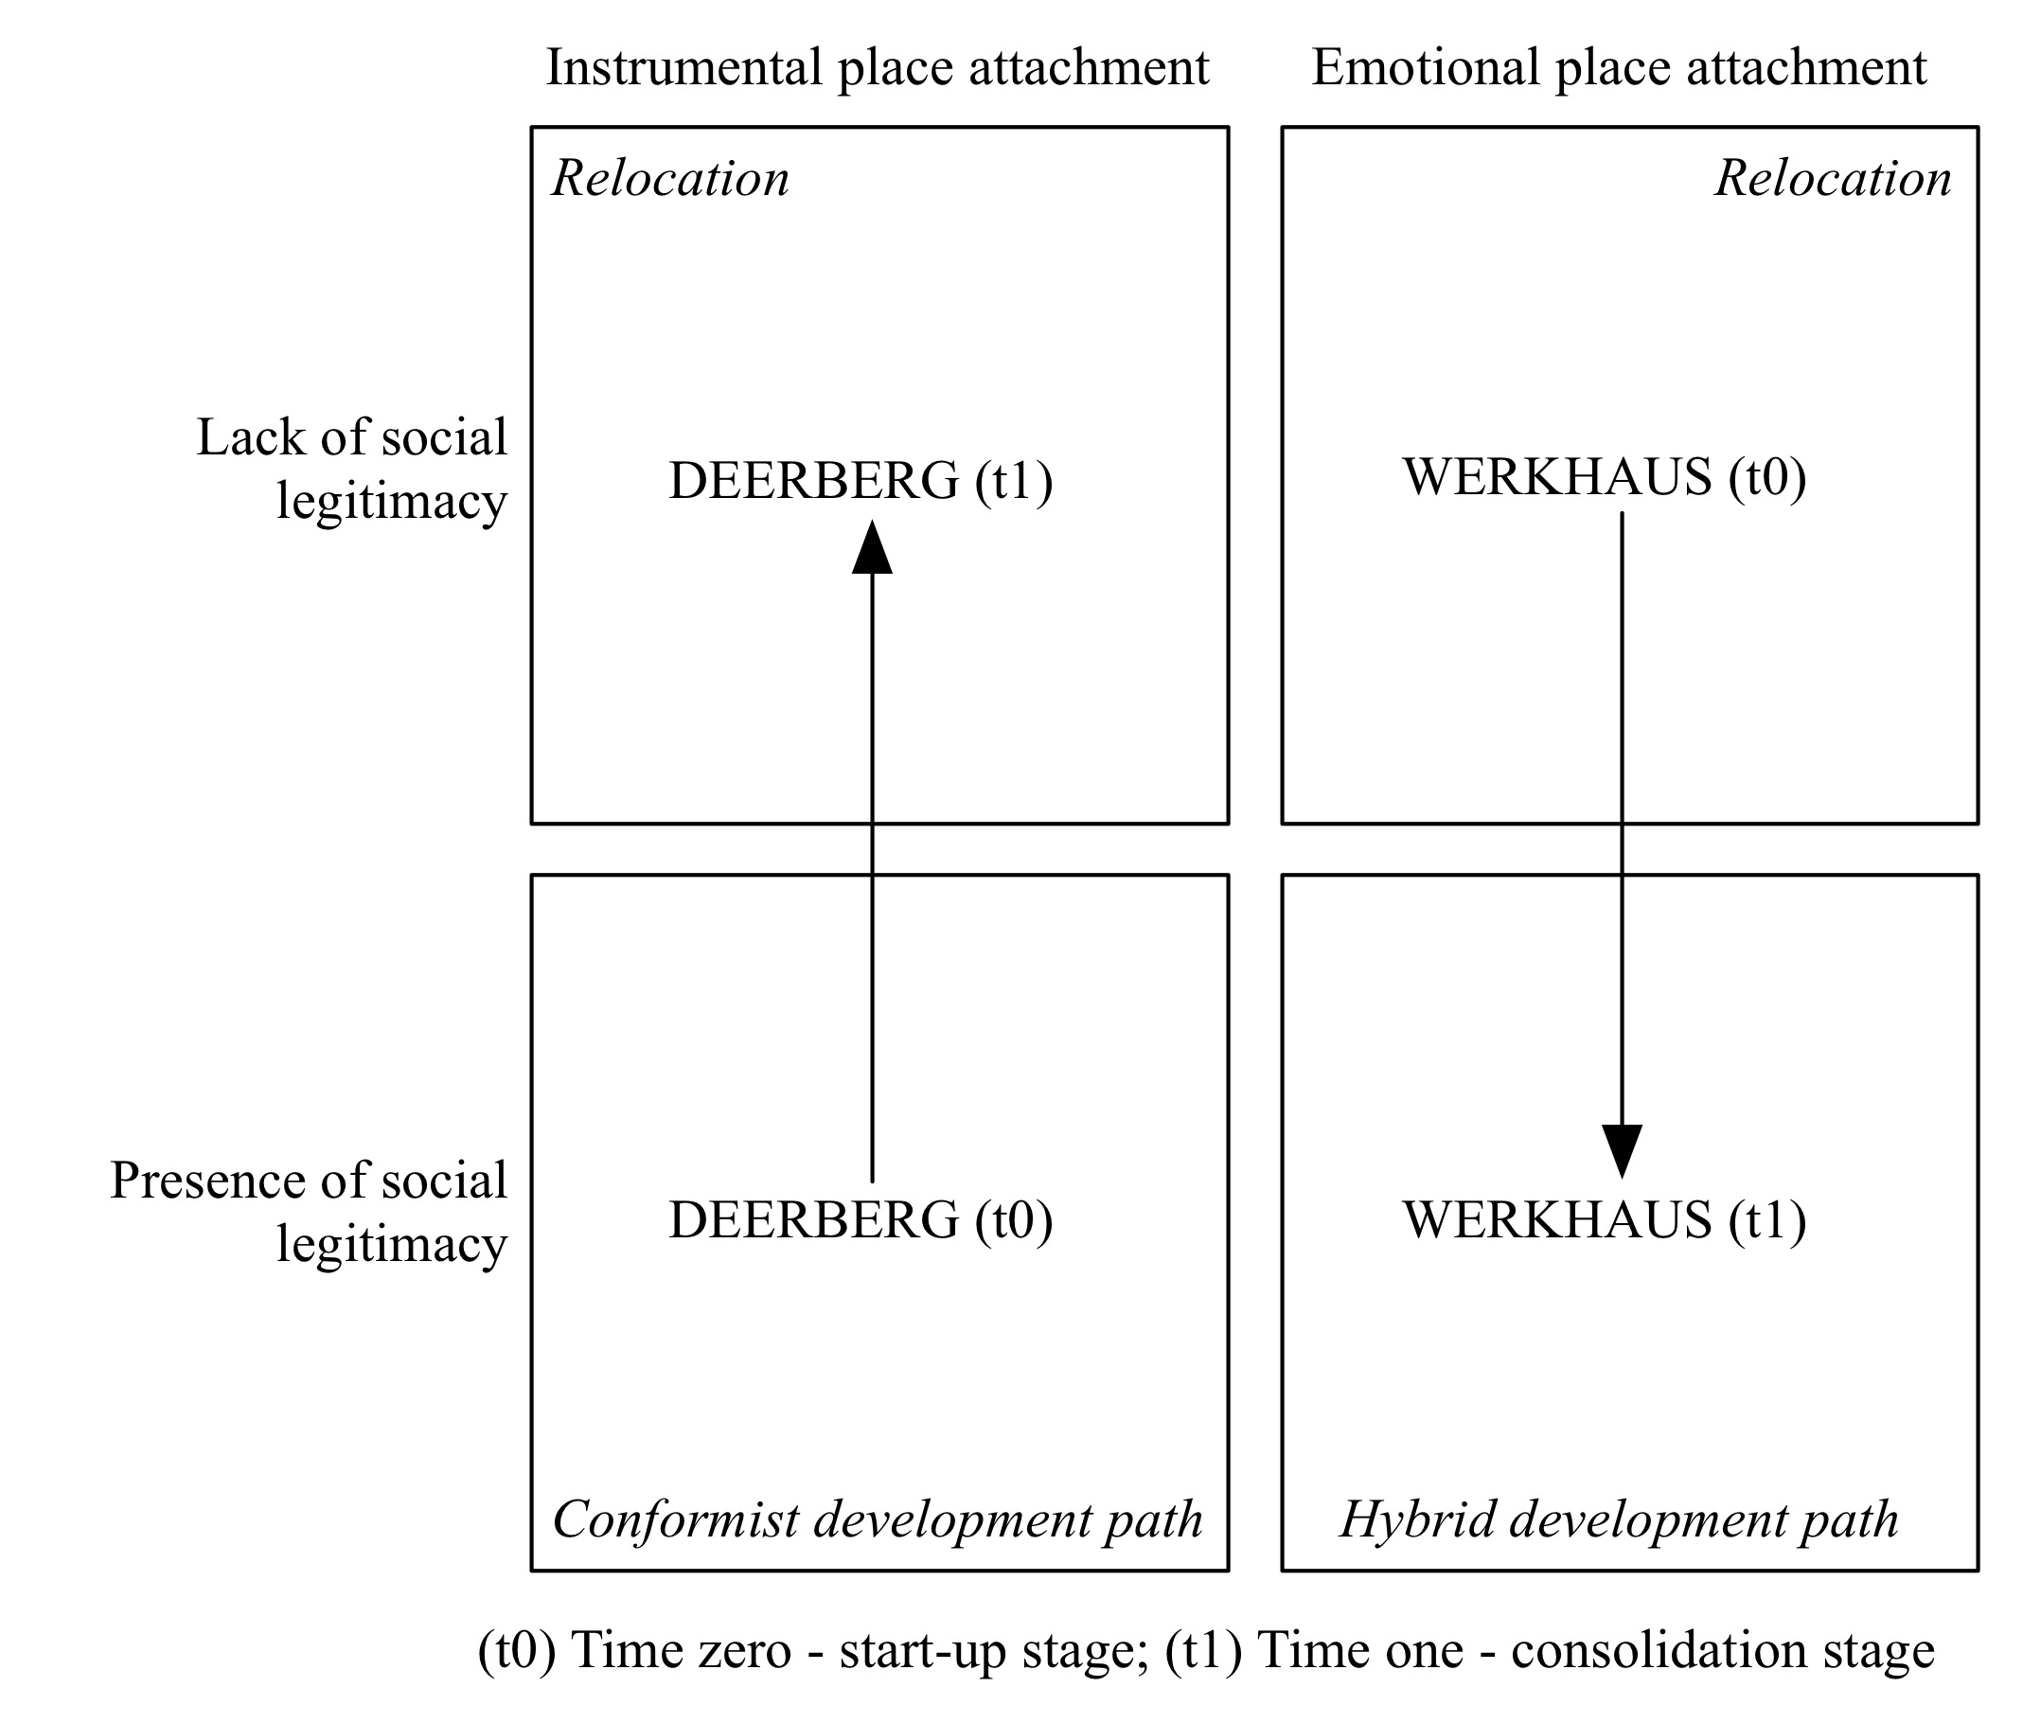
In particular, our study supports the use of conformist and insurgent as dominant ways for the initial development of sustainable ventures. However, we demonstrate that conformist and insurgent venture paths are not stable, and change depending on the interplay between the entrepreneur’s place-attachment and received social support in the operating place.
First, we propose that sustainable entrepreneurs that face lack of social legitimacy (“The local council and chamber of commerce did not take my entrepreneurial efforts serious and did not provide any support. Anyway, I still tried to make it work here!”, male entrepreneur B) can reach a point that makes them move from the insurgent sidewalk to the conformist sidewalk by means of switching the place, to a more socially supportive environment (“I really care about the region, but I did not see myself pushing further in the region as I got access to more support and key resources for my business in another place”, male entrepreneur B).
Second, we argue that once a sustainable venture emerges via the conformist path, a sustainable entrepreneur with a strong instrumental place-attachment follows the conformist path (“The firm just uses the regional image for selling our product - that’s it.”, procurement manager A), when losing the necessary legitimacy, by switching place, and thus continuing to stay in a socially supportive environment (“The municipality has built up barriers for our firm to expand its local production site (…) so we decided to centralize operations in a new location where we find better support and more qualified personnel.”, female entrepreneur A).
Third, we suggest that only sustainable entrepreneurs with a strong emotional place-attachment (t0) (“I always feel at home here and I also feel responsible for the community.”, female entrepreneur B) are not only moving from insurgents to conformists by switching place, but are also willing to come back and contribute to the local community (t1) where their venture evolved in the first place (“It’s good to see that green ideas that our venture shares have been spread more widely across the region compared to its early years.", male entrepreneur B; “The local job center turns now to us for locals who are difficult to place in the job market.”, female entrepreneur B). In this sense, sustainable entrepreneurs can develop a hybrid path (in t1), which both enables them to finally realize their initial reactive behavior (in t0) (insurgent) and to benefit from a higher degree of social legitimacy, supporting their high-growth sustainable business.
Based on the presented insights, we introduce the decisive role of a sustainable entrepreneur’s attachment to the operating place. We argue that distinguishing between emotional (‘caring about the place’) and instrumental (‘using the place’) place-attachment of sustainable entrepreneurs helps further developing a holistic, but also a more dynamic understanding of conformist and insurgent paths in the sustainable entrepreneurship journey. Thus, in spite of the limitations of small N case study research, we seek to stimulate further holistic research on sustainable entrepreneurship by introducing a ‘place-based’ path model based on the interplay between – emotional and instrumental – place attachment and social legitimacy. In doing so, we contribute to literature by extending our psychological and socio-spatial knowledge of sustainable venture development.

References
Giuliani, M.V., 2003. Theory of attachment and place attachment, in: Bonnes, M., Lee, T., Bonainto, M. (Eds.), Psychological Theories for Environmental Issues, pp .137-170. Aldershot: Ashgate.
Hall, J., Daneke, G., Lenox, M., 2010. Sustainable development and entrepreneurship: past contributions and future directions. Journal of Business Venturing, 25, 439-448.
Kibler, E., Kautonen, T., Fink, M., 2014. Regional social legitimacy of entrepreneurship: Implications for entrepreneurial intention and start-up behaviour. Regional Studies, 48, 995-1015.
Lang, R., Fink, M., Kibler, E., (2014). Understanding place-based entrepreneurship in rural Central Europe: A comparative institutional analysis. International Small Business Journal, 32, 204-227.
Mair, J., Marti, I., 2009. Entrepreneurship in and around institutional voids: A case study from Bangladesh. Journal of Business Venturing, 24, 419-435.
Marquis, C., Battilana, J., 2009. Acting globally but thinking locally? The enduring influence of local communities on organizations. Research in Organizational Behavior, 29, 283-302.
McKeever, E., Jack, S., Anderson, A., 2015. Embedded entrepreneurship in the creative reconstruction of place. Journal of Business Venturing, 30, 50-65.
Muñoz, P., Dimov, D. 2014. The call of the whole in understanding the development of sustainable ventures. Journal of Business Venturing, Doi:10.1016/j.jbusvent.2014.07.012.
Pacheco, D., Dean T., Payne, D., 2010. Escaping the green prison: entrepreneurship and the creation of opportunities for sustainable development’. Journal of Business Venturing, 25, 464-480.
Santos, F., Eisenhardt, K., 2009. Constructing markets and organizing boundaries: Entrepreneurial power in nascent fields. Academy of Management Journal, 52, 643-671.
Seghezzo, L. 2009. The five dimensions of sustainability. Environmental Politics, 18, 539-556.
Shepherd, D., Patzelt, H., 2011. The new field of sustainable entrepreneurship: studying entrepreneurial action linking “what is to be sustained” with “what is to be developed”. Entrepreneurship Theory and Practice, 35, 137-163.
Shrivastava, P., Kennelly, J.J., 2013. Sustainability and place-based enterprise. Organization & Environment, 26, 83–101.
Yin, R.K., 2009. Case Study Research: Design and Methods, 4th ed. Thousand Oaks, CA: Sage.

Appendix 1:
Instrumental place attachment | (“The firm just uses the regional image for selling our product - that’s it.”, procurement manager A
Emotional place attachment | “I really care about the region, but I did not see myself pushing further in the region as I got access to more support and key resources for my business in another place”(male entrepreneur B); “I always feel at home here and I also feel responsible for the community.” (female entrepreneur B)
Lack of social legitimacy | “The local council and chamber of commerce did not take my entrepreneurial efforts serious and did not provide any support. Anyway, I still tried to make it work here!” (male entrepreneur B); “When we planned to expand the production sight, we got into real troubles with the local authorities, because they would not sell us the neighboring property.” (female entrepreneur B); “The community thought our business idea would not work anyway and this was than really the case. They did not buying anything in our local shop.” (senior employee B); “When we opened the business, I was considered a greenie crackpot.” (male entrepreneur B)
Presence of social legitimacy | “It’s good to see that green ideas that our venture shares have been spread more widely across the region compared to its early years."(male entrepreneur B); “The local job center turns now to us for locals who are difficult to place in the job market.” (female entrepreneur B); When the firm was founded, the municipality and the local community believed in our business idea an supported us with financing, logistics and site” (male entrepreneur A)
Insurgent development paths | “I really care about the region, but I did not see myself pushing further in the region as I got access to more support and key resources for my business in another place”(male entrepreneur B)
Conformist development path | (“The municipality has built up barriers for our firm to expand its local production site (…) so we decided to centralize operations in a new location where we find better support and more qualified personnel.”, female entrepreneur A

