Gateway load balancing using multiple QoS parameters in a hybrid MANET

Rashmi Kushwah1 • S. Tapaswi1 • Ajay Kumar1 • K. K. Pattanaik1 •
S. Yousef2 • M. Cole2

Springer Science+Business Media New York 2016

Abstract A Mobile ad hoc network (MANET) is a self configurable wireless network in which mobile nodes communicate with each other in a multihop fashion without any pre-installed infrastructure. A MANET can be con- sidered to be a standalone network. To enhance the con- nectivity of a MANET it can be connected to the fixed network, thus forming a heterogeneous network. The integration of MANET and the Internet is called a hybrid MANET which is facilitated by special nodes called Internet gateway nodes. Load balancing among gateways is a challenging task when a MANET is connected to Inter- net. Gateway nodes with higher loads will lead to discon- nected networks and depletes the node’s resources which include their batteries, memory and bandwidth quickly. Gateway selection based on the shortest path may increase traffic concentration on one particular gateway which leads to congestion and increases delay in the network. In this paper a QoS based load balancing mechanism has been

& S. Tapaswi stapaswi@iiitm.ac.in
Rashmi Kushwah rashmik@iiitm.ac.in
Ajay Kumar ajayfma@iiitm.ac.in

K. K. Pattanaik kkpatnaik@iiitm.ac.in
S. Yousef sufian.yousef@anglia.ac.uk
M. Cole michael.cole@anglia.ac.uk

1 ABV-Indian Institute of Information Technology and
Management, Gwalior, India
2 Anglia Ruskin University, Chelmsford, UK
proposed among multiple gateway nodes that provide communication between mobile nodes and fixed nodes in the Internet to select lightly loaded gateways so that more packets will be delivered to the fixed host in the Internet. The proposed QoS based scheme selects four QoS parameters that are (1) connecting degree, (2) interface queue length, (3) routing table entries and (4) hop count. A weight based method is used to select the gateway which combines all four QoS metrics. Simulation results demonstrate that when compared with individual parame- ter, the average ETE delay, queue size and traffic load of gateway generated by proposed algorithm is decreased by
17, 25 and 15 % respectively and when compared with existing schemes, the average ETE delay, queue size and traffic load of gateway is decreased by 25, 25 and 16 % respectively.

Keywords Mobile adhoc network Load balancing
Integrated internet MANET Gateway discovery QoS

1 Introduction

Current research on integration of MANET and the Internet has become important because of its usefulness. A stan- dalone MANET has limited connectivity, limited wireless coverage, limited applications and services [1, 2]. To extend the usefulness of MANET, a gateway is used to provide communication with the Internet as shown in Fig. 1. A gateway is a special node that translates the address space of MANET to the Internet and vice-versa. Such integrated heterogeneous networks are called a hybrid MANET. One of the most important issues in integrated Internet MANET is balancing the load among available gateways to improve the performance of the network. In

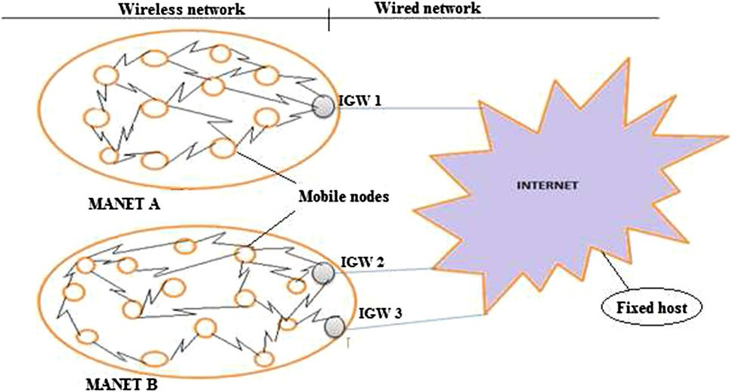

Fig. 1 Proposed architecture of MANET Internet connectivity

real time applications some gateways are heavily loaded while others are underutilized. Heavily loaded gateways deplete their batteries quickly and this leads to an increase in packet drop rate. Therefore a gateway load balancing scheme is required that evenly distributes the traffic among available gateways and hence improves the overall per- formance of integrated Internet MANET.
In earlier studies the QoS parameters were taken at the MANET interface side and the QoS parameters on fixed Internet side were not considered. Thus in the proposed algorithm a new parameter connecting degree is introduced for achieving load balancing in gateway selection in a hybrid MANET. Connecting degree is an important parameter in hybrid MANET which helps to improve the performance of load balancing significantly. It can be defined as the number of fixed hosts connected to the gateway on fixed Internet side. In this paper a QoS based load balancing scheme has been presented among multiple gateway nodes for connecting MANET to the fixed net- work using four QoS parameters namely Connecting Degree (CD) of the gateway, Interface Queue Length (IQL) of the gateway, average Routing Table Entry (RTE) of the gateway and Hop Count (HC) between the MANET node and the gateway. The objective is to distribute the traffic among available gateways so that the traffic is evenly distributed among gateways. Many gateway selection schemes for load balancing have been proposed in the lit- erature but none of them consider the connecting degree as one of the important QoS parameter while selecting a lightly loaded gateway. Apart from this parameter other QoS parameters are also considered such as RTE, HC, IQL that effects the load on the gateway. To combine the four metrics into one comparable metric Simple Additive Weighting (SAW) [6] method has been used. The perfor- mance of hybrid MANET is shown in terms of traffic load and queue size of gateway which was not considered in the earlier research. The proposed QoS based scheme has been compared with an existing scheme [5] to show the effi- ciency of this proposed scheme as compared to earlier work.
The problem of integrating MANET to the Internet becomes challenging due to their architectural differences such as routing interoperability, differences in topology, variation in packet formats, handover decision and IP mobility issues etc. Further gateway selection and load balancing is a fundamental challenging issue in the hybrid MANET. In most of the gateway selection schemes traffic is not distributed over multiple gateways, one gateway is used as a primary gateway and other alternate gateways are used when primary one is not working. This makes the problem of gateway discovery and load balancing more challenging. The proposed scheme redirects the traffic of the source node from heavily loaded gateway to lightly loaded gateway, preventing congestion in advance. The aim is to obtain better network performance, such as higher throughput and better network resource utilization.
The remainder of the paper is structured as follows: Sect. 2 provides the challenges in the field of hybrid MANET. Section 3 presents related work for adhoc net- work connected to the fixed network. Section 4 describes the proposed QoS based gateway load balancing scheme to distribute traffic among available gateways when MANET connected to Internet. Section 5 discusses the experimental results and analysis. Finally concluding remarks are dis- cussed in Sect. 6.

2 Challenges for integrated internet MANET

Interconnecting MANETs to the Internet is not easy due to their complementary sets of requirements and variation in routing protocols, topology and packet formats. Five main challenges of integrated Internet MANET are presented in this paper as shown in Fig. 2.

2.1 Routing

The routing interoperability considers integration of MANET routing protocols with Internet based routing. For integrating MANET to the Internet an intermediate node called an Internet Gateway (IGW) is present which con- tains protocols of both MANET and fixed network. MANET-Internet connectivity is more challenging with a

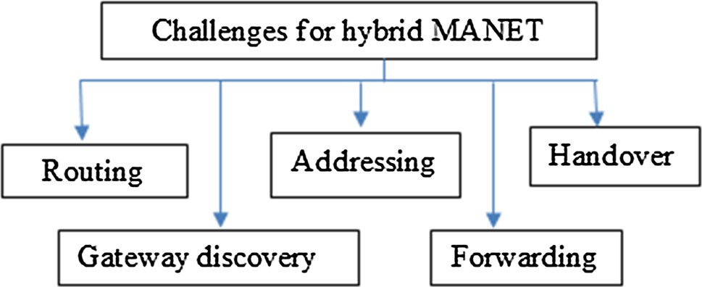

Fig. 2 Challenges for hybrid MANET

reactive routing protocol [3] than a proactive because the former do not contain complete routing information of MANET whilst the later do.

2.2 Gateway discovery

Gateway discovery is an important step in integrated Internet MANET. A Source Mobile Node (SMN) in MANET must determine a gateway before connecting to the fixed host. Three gateway discovery approaches have
2.2.3 Hybrid approach

The Hybrid discovery method combines the advantages of the above two methods to balance the control overhead and delay. For mobile nodes up to fixed number of hop the proactive gateway method is used and after this range the reactive discovery approach is used. The overhead hH of hybrid approach can be calculated as follows:
NHY
hH ¼ NTTL ðkGA tÞþ SRQP X kS tÞ ð4Þ
ð
been proposed in [4, 5].

2.2.1 Proactive approach

In this approach gateway discovery is started by an IGW that broadcasts Gateway Advertisement (GWADV) peri- odically with time interval (T) between two successive advertisements. The advantage of the proactive approach is that it provides short delay and good connectivity. The disadvantage is that the MANET is flooded with control messages so scarce resources of MANET such as band- width and power will be consumed more. The total IGW discovery overhead in terms of number of message can be calculated as follows:
hP ¼ Nadhoc NG ðkGA tÞ ð1Þ

where Nadhoc ¼ total number of wireless nodes, kGA t ¼ gateway transmission rate in a time interval t, NG ¼ number of IGW’s.

2.2.2 Reactive approach

In this approach the gateway discovery is originated by the Mobile Nodes (MNs) that need Internet connectivity with the fixed host by broadcasting a solicitation message to all gateways in the MANET [7]. The advantage of this approach is that network is not flooded unnecessarily with control messages. The disadvantage is that route discovery delays may be increased. The overhead hR of the reactive approach can be estimated as follows:
NS
hR ¼ SRQP X kS tÞ ð2Þ
ð
a¼1

NG
SRQP ¼ Nadhoc þ X NARQ MPL ð3Þ
b¼1

where SRQP = total IGW route requests and IGW route replies, kS t = average number of gateway discoveries during time interval t, NARQ = number of requests accepted by the gateway, MPL = average path length between active source and gateway, NS and NG are total number of active sources and gateways respectively.
C¼1

NHY ¼ NS ð1 NPRO =NS Þ ð5Þ

where NTTL = number of mobile nodes within Time To Live (TTL) range for each IGW, NS = number of active source nodes, NPRO =NS = probability that active sources reside in the proactive area and NHY is the number of source mobile nodes which are not in the proactive range.

2.3 Addressing

MANET nodes require an IPv4 or IPv6 based address space to support communication and internetworking with the fixed IP based network to organize a topologically correct and globally routable address. The addressing mechanism of MANET should be autoconfigured to handle the self organized and dynamic topology of MANET. IPv6 supports two types of auto configuration features [4]: stateful auto-configuration and stateless auto-configuration.

2.4 Forwarding

In MANET the gateway forwarding scheme plays an important role for internetworking between MANET and the Internet. Two common gateway forwarding approaches [4] are used namely tunneling and non tunneling based forwarding in hybrid adhoc network.

2.5 Handover decision

Handover is performed when mobile nodes switch their gateway when it is communicating with the corresponding node in the fixed network. Movement detection methods [4] such as forced and optimization based handover are used to perform handover in hybrid adhoc network.

3 Related work

Load balancing among gateways aim to transport traffic from those areas that are heavily loaded to the less con- gested and optimal routes to reduce delay and improve throughput of the network. If the traffic is not distributed

evenly among gateways then some gateways become congested while other gateways remain underutilized and idle. There are various proposals for gateway load bal- ancing. In [8] gateway selection is based on two metrics that are minimum hop count between mobile node and gateway and maximum residual IGW capacity. The selection criteria of an IGW is as follows:
ncurrent ¼ aðd=dmax Þþ ð1 aÞðhmax =hÞ ð6Þ

where a is the weighing factor determined by network status, d is residual IGW capacity, dmax is maximum residual capacity, h and hmax are hop count and maximum hop count among all paths to the IGW respectively. In [9]a WLB-AODV protocol is presented which is a modified version of AODV. It is based on three parameters: (1) routing table entries, (2) hop count and (3) interface queue length from source mobile node to gateway node. This protocol shows better performance than the AODV Pro- tocol. The improvement of WLB-AODV over AODV is that it tries to select the path which is less loaded even it may be longer. WLB-AODV enhances the throughput and reduces delay of the system. The hybrid gateway discovery method was used for gateway selection. In [10] the gate- way is selected based on path latency, path availability period, and residual load capacity of a path. Based on these parameters, the weight value of a path is selected and a gateway will be chosen by the MANET node based on maximum path value. For gateway selection the hybrid discovery method was used. Gateway selection based on path parameters improves throughput and reduce delay of the network. The study also considers weighing factors for gateway selection parameters. In [11] the Location Aided Routing (LAR) protocol is proposed for prediction of link connectivity, where the adhoc network is attached to the Internet through IGW. It evaluates expiration time of the route by calculating expiration time of the link between adjacent neighbor nodes.
Various load balanced routing protocols and load met- rics like active path, traffic size, packet in interface queue, probability of channel access and delay of MANET node for adhoc mobile wireless network is presented in [12]. Three types of load aware routing protocol are delay based, traffic based and hybrid based. An example protocol for a delay based protocol is Load Aware On-Demand Routing (LAOR). Associativity Based Routing (ABR) and the Load Balanced Adhoc Routing (LBAR) comes under traffic based category. Load balancing in hybrid based protocols combines the features of delay based and traffic based. Load balancing between intra and inter MANET is pro- vided by hybrid metric [13] in which three parameters are selected for hybrid metrics. The first parameter is shortest hop count between SMN and IGW node, the second parameter is the traffic load among MANETs and the third
parameter is the traffic load inside the MANET which is associated with the node density available to deliver the traffic. In [14] the IGW discovery approach is proposed for a real time application. When a mobile node wants to forward real time traffic to the fixed host and if it is not supplied in a specified time interval, the fixed host direct a QoSLOST message to the SMN. After a fixed interval of time each IGW checks if it has received a QoSLOST message from a fixed host. If the IGW has not received the message, then only it sends a GWADV message to the MANET.

4 Proposed QoS based gateway load balancing scheme

This paper proposes a QoS based load balancing mecha- nism among gateways when MANET is connected to the Internet. The goal is to deliver the maximum number of packets from MN in MANET to a fixed host in the Internet. Selecting a lightly loaded gateway will reduce energy consumption, delay of the gateway and increase throughput of the network.

4.1 Important gateway selection parameters

Important gateway selection parameters used in the pro- posed method are as follows:

1. Connecting Degree (CD) The connecting degree of a gateway is described as the sum of wired nodes communicating to the MANET node through that gateway.
2. Interface Queue Length (IQL) Each mobile node in MANET keeps a queue of packets to be forwarded to the fixed host in the Internet. The queue length represents the current load of a mobile node and if it is longer the node is more occupied. By taking the minimum value of average traffic queue size the traffic can be distributed from a heavily loaded path to a lightly loaded path. IQL is used to determine the load of gateway and helps to find lightly loaded gateways.
3. Routing Table Entry (RTE) Every gateway node maintains the number of entries of valid routes in its routing table that consist of routing information to the destination. Gateways with more routing table entries will act as an occupied node and should be prevented for MANET Internet connection.
4. Hop Count (HC) The hop count is the minimum distance between SMN and the IGW. The path is more reliable in a wireless medium between nodes if it has a smaller hop count. If multiple paths exist between SMN and IGW node then the preferred path has the

minimal hop count. Minimum hop count is calculated by H(m,g):
Hðm; gÞ ¼ min HðPÞ : m ! g ð7Þ

where m is the source mobile node and g is the gate- way and H(m,g) is the minimum distance between mobile node to the gateway.
Evaluation of candidate gateways is based on IQL, RTE, HC and CD. When a SMN receives an interface queue length, routing table entry, connecting degree of gateway and hop count from gateway, it combines the four parameters with weighing factor C1 ; C2 ; C3 and C4 . These factors are the constants and show the impact of each parameter on the metric. For example the connecting degree of a gateway is mandatory so the weighting factor can also be increased for this parameter while choosing lightly loaded gateways among multiple gateway nodes. Similarly hop count, routing table entry and interface queue length should be minimized thus these parameters may be given less importance. Whenever any SMN that requires communication to the fixed host in the Internet receives multiple gateway advertisement it uses the fol- lowing formula to select a lightly loaded gateway.
Wi ¼ C1 ðCDÞþ C2 ðIQLÞþ C3 ðRTEÞþ C4 ðHCÞ
ð8Þ

where Wi is a weight value of each gateway i,
0 C1 ; C2 ; C3 ; C4 1 and C1 þ C2 þ C3 þ C4 ¼ 1
The traffic from a highly loaded gateway to the lightly loaded gateway is diverted based on the weighted value Wi . The IGW with lowest value of Wi is elected as a best candidate IGW for communication between MANET and Internet.
The advantage in the proposed scheme is that it does a priori switch of the network traffic at the source node to the gateway which has less weight, which helps in less network delay for the successful packet delivery. The proposed QoS based load balancing scheme selects an optimum gateway among a set of gateways based on multiple QoS metrics, from MANET as well as fixed Internet perspective. The goal of proposed gateway load balancing using multiple QoS parameters is twofold: First to select the gateways that are lightly loaded, and second efficient resource utilization. Since in a hybrid MANET complete traffic of all MANET nodes passes through external links of fixed capacity. There is a higher proba- bility of congestion or bottleneck on these external links when connected hosts are very high in number, hence this results in severe degradation in network performance. This is a very important issue and has not been consid- ered in earlier studies of gateway selection and load balancing. The proposed scheme takes care till the packet
delivery is successful because of balanced load/less con- gestion, there are fewer dropped packets. Further since this approach is more holistic in nature, and parameters which are more important in both fixed and wireless network have been considered, it reduces the overall delay of the network and provides better load balancing among a set of multiple gateways.

4.2 QoS based gateway selection algorithm

The registration procedure for connectivity between a MANET and the Internet is provided by the reactive registration method. When a SMN wants to access the fixed host it constructs a Gateway Solicitation (GWSOL) message and broadcasts it to the available gateway in the network. When gateway receives the GWSOL message from SMN, it constructs a Gateway Advertisement (GWADV) message and sends it to the SMN by uni- casting. The GWADV message is modified to carry gateway related information in the adhoc network with its current parameter interface queue length, routing table entry, hop count and connecting degree as shown in Fig. 3. When an intermediate node receives a gateway advertisement it stores the values of all QoS parameters, updates the parameter in its routing table and broadcasts the message to other mobile node in the network until it is received by the SMN. When the SMN receives all QoS parameters it selects the optimum gateway by using the mechanism presented in the previous section. Finally the SMN can communicate with the fixed host through this gateway.
Since MANET has a dynamic topology and wireless interface it is necessary to maintain up to date information using the mobile nodes. With the help of interface queue length, routing table entries, hop count and connecting degree the required information is propagated up to the source mobile node. In this way any MANET node that wants to communicate to a fixed host in the Internet cal- culates Wi to select a lightly loaded gateway and switch the gateway according to the minimum weight value of the gateway. Table 1 shows QoS based gateway selection which includes all four QoS parameters.

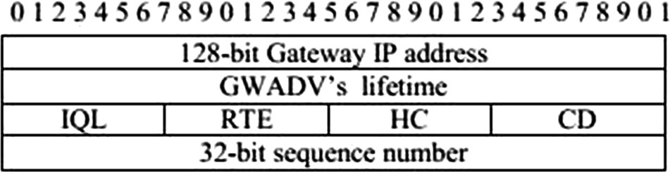

Fig. 3 GWADV header format

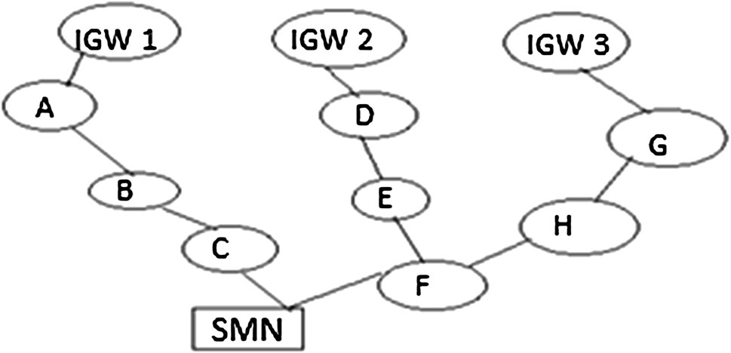

Fig. 4 IGW selection in integrated Internet MANET

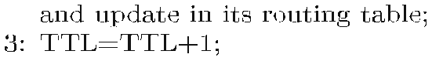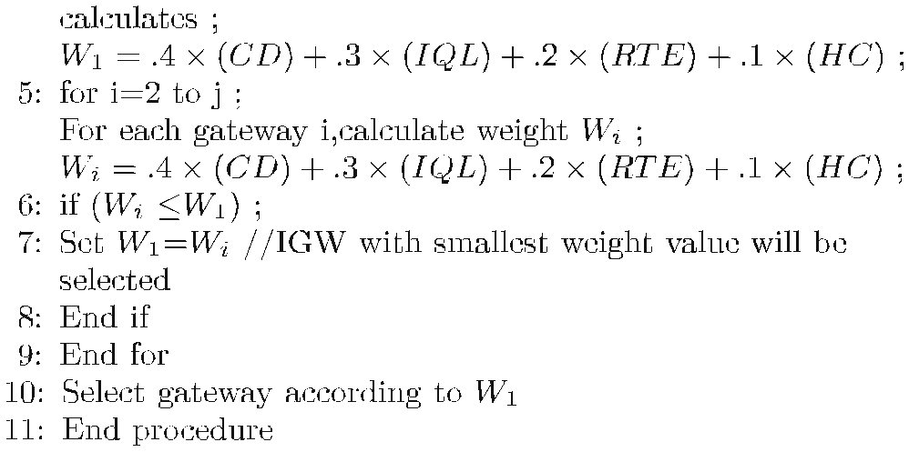The proposed algorithm of load balancing among mul- tiple gateways is presented in Algorithm 1. In step 1 each gateway sends GWADV to the requesting SMN with the QoS parameters: IQL, RTE, and its CD. In step 2 inter- mediate MN receives QoS parameters, updates their rout- ing table and further broadcasts the GWADV. In step 3
GWADV is forwarded to the next neighbor MN and TTL value is increased by one. When SMN receives multiple GWADV’s, it calculates the weight value of each gateway based on four QoS parameters IQL, RTE, CD and HC by using a for loop in step 4 and 5. The MN compares weight value of each gateway and selects the gateway with mini- mum weight value in step 6. Now further communication of SMN and gateway takes place through this gateway until a gateway of minimum weight value is not found.

4.3 Working example of the proposed scheme

The working of the proposed scheme is presented in Fig. 4. Let a SMN receive GWADV from three gateways IGW1, IGW2 and IGW3. These gateways send GWADV with their current information such as IQL, RTE, HC and CD to their neighbors A, D and G. The mobile node A, D and G update the above parameters in their routing table, hop count is increased by one and they broadcast the message to the other MNs in the network. The SMN receives GWADV from three
different gateways : IGW1 - A - B - C - SMN, IGW2 - D - E - F
- SMN and IGW3 - G - H - F - SMN. The SMN calculates the weight of three different gateways according to Eq. (8) and selects the optimum gateway with minimum weight value. The values of RTE, CD, HC and IQL are shown in Table 2, based on the simulation results.

5 Simulation analysis

The performance metrics, various simulation parameters, simulation model and result analysis is described in this section

5.1 Performance metrics

The following performance metrics have been used to analyse the effect of proposed approach.

1. End-To-End (ETE) delay is the difference between the time when a data packet is successfully received by the IGW and the time when data packets is generated by the SMN. This delay includes propagation, transmis- sion and queuing delay at the source and all the intermediate nodes.
2. Traffic load represents the average data traffic received
at the gateway in the simulation time.
3. Queue size represents the average number of packets buffered in the interface queue of gateway.

Table 1 IGW selection scenarios

Scenarios C1 C2 C3 C4 Note
Table 2 QoS parameter for gateway nodes
CD 1 0 0 0 Totally based on CD IQL 0 1 0 0 Totally based on IQL RTE 0 0 1 0 Totally based on RTE HC 0 0 0 1 Totally based on HC
QoS based* .4 .3 .2 .1 Combine the four metrics

QoS* based include (CD, IQL, RTE, HC)

Scenarios Gateway RTE CD HC IQL

1 IGW1 12.12 2 3 1.5
2 IGW2 11.23 1 4 0.45
3 IGW3 10.20 3 3 0.41
4 IGW4 8.71 4 2 0.35

5.2 Simulation model

To analyze the behavior of the proposed scheme OPNET Modeler 18.0 has been used. The proposed algorithm is evaluated in two phases. In the first phase of simulation the proposed scheme is compared with individual QoS parameters with simulation time. A network topology is created in the simulation area of 800 800 m with four gateway nodes and 30 mobile nodes. The simulation run time is 600 s and the transmission range of each MN is 300 m. MNs communicate with each other by the AODV protocol. To manage the mobility of MNs mobile IP [15, 16] home agents and foreign agents are installed in the gateways. Simulation parameters are given in Table 3. In the second phase of simulation this proposed scheme is compared with the existing scheme of Attia [5] using dif- ferent parameters. Two fixed nodes for communicating with the gateway which are equipped with an IEEE 802.11 g interface are present in the network. For mobility a random waypoint mobility model is used in which node moves with random speed between 1 and 5 m/s with pause time of 20 s before moving to the new destination. In this proposed scheme it is assumed that all gateways are at the same battery level. Link capacity to the fixed Internet side is also assumed fixed (802.11 g, 54 Mbps) and more than that on the link capacity at the MANET side (Fixed 2
Mbps). Moreover gateways are also considered as sta- tionary nodes in the proposed scheme.
As described in Sect. 4.2, four different weighting fac- tors C1 ; C2 ; C3 and C4 are assigned to CD, IQL, RTE, HC respectively. To get the appropriate value of each of the constants the performance of each QoS parameter is evaluated individually with respect to ETE delay, traffic load and queue length. In the simulations performed, where Wi achieves the optimum results, the weights are assigned to the constants accordingly.

5.3 Results and analysis

Figure 5 shows that a QoS based scheme achieves the best performance among the existing schemes (IQL based, RTE based, HC based and CD based) in terms of average traffic load. The CD based scheme achieves the best performance among four individual parameters. The IQL based scheme achieves better performance than RTE and the hop count based scheme. The hop count based scheme gives the worst performance. Single QoS parameters such as IQL, RTE or CD do not perform well. Therefore a proposed QoS based scheme which combines all four QoS parameters can achieve best performance. The traffic load is highest in the HC based scheme when a MN selects a gateway based on the minimum number of hops and increases the buffer overflow at the gateway node. In the proposed QoS based scheme traffic is distributed among multiple gateways, so this will reduce buffer overflow at the gateway and reduce the traffic load on the gateway.
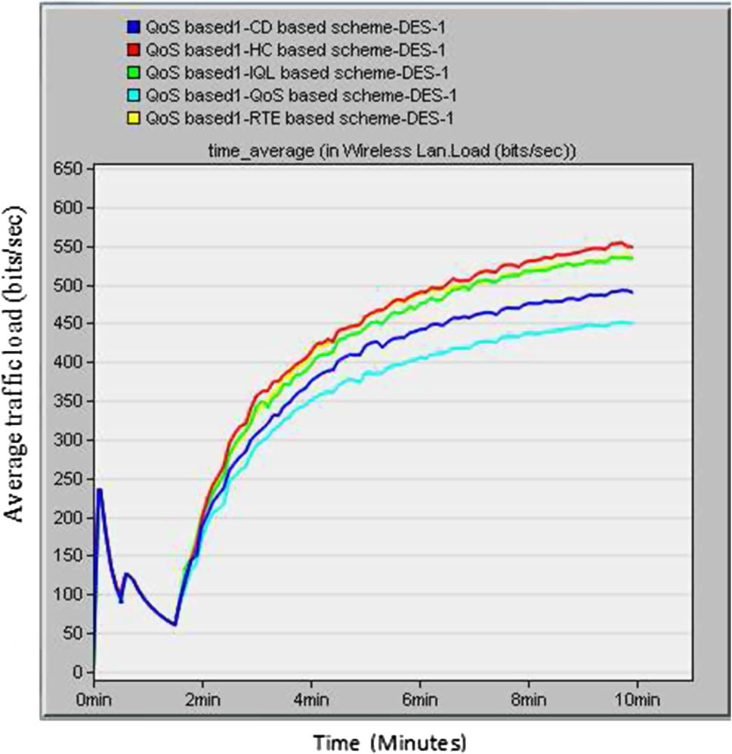Figure 6 illustrates that QoS based mechanism performs better in terms of ETE delay among the four schemes when traffic is diverted from heavily loaded gateways to the lightly loaded gateways. The proposed QoS based scheme combines four parameter and chooses the best path between SMN and IGW. The RTE based scheme gives the

Table 3 Simulation parameters

Simulation parameter Value

Simulation area 800 800m
Wireless MAC interface 802.11 g
Packet size Constant (1024) Radio range of mobile node 300 m
Network Size 30 mobile nodes
Number of gateways 4
Number of fixed node 2
Packet inter-arrival time Constant (1) Mobility pattern of node Random waypoint Node speed 1–5 m/s
pause time period 20 s Traffic source CBR Simulation time 600 s
Stop time End of simulation
Packet sending rate 4 packets/s
Ad hoc routing protocol AODV

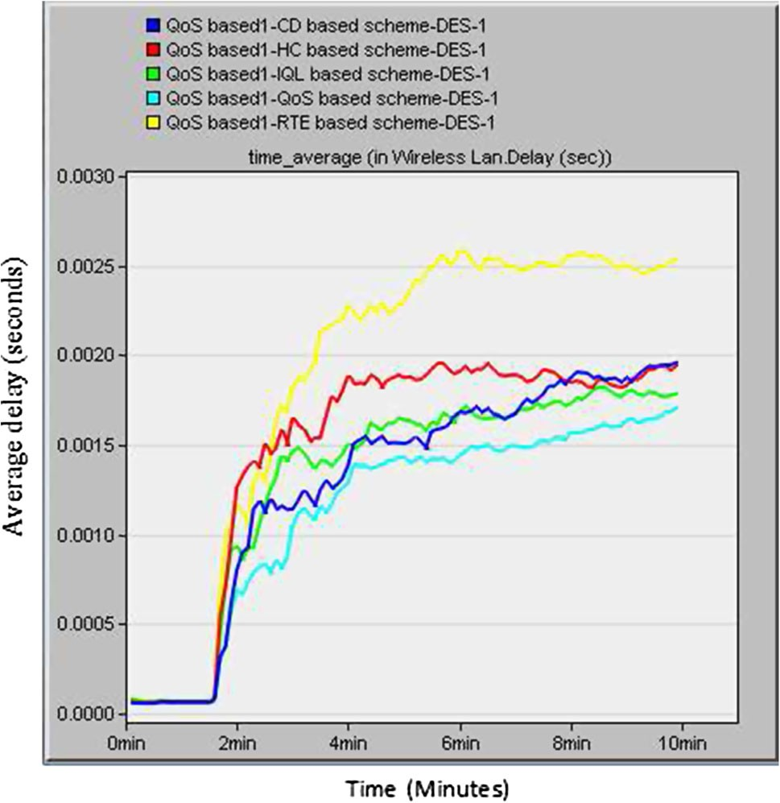

Fig. 6 Comparison of individual QoS parameter with proposed QoS
based scheme for average ETE delay
Fig. 7 Comparison of individual QoS parameter with proposed QoS
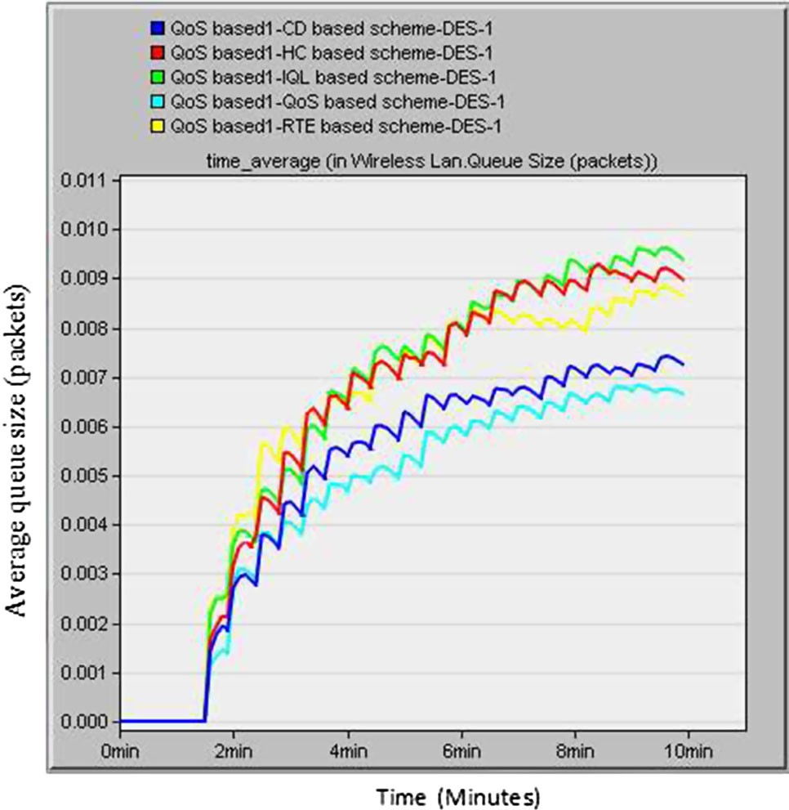based scheme for average queue size

worst ETE delay among the four schemes because traffic is concentrated on one particular gateway in this scheme. The CD based scheme achieves second best performance in this initial phase but after 4800 s its performance degrades. The IQL based scheme gives the third best performance. The HC based scheme achieves the fourth best performance in terms of ETE delay as MN chooses the nearest gateway and it increase the traffic load of gateway and hence con- gestion occurs in the network.
Figure 7 shows that the proposed QoS based scheme achieves better results in terms of minimum queue size. The SMN searches for a new gateway and switches to another gateway, if the current gateway with which it is connected receives heavy traffic. Thus the queue size of the current gateway gets reduced. The CD based scheme ef- fectively distributes the traffic load among gateways to maintain the connecting degree to a certain threshold and chieve second best performance. The HC and IQL based schemes give poor performance because the queue length increases at the gateway in both schemes. In proposed scheme the mobile nodes select gateways based on four QoS parameters which will distribute the traffic among gateways proportionately this results in reduction of the queue length at the gateway.
Table 4 shows the comparison of performance of the proposed scheme with individual QoS parameter Vs com- bined QoS parameter with 30 nodes. Compared with individual parameters, the average ETE delay, queue size and traffic load of gateway generated by proposed algo- rithm is decreased by 17, 25 and 15 % respectively.
It is clear from the simulation results that CD is an important metric among the four QoS parameters, followed by the IQL, RTE and HC metrics. The four QoS metrics with following weighing factor are combined: C1 ¼
:4; C2 ¼ :3; C3 ¼ :2 and C4 ¼ :1 for CD, IQL, RTE, HC
metrics respectively in the proposed QoS based gateway selection scheme. The proposed scheme achieves better load balancing as it consists of CD metric. Also, there is less ETE delay and a reduction in queue size. Therefore the proposed QoS based approach selects lightly loaded gate- ways, with the shortest paths and leads to less traffic from SMN to the gateway resulting in better gateway load balancing.
In an unbalanced scenario, resources are not utilized optimally as one gateway is heavily loaded while others may be idle. Therefore when traffic increases on one par- ticular gateway a queue of packets will be formed on their interface, resulting in dropped packets, network delay and throughput degradation. In the proposed scheme when a gateway handles heavy traffic the source node starts to search for an alternative gateway, so that the load remains balanced. The proposed algorithm calculates the weight value of each gateway by combining four QoS parameters i.e CD, IQL, RTE and HC and source node in MANET registers to another gateway as soon as it finds the gateway with minimum weight value and the load on each gateway is well distributed. The average ETE delay, average queue size and traffic load increases in other schemes due to net- work congestion and excess interference around the gate- way, and incoming packets may get dropped at the gateway.

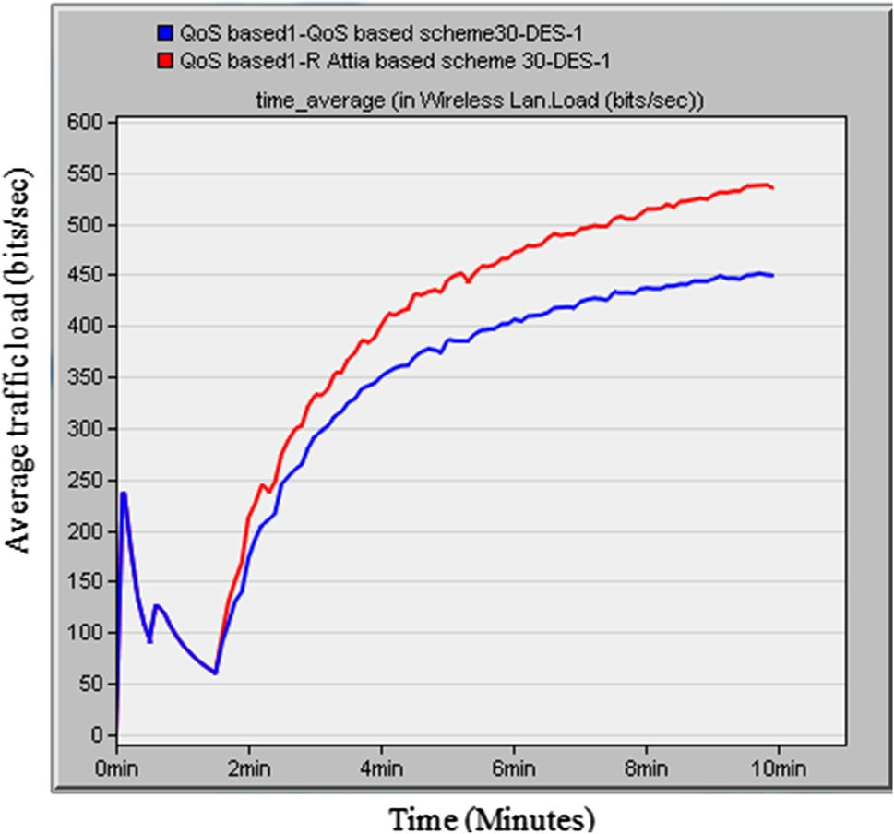

Fig. 8 Comparison of proposed QoS based scheme for average traffic load with 30 MNs
Fig. 9 Comparison of proposed QoS based scheme for average ETE
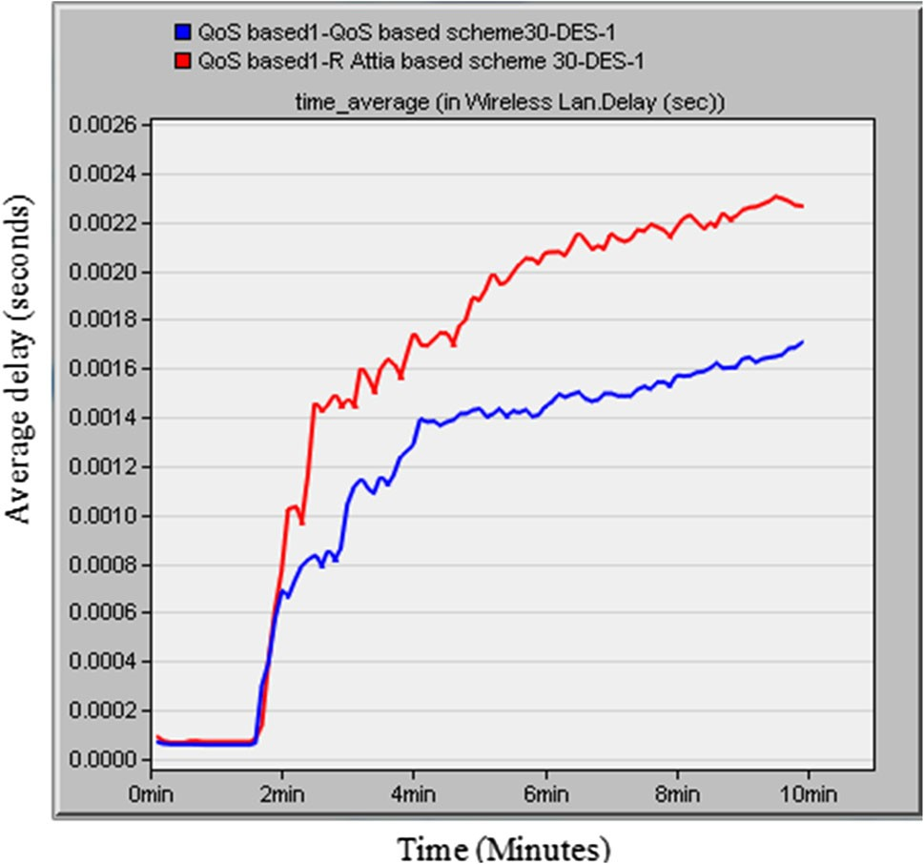delay with 30 MNs

The proposed QoS based gateway load balancing approach has been compared with that of Attia [5] as it covers major existing QoS parameters (Trip Time (TT) in terms of bandwidth and queue length, Gateway traffic Load (GL), Hop Count (HC)) and their optimum use. Figure 8 shows the comparison of the proposed QoS based scheme for average traffic load for 30 MNs. Results shows that among the two schemes the proposed QoS based gateway load balancing scheme has the lowest traffic load. This is because it uses an efficient mechanism which effectively distributes the traffic among gateways to avoid the situation where a gateway becomes a traffic bottleneck whereas the traffic load is much higher in other scheme. The proposed scheme results in better load balancing. The traffic is distributed evenly among gateways so buffer overflow is reduced as is the number of dropped packets at the gateway.
Figure 9 depicts the performance comparison of pro- posed QoS based scheme for average the ETE delay for 30
MNs. The traffic is well distributed among all the gateways resulting into less ETE delay. The results indicate that the proposed scheme with all the four QoS parameters
achieves less ETE delay as it finds comparatively less loaded gateway than the existing schemes. The scheme defined in [5] did not consider the connecting degree as one of the important parameters at the fixed Internet side, since in hybrid MANET the traffic of all of the MANET nodes passes through external links of fixed connected hosts and hence its ETE delay is more compared with the proposed scheme.
Figure 10 illustrates the performance comparison of average queue size for the two schemes with 30 MNs. It is observed that the proposed QoS based scheme achieves a smaller queue length than the existing scheme for all of the gateways. In the proposed scheme MN select gateway based on minimum weight value of gateway using four QoS parameters. This will distribute the traffic between gateways and hence reduce the packet queue length at gateways. In [5], the selection of gateway is not improved as the decision taken is only based on mobile nodes and the fixed infrastructure is not considered. In the proposed scheme, load balancing contributes to the overall perfor- mance of the network by redirecting the traffic among the gateways originated from active source and reduces the

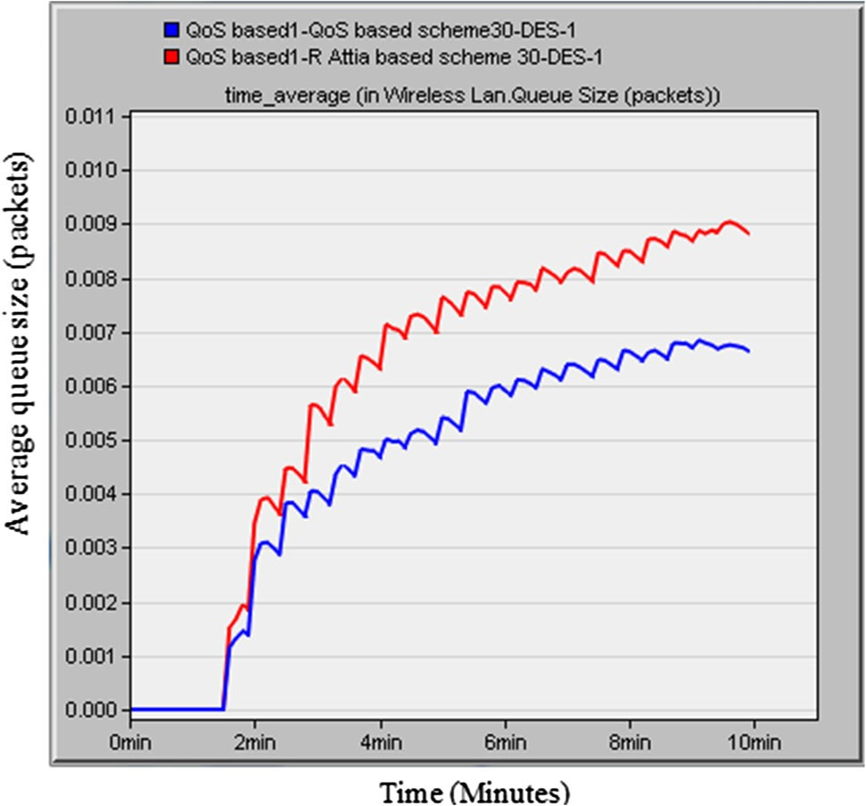

Fig. 10 Comparison of proposed QoS based scheme for average queue size with 30 MNs

Table 5 Comparison of performance with existing scheme [5] with
proposed QoS based scheme with 30 nodes

generated by proposed algorithm is decreased by 25, 25 and 16 % respectively.

6 Conclusion

In the proposed approach of gateway load balancing the connecting degree of a gateway is considered an important parameter at the fixed interface side that affects the perfor- mance of load balancing significantly. The proposed approach considers the four QoS metrics for MANET and Internet connectivity: connecting degree of the gateway, average interface queue length of the gateway, average routing table entry of the gateway and hop count between MANET node and the gateway. The weight based method is used for combining all four QoS parameters. A lightly loaded gateway is selected based on the minimum weight value of gateway. The proposed algorithm is evaluated in two differ- ent simulation phases. In first phase of simulation QoS based approach has been compared with multiple scenarios with individual parameters. Results show that the proposed approach achieves better results in comparison to parameters if considered individually. In the second phase of simulation the QoS based algorithm has been compared with an existing
Effect on With
existing scheme
With proposed
QoS based scheme
Percentage
improvement
algorithm. Results show that the proposed approach outper- forms the existing scheme in terms of average ETE delay,
queue size and traffic load of gateway. Simulation results
Average ETE
delay (s) Average queue
size (packets)
Average traffic load (bits/s)
.002264 .0017 25

.008816 .006637 25

535.04 449.28 16
demonstrate that when compared with individual parameters, the average ETE delay, queue size and traffic load of gateway generated by proposed algorithm is decreased by 17, 25 and
15 % respectively and when compared with existing scheme, the average ETE delay, queue size and traffic load of gateway is decreased by 25, 25 and 16 % respectively. The proposed algorithm selects lightly loaded gateways which results in better gateway load balancing in hybrid MANET.
average queue size of the packets in the network
interface.
The proposed approach gives more promising results while selecting lightly loaded gateways when there are high numbers of fixed hosts connected to the gateway on fixed Internet side. The probability of congestion is high on the connected external links when connected hosts are more in number hence this results in severe degradation of network performance. In this case source nodes select the less loaded gateway by using the minimum weight value of gateway using four QoS parameters to send the traffic to the fixed host and gives better results.
Table 5 shows the comparison of performance of the existing scheme to the proposed QoS based scheme with 30 nodes. Compared with the existing scheme [5], the average ETE delay, queue size and traffic load of gateway

Acknowledgments This paper describes work in part undertaken in the context of the UKIERI Project UGC2013-14/037 on ‘‘Interfacing Adhoc Mobile Networks with IP Mobile Systems’’. The project is a collaborative work supported under UKIERI programme between ABV-Indian Institute of Information Technology and Management, Gwalior, INDIA and Anglia Ruskin University, UK. The authors would like to thank ABV-Indian Institute of Information Technology and Management, Gwalior, India and Anglia Ruskin University, UK for providing the infrastructure and academic support.
References

1. Conti, M., & Giordano, S. (2014). Mobile ad hoc networking: Milestones, challenges, and new research directions. Communi- cations Magazine, IEEE, 52(1), 85–96.
2. Conti, M., & Giordano, S. (2007). Multihop ad hoc networking: The theory. Communications Magazine, IEEE, 45(4), 78–86.

3. Boukerche, A., Turgut, B., Aydin, N., Ahmad, M. Z., Boloni, L.,
& Turgut, D. (2011). Routing protocols in ad hoc networks: A
survey. Computer Networks, 55(13), 3032–3080.
4. Attia, R., Rizk, R., & Ali, H. A. (2015). Internet connectivity for mobile ad hoc network: A survey based study. Wireless Net- works, 21(7), 2369–2394.
5. Attia, R., Rizk, R., & Ali, H. A. (2015). Efficient internet access framework for mobile ad hoc networks. Wireless Personal Communications, 84(3), 1689–1722.
6. Rao, R. V. (2007). Decision making in the manufacturing envi- ronment: Using graph theory and fuzzy multiple attribute deci- sion making methods. Berlin: Springer.
7. Ruiz, P. M., Ros, F. J., & Gomez-Skarmeta, A. (2005). Internet
connectivity for mobile ad hoc networks: Solutions and chal- lenges. Communications Magazine, IEEE, 43(10), 118–125.
8. Park, B. N., Lee, W., Lee, C., & Shin, C. K. (2006). QoS-aware adaptive Internet gateway selection in ad hoc wireless Internet access networks. In 3rd International conference on broadband communications, networks and systems, 2006. BROADNETS
2006 (pp. 1–10). IEEE.
9. Zaman, R. U., Khan, K. U. R., & Reddy, A. V. (2010). Gateway load balancing in integrated internet-MANET using WLB- AODV. In Proceedings of the international conference and workshop on emerging trends in technology (pp. 411–416). ACM.
10. Bouk, S. H., Sasase, I., Ahmed, S. H., & Javaid, N. (2012).
Gateway discovery algorithm based on multiple QoS path parameters between mobile node and gateway node. Journal of Communications and Networks, 14(4), 434–442.
11. Wu, M., Seah, W. K., & Wong, L. W. (2005). A link-connectivity- prediction-based location-aided routing protocol for hybrid wired-wireless networks. ICMU: Proc.
12. Toh, C. K., Le, A. N., & Cho, Y. Z. (2009). Load balanced routing protocols for ad hoc mobile wireless networks. Commu- nications Magazine, IEEE, 47(8), 78–84.
13. Le-Trung, Q., Engelstad, P. E., Skeie, T., & Taherkordi, A. (2008). Load-balance of intra/inter-MANET traffic over multiple internet gateways. In Proceedings of the 6th international con- ference on advances in mobile computing and multimedia (pp.
50–57). ACM.
14. Domingo, M. C., & Prior, R. (2007). An adaptive gateway dis- covery algorithm to support QoS when providing Internet access to mobile ad hoc networks. Journal of networks, 2(2), 33–44.
15. Ding, S. (2009). Mobile IP handoffs among multiple internet gateways in mobile ad hoc networks. Communications, IET, 3(5),
752–763.
16. Perkins, C. E. (2002). IP Mobility Support, IETF RFC 3311.
S. Tapaswi is a Professor in Information Technology at Atal Bihari Vajpayee-Indian Institute of Information Technology and Management, Gwalior, Madhya Pradesh, India. Her primary research areas of interest are Computer Networks, Network Security, Mobile Adhoc Net- works, Cloud Computing.

Ajay Kumar is Associate Pro- fessor at ABV-IIITM Gwalior. He received his Ph.D. in Math- ematics from Indian Institute of Technology Roorkee. His research interests are Mathe- matical Modelling, Social Net- work Analysis based on graph theory.

K. K. Pattanaik is Associate Professor at ABV-IIITM Gwa- lior. He received his Ph.D. in Computer Science as major from Birla Institute of Technology Mesra, Ranchi in 2010. His research interests are Distributed Systems, Grid Computing, Net- work level communication issues (in Data Center Networks and Wireless Sensor Networks), Multi-Agent Systems.

heterogeneous networks.

Rashmi Kushwah received the B.E. degree in Computer Sci- ence and Engineering from UIT Barkatullah University, Bhopal, in 2006 and the M.Tech. degree in Software Engineering from Maharshi Dayanand University, Rohtak in 2009. She is currently pursuing her Ph.D. in Informa- tion Technology at ABV-Indian Institute of Information Tech- nology and Management, Gwa- lior, India. Her research interests include performance of mobile adhoc network and
S. Yousef is Director of Telecommunication Engineer- ing Research Group (TERG), at Anglia Ruskin University. He Graduated from Baghdad University in Electronic and Electrical Engineering and completed his M.Sc. in Telecommunication Systems Management and his Ph.D. at Anglia Ruskin University in
1998. During his research he won the Royal academy of Engineering award to be sec- onded to GEC Marconi for one
year during 1999. His main theme of expertise is electronic design of telecommunication networks in their wired and wireless status.

Currently Dr. Yousef is the project leader for the partnership (UKIERI) Project between Anglia Ruskin University in UK and the ABV-Indian Institute of Information Technology and Management (IIITM) in Gwalior in India.

M. Cole is Deputy Dean for Research and External income in the Faculty of Science and Technology in at Anglia Ruskin University, UK. He became Director of Research, Knowl- edge Transfer and Scholarship for the Faculty of Science and Technology in April, 2010. Hegraduated from the Univer- sity of Cambridge in 1986 hav- ing read Natural Sciences. He then became the first Ph.D. bursary student supported by the Royal Botanic Gardens. Having
worked with colleagues at both Birkbeck College and Imperial
College, University of London, Professor Cole obtained his Ph.D. in Natural Product Chemistry in 1990. Following a short spell in industry, Professor Cole joined the Forensic Science Unit at the University of Strathclyde in 1991 as a short course tutor. He became the Reader of Forensic Science and Director of the Forensic Science Unit in 2000. He was the youngest full Professor of Forensic Science in the world, when he joined Anglia Ruskin University in 2001, and was also the Head of Department for Forensics Sciences. His research interests include development of methods for (1) drug identification and comparison, (2) development of IT solutions for intelligent decision making in forensic science and (3) development of IT methodologies.

