**Efficient Approach to Enhance Drug Solubility by Particle Engineering of Bovine Serum Albumin**

Mouhamad Khodera*, Hamdy Abdelkadera,b, Amr ElShaera, Ayman Karamc, Mohammad Najlahd, Raid G. Alanya,e

a Drug Discovery, Delivery and Patient Care (DDDPC) Theme, School of Life Sciences, Pharmacy and Chemistry, Kingston University London, Kingston Upon Thames, London

b Department of Pharmaceutics, Faculty of Pharmacy, Minia University, Minia, Egypt.

c Institute of Chemistry of Poitiers : Materials and Natural Resources, Catalysis and unconventional media's Team

University of Poitiers

d Faculty of Medical Science, Anglia Ruskin University, Bishops Hall Lane, Chelmsford CM1 1SQ, United Kingdom

eSchool of Pharmacy, The University of Auckland, Auckland, New Zealand

*Corresponding author

Mouhamad Khoder, Ph.D.

Drug Discovery, Delivery and Patient Care (DDDPC) Theme,

School of Life Sciences, Pharmacy and Chemistry,

Kingston University London, Penrhyn Road,

Kingston Upon Thames, Surrey KT1 2EE, UK,

Tel +44 20 8417 9000

e-mail: [m.khoder@kingston.ac.uk](mailto:m.khoder@kingston.ac.uk),

[mouhamad.khoder@gmail.com](mailto:mouhamad.khoder@gmail.com)

**ABSTRACT**

The aim of this study was to investigate the use of bovine serum albumin (BSA) as a solubility enhancer for indometacin (IND) as a model drug. IND-BSA solid dispersions were prepared by both spray drying and freeze drying techniques using IND:BSA solution (20:1 Molar Ratio (MR)) and IND:BSA suspension (100:1 MR). The solid state of IND in solid dispersions was characterised by SEM, DSC and XRD. The aqueous solubility of IND in the presence of increased amounts of BSA was evaluated. Additionally, IND dissolution and release profiles were evaluated. IND in solid dispersions with BSA showed significantly higher solubility in water than that of the physical mixture of both. Enhancement factors of 24,000 and 100,000 were obtained for the solid dispersion formulated in 20:1 MR and 100:1 MR, respectively. Dissolution studies *in-vitro* indicated a significant increase in the dissolution rate of IND from solid dispersions compared to that of the free drug, with almost 95% of the drug dissolved in the first 5 min. Furthermore, an immediate release of IND from BSA solid dispersions was shown. The potential use of albumin as solubility enhancer for poorly soluble drugs, particularly, for immediate release volume-limited dosage forms is reported.

**Keywords:**

Bovine serum albumin, Indometacin, solid dispersion, solubility enhancer, dissolution rate.

**Abbreviations:**

BSA: Bovine serum albumin

IND: Indometacin

FD-sol: Freeze dried from solution

FD-sus: Freeze dried from solution

SD-sol: Spray dried from solution

SD-sus: Spray dried from suspension

1. **Introduction**

Poor drug solubility remains one of the major challenges in drug discovery and development process as it leads to erratic absorption and poor oral bioavailability (Bellantone, 2014). Poor solubility is also a key limiting factor in the development of volume-limited formulations such as ocular, intramuscular, pulmonary, and nasal dosage forms. According to Nernst–Brunner/Noyes–Whitney equation, low solubility implies slow dissolution rate, hence, compromising further drug bioavailability. Almost 60-70% of drugs in development are poorly soluble in water with almost 40% being practically insoluble (Bosselmann and Williams, 2012). Over the years, different strategies have been developed to overcome poor solubility issues. This includes micronization and nanonization, particle engineering, amorphisation, solid dispersion, salts formation, the use of surfactant “micellization”, cyclodextrins and polymeric complexations (Cavallari et al., 2005; Chen et al., 2011; Del Valle, 2004; Junghanns and Müller, 2008; Owen, 2013; Strickley, 2004). Nevertheless, these strategies are not always able to satisfactorily improve the drug solubility and the combination of more than one strategy may be required. Therefore, the development of innovative solubility enhancing approaches is still needed to keep pace with the dramatically growing number of new drug candidates that are poorly soluble in water.

Known as the most abundant protein in plasma, albumin has been suggested as a non-toxic, biodegradable, highly soluble, and stable pharmaceutical excipient (Evans, 2002; Liu and Chen, 2016). Albumin has several physiological functions such as maintaining plasma osmotic pressure and neutralising free radicals (Evans, 2002; Liu and Chen, 2016). Most importantly, it plays the role of an “*in-vivo* solubilizing agent” allowing the solubilisation of a wide range of biomolecules and drugs in a hydrophilic medium, i.e. the plasma (Ghuman et al., 2005; Peters Jr, 1995). Solubilizing properties of albumin are mainly due to its remarkable ability to form reversible binding complexes with ligands. This allows the bound molecule to flow in the blood at concentrations higher than that of its initial solubility (Ghuman et al., 2005; Urien et al., 2007). Albumin has two main sites that bind the ligands mainly by hydrophobic and electrostatic interactions. Although the overall charge of albumin is negative at the physiological pH, the two principal binding sites are positively charged which promotes the binding of anionic molecules. Furthermore, albumin has several secondary binding sites increasing the number of bound molecules, e.g. up to seven fatty acid molecules (Evans, 2002). Amongst substances showing the highest affinity to albumin, anionic molecules (weak acid) and hydrophobic molecules of medium size (100-600 Da); poorly soluble drugs (Peters Jr, 1995; Urien et al., 2007). Interestingly, albumin molecule possesses numerous accessible free amino and carboxyl groups amenable to form highly soluble salts with acidic or basic drugs, respectively (Owen, 2013; Phelps and Putnam, 1960; Serajuddin, 2007). Furthermore, the buffer capacity of albumin, although weak, may help in enhancing the solubility of drugs that are ionisable in the pH range of albumin solutions (pH 5.2-7) (Curvale, 2009). Despite the exceptional capacity of albumin to physiologically solubilise poorly soluble drugs, no comprehensive study has yet explored the applicability of this unique property *in-vitro.* Though, few and partial data have been transiently mentioned in the literature (Devang et al., 2014; Kim et al., 2011; Li and Yao, 2009). Bovine serum albumin (BSA) is chemically similar to human albumin and is widely used in pharmaceutical industry owing to its abundance, low cost, ease of purification, biocompatibility and biodegradability (Yu et al., 2014).

The aim of this study is to comprehensively investigate the potential use of BSA as a solubility enhancer of IND (a model drug). IND is a member of acid class of non-steroidal anti-inflammatory drug that is described as poorly soluble and highly permeable (Class II) drug (El-Badry et al., 2009). It is has been reported that IND binds with high affinity to albumin molecule (Bogdan et al., 2008) and that its chemical structure is susceptible to form salt bridges with albumin amino groups (Trivedi et al., 1999). Prepared by two different particle engineering techniques (freeze drying and spray drying), IND-BSA solid dispersions are characterised by different scanning electron microscopy (SEM), differential scanning calorimetry (DSC), and powder X-ray diffraction (XRD). IND aqueous solubility in the presence of increased amounts of BSA is evaluated. In addition, IND dissolution rates and release profiles are evaluated *in-vitro* under physiological conditions

1. **Materials and Methods**
   1. *Materials*

BSA lyophilised powder was purchased from sigma-Aldrich (UK). IND was purchased from Acros organics (USA). Acetonitrile, sodium acetate, glacial acetic acid, orthophosphoric acid and all other materials and reagents used in the analytical methods were of analytical grade of purity and were all purchased from sigma-Aldrich (UK).

* 1. *Solid dispersions preparation*
* *Freeze dried solid dispersion*

Initially, 0.12 g IND was dissolved in 5 mL ethanol and gradually added to 100 mL BSA solution (1% w/v), a clear IND:BSA hydro-alcoholic solution (20:1 IND:BSA MR) was formed. Alternatively, 0.5 g IND was dissolved in 15 mL ethanol and gradually mixed with 100 mL BSA solution (1% w/v), this resulted in the formation of a BSA colloidal suspension (100:1 IND:BSA MR). The resulting solution and suspension were immediately frozen in liquid nitrogen and freeze-dried for 72 h using (VirTis BenchTop Pro, UK).

* *Spray*-dried *solid dispersion*

For the spray dried formulations, resulting BSA-IND solution and suspension were spray-dried using a lab-scale nozzle-type spray dryer (Buchi, Switzerland) operated at feeding rate of 1 mL/min and an inlet and outlet temperatures of 120 °C and 50-60 °C, respectively.

The resulting solid dispersions were named as shown in table 1:

Table 1: Composition of **IND:BSA** solid dispersions.

|  |  |  |
| --- | --- | --- |
| Formulation  Code | IND:BSA molar ratio | Preparation  Method |
| FD-sol | 20:1 | freeze dried from solution |
| SD-sol | 20:1 | spray dried from solution |
| FD-sus | 100:1 | freeze dried from suspension |
| SD-sus | 100:1 | spray dried from suspension |

IND and BSA powders, at similar molar ratios to the above, were mixed to produce dry physical mixtures (IND:BSA-PM) for comparison purposes.

* 1. *Differential scanning calorimetry (DSC)*

DSC analysis of IND, BSA, IND:BSA-PMs and the solid dispersions were performed using differential scanning calorimeter (Mettler Toledo, DSC822e, UK). Samples (2-5mg) were weighed and crimp-sealed in aluminium pans with the led pierced to ensure constant pressure. Analysis was carried out under nitrogen gas flow (20 mL/min) over a temperature range of 25 °C to 300 °C and at a heating rate of 10 °C/min. The obtained thermograms were analysed using STAReSW 10.00 software.

* 1. *X-ray Diffractometry*

IND, BSA, IND:BSA-PMs and the solid dispersions were also characterised by X-ray diffraction through Bruker diffractometer (Bruker AXS D8 Advance; Bruker Corporation, Billerica, MA, USA). The diffractometer operated at room temperature and at 40 kV. The scanning diffraction angle (2θ) ranged from 2° to 45° with a step size of 0.1°. The data were collected and analysed using DIFFRAC plus XRD commander software (Bruker Corporation).

* 1. *Scanning electron microscopy*

Scanning electron microscopy (SEM) images of IND and BSA as raw powders, and the solid dispersion powders were obtained using Zeiss Evo50 electron microscope (Oxford instrument, UK). Prior to imaging, the samples surfaces were sputter-coated with gold. The electron microscope was operated at an accelerating voltage of 30 kV under low-vacuum mode.

* 1. *Aqueous solubility studies*

The aqueous solubility of IND was carried out by adding excess amounts of IND (50 mg) to 1 mL BSA solutions of serial concentrations of (0, 0.3, 0.6, 0.9, 1.8 and 3.6 mM). In order to evaluate the solubility of IND formulated with BSA in the solid dispersions, calculated amounts of IND:BSA solid dispersions were added to 1 mL distilled water to obtain a range of BSA concentrations similar to the above mentioned. IND solubility was also evaluated in phosphate buffer (pH 7) in order to assess the solubility enhancement due to the pH effect of BSA solutions (pH 5.2-7, weak buffer capacity). The samples were shaken at 25 °C for 24 h until solubility equilibrium was reached. Samples were then centrifuged for 3 min at 10,000 rpm (RCF: 12.27 × 104) (Thermo Scientific, Germany) and the supernatants were filtered through 0.45 μm hydrophilic membrane filters (Rodisk, Gelman Sciences). The filtrates were then collected and the drug concentration was determined by HPLC analysis. To evaluate the performance of BSA as solubility enhancer, the solubility enhancement factor was calculated as the ratio of IND apparent solubility in presence of BSA to its initial water solubility in the absence of BSA.

* 1. *HPLC quantification of IND*
* *Chromatographic conditions*

Analysis was performed using PerkinElmer HPLC system (USA) which consisted of a degasser, a pump, an auto-sampler, and a UV detector. Chromatographic separation was achieved on a reversed-phase analytical column (4.6×150mm, C18, 5μm, 130Å) (HyperCloneTM). The mobile phase consisted of 60 % acetonitrile and 40 % acetate buffer (0.02 M) and adjusted to pH 4 using orthophosphoric acid. The flow rate was 1.0 mL/min, the simple injection volume was 10 µl, and the UV-detector was set at 320 nm.

*- Preparation of Calibration standards*

IND calibration standards were obtained in both the mobile phase and in BSA solution (0.03 mM, ~10 mg/L). In both media, the method was linear over a range of 2 µg/mL to 0.5 mg/mL, with correlation coefficients (r2) in the range of (0.998 to 0.999). IND samples (BSA-free samples) were adequately diluted with the mobile phase and drug concentrations were calculated using the calibration curves prepared by mobile phase. For BSA-containing samples, supernatants were diluted with distilled water until meeting the BSA concentration in the calibration curves (i.e. 0.03 mM, ~10mg/L) and the drug concentrations were calculated according to the calibration curve prepared by BSA solution.

*-Extraction procedure:*

Briefly, filtered 0.2 mL of BSA-containing samples was placed in 1.5 mL Eppendorf tubes and 0.8 mL acetonitrile was added. Samples were vortex-mixed for 2 min, left for 30 min to complete BSA precipitation and centrifuged at 10,000 rpm (RCF: 12.27 × 104) (Thermo Scientific, Germany) for 5 min. The supernatants were filtrated through 0.45 μm Milipore filters and diluted 5 times with the mobile phase before being injected into the HPLC system.

* 1. *Dissolution and release studies*

*In-vitro* dissolution studies were performed using the USP Dissolution Apparatus 2–Paddle (CALEVA, UK). Dissolution studies of untreated IND powder, SD-sol, and FD-sol were conducted in 900 mL phosphate buffer, pH 7 at 37 ± 0.5 °C, using a stirring rate of 100 rpm and a dose equivalent to 20 mg IND. The powders were sprinkled over the dissolution medium and aliquots of 2 mL were withdrawn at 0, 5, 10, 15, 20, 30, 45, and 60 min and filtered through 0.45μm Milipore filters before being analysed using UV spectrometer (JENWAY, UK) at 320 nm.

*In-vitro* drug release study was performed on the Franz diffusion cells (LOGAN Instruments Corp, USA) using cellulosic synthetic membrane (Cut-off 12 KD, Medicell Membrane Ltd, UK) that allows the diffusion of free drug only and prevents the transport of BSA. Synthetic membranes were soaked in distilled water for 24 h before being mounted between the two compartments of the Franz cell. Receptor’s compartment was filled with 12 mL phosphate buffer (pH 7) that was continuously homogenized using stirring magnetic bars and kept at 37 ± 0.5 °C. IND solution at (0.05% w/v) was prepared in distilled water containing (10% w/w) ethanol as co-solvent. Similarly, SD-sol and FD-sol solutions at equivalent concentrations of IND were prepared by dissolving appropriate amounts of solid dispersions in water. An aliquot of 2 mL of the mentioned IND solutions were placed in the donner compartment and covered with Parafilm to prevent the sample evaporation. Samples of 1 mL were collected after 0. 0.5, 1, 2, 3, 4, 5, and 6 h and replenished by fresh phosphate buffer. Samples were analysed using the UV spectrometry methods mentioned above.

* 1. *Statistical analysis*

Statistical significance was determined using the one-way analysis of variance (ANOVA) and Student’s t-tests as appropriate. All experiments were performed in triplicate and values were expressed as the mean ± standard deviation. Values of *P<0.05* were considered statistically significant.

1. **Results**
   1. *Solid dispersions characterisation*

Fig. 1 shows the DSC thermograms of IND as a raw material and after formulating in BSA solid dispersion. Pure IND shows a sharp endothermic peak at 160 °C, assigned to its melting point (Heinz et al., 2007). The same peak was also seen in IND:BSA-PM, indicating the crystalline state of the drug. However, the peak disappeared completely from all spray-dried and freeze-dried solid dispersions thermograms (Fig. 1). Furthermore, the melting peak of IND was not shown at high IND:BSA ratios, i.e. SD-sus or FD-sus. Noteworthy, all resulting powders of solid dispersions were of yellow colour regardless IND:BSA molar ratios and the drying method.

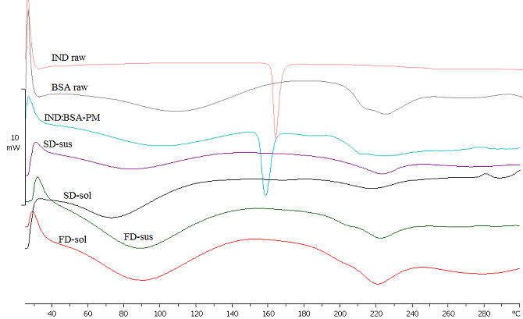

Fig. 1: DSC thermograms of IND raw material, BSA raw material, IND:BSA-PM, SD-sus, SD-sol, FD-sus, and FD-sol.

The solid state of IND in the BSA matrix was also examined using the XRD as shown in Fig. 2. The XRD pattern of pure BSA did not show any high-intensity diffraction peaks indicating its amorphous state. On the other hand, the XRD pattern of pure IND exhibits characteristic high-intensity diffraction peaks corresponding to γ-IND crystal structure (Aceves-Hernandez et al.). The same characteristic peaks were identified in the XRD pattern of IND:BSA-PM (Fig. 2). However, the XRD patterns of both spray dried and freeze dried IND:BSA solid dispersions show the complete disappearance of all the characteristic crystalline peaks of IND (Fig. 2).

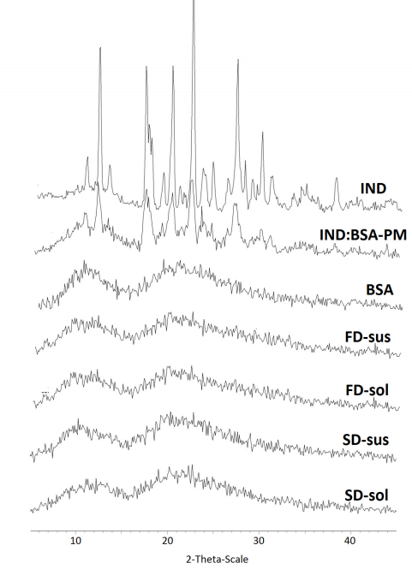

Fig. 2: X-ray powder diffraction spectra of IND raw material, BSA raw material, IND:BSA-PM, SD-sus, SD-sol, FD-sus, and FD-sol.

The surface morphology of IND, BSA and IND-BSA solid dispersions powders was examined using scanning electron microscopy (Fig. 3). SEM images of pure IND showed irregular shaped crystals whereas BSA SEM image revealed big plate-like chunks (Fig. 3a-b). The SEM images of FD-sol and FD-sus powder revealed ribbon-like and plate-like structures, respectively, without any evidence of crystallinity (Fig. 3c-d). SD-sol displayed rounded and smooth microparticles with an average size inferior to 2 µm and a single hole at their surface (Fig. 3e). On the other hand, SD-sus powder displayed a smaller average size and slightly rougher surface with a complete absence of the holes (Fig. 3f).

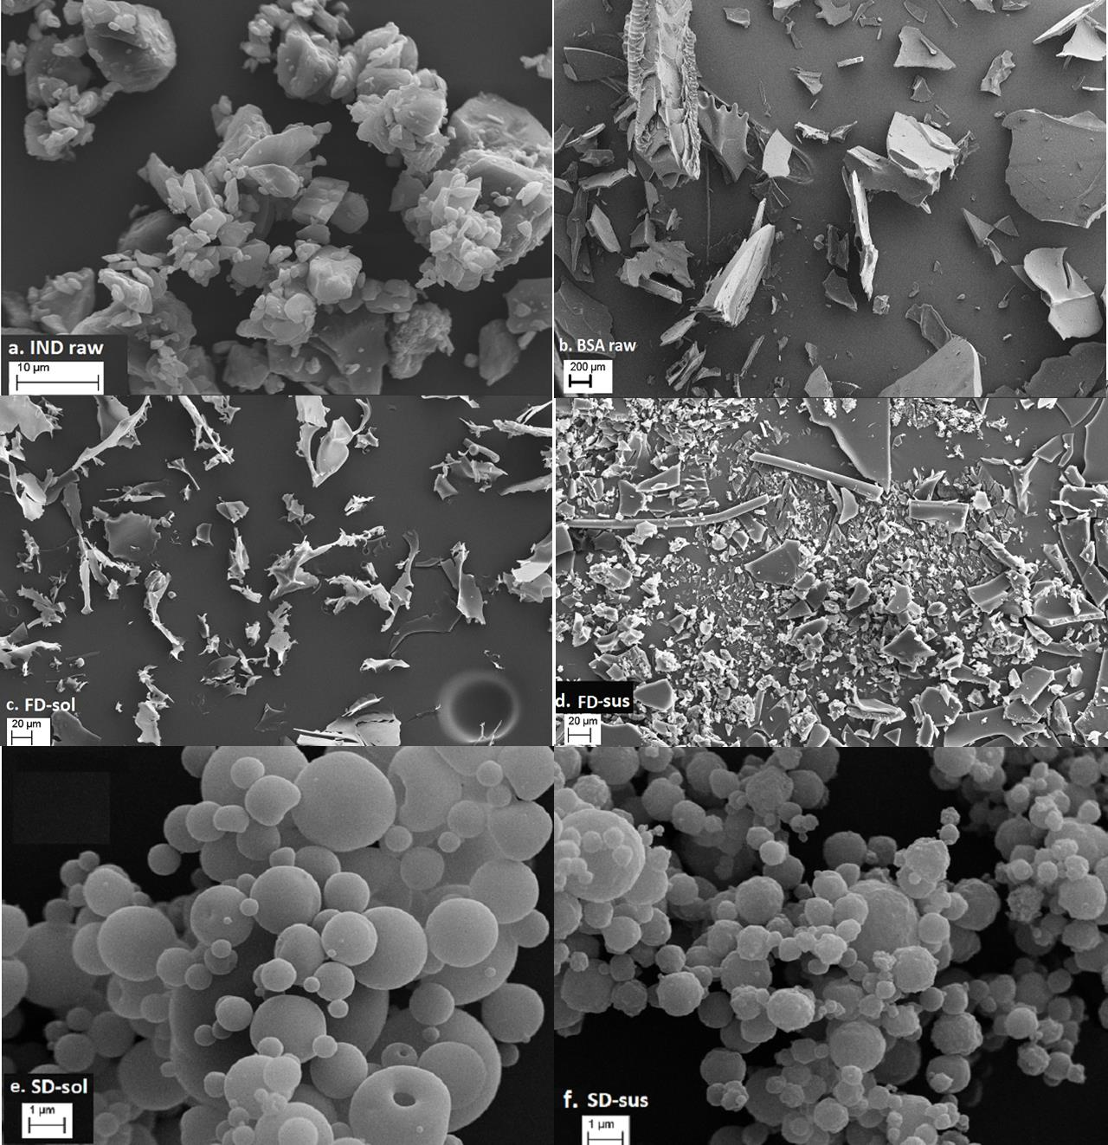

Fig. 3: Representative SEM images of (a) IND raw material (scale bar 10µm), (b) BSA raw material (scale bar 200 µm), (d) FD-sol (scale bar 100µm), and (e) FD-sus (scale bar 100µm) (e) SD-sol (scale bar 1µm), and (f) SD-sus (scale bar 1µm).

* 1. *Solubility studies*
* *IND-BSA physical mixture*

The concentrations of dissolved IND (mg/L) as a function of BSA concentration (mM) are shown in the Fig. 4a. The addition of increased amounts of BSA to water led to a significant and steady increase in IND concentrations (*P<0.05*). The initial solubility of IND, without any addition of BSA, was around 0.8 mg/L similar to published literature (Samuel H. Yalkowsky, 2010)(Samuel H. Yalkowsky, 2010). However, IND solubility increased significantly to 5270 mg/L with an enhancement factor of 6500 fold in the presence of 3.6 mM BSA (24% w/v of BSA in water) (Fig. 4a). Visually, the enhanced solubility of IND resulted in higher yellow colour intensity of the solutions; as the BSA concentration increased, more IND dissolved and the yellow colour of the resulting solution became more intense (Fig. 4c).



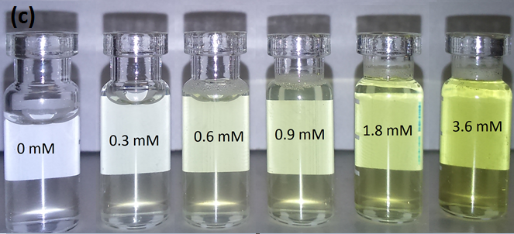

Fig. 4: (a) IND solubility (mg/L) at 25 °C in water as a function of the BSA concentration (mM) (physical mixture). (b) Phase solubility diagrams of BSA/IND (physical mixture). (Mean ± SD; n=3). (c) IND water solutions in the presence of mm BSA in serial concentrations (physical mixture).

For better understanding of the solubility data, the phase solubility diagram was constructed by plotting the total molar concentration of dissolved IND against the total molar concentration of BSA (Fig. 4b). The phase solubility diagram revealed a linear relationship with an “AL-type” and a slope of ~ 4, demonstrating that each albumin molecule dissolves four IND molecules (Higuchi, 1965). The binding constant (K), which reflects the strength of the binding interaction, can be determined from the solubility diagram using the slope and the drug initial solubility (S0), i.e. drug solubility when no BSA is present (Loftsson et al., 2005):

K = slope / [S0 (1 - slope)]

The BSA-IND binding constant estimated from the solubility diagram was ~ 6*105 mole-1, which is also in accordance with previous reports (Khodarahmi et al., 2012; Trivedi et al., 1999). IND solubility was also evaluated in a phosphate buffer (pH 7); although the IND solubility increased significantly to 472 mg/L (data not shown), this was significantly lower than the solubility enhancements obtained in BSA solutions.

* *IND-BSA solid dispersions*

IND-BSA solid dispersions were prepared by both spray drying and freeze drying techniques using IND-BSA solution at (20:1 MR) which is 5 folds higher than the association stoichiometry (4:1) described in the previous section. Fig. 5a shows that IND solubility increased significantly after being formulated in SD-sol and FD-sol compared to that gained by the physical mixture (*P<0.001*). Furthermore, FD-sol resulted in significantly higher solubility (*P<0.05*) compared to that of SD-sol (Fig. 5a). IND solubility was improved ~20,000 fold by SD-sol and ~24,000 folds by FD-sol when BSA is added at 3.6 mM (the highest in this study) (Fig. 5). The phase solubility diagrams revealed linear relationships with slopes of 12.5 and 14.2 in the case of SD-sol and FD-sol, respectively (Fig. 5c). This means that each albumin molecule dissolved 12 to 14 IND molecules. As the MR of IND:BSA solution used to prepare the solid dispersions is (20:1) and each BSA molecule dissolves 12 to 14 IND molecules; thus, 60 to 70 % of the total amount of IND loaded in the formulations was dissolved after the reconstitution in water.

To explore a potential higher solubility of IND, the MR of IND:BSA in the solid dispersions was increased from (20:1) to (100:1). Increasing the amount of IND required a higher volume of ethanol as co-solvent in the initial step of the formulation. This resulted in unfolded BSA molecules forming a colloidal suspension in water. It is worth to mention that the complete precipitation “separation” of BSA must be avoided, as this will reduce the interaction with the drug during the drying process and yield a solubility enhancement comparable to what was attained by physical mixture study (data not shown). Additionally, the fully precipitated BSA will hinder the spray drying process.



Fig. 5: IND solubility (mg/L) in water 25 °C as a function of the BSA concentration (mM): (a) IND:BSA-PM, SD-sol and FD-sol. (b) IND:BSA-PM, SD-sus and FD-sus. (Mean ± SD; n=3). BSA/IND phase solubility diagrams: (c) Fd-sol and SD-sol. (Mean ± SD; n=3). (d) BSA/IND phase solubility diagrams of Fd-sus and SD-sus.

Fig. 5b shows the dissolved amounts of IND (mg/L) as a function of BSA concentrations (mM) for IND:BSA physical mixture (PM), SD-sus and FD-sus. IND solubility increased significantly after increasing the IND:BSA MR to (100:1) (*P<0.001*) (Fig. 5b). Interestingly, and in accordance with the formulations dried from BSA solutions, the solid dispersion prepared by freeze drying (FD-sus) offered significantly higher solubility of IND (up to 100,000 folds) compared to that of spray drying technique (up to 71,000 folds). The phase solubility diagrams of IND:BSA 100:1 ratio revealed linear relationships with the slopes of 45 and 63 for SD-sus and FD-sus, respectively (Fig. 5d). Accordingly, each BSA molecule would dissolve between 40 and 60 molecules of IND. Since an IND:BSA suspension of (100:1 MR) was used to prepare the solid dispersion and each BSA molecule dissolves 40 to 60 IND molecules, almost 40 to 60 % of IND amount loaded in the SD-sus and FD-sus was dissolved after reconstituting in water.

* 1. *Dissolution and release studies*

Fig. 6a shows the dissolution profiles of IND (raw material), SD-sol and FD-sol, in phosphate buffer (pH 7) at 37 °C. The dissolution rate of IND was relatively slower than those of SD-sol and FD-sol with almost 70% dissolved after 1h (Fig. 6a). On the other hand, formulating IND in BSA solid dispersions resulted in an immediate dissolution with almost 95% dissolved within the first 5 minutes.



Fig. 6: (a): In-vitro dissolution profiles of IND as raw material, SD-sol and FD-sol in phosphate buffer pH 7. (b): In-vitro release profiles of IND from aqueous solution, SD-sol solution and FD-sol solution. (Mean ± SD; n=3).

*In-vitro* release of IND from BSA solid dispersions was evaluated across a semi-permeable membrane using vertical Franz diffusion cells under physiological conditions (phosphate buffer-pH 7 at 37 °C). Fig. 6b shows that IND release kinetics from both SD-sol and FD-sol solutions were similar to that of IND aqueous solution. At the end of 6 h, approximately 50% of IND was diffused to the receptor compartments of Franz cells, regardless the presence of BSA.

1. **Discussion**

Particle-based solid dispersion is an established technology used to enhance drugs solubility. Converting the drug into the amorphous state and the drug-carrier interactions are the instrumental factors in the design and performance of the relevant solid dispersion (Graeser et al., 2010; Huang and Dai, 2014). Because of the higher Gibbs free energy of the amorphous form, the energy required to dissolve the drug from amorphous state is far less than that required for the equivalent amount from the crystalline state (Hancock and Zografi, 1997). In addition, the hydrophilic surrounding matrix provided by the carrier (BSA) is expected to have a positive impact on the drug solubility and dissolution rate. In this study, two different particle engineering technologies were used to prepare IND:BSA solid dispersions; spray drying and freeze drying. The molecular proximity produced during the drying process is thought to promote additional interactions between BSA and IND, hence, improve the drug solubility further. The use of two different drying mechanisms might lead to different interactions between IND and BSA, hence, different solubility enhancement. In spray drying, the solvent removal takes place in milliseconds preventing phase separation between the drug and the carrier, while freeze dying involves the sample freezing followed by a very slow drying process taking place under low temperature and pressure.

The yellow colour of the obtained solid dispersions and the results of the SEM, DSC, and XRD (Fig. 1-3) indicate all the transformation of IND into the amorphous or/and molecular state within the BSA matrix (Cavallari et al., 2005). A typical difference has been observed between the surface morphology of the microparticles spray dried from solution and those spray dried from suspension. The presence of a single indentation in the surface of SD-sol microparticles could be explained by the formation of a skin-like outer layer on the droplet surface during the early stage of the drying process (Fig. 3). This layer reduces the evaporating rate, hence, the cooling effect inside the droplet. As a result, a considerable rise in temperature and vapour pressure takes place inside the particle until the formed skin-like shell cracks open to allow vapour escaping. This results in a sudden under-pressure within the particle cavity causing the shell indentation (Walzel and Furuta, 2011). In the case of SD-sus microparticles, the presence of dispersed insoluble particles in the droplet renders the crust formed by drying process more diffusible (Fig. 3). This produces a permeable outer layer allowing a progressive evaporation of the liquid. As a result, the drying process, executing from the outer shell, reduces the size of the droplet steadily and this leads to the absence of holes in smaller size microparticles (Walzel and Furuta, 2011).

Pure IND showed a very poor solubility in water. This might be due to the crystalline state and its highly lipophilic properties. However, the results shown in present work demonstrated clearly the positive impact of the addition of increased amount of BSA on the aqueous solubility of IND. BSA solutions have a weak buffer capacity with a pH ranging from 5.2 to 7 (Curvale, 2009). Therefore, IND molecules, as weak acid (p*K*a 3.8), might undergo a considerable dissociation in BSA solution. Consequently, this might lead to IND solubility enhancement. In order to test this hypothesis, IND solubility was evaluated in phosphate buffer (pH 7). Although IND solubility increased significantly in phosphate buffer (up to 472 mg/L) (data not shown), this was significantly lower than the solubility enhancements obtained in BSA solutions (Fig. 4). This suggests that IND enhanced solubility in BSA solutions is not mainly dependent on the dissociation of IND molecules and that other solubility enhancing mechanisms could be involved, i.e. salt and binding complex formation. It has been reported that several IND molecules may bind to one albumin molecule, suggesting that IND:BSA binding process might be more complicated than the simple accommodation of an IND molecule in the hydrophobic cavity of albumin (Curry, 2002; Ghuman et al., 2005). Several interaction bonds may contribute in IND:BSA binding process, including hydrophobic interactions, hydrophilic interactions and salt bridges formation (Bogdan et al., 2008; Zhang et al., 2012). However, according to Trivedi et al., the major forces involved in IND-albumin binding are the hydrophilic forces for the first molecule of IND, followed by the formation of salt bridges between IND carboxylate groups and the positively charged residues of buried lysine in BSA molecules (Trivedi et al., 1999). According to our results, each BSA molecule would provide three to four accessible lysine residues to interact with IND molecules and lead to the formation of highly soluble IND:BSA salt. Therefore, the salt bridges formation, IND-BSA binding, and to less extent IND ionisation are thought to be main reasons for the IND solubility enhancement observed in BSA solutions.

The preparation of BSA-IND solid dispersions helped to enhance the solubility of IND significantly compared to that of the physical mixture samples (Fig. 5). Indeed, increasing IND:BSA molar ratio (to 20:1 and then to 100:1) and the extreme molecular proximity produced during the drying process are thought to promote the formation of additional salt bridges between the carboxylate groups of IND and the positively charged residues of BSA. Furthermore, the use of ethanol as co-solvent and the increased acidity caused by the co-dissolving of IND in BSA solution, might lead to conformational changes and then the unfolding of BSA molecule. Consequently, more buried lysine residues are exposed to the surface making them more accessible for interacting with indometacin (Edwards-Lévy et al., 1993). Interestingly, the solid dispersions prepared by freeze drying offered significantly higher solubility of IND compared to those prepared by of spray drying technique. This might be attributed to the ultra-fast liquid nitrogen freezing followed by a soft and slow freeze drying process preserving the molecular distribution and interactions between IND and BSA molecules (Wanning et al., 2015). Although having the same pH (data not shown), solid dispersions samples displayed higher IND solubility compared to that of the physical mixture samples. This confirms the limited role of the albumin pH and buffer capacity in IND solubilisation. The solubility enhancement achieved by formulating IND in BSA solid dispersions (up to 100,000 folds, Fig. 5) is significantly higher than all other enhancements achieved by other strategies, such as the hydrophilic polymers solid dispersion (~4 fold), cyclodixtrine complexing (~10 folds), complexation with polymers (up to 10 folds), and the use of amino acid as counterions (up to 10000 folds) (El-Badry et al., 2009; ElShaer et al., 2011; Lin et al., 1991; Shibata et al., 2009).

The preparation of IND-BSA solid dispersions led to an effective enhancement in the dissolution rate of IND (Fig. 6a). It is generally believed that the drug in amorphous state homogenously dispersed within a hydrophilic carrier enhances the dissolution rate effectively (Graeser et al., 2010). Besides, the formation of salt bridges might also help protect the molecular state “solid solution” of IND in BSA matrix. As a result, the step of drug dissolution is bypassed resulting in the immediate dissolution reported in this study (Fig. 6a) (Fotaki et al., 2014). After dissolution, the drug release from albumin complex is essential to allow an immediate absorption, hence, improved bioavailability. The release experiment confirmed the ability of BSA to immediately release the bound IND. The concentration gradient and the osmotic pressure driving forces on both sides of the membrane seemed to be high enough to dissociate the IND molecules and render them immediately available for diffusion through the cellulosic membrane mounted to Franz diffusion cell (Fig. 6b). This reflects the weakness the intermolecular forces associating IND to BSA molecules.

1. **Conclusion**

In this study, the use of BSA as a solubility enhancer of IND, a model drug, was demonstrated. In a physical mixture of both, the solubility of IND was found to be dependent on the concentration of BSA. Particle engineering techniques such as spray drying and freeze drying, used to prepare solid dispersions of IND in BSA, were of great importance in producing significant enhancement in drug solubility compared to that of aforementioned physical mixture. Solid dispersions prepared from IND:BSA suspensions (100:1 MR) showed superior drug solubility compared to that made from IND:BSA solutions (20:1MR). Furthermore, freeze drying technique was found to yield solid dispersions having significantly higher solubility than that of the corresponding ones prepared by spray drying. Particle engineering techniques were found to transform the drug into an amorphous state and the drug-albumin interactions were believed to include hydrophobic interactions, hydrophilic interactions and salt bridges formation. *In-vitro* dissolution studies showed a significant increase in the dissolution rate of IND from solid dispersions compared to that of the free drug, and an immediate release of IND from BSA solid dispersions was reported. Overall, the results demonstrated the importance of particle engineering technology to prepare albumin-drug solid dispersions as a method of enhancing the solubility and the dissolution of poorly water soluble drugs. Future work may include investigating the use of albumin solid dispersion to enhance the solubility of poorly water soluble drugs that are lipid soluble or none-ionised. Additionally, stability, storage and cost effectiveness investigations need to be realised in order to explore the potential applications of the albumin use to improve drugs solubility.

**References**

Aceves-Hernandez, J.M., Nicolás-Vázquez, I., Aceves, F.J., Hinojosa-Torres, J., Paz, M., Castaño, V.M., Indomethacin polymorphs: Experimental and conformational analysis. Journal of Pharmaceutical Sciences 98, 2448-2463.

Bellantone, A.R., 2014. Fundamentals of Amorphous Systems: Thermodynamic Aspects, in: Shah, N., Sandhu, H., Choi, S.D., Chokshi, H., Malick, W.A. (Eds.), Amorphous Solid Dispersions: Theory and Practice. Springer New York, New York, NY, pp. 3-34.

Bogdan, M., Pirnau, A., Floare, C., Bugeac, C., 2008. Binding interaction of indomethacin with human serum albumin. Journal of Pharmaceutical and Biomedical Analysis 47, 981-984.

Bosselmann, S., Williams, R.O., 2012. Route-Specific Challenges in the Delivery of Poorly Water-Soluble Drugs, in: Williams Iii, O.R., Watts, B.A., Miller, A.D. (Eds.), Formulating Poorly Water Soluble Drugs. Springer New York, New York, NY, pp. 1-26.

Cavallari, C., Albertini, B., Rodriguez, L., Rabasco, A.M., Fini, A., 2005. Release of indomethacin from ultrasound dry granules containing lactose-based excipients. Journal of Controlled Release 102, 39-47.

Chen, H., Khemtong, C., Yang, X., Chang, X., Gao, J., 2011. Nanonization strategies for poorly water-soluble drugs. Drug Discovery Today 16, 354-360.

Curry, S., 2002. Beyond Expansion: Structural Studies on the Transport Roles of Human Serum Albumin. Vox Sanguinis 83, 315-319.

Curvale, R.A., 2009. Buffer Capacity of Bovine Serum Albumin (BSA) The Journal of Argentine Chemical Society 97 (1), 174-180.

Del Valle, E.M.M., 2004. Cyclodextrins and their uses: a review. Process Biochemistry 39, 1033-1046.

Devang, S., Sundeep, P., Muralikrishna, M., Gajendra, C., Murali, S., Ajay, S., Matthew, G.S., John, H., Roy, H., Punit, M., Sandhya, M., 2014. A Systematic Evaluation of Solubility Enhancing Excipients to Enable the Generation of Permeability Data for Poorly Soluble Compounds in Caco-2 Model. Drug Metabolism Letters 8, 109-118.

Edwards-Lévy, F., Andry, M.C., Lévy, M.C., 1993. Determination of free amino group content of serum albumin microcapsules using trinitrobenzenesulfonic acid: effect of variations in polycondensation pH. International Journal of Pharmaceutics 96, 85-90.

El-Badry, M., Fetih, G., Fathy, M., 2009. Improvement of solubility and dissolution rate of indomethacin by solid dispersions in Gelucire 50/13 and PEG4000. Saudi Pharmaceutical Journal 17, 217-225.

ElShaer, A., Khan, S., Perumal, D., Hanson, P., R. Mohammed, A., 2011. Use of Amino Acids as Counterions Improves the Solubility of the BCS II Model Drug, Indomethacin. Current Drug Delivery 8, 363-372.

Evans, T.W., 2002. Review article: albumin as a drug—biological effects of albumin unrelated to oncotic pressure. Alimentary Pharmacology & Therapeutics 16, 6-11.

Fotaki, N., Long, M.C., Tang, K., Chokshi, H., 2014. Dissolution of Amorphous Solid Dispersions: Theory and Practice, in: Shah, N., Sandhu, H., Choi, S.D., Chokshi, H., Malick, W.A. (Eds.), Amorphous Solid Dispersions: Theory and Practice. Springer New York, New York, NY, pp. 487-514.

Ghuman, J., Zunszain, P.A., Petitpas, I., Bhattacharya, A.A., Otagiri, M., Curry, S., 2005. Structural Basis of the Drug-binding Specificity of Human Serum Albumin. Journal of Molecular Biology 353, 38-52.

Graeser, K.A., Patterson, J.E., Zeitler, J.A., Rades, T., 2010. The Role of Configurational Entropy in Amorphous Systems. Pharmaceutics.

Hancock, B.C., Zografi, G., 1997. Characteristics and Significance of the Amorphous State in Pharmaceutical Systems. Journal of Pharmaceutical Sciences 86, 1-12.

Heinz, A., Savolainen, M., Rades, T., Strachan, C.J., 2007. Quantifying ternary mixtures of different solid-state forms of indomethacin by Raman and near-infrared spectroscopy. European Journal of Pharmaceutical Sciences 32, 182-192.

Higuchi, T., 1965. Advances in Analytical Chemistry and Instrumentation, Chapter 4. Phase Solubility Studies. 117-212

Huang, Y., Dai, W.-G., 2014. Fundamental aspects of solid dispersion technology for poorly soluble drugs. Acta Pharmaceutica Sinica B 4, 18-25.

Junghanns, J.-U.A.H., Müller, R.H., 2008. Nanocrystal technology, drug delivery and clinical applications. International Journal of Nanomedicine 3, 295-310.

Khodarahmi, R., Karimi, S.A., Ashrafi Kooshk, M.R., Ghadami, S.A., Ghobadi, S., Amani, M., 2012. Comparative spectroscopic studies on drug binding characteristics and protein surface hydrophobicity of native and modified forms of bovine serum albumin: Possible relevance to change in protein structure/function upon non-enzymatic glycation. Spectrochimica Acta Part A: Molecular and Biomolecular Spectroscopy 89, 177-186.

Kim, T.H., Jiang, H.H., Youn, Y.S., Park, C.W., Tak, K.K., Lee, S., Kim, H., Jon, S., Chen, X., Lee, K.C., 2011. Preparation and characterization of water-soluble albumin-bound curcumin nanoparticles with improved antitumor activity. International Journal of Pharmaceutics 403, 285-291.

Li, J., Yao, P., 2009. Self-Assembly of Ibuprofen and Bovine Serum Albumin−Dextran Conjugates Leading to Effective Loading of the Drug. Langmuir 25, 6385-6391.

Lin, S.-Z., Wouessidjewe, D., Poelman, M.-C., Duchêne, D., 1991. Indomethacin and cyclodextrin complexes. International Journal of Pharmaceutics 69, 211-219.

Liu, Z., Chen, X., 2016. Simple bioconjugate chemistry serves great clinical advances: albumin as a versatile platform for diagnosis and precision therapy. Chemical Society Reviews 45, 1432-1456.

Loftsson, T., Jarho, P., Masson, M., Jarvinen, T., 2005. Cyclodextrins in drug delivery. Expert Opin Drug Deliv 2, 335-351.

Owen, I.C., 2013. Salt Forms: Pharmaceutical Aspects, Encyclopedia of Pharmaceutical Technology, Third Edition. Taylor & Francis, pp. 3177-3187.

Peters Jr, T., 1995. 3 - Ligand Binding by Albumin, All About Albumin. Academic Press, San Diego, pp. 76-132.

Phelps, R.A., Putnam, F.W., 1960. Chapter 5 - Chemical Composition and Molecular Parameters of Purified Plasma Proteins, The Plasma Proteins. Academic Press, pp. 143-178.

Samuel H. Yalkowsky, Y.H., and Parijat Jain, 2010. Handbook of Aqueous Solubility Data, Second Edition, in: 2010, C.P. (Ed.), Handbook of Aqueous Solubility Data, Second Edition. CRC Press.

Serajuddin, A.T.M., 2007. Salt formation to improve drug solubility. Advanced Drug Delivery Reviews 59, 603-616.

Shibata, Y., Fujii, M., Sugamura, Y., Yoshikawa, R., Fujimoto, S., Nakanishi, S., Motosugi, Y., Koizumi, N., Yamada, M., Ouchi, K., Watanabe, Y., 2009. The preparation of a solid dispersion powder of indomethacin with crospovidone using a twin-screw extruder or kneader. International Journal of Pharmaceutics 365, 53-60.

Strickley, R.G., 2004. Solubilizing Excipients in Oral and Injectable Formulations. Pharmaceutical Research 21, 201-230.

Trivedi, V.D., Vorum, H., HonorÉ, B., Qasim, M.A., 1999. Molecular Basis of Indomethacin-Human Serum Albumin Interaction. Journal of Pharmacy and Pharmacology 51, 591-600.

Urien, S., Tillement, J.-P., Barré, J., 2007. The Significance of Plasma-Protein Binding in Drug Research, Pharmacokinetic Optimization in Drug Research. Verlag Helvetica Chimica Acta, pp. 189-197.

Walzel, P., Furuta, T., 2011. Morphology and Properties of Spray-Dried Particles, Modern Drying Technology. Wiley-VCH Verlag GmbH & Co. KGaA, pp. 231-294.

Wanning, S., Süverkrüp, R., Lamprecht, A., 2015. Pharmaceutical spray freeze drying. International Journal of Pharmaceutics 488, 136-153.

Yu, Z., Yu, M., Zhang, Z., Hong, G., Xiong, Q., 2014. Bovine serum albumin nanoparticles as controlled release carrier for local drug delivery to the inner ear. Nanoscale Research Letters 9, 1-7.

Zhang, J., Sun, H.-H., Zhang, Y.-Z., Yang, L.-Y., Dai, J., Liu, Y., 2012. Interaction of Human Serum Albumin with Indomethacin: Spectroscopic and Molecular Modeling Studies. Journal of Solution Chemistry 41, 422-435.

**Acknowledgments**

This work was supported by Kingston University and the Council for At-Risk Academics (CARA).

**Legend** **to Figures**

Fig. 1: DSC thermograms of IND raw material, BSA raw material, IND:BSA-PM, SD-sus, SD-sol, FD-sus, and FD-sol.

Fig. 2: X-ray powder diffraction spectra of IND raw material, BSA raw material, IND:BSA-PM, SD-sus, SD-sol, FD-sus, and FD-sol.

Fig. 3: Representative SEM images of (a) IND raw material (scale bar 10µm), (b) BSA raw material (scale bar 200 µm), (d) FD-sol (scale bar 100µm), and (e) FD-sus (scale bar 100µm) (e) SD-sol (scale bar 1µm), and (f) SD-sus (scale bar 1µm).

Fig. 4: (a) IND solubility (mg/L) at 25 °C in water as a function of the BSA concentration (mM) (physical mixture). (b) Phase solubility diagrams of BSA/IND (physical mixture). (Mean ± SD; n=3). (c) IND water solutions in the presence of mm BSA in serial concentrations (physical mixture).

Fig. 5: IND solubility (mg/L) in water 25 °C as a function of the BSA concentration (mM): (a) IND:BSA-PM, SD-sol and FD-sol. (b) IND:BSA-PM, SD-sus and FD-sus. (Mean ± SD; n=3). BSA/IND phase solubility diagrams: (c) Fd-sol and SD-sol. (Mean ± SD; n=3). (d) BSA/IND phase solubility diagrams of Fd-sus and SD-sus.

Fig. 6: (a): In-vitro dissolution profiles of IND as raw material, SD-sol and FD-sol in phosphate buffer pH 7. (b): In-vitro release profiles of IND from aqueous solution, SD-sol solution and FD-sol solution. (Mean ± SD; n=3).