Strength analysis of aluminium foil parts made by composite metal foil manufacturing

Javaid Butt (Corresponding Author)
Engineering & Built Environment, Anglia Ruskin University, Bishop Hall Lane, CM1 1SQ, Chelmsford, United Kingdom
javaid.butt@anglia.ac.uk
+44 7708267550
+44 845 196 3983
Habtom Mebrahtu
Engineering & Built Environment, Anglia Ruskin University, Bishop Hall Lane, CM1 1SQ, Chelmsford, United Kingdom
habtom.mebrahtu@anglia.ac.uk
+44 845 196 3910
Hassan Shirvani
Engineering & Built Environment, Anglia Ruskin University, Bishop Hall Lane, CM1 1SQ, Chelmsford, United Kingdom
hassan.shirvani@anglia.ac.uk
+44 845 196 3900

Abstract
A number of different parts for mechanical testing were produced using Composite Metal Foil Manufacturing (CMFM). This process is a combination of Laminated Object Manufacturing and brazing technology. Aluminium is one of the toughest metals to join and CMFM can achieve this task with ease. By using aluminium 1050 foils of 0.1mm thickness, various parts were made according to British and International Standards, including lap joints, peel specimens, dog-bone specimens and tested for their mechanical properties. A special, 80% zinc and 20% aluminium by weight, brazing paste was utilized for joining the foils together. The test of the single lap joints show that none of the specimens failed at the bonded area and the failure was always due to fracture of the parent metal. Cohesive failure was also observed for the single lap joints by using 10mm thick aluminium metal plates. It helped in calculating the lap shear strength which is a useful design parameter. The peel test showed good bond consistency in all the specimens with an average peel strength of 20 MPa. Comparative tensile test was conducted with a dog-bone specimen machined from a solid block of aluminium 1050 and specimens made with CMFM. The results showed that the specimens made by CMFM fracture at force values that are higher than that of the parent metal. This demonstrate that CMFM has the capability to produce high quality and stronger parts as compared to conventional machining methods employed for the production of metal parts. The effect of using different number of layers for the same cross-sectional area has also been investigated.

KEYWORDS: Additive manufacturing, Brazing, Laminated object manufacturing, Lap-shear testing, Metal foil, Metal parts, Peel test, Tensile testing

Introduction
Additive Manufacturing (AM) of metal parts provide solutions to real world problems as they can be tested under similar conditions to show their behaviour. A large number of AM processes are commercially available that use plastics, polymers, photopolymers, ceramics etc. to produce parts [1-5]. These parts mainly serve as prototypes and do not give any insight into the design parameters. There has always been an emphasis on the production of metal parts using AM because it provides an environment for direct testing. Furthermore, AM methods can produce complex geometries like conformal cooling channels for injection moulding, which are not possible with conventional machining/subtractive techniques. A couple of commercially available AM processes capable of producing metal parts are Direct Metal Laser Sintering (DMLS) and Electron beam Melting (EBM). They use powder metals and have been widely researched over the years [6-9]. Although these technologies are capable of producing good quality parts, they still do not ease the pressure when it comes to the production of metal parts because of the very high cost of their machines and inability to cope with the material requirements [10, 11]. They have a number of limitations like materials, particular grain size of powder metal to achieve certain degree of mechanical integrity, size of parts being made, build speed, surface finish etc. Also, after production, the powder removal process requires more time and thus reduces the efficiency of the process [12, 13]. Therefore, efforts were made to overcome these limitations and other AM technologies were pursued. This idea led to the modification of Laminated Object Manufacturing (LOM). The LOM method originally made use of paper sheets with adhesives on one side but since the setup was cheap, further materials including plastic and metal laminates were experimented with, to enhance the capabilities of this technology [14]. One such method is known as Metal Foil LOM (Laminated Object Manufacturing) and uses metal sheets for the production of parts. It was an experimental approach that was aimed at the production of large moulds. For the structural stability of the parts, Metal Foil LOM can only work with foils having a thickness of more than 0.5mm as anything less than that results in a significant staircase effect. The produced parts are not of very good quality either and have a poor surface finish. Post processing is required to improve the mechanical properties of the parts which makes the process inefficient [15, 16]. Epoxy adhesives and glues have also been used to join metals sheets together using LOM but the produced parts are far from perfect in terms of their material properties and in some cases serious failures have occurred [17, 18]. Another method that has shown promise is known as Ultrasonic Consolidation (UC). It has shown great promise in working with difficult metals like aluminium and stainless steel. It combines ultrasonic seam welding of metals and layered manufacturing techniques to build up a solid freeform object. The process uses a sonotrode connected to a transducer to apply pressure and ultrasonic oscillations for bonding. The process is repeated until the required height is achieved and then a CNC (Computer Numerical Control) mill is used to trim the excess foil from the component and achieve the required geometry. Another finishing mill is brought into action to create the required tolerance and surface finish. After the trimming and finishing, the finished part is removed from the anvil [19, 20]. The biggest challenge of this process is optimization of the process for bond density and plastic flow to have a better contact between the foils [21]. All of these processes have been researched upon and parts have been produced using them but they are limited in what they can do and achieve in terms of producing metal parts.
In addition to making metal parts by alternative and cheaper methods, the production of composite materials has been receiving unprecedented attention from the academia, mainstream media, investment community and national governments around the world. Metal composites or metal matrix composites (MMCs) are gaining popularity because a number of industries rely on them to provide cheaper, lighter, and stronger alternatives. AM processes are not far behind in this endeavour either and a number of them have produced MMCs including Selective Laser Melting/Sintering (SLM/ SLS), Laser Engineered Net Shaping (LENS), Three Dimensional Printing (3DP), LOM and UC. However, it required a great degree of additional equipment and time to produce a metal composite using AM processes and their mechanical integrity in some cases is far from ideal [22-24].
This study clearly indicates that there is a gap that needs to be filled when it comes to the production of cheap and high quality metal parts. The limitations related to conventional metal AM methods have to be minimised to make way for better and efficient product development. Another process has joined the list of metal AM methods capable of using metal foils for the production of functional parts and is termed as Composite Metal Foil Manufacturing (CMFM). It combines the simplicity of LOM with the flexibility of brazing. This integration makes the process adaptable to changes. A model of a machine based on the principle of CMFM is shown in Fig. 1. The product development has two stages -- the principles of LOM for cutting and placing of sheets and brazing to join the foils and produce a part. Brazing is similar to soldering but the main difference lies in the operating temperatures as joining operations that are under 450 °C are considered to be soldering and those above 450 °C lies under brazing. Copper, silver, and gold are easy to braze because they have good braze-ability. Iron, mild steel and nickel are next in difficulty. Because of their thin, strong oxide films, stainless steel and aluminium are even more difficult to braze. A detailed description of the process has been presented in our previous research along with the testing of copper foils to establish the effectiveness of the process [25, 26]. To demonstrate the flexibility of the proposed process 0.1mm thick Aluminium 1050 grade foils with a H14 ½ hard temper was chosen for the research work. Aluminium is one of the hardest metals to braze and various aluminium alloys have different braze-ability: 1xxx, 2xxx, 3xxx, 4xxx, and 7xxx are easier to braze than the 6xxx series alloys. Magnesium content in the 5xxx series alloys makes them the most difficult to braze. It is because in addition to the oxide layer of aluminium, the oxide layer of magnesium needs to be removed as well to perform the brazing process. The magnesium oxide layer also forms on contact with air so instead of one, now there are two layers to remove for joining aluminium alloys containing magnesium [27]. The removal of the oxide layer is the key to the brazing process as once it is removed; the process can go on easily. Aluminium oxide is not so easily removed and requires stronger fluxes that can go up to temperatures of 550 °C. . In case of very thin aluminium foil, which is the case for this research work (0.1mm), there is a danger of pitting so proper care must be given in dealing with such cases. For these reasons, 80% zinc and 20% aluminium by weight brazing paste with non-corrosive flux was chosen to produce aluminium specimens. The melting point of the brazing paste in use ranges between 410 - 470 °C and it becomes liquid in this range. However, it should not be kept at these temperatures for longer periods of time as the flux would burn off and the paste would not be able to penetrate the tenacious oxide layer on the surface of the aluminium foil.
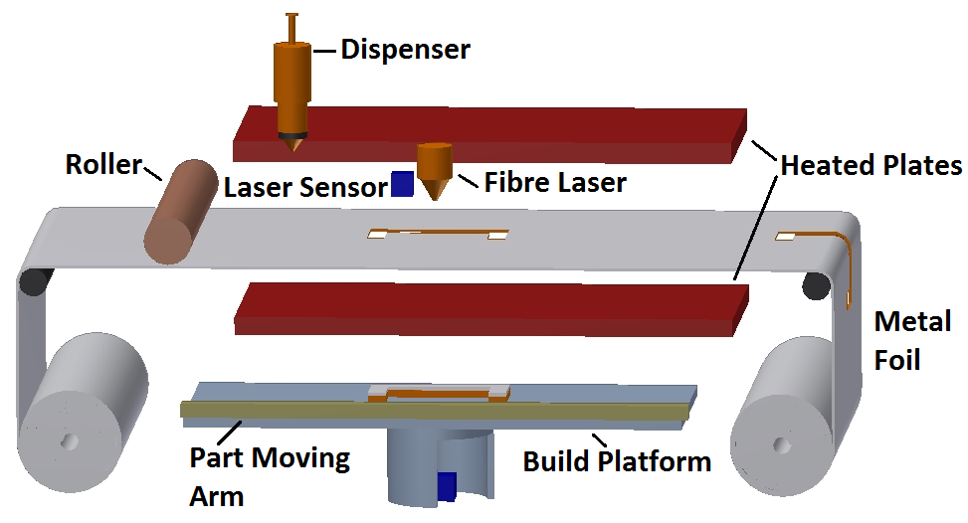
Figure 1: Composite metal foil manufacturing process

Experimental Procedure
CMFM is an extremely complex process and a number of different components have to work together in complete harmony to produce parts. That is why, the complex process was broken down into simple independent steps for practicality. An experimental procedure was devised to create metal parts using metal foils. The use of metal foils make the production of parts very cheap as compared to other AM methods. The process of brazing can be tricky for aluminium, therefore, it was essential that proper care was given to every specimen. The ability of the process to work with difficult metals such as aluminium is what makes it flexible as well as adaptable; two characteristics that are very important in a metal parts manufacturing system.
The foils of aluminium were used as supplied without any surface treatment as it takes time and one of the key features of the process is that it reduces the production time to a great extent compared to other AM methods. The foils were cut and then deposited with brazing paste. Every specimen was sandwiched between two stainless steel plates fitted with nuts and bolts. At any given time, only one specimen was placed inside the plates and a uniform layer of paste was achieved by tightening the nuts with a torque wrench. The use of torque wrench ensured that repeatability can be observed in all the specimens by creating a uniform layer of paste equal to 0.1mm. The plates along with the paste-coated foils were was placed inside a furnace. The structure was heated for a pre-defined time based on the thickness of the specimen being produced and then taken out. No post-processing is required to enhance the mechanical characteristics, therefore, after cooling the specimen could be used for testing. This setup was instrumental in determining some key aspects of the process and helped in eliminating the guesswork when test specimens were made using components of the real machine.
Three tests including lap-shear test, peel test and comparative tensile test were carried out to assess the capability of CMFM while working with difficult metals. Specimens were produced using 0.1mm thick Aluminium 1050 grade foils with a H14 ½ hard temper bonded by a special, 80% zinc and 20% aluminium by weight, brazing paste. Table 1 and Table 2 show the composition and mechanical properties of the materials used. British and International Standards were followed for the production of parts and testing. The tests presented in this research analyse the tensile properties of the specimens and assess the capability of the process in making parts that provide consistent results and better material properties compared to conventional subtractive technologies.
Table 1: Chemical composition of materials
Materials | Chemical composition (in weight %)
 | Cu | Si | Fe | Mn | Mg | V | O | Al
Al 1050 | 0.05 | 0.25 | 0.40 | 0.05 | 0.05 | 0.05 | - | Balance

Table 2: Mechanical properties of materials
Mechanical Properties | Materials
 | Al 1050 H14 | Brazing Paste
Yield Strength (MPa) | 105-145 | 45
Tensile Strength (MPa) | 120 | 60
Young’s Modulus (GPa) | 69 | 60

Tensile Lap-shear Test
Single lap joints using foils of 0.1mm (t) thickness are not generally produced which accounts for the lack of a specific standards for such thickness. However, BS EN 1465: 2009 [28] was followed and INSTRON 5582 machine was operated at a speed of 10mm/min for testing. The dimensions of the specimen are shown in Fig. 2. The thickness of the brazing paste was kept at 0.1mm, therefore, the final thickness of the brazed region will be 0.3mm.
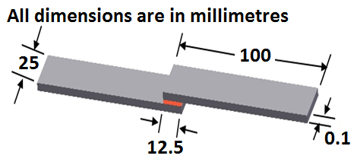
Figure 2: Dimensions of lap joint [28]

Peel Test
BS EN ISO 11339:2010 [29] was followed for the production and testing of the peel specimen. The testing machine was operated at a speed of 10mm/min. The dimensions of the specimen are shown in Fig. 3. The thickness of the paste was kept at 0.1mm which makes the overall thickness of the 150mm bonded region as 0.3mm.
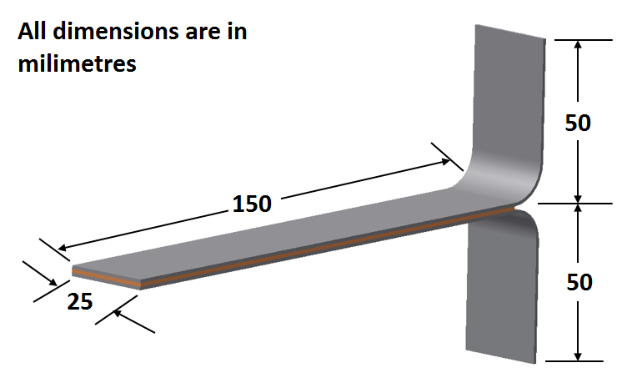
Figure 3: Dimensions of T-peel specimen [29]

Tensile Testing for Dog-bone Specimens
The dog-bone specimens for tensile test were produced in accordance with ISO 6892-1 [30]. A specimen was machined out of a solid aluminium 1050 block and then compared to parts produced by CMFM. Three specimens were produced using foils of 0.05mm, 0.1mm and 0.2mm thickness. The reason for making three different specimens with foils of different thickness is to analyse their effect. The dimensions of the specimen are shown in Fig. 4 whereas Table 3 shows the specification of the three specimens.
Table 3: Specification of the aluminium specimens
Thickness (mm) | Number of foils
0.05 | 18
0.1 | 14
0.2 | 9

For all the specimens the overall thickness was the same but the individual thickness of the foils differ. The thickness of the paste was again kept at 0.1mm.
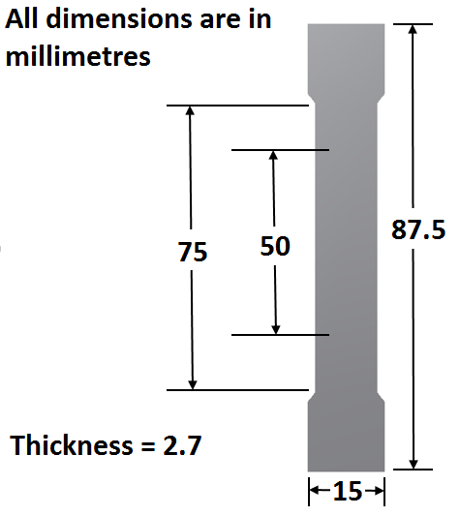
Figure 4: Dimensions of the dog-bone specimen [30]

Results & Discussion

Results from Lap-shear Test
The single lap joints produced by CMFM fractured within the base metal whereas the brazed zone was unaffected. This shows that the bond is stronger than the material. Such a fracture occurred because less force is needed for failure of the single foil compared to the bonded region that has twice the thickness. Lap-shear testing is generally affected by lap joint length, gauge length and asymmetric loading. These factors were kept in check to ensure consistent testing conditions. Fig. 5 shows the failure modes of the lap-shear specimens and the test results are shown in Fig. 6. The failure mode was substrate failure (SF) according to BS EN ISO 10365:1995 [31].

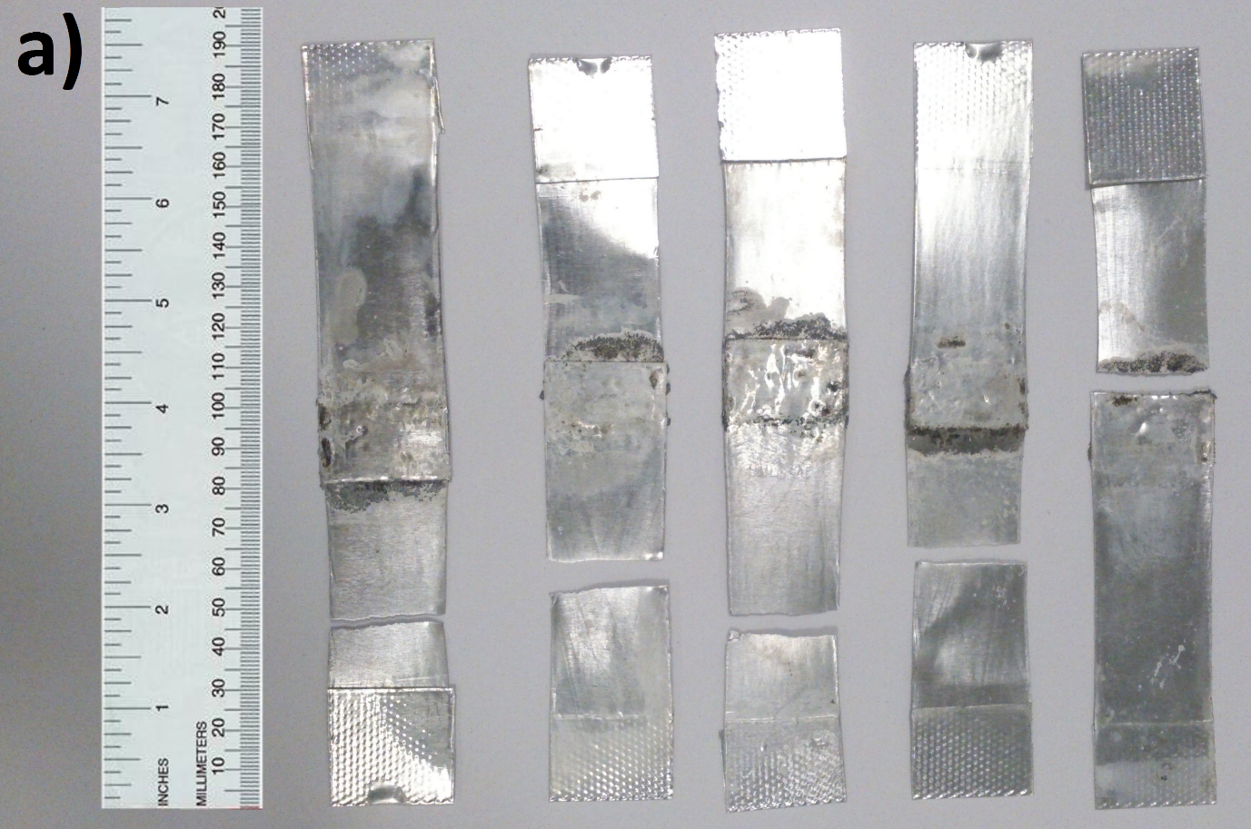
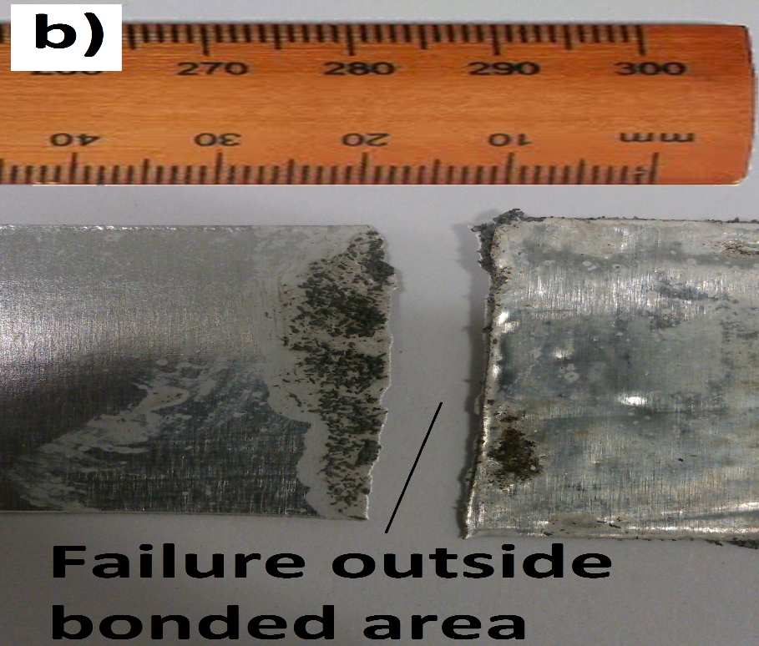
Figure 5: Failure Modes of Lap-Shear Specimens

Figure 6: Lap-Shear Test Results
Two different modes of failure were observed from the testing:
- When the fracture was at the base metal adjacent to the brazed region as seen for S1, S2 and S3. Such a failure is characterized by a smaller displacement range to failure. Smaller displacement range resulted in smaller plastic deformation of the foil before failure. Once a crack was initiated, it ran across the width of the foil to cause fracture.
- When a break occur away from the bonded area. Stretching of the foil on either ends of the bonded area led to a fairly larger displacement range in the case of S4 and S5.

Calculation of lap-shear strength
For industrial applications, tensile lap-shear strength of the bond or in other words joint tensile strength $\left(ϭ\right)$is important, therefore, lap joints with 10mm thick Al 1050 plates were made according to BS EN 1465: 2009. The reason for the mentioned thickness is that anything less than that resulted in substrate failure and calculation of joint tensile strength requires cohesion failure which can be observed with 10mm thick plates.
The bond strength $(Ʈa)$ has been calculated as a maximum shear stress achieved in the bond layer, based on recorded maximum tensile forces for each tested joint:
$Ʈa=Fmax / Length of the lap joint*Width of the substrate$ (1)
The joint tensile strength $(ϭ)$ as a maximum tensile stress transferred crossover the joint:
$ϭ =Fmax / Thickness of the substrate*Width of the substrate$ (2)
The values of the bond shear strength and joint tensile strength are calculated by using equations (1) and (2). They are presented in Table 4.

Table 4: Calculation of joint tensile strength at 12mm overlap length
Specimens | F_{max} (N) | Bond Shear Strength (MPa) | Joint Tensile Strength (MPa )
S26 | 15520 | 51.73 | 62.08
S27 | 15600 | 52 | 62.4
S28 | 16000 | 53.3 | 64
S29 | 15560 | 51.86 | 62.24
S30 | 15900 | 53 | 63.6
 |  | Average = 52.378 | Average = 62.864

The experimental calculation yields shear strength of 52.378 MPa (N/mm²) for the bond produced by the brazing paste used. This value is quite high as compared to some of the industrial adhesives [32] including a very ductile polyurethane adhesive (Sikaflex-255 FC with a shear strength of 8.26 MPa); a very brittle two-component epoxy adhesive (Araldite® AV138/HV998, with a shear strength of 30.2 MPa, from Huntsman), and an intermediate two-component epoxy adhesive (Araldite® 2015, with a shear strength of 15.9 MPa, from Huntsman). The joint tensile strength is 62.864 N/mm² and must be kept in mind while designing products using CMFM.

Results from Peel Test
The bond effectiveness was determined by the peel test. The specimens had a bond thickness of 0.1 mm, therefore, the thickness of each specimen becomes 0.3 mm after it has been produced and is ready for testing. The results of a peel test are generally influenced by peel angle and peel rate, therefore, special care was given to keep them constant for the five specimens. The peel rate was 10mm/min and the peel angle was 180 degrees. Fig. 7 is the graphical representation and Fig. 8 shows the two failure modes observed during the peel test.
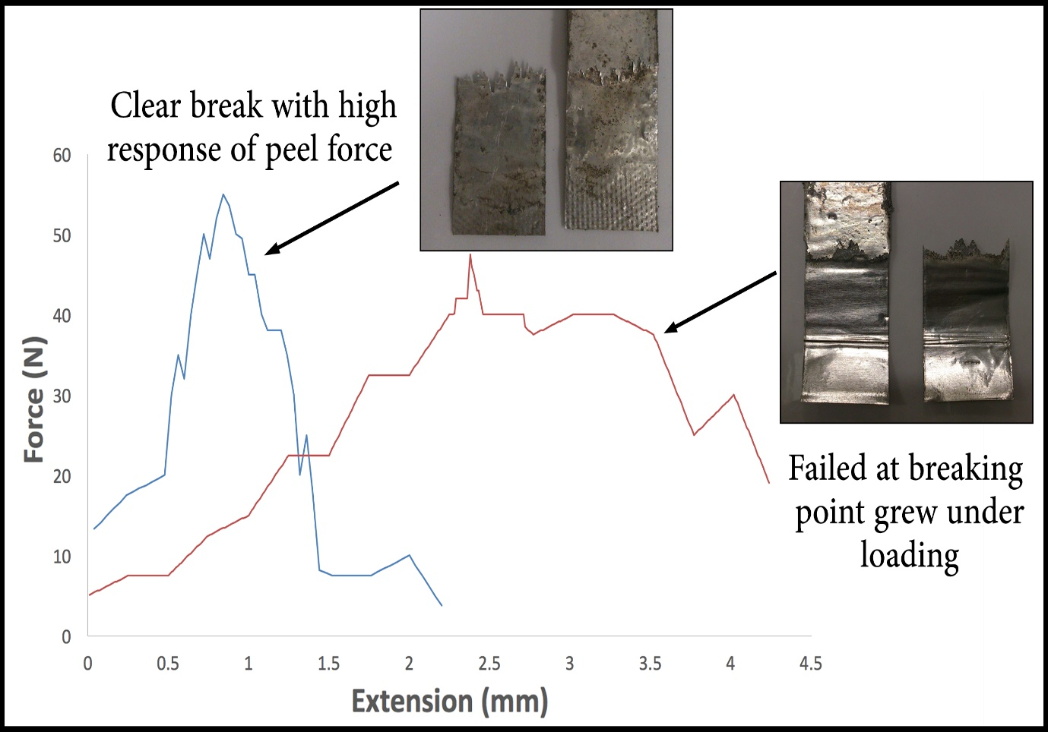
Figure 7: Fracture Modes of Aluminium Peel Test
The peel test resulted in two failure modes (Fig. 9):
1. When a specimen show less and small teeth at the beginning of the brazed region indicating a strong bond between the two foils, giving a high load ranging from 55-50.5N.
2. When a specimen show a large number of teeth resulting in more breaking points that grew as the load is being applied. Such failures result in a comparatively low force values of around 45.5N.
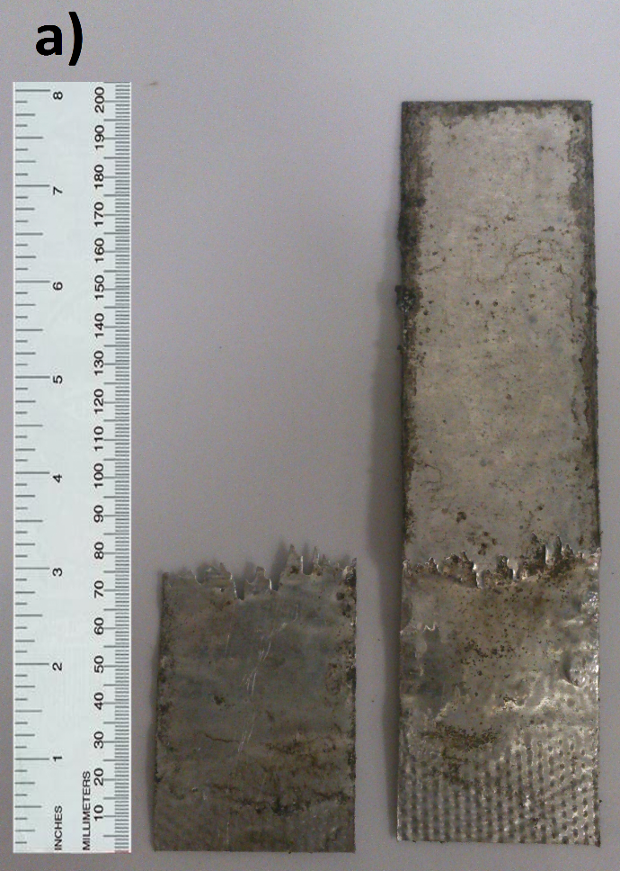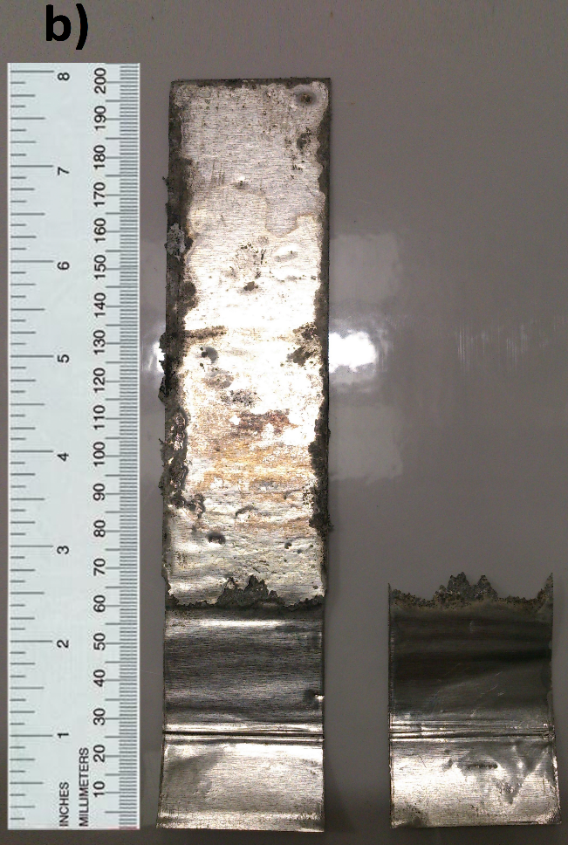
Figure 8: Two fracture modes: a) Less and regular teeth; b) More and irregular teeth

Figure 9: Peel test results
Table 5 calculates the average force (from the graph) and peel strength which is obtained by dividing the maximum force with the cross-sectional area (0.1 mm x 25 mm = 2.5 mm²) of each specimen.
Table 5: Peel strength calculation
Specimens | Maximum Peeling  Force (N) | Average Peeling  Force (N) | Peel Strength (N/mm²) | Type of Failure
S1 | 45.5 | 21.73 | 18.2 | Delamination Failure
S2 | 50.5 | 22.15 | 20.2
S3 | 52 | 23.18 | 20.8
S4 | 55 | 23.11 | 22
S5 | 47.5 | 22 | 19
Average Peel Strength = 20.04 N/mm²

The maximum force for the peel tests was much lower than the maximum force for Al 99.5 which is 250N (100MPa or 100N/mm²) for a cross-sectional area of 2.5 mm² (25 mm x 0.1 mm). These test results differ significantly from adhesive bonds that fail uniformly upon the application of load. When a load was applied to the brazed specimens, they showed the formation of teeth. The reason for the formation of teeth is the presence of un-bonded area indicating an absence of bond between the two foils. The teeth signify the integrity of the bond produced by CMFM. Smaller teeth indicating a better bond whereas larger teeth signify a poor bond. The presence of un-bonded areas can be attributed to the application of insufficient force during brazing, resulting in the paste not being able to penetrate the tenacious oxide layer at the interface. The peel test proved useful in understanding the overall bond effectiveness produced by CMFM. The substrate failed by splitting in layers, therefore, the failure pattern was given the designation DF (delamination failure).

Results from Dog-bone Tensile Test
The tensile test was carried out to analyse the behaviour of the specimens produced by CMFM under tensile forces. This test clearly demonstrates that bond produced by CMFM fractures at a higher force value compared to a part product manufactured from conventional machining methods. Fig. 10 shows the fracture modes of aluminium and one of the composite specimens. Fig. 11 shows the comparison among the specimens.
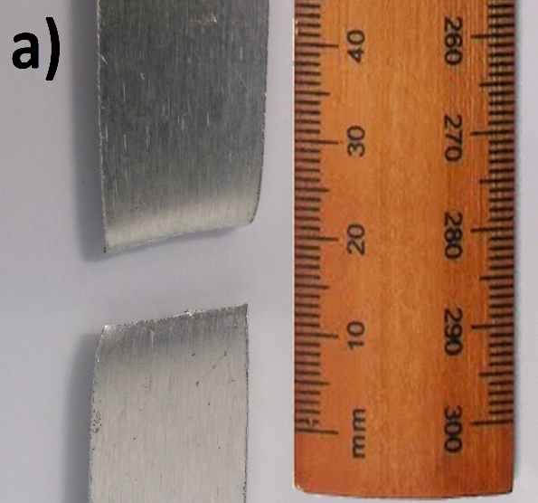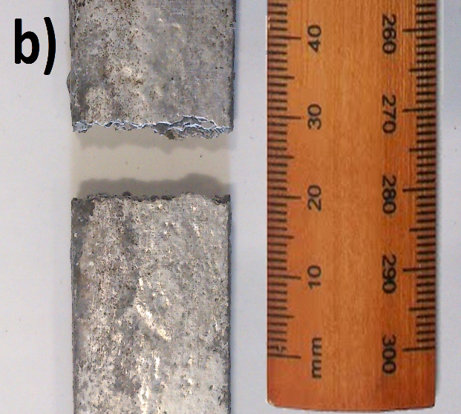
Figure 10: Fracture modes: a) Al 1050; b) Composite specimen

Figure 11: Comparative Tensile Test
The maximum force value for the solid aluminium 1050 specimen is 4.483kN and its curve has well defined elastic and plastic regions as is expected from an aluminium alloy. On the other hand, the specimen made up of 18 layers (0.05mm thick foils) showed maximum force value of 4.923kN, the specimen made up of 14 layers (0.1mm thick foils) showed value of 4.853kN and the specimen made up of 9 layers (0.2mm thick foils) showed value of 4.754kN. The first specimen showed 9.8%, second showed 8.25% and the third showed 6% higher force values as compared to the parent aluminium. The values obtained from the tensile test are plotted in Fig. 12 which shows a linear relationship between number of layers and force values. It clearly indicates that the more the number of layers used for a particular thickness, the more force is required to fracture the part.

Figure 12: Relationship between strength and foils of different thickness
The specimens produced by CMFM showed higher values because of the formation of an intermetallic bond between the metal foils and the paste. Aluminium has a yield strength of 75 MPa and the paste has a yield strength of 45 MPa. Theoretically, these two strengths tend to add up with each layer [33]. The same increase is not obtained through experiments but Fig. 10 shows some addition in strength nonetheless. This experiment also validates the effect of increased strength with higher number of layers. 0.2mm thick foils were only 9 to produce the 2.7mm thick specimen, giving an increase of 6%, 0.1mm thick foils were 14, giving an increase of 8.25% and 0.05mm thick foils were 18, thus giving 9.8% higher values. This clearly indicate that increase in number of layers increase the strength of the part produced for the same cross-sectional area.
Aluminium is a ductile metal, therefore, it shows pronounced elastic and plastic region before fracture. The composite specimens, on the other hand, show high strength but a relatively small plastic region due to the presence of bonds. The intermetallic bonds between the metal foils and the paste prevent the aluminium layers from following their ductile nature. The presence of bonds is also responsible for a much less percentage elongation of the specimens as compared to the parent aluminium as is evident from Table 6.
Table 6: Tensile test values
Specimens | Total Elongation (%) | Ultimate Tensile Strength (MPa)
Al 1050 | 21.5 | 132.8
0.05mm | 2.6 | 145.8
0.1mm | 2.8 | 143.8
0.2mm | 3.1 | 140.8

Comparison with Plate press-soldering process
CMFM is a relatively new process and has shown great promise in the testing stage. It has huge potential and can one day be commercialised as a cost-effective metal AM method capable of producing high quality metal and composite parts. This process has a remarkable similarity with another process which is also in the developmental stages known as plate press-soldering (PPL). This process makes use of two massive steel plates as heat source to provide heat to metal sheets that have been coated with solder material for joining via contact heating. The process recommends the utilization of thicker plates to save time but thicker plates are more expensive than thin metal sheets. CMFM, on the other hand can work with metal sheets of varied thicknesses without any issue as shown in the results presented in this research. PPL also required a pre-process for roughening the metal plates by sand blasting to ensure sufficient adhesion [34] whereas CMFM can work with metal foils without any surface treatment thereby saving time and resources. The heating of the pre-coated metal sheets is more or less the same in both the processes. PPL claims to produce parts with lower residual stress and reduced warping but the data presented is not substantial enough whereas we have shown in our previous work that the thermal stress and strain generated during the brazing process of CMFM is not high enough to impact the structural integrity of the final products [35]. PPL also requires reworking of the resulting part after joining according to the desired geometry whereas CMFM does not require post-processing. The parts produced by CMFM, after joining, can be used for engineering applications. Two 100mm long and 7mm thick spanners, one from aluminium and the other a composite of aluminium and copper, produced by the process of CMFM are shown in Fig. 13 that clearly demonstrates the quality of parts that CMFM is capable of producing. It also shows that CMFM is not affected by the staircase effect that a number of metal foil using methods suffer from [15, 16]. . It is because the layer of paste becomes solid and acts as a stiff sheet between two metal foils. Furthermore, the parts produced by CMFM show a much higher tensile strength as compared to solid parent metals which is something that the process of PPL is struggling with. The mechanical testing of the parts produced by PPL show bending tests performed on them but they are not even comparable to the base material. A great deal of research is needed to make this process viable for the production of metal parts with good mechanical properties. It already has a pre and post process to get the desired geometry and a secondary process to enhance mechanical properties will make the build of a single part more time consuming than it already is. The process of PPL is still in its early stages and require more work to ensure reproducible properties of the parts and choosing a suitable solder material. It is also been aimed more towards producing large metallic tools rather than different shapes and geometries. CMFM has shown reproducible and repeatable results as shown by our previous work [36] and at this stage is a much more efficient process compared to PPL.
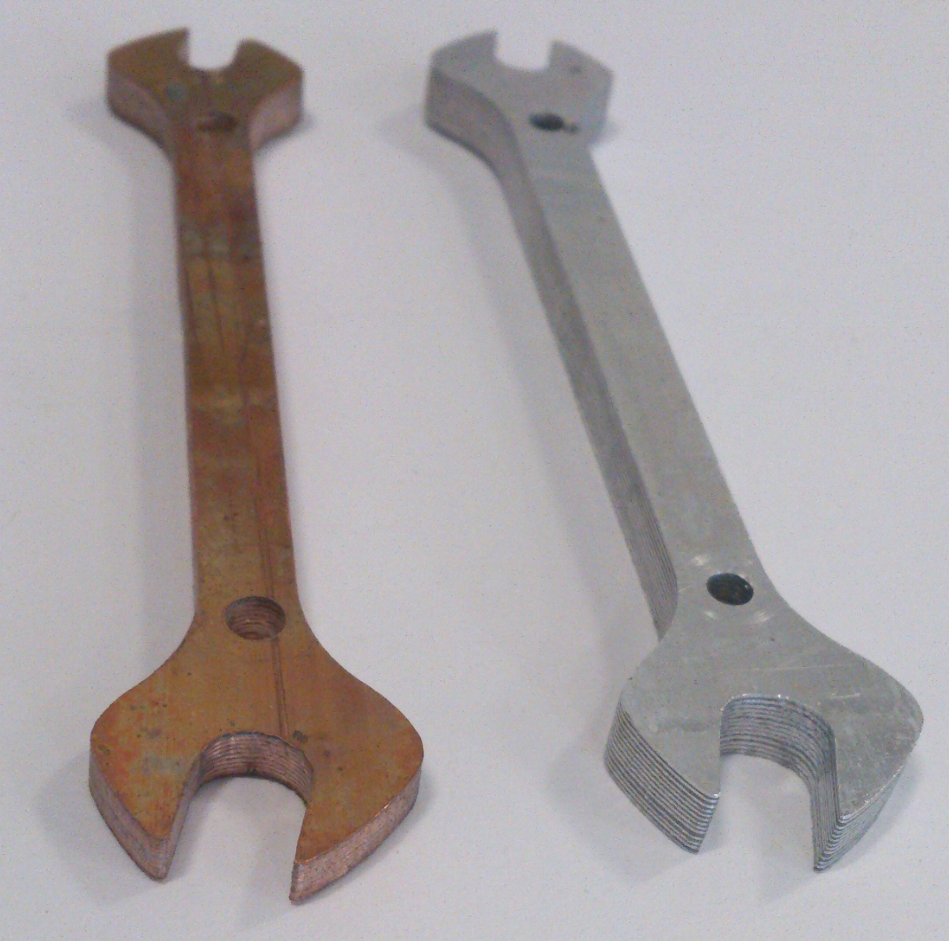
Figure 13: Spanners produced by CMFM
Scanning Electron Microscope (SEM) was utilized to take a closer look at the bonding interface between the paste and the metal foils (Aluminium spanner from Fig. 13). Fig. 14a shows that the layers of metal foil and paste are diffusing indicating the presence of a larger and stronger bonded area. A much closer look at the layer of paste in Fig. 14b showed voids and cavities indicating that even after good diffusion at the surface of the metal foil, there are still spaces within the paste layer that could lead to failure. However, those voids did not affect the mechanical properties to a large extent as during tensile testing, the parts made by CMFM proved to be stronger than solid aluminium. PPL also showed a good diffusion zone but it was not good enough to enhance the mechanical properties of parts produced by it.
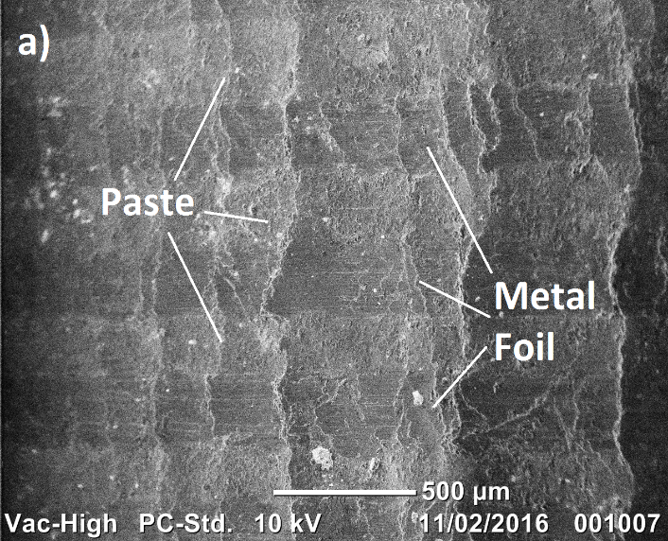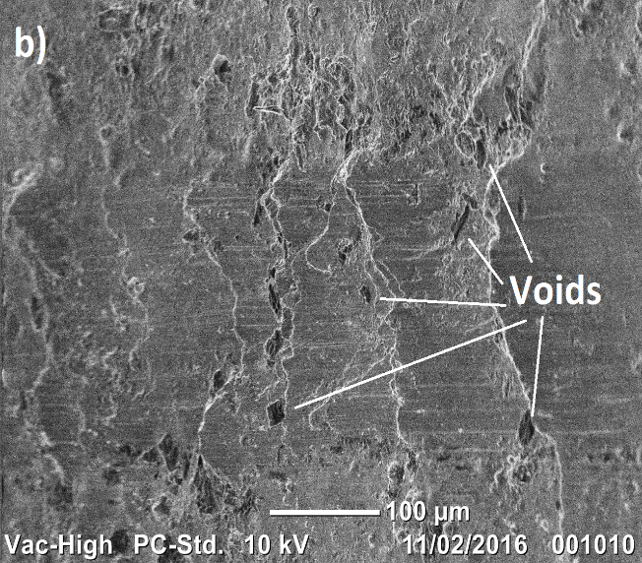
Figure 14: SEM Analysis: a) Part at x50; b) Part at x200

Potential of Application
CMFM is a very capable process and can give tough competition to the current metal AM methods. This process has the potential to follow the same pattern as three dimensional (3D) printers have gone through in recent years. 3D printers can produce bespoke plastic parts with ease and CMFM can do the same but with metal parts. There has always been on emphasis on the production of metal parts as they provide an environment for testing and show how a part might behave under different conditions. CMFM can produce metal parts quickly, cheaply and is much simpler compared to the rival technologies.
CMFM can work with tough metals like aluminium that are not easy to join as shown through this research work. Foils of different thickness are joined using CMFM which shows the flexibility of the process. It also has the capability to produce composites in the same way as single material parts without the use of additional machinery. This feature makes the process more versatile and appealing to the metal prototyping sector. CMFM is capable of producing overhanging and complex shaped geometries with ease without compromising their mechanical integrity.
The additive manufacturing identified with the generation of metal parts using the new process can work with an extensive variety of metals under typical conditions regardless of their joining capacities. The feedback that parts delivered by added substance fabrication techniques are not sufficiently solid for genuine applications can without much of a stretch is hushed with the obtained trial results. Applications can extend from little bespoke parts to large scale functional products that can be utilized with no post handling (Fig. 13). They include but are not limited to mechanical workshop tools, motor industry (engines and their parts), large moulds etc. This process is an addition to the list of metal AM methods and have distinct advantages including higher lap shear strength, peel strength, corrosion resistance [36], tensile strength etc., and is well-suited for single builds.
In terms of production time, CMFM can produce parts at a much faster rate. Fig. 13 shows two dog-bone specimens made by CMFM and DMLS machine (EOS M290). A visual inspection shows that the part produced by the former process (Fig. 15a) has a better surface finish and as it has already been established, possesses a higher lap shear and tensile strength. The part made by the latter process has a grainy finish (Fig. 15b) and at some areas show impressions of the build material structure (Fig. 15c). The dog-bone specimen with a thickness of 2.7mm using foils of 0.1mm thickness can be made in approximately 30 minutes. The same part in DMLS takes a longer time: 45 minutes for the gas to fill the build chamber, 20 minutes for setting up and levelling of the build platform, 40 minutes for the part to be made including a 4mm thick support structure otherwise the actual part would not adhere to the surface, 15 minutes for powder removal after the build, 10 minutes for removing the part from the build platform and the support structure from the part. It clearly shows the inefficiency of a well-established metal AM method when it comes to performing single builds.
The parts made by DMLS are not without inaccuracies. The accuracy depends on a number of factors including powder material, grain size, layer thickness etc., and is an issue in all three axes. The achievable part accuracy depends on which powder material is used, varying from about ± 50 µm for Direct-Metal 20 to about ± 100 µm for Direct-Steel 50. The resolution in the vertical direction (perpendicular to the layers) is determined by the layer thickness. For Direct-Metal 20, Direct-Steel 20 and Direct-Steel H20 it is typically 0.02 mm, for Direct-Metal 50 and Direct-Steel 50 it is 0.05 mm. For Direct-Metal 50 (grain size approx. 50 mm) accuracies of ± (0.05 % + 50 mm) are obtainable. Due to the slightly higher shrinkage during exposure and the smaller powder particle size the obtainable accuracy for Direct-Metal 20, Direct-Steel 20, Direct-Steel H20 and Direct-Steel 50 ± (0.07 % + 50 µm) [37]. In the case of CMFM, there is not a considerable amount of inaccuracy/deformation in the X and Y axes [35]. The accuracy of the Z-axis depends on the uniformity/non-uniformity of the metal foil used and varies according to that factor. The accuracy in the vertical direction (Z axis) depends on the layer thickness and is found to be ±100 micron.

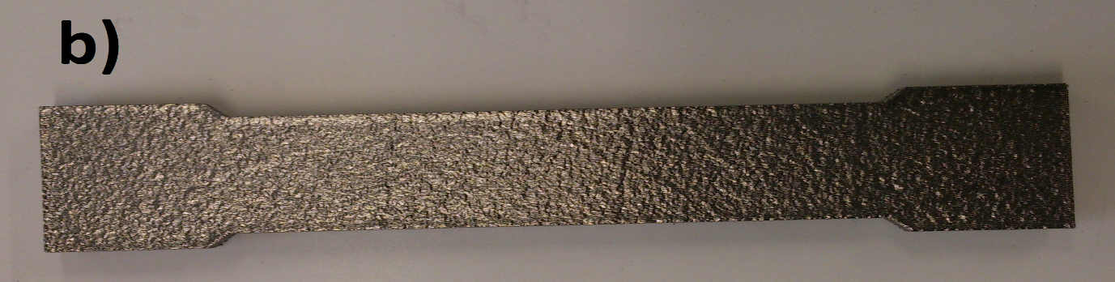
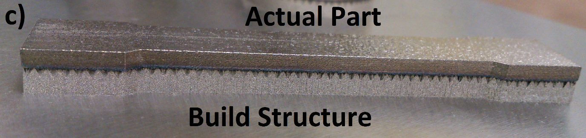
Figure 15: Parts made by different processes: a) Final part by CMFM; b) Final part by DMLS; c) Part by DMLS with support structure

Conclusions
The results presented in this paper show the effectiveness of CMFM. The lap-shear testing showed two modes of failure but the failure mode was always substrate failure whereas the bonded area remained unaffected and intact. The peel test also exhibited two modes of failure with the presence of shorter and longer teeth signifying the presence of an effective and un-effective bond respectively. The strength of the dog-bone specimens produced by CMFM is higher than the specimen produced by conventional machining method. It was argued and validated that the strength increases with increase in the number of layers for a particular cross-sectional area. The specimen produced by 0.05mm thick layers showed 9.8%, 0.1mm thick layers showed 8.25% and the specimen produced by 0.2mm thick layers showed 6% higher fracture values than the parent aluminium. This is an added feature that the process can offer for the production of metal parts using foils of different thickness.

References
[1] Dickens, P.M., 1995. Research developments in rapid prototyping. Proceedings of the Institution of Mechanical Engineers, Part B: Journal of Engineering Manufacture, 209(4), pp.261-266.
[2] Himmer, T., Nakagawa, T. and Noguchi, H., 1997, August. Stereolithography of ceramics. In International Solid Freeform Fabrication Symposium, Austin, TX (pp. 363-369).
[3] Kai, C.C., 1994. Three-dimensional rapid prototyping technologies and key development areas. Computing & Control Engineering Journal, 5(4), pp.200-206.
[4] Pham, D.T. and Gault, R.S., 1998. A comparison of rapid prototyping technologies. International Journal of Machine Tools and Manufacture, 38(10), pp.1257-1287.
[5] Zhang, Y., He, X., Du, S. and Zhang, J., 2001. Al2O3 ceramics preparation by LOM (laminated object manufacturing). The International Journal of Advanced Manufacturing Technology, 17(7), pp.531-534.
[6] Calignano, F., Manfredi, D., Ambrosio, E.P., Iuliano, L. and Fino, P., 2013. Influence of process parameters on surface roughness of aluminum parts produced by DMLS. The International Journal of Advanced Manufacturing Technology, 67(9-12), pp.2743-2751.
[7] Cormier, D., Harrysson, O. and West, H., 2004. Characterization of H13 steel produced via electron beam melting. Rapid Prototyping Journal, 10(1), pp.35-41.
[8] Mitchell, A., 1999. The electron beam melting and refining of titanium alloys. Materials Science and Engineering: A, 263(2), pp.217-223.
[9] Simchi, A., 2006. Direct laser sintering of metal powders: Mechanism, kinetics and microstructural features. Materials Science and Engineering: A, 428(1), pp.148-158.
Simchi, A., Petzoldt, F. and Pohl, H., 2003. On the development of direct metal laser sintering for rapid tooling. Journal of Materials Processing Technology, 141(3), pp.319-328.
[10] Sonmez, F.O. and Hahn, H.T., 1998. Thermomechanical analysis of the laminated object manufacturing (LOM) process. Rapid Prototyping Journal, 4(1), pp.26-36.
[11] Ponader, S., Vairaktaris, E., Heinl, P., Wilmowsky, C.V., Rottmair, A., Körner, C., Singer, R.F., Holst, S., Schlegel, K.A., Neukam, F.W. and Nkenke, E., 2008. Effects of topographical surface modifications of electron beam melted Ti‐6Al‐4V titanium on human fetal osteoblasts. Journal of biomedical materials research Part A, 84(4), pp.1111-1119.
[12] Murr, L.E., Gaytan, S.M., Ceylan, A., Martinez, E., Martinez, J.L., Hernandez, D.H., Machado, B.I., Ramirez, D.A., Medina, F., Collins, S. and Wicker, R.B., 2010. Characterization of titanium aluminide alloy components fabricated by additive manufacturing using electron beam melting. Acta materialia, 58(5), pp.1887-1894.
[13] Khaing, M.W., Fuh, J.Y.H. and Lu, L., 2001. Direct metal laser sintering for rapid tooling: processing and characterisation of EOS parts. Journal of Materials Processing Technology, 113(1), pp.269-272.
[14] Mueller, B. and Kochan, D., 1999. Laminated object manufacturing for rapid tooling and patternmaking in foundry industry. Computers in Industry, 39(1), pp.47-53.
[15] Prechtl M, Otto A, and Geiger M (2005) Rapid Tooling by Laminated Object Manufacturing of Metal Foil. Trans Tech., Vol. 6-8, pp. 302-312.
[16] Prechtl M, Pursche L, Otto A (2004) System Technology and data Preparation for Automated Laser Assisted Stacking of Metal Foil. In: Proc. of the 4th International Conference on Laser Assisted Net Shape Engineering – LANE, Germany; pp. 601-610.
[17] Armstrong, K.B., 1997. Long-term durability in water of aluminium alloy adhesive joints bonded with epoxy adhesives. International Journal of Adhesion and Adhesives, 17(2), pp.89-105.
[18] Kinloch, A.J., 2003. Toughening epoxy adhesives to meet today's challenges. MRS bulletin, 28(06), pp.445-448.
[19] Kong, C.Y. and Soar, R.C., 2005. Fabrication of metal–matrix composites and adaptive composites using ultrasonic consolidation process. Materials Science and Engineering: A, 412(1), pp.12-18.
[20] Kong, C.Y., Soar, R.C. and Dickens, P.M., 2002, August. An investigation of the control parameters for aluminum 3003 under ultrasonic consolidation. In Proceedings of the 13th Solid Freeform Fabrication Symposium (pp. 199-210).
[21] Kong, C.Y., Soar, R.C. and Dickens, P.M., 2003. Characterisation of aluminium alloy 6061 for the ultrasonic consolidation process. Materials Science and Engineering: A, 363(1), pp.99-106.
[22] Facchini, L., Magalini, E., Robotti, P., Molinari, A., Höges, S. and Wissenbach, K., 2010. Ductility of a Ti-6Al-4V alloy produced by selective laser melting of prealloyed powders. Rapid Prototyping Journal, 16(6), pp.450-459.
[23] Gu, D. and Shen, Y., 2006. WC–Co particulate reinforcing Cu matrix composites produced by direct laser sintering. Materials Letters, 60(29), pp.3664-3668.
[24] Kumar, S. and Kruth, J.P., 2010. Composites by rapid prototyping technology. Materials & Design, 31(2), pp.850-856.
[25] Butt J, Mebrahtu H, and Shirvani H (2015) Rapid prototyping by heat diffusion of metal foil and related mechanical testing. Int. J. of Adv. Manuf. Tech., 1-10. doi: 10.1007/s00170-015-7882-8.
[26] Butt J, Mebrahtu H, and Shirvani H (2014) A novel rapid prototyping process for the production of metal parts,’’ Proceedings of the Second International Conference on Advances in Civil, Structural and Mechanical Engineering, Birmingham, UK, pp. 26-29. doi: 10.15224/ 978-1-63248-054-5-45.
[27] ASM Metals Handbook (1985) Heat Treating, 9th edition, Vol. 4. American Society for Metals, Metals Park, OH, pp. 763-74.
[28] BS EN 1465: 2009, Adhesives — Determination of tensile lap-shear strength of bonded assemblies.
[29] BS EN ISO 11339:2010, Adhesives — T-peel test for flexible-to-flexible bonded assemblies.
[30] BS EN ISO 6892-1:2009, Metallic materials — Tensile testing, Part 1: Method of test at ambient temperature.
[31] BS EN ISO 10365:1995, Adhesives -- Designation of main failure patterns.
[32] Da Silva, L.F., Carbas, R.J.C., Critchlow, G.W., Figueiredo, M.A.V. and Brown, K., 2009. Effect of material, geometry, surface treatment and environment on the shear strength of single lap joints. International Journal of Adhesion and Adhesives, 29(6), pp.621-632.
[33] Anglia Polytechnic University, Hassan Shirvani (2000) Honeycomb structure, method of forming a honeycomb structure and method of joining aluminium or aluminium alloy bodies. GB Patent: WO0033997 (A1).
[34] Strasser C, Prihodovsky A, Ploshikhin V. 2015. Plate press-soldering for the manufacture of large metallic tools. [ONLINE] Available at: https://www.rtejournal.de/ausgabe12/4242/view?set_language=en. [Accessed 29 February 16].
[35] Butt, J., Mebrahtu, H. and Shirvani, H., 2015. Thermo-Mechanical Analysis of Dissimilar Al/Cu Foil Single Lap Joints Made by Composite Metal Foil Manufacturing. World Academy of Science, Engineering and Technology, International Journal of Mechanical, Aerospace, Industrial, Mechatronic and Manufacturing Engineering, 10(1), pp.41-46.
[36] Butt, J., Mebrahtu, H. and Shirvani, H., 2015. Peel and tensile test investigation of aluminium 1050 foil parts made with a new additive manufacturing process. International Journal of Rapid Manufacturing, 5(1), pp.95-115.
[37] Syvanen T (1996) Direct Sintering of Metals Material and Process Development. M. Sc. Thesis, Tampere University of Technology.

